Measurement methods of acoustics properties for alternative ventilation ducts

Zekic, Suzana
Imtech Engineering Services London & South
20 Kingston Road, Staines-upon-Thames, Middlesex TW18 4LG

Gomez-Agustina, Luis; Aygun, Haydar; Chaer, Issa
London South Bank University
103 Borough Rd, London SE1 0AA
ABSTRACT
The use of plastic and alternative ducts in residential ventilation has significantly increased with the demand for mechanical ventilation systems which in turn responds to national and international legislation on energy conservation. Current building regulations require air-tight building fabric, limiting the use of natural ventilation due to security, noise, and air pollution. To date there is no information available on the acoustic characteristics of plastic and other alternative ventilation ducts to enable accurate noise transfer predictions in design assessments. As a part of an ongoing research into the determination of those acoustic characteristics, a preliminary critical review has been carried out on acoustic testing methodologies and procedures for ventilation ducts as used in the industry and in research. This paper presents a collation and scrutiny of information gathered from the literature and from an UK industry-wide consultation. The review has shown that there is a lack of reliable test methods and procedures applicable to the determination of acoustic characteristics of alternative ventilation ducts. The results from the review will enable the development of a robust, industry-accepted and standardised test procedures and novel data.

1. INTRODUCTION

The use of plastic and alternative ducts for residential ventilation has significantly increased with the demand for mechanical ventilation systems which in turn responds to national and international legislation on energy conservation and ensuring good indoor air quality [1]. Current building regulations increasingly require airtightness in the building fabric and limiting the use of natural ventilation due to security, noise, and air pollution concerns. Figure 1 below shows samples of residential ventilation systems.

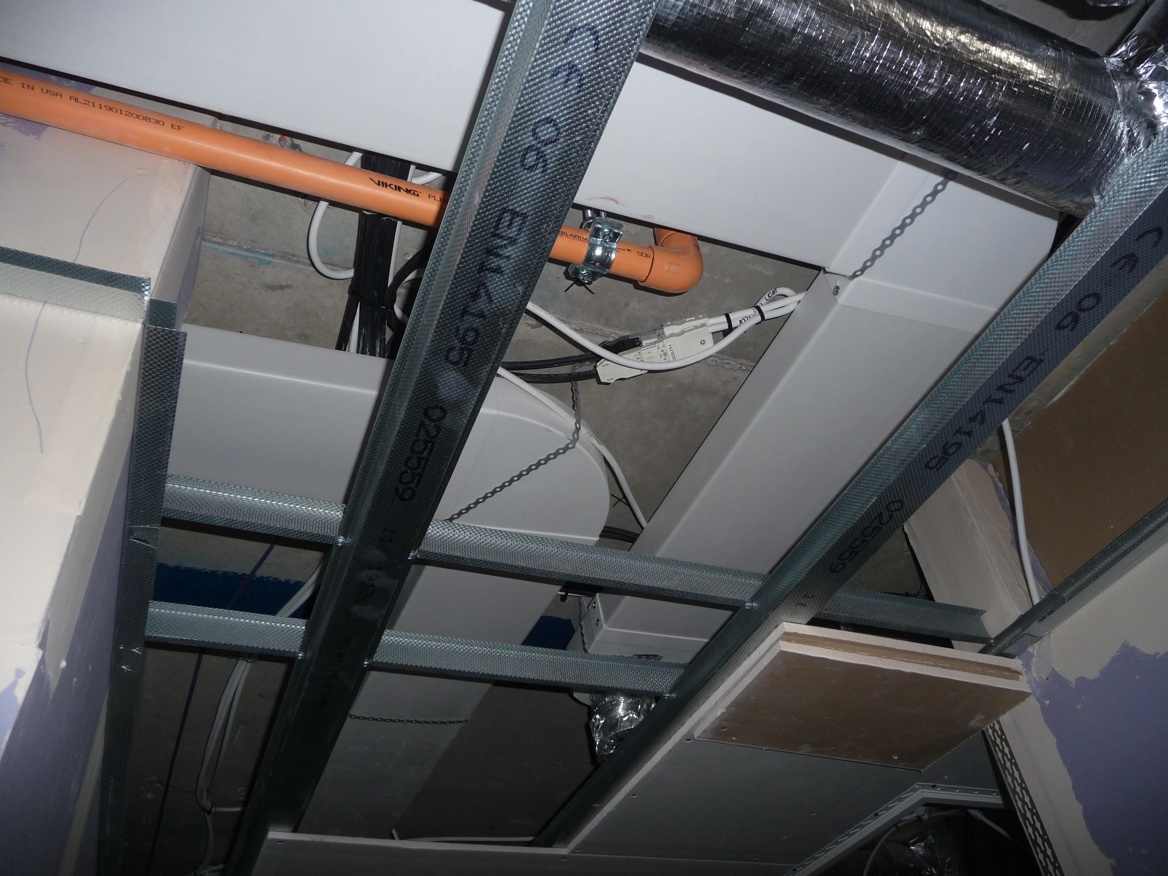
Figure 1 Typical installation of residential ventilation ductwork, plastic (left) and galvanised steel (right)
To date there is no information available on the acoustic characteristics of plastic and other alternative ventilation ducts to enable accurate noise transfer predictions in design assessments. The absence of accurate information leads to crude estimations or calculations based on galvanized ducting data.
Plastic (polyvinyl chloride PVC, most frequently used for residential ventilation) and galvanised steel have quite different values for stiffness, internal damping, surface roughness, superficial mass density and elasticity. It is anticipated that these marked physical and mechanical properties will render significant acoustics characteristics.
In order to close this knowledge gap a research project supported by the industry has been set up with the aim to determine the acoustic characteristics of plastic and alternative ventilation ducts and their ancillaries for the development of databases, prediction models and guidance in the design of practical ventilation installations [2].
To develop this new information suitable customised test methods will need to be identified or created.
This paper presents a survey and preliminary review of the most relevant standardised test procedures found in the literature. The identified literature is reviewed and scrutinised to inform the creation of a robust and industry accepted test procedure that will have the potential to be internationally standardised.

2. EXISTING STANDARDISED TESTING METHODS

The review of the relevant literature has revealed the absence of a suitable acoustic test procedure for determining the acoustic characteristics of the plastic and other alternative ventilation ductwork.
Due to this lack of specific test methods, the review consequently focused on standardised methods used for obtaining acoustic data of galvanised ductwork.
The most suitable method of testing ductwork found is published by the American Society for Testing and Materials (ASTM) E477 [3] details of which will be described in this document in section 2.1.
In the UK and Europe the following standards were located and described henceforth
- BS EN ISO 11691 [4] was found to be applicable for measuring transmission losses
- BS EN ISO 5135 [5] was found to have guidance on the determination of break out and break in noise levels
- BS EN ISO 7235 [6] applicable for testing silencers its insertion losses of ducted silencers with and without airflow as well as regenerative sound power levels due to airflow
- BS ISO 13347-4 [7] sound intensity method for determination of fan sound power levels under standardised laboratory condition

2.1. ASTM – E477
This standard test method is used for measuring acoustical and airﬂow performance of duct liner materials and prefabricated silencers using the substitution method. The usefulness and the popularity of this standard have been proven by finding it being recorded as a reference in many published papers and articles, the main one being ASHRAE’s HVAC Application Handbook [8].
This standard testing method provides guidance on the measuring insertion losses of the straight duct and bends, (see Figures 2 and 3) as well as its regenerative sound power levels occurring due to high airflow velocities.

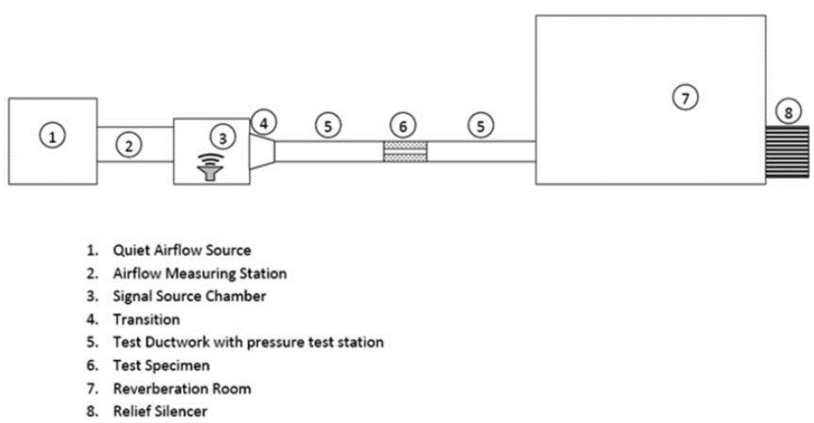

Figure 2 Extract from ASTM E477 [3] illustrating typical facility for rating straight duct silencers with or without airflow
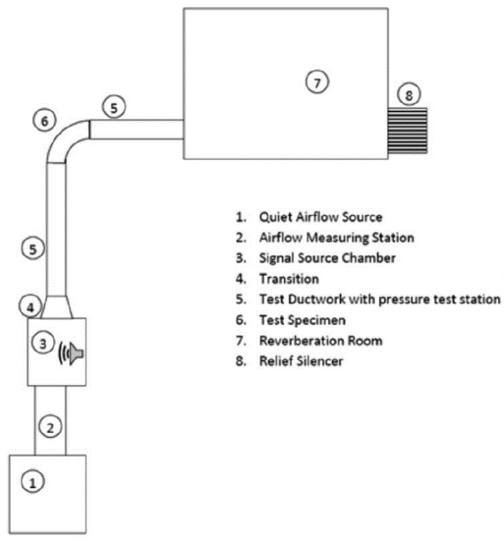
Figure 3. Extract from ASTM E477[3] illustrating typical facility for rating elbow duct silencers with or without airflow
However, as noted by Ruan [9] this testing method can only be applied in a special facility using expansive measuring equipment that takes a long time to set up and record measurements. Furthermore, this standard does not have any guidance for obtaining break out and break in noise levels of the tested piece.

2.2. BS EN ISO 11691
This standard describes a laboratory survey method using substitution procedure to determine the insertion loss of ducted silencers without the airflow. Originally published in 1995 this standard was revised in 2009.
BS EN ISO 11691 [4] offers an established and standardised method for measuring transmission loss of silencers and other duct elements used in ventilation. As with the previous testing method, sound source, test piece and the receiving end are required (see Figure 4) noting that other than reverberation room measuring environments such as free field over one or more reflecting planes can be used that is perceived as an advantage for not requiring specialized testing facility.
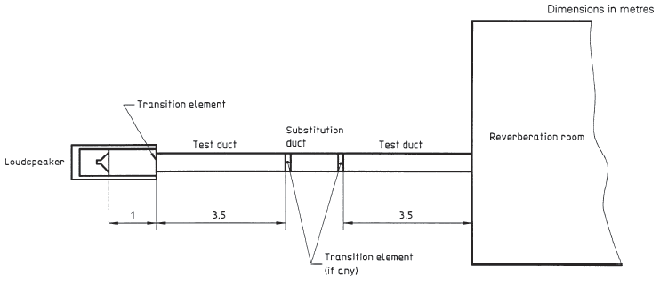
Figure 4 Extract from BS EN ISO 11619 [4] showing test facility set up
It should be noted that due to the measurement uncertainty as exact information on the precision method is not defined, this international standard is denoted a “survey standard”.
Also, reviewing this testing method, it became clear that through the application of this standard only insertion losses can be obtained with no defined methods as to how to obtain breakout and break-in nor the regenerative sound power levels of silencers and other typical ventilation duct pieces. This limitation is restricting its suitability for the deployment in acquiring acoustic characteristics of the plastic and other alternative material ventilation elements although it should be noted that the described test set up (using reverberant room) is very much similar to ASTM E477 [3], the repeatability that offers confidence in the existing consistency across the standards.

2.3. BS EN ISO 5135
The testing guidance within this document relates to the determination of sound power levels from ventilation system elements measured within the reverberation room.
Although fully relating to testing elements as used in ventilation systems, this standard has been found to provide no guidance for obtaining transmission loss or regenerative sound power level and can only be used for limited applications – obtaining the break out and break in noise levels for the tested piece as shown in Figure 5 below.
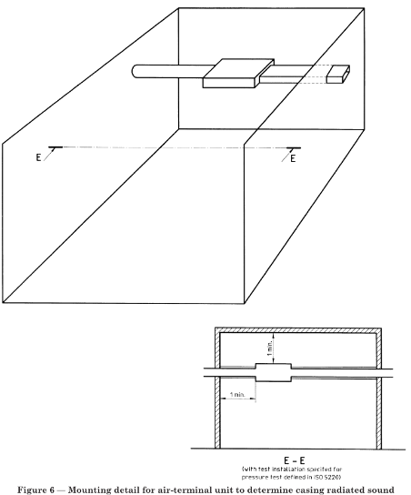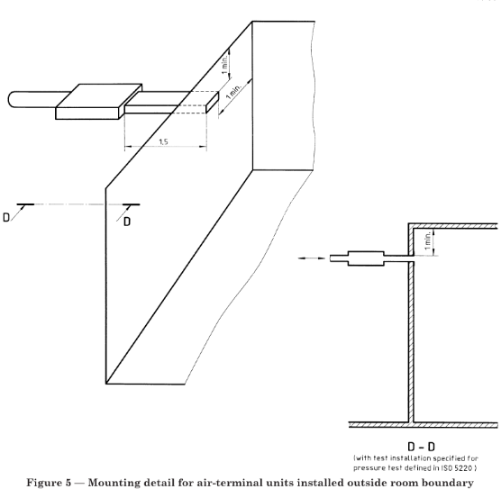
Figure 5 Extracts from BS EN ISO 5135 [5] showing mounting detail for duct element to determine casing radiated noise levels (left) and mounting detail for air-terminal units installed outside room boundary (right)
It is perceived that the concepts mentioned and described within this standard can be adopted along with others required to obtain transmission loss and regenerative noise levels to have at one place methods to attain complete acoustic characteristics of the tested pieces.

2.4. BS EN ISO 7235
This standard, last revised in 2009, describes laboratory measurement procedures for attaining insertion loss and flow noise for ducted silencers and air-terminal units using the substitution method. Figure 6 shows typical arrangements for in-duct and reverberation room measurements. In the UK, to perform tests in accordance to this standard, laboratories need to have a certificate of the accreditation from the UK Accreditation Service (UKAS) with only three known companies registered at the present.
The stringent rules for the accreditation of the testing facilities in one way offer guarantee that the testing and the obtained data have significant weighting but at the same time represent an obstacle as the specific and complex test rig is required for the tests with the airflow.
Moreover, this standard does not provide details on attaining break-out and break-in values which limits the suitability of its application for obtaining acoustic properties of plastic and other alternative ventilation ducts.
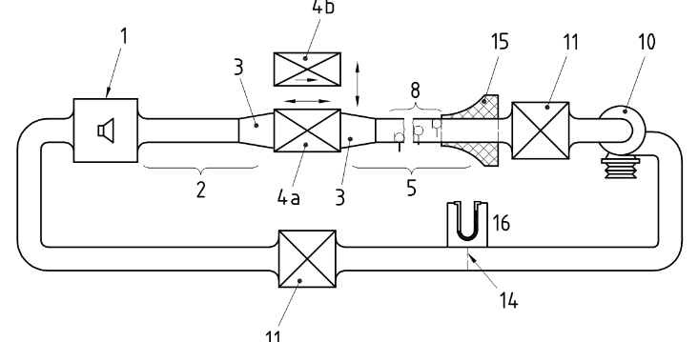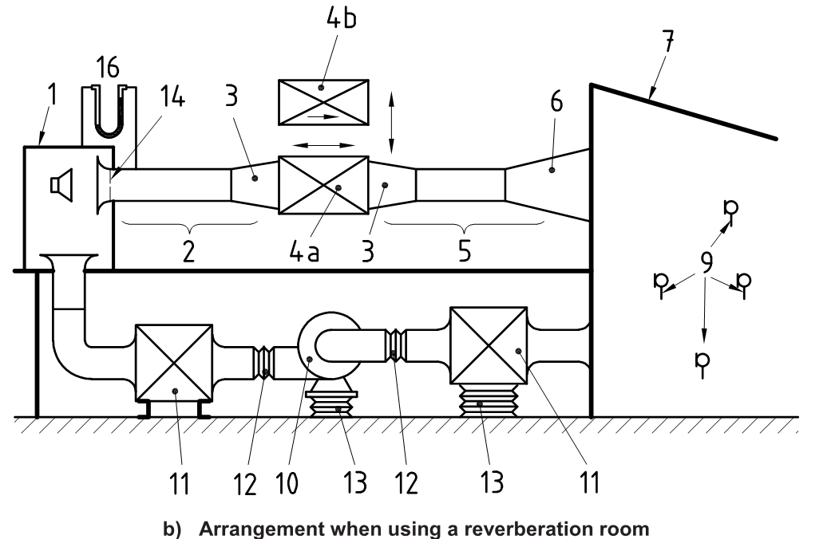
Figure 6 Extracts from BS EN ISO 7235 [6] showing examples of arrangements of the test facility for in-duct measurements (above) and when using a reverberation room (below)

2.5. BS ISO 13347-4
In the absence of straightforward acoustic testing methods not requiring specialist laboratory facilities, the sound intensity probe method has been initially considered for its capability of measuring noise emissions in situ as shown in Figure 7. Within BS ISO 13347-4 [7] determination of fan sound power levels in the standardized laboratory conditions was described using a sound intensity method that as a model could be applied to obtaining breakout noise levels from the tested piece, either straight duct or bends.
In the past, research on the effect of joints to the breakout noise [10] have shown that breakout values obtained through experimental method using sound intensity probe are in line with the numerical methods – confirming the suitability of this method for the proposed task.
Advantage of using a sound intensity probe lies in the fact that it is a quick and effective method suitable for in situ application thus not requiring special testing facilities. However, it is not clear the potential extent of measurement uncertainty when obtaining transmission losses. The suitability of the sound intensity probe as a testing method for the objectives of the research is an area that needs to be further investigated.

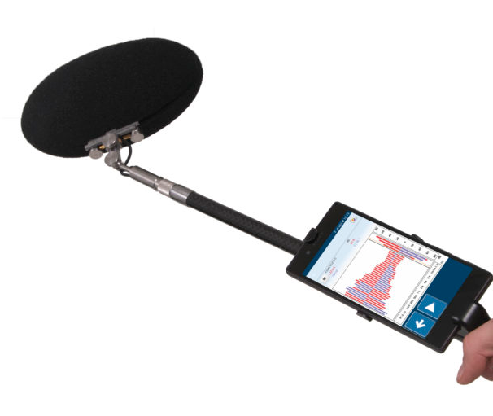
Figure 7 Handheld Sound intensity probe (image courtesy of Norsonics)

3. INDUSTRY WIDE CONSULTATION

An UK industry-wide consultation has been conducted through a dedicated working group of experts to gather insights and views from practitioners on the data needed and suitable test procedures. The group is supported by the Chartered Institute of Building Services Engineers (CIBSE) and is formed from thirteen representatives from leading multidisciplinary engineering companies, acoustics consultancies and laboratories. In a series of consultations the group has confirmed the need for research into acoustic properties of the plastic and alternative ventilation ducts. Views on the development of robust, practical and industry-accepted novel test procedures were sought as existing test procedures do not appear fully suitable and harmonised. The consultations so far have revealed recommendations [11] for acoustic testing to be carried in standardised reverberant rooms rather than in real-world room, as the latter is deemed to be project-specific only applicable to the unique projects.
Testing and generating data specific for duct profile sizes and ancillaries were considered to be of importance and priority as well as testing certain setups such as two 90⁰ bends in close proximity to each other.
Finding out regenerative noise levels created at high air velocities would enable to explore a potential reduction in duct sizes for improved space coordination of building services during installation.
The consultation has highlighted the need to investigate sound attenuation homogeneity along the length although attenuation per meter is still required.
It was suggested the exploration of other non-standardised and not widely known customised tests used by some established firms.

4. CONCLUSIONS

Following a preliminary review of standardised testing methods in the relevant literature, no specific and suitable test procedure has been found for the intended purpose of determining the acoustics characteristics of plastic and alternative ventilation ducts and its ancillary elements.
Relevant test procedures appeared to be not well harmonized and none was found to be fully suitable for the purposes of the research objectives. It was found that certain testing procedures require expensive and onerous testing facilities that although offer reliable laboratory conditions they are only useful for obtaining some of the acoustic characteristics of interest such as transition losses and regenerative sound power levels. Other testing procedures identified and reviewed were found to be easier to set up and execute but equally do not provide complete methods for testing and obtaining acoustic properties of alternative ductwork
A UK industry consultative group made from professional experts has been created to advise on topics of the research. In specific, the group has been consulted on practical aspects and requirements to ensure that the outcomes will address the needs of the industry where the research will be applied. Through a series of consultations it has been confirmed the need for acoustic data of plastic ventilation ducts and a dedicated and traceable testing procedure to obtain that data. The group has suggested exploring non-standardised in-house test procedures developed by some established firms.
The outcomes from an exhaustive literature review combined with the input from the industry will enable the development of robust, industry-accepted and standardised test procedures which in turn will lead to generation of novel data.

5. ACKNOWLEDGEMENTS

The authors would like to express the gratitude to Imtech Engineering Services London and South for sponsoring the PhD programme for which this research is part of.

6. REFERENCES

[1] Dwyer, T., “Ventilating future homes for health comfort and wellbeing”, CIBSE Journal, 2020

[2] Zekic S and Gomes L A, “Towards the determination of Acoustic characteristics of ventilation plastic duct in the built environment”, INTER-NOISE, 2019

[3] ASTM E477 Standard Test Method for Laboratory Measurements of Acoustical and Airﬂow Performance of Duct Liner Materials and Prefabricated Silencers, West Conshohocken, 2013

[4] British Standard Institution BS EN ISO 1169, Acoustics — Measurement of insertion loss of ducted silencers without flow — Laboratory survey method. London: BSI, 2009

[5] British Standard Institution BS EN ISO 5135, Acoustics — Determination of sound power levels of noise from air-terminal devices, air-terminal units, dampers and valves by measurement in a reverberation room, London: BSI, 1999

[6] British Standard Institution BS EN ISO 7235, Acoustics —Laboratory measurement procedures for ducted silencers and air-terminal units — Insertion loss, flow noise and total pressure loss. London: BSI, 2009

[7] British Standard Institution BS ISO 13347-4, Industrial Fans – Determination of fan sound power levels under standardised laboratory conditions – Part 4 Sound Intensity. London: BSI, 2004

[8] ASHRAE Handbook HVAC Applications, Atlanta, ASHRAE, 2019

[9] Ruan, K, "Numerical and experimental techniques for assessing the acoustic performance of duct systems above the plane wave cutoff frequency", Theses (PhD), University of Kentucky, 2018

[10] Jade, N, Venkatesham, B, “Effect of a joint on breakout noise characteristic of rectangular duct”, Building Acoustics, Vol. 26(3) 169–180, 2019

[11] CIBSE Consultative Group, Private communications, 2020

suzana.zekic@imtech.co.uk
gomezagl@lsbu.ac.uk

