A NEW KIND OF LOW FREQueNCY ABSORBER DESIGN SUITABLE FOR MUSIC RECITAL HALLS

S Dance Acoustics Group, London South Bank University, UK
D Shearer Acoustics Group, London South Bank University, UK
P Menin Acoustics Group, London South Bank University, UK

INTRODUCTION
A recital hall of light weight construction had been commissioned. The newly built hall was reported to be loud with an unusual balance by professional musicians. Hence, the Acoustics Group was asked to independently assess the room acoustics of the hall. The hall had a volume of approximately 800m³ with flexible seating for up to 100 people. The hall had a beautiful traditional wood finish and a floor comprising a single continuous area with no raised elements. To give a flexible acoustic curtain rails run down either side of the hall, see Figure 1. The curtain rail then runs behind a fake rear wall which hides the curtain when not in use, see Figure 2. The hall is now always configured with the curtains fully extended, as this is the subjectively preferred condition by the performers. This paper reports on the effect on the acoustics of the hall of the fake rear wall and the curtains through sets of room acoustic measurements.

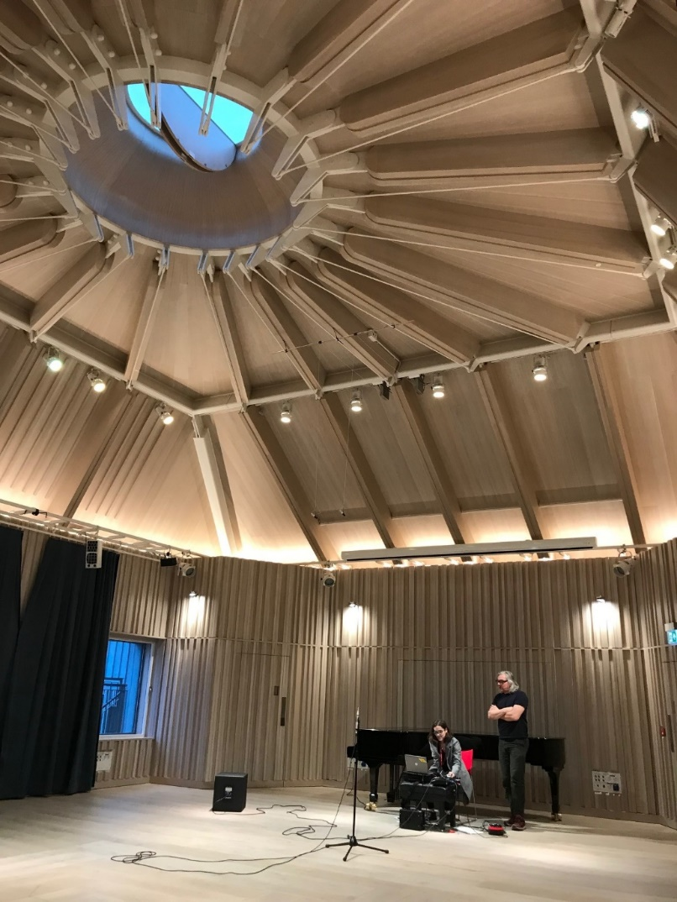
Figure 1. Recital Hall showing the curtain and curtain rail

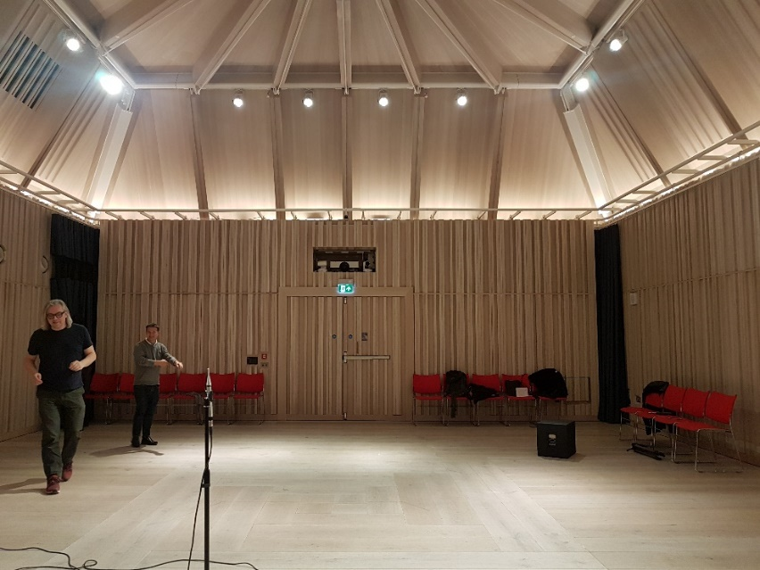
Figure 2. The fake rear wall and curtain rail (curtains were completely hidden during measurements)

ROOM ACOUSTICS MEASURMENTS IN THE HAll
Room acoustics measurements were undertaken in the recital hall to 3382-1 [1]. The measurement system used was winMLS using a 4 second exponential sine sweep outputting to an Omni-directional loudspeaker through a Nor 280 power amplifier or to a subwoofer through a Class D music amplifier. A ¼” omnidirectional measurement microphone was used, a Class 1 Earthworks M30BX, see Figure 1. Two source positions and six receiver positions were used in the measurements, see Figure 3, and each combination’s result is an average of three separate sweeps. The room was configured with 18 seats set against the walls, see Figure 2 and either the curtains fully extended or hidden behind the fake wall.

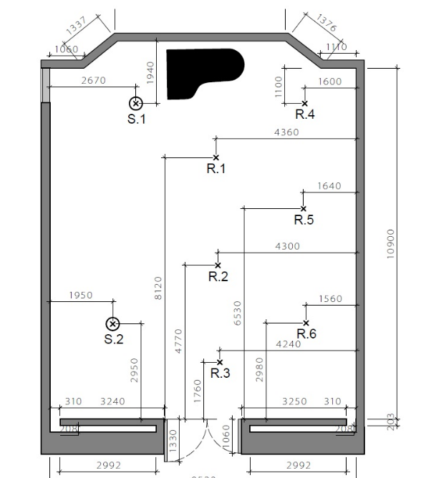
Figure 3.Shows the fake rear wall and the source and receiver measurement positions in the hall

Reverberation Time in the Hall with Hidden Curtains
One set of room acoustic measurements, T20, were taken in the hall using a Rion dodecahedron loudspeaker set at 1.5m from the floor and a microphone set to 1.2 m.

Figure 4. Reverberation time measurements, T20, in the empty hall with curtain hidden

From Figure 4 it can be seen that there is a significant dip in the reverberation time in the hall between 50 Hz and 200 Hz. This is the objective data to support the performers and audience account of the unbalanced nature of the hall. Normally the reverberation time should be flat compared to the mid frequency or rise by up to 20% [2], as given by the Bass Ratio, BR, parameter.

$$BR=\frac{T_{125}+T_{250}}{T_{500}+T_{1000}}$$

where T_{f}is the reverberation time by octave band frequency (Hz).

In the case above the Bass Ratio is 0.66 much less than is deemed suitable for musical performance [2] with a T_{mf} of 1.44 seconds. Hence, the musicians always extend the curtains to their full extent. As low frequency performance was identified as critically important to the hall a subwoofer was used in addition to the omni-source to ensure the hall was responding as thought.

Comparison of the Omni-Speaker and Subwoofer RT Measurements
Two sets of room acoustics measurements, T20, were undertaken in the hall each using a different type of sound source. The sound source chosen was a Rion dodecahedron loudspeaker set at 1.5m from the floor and a JBL 6112 subwoofer on the floor facing the corner of the room. All microphones were set to 1.2m from the floor.

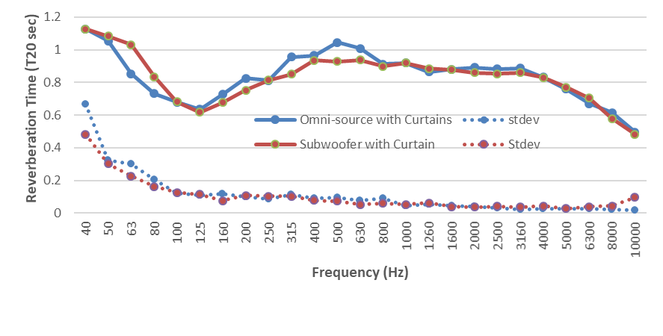
Figure 5. Reverberation time measured in the hall using omni and subwoofer as the sound source

It can be seen from Figure 5 that the standard deviation of the 12 measurement positions taken was smaller at low frequency using the subwoofer, below 100 Hz. This is likely due to the high pass filter in the Nor 280 amplifier, 100 Hz, and the size of the drivers in the dodecahedron loudspeakers, 5” compared to the JBL 12” driver. This of course has the opposite effect at high frequency when the subwoofer is seen to be less consistent, see Figure 5.

Again T20 measurements show a significant drop in the reverberation time centred around 125 Hz, see Figure 5. However, the Bass Ratio was improved to 0.82 with a T_{mf}=0.90 seconds for the omni-source. So the room acoustic parameters are in agreement with the musicians.

ASSESSMENT OF THE ROOM ACOUSTICS OF THE HALL
Assessing the room acoustics of the hall using the new Norwegian Standard 8178 [3]. It can be seen that the hall fails to meet the criteria for frequency dependency below 500 Hz, either with the curtains extended or with the curtains hidden.
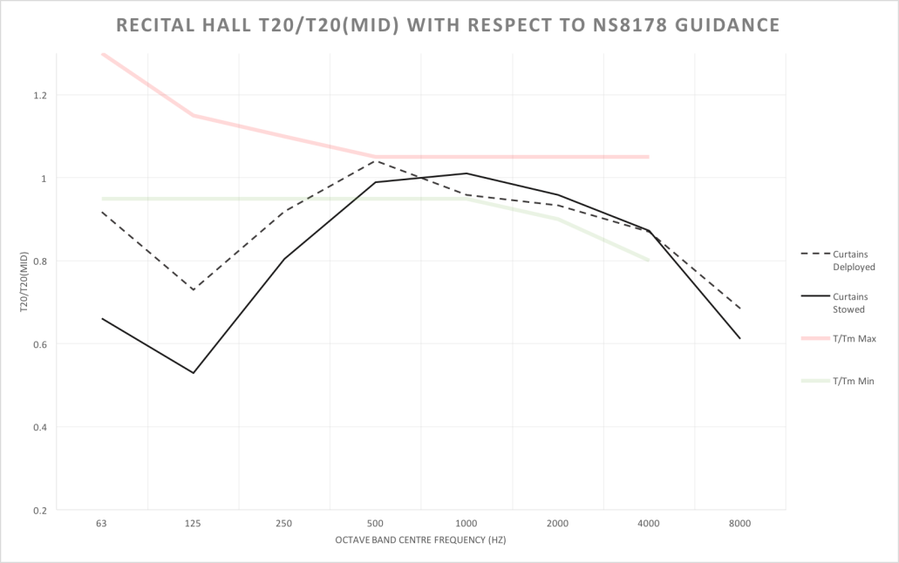
Figure 6. Frequency dependencyof the hall in comparison, T_{mid},with curtains deployed and with hidden curtains according to NS8178:2014

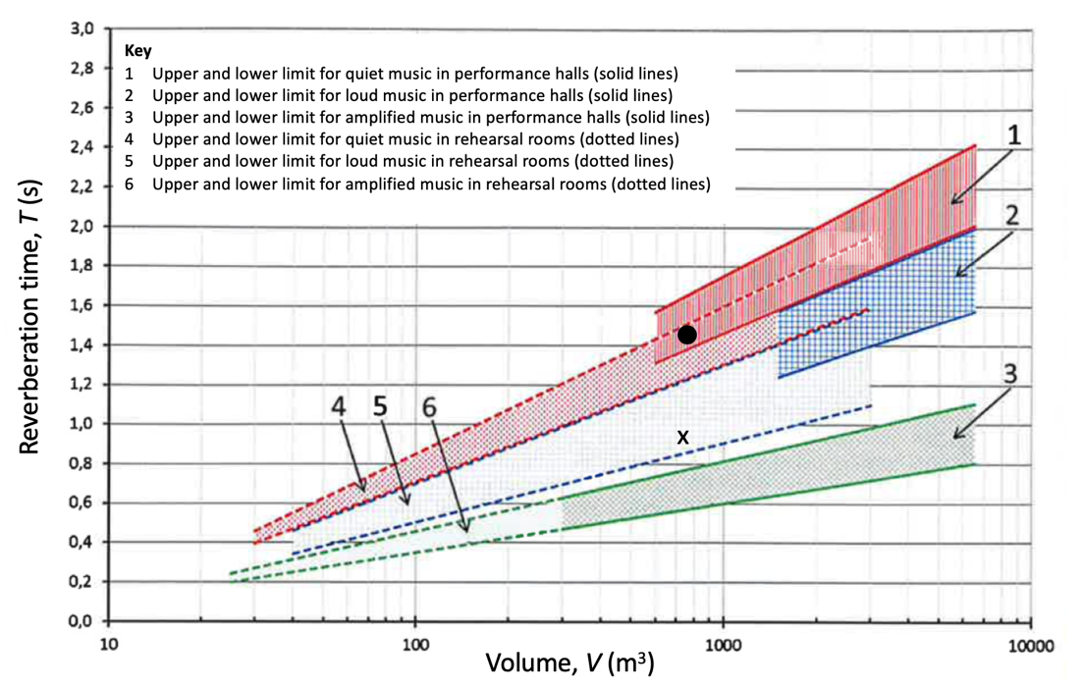
Figure 7. T_{mid} reverberation time of the hall, O with curtain hidden and X with curtains extended

However, when you focus on the mid frequency performance of the hall, T_{mid}=T₅₀₀ and T₁₀₀₀ averaged then the hall behaves well for large ensembles when the curtain is extended, such as brass or operatic styles of performance, or with curtains hidden for small ensembles for instance chamber music, see Figure 7.

DISCUSSION
From the room acoustic measurements, the hall can be said to have an unusual acoustic. So some analysis of the acoustic may help explain the low frequency dip in the reverberation time. Low frequency sound has a long wavelength so a change to the acoustic must be due to a physically significant construction. The most obvious would be the fake rear wall which is an unusual design feature. Each wall creates a gap of approximately 3.25m by 3.6m by 0.2m with a slit opening of 0.31m running the full height of the wall, and continuing along the top of the fake wall over the doorway.

Fuchs and Lamprecht [4] produced many reverberation and noise control designs which had similar characteristics to reduce the reverberation in too reverberant rooms. These were all based on ¼ wavelength resonators filled with porous absorption (fibreglass). They were placed high up in the corner of the room and had a small opening at one end.

Comparing the two omni-source room acoustic measurements for the hall, see Figure 8, it can be seen that between 50 and 160 Hz the reverberation times are very similar. However, across the full frequency range the averaged T20 was reduced from1.14 seconds to 0.84 seconds, for curtains hidden and curtains extended respectively.

The similarity in the curves at low frequencies would indicate that the curtains in the fake wall were not affecting the absorptive properties. This would mean the fake wall was perhaps acting as a resonator. The dimensions of the fake wall would suggest a resonance between 113 Hz and 126 Hz.

Figure 8. Measured Reverberation Time, T20, with curtain extended and with curtain hidden.

VERIFICATION WORK
As a geometric based model would not be able to simulate the effect of the fake wall other possible solutions will need to be found. Conclusions can only be drawn when a suitable model has been developed to recreate the effect of the fake wall. There are several possible options to simulate or measure a room with a fake wall. Firstly, it would be conceivable to run a wave based computer simulation of the recital hall either in COMSOL a Finite Element Model [5], or a Finite Difference Time Difference Model [6]. Secondly through recreating the space using either physical scale model [7] or by recreation of the room with a similar geometry. Through either method it would be possible to determine if this geometry is useable as a new form of simple low frequency absorber that’s effective over two octave bands.

Computer Simulation
A preliminary study using a simple COMSOL model has been undertaken. A simplified version of the hall has been simulated; see Figure 9 and Figure 10.

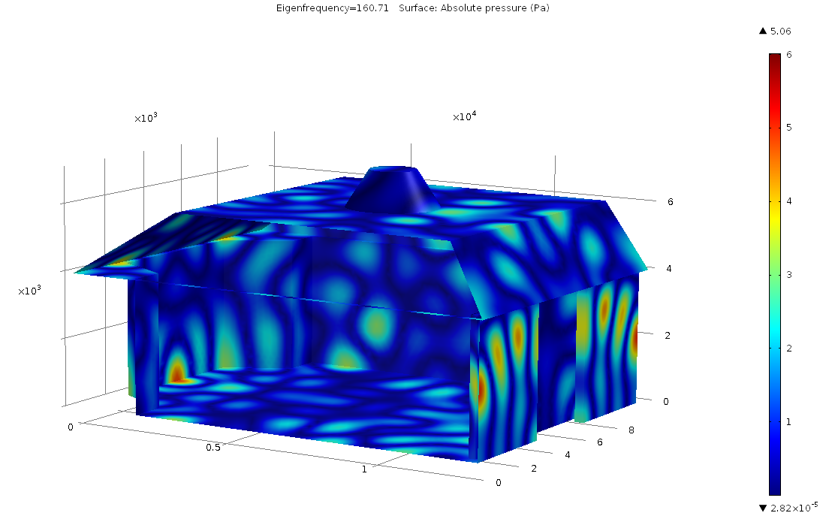
Figure 9. An example COMSOL Modal Analysis at 160 Hz with the fake wall

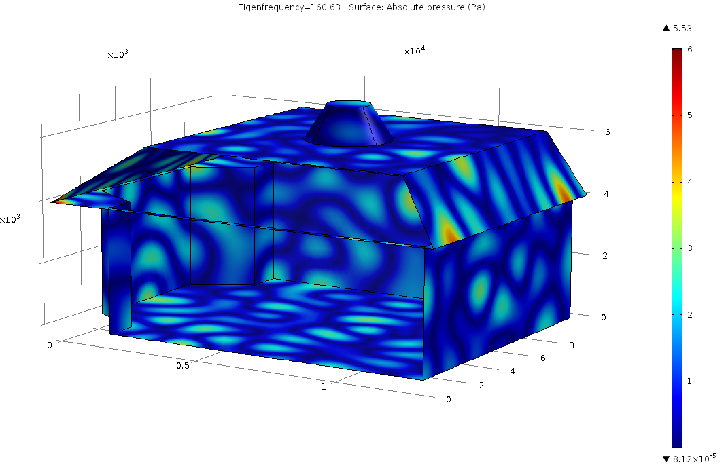

Figure 10. An example COMSOL Modal Analysis at 160 Hz without the fake wall

The preliminary results do seem to predict a density of trapped modes behind the wall around 150 Hz which would suggest it is possible to simulate the low frequency behaviour of the room.

Reconstruction
The LSBU reverberation chamber was redesigned to temporarily align with that of the empty recital hall, see Figure 11.
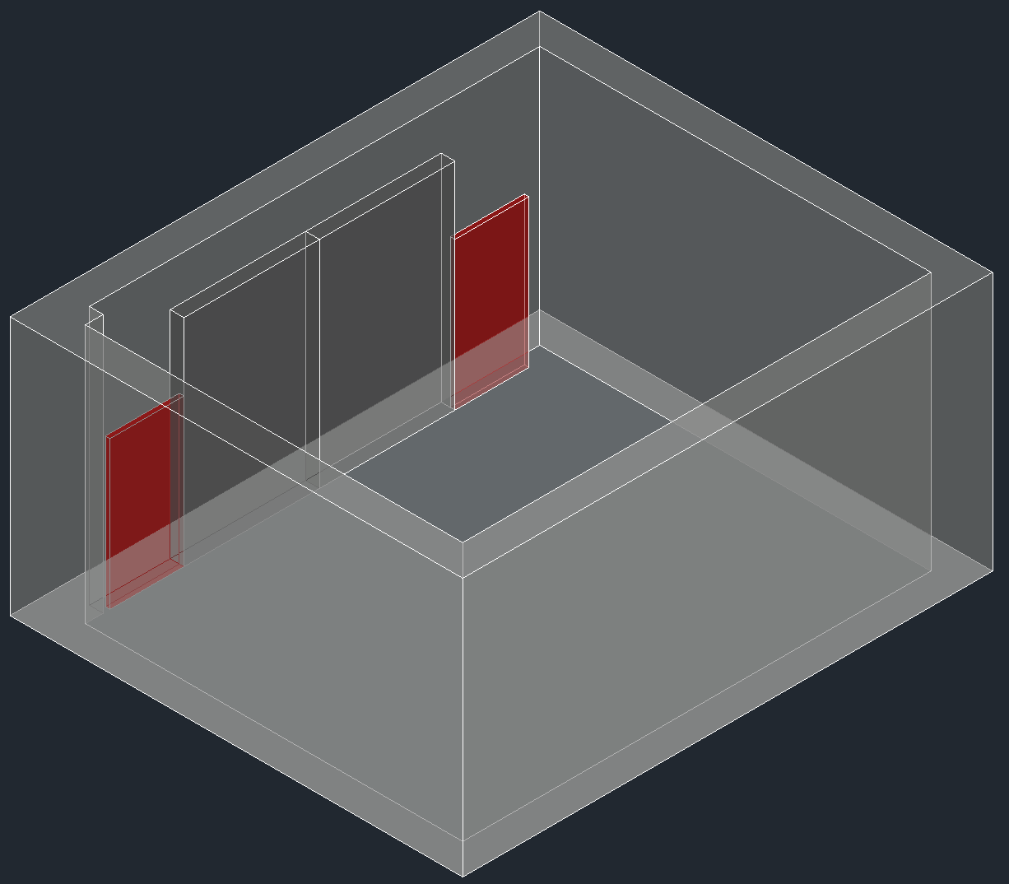
Figure 11. The redesign of the reverberation chamber to reconstruct the recital hall

To achieve the design two fake rear walls were installed, see Figure 12. The height of the walls was 2.4m in a room 4.2m tall, in the same proportion as the recital hall. The panels were not as wide of those in the recital hall but did leave a similar air gap at the side, 0.12m and 0.40m compared to 0.31m. The spacing behind the walls was 0.15m compared to 0.21m in the hall. The reverberation time, T₂₀, was measured in accordance to ISO 354:2003 [8] using a Nor 121 sound analyser using interrupted pink noise through an audio amplifier and subwoofer in the chamber, see Figure 12, and again with the panels in the middle of the room flat on the floor.

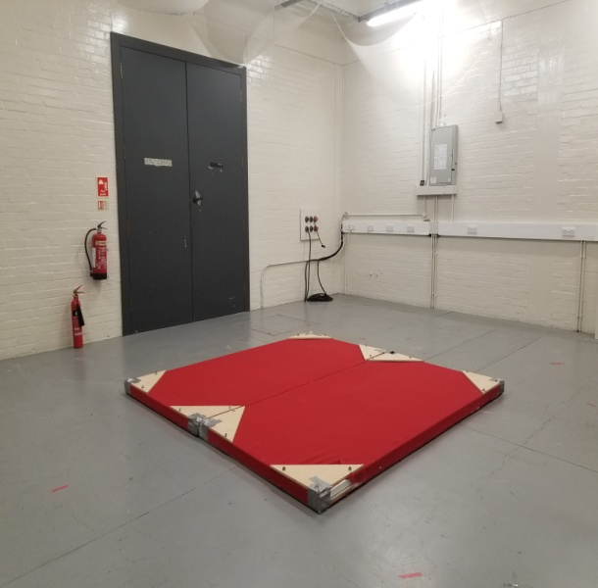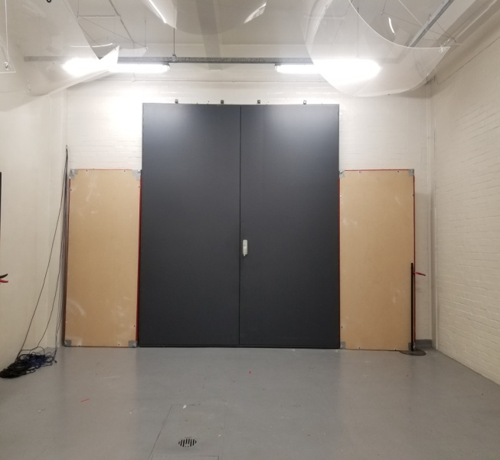

Figure 12. Rev chamber, 203m³, with panels on the floor and up as a fake rear wall, 0.15m spacing

Figure 13, Reverberation time empty, in recital hall configuration and with panels on the floor

As can be seen from Figure 13 the reverberation time was significantly reduced at frequencies 80-160 Hz when the fake rear wall was in place compared to the empty chamber, This clearly shows that the geometry of the fake wall was attenuating the low frequency sound which is not achieved when the panels were located on the floor.

CONCLUSIONS
A recital hall has been measured, assessed and compared to current guidance. The hall was found to have a significant low frequency dip which produced a Bass Ratio of 0.66 and 0.82 with curtains extended. This is much lower than the recommended 1.2 for music performance spaces. It was hypothesized that the fake rear wall was acting as a low frequency absorber effective over 2 octave bands.

This theory was tested using computer simulation which demonstrated modes being trapped behind the non structural wall. A further tested was undertaken building a similar fake wall in a reverberation chamber where a similar result was found, although only over one octave band.

It is proposed that this geometry could be used in heavy weight buildings where boominess is known to exist and has been difficult to remove usually involving many purpose built Helmholtz resonators [9].

ACKNOWLEDGEMENTS
This work was partially funded by the EPRSC UK Acoustics Network (EP/R005001/1) and London South Bank University.

REFERENCES
1. ISO 3382-1 Acoustics – Measurement of room acoustics parameter Part 1: Performance Space, 2009
2. M. Barron. Auditorium acoustics and architectural design. E & FN Spon, London, 1993
3. NS8178:2014 Acoustic criteria for room and spaces for music rehearsal and performance
4. H. Fuchs, Lamprecht. Covered broadband absorbers improving functional acoustics incommunication rooms, Applied Acoustics, 74(1), 18-27, 2013
5.Comsol website uk.comsol.com [accessed 5/3/2019]
6. S. Bilbao, B. Hamilton. Higher-order accurate two-step finite difference schemes for the many-dimensional wave equation, Journal of Computational Physics, 367, 134-165, 2018
7. S. Brown. The suitability of additive manufacturing materials in a 1:10 scale reverberation chamber, Proceedings of Inter-noise 2016, 468-478, Hamburg, 2016
8. ISO 354:2003. Measurement of sound absorption in a reverberation room
9. C. Higgins. An investigation into the Helmholtz resonators of the Queen Elizabeth Hall, MSc Thesis, London South Bank University, 2014,

