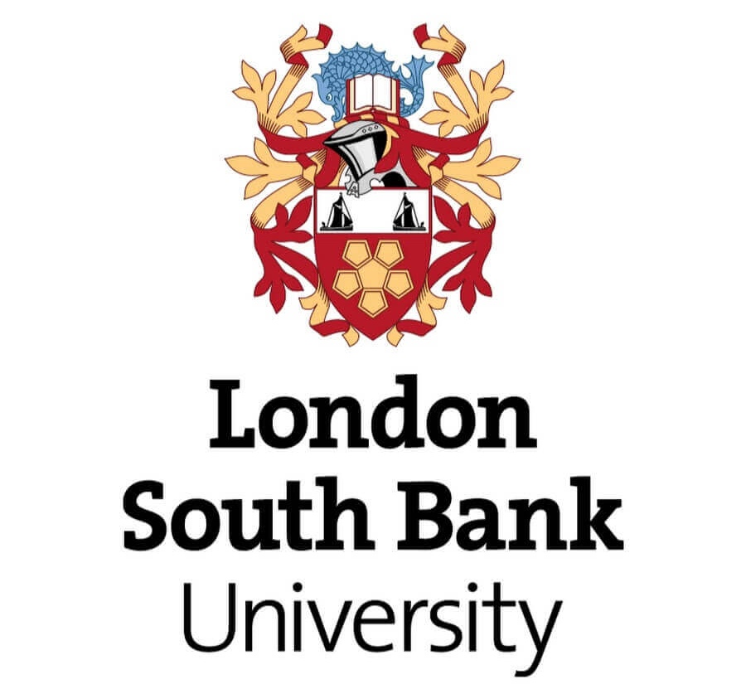

A dissertation submitted in partial fulfilment of the requirements
of London South Bank University for the degree of Master of Research (MRes)
General Engineering – Sustainable Design and Development

"Translating" the United Nations Sustainable Development Goals
to Enable the Systemic
Green Transformation
of the Data Centre Industry

Dominika Izabela Ptach

ORCID ID: 0009-0005-1830-3602

Mode of study: Part-time
Supervisors:
Prof. Deborah Andrews
Prof. Simon P. Philbin
October 2023

Abstract
The data centre industry is one of the fastest-growing sectors, driving the growing prominence of the digital economy. A vast digital infrastructure underpins all continuously running digital services worldwide. At the core of the infrastructure are energy and resource-demanding data centres, which house a significant amount of equipment and complex systems. The data centre industry is essential in innovation and sustainable transformation and can significantly contribute to achieving the United Nations' Sustainable Development Goals (SDGs). This study investigates data centre industry all-round sustainability impacts and proposes a framework to help industry stakeholders comprehend actions towards SDGs. The study employs a qualitative approach and composes primary source data from stakeholder interviews, co-creation workshops and feedback received. The fundamental findings reveal the need for sustainability and SDGs education. Furthermore, stakeholders believe SDGs are ambiguous and complex to translate for companies' needs and communicate meaningful contributions. As a result, the research project proposes an Action Bank - a simple educational database of SDGs translated to this unique sector. The solution addresses the need for increased sectoral awareness, clarity, and guidance on SDGs and aims to provide a blueprint of action for the industry. Lastly, this study provides the foundation for further research as the subject requires further exploration and more robust data collection from a larger sample covering all industry sub-sectors.

Acknowledgements

Firstly, I would like to express my deepest gratitude to Prof. Deborah Andrews and Prof. Simon P. Philbin of the School of Engineering at London South Bank University for their supervision, support and confidence throughout the course of this research.
I am incredibly grateful to get the opportunity to pursue this research thanks to the sponsorship of the School of Engineering and the Circular Economy for the Data Centre Industry (CEDaCI) project. I also thank the LSBU colleagues for their brainstorming help, feedback, and moral support.
Lastly, I could not have undertaken this journey without family and friends' continuous love and support. I especially want to thank my life partner, Kamil, for his infinite patience and for always believing and motivating me to achieve my goals.

Table of Contents
1 Research Overview 9
1.1 Introduction 9
1.2 Focus and Scope 11
1.3 Relevance and Importance 12
1.4 Problem Statement 14
1.5 Research Questions 14
1.6 Research Aim and Objectives 15
1.7 Overview of the Dissertation Structure 16
2 Literature Review 18
2.1 Introduction to Sustainable Development and UN Sustainable Development Goals 18
2.2 Significance of the Data Centre Industry 20
2.3 About Data Centres 21
2.3.1 Data Centre Business Models and Subsectors 22
2.4 Data Centre Industry Impacts Across the Triple Bottom Line 24
2.4.1 Economic Impacts 24
2.4.2 Environmental Impacts 27
2.4.3 Social Impacts 38
2.5 Current State and Opportunities for the DC Sector to Support the 2030 Agenda 44
2.5.1 Business vs Sustainability 45
2.5.2 The Private Sector – a Key Agent in the 2030 Agenda 46
2.5.3 The potential of the ICT Sector and Data Centre Infrastructure at its Core 48
2.5.4 What the Data Centre Industry is Currently Doing Towards Sustainability and the SDGs? 48
2.5.5 Sustainability Reporting 55
2.5.6 SDGs in Sustainability Reporting 61
2.6 Summary and Opportunities for Research 63
3 Research Design 69
3.1 Overview 69
3.2 Methodological Approach - Saunders’ Research Onion 70
3.2.1 Research Philosophy 71
3.2.2 Research Approach 72
3.2.3 Research Strategy 72
3.2.4 Time Horizon & Participant recruitment 78
3.2.5 Techniques & Procedures 80
3.2.6 Limitations of methods 82
4 Data Collection 84
4.1 Semi-structured interviews 84
4.1.1 Overview and questions 84
4.1.2 Participants 87
4.2 Co-creation workshops 88
4.2.1 Overview 88
4.2.2 Participants 88
4.2.3 Workshop structure 89
4.3 Feedback Session 93
4.3.1 Overview 93
5 Data analysis & concept development 93
5.1 Interview analysis 93
5.1.1 Overview 93
5.1.2 Transcription 94
5.1.3 Manual coding 94
5.1.4 Affinity mapping 96
5.1.5 Aggregating data and trends 96
5.2 Interview findings 96
5.3 Challenges and opportunities 114
5.3.1 Project drivers/criteria 115
5.4 Inspirations for the concept development 116
5.4.1 Blueprint for leadership from the UN Global Compact 116
5.5 Review of the available tools – Competitive analysis 119
5.6 Concept brainstorming 121
5.7 Concept selection – researcher-led SWOT Analysis 123
5.8 Development through co-creation – Results 127
5.9 Concept Proposal 131
5.9.1 Dataset structure 132
5.9.2 Excel Dashboard Proof-of-Concept (PoC) 136
5.9.3 Final Proposal - SDG in Data Centre Industry Action Bank 137
5.9.4 Feedback and recommendations 140
6 Conclusion and future work 142
7 Research outputs 145
8 References 148
Appendix 157
8.1 Project timeline 157
8.2 Review of the available tools – Competitive analysis 158
8.3 Full list of action points for DCI 161
8.4 Turnitin Receipt 166

Abbreviations

CE – Circular Economy
CM – Conflict Minerals
CRM – Critical Raw Materials
CSR – Corporate Sustainability Reporting
DC – Data Centre
DCI – Data Centre Industry
ESG – Environmental, Social and Governance
ICT – Information, Communication and Technology
IDCs – Internet Data Centres Data Centres
IOT – Internet of Things
MDGs – Millennium Development Goals
SD – Sustainable Development
SDGs – Sustainable Development Goals
TBL – Triple Bottom Line
UN – United Nations

List of Figures and Tables

Figure 1 UN Sustainable Development Goals. 18
Figure 2 Data centre industry sub-sectors as identified by the CEDaCI Project. 24
Figure 3 The Double Diamond framework by the Design Council 75
Figure 4 Inside the Double Diamond – stages and methods. 76
Figure 5 SDG reverse psychology “ice-breaker”. 91
Figure 6 Workshop exercise boards prepared. 92
Figure 5 Interview analysis steps overview. 94
Figure 6 Sustainability trends identified in the interviews. 101
Figure 7 Sustainability challenges identified in the interviews. 103
Figure 8 SDGs challenges mentioned by participants. 106
Figure 9 SDG opportunities mentioned by participants. 110
Figure 10 UN SDGs officially adopted by the participant's companies. 112
Figure 11 SDGs participants find relevant to DCI (if the participant's company did not officially adopt SDGs). 113
Figure 12 Brainstorming board on SDG 8. 129
Figure 13 Brainstorming board on SDG 9. 129
Figure 14 Brainstorming board on SDG 10. 130
Figure 15 Brainstorming board on SDG 6. 130
Figure 16 Snapshot of the dataset in Excel. 134
Figure 17 Snapshot of the Excel PoC (SDG 6). 134
Figure 18 Snapshot of Excel PoC (SDG 8). 135
Figure 19 DCI Action Bank proposal (homepage). 139
Figure 20 DCI Action Bank proposal (search). 139
Figure 21 DCI Action Bank proposal (results). 140

Table 1 Research Questions 15
Table 2 Review of the chosen metrics disclosed in chosen sustainability reports. 59
Table 3 The review of the SDGs mentioned in chosen sustainability reports. 60
Table 4 Examples of SDG goals and targets which the DCI can directly influence. 66
Table 5 Examples of SDGs which the DCI can indirectly influence. 67
Table 6 Research questions and corresponding methods. 70
Table 7 Limitations of chosen methods 82
Table 8 Background of participants 87
Table 9 Understanding of sustainability - key subjects mentioned by interviewees. 99
Table 10 Concept 1 - SWOT analysis. 125
Table 11 Concept 2 - SWOT analysis 126
Table 12 Example SDGs actions for DCI 131

Research Overview

Introduction

The last three decades have seen rapid growth in the data centre industry (DCI), which has significantly affected the world we live in today. With the supposedly positive impact of digital technologies, nobody questioned the industry's sustainability for many years. Only recently, research has started to identify the trade-offs of information and communication technology (ICT), particularly for data centres (DCs). The increasing environmental concerns sparked discussions about sustainability in many industries, governments, and communities, including the data centre industry.
Correspondingly, the notion of sustainable development was incorporated by the United Nations into the Millennium Development Goals (MDGs) (1990-2015) and subsequently into Sustainable Development Goals as part of the 2030 Agenda (2016-2030). SDGs are a framework for governments, local institutions, and the private sector to ensure sustainable development transnationally. The 2030 Agenda presented 17 goals formulated around themes known as the five P's: People, Planet, Prosperity, Peace, and Partnership. All 17 goals are of interlinked nature, with each goal being extended by 169 specific targets and 231 global indicators, aiming to engage governments, the private sector, and the public. Since the SDGs framework has been designed on the country level, it is challenging to translate goals and targets to specific industries, businesses or the general public. The agenda is very ambiguous on purpose - to fit many contexts. However, at the same time, it is prone to misinterpretation and often used for a marketing advantage, commonly called greenwashing or SDG-washing. Although the relationship between business and the goal of pursuing sustainability remains complicated and has yet to be fully explored through research, various studies have emphasised the need to move beyond business as usual.
The Agenda 2030 highlights the digital economy as a vital enabler in achieving the UN SDGs. Henceforth, digital infrastructure, a core building block of the digital economy, is crucial to sustainable adaption. For this reason, the data centre industry must elevate its sustainable endeavours. Nonetheless, there are a few critical obstacles to greener DCs' operations; issues include poor sustainability practices, lack of circular economy (CE) and SDG awareness in the sector. To support the 2030 Agenda, DCI needs help understanding and adopting the ambiguous SDG objectives. To do so, it is essential to grasp the sectoral challenges and linkages and strive to comprehend sustainability as broadly as attainable. Therefore, a whole-systems approach, life cycle, thinking, and creative problem-solving are vital in addressing this problem and are underpinning this research.
This dissertation begins with the research project overview, followed by a literature review, which offers a comprehensive summary of recent academic and white papers organised by the impacts across three pillars of sustainability. Additionally, it reviews opportunities for the sector to contribute to sustainable development goals and presents research gaps in present awareness and approach to tackling the SDGs. Further, the research reflects on the literature and proposes a research design including a mono method, qualitative approach to obtain primary source data from industry stakeholders to capture the state-of-the-art awareness, understanding, and approach to sustainability and SDGs and attempts to translate SDGs for the context of this specific sector. The outcome of this project is a dataset and a simple tool that collects a set of actionable interventions for SDGs for the industry stakeholders.

Focus and Scope

The empirical research study focuses on the awareness of data centre industry stakeholders of sustainability and the SDGs during the so-called “climate emergency”. A recent 2023 annual SDG progress report from the UN Secretary-General states that almost 50% of the targets are moderately or severely off-track, and approximately 30% have either stagnated or "regressed below the 2015 baseline." (SDG Development Hub, 2023). We are at the so-called "SDGs moment" when urgent action is required in an attempt to achieve the UN's goals and targets. Data centres are the backbone of all digital services and are a critical part of the digital economy, therefore crucial in achieving the SDGs, as identified by the 2030 Agenda itself.
Nevertheless, due to the magnitude and complexity of the digital infrastructure and associated sustainable development matters, the scope of this study needs to be clarified. Accordingly, this research is limited to the data centre industry stakeholders, understood as actors involved in a data centre's entire life cycle- from site selection and planning through the operations to the decommissioning and end-of-life. Notably, the research is set in the European context, specifically the UK and European Union.
The project intended to discover which SDGs are relevant to the data centre industry and explore if a tool can support the sectoral adoption of SDGs. This research aimed to comprehend the industry challenges and the SDGs as fully as possible. Nevertheless, it is limited to the time and resource constraints of the master-level project. As a result, all SDGs except for SDG 1. End poverty, SDG 2. Zero hunger, SDG 7. Affordable and clean energy and SDG 16. Peace, justice and strong institutions were explored. The reason for excluding the abovementioned goals is the lack of currently available evidence of direct influence on SDGs 1, 2, and 16. Moreover, recent industry attention and endeavours are concentrated on energy efficiency; therefore, SDG 7 do not require urgent further exploration as identified through the research.

Relevance and Importance

The proposed research is significant, as there are limited resources exploring sustainability maturity and awareness of this unique sector – for instance reports from the Uptime Institute (Davies et al. 2022) or SuperMicro (2018) – these resources are commonly studies conducted by businesses, industry associations and authorities. Although there is guidance from UNEP, UN Global Compact (for example, the “SDG Compass – A Guide for Business to take Action to Advance Sustainable Development Goals” by GRI (2015)and similar groups for other sectors, such as mining, construction or agriculture industries, there is a need for resources that explore all SDGs in the context of the DCI. Examples of the SDGs studies from other sectors include the works of Barbosa Júnior et al., (2023); Castor et al., (2020); Mansell et al., (2020). Companies mention SDGs in their ESG reporting. However, they take a selective, superficial approach to embarking on SDGs. SDGs are known to have limitations and barriers to embarking on them, as explored by (Berning, 2019; Gusmão Caiado et al., 2018; Hák et al., 2020). More frequently, "greenwashing" practices can be observed. Furthermore, "SDGs-washing" and "blue-washing" defined as the disclosure of positive contributions to SDGs while ignoring the adverse impacts and using the UN logo to declare sustainability untruthfully. Researcher involvement in the CEDaCI project provided insight in the circular economy and sustainability challenges in the DCI prior to undertaking this research. Amongst other achievements (for instance the Situational Analysis of CE in this sector by WeLOOP, (2020)), CEDaCI developed a Circular Data Centre Compass – a decision making tool, for the equipment procurement, reuse and end-of-life. It was built upon the life cycle sustainability assessment including environmental, economic and – first time ever in DCI – social aspects, and material criticality. (Kerwin et al., 2022). This assessment, and other project outcomes, however, did not focus on the SDGs, leaving an opportunity for further research.
Furthermore, in the academic literature, only one publication covers this sector's impacts on the SDGs: "Tools Towards the Sustainability and Circularity of Data Centres" by Hoosain et al., (2022). Nonetheless, the authors leave unfulfilled research opportunities as the discussed arguments lack adequate references, which weakens the quality and authenticity of the research paper.
Hence, this research will be of value to researchers and industry stakeholders working towards implementing all UN SDGs from the perspective of DCI. It will be a first attempt to explore this subject and create fundamental knowledge for further research. Moreover, the proposed solution has educational value. It can be used by the general public, students, and journalists and acts as a conversation starter to accelerate action on the industry's sustainability endeavours.

Problem Statement

This research study investigates data centre industry all-round sustainability impacts to propose a framework to help industry stakeholders comprehend actions towards SDGs. To achieve this, SDG goals and targets relevant to the DCI need to be identified, on various levels, including product/services, operations, and wider industry social impacts associated with supply chains. Consequently, this study employs Saunders’ “research onion” to determine the methodology and research design. The research is essentially guided by the Double Diamond process using various methods and techniques conjoined with creative problem-solving. The research also explores problems in the DCI, such as a lack of or inaccurate monitoring and reporting on SDGs, a lack of knowledge of sustainability-related matters, and a need for increased collaboration and partnership. Finally, the research determines the requirements for a universal educational tool to help DCI stakeholders identify actions towards SDGs and gather a simple database of SDG-translated action points. The outcome of this research is the design proposal and Excel-based prototype for industry stakeholders to interact with.

Research Questions

In order to achieve the research output, the following questions need to be answered (See Table 1 Research Questions). Firstly, current sectors’ efforts must be explored, including understanding the general approach, current reporting/monitoring practices and relevant metrics or indicators. This is explored through the literature (including white papers and academic literature), industry sustainability or ESG reports, and interviews with industry experts. Correspondingly, relevant SDGs need to be identified, and their interconnectedness needs to be explored to start thinking creatively about systematising goals and targets in the context of DCI. Lastly, but importantly, there is a need to understand the potential users and identify their needs, awareness and problems.

Table 1 Research Questions
Main Question | Supporting Questions
1. How can DCI companies meet the SDGs? | 1a. What are the currently available tools/ practices?
 | 1b. Are there existing relevant metrics or indicators?
2. Which SDGs are relevant to the data centre industry? | 2a. How to systematise the goals and targets in the context of DCI?
 | 2b. What are the synergies and trade-offs?
3. To whom would the proposed tool be directed? | 3a. What are the users’ needs, awareness, problems?

Research Aim and Objectives

The main aim of this research was to investigate data centre industry all-round sustainability impacts and to propose a framework to help industry stakeholders comprehend actions towards SDGs. A set of research objectives was prepared to determine the requirements for the tool:

- To conduct comprehensive literature review to investigate sustainability impacts accordingly to Triple Bottom Line definition.
- To collect primary source data on sustainability and SDGs maturity in the sector, through interviews with various data centre industry stakeholders.
- To design and carry out co-creation workshops to support the development of the tool.
- To gather the requirements and inspirations for the design solution.
- To develop a framework and/or a proposal for a web application that addresses the requirements gathered throughout the research.
- To obtain feedback on the proposed framework and propose recommendations for further development.

Overview of the Dissertation Structure

This dissertation consists of 7 Chapters. The first part - an introductory chapter -outlines the research problem, its scope and relevance, and sets research questions and objectives. The second chapter discusses relevant literature and outlines the research gaps to be addressed by this study. Chapters 2.2 to 2.6 were prepared as part of a book published by the Royal Society of Chemistry (RSC) – “The Circular Economy. Meeting Sustainable Development Goals” (Ptach et al., 2023). Chapter 3 summarises the research design and methodological approach underpinning this research and explains the main theories and concepts. Furthermore, it explains the research design and methods employed at every stage of the research process. Chapter 4 describes data collection activities and participants and the analysis process. Chapter 5 presents the findings and describes the development of the intervention and the feedback received. Chapter 6 - presents conclusions and avenues for future research. The last section – Chapter 7, summarises achievements throughout the search journey.

Literature Review

Introduction to Sustainable Development and UN Sustainable Development Goals

The notion of Sustainable Development (SD) has been observed globally since the proceedings of the United Nations concentrated on seeking sustainability because of the environmental, social, and economic crises of the future of humanity and the planet.
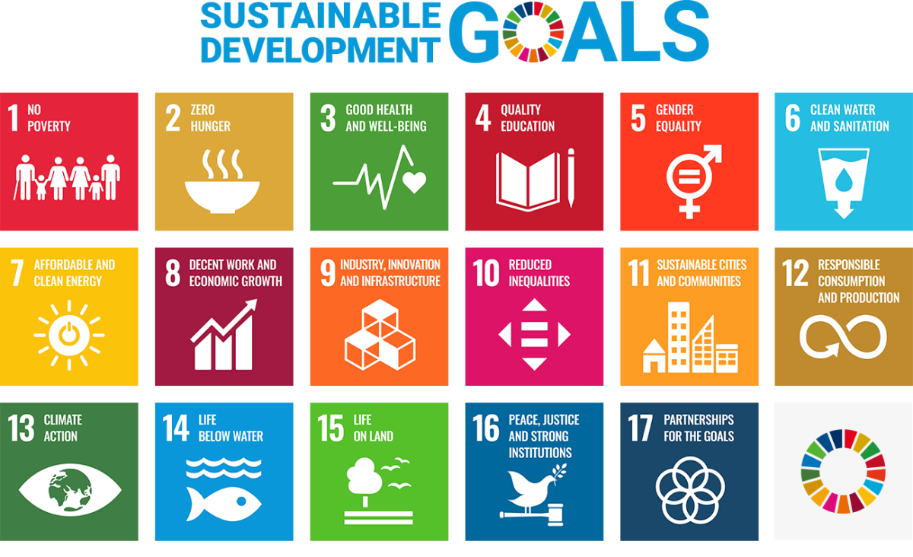
Figure 1 UN Sustainable Development Goals (United Nations Department of Global Communications, 2023 – permission to use from Sustainable Development Goal (SDG) logo Guidelines).

The United Nations Commission on Environment and Development, also historically known as the Brundtland Commission, established the first official definition of SD in the Our Common Future report as a plan to "meet the necessities of the present generation without harming the future generation's capacity to meet their own" (Brundtland, 1987). Consequently, with the new Millennium, the urgency to build a better future resulted in forming an 8-goal framework aiming to end poverty and hunger, reduce inequalities and ensure balanced economic growth worldwide, known as Millennium Development Goals (MDGs). The progress in achieving the MDGs was uneven, and although only some of the aims were met, MDGs became the groundwork for Sustainable Development Goals (SDGs), also known as Global Goals. The SDG framework consists of six MDGs and an additional eleven goals, formulated around themes known as the five P's: People, Planet, Prosperity, Peace, and Partnership (Sachs, 2012; Sachs et al., 2019). All the goals are of interlinked nature, with each goal being extended by specific targets and indicators (a total of 17 goals, 169 targets, 231 indicators), aiming to engage governments, the private sector, and the public in the sustainable challenge of the 2030 Agenda (United Nations, 2015) Agenda 2030 has a strong brand identity – SDGs are presented as colourful tiles with pictograms, making them unique and recognisable worldwide (See Figure 1).
Unfortunately, global efforts failed to achieve the MDGs agenda by the year 2015. Similarly, SDGs are also off track seven years into the 2030 Agenda, according to the 2023 report by the UN Secretary-General (SDG Development Hub, 2023). Thus, the setbacks spark criticism about the ambitions of the UN Framework evident in the works of Berning, Hák and Castor et al. Ambiguity is emphasised as the most significant obstacle in creating effective and practicable strategies for implementing the Global Goals. Hák highlights the extremes of the goals and targets, either too methodological or too abstract (Berning, 2019; Hák et al., 2020). Furthermore, other researchers mention problems with monitoring and reporting progress, the need for expert-level sustainability knowledge, and the failure to recognise the interlinked nature of SDGs (Castor et al., 2020).

Significance of the Data Centre Industry

Data centres play a crucial role in today's global society and digital economy. Whether we are searching for news on our smartphones or connecting to a virtual meeting at work, data centres are in the background of all online activities. Organisations across various sectors that process, store, and disseminate extensive amounts of data rely heavily on data centres. Indeed, the world had already recognised their growing importance since the COVID-19 pandemic when many services moved to online provision, and the volume of internet users increased remarkably. Although it appears to be problematic to grasp the true impact of digital infrastructure as the term "cloud" seems intangible. However, data centres are the engines of all digital products and services, and an estimated 7.2 million data centres with 70 million servers are continuously running to provide digital services across the globe (Thibodeau, 2017). The energy-intensive operations and infrastructure embodied footprint of the Data Centre Industry (DCI) potentially impact the economy, society, and environment as explored in the subsequent chapters. On that account, data centres, as the backbone of all information and communication technology, significantly impact several of the UN SDGs, for instance: Goal 7: Affordable and clean energy; Goal 9: Industry, innovation, and infrastructure; Goal 11: Sustainable cities and communities; Goal 12. Ensure sustainable consumption and production patterns; and Goal 13: Climate action.
The DCI is one of the fastest-growing sectors. According to the report by DataReportal titled "Digital 2022 Global Overview" (Kemp, 2022), the world's population stood at 7.91 billion in January 2022, with 4.95 billion internet users representing 62.5% of the world's total population. Furthermore, due to ever-growing digital adoption, internet users have doubled in the last decade, global internet traffic grew 15-fold between 2010 and 2020, and a further 40% growth occurred in 2020. Data processing and producing data is the primary driver of the industry. The last decade has seen 550% growth in data centre computing operations (Masanet et al., 2020), and predictions state a further fivefold increase in global demand and reliance on data centres by 2030 (Andrews and Whitehead, 2019). This trend is driven by the growing popularity of services and technologies, such as video streaming, bitcoin mining, and the internet of things (IoT).
Some sources claim that approximately 7.2 million data centres are working 24/7 worldwide to meet the constant and growing demand (Taylor, 2022; Thibodeau, 2017). Different sources report various levels of activity in the sector. Moreover, Intellect UK (Fryer, 2013) explains that the total number of data centres remains unknown due to inconsistent definitions of what a data centre is. Most data centres are congregated in four main countries across the world, namely the United States, Germany, the United Kingdom, and China. More than half of Europe's data centres are concentrated in the North-West of the continent, with the highest number - 456 data centres in the UK (Cloudscene, 2022; Taylor, 2022).

About Data Centres

Data centres originated from large computer rooms that were first built in the 1940s. Later in the 1980s, the introduction of microcomputers allowed the transfer of networking equipment to designated rooms, naming those spaces "data centres" for the first time. The industry experienced tremendous growth on the verge of the new millennium. Due to the "dot-com bubble" and the rising number of Internet users, companies started to build Internet Data Centres (IDCs) rapidly. Since then, data centres have generally remained the same except for consecutive technological advances. Data centres are the physical facilities housing the computer systems and supporting equipment. The Green Grid describes data centres as: "a building or portion of a building whose primary function is to house a computer room and its support areas. Data centres typically contain high-end servers and storage products with mission-critical functions"(The Green Grid, 2011-2024) .

Depending on the definition, data centres can vary from small cabinets through to designated rooms or entire floors to a complex of large warehouses - the largest data centre campus in China takes up to one million square metres (Moss, 2022). Intellect UK (Fryer, 2013) reports that infrastructure qualifies as a data centre if operated with specific environmental and safety controls; therefore, a standalone rack of servers does not qualify as a data centre. Furthermore, data centres comprise the following components: a facility, computing infrastructure (including servers, storage and networking equipment, firewalls, cabling, and racks), support infrastructure (such as uninterruptable power supply, heating, ventilation, and cooling (HVAC), and security) and operational staff (Yasar et al., 2022).

Data Centre Business Models and Subsectors

There are various types of data centres, which organisations choose to engage with according to their requirements (Yasar et al., 2022). The main types of the data centre include:
- enterprise (in-house data centre managed within the organisation),
- cloud (providers leasing infrastructure as a service),
- colocation (rental spaces in a data centre, where organisations can install their own hardware, but the infrastructure is provided)
- edge (small data centres at a required location),
- hyperscale (large-scale providers such as Amazon, Google, and Meta)
- There are two primary business models, namely: wholesale and colocation. In the first model, multiple customers store servers in rented racks in a shared facility; in the second model, one customer rents a third-party facility exclusively (Longbottom, 2020).
The data centre industry is extensive and involves various actors and 11 sub-sectors, as consolidated by the Circular Economy for the Data Centre Industry (CEDaCI) project (WeLOOP, 2020) (See Figure 2). The stakeholders include:
- Suppliers (this includes suppliers of rack and cabling or energy)
- Designers and manufacturers of computing hardware and ICT infrastructure
- Building construction and maintenance companies
- Data centre operations
- Decommissioning and data sanitation services
- Recyclers, refurbishment services and re-manufacturers
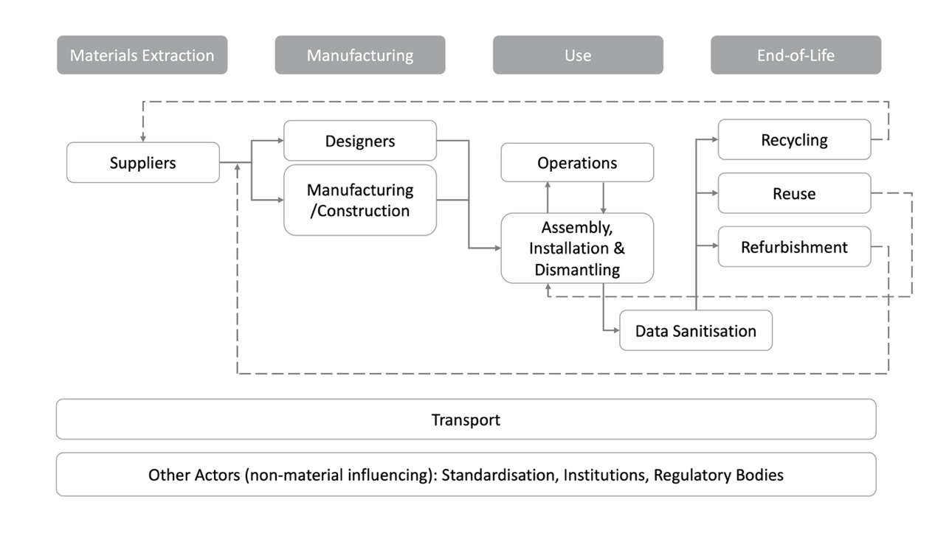
Figure 2 Data centre industry sub-sectors as identified by the CEDaCI Project.

Data Centre Industry Impacts Across the Triple Bottom Line

The structure of this section follows the three dimensions of sustainability as defined by the triple bottom line definition (Elkington and Rowlands, 1999). Positive and negative impacts are across the pillars of the economy, environment, and society. The environmental impacts are further divided into subsections concerning energy consumption, renewable energy, greenhouse gas emissions, water consumption, and resource consumption.

Economic Impacts

Data centres are the backbone of the digital economy, which researchers, governments and businesses recognise as key to economic growth. The statistics are evidence of the economic significance of data centres globally. For instance, the data centre sector contributes over 5% of gross value added (GVA) (Fryer, 2013). Moreover, the UN Conference on Trade and Development in Digital Economy Report in 2019 estimated that the digital economy size ranges from 4.5% to 15.5% of GDP (gross domestic product), depending on the scope of the definition (United Nations Conference on Trade and Development, 2019). According to Cloud Scene, the market for data centre providers in the UK is thriving, and the digital economy contributes 8% to the total GDP (Cloudscene, 2022). The market for UK data centres is the second largest in the world and the largest in Europe, with a vital cluster in London. As identified by the Tech UK (2020) report, "Each new data centre contributes between £397M and £436M gross value added per year to the UK economy while that of each existing data centre is estimated to lie between £291M and £320M per annum". The data centre sector, therefore, is and will remain of great attention and value to local and global economies.
Data centres are essential to the public because of the services they deliver and the employment they also provide. According to Uptime Institute statistics, the data centre sector employs many highly skilled professionals - approximately 2 million full-time employees worldwide in 2019 (Ascierto, 2021). Moreover, the resourcing requirement is projected to rise to 2.3 million people by 2025. The highest employee demand is likely to come from colocation, cloud, and consumer internet companies, especially in the developing markets of the Asia-Pacific (APAC) region, but less in North America and Europe, the Middle East and Africa (EMEA). More mature markets in the US and Western Europe will create opportunities for senior specialists. Often located in sites away from the cities, data centres offer valuable and well-paid career opportunities for the local communities. Although, some argue (for instance article by Andreassen (2023)) that data centres create few job openings due to innovations in automation, such as using artificial intelligence (AI) monitoring technologies. Some automated data centres have been built in the Arctic Circle, where no staff are required, for instance, the Facebook data centre in Lulea, Sweden. However, Uptime Institute (Ascierto, 2021) predicts that the automation and use of AI are considered to have an insignificant impact on staffing demand.
The above trends significantly impact the economy and wider society, thereby creating educational paths and career opportunities. The DCI workforce requires relevant further or higher education as well as role-specific training. Therefore, the industry also offers many apprenticeship prospects. As Intellect UK outlines in the report titled "So what have data centres ever done for us?", the DCI sector involves various technical and additional roles (Fryer, 2013). Furthermore, direct, and indirect jobs can be differentiated to help understand the employment landscape. Direct employment comprises roles in the design and construction of the facility and management of data centre infrastructure. Indirect employment is much broader and involves people employed in supply chains and those in colocation services. Some examples of indirect roles, which demonstrate a wide range of careers in the sector, include the following:
- Location consultants and location finders
- Planning consultants and planning advocacy services
- Real estate companies who sell data centre capacity and negotiate deals
- Data centre search and selection companies
- Lawyers and contract negotiators
- Specialist accountants, finance consultants and providers
- Energy managers and energy consultants
- PR and media consultants
- Industry associations, professional bodies, and standards bodies
- Conference organisers and specialist publishers

Environmental Impacts

Energy consumption and associated GHG (greenhouse gas) emissions are receiving significant attention in the data centre sector, which is primarily due to the recently introduced decarbonisation policies as part of the Paris Agreement Under the United Nations Framework Convention on Climate Change, also called the Paris Agreement. There is limited data available on GHG emissions of the DCI sector. However, the International Energy Agency (IEA) reported that data centres and transmission networks produced approximately 300 Mt CO₂-eq in 2020 (including embodied emissions) (Kamiya, 2022). Although the GHG emissions from data centres and network operations are significant, it is vital to underline the non-energy impacts of the sector. The sector needs to recognise environmental impacts associated with resource pressures of hardware and infrastructure manufacturing (such as raw materials extraction, including critical raw materials and rare earth elements), water and energy consumption during operations and associated e-waste and end-of-life scenarios. Environmental and social impacts need more attention and action from industry, governments, and researchers. The significance of those impacts was repeatedly stressed though the works of CEDaCI project ((Circular Economy for Data Centre Industry project - CEDaCI.org, 2018-2023). Scoping and measuring both emissions and broader environmental impacts is complex, but assessment is crucial to understand the true level of sustainability, reduce footprints and reach climate agreements.
Researchers (Andrews et al., 2021; Flucker et al., 2018; Laurent and Dal Maso, 2020; Whitehead et al., 2014) agree that a life cycle approach is necessary to assess the sustainability impacts of the DCI fully. The Life Cycle Assessment (LCA) method is systematised by the ISO 14044 standard and further adopted by the Green Grid, specifically for the data centre sector (Aggar et al., 2012). It considers all life cycle stages, from materials extraction and manufacturing of IT hardware and construction of a building to operations, decommissioning and end-of-life scenarios, thereby uncovering both embodied and operational environmental impacts. Although the level of sophistication and the large number of data centre components often make LCA assessment problematic and time-consuming. Furthermore, there is a need for open-source, primary inventory data to conduct accurate assessments. There are a small number of research studies on the life cycle assessment of data centres, including studies by Letteri (2012), Shah (2012) and Whitehead (2014, 2015). All these studies identified that operations are directly responsible for environmental impacts. However, the embodied carbon impact cannot be overlooked, and the significance of embodied impacts will likely increase according to sectoral growth and improved operational energy efficiency.
Other evidence of possible non-energy impacts of digitalisation on the environment was presented in the report by Öko Institute, titled "Impacts of the digital transformation on the environment and sustainability" for the European Commission (Liu et al., 2019). As in other LCA studies, the authors pointed out that there are broader implications beyond GHG emissions and the high energy consumption of data centres. In this regard, they collected literature on resource depletion, water consumption, land use and land use change and biodiversity and presented a comprehensive review of broad systemic impacts.

Energy Consumption

The data centre industry is promoted as a high-energy consumer. However, industry practitioners argue that the sector is not the most significant offender when looking at the numbers and trends and instead point at the user demand and energy-intensive technologies, such as blockchain (a system in which a record of transactions made in bitcoin, or another cryptocurrency are maintained across several computers that are linked in a peer-to-peer network). The electricity use of a data centre was first researched by Koomey (2011) in 2008 and followed by many other researchers (Avgerinou et al., 2017a; Masanet et al., 2020; Shehabi et al., 2016). According to Greenpeace, 21% of electricity consumption in the IT sector was used by data centres, 29% by networks, 16% by manufacturing and 34% by electronic devices (Cook et al., 2017). The most recent data from the IEA reveals that data centres used between 220 and 320 terawatt hours (TWh) of energy in 2021 (Kamiya, 2022). This is 10-60% more than in 2015, when the approximate usage accounted for 200 TWh. The energy utilised by data centres is equivalent to that of some nations, for instance, the United Kingdom (294.4 TWh in 2021). In 2021 data centres accounted for 0.9-1.3% of global electricity demand. These numbers exclude the data centre transmission networks, which consumed additional 220 TWh in 2015 and 260-340 TWh.
The increase in energy consumption in the last decade is limited due to the energy efficiency improvements in hardware and cooling. Another reason is clustering and integrating smaller, ineffective data centres into the bigger and more efficient facilities, which counterbalance the rise in energy consumption. Nevertheless, data centres need to be wary of the energy efficiency rebound effect as the savings from the above practices are constantly challenged by the ever-rising demand for digital services. Still, some forthcoming energy demand models are controversial and troubling. A projection created by Andrae and Edler, 2015) assumed an increase in electricity consumption by a factor of 3-8% a year between 2019 and 2030.

GHG Emissions

Eurostat (Eurostat, 2023) defines greenhouse gases as a group of gases contributing to global warming and climate change. The Kyoto Protocol (1997) defines the seven gases, including carbon dioxide, methane, nitrous oxide and four fluorinated gases. For ease of measuring and comparison, GHG are measured in carbon dioxide equivalents (CO₂). Hence carbon is often the centre of focus, and another term used interchangeably with GHG emissions is carbon footprint.
For 2020, IEA reported an estimated 300 million tons of CO₂ embodied and operational emissions for data centres and transmission networks combined, approximately 0.6% of global emissions. For reference, this number is higher than the total CO₂ emissions of Poland in 2021. That is 16% higher than the anticipated emissions calculated by the Climate Group (GeSI) in 2008, which estimated the total carbon footprint to reach 259 MtCO₂ in 2020 (SMART 2020: Enabling the low carbon economy in the information age, 2008). Another source, Climatiq, calculated that global emissions from cloud data centres range from 2.5% to 3.7% of all global greenhouse gas emissions. Therefore, we can ask the following question: What do these carbon emission numbers mean to the data centre industry?
The GHG Protocol Corporate Standard describes a multi-level international accounting tool in which GHG emissions are categorised into three groups or 'scopes' (Ranganathan et al., 2015). Scope 1 includes direct emissions from owned or controlled sources, for example, running vehicles. Scope 2 includes indirect emissions from the generation of purchased electricity. Scope 3 includes all other indirect emissions from both upstream and downstream of the company value chain. Indeed, it is particularly challenging to assess the GHG emissions for data centre services due to the complexity of the infrastructure and the often-shared services. GHG Protocol has therefore prepared comprehensive guidance for ICT businesses which follows a life cycle approach. The framework (ICT Sector Guidance built on the GHG Protocol Product Life Cycle Accounting and Reporting Standard Chapter 1: Introduction and General Principles, 2017) considers three components for data centre services, namely: emissions of the data centre, the network, and the end-user devices. Although accounting for the energy of the connected devices may escalate the numbers dramatically. For instance, the Carbon Table 2. In Microsoft Sustainability Report 2021 (2021 Environmental Sustainability Report. From pledges to progress, 2021) (page 18) shows nearly 124,000 and 164,000 metric tons of carbon dioxide (CO₂) for Scope 1 and 2, respectively. At the same time, Scope 3 emissions reached 13,785,000 metric tons of CO₂. Scope 3 outweighed Scope 1 and 2 nearly 48 times, regardless of the savings made in direct and indirect emissions. This example demonstrates the significance of supply chain emissions, which is the most carbon-intensive segment, but is often ignored, misunderstood and unreported, accounting for up to 80% of total company impacts. GHG Protocol emphasises that focusing on GHG emissions is a good point of reference for businesses to assess their environmental performance, and Scopes 1 and 2 are good places to start due to data availability. Meanwhile, the Uptime Institute Data Centre Survey from 2022 reports that only 37% of companies collect carbon footprint data, thereby indicating a substantial opportunity for improvement (Davis et al., 2022).

Renewable Energy

It can be observed that all the energy consumed by the industrial sector would lead to enormous GHG emissions if the electricity were produced only by combusting fossil fuels. This is because burning oil, gas, and coal leads to increased carbon in the atmosphere, which in a broader context, causes climate change and has a negative impact on the ecological environment and human health. Consequently, under pressure from the media, legislators and clients, the data centre sector heavily invests in renewable energy to improve its reputation and environmental profile and avoid price volatility. Hyperscale cloud operators have the advantage in renewable energy procurement. Due to the nature of the cloud business model, such operators control their direct energy procurement and locate sites close to renewable resources. Hence hyperscale companies are the primary purchasers of all corporate power purchase agreements (PPAs), with Amazon Web Services, Microsoft, Meta, and Google leading the way in this area (Kamiya, 2022; Kamiya and Kvarnström, 2019).
There are different sustainable strategies for procuring renewable energy. The most common are renewable energy certificates (RECs) and power purchase agreements (PPAs). RECs are defined as: “a market-based instrument that certifies the bearer owns one megawatt-hour (MWh) of electricity generated from a renewable energy resource” (Chen, 2022). However, this approach does not guarantee that the energy used is “green”. For instance, the energy mix in the region of data centre operations may be fully supplied by fossil fuels, and the purchased renewable energy will be generated and used elsewhere. PPAs are contracts between suppliers and buyers to purchase energy at a specific cost, volume, and timeframe. There are two types of PPAs, which are direct/physical or financial/virtual. Only the first type allows for the physical delivery of renewables to the buyer, and the second type sells the power to the wholesale market (Mytton, 2021b).
The aforementioned strategies can be regarded as offsetting mechanisms, which aim to alleviate previously generated emissions. However, those offsets do not reduce or remove emissions completely. PPAs and RECs still face problems in matching renewable energy purchased and the energy consumed by the facility. Moreover, they are often used to greenwash the sustainability portfolios of companies (Mytton, 2021b). Nevertheless, these procurement strategies enable renewable energy investments globally and help to decarbonise the energy systems.

Water Consumption

Water scarcity is becoming a global problem, and the data centre industry also contributes to water stress and competition for water sources with local communities. Some controversial projects and recent environmental disasters have brought more attention to the water issue. For instance, Google's Luxembourg data centre proposal in 2019(Moss, 2022) or recent news headlines questioning water use by data centres during the extreme drought in August 2022 in the UK (Hancock, 2023).
Data centres use water directly for cooling and indirectly through electricity generation (i.e., thermoelectric power). Limited studies are available on direct and indirect water use; examples include the work of Mytton (2021) and Ristic (2015). The total amount of sectoral water consumption remains uncertain due to the lack of data. Nevertheless, the researchers above were able to present water use estimations. Mytton calculated that US data centres consume 1.7 billion litres of water daily. Therefore, the US data centre yearly water footprint stands at 620.5 billion litres. This number is very close to the 2014 average of 626 billion litres reported by Shehabi et al. (2016), who created a direct and indirect water use forecast for 2014 to 2020. Though the forecast did not oversee the industry improvements in technologies and strategies, in fact, electricity generation is responsible for most of the water consumed. Furthermore, Rustic documented that data centres use between 4 and 544 Litre of water per kWh, and outbound data traffic cause 1 to 205 litres of water per gigabyte. Öko-Institut report(Liu et al., 2019) used these numbers to estimate the total water consumption for a 198ThW data centre in 2018 to be 740 – 106,822 million m³ annually. The range of calculations reflects the uncertainty in the exact number of data centres and the lack of data about water usage according to different variables. Moreover, water footprint studies have tended to explore the operations only. Nevertheless, examining a data centre's whole life cycle, hardware and building manufacturing, decommissioning, and end-of-life scenarios needs to be considered. Moreover, Rustic emphasises the urgent need for more research regarding “the water intensity of different HVAC technologies in different climates and the water intensity of electricity generation” and recommends a systemic approach and implementation of standardised metrics. All the above studies suggest that water use in the data centre sector requires the necessary attention and transparent reporting, and further study of the sustainability impacts of water use is also needed.
Another area that requires more attention is alternative cooling methods and the free water cooling or waterside cooling. Some projects using water from natural reservoirs have been implemented thus far, for example, Google's 2011 data centre in Hamina, Finland (Hamina, Finland – Data Centres – Google, 2022). This facility is located near the Baltic Sea gulf, which supplies the data centre with seawater delivered through the granite tunnels built initially for a local paper mill. Cold sea water enters the system and takes the heat away from the site, and before releasing it back into the sea, warm and cold water is mixed to reduce the temperature, so it is similar to inlet seawater. This practice claims to reduce marine life impacts, but data nor independent studies that analyse the long-term effects of such actions are available. IEEE Spectrum reports that Microsoft's experiment with submerging a data centre under the sea proclaims no negative results on marine life, as “any heat generated by a Natick pod would rapidly be mixed with cool water and carried away by the currents. The water just meters downstream of a Natick vessel would get a few thousandths of a degree warmer at most.” (Cutler et al., 2017). Nevertheless, scientists warn that ocean thermal pollution can adversely affect aquatic life, causing oxygen level reductions, disruption to animal reproductive cycles, and other physiological impacts (Speight, 2020). Moreover, there is no legal control over utilising the ambient environment as coolants, which puts a question forward whether using seawater for cooling is truly environmentally friendly and green, as companies claim.

Physical Resource Consumption

A significant majority of concern focuses on climate change and the environmental impacts of data centre operations (i.e., energy-related), the embodied impacts of a data centre and those at the end of life are often overlooked (Laurent and Dal Maso, 2020). While manufacturing uses more than a quarter of electricity in the IT sector, electronic and electrical equipment cause 1 to 4% of environmental impacts in Europe alone (Labouze et al., 2003). Each piece of data centre hardware contains more than 50 materials: ferrous and non-ferrous metals, platinum group metals (PGM), precious metals (PM), rare earth elements (REE), plastics and, in some cases, ceramics (WeLOOP, 2020). Twenty-three of 30 elements used in IT hardware European Commission are classified as Critical Raw Materials (CRMs) (Doyle, 2020), which can be considered as strategically significant resources for the growth of the European economy at high risk of limitations and disruptions to their supply chains. Raw materials are not finite; therefore, endless extraction and wasteful linear consumption threaten resource availability for future generations. Moreover, researchers have identified environmental impacts associated with material extraction and mining waste from linear consumption, including land use change and air, water and soil pollution with heavy metals and radioactive particles. For instance, the largest cobalt and tantalum deposits are concentrated in the Democratic Republic of Congo (DR Congo), a politically unstable region associated with unethical artisanal mining, where extraction causes land degradation and soil pollution and threatens the agriculture sector (Banza Lubaba Nkulu et al., 2018).
Researchers (Andrews et al., 2021; Andrews and Whitehead, 2019) emphasise the urgent need for higher material resource efficiency in data centre equipment to secure the future supply chain of critical materials. Furthermore, CEDaCI research identified printed circuit boards (PCBs) as components with the highest environmental impact, advising recycling and refurbishment take-back schemes for economic value preservation and environmental impact reduction. The research also advocates responsible data centre equipment consumption and eco-design improvements to accommodate more efficient material recovery. Such practices and new business models, particularly the circular economy, need to be promoted in the data centre sector since most efforts concentrate on energy consumption only. The circular economy is a key to the long-term benefits across all three pillars of sustainability and therefore ensures a safe and prosperous future for many industries. The 2022 Uptime Institute Global Data Centre Survey further presents trends in reporting environmental data. For instance, only 28% of companies currently measure their e-waste generation or equipment life cycle(Davis et al., 2022). Such poor practice might be a significant barrier to achieving circularity in the sector. One of the strategies is designing for a longer lifespan, which should be applied not only to consumer devices but to IT assets as well. Nevertheless, due to supply chain pressures, the industry's attention is switching from operational energy to resource efficiency, meaning that more and more companies are turning to circular thinking. With the popularity of cloud and infrastructure-as-a-service models, the sustainability choices and equipment reuse are in the providers' hands, as they have hardware ownership. Predominantly hyperscalers and OEMs (original equipment manufacturers) often introduce new circular plans. For example, in 2020, Microsoft launched Circular Centres, committed to reusing and repurposing equipment in its data centres; Google similarly refurbishes its IT assets and sells them in the secondary market (23% of dc hardware components were refurbished in 2020) and worked closely with Ellen MacArthur Foundation to analyse the ongoing circularity projects. OEMs, for instance, Dell, HPE and Lenovo, offer a hardware-as-a-service model allowing to lease equipment for a fixed time (Google, 2018; Swinhoe, 2022). Hopefully, more businesses will see the circular economy as an excellent opportunity for environmental footprint reduction and financial benefits, and the number of companies reporting on e-waste or equipment life cycle will grow significantly in the near future.

Social Impacts

The data centre industry, and specifically the digital infrastructure, strongly influences the local and global economy and environment and has numerous associated societal and political implications. A report prepared by Öko-Institut for the European Commission by Liu et al. (2019) noted the digital infrastructure spill over effects including unethical labour practices, gender inequalities, hazardous working conditions, water scarcity and pollution. These potential systemic impacts are not direct effects of the industry operations and are primarily associated with the highly complex and long supply chains of electronics and electrical equipment. Nevertheless, there are also positive contributions of the industry to the digitalisation of developing countries, such as providing access to the internet and education for many remote areas in low-income countries. The sector needs mechanisms to pinpoint and address systemic social impacts and often overlooks this pillar of sustainability, which is paramount to the holistic perspective.
As a result of numerous corporate scandals in the 1990s, growing distrust in business activities, and rising public environmental awareness and concern, companies were pressured to act transparently and ethically (Toms, 2019). Ever since, businesses carefully monitor activities to maintain their reputation, as associations with unethical practices can put the company image to customer boycotts and damaging financial costs. Subsequently, a notion of Corporate Social Responsibility (CSR) was developed, and in 2008 the International Organisation for Standardisation (ISO) formulated voluntary, universal guidance (ISO 260000) for implementing it in business practice. CSR assumes organisations' responsibility for its decisions' environmental and social impacts and advocates for transparency and ethical conduct (Andrés et al., 2019). ISO 260000 is strongly encouraged in business practice, yet it is still voluntary in many countries. In European Union, CSR reporting is outlined by Directive 2014/95/EU, commonly referred to as the Non-Financial Reporting Directive (NFRD). The directive covers non-financial information disclosure on subjects concerning the environment, social conduct towards employees, human rights, anti-corruption and bribery and diversity of the company board. It is soon to be replaced by a broader scope covering all businesses regardless of size, the Corporate Sustainability Reporting Directive (CSRD). Concerning the UK, CSR is encouraged but not mandatory.
As mentioned previously, CSR coverage limits social sustainability to the borders of direct influence, such as immediate employees and headquarters. Furthermore, social sustainability can be interpreted in many ways, and it is hard to formulate a single definition (Vallance et al., 2011). Nonetheless, an understanding of indirect implications in a systemic context of business actions is needed.
One of the assessment methodologies currently recommended by UNEP is developed by the Social Life Cycle Initiative social life cycle assessment (s-LCA) (Guidelines for Social Life Cycle Assessment of Products and Organizations, 2020). The method is used for assessing the social and socio-economic impacts as well as the potential impacts of products and services. This method analyses good and adverse implications from extraction and processing of raw materials, manufacturing, logistics, operations, reuse, maintenance, recycling, and landfill disposal – i.e., a whole life-cycle perspective. S-LCA is becoming of increasing interest to businesses, thereby allowing for transparency and mapping hotspots for improvement and overall sustainability, which is not only becoming an essential requirement for clients, but also an opportunity for unlocking new potential for businesses. In 2020, a set of “UNEP Guidelines for Social Life Cycle Assessment” were jointly published by the Social Life Cycle Alliance and the Life Cycle Initiative.
S-LCA methodology has a number of limitations and challenges associated with data quality, uncertainty or issues with weighting impact categories. As for instance explored in the context of construction sector by Sandanayake et al. (2023). “UNEP Guidelines for s-LCA of Products and Organisations” (2020) also outline this methodology limitations, with one of the most significant issue being the need for more open-source data. It further describes that, although there are s-LCA databases available, such as Social Hotspot Database (SHDB) and Product Social Impact Life Cycle Assessment (PSIA) database, often the s-LCA inventories need bespoke data collected through the questionnaires or guided interviews. Currently, limited or no known literature sources explicitly discuss the data centres' social impact, those studies include Hoosain et al., (2022) and Liu et al., (2019). Specifically focusing on s-LCA, only a study on desktop computer by Subramanian and Yung, (2018) was identified. Accordingly, to researcher’s knowledge, the CEDaCI project pioneered the S-LCA for server equipment in the DCI – the project developed a framework following the UNEP Guidelines and collected insights through stakeholder engagement. This assessment, however, did not include SDGs.
However, the social effects can be explored by looking at electronic and electrical equipment as well as data centre buildings, specifically materials used for manufacturing those mentioned earlier and the end-of-life scenarios. There are numerous resources exploring social and political issues associated with materials extraction and e-waste, for instance, Global E-Waste Monitor (A New Circular Vision for Electronics Time for a Global Reboot, 2019) or Ellen MacArthur Foundation e-waste reports (Odumuyiwa et al., 2021).
Data centre equipment has a significant embodied impact; Whitehead (2015) estimated that during the assumed 60-year-long life of a data centre, 15% of its impact derives from the building and facilities, while the remaining 85% derives from IT equipment. Two primary materials of data centre building are concrete and steel, while manufacturing digital infrastructure equipment requires three primary materials: "common" metals and polymers and critical raw materials (CRMs). This includes various metals such as steel, copper, aluminium, zinc, and brass; polymers (such as ABS, HDPE, PUR, PVC, GPPS, PBT, and EVA); and CRMs including antimony, beryllium, chromium, cobalt, lithium, magnesium, palladium, silicon, dysprosium, neodymium, praseodymium, and terbium. Although the CRMs account for 0.2% of the equipment, Andrews and Whitehead argue they are crucial to the electronics' functioning and, therefore, of high economic value (Andrews and Whitehead, 2019). Moreover, some elements - gold and 3T: tantalum, tin, and tungsten - are classified as Conflict Minerals (CMs), that is, minerals extracted in politically unstable regions. Mines of these conflict resources are located in African countries, particularly the eastern, remote regions of the Democratic Republic of Congo controlled by armed rebel groups. Consequently, extracting these precious elements results in local conflicts and even war and cruel exploitation of local communities, including children and women. The 2018 study by UN Environment Programme (GLOBAL MERCURY ASSESSMENT, 2018) estimated that around 15 million people work in the artisanal and small-scale gold mining (ASGM) sector globally, including over 600,000 child and 4.5 million female workers. For many local communities, however it is the only opportunity for income and livelihood guarantee.
The data centre industry is one of the sectors contributing to the Waste Electrical & Electronic Equipment (WEEE) and contributes to growing regional and global e-waste streams, reached 54 million tonnes per year in 2020 Approximately 83% of e-waste end-of-life management is undocumented, and often the end-of-life of WEEE remains unknown. Possible scenarios include dumping, burning, trading, or recycling in illegal or uncompliant conditions. The remaining 17.4% of recorded e-waste is still likely to be mishandled by either ending up in a landfill or exported to low-to-middle-income countries to avoid recycling costs (A New Circular Vision for Electronics Time for a Global Reboot, 2019). For instance, Nigeria and China both struggle with the infamous illegal e-waste industry, which has a damaging impact on local communities and the environment and is the primary hotspot for illegal workers. It is impossible to pinpoint a specific number of people employed in the entire illegal e-waste industry. However, World Economic Forum report (A New Circular Vision for Electronics Time for a Global Reboot, 2019) speculates that in Nigeria, the number of workers stands at approximately 100,000, while in China, the number possibly reaches 690,000. Together it accounts for more than the population of Leeds in the UK. Moreover, the ratio of female and child workers in Africa and Asia working in e-waste processing plants accounts for 30% of the workers. People engaged in uncontrolled and illegal recycling or disposal activities often lack protective equipment, suitable tools and safe working conditions and unknowingly mishandle toxic substances. The report further explains that some processing techniques include burning or melting the electronic parts in acid to collect valuable metals. The results of such practices and exposure to many highly toxic fumes and substances can have long-lasting effects on human health and well-being. Some of the atrocious effects include carcinogenic diseases caused by exposure to heavy metals and radioactive uranium. Other consequences affect specifically women's sexual and prenatal health, causing miscarriages and premature and stillbirths. Also, new-born babies are at risk of low birth weights, defects, and high infant mortality. Furthermore, in the even broader context, non-direct impacts of mishandling e-waste include water, air and soil pollution, contaminant food chains and drinking water, which can have a catastrophic impact on human health.
On the contrary, digital infrastructure plays an important role in providing services to the developing countries of the Global South. The digital divide between developed and developing countries significantly impacts many people. Furthermore, the COVID-19 pandemic has even further increased the inequalities in access to digital services. Connectivity is mostly provided thanks to mobile networks and the underpinning network towers. Interestingly, rapidly developing African countries are becoming attractive regions for new data centre projects. Currently, there are 86 colocation data centres from 15 countries in Africa(Colocation Africa - Data Centres, n.d.).

Current State and Opportunities for the DC Sector to Support the 2030 Agenda

This section explores sustainability in the context of business and outlines the reasons why the private sector, specifically the data centre industry, should support sustainable transformation, circular economy business models and the pursuit of a trajectory towards realising the UN SDGs. It also discusses the sustainability maturity of the sector and reviews standards and initiatives in the sector as well as current reporting requirements. Finally, the section presents the findings on reported metrics and SDGs from recent sustainability reports and other documents, such as CSR or ESG reports, which are available in the public domain.

Business vs Sustainability

Research often portrays business and sustainability as subjects that contradict each other due to conflicting prerogatives. Although the Brundtland Commission developed a standardised definition of sustainability, it is frequently used interchangeably with CSR or ESG definitions. Moreover, the intersection of business and sustainability linkages still needs further exploration in research. The concept of the three sustainability dimensions (i.e., environmental, social, and economic) has been in place for many years now. Still, many industries do not fully understand the holistic approach, as described by Dyllick and Muff (2015), who demonstrate the great divide between business sustainability and sustainable development in their work.
The Triple-Bottom-Line (TBL) concept coined in 1994 was created with businesses in mind, initially as an accounting framework to measure business performance other than financial performance. Furthermore, the Environmental, Social and Governance (ESG) framework was developed for investments, as well as GRI standards, which are widely used by the industrial sector. Nevertheless, with the private sector's immediate attention on financial growth, it is unlikely that Elkington's triple bottom line's social or environmental values will be the leading business concern (Berning, 2019; Scheyvens et al., 2016). For decades, sustainability appeared to be only a Corporate Social Responsibility (CSR) strategy. However, according to Azapagic and Perdan (2000), companies' performance in environmental and social contexts started to matter to the public in the new millennium, which is inspiring debates on how the private sector can support sustainable development.

The Private Sector – a Key Agent in the 2030 Agenda

The 2030 Agenda for Sustainable Development, consolidated by the United Nations (2015), outlines the scale, ambitions, and means of implementing the proposed goals and targets. As the recent 2022 progress update suggests, initial progress on the sustainable development goals is insufficient, and it is estimated that the targets will not be achieved in the given timeframe. Moreover, the COVID-19 pandemic has further reversed the progress towards the 2030 Agenda, pushing many people back into poverty. Therefore, researchers and leaders agree that strengthened action and an efficient strategy are required to progress towards sustainable development.
To achieve the 2030 Agenda, the authors call for Global Partnership. Although the concept is proposed on the global level, primarily addressing national and regional governments of all countries, the UN recognises the importance of engaging other agents: the private sector, society, the UN structures, and all other available resources. In the means of implementation section, the authors emphasise the crucial role of business:
"We acknowledge the role of the diverse private sector, ranging from micro-enterprises to cooperatives to multinationals, and that of civil society organisations and philanthropic organisations in the implementation of the new Agenda"(United Nations, 2015).

Sachs (2012) and Hák (2020) also recognised the significance of the private sector in reaching SDGs. With both multinational and small and medium enterprises, private companies can accelerate all areas of sustainable development locally and globally. The private sector is the main constructive of the global economy and directly influences wider society. Therefore, it is necessary to take leadership and responsibility for its operations by introducing measuring and reporting strategies, shaping policies, and collaborating with the stakeholders (Sachs, 2012).
There are great opportunities for the private sector to advocate and lead sustainable development. However, the main driver behind the emerging transformation must be critical changes in social and economic models and the introduction of sustainable practices (Adams and Luchsinger, 2015; Scheyvens et al., 2016). The current way of conducting business, aka business-as-usual (BAU), solely concentrates on the financial benefit and the exploitation of the economic system and resources (Dyllick and Muff, 2015). The BAU approach poses a question, as formulated by Scheyvens (2016):
"Can, for example, a profit-motivated business really make a meaningful contribution to the achievement of the SDGs or are we likely to see 'business-as-usual', which results in greater profits for some, and lost opportunities for many?

The circular economy is one of the possibilities for securing a prosperous future without abusing the ecosystem; however, it requires changing current linear economic models and establishing a new paradigm for businesses.

The potential of the ICT Sector and Data Centre Infrastructure at its Core

Data centres are the backbone of all digital technologies. Furthermore, technology and the digital economy were recognised by the 2030 Agenda as enabling factors in achieving sustainable development globally. Likewise, the joint research of The Earth Institute and Ericsson, identified the ICT sector as having a “great potential to accelerate human progress, to bridge the digital divide and to develop knowledge societies, as does scientific and technological innovation across areas as diverse as medicine and energy”. Another report from Huawei (2018) also presents favourable arguments for the ICT to support the SDGs. Huawei’s researchers conducted benchmarking exercises to showcase that digitally advanced countries reported higher progress towards the SDGs. Therefore, they suggest that innovation and investment in ICT and infrastructure can positively stimulate sustainable development through wealth creation and expanding highly skilled and digitally literate society.

What the Data Centre Industry is Currently Doing Towards Sustainability and the SDGs?

Sustainability Maturity and Awareness

Sustainability efforts in the data centre industry primarily focus on energy efficiency due to energy-intensive operations, meaning that other non-energy impacts remain overlooked. Moreover, the term "sustainability" has become so fashionable and overused that it has somewhat lost its true meaning. Therefore, and due to limited evidence, there is a need for research on sustainability and circularity awareness and the sustainability and circularity maturity of the sector. The available sources are reports from publishing bodies such as Uptime Institute or research executed by private companies, e.g., SuperMicro.
Recent articles and reports from the Uptime Institute warn that the sector's awareness is still low, and attitudes toward green strategies differ between the regions (Davis et al., 2022). Europeans appear to see sustainability as an opportunity but are critical of the progress made to date, whereas North America and Asia-Pacific countries are more sceptical. The Uptime Institute Global Data Centre Survey 2021 of 400 data centre owners and operators revealed that 38% of respondents genuinely agree that data centre actions towards reducing energy, water and GHG emissions are meaningful. However, 45% still believe these actions are not delivering any change. Moreover, the survey declares that Europeans are critical of the progress, as 35% of operators think environmental advances are effective and call for more regulations for the sector. On the contrary, in North America, 45% of respondents believe current sustainability commitments are successful, while more than half (55%) disagree with this statement. Interestingly, the findings from the previous year revealed a tendency to deny climate change and nearly a third of managers in data centres located in North America did not believe that human activity contributes to climate change or did not believe in climate change at all at the time of the survey (Ascierto and Lawrence, 2020).
In another report from SuperMicro (2018), only 28% of industry decision-makers consider environmental issues when selecting data centre technology. The report explains further that the reasons behind such a small percentage are costs-saving (29%), lack of knowledge and resources (27%) and environmental impacts being outside of companies' main concern (14%). Furthermore, the study shows that 58% of companies surveyed already have an environmental policy or considering one at the time of the survey. Moreover, SMEs may lack the capacity to have such a policy due to a less budget to spend on a more comprehensive and meaningful strategy. Large companies are more likely to employ external experts or create sustainability-dedicated departments to do so. One of the additional reasons for it is that sustainability is a nice-to-have and voluntary addition to the company's picture.

Data Centre Industry Standards and Initiatives

The 2016 Paris Agreement on climate change was a wake-up call and groundwork for new policies and regulations. Consequently, various initiatives concerning environmental impacts were initiated across governments, businesses, and academia. In the data centre industry, however, evidence shows that a limited number of such proposals exist.
Presently, there are a few data centre sector regulations and certifications. Those mainly focus on the energy efficiency of the building or data centre components (e.g., HVAC, servers, data storage), are voluntary or mandatory, and vary between countries or regions, which causes a lack of consensus in the industry (Fiona Brocklehurst, 2021). The internationally recognised credentials are, for instance:
- Eco-label EPEAT (Electronic Product Environmental Assessment Tool) for servers NSF/ANSI 426–2019.
- Certification scheme by CEEDA (Certified Energy Efficient Data Centre Award)
- Certification scheme by DCA (Data Centre Alliance)
- Building certification by LEED (Leadership in Energy and Environmental Design) for building design and construction and operations and maintenance of DCs
In the European Union, currently established notions are:
- Regulation on eco-design requirements for servers and data storage products EU 2019/42
- Energy Efficiency Directive (under Fit for 55 legislative package)
- EU Code of Conduct (CoC) on Data Centre Energy Efficiency

The EU 2019/424 regulation (also known as Lot 9) sets out the sustainable design practice requirements for data centre electronics but mostly focuses on server design. The subsequent Energy Efficiency Directive by European Commission proposed as part of the Fit for 55 legislative package (including policies that aim to lower net GHG emissions by at least 55% by 2030) outlines energy-related sustainability reporting requirements for data centre operators. Furthermore, the directive incentivises data centres to explore waste heat reuse potentials by requiring a cost-benefit assessment of waste heat utilisation in DCs above the 100kW capacity threshold. In February 2022, the forenamed directive was additionally strengthened to ensure data collection transparency and quality. The EU Code of Conduct on Data Centre Energy Efficiency is a very comprehensive, voluntary guideline for various DCI stakeholders, outlining best practices and setting out the targets and requirements for energy consumption reduction in a “cost-effective manner without hampering the mission-critical function of data centres”. Furthermore, it is the only independent initiative which monitors energy consumption and has mobilised 290 participating data centres. As concluded by Avgerinou (2017), the EU Code of Conduct on DC Energy Efficiency is an incredibly effective non-regulatory act. Additionally, a sustainability certification BREEAM (Building Research Establishment Environmental Assessment Methods) for data centres functions explicitly in the United Kingdom.
To allow for monitoring of the progress of any of the above measures, there is a need for standard practices and metrics. Different bodies, official, commercial, and non-profit, proposed an overwhelming number of metrics, making the scope difficult to navigate and causing inconsistencies in calculating practices. The primary triad of standardisation establishments in Europe are concurrent CEN (European Committee for Standardization), CENELEC (European Committee for Electrotechnical Standardization), and ETSI (European Telecommunications Standards Institute). While ISO (International Organization for Standardization) and the International Electrotechnical Commission (IEC) are working jointly to develop international standards and guidelines, previously, many industry-developed metrics were subsequently standardised and officially approved. For instance, power usage effectiveness (PUE), water usage effectiveness (WUE) or carbon usage effectiveness (CUE), which were standardised by Green Grid - a non-profit industry consortium. The recent effort to create industry-agreed global standards is the EN 5060051 standard series, also known as ISO/IEC 30134: Information technology – Data centres – Key Performance indicators (Cappella, 2021). This series focuses on the energy and sustainability of data centres and consists of the following metrics:
- Power Usage Effectiveness (PUE),
- Renewable Energy Factor (REF),
- IT Equipment Energy Efficiency (ITEEsv),
- IT Equipment Utilisation of Servers (ITEUsv),
- Energy Reuse Factor (ERF),
- Cooling Efficiency Ratio (CER),
- Carbon Usage Effectiveness (CUE)
- and Water Usage Effectiveness (WUE).
The industry itself is leading innovation in many practices and standards. Further significant initiatives in the sector concerning energy efficiency, resource efficiency and sustainability are Climate Neutral Data Centre Pact, Circular Economy for the Data Centre Industry (CEDaCI), Open Compute Project (OCP), Circular Electronics Partnership (CEP) and Free ICT Europe.

Climate Neutral Data Centre Pact

Since data centre operators and trade associations committed to the European Green Deal with ambitions to become climate neutral by 2050, an initiative – the Climate Neutral data centre pact, was formed in 2018. The initiative is a set of conformed actions across areas such as energy efficiency and conservation, clean (renewable) energy procurement, water conservation, circular economy, and governance. This self-regulatory initiative claims to be a one-step-ahead response to the upcoming 2024 EU regulations for the sector.

Circular Economy for the Data Centre Industry (CEDaCI)

Another initiative, the Circular Economy for the Data Centre Industry (CEDaCI) project, pioneers building a circular economy for the sector in Northwest Europe. The CEDaCI initiative aims to raise awareness and increase equipment reuse and remanufacture while reducing e-waste rich in precious virgin materials and CRMs and securing a resilient and viable supply chain. Furthermore, the project advocates for improved Eco-design guidelines and product life extension and educates SMEs from various data centre subsectors about circularity-friendly decision-making and conscious hardware consumption.

Open Compute Project (OCP)

OCP is a collaborative, transnational project based in Prineville, Oregon, in the United States. Its mission is to advance the efficiency, sustainability and scalability of data centre hardware and infrastructure. The unique selling point of this initiative is an innovative approach to reducing the complexity of the designs and manufacturing and strongly promoting the open-source approach over ownership.

Circular Electronics Partnership (CEP)

CEP is a global partnership of leading tech, consumer goods and waste management organisations with a common mission to transform electronics and electrical equipment industries towards the circular economy. This initiative will set a sectoral roadmap, and design solutions and interventions to achieve CE principles by 2030.

Free ICT Europe (FIE)

FIE is a not-for-profit foundation of independent bodies representing and supporting fair and open IT hardware and software markets. Foundation strives for the freedom and competitiveness of providers and stands for ICT secondary market in Europe. FIE collaborates with decision-makers and businesses to actively shape EU legislation for sustainable hardware transformation.

Sustainability Reporting

Sustainability reporting aims to disseminate companies' non-financial information to increase transparency about business operations and showcase positive contributions to society. It can be voluntary or mandatory, depending on the nature of the business and region. As mentioned previously, Section 2.5.4.2, in the European Union, sustainability reporting is mandatory for specific companies and outlined by the Non-Financial Reporting Directive (NFRD) and shortly by the Corporate Sustainability Reporting Directive (CSRD), whereas in the UK, it is not required but encouraged. Nevertheless, more mandatory reporting requirements are on the way. New policies are most likely to incentivise companies to report data by imposing penalties or similar forms of reprimand. In the EU, firms need to disclose specific environmental and social information; however, there is no standard format. Companies can use European, international, or national guidance, depending on their requirements. There are various initiatives including the Organisation for Economic Cooperation and Development Guidelines (OECD), United Nations Global Compact's Communication on Progress (COP), the International Integrated Reporting Council (IIRC) and leading guidelines from the Global Reporting Initiative (GRI) to name a few.
GRI is the independent, international body with the most extensive and widely relevant benchmark for sustainability reporting. GRI also acknowledged the private sector's significance in achieving SDGs and collaborated with the UN to encourage governments and businesses to measure their environmental, social, and economic contributions. As a result, GRI, together with the UN Global Compact and the World Business Council for Sustainable Development, designed the SDG Compass (SDG Compass – A Guide for Business Action to Advance the Sustainable Development Goals (2015)) to guide on "how they can align their strategies as well as measure and manage their contribution to the realisation of the SDGs". It is, however, a directory of relevant business tools which might help build SDG reporting following GRI standards.
Sustainability reporting practices across all sectors, including the data centre industry, require an agreed, consistent approach. Sector-specific guidance is required to prevent misinterpretation, resulting in ineffective and inaccurate disclosures. For instance, more clarity on the span of companies' environmental and societal responsibilities is needed, especially in light of Scope 3 emission reporting, from which companies currently refrain, possibly because it accounts for the highest GHG emissions.
Sustainability reports vary between data centre providers and hyperscale cloud suppliers and large colocation companies tend to have a more meticulous approach and publish extensive environmental data, which they have collected over longer periods of time. To explore differences and similarities in disclosed metrics, several most recent (mostly from 2021, due to industry reporting period) sustainability reports, or equivalents available publicly on various companies’ websites, were reviewed (See Table 2) (2021 Environmental Sustainability Report. From pledges to progress, 2021; Colt Data Centre Services, 2021; Digital Realty, 2021; Equinix, 2021; Google, 2022; Meta, 2021; Virtus Data Centres, 2021).
For instance, the Environmental Report 2022 (Google, 2022), 2021 Sustainability Report(Meta, 2021) by Meta, and Environmental Sustainability Report (2021 Environmental Sustainability Report. From pledges to progress, 2021) by Microsoft recorded detailed disaggregated data on Scope 1, 2 and 3 emissions, general energy data (including consumption, efficiency and renewable), and detailed water-related figures (covering consumption, withdrawal, and discharge). Additionally, the Environmental Report 2022 by Google and the 2021 Environmental Sustainability Report by Microsoft include carbon intensity and full waste-related statistics. Google and Meta reports follow GRI standard reporting practice, whereas the document from Microsoft pursues the Sustainability Accounting Standards Board (SASB) guidelines. Sustainability Report 2020 (Virtus Data Centres, 2021) includes less information and significantly fewer statistics compared to the aforementioned reports. All reviewed reports disclosed data on renewable energy mix ratios and covered Scopes 1 and 2 of GHG emissions. Amongst those documents, reports by Equinix (2021), Google, and Meta feature energy efficiency data by presenting the PUE metric. Lastly, the 2021 Sustainability Report by Meta stated the annual water usage effectiveness of their facilities.
The reason for differences in the amount of data and level of detail is possibly due to business size. The report by Virtus Data Centres is less exhaustive, possibly due to the fact that it is published by a much smaller business than other reports mentioned, which originate from companies that operate hundreds of facilities.
Table 2 Review of the chosen metrics disclosed in chosen sustainability reports.
 | 2021 Equinix Sustainability Report | 2021 Annual Sustainability Report Colt Group | Environmental, Social and Governance Report 2021 by Digital Realty | Sustainability Report 2020 by Virtus Data Centres | Environmental Report 2022 by Google | 2021 Sustainability Report by Meta | 2021 Environmental Sustainability Report by Microsoft
Energy Consumption | + | + | + |  | + | + | +
Renewable Energy Consumption | + | + | + |  | + | + | +
Renewable Energy [%] | + | + | + | + | + | + | +
PUE | + |  |  |  | + | +
WUE |  |  |  |  |  | +
Scope 1 | + | + | + | + | + | + | +
Scope 2 | + | + | + | + | + | + | +
Scope 3 |  | + | + | + | + | + | +
Table 3 The review of the SDGs mentioned in chosen sustainability reports.
Sustainability, CSR, ESG or equivalent report | Goal 1. | Goal 2. | Goal 3. | Goal 4. | Goal 5. | Goal 6. | Goal 7. | Goal 8. | Goal 9. | Goal 10. | Goal 11. | Goal 12. | Goal 13. | Goal 14. | Goal 15. | Goal 16. | Goal 17. | Total SDGs
2021 Equinix Sustainability Report |  |  |  |  | + |  | + | + | + | + |  |  | + |  |  |  |  | 6
2021 Annual Sustainability Report Colt Group |  |  | + | + | + |  | + | + | + | + | + | + | + |  |  | + | + | 12
Environmental, Social and Governance Report 2021 by Digital Realty |  |  |  |  |  |  | + |  | + |  | + |  | + |  |  |  |  | 4
Sustainability Report 2020 by Virtus Data Centres |  |  |  |  |  |  |  |  |  |  |  |  |  |  |  |  |  | 0
Business for 2030 initiative – Google |  |  |  | + |  |  |  | + | + |  |  |  |  |  |  |  | + | 4
2021 Sustainability Report by Meta |  |  | + |  | + |  |  | + | + |  |  |  | + |  |  | + | + | 7
Microsoft and the United Nations Sustainable Development Goals | + | + | + | + | + | + | + | + | + | + | + | + | + | + | + | + | + | 17

SDGs in Sustainability Reporting

Business plays a crucial role in sustainable development, and SDGs are setting the direction on which companies can reflect in their strategies and activities. Matters across climate change, resource consumption and production, biodiversity preservation, human health and wellbeing, and education are equally important to transnational governments and the private sector. Additionally, SDGs have the potential to bring new business opportunities in sustainable innovation and transformation, thereby building reliable and worthwhile supply chains or engaging and shaping environmental regional and national policies.
However, companies should refrain from using sustainability reporting as a marketing opportunity or competitive advantage. A common practice is only to disclose positive and attractive details while ignoring unfavourable information, consequently altering the perception of the company's performance, called greenwashing. Furthermore, "SDG-washing" and even "blue-washing" has been recognised, by declaring positive contributions to SDGs while ignoring the negative impacts and using the UN logo to proclaim sustainability without genuine action, respectively.
There are numerous reports on SDGs in the private sector. For instance, SDG Compass (by GRI, WBSCD and UN Global Compact (GRI et al., 2015)), SDG Industry Matrix (United Nations Global Compact and KPMG, 2015), Making the SDGs relevant to business (by PRé -Sustainability & 2.0 LCA consultants (Weidema et al., 2018)), and many more. All those whitepapers aim to translate the SDGs to business needs and opportunities, provide sectoral guidance and educate for a sustainability-orientated business journey. Moreover, the PRé-Sustainability report encourages connecting SDGs to Life Cycle Assessment, and KPMG's How to report on SDGs(2018) proposes how to measure progress towards global goals. Moreover, SDGs opened a market for a myriad of tools and aids for building SDG-based business strategies. For instance, SDG Action Manager, Sustainability Measurement Tool - SDG Monitor, SDG Impact Assessment Tool. Different tools require a mixed level of previous sustainability and SDGs knowledge from the user and provide various options. Most often, those tools provide a platform to organise ideas for acting on SDGs. Though the overwhelming private sector guidance and platforms available, resources specific to the data centre sector are missing. The literature search only identified -one current study which discusses the sector's impact on the SDGs: "Tools Towards the Sustainability and Circularity of Data Centres" (Hoosain et al., 2022). Unfortunately, the arguments given by the authors lack correct references. Besides, this investigation into SDGs in the DCI seems over simple and incomplete, leaving an unfulfilled research opportunity.
Studying the latest available sustainability reports and equivalents (Colt Data Centre Services, 2021; Digital Realty, 2021; Equinix, 2021; Google — BUSINESS FOR 2030, no date; Meta, 2021; Microsoft, 2019; Virtus Data Centres, 2021), SDGs mentioned in the reports were identified and organised (See Table 3).
Most of the reviewed documents mentioned SDGs in their strategies, apart from the following: the Sustainability Report 2020 by Virtus Data Centres, 2021 Environmental Sustainability Report by Microsoft (a special report on SDGs was issued separately) and Environmental Report 2022 by Google (SDGs are not disclosed in the report, but Google takes part in the Business for 2030 Initiative). Although the approach and total number of SDGs mentioned varies, the 2021 Environmental Sustainability Report by Microsoft mentioned all 17 goals in their extensive document, which primarily focuses on four goals, including Goal 4. Quality Education, Goal 8. Decent work and economic growth, Goal 13. Climate Action and Goal 16. Peace, justice, and strong institutions; and showcases positive contributions to all other SDGs. Another report with comprehensive SDG coverage is 2021 Annual Sustainability Report Colt Group, which records not only goals but also associated targets. The other documents include seven or fewer goals. The most commonly declared SDGs are:
- Goal 7. Affordable and clean energy
- Goal 8. Decent work and economic growth
- Goal 9. Industry, innovation, and infrastructure
- Goal 13. Climate change (environmental dimension)
- Goal 17. Partnership for the goals
From which only Goal 13. links to the environmental dimension, and Goal 7. to the society. The remaining Goals, 8, 9 and 17, refer to the economy.
Commonly, the declared SDGs tend to record positive actions and most often refer only to business operations and direct employees while overlooking trade-offs or indirect implications. The selected SDGs appear to frequently fit into ongoing business community initiatives, such as education programmes, donations to charities, or similar projects, and it is difficult to ascertain whether the companies have plans to increase SDGs coverage in the future.

Summary and Opportunities for Research

The presence of data centre infrastructure is paramount to the digital economy. It has transformed the traditional economy paradigms and enabled business innovation, automation, and instantaneous access to services as diverse as healthcare, leisure and entertainment and e-payments. During the recent COVID-19 pandemic, the digital economy has allowed flexibility for working from home and delivering many traditional services digitally, significantly increasing the number of internet users and the volume of data traffic once more. There are countless examples of the economic and social benefits of the digital economy, but the environment remains a substantial trade-off. Indeed, the data centre infrastructure is hidden away in windowless warehouses, invisible even if located at the heart of a city. The 24/7 operations consume vast amounts of energy; similar to the demands of some regions or even entire countries. Moreover, evidence suggests further increase in energy usage in the future due to the ever-rising demand for digital services. Furthermore, the thousands or millions of servers, other networking equipment, the extensive supporting infrastructure, and the facility structure all include embodied carbon footprints.
Therefore, it is essential to utilise the whole-system approach (making sense of the complexity and interlinkages) and life cycle thinking (quantifying environmental impacts throughout products or services lifespan) to fully understand the influence of DCI on overall sustainability, equally positive and negative. This chapter has described examples of the favourable and damaging impacts aligned with the three pillars of sustainability - social, economic, and environmental - outlined by the triple bottom line definition. The scope of the demonstrated implications covered fundamental hotspots in the data centre life cycle, from materials extraction, through operations to electronic waste at the end-of-life, and sectoral and systemic challenges for the data centre sector. Simultaneously, the DCI sector has the potential to, directly and indirectly, contribute to the 2030 Agenda for Sustainable Development, which emphasises the digital economy and technology as integral enabling elements of the future world. Currently, a limited number of SDG goals and targets are mentioned in business sustainability/CSR/ESG reports, and documents frequently focus on SDGs that correspond to direct employees, GHG emissions, and community service projects. Moreover, SDGs are often used to demonstrate positive contributions while overlooking associated trade-offs. The data centre industry has the opportunity to directly influence several of the SDGs (See Table 4.).
Table 4 Examples of SDG goals and targets which the DCI can directly influence.
Goal | Target
Goal 7. Ensure access to affordable, reliable, sustainable, and modern energy for all. | 7.2 By 2030, increase substantially the share of renewable energy in the global energy mix.
Goal 8. Promote sustained, inclusive, and sustainable economic growth, full and productive employment, and decent work for all.
Goal 9. Build resilient infrastructure, promote inclusive and sustainable industrialisation and foster innovation. | 9.c Significantly increase access to information and communications technology and strive to provide universal and affordable access to the Internet in least developed countries by 2020.
Goal 12. Ensure sustainable consumption and production patterns. | 12.2 By 2030, achieve the sustainable management and efficient use of natural resources.
 | 12.5 By 2030, substantially reduce waste generation through prevention, reduction, recycling, and reuse.
 | 12.6 Encourage companies, especially large and transnational companies, to adopt sustainable practices and to integrate sustainability information into their reporting cycle.
Goal 17. Strengthen the means of implementation and revitalise the Global Partnership for Sustainable Development. | 17.8 Fully operationalise the technology bank and science, technology, and innovation capacity-building mechanism for least developed countries by 2017 and enhance the use of enabling technology, in particular information and communications technology.

Furthermore, it is likely that the DCI can have an indirect impact on the following SDGs (See Table 5).

Table 5 Examples of SDGs which the DCI can indirectly influence.
Goal
Goal 1. End poverty in all its forms everywhere.
Goal 3. Ensure healthy lives and promote well-being for all at all ages.
Goal 4. Ensure inclusive and equitable quality education and promote lifelong learning opportunities for all.
Goal 5. Achieve gender equality and empower all women and girls.
Goal 6. Ensure availability and sustainable management of water and sanitation for all.
Goal 8. Promote sustained, inclusive and sustainable economic growth, full and productive employment and decent work for all.
Goal 11. Make cities and human settlements inclusive, safe, resilient and sustainable.
Goal 16. Promote peaceful and inclusive societies for sustainable development, provide access to justice for all and build effective, accountable, and inclusive institutions at all levels.

Nonetheless, due to the complexity and vastness of this unique sector, this subject requires further attention and investigation from researchers inside and outside the industry. In order to determine and translate relevant goals and targets for DCI, there is a need for multidimensional research into all SDGs in the sector's value chain and analysis of the industry landscape for opportunities and barriers. Therefore, there is a need for research addressing the following research questions:
- Which UN SDGs are relevant to the Data centre industry?
- How can the goals and targets in the context of DCI be systematised?
- What are the synergies and trade-offs?
- How can DCI companies monitor and report on their progress towards Sustainable Development Goals?
This highlights the gaps in current practice and the need to consolidate relevant, cross-sectoral metrics and indicators, tools or frameworks and further explore challenges that stakeholders may face when reflecting on SDGs. Insights from the DC business stakeholders would be beneficial to identify the current approach to addressing and monitoring SDGs, the knowledge and awareness of the 2030 Agenda framework and the prospects of advancing the SDG progress within DCI. Such research would be of value to researchers and industry stakeholders working towards implementing UN SDGs in this extraordinary industry and could inspire other sectors.

Research Design

Overview

The overarching aim of this research was to investigate data centre industry all-round sustainability impacts and to propose a framework to help industry stakeholders comprehend actions towards SDGs. The initial research identified a critical gap in the academic literature on this unique subject. According to the author's knowledge, only one academic publication attempting this subject was published by Hoosain et al. (2022), as identified through literature review. Although there are numerous industry reports and white papers, the information is challenging to navigate, dispersed and not systematised. Therefore, the project intended to comprehend the state-of-the-art industry resources and collect primary source data through an empirical approach (as described in detail in this section). All decisions around research design were made using Saunders’ “research onion" approach. Research design followed a principal approach – design thinking and a double-diamond process for creative problem-solving, explained further below (see Table 6). At each stage, specific qualitative methods were chosen to provide data to answer the defined research questions (as per Table 6). The concluding goal of this research was to develop a framework to support industry stakeholders in understanding actions towards SDGs.

Table 6 Research questions and corresponding methods.
Main Question | Sub-questions | Methods
How can DCI companies meet the SDGs? | What are the currently available tools/ practices? | - Literature Review  - Market research  - Semi-structured Interviews
 | Are there existing relevant metrics or indicators?
Which UN SDGs are relevant to the Data centre industry? | How to systematise the goals and targets in the context of DCI? | - Literature Review  - Semi-structured Interviews  - Co-creation Workshops
 | What are the synergies and trade-offs?
To whom would the proposed tool be directed? | What are the users’ needs, awareness, problems? | - Semi-structured Interviews  - Feedback Sessions

Methodological Approach - Saunders’ Research Onion

The “research onion”, proposed by Saunders, (1997) is a framework providing structure to the research process and research design development. It guides the researcher through the decision-making process, uncovering the layers of depth, similar to peeling an onion. Although this tool was primarily addressed to researchers in the business field, it is recognised as an important model helping justify choices made on the course of research in any given field. This process consists of 6 steps – layers which need to be broken down in order to develop the research methodology, namely: 1) research philosophy, 2) research approach, 3) research strategy 4) choices 5) time horizon) and 6) techniques and procedures. These layers also naturally reflect the structure of this chapter.

Research Philosophy
Research philosophy is the first layer of the Saunders’ “research onion”, and it is a researcher’s reflection on what is defined as knowledge and how it’s being developed. The research philosophy consists of three pillars ontology epistemology and axiology. The first one reflects on the nature of reality and the second, on how to study reality, what are the limits and how to gather and validate knowledge and last one – questions the role of values and ethics.
There are several research philosophies - positivism, critical realism, interpretivism, and pragmatism to name a few; each is characterised by a different combination of ontological, epistemological and axiological standpoints.
Considering the research aims and objectives, stakeholder engagement is crucial to an in-depth exploration of the novel subject studied. Hence the qualitative approach, which is characterised by a participant-centric mindset and contextual understanding, as further described in the following chapter. Such an approach is closely aligned with interpretivism, which is defined as follows:
- Ontology - defines nature as complex and interpreted differently depending on context, perspectives and experiences.
- Epistemology - it is striving to contribute to knowledge by offering a new understanding.
- Axiology – the researcher offers reflexive and subjective interpretations of the subject.
Therefore, interpretivism is associated with inductive methods and an in-depth exploration of small data samples. Thus, based on the above explanation, the philosophy that the researcher decided to undertake in this study is interpretivism.

Research Approach
An inductive approach was chosen to capture real-life knowledge about potential sectoral SDG adoption – a topic that is not currently explored in research. Stakeholder engagement was planned due to multiple benefits to the research process. Not only does it support knowledge exchange, but it also creates more perspectives and insights on potential solutions as well as a richer picture of the problem space. An important aspect of this empirical study was to explore the stakeholders' sustainability and SDG awareness; identify needs and opportunities; and thereby collect requirements for a proposed solution.
Further, the qualitative approach was chosen over the quantitative approach, also due to the project constraints. This approach allowed for a smaller sample size, which was achievable in the timeframe of this project; contrary to using surveys that would not allow for achieving a representative sample in the timeframe of the masters-level project sufficient for quantitative exercises.
The inductive approach focused on creating theories around observations and patterns, which is less systematised, can in some cases be prone to research bias. Thus, the study was carefully designed around various data collection methods to increase credibility. Furthermore, the limitations of methods are explained in the subsequent chapter and implications are outlined in the discussion chapter.

Research Strategy

The Double Diamond

Mono-method strategy, focused on qualitative data collection activities, designed around the Double Diamond design framework.
The Double Diamond model is an iterative process applying divergent-convergent thinking and various design methods and principles. This framework fosters innovation and aids both designers and non-designers to address global economic, social, and environmental challenges. At its core, there are values such as “putting people first”, “communicating visually and inclusively”, “collaboration and co-creation” and “iteration, iteration, iteration”(Design Council, 2023) . Moreover, Double Diamond consists of four phases: discover, define, develop, and deliver. Each stage of the model uses specific techniques to understand the context and develop a solution:
- Discover – this stage aims to understand the challenge by engaging with people affected by the issue.
- Define – here, the insights from the previous stage should help to phrase the challenge, possibly tackling it from a previously unassumed perspective.
- Develop – involves various activities, seeking inspiration and co-creating with stakeholders.
- Deliver – lastly, finalising the solution and testing it on a small scale, to implement necessary improvements.
The history of double-diamond thinking reaches back to the time of the emergence of systems thinking, but it became much more defined on the verge of the new millennium (between 1996 to 2004). Practitioners, like Béla H. Bánáthy, Nigel Cross, Alex Osborn, Sid Parnes, and the UK Design Council, who have significantly contributed to the development of this framework, should be highlighted, together with the work of many designers and society in general. In 2003, Richard Eisermann, the Director of Design and Innovation at the Design Council recognised a need to standardise the design process and prompted his design colleagues with a question: “How do we describe the design process?” (Design Council, 2023). The team has reviewed various projects, including business, science and technology, and social challenges, striving to find similarities in the approaches used, to propose a flexible framework that can be applied to work with any client. Different teams fed into this design process mapping exercise, with the final outcome being a convergent and divergent, iterative process, famously divided into Discover, Define, Develop and Deliver phases. The most common illustration of this framework became a diagram first published by the UK Design Council in 2004, and recently revised in 2019. Originally, the model was meant to illustrate design thinking. As defined by the Interaction Design Foundation, Design Thinking is “a non-linear, iterative process that teams use to understand users, challenge assumptions, redefine problems and create innovative solutions to prototype and test” (Design Council, 2023). However nowadays, the Double Diamond design is considered a versatile tool, applicable in a number of design research, project management context – anytime a process is mentioned. This approach is especially useful to open-ended issues and proposes a solution at the intersection of desirability, technological feasibility and economic viability. It continues to be valued and employed beyond the design environment, due to the critical role of the people or stakeholders in the process and outcome. Hence, Double Diamond combined with the inseparable Design Thinking approach, represents the most suitable choice to achieve the goal of this research – the development of a solution for improved SDG adoption in the data centre industry. This framework greatly illustrates the research process, providing a structured yet creative approach to working through a problem, through the use of convergent and divergent thinking and continuous iterations. It helps to deeply immerse in the problem and frame the challenge, generate human-centred ideas, and select, test and deliver the most viable solution. Additionally, the researcher’s background is also in product design; and therefore, this is a framework that the researcher is acquainted with and can be easily adjusted to meet the needs of the research study.

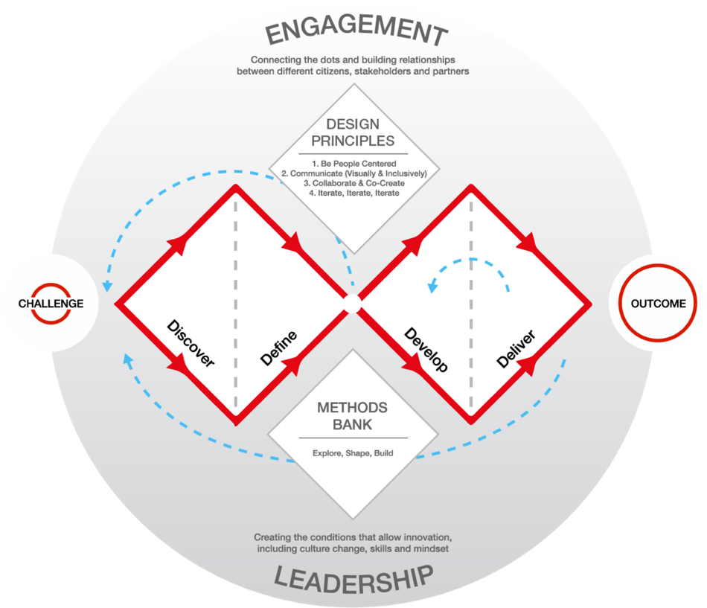

Figure 3 The Double Diamond framework by the Design Council
(licensed under a CC BY 4.0 license).

Various methods were employed for the subsequent phases of the Double Diamond process model (see Figure 5). The details of each stage are additionally described below.
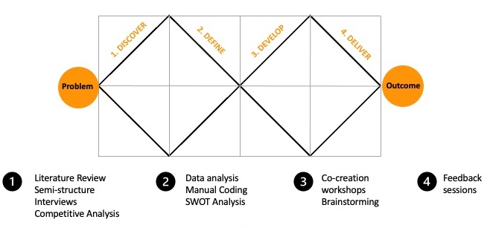

Figure 4 Inside the Double Diamond – stages and methods.

Discover
This stage aims to immerse in the problem. At this stage, both primary research with the relevant stakeholders or experts and secondary research or desk search should be conducted to understand the given challenge in depth. As part of this project stage, an extensive literature review of nearly 100 sources (listed in the Appendix) was completed to comprehend the sector's maturity, challenges and opportunities from the sustainability and SDGs perspective. Moreover, qualitative methods were used to help identify challenges and opportunities for SDG adoption, particularly semi-structured interviews with industry stakeholders. Also, existing SDG tools and frameworks were identified and reviewed.

Define
The define stage aims to define the challenge into a problem statement. Therefore, the findings from the previous stage were analysed using affinity mapping to information into themes to help frame challenges and opportunities for SDG adoption. Then, the problem statement and project criteria were formulated. Moreover, a researcher-driven SWOT exercise was used to propose the project direction.

Develop
The aim of the develop stage is to generate solutions to the problem. For the concept development, co-creation workshops were used – this will provide additional empirical data to support the development of the tool. Mock-ups were prepared using Excel and Figma.

Deliver
The deliver stage aims to validate the solutions. To finalise, deliver and evaluate the concept, remote feedback sessions were conducted to gather feedback and identify further improvements.

Lifecycle Thinking

Life-cycle thinking is an approach considering the environmental, economic and social consequences of a product or service throughout its life. One of the tools is Life Cycle Sustainability Assessment (LCSA), which considers gains and losses in the across-the-board impacts of services and products at all stages of processing, including extraction, conversion, transformation, distribution, operations, and the end-of-life scenarios. Lifecycle thinking enables more efficient adoption of the sustainable development agenda through informing projects decisions, as it allows to identify best product or services choices at each stage of lifespan. Indeed, the ISO14044:2006 Life cycle assessment standard itself mentions contribution to SDGs 12- Sustainable consumption and production) and 13 - Climate action. This study however did not involve the LCA tools as it requires complex datasets, which are not readily available for the data centre industry, as described in the literature review 2.4.2 Environmental Impacts. There are other useful life cycle thinking tools, respectively: mapping and research. Both help to systematically approach identifying all the processes, materials, inputs, and outputs that go into product or service. Adding life-cycle perspective is vital to think about data centre facilities and its operations and end-of-life holistically. In this research, life-cycle perspective was integrated to account for data centre lifecycle and sub sectors involved. The life cycle stages of a data centre were identified and informed question for the stakeholder interviews in the Discover phase. Also, insights gathered through the workshops were mapped to the life cycle perspective, to help structure the tool contents in the Develop stage.

Time Horizon & Participant recruitment
The data was collected at a specified point in time. The research study began in October 2021 in the part-time mode, with expected completion within 24 months, that is, October 2023 and was successfully completed within this timeframe. The achieved milestones were as follows (a detailed Gantt chart is attached in the Appendix):
- RES2 Panel Review (Research Proposal) – April 2022
- Ethics Approval was accepted – June 2022
- Semi-structured interviews – July to September 2022
- Book Chapter submission – December 2022
- Co-creation workshop – May 2023
- Feedback session – July 2023

At every stage of data collection, participants were meant to ideally represent various sub-sectors within Data Centre Industry or Sustainable Development. The population of the study did not involve vulnerable participants, and no sensitivity issues were identified. Ethical Approval was submitted to proceed with activities involving participants from the industry.
A stratified sampling approach was used in the study; participants were carefully chosen from various sub-sectors within the data centre industry or from the sphere of sustainable development. Contributors were sourced using contacts of the Circular Economy for Data Centre Industry project (CEDaCI), which consists of stakeholders working within various subsectors of the Data Centre industry in North-West Europe. Besides, participants were also contacted through social media, particularly the LinkedIn platform. Participants were selected and invited to each part of the study via email or LinkedIn. Particularly LinkedIn, a business social media platform, was helpful to browse for potential connections, thanks to filtering options, such as specific role, area, and company. The platform also allowed us to quickly establish relationships (i.e., “connections”) with potential interviewees and allowed us to contact them directly in a much more accessible and effective way than via e-mail invitations.
Besides, participants were also recruited during the industry-relevant events, using cards with an invitation to the study, although this route did not succeed in securing any contributors. For each data collection stage, a different number of participants was intended, as follows:
- Semi-structured interviews (10-12 participants),
- Co-creation workshops as part of Design Development (1 or 2 workshops depending on the iterations needed) (8-10 participants)
- Focus group as part of evaluating the tool (2 participants).

Techniques & Procedures

Semi-structured interviews
As explained in the Research Approach section, stakeholder engagement was identified as beneficial to the research. There is a number of stakeholder engagement methods to collaborate with individuals or groups important to the studied phenomena on various levels.
For an in-depth exploration of complex issues and individual perspectives, the best method is semi-structured interviews. This method allows for flexibility to converse with a diverse audience of experts, allowing both interviewee and interviewer have the opportunity to ask follow-up questions and explore new ideas. Apart from adjustability, such method introduces some level of structure, allowing for more systematic analysis. Hence, semi-structured interviews were chosen as a suitable qualitative data collection medium.
The interviews aimed to explore further topics previously identified in the literature review. Precisely, further determine and interpret relevant goals and targets, explore ways of systematising them, investigate synergies and trade-offs, and opportunities and challenges stakeholders may come across with regards to reflecting on, monitoring and reporting progress towards SDGs. The key themes for designing the interview included:
- Awareness – the company’s knowledge and awareness about sustainable development practices and, specifically, the SDGs.
- Practices – corporate sustainability reporting, ESG and acknowledgement of the SDGs. Current monitoring and reporting strategies across the triple bottom line.
- Challenges and opportunities – the importance of sustainability and views on contribution to the achievement of the SDGs; the challenges and opportunities; and interviewee views on which SDGs and corresponding targets on which the businesses could have an impact.
- Support needed – the need to comprehend SDG frameworks, strategies, and tools used. Examine required guidance and opportunities.
- Descriptive statistics –capturing basic descriptive data on the participants, such as the type of company/organisation they worked for as well as job title/category.

Co-creation workshops

Co-creation is a controlled process of collaboration involving chosen stakeholders, gathered together to brainstorm and ideate (Interaction Design Foundation, 2021). Most commonly, co-creation takes the form of facilitated workshops. For the needs of the research study, workshops were planned online and prepared using a collaborative whiteboard space (Miro). At this stage of the research, the primary solution was defined, and the aim of the co-creation workshops was to determine the content and prioritise features of the tool. Precisely, the goal of the workshop was to translate the SDGs for the context of this sole sector. Besides, it was an opportunity to collect primary feedback on the idea. The proposal was to prepare activity boards, where participants can brainstorm ideas together. The co-creation exercises were preceded by a brief introduction to the research and an ice-breaker activity, as fully described in the forthcoming chapter.

Feedback Sessions

The aim of the feedback sessions was to collect opinions on the functionality of the tool and opportunities for further development. At the stage of the research proposal, the sessions were ambitiously assumed to involve extensive user testing and focus groups. In reality, only two feedback sessions were conducted due to participants availability and time constraints. Nevertheless, both provided thought-provoking and valuable critique to evaluate the outcome of the project and opportunities for further research.

Limitations of methods
Each of the methods considered is characterised with specific strengths but also limitations. All potential limitations were gathered in a table below.
Table 7 Limitations of chosen methods
Method | Limitations
Literature Review | Researcher bias on the choice of literature may impact the accuracy of presenting the state-of-the art knowledge. Also due to limited data available on the subject studied, increased reliance on the industry white papers.
Competitive Analysis | The insights on the tools may be limited, depending on availability of access to the tool. Perception of strengths and weaknesses is subject to researcher bias.
Semi-structured interviews | Limited sample size. Interpretation of the interviews is subject to researcher bias and participant responses subject to social desirability bias.
Manual coding | Sorting and categorising the data into themes subject to researcher bias.
Researcher-driven SWOT | View on what is considered strengths, weaknesses, opportunities and threats, is subject to researcher bias. Furthermore, SWOT doesn't essentially include a framework for prioritisation, therefore a better option may be to introduce a decision matrix reflecting on the project drivers.
Co-creation workshops | Issues with managing the group dynamic, and groups of different size. Constraints to conducting the workshops online include digital barrier for some participants. Varied level of stakeholder engagement in the workshop activities.
Feedback sessions | Limited sample size. Subjective to participant and level of previous involvement in the study – social desirability bias.

,

Data Collection

Semi-structured interviews

Overview and questions

The semi-structured interviews were conducted online, using communications platforms such as Zoom or MS Teams, thereby allowing for flexibility for both interviewer and interviewee. Moreover, such platforms allowed for automatic audio/video recording, which was used for the following transcription and qualitative data analysis. This activity took part between July and October 2022.
The interview requests were sent to 30+ industry experts representing varied expertise in the data centre industry and/or sustainable development to accurately reflect the real-world scenario. The response to the invitation to the study can be considered fair. Twelve participants responded to the invites positively and took part in the interviews. However, eleven interview responses were used for further analysis because one participant could not provide in-depth, usable insights as they had an insufficient connection with the industry. This sample, and the results, are considered satisfactory for the nature of the study.
Each interview lasted between 30 and 60 minutes. To support open-ended and two-way communication a set of guidance questions was prepared and split into two parts, respectively:

Part 1. Knowledge, experiences, and views on Sustainability in the Data Centre industry
The first part of the interview aimed to identify how the industry perceives sustainability and sustainable development. The aim was to comprehend how to define sustainability in the context of this sector, as there are many definitions and sustainability is often spoken about only in the context of energy efficiency. Furthermore, the objective was to identify the sustainability trends or main contributors to the sustainability portfolio, beyond energy efficiency improvements. In this part, the guidance questions were as follows:
- How do you understand/how could you explain sustainability in the context of the data centre industry? What do you understand about sustainability in the data centre industry?
- From your experience, what are the current sustainability trends/main contributors in this sector?
- What could be done beyond the current sustainability efforts focusing on energy efficiency?
- From your experience, what are the biggest environmental, social, and economic challenges in implementing sustainable practices in the sector?

Part 2. Knowledge, experiences, and actions on SDGs in the Data Centre industry.
The second part of the interview aimed to identify whether the industry is familiar with SDGs and how the industry perceives the goals of the 2030 Agenda. Moreover, to pinpoint what are the barriers, challenges and opportunities in better adoption of SDGs by the DCI. Also, what could be the benefits of implementing the 2030 Agenda, and what would motivate the industry to do so.
The supporting questions included:
- Knowledge of Sustainable Development Goals in the Data Centre industry. Did you come across SDGs in the sector? When was the last time?
- Which SDGs do you think are the most important to the sector?
- Is your company committed to the achievement of SDGs?
- What are the greatest barriers for companies to implement SDGs?
- Do you think the sector can benefit from implementing Sustainable Development Goals?
- Does your company measure the performance toward the achievement of SDGs?
- Are you using any tools/frameworks? Which tools or frameworks have you used and why? Which have you used lately?
- What kind of guidance is missing/needed?
- How do you think the sector can benefit from implementing Sustainable Development Goals?
- What are the biggest challenges in measuring SDG performance in the sector?
- What are the biggest opportunities for measuring SDG performance?
- What are your thoughts about the possibility of SDG performance-related data being reported by businesses?
- Do you think that ability to compare the progress towards SDGs amongst companies would motivate them to implement the global goals?
- Do you think it should be a legal requirement that companies report against SDGs?

Participants

Although no quantitative data were collected, some descriptive statistics were assembled to understand the appropriate background of the invited experts, organised in Table 7.
Table 8 Background of participants
Identifier | Job role category | DC Sub-sector
A | Upper Management | Consulting
B* | Upper Management | Refurbishment
C | Consultant | Consulting
D | Upper Management | Design & Construction
E* | Sustainability Department | Refurbishment
F | Sustainability Department | Refurbishment
G | Upper Management | Manufacturing
H | Research | Research
I | Consultant | Consulting
J | Upper Management | Refurbishment
K | Consultant | Consulting

In the interviews, most participants were senior practitioners working in various positions within upper management (42% of surveyed) or consultants (25% of surveyed). A similar number of participants worked in sustainability departments (16% of surveyed), and in academic research closely involved with the industry (16% of surveyed).
Participants were also representatives of various sub-sectors, and the final group included the following sub-sectors: research (18% of the representative subsectors), refurbishment (27%), consulting (36%), and design, construction & manufacturing (18%). Two participants represented the same company and the same sub-sector but worked in different positions. Therefore, their insights were valuable and varied.
One of the participants was not directly involved with the data centre industry, unlike the others. For this reason, numerous questions were omitted, and the interview did not introduce any insights specific to this sector. Since the participant had impressive knowledge and experience, the obtained insights did align with the goal of the interview.

Co-creation workshops

Overview

At the time of the co-creation workshops, the primary concept of the study was developed, and the aim of the co-creation workshops was to determine the content and prioritise features of the tool; thus, the workshops were titled: “How the UN SDGs translate to data centre sector challenges?” and the aim of the co-creation was to gain insights needed to translate the SDGs for the context of this unique sector.
This activity took part in May 2023 and was split between two workshops. The co-creation workshops were conducted online, using communications platforms such as Zoom or MS Teams, and collaborative whiteboard - Miro.

Participants

The study involved two groups of participants – firstly, a group of six and then a group of two, explained in the further below. The sessions were too recorded for qualitative data analysis. Each session lasted for three hours. Contributors were of wide-ranging expertise in the data centre industry and/or sustainable development. The majority of participants were, again, senior practitioners working in various positions of DCI.
Throughout the research, the aim to have a diverse audience, not limited to sustainability professionals (although also involving a few of them), to gain better insights was achieved successfully and adequately to the requirements of the project. As the research is limited by time and resource constraints, the achieved number of participants was sufficient to represent the “mini” landscape of the data centre industry. Regardless of the challenges associated with recruiting suitable and willing contribute individuals, the response right was fair. Especially, considering that the participants voluntarily contributed 3 hours of their time to this activity. The diversity of sub-sectors, companies and roles, even the context of different countries, allowed for interesting observations and determining thought-provoking trends and collaboration.

Workshop structure

As previously explained, the workshops were titled: “How the UN SDGs translate to data centre sector challenges?” as the title suggests, the goal was to translate the SDGs for the context of the sector.
The activity boards, where participants can brainstorm ideas together, were prepared. The co-creation exercises were preceded by a brief introduction to the research and an ice-breaker activity. There were two workshop sessions, and the content had to be adjusted in a split, as it was impossible to fit all SDGs into 3 hours brainstorm. As a result, insights on 14 out of 17 SDGs were collected except for SDG 1. End poverty, SDG 2. Zero hunger, SDG 7. Affordable and clean energy and SDG 16. Peace, justice and strong institutions have been explored. Due to the limited time the goals were prioritised as identified as most relevant throughout the literature.
The structure of the workshops was as follows:
- Firstly, the researcher gave a 15–20-minute introduction to the project to explain the context, significance, research gaps, scope of the project and aims. Furthermore, participants were presented with the workshop agenda to inform about the structure and timing of exercises. Lastly, a short explanation on how to interact through the Miro platform was delivered.
- This was followed by a brief facilitation exercise using reverse psychology, inspired by conference paper: “Being bad to do good: using reverse psychology to embed Life Cycle Thinking and knowledge of Sustainable Development Goals in design and engineering curricula” (Andrews, et al., 2020). Participants were asked to pick an SDG and think of ways of destroying it - what are the worst things data centre sector can do to eradicate this SDG? As shown on Figure 5 SDG Reverse Psychology Ice Breaker. As from Oxford Languages reverse psychology is: “the principle or practice of subtly encouraging a behaviour or belief by advocating its opposite."; the aim of this warm-up was to familiarise the participants with SDGs and encourage curiosity and thinking about the challenges creatively and innovatively, while breaking the ice in a humorous way.
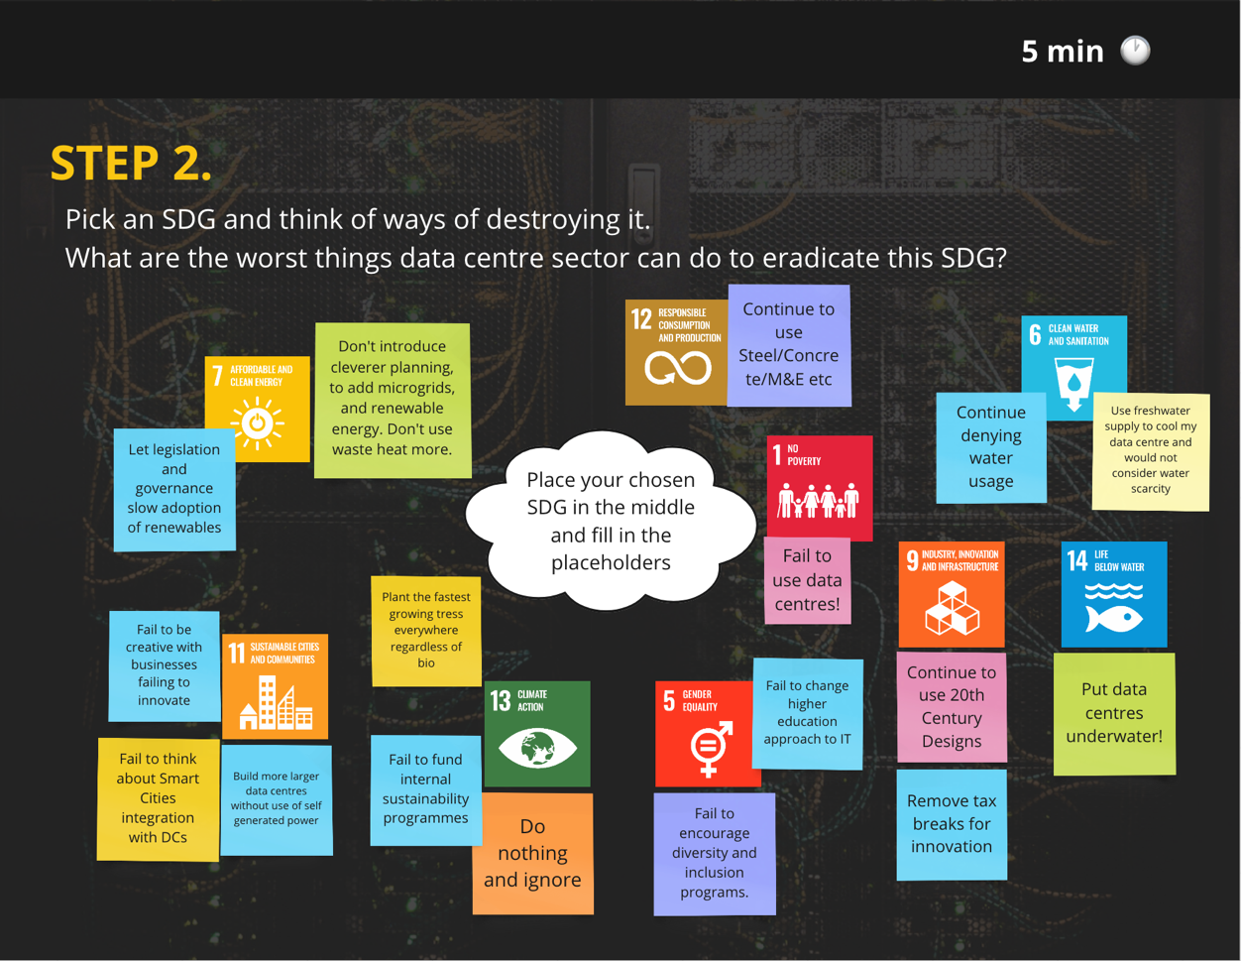
Figure 5 SDG reverse psychology “ice-breaker”.
- 14 out of 17 SDGs were chosen to be explored in co-creation sessions and were organised in groups, inspired by the layers of the SDGs Wedding Cake model by Stockholm Resilience Centre (Rockström and Sukhdev, 2016), respectively:
  - economic dimension goals: 8,9,11,12,17.
  - social dimension goals: 3,4,5, 10.
  - and environmental dimension goals: 6,13,14,15.
Participants were asked to look at SDGs and preselected UN Global Compact Business Actions and/or targets related to economic, social and environmental dimensions and brainstorm how these goals apply to the data centre sector, by writing the ideas on the digital sticky notes, followed by a brief discussion. The activity boards presented as follows:
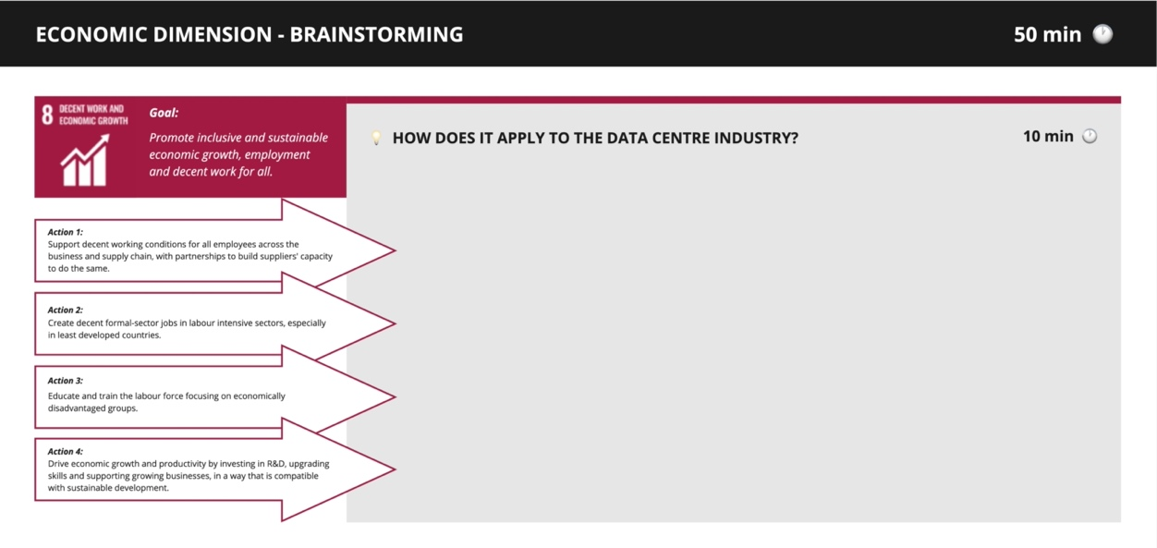
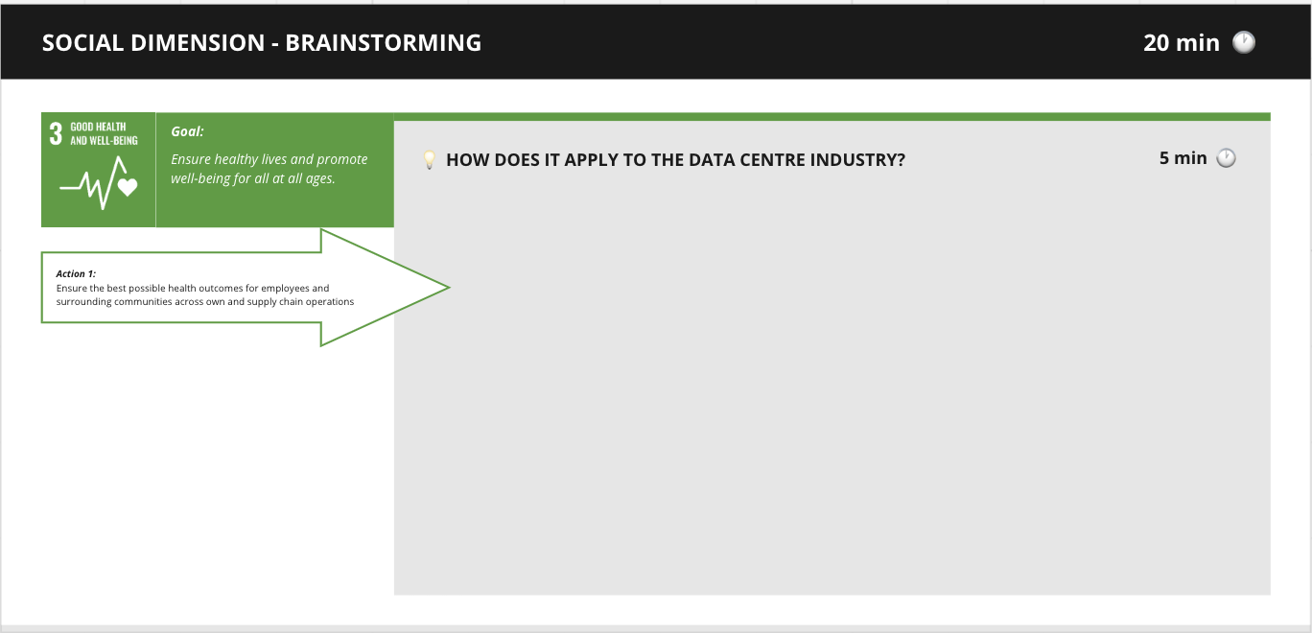
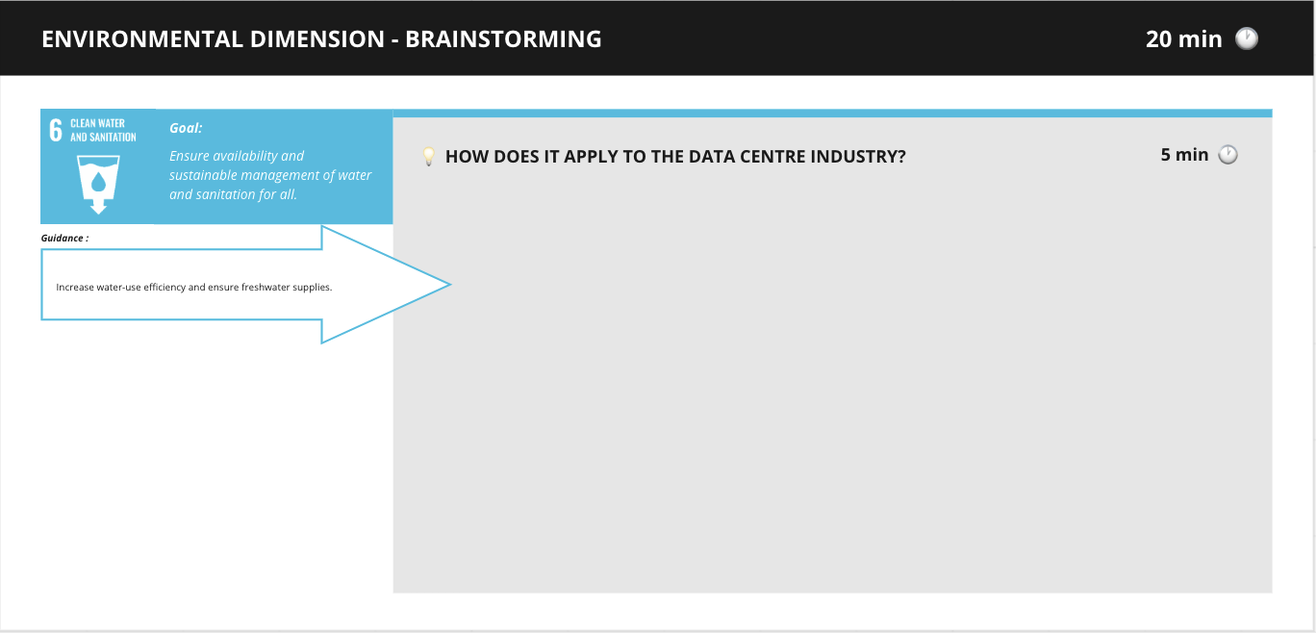
Figure 6 Workshop exercise boards prepared.
Lastly, the plan was to ask participants to vote on ideas to prioritise them, using the Miro voting feature, but it appeared not feasible with the decided timeframe of the workshops.
- Lastly, participants were asked for feedback by writing comments on the digital sticky notes or to give verbal feedback.

Feedback Session

Overview

Lastly the feedback was gathered from two experts. The aim was to have two views, one of a person who was involved at earlier stages of the research and was somewhat familiar with the research journey; and other individual who did not partake in any of the research activities and had an unbiased, fresh perspective on the presented solution. This allowed for a balanced critique and recommendations for future development of proposed concept.
The feedback sessions took maximum of 30 minutes and consisted of 15-minute presentation about the research progress and the concept walkthrough, followed by a brief discussion.

Data analysis & concept development

Interview analysis

Overview

The steps of the analysis were as follows: transcription, initial analysis using special software, manual coding, affinity mapping, and, lastly, aggregating data and trends.
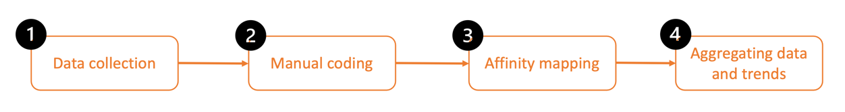
Figure 5 Interview analysis steps overview.
The finalised process consisted of the following steps:
- “Pen and paper” open coding.
- Matrix analysis - organised insights in tables using Excel.
- Use Miro digital sticky notes to do affinity mapping exercise., using common sense making and analytical thinking to group findings by themes.
- Analysed most reoccurring themes – hotspots - to obtain quantitative data to present it in the form of tree diagrams.
- Review the hotspots and summarise the findings.

Transcription

The total interview recordings were approximately 12 hours. For ease and effective transcription, the researcher used transcription software. The transcripts had to be adjusted manually using intelligent verbatim, where needed, meaning that all unnecessary words or non-verbal content were removed, and some editing was done to correct the grammar or redundant words or sentences. As it is the best way to preserve a sense of what was said rather than the exact language that was used. Those were then uploaded to the software of choice - NVivo.

Manual coding

Since the gathered qualitative data was not too extensive (12 participants), the researcher decided to comprehend the data manually, through “pen and paper” using analytical and critical thinking. All interviews were printed and eye-scanned to organise key themes and concepts This approach gave the freedom to create notes and mind maps much more freely and intuitively than in the software. Lastly, those handwritten codes and thoughts were then transferred to Excel, where thematic tables with quotes and notes were organised.
This stage resulted in a very structured system, of the following themes more rigorously informed by the interview structure:
- Interviewee background
- Sustainability
  - Importance
  - Definitions
  - Trends
- Sectoral challenges
- Life-Cycle Perspective
  - IT Hardware
- SDGs Familiarity with SDGs
  - Aligning with the SDGs
  - Measurement and reporting
  - Relevant SDGs
  - SDGs Benefits
  - SDG Challenges
  - SDG Opportunities
- Approach to Policy

Affinity mapping

It was decided to use the affinity mapping technique, which is very commonly used in the design process and similar to any other qualitative data analysis method. Affinity diagramming also aims to cluster large amounts of information in a structured fashion. All information was copied into Miro (a visual collaborative whiteboard platform), allowing to use digital sticky note. Each participant information was assigned a different coloured sticky note to understand the motivations and the context of each interviewee and to compare key patterns amongst interviewees. The sticky notes were then categorised into groups., the key themes were presented as follows:
- Sustainability trends, e.g., resource efficiency, greenwashing, circular economy.
- Sectoral challenges, e.g., implementing sustainability, education, and attitudes.
- SDG benefits, e.g., financial benefits.
- SDG challenges, e.g., complexity and relevance, lack of collaboration.
- SDG opportunities, e.g., education, aligning the sector.

Aggregating data and trends

To aggregate how often the recorded insights occurred, excel was used to create tree maps. Such diagrams helped to visualise the hotspots, providing an accessible way to display quantities and patterns for quick interpretations.

Interview findings

As explained in the interview structure section, the first part of the interview was focused on the industry approach to sustainability, how the sector perceives it, and how people define it. Followed by a second part dedicated to knowledge, experiences, and actions on SDGs in the Data Centre industry. Key insights are expanded on below.

Approach to Sustainability
As an opening question, interviewees were asked about their professions, their view on sustainability importance and their understanding of sustainability. From a range of responses, it appears that the significance of sustainability and the motivation behind sustainable practices often depend on a character's personal approach, as summarised by Participant J: “On a personal side, I think sustainability is something we need to take personal responsibility for”.
Participants believe sustainability starts with the individual attitude that can be later continued and embedded at work. Participant D suggested that the responsibility to be sustainable lies on each person and cannot be assigned only to businesses, as cited: “Often, I think this is actually a personal call to action. What are we doing personally about it? We can't just leave it to an organisation to do something. It is the people within those organisations that do so if we are walking the talk. We will embed sustainable practices into our own lives.”
Furthermore, it can be understood that sustainability is a behaviour that we develop, and it may be embraced by a widely broadcasted climate emergency that we live in. As evidenced by a few quotes from the interviewees - Participant K said: “From a purely personal perspective, you know, we all want to reduce our impact on the planet, and we all want to do a better job of being sustainable. And that's a purely personal thing.”
Early in the interviews, it was apparent that the sector is still at the beginning of grasping sustainability. Further, it is perceived as a relatively new problem in the industry and needs to be more commonly understood and prioritised. As one of the participants alleged: “Well, let's be honest, the sustainability goals in the data centre are still very new. It's a new subject that we're working with.”
It can be agreed that the industry had generally assumed that sustainability could be achieved while continuing business-as-usual. However, now the sector has started to recognise that achieving sustainability goals requires flexibility and a holistic approach. Unfortunately, the sector still struggles with a narrow-minded perspective on sustainability, focused primarily on energy efficiency and carbon, as one of the speakers (Participant B) believed: “There is a start towards a more holistic view of how we can make decisions more sustainable. But I think the reality is - most aren't … are a long way away from that, yet I still feel like we're at the very beginnings of trying to make data centres more sustainable, in my opinion.”
Since the definitions of sustainability or sustainable development may not be common knowledge, and further, there is no joint definition of sustainability in the context of data centre industry challenges, there is a likelihood of misinterpretation and greenwashing. Hence, in one of the first questions, all participants were asked how they understood sustainability in the context of the data centre industry. The answers confirmed that participants have a mixed understanding of what sustainability truly means. Indeed, all the interviewees struggled to come up with a concise definition. Instead, they attempted to explain it by describing and mentioning different hotspots that the industry focuses on, such as circular economy, carbon emissions, water efficiency, and more, as shown in Table 8 below.
Table 9 Understanding of sustainability - key subjects mentioned by interviewees.
Participants | A | B | C | D | E | F | G | H | I | J | K
Carbon emissions |  | x | x | x | x | x | x | x |  |  | x
Circular economy |  | x |  | x | x | x |  |  |  | x
Energy | x | x | x | x |  | x | x | x | x | x | x
Resource efficiency | x | x | x | x | x |  |  | x |  | x | x
Social impact |  |  | x |  | x
Waste heat |  | x |  | x |  | x
Water usage |  | x |  |  |  | x |  |  | x

The industry's most prominent area of focus, as identified in the literature review, is energy efficiency. Hence, repeatedly, participants talked about energy throughout the interviews. Although few of them agreeably emphasised that the sector is actively promoting energy efficiency. As quoted by Participant I: "So, what the industry is understanding of it [sustainability] very much is - it’s energy efficiency."

The energy, in many different contexts (efficiency, consumption, PUE, renewables) was mentioned by nearly all participants – except for Participant E. One of the reasons behind associating sustainability with energy efficiency is the high energy consumption during data centre operations and a constant drive to improve efficiency.
Participants C and K stressed that, unfortunately, there is no way to showcase energy efficiency for data centres accurately. They asserted that PUE (power usage effectiveness) is only a proxy and is often misunderstood or misinterpreted. They further explained that this metric is sensitive to manipulation and varies depending on factors like location. Besides, it is not a comparative metric or invariably representative of actual energy efficiency. Another participant defended that at the end of the day, the data centre can only control its energy, precisely, how energy efficient it is, how much electricity it pulls off the grid, where it connects to, where that energy is sourced from, whether there is an on-site renewable power generation. Renewable energy is also a hotspot for debate, as commonly, companies will invest in PPAs and RECs, which are not always a guarantee of green energy.

Sustainability trends

As a follow-up to the sustainability importance and definitions, interviewees were asked about sustainability trends beyond energy efficiency. When asked about sustainability trends or hotspots, participants would talk about the various matters organised into the group of predominant topics and assigned a value (number of mentions) to create tree maps using Excel (see Figure 7).
The interviews show that a primary trend accompanying sustainability in the data centre sector is the Circular Economy (CE) – 7 out of 11 participants directly or indirectly talked about matters associated with CE, followed by closely associated energy and carbon or GHG emissions. By indirectly, the study means that interviewees did not mention CE specifically but alluded to it in points around resource efficiency, product life extension, heat reuse and similar.

Figure 6 Sustainability trends identified in the interviews.

In the example of CE mentioned with regard to the equipment life extension, participants talked about reuse, refurbishment and recycling benefits and challenges. The industry appears to have a sense of conflict of interest between OEMs generating profits through a linear economy approach and keeping the equipment in use by introducing circular economic business models. One of the interviewees emphasises that awareness about refurbished hardware needs to be increased with legislation and advocating for free hardware security patches. In consequence, there will no longer be security risks. Furthermore, the circular economy business model is also referred to in regard to waste heat reuse as an additional opportunity for increasing resource efficiency and closing the loop locally.
Moreover, participants frequently talked about energy and emissions - two anticipated topics in the sustainability discussion. They specifically debated growing awareness about Scope 3 emissions and a greater understanding of their correlation with energy consumption. Both of those observations were possibly caused by the upcoming at the time of the interviews (and introduced on the 5th of January 2023) reporting requirements – the Corporate Sustainability Reporting Directive in the UK. Hence, sustainability is becoming a fundamental customer requirement: “[…] How sustainable is the server that I'm deploying? Or how sustainable is the network switch? What is the scope of emissions or the supply chain? What is the carbon impact of this footprint that I have, and also, how green is the colocation or the data centre that I will be using? All of those things are becoming more important for the end user.” (Participant G). Essentially, as one of the interviewees explained, the end-users are a vital catalyst for introducing more sustainable decision-making in colocation, driven by the urge to reduce their carbon footprint with stricter Scope 1-3 reporting regulations (see Section 2.5.4.2.).
Importantly, interviewees highlighted that there needs to be more attention to the problem of water consumption and water efficiency. On the contrary, participants would least mention matters regarding greenwashing, recruitment (understood as one of the critical factors in sustaining the industry), financial dimension (economic dimension and finance underpinning sustainability decisions), software efficiency (closely related to energy efficiency), alternative cooling and social impact (meaning lack of acknowledgement of sustainability social impacts).
Sectoral challenges

Participants were specifically asked about sectoral economic, environmental and social challenges or explored various matters themselves in their responses. These were again, analysed and synthesised into the group of predominant topics, presented in the tree map underneath (see Figure 8).
One of the most often directly or indirectly stated sectoral challenges concerning sustainability is the industry mindset. Various participants emphasised that the sector is slow to change and does not take a proactive approach to implementing sustainable practices. Some suggested that the problem behind the lack of action and innovative thinking is the industry's demographics – stating that the generation of workers with conservative attitudes lacks diversity and openness to change the ways of doing things.

Figure 7 Sustainability challenges identified in the interviews.

Statistics confirm that most of those working in DCI have more than 20 years of experience, suggesting that their age is above 40. Moreover, depending on sources, the industry is 80-90% male-dominated, and with the majority being white people.
Furthermore, two participants mentioned the diversity challenge, specifically the industry's lack of female and BAME representatives. Further, what can be observed is a desire to be more sustainable but at the minimum risk and cost. Consequently, the decision-makers are significantly likely to continue to take business-as-usual provisions. Participants deliberated that sustainability needs to give a financial benefit. Notably, investors are starting to put sustainability as a requirement. Interestingly, experts from the refurbishment sub-sector stated they are working hard to educate and overcome the behavioural barrier from buying used and refurbished equipment. As one participant humorously alleged: ‘Oh, we're going to fit our brand new data centre with second hand.’ But I don't think that conversations ever happened, and it's just stigma because it’s the same warranties, the same reliability, the same everything, right? Just a lower cost and a better footprint. I think that's driven by societal behaviours.”
Some of those behavioural problems are likely to be linked to education. This challenge refers to employees as well as customers. As one interviewee concluded: “So there's a huge education barrier to adopting more sustainable practices. There's also quite a conservative attitude in the sector. It's predominantly older people that run the sector still, and they're quite traditional.”
Another reason for the educational barrier is that sustainability is a vast and complex field. As explained earlier, it is hard to conclude sustainability in the context of DCI with a single, universal definition. The interviewees uncovered that sustainability needs to be more apparent to average data centre industry employees and is often siloed to upper management or sustainability departments. The additional reoccurring theme is customer education, for example, not blaming colocation providers for the inefficiency of the hardware because they do not have control over their clients' choice of assets. Lastly, there is a significant knowledge gap in the general public, who is consuming tons and tons of data through digital services but needs a greater understanding of the impact of digitalisation.

SDG challenges

The often-mentioned SDG challenges were related to the complexity of the 2030 Agenda and the relevance of the goals and targets to the data centre sector (See Figure 9). "It's difficult to apply them because a lot of these sustainability goals are very generic." - mentioned Participant K. It appears that stakeholders struggle with understanding SDGs and linking them with data centre- concerns. Participant H said:
"I think one of the greatest barriers is (…) not knowing how to implement them. Not fully understanding what they mean. (…) whilst the whole concept of SDGs is absolutely fantastic."

Figure 8 SDGs challenges mentioned by participants.

Other interviewees pointes to the problem that large hyper-scale companies, who own all their infrastructure and assets and keep everything in-house, have better chances to set KPIs (key performance indicators) accurately. In contrast, the same level of detail is impossible in the colocation data centre. Furthermore, SDGs are just a part of sustainability strategy and one framework in many other tools. Participant E. says there are more significant compliance issues than the problems that goals try to address.
As explored through the literature review, the sector needs help with the problem of greenwashing and SDG-washing. This can be observed through using United Nations and SDG colourful icons in companies' communications but not communicating actions behind it, not disclosing negative impacts or measuring them. This challenge was also often mentioned in the interviews. Participants would describe embedding SDGs as creative, minimal and skewed.
"I haven't seen any organisation thoroughly embed the SDGs into business strategy. I think they get put up as logos, as anchors in frameworks and that's great. It's better than not doing it. But actually, I never really sit in meetings where SDGs have been discussed. Unfortunately, because I think it's a really good piece of work." - described Participant E.

It can be understood from the interviews that companies will usually add SDGs to the existing strategy in a reactive rather than proactive approach. Meaning that SDGs are not actually guiding any action as they should. Due to the lack of agreed practices and metrics, companies always find a way to tell a compelling story and show numbers that put them in a good light based on privately owned data.
This already superficial approach does not support minimal action towards a sustainable future, not to mention overlooking trade-offs and geo-political implications like, for example, the well-being of communities in the Global South involved in the supply chains. Moreover, the industry employs a reductionist approach to sustainability, setting measurable targets and goals. As one of the participants said:
"It is a bit of a cliche, but if you can't measure it, you can't manage it."

Recording and tracking sustainability achievements, such as carbon footprint, is crucial to decarbonisation. However, the complexity of sustainability challenges is a wicked problem that needs a deep understanding of the stakeholders and innovative approaches such as systems thinking, design thinking and creative problem-solving.
Participant E said:
"So, I think we tend to be very good at looking at things in isolation. And I think what the SDGs were designed for, was to enable us to take a look at those holistic impacts.".

The key to acting on SDGs is looking at all the contexts and acknowledging that all the goals are equally important.

Another challenge identified from the interviewees is working in silos. This relates to sustainability in general; however, many participants mentioned it in this part of the interview. The industry sub-sectors need to be more cohesive and communicate with each other. Each of them has their targets and strategies to achieve them. Moreover, there is an accountability issue, blaming other industry branches for sustainability debacles.
Further, one participant had past experience of sustainability being siloed to the sustainability department or lead only and suggests the whole organisation - all employees - should be engaged in the sustainability mission and create a sense of awareness and common purpose. Another participant had the opposite view, stating that the 10-year framework is generally essential and sound. However, it will not matter to an average employee.

Furthermore, SMEs may struggle to embrace SDGs. Sustainability obstacles for smaller companies might be more challenging to overcome, even if the motives are genuine. Large providers have a standing advantage in circular projects and money to invest in R&D. They have funding and access to experts to showcase sustainability and SDG contributions. However, smaller companies may need help to take similar steps. They need to learn how they can contribute.

SDG Opportunities
Alongside the challenges or barriers, participants were also asked about opportunities for increased SDG adoption. The key themes were concerned with aligning the sector and education (See Figure 9).
SDGs are introducing new sustainability perspectives and encouraging industry to look beyond energy efficiency. Participants mentioned education on multiple occasions. Participant J emphasises that sustainability education and creating a people culture is vital to keep people motivated and focused on purpose.
Further participants suggested simplifying or translating SDGs, as per quote:
"It would probably be useful to how do we translate these into [DCI] so it’s clear for people how they align." (Participant B)

Figure 9 SDG opportunities mentioned by participants.
Some interviewees gave ideas on setting up a pledge platform for companies to increase accountability or introducing a star system to reward those who make efforts towards SDGs (such initiative exists already - Support for the Goals – See section 6.3). An intriguing suggestion was to create a tool to showcase monetary value when contributing to sustainable practices and SDGs. This recommendation highlights the industry mindset - sustainability requires a strong business case. Financial gains are the primary benefit associated with sustainability, and ESG benefits are secondary.

Participants' ideas on aligning the sector focused on standardising metrics or certifications and clarifying responsibilities within the sector. Indeed, Participant (G) predicted that standardisation will occur organically when people repeat the same behaviour. Others believed that it depends on mandatory reporting. The question is, who will lead this transformation? Opinions about the bottom-up or top-down approach differed across the participants.

Data access is crucial to setting the industry's common goals and KPIs. Participants (G), (I) and (J) stressed the importance of open-source data. An interesting suggestion for protecting companies and government interest was introducing an industry census similar to the US financial companies census, allowing the anonymous sharing of sensitive or damaging data.

SDGs review
Not all participants were working for companies that embed SDGs. Some of the representatives were independent (i.e., self-employed). Two participants were unfamiliar with SDGs, and others had mixed knowledge, from limited to very good (and especially sustainability leads).
Participants (D), (F) and (J) work for the companies that officially adopted SDGs. The most common goals are 3, 4, 6, 7, 8, 9, 11, 12, 13 and 15 (see Figure 11).

The remaining participants were asked to elaborate on the SDGs they believe are relevant for the data centre sector and why. As a result, the interviews covered SDGs 5 to 14, and 16 and 17 (See Figure 12).

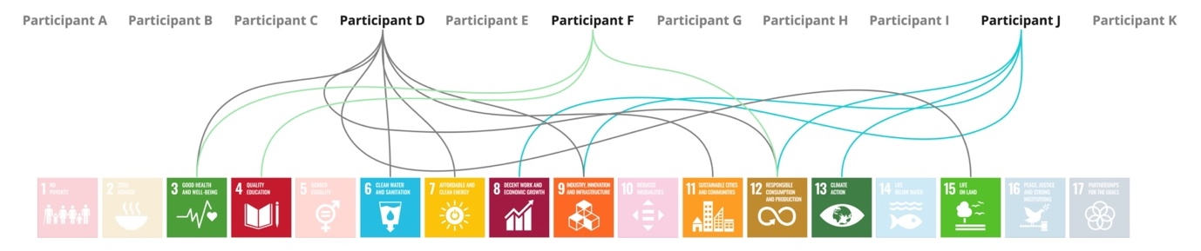
Figure 10 UN SDGs officially adopted by the participant's companies.

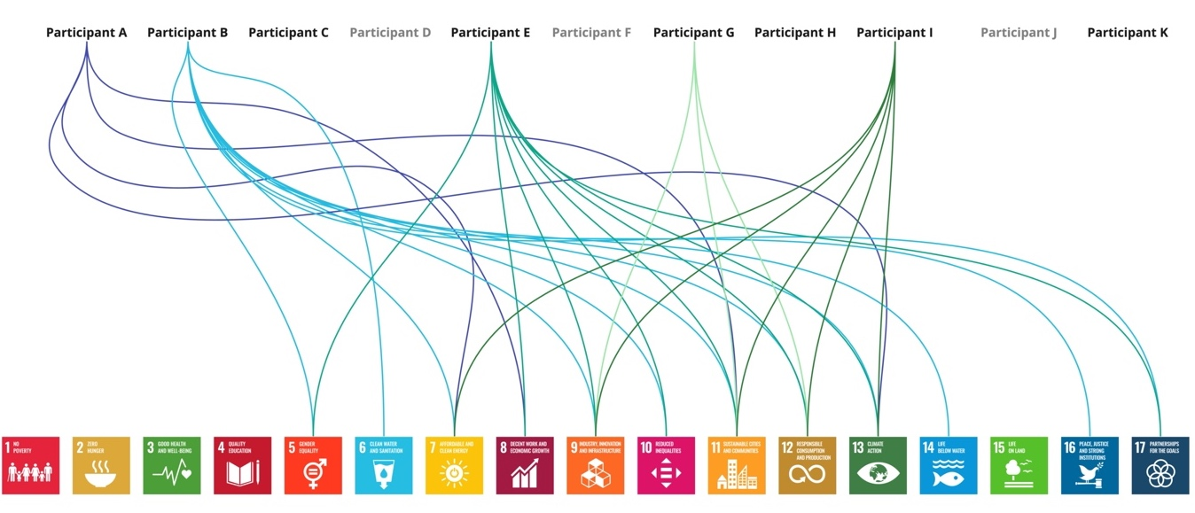
Figure 11 SDGs participants find relevant to DCI (if the participant's company did not officially adopt SDGs).

Challenges and opportunities

The initial observations show that sustainability and SDGs need more familiarity and understanding; the goals are perceived as ambiguous and constructed in a way that makes it hard for businesses to translate them down to their needs and specific sectors. Consequently, SDGs are misinterpreted and used for a marketing advantage, also known as SDG-washing.
Also, the data centre industry is a unique and particularly secretive sector. The multiple subsectors that are working in silos often lack collaboration and an understanding that sustainability is a team endeavour and joint responsibility and is therefore not limited to one actor or stakeholder.
The primary and secondary research confirmed a need for a universal tool for use in the data centre industry to help stakeholders with green decision-making and corresponding progress towards SDGs. Moreover, the findings emphasise the need for whole system thinking and bespoke education and guidance for the private sector, which is a key agent in the global sustainability agenda on the example of the data centre industry. The tool that will translate the SDGs for the unique context will benefit stakeholders. It will help them understand the SDGs better and provide a blueprint of what action can be taken and expanded on in the future. Moreover, such tool should highlight the need for cross-sectoral cooperation and awareness building. Lastly, aligning the sector with action points will help multiply the impact of declared actions.
The following points were gathered to summarise the insights from the stakeholder interviews and analysis of the available literature. Moreover, it aims to objectively present the scope of the problems and opportunities that are addressed in this research and proposed concept. The subject is very complex; therefore, the most pressing issues are prioritised in relation to the constraints of this research. To summarise:

- The sustainability maturity of the sector is still very low, and education is needed to raise awareness about sustainability and SDGs.
- Adoption of SDGs is limited to 2-5 goals and interpreted in as many ways as there are companies implementing them.
- Companies often use external expertise, such as consultancies, which create bespoke ESG, CSR or sustainability strategies. Some smaller companies may be left behind because of lower budget for such initiatives.
- There are many generic reports on SDGs adoption by businesses, but there is a lack of sectoral guidance. SDGs are ambiguous and designed on the country level. There is a need to provide better understanding of SDGs in the context of DCI.

Project drivers/criteria

A set of project drivers were identified to support the direction of the concept development and assess the achievement of a final proposal. These drivers were formulated based on the interview insights, the review of the available tools (See section 6.3) and resources available to the researcher. Consequently, the proposed tool for the data centre industry stakeholders to support the progress towards SDGs needs to be:
- Accessible – ideally, the tool format would be a web-based application accessible to any internet user.
- Educational – this tool aims to educate the users and build awareness about the SDGs in the data centre industry. However, the subject should be open to a broader audience.
- Universal – the tool should be available to all data centre stakeholders, accessible, and provide comprehensive information, emphasising that sustainability and SDGs are a common cause.
- Unambiguous and understandable – the contents (actions) should be simple to understand and communicated clearly.
- Feasible – the tool proposal will be developed using available platforms such as Excel and Figma, considering that the researcher has software development expertise.

Inspirations for the concept development

Blueprint for leadership from the UN Global Compact

The UN Global Compact has introduced a framework, which is called the Blueprint for SDG Leadership and is applicable for companies of all sizes aspiring to SDG leadership. The framework is based on past and present learnings from business interactions with SDGs. The framework aims to scale up the business contributions to the SDGs globally. To support all types of business leadership, the Blueprint combines SDG leadership principles – intentional, ambitious, consistent, collaborative and accountable – and so-called SDG Briefs. Each SDG has a dedicated page explaining critical links between the business and each SDG. The information includes:
- Opening narrative – introduction on how leadership can contribute to a particular SDG.
- Leadership qualities – guiding questions about evaluating action against leadership qualities.
- Business actions – illustrative examples of desirable practices.
- Interconnectedness – linkages with other goals to encourage a holistic view.
- SDGs targets – specific targets identified.
The content was designed to inspire businesses to integrate holistic, systemic and critical thinking—mindsets vital for leaders to accelerate potential contributions towards the 2030 Agenda. The Blueprint proposes Business Actions - ambitious, generic actions, which are much more straightforward and tangible instructions on how to act on SDGs effectively. At the same time, the business actions are general enough to apply to all types of businesses and be relevant to product, process, and business model innovations; supply chain cooperation and supplier selection; multi-stakeholder partnerships; community engagement for behavioural change; policies and practices across operations.
Authors have highlighted that the Blueprint aims to provide critical questions, insightful narratives, and example practices, but it does not provide a checklist or specific guidance (United Nations Global Compact, 2018). Moreover, it is a dynamic framework that may change in the future and will always offer a partial overview, as there is further work to be undertaken in this area.
This UN Framework became a primary inspiration for the solution for the data centre industry businesses – the question that emerges is: Can such a narrative and actions be provided to support the DCI stakeholders and help them grasp the ambiguity of SDG? To answer the raised question, co-creation workshops were designed to brainstorm on SDGs in the data centre industry. Workshops utilised interactive, collaborative online whiteboards - each SDG activity board included the full name of the goal and pre-selected, relevant targets and/or business action from the Blueprint to give participants a direction when brainstorming on the data centre context. It would not be possible to list all targets for each SDG and doing so would not be valuable as most targets are formulated on a country level or completely irrelevant for this context.
For instance, for Goal 5. “Achieve gender equality and empower all women and girls”; supporting messages included two actions from the Blueprint:
- Action 1. “Prevent gender-based discrimination.”
- Action 2. “Support women's employment.”
And two relevant targets, respectively:
- Target 5.5 “Ensure women's full and effective participation and equal opportunities for leadership at all levels of decision-making in political, economic and public life.”
- Target 5.b ”Enhance the use of enabling technology, in particular information and communications technology, to promote the empowerment of women.” (United Nations, 2015)

Review of the available tools – Competitive analysis

There is a myriad of resources, from frameworks to reports, aimed to help manage contributions to the 2030 Agenda. It may be overwhelming for the potential users to manage the vast amount of information and decide which of the resources to use. Therefore, a desk search and review of tools aimed to identify available resources, specifically web platforms/applications, offering support with determining goals, setting KPIs, measuring SDG contributions or providing any SDG support. Besides, it aspired to explore those products/services’ strengths and weaknesses.
A total of 11 tools were categorised and summarised across strengths, weaknesses, cost, scoring and reporting (See Appendix - Review of the available tools – Competitive analysis). Two of those were directories – SDG Compass and SDG Accelerator Kit. The SDG Compass is a catalogue of existing business tools that help assess organisations' impact on the SDGs. Similarly, the SDG Accelerator Toolkit developed by the United Nations Sustainable Development Group (UNSDG) is described as a “one-stop-shop for the latest resources to support the achievement of Global Goals”. Furthermore, one of the collected platforms was called ‘Support the Goals’, which is a service offering evaluation of the business and offering an incentive–star award system. It is a simple, unbiased “traffic light” ranking system to show the company’s progress towards completing five key criteria: “priority goals, measurable targets, taking action, performance data, and supplier education. A star is awarded for each criterion that evidence is available on the company website or elsewhere in the public domain” (Support the Goals, 2023).
Other tools include:
- Business Call to Action Impact Lab – a platform for inclusive businesses to better measure and manage their impact on the SDGs. It covers the full impact management process to support companies in understanding, proving, and improving their impact.
- ESPON’s SDGs benchmarking tool – the tool offers support to regional governments in achieving the SDGs. It presents indicators to measure and monitor the SDGs and benchmark similar regions.
- SDG Action Manager – a web-based impact management solution allowing for dynamic self-assessment, benchmarking, and improvement, a platform informed by the work and feedback of a range of stakeholders, including experts in corporate sustainability, civil society, UN, and academia.
- SDG Impact Assessment Tool – an interactive tool, providing a platform to assess the impact of solutions, research activities, organisations, projects or other initiatives with users’ own knowledge.
- SDG Monitor – a cloud-based tool that helps companies and organizations to measure and communicate their sustainability performance and to show its impact.
- SDG Project Assessment Tool – a framework with 54 sustainability principles and related performance criteria around thematic areas, such as urban planning, mobility, resilience and smart solutions.
- SDG Synergies – a practical tool for understanding how groups of policy areas and targets interact, using systems thinking. It records, visualises and analyses how multiple targets are likely to interact in a given context.
- SDG Tool – a questionnaire that adapts and streamlines itself depending on your answers. The final output is a full list of the targets which are relevant to the user’s project, which can be adjusted and then exported to various formats for reporting.
The SDG Tool and SDG Project Assessment Tool are specific to, respectively, biodiversity and conservation projects, and urban planning projects, as they are questionnaire-based frameworks, with specific questions formulated for those contexts. These are the more focused examples, as the rest of the tools mentioned above are aimed at the general audience. Although for general use, some of these tools required basic familiarity and knowledge of SDGs and sustainable practices. Most of those tools were free of charge, but some required registration or offer extra features at additional cost.

Concept brainstorming

The SDGs are a comprehensive global framework specifically designed to align the world’s governments to tackle the most pressing problems and needs across society. As the UN defines, the 2030 Agenda is a "shared blueprint for peace and prosperity for people and the planet, now and into the future". Since the framework was developed on a country level, evidence suggests that businesses within the data centre sector struggle to interpret the goals due to ambiguity and irrelevance. Another pressing issue is awareness and education about SDGs. It can be understood that the average DCI stakeholder lacks familiarity and an understanding of the SDGs and sustainable practices, thereby posing a significant barrier in attempting to interact with SDGs.

The first solution to this issue would be a set of new “translated” goals and targets for the data centre sector, which would be similar to the qualities and behaviours for inventors, leaders and designers proposed by the Inner Development Goals initiative (as described in the previous chapter). Moreover, and inspired by the Blueprint for Leadership from UN Global Compact, there is a potential for creating similar guidance but sector-specific: a shared blueprint for the viable and prospering data centre sector today and in the future.
Further, such guidance in the form of translated SDGs can be used to facilitate purposely designed open-source workshops or training materials for business stakeholders in the data centre sector, which is required for improved accessibility for small and medium-sized companies. Such materials may also take the form of a checklist of best practices or considerations when starting the conversation on SDGs in DCI. Another possibility would be decision trees of decisions and possible consequences or questionnaire-based tools with a set of sector-specific questions. Such frameworks are self-explanatory and would not require guidance from a sustainability/SDG professional.
Another considered strategy is using the gamification approach, defined as using gameplay non-game contexts to engage users. Such a tactic is already popular in the business setting and is often applied across employee training, recruitment, evaluation or increasing overall productivity. This approach brings a lot of benefits and most importantly, motivates the user. This concept could take the form of a set of playing cards, a board game or simulations of a given scenario.
At the research design stage, a SWOT (strengths, weaknesses, opportunities and threats) analysis was planned to help determine project direction and compare concepts against project drivers.

Concept selection – researcher-led SWOT Analysis

The two main concepts – translating SDGs and the gamification approach – were compared using SWOT Analysis to identify strengths, weaknesses, opportunities and threats (as presented in Table 9 and Table 10).
The first concept, a set of translated SDGs, could potentially become a scalable and accessible framework. It could create a shared understanding of the SDGs in the context of the data centre industry, thereby helping to align the sector on a unified sustainability mission. Further, this concept could encourage an SDG-focused approach for stakeholders yet to start this adventure. Moreover, the impact of standardised action would be much easier to multiply. Similarly, as SDG corresponding targets and indicators, those translated actions could be linked to existing policies, certifications, and international conventions. The solution does not need to be complete but may be a starting point, specifying SDGs that require further research and development.
Such a concept could be expanded further by adding layers of complexity, for example, exploring the interconnectedness of actions. Therefore, the proposed solution may appear superficial since the intricacy of the researched subject and project constraints may not allow in-depth exploration of all SDGs and analyses of all stakeholder groups. Lastly, the tool may offer educational value but may not replace the need for external expertise identified in the interviews. The second direction, the gamification approach could be viewed as an entertaining and user-friendly way of tackling the SDG challenge. Since the interviews identified issues with the stigma and reluctant attitude of the data sector stakeholders being a major barrier, such an approach would help involve the stakeholders and “break the ice”. The approach also encourages critical thinking, creativity and problem solving – which could help stakeholders step out from the reductionist and profit-driven business approach and look at SDGs from a different perspective. Nevertheless, such a game could meet with disapprobation from the more conservative industry professionals. The game could either be a standalone material or a part of the facilitated workshop/training. However most likely for internal use, therefore limiting the collaboration and interdisciplinarity across the whole industry.
After comparing the strengths, weaknesses, opportunities and threats (see Table 9), many more benefits arise from pursuing the first direction – translating SDGs. Hence, this concept has been considered further, and more research and data are needed to develop this intervention.

Table 10 Concept 1 - SWOT analysis.
Concept 1.
STRENGTHS | WEAKNESSES
- Broad and accessible framework.  - Helps specify SDGs for further development.  - Simplifies the process of transitioning into an SDG-oriented strategy/business model.  - Creates a common and correct understanding of SDGs in the DCI context.  - Making sustainability leads/consultants' work easier. | - Due to the complexity of the problem and time constraints may not be delivered to a comprehensive level.  - Need to prioritise certain stakeholders and challenges over others.  - The tool will be of help but may not fully replace the need for external expertise.
OPPORTUNITIES | THREATS
- Simplifying things may attract more businesses and stakeholders to join the SDGs journey.  - Creates common cause for stakeholders and by aligning the action helps to multiply the impact.  - Can be tied to existing policies, certifications, international conventions.  - Translating SDGs is one of the steps in policymaking, therefore it may help in development of new policies.  - Creating sectoral guidance.  - Make it in a format that can be easily updated.  - A baseline for more tools in the future. | - Keeping up to date – dynamic framework.  - Fragmented approach because of the scale of the industry.

Table 11 Concept 2 - SWOT analysis
Concept 2.
STRENGHTS | WEAKNESSES
- Accessible way of learning.  - Fan and hands-on format. | - Conservative industry thinkers may not accept the format.  - It may end-up being too complex to be a standalone tool without an external lead.  - For internal use, it limits knowledge exchange between actors.  - It may need to be tailored for specific sub-sectors – may be not feasible.
OPPORTUNITIES | THREATS
- Icebreaker for conservative industry thinkers.  - It could be a continuation/ based on other frameworks. | - No IP.  - Misinterpretation due to lack of knowledge.  - Needs to be updated when the guidelines, policies etc. change (dynamic tool).

Development through co-creation – Results

All Agenda 2030 goals and targets were reviewed carefully to identify the most relevant points that potentially relate to the data centre industry context. It can be alleged that to comprehend 17 targets and 169 goals is time-consuming and overwhelming for both researchers and industry professionals. Consequently, it was realised that in order to translate or redesign those goals and targets to this unique perspective, stakeholder participation is essential. Therefore, some sort of co-creation activity was planned at the research design stage, but at this point, the main subject of the workshop was identified and formulated as follows:
“How do the UN SDGs translate to data centre sector challenges?”.
The workshops were designed to be facilitated remotely, using a collaborative whiteboard (Miro). The designated time was 3 hours, and the general agenda of the workshop included a research introduction, an ice-breaker exercise, the main activity and lastly, feedback and any other ideas.
The primary aim was to obtain insights into all the SDGs in relation to the DCI; however, it would not be feasible in the timeframe of the workshop. Also, due to the participants' limited availabilities, the workshops were split into two uneven groups. The first session was a group of 8, which due to its size, was much more challenging to engage and time-keep, and the second with only 2 participants, resulted in a slower pace of the workshop and more accessible setting for each participant to talk about their ideas in the forum.
The first session verified that the workshop plan was overly ambitious, and the timings needed to be more relaxed, allowing for additional conversations without compromising the meeting timeframe. Unfortunately, the voting exercise was not feasible and had to be skipped due to the technical and time issues. Also, clarification on the scope of the study was needed, as the data centre industry was understood in numerous ways and mistaken with digital infrastructure or digitalisation/digital economy in general. Hence the first workshop only gathered data on the SDGs associated with the economic layer (as generally categorised by the researcher), that is:
- 8. Decent work and economic growth,
- 9. Industry, innovation and infrastructure,
- 11. Sustainable cities and communities,
- 12. Responsible production and consumption,
- 17. Partnerships for the goals.

The second session was adjusted according to the learnings from the first group. However, due to the size of the group, it was possible to collaborate more efficiently and effectively. This workshop focused on gathering insights into the remaining SDGs. That is those associated with the social and environmental dimensions, that is:
People-focused SDGs:
- 3. Good Health and Well-being
- 4. Quality education
- 5. Gender equality
- 10. Reduced inequalities
Environment-focused SDGs:
- 6. Clean water and sanitation
- 13. Climate Action
- 14. Life below water
- 15. Life on land

All participant insights were gathered on SDG-themed boards, as per the examples in Figures 13 to 16 .
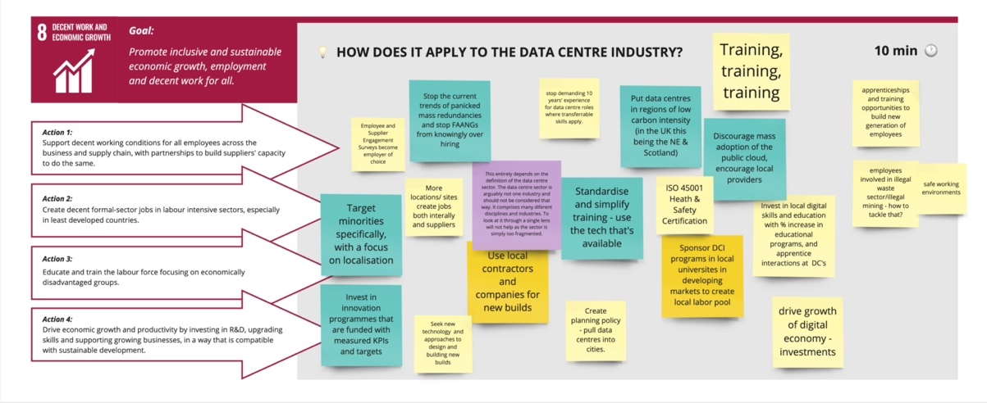
Figure 12 Brainstorming board on SDG 8.
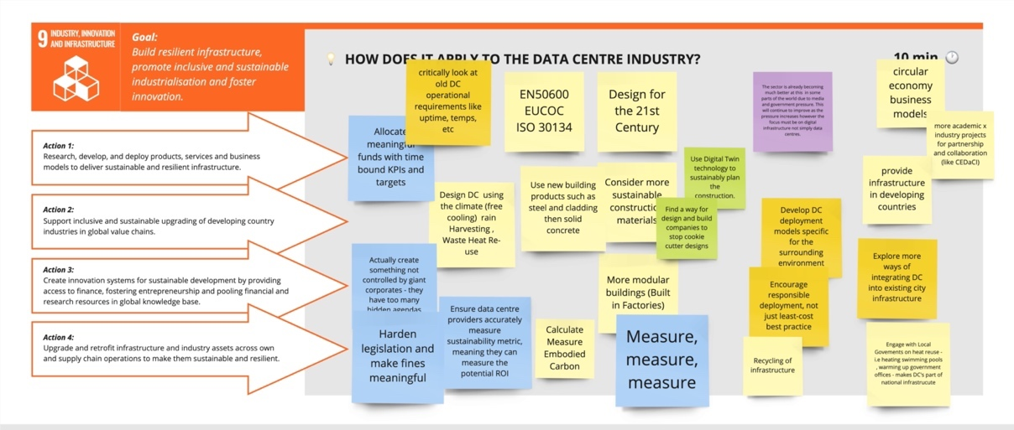
Figure 13 Brainstorming board on SDG 9.
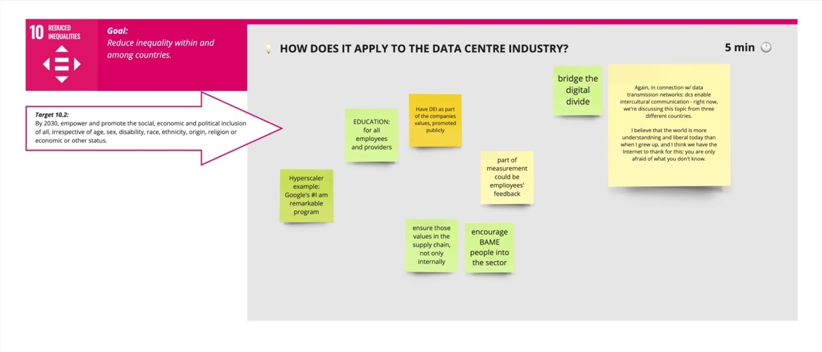
Figure 14 Brainstorming board on SDG 10.

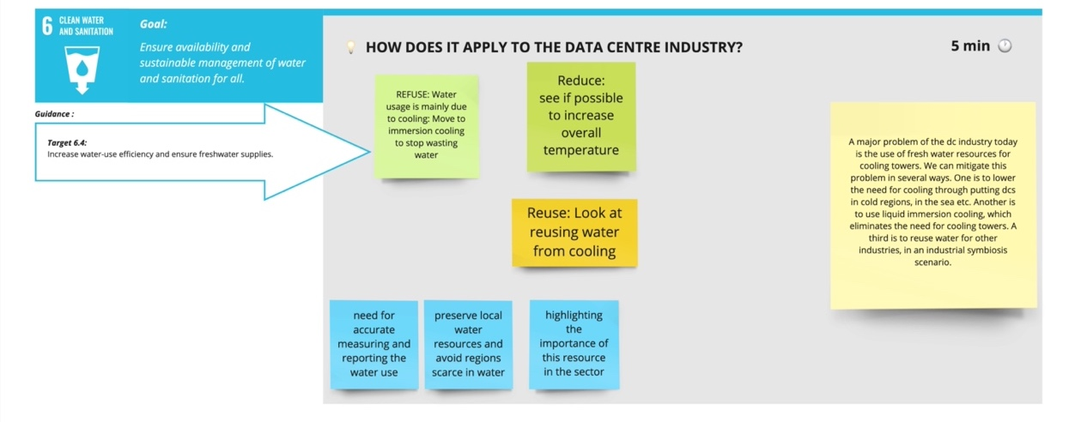
Figure 15 Brainstorming board on SDG 6.

The findings from both workshops were organised and rephrased into well-defined actions and organised in tables. The representative examples of insights for each SDG are listed in Table 11. A full list of 59 SDG action points is available in the Appendix.
Table 12 Example SDGs actions for DCI
UN SDGs | DCI Action
1. End poverty | Lack of data
2. Zero hunger | Lack of data
3. Good health and wellbeing | Ensure the wellbeing and good working conditions of employees involved in the supply chain are respected.
4. Quality education | Promote sustainability education amongst all data centre industry stakeholders, including suppliers and end-users.
5. Gender equality | Encourage and increase number of females in technical positions, rather than non-technical.
6. Clean water and sanitation | Advocate for accurate measuring and reporting of the water use in the sector and acknowledging the importance of this resource.
7. Affordable and clean energy | Lack of data
8. Decent work and economic growth | Increase visibility of the sector and promote it as a career of choice. Especially, encourage economically disadvantaged groups.
9. Industry, innovation and infrastructure | Consider upgrading and retrofit ting existing infrastructure, where possible.
10. Reduced inequalities | Incorporate Diversity, Equality and Inclusivity values into the business operations and supply chains and promote them publicly.
11. Sustainable cities and communities | Reuse heat and regeneration in rural and urban areas.
12. Sustainable consumption and production | Implement life cycle thinking and planning. Popularise Life Cycle Sustainability Assessments to bring attention to other impacts of infrastructure beyond carbon.
13. Climate action | Rethink offsetting claims, focus on reducing impacts first.
14. Life below water | Use Ocean thermal energy conversion (OTEC) and Seawater Air Conditioning (SWAC) for infrastructure cooling.
15. Life on land | Explore possible connections between waste heat reuse and commodity dehydration in agriculture.
16. Peace, justice and strong institutions | Lack of data
17. Partnership for the goals | Establish a knowledge base, help navigating and streamlining the resources and information.

Concept Proposal

After the previous stages – interviews and co-creation workshops – the insights were analysed and formulated into actions or suggestions for the data centre sectors, translating general SDGs for this unique context, as described in the section above. The final list consists of 40 actions with respective life cycle stages and interconnected SDGs; hence, the most efficient and versatile way to organise it was to create a simple data set using Excel. Creating a data set ensured the flexibility and longevity of the findings, allowing for future visualisations or further development, and ensuring that the data could be queried and filtered quickly.

Dataset structure

The dataset was structured to focus on the action level, which means each record represents 1 of 40 SDG actions. The dataset is comprised of four types of columns:
- Action – contains a brief description of SDG action, for instance: “Consider upgrading and retrofitting existing infrastructure, where possible”.
- Primary SDGs – a goal that the action is associated with (1 of 17 SDGs; missing data on SDGs 1, 2, 7 and 16), in this example: SDG 9. Industry, innovation and infrastructure.
- Life-cycle stage – life-cycle stage of a data centre, formulated as: 1) Site Selection and Acquisition; 2) Design and Planning; 3) Construction; 4) Equipment Procurement and Installation; 5) Operations and Maintenance; 6) Decommissioning and End-of-Life; 7) All.
- SDGs 1 through 17 – a series of 17 columns containing a binary value indicating whether the action described in this row can have an impact on this particular SDG (excluding the action’s primary SDG).
After creating the data set the following questions arose: How to make this dataset practical to the stakeholders? How could stakeholders access this information, and how to make it easy to navigate?
Subsequently, a simple filtering tool proposal was prepared, allowing users to look up the relevant information by choosing a specific SDG or life cycle stage. Excel was used again to build this basic filtering functionality with no coding skills required.

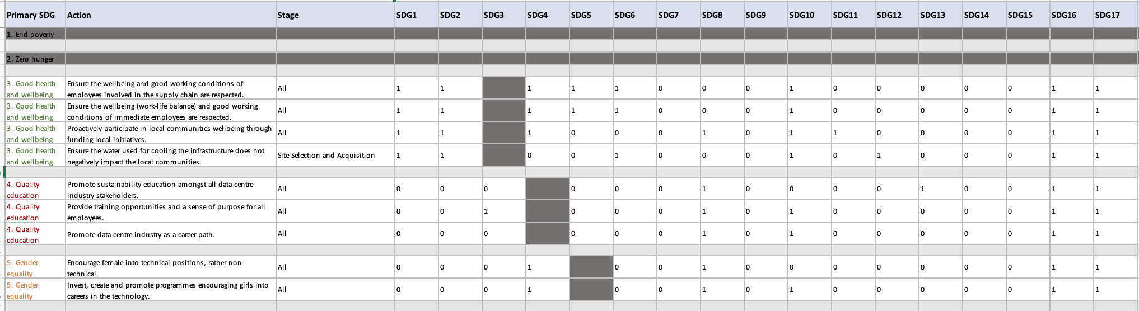
Figure 16 Snapshot of the dataset in Excel.
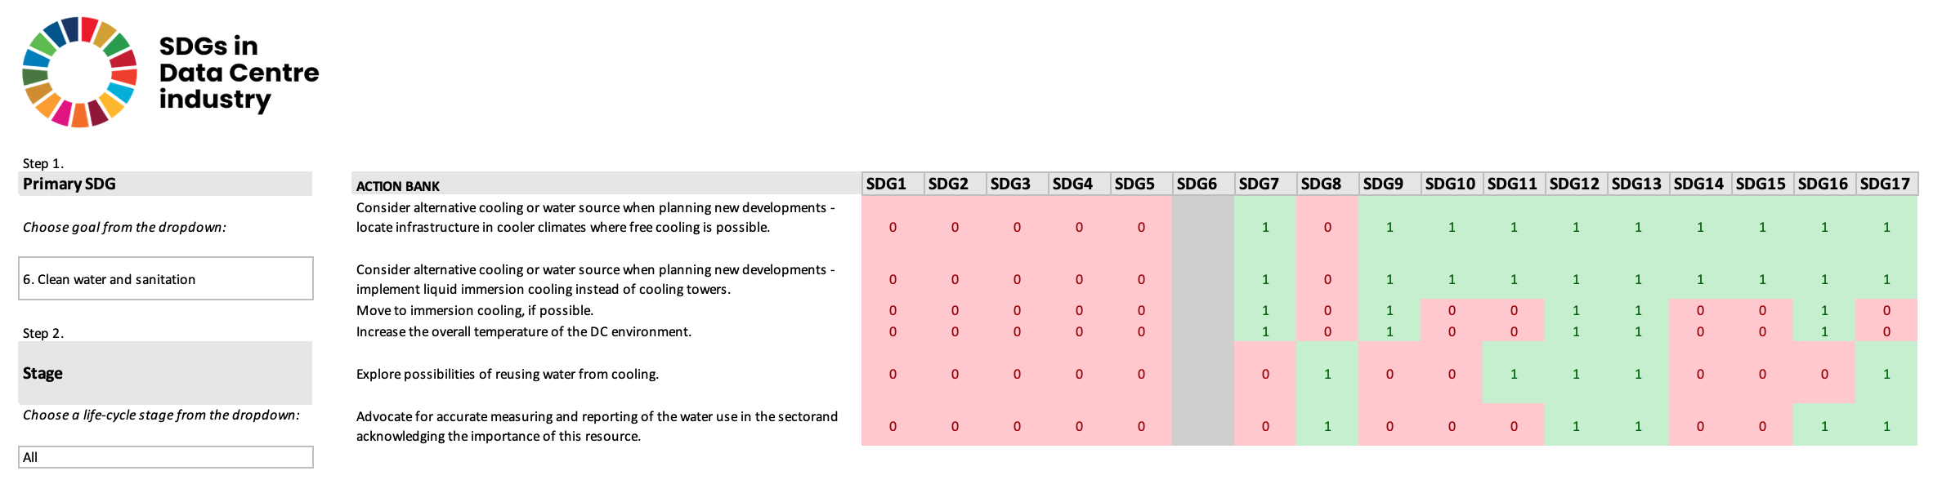
Figure 17 Snapshot of the Excel PoC (SDG 6).

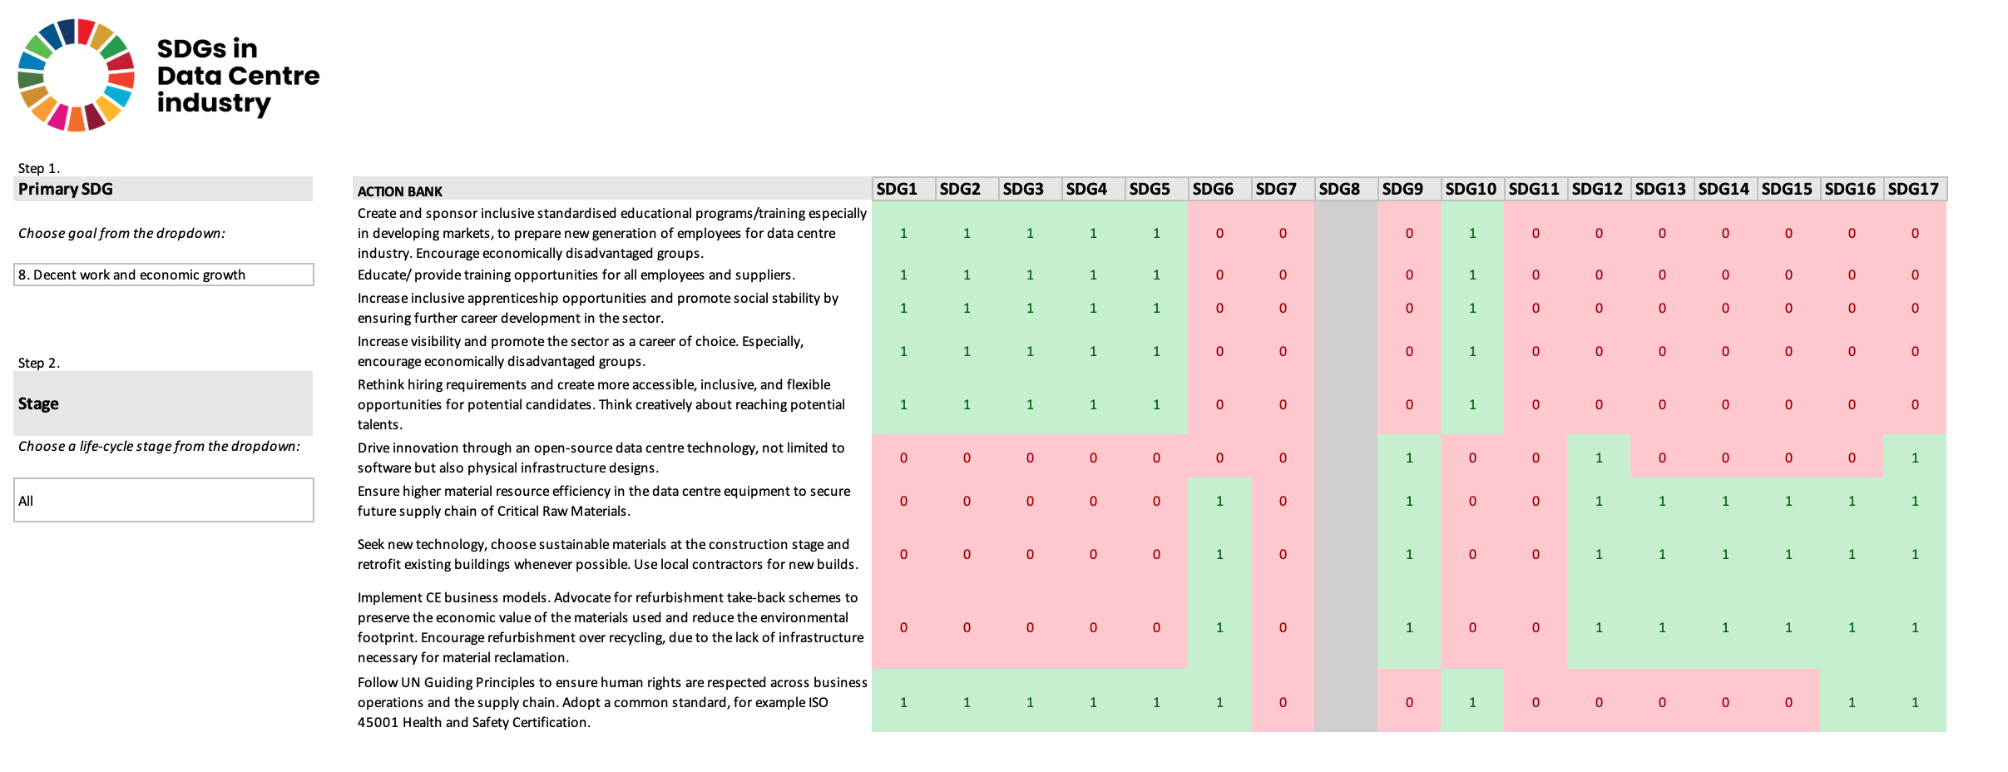
Figure 18 Snapshot of Excel PoC (SDG 8).

Excel Dashboard Proof-of-Concept (PoC)

A simple Proof-of-Concept (PoC) was developed to allow the user to understand better how the specific SDG can be understood in the context of the data centre industry. Users can choose an SDG and the data centre life-cycle stage to display what action can be taken to support this goal. Additionally, the dashboard showcases how actions are interconnected with other goals. In the example scenario, a stakeholder is interested to see what can be done in Operations and Maintenance on SDG 13: Climate Action. In this case, the user arrives at the dashboard and selects the criteria mentioned above. As a result, the dashboard shows the following suggested actions:
- Encourage businesses to measure and report data, even on a voluntary basis.
- Substantially reduce emissions associated with own and supply chain operations in alignment with climate science.
- Rethink offsetting claims and focus on reducing impacts first.
- Procure renewable energy if possible.
Furthermore, the user can see that each action has potential associations with other goals.

To build the PoC, different Excel formulas were explored with the support of Chat GPT. The primary idea was to use the Pivot tables or the VLOOKUP formula to build basic filtering functionality. Pivot tables are commonly used to analyse large amounts of complex data and allow for generating interactive dashboards. However, in this case, the data is non-numerical. Therefore, Pivot tables were unsuitable for getting the expected text-based results. Next, the VLOOKUP formula was employed to filter the rows of information. Yet, this formula only works for retrieving one row of data at a time, but one SDG can have multiple actions (rows) assigned to it. The formula looks for a defined value in the leftmost column of a table and returns a corresponding value from a specified column.
Upon the initial investigation, no predesigned Excel formula would return multiple rows of data for a given value. Consequently, ChatGPT was employed to research and experiment with the solution to achieve this functionality. To do so, ChatGPT was prompted to suggest an alternative formula to VLOOKUP that returns more than one row of data. The chatbot proposed combining INDEX and SMALL functions or IF, IFERROR, INDEX, SMALL, and ROW functions to retrieve data based on specific criteria. Further, it returned a formula that needed some modifications, such as adjusting the range of data, handling empty cells (when no data matched) or addressing issues with long text-based values. Lastly, ChatGPT was prompted to introduce the logic to handle the "All" option for one of the filtering criteria and to show an empty cell when no data records matched while maintaining all previous functionality.

Final Proposal - SDG in Data Centre Industry Action Bank

Lastly, an interface mock-up incorporating a simple branding identity following one of the UN SDGs was developed. The introduction of the mock-up in this research not only helped envision and communicate the concept to obtain feedback but also introduced a design element to the dissertation, thereby embracing an innovative approach to SDGs in alignment with the researcher's design background and methodology embedded in design principles.
The final proposal addressed key objectives described in the project criteria (see Chapter 6.1.1). An accessible web application format will allow users to access information from any device with an internet connection. The solution aims to have an educational and awareness-building purpose; hence, the convenient and universal format is essential. The interface is straightforward and intuitive, using basic web elements, such as prominent buttons and a standard navigation bar on the top of the screen. The results are organised in an uncomplicated table, and the contents are unambiguous and understandable. The wireframes were created using Figma (a prevalent web application for interface design), and functionality was built in Excel (as described in the previous chapter).

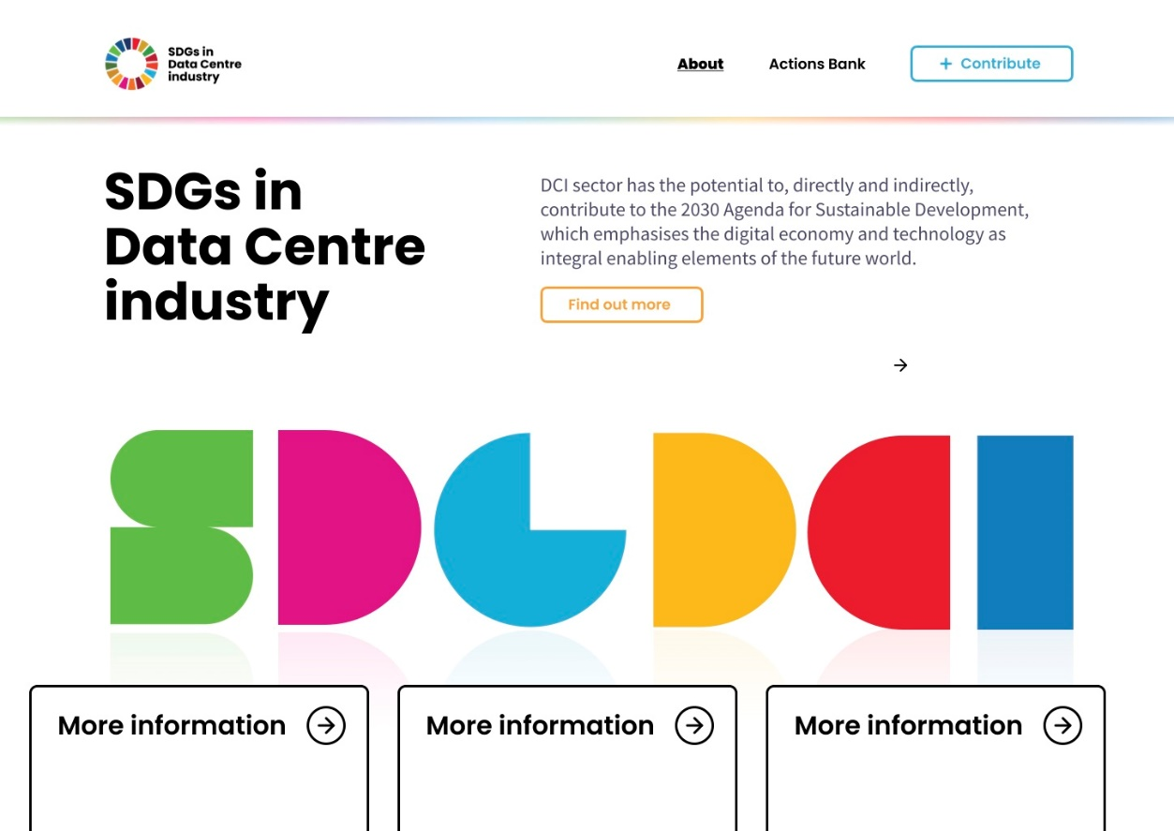
Figure 19 DCI Action Bank proposal (homepage).

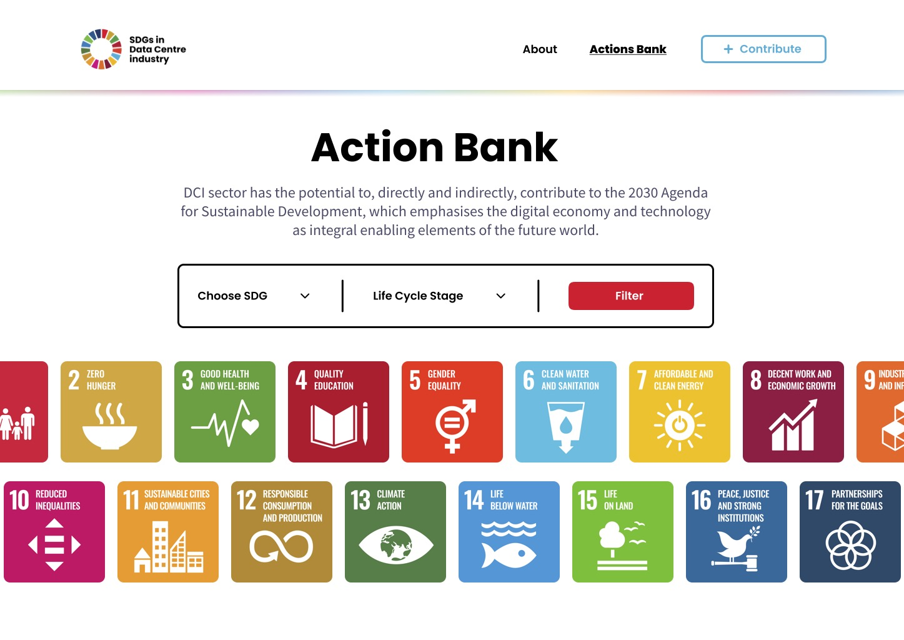
Figure 20 DCI Action Bank proposal (search).

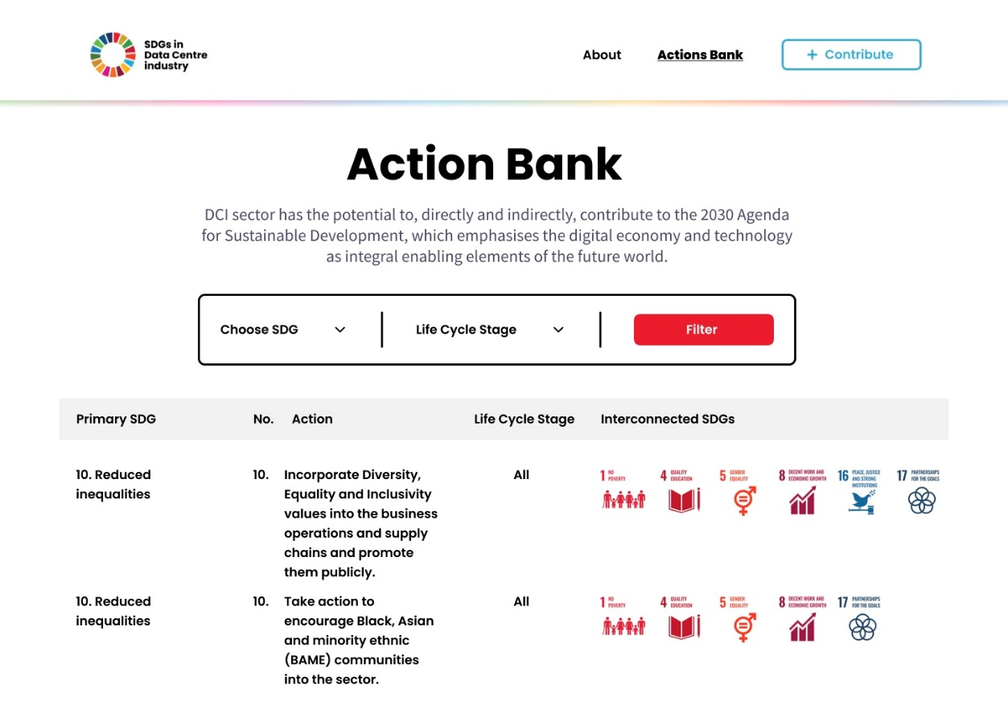
Figure 21 DCI Action Bank proposal (results).

Feedback and recommendations

As described previously, the feedback was collected from two experts. Firstly, a presentation explaining the research journey and the concept proposal was shown, followed by a brief critique and recommendations for the future development of the idea. The responses gathered insights around the following points:
- The first impression of the concept.
- Likes and dislikes about this idea.
- Possible improvements to the proposal.
- Other stakeholders who could find this concept useful.
- The value of the idea.
- Likelihood of recommending this idea to others.

The first critique came from a professional not involved in any of the earlier stages of the project and working in the regulatory environment. Their first impression of the research subject was that, in principle, it is a significant topic and solution, but it may not be successful in the real-life industry setting. The participant felt that the actions are too theoretical and not underpinned by empirical targets or standards and regulations, and the industry professionals' decision-making process heavily relies on numbers and embeds a reductionist approach. The participant suggested that further development should connect the actions with concrete standards and regulations and define more pragmatic targets, which can be understood considering the participant's regulatory background.
Such an approach was considered during the research process; however, this would require more subject-specific knowledge, and the involvement of more experts and the project's timeframe did not allow for exploration on another level. Further recommendations included investigating potential collaboration/integration with the Carbon Neutral Data Centre Pact initiative.
The second feedback session was much more detailed and provided more insights. One of the reasons for this may be the previous involvement of the participant in the co-creation stage and a sustainability background. The participant was impressed with the project's progress and was very supportive of the concept and overall approach adopted in the study. The participant had no dislikes about the proposal but agreed with other suggestions that further development should implement some correlation with certifications or regulations. Moreover, the interview suggested the solution could be a great source of knowledge for education or even journalists. In general, the solution would help people from outside the industry comprehend the overwhelmingly complex sustainability challenge. Additionally, the participant would happily recommend this solution to other industry professionals through their company knowledge hub.

Conclusion and future work

The overarching objective of this research study was to comprehend the data centre industry's all-round sustainability impacts and discover opportunities for improved SDG adoption in this sector. Several methods were employed to achieve various research objectives, including a whole-systems approach, life cycle thinking, and creative problem-solving.
Moreover, the study utilised the TBL definition and organised findings from various sources, namely academic literature as well as numerous white papers and reports. A significant result of the comprehensive literature review was its contribution to the Royal Society of Chemistry book. A broad range of sustainability impacts were identified throughout the data centre life cycle, from materials extraction through operations to electronic waste at the end-of-life, and sectoral and systemic challenges for the sector. Furthermore, the study reviewed chosen sustainability or ESG reports of major cloud providers, and current sustainability reporting requirements, to research how the industry's key players oversee the sustainability. The secondary research confirmed the need for an in-depth investigation to understand SDG adoption by the industry stakeholders. To direct the project forward, the following research questions were formulated:
1. How can DCI companies meet the SDGs?
2. Which SDGs are relevant to the data centre industry?
3. To whom would the proposed tool be directed?
Further, the study continued to strive to pinpoint relevant SDG goals and targets; understand how the businesses are acting on the SDGs currently; and help stakeholders act on Agenda 2030 in the future. This was primarily achieved through stakeholder interviews, which allowed for a thorough exploration of complex issues. The key learnings from the interviews underlined that sustainability and SDGs need more familiarity and understanding; the goals are perceived as ambiguous and constructed in a way that makes it hard for businesses to translate them to their needs and allow them to communicate their contributions. Also, the data centre industry is a unique and particularly secretive sector. The multiple subsectors work in silos and lack collaboration and understanding that sustainability is a team sport and joint responsibility - not limited to one actor or stakeholder.
The research focused on creating an educational tool for use by practitioners and industry stakeholders' ideas on SDGs were gathered through co-creation workshops. As a result, the "Data Centre Industry Action Bank" was proposed, which is a set of co-created, rephrased targets to educate and explain how to approach a vast 2030 framework of 17 goals and 169 targets.
To conclude, the research answered all the above questions by developing a unique and empirically underpinned proposal for a universal tool for DCI stakeholders. The tool includes examples of how the data centre industry stakeholders can comprehend specific SDGs by providing ideas on what action can be taken to support these goals. The study strived to identify that all goals are equally important. Primary-source data was collected through interviews, co-creation workshops and expert feedback, and the tool currently contains insights on 14 out of 17 SDGs.
This research is significant as it creates a new and robust academic understanding of this subject and fundamental knowledge for further research. Moreover, the proposed solution has educational value and endeavours to accelerate the industry's sustainability efforts and action on SDGs at a critical time when the achievement is off-track and lacks an innovative and practical approach.

Limitations and future work
Although the primary source data is a great strength of this research, the sample size was limited, due to challenges with participant recruitment and time constraints. Therefore, generalisability is restricted, and more research is required to represent all industry sub-sectors more comprehensively. Also, ideally, participants would represent all seniority levels. The research could also expand to other countries, outside of North-Western Europe, and offer global coverage. This however would be very resource-consuming and challenging to achieve through interviews – a global survey could be a potential pathway for this research. Also, the indivisible limitations of qualitative data analysis are researchers' subjectivity and, consequently - limited generalisability in analysing and interpreting the data. Hence, future research should introduce a more significant sample, which can be easier to achieve through an incorporating quantitative approach.
There were also challenges associated with co-creation workshops, which included difficulties with handling the group dynamics and timekeeping. In future research, the optimal group for such a workshop would be up to four participants, allowing for uninterrupted, productive and timely discussion. Also, the workshops would preferably take place in person, as not all participants were experienced in using digital whiteboards. A face-to-face session could provide more space and means for expressing thoughts and ideas more openly and intuitively, which would potentially lead to different results than online. Nevertheless, the digital workshop is a more convenient and accessible option, allowing participants to join from their location, without major disruption to their schedules.
Moreover, further feedback would be beneficial to identify additional improvements and considerations. As recorded, research needs to be expanded regarding measuring the SDG achievements and particularly matching proposed actions with KPIs, SBTs, standards, and other industry standards. This would allow to link actions with the current market best practice.
Additionally, the proposed new tool derived in this study only recorded connection to other SDGs, without specifying positive or negative correlation. There is an opportunity to explore this in the future and make the tool more influential. Lastly, the process and learnings from this research can be applied to other industries helping to support the 2030 Agenda and contribution to SDGs beyond the data centre industry.

Research outputs

Knowledge dissemination activities were planned and successfully delivered as part of this research to engage with other researchers and exchange knowledge on Sustainability and UN SDGs in the Data Centre industry—additionally, the undertaken activities aligned with the researcher's learning outcomes.
The most significant achievement in disseminating the research findings is a peer-reviewed publication in the Royal Society of Chemistry book, "The Circular Economy. Meeting Sustainable Development Goals." (2023), edited by Sadhan Kumar and Gev Eduljee. The literature review conducted as part of this research was contributed as the chapter titled: "Sustainable Development Goals, Circularity and the Data Centre Industry: A Review of Real-World Challenges in a Rapidly Expanding Sector.". The chapter organised state-of-the-art knowledge about the three dimensions of sustainability impacts of the data centre sector; current standards and initiatives; reporting and an analysis of publicly available recent sustainability reports (or equivalents) of major data centre providers. This contribution is significant for the academic community as it fills a gap in the availability of academic literature in this subject area.
Furthermore, the research has been disseminated at leading international conferences, namely:
A. The Nineteenth International Conference on Environmental, Cultural, Economic & Social Sustainability, 1-3 February 2023, Ljubljana, Slovenia. The researcher attended this conference online and delivered a video presentation titled "UN Sustainable Development Goals in the Data Centre Industry. Interviews with data centre experts."
B. The 2023 International Conference on Resource Sustainability (icRS 2023), 7-9 August 2023, Surrey, UK. A verbal presentation titled "Translating" UN Sustainable Development Goals for an All-round Data Centre Industry Green Transformation" was delivered at this event.
C. The 11th International Conference on Life Cycle Management 2023 (LCM2023), 6-8 September 2023, Lille, France. A presentation titled "Investigating Sector-Relevant SDGs and Opportunities for Increasing Sustainability Maturity of the Data Centre Industry According to the Triple Bottom Line" was presented in a themed session on innovative approaches to achieving SDGs

References

2021 Environmental Sustainability Report. From pledges to progress (2021). Available from: https://query.prod.cms.rt.microsoft.com/cms/api/am/binary/RE4RwfV
A New Circular Vision for Electronics Time for a Global Reboot (2019). Available from: www.weforum.org
Adams, B. and Luchsinger, G. (2015) Are FfD3 and Post-2015 striking the right public-private balance? Available from: www.globalpolicywatch.org [Accessed 18 March 2022].
Aggar, M., Banks, M., Bank, D., Dietrich, J., Shatten, B., Member, I., Stutz, M., Tong-Viet, D. E. and Page, I. (2012) Data Centre Life Cycle Assessment Guidelines. Available from: [Accessed 24 November 2021].
Andrae, A. S. G. and Edler, T. (2015) On Global Electricity Usage of Communication Technology: Trends to 2030, Challenges 2015, Vol. 6, Pages 117-157, 6 (1), pp. 117–157. DOI:10.3390/CHALLE6010117.
Andreassen, B. L. (2023) Scandinavian data centres: fewer jobs and less profit than forecast — Nordic Labour Journal. Available from: http://www.nordiclabourjournal.org/i-fokus/in-focus-2023/theme-nordic-infrastructure/article.2023-04-25.6991080087 [Accessed 10 March 2024].
Andrés, M., Agudelo, L., Jóhannsdóttir, L. and Davídsdóttir, B. (2019) A literature review of the history and evolution of corporate social responsibility, International Journal of Corporate Social Responsibility 2019 4:1, 4 (1), pp. 1–23. DOI:10.1186/S40991-018-0039-Y.
Andrews, D., Newton, E. J., Adibi, N., Chenadec, J. and Bienge, K. (2021) A circular economy for the data centre industry: Using design methods to address the challenge of whole system sustainability in a unique industrial sector, Sustainability (Switzerland), 13 (11). DOI:10.3390/SU13116319.
Andrews, D. and Whitehead, B. (2019) Data Centres in 2030: comparative case studies that illustrate the potential of Design for the Circular Economy as an enabler of Sustainability. Available from: https://openresearch.lsbu.ac.uk/download/714b4e76baebeea7c85bfc80323eb068211afaff3873c68ed9afe38728cdd271/170605/Andrews_SI%202019%20paper.pdf [Accessed 16 December 2022].
Arnold, R. D. and Wade, J. P. (2015) A Definition of Systems Thinking: A Systems Approach, Procedia Computer Science, 44, pp. 669–678. DOI:10.1016/j.procs.2015.03.050.
Ascierto, R. (2021) The people challenge: Global data center staffing forecast 2021-2025.
Ascierto, R. and Lawrence, A. (2020) Uptime Institute global data center survey 2020. Available from: [Accessed 20 December 2022].
Avgerinou, M., Bertoldi, P. and Castellazzi, L. (2017a) Trends in Data Centre Energy Consumption under the European Code of Conduct for Data Centre Energy Efficiency, Energies 2017, Vol. 10, Page 1470, 10 (10), pp. 1470. DOI:10.3390/EN10101470.
Avgerinou, M., Bertoldi, P. and Castellazzi, L. (2017b) Trends in Data Centre Energy Consumption under the European Code of Conduct for Data Centre Energy Efficiency, Energies 2017, Vol. 10, Page 1470, 10 (10), pp. 1470. DOI:10.3390/EN10101470.
Azapagic, A. and Perdan, S. (2000) Indicators of Sustainable Development for Industry: A General Framework, Process Safety and Environmental Protection, 78 (4), pp. 243–261. DOI:10.1205/095758200530763.
Banza Lubaba Nkulu, C., Casas, L., Haufroid, V., De Putter, T., Saenen, N. D., Kayembe-Kitenge, T., et al. (2018) Sustainability of artisanal mining of cobalt in DR Congo, Nature Sustainability, 1 (9), pp. 495. DOI:10.1038/S41893-018-0139-4.
Barbosa Júnior, I. de O., Macêdo, A. N. and Martins, V. W. B. (2023) Construction Industry and Its Contributions to Achieving the SDGs Proposed by the UN: An Analysis of Sustainable Practices, Buildings 2023, Vol. 13, Page 1168, 13 (5), pp. 1168. DOI:10.3390/BUILDINGS13051168.
Berning, S. C. (2019) The Role of Multinational Enterprises in Achieving Sustainable Development - The Case of Huawei, European Journal of Sustainable Development, 8 (3), pp. 194–194. DOI:10.14207/EJSD.2019.V8N3P194.
Cappella, N. (2021, September 10) The EN 50600: How to meet the European standard for data centres. Available from: https://www.techerati.com/features-hub/opinions/the-en-50600-how-to-meet-the-european-standard-for-data-centres/ [Accessed 20 December 2022].
Castor, J., Bacha, K. and Fuso Nerini, F. (2020) SDGs in action: A novel framework for assessing energy projects against the sustainable development goals, Energy Research and Social Science, 68. DOI:10.1016/j.erss.2020.101556.
Chen, J. (2022) Renewable Energy Certificate (REC): Definition, Types, Example. Available from: https://www.investopedia.com/terms/r/rec.asp [Accessed 16 December 2022].
Circular Economy for Data Centre Industry project - CEDaCI.org [no date]. Available from: https://www.cedaci.org/ [Accessed 20 December 2022].
Cloudscene [no date] Cloudscene Data Center Market Overview - United Kingdom, 2022. Available from: https://cloudscene.com/market/data-centers-in-united-kingdom/all [Accessed 15 December 2022].
Colocation Africa - Data Centres [no date]. Available from: https://www.datacentermap.com/africa/ [Accessed 20 December 2022].
Colt Data Centre Services (2021) 2021 Annual Sustainability Report Colt Group. Available from: https://www.colt.net/wp-content/uploads/2022/06/FE10687-ESG-Sustainability_11-1.pdf
Cook, G., Lee, J., Tsai, T., Kong, A., Deans, J., Johnson, B. and Jardim, E. (2017) Clicking Clean: Who is winning a race to build a green internet? . Available from: https://www.greenpeace.org/static/planet4-international-stateless/2017/01/35f0ac1a-clickclean2016-hires.pdf
Corbin, J. M. and Strauss, A. (1990) Grounded theory research: Procedures, canons, and evaluative criteria, Qualitative Sociology, 13 (1), pp. 3–21. DOI:10.1007/BF00988593.
Cutler, B., Fowers, S., Kramer Jeffrey and Peterson, E. (2017, February 21) Want an Energy-Efficient Data Center? Build It Underwater - IEEE Spectrum. Available from: https://spectrum.ieee.org/want-an-energyefficient-data-center-build-it-underwater [Accessed 16 December 2022].
Davis, J., Bizo, D., Lawrence, A., Rogers, O. and Smolaks, M. (2022) Uptime Institute Global Data Center Survey 2022.
Design Council (2023) Framework for Innovation - Design Council. Available from: https://www.designcouncil.org.uk/our-resources/framework-for-innovation/ [Accessed 18 October 2023].
Digital Realty (2021) Digital Realty’s annual Environmental, Social and Governance (ESG) Report. Available from: https://go2.digitalrealty.com/rs/087-YZJ-646/images/Report_Digital_Realty_2206__ESG_Report.pdf
Dominici, G. (2012) Editorial Note ‘Why Does Systems Thinking Matter?’, Business Systems Review. Available from: http://dx.medra.org/10.7350/BSR.A02.2012 [Accessed 8 October 2023].
Doyle, K. (2020, November 17) What are Critical Raw Materials? Available from: https://www.techbuyer.com/uk/blog/what-are-critical-raw-materials-crm [Accessed 19 December 2022].
Draper, S. (2018) Systems thinking: Unlocking the Sustainable Development Goals | Forum for the Future. Available from: https://www.forumforthefuture.org/blog/systems-thinking-unlocking-the-sustainable-development-goals [Accessed 27 September 2023].
Dyllick, T. and Muff, K. (2015) Clarifying the Meaning of Sustainable Business, Http://Dx.Doi.Org/10.1177/1086026615575176, 29 (2), pp. 156–174. DOI:10.1177/1086026615575176.
Elkington, J. and Rowlands, I. H. (1999) Cannibals with forks: the triple bottom line of 21st century business, Alternatives Journal (Waterloo), 25 (4), pp. 42–43. Available from: https://www.proquest.com/docview/218750101?pq-origsite=gscholar&fromopenview=true [Accessed 14 December 2022].
Equinix (2021) Sustainability Report FY2021. Available from: https://sustainability.equinix.com
Eurostat (2023) Glossary: Greenhouse gas (GHG) . Available from: https://ec.europa.eu/eurostat/statistics-explained/index.php?title=Glossary:Greenhouse_gas_(GHG) [Accessed 16 December 2022].
Fiona Brocklehurst (2021) International Review of Energy Efficiency in Data Centres Acknowledgements.
Flucker, S., Tozer, R. and Whitehead, B. (2018) Data centre sustainability – Beyond energy efficiency, Building Services Engineering Research and Technology, 39 (2), pp. 173–182. DOI:10.1177/0143624417753022/ASSET/IMAGES/LARGE/10.1177_0143624417753022-FIG2.JPEG.
Fryer, E. (2013a) Er, what IS a data centre? Intellect UK.
Fryer, E. (2013b) So what have data centres ever done for us? Intellect UK.
GLOBAL MERCURY ASSESSMENT 2018 (2018). Geneva.
Google (2018) Data Centres: Circular Economy - Google Sustainability - Once is Never Enough. Available from: https://sustainability.google/progress/projects/circular-economy/ [Accessed 18 January 2023].
Google (2022) Google Environmental Report 2022. Available from: https://www.gstatic.com/gumdrop/sustainability/google-2022-environmental-report.pdf
Google — BUSINESS FOR 2030 [no date]. Available from: http://www.businessfor2030.org/google [Accessed 23 December 2022].
GRI, United Nations Global Compact and WBCSD (2015) SDG Compass - The guide for business action on the SDGs. Available from: www.sdgcompass.org
Gro Harlem Brundtland (1987) Our Common Future.
Guidelines for SOCIAL LIFE CYCLE ASSESSMENT OF PRODUCTS AND ORGANIZATIONS 2020 (2020).
Gusmão Caiado, R. G., Leal Filho, W., Quelhas, O. L. G., Luiz de Mattos Nascimento, D. and Ávila, L. V. (2018) A literature-based review on potentials and constraints in the implementation of the sustainable development goals, Journal of Cleaner Production, 198, pp. 1276–1288. DOI:10.1016/J.JCLEPRO.2018.07.102.
Hák, T., Janousková, S. and Moldan, B. (2020) Sustainable Development Goals: A need for relevant indicators , Ecological Indicators, 60, pp. 565–573. DOI:0.1016/j.ecolind.2015.08.003.
Hamina, Finland – Data Centres – Google (2022). Available from: https://www.google.com/about/datacenters/locations/hamina/ [Accessed 19 December 2022].
Hancock, C. (2023, August 23) Thames Water Probes Data Centers’ Water Usage During UK Drought - Bloomberg. Available from: https://www.bloomberg.com/news/articles/2022-08-23/uk-utility-probes-data-centers-water-usage-during-drought [Accessed 19 December 2022].
Hoosain, M. S., Babu, P. S., Kass, S. and Ramakrishna, S. (2022) Tools Towards the Sustainability and Circularity of Data Centres. DOI:10.1007/s43615-022-00191-9.
Huawei (2018) Accelerating SDGs through ICT Digital Solutions Next Steps Recommendations for accelerating digitally enabled-sustainable development.
ICT Sector Guidance built on the GHG Protocol Product Life Cycle Accounting and Reporting Standard Chapter 1: Introduction and General Principles (2017). Available from: http://www.ghgprotocol.org/standards/product-standard
Interaction Design Foundation (2021) What is Co-Creation? | IxDF. Available from: https://www.interaction-design.org/literature/topics/co-creation [Accessed 8 October 2023].
Kamiya, G. (2022) Data Centres and Data Transmission Networks. Available from: https://www.iea.org/reports/data-centres-and-data-transmission-networks
Kamiya, G. and Kvarnström, O. (2019, December 20) Data centres and energy – from global headlines to local headaches? – Analysis - IEA. Available from: https://www.iea.org/commentaries/data-centres-and-energy-from-global-headlines-to-local-headaches [Accessed 19 December 2022].
Kemp, S. (2022) Digital 2022: Global Overview Report - DataReportal - Global Digital Insights. Available from: https://datareportal.com/reports/digital-2022-global-overview-report [Accessed 14 December 2022].
Kerwin, K., Andrews, D., Adibi, N., Whitehead, B., Szablewski, C. and Chenadec, J. (2022) Developing a Circular Economy for the Data Centre Industry-how the CEDaCI project contributes to sustainable decision making. DOI:10.1051/e3sconf/202234906007.
Koomey, J. G. (2011) Growth in Data Center Electricity Use 2005 to 2010. Available from: http://www.koomey.comhttp://www.analyticspress.com/datacenters.html
KPMG (2018) How to report on the SDGs. What good looks like and why it matters.
Labouze, E., Monier, V. and Puyou, J.-B. (2003) Study on External Environmental Effects Related to the Life Cycle of Products and Services - Final Report.
Laurent, A. and Dal Maso, M. (2020) Environmental sustainability of data centres: A need for a multi-impact and life cycle approach. Available from: https://c2e2.unepccc.org/kms_object/environmental-sustainability-of-data-centres-a-need-for-a-multi-impact-and-life-cycle-approach/
Lettieri, D. J. (2012) Expeditious Data Center Sustainability, Flow, and Temperature Modeling: Life-Cycle Exergy Consumption Combined with a Potential Flow Based, Rankine Vortex Superposed, Predictive Method - ProQuest. University of California, Berkeley. Available from : https://www.proquest.com/openview/b5823fb1424849865ad64c4e52772644/1?pq-origsite=gscholar&cbl=18750
Liu, R., Gailhofer, P., Gensch, C.-O., Köhler, A. and Wolff, F. (2019) Impacts of the digital transformation on the environment and sustainability. Berlin.
Longbottom, C. (2020) Retail colocation vs. wholesale data centers: How to choose | TechTarget. Available from: https://www.techtarget.com/searchdatacenter/tip/How-does-a-wholesale-data-center-differ-from-retail [Accessed 19 December 2022].
Mansell, P., Philbin, S. P. and Konstantinou, E. (2020) Delivering UN Sustainable Development Goals’ Impact on Infrastructure Projects: An Empirical Study of Senior Executives in the UK Construction Sector, Sustainability 2020, Vol. 12, Page 7998, 12 (19), pp. 7998. DOI:10.3390/SU12197998.
Masanet, E., Shehabi, A., Lei, N., Smith, S. and Koomey, J. (2020) Recalibrating global data center energy-use estimates, Science Magazine Article, 367 (6481). DOI:10.1007/s12053-019-09809-8.
Meadows, D. (1999) Leverage Points Places to Intervene in a System, The Sustainability Institute. Available from: [Accessed 27 September 2023].
Meta (2021) 2021 Sustainability Report. Available from: https://sustainability.fb.com/2021-sustainability-report/
Microsoft (2019) Microsoft and the United Nations Sustainable Development Goals 2021 Report . Available from: https://query.prod.cms.rt.microsoft.com/cms/api/am/binary/RWMGbt
Moss, S. (2022a, May 5) Luxembourg’s economy minister calls on Google to make decision about delayed $1bn data center - DCD. Available from: https://www.datacenterdynamics.com/en/news/luxembourgs-economy-minister-calls-on-google-to-make-decision-about-delayed-1bn-data-center/ [Accessed 16 December 2022].
Moss, S. (2022b, May 18) In search of the world’s largest data center - DCD. Available from: https://www.datacenterdynamics.com/en/analysis/in-search-of-the-worlds-largest-data-center/ [Accessed 16 December 2022].
Mytton, D. (2021a) Data centre water consumption, Npj Clean Water 2021 4:1, 4 (1), pp. 1–6. DOI:10.1038/s41545-021-00101-w.
Mytton, D. (2021b) Renewable energy for data centers: Renewable energy certificates, power purchase agreements and beyond.
Odumuyiwa, V., Adelopo, A. and Nubi, E. A. (2021) Circular economy in Africa: examples and opportunities.
Ptach, D. I., Andrews, D. and Philbin, S. P. (2023) Sustainable Development Goals, Circularity and the Data Centre Industry: a Review of Real-world Challenges in a Rapidly Expanding Sector, in: The Circular Economy: Meeting Sustainable Development Goals. Royal Society of Chemistry,51, pp. 252–285.
Ranganathan, J., Corbier, L., Schmitz, S. and Oren, K. (2015) GHG Protocol Initiative: A Corporate Accounting and Reporting Standard.
Ristic, B., Madani, K. and Makuch, Z. (2015) The Water Footprint of Data Centres, Sustainability 2015, Vol. 7, Pages 11260-11284, 7 (8), pp. 11260–11284. DOI:10.3390/SU70811260.
Rockström, J. and Sukhdev, P. (2016) The SDGs wedding cake - Stockholm Resilience Centre. Available from: https://www.stockholmresilience.org/research/research-news/2016-06-14-the-sdgs-wedding-cake.html [Accessed 27 September 2023].
Sachs, J. D. (2012) From Millennium Development Goals to Sustainable Development Goals, The Lancet, 379 (9832), pp. 2206–2211. DOI:10.1016/S0140-6736(12)60685-0.
Sachs, J. D., Schmidt-Traub, G., Mazzucato, M., Messner, D., Nakicenovic, N. and Rockström, J. (2019) Six Transformations to achieve the Sustainable Development Goals, Nature Sustainability, 2 (9), pp. 805–814. DOI:10.1038/s41893-019-0352-9.
Sandanayake, M., Ayassamy, P. and Pellerin, R. (2023) Social Life-Cycle Assessment in the Construction Industry: A Review of Characteristics, Limitations, and Challenges of S-LCA through Case Studies. DOI:10.3390/su151914569.
Saunders, M. N. (1997) ‘Research Methods for Business Students’ Chapter 4: Understanding research philosophy and approaches to theory development. Available from: www.pearson.com/uk [Accessed 10 March 2024].
Scheyvens, R., Banks, G. and Hughes, E. (2016) The Private Sector and the SDGs: The Need to Move Beyond ‘Business as Usual’, Sustainable Development, 24 (6), pp. 371–382. DOI:10.1002/SD.1623.
SDG Action Manager [no date]. Available from: https://app.bimpactassessment.net/get-started/partner/ungc [Accessed 20 December 2022].
SDG Compass – A Guide for Business Action to Advance the Sustainable Development Goals [no date]. Available from: https://sdgcompass.org/ [Accessed 20 December 2022].
SDG Impact Assessment Tool [no date]. Available from: https://sdgimpactassessmenttool.org/en-gb [Accessed 20 December 2022].
SDG Knowledge Hub (2023) UN Secretary-General’s Report Outlines Rescue Plan for People and Planet | News | SDG Knowledge Hub | IISD,
Shah, A. J., Chen, Y. and Bash, C. E. (2012) Sources of variability in data center lifecycle assessment, in: IEEE International Symposium on Sustainable Systems and Technology.
Shehabi, A., Smith, S., Sartor, D., Brown, R., Herrlin, M., Koomey, J., et al. (2016) United States Data Center Energy Usage Report. Available from: https://eta-publications.lbl.gov/sites/default/files/lbnl-1005775_v2.pdf
SMART 2020: Enabling the low carbon economy in the information age (2008). Available from: https://gesi.org/research/smart-2020-enabling-the-low-carbon-economy-in-the-information-age
Speight, J. G. (2020) Sources of water pollution, Natural Water Remediation, pp. 165–198. DOI:10.1016/B978-0-12-803810-9.00005-X.
Subramanian, K. and Yung, W. K. C. (2018) Modeling Social Life Cycle Assessment framework for an electronic screen product – A case study of an integrated desktop computer, Journal of Cleaner Production, 197, pp. 417–434. DOI:10.1016/J.JCLEPRO.2018.06.193.
SuperMicro (2018) Data Centres & The Environment: The State of Global Environmental Sustainability in Data Center Design . Available from: www.supermicro.com/WeKeepITGreen [Accessed 20 December 2022].
Support the Goals (2023) About Support The Goals. Available from: https://supportthegoals.org/about-us/# [Accessed 18 October 2023].
Sustainability Measurement Tool | SDG Monitor [no date]. Available from: https://www.sdgmonitor.co/ [Accessed 20 December 2022].
Swinhoe, D. (2022) Data Centre Dynamics - Re-use, refurb, recycle: Circular economy thinking and data center IT assets. Available from: https://www.datacenterdynamics.com/en/analysis/re-use-refurb-recycle-circular-economy-thinking-and-data-center-it-assets/ [Accessed 18 January 2023].
Taylor, P. (2022a) Number of data centers worldwide 2015-2021 - Statista. Available from: https://www.statista.com/statistics/500458/worldwide-datacenter-and-it-sites/ [Accessed 14 December 2022].
Taylor, P. (2022b, September 26) Data centers worldwide by country 2022 - Statista. Available from: https://www.statista.com/statistics/1228433/data-centers-worldwide-by-country/ [Accessed 16 December 2022].
Tech UK (2020) The UK Data Centre Sector. The most important industry you’ve never heard of.
The Earth Institute and Ericsson [no date] How Information and Communications Technology can Accelerate Action on the Sustainable Development Goals ICT & SDGs Final Report. Available from: [Accessed 14 March 2022].
The Green Grid [no date] The Green Grid Glossary . Available from: https://www.thegreengrid.org/en/resources/glossary [Accessed 14 December 2022].
Thibodeau, P. (2017) Data centers decline as users turn to rented servers - Computerworld. Available from: https://www.computerworld.com/article/3188885/data-centers-decline-as-users-turn-to-rented-servers.html [Accessed 14 December 2022].
Toms, S. (2019) Financial scandals: a historical overview. DOI:10.1080/00014788.2019.1610591.
United Nations (2015) Transforming our world: the 2030 Agenda for Sustainable Development.
United Nations Conference on Trade and Development (2019) Digital Economy Report 2019. Value Creation and Capture: Implications for Developing Countries.
United Nations Departament of Global Communications (2023) SUSTAINABLE DEVELOPMENT GOALS UNITED NATIONS DEPARTMENT OF GLOBAL COMMUNICATIONS GUIDELINES FOR THE USE OF THE SDG LOGO INCLUDING THE COLOUR WHEEL, AND 17 ICONS.
United Nations Global Compact [no date] SDG Blueprint | About the SDG Blueprint, 2018. Available from: https://blueprint.unglobalcompact.org/sdgs/about/ [Accessed 9 October 2023].
United Nations Global Compact and KPMG (2015) SDG INDUSTRY MATRIX.
Vallance, S., Perkins, H. C. and Dixon, J. E. (2011) What is social sustainability? A clarification of concepts. DOI:10.1016/j.geoforum.2011.01.002.
Virtus Data Centres (2021) Sustainability Report 2021. Available from: https://virtusdatacentres.com/images/sustainability/VIRTUS_Sustainability_Report_FY_2020_4.pdf
Weidema, B., Goedkoop, M. and Mieras, E. (2018) Making the SDGs relevant to business Existing knowledge on the linking of SDGs to business needs and the role of LCA in meeting the needs and filling the gaps.
WeLOOP, B. (2020) A SITUATIONAL ANALYSIS OF A CIRCULAR ECONOMY IN THE DATA CENTRE INDUSTRY. Available from: https://www.weloop.org/wp-content/uploads/2021/09/2020_04_16_CEDaCI_situation_analysis_circular_economy_report_VF.pdf
Whitehead, B., Andrews, D., Shah, A. and Maidment, G. (2014) Assessing the environmental impact of data centres part 1: Background, energy use and metrics, Building and Environment, 82, pp. 151–159. DOI:10.1016/J.BUILDENV.2014.08.021.
Whitehead, B., Andrews, D., Shah, A. and Maidment, G. (2015) Assessing the environmental impact of data centres part 2: Building environmental assessment methods and life cycle assessment, Building and Environment, 93 (P2), pp. 395–405. DOI:10.1016/J.BUILDENV.2014.08.015.
Yasar, K., Loshin, P. and Lutkevich, B. (2022) What is a Data Center? Definition from TechTarget.com. Available from: https://www.techtarget.com/searchdatacenter/definition/data-center [Accessed 14 December 2022].

Appendix

Project timeline

Stage | Timeframe
Project Planning | 2 weeks | October 2021
Identify Research Topics | 1 week
Formulate Research Questions | November 2021 – April 2022
Prepare Literature Review
Finalise Research Question
Define Methodology | April 2022
Ethics submission and Approval
Information Collection/ Design Development | May – December 2022
Analysis and Reflection | January – February 2023
Synthesis and Evaluation
Writing Up | March – August 2023
Proof Reading and Thesis Completion
Submission | October 2023
Viva Voce | Autumn 2023

Review of the available tools – Competitive analysis

SDG Tool | Audience | Type | Strengths | Weaknesses |  | Cost | Scoring | Reporting
Business Call to Action Impact Lab | General | Web application | - Educational modules  - Structured, easy to follow approach to building strategy |  |  | Free (Membership required for full access) | No | No
ESPON’s SDGs benchmarking tool | Regional Governments | Web applications | - Source of inspiration  - Linked to recognised frameworks and initiatives |  |  | Free | Yes (linked to metrics) | No
SDG Acceleration Toolkit | General | Directory | - List of tools or metrics for specific SDGs |  |  | Free | No | No
SDG Action Manager | General | Web application | - A comprehensive set of questions tailored to the specific sectors  - Simple to interact with | - Proposes only a few goals (2-3) tailored to the business after a quiz (baseline profile)  - No trade-offs considered |  | Free | Yes | No
SDG Compass | General | Directory | - List of tools or metrics for specific SDGs  - Linked to GRI standards |  |  | Free | No | No
SDG Impact Assessment Tool | General | Web application | - Considers trade-offs through letting users decide direct or indirect positives and negatives | - For knowledgeable users |  | Free | No | No
SDG Monitor | General | Web application | - Data visualisation  - Allows for setting up short and long term goals  - Linked to frameworks and standards  - Advanced functionality |  |  | Free | Yes | No
SDG Project Assessment Tool | Urban projects | Web application | - Focused on 54 sustainability principles specific to urban projects |  |  | Free | No | No
SDG Synergies | General | Web application | - Analysing synergies and trade-offs  - Highly collaborative |  | - For knowledgeable users | Free | Yes | No
SDG Tool | Biodiversity and Conservation | Web application | - Shows specific targets, not only SDGs  - Questionnaire-based |  | - No trade-offs considered | Free | No | No
Support the Goals | General | Scoring metric | - Raising awareness of the SDGs in the business community  - Structured approach to planning, target setting, and reporting with respect to the SDGs  - Employs young volunteers to provide experience in corporate sustainability |  | - Research analysis based on the business website and publicly available information  - No trade-offs considered | Free | Yes | No

Full list of action points for DCI

1. End poverty | Lack of data
2. Zero hunger | Lack of data
3. Good health and wellbeing | Ensure the wellbeing and good working conditions of employees involved in the supply chain are respected.
3. Good health and wellbeing | Ensure the wellbeing (work-life balance) and good working conditions of immediate employees are respected.
3. Good health and wellbeing | Proactively participate in local communities wellbeing through funding local initiatives.
3. Good health and wellbeing | Ensure the water used for cooling the infrastructure does not negatively impact the local communities.
4. Quality education | Promote sustainability education amongst all data centre industry stakeholders, including suppliers and end-users.
4. Quality education | Provide training opportunities and a sense of purpose for all employees.
4. Quality education | Promote data centre industry as a career path and introduce special training programmes.
5. Gender equality | Encourage and increase number of females in technical positions, rather than non-technical.
5. Gender equality | Invest, create and promote programmes encouraging girls into careers in the technology.
6. Clean water and sanitation | Consider alternative cooling or water source when planning new developments. For example:  cooler climates, where free cooling is possible,  liquid immersion cooling instead of cooling towers,  reuse water from other industrial sources.
6. Clean water and sanitation | Adopt immersion cooling by retrofitting the existing infrastructure, if possible.
6. Clean water and sanitation | Increase the overall temperature of the DC environment.
6. Clean water and sanitation | Explore possibilities of reusing water from cooling.
6. Clean water and sanitation | Advocate for accurate measuring and reporting of the water use in the sector and acknowledging the importance of this resource.
7. Affordable and clean energy | Lack of data
8. Decent work and economic growth | Create and sponsor inclusive standardised educational programs/training especially in developing markets, to prepare new generation of employees for data centre industry. Encourage economically disadvantaged groups.
8. Decent work and economic growth | Educate/ provide training opportunities for all employees and suppliers.
8. Decent work and economic growth | Increase inclusive apprenticeship opportunities and promote social stability by ensuring further career development in the sector.
8. Decent work and economic growth | Increase visibility of the sector and promote it as a career of choice. Especially, encourage economically disadvantaged groups.
8. Decent work and economic growth | Rethink hiring requirements and create more accessible, inclusive, and flexible opportunities for potential candidates. Think creatively about reaching potential talents.
8. Decent work and economic growth | Drive innovation through an open-source data centre technology, not limited to software but also physical infrastructure designs.
8. Decent work and economic growth | Ensure higher material resource efficiency in the data centre equipment to secure future supply chain of Critical Raw Materials.
8. Decent work and economic growth | Seek new technology, choose sustainable materials at the construction stage and retrofit existing buildings whenever possible. Use local contractors for new builds.
8. Decent work and economic growth | Implement CE business models.
8. Decent work and economic growth | Advocate for refurbishment take-back schemes to preserve the economic value of the materials used and reduce the environmental footprint. Encourage refurbishment over recycling, due to the lack of infrastructure necessary for material reclamation.
8. Decent work and economic growth | Follow UN Guiding Principles to ensure human rights are respected across business operations and the supply chain. Adopt a common standard, for example ISO 45001 Health and Safety Certification.
9. Industry, innovation and infrastructure | Introduce more innovative data centre designs. Update and adapt design practices for the current and future challenges.
9. Industry, innovation and infrastructure | Introduce sustainable construction materials and practices for new builds. Employ technology for more sustainable planning, e.g. Digital Twin.
9. Industry, innovation and infrastructure | Consider upgrading and retrofit ting existing infrastructure, where possible.
9. Industry, innovation and infrastructure | Plan accordingly to local needs, resources, climate and environment.
9. Industry, innovation and infrastructure | Explore integrating data centres in the existing infrastructures.
10. Reduced inequalities | Incorporate Diversity, Equality and Inclusivity values into the business operations and supply chains and promote them publicly.
10. Reduced inequalities | Take action to encourage Black, Asian and minority ethnic (BAME) communities into the sector.
10. Reduced inequalities | Create and promote programmes to empower underrepresented groups, such as #I am remarkable programme by Google.
11. Sustainable cities and communities | Retrofit existing building when possible.
11. Sustainable cities and communities | Protect local communities access to resources.
11. Sustainable cities and communities | Create integrated planning strategy for smart cities.
11. Sustainable cities and communities | Reuse heat and regeneration in rural and urban areas.
12. Sustainable consumption and production | Encourage sharing economy models - XaaS - Anything as a service, for example for hardware procurement - hardware as a service (HaaS), or infrastructure as a service (IaaS).
12. Sustainable consumption and production | Think outside of linear, business-as-usual models. Implement circular economy business model for sustainable consumption of hardware and buildings.
12. Sustainable consumption and production | Implement life cycle thinking and planning. Popularise Life Cycle Sustainability Assessments to bring attention to other impacts of infrastructure beyond carbon.
12. Sustainable consumption and production | Rethink zero-carbon claims to avoid greenwashing and inaccurate reporting.
12. Sustainable consumption and production | Educate stakeholders about the potential sustainability impacts and provide information to make informed business decisions.
12. Sustainable consumption and production | Choose refurbished equipment, when possible. Use recycling as a last option. Support secondary IT hardware and software market, resale and refurbishment.
12. Sustainable consumption and production | Increase the recovery of CRMs and materials in recycled equipment.
13. Climate action | Promote climate education and behaviour. Educate the end users.
13. Climate action | Take a holistic approach to the data centre infrastructure environmental impact.
13. Climate action | Adopt life cycle thinking and implement life cycle assessment methodologies to fully understand impact of a product or system on the environment, rather than only focusing on carbon.
13. Climate action | Encourage businesses to measure and report data even if it is on a voluntary basis.
13. Climate action | Rethink offsetting claims, focus on reducing impacts first.
13. Climate action | Procure renewable energy if possible.
14. Life below water | Use Ocean thermal energy conversion (OTEC) and Seawater Air Conditioning (SWAC) for infrastructure cooling.
15. Life on land | Preserve land and retrofit existing buildings for housing the infrastructure.
15. Life on land | Explore possible connections between waste heat reuse and commodity dehydration in agriculture.
15. Life on land | Moving to circular business models and recycling and reclamation of materials, to reduce reliance on new materials extraction and therefore protecting the land.
16. Peace, justice and strong institutions | Lack of data
17. Partnership for the goals | Increase collaboration. Create funded independent communities.
17. Partnership for the goals | Establish a knowledge base, help navigating and streamlining the resources and information.
17. Partnership for the goals | Promote standardisation and use of global standards.
17. Partnership for the goals | Educate all stakeholders and supply chain actors.
17. Partnership for the goals | Enter into partnerships and increase funding for a community initiatives created in support of UN Sustainable Development Goals.

Turnitin Receipt

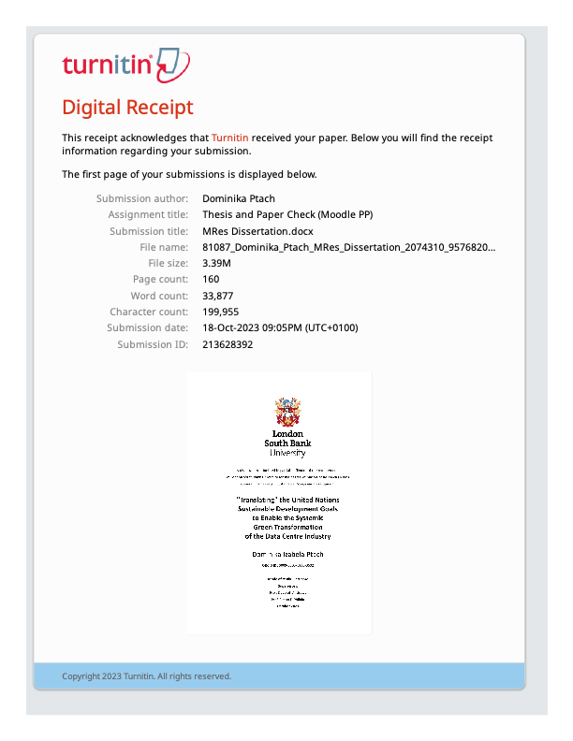

The CEDaCI Project is an Interreg Northwest Europe project aiming to introduce circular business models to improve material efficiency and secure the future supply chain of critical raw materials through increased collaboration and communication between DCI stakeholders.
GVA means value generated by any unit engaged in the production of goods and services.
SDGs are not disclosed in the sustainability report, but Google takes part in the Business for 2030 Initiative.
A special SDG report by Microsoft focuses on 4 goals, but states contribution to all 17.

