modelling of a magnetic adhesion Robot for NDT inspection of large metal structures
G. Shirkoohi and Z. Zhao
School of Engineering,
London South Bank University,
103 Borough Road, London SE1 0AA
United Kingdom
Non-destructive evaluation of structures such as ships and large oil tanks can be rapidly carried out using robots employing magnetic adhesion. This eliminates the need for the use of laborious suction systems, usually employed in climbing robots. However, since the operation of the robot is very much dependent on the speed at which the robot can move before the adhesion is lost, there is a need for determining limits at which magnetic force becomes ineffective. Finite element models and dynamic solution of magnetically supported robots have been presented in order to determine the speed limits at which they can operate.
Keywords: Magnetic adhesion, velocity modeling, eddy currents.

Introduction
Inspection of large structures is generally difficult, at times hazardous and usually requires stringent safety procedures. Wall climbing robots with various types of air suction systems can be employed to carry out critical inspection of large structures such as ships and large oil tanks. This would typically involve erecting large scaffolding arrangement for safe operation and recovery of the robots, should the robot adhesion system fail. One of the benefits of dealing with these types of structure is that they are, in most cases, made of ferromagnetic materials. Magnetic adhesion is frequently used for providing support in many designs of robots, utilised in applications where large metal structures are investigated for defects.¹⁻³ One of the main advantages is that, since the magnetic force is localised to the permanent magnets, if all else fails, the robot will remain stuck to the structure until it is recovered. This coupled with the fact that the very strong rare earth magnets such as NdFeB compounds, initially invented by Sagawa in 1982,⁴ and shown to hold great promise,⁵ have become inexpensive and available for such applications. The relative low cost and very high strength exhibited by these magnets have made them very attractive for applications in robotics. This paper investigates changes in the field distribution profile for a magnetic adhesion robot.
The attractive magnetic force impressed by the magnet blocks on the ferromagnetic structure can be assumed to be directly proportional to the magnetic flux distribution. The study shows that this is very much dependant on the speed at which the robot travels.
  - Construction of the Model

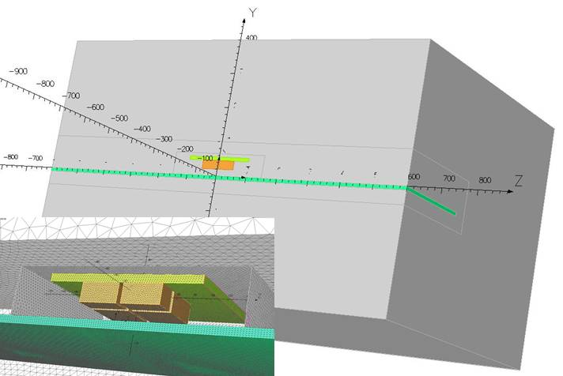
Figure 1.Geometry of the robot and the ferromagnetic wall, showing only half the geometry needs to be modelled. Fine mesh in the regions including the magnets is achieved by enclosing these in a small air box. Inset; fine mesh arrangement for the magnets.
Here a small robot designed with six blocks of NdBFe magnets is being investigated using a dynamic finite element electromagnetic solver. A unique velocity solver has been utilised, which was originally developed back in the 1980’s to support oil and gas pipeline inspection, to predict the effects of speed of the robot on the adhesion force. Figure 1 shows the geometry needed for solving the model with movement along the z-direction. The model was constructed using half of the geometry in the x-y volume since there is symmetry in the y-z plane. Normally, advantage would also be taken of the symmetry in the x-y plane, and practically only one quarter of the geometry needs to be modelled. However since velocity along the z-axis needs to be considered the latter could not be incorporated. Only the volumes with functional magnetic properties need to be in the model.
These include nine volumes for six magnets, one for high grade mild steel backing plate for concentrating the magnetic field of the magnets, one for the ferromagnetic wall of the structure to be investigated and one for the surrounding air. The model comprised of over eight million elements with close to ten million edges. The boundary condition of tangential magnetic was set on the y-z (symmetry) plane.

Results and Discussions

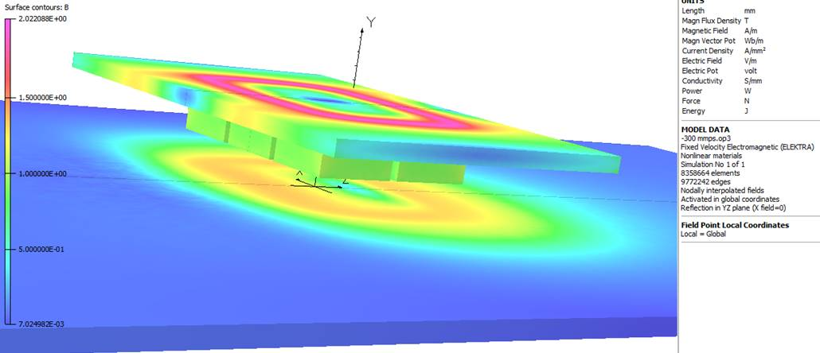
Figure 2. Profile of the flux density for the six magnets and steel backing plate, and the ferromagnetic wall of the structure being inspected.
Several solutions were obtained for different velocities ranging between zero and 834 mm/s (3.0 km/h) in steps of 100 mm/s, in order to observe variation of flux profile with the movement of the robot.
Figure 2 shows the flux density distribution in the six magnets and steel backing, as well as the ferromagnetic wall of the structure being inspected. This figure shows that due to the high energy associated with these rare earth magnets, localised flux saturation levels of around 2 Tesla is observed in the steel backing plate which holds the magnets.
Figure 3 shows the full geometry with all the six magnets attached to the soft magnetic backing plate of the robot and the field distribution in the ferromagnetic steel wall, representing the steel structure being investigated. Anisotropic NdFeB magnets were modelled in accordance with the second quadrant characteristics data provided by the manufacturers. The patch ribbon directly below the centre of the magnet assembly shows the flux pattern in the centre of the ferromagnetic mild steel wall, when the robot is stationary.
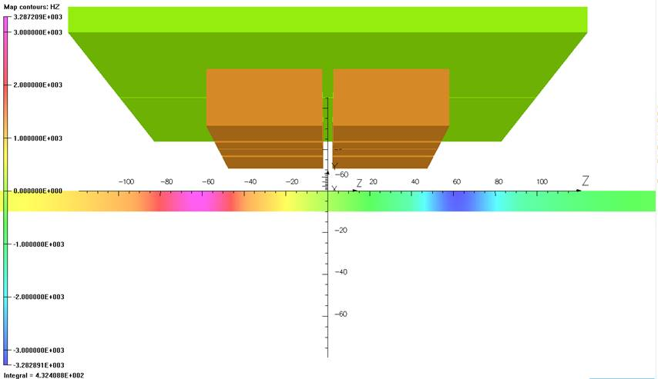

Figure 3. Magnetic field strength profile, along the direction of the movement of the robot (z-direction) inside the ferromagnetic wall, of the structure being inspected. At this instant the robot is stationary.
Figure 4 shows the field distribution in the same region below the centre of the magnets. The flux pattern in the centre of the ferromagnetic mild steel wall is clearly seen to be distorted compared with that of the stationary robot, as the robot moves from left to right at a speed of 300 mm/s (around 1.0 km/h). As well as the reduction of the magnetic adhesive force between the magnets and the ferromagnetic steel wall, due to the distortion of the magnetising field, some of the energy exhibited by the magnets is also expected to be dissipated in the steel wall, as eddy currents are built up, caused by the movement of the magnetic flux. This in turn would result in slight deceleration of the moving robot, requiring slightly larger driving force, in order to drive the robot at the desired speed.
In figures 3 and 4, presentation of the field and flux distribution has to be confined to the ferromagnetic wall only (shown in the rectangular patches below the magnets). This adjustment is necessary since the flux distribution in the magnets is very high this would and normally result in the comparatively lower flux levels in the steel wall to go unnoticed. For this reason, the magnets and the backing plate are presented in their designated material colours. Another point to note is that in practice the movement of the robot is assumed to be from left to right, however, in the model this is done by moving the wall plate from right to left, which effectively produces the same effect. In figure 4, the internal field in the z direction is seen to be subjected to a drag due to motion of the robot, compared to the same field profile shown in figure 3, when the robot is stationary, as would be expected. The deep red and deep blue areas (darker shades in grey scale) of flux profile in these figures show regions of high current density, where difference in colours imply opposite polarity. Inspection of flux patterns for different speeds show that as the speed increases, the localised field values in these regions increases. This indicates that eddy currents generated in the steel wall increases, again this is to be expected.
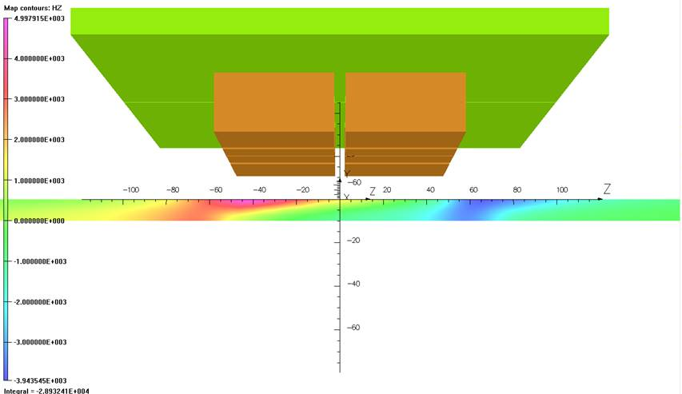
Figure 4. Magnetic field strength profile in z-direction, inside the ferromagnetic wall of the structure, with the travelling at 300 mm/s. Robot movement is from left to right.
Figure 5 shows the field distribution resulting from the magnet assembly in a cut plane blow the robot, when the robot is travelling at a speed of around 700 mm/s. Solutions for the model at various speeds show the shift in the magnetic field distribution and hence the adhesive force needed for keeping the robot attached to the structure. The results could provide the means for determining optimum speeds for safe operation of the robot which normally depends on the payload, usually consisting of NDT sensors and associated circuitry.
Figure 6 shows Field profile inside the ferromagnetic wall directly below the NdFeB magnet assembly, when stationary, and travelling at various speeds from 100 to 800 mm/s (0.3 to 2.9 km/h). The patches shown here are at exactly same position with respect to the magnets similar to those shown in figures 3. Speeds at which the field plots are associated are indicated on the left hand side of each plot.
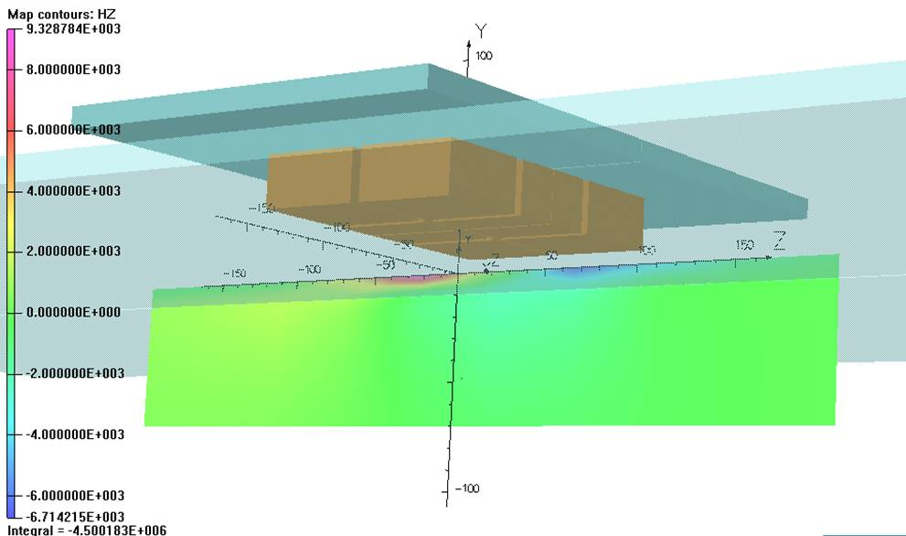
Figure 5. Field profile inside the ferromagnetic wall directly below and at the centre of the NdFeB magnet assembly, travelling at a speed of around 700 mm/s. The continuous wall is shown as a transparent block stretching out blow the robot.
When the robot is stationary the field distribution across the thickness of the wall is seen to be uniform. At low speeds (see figure 6), the field uniformity is maintained, as seen in the profile for 100 mm/s, and to some extent at 200 mm/s. however, at speeds greater than 400 and 500 mm/s, fields attenuate across the thickness. Field levels drop on the outer surface of the ferrous structure. High fields are seen to migrate towards the upper surface which is closer to the magnets. This is coupled with higher localised flux values, resulting in concentrated and more intense formation of eddy currents.
Maintaining the adhesion for the robot to the ferromagnetic structure whilst moving at desired speed would also need to take into account mass of the payload which could be as much as 25 kg for a robotic arm with 7 DOF. One of the key features of such a fast moving robot is the agility with which it can be deployed. During inspection the robot would usually be expected to move at a reasonable speed so that measurements could be carried out through sensors which normally require time for transmission and detection of signals, depending on the type of sensor employed. However, if spot-checks are required at some distance from each other, then the robot needs to move at high speed to different locations in order to minimise overall evaluation time.
Figure 7 shows the steep and shallow profiles of stern segment of the hull of a container ship and the magnetic adhesion robot that needs to negotiate them during the inspection process.⁶
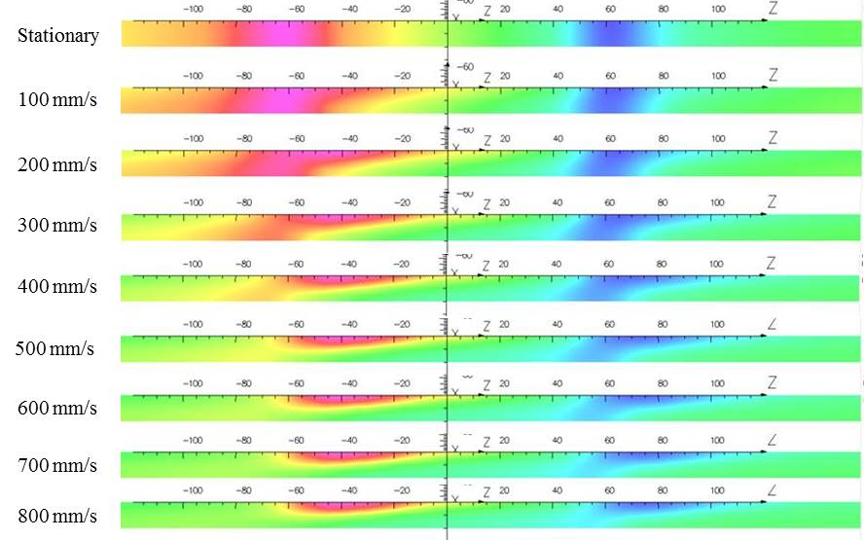
Figure 6. Field profile inside the ferromagnetic wall directly below and at the centre of the NdFeB magnet assembly, when stationary, and travelling at speeds of 100 to 800 mm/s.

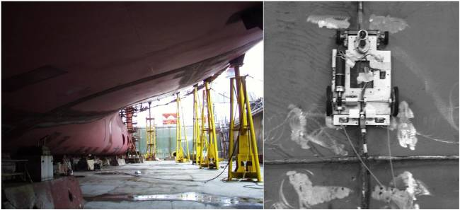
Figure 7. Steep and shallow profiles of stern segment of the hull of a container ship and a magnetic adhesion robot.⁶
Typically the hull is tens of meters high and tens of meters wide, with lengths of the orders of hundreds of meters. Inspection procedures would usually require erection of scaffolding and personnel operators climbing ladders and operating test systems at elevated heights and in adverse weather conditions. An optimised fast moving robot with strong magnetic adhesion can prove invaluable for such applications.
The flux patterns show that eddy currents are produced as a result of the movement of the robot. The magnetic fields produced by the high strength NdFeB magnets are large enough to produce significant flux signature in the ferromagnetic steel wall, which could be used for detection of defects using magnetic sensors. There would however be the problem of shielding the magnetic sensors from the large fields of the magnets in order to detect the secondary signals in the steel. Correlation of the speed of the robot and the expected eddy currents generated in the steel at the given speed could however, provide the desired detection strategy.

Conclusions
Models of a magnetically adhesive robot with six blocks of high strength NdFeB magnets is presented, where a combination of flux concentration and annihilation, and eddy current generation is shown to occur when the robot is on the move. Persistence of both these effects is seen to be enhanced by the rise in the speed of the robot. Although the robot is not expected to travel at very high speeds, the magnetic attraction force produced by the magnets and the overall weight of the robot which would include the payload would determine the maximum speed at which the robot could move.
References
- W. Shen, et al, Proc. IEEE, Int. Conf. Mech.s & Auto., 2078 (2005).
- M.F. Silva, et al, Journal of Robotics, ID 906545, 1-16 (2012).
- S. Hussain, et al, Int. Journ. Int. Sys. Tech. & App., (2012).
- M. Sagawa, Nd-Fe-B magnet-past, present and future, IEEE Intermag Europe Conference, 24-28 March 17, Dublin Ireland,YA-02 (2017).
- M.A. Rahman, et al., IEEE Transactions on Magnetics, Vol 21(5), pp. 1712-1716 (1985).
- B. Bridge, et al, IV International Workshop “Computational Problems of Electrical Engineering,” 171- 178, Zakopane, Poland (2002).

