Journal of British Studies
Trajectories of Aristocratic Wealth 1858-2018: Evidence From Probate
--Manuscript Draft--

Manuscript Number: | 6547R1
Full Title: | Trajectories of Aristocratic Wealth 1858-2018: Evidence From Probate
Article Type: | Original Manuscript
Corresponding Author: | Matthew Bond  London South Bank University  London, UNITED KINGDOM
Corresponding Author Secondary Information:
Corresponding Author's Institution: | London South Bank University
Corresponding Author's Secondary
Institution:
First Author: | Matthew Bond
First Author Secondary Information:
Order of Authors: | Matthew Bond
 | Morton Julien, PhD
Order of Authors Secondary Information:
Abstract: | In the past two decades the British hereditary aristocracy's decline, has received scant scholarly attention. The path and reasons for the reduction in their wealth, power and status were described in major historical works of the 1960s to the 1990s. They laid responsibility for the decline on features of the British aristocracy that are anachronistic in modern capitalist societies such as their landed, rentier status, conspicuously sumptuous lifestyles and disdain for commerce. This paper reappraises these arguments by examining the decline of the hereditary peerage’s wealth using a new dataset including all available probate grants for hereditary peers from 1858-2018. Wealth is adjusted for prices as well as for per capita wealth. The paper challenges established research by finding their absolute and relative mean wealth did not decline during the agricultural depression of the late 19th Century, and that serious decline only began after World War 2. Since the 1980s there are signs of resurgence with the value of peers’ grants reaching Victorian levels in real, but not relative terms.  Controlling for the age of a peerage we find decline in the inter war years was masked by new peerages created for wealthy businessmen. Differences in wealth between old and new peerages,however, disappeared over time. The findings suggest the aristocracy’s decline was due less to characteristics particular to it than to external fiscal and political forces, specifically, the impact of war on capital, and the tightening taxation regime allied to the broader post-war political and fiscal environment.
Powered by Editorial Manager® and ProduXion Manager® from Aries Systems Corporation

ManuscriptManuscript Click here to access/download;Manuscript;RevisClick here to download Manuscript Peerage Wealth.doced x
Trajectories of Aristocratic Wealth.docx

Trajectories of Aristocratic Wealth 1858-2018: Evidence From Probate

Abstract
In the past two decades the decline of the British aristocracy, and its apotheosis, the hereditary peerage, has received scant scholarly attention. The path and reasons for the reduction in their wealth, power and status were described in major historical works of the 1960s to the 1990s. These works laid much responsibility for the decline on features of the British aristocracy that are anachronistic in modern capitalist societies such as their landed, rentier status, conspicuously sumptuous lifestyles and disdain for commerce helped on by reductions in the value of agricultural land from the 1870s. This paper reappraises these arguments by examining the decline of the hereditary peerage’s wealth using a newly created dataset that includes all available probate grants for peers from 1858-2018. Wealth is adjusted for prices as well as for per capita wealth, real and relative inflation respectively. The paper challenges established research by finding that not only peers’ absolute but also relative mean wealth did not decline during the agricultural depression of the late 19th Century, and that serious decline only began and accelerated from World War 2. Since the 1980s there are signs of resurgence with the value of peers’ grants reaching Victorian levels in real, but not relative terms. The comprehensive character of the data as well as the distinction between real and relative wealth allows for multiple conceptual and analytic additions to the existing debates. When controlling for the age of a peerage we find decline in the inter war years was masked by new peerages created for wealthy businessmen who were much wealthier than the older, landed peers. Significantly, however, the differences in wealth between old and new peerages disappeared over time suggesting that dynastic family empires were difficult to maintain in the face of inheritance and wealth taxes and the shocks of war regardless of traditional landed status. Thus, the findings suggest that the wider aristocracy’s decline was due less to characteristics particular to it than to external fiscal and political forces, specifically, the impact of war on capital, and the tightening taxation regime allied to the broader post-war political and fiscal environment.

Introduction
Why study the British hereditary aristocracy? Although possessing some remaining noble privileges ranging from trivial titular rights to the more significant constitutional entitlement of membership of 92 peers in the House of Lords, they are popularly perceived as historic relics shorn of wealth, power and status, lacking even a coherent group identity. Academic writing on this group, which flourished during the 1960s to 1990s, include major works by FML Thompson, WD Rubinstein, ML Bush, JV Beckett, Peter Mandler, and, most prominently, David Cannadine.² The past three decades has seen few published articles on the British aristocracy and, with the exception of Wasson, no major monographs. This sudden termination following shortly after Cannadine, leaves the impression that the thesis embodied by these writers is the settled last word on the matter. Consequently, there seems little point devoting scholarly attention to a group whose decline has been well-charted by eminent historians, is of minor contemporary relevance and faces a perilous future.
We suggest, however, there are three reasons to continue studying the power, status and wealth of the British aristocracy since the nineteenth century. First, serious students of the aristocratic decline literature are faced by as yet unresolved views in regard to the trajectory of aristocratic wealth, the focus of this paper. For example, should they follow the tone of Cannadine in seeing a relentless decline in aristocratic fortunes which chimes with the strong note of decline on which Beckett finishes, or should they follow the broad position of FML Thompson and ML Bush who emphasise more aspects of persistence and resilience?
Certainly all sides accept that aristocratic decline began in earnest in the 1880s with the combination of a collapse in agricultural prices beginning in the 1870s along with the Reform Acts, followed by the dispersal of aristocratic landed holdings on which the aristocracy’s character, status and power rested, exacerbating anti-aristocratic changes in the wider culture and media. The two wars are treated ambivalently as a cultural opportunity for aristocratic leadership and sacrifice, and as specifically problematic for the aristocracy in the amount of human sacrifice they endured. Whereas sometimes the loss of landed wealth is seen as cause of the decline, sometimes it is the commitment to maintain landed holdings that is treated as a problem since they yield little wealth, are easy to tax, and are part of an anachronistic status culture which is incompatible with late-modern capitalism. Finally, taxation is often treated not as a primary cause, but as the final nail in the coffin – the ever-increasing taxation of estates especially through death duties from the 1890s onwards undermines the already weakened and demoralised aristocracy. Thompson, however, suggests that from 1880 to WWI the aristocracy made a series of canny adjustments to the pressures of industrial capitalism, but thereafter they struggle while Bush argues that the beneficial effects of policy driven “escape hatches” including the National Trust, funds for the maintaining of estates, tax reliefs offered by all governments as well as their “inclination to honour the affluent” along with the rise in the value of land see them persist as part of the plutocracy well beyond the middle of the twentieth century?
It is difficult to arbitrate between these positions because of the second difficulty and reason to revisit the aristocratic decline debate – the inconsistency of the data which generates imprecision of explanation on the one hand, and the capacity to see evidence supporting both a decline thesis and a persistence thesis at one and the same time. This comes about because it is not clear what are the proportions of those who prosper relative to those who do not, nor who does the prospering versus who does not, nor by how much, nor when this decline or prospering occurs. The student of decline is then left struggling to integrate minority counter examples into the broad tone of decline¹⁰ or persistence.¹¹

- See for example Cannadine’s suggestion that, after hundreds of pages detailing economic decline, an unstated proportion of the super-rich sustained themselves through the twentieth century via diversification, but that even these survivors could not be thought of as aristocrats (The Decline and Fall, p. 420) and were losing their identity in an “irreversible fragmentation” (ibid, p. 444). Or again, towards the end of the book, he repeats that “a small number of grandees remain quite extraordinarily rich” in the 1970s led by the top Dukes who still own considerable land (ibid, p. 657). But again, we have no idea of the number of peers this might refer to, let alone aristocrats more generally. For those that do not prosper there are examples of selling homes and estates, of some tenaciously holding on to unclear proportions of those estates, of decay but not of extinction, of an unstated proportion of the aristocracy becoming “indistinguishable from many other upper-middle-class professionals” (ibid, p. 658). And, finally, there is the uncertain group of nouveaux pauvres who have very little indeed (ibid, p. 660). Cannadine, four years later, settles on the notion of a fragmented aristocracy with the super-rich able to “survive unscathed from the nineteenth into the twentieth century”, in this case in relation to the question of debt, while the poorer sort do not (Aspects of Aristocracy. Penguin: London. 1994, p. 54). But even here, we do not know how far into the twentieth century this occurs, how rich you have to be to prosper, how many of the rich prosper, nor even what “not surviving unscathed” entails. We are left in a miasma of uncertainty that prevents us from getting to grips with the facts of who declines, by how much and when. Not only does this undermine confidence in causal explanations of the aristocracy as a whole and its component parts, but it also obscures the basic thesis about just who declined and by how much. But there is no doubt that the language and the vast majority of examples seen throughout the book, lean the reader towards an argument for significant consistent broad decline in wealth and power to a state of fallenness notwithstanding these rather impressionistic caveats.
Equally, if we turn to Beckett we see him state that “a great many families could not make ends meet” (The Aristocracy in England, p. 294) only to quickly state that many borrowed to invest (ibid, p. 298) and yet this debt often caused further hardship (ibid, p. 301) though few went bankrupt because of this (ibid, p. 303), and all again without any clear sense of proportions or degree of economic impact. We see that between 1917 and 1921 “one-quarter of the land of England must have changed hands” (ibid, p. 475) but then hard on the heels of this he states that in 1980 fifty percent of large landowners “still owned all or a substantial proportion of the core estate in the family’s possession a century earlier” (ibid, p. 476), and then in the next two pages he details the growth in sales based on financial difficulties sparked by the agricultural depression of the 1870s and exacerbated by everything from the People’s Budget of 1909 to the capital transfer tax of the 1970s. The general thrust is certainly one of decline, but amidst the welter of causes and exemptions it is difficult to fully grasp what is really going on.
- Consider that Thompson states that “the universality of the [late nineteenth century agricultural] depression and its severity have been much exaggerated in the past, and the period in fact emerges as a continuation” (English Landed Society, p. 309). But this follows closely on his argument that “Many landowners found that their agricultural incomes fell steeply in the fifteen or twenty years after 1878, sometimes by as much as half” while the cost of living did not (ibid, p. 303). The interjection of “Nevertheless” to offset the one against the other is a stylistic rather than analytic move. Or again, when we see him argue that by the 1920s there was a deeply undermining loss of aristocratic income from the ownership of land which yielded only 3% as compared to securities at 7-8%, and upon which rents were taxed as income, and in which a quarter of private land had changed hands, largely in the direction of tenant farmers such that many aristocrats sold their land (ibid, pp. 330ff) it is unclear to whom this is happening and by how much they are affected for good or ill. Indeed, he says that of their non-agricultural income we know very little “but their dividends presumably fell away after 1929” and that “mineral incomes also presumably suffered” (ibid, p338). Equally in his later articles on twentieth century persistence (‘English Landed Society in the Twentieth Century I Property’ 1990, ‘English Landed Society in the Twentieth Century’ 2007) there is alternating evidence and, again, the proportions, timings and characteristics of the super-rich, are left so unclear we are held back from developing conceptual and factual precision regarding this group and how far the persistence of the aristocracy really extends in time, community and degree.
Even Bush who is the most willing to argue for the persistence of aristocratic wealth, and perhaps most clear in his timings, suffers from this imprecision which clouds analysis. For example, following World War 1 “the English aristocracy did not become impoverished as a group. Many of its members, especially peers and baronets, remained part of the rich. Several families even preserved the traditional aristocratic way of life until the second world war when heavy taxation and the absence of servants delivered the coup de grâce” (The
A great deal of the power of the work on the British aristocracy and peerage is precisely in the great range of evidence and detail cited by each writer, which we can barely touch on here, but it is also what leads to confusion.
Thus, if we focus on the question of timings, the literature leaves us with several central questions. Was the greatest decline at the end of the 19th century or between the wars? Did the decline continue after World War 2 or even intensify? To what extent did the improvement in land values really affect the fortunes of the aristocracy, and for how long? How does aristocratic wealth today compare with its level between the wars or in the 19th century? ¹² Equally, if we focus on the composition of the aristocracy, of the many asides that are made regarding the resilience of the wealthier sort, we have little sense of what characteristics, how economically resilient and how prevalent this group is over what time frame.¹³ Many unanswered factual questions remain that can only be addressed by further research.
Our intention is to establish such facts, at least in terms of one comprehensive and consistent type of evidence, probate wealth, and then to evaluate and reconstruct existing accounts in light of this material.
Detailing the trends and timings of changes in aristocratic wealth more accurately through a consistent form of data is important because it will bring into focus more precisely the character and structures of this decline and persistence, and might also lend support to some mechanisms of decline postulated by the historians under consideration and contradict others. It will become possible, we suggest, to arbitrate between the role of capitalist globalisation, wealth taxation, the rise of plutocrats and the effect of war more effectively, though this will come at the cost of a loss of the historiographical richness upon which current scholarship largely stands. In simple terms, if the first reason to revisit the question of the British aristocracy is to establish some key facts and components of their decline

English Aristocracy, p. 153). But to whom he is referring is still vague enough that once again we are unable to define how far this persistence really extends in time, community and degree.
- It is certainly the case that some historians are explicit in their timings, at least in their broad statements and chapter headings. Thompson treats 1880-1914 as an “Indian Summer” and 1914-39 as a period of “Eclipse”. Bush, as we have seen asserts the persistence of some families up to World War 2 and collapse thereafter. But each seems to suggest even further persistence as well as earlier collapses blurring the timings that their overviews assert.
- See footnotes 10 and 11.
more securely, the second is to ask which factors appear to correlate with, and perhaps explain, the observed decline, and which do not, as well as to bring into focus different features of the aristocracy.
The third reason to revisit the debate is that the capacity to answer some of these questions has improved in that cognate disciplines have made significant progress in related topics such as the transition from oligarchic to democratic rule, the historical persistence of educational advantage, the evolution and concentration of capital, and the history of economic inequality. Concepts, analytic techniques and findings from these studies might be co-opted to improve historical understanding of aristocratic decline in Britain. In a nutshell, we can ask whether methods other than those used by most historians in their consideration of the aristocracy reveal new, more secure facts and explanations about its condition and character.
To address these issues we constructed a consistent empirical framework for measuring one key feature of aristocratic decline – their reduction in wealth. We did this using the most established means of identifying individual wealth – probate – on one key subgroup of the aristocracy, the hereditary peerage. We argue that although there has indeed been a decline in the wealth of the hereditary peerage, several adjustments need to be made to existing views of this decline. First, the precise degree and rate of that reduction has never been identified, nor has it been identified for different components of the peerage. We provide a clearer and more detailed account of this decline. Second, we show the timings of the decline are significantly different from most previous accounts, thereby indicating different primary reasons for it. Third, we may, in fact, be witnessing a resurgence in this wealth. Fourth, we find that older more status-grounded titles fare no better or worse than recently created or business-grounded titles. Fifth, we find that younger richer titles were not more resilient than less rich older titles. As a preliminary conclusion to further work, we take this to indicate that neither status nor sheer initial wealth is, at first glance, significantly related to the persistence of wealth, nor that the agricultural depression of the 1870s was as significant a factor in this decline as historians have suggested. Rather, we suggest that the peerage were, and remain, rational economic actors and it is external factors of concerted and committed taxation regimes and war that are the primary factors influencing aristocratic wealth.

Existing methods
Before outlining our empirical approach, we summarize the methods that one can extract from the tapestry Cannadine and others weave as something like:
- A complex and undoubtedly rich and extensive series of family focussed case studies, some superficial, some in detail and depth largely outlining declining wealth, as well as confidence, political influence, status and glamour.
- Some general data taken at second hand of say the number of deaths during World War 1, or the number of landless aristocrats, or broad data as to the character of the British economy. These are rarely presented in detail, used in a consistent way or presented as having a specific effect, let alone a time-identified quantifiable effect.
- Some rather impressionistic and idiosyncratic second-hand sources, such as newspaper articles, fiction, and commentary in letters by prominent figures. These sources are typically held to express the general attitude towards, or indeed facts about, the position of the aristocracy. Thus, we see examples of hostile editorials, journalistic commentary on land sales from the Estate Gazette, novels, speeches in parliament, open and private letters of complaint by aristocrats of their financial burdens, and so on.
- Various specific events or further case studies at a social or national level that are treated as part of the causal impact on the decline. For example, specific references to legislation or budgets.
This work’s persuasive power comes from the sheer weight of examples acting as confirming instances of a broadly coherent narrative yielding a powerful story of the decline and ultimate fall of the aristocracy, notwithstanding the persistence of the ill-defined super-rich, due to the globalised industrialisation of the economy, the growth of democracy and the end of the culture of deference that began with a vengeance in the 1880’s, a narrative that would have been very difficult to develop without these exploratory methods. But how sure can we be of the character and extent of this decline it if it is based on such a multitude of instances? And how sure can we be of the causes if there is no consistent and clear evidence of the timings of the putative cause and the decline? And how can we place the alternative evidence and associated thesis that some of the aristocracy were more resistant to this decline? These are almost entirely questions of evidence. We might here note Thomas Piketty’s significant incursion into the field of wealth analysis in his Capital when he notes that the central weakness of much writing on this topic is that, in such a highly contentious and politically charged arena, “Without precisely defined sources, methods, and concepts, it is possible to see everything and its opposite”. The solution in his own work is to establish consistent and comparable sources of data over the long term. Equally, WD Rubinstein finds that, when considering questions of wealth and elites, “it is regularly the case that an application of searching data to a commonly-received opinion reveals it to be unsustainable, often based on quite confused thinking and incorrect tacit assumptions, as well as upon quite inadequate evidence… and it is the massing of far-reaching evidence in a cogent way which alone makes useful generalization possible”. It is too easy to find evidence supporting any thesis you wish in a field as data rich and ideologically charged as wealth and power.

Hence our interest in probate. Although probate has its limitations which we discuss later in this paper, it allows for a more general and consistent measure of wealth than the necessarily varied and partial facts of exploratory historiography of the sort applied in this field, which, moreover, is susceptible to influence by outliers or the self-selecting samples of those very few families that left detailed records, accounts and diaries. Probate does not demand that we slowly build up a picture of wealth from a range of different sources many of which will make comparison and evaluation difficult. How secure can our evidence be if, for example, we use a newspaper report on the wealth of a specific peer, the letter of another peer complaining of their financial pressures, the sale of the family estate by another, and the opening to the public of an estate by yet another? A picture might emerge, but it will tend to imprecision and its generalizability will be suspect. Probate allows us to track shifts in the wealth of an entire cohort with consistency and precision allowing for comparison and generalizability. It is also more independent of the researcher who does not choose sources or interpret these to the same extent as, say, looking for letters that have been preserved in the public realm, or gaining access to the self-curated archives of a specific estate, or citing occasional newspaper commentaries on an individual’s wealth. Thus, probate makes it more possible to identify not only genuine trends in aristocratic wealth, but also to identify notable shifts in this wealth in order to take the first step to secure explanation – identifying correlations between those shifts in wealth and external events within identifiable time periods. Moreover, it allows us to drill down into the cohort to identify consistent differences within it – how do old versus new titles fare over time? What is the initial wealth of new titles at different periods? All of this will allow for the refinement of any thesis as regards the fortunes of a group, and the increased security of the causal explanations or mechanisms of those fortunes.
Having suggested the initial value of using probate as a measure of wealth, and before we look at debates as to its limitations, let us begin by laying out to what this analysis of probates can contribute: the arguments and evidence from the existing literature as regards the nature and causes of the decline in the wealth of the aristocracy.

Existing theses and evidence
The most famous and comprehensive analysis of the British aristocracy is no doubt Cannadine’s, whose argument is that despite being “in charge and on top in the 1870s” “the unmaking of the British upper classes … begins in the 1880s” and that by the 1930s their loss of land, wealth and prestige
“must rank as one of the most profound economic and psychological changes of the period”. Indeed, “In strictly economic terms, there can be no doubt that the British patricians were a failing and fragmenting class in the years from the late 1870s to the late 1930s”.
The tone of the book is clear: despite some ups and downs, there is a massive collapse in wealth, status and political influence in this period. What is the evidence, and with it the proposed causal mechanisms or significant contributing factors to this decline and fall? Cannadine and others argue that the development of global industrial capitalism and the rise of democracy were the underlying causes of their fall, these in turn generated four or five more proximate causes for decline in aristocratic wealth, none of which is given precedence thereby indicating that they are part of general series of problems for the British aristocracy that combine to bring them down:
- The vulnerability of land as a source of wealth and income- The development of modern capitalism threatened the aristocracy’s wealth in two ways. First, agriculture became a less central part of the economy with other assets offering increasingly greater returns than land. Second, economic globalisation created greater competition from abroad exerting downward pressure on agricultural prices, values and rentals. The British aristocracy’s dual role as a wealth elite and a landed elite became increasingly untenable. This vulnerability was most clearly manifested during the agricultural depression of the late 19th century and in the fall in agricultural prices after World War 1. Bush, Thompson and Cannadine argue that these pressures only really eased, and to some extent were reversed, after World War 2. But overall, the association with land ultimately had an impoverishing effect on the aristocracy.
- The emergence of a non-aristocratic plutocracy, - Throughout its history, the aristocracy, especially the peerage, has included many of the wealthiest individuals of their time. Cannadine argues that from the 1880s onwards new untitled, plutocratic wealth (often foreign) overshadowed the wealth of the aristocracy. The rise of new wealth dented the aristocracy’s relative position, leading to a loss of status. Note that unlike the vulnerability of land or confiscatory taxation, this does not necessarily imply impoverishment, it could even happen if the aristocracy were getting richer, but others were getting richer even faster.
- Loss of Influence and Confidence. At times most writers on the aristocracy will point out that there are plenty of aristocrats who continued to do economically very well, but that even so, with less land, less political influence (following the Reform Acts, the growth of the political working class, and concurrent hostile media) and less cultural cache, they lose their confidence and fray as a cohesive and active group. As Cannadine says on the heels of his description of the deterioration of the aristocracy’s economic position and the necessity to sell land, “the evidence is invariably impressionistic, but the message it conveys and the mood it expresses are both clear and unequivocal: confidence to anxiety, buoyancy to pessimism, expansiveness to retrenchment, and acquisitiveness to dispersal.”
- Taxation on land and wealth. Starting in 1894 with the introduction of death duties by Harcourt, the wealth of the aristocracy was adversely affected by increasing levels of taxation. Death duties rose to 15% in 1909 and to 60% in 1939 and peaking at 85% for estates valued over £750,000 before being replaced by the Capital Transfer Tax in 1975 and the Inheritance Tax in 1986 which saw a reduction in the amount of tax paid on estates. Other taxes affecting the aristocracy included the
Incremental Land Duty and the Undeveloped Land Duty. These taxes’ relevance is not just that they affected the aristocracy, the non-aristocratic rich were hit as well, but they struck particularly hard at land and dynasty, which were so important to the institution of hereditary aristocracy.
As well as these systematic, long term threats to aristocratic wealth the authors also note the effects of a fifth shock to aristocratic fortunes:
- War In most accounts of aristocratic decline the effects of the two world wars are noted. Authors highlight the disproportionate human losses incurred by the aristocracy in World War 1, but also privations incurred during World War 2 such as the billeting of troops in stately homes. It is unclear the exact effects that war had on aristocratic wealth. In historical accounts the loss of human capital is noted, but war is also seen as eroding deference and in prompting states to tax the wealthy in search of additional revenues. Economic discussions of the history of capital and inequality also stress the destructive effects war has on capital. This source of decline is not exclusive to the aristocracy and reminds us that historians may have been misguided in seeking explanations focused on factors particular to noble families rather than seeing them treading the same path as the rest of the rich in the twentieth century. In any case we would expect war to have an impoverishing effect and for wealth to decline more rapidly during and after war.
This paper does not directly test the effect of these mechanisms, but it does permit us to assess their credibility in a way previous discussion of decline could not. By charting the decline in wealth in a coherent and comprehensive manner, we can determine if the timings and trends are consistent with the mechanisms postulated above.

Probate and its limitations
As stated earlier, we use probate records to provide a framework to examine trends and changes in the wealth of the hereditary peerage. Our study begins in 1858 when comprehensive probate records across all dioceses and courts were first collated centrally which also pre-dates the onset of decline identified by most historians. These records are held at Somerset House in London, but have been entirely digitised to allow for remote access and searching by name and date of death. For records from 1996 more detailed searches are possible in terms of date of probate, and first names. These are now publicly available on the website https://probatesearch.service.gov.uk/.
Probate records, which show identifiable individuals’ wealth at death have been used by a range of historians and social scientists including Rubinstein, Nicholas, Rothery, Clark and Cummings, Owens et al., Green et al. and, in the Swedish context, Bengtsson et al. covering investigations in wealth from the early nineteenth century onwards.²⁹
While probates are, we suggest, the best generalisable measure of identifiable individuals’ wealth available, they have limitations. First, they only measure wealth at death and may not reflect the wealth an individual has owned in their lifetime. For example, individuals who die at an old age may have run down their wealth in retirement or withdrawn wealth to move it into more obscure personal

²⁹ WD Rubinstein Men of Property: The Very Wealthy in Britain Since the Industrial Revolution (New Brunswick
1981), Tom Nicholas ‘Clogs to Clogs in Three Generations? Explaining Entrepreneurial Performance in Britain Since 1850’ Journal of Economic History 59 (1999), Tom Nicholas ‘Businessmen and land ownership in the late nineteenth century‘ Economic History Review 52 (1999), Alastair Owens, David R. Green, Craig Bailey and Alison C. Kay ‘A measure of worth: probate valuations, personal wealth and indebtedness in England,1810–40’ Historical Research, vol. 79, no. 205 (2006), Mark Rothery ‘The Wealth of the English Landed Gentry 1870-1935’ Agricultural History Review (2007), David Green, Alastair Owens, Josephine Maltby and Janette Rutterford ‘Lives in the balance? Gender, age and assets in late-nineteenth-century England and Wales’ Continuty and Change 24 (2) (2009), Gregory Clark and Neil Cummins, ‘Intergenerational Wealth Mobility in England, 1858-2012’ The Economic Journal 125 (2014) and Erik Bengtsson, Anna Missiaia, Mats Olsson and Patrick Svensson, ‘Aristocratic Wealth and Inequality in a Changing Society: Sweden 1750-1900’ Scandinavian Journal of History 44 (2019).
avenues. Second, they do not include wealth held in trusts which is subject to different taxation regimes. Third, especially when death taxes are high, individuals can try to reduce the taxes on their estates through inter-vivo gifts. Fourth, there have been changes in the way probate grants have been calculated over time. According to English (1984) they only included gross valuations not inclusive of debt until 1881. Until 1898 they only included unsettled personal wealth, excluding realty of any sort; that is, they only include the personal wealth of the deceased over which there is no legal claim of control, and they do not include property and land of any sort. From 1898 onwards unsettled property was included, i.e. property which was in the total control of the deceased. In 1926 settled wealth and land was included, i.e. that on which there were legal constraints such as endowments, and this is shown separately from unsettled wealth and land in the probate grant. Following Rothery we exclude settled wealth and only include unsettled wealth in our analysis, i.e. only personal wealth including property that was in the absolute control of the deceased. We have made this choice because we are interested in the wealth that is under the control of the individual heir as opposed to settled wealth, which is tied up in legal constraints and is often used to provide income for family members. This does away with the problem of the later inclusion of settled wealth which we also exclude.
However, several historians such as Daunton (1989), as well as English (1984), Nicholls (1988), and Green et al. (2009) have insisted that probates do not reveal the composition of wealth and are unreliable if not supplemented by alternative sources such as death duty registers that exist up until 1903 and case studies. We certainly agree that probate is in some ways a blunt tool that does not reveal the composition of wealth, the character of any bequests, the specifics of any recipients, the expenditure of wealth over a lifetime, and that any sample skews to older age.

These limitations do not, we argue, present insuperable barriers to our aim of tracing the trajectories of aristocratic wealth over the past 160 years. Since we are not seeking to unpick in detail the wealth of individual families, or the internal financial mechanics of those families, or the destination of wealth beyond the primogeniture heir, we can accept most of the limitations detailed above.
Moreover, if there is consistent underreporting in probates this does not affect the analysis of trends to the extent to which pressures for underreporting are consistent across the period of our study. But what of limitations which are not consistent? Two of the sources of inconsistencies would seem to flatter the decline thesis: the inflated size of pre-1881 probates using gross as opposed to net values, and the increasing reliance on trusts and inter vivo gifts which accelerate in the twentieth century, especially from the 1920s (see Daunton (2002), see especially pages 137-8 and note 10 therein). So any counter trends would more strongly undermine the decline thesis. The third inconsistency: the inclusion of unsettled realty from 1898 would flatter the anti-decline thesis of this period, but observation of the data does not show an upward break at this point, rather our data show a consistent trend upwards without obvious change. Taking into account these biases, we consider the use of probates in measuring unsettled, entirely personal wealth across generations in a primogeniture system to be an effective tool in identifying generalities and trends.

There were 3219 hereditary peers who died between 1858 and 2018. We managed to locate grants for 2492 (77.4%). Grants were missing for several possible reasons. First, peers might have died destitute or without enough wealth to require probate. Second, peers may have emigrated, and their taxable property might be in a different jurisdiction. Third, some peers may have their wealth tied up in trusts which would not appear in their probates. The different sources of missing probates will have contrasting implications for our estimates of wealth. To the extent that peers are destitute or too poor to have a probate record it will inflate recorded mean wealth, while the extent to which they are hiding their wealth in trusts (and other means), it will deflate recorded mean wealth. It is impossible to know the balance of these two factors although it is more likely that hidden wealth will outweigh impoverishment because it will only take a few large, hidden fortunes to offset many destitute peers.

Inflation and its Implications
One of the great difficulties with the historical literature is a focus on sheer monetary values without considering the effects of inflation and the growth of Britain’s wealth. For example, Rubinstein’s focus on the number of half, full or multimillionaires over time suffers from this problem. Someone who is a half millionaire in the mid nineteenth century is probably much wealthier than someone who is a full millionaire in the mid twentieth century because of inflation. Even if there were no inflation, in a growing economy, a millionaire from the mid nineteenth century would have greater relative economic status than her counterpart in the mid twentieth century.
To capture these changes in the value of monetary wealth we make two different adjustments to convert historical values into 2018 pounds using the Measuring Worth website. The first adjustment for inflation is to multiply the probate grant by the percentage increase in the Retail Price Index between the year of death and 2018. The second adjustment shows what the probate grant would be in 2018 if its size relative to GDP per capita were the same at time of death. Each serves a different purpose when describing decline: if the RPI adjustment goes down it indicates impoverishment if the GDP per capita adjustment goes down it indicates only relative decline – it could easily be the case that the purchasing power of hereditary peers’ wealth remained unchanged from their predecessors while the wealth of the average person increased thereby generating relative decline.
This distinction will, as we shall see, allow for some conceptual refinement in thinking through the connection between status and wealth for the aristocracy. It also establishes, in the most general possible sense, a comparative context for aristocratic wealth since it evaluates the wealth of this group against the fluctuating wealth of the average individual. Thus, when we see the relative-adjusted wealth of the aristocracy rising in the late nineteenth century it means it is rising against the average growing wealth of the British citizen. Equally when we see it holding its own in the first part of the twentieth and twenty-first centuries, it means that the wealth is growing at the same rate as the averaged rest of the country. While still a broad brush finding this would be, nevertheless, an extraordinary and challenging result – to grow one’s intergenerational wealth at the same rate or faster than average per capita wealth in the era of growing democracy, industrialisation and declining land values sits starkly against the evidence and broad interpretations adduced by the historians outlined in this paper. Equally, for this apparently feudal status group, to maintain its relative wealth against the rising wealth of the country in the era of meritocratic late capitalism would merit further reflection and investigation.

Trends and Changes in the Hereditary Peerage’s Wealth
Real Wealth over Time
We start off by looking at real wealth (RPI adjusted) over time. Figure 1 below displays the change in probate grant values. The data points are 10-year averages beginning in 1858-1867 and ending in 2008-18.

Figure 1 about here

Perhaps the most surprising finding is the growth in average probate grants prior to the First World
War. Despite one dip from 1858-67 to 1868-1877 there is an unbroken rise. The peerage’s wealth appears untouched by the agricultural depression and far from suffering impoverishment, our evidence is consistent with their getting wealthier. Contrary to the claims of Cannadine, exposure to the forces of international capitalism did not economically damage, let alone immiserate the peerage, which is consistent with Rothery’s finding for the landed Gentry. What the causes might be for this increase are uncertain. If one accepts the impact of crashing land prices and rental returns presented by many
of the scholars treated here, then these findings support the notion that the peerage were successfully diversifying by selling off land and precious objects and investing the proceeds in non-agricultural sectors of the economy, or else were utilising their land through mining, transport, urbanisation and the like, in ways that generated new wealth. Either way, the strategies of the late nineteenth century aristocracy appear to be much more successful than has previously been suggested.
It is only in the inter war years that signs of decline become visible. This is the period of the great land sell-off which has been described as the biggest reorganisation of landownership since the Norman Invasion. Typically, historians have viewed the sell-off as a response to the pressures of a depressed agricultural economy and the burden of taxation. While there is evidence of decline as shown in the drop of average probate values from 1908-17 to 1918-27 there was a rebound in the 1928-37 cohort. Rather than decline, it is best considered a period of constancy. While the upward march of peerage wealth witnessed in the late 19th century was halted, the resiliency of that wealth is a surprise given that there was the triple shock of agricultural adversity, the aftermath of war and increasingly confiscatory levels of taxation. The Indian Summer that Thompson describes extends further, and the survival that Bush talks of in which “[s]everal families” could live like aristocrats until World War 2 (1984: 153) needs to be significantly expanded. Again, it may well be that the selloff and reinvestment or new utilisation of assets such as land had a bigger and wider impact than has previously been proposed.
It is during World War 2 and its aftermath that clear signs of decline become apparent. The 1938-47 cohort showed a large decline in its average probate, but unlike previous drops, there is no rebound and the mean plummeted until a minor increase in 1968-77 followed by a drop to the lowest value in our study 1978-87. Scholars of the post war aristocracy such as Cannadine and Mandler have talked about a revival in aristocratic wealth in the 50s to 70s as a result of increasing land values and their new role as guardians of the national heritage through their proprietorship of stately homes, but the magnitude of these positive effects was outweighed by downward pressures resulting in a sustained and steep decline in the hereditary peerage, and likely wider aristocratic wealth. What sort of downward pressures could these be?
First, there were the sustained assaults on wealth manifested in higher death duties for larger estates that began in 1914 at 20% before jumping in 1919 to 40%, 1930 to 50%, 1940 to 69% and 1950 to 80%. With a lag of 30 years to see the effect of death duties extracted from one generation to the next, this fits the graph rather well. If we add increasing top income tax to 60% in the 1930s and 80-90% in the 1940s onwards we would expect a short lag on the accrual of wealth, this too fits the graph rather well. Second, there was the destruction of capital associated with World War 2 which has been identified by Piketty as a factor reducing concentrated wealth in the second half of the twentieth century, though as stated the effects of World War 1 were short-lived. Whatever the explanation, it is only as late as the second world war and its aftermath that levels of decline postulated by some scholars to have occurred in earlier periods began. But it is worth noting that even at their lowest economic moment, 1978-1987 the average price-adjusted amount they left was the very considerable mean amount of over four million pounds.
The mean value of the peerage’s probate grants rose or maintained itself during the period it was supposed to be in decline, it was in decline when it was supposed to be having a brief resurgence, and it was still in the upper reaches of the 1% at its lowest point. This indicates, in the first instance, that it is only the combination of war and sustained high levels of taxation on inheritance and marginal incomes, along with an absence of alternative government economic supports for the group contra
Bush’s idea of “escape hatches”, that generates significant changes in wealth. In other words, it is government fiscal policy, not economic structural forces or the vicissitudes in prices, that governs the wealth of the peerage, and by extension the hereditary aristocracy as a whole.
With the 1988-1997 cohort we see a rise in the mean value of probates that continued until the most recent cohort returning probate values to Victorian levels although falling short of Edwardian and inter war levels, and the most recent mean is significantly flattered by the inclusion of the 6th Duke of
Westminster’s vast fortune. Nevertheless, even without Westminster, the mean value of peerage probate would be more than double that of its low point. The resurgence in wealth began during the Conservative governments led by Margaret Thatcher and John Major. Of course, these governments are well known for favouring lower taxes, a reputation that owes perhaps a little more to their rhetoric than their actions, but there is no doubt their tax changes made the intergenerational transfer of wealth easier. In 1986 Thatcher’s second government replaced the Capital Transfer Tax with the Inheritance Tax which made inter-vivo gifting of wealth much easier as well as reducing rates of tax on inherited fortunes. Again, this is something that benefitted all wealthy families but is especially important to the institution of a hereditary aristocracy and could be contributing to a longer-term resurgence in aristocratic wealth.
To validate these findings and ensure they are not artefacts of the grouping of peers into death cohorts, Figure 2 displays logged probates over time for four different periods covered by our study, which showed distinct patterns in the cohort analyses. The periods are 1858-1918, 1919-1938, 1939-1978 and 1979 to the present. The first period begins before the agricultural depression and continues through it to the end of the First World War, the second is the interwar period, the third includes World War 2 through the post war consensus and the fourth starts with the first Thatcher government and runs to 2018.
The fitted regression lines in the four graphs largely confirm the earlier discussion. The 1858-1918 and 1979 to 2018 gradients are positively signed and significantly different from 0 at the 0.05 level. The 1919-38 gradient is positively signed but not significantly different from 0 at the 0.05 level, while
1939-78 is the only period with a negative sign and is significantly different from 0 at the 0.01 level. Decline is only evident post World War 2, but it is a major decline outweighing early periods of growth and later signs of resurgence.

Figure 2 Here

To summarise, since Cannadine wrote The Decline which we take as the last major evaluation of the condition of the aristocracy in the modern era we see significant improvement in the fortunes of the hereditary peerage over the last thirty years, something that is entirely at odds with the trajectory outlined by him, and indeed by the majority of writers. Even those that argue for a degree of persistence limit this to the “super-rich” aristocracy and certainly do not speak of a general improvement in fortunes. What this indicates, at first glance, is that as government policy becomes more conducive to wealth accumulation and inheritance, so wealthy aristocratic families do better.

Relative Wealth Over Time
This collation and averaging of the changes in peers’ real wealth over time tells a story different from many accounts of aristocratic decline. There were no consistent signs of impoverishment until World War 2 followed by a sharp fall before some signs of resurgence. This is, however, a partial account and one of the key planks of historians’ description of aristocratic decline is the loss of their prestige, power and wealth relative to other actors in society such as businessmen and professionals. The previous findings controlled for the effects of inflation but took no regard of the greatly increased overall wealth of British society. Suppose we adjust someone’s grant in 1875 and find that it is worth ten million in 2018 pounds. We can legitimately say that his grant gives him the same purchasing power as someone who left an estate worth ten million pounds in 2018. The difference is there were many fewer individuals who left estates equivalent to ten million 2018 pounds in 1875 than in 2018. While maintaining the ability to sustain a lifestyle over time would be a significant achievement in a pre-modern society, in a growing modern society standing still means falling behind.

Figure 3 here

Figure 3 is a graph much like Figure 1 but the mean is for the relative measure of value that accounts for growth in GDP per capita. When interpreting this figure, it is worth keeping in mind that a positive gradient indicates not only that the hereditary peerage’s wealth is growing, but it is growing faster than the rest of society so its relative position improves, and the opposite when the gradient is negative. Any identifiable flatness, say between the 1870s and 1920s indicates that the wealth of the peerage is growing at the same rate as the rest of society for that period. At first glance the graph shares similarities to Figure 1, most notably the peerage’s wealth increased rapidly through the agricultural depression to the First World War. Even during the Edwardian rise of plutocrats, the peerage not only kept up but moved ahead – a remarkable state of affairs considering existing accounts. During the inter-war years there are stronger signs of decline as the rebound in 1928-37 did not compensate for the sharp drop in 1918-27 as it did with RPI adjusted purchasing power.
Nevertheless, as stated, between 1878-87 and 1928-37 the relative wealth of the peerage is keeping up with the rest of society. The post-World War 2 fall is much more dramatic indicating a sharp loss in the hereditary peerage’s relative position. We will discuss this matter in greater depth shortly, but there are also signs of resurgence in their wealth after the 1978-87 cohort, which is particularly striking as it expresses the notion that this feudal status group is prospering more effectively than the average person in the era of late modern global capitalism.

Figure 4 about here
As we did with real wealth, we include graphs of individual probates by year with best fitting regression lines. The graphs tell a similar story to Figure 2. The 1858-1918 and 1979-2018 graphs have positive gradients although neither are statistically significantly different from 0. The 1919-1938 gradient is slightly negative but not statistically different from 0. The overall stability from 1858 to 1938 in their wealth relative to per capita wealth is remarkable and indicates their economic preeminence continued right up to The Second World War. Even if not as wealthy as the richest
Edwardian plutocrats, as a group they had not lost any ground against the average citizen. The 19391978 gradient is sharply downward and significant at the 0.01 level. The difference from real wealth is that the decline is much sharper for the post World War 2 period and improvements in other periods are relatively minor, but, to repeat, the stability noted is striking since it means this supposedly feudal status group is holding its own against growing average wealth until World War 2.
Before concluding this analysis of relative wealth, it is worth dwelling on the resurgence in aristocratic fortunes in recent years. One of the most startling findings when looking at real wealth was that recently aristocratic wealth had recovered to Victorian levels. To focus on purchasing power in this case can be very misleading because it does not consider how vastly richer Britain is in the twenty first century than it was in the nineteenth. The hereditary peerage, having recently left fortunes as vast as the Victorians (though not so large as the Edwardians) in absolute terms, remain extremely rich but have lost a lot of ground relative to the rest of British society. To see just how far the peerage has fallen in relative terms we show the top ten grants for 1878-1887, 1898-1907 and 2008-2018. 1878-1887 is included because average grant size in real terms is most like the amount in
2008-18. 1898-1907 is included because it is the peerage’s relative mean peak. The values in the table are adjusted so that they are in the amount of 2018 pounds that would be needed for their fortune to remain at the same ratio to GDP per capita that obtained when they died.

Table 1 about here
The table shows quite clearly how the relative wealth position of the peerage has changed. To keep the same position in the wealth hierarchy as their forebearers in the late Victorian era and early twentieth century, the most recent cohort of peers would have had to leave, on average, vastly more wealth, significantly more than ten times what they did leave (excluding the Duke of Westminster and Baron Barnard). It would have needed to include billionaires and every peer making the top ten would have had to be a centimillionaire. The Duke of Westminster, who is an outlier in the 2018 cohort, leaving approximately 3 times what his nearest rival left, would have only been the fourth richest in 1878-97 and would have not made the 1908-17 list at all. The top ten peers in 2018 are certainly very rich and firmly members of the far upper reaches of the 1%, but their fortunes place them in a much lower position in the wealth hierarchy than peers occupied in the past. If hereditary peers are to return to the position they occupied in their past they will need to grow their fortunes at a very much faster rate than the rest of society.
But we must be nuanced here. One might still argue that if RPI adjusted probates approach those of the Victorian period, it is equivalent to saying that peers are able to afford the lifestyle that they had in the salad days of their power – the multiple homes, the high status consumption practices whose pleasures most of us could only dream of. Even if the average British worker can now afford one, or even two, horseless carriages and so, in some senses has caught up with aspects of aristocratic wealth, the gulf is substantial. Even at their lowest, with an average probate of £4 million net of debts, after having lived a life typically with high consumption costs, they are still well placed in the upper reaches of the 1%. It may even be that there are hundreds of thousands of ordinary people whose homes in London and the South East are worth around £1 million on which, after a lifetime of work, there may be no debt. But the difference in wealth between that and someone who can leave £4m let alone £16m (the latest cohort’s RPI adjusted average) is typically underestimated. Leaving £4m net of debts means that the heir could receive a £2m London home, a £1m country home and £1m of liquid assets, with no mortgages, and again this is for the peerage at its poorest. Owning £16m means you could have a large London home, a country mansion and land, a large foreign holiday villa, several cars each in excess of 3 or 4 years of average annual salaries, you could eat where and when you like, dress with elegance, and live very comfortably off your spare assets for the rest of your life without ever really having to work. If we take social status to be measured in part by differences in wealth, then relative wealth might well be a valid measure to grasp an aspect of the status position of the peerage, aristocracy or whoever. But this is obviously unsatisfactory. Status also includes group behaviours that generate exclusion and inclusion, deference and a sense of eminence, and a central version of such behaviour is consumption and lifestyle. Assuming that the peerage maintain their status group in part through their consumption practices, then simply maintaining their purchasing power would be more important than sheer scales of relative difference when discussing their resilience and persistence.

‘New Wealth’ and Aristocratic Decline
A keen observer of the hereditary peerage looking at Table 1 will have noticed something curious. The peers leaving the largest grants in 1908-17 include several individuals who had only been in the peerage for a very short time; four of them are Edwardian and two are late Victorian creations. For example, Baron Winterstoke, William Wills, a member of the Wills business family, one of the founders of Imperial Tobacco and a Liberal MP was made a peer only 5 years before he died. Similarly, another former Liberal MP, Baron Swaythling, Samuel Montagu, who founded the
Federation of Synagogues and the bank Samuel Montagu and Co was a peer for 4 years before his
death in 1911. When, however, we turn to the most recent cohort there is just a single peer whose title was created in the twentieth century, Baron Ashton of Hyde, all other peerages were created before 1885 only after which non-landed peers began to emerge in number. To sum up this curious state of affairs, non-landed new wealthy peers burst on the scene from 1885 but their pre-eminence disappeared by 2018, while the pre-1885 older peers, like the tortoise to the hare are now among the wealthiest hereditary peers.
One way of thinking through the contrasting composition of the lists is in terms of two questions: 1) was the decline in peerage wealth masked by raising plutocrats to the peerage from 1885 onwards? and 2) did the plutocratic, non-landed peerage created after 1885 follow a similar or even more precipitous downward trajectory than the older, landed peerage?

Before we attempt to answer these questions, we need to ask how post 1884 peers who don’t come from landed backgrounds and may have disdained the purchase of landed estates themselves should be treated. Aristocratic decline scholarship has tended to focus on the traditional landed elite without as much focus on the new non-landed, often plutocratic, peers. One can criticise this choice as the
British aristocracy has always been ‘younger’ than the reputation it projects. Like other aristocracies, it has been constantly refreshed by new members and, in fact, demographic pressures make new blood a requirement for survival. The focus on land receives its justification from the fact that throughout the vast bulk of its history land has been the foundation of its power, wealth and status, nonetheless, we would contend that the experiences of new peers whose elite standing does not necessarily rest on land can teach the student of decline valuable lessons.⁴⁴
Returning to our questions, in pursuit of an answer we have divided creations into four periods 1)1283-1782, 2)1783-1884, 3)1885-1938 and 4) 1939+. The first period includes the oldest peerages through to 1782. The second period includes peerages from 1783 when Pitt the Younger became PM and started creating peerages at a fast pace through the Hanoverians to the penultimate year of Gladstone’s second premiership. The third ranges from 1885 to just before World War 2; the key feature of this period was the link between becoming a peer and owning land was partially sundered with an influx of ‘middle class’ and industrialist peers. The final period starts during the war and contains a more varied mix of peers than ever before including those rewarded for service during war and a larger number of Labour peers. It is also during this period that the hereditary principle in creating peerages disappeared to be replaced with life peerages (which are not included in the analyses).
Figures 5 and 6 display changes in the mean real and relative values of these peerages’ probates over time. The figures give a generally positive answer to the first question. Starting with real wealth the landed elites represented by the two older groups showed decline in real terms after 1898-1907, earlier than the decline noted when all peers, regardless of date of creation, were included. The influx of new wealth represented by the likes of the Barons Swaythling and Winterstoke inflated the mean values of probates in 1908-17, obscuring the fact that the two groups of traditionally landed elites had started down the route of decline. However, while pushing back the onset of decline it still does not overlap with the agricultural depression, during which, in fact, the traditional landed elites were leaving increasingly large fortunes, with the hoariest peerages showing the greatest increases.

Figures 5 and 6 here

Turning to the relative measure, signs of decline are pushed back further. While the traditional landed elites left increasingly larger grants in absolute terms through the agricultural depression their relative fortunes tell a different story. Growth in the relative size of the second oldest group’s grants ceased after 1878-1887 and then held nearly steady until 1898-1907. The oldest peerages resisted decline a little longer showing the first signs in 1888-1897. Even against the rising wealth of the country, the older titles essentially maintained their relative wealth into the Edwardian era. For both groups of traditional landed elites, the sharpest declines occurred through the interwar years.
The new, substantially non-landed peerage created after 1885 showed little sign of major decline before World War 2, as Edwardian and inter war plutocrats died leaving vast financial legacies. There was a huge slump, however, in the size of grants left by the new peerages during World War 2 where the differences between their grants and other grants narrowed and they ceased leaving the largest grants.
After World War 2 the process of convergence continued with each of the groups showing fluctuating fortunes. The oldest group showed the most stability, modestly increasing its wealth in real and relative terms from 1978-87 onwards. The two oldest groups left the largest grants on average in the most recent period. Thus we can respond emphatically in the positive to our second question as the plutocratic advantage in the early twentieth century is wiped out by the end of the period covered by the study showing a steeper decline than the earlier titles.

Discussion
In this paper we used the hereditary peerage’s probate grants since 1858 to create a consistent framework to measure changes in their wealth over time. Our major findings include:
- Hereditary peers suffered a drop in their real wealth over time, but impoverishment was limited. They have remained wealthy.
- Hereditary peers suffered a sharper drop in their relative wealth. Today they are merely rich; in the past they were members of the dominant super-rich.
- Hereditary peers’ probate grants increased in real and relative terms during the agricultural depression 1873-96, held steady during the interwar years and witnessed their greatest drop in average probate grants after World War 2.
- There are signs of resurgence in hereditary peers’ wealth in recent decades.
- The creation of new peerages from 1885 onwards inflated the average wealth of the hereditary peerage until World War 2.
- Stripping out peerages created from 1885 onwards pushes back the decline of the older, landed titles by approximately one to two decades; however, even in relative terms, and even without new wealth, the most stringent possible analysis, the landed titles maintained the main part of their wealth through to World War 1.
- The ‘new’, less landed and more middle-class peerages showed strongest declines during
World War 2 and its aftermath.

Amidst this welter of findings are any more general lessons to be discerned? We feel these results tell us something important both about historians’ attempts to explain the decline of the British aristocracy and the place of dynasties and inheritance in capitalist societies.

Do we need a particular explanation for the decline of aristocratic wealth?
When telling the history of the British Aristocracy over the last one and a half centuries the historian needs to relate two stories. First, there is the account of the flesh and blood individuals who filled and fill the different titles; how their actions precipitated, mitigated or avoided the decline in aristocratic fortunes. Were some peers especially feckless, some especially enterprising and others covertly using their testamentary freedom to practise financial primogeniture to consolidate family wealth? Second, there is the account of the financial pressures placed on the aristocracy in an industrial capitalist, increasingly democratic and globalised society. These are largely impersonal, abstract forces facing not only the British aristocracy but a variety of different social groupings across the world. While the first account necessarily requires reference to particular individuals, the second can draw on more general, nomothetic explanations. If we follow this second general path, we are led to ask, did the British aristocracy decline because they were an aristocracy or did they follow the fate of the British bourgeoisie and the rich in the face of democratising, redistributive pressures that emerged across the world?
Historians have divided in their answers to this question. The most notable scholar to answer that it is because they are an aristocracy is Martin Wiener. Wiener’s thesis is that the British aristocracy’s obsession with status, disdain for business and sumptuous lifestyle left them ill prepared for capitalist society and its hard-headed focus on hard work and profits. His argument is, of course, not the typical decline argument as he claims aristocracy lives on, or at least its values do, at the expense of the
British economy and is responsible for its relative decline. While not sharing his broader criticisms, David Cannadine, notwithstanding his references to the minority of super-rich peers, holds similar views of much of the aristocracy as being ill equipped for the modern world, unable to foresee, nor socially and politically nimble enough to sidestep the encroaching dangers of modern society and the threats it posed their wealth. A final example is ML Bush who claims the aristocracy shunned commercial matters and was more interested in funding consumption in order to demonstrate social status. The British aristocracy according to this view failed not only because it faced a hostile environment, but because its underlying character prevented it from adjusting. In the economic sphere its feudal values left it vulnerable in the face of the cold logic of the market.
On the other side are scholars who claim the aristocracy was generally economically rational, often entrepreneurial and keen to seize economic opportunities. Beckett argues they were responsible for professionalising estate management, they played a significant role in the agricultural revolution, they exploited mineral resources on their estates, they contributed to industrialisation and they improved communications. One might argue that FML Thompson finally takes the view that the successful aristocracy are rationally competent, and, indeed, become individualists who are happy to let the unsuccessful components of their order fail. Another who argues for the economic rationality and innovativeness of the British aristocracy is Wasson. Criticising Martin Wiener he writes: ‘The Wiener thesis is odd in many respects. First, it posits that the most entrepreneurial and acquisitive aristocracy in Europe, noted for digging mines, constructing harbours, managing railroads, promoting resorts, and investing heavily in the stock market somehow destroyed the dynamism of industrialists.’ From this perspective fault for the aristocracy’s economic decline lies not with them but with broader changes in the economy and a fiscally confiscatory state; lugging feudal baggage was not a hindrance.
How do our findings contribute to the debate? We see them as supporting the latter view - there is little that is peculiar to the aristocracy to explain their economic decline, and the difficulties they faced were similar to those faced by the rich more generally in the twentieth century. The first of our findings, in support of this thesis, is the resilience of aristocratic wealth during the agricultural depression 1873-96. One to two generations after the repeal of the Corn Laws and during economic turmoil, the aristocracy was still able to increase its wealth not only in real but also in relative terms. With their fortunes free from death duties and other taxes on their wealth and income low, they were able to thrive in a relatively unfettered capitalist economy. There seemed no ill fit between the economic orientation of the aristocracy and the logic of the market. One can imagine a counterfactual scenario where taxes on wealth and inheritance had remained what they were before Harcourt’s 1894 budget; would they have continued to increase their wealth, growing richer relative to the rest of the society? How much more powerful would the hereditary peerage have remained if it were brim full of centimillionaires and billionaires?
Unfortunately, a view of that counterfactual world will forever elude us, but we do have the trajectory followed by the peerage in the world we inhabit. We can learn valuable lessons looking at the paths followed by the peerages grouped by their date of creation. Beginning with the oldest peerages, although neither as early nor as precipitous as suggested by most historians it is worth noting that their decline, which began around the turn of the nineteenth century into the twentieth century, followed the national pattern of declining inheritance flows described by Piketty in his discussion of the British case, with a steady decline punctuated by the shocks of the two world wars until stabilising in the
latter half of the century with some signs of resurgence. If we then focus on the newer, less landed and more middle-class peerages that were created from 1885 through to World War 2, the level of wealth they left in the inter war years was very great in real terms and relative to the rest of the peerage and society. Remarkably, however, this difference becomes entirely dissipated with the older peerages leaving greater amounts on average by the time we reach the latest cohort; the newer were just as vulnerable to decline as the older ones. But, surely, if we were to adopt some variant of the Wiener thesis then the more recently ennobled peers, especially if they are not attached to the land and come from middle class backgrounds, should be more immune to the aristocratic values responsible for economic decline, and yet they have fallen as far, if not further. One could try to rescue the argument by stating that perhaps the reason the new peerage dynasties declined is their ennoblement meant they were inculcated with aristocratic values. Going beyond the scope of this study one could then test this thesis by comparing the new peerage wealth trajectories with those of rich individuals in the interwar years who did not receive peerages; or we could measure and compare the specific wealth deciles of the aristocracy over time and by family (older and new titles) against similar wealth amounts in families, say with unusual surnames, belonging to the general population.
Until, however, someone carries out these studies, it is most natural to view the post 1884 peerages’ decline in wealth as disconfirming evidence of the explanatory power of anti-capitalist peculiarity of the aristocracy.

The stability and minor resurgence of wealth among peerages created before 1783 is also evidence that aristocratic values are not a barrier to economic success. Since the 1980s their wealth has increased in real terms and at a speed that has improved their relative position. These are the peers who are most likely to own historic landed estates and have been less touched by middle class influences, yet they have taken advantage of the opportunities created by the reduction in taxes on wealth and inheritance since the Thatcher governments. Perhaps they have benefited from the heritage industry in ways other peers cannot, but, as Mandler has described entrepreneurial flair was necessary for them to take advantage of these opportunities.
The differences between the opposing sides of the debate are overshadowed by, in our eyes, a naïve point of agreement. The debate revolves around whether they are rentiers, who receive income simply through ownership of land and through advantages buttressed by noble privilege, or if they are entrepreneurs actively chasing down economic opportunities. Both sides agree, however, that while being a rentier was a feasible strategy in earlier, less market-oriented times, it is a detriment to economic advancement in a developed capitalist society and has contributed to the aristocracy’s economic decline. It is simply not true, however, that capitalism is the enemy of the rentier. As Piketty has written:
‘…rent is a reality in any market economy where capital is privately owned. The fact that landed capital became industrial and financial capital and real estate left this deeper reality unchanged. Some people think that the logic of economic development has been to undermine the distinction between labor and capital. In fact, it is just the opposite: the growing sophistication of capital markets and financial intermediation tends to separate owners from managers more and more and thus to sharpen the distinction between pure capital income and labor income.’ (p. 424)
Our findings support the idea that the peerage entered the Twentieth Century in good financial shape with few signs that they would end up a century later just trying to keep up with where they had been in an immensely richer society. It was not the special characteristics of the aristocracy as a rent seeking anachronistic status group that undermined their wealth, nor was it capitalism; instead, fault for economic decline lay, on the one hand, with taxes on wealth and inheritance and, on the other, with the shocks of war. Thus it is that in the stability and lower tax regime that followed the Thatcher governments there have even been, as might be expected on our account, signs of resurgence. The lesson we should learn is not that decline was inevitably going to happen, but that it was an inadvertent consequence of fiscally targeting the wealthy. If the pressure were lifted it is quite conceivable the aristocracy would make up much of the economic ground it lost in absolute and perhaps even relative terms.

Conclusion
In this study we charted the wealth of the British aristocracy over time using all available probate grants for the hereditary peerage from 1858 to 2018. This allowed us to build a framework for evaluating its wealth and for testing conjectures and claims from the historical literature. Our findings are broadly consistent with some the main contours of the historical decline literature, but they have innovated by distinguishing between real and relative decline, pinpointing the timing of decline, disaggregating titles by age then identifying wealth by age of title, showing that being in possession of greater wealth does not of itself economically protect future generations, and highlighting the most likely mechanisms of decline. By more precisely identifying the empirical features of their decline in wealth our paper challenges the notion that there was something irrational and pre-modern about the aristocracy’s economic behaviour.
Our findings also help to reconcile arguments regarding the nature of British aristocratic decline with arguments regarding the role of the landed classes in the transition to capitalism and democracy. Placing the British aristocracy into a broader comparative framework it is puzzling why they played a largely accommodative role in the second half of the 19th Century and have since allowed so many of their advantages and privileges to disappear and erode, when other aristocracies, most notably the Junkers, fought tooth and nail for their privileges. A generation after the corn laws had been abolished in Britain in 1846, German conservative agrarians spearheaded by the Junkers successfully imposed tariffs on agricultural and industrial goods in 1879; in 1894 the same year that the House of Lords allowed Harcourt’s death duties to become law in England, Caprivi was forced from the German Chancellorship for making moves toward free trade. In 1909 death duties were rejected in
Germany the same year that the British aristocracy commenced its failed revolt against the People’s Budget.
While the British aristocracy acquiesced or was compelled to make concessions to capitalism and democracy, the Junkers successfully adopted a strategy of reaction thwarting free trade, fiscal redistribution and attempts to extend democracy.
Many reasons have been adduced for the liberal, pacific route taken by the British aristocracy as opposed to the reactionary route followed by the Junkers. These include the greater ‘political sagacity’ of the British aristocracy in terms of judiciously determining when to make concessions to other social interests; the lack of a parliamentary tradition among the Junkers as opposed to the British Aristocracy; the existence of a large peasantry with whom the Junkers could form reactionary alliances with against capitalists and urban workers that was not available to the British; the fact that the British Aristocracy was just a step ahead of the Junkers with their reactionary period in the first half of the 19th Century instead of the second half; the farming conditions in Prussia which gave rye an agricultural advantage over grains including wheat which modern palates found more favourable and which could be grown more efficiently on North American and Russian prairies putting the Junkers at a disadvantage on international markets; and, the agrarian upper classes in Britain were not so threatened by capitalism and democracy as, ‘the economic position of the governing classes eroded slowly and in a way that allowed them to shift from one economic base to another with only a minimum of difficulty’ (Moore
1966).⁵⁴
The last reason listed, the viability of the British aristocracy’s wealth to act as a buffer that allowed it to adjust peacefully to capitalism and mass democracy, however, does not sit well with a description of the deterioration of aristocratic finances from the 1880s to World War I sampled from the British aristocratic decline literature: ‘In sum, their finances were being squeezed, and their fortunes were being surpassed: in the sixty years from the late
1870s, the grandees and the gentry were living in a new and increasingly hostile financial world.’⁵⁵ The claims of the British aristocracy literature create a puzzle for scholars trying to explain their accommodative approach; why didn’t the British aristocracy follow the Junkers’ reactionary, rent seeking route rather than stoically oversee their financial, political and social ruin? Our findings have shown that the puzzle is more apparent than real and one that is created by exaggerating the economic decline of the British aristocracy. Until World War II they were, for the most part, getting wealthier or holding steady in both real and relative terms and they were getting refreshed with new members drawn from the burgeoning new class of plutocrats. If their political power was being eroded and they didn’t receive the deference of their forefathers, nevertheless, the peerage from the second half of the nineteenth century, saw their wealth grow or at least hold steady, which for a traditional status group interested in maintaining a way of life would hardly constitute a crisis.⁵⁶ The route taken by the Junkers was certainly not without risk of conflict from other social groups internally and ire from foreign powers resentful of their militaristic, protectionist approach. What point was there fighting against the tide of modernity and risking obliteration if the British peerage was getting richer or at least maintaining the wealth to preserve a desired lifestyle and elite social status?
Our findings, by creating a consistent, clear framework for evaluating British aristocratic wealth for more than a century and a half illuminate areas of historical inquiry that have been too often tackled by partial evidence or

- For discussion of these differences between the approaches of the Junkers and the British Aristocracy see
Alexander Gerschenkron, Bread and Democray in Germany, (Ithaca: 1943), Sybille Lehmann, The German ‘Elections in the 1870s: Why Germany Turned From Liberalism to Protectionism’ Journal of Economic History’
Vol 70 (2010) Barrington Moore Social Origins of Dictatorship and Democracy, (Middlesex, 1966), Hanna Schissler, ‘The Junkers: Notes on the Social and Historical Significance of the Agrarian Elite in Prusia, in
Robert Moeller ed, Peasants and Lords in Germany: Recent Studies in Agricultural History, (Winchester, Mass
1986)
- Cannadine The Decline and Fall p. 95
- We might also note that the possession of great wealth and historical social status would likely maintain influence even as direct control slipped away.
anecdote from prominent members and helped clear up historiographical inconsistencies. The next step is twofold. First, to acquire similar data in other countries that have (or have had) aristocracies. Only then can we profitably develop analytic frameworks to compare the strategies developed by different national aristocracies when faced with the transition to capitalism and democracy. Second, to acquire similar data for non-aristocratic elites in Britain for the same period. This will permit scholars to determine the extent to which the decline and persistence of the aristocracy can be interpreted as typical elite behaviour in Twentieth Century Britain, or whether there is something peculiar about this notionally ‘feudal’ status group.

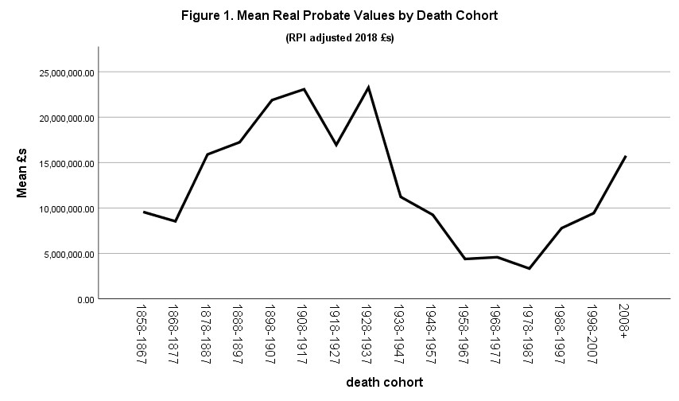

Figure 2. Logged Probate Values Over Time (RPI adjusted 2018 £s)
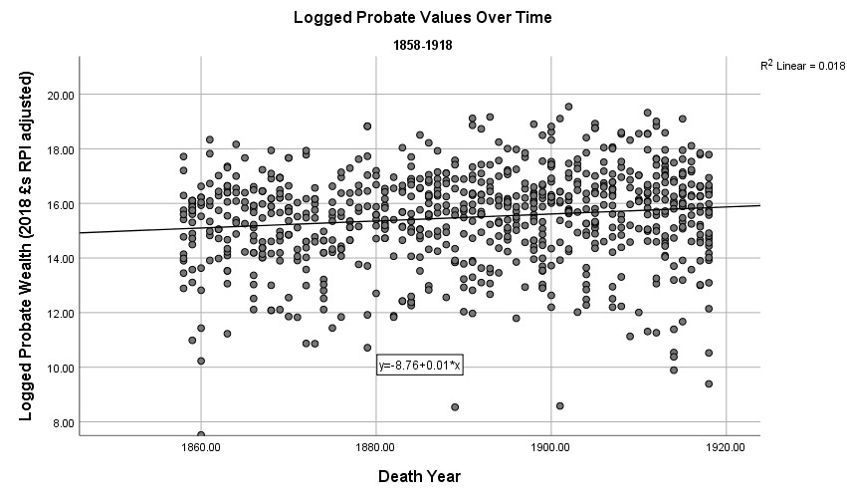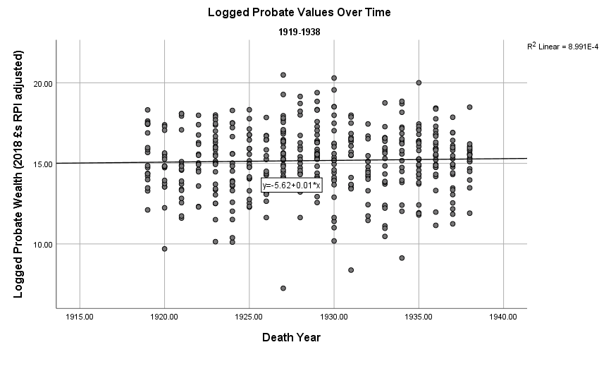

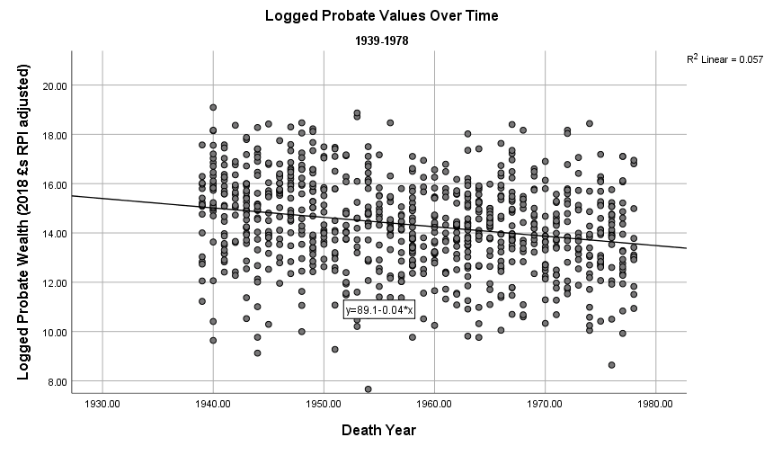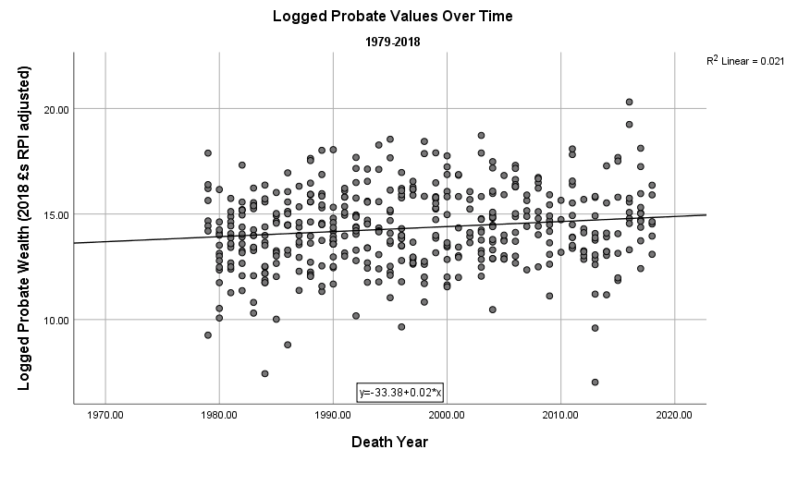

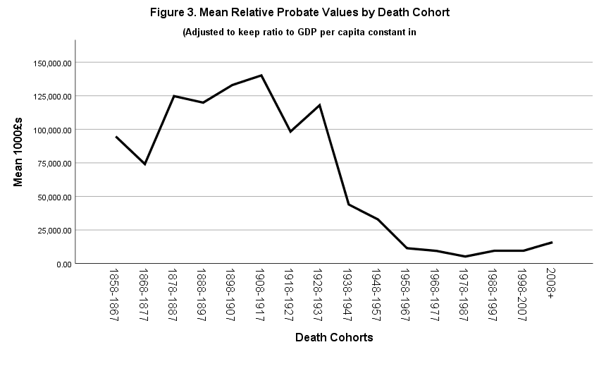

Figure 4. Logged Probate Values Over Time
(GDP Per Capita Adjusted 2018 £s)
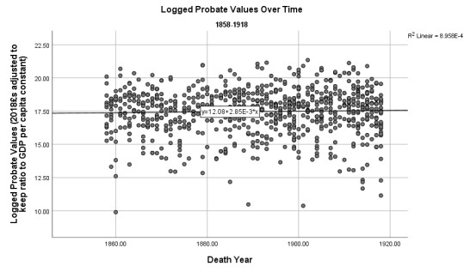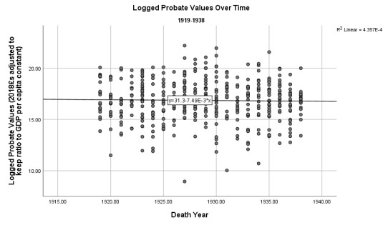

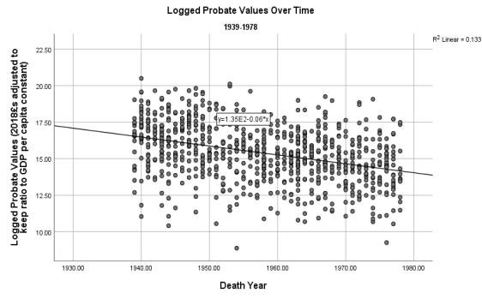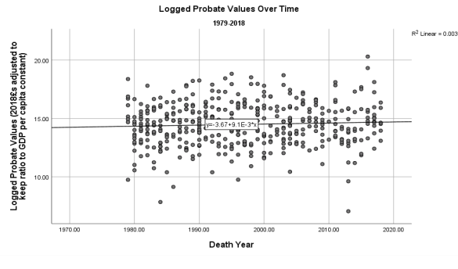

Table 1. Top ten grants adjusted to amount of 2018 pounds to keep ratio to GDP same as when they died
1878-87 |  | 1908-1917 |  | 2008-2018
Name | Probate Grant (2018 £s) | Name | Probate Grant (2018 £s) | Name | Probate Grant (2018 £s)
Duke of  Portland  (d. 1879) | 1,261,350,000 | Baron  Winterstoke  (d. 1911) | 1,488,177,007 | Duke of  Westminster  (d. 2016) | 653,403,275
Earl of  Dudley  (d. 1885) | 855,543,686 | Baron  Rothschild  (d. 1915) | 1,177,000,000 | Baron  Barnard  (d. 2016) | 227,302,982
Baron  Penrhyn  (d. 1886) | 636,626,928 | Baron Furness (d. 1912) | 1,072,831,636 | Duke  Beaufort  (d. 2017) | 73,609,978
Baron  Overstone  (d. 1883) | 535,163,387 | Baron  Wandsworth (d. 1912) | 905,115,892 | Duke  Grafton  (d. 2011) | 73,171,247
Baron Hindlip (d. 1887) | 452,250,704 | Duke  Devonshire  (d.1908) | 757,456,992 | Earl Bathurst (d. 2011) | 55,883,078
Earl of  Durham  (d. 1879) | 420,450,000 | Earl Derby (d. 1908) | 715,580,861 | Earl Devon (d. 2015) | 47,483,995
Duke  Buccleuch  (d. 1884) | 383,650,380, | Earl Spencer (d. 1910) | 709,659,857 | Duke  Marlborough  (d. 2014) | 32,601,923
Earl  Lauderdale  (d. 1878) | 375,711,912 | Duke  Sutherland  (d. 1913) | 691,732,843 | Baron  Braybrooke  (d. 2017) | 30,849,530
Earl  Sandwich  (d. 1884) | 271,450,512 | Baron  Airedale  (d. 1904) | 685,538,157 | Earl Leicester (d. 2015) | 30,632,531
Earl Crawford (d. 1880) | 237,720,000 | Earl Leicester (d. 1909) | 679,596,861 | Baron Ashton of Hyde  (d. 2008) | 18,446,780

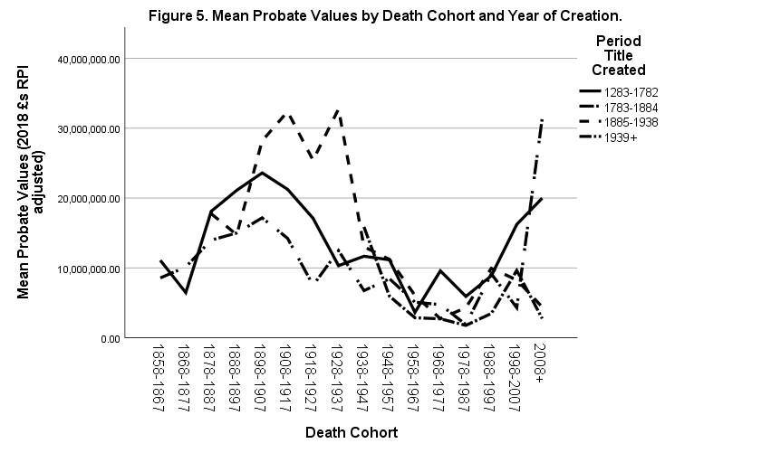

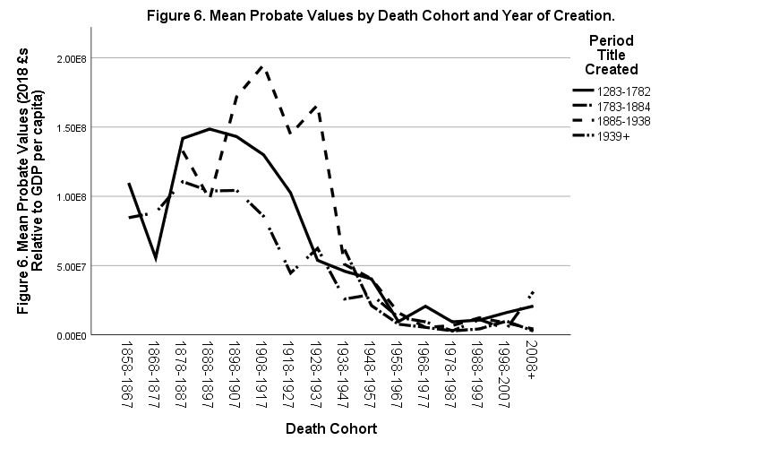

Popular culture is replete with portrayals of the aristocracy as wrapped in a sense of decay and experiencing imminent decline. Consider the serialisation of Evelyn Waugh’s Brideshead Revisited and the television series and film Downton Abbey. The BBC documentary ‘The Last Dukes’ (2015) portrays Dukes as a group under threat whose way of life is fast disappearing. A Google Trend Search for the English aristocracy shows decline in interest since 2004. The Nouvelle Pauvres (1984) by Monson and Scott gives many examples of down at heel aristocrats. See below for references to historical works that treat the aristocracy as undergoing bourgeoisification and becoming working professionals. As FML Thompson stated in his presidential address to the Royal Historical Society in 1989, the landed aristocracy “has performed an astonishing vanishing trick. This has been so effective that most people believe that the landed aristocracy has vanished from the public consciousness because it has been obliterated, apart from a few harmless survivors who act as caretakers for sundry parts of the national heritage” (FML Thompson, ‘English Landed Society in the Twentieth Century I Property: Collapse and Survival’ in Transactions of the Royal Historical Society , Vol. 40 (1990) p. 10). ² FML Thompson, English Landed Society in the Nineteenth Century (London 1969); WD Rubinstein, Elites and the Wealthy in Modern Britain: Essays in Social and Economic History (London 1987); ML Bush, The English Aristocracy: A Comparative Synthesis (Manchester 1984); JV Beckett, The Aristocracy in England,1660 -1914 (Oxford 1986); Peter Mandler, The Fall and Rise of the Stately Home (New Haven 1997); and David Cannadine. The Decline and Fall of the British Aristocracy (New Haven 1990).
Ellis Wasson. Born to Rule: British Political Elites (Stroud 2000) and Aristocracy and the Modern World (London: Palgrave 2006). There have been some journalistic pieces such as Chris Bryant’s Entitled. Rubinstein has expanded and reissued his Elites in 2017 but the chapters on the aristocracy are from the 1980s.
For example, Cannadine, The Decline and Fall of the British Aristocracy pp. 92-94, Beckett The Aristocracy in England,1660 -1914 p198, ML Bush The English Aristocracy: A Comparative Synthesis pp. 62-69, 152-155, Thompson English Landed Society in the Nineteenth Century p. 308.
We see much of the loss of political influence with the growth of new political parties, and of the restrictions of the power of the House of Lords. For example, Cannadine (The Decline and Fall, pp. 37-54, esp. 39); Beckett (The Aristocracy in England, p.13); Bush (The English Aristocracy, pp.167-169).
We see much writing on retrenchment, loss of confidence, fragmentation, the reduction of influence associated with the loss of land upon which farmers lived and others used, the decline in safe seats voted in by dependents, and so on. For example, Cannadine (The Decline and Fall, p. 98; p444); Beckett (The Aristocracy in England, p. 474); or see Bush on the rise of the landless aristocrat (The English Aristocracy, p.157)
For example Cannadine on the intersection of the loss of political influence and the growth in hostile media and legislation, (The Decline, pp. 41, 61-62)
See Thompson (English Landed Society: chapters 11 and 12), also Thompson (‘English Landed Society in the Twentieth Century I Property’ 1990, and ‘English Landed Society in the Twentieth Century’ in Anciennes et nouvelles aristocraties: De 1880 à nos jours. Open Edition Books: 2007) in which he emphasises the persistence of the richer aristocracy through to the 1980s.
See Bush (The English Aristocracy, p. 166; p. 158).
Daron Acemoglu and James Robinson, Economic Origins of Dictatorship and Democracy (Cambridge 2006), Aaron Reeves, Sam Friedman, Charles Rahal and Magne Flemmen, ‘The Decline and Persistence of the Old Boy: Private Schools and Elite Recruitment 1897 to 2016’ American Sociological Review 82 (2017), Thomas Piketty Capital in the Twenty First Century (Cambridge Mass 2014) and Facundo Alveredo, Anthony B. Atkinson and Savlatore Morelli, ‘Top Wealth Shares in the UK Over More than a Century’ Journal of Public Economics 162 (2017) .
The peerage has tended to be the evidentiary focus of existing scholarship on the aristocracy. See following footnote. We avoid considering life peerages since it is the aristocracy as a transmitter of wealth and power across generations through the mechanism of primogeniture and inherited status that is the object of interest here.
These tend to be the great families, in part since they leave more data, more letters, more actions in the public realm, more holdings and interests. See for example, the acknowledgements in FML Thompson (English Landed Society in the Nineteenth Century, p. viii). Historians do have data on less notable families, but these tend to be rare diaries – a purely self-reporting account making up a tiny proportion of the group under study. So, one might argue that historians of the aristocracy have built their arguments on a rather limited convenience sample from a small subgroup of a small subgroup of the aristocracy – the upper peerage, with much of this material being from self-selected archives.
Piketty Capital, pp. 2-3.
Rubinstein Elites and the Wealthy, p. 11
All this expresses, of course, debates exercised in the philosophy of knowledge, from Popper and before, but the reference to Piketty and Rubinstein is more apposite given their sensitivity to the charged character of writing on wealth and inequality, and hence the ease with which opinion can distort fact-finding and analysis.
Cannadine, The Decline and Fall of the British Aristocracy p. 125
Cannadine, The Decline and Fall of the British Aristocracy p. 125
Cannadine, The Decline and Fall of the British Aristocracy p. 136
See eg Cannadine (The Decline and Fall, pp. 92-94), Beckett on falling rents against consistent costs (The Aristocracy in England, p. 198; pp. 203-4), Bush on falling rents and increasing costs (The English Aristocracy, pp. 62-3) and on falling rents caused by foreign farm products (ibid, pp. 152-155), and Thompson who argues that behind all other changes was the great agricultural depression of 1873-96 plus the importation of American wheat, refrigeration and foreign wool (English Landed Society in the Nineteenth Century, p308).
See eg Cannadine (The Decline and Fall, pp. 90-91). Also see Bush (The English Aristocracy, p. 158)
Cannadine, The Decline and Fall p. 125, see also retrenchment p98 and fragmentation p. 444.
Cannadine (The Decline and Fall, p. 97), Beckett (The Aristocracy in England, pp. 477-8), Bush (The English Aristocracy, pp. 155-6), Thompson (English Landed Society in the Nineteenth Century, p328; p333).
Beckett points to an interwar recession in agriculture (1986: 477-8), Bush talks of the impact of post-war taxes (The Aristocracy in England, p. 153), Thompson talks of the passing of estates to distant cousins as well as increased tax and stable rents (English Landed Society in the Nineteenth Century, p328).
Piketty, Capital, Alveredo, Atkinson and Morelli ‘Top Wealth Shares in the UK’
One should note that such an approach is likely to significantly underestimate the overall wealth of the ecosystem, as it were, in which the peers live. Settled wealth can generate personal income, it can also provide for members of the wider family generating a wealthy close network of individuals, and it can be used in many cases as an investment vehicle for growth. A large settled fortune can be a very effective bulwark against the vicissitudes of the world. Thus, by excluding this wealth we flatter any argument for decline and make more difficult any argument for persistence.
Martin Daunton. ‘“Gentlemanly Capitalism” and British Industry 1820-1914’ Past & Present 122 (1989) pp.
-158. Barbara English ‘Probate Valuations and the Death Duty Registers’ Bulletin of the Institute of Historical Research, Volume 57, Issue 135, May 1984, Pages 80–91. David Nicholls ‘Fractions of Capital: The Aristocracy, the City and Industry in the Development of Modern British Capitalism’ Social History, Vol. 13, No. 1 (Jan., 1988), pp. 71-83.
Owens et al. actually defend the use of probate even in periods in which they report only gross wealth. They find that gross probates approached between fifty and 100 per cent of the net value of an estate in two thirds of average cases and in over four fifths of wealthy cases. Alastair Owens, David R. Green, Craig Bailey and Alison C. Kay ‘A measure of worth: probate valuations, personal wealth and indebtedness in England,1810–40’ Historical Research, vol. 79, no. 205 (2006).
Martin Daunton Just Taxes (Cambridge 2002).
Daunton (2002) argues that the use of trusts really began to worry the Treasury in the 1910s-20s. Cummins ‘Hidden Wealth’ (2019) also argues that hidden wealth via trusts and other mechanisms becomes an issue from the 1920s and argues that it accounts for 20-32% of the decline in wealth among the richest Britons up to 1992.
He does occasionally adjust for RPI inflation, e.g. when comparing the probates of newly created peers (Rubinstein 2017, pp. 234-235), but this is rare in his work.
https://www.measuringworth.com/calculators/ukcompare/
Additional comparative analyses of other specific rich or influential groups such as non-peerage politicians, businessmen and the rich would allow for greater explanatory refinement and confidence – it would bring the broad brush into greater resolution, as it were. For example, it would allow for greater confidence in making claims over whether there is something particular to the peerage that effects their wealth. We make an initial effort in the following by comparing pre and post Edwardian titles.
Further precision could be established here by separating out the wealthy from the less wealthy peers in order to reveal whether some rich peers were doing so well their probates masked the collapsing probates of others. However, as we shall see, when we separate titles by age (Figure 5) this reveals different starting levels of wealth, and all titles increase in wealth during this period.
Logged because certain extreme outliers were having an extreme effect on the OLS line fitted to the data. We have created a graph using logged values and it is largely the same as Figure 1. Copies of the logged graph are available on request.
All this shows how unlikely such a return to the past could be – it would entail the British peerage coming to own vast amounts of the assets that are central to wealth production in the twenty-first century – prime urban land, core minerals, central productivity-oriented communications infrastructure, innovative listed companies that are at the forefront of the speculative stock market. And remember, we are talking here of their personal wealth, not their settled family-oriented wealth. No-one is suggesting this. The puzzle for scholars of the aristocracy is, rather, that if they show equal or greater persistence as compared to the typical rich, should we see them as rational economic actors at an elite level, or are their traditional status features benefiting them in some anti-modern economic manner, or is there some combination of the two at work?
https://www.independent.co.uk/news/business/news/uk-million-pound-properties-homes-777000-zooplahousing-marketstudy-a8202056.html
All this also casts a question over the idea of the “working peer” – they may have worked, but on this reckoning, on receipt of probate, the average peer has never had to work.
The second youngest peerage belonged to the Duke of Westminster, which was created in 1874 although the family had a marquessate from 1831, an earldom from 1784, a barony from 1761 and a baronetage from 1622. ⁴⁴ We are particularly interested in identifying differences, or not, in the decline of these bourgeois versus landed peers below. However, one might also explore the links between wealth and status by considering the effects of cultural history and memory on power, and influence This work has begun in some ways amongst French and other European scholars influenced by Bourdieu. See, for example, the many essays, especially those of the editors and Monique de Saint Martin, in Nobilities in Europe in the Twentieth Century: Reconversion Strategies, Memory Culture and Elite Formation edited by Yme Kuiper, Nikolaj Bijleveld and Jaap Dronkers (2015).
See footnotes 15 and 16.
It should be noted that Baron Winterstoke ended up the owner of a large estate. Writing of the Wills family FML Thompson notes: ‘The Wills family in particular produced millionaires like rabbits, three just before 1914 and four more in the interwar years (and a further couple in the 1940s): the tobacco money was poured into Bristol University, but it was also employed in sprinkling Somerset and Gloucestershire with their country houses and estates.’ Thompson reminds us that gentrification continued after 1885 and that millionaires continued to be attracted to land. The point is that post 1885 land was neither the basis of ennoblement nor was ownership of an estate a de facto requirement of being a peer.
There is an interesting opportunity, here, to contribute to debates around the open character of the elite initiated by Stone, L and Fawtier Stone, J.C (1986) An Open Elite: England 1540-1880. Oxford: Clarendon Press. In particular, it might be possible to define the amount of wealth required to get a new title.
We might note that this disaggregation of titles into the richer post 1884 cohort which loses more wealth than the less rich older titles begins to unpick the confusion and imprecision around the notion of the super-rich detailed previously. We can see somewhat more clearly who the super-rich peers are as a group. The fact that this wealthy group collapses more precipitously than the less wealthy groups also gives us a good first indication that, contra all the views discussed on the super-rich peerage, sheer possession of a greater fortune does not in itself seem to be the basis for economic resilience and persistence for future generations. Greater clarity would come were we to divide the entire peerage by deciles of wealth from their first available record, and track these inter-generationally by family.
Martin Wiener, English Culture and the Decline of the Industrial Spirit: The Wiener Debate (Cambridge, 1981)
It Is worth noting that Cannadine takes a highly uncharitable view of the British aristocracy. For example, among the many case studies he mentions, the intellectual titan, Nobel laureate and peace campaigner, Bertrand, Third Earl Russell, is briefly mentioned simply as, ‘one of the cleverest men of his generation.’
FML Thompson, ‘English Landed Society in the Twentieth Century I Property’. Curiously, he theorises little as to the characteristics of the failure.
Ellis Wasson, Aristocracy in the Modern World (London: 2006)
See the line for Britain in Figure 11.12 p. 425.

