BENCHMARKING OF SUPERMARKET ENERGY CONSUMPTION
A Foster, J Evans and G Maidment.
London South Bank University, Food Processing, North Somerset, Langford, UK,
alan.foster@lsbu.ac.uk, Fax: +44 (117) 92892314

ABSTRACT
Energy consumption data for supermarket stores have been obtained and compared with data from other studies. Correlations and trends from the data have been analysed to investigate what influences energy consumption in a retail store. Energy consumption of the supermarkets was well correlated with both sales floor and total floor area. Once floor area was taken into account, there was no difference in energy consumption between different store types. There was a positive correlation with store age and hours open, however, it was much smaller than those for floor area. The mean specific energy consumption (SEC) of the data set was 566 kWh.m².year⁻¹ based on electrical energy consumption and sales floor area. This rose to
759 kWh.m².year⁻¹ when gas was included. From other studies the SEC varied from 407 to 1700 kWh.m².year⁻¹ based on electrical energy consumption.
Key words: Benchmarking, supermarket, energy, retail.

INTRODUCTION
In the UK, retail and catering account for 7.7 million tonnes of oil equivalent (MTOE) per year or 18 MtCO_{2e} emissions (Kolokotroni et al, 2015), whereas, energy consumption has been estimated to be around 12.0 TWh and approximately 3% of total electrical energy consumption (Tassou et al, 2011). The UK supermarket sector is estimated to be responsible for 0.9% of UK greenhouse gas emissions (through the use of lighting, heating, cold stores and on-shelf refrigeration) (Sustainable Development Commission, 2008) but it has been estimated that indirectly (supply and value chains) it may have been responsible for up to 10% of emissions in the period between 2000 and 2010 (Sullivan and Gouldson, 2013).
From the mid-2000s retailers started setting targets to reduce emissions; these targets were based on metrics such as greenhouse gas emissions per unit of floor area (Sullivan and Gouldson, 2013). Sullivan and Gouldson showed that the 7 major UK retailers all had climate change commitments.
There is evidence that UK supermarkets significantly improved their operational efficiency over the period 2000–2010. For example, Sullivan and Gouldson (2013) show total greenhouse gas emissions relative to a 2007 baseline for six supermarket chains with significantly improved emissions. The energy intensity improvements were on average between 2.5 and 5.5% per year and over longer periods (i.e. up to 10 years) these companies have consistently achieved annual improvements of between 2 and 3%. These efficiency gains were found to often have been outstripped by the impacts of business growth so overall carbon use was increased.
UK supermarkets have set themselves stringent voluntary targets to further reduce energy intensity, which Gouldson and Sullivan (2013) believe are both credible and align with policy goals set by national governments.
Sullivan and Gouldson (2013) reported that only 7 out of the 9 major UK supermarkets were reporting on their environmental performance. They also said that there is limited consistency in the information provided on emission sources and on the factors that influence performance, therefore it remains difficult to make a robust comparison of performance across the sector, or to develop a robust benchmark (or ranking) of performance.
Uncertainty exists on the average energy use intensity of supermarkets, and this is often exacerbated by different ways of calculating energy intensity. Some are based on total energy consumption, while others are only electrical consumption, ignoring gas. Some studies divide total energy use by the total floor area and others divide it by the sales floor area. Even when these differences are taken into account there is a large variability in the data. For example Tassou et al (2011) showed electrical energy over sales floor area of between 770 and 1480 kWh.m⁻².year⁻¹ from hypermarket to convenience size stores. Van der Sluis et al (2015) showed specific energy consumption (SEC) values (total energy over gross floor area) of between 407 to 800 kWh.m⁻².year⁻¹ (lowest from a Dutch supermarket chain and highest in Canadian stores). Even when the difference in calculation of energy intensity is taken into account, the electrical energy intensity in UK supermarkets (Tassou et al, 2011) appears to be 2.5 times as high as the value in Dutch supermarkets (Van der Sluis et al, 2015).
The disparity between these data sets indicates that UK supermarkets use considerably more energy than continental supermarkets. These benchmarks were based on data from different time periods so did not necessarily take into account changes in practise and energy efficiency.
Kolokotroni et al (2015) reported on examples of low carbon supermarkets and guidelines on how to achieve such buildings. They reported that there is potential for significant energy savings with attractive financial return.
Hill et al. (2010) summarised low energy design initiatives as;
- Enhanced utilisation of daylight.
- A combination of natural and mechanical ventilation, with heat exchange.
- Improved refrigeration cabinets, with doors on frozen food cabinets.
- Improved control over lighting and ventilation, and acceptance of a wider range of internal temperatures.
- LED display lighting.
- Renewable energy sources, such as biomass or wind power.
Applying doors on chilled cabinets is considered to be an important factor in reducing the energy consumption of the refrigeration system. Lindberg et al (2010) carried out laboratory measurements and field measurements in a supermarket on vertical cabinets without and with doors. The main conclusion from the supermarket study was that the doors on the cabinets reduced the direct electric energy use for the refrigeration system (-26 % for a winter climate). Studies by Schmidt (2007), Faramarzi et al (2002), Kröger (2007), Hale et al (2008), Navigant Consulting (2013) and KWN (2004) have shown savings of 50, 68, 70, 80 (reduction in rated capacity), 50-80 and 86% respectively.
This paper analyses recent, so far unpublished, UK supermarket energy intensities and compares them with the previous published data and looks for correlations and trends in the data which help better understand the energy consumption.

Method
Energy consumption data for 2015 was analysed for 565 retail (supermarket) stores from one retailer in the UK. All of the stores considered in the analysis contained refrigerated food. Electrical energy consumption (EE) and total energy consumption (TE) were included, where,
TE = EE + Gas consumption
Energy consumption related to both sales floor area (SFA) and total floor area (TFA) were analysed.
Two specific energy consumptions (SEC) were calculated.
SEC_{TE}/_{TFA} = TE / TFA
SECE_{E}/_{SFA} = EE / SFA
These two SECs were found in the literature and therefore made comparison easier.
Effect of store age and opening hours on specific energy consumption were assessed to see if they had an impact on SEC.
All of the stores had sub-metering of both the electrical and gas energy consumption. This sub-metering was analysed to investigate reasons for differences between this and data in the literature.

Results

SEC
Figure 1 shows TE plotted against TFA (left) and SEC_{T}/_{TFA} against TFA for the 553 stores which contained GFA data. Linear regression gave the following
TE = 0.372±0.006 * TFA (m²) + 300±43 MWh.year⁻¹ (R² = 0.868) ± is to one standard deviation (SD).
SEC_{T}/_{TFA} was found to decrease slightly with TFA.

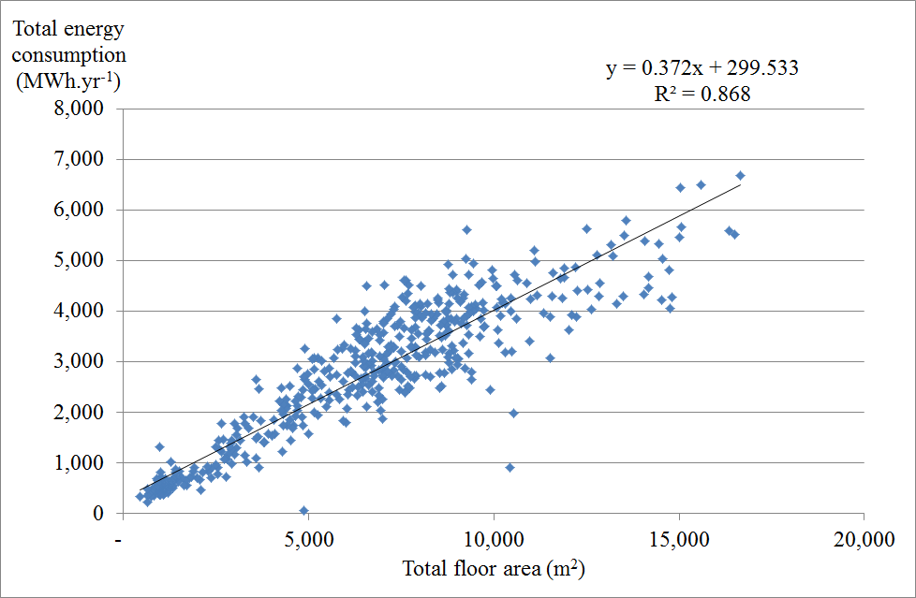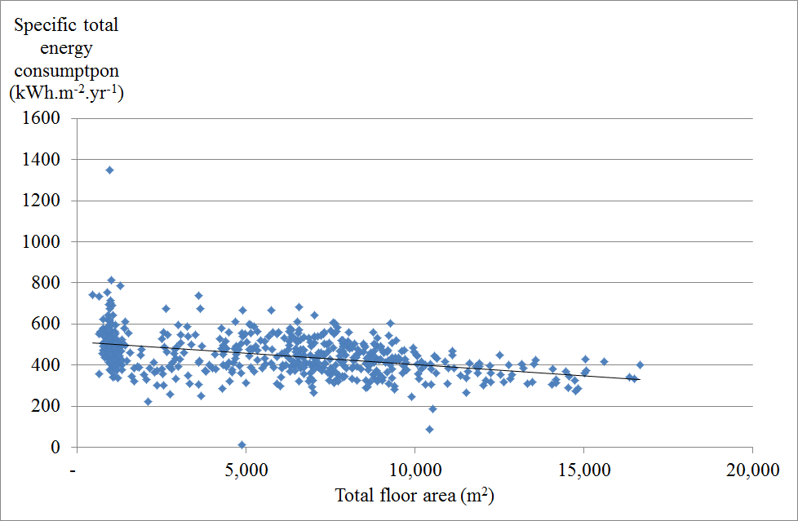
Figure 1. Total energy vs TFA.
Figure 2 shows EE plotted against SFA (left) and SEC_{EE}/_{SFA} against SFA for 557 stores which contained SFA data. A slightly better correlation was given than for TE plotted against TFA. Linear regression gave the following
Electrical energy = 0.515±0.007 * SFA (m²) + 147±28 MWh.year⁻¹ (R² = 0.903) ± is to one standard deviation (SD).
SEC_{EE}/_{SFA} was also found to decrease slightly with TFA.
Although most of the stores were close to the best fit line, there were some results which deviated considerably. Further analysis pointed to this being more related to inaccurate placing of the sub-meters and high levels of un-sub-metered energy rather than particular characteristics of the stores.

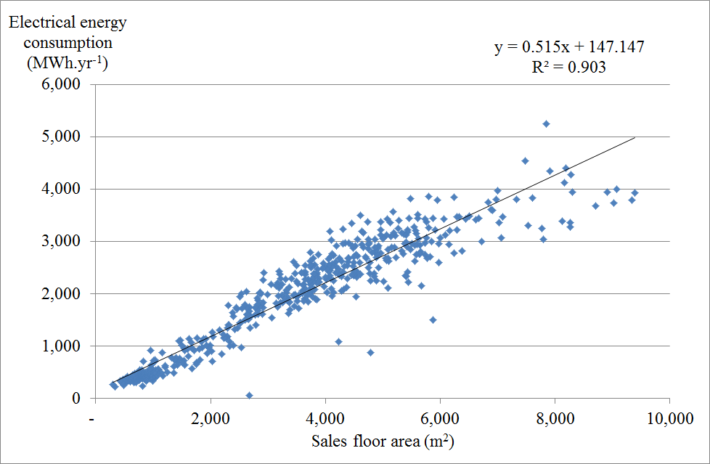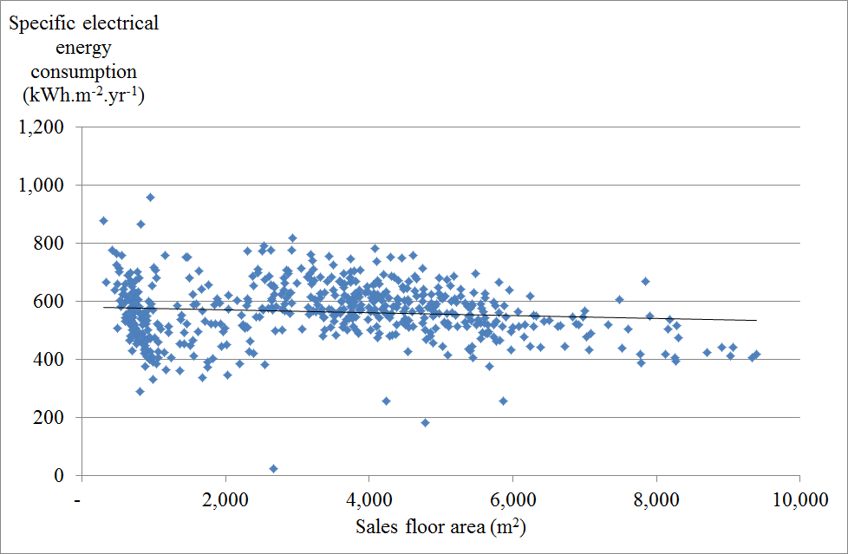
Figure 2. Electrical energy vs SFA.
Table 1 shows means, SD and sample sizes for the parameters analysed.

Table 1. Mean standard deviation and sample size of supermarket store parameters.
 | Mean | SD | Sample size
Gross floor area (m²) | 5845 | 3808 | 553
Sales floor area (m²) | 3306 | 2054 | 557
Total energy consumption (MWh.year⁻¹) | 2447 | 1514 | 565
Electrical energy consumption (MWh.year⁻¹) | 1846 | 1109 | 565
SEC_{T/TFA} (kWh.m⁻².year⁻¹) | 450 | 104 | 553
SEC_{E/SFA} (kWh.m⁻².year⁻¹) | 566 | 98 | 557

Sub metering
Both the gas and EE were sub metered. Figure 3 shows that 75% of the TE was EE, 33% of the EE consumption was for refrigeration and 45% of the refrigeration was ‘other refrigeration’. Therefore a large proportion of the refrigeration energy was used by an undetermined category. The split between low temperature (LT) and high temperature (HT) refrigeration was about 50/50. Half of the refrigeration was considered as ‘other’, this covers the cold store warehouses, however, it would normally be expected that the cold store warehouses use about 10% of the refrigeration (Tassou et al, 2011). Therefore it is likely that there were other unknown consumers of energy in this category.
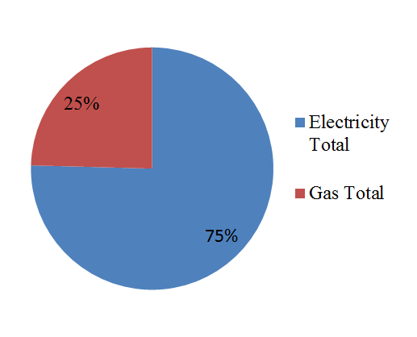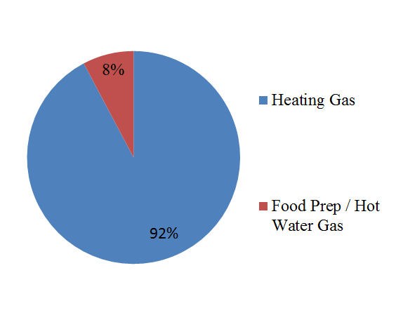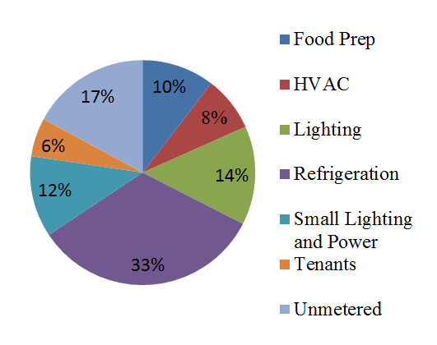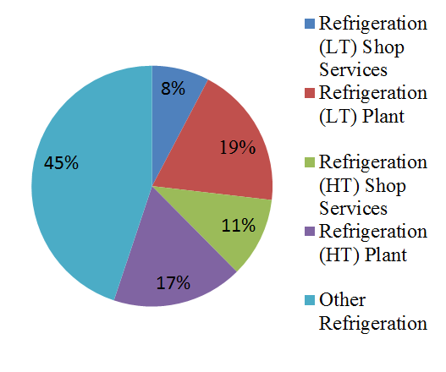
Figure 3. Mean electrical and gas consumption split by sub-meters.

Opening hours and store age
Two factors (hours the store was open and store age) were considered to see if they had a significant effect on SEC. Both hours open and store age had a significant (p<0.05) positive slope, e.g. an increase in the parameter increases energy consumption. A multiple regression was carried out and the results are below.
TE = 0.297±0.007 * TFA (m²) + 24.6±2.1 * Store age (yr) + 9.03±1.13 * hours open (h/.week⁻¹) - 681±115 MWh.year⁻¹ (R² = 0.901)
EE = 0.450±0.010 * SFA (m²) + 13.0±1.4 * Store age (yr) + 3.24±0.78 * hours open (h/.week⁻¹) - 205±79 MWh.year⁻¹ (R² = 0.916)

Comparison with other studIes

SEC
Van der Sluis et al (2015) reported SECs for Swedish, USA and Canadian stores which reduced with increasing floor area. This was shown in the data presented here, where the negative slopes of both SEC_{T} and SEC_{E} with TFA and SFA respectively were statistically significant (P<0.05). The SEC_{T/TFA} was very similar to the Swedish stores but lower than the stores in USA and Canada.
Van der Sluis et al (2015) also showed data for a Dutch store which resulted in a SEC_{EE/SFA} of
407 kWh.m^{-2.}yr⁻¹ in the range of SFA from 400 to 1000 m². This is 27% lower than the value reported here (SEC_{EE/SFA} of 558 kWh.m^{-2.}yr⁻¹).
The data presented in this paper showed a much lower SEC_{EE/SFA} than reported by Tassou et al (2011). Tassou et al reported a very strong inverse power relationship when all sizes of stores were analysed. It was not possible to compare the stores with SFA below 280 m², as this was below the minimum size in our study. However, Tassou et al showed SEC_{EE/SFA} reducing from about 1500 to 850 kWh.m⁻².year⁻¹ for SFA between 280 and 1400 m². In the current study for this range of SFA, we had a mean SEC_{EE/SFA} of
554 kWh.m⁻².year⁻¹. The best fit is for the largest stores between 5000 and 10000 m² SFA. In this range, Tassou et al showed SEC_{EE/SFA} reducing from just over 870 to 660 kWh.m⁻².year⁻¹ compared to
523 kWh.m⁻².year⁻¹ for this range of SFA with the data reported in this paper.

Table 2. Specific energy consumption of retailers found in the literature as well as this study.
Source | Store location and date | Energy intensity (kWh/m2) | Basis of SEC | Floor area applicable for | Notes
This study | UK (2015) | 566 | Electrical energy /SFA | 3306 | Reduces with larger FA
Tassou et al (2011) | UK | 1700 to 1320 | Electrical energy /SFA | 80 to 280 | Reduces with larger FA
Tassou et al (2011) | UK | 1500 to 850 | Electrical energy /SFA | 280 to 1400 | Reduces with larger FA
Tassou et al (2011) | UK | 920 | Electrical energy /SFA | 1400 to 5000 | Reduces with larger FA
Tassou et al (2011) | UK | 870 to 660 | Electrical energy /SFA | 5000 to 10000 | Reduces with larger FA
Van der Sluis et al (2015) | Netherlands (2013) | 407 | Electrical energy /SFA | ~400 to ~1000
This study | UK (2015) | 450 | Total energy /GFA | 5845 | Reduces with larger FA
Van der Sluis et al (2015) | Sweden (old) | ~ 500 to ~250 | Total energy /GFA | ~200 to ~9000 | Reduces with larger FA
Van der Sluis et al (2015) | Sweden (new) | ~ 550 to ~200 | Total energy /GFA | ~1000 to ~14000 | Reduces with larger FA
Van der Sluis et al (2015) | USA | ~ 700 to ~500 | Total energy /GFA | ~3000 to ~7500 | Reduces with larger FA
Van der Sluis et al (2015) | Canada | ~ 1000 to ~700 | Total energy /GFA | ~2000 to ~1100 | Reduces with larger FA

Sub metering
As the SEC for the stores reported here was significantly lower than that reported by Tassou et al (2011), it is worthwhile to compare the sub-metering to assess whether this difference can be due to a particular sub-meter rather than a reduction in all meters.
Tassou et al (2011) stated that more than 70% of the energy consumed was electricity, in this study it was 75%. They also stated that for a hypermarket 29% of the EE was for refrigeration, this is similar to the 33% reported here. A clear difference is in lighting, where Tassou et al report 23%, whereas in this study it was 14%. During this study it was noticed that many of the stores were undergoing or had undergone changes in store lighting to more efficient (LED) lighting. It is quite likely that the data from Tassou et al, had less efficient lights due to the date the data was recorded. Due to the different categories used by the stores and large level of unmetered energy in this study, it was not possible to draw further conclusions.

DISCUSSION AND Conclusions
Energy consumption (both EE and TE) of supermarkets is well correlated with both SFA and TFA. There is a positive correlation with store age and hours open, however, it is much smaller than that for floor area. SEC was found to reduce with increasing floor area.
The UK stores studied had significantly lower SECs than the UK stores represented by Tassou et al (2011) and also than the USA and Canada stores shown in Van der Sluis et al (2015). The stores studied had similar SEC to the Swedish stores presented but higher than the Dutch stores shown in Van der Sluis et al (2015).
Some of the reduction in energy between the Tassou et al data and the current data was possibly due to more modern low energy lighting, however this difference only accounts for 9% of the electrical energy consumption. The Tassou SEC was 32% higher for the larger stores and higher still for the smaller stores so the difference in energy between the two sets of data cannot be easily accounted for.
If we assume the Tassou data was recorded in 2009 (1 year before paper was submitted), then there are 6 years of potential energy efficiency improvements between the data sets. If we assume a 4% reduction in energy intensity per year over this period, this would account for a 24% reduction, therefore energy efficiency improvements with time still do not seem to cover the differences in the data.
More SEC data for different retailers in the UK and around the world is needed to better understand the differences between the data sets with the aim of reducing overall SEC.

ACKNOWLEDGEMENTS
This work is carried out as part of the EPSRC i-STUTE EUED energy centre and End Use Energy Demand Centres Collaborative Projects (EP/P006779/1).

Nomenclature

SEC Specific Energy Consumption (kWh.m⁻².yr⁻¹)
SD Standard deviation
SFA Sales floor area (m²)
TFA Total floor area (m²)
Subscripts
EE Electrical energy consumption (kWh.yr⁻¹)
TE Total energy consumption (kWh.yr⁻¹)

References
Deloitte, 2017. Global Powers of Retailing 2017 - The art and science of customers. Deloitte Touche Tohmatsu Limited. https://www2.deloitte.com/content/dam/Deloitte/global/Documents/consumer-industrial-products/gx-cip-2017-global-powers-of-retailing.pdf
Faramarzi, R. .T, Coburn, B. A. and Sarhandian, R. 2002. Performance and energy impact of installing glass doors on an open fronted vertical deli/dairy display case. ASHRAE Transactions, 108(1) 673-679.
Gouldson, A.,Sullivan,R.,2013.Long-term corporate climate change targets: what could they deliver? Environmental Science & Policy 27,1–10.
Hale E. T., Macumber D. L, Long N. L., Griffith B. T., Benne K. S., Pless S. D., and Torcellini P. A., 2008. Technical. Support Document: Development of the Advanced Energy Design Guide for Grocery Stores—50% Energy Savings. National Renewable Energy laboratory. Technical Report NREL/TP-550-42829.
Hill, F., Courtney, R., Levermore, G., 2010. Towards a zero energy store–a scoping study (ZEST). Sustainable Consumption Institute, University of Manchester, Manchester, UK.
Kröger, J., 2007. Fortschritte in der Kältetechnik – geringer Energieverbrauch ist gefragt. Kälte Klima Aktuell, 1, S. 70.
Kolokotroni, M., Tassou, SA., Gowreesunker , BL., 2015. Energy aspects and ventilation of food retail buildings. Advances in Building Energy Research 9(1).
KWN Engineering, 2004. Testreihe Glasstüren für Wandkühlregale REMIS bei AGM Österreich.
Lindberg, U., Axell, M. and Fahlén, P., 2010. Vertical display cabinets without and with doors – a comparison of measurements in a laboratory and in a supermarket. IIR, Sustainability and the Cold Chain, Cambridge, UK.
Navigant Consulting Inc., 2013. Guide for the Retrofitting of Open Refrigerated Display Cases with Doors. US Department of Energy, Energy Efficiency & Renewable Energy.
Schmidt, R., 2007. Technologieauswahl aus Sicht der REWE Group. Deutsche Kälte-Klima-Tagung 2007, Hannover, 22. – 23.
Sullivan, R., Gouldson, A., 2013. Ten years of corporate action on climate change: What do we have to show for it? Energy Policy, 60, 733–740.
Sustainable Development Commission, 2008.Green, Healthy and Fair: A Review of the Government's Role in Supporting Sustainable Supermarket Food. SDC, London.
Tassou, SA., Ge, YT., Hadawey, A., Marriott, D., 2011. Energy consumption and conservation in food retailing. Applied Thermal Engineering. 31, 147–156.
van der Sluis, S., Lindberg, U., Lane, A-L., Arias, J., 2015. Performance Indicators or Energy Efficient Supermarket Buildings. Proceedings of ICR 2015, August 16 - 22 - Yokohama, Japan.

