QUIET DRONES
International Symposium
on
UAV/UAS Noise
Paris – 25th to 27thMay 2020

The Sound of the Drone Uprising – Aeroacoustics of Drone Blades

Josephine Nixon, London South Bank University, Author1@Organisation.com
Stephen Dance, London South Bank University, dances@lsbu.ac.uk

Summary
This paper explores the relatively new phenomena of drones and thesurrounding aero-acoustic function of their blades. Drones have become increasingly accessible to the public ranging insize and price from £20 to £10000+. The need to further understand theaeroacoustics surrounding drones has thus increased. Existing research has tended to focus on health,safety and security,with a limited amount ofresearch in the last few years on the acoustics of drones. This paper explores changing the shape of the wing to reduce the sound emission from the drone in terms of both sound level and tonality. Four blade designs have been tested on a Phantom IV drone to estimate total sound power. It was found that it is possible to significantly reduce sound emission whilst maintaining the drone’s ability to hover.
- Introduction
Drones have become increasingly accessible to the public ranging in size and price from £20 to £10000+ as such their use of rapidly multiplying and hence aero-acoustics needs to be investigated to understand if the noise produced can be lessened or made less annoying. Existing research has tended to focus on health, safety and security, (Finn et al:2012, Clarke et al:2014, BBC:2019) with a limited amount of research being undertaken in the last few years on the acoustics of drones (Intaretep: 2016, Bown:2018, Oeckelet al: 2018). This paper explores the aeroacoustics and characteristics of drone blades, along with how noise emission from the blades can be controlled or mitigated. The race is on for quiet, secure and safe drones to avert a rising noise climate.
- The Drone
The DJi Phantom IV drone was used in this study. Mainly used for recreation, it weighs 1380g and has a diagonal dimension of 350mm and uses four rotate blades each with a 234mm diameter, see Figure 1.
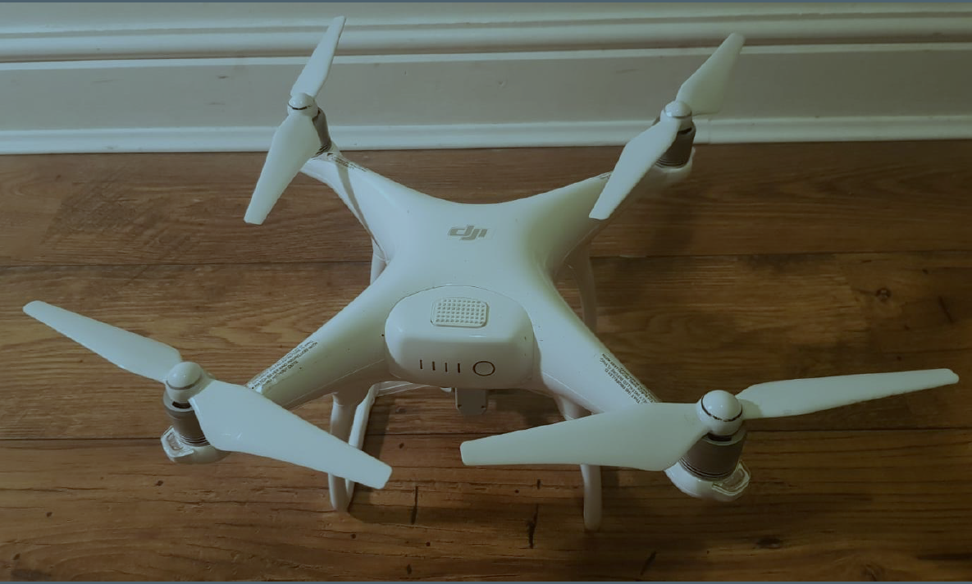
Figure 1- DJi Phantom IV drone

Blade DesignAerodynamic noise is very strongly dependent on airflow speed. Two important areas when looking at aerodynamic noise within aeroacoustics is the blade passing frequency and the proportionality of airflow to noise emissions.

The blade passing frequency is important as this determines any fundamental tones and harmonics from a blade. The blade passing frequency (BPF) is the fundamental frequency, fo, created by the number of times a blade passes a particular point, equation 1:

𝑓₀ = N *RPM/60 (1)

Where N is the number of blades.

Research, such as Kleiet al:2014,Pechanet al: 2015 and Muller et al: 2014, amongst others have looked at the frequency spectrum produced in relation to blades from aircraft. The shape of the blade and speed at which it travels can affect the noise emission. The quicker the blade spins, the more turbulence the blade tip would cause. The speed or velocity of the wing tip affects the noise emission from the blades; it is an interlinked relationship. The shape of the blades prop, could therefore impact the speed in which the rotor has to turn to ensure the drone hovers

The excessive noise, E, created changing the design of the blade is given by equation 2.

$E=10lg⁡{\left(\frac{V}{V_{0}}\right)}^{6}$ (2)

Where V is the velocity of the new blade tip (m/s), V₀ is the blade tip velocity of the original blade (m/s).
- Blade Design
The thicker the blade the more resistance there would be through the air, increasing air turbulence, vibration and thus noise. Leslie et al: 2008 explored the possibility of broadband noise reduction through boundary layer tipping from a mini UAV / Drone. They considered the blades tonal and concluded “these tones are manifesting themselves as a large broadband hump due to the range if velocities across the propeller range.” (Leslie et al:2008).

Intaretepet al: 2016 explored four different commercially available propeller configurations for a
DJi Phantom IV drone, along with their rotors and concluded that “[t]he acoustic spectra of the
Quadcopter is dominated by high and sustained noise at the blade passing frequency and shaft rate and their harmonics up to the mid frequency range” (Intaretepet al:2016). The shape of the bladeswere noted to remain the same;however, different materials were used (e.g. white carbon, original plastic, black carbon). The shape and size of the blade will be to determine if this impacts the tonality or sound power level.

According to a recent study by NASA, the noise made by roads traffic was “systematically judged less annoying” than the high-pitched buzzing made by drones” (Bown: 2018). The blade design expands on Leslie et al: 2010 argument by looking at the level and type of noise emitted in relation to the shape, material, size/dimensions (length and width) and weight of the blades.

For this study, different blades were fitted to the drone and the noise emission measured. The following blades were tested; original quick release blade, quick release blades with shaped props, altered quick release blades and carbon fibre blades, see Figures 2,3,4,5 respectively

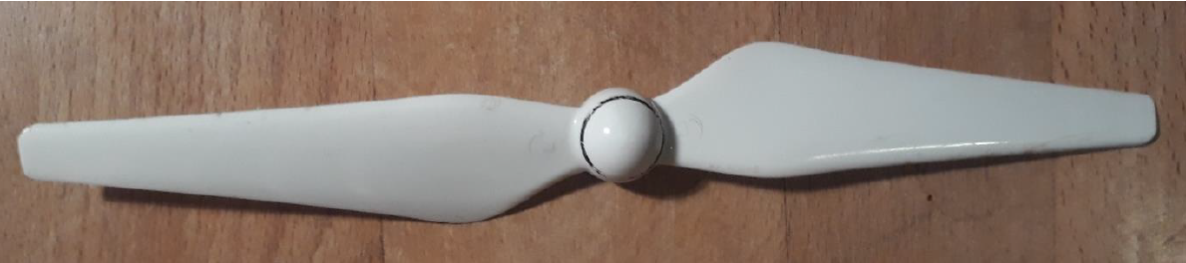
Figure 2 – Photograph of Original Blade
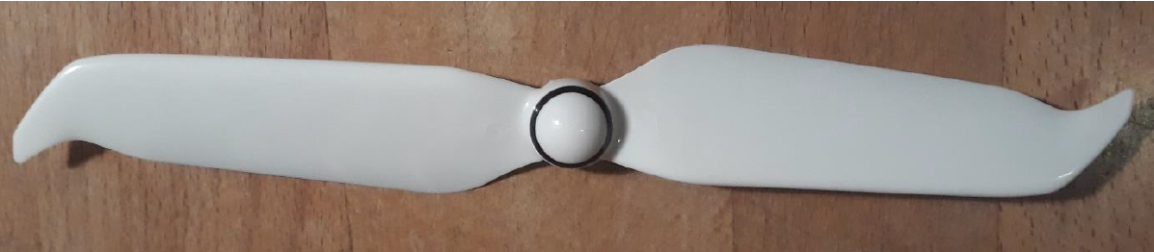
Figure 3 – Photograph of Blade with Shaped Props
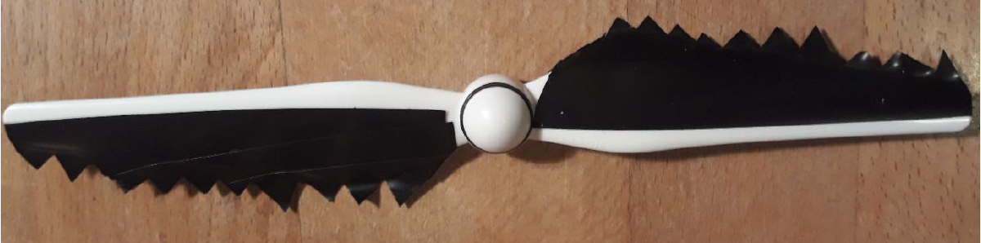
Figure 4 – Photograph of Altered Blade

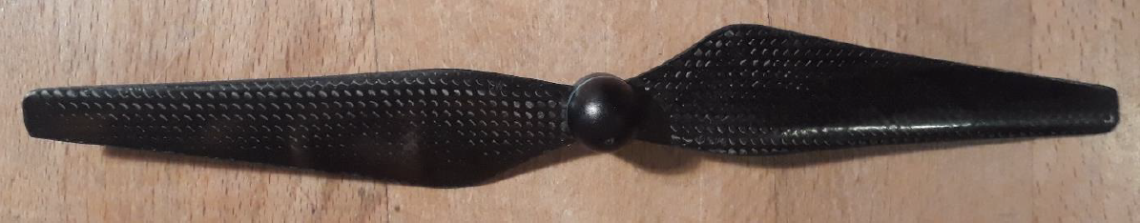
Figure 5 – Photograph of Carbon Fibre Blade

Three of the blades are available on the commercial market for the DJi Phantom iV; the original quick release blades come with the drone, figure 2. The quick release blades with shaped props have since been designed and manufactured by DJi and sold as a Low Noise Propellers, they are made to fit both the Phantom IV and the more modern DJi drone model; the Mavic drone, see Figure 3. The carbon fibre blades sold by a different manufacture as a ‘quieter’ option for Phantom IV drones, see Figure 5. The altered blade type is not available on the market. This blade type was designed following research to be a ‘quieter blade’, see Figure 4, with electrical tape layered over the top surface, but kept as smooth as possible. The blades were then shaped to take on a toothmark / v-shape edging, the shape of modern jet engine and modern stealth fighter. Full blade specifications are given in Table 1.

Table 1: Blade specifications and dimensions

Blade Type | Weight (g) | Material | Max width (mm) | Blade length (mm) | Blade name
Quick Release | 42 | Coated Smooth Plastic Surface | 30.8 | 236 | Original
Quick Release Shaped | 44 | Coated Smooth Plastic Surface | 32.2 | 238 | Shaped
Quick Release Altered | 49 | Electrical Tape on Plastic Surface | 36.4 | 236 | Altered
Carbon Fibre | 56 | Smooth Carbon Fibre | 30.8 | 234 | Carbon Fibre
- Methodology
The free-field method to determine sound power, as prescribed in BS EN ISO 3745: 2012 (Acoustics – Determination of sound power levels and sound energy levels of noise sources using sound pressure – Precession methods for anechoic rooms and hemi-anechoic rooms), could not be undertaken due to constraints by the available anechoic chambers construction. In order for the drone to fly unassisted, it requires a compass, GPS Signal or Signalling Point. These signals are blocked within the anechoic chamber due to the mass of the wall construction and amount of steel in the chamber design. Previous research (Nixon: 2017) tried to undertake measurements within the anechoic chamber, but the drone was unstable, flipping over and breaking the blades on the grated floor. This was caused by a lack of signal, which automatically forces the drone to land as a safety measure.

Instead the BS EN ISO 3741: 2010 method was employed which required testing in the reverberation chamber, as the drone was able to pick up a reference/signalling point and fly and hover unassisted for 30 seconds which was repeated three times for each blade design. Four people wearing safety glasses using four class 1 sound level meters positioned around the drone at hover height, 1.6m, took measurements. In addition, two meters one meter above and below the hovering drone took measurements; these meters used microphone extension cables. The average of the three sound level measurements were taken.

Reverberation time measurements were undertaken in the occupied chamber using the impulsive sound source method. The sound source was multiple large balloons each with at least 40cm diameter. In this case two balloons were burst whilst the six sound meters measured the decay which were then automatically converted to T₂₀ in 1/3 octave bands.
- Measurements
Presented the measured 1/3 octave bands averaged for the six sound level meters for the three 30 second flights for the four different blade designs, see figure 6.
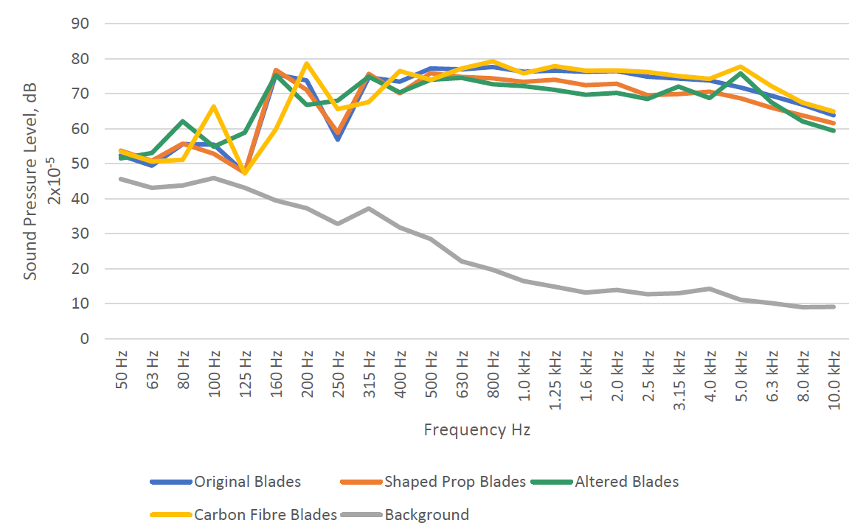

Figure 6-Averaged Sound Pressure Level- Hover Results for each Blade Type

Presented the measured 1/3 octave band reverberation time as averaged over 12 source-receiver positions with four people in attendance in the reverberation chamber, see figure 7.
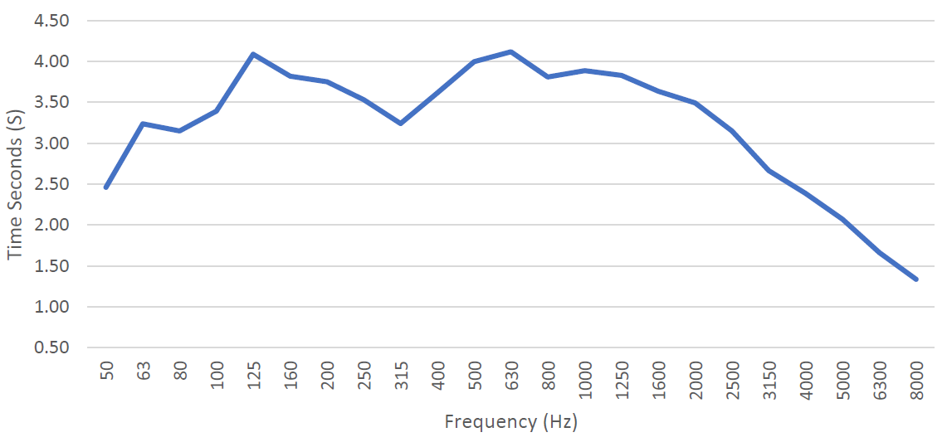
Figure 7- Averaged reverberation time, T20, in an occupied reverberation time
- Measurement Analysis
In this section, analysis of the measurements has been undertaken: Sound power levels have been determined, tonality considered, as well the results of a detailed FFT analysis.
  - Sound Power Levels
The overall sound power levels of each hover, as averaged over three flights was determined, based on the sound pressure level spectra and the reverberation time data collected. The weighted and unweighted results are presented in Table 2.

Table 2: Calculated averaged sound power levels produced by the drone using four blade types
 | Lw_{Z} | Lw_{A}
Quick Release | 84.6 | 83.7
Shaped | 82.3 | 80.6
Quick Release Altered | 81.7 | 80.0
Carbon Fibre | 85.4 | 84.6
Background Noise | 45.6 | 28.8

The A-weighted sound power levels were similar to the Z-weighted levels indicating a broadband sound source emission, see Figure 6. The Carbon Fibre blade had the highest sound power emission, see Table 2. These blades had been expected to be quieter due to the marketing materials. The Altered blades had the lowest emissions.There was a 3.7dB difference between the Original blades and Altered blades in terms of sound power levels, A-weighted.

  - Tonality
From Figure 6, it can be seen that significant noise emission occurred at 160 Hz for the plastic blades (Original, Shaped and Altered) but the frequency of the onset was increased to 200 Hz for the Carbon Fibre blades. At 250 Hz there was a significant dip in sound emission for the Original and Shaped blades that was reduced by 10 dB for the Altered Blades. This more balanced sound spectra for the Altered blades produced less noticeable tonality than for the other blades. This was backed up by a survey of the four observers taking the measurement all agreeing that subjectively the Altered blades were the quietest, see Table 3. Table 3 considered subjective tonality in accordance to BS 4142:2014, where tonality can be rated as 3, 6, or 9 dB.

Table 3: Rated Level for the Drone using 4 blade designs considering subjective tonality

 | Averaged LAeq, 30 s | BS4142 Tonality Penalty | Rated Level (dB)
Quick Release | 86.7 | 3 | 89.7
Shaped | 83.6 | 3 | 86.6
Quick Release Altered | 83.1 | 0 | 83.1
Carbon Fibre | 87.7 | 3 | 90.7

  - FFT Analysis
An FFT is a different way to explore tonality and the relationship tonality may have with the different blade types. The results from the FFT for the different blade types are shown in Figure 5.10.

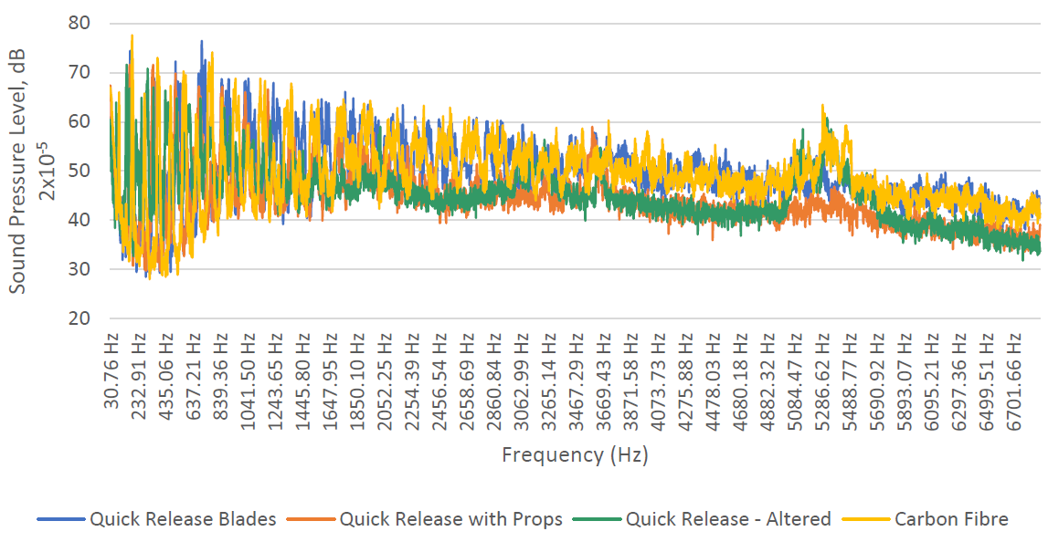
Figure 5.10 – FFT for all blade types as measured at one location over the duration of a Hover.

As seen from Figure 5.10 of the FFT for all blade types, it can be clearly seen that the Altered blade(green line) was significantly lower in the mid-high frequencies with a lower fundamental frequency, 151 Hz. The Original blade had 177 Hz fundamental, Shaped 171 Hz and Carbon Fibre 190 Hz. Harmonics of the fundamental are also shown in Figure 5.10.

Using equation 1 it possible to calculate the rotor speed per blade type from the fundamental frequency, see Table 4. By calculating the RPM, whilst the drone hovers, the work rate of the motor was found. The lower the RPM the more lift the blade must be producing but the harder the motor must work to maintain the hover. As observed by the heat of the motors after the flight tests. The Altered blade was by far the hottest, although not measured. Using the blade dimensions given in Table 1, the blade tip velocity was calculated see Table 4. Now using equation 2 the excess sound produced by the blade due to air turbulence could be calculated, also see Table 4.

Table 4: The blade rotation rate, blade tip velocity and excess sound for the four blade types

 | Rotation Speed (RPM) | Blade Tip Velocity (m/s) | Excess Sound (dB)
Quick Release | 5310 | 65.58 | n/a
Shaped | 6130 | 63.90 | -0.67
Quick Release Altered | 4530 | 55.95 | -4.14
Carbon Fibre | 6700 | 69.80 | 1.63

The predictions based on blade tip speed agree closely with the measurement of the fundamental sound emission for the different blade types, see Figure 5.10. A reduction of 4.1 dB was predicted, a 3.6 dB reduction achieved.
- Discussion
The quietest blade was found to be the Altered blade. The Altered blade was 3.6 dBA quieter than the original blade. This could be due to a number of factors, such as the additional lift created by the larger surface area, which allow the blade to rotate more slowly but create the same amount of lift force. The v-cut teeth would smooth the airflow and hence help create less turbulence.

However, there is another aspect the perceived sound produced by the four types of drone. When this is considered, see Table 4, the carbon fibre blade are the loudest, and the altered quick release the least noisy.
- Conclusions
In summary, by testing a commercial drone using four different blade designs it is possible to analyse the sound emissions during an indoor hover. Three of the blade designs were commercially available and one was an adaptation of the standard blade. The analysis of the measurements showed that the Altered blade design was significantly quieter, 3.7 dB, and but in terms of perception were rated 6.6 dB less than the Original blade design.

The rotation speed of the blade was found to be the determining factor for sound emission and this would be the optimisation criteria for acoustic emission in future blade designs. It was observed that the motors on the drone were significantly hotter after the three consecutive 30 seconds flights. As this takes power it is very likely that flight time would be compromised with the Altered blade design.

References
Finn, Rachel L., and Wright, David (2012), Unmanned Aircraft Systems: Surveillance, Ethics and
Privacy in Civil Application, Computer Law and Security Review 28 (2012) p184 – 194.
Clarke, Roger, (2014), Understanding the Drone Epidemic, Computer Law and Security Review
30 (2014) p230-246
BBC (2019), Coventry City Council set to ban Drones, https://www.bbc.co.uk/news/ukengland-
coventry-warwickshire-46751423, published 3/1/2019 accessed 27/01/2019
Intaratep N., Alexander W. N., Devenport W. J., Grace A. M., and Dropkin A., (2016) Experimental
Study of Quadcopter Acoustics and Performance at Static Thrust Conditions, American
Institute of Aeronautics and Astronautics, Aeroacoustics Conferences (22nd AIAA/CEAS) 30
May – 1 June 2016, Cross Mark AIAA 2016-2873 Lyon, France
Bown, Jessica (2018),Why your pizza may never be delivered by drone, Technology of Business
Reporter, BBC news https://www.bbc.co.uk/news/business-46483178, published 14/12/2018
accessed 27/01/2019
Oeckel Konrad, Heimann Jan, Kersscher Michael, Angermann Sven, Heilmann Gunnar (2018),
Comparative Acoustic Examination of UAV Propellers, Inter-Noise 2018 26-29 August, Impact
of Noise Control Engineering,
Klei, Christine E., Buffo, Rainer M and Stumpf E. (2014), Effects of Wing Tip Shaping on Noise
Generation, Inter0noise 2014 Conference, Melbourne, Australa, Institute of Aerospace
Systems, RWTH Aachen University, Germany.
Pechan T. and Sescu A.(2015), Experimental Study of Noise Emitted by Propeller’s Surface
Imperfections, Applied Acoustics, 2015 Issue 92, p12-17
MilijkovicDubravko (2018), Methods for Attenuation of Unmanned Aerial Vehicle Noise,
DOI: 10.23919/MIPRO.2018.8400169
Leslie A., Wong K. C., and Auld D., (2008), Broadband Noise Reduction from a Mini-UAV
Propeller through Boundary Layer Tripping, Acoustics and Sustainability: How Should
Acoustics Adapt to Meet Future Demands? AAS 2008, 24-26 November, Geelong Australia
Leslie A., Wong K. C., and Auld D., (2010), Experimental Analysis of the Radiated Noise from a
Small Propeller, Proceedings of 20th International Congress on Acoustics, ICA 2010, 23-27
August 2010 Sydney, Australia
Nixon J., (2017), ‘Attack of the Drones! Noise Impact from Recreational Drone use in a Rural
Area, Roxwell’, London South Bank University, Diploma thesis

