Infrastructure Development in the UK: Key Drivers and Implementation Challenges.
Rafiu Dimeji Seidu¹, Herbert Robinson², Bert Ediale Young³, Michael Ryan⁴, Daniel Fong⁵
^{1, 3-5}Division of Construction Property and Surveying, London South Bank University, London, United Kingdom.
²The African Capacity Building Foundation, Fairbairn Drive, Mount Pleasant, Harare, Zimbabwe.

*CORRESPONDING AUTHOR
Rafiu Dimeji Seidu, Division of Construction Property and Surveying, London South Bank University, 103 Borough Road, London SE1 0AA, United Kingdom; seidur@lsbu.ac.uk

Abstract
Infrastructure is a critical factor in fostering strong and sustained economic growth, hence, sufficient attention should be given to the allocation of investment. Although UK infrastructure investment have risen in line with the global trend, the level of investment remains in the lower percentile when compared to other leading countries such as Singapore and China.
The study examines the challenges of infrastructure development in the UK and explored the policies required to stimulate investment. Using semi-structured interviews, the views of key stakeholders involved in infrastructure operating across key sectors of transport and energy were captured to gain an insight into the key policy drivers of infrastructure investment.

Findings from the research suggests that policy changes are required to stimulate significant investment if the UK is to become a world leader in infrastructure. Key criticisms of UK infrastructure policy focussed on comparatively low level of investment, inadequate collaboration between key stakeholders, and the regional bias of investment in favour of London which disproportionately affects the Northern regions.
To facilitate economic growth, the identification of future investible pipeline of infrastructure projects, increasing collaboration with local stakeholders and addressing the regional biases will be critical to ensure synergy and ownership and to scale up the implementation of UK future infrastructure development plans. Considerations should also be given to the need to set up infrastructure banks similar to what is in operation in other countries such as China and Singapore to stimulate private investment and to complement public sector budget allocations. Improving infrastructure project implementation through institutional coordination will boost economic growth post Brexit, support the development of new trading agreements and enhance the country’s economic performance after the pandemic.

Keywords: Infrastructure, Investment, Policy Drivers, Investible Projects, Economic Growth.

1. INTRODUCTION
Infrastructure plays a key role in economic development by providing a competitive advantage in the market, and in driving international trade in goods and services. Infrastructure such as roads, ports, power supply, railways, airports, telecommunication systems, factories, warehouses, and business parks are therefore required to support industrial production, manufacturing, retail and the services sector (Robinson et al, 2015). For example, to facilitate exports of goods and services, it is essential to reduce production, distribution and transaction costs by improving energy efficiency of buildings and expanding road, rail and other communication infrastructure. Inadequate infrastructure can have a damaging effect on the economy such as reduced economic growth, job opportunities, productivity and competitiveness (Seidu et al., 2020).
Infrastructure is a critical factor in fostering strong and sustained economic growth. Sufficient attention should therefore be given to allocation of investment and utilisation of resources to produce the maximum impact of increased infrastructure investment (Yu, 2017). However, appropriate policy measures are crucial to stimulate infrastructure investment and to promote, for example, efficiency, and productivity as well as to reduce social, environmental and economic costs in response to global and national agenda such as climate change, sustainability, and building Information Modelling (BIM). Project selection and implementation of infrastructure guided by appropriate policies will significantly enhance the growth benefits and return on investment (World Bank Group, 2014).

Investment levels in infrastructure in the UK were noted to be comparatively low when compared to equivalent developed nations. There are also clear arguments as to regional dimensions of infrastructure projects to maximise impact, as well as a proactive infrastructure policy creating “spare capacity” to support further growth. For example, London benefits from a disproportionate amount of infrastructure funding; focusing particularly on transport. There are calls for further devolution to cities and regions, following the City Deal agreements, and Localism Act 2011, including more power to cities and regions to receive grants for infrastructure plans, and more control over spending and the ability to attract private investment.

Given the potential for an economic downturn after Brexit, with the Office of Budget Responsibility forecasting that the economy could be £26bn smaller by 2020/21 than was expected in March 2016 (Rumfitt, 2017), there is a potential to utilise infrastructure as an engine to grow the UK economy, address regional disparities and to create employment. It was also predicted that unemployment will surge to 2.6m in mid-2021 due to the government struggling with the increasing rate of Covid-19 (BBC, 2020). Covid-19 and the agreement on Brexit trade is likely to impact negatively on infrastructure investment. Against this background, it is important to review the UK policy framework, key drivers for infrastructure investment, and lessons learned from current practices in the UK as well as other countries. Following this introduction, the paper starts with a literature review focusing on infrastructure policy, implementation challenges and scale of national and regional investment in the UK. The research methodology is outlined and findings from semi-structured interviews are summarized followed by a discussion on the key issues relating to UK infrastructure policy, criticisms on current implementation practices and suggestions on the way forward to stimulate infrastructure investment.

2. LITERATURE REVIEW
Infrastructure Policy and Implementation Challenges
Infrastructure services are central to household, community and economic activities as they facilitate human development, and increase productivity in industry. Key issues on the delivery of infrastructure concerns decisions on what types of infrastructure are required, where they are needed, when and how they should be provided (Howes and Robinson, 2005). Infrastructure policy is also expected to clarify requirements at the planning stage when the size, programme and technical issues are decided and how they interact during execution stage, institutional capacity and level of regional development (IMF, 2015). Establishing a policy framework is therefore fundamental to improving the efficiency and effectiveness of infrastructure delivery (OECD, 2015). All policies are based on a conception of moving from a particular situation to an ideal or desired state and every policy also implies a theory or causal relationship (Howes and Robinson, 2005).
However, if the theory or cause-effect links are incorrect, the policy will fail irrespective of how well it is implemented. Seidu et al., (2020) also noted that policy consistency is essential in UK infrastructure to simplify the process, to ease the burden caused as a result of cost and time overrun, leading to improvement in pre and post contract cost and time estimating.
Infrastructure policy for growth and economic development if properly designed will not only reduce deficits in key types of infrastructure to facilitate growth and development but can act as a powerful tool to address other effects such as migration and population changes, increasing employment and income earnings (Fay and Straub, 2019). According to Cerra et al., (2017) infrastructure policy can contribute to public investment efficiency by acting as a catalyst for increase and prolonged private investment in the development process.
Governance challenges can also be found in the five stages associated with the life cycle of an infrastructure asset (OECD, 2015), from evaluation of infrastructure needs, decision or prioritisation, project preparation, construction and operation/delivery/maintenance. Overcoming the challenges from gathering of data will enable stakeholders to identify the infrastructure needs, prioritisation of the needs during the planning process for aggregation of the projects followed by analysing the costs and benefits to determine value for money. It is also important to select the best procurement system and to manage the supply chain to avoid time and cost overruns inherent in many infrastructure projects. Applying the correct incentives and tools for monitoring infrastructure performance including provision of planned/unplanned maintenance management is also critical (OECD, 2015).
The UK government infrastructure plan sets out the policy aims but in terms of actual implementation, there are a number of criticisms. The current process operates under a framework set out by the Treasury: the Green Book (HM Treasury, 2011) which defines the requirement for Government to approve funding. The steps of gaining agreement follows a process of action justification, objective setting, option appraisal, solution development, solution implementation, and evaluation. The Treasury has used a cost to value analysis since the 1960s to establish the projects that are best to pursue (The Economist, 2017). The cost- benefit analysis of each project is quantified and assigned monetary values to enable direct comparisons of various options. London and the South East can show a higher return on investment due to the ability to maximise the multiplier effect in terms of increased employment levels, increased investment to local areas, and the amount of use a new service would attract (HM Treasury, 2011; Airports Commission, 2014).
Policy makers need to engage with different stakeholders for debating critical policy issues and to capture a range of views such as private investors, regional leaders, regulators, design and construction firms, consumers and users, and special interest groups like trade unions, environmentalists and conservationists (Howes and Robinson, 2005). Depending on the issues different stakeholder interest may impact on the success or failure of a policy. For example, a policy aimed at attracting private investment for infrastructure development should adequately capture the views of the private sector. ‘Joining the dots’, an initiative formed by The Royal Institute of British Architects (RIBA) with regards to addressing problems with the current approach to the implementation strategy of infrastructure investment (RIBA, 2018) argues that this system is broken. The current system is too centralised to maximise value from projects and would benefit from devolution. ‘Join the dots’ calls for more use of local expertise when making decisions on projects, as well as more varied tools of analysis in terms of value recognition. Cross departmental cooperation or collaboration is critical so that local economic and neighbourhood plans relate to local infrastructure plans and the views of different public bodies are reflected in the values related to new projects. For example, there are a wide range of public bodies which are involved in decision making about infrastructure each with their own strategic aims. Projects tend to arise from a single department or public body, the process for decision making about infrastructure is highly technocratic with political sensitivities, where Ministers or local politicians set the goals for evaluating the project by civil servants or local authority officers (RIBA, 2018). For example, transport infrastructure schemes generally aim to increase capacity or to reduce journey times, in line with the policy objectives of the Department for Transport without necessarily conceived to address the ‘big picture’ such as supporting communities and new housing. Hence, making the process rigorous with a systematic approach will ensure that public officials are held accountable for their decision, and preventing an over estimation of project costs and benefit analysis (RIBA, 2018). The City Deals Act (HM Government, 2011) attempts to address this criticism by focusing on the relationship between local government and stakeholders as opposed to central government, as too often there are uneven and inequitable social outcomes as a result of limited information being presented to central government (O’Brien and Pike, 2015). However, even with the introduction of the City Deals Act, it is clear that the Greater London Authority has powers which are far more extensive than the rest of the country, with the Mayor of London able to strike deals with central government over control of assets. Although there is support for new devolution deals being implemented such as the City Deals agreement in 2011, there is a need for a solution in every area of the country before forging deals with independent cities and regions (RIBA, 2018).
There is a likelihood that attention will focus on macroeconomic effects of large-scale infrastructure investment with less consideration given to micro-level effects of the project (RIBA, 2018). This is sometimes reflected in situations where large-scale projects are taking precedence over local infrastructure projects (i.e., HS2, Crossrail, Thames Tideway), resulting in significant challenges as a result of not considering other sustainable options. A recent estimate put the annual cost of congestion on major roads to be over £9 billion (The Guardian, 2017), while disruption from flooding costs a further £1 billion every year (Atkins et al, 2016). RIBA, (2018) suggested the idea of integrated urban models based on a combined model of “street networks, public transport networks, land use, density and demographic data.” It is argued that this approach will allow decisions to be made based on information showing how infrastructure will interact with each other and the local economy but requires heavy involvement at a local authority level, which currently is not the case. Developed nations have been able to strengthen their policy capacity where there is a need to improve infrastructure delivery, to remain internationally competitive and to cope with the increasing challenges of globalisation (Howes and Robinson, 2005).
Global Competitiveness and Infrastructure Investment
Governments throughout the world are continuously increasing investment to support national development objectives (Howes and Robinson, 2005). Over the past decade there has been a renewed focus on infrastructure in the UK, and investment levels have steadily increased across all sectors with ongoing redistribution across regions.
The UK has comparatively low levels of infrastructure investment when compared to countries in the Organisation for Economic Co-operation and Development (OECD) - an economic organisation consisting of 36 member states, founded in 1961 to stimulate economic growth. In terms of investment of Gross Fixed Capital Formation (GFCF), the UK was ranked in the bottom 10th percentile of government investment in non-financial assets. Prior to 2008, the country has climbed from the bottom 10th percentile, spending an average of 2.7% of GDP on GFCF which was lower than the OECD average (Office of the Chief Economic Adviser Scottish Government, 2018). The UK remained 11th position out of 141 countries in 2019 on infrastructure quality whilst spending is below other G7 nations (Rhodes, 2020). With a fall in investment in countries such as Greece and Portugal, the UK remains at the lower end of non-government GFCF as a percentage of gross domestic product (GDP) across the OECD in 2015 (ONS, 2018). UK capital investment was 16.8% of GDP in 2016, while the average across all OECD countries was 21.5%, placing UK in 34th position out of 36 countries, below average (20th position) for investment in dwelling and 33rd position on machinery and equipment (TUC, 2018).
In a global competitiveness report published by the World Economic Forum in 2012, the UK ranked 24th for “quality of overall infrastructure” (Rumfitt, 2017). In contrast, Singapore continuously scores highly on global competitiveness and infrastructure rankings. During the early stages of growth in Singapore, there was a heavy focus on infrastructure, supported by 14 World Bank loans between 1963 and 1975. This financed the deep-sea terminal project at the Port of Singapore which singlehandedly doubled the country’s energy capacity. Infrastructure Asia was established by the Monetary Authority of Singapore in 2018, to facilitate regional collaboration with regards to infrastructure (Lai, 2011). The overarching strategy of this organisation was to increase the ‘investible’ number of projects by serving as a bridge between banks, stakeholders, developers across the industry and the public sector (kikuchi and Unzaki, 2019). These funds were estimated to create a further $39.8billion of investment (Lai, 2011). There are also key lessons that can be learned from Singapore in terms of widespread collaboration between all stakeholders, as opposed to a central government led approach (Lai, 2011).
In terms of overall infrastructure investment, China leads the way with a focus on building reliable rail and road systems, alongside electricity and telecommunication links. In the period between 2001 and 2004, investment in the rural road system increased by 51 percent year on year. The aggressive level of spending was maintained to resuscitate the economy after a reduction in growth (Chen et al., 2013). China managed to sustain growth levels above 6% over a period of 5 years, with figures between 8-12% between 2010 and 2013. Among other factors, large infrastructure spending clearly impacted on the growth figures (Trading Economics, 2019). China is following a policy of aggressive infrastructure investment with 8.5% of GDP as shown in figure 1, with the goal to drive economic growth, power their industries, linking the country via road and rail connectivity and developing urban centres. In contrast, the European Union and United States spends about 2.6% of their GDP on infrastructure for the period 1992-2011. China is currently investing over and above what is required, meaning that they can reduce spending in the future and maintain a sufficient level of infrastructure stock to meet the needs of the population (McKinsey, 2013). This approach aligns with economic views that proactive investment over and above the demand level is a more advantageous method of infrastructure investment (McKinsey, 2013). China with an increased focus and level of funding on infrastructure adopted a supply led strategy with funds created generating a further $39.8billion of investment in industry, and the public sector.
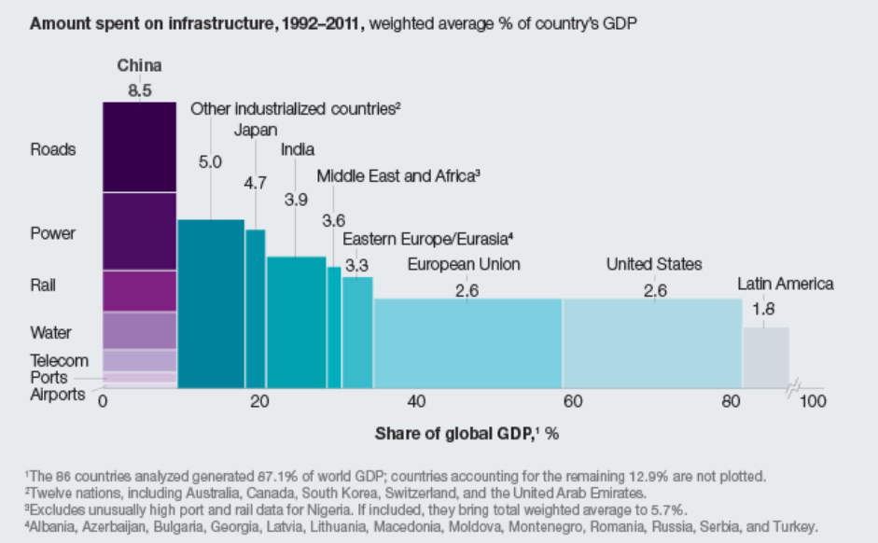
Figure 1: Spending on infrastructure. Source: McKinsey (2013)
China’s infrastructure stock is at 76% of GDP. Within the EU, the UK infrastructure stock of 57% of GDP is also well below the average and significantly behind Germany (71%), Spain (73%), and Italy (82%) as shown in figure 2. Significant investment is therefore required from the UK to build infrastructure stock to facilitate economic growth.

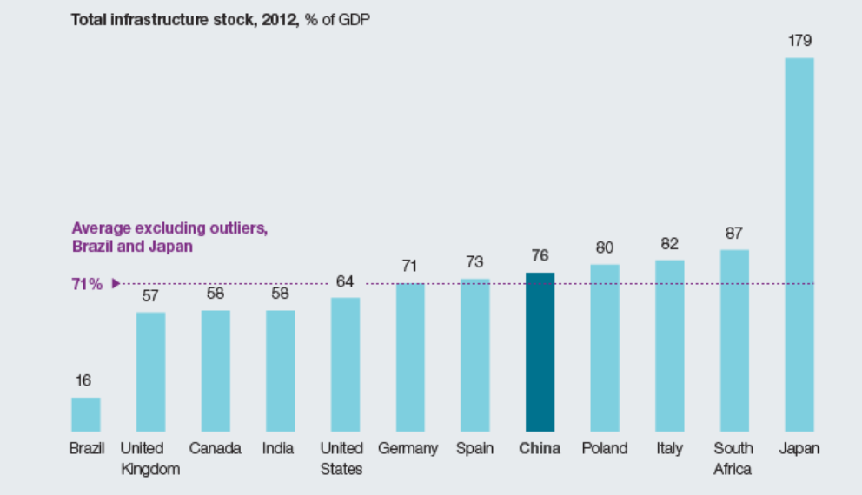
Figure 2: Comparing country spending as a percentage of GDP Source: McKinsey (2013).
UK Infrastructure Investment at National and Regional Levels
The level of government infrastructure investment for 2006-2016 was growing steadily year on year, as shown in Figure 3 (ONS, 2018).
Figure 3: Government infrastructure investment estimates, current prices UK, 2006 to 2016.
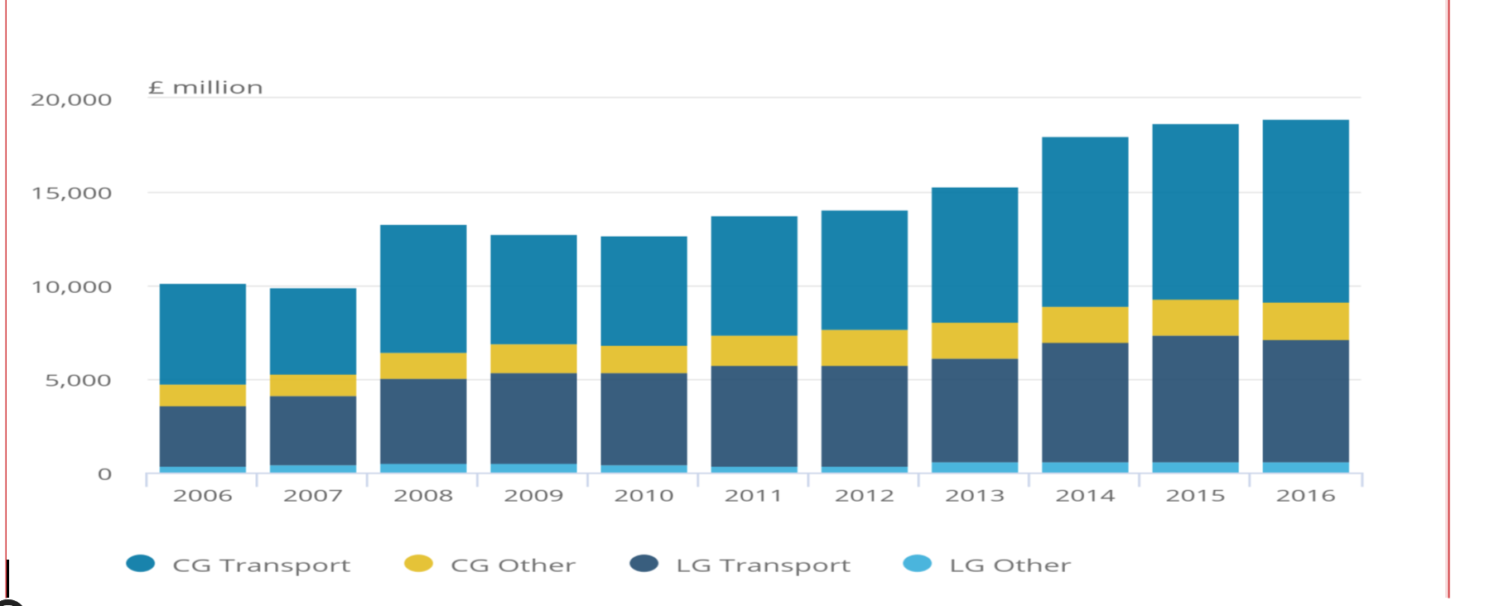
CG: Central Government, LG: Local Government.
Source: Office for National Statistics (ONS, 2018).
Energy has become a priority (see Table 1 below) as a result of environmental pressures and increasing dependent on electricity. In an effort to support this commitment, the government passed the Energy Act in 2013, which introduced Electricity Market Reform.
Table 1: Infrastructure construction (new work) by sub-sector, current prices, UK: 2010 to 2017
Type of work | 2010 | 2011 | 2012 | 2013 | 2014 | 2015 | 2016 | 2017
Water | 2,787 | 2,281 | 1,824 | 1,248 | 691 | 652 | 761 | 1,314
Sewerage | 1,037 | 795 | 710 | 480 | 366 | 448 | 651 | 990
Electricity | 1,348 | 1,635 | 2,383 | 3,453 | 4,829 | 8,114 | 7,983 | 8,903
Roads | 3,789 | 3,836 | 2,280 | 2,583 | 2,762 | 4,036 | 4,518 | 4,221
Railways | 2,333 | 4,065 | 4,137 | 5,002 | 4,066 | 2,999 | 2,655 | 2,879
Harbours | 370 | 462 | 482 | 586 | 897 | 975 | 746 | 665
Others | 1,874 | 2,246 | 2,607 | 1,981 | 1,715 | 1,589 | 1,086 | 755
Total New Work | 13,540 | 15,320 | 14,425 | 15,332 | 15,325 | 18,812 | 18,403 | 19,728
Of which public | 37.0% | 33.6% | 30.0% | 39.2% | 37.9% | 35.9% | 36.8% | 37.1%
Of which private | 63.0% | 66.4% | 70.0% | 60.8% | 62.1% | 64.1% | 63.2% | 62.9%
Total repair and maintenance | 6,841 | 7,755 | 7,672 | 8,086 | 8,801 | 8,496 | 8,067 | 8,817
Source: Office of National Statistics, 2018

The Covid-19 outbreak and uncertainty about post Brexit trade agreement posed a greater challenge on actualising a number of projects in the concept stage due to commence after 2021 Spending Review Period when unemployment and national debt is predicted to increase (BBC, 2020). The UK government focused heavily on infrastructure development as a way of levelling up and uniting the countries by investing about £4 billion on levelling up fund, £4.2 billion on intra city transport settlement (HM Treasury, 2020). Hence, the government is investing in infrastructure to boost economic recovery and create a sustainable growth with the injection of £8.6 billion in summer on infrastructure, decarbonisation, maintenance projects and employment support (HM Treasury, 2020). The government has pledged to invest a further £27 billion on economic infrastructure to support the recovery in 2021-22 and a long-term settlement in road, rail, broadband and floor defence as priority (HM Treasury, 2020).
Investment in the Energy Sector
Major projects like Hinkley Point C focus on securing future energy supply, as well as a focus on renewable energy projects such as offshore windfarms to support a move to lower carbon electricity generation. This is evident in 2018 infrastructure policy and set the UK on a new national record on electricity generation without burning coal. The impact of this policy and investment level, saw an increasing in energy capability to power hundreds of thousands of homes, with lower cost to power industry (Infrastructure and Project Authority, 2018).
Given the drive towards more renewable energy and lower emissions, resulting in an increasing investment levels in energy making up the second most invested sector in the UK. Also, with increased consumption due to a society increasingly dependent on electricity, necessitating a future plan for large scale wind farms and interconnector projects from Europe to boost the supply. Despite this policy initiative, the environmental audit committee noted that there has been a drop in the annual investment in clean energy by the UK government, a fall of 10 percent in 2016 and a further 50 percent in 2017. This is in part due to austerity measures being imposed, including cancellation of the zero carbon homes policy which should have started in 2016 and the removal of the climate change levy exemption for renewables (Environmental Audit Committee, 2018).
Investment in energy has increased over the past decade. However, 2017 was the third year of decline with energy efficiency the only sector experiencing growth. Despite this decline in spending, energy again saw the largest share of investments worldwide (International Energy Agency, 2018). UK investment aligns to this trend with increased investment from 2004, specifically in the electricity sector. Despite falls in recent years to below the 2014 level, the UK went against the trend in 2017 with a slight increase in overall sector growth (Department for Business, Energy and Industrial Strategy, 2018). The investment level in energy was estimated to be up to £100bn by 2020.
Investment in the transport sector
Currently transport investment is heavily focused on transformative high speed rail links, specifically HS2. There are significant criticisms of the HS2 scheme, with high costs, low return for the majority of UK taxpayers, and a waste of resource allocation. The Department of Transport provided an appraisal report setting out the key benefit as saving in journey time relates to added value, i.e., “time is money”. HS2 set out to reduce journey times from Birmingham to London from 84 minutes to 49 minutes. However, the cost of the scheme, originally valued at £34 billion, is significantly higher than the original HS1 and the economic case was based on estimates of demand growth that were much higher than any previous estimate for long distance travel (Aizlewood and Wellings, 2011). Department for Transport (2010), estimated that the level of demand will increase by 267% by 2033, which was claimed to be over forecast by two thirds in HS1 leading to the argument for the realisation of the acclaimed forecast by the analysis. Income generated will be used to offset construction costs on many infrastructure projects, and if these are overestimated during bidding stage, it leaves the government and investors open to overpaying or raising costs to the customer (DfT, 2010b). Long term forecast demand caution as societal needs change, with the current pace of technology with the use of Bim360, CostX, Artificial Intelligence and Machine Learning Quantity Surveyors can now produce more accurate estimates (Seidu et al., 2020).
One of the main arguments for HS2 is to bridge the North-South divide by allowing for regeneration, however, as the figures show the major redevelopment will focus around London (Aizlewood and Wellings, 2011). Despite the disparity in regional funding on HS2, an additional £37million was allowed in 2018 budget to support the development of Northern Powerhouse Rail. A year earlier, the Transforming Cities Fund (TCF) was launched to improve transport links within the regions in order to promote growth. The allocation of £2.5billion to local metro mayors for local and regional investments, shows the nature of investments currently, to promote growth outside of London while continuing to allocate large funds to support infrastructure in London.
The phase one of HS2 will run through 50km of tunnels and over 16km of viaducts. When reviewed in 2015, it was estimated to cost between £35b-£45b with expected phased delivery time of around 2029 and 2033. The benefit/cost ratio was at 1.2:1 which will increase to 1.5:1 when the second phase is considered together (Smith. K, 2020). The second phase will run between Fradley in the West Midlands and Crewe in Cheshire and form a Y shape, with an eastern and a western leg, connecting at Crewe and running through to Manchester. The eastern axis will connect with West Midlands and run through to Leeds (Burroughs. D, 2020). The greatest challenges are the uncertainty surrounding the cost, despite the phase one being targeted to be delivered with £40 billion. There are some differences in assessment in cost with the former HS2 Chairman predicting that £106 billion will be required to complete the project while National Audit Office concluded that this will be in the range of £65b - £88b based on 2015 estimated cost (Burroughs. D, 2020).

Regional distribution of infrastructure Investment

Infrastructure investment in Scotland and the North East has increased considerably over the past few years. In 2017, the North East had the highest proportion of infrastructure investment as a percentage of new construction work at 31% (see Table 2). This is due to large scale renewable energy projects, such as wind farms and biomass plants whist London share has declined over the same period (ONS, 2018). This is due to a number of factors such as the existing number of large-scale infrastructure projects ongoing, and possibly due to criticisms as to the share of London investment which is disproportionate to the rest of the country.

Table 2: Infrastructure share of total new construction work by region, UK: 2010 to 2017
Region | 2010 | 2011 | 2012 | 2013 | 2014 | 2015 | 2016 | 2017
North East | 8% | 15% | 25% | 16% | 20% | 35% | 28% | 31%
North West | 18% | 19% | 19% | 18% | 21% | 21% | 20% | 18%
Yorkshire and the Humber | 26% | 18% | 17% | 20% | 17% | 17% | 19% | 19%
East Midlands | 15% | 16% | 21% | 20% | 15% | 22% | 23% | 23%
West Midlands | 13% | 12% | 17% | 18% | 14% | 16 | 10% | 7%
East | 19% | 19% | 21% | 24% | 21% | 23 | 18% | 22%
London | 22% | 30% | 27% | 24% | 16% | 13 | 11% | 11%
South East | 17% | 19% | 17% | 19% | 17% | 18% | 17% | 20%
South West | 10% | 11% | 13% | 11% | 14% | 18% | 18% | 13%
Wales | 22% | 20% | 14% | 21% | 17% | 19 | 22% | 27%
Scotland | 19% | 21% | 19% | 25% | 27% | 37% | 32% | 29%

Source: Office of National Statistics (2018)

Table 3: Cumulative per capita regional investment by funding source (2018/19 – 2020/21)
Funding Source
Region | Central and Local Government | Private | Total
East Midlands | £1,190 | £1,607 | £2,797
East of England | £971 | £1,379 | £2,350
London | £1,718 | £1,283 | £3,001
North East | £786 | £2,252 | £3,038
North West | £1,636 | £1,160 | £2,796
South East | £1,416 | £1,252 | £2,669
South West | £964 | £2,352 | £3,316
West Midlands | £1,079 | £1,132 | £2,211
Yorkshire and The Humber | £866 | £1,435 | £2,301

Source: Infrastructure and Projects Authority (2018)

Although the above figures show some uneven distribution of funding, independent of government figures found that London is set to receive 2.6 times more than the North, with this figure rising if looking at specific regions such as Yorkshire and the North East (see Table 2 and 3).

Figure 4: Overall spending on transport by region 2012/13 to 2016/17
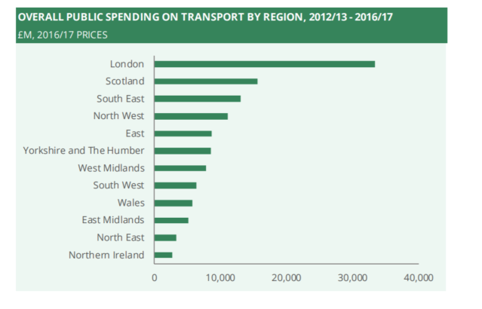Source: House of Commons, 2018
The Institute for Public Research in the North (IPPR) claimed that government figures exclude Transport for London spending plans after 2021, due to a deal between the Transport Secretary and Transport for London which will allow London to maintain business rates to spend on transport, equating to nearly £12billion. This means, London will not contribute to transport investment across the country, generating an additional £240 million per year (Raikes, 2018). With regards to historic spending patterns, apart from spending on roads, London receives significantly more spending per head of resident population on all other forms of transport expenditure (see figure 4). This reflects the relative concentration of public transport within the capital, and also the fact that many people who are not resident in London use the city’s transport system on a frequent basis. There is an argument that with further devolution, northern and regional cities may also be able to agree similar deals, however currently government spending figures, as with the above findings from HS2, should be viewed cautiously.
3. RESEARCH METHOD
Qualitative research approach was adopted as appropriate for small samples to allow for an in-depth exploration, discussion and analysis of the subject (Collis & Hussey, 2003). A semi structured interview format was selected for increased flexibility while maintaining focus on the objectives of the research (Wilson, 2006). The sample detailed below provided the profile of the participants who are professionals with extensive experience and in-depth knowledge of infrastructure development. The key themes/questions explored are shown in Appendix 1.
Profile of Participants in the Sem-structured Interviews
Respondent A: A service provider who interfaces with government to secure funding for infrastructure project. He focused on international comparisons with other market, comparing funding levels to previous years, challenges, and the change from regulatory input to output driven funding models.
Respondent B: A tier one infrastructure contractor provided insight into the changing nature of infrastructure investment, where the industry is focusing geographically, and in which sector.
Respondent C: A researcher with knowledge on regional allocation of funding focusing on the North of England. The Respondent provided further insight into analysis of government figures with the IPPR being an influencer of government policy and analyser of government figures.
Respondent D: A member of an office of government involved in green energy working groups. Respondent provided a perspective on the government’s reaction to where investment should be targeted with particular reference to Crossrail 2 initiative.

The format also allows for comparable and context-specific data to be collected from various respondents to build a richer picture. The interviews were conducted on a one-to-one basis in a location selected by the respondent to limit outside influence and to offer a level of control to ensure unbiased responses. The interviews were audio recorded to ensure accuracy of data included in the research.
4. KEY FINDINGS, ANALYSIS AND DISCUSSION

Respondent A
Respondent A used the National Grid as a case study to argue that National Grid are being allocated less money to work with whilst reaffirming the Department for Business, Energy and Industrial Strategy claim in 2018 stating that “Global investment levels in energy have been falling consistently for the past three years and the UK investment levels align to this”. In 2017, the UK went against a global trend of declining energy investment with a slight increase in overall sector growth (Department for Business, Energy and Industrial Strategy, 2018).” As a result of a change in funding model encouraging the National Grid to be more careful with the choice of projects, or prioritise maintenance over construction of new assets. This is more advantageous to the customer, as National Grid are asked to provide ‘more with less’ and therefore customers should expect a better service. Controlled funding helps the National Grid to look further out in terms of timescales and be more proactive in their maintenance and project choice. The decline in funding can be explained by the government policy of austerity, although this goes against government claims that infrastructure is a priority. These views only relate to the UK and will not explain global decreases in funding, where input funding model is still applicable like US.
A further criticism of the current infrastructure policy system by respondent A is the level of bureaucracy and planning. He noted that some of the considerations required for project selection are plans to offset any potential disruption, the visual impact of projects, and the involvement of local SMEs. He further noted that ‘one potential reason for success of infrastructure in other countries, such as China, is the more flexible planning and construction process’. Therefore, the end costs of the projects are lower and the ability to recoup costs on the projects are also easier. National Grid form part of an initiative set up by the Infrastructure Client Group called “Project 13”. A tagline on the home page of Project 13 website is “Project 13 is an industry-led response to infrastructure delivery models that fail not just clients and their suppliers, but also the operators and users of our infrastructure systems and networks.” (Institution of Civil Engineers, 2018). This forms part of a growing trend as the UK system does not maximise the potential of infrastructure. He argued that it is important to cultivate a new and diverse way to procure infrastructure projects to streamline the process and minimise the number of projects that are delayed and over budget.
Respondent B
Respondent B commented as follows with regard to the marginal increase in infrastructure spending over the past five to ten years:
“Statistically there has been an increased focus on infrastructure, psychologically there hasn’t”
There is generally a negative sentiment in the industry towards tight government budget and time constraints resulting in expensive and delayed projects, exacerbated by delays in decision making with HS2 cited as a prime example. For example, the level of process involved before capital costs on projects even commence resulted in high costs per mile on rail projects on completion – “the government needs to work with Contractors to solve this” and to achieve an increased value for money as a result of a more streamline process. Changes in government also mean that decisions can be changed or delayed resulting in even higher costs to Contractors for labour, plant or material suppliers already engaged.
“There is a greater recognition of the role infrastructure investment plays in economic growth, but a lack of commitment in actioning plans”

The advice given to UK government in terms of improvements in policy are to demonstrate more commitment to UK based infrastructure companies, and a redirected focus from “low cost “solutions, to find the best and most realistic solution instead working with Contractors.
In terms of the distribution of funding on the UK, “perception is reality, and London does receive higher levels of investment.” This has stunted growth in certain areas of the UK, although it is noted that growth for London contributes to the country as a whole and is not as simple as diverting funds elsewhere. This aligns with the views of Luke Raikes (2018) in terms of the overall spending figures, the regional bias which forms part of the North/South debate. Respondent B further noted that if the North lacks anything it is flagship projects in the mould of HS2 or Crossrail as “this would underpin overall investment in the region”
Respondent C
Respondent C focused on the reactionary nature of the industry, the disparity in funding and dominance of London, the Northern Powerhouse initiative and devolution. He noted that spending on infrastructure has increased marginally in the last few years, but with London receiving twice as much as other areas of the country. He further noted that “this increase is not surprising, as it is purely in line with UK infrastructure needs.” The lack of proactive infrastructure led growth is a weakness of the UK policy, unlike other leading countries. London is given as an example of the reactionary nature of the industry, with transport projects often based on relieving congestion. While this is required to keep cities running, it is not a sustainable way to run an economy. He noted one of the only non-reactive projects is HS2 and argued that HS2 had a relatively low-cost value ratio. Raikes, (2018) concurred and indicated that this cannot be looked at in isolation as “political and social considerations also need to be taken into account.” The traditional method of economic appraisal cannot be applied to transformative projects such as HS2, like the borders railway in Scotland which was not based on traditional economic appraisal but has turned out to be a success.
The slow process of actioning projects is highlighted as a weakness in the current UK approach: “The amount of work done prior to construction phase needs to be looked at. Gold plated rail projects need to be benchmarked against comparable projects, possibly in other countries.” It is noted that Scotland is comparably quicker in getting projects off the ground due to the devolution of powers in the region. They are able to invest more in infrastructure, and focus on projects with importance to the region.
“The dominance of London, and the idea that it subsidises the rest of the country is not a good economic model.” Lower productivity in Northern regions results in lower taxation and higher productivity in London results in higher taxation – this is the basis of Respondent C subsidy argument. Therefore, the level of tax in London is higher as expected. The North is stuck in a cycle of low productivity, while London is in a virtuous cycle of growth. Low productivity in the North is also due to the fact that “TfL [Transport for London] has historically had the capacity to bring forward projects to central government”. The North now has Transport for North which has already had a large impact in only a few years (Raikes, 2018).
Devolution is a way of improving the pace of progress, allowing for proactive infrastructure led growth due to smarter and better understanding of regional specificity and requirements. “Relying on central government as a funding source is not sustainable.” France is very similar to the UK, as evident in the dominance of Paris. Other countries have shown a different approach, less reliant on central government, can be adopted with success. For example, Japan has been decentralised over a 15-year period to form micro governments in the regions (Kikuchi and Unzaki, 2019). Germany is federalised, with regional governments involved in central government decision making and are shown to be doing well in global infrastructure rankings. The City Deals act introduced in 2011 was a step toward evening things out if it was only “tokenistic” (Raikes, 2018).
Respondent C policy recommendations is for further devolution including proper agreements with terms of trade as opposed to ad hoc deals. He emphasised that “there is a role for infrastructure in the growth of an economy, but it needs to be assertive and sensible. There is potential in the North which can be unlocked”
Respondent D
Respondent D believe that transport links across the nation urgently need rejuvenating and ability to boost productivity through infrastructure has stagnated as a result. He stressed the need to focus on sustainable and modern technology involved in infrastructure, with the view that the UK should better prepare for the rise of automation, supporting action at European level to manage one of the most profound changes in the world of work since the industrial revolution. He cited examples such as supporting investment in a green economy, renewable energy, sustainable transport systems and environmental management practices based on scientific evidence.
In terms of international comparisons, Hong Kong was highlighted with development plans which provide a funding stream with integrated plans making the most of available opportunities to help pay back the investment faster. The Respondent identified, the Upper Lea Valley community in London, as an area which could be regenerated and support new development plan with the Crossrail 2 project. These mechanisms could be developed to provide additional funding streams for similar type of projects in future with collaboration approach similar to Asian countries and cities which the UK should replicate (Lai, 2011).
He argued that on a global scale, infrastructure spending has increased over the past two decades. There is a growing number of structured spending plans or commitments, such as the G20 Roadmap, the UK National Infrastructure Delivery Plan, the European Union Trans European Network for Energy, and Infrastructure Asia. The drivers behind each of these plans vary. For example, spending figures vary, the amount of private sector investment varies, as well as the level of collaboration between central government and local stakeholders. Forecasts by Global Construction 2030 predicted that the volume of construction output will grow to $15.5 trillion worldwide by 2030. China, India, and the US are predicted as the country’s leading the way. They also predicted that the UK will be the largest infrastructure market in Europe, overtaking Germany, given the government project pipeline (Global Construction Perspectives and Oxford Economics, 2015).
Emerging Issues
Key findings from the interview conducted with key stakeholders are analysed under the following subheadings:

Understanding the Key Drivers of Infrastructure Investment
The UK government sets out its own drivers in the National Infrastructure Plan which are to raise productive capacity, attract private investment, and enable trade on an international level. The links between infrastructure and growth are visible, and there are countries showing impressive growth rates with heavy infrastructure investment. The UK is following global trends of increased infrastructure investment in sectors with the highest returns (energy and transport). However, the UK falls behind on the percentage spend relative to GDP when compared to other leading countries. The percentage spending relative to GDP in China is more than three times that of countries in the European Union, and the spending is well over the level of estimated needs to create “spare capacity” thus maximising the multiplier effect.
There are several key projects that are designed to raise UK’s productive capacity, attract investment and create a competitive advantage such as Crossrail, which is the largest infrastructure project in Europe, and HS2, with plans for further large-scale projects such as HS3 and Crossrail 2. However, the National Grid highlighted decreasing levels of investment in energy despite sustained increases up to several years ago. This may be due to Brexit uncertainty putting some projects on hold, as well as reducing access to funding from the EIB. Investment in transport and energy is not at a level to create “spare capacity” and therefore there will be limited increase in productive capacity.
Reducing the Heavy Reliance on Central Government Funding
There is still a heavily reliant on central government funding with limited levels of private investment. The decline in funding can be explained by the government policy of austerity, although this goes against government claims that infrastructure is a priority. By leaving the EU, and cutting off access to the EIB, private investment will be even less accessible unless other policy measures are put in place. The challenges posed by covid-19 with predicted employment and debt will affect the level of infrastructure investment in UK, the temporary new trade relationship with EU making the future of investment in infrastructure uncertain.

Learning from the Collaboration Experience of other Countries
On a global scale, Singapore consistently scores high on infrastructure rankings as do several other countries across Asia, with China investing the largest amount globally for several years. The main characteristic of the Singapore model is collaboration, with Infrastructure Asia acting to bridge the gap between banks and developers. This is similar to the role of the European Investment Bank (EIB) within the European Union which acts as a source of funding for projects which may fall outside the scope of Government backed initiatives. Since the government has left the EU, access to such EIB facility will definitely come to an end. There is a healthy pipeline of work and a commitment to infrastructure investment in several areas where there are needs for improvements if UK is to become world leaders of infrastructure. Increased collaboration will improve project implementation and this could be in the form of an ‘infrastructure bank’ similar to Singapore or Germany, or simply increased devolution to regions and cities in order to allow collaboration between local stakeholders.
Overcoming Implementation Challenges and Level of Bureaucracy
Project 13 shows that there is sentiment in the industry that the current strategy does not produce the best results, highlighting the number of projects going over the budget with programme delays. Rationalizing the process is one way to minimise initial output costs, by reducing extensive planning requirements which would also reduce overall costs and make the return on investment much easier to accomplish. Further criticisms from the stakeholder’s interview echoed the level of bureaucracy and slow pace of project implementation clearly reflected in the amount of time it has taken to reach the construction phase of HS2. The project has been given a formal notice to proceed in April 2020 with detail design and construction of phase 1 linking London, Birmingham and Lichfield despite being awarded since 2017. This slow progress, paired with the vulnerability to changes in government policy, means that the UK may never be in a position to drive forward proactively with infrastructure investment.

Addressing Regional Bias to Unlock Infrastructure Investment
London and the South East receive a disproportionate and unfair level of funding. By limiting the level of devolution in regional cities, there will be limitations in forming international relationships in other areas to promote infrastructure investment. Further devolution using other hybrid models such as Japan and Germany will be useful to unlock the potential of disadvantaged regions.
5. CONCLUSION
Findings from the research suggests that policy changes are required to stimulate significant investment if the UK is to become a world leader in infrastructure. Key criticisms of UK infrastructure policy focussed on (i) comparatively low level of investment, (ii) inadequate collaboration between key stakeholders, and (iii) the regional bias of investment in favour of London which disproportionately affects the Northern regions.
The UK falls behind in terms of percentage spend relative to GDP but with a strong pipeline of major projects, the UK will experience growth as the main power in Europe for infrastructure over the next decade. In contrast, the levels of investment in some Asian countries such as (Singapore and China) are much higher than the global average. Considerations should also be given to the need to set up infrastructure banks similar to what is in operation in other developed nations to stimulate private investment and to complement public sector budget allocations.

There is significant scope for improved collaboration with local stakeholders to address the high levels of bureaucracy associated with the UK policy framework. Collaboration is a key feature of the success stories in Singapore and other countries where infrastructure investments are higher which is achieved through a policy framework where all infrastructure stakeholders are engaged. Improving infrastructure project implementation through institutional coordination will boost economic growth post Brexit and support the development of new trading agreements. To optimise infrastructure investment, increasing collaboration with other regions and local stakeholders will be critical to ensure synergy, ownership and future-proofing of UK future infrastructure development plans, and the identification of future investible pipeline of infrastructure projects.

There are regional biases in the UK infrastructure policy that prevents maximising the potential growth from infrastructure investment. Regional disparity still exists, with a disproportionate focus on London despite the ‘subsidy’ argument benefitting other regions. Although the return on infrastructure investment is larger in London, some investment opportunities in the North are being overlooked, which is a key area of development which can aid growth across the UK as a whole.
A review of policy is necessary focusing on a variety of alternative suggestions such as Institute for Public Policy Research (IPPR) spending reviews for increased investment, further devolution to allow for investment in disadvantaged regions, a replacement for the EIB will dedicated infrastructure Banks to stimulate private investment as the UK has exited the EU and more collaboration between all stakeholders to maximise the potential of infrastructure within the UK.
REFERENCES
Aizlewood, K. & Wellings, R. (2011). High Speed 2: the next government project disaster? Institute for Economic Affairs Discussion Paper 36. Retrieved from www.iea.org.uk.
Airports Commission (2014) Local Economy Impacts: Assessment. An independent commission appointed by Government. Retrieved from https://assets.publishing.service.gov.uk/government/local-economy-assessment.
BBC, (2020) Spending Review: Unemployed predicted to rise to 2.6 million https://www.bbc.com/news/uk-politics-55072987
Burroughs. D, (2020). Construction begins on Britain’s HS2 project. International Railway Journal. Available from: https://www.railjournal.com/construction-begins-on-britains-hs2-project
Cerra V, Cuevas A, Góes C, Karpowicz, I, Matheson, T., Samake, I and Vtyurina S (2017). Highways to heaven: Infrastructure determinants and trends in Latin America and the Caribbean. Journal of Infrastructure, Policy and Development, 1(2): 168-189
Chen Y, Matzinger S and Woetzel J (2013, 1 June). “Chinese infrastructure: The big picture”. McKinsey Quarterly, 2013(2).
Collis J and Hussey R (2014). Business Research: A Practical Guide for Undergraduate and Postgraduate Students. 4th Ed. London, UK: Palgrave Macmillan.
Department for Business, Energy and Industrial Strategy, (2018) Energy Trends. Available at https://www.gov.uk/government/statistics/energy-trends
Department for Transport (2010b) High Speed Two Cost and Risk Model, London: DfT (March 2010).
Global Construction Perspectives and Oxford Economics, (2015), A global forecast for the construction industry to 2030
HM Government (2011) Unlocking growth in cities. Available at https://assets.publishing.service.gov.uk/government/UnlockingGrowthCities
Howes, R and Robinson, H (2005) Infrastructure for the Built Environment: Global Procurement Strategies, Elsevier Butterworth-Heinemann, Oxford
Infrastructure and Projects Authority (2019). Analysis of the National Infrastructure and Construction Pipeline. London, UK: Infrastructure and Projects Authority, HM Treasury.
International Monetary Fund (2015). Making Public Investment More Efficient. Washington DC: International Monetary Fund.
Institution of Civil Engineers, (2018), Project 13, [ONLINE] Available at http://www.p13.org.uk
International Energy Agency (2018), World Energy Investment 2018
Lai, Kathy, (2011), How Singapore and the GIF are bridging the infrastructure gap in Asia and beyond, [ONLINE] Available at: http://blogs.worldbank.org/ppps/how-singapore-and-gif-are-bridging-infrastructure-gap-asia-and-beyond
Marianne Fay and Stéphane Straub (2019) Rising incomes and inequality of access to infrastructure among Latin American Households. Journal of Infrastructure, Policy and Development (2019) Volume 3 Issue 1. DOI: 10.24294/jipd.v3i1.1116
O’Brien P and Pike A (2015). “City deals, decentralisation and the governance of local infrastructure funding and financing in the UK”. National Institute Economic Review, 233(1): R14–R26. https://doi. org/10.1177/002795011523300103.
Office of the Chief Economic Adviser in the Scottish Government (2018). Exploring the Economic Rationale for Infrastructure Investment. Edinburgh, Scotland: Office of the Chief Economic Adviser, Scottish Government.
Office for National Statistics, (2018), Developing new statistics of infrastructure
Office for National Statistics, (2018), An analysis of investment expenditure in the UK and other Organisation for Economic Co-operation and Development nations. Available from: https://www.ons.gov.uk/economy/grossdomesticproductgdp/articles /2018-05-03
Raikes L (2018). Future Transport Investment in the North: A Briefing on the Government’s New Regional Analysis of the National Infrastructure and Construction Pipeline. London, UK: Institute for Public Policy Research.
Rhodes Chris (2020) Infrastructure policies and investment, House of Common Library, Research Briefing.
RIBA, (2018), Joining the dots: a new approach to tackling the UK’s infrastructure challenges
Robinson, H, Symonds, B., Gilbertson, B and Ilozor, B (2015) Design Economics for the Built Environment: Impact of Sustainability in Project Evaluation”, Wiley-Blackwell, Oxford
Rosewell B (2012). “What are the likely economic and societal impacts of HS2?”. Science in Parliament, 69 (3): 24–29.
Rumfitt A (2017). “Analysing ‘Brexit’: Opportunities and challenges for economic growth”. Journal of Urban Regeneration & Renewal, 10(3): 216–226.
Seidu R, Young B, Robinson H and Ryan M (2020) The impact of infrastructure investment on economic growth in the United Kingdom. Journal of Infrastructure, Policy and Development (2020) Volume 4 Issue 2. DOI: 10.24294/jipd.v4i2.1206
Seidu R D, Young B E, Clack J, Adamu Z, Robinson H (2020). Innovative Changes in Quantity Surveying Practice through BIM, Big Data, Artificial Intelligence and Machine Learning, An International Journal of Applied Science University Journal PP: 37 – 47, vol 4 No 1.
Smith, K. (2020) HS2 contractors set to proceed with phase one detailed design and construction. International Railway Journal. Available from: https://www.railjournal.com/passenger/high-speed/hs2-contractors-proceed-phase-one-design-construction.
The Economist (2017, 29 July). “Does London get a better deal than the regions?” The Economist. Available at: https://www.economist.com/britain/2017/07/29/does-london-get-a-better-deal-than-the-regions.
The Organisation for Economic Co-operation and Development, (2018), Roadmap to infrastructure as an asset class, 2018, [ONLINE] Available at: http://www.oecd.org/g20/roadmap_to_infrastructure_as_an_asset_class_argentina_presidency_1_0.pdf,
The Organisation for Economic Co-operation and Development, (2015) Towards a Framework for the Governance of Infrastructure. Available from: https://www.oecd.org/gov/budgeting/Towards-a-Framework-for-the-Governance-of-Infrastructure.pdf
Tomoo Kikuchi and Sayaka Unzaki (2019) Japanese infrastructure investment in Southeast Asia, Journal of Infrastructure, Policy and Development (2019) Volume 3 Issue 1. DOI: 10.24294/jipd.v3i1.1116
The Guardian (2017). Traffic jams on major UK roads cost economy around £9bn. Available at https://www.theguardian.com
Trading Economics (2019) UK Economics Indicator, Trading Economics, available at https://tradingeconomics.com
TUC News (2018) UK near bottom of OECD rankings for national investment. Available from: https://www.tuc.org.uk/news/uk-near-bottom-oecd-rankings-national-investment

UK Trade & Investment (2013). Investing in UK Infrastructure. London, UK: UK Trade & Investment, HM Treasury.
Wilson JM (2006). “Quantitative methods for business, management and finance, 2nd ed”.Journal of Modelling in Management, 1(1): 85–86. https://doi.org/10.1108/17465660610667829.
World Economic Forum (2012). The Global Competitiveness Report 2019. Geneva, Switzerland: World Economic Forum.
World Bank Group (2014). Results and Performance of the World Bank Group 2014 available at ieg.worldbankgroup.org
Yu H (2017). “Infrastructure connectivity and regional economic integration in East Asia: Progress and challenges”. Journal of Infrastructure, Policy and Development, 1(1): 44–63. https://doi.org/10.24294/jipd. v1i1.21.

APPENDIX A – INTERVIEW QUESTIONS

- Introduction and Background
- What is the name of your organisation, and what is your role?
- Can you provide a summary of your organisation’s involvement in terms of UK infrastructure?

- Infrastructure Policy
- What is the philosophy that currently underpins infrastructure investment – what are the current drivers? (For example, the National Infrastructure Delivery Plan, there is the need to raise the productive capacity of the economy, attract private investment, and enable trade on an international level).
- There has been a slight increase in terms of infrastructure spending as a percentage of GDP over the past few years. Do you see an increased focus on infrastructure compared to previous years or previous governments?
- What do you see as the main changes in terms of UK infrastructure policy and investment strategy over the past decade?
- Do you see a growth in investment in any particular sector, i.e., energy, transport (transport sub-sectors)?
- Do you view any particular sector to have a larger impact on regions than others?
- Do you see infrastructure investment as reactionary or proactive in nature?
- Where do you see the majority of infrastructure investment being directed geographically, and if you see a disparity (i.e., a North/South divide) do you see this as positive or negative, i.e., is the argument that London acts as a subsidy for the rest of the country a valid argument?
- Do you know, and can you provide an overview of the government’s commitment to the Northern Powerhouse initiative?
- What recommendations would you give the government in terms of infrastructure policy which you feel could improve the current impact of infrastructure?

- Best Practice – Examples of previous projects/policies which should be replicated
- In your experience, what are the major problems in project implementation?
- In your opinion, what comments or advice would you give with regards to current policy?
- What is your view about maintenance of current infrastructure over large scale new projects? Do you believe that lack of investment in maintenance is having a detrimental effect on the economy in terms of output productivity, or is the return on investment linked to larger projects preferable? If so, how?
- Do you see any lessons which can be learned from other countries?

