

**London South Bank**

**University**

**Division of Accounting, Finance & Economics**

**School of Business.**

**An Investigation into Variations of Brownian Motion: Towards a Deeper Understanding of Financial Asset Pricing**

**A thesis submitted to London South Bank University**

**for the degree of Doctor of Philosophy**

**In the school of Business**

By

**Muhammad Bilal Shakeel 2717487**



Contents

Dedication 6

Declaration 7

Acknowledgement 8

Abstract 9

Chapter 1: Introduction 10

Background: 10

Research Motivation: 10

Aims of the Research: 12

Motivation and Contribution: 13

Chapter 2 Returns Distribution: 16

Background: 16

Non-Normality and Fat tails: 17

Alternatives to Normal Distribution: 18

Application to Risk Management: 19

Parametric Returns Distributions: 20

Non-Parametric Returns Distributions: 24

Theory of Random Walks: 27

Independence of Price Returns: 28

Bachelier-Osborne Model: 29

Chapter 3 Brownian motion: 31

Background: 31

Bachelier’s Model: 31

Einstein’s Diffusion equation: 33

Movement of Particle: 34

Standard Brownian Motion: 35

Geometric Brownian Motion: 35

Variations of Brownian Motion: 36

Constant Elasticity of Variance Model: 37

CIR Process: 39

Hull-White Model: 39

Heston Model: 40

Multi Fractal Random Walk Model: 40

Jump Diffusion Model: 41

Chapter 4 Probability Distributions: 42

Introduction: 42

Normal Distribution: 43

Lognormal Distribution: 45

Poisson Distribution: 46

Chi-Square Distribution: 48

Gumbel Distribution: 49

Weibull Distribution: 50

Student’s-t Distribution: 51

Pareto Distribution: 52

Gamma Distribution: 53

Logistic Distribution: 54

Laplace Distribution: 55

Cauchy Distribution: 56

Exponential Distribution: 57

Stable Distribution: 58

Jump Diffusion Process: 61

Chapter 5 Simulation and MATLAB computation: 63

Introduction: 63

Simulations: 63

Monte Carlo Simulations: 65

Deterministic problems whose solving is hard or expensive: 66

Complex phenomena not known enough: 66

Statistical problems with no analytical solution: 66

Monte Carlo in Financial Markets: 67

Random Numbers: 69

Using random numbers in simulation experiments: 69

Standard Brownian Motion: 70

Geometric Brownian Motion: 70

The Modified Model: 74

Building the Histogram: 80

Goodness of fit: 85

Chapter 6 Modified Brownian Motion Approach to Modelling Returns Distribution: 86

Introduction: 86

Analysis and Results: 88

Further Discussion: 92

Application in Exceedance Correlation: 95

Chapter 7 Discovering the Irrationality behavior function $f(Z)$: 97

Retrospective study of $f(Z)$: 97

Structure and parameters 101

Stock Market: 101

Semi-closed Experiment: 102

Information Criteria: 102

Findings and Remarks 103

Allocation problem: 103

Stylised Facts: 104

Demand and Supply: 106

News and Dynamics: 106

Further Research 110

Discovering Irrational Behaviour: 111

Towards the $f(Z)$ function: 113

Connecting $f(Z)$ with irrational behaviour: 118

Discussion and conclusion: discovering the psychological soliton. 120

Further connections in Physics: 123

Further Questions and Work: 125

Development of GARCH Process: 126

Mathematical representation of GARCH process and Extensions: 127

GARCH (p, q): 128

Exponential GARCH (EGARCH (p, q)): 129

Asymmetric GARCH model or A-GARCH 130

A-GARCH Volatility forecasts 130

GJR- GARCH: 131

IfBM GARCH: 132

The Original ITO Lemma 133

Modified ITO Lemma with dt 134

Modified ITO Lemma with √(dt) 136

Chapter 8 Modelling and Forecasting the Kurtosis and Returns Distributions of Financial Markets: Irrational Fractional Brownian Motion Model Approach. 138

Introduction 138

Geometric Brownian Motion model 143

Irrational Fractional Brownian Motion model 143

Forecasting Kurtosis and Returns Distribution 146

Conclusion 153

References: 155

Appendices: 167

The Logistic Distribution: 167

The Scaled-t Distribution: 167

The Exponential Power Distribution. 167

**Matlab Functions** 168

Table of Figures:

Figure 1:Standard normal pdf. 44

Figure 2:Lognormal pdf. With different values of σ 47

Figure 3:Poisson pdf. With different values of λ 48

Figure 4:Chi-squared pdf. For different values of k 49

Figure 5:Gumbel pdf. With different values of $μ and σ$ 50

Figure 6: Weibull pdf. With different values of $λ and k$ 51

Figure 7:Student’s-t pdf. With different values of $v$ 53

Figure 8:Pareto pdf. With different values of $α and β$ 54

Figure 9:Gamma pdf. With different values of $α and β$ 55

Figure 10:Gamma pdf. With different values of $μ and σ$ 56

Figure 11:Laplace pdf. With different values of $μ and σ$ 57

Figure 12:Cauchy pdf. With different values of $μ and σ$ 58

Figure 13:Laplace pdf. With different values of $μ$ 59

Figure 14: Plot of Chinese stock prices,1000 simulations and the average. 73

Figure 15: Graph of inverse tangent. 75

Figure 16: S&P500 from 01-2009 to 12-2010 with GBM and MBMM with -2atan(Z) 80

Figure 17: S&P500 from 01-2009 to 12-2010 fitted with GBM and MBMM with -5atan(Z) 80

Figure 18: S&P500 from 01-2009 to 12-2010 fitted with GBM and MBMM with -7atan(Z) 81

Figure 19: S&P500 from 01-2009 to 12-2010 fitted with GBM and MBMM with -9atan(Z) 81

Figure 20: S&P500 with GBM and MBMM (K=-28,c=0.6) 90

Figure 21: Kf (Z) for different negative values of K. c=1. 94

Figure 22:Right Tail of S&P500 for Historic, GBM & MBMM 94

Figure 23: Composition of simulated stock market 102

Figure 24: Plot of the information feedback function *K fc (Zt)* for ****= - 5, c = 1 as a function of  117

Figure 25: Plot of the information feedback function *K fc (Zt)* for various *K* values = -1, - 5, and – 10, and for *c* = 1 as a function of *Zt* 117

Figure 26:Plot of the information feedback function *K fc (Zt)* for *K* = - 5, and various *c* values : *c* = 0.5, 1, and 2, as a function of *Zt* 118

Figure 27:Plot of the information feedback function *K fc (Zt)* for *K* = - 5 and *c* = 1 as a function of ****, emphasizing the various regions of interest. 119

Figure 28:Three dimension figure illustration of ****with Time and $Zt$ 122

Figure 29: Comparison of three simple pulse shapes 125

Figure 30: Comparison of three simple kink shapes 126

Figure 31: Plot of the response/feedback f(Z) function, Equation (6) emphasizing the various regions of interest 145

Figure 32: GBM and IFBM, with optimal k and c ,best fitted two-year daily S&P500 data over 2010-2011. 146

Figure 33: Scatter plot of (k/c) values with corresponding 2-year time periods, between *t* = 1 (for Jan 01, 1950 – Dec 31, 1951) till t= 33 (for Jan 01, 2014- Dec. 31, 2015) 149

Figure 34: Scatter Plot of k/c versus one period lagged k/c. 152

Figure 35: Distribution of S&P500 returns for 2014-15 with GBM, IFBM simulation and IFBM forecast. 154

# Dedication

*To my Parents for everything!*

# Declaration

No portion of the work referred to in the thesis has been submitted in support of an application for another degree or qualiﬁcation of this or any other university or other institute of learning. Where other work is quoted, due reference has been made

# Acknowledgement

Firstly and most importantly, I am deeply indebted to my Director of Studies, Dr. Gurjeet Dhesi and my mentor Professor Parmjit Kaur, for Their tremendous support, constant encouragement and guidance since I started my education in UK and throughout my PhD. They have given me all the love, kindness and care possible unconditionally. I am extremely fortunate to have known Them and I have learnt so much from Them. They have inspired me to become an ambitious independent researcher and most importantly a better human being. Gurjeet has been such an excellent mentor, teacher and friend, it has been a privilege to have him as director of studies and I could not have achieved all I have without His enthusiasm, untiring support and calm advice throughout this project which made this research much more productive and enjoyable. He is always the polar star for me not to lose a direction.

I wish to express my deep and sincere gratitude to my second supervisor, Dr. Lee Rose. He has always given me important suggestions and advice about how to improve my research. I am very grateful to Professor Marcel Ausloos for the excellent and valuable advice to conduct and present the research work. I am very lucky to have and thank my fellow PhD colleagues Washad, Kevin, Ling and my dear friends Babar and Kashif for their ideas, support and timeless friendship. I am thankful to London South Bank University especially the Business School for giving me this opportunity.

I feel a deep sense of gratitude for my brothers, Omer, Shahbaz, Irfan, Fahad and Muaaz, for rendering me the sense and the value of brotherhood. Their trust and unfaltering support always kept me going in this project. I would not have come to where I am without their constant love and trust. I wish also to express my deep and sincere love to my sisters; nephews and nieces whose unfaltering love and encouragement have been truly heart-warming. My lovely wife has been by my side since we got married, her constant love and trust have been my strength in this project. Also during this journey, I have been blessed with a beautiful daughter Zainab who has given a new meaning to my life.

I dedicate this work to my father and mother who have been waiting for my degree and thesis with endless support and trust. I want to thank my family for their constant support, both mentally and physically.

Finally, I want to pay my gratitude to the near and dear ones, who are gone but not forgotten.

I could not imagine finishing this without all the help from those people that care about me. Without the help of all these people, none of the current work would have been feasible.

# Abstract

*Modelling the asset returns distribution has been the focal point of modern finance for almost a century. The extensively studied and applied Geometric Brownian Motion (GBM) modelling process provides the returns distribution to asset prices which is normally distributed. However historical asset returns are skewed and possess excess kurtosis, indicating that a returns distribution has a thicker tail when compared with the normal distribution. Numerous alternate distributions have been proposed to model asset returns, however these distributions are imposed on data exogenously with complex equations for parameter estimation. This innovative research modifies the GBM model by embedding an extra factor to capture leptokurtosis of historic data. This extra factor incorporates a weighting factor and a stochastic function modelled as a mixture of power and trigonometric functions. Simulations based on this Modified Brownian Motion Model with optimal weighting factors selected by goodness of fit tests, substantially outperform the basic GBM model in terms of fitting the returns distribution of historic data price indices. Furthermore this research provides an interpretation of the additional stochastic term in relation to irrational behaviour in financial markets. An innovative extension of Geometric Brownian Motion model is developed by incorporating a weighting factor and a stochastic function modelled as a mixture of power and trigonometric functions. Simulations based on this Modified Brownian Motion Model with optimal weighting factors selected by goodness of fit tests, substantially outperform the basic Geometric Brownian Motion model in terms of fitting the returns distribution of historic data price indices. Furthermore we attempt to provide an interpretation of the additional stochastic term in relation to irrational behaviour in financial markets and outline the importance of this novel model.*

*Following a Geometrical Brownian Motion extension into an Irrational fractional Brownian motion model, we re-examine irrational agent behaviour reacting to time dependent news on the log-returns for modifying a financial market evolution. We specifically discuss the role of financial news or economic information positive or negative feedback of such irrational (or contrarian) agents upon the price evolution. We observe a kink-like effect reminiscent of soliton behaviour, suggesting how analysts' forecasts errors induce stock prices to adjust accordingly, thereby proposing a measure of the irrational force in a market.*

*This research also reports a new methodology and results on the forecast of the numerical value of the fat tail(s) in asset returns distributions using the Irrational fractional Brownian Motion Model. Optimal model parameter values are obtained from fits to consecutive daily two-year period returns of S&P500 index over [1950-2016], generating 33-time series estimations. Through an econometric model, the kurtosis of returns distributions is modelled as a function of these parameters. Subsequently an auto-regressive analysis on these parameters advances the modelling and forecasting of kurtosis and returns distributions, providing the accurate shape of returns distributions and measurement of Value at Risk.*

# 

# Chapter 1: Introduction

## Background:

The financial returns modelling has been an important topic in finance for almost a century and several theoretical models have been applied to model financial returns. The most significant and famous of the theoretical models is the Brownian Motion Model (*hereafter* Brownian Motion) (Brown, 1828) or the Random Walk Model (Bachelier, 1900; Cootner, 1964), which is the cornerstone of mathematical finance. Brownian Motion states that the price today is independent of the price yesterday (Bachelier 1900, Davis and Etheridge, 2006). The idea of price movement is analogous to the concept of movement of free particles in a fluid, a process which is described by a partial differential equation, and which has been adapted for finance in almost the same way but with extensions through stochastic calculus. This is fundamental for asset pricing in a perfect market environment. Several consequent extensions have been established on the basis of this model, for example the famous Efficient Market Hypothesis (Fama, 1970) and Black-Scholes Option Pricing formula (Black, Scholes, 1973).

## Research Motivation:

Financial modelling is based on the normal distribution and its properties. However, it is now generally acknowledged that the distribution of financial returns (especially with horizons shorter than a month) is not well described by a normal distribution. In particular, the empirical return distributions, while unimodal and approximately symmetric, are typically found to exhibit considerable leptokurtosis, i.e. they are more peaked in the centre and have fatter tails than the Gaussian with the same variance.

The assumption of normality has been seriously challenged by the work of Clark (1973), Fama (1965) and Mandelbrot (1963). For example, Mandelbrot proposed that financial returns can be modelled using a stable Paretian distribution with a characteristic exponent of less than 2, displaying the fat tails and an infinite variance. And Fama (1965) verified Mandelbrot’s findings by using thirty stocks of the Dow Jones Industrial Average, and concluded that stocks have much greater volatility than that predicted by the standard deviation of Normal Distribution.

The emergence of stable Paretian distributions, with a better fit for financial returns, raised further doubts about standard statistical tools, leading many researchers to look for alternatives. Clark (1973) proposed a finite-variance subordinated stochastic process and established that the lognormal distribution provided a better fit for cotton futures prices than the stable Paretian distributions. Peters (1991) discovered that the distribution of S&P500 weekly stock returns from (1928-1989) was: negatively skewed, possessed fat tails and had a high peak.

Since the seminal work of Mandelbrot, numerous distributions have been applied on empirical data and many new distributions have been developed. Some of these distributions favour the central limit theorem, some are based on solutions to specific equations and others rely on descriptive statistics; and many studies have shown that these distributions do, in fact, provide a better fit of empirical data than the Gaussian distribution. Some of the notable candidates include alpha-stable, jump diffusion, logistic, Weibull, scaled-t, hyperbolic and mixture distributions amongst others (Kou, 2002).

Almost every distribution has different or extra parameters as compared to the normal distribution; thus parameter estimation for the new model is as vital as its application.

## Aims of the Research:

This thesis consists of a selection of work which I have contributed to the field of Financial Economics over the past few years. The layout of this thesis is presented in an alternative format. The work presented in the form of chapters is either papers published in refereed journals or papers currently under review for refereed journal. The conclusion is listed at the end of each chapter, indicating that we have (or have made progress) in achieving the aims of this work.

Main aim of this thesis is to modify the Brownian Motion Model for a better fit of financial returns distributions.

In order to achieve the above mentioned research aim, the following work objectives have been set:

* Add extra function to enhance the Brownian Motion Model used in finance and thereby better explain the data.
* Determine the extra components relating to the irrationality of the market for the pricing model.
* Run simulations to provide the best-fit modified model for empirical data.
* Interpret the extra components with respect to Economic Theory, to see if these can be related to extreme events in finance which act as driving forces to price movement.
* Analyse the modified model to confirm its mathematical and statistical rigour.
* To further investigate the implications and applications of the modified model.

## Motivation and Contribution:

**Chapter 2 Returns Distribution:** This chapter leads on from chapter 2. After modelling the asset price to the Brownian Motion, it is imperative to apply some Mathematical model for further analysis and application. This chapter presents a brief description of different approaches of modelling the asset prices.

**Chapter 3 Brownian Motion:** The history of Mathematical Finance and the modelling of risky asset prices both begin with Brownian motion. Thus this chapter presents a brief review of history of Brownian Motion and its evolution from natural sciences to Mathematical Finance. I expect this review will help the readers understand about the aim of this work as modifying the Brownian Motion in context and its application in Mathematical Finance.

**Chapter 4 Probability Distributions:** This chapter presents a brief selection of different probability distributions applied to different financial instruments over the years. The emphasis in this chapter is to highlight that these probability distributions do not always model the empirical data.

**Chapter 5 Simulations and MATLAB codes:** The main motivation came from while working on previous chapters. Simulations have been applied in decision making and Finance for a long time. The policy contribution of this research would be in the modification and application of Brownian Motion to asset pricing. In particular, the empirical and experimental study of the modified model will enhance the application of the Brownian Motion model – leading to the possibility of improving the performance of underlying financial instruments and processes, which it is acknowledged, is the method most commonly used by financial practitioners and researchers for asset pricing.

**Chapter 6 Modified Brownian Motion Approach to Modelling Returns Distribution:** The motivation came from an experimental paper (Dhesi *et al*., 2011) relating to the semi-closed stock market. The model used for the experiment was the Geometric Brownian Motion (GBM) model with extra factors for demand and supply embedded into it. The research develops the theory of the Modified Brownian Motion Model and applies this to asset pricing in the financial domain and then investigates its implication and application. The robust test of its theoretical strength will be undertaken by using techniques of stochastic calculus and empirical financial econometrics.

Furthermore, apart from the theoretical or technical side of academic research, the research also focuses on the empirical application of the modified model on real financial data. The goodness of fit test is conducted by simulating the return distribution from the theoretical model and comparing this to the empirical return distribution. In addition, to see whether this new model provides a better understanding and interpretation of various financial anomalies and irrationalities, the results are compared to those obtained from the original Brownian Motion model.

**Chapter 7 Discovering the irrationality behaviour function $f(Z)$:**

This chapter aims at designing the different important components of a semi-closed simulated stock market (pricing mechanism, stock allocation and news generation). The purpose is to understand the interactions of the different aspects within a ‘semi-closed’ system. The complexity and nature of the system led to the process of modifying the pricing mechanism which is viewed from a different angle to the classical Brownian Motion and the Random Walk model. However, it incorporates the essence of these two fundamental theories and then investigates the matrix of investors’ behaviour in relation to news feedback. This chapter also explores the realm of randomly generated news to the responses of participants to determine rational and irrational behaviour. This is carried out through uncompressing the time within the experiment and looking at concordant and disconcordant behaviour. The focus is on how the modified pricing equation adapts to the conditions and uniqueness surrounding a semi-closed stock market.

Following a Geometrical Brownian Motion extension into an Irrational fractional Brownian motion model, this chapter re-examine irrational agent behaviour reacting to time dependent news on the log-returns for modifying a financial market evolution. We specifically discuss the role of financial news or economic information positive or negative feedback of such irrational (or contrarian) agents upon the price evolution. We observe a kink-like effect reminiscent of soliton behaviour, suggesting how analysts' forecasts errors induce stock prices to adjust accordingly, thereby proposing a measure of the irrational force in a market.

**Chapter 8 Modelling and Forecasting the Kurtosis and Returns Distributions of Financial Markets: Irrational Fractional Brownian Motion Model Approach:**

This chapter reports a new methodology and results on the forecast of the numerical value of the fat tail(s) in asset returns distributions using the Irrational fractional Brownian Motion Model. Optimal model parameter values are obtained from fits to consecutive daily two-year period returns of S&P500 index over [1950-2016], generating 33-time series estimations. Through an econometric model, the kurtosis of returns distributions is modelled as a function of these parameters. Subsequently an auto-regressive analysis on these parameters advances the modelling and forecasting of kurtosis and returns distributions, providing the accurate shape of returns distributions and measurement of Value at Risk.

# Chapter 2 Returns Distribution:

## Background:

Many attempts have been made, since the first agreement to trade on the NYSE in (1792), to model the stock market’s behaviour. But so far, can anybody claim to have found out the rules enabling them to predict tomorrow’s move for instance? And do these rules even exist? Actually, the efficient markets theory states that market prices reflect the knowledge and expectations of all investors. As a consequence, this theory predicts, according to Fama (1965) that the market would react quickly to such a discovery and these patterns would be modified instantly. Contrary to natural laws that govern physics, laws of the market adjust themselves to new discoveries.

The risk of the asset price is fully described by the asset return distribution. Bachelier (1900), considered as a pioneer in the study of financial mathematics and stochastic processes, is credited with being the first academic to discuss the use of Brownian motion to evaluate stock options. Almost 60 years later, Osborne (1959) formally specified the asset return generating process as Brownian motion. They both assume that price changes from transaction to transaction in the individual security are random drawings from the same distribution, implying that successive price changes are independent and identically distributed (IID). The central limit theorem leads us to expect that the distribution of the sum of IID random drawings generally approaches a normal distribution as the number of items in the sum increases. Thus the distributions of daily, weekly, and monthly price changes are approximately normal in the Bachelier-Osborne model. Strictly speaking, continuously compounded single-period returns are IID normal, which implies that single-period gross simple returns are distributed as IID log-normal variants. The IID (log) normal distribution assumption is then widely accepted in modern financial theories: portfolio theory Markowitz (1952), capital asset pricing model (Sharpe, 1964; Lintner, 1965; Mossin, 1966; Black, Jensen, and Scholes, 1972), option pricing (Black and Scholes, 1973; Merton, 1973), arbitrage pricing theory (Ross, 1976) and risk management (Risk Metrics, 1996). But as attractive as the log-normal model is, it is not consistent with all of the properties of historical stock returns. Historical returns show the weak evidence of the skewness and the strong evidence of the excess kurtosis on a short horizon. Sample estimates of the skewness for daily US stock returns tend to be negative for stock indexes, but close to zero or positive for individual stocks, whilst those of the excess kurtosis for daily US stock returns are large and positive for both indexes and individual stocks, indicating that returns have more mass in tail areas than would be predicted by a normal distribution. Hence, the initial approach does not satisfy any requirements of the empirical asset return distribution.

## Non-Normality and Fat tails:

A fat-tailed distribution is first captured by Mandelbrot (1963) who criticises the extensive reliance on the normal assumption for asset pricing and the investment theory. Fama (1963, 1965), Clark (1973) and Robert and Nicholas (1974) argue the non-normality of stock returns and develop their modelling as IID draws from fat-tailed distributions (e.g. non-normal stable distributions). The non-normal stable distribution has more probability mass in tail areas than the normal distribution. Although stable distributions were popular in 1960’s and early 1970’s, they have fallen out of favour, partly because they make a theoretical modelling so difficult. Although standard financial theories always require the finite second moment of asset returns and often finite higher moments as well, stable distributions have some counter-factual implications:

Firstly, they imply that sample estimates of second and higher order moments will tend to increase as a sample size increases, whereas these estimates seem to converge in practice.

Secondly, they imply that long-horizon returns will be just as non-normal as short-horizon returns. In practice, the evidence for the non-normality is much weaker for long-horizon returns than for short-horizon returns.

## Alternatives to Normal Distribution:

Various candidates for the asset return distribution have been suggested in the literature. Recommended symmetric distributions are Student-t and Generalised Error Distribution (GED). The Student-t has fatter tails compared with the standard normal distribution and the kurtosis is determined by the degrees of freedom parameter. The GED of Subbotin (1923) is first used by Nelson (1991) for modelling a stock return distribution. It possesses a moment generating function for the straightforward derivation of moments that are used to price derivative assets. Moreover, Theodossiou (2000) demonstrates that the parameter estimation of GED is no less sensitive to outliers in the data than the Generalised-t distribution, and it is much more flexible in specifying tails via a shape parameter.

Recent research studies the asymmetry and higher order moments of the asset return distribution. The latest finance theory extends the classical modern finance theory based on the mean-variance normality, into the theory associated with higher order moments such as skewness and kurtosis. The asset pricing theory concerns the pricing of systematic higher order co-moment risk, like co-skewness or co-kurtosis risk (Harvey and Siddique, 2000; Chung, Johnson, and Schill, 2006; Vanden, 2006; Post, Van Vliet, and Levy, 2008; Adrian and Rosenberg, 2008). The importance of including the higher order co-moments is also found in the portfolio theory as being essential factors for optimal asset allocations (Mitton and Vorkink, 2007; Guidolin and Timmermann, 2008). The option pricing study of Bakshi, Kapadia, and Madan (2003) provides several insights into economic significances of the skewness and it also provides an explanation for the presence and the evolution of the risk-neutral skewness over time and across cross-section. Although these theories fundamentally concern the existence of higher-order (co-)moments of asset returns and the including them as systematic factors for the efficient pricing of the risk, they do not much concern the choice of the distribution and the estimation of higher order moments.

## Application to Risk Management:

Risk management is most sensitive to the underlying distribution of the asset return, since the risk is usually defined as a maximum loss given the probability. For instance, Value-at-Risk (VaR) depends entirely on the quantile of the distribution. Hence, the risk management devotes all efforts to the accurate modelling of the return distribution. Early VaR models employ a symmetric distribution determined by the first two moments, e.g. normal distribution. The Risk Metrics of the JP Morgan company is a typical example. However, such models fail to improve accuracy and efficiency because of the biased choice of the distribution. Recent studies deal with the choices of distribution that allow for the asymmetry and higher order moments. Mittnik and Paolella (2000) shows that the asymmetric modelling of the second order moment improves the VaR forecast. Furthermore, Venkataraman (1997), Fernández and Steel (1998) and Giot and Laurent (2003) improve the VaR forecast by employing the family of skewed distributions. Most recently, Bali, Mo, and Tang (2008) demonstrate that the GARCH specification of the first four moments with a skewed generalised Student’s t distribution improves the accuracy of the VaR forecast in line with Hansen (1994), Harvey and Siddique (1999), Jondeau and Rockinger (2003).

In addition to the non-normality of the asset return distribution, the time-varying nature is another key factor in modelling and forecasting the asset return distribution. Hence, the modelling of the return distribution usually comprises two procedures:

1. the specification of the return distribution and
2. the time-dependence specification of the return distribution. Procedures are methodologically embodied in a parametric, a non-parametric, or a hybrid manner.

## Parametric Returns Distributions:

The parametric approach is the one most dominant in the literature. A distribution form is pre-specified and a time-varying structure is then applied to moments of the asset return distribution. As discussed above, there are a number of distribution families for describing the asset return distribution. However, the goodness-of-fit of the selected distribution family varies over time horizons and across asset returns. The time-varying structure is mainly specified by the autoregressive process. The autoregressive model of the first order moment (mean) has a long history in the time series model. The time-varying second order moment is generally modelled by the GARCH process (Engle, 1982; Bollerslev, 1986) where volatility depends on its own past values as well as past squared errors. There is a number of extended GARCH version. ARCH-M (Engle, Lilien, and Robins, 1987) specifies a relationship between the excess return and the risk premium in the term structure, but the empirical evidences for the relationship are not robust. The exponentially weighted moving average (EWMA) of Risk Metrics (1996) is the special case of the no stationary version of the GARCH which is introduced as IGARCH (Engle and Bollerslev, 1986). Risk Metrics is the first step in the industry to combine risk management with the GARCH family. IGARCH assumes the infinite horizon of decaying horizon of the volatility, but empirical findings describe that shock on the volatility seems to have a long, but not infinite memory. Hence, Risk Metrics tends to overestimate the persistence of the volatility. Over persistence of the volatility stimulates the fractionally integrated GARCH model (FIGARCH, Bollerslev and Mikkelsen, 1996). A fractional parameter controls the rate of the hyperbolic decay in the autocorrelation of the conditional variance. The generalisation of FIGARCH is hyperbolic GARCH (HYGARCH, Davidson, 2004). Component GARCH (CGARCH, Ding and Granger, 1996; Engle and Lee, 1999) also captures slow decay in the conditional variance.

In the second-order moment (volatility) specification, the asymmetric effect on the conditional variance is an important issue in the empirical finance. Exponential GARCH (EGARCH, Nelson, 1991) captures the widely accepted notion that negative shocks lead to larger conditional variances than positive shocks. GJR-GARCH (Glosten, Jagannathan, and Runkle, 1993) is another such extension which sought to capture such asymmetry. These two models therefore reflect the leverage effect in stock return (Black, 1976). Engle and Ng (1993) propose the feedback mechanisms of positive and negative shocks (good and bad news) using the news impact curve to evaluate asymmetric GARCH models. Their empirical results of daily Japanese stock return data suggest that GJR-GARCH is the best parametric model. EGARCH also can capture most of the asymmetry, but there is evidence that the variability of the conditional variance implied by EGARCH is too high. Threshold GARCH (TGARCH, Zakoian, 1994), smooth transition GARCH (STGARCH, González-Rivera, 1998) and asymmetric power ARCH (APARCH, Ding, Granger, and Engle, 1993) are also included in the asymmetric GARCH models.

Early GARCH family assume fundamentally that time dependent structure of asset return can be described completely by the first two conditional moments. However, the non-normality of asset return cannot be explained completely by the first two moments. It needs higher order moments than second order moment. At least skewness and kurtosis must be included because skewness describes the asymmetry and kurtosis the degree of fat-tail. Moreover, the time-dependence of these two moments should be specified for time-varying nature. Therefore, volatility specification alone by the classical GARCH-family is not enough to describe the time-varying non-normal asset return distribution. Harvey and Siddique (1999) present the methodology for estimating time-varying conditional skew-ness with the non-central Student’s t distribution (GARCHS). They find that the conditional skewness is important in daily, weekly and monthly stock returns. They show that the evidence of asymmetric variance is consistent with conditional skewness, and inclusion of conditional skewness also impacts the persistence in conditional variance. Brooks, Burke, Hervi, and Persand (2005) propose the model for the autoregressive conditional heteroscedasticity and kurtosis with the standard Student’s t distribution (GARCHK). They find significant evidence of the presence of autoregressive conditional kurtosis in a set of four daily financial asset return series comprising US and UK stocks and bonds. Hansen (1994) generalises ARCH model to specify the higher order moments parameters on the past information set. He uses the specialised version of generalised Student’s t distribution. He finds the substantial empirical evidence of significantly time-varying higher order moments: the skewness and degrees-of-freedom parameters that are used to model the standard residuals on the one-month excess holding yield on U.S. Treasury securities and the monthly Dollar/France exchange rate, are statistically significant. Following Hansen (1994), Jondeau and Rockinger (2003) provide the different econometric specification of the time-varying higher order moments (GARCHSK). They specify the time-dependence of higher order moments, as well as contemporary relationship between moments (skewness parameter and kurtosis parameter) which is not found in Hansen (1994). They provide evidence that time-varying skewness and degrees-of-freedom parameters of the generalised skewed Student’s t distribution for standardised residuals on a set of daily stock indexes and foreign exchange rate are statistically significant. In most cases, they find a time-dependence of the asymmetry parameter, whilst the degree-of-freedom parameter is generally found to be constant over time. They also provide evidence that skewness is strongly persistent, whilst kurtosis is much less persistent. The model of Jondeau and Rockinger (2003) is most popular among parametric time-varying higher order moment models because of its general specification. However, as presented in their paper, there are many possible specifications (6 cases) compared with other models, since there are more parameters that must be considered.

In spite of intensive efforts for developing parametric models, they still suffer from several uncertainties. Most well-established uncertainties associated with parametric econometric models can be summarised as follows:

Firstly, there is an uncertainty in selecting the best approximation to the true (unknown) asset return distribution, which also tends to vary over time horizons and across asset returns. The choice of an appropriate distributional form is also likely to be affected by the nature of the markets, the assets and the regions. Moreover, we must test the goodness-of-fit in order to select the best one. Simply put, the use of an incorrect distribution will clearly affect the entire empirical analysis.

Secondly, there are uncertainties in modelling the time-dependent structure of the underlying parameters. Especially, when modelling dynamic interactions among the first four moments considered by Jondeau and Rockinger (2003), the misspecification error will be likely to be more substantial, potentially resulting in misguided empirical findings.

Finally, computational complexity and burden will be non-negligible. The distribution is determined by parameters which are estimated by MLE using a numerical optimisation algorithm. Most parametric models employ MLE technique, mainly using the numerical optimisation algorithm to deal with the potential non-linearity and asymmetry of the likelihood function. Indeed modelling the time-varying interactions among the higher order moments obtained from the underlying asymmetric distribution function (e.g. skewed Stu-dent’s t-distribution) makes it much more complicated to optimise the likelihood function.

## Non-Parametric Returns Distributions:

In this regard, the non-parametric modelling of the asset return distribution may be an alternative approach. It is parameter free and should be a robust approach when we have enough observations to estimate an empirical distribution. The use of the non-parametric approach is found in the historical simulation technique for the VaR analysis and the stochastic dominance evaluation. Even though the non-parametric approach is easier, less uncertain and more robust than the parametric approach, there is a lack of dynamics on the asset return distribution. Ignoring the time-varying nature is more likely to provide misleading results. In order to mitigate the drawbacks of the non-parametric approach, a hybrid approach has been developed. It takes advantages from the parametric and the non-parametric approaches to improve the modelling of the asset return distribution. A filtered historical simulation (Barone-Adesi, Giannopoulos, and Vosper, 1999, 2002) strongly supports the advantage of the hybrid approach to the VaR analysis. Therefore, it is prudent to develop the hybrid approach which is essentially required in modelling the time-varying non-normal asset return distribution.

Anyhow, financial and scientific communities persist in building new models, not only because we are eager to understand, but mainly because predicting tomorrow’s move is not the only way to make money. Where the study of Fundamentals or Technical Analysis is broadly used by traders on the market floor, Quantitative Finance tries to evaluate risk and hence price assets using statistical models of the market.

On market floors, two completely different types of traders usually coexist: fundamentalists and chartists. Fundamentalists believe that the stock price of a company reflects its intrinsic value. This intrinsic value depends on the present and forecast economic situation of the company (its “fundamentals”) and is mainly influenced by any new piece of information about these fundamentals. The problem is to evaluate this intrinsic value.

On the other hand, chartists only analyse historical data (the “charts”) of the stock, mainly the historical price, but other indicators as well, such as traded volumes, volatility, past resistance and support thresholds, etc. They try hard to find out hidden patterns that replicate over days, weeks, month or years, according to their speculative or investment needs. The assumption is that the market should have a short/long term memory, so we could use the past to predict the future. But here, the efficient market hypothesis asserts that all information which can be learned from technical analysis of stock prices is already reflected in those prices. According to this hypothesis, past stock prices may be useful to estimate the parameters of the distribution of future returns, but they do not provide information which permits an investor to outperform the market.

Broadly speaking, none of those stock traders (fundamentalists or chartists) daily use the quantitative models. But these models are used on the floor by derivative traders and in risk divisions of investment banks to elaborate the global trading policy of the bank, the risk aversion, the over-night limits of individual traders, etc.

It is not surprising to learn that quantitative models are neither fundamentalists nor chartists. They are much more deeply involved with maths. In fact, the theory underlying most of these models, called the “Theory of Random Walks”, claims that successive price changes $(P_{t}-P_{0})$ or price returns $(\frac{P_{t}}{P_{0}})$ are independent, identically distributed (i.i.d.) random variables. This i.i.d. hypothesis has been studied by E. Fama in (1965) and is still discussed today.

Under this assumption of i.i.d. price returns, many models have been developed, but two of them are used commonly nowadays. The first and most common one, called the Bachelier-Osborne model and elaborated in (1959), states that price returns have a constant finite volatility over a given period of time (“time lag t ”), e.g. one day, one week, one month, etc. This theory results in a log-normal distribution for price returns and volatility proportional to the square root of the time lag, i.e. the weekly volatility will be about $\sqrt{5}$ times higher than the daily one. But it is now known that price returns do not follow a Gaussian distribution, since they exhibit kurtosis and fat tails: dramatic draw downs and spectacular jumps arise far more often than predicted by a Normal distribution. Hence, the idea of infinite volatility appeared. It was introduced by Mandelbrot in (1963) and leads to stable Pareto-Levy distributions that can exhibit fat tails. Unfortunately, the hypothesis of infinite volatility supposes that the variance increases indefinitely with sample size, which is not verified by empirical data.

## Theory of Random Walks:

The Theory of Random Walks has been used for almost 50 years by the main statistical models of the stock markets. It was first introduced by Bachelier in his 1900 dissertation written in Paris, “Théorie de la Spéculation” (and in his subsequent work, esp. 1906, 1913), in which he anticipated much of what was to become standard fare in financial theory: the random walk of financial market prices, Brownian motion and martingales (all before both Einstein and Wiener!). His innovativeness, however, was not appreciated by his professors or contemporaries. Virtually nothing else is known of this pioneer - his work being largely ignored until the 1960s when Osborne introduced his model based on Bachelier’s work.

A random walk is a random process consisting of a sequence of discrete steps of fixed length totally independent one from another. For instance, the random thermal perturbations in a liquid are responsible for a random walk phenomenon known as Brownian motion, and the collisions of molecules in a gas are a random walk responsible for diffusion.

Applied to our problem, this theory is founded on two strong hypotheses: price returns are independent (tomorrow’s price return does not depend on today’s or on any other price return) and identically distributed (they all follow the same distribution). This is called the i.i.d. hypothesis.

We will usually use the log return, mainly for two reasons:

1. Financially, it corresponds to the continuously compounded return of the asset S;
2. Numerically, it has the advantage of guaranteeing the positivity of the price.

Obviously, any hypothesis about the independence and identical distribution of price changes is directly applicable to price returns and log returns.

## Independence of Price Returns:

As said before, all of the assumptions about price returns can be applied to price changes and log returns. Since we will not consider the mathematical aspect of the theory in this paragraph, we will prefer to use the price returns, simpler to tackle and often discussed in the financial press in terms of percentage of variation.

The hypothesis of independent price returns is extremely important - and controversial - since it underlies all of the theory of random walks, and so all of the models developed around it. E. Fama discussed abundantly this hypothesis in his paper “The Behavior of Stock-Market Prices” Fama (1965) and states that the independence of price returns is the result of a noisy price mechanism. By noise, one should understand the psychology of diﬀerent traders and the uncertainty or disagreement about the intrinsic value of the security, which depends on new information arrived or about to arrive. If successive bits of new information arise independently across time and if noise or uncertainty concerning intrinsic value does not tend to follow any consistent pattern, and then successive price returns in a common stock will be independent.

A third and crucial condition for independence of price returns is the existence of “superior traders”, viz. traders who will detect abnormalities on stock prices - departure of the security price from its intrinsic value - and will correct them by buying (resp. selling) the security if it is underestimated (resp. overestimated). If there are enough such traders, then the price will tend to stabilise around its intrinsic value, reducing risks of bubbles or crashes.

In the light of the recent scandals about the conflicts of interests of financial analysts working for the largest Investment Banks that participated in the creation of the speculative bubble around the “new economy”, it is legitimate to wonder if this last condition enunciated by Fama is still respected, and then if the hypothesis of independent price returns still holds. But this problem is out of the scope of this thesis, and from now on we will make the assumption that the hypotheses underlying the Random Walk are respected: price returns will be considered independent and identically distributed.

Let us have a look now at the classical statistical model of the stock market, the Geometric Brownian Motion.

## Bachelier-Osborne Model:

The basic theory, known as the Bachelier-Osborne model, states that the stock index prices S**t** follow a Geometric Brownian Motion (GBM). The description ”Brownian motion” comes from the fact that the same process describes the physical motion of a particle subject to random shocks, a phenomenon first noted by the British physicist Brown in 1828, observing irregular movement of pollen suspended in water. The first mathematically rigorous construction of Brownian motion was carried out by Wiener in 1923. This theory is based on Markov Processes, Wiener processes and Itˆo processes.

# Chapter 3 Brownian motion:

## Background:

The phenomenon of Irregular motion of particles (dust, coal or pollen) in air or fluid has been observed by scientists during eighteenth century. According to Davis and Etheridge (2006) Brownian motion is generally considered to be discovered by a Scottish botanist Robert Brown in 1827. He observed that tiny pollen grains present in water move in a weird and abnormal pattern. Initially he thought that pollen grains were alive but later when he observed the same phenomenon to dust particles in air, he concluded that it was the unusual motion of fluid molecules which make the particle move.

The history of stochastic integration and the modelling of risky asset prices both begin with Brownian motion. The earliest attempts to model Brownian motion mathematically can be traced to three sources, each of which knew nothing about the others: the first was that of T. N. Thiele of Copenhagen, who effectively created a model of Brownian motion while studying time series in 1880.; the second was that of Louis Bachelier , who created a model of Brownian motion while deriving the dynamic behaviour of the Paris stock market, in 1900 (Bachelier); and the third was that of A. Einstein, who proposed a model of the motion of small particles suspended in a liquid, in an attempt to convince other physicists of the molecular nature of matter, in 1905. Of these three models, those of Thiele and Bachelier had little impact for a long time, while that of Einstein was immediately influential.

## Bachelier’s Model:

Consider $P(x,t)dx$ represent the probability of price being in the interval $[x,x+dx)$, at time t. Then the diffusion equation of probability P is written as (Davis and Etheridge, 2006):

:



$(3.1)$

With the solution



$(3.2)$

The notion is directly related to that of the movement of particle in a fluid or air, moving freely thus following an abnormal pattern. The continuous impacts of particle with fluid molecules from different directions through different angles cause the irregular movement of particle; hence the probability of position of particle at future time can be proportional to different probabilities of being at different positions. Thus making the displacement of particle during a small time interval is almost independent of its previous movements (Einstein, 1906;Wax, 1954).

Bachelier is now seen by many as the founder of modern Mathematical Finance. Ignorant of the work of Thiele (which was little appreciated in its day) and preceding the work of Einstein, Bachelier attempted to model the market noise of the Paris Bourse. Exploiting the ideas of the Central Limit Theorem, and realizing that market noise should be without memory, he reasoned that increments of stock prices should be independent and normally distributed. He combined his reasoning with the Markov property and semi groups, and connected Brownian motion with the heat equation, using that the Gaussian kernel is the fundamental solution to the heat equation. He was able to define other processes related to Brownian motion, such as the maximum change during a time interval (for one dimensional Brownian motion), by using random walks and letting the time steps go to zero, and by then taking limits.

Bachelier’s Brownian motion arises as a model of the fluctuations in stock prices. He argues that the small fluctuations in price seen over a short time interval should be independent of the current value of the price. Implicitly he also assumes them to be independent of past behaviour of the process and combined with the Central Limit Theorem he deduces that increments of the process are independent and normally distributed. In modern language, he obtains Brownian motion as the diffusion limit (that is as a particular rescaling limit) of random walk. Having obtained the increments of his price process as independent Gaussian random variables, Bachelier uses the ‘lack of memory’ property for the price process to write down what we would now call the Chapman-Kolmogorov equation and from this derives (not completely rigorously) the connection with the heat equation. This ‘lack of memory property’, now known as the Markov property, was formalised by A. A. Markov in 1906 when he initiated the study of systems of random variables ‘connected in a chain’, processes that we now call Markov chains in his honour. Markov also wrote down the Chapman-Kolmogorov equation for chains but it was another quarter of a century before there was a rigorous treatment of Bachelier’s case, in which the process has continuous paths.

## Einstein’s Diffusion equation:

In 1905, Albert Einstein, unaware of Bachelier’s work discovered the Brownian motion model for a particle suspended in fluid. He used a probability model to explain the Brownian motion. He showed that Brownian motion resulted by the continuous impacts of particle with fluid molecules when different molecules hit the particle from different directions through different angles, causing irregular movements of particle. In that way he provided the solution of Fourier’s Heat equation:



$(3.3)$

By the function



$(3.4)$

Where U(x,t) represent the position of particle at time t and D is the coefficient of diffusion. Einstein also found the value of D as



$(3.5)$

Where

* kB is Boltzmann constant
* T is temperature of fluid
* a is radius of particle
* η is viscosity of fluid

By comparing Bachelier’s results to those of Einstein’s, one can observe many similarities between the two sets of equations.

## Movement of Particle:

By connecting price process to particle movement Bachillier provided a route to consider the process from discrete to continuous format, further expressing the distribution of prices to be normal(Gaussian) (Davis and Etheridge , 2006). However Bachillier could not express the theory in terms of mathematics, which was duly done by a number of mathematicians and physicists during 20th century including Einstein, Langevin, Norbert Wiener, Kolmogorov, Smoluchowski, Doob, and Kiyosi Ito amongst others (Davis & Ethridge, 2006). Bachillier could be regarded as the first person to present the EMH in his book ,’Theory of Speculation’, by presenting the idea of price movement as a complete random and continuous process. He also made the assumption that probability of price moving up or down during any small interval of time is equal (Davis and Etheridge, 2006).

## Standard Brownian Motion:

A standard Brownian Motion or Wiener process $\left(W_{t},t>0\right)$ is defined as a stochastic process with following properties:

1. Continuous sample paths
2. Independent increments, that is, for each is independent of values such that
3. Stationary Increments, for each depends only on
4. Increments are stationary and normally distributed.

## Geometric Brownian Motion:

The stochastic model to represent stock price using Brownian Motion model is given by:



* α is instantaneous rate of returns
* σ is standard deviation of returns
* W is standard Brownian motion

For any initial value S(0) above mentioned equation has solution



$(3.7)$

With $μ=α+\frac{1}{2}σ^{2}$ is obtained by applying Ito’s lemma.

## Variations of Brownian Motion:

Since the situation of world in general and of financial market in particular is not same all the times thus element of risk increases or decreases with the time and so returns associated with these factors vary in each situation which does not support the assumption that returns are identically distributed as the standard deviation of returns will vary during different periods which will be less when markets are stable and increased during the period of instability. Benoit Mandelbrot, as cited by John Norstadt (2005), believe that returns most likely have a fractal distribution , a key property of such distribution is that it has infinite variance which is against the assumption of a Random Walk Model that returns have a finite variance.

Bachelier’s seminal work for finance was almost unnoticed till 1950. By the evolution in computing technology and Economics and Finance, researchers and academics started thinking along those lines. Following Bachelier’s work, several improved models for asset pricing, derivatives and interest rates were developed. The Table below presents a snapshot of different variations of GBM model which are applied to price different financial instruments and their underlying volatility:

|  |  |  |  |  |
| --- | --- | --- | --- | --- |
| **Name** | **Model** | **EXTRA FACTOR** | **Application in Pricing** | **Limitations** |
| GBM |  |  | Stock | The returns are not Normally distributed |
| CEV (1975) | $$dS_{t}= μS_{t}dt+σS_{t}^{α}dW_{t}$$ | α ≥0 | Stock, Commodities | Assumes a positive probability of stock price being zero. |
| CIR (1985) | $$dS_{t}=k(μ-S_{t})dt+σ\sqrt{S_{t}}dW_{t}$$ | k,α=1/2 | Interest Rate, Volatility | Accommodates only positive interest rates |
| HULL-WHITE(1990) | $$dS_{t}=(μ_{t}-β_{t}S_{t})dt+σdW_{t}$$ | $$β_{t}$$ | Interest Rate, Bonds | Possibility of negative interest rates |
| HESTON (1993) | $$dS_{t}= μS_{t}dt+\sqrt{V_{t}}S_{t}dW_{t}^{s}$$& $$dV_{t}=k(σ-V_{t})dt+γ\sqrt{V_{t}}dW_{t}^{v}$$ | $V_{t}$ is not constant | Volatility | Tricky to estimate parameters, not a good fit for small data set. |
| MRW(1997) | $$Y_{t}^{T}=μt-\frac{1}{2}σ^{2}δt+σB_{δt}$$ | T | Volatility, VaR | Non-Stationary, Challenging to model realistic financial market |
| Jump Diffusion | $$dS\left(t\right)=S\left(t\right)dt+S\left(t\right)dz\left(t\right)+S\left(t\right)dJ\left(t\right)$$ $dJ\left(t\right)=\left(YN\left(t\right)-1\right)dN(t)$, | dJ(t) | Option Pricing | Mixed density |

Table (1): Some variations of Brownian Motion.

### Constant Elasticity of Variance Model:

The major assumption of GBM model is constant volatility of stock prices. Numerous empirical studies have shown that stock returns are heteroskedastic and hence the volatility is not constant. To address this issue, Constant Elasticity of Variance (CEV) model was developed by John Cox (1975). It is a common model among financial researchers and practitioners to model stock, derivative and commodity prices. The CEV model is represented by

$dS_{t}= μS_{t}dt+σS_{t}^{α}dW_{t}$ α ≥0, σ≥0. $(3.8)$

By comparing the CEV model to GBM model it can be observed that parameter α represents the variation and it governs the relation between asset price and its standard deviation (Knessl,Hu 2010). The CEV model converges to GBM model when α takes a value 1.

The Vasicek model uses a mean-reverting stochastic process to model the evolution of the short-term interest rate. Mean reversion is one of the key innovations of the model and this feature of interest rates can also be justified with economic arguments. High interest rates tend to cause the economy to slow down and borrowers require less funds. This causes the rates to decline to the equilibrium long-term mean. In the opposite situation when the rates are low, funds are of high demand on the part of the borrowers so rates tend to increase again towards the long-term mean. (Zeytun & Gupta, 2007, p. 2) The model assumes that the current short interest rate is known for sure and the subsequent values of it follow this stochastic differential equation

$dr_{t}=α\left(γ-r_{t}\right)dt+σdZ_{t}$ $(3.9)$

$r_{t}$ is a continuous function of time (no jumps) and follows a Markovian process, which means that the system has no memory. That is, future developments of the short rate are independent of past movements. Since this is a continuous Markovian process it´s called a diffusion process. The model assumes the market to be efficient.

In the formula $γ$ is the long-term mean of the short-term interest rate $r_{t}$ (the shortest possible - usually understood as instantaneous). In some advanced models the longterm mean isn´t constant but a function of time. $α$ is the speed of adjustment with which $r_{t}$ closes on the long-term mean $γ$. If $r_{t} > γ$ then the coefficient $α> 0$ makes the drift-term negative and thus the rate will be pulled back down towards the mean. The opposite happens when $r_{t} < γ$. (Zeytun & Gupta, 2007) Because there is only one factor, all interest rates are ultimately dependent on the shortest interest rate $r_{t}$.

The second term aims to capture the instantaneous volatility caused by possibly infinite number of unpredictable factors. The symbol $σ$ is the volatility and $Z_{t}$ is a Brownian Motion. The market price of risk is assumed to be a constant and usually negative or zero to guarantee a positive premium for bond prices (Vasicek, 1977). In order to construct the term structure (a function of $r_{t}$) we only need the long-term mean, the speed of adjustment and the standard deviation.

### CIR Process:

To model the interest rates, Cox-Ingersoll-Ross (1985) developed the CIR model (stochastic process) which represents a variation of GBM model. The theoretical CIR model is represented as (Cox *et al*., 1985):

$dS_{t}=k(μ-S_{t})dt+σ\sqrt{S_{t}}dW_{t}$. $(3.10)$

$k >0,μ>0,σ>0 and W_{t}$ is a standard Brownian Motion. This process has some interesting properties from an applied point of view, for example, the interest rate stays non-negative, and is elastically pulled towards the long-term constant value µ at a speed controlled by $k$ (i.e. mean reversion). These properties are useful in modelling real life interest rates. Specifically, the condition $2kμ≥σ^{2}$ is to enforce that $S_{t} is$ positive. Intuitively, when the rate is at a low level (close to zero), the standard deviation $σ √ S_{t}$ also becomes close to zero, which dampens the effect of the random shock on the rate. Consequently, when the rate gets close to zero, its evolution becomes dominated by the drift factor, which pushes the rate upwards (towards equilibrium). The interest rate behaviour implied by this structure thus has the following empirically relevant properties:

1. Negative interest rates are precluded.
2. If the interest rate reaches zero, it can subsequently become positive.
3. The absolute variance of the interest rate increases when the interest rate itself increases.
4. There is a steady state distribution for the interest rate.

The CIR process confirms the practical assumptions that higher volatility is caused by high interest rates. Therefore outcomes of CIR process tend to heavy-tailed distributions rather than being Gaussian. The square root factor in the last part of model restricts S (interest rates) to be positive only. The drawback in assumptions of CIR process is that parameter estimation is significant over short interval of time, because the assumption of normality is compromised over longer periods of time. Although CIR model is mainly used in finance in modelling interest rates, it should be noted that this process has other financial applications. For example, the stochastic volatility of the stock price and the credit spread (Brigo and Alfonsi, 2005).

### Hull-White Model:

Hull and White model (1990) is widely used model to model interest rates. It is one of the no-arbitrage models to model interest rates. The theoretical equation of Hull-White model is given by:

$dS_{t}=(μ_{t}-β_{t}S_{t})dt+σdW_{t}$ $(3.11)$

Note that in above model µ and β are also functions of time. However the disadvantage associated with Hull-White model is that it can produce negative values for interest rates which is very rare in financial markets.

### Heston Model:

Heston (1993) developed the Heston model to model asset prices and corresponding volatilities. It is a stochastic volatility model and is a variation of Brownian Motion. However, a significant characteristic of Heston model is that it considers asset volatility as a random process as well instead of a constant value. Therefore, the stochastic model has two equations, one representing the asset price and other associated with asset volatility:

$dS_{t}= μS_{t}dt+\sqrt{V_{t}}S_{t}dW_{t}^{s}$ $(3.12)$

$dV_{t}=k(σ-V_{t})dt+γ\sqrt{V_{t}}dW_{t}^{v}$ $(3.13)$

It can be observed that volatility in Heston model is represented by CIR process.

Moreover the CIR model, the Hull-White model and the Heston model represents different variations of Ornstein-Uhlenbeck process which represents a variation of Brownian Motion. Uniqueness in CIR model is that second expression for on the right-hand side is an extension of CEV model.

### Multi Fractal Random Walk Model:

Another variation of Brownian Motion is known as Multi Fractal Random Walk model. The Multi Fractal Random Walk (MRW) model was introduced by Bacry *et al*. in (2001). The MRW model is given by:

$Y_{t}^{T}=μt-\frac{1}{2}σ^{2}δt+σB_{δt}$ $(3.14)$

Where T represents the magnitude of correlation between two points (prices on two days) and B represents a standard Brownian Motion. MRW model has been applied to forecast volatility and pricing the options when volatility and correlation are not constant (Duchon & Robert, 2008).

### Jump Diffusion Model:

Since the stock price returns do not follow a normal distribution and show the signs of heavy tails, therefore Jump diffusion models are used to model the heavy tails of return distributions. The introduction of additional Poisson jumps makes the return distribution leptokurtic. The corresponding stochastic differential equations for these models are:

$dS\left(t\right)=S\left(t\right)dt+S\left(t\right)dz\left(t\right)+S\left(t\right)dJ\left(t\right)$ with

$dJ\left(t\right)=\left(YN\left(t\right)-1\right)dN(t)$, $(3.15)$

where $N(t)$ a homogeneous Poisson process with intensity λ and Yj is the size of the jth jump, which are log-normally distributed. A Poisson process is a stochastic process where events occur continuously and independently of each other. N(t) measures the number of events or jumps that have taken place up-to time t. The waiting time between jumps is an exponential distribution.

# Chapter 4 Probability Distributions:

## Introduction:

Researchers have been interested in modelling the asset returns distributions for many years. The major reason of this interest is that the returns distribution has direct bearing on the descriptive validity of theoretical models in Finance. Such models include mean-variance portfolio theory, capital asset pricing models, and pricing models of other financial instruments amongst others. In the quest for satisfactory descriptive models of stock returns, numerous distributions have been tested and several new ones have been developed over past half century. Despite the modern inclination of applying conditional distributions (Time dependant models ARCH, GARCH), Tucker (1992) claims that the descriptive validity of unconditional distributions still remains unknown and it is not entirely clear which distribution should be used to model financial assets.

The unconditional or time-independent distributions can be divided into two categories. The first category consists of distributions with finite variance. Examples include the normal distribution, lognormal distribution, student-t distribution, jump diffusion process, Weibull distribution, and hyperbolic distribution amongst others. The other category consists of distributions with infinite variance. A widely used infinite variance model is the stable distribution. This chapter presents a brief account of some distributions from each category mentioned above to highlight how these distributions fall short of modelling the asset returns distribution.

## Normal Distribution:

The introduction of the normal distribution by Abraham de Moivre, in 1738 as an approximation for binomial distributions as sample sizes became larger, provided researchers with a critical tool for linking sample statistics with probability statements. The probability density function of the Normal distribution is:

$$f\left(x | μ,σ^{2}\right)=\frac{1}{\sqrt{2πσ^{2}}}e^{-\frac{{(x-μ)}^{2}}{{2σ}^{2}}} (4.1)$$

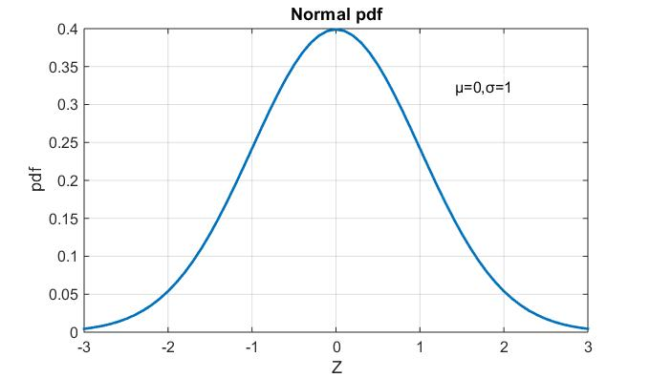

Figure 1: Standard normal pdf.

The bell curve, that characterises the normal distribution, was refined by other mathematicians, including Laplace and Gauss, and the distribution is still referred to as the Gaussian distribution. One of the advantages of the normal distribution is that it can be described with just two parameters – the mean and the standard deviation – and allows us to make probabilistic statements about sampling averages. In the normal distribution, approximately 68% of the distribution is within one standard deviation of the mean, 95% is within two standard deviations and 98% within three standard deviations. In fact, the distribution of a sum of independent variables approaches a normal distribution, which is the basis for the central limit theorem and allows us to use the normal distribution as an approximation for other distributions (such as the binomial).

The Gaussian distribution, also called the normal distribution or the bell curve, is ubiquitous in nature and statistics due to the central limit theorem: every variable that can be modelled as a sum of many small independent variables is approximately normal. The Gaussian distribution is the only stable distribution having all of its moments finite.

The central limit theorem states that the sum of a number of random variables with finite variances will tend to a normal distribution as the number of variables grows. A generalization of the central limit theorem states that the sum of a number of random variables with power-law tail distributions decreasing as $1/{|x|}^{(α+1)}$ where $0 < α < 2$ (and therefore having infinite variance) will tend to a stable distribution $f(x; α, 0, c, 0)$ as the number of variables grows, where c is a scale parameter.

This distribution is commonly used to model equity returns, and, indeed, the changes in many financial quantities. Errors in observations of real phenomena are often normally distributed. The normal distribution is also common because of the Central Limit Theorem.

Given that market log returns are additive, due to the central limit theorem (above), one might expect market log returns above anything but the highest frequency to be approximately normally distributed. This is only the case over the longest of time periods, such as annual returns. One simple explanation (my own) is as follows. Price-influencing events may be normally distributed, but the likelihood of said events being reported in the news increases with the magnitude of the impact of the event. For the latter distribution, one can factor in the tendency for the media to simplify and exaggerate. Multiply the normal distribution by the distribution according to the likelihood/duration/impact of news reports and one has a much fatter-tailed distribution than a Gaussian.

## Lognormal Distribution:

A random variable X will have a lognormal distribution if the natural log of X $(lnX)$ is normally distributed. So we examine if the natural logarithm of a random variable is normally distributed or not. If it is, then the random variable itself will have a lognormal distribution. A lognormal distribution has two important characteristics:

* It has a lower bound of zero.
* The distribution is skewed to the right, i.e., it has a long right tail.

Note that this is in contrast with a normal distribution which has zero skew and can take both negative and positive values. Just like a normal distribution, a lognormal distribution is also described by just two parameters, namely, $μ and σ$. The pdf of a lognormal distribution is:

$$f\left(x | μ,σ^{2}\right)=\frac{1}{x\sqrt{2πσ^{2}}}e^{-\frac{{(lnx-μ)}^{2}}{{2σ}^{2}}} (4.2)$$

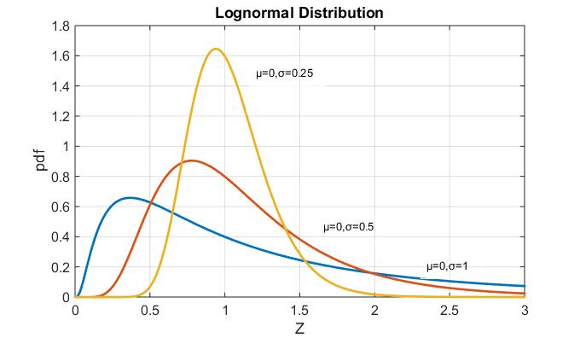

Figure 2: Lognormal pdf. With different values of σ

A lognormal distribution is commonly used to describe distributions of financial assets such as share prices. A lognormal distribution is more suitable for this purpose because asset prices cannot be negative. An important point to note is that when the continuously compounded returns of a stock follow normal distribution, then the stock prices follow a lognormal distribution. Even in cases where returns do not follow a normal distribution, stock prices are better described by a lognormal distribution.

## Poisson Distribution:

The Poisson distribution is a discrete probability distribution that expresses the probability of a number of events occurring in a fixed period of time if these events occur with a known average rate and are independent of each other.

The Poisson distribution serves for modelling the distribution of events having pre-set time intensity. The random variable X is the count of a number of discrete occurrences (sometimes called “arrivals”) that take place during a time-interval of given length. If the expected number of occurrences in this interval is 1, then the probability of exactly X— k occurrences (k being a non-negative integer, k= 1,2 ...) is equal to:

$$f\left(k,λ\right)=\frac{λ^{k}e^{-λ}}{k!} (4.3)$$

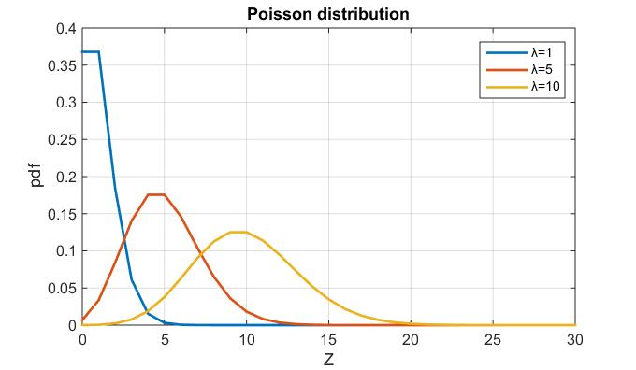

Figure 3: Poisson pdf. With different values of λ

The parameter λ is a positive real number, equal to the expected number of occurrences that occur during a given interval. It is also called an intensity or hazard rate. The time intensity is the number of events occurring per unit of time. The Poisson distribution serves, for instance, for assigning a probability to the number of typos when the rate of typos per unit of time is given. The Poisson distribution is the law of rare events when used in finance. It serves for modelling the behaviour of prices, for assigning a probability to “jumps,” or large price deviations, during a given time interval. The Poisson distribution also serves for modelling the number of claims in insurance.

## Chi-Square Distribution:

A chi-square distribution is the distribution of sum of squares of $k$ independent standard normal random variables with $k$ degrees of freedom.The probability distribution function of chi-square distribution is given by:

$$f\left(x:k\right)=\left\{\begin{aligned}\frac{x^{\left(k/2-1\right)}e^{-\frac{x}{2}}}{2^{\frac{k}{2}}Γ\left(\frac{k}{2}\right)} ;x>0 (4.4) \\ 0 otherwise\end{aligned}\right.$$

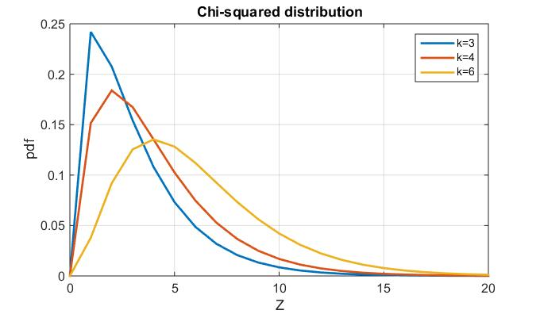

Figure 4:Chi-squared pdf. For different values of k

The Chi-Square is one of the most widely used distributions in inferential statistics. So understanding the Chi-Square distribution is important for hypothesis testing, constructing confidence intervals, goodness of fit, Friedman’s analysis of variance by ranks, etc. The distribution is also important in discrete hedging of options in finance, as well as option pricing.

## Gumbel Distribution:

The probability distribution function of Gumbel distribution is given by:

$$f\left(x;μ,σ\right)=\frac{1}{σ}e^{\frac{μ-x}{σ}}e^{-e^{\frac{μ-x}{σ}}} (4.5)$$

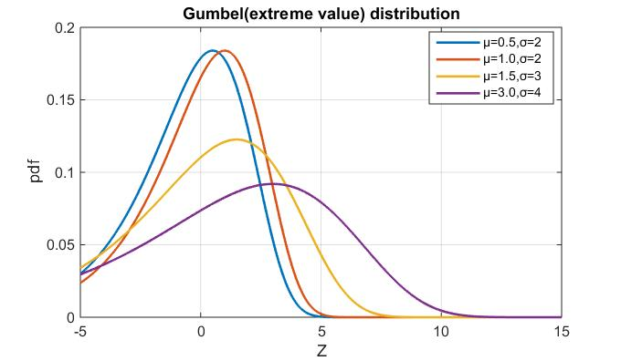

Figure 5:Gumbel pdf. With different values of $μ and σ$

The Gumbel distribution has two parameters: µ, location; σ, scale. It is used to model the distribution of maximum (or minimum) of a number of samples of various distributions. Gumbel distribution is one of the extreme value distributions applied in finance.

Extreme Value distributions arise as limiting distributions for maximums or minimums (extreme values) of a sample of independent, identically distributed random variables, as the sample size increases. Extreme Value Theory (EVT) is the theory of modelling and measuring events which occur with very small probability. This implies its usefulness in risk modelling as risky events per definition happen with low probability. Thus, these distributions are important in statistics. These models, along with the Generalized Extreme Value distribution, are widely used in risk management, finance, insurance, economics, hydrology, material sciences, telecommunications, and many other industries dealing with extreme events.

## Weibull Distribution:

Another member of extreme value distributions is Weibull distribution. It is a continuous probability distribution and general form of probability distribution function is given by:

$$f\left(x;λ,k\right)=\frac{k}{λ}{\left(\frac{x-μ}{λ}\right)}^{k-1}e^{-{\left(\frac{x-μ}{λ}\right)}^{k}} (4.6)$$

With $x≥μ,k>0,λ>0,-∞<μ<+∞$. $λ$ is scale parameter, $k$ is shape parameter and µ is location parameter. The two-parameter form of Weibull distribution is obtained by setting $μ=0,$ and one parameter case is obtained by setting $μ=0, k=constant.$

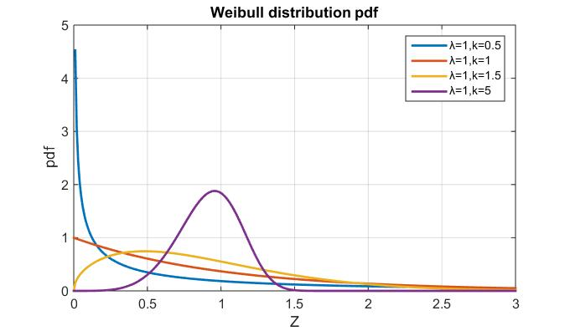Figure 6: Weibull pdf. With different values of $λ and k$

The Weibull distribution is a versatile distribution that can be used to model a wide range of applications in engineering, medical research, quality control, finance, and climatology. For example, the distribution is frequently used with reliability analyses to model time-to-failure data. The Weibull distribution is also used to model skewed process data in capability analysis.

The Weibull distribution is described by the shape, scale, and threshold parameters, and is also known as the 3-parameter Weibull distribution. The case when the threshold parameter is zero is called the 2-parameter Weibull distribution. The 2-parameter Weibull distribution is defined only for positive variables. A 3-parameter Weibull distribution can work with zeros and negative data, but all data for a 2-parameter Weibull distribution must be greater than zero.

## Student’s-t Distribution:

The t-distribution is a continuous distribution that is specified by the number of degrees of freedom. It is a symmetric, bell-shaped distribution that is similar to the normal distribution, but with thicker tails. The probability distribution function of t-distribution is:

$$f\left(x\right)=\frac{Γ\left(\frac{v+1}{2}\right)}{\sqrt{vπ}Γ\left(\frac{v}{2}\right)}{\left(1+\frac{x^{2}}{v}\right)}^{-\frac{v+1}{2}} (4.7)$$

Where $v$ is the number of degrees of freedom and Γ is is the Gamma function.

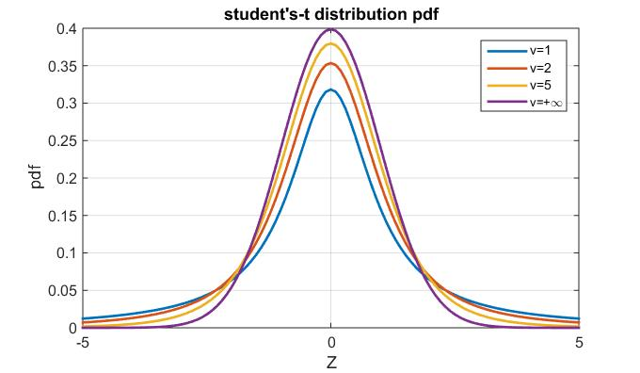

Figure 7: Student’s-t pdf. With different values of $v$

The student’s t-distribution is commonly used in finance and risk management, in particular to model conditional asset returns for which the tails of the normal distribution are almost too thin. Bollerslev (1987) used the student’s t to model the distribution of foreign exchange returns; Mittnik, Rachev and Paolella (1998) fitted a return’s distribution using a number of parametric distributions including Student’s-t, and found that partially asymmetric Weibull, Student’s-t and the asymmetric stable distributions provide the best fit according to various measures. More recent applications include Alberg *et al*. (2008) and Frances *et al*. (2008).

## Pareto Distribution:

The Pareto Distribution was first proposed as a model for the distribution of incomes. It is also used as a model for the distribution of city populations within a given area. The probability distribution function of Pareto distribution is:

$$f\left(x\right)=\frac{αβ^{α}}{x^{α+1}}; β≤x<∞;α,β>0 (4.8)$$

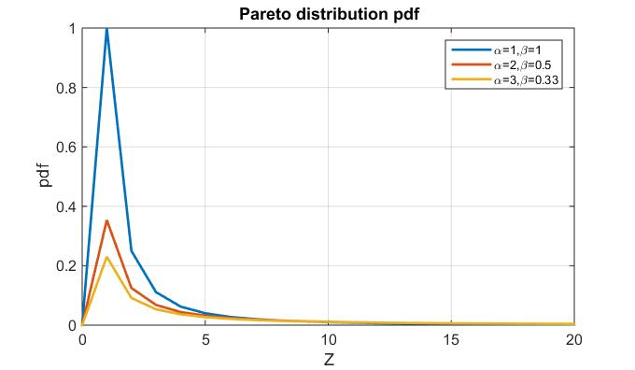

Figure 8: Pareto pdf. With different values of $α and β$

The Pareto distribution is a skewed, heavy-tailed distribution that is sometimes used to model the distribution of incomes and other financial variables (Pareto, 1896), but, as power-law relations have been discovered in several fields of the natural sciences (Sornette, 2004), its range of applicability has enlarged significantly in the last few decades. Many empirical finance studies have applied Pareto distribution to model the right tail of the distribution.

## Gamma Distribution:

The probability distribution of Gamma distribution is:

$$f\left(x\right)=\frac{β^{α}x^{α-1}e^{-βx}}{Γ(α)} , x,α,β >0 (4.9)$$

Where α is the shape parameter and β is scale parameter. For $α=1$ this distribution converges to the exponential distribution and for $β=2$ to the chi-square distribution.

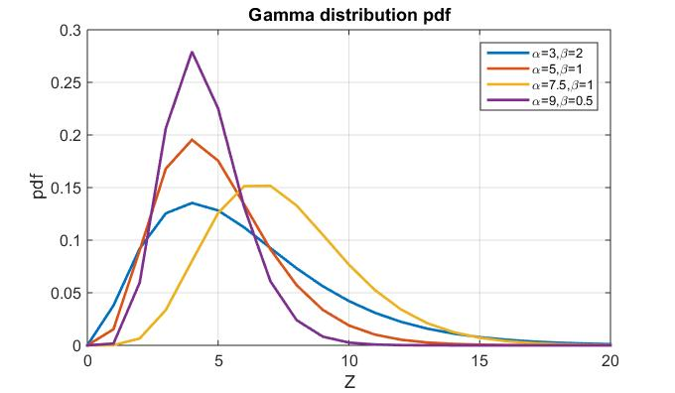

Figure 9: Gamma pdf. With different values of $α and β$

The Gamma distribution can be identified naturally in the processes where the waiting times between events are relevant, for example the size of loan defaults or insurance claims.

## Logistic Distribution:

The Logistic distribution is continuous probability distribution which resembles the Normal distribution in shape but has higher kurtosis (heavy tails). The probability distribution function of Logistic distribution is given by:

$$f\left(x\right)=\frac{e^{-\left(\frac{x-μ}{σ}\right)}}{σ{\left(1+e^{-\left(\frac{x-μ}{σ}\right)}\right)}^{2}} (4.10)$$

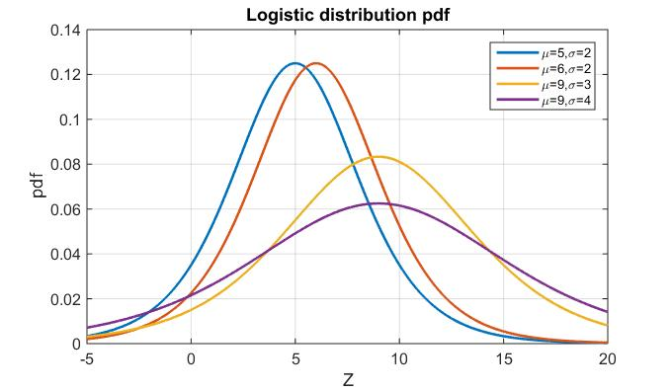

Figure 10: Gamma pdf. With different values of $μ and σ$

The Logistic distribution is used for modelling growth and has applications in modelling life data. It has been used to describe how new technologies diffuse and replace each other (Fisher and Pry, 1971). A notable application of logistic distribution in finance is to estimate value at risk (VaR). The Logistic distribution is also the base of a certain type of regression model known as Logistic regression.

## Laplace Distribution:

Laplace distribution or double exponential distribution is continuous probability distribution. Its probability distribution function is given by:

$$f\left(x\right)=\frac{1}{2σ}e^{-\frac{\left|x-μ\right|}{σ}} (4.11)$$

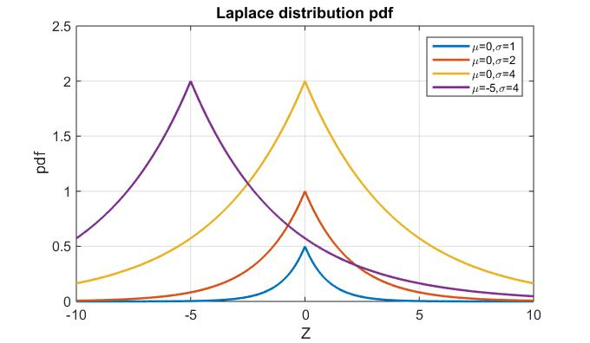

Figure 11: Laplace pdf. With different values of $μ and σ$

Kotz *et al*. (2012) note that Laplace distribution has been successfully applied in finance, particularly for modelling financial returns. This is due to the fact that the Laplace distribution caters for leptokurtic and skewed data which are significant features of real life data. Whereas traditional Gaussian based distributions do not support these features. Laplace distribution has also been applied in modelling currency exchange rates and interest rates.

## Cauchy Distribution:

Cauchy distribution (Lorentz distribution) is a continuous probability distribution. The probability distribution function is given by:

$$f\left(x\right)=\frac{1}{πσ\left(1+{\left(\frac{x-μ}{σ}\right)}^{2}\right)} (4.12)$$

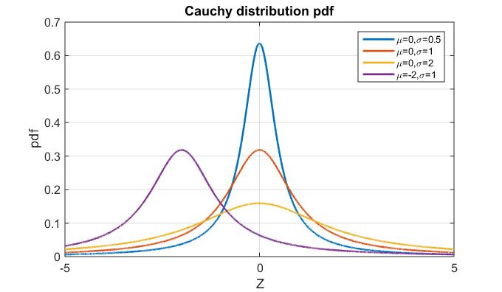

Figure 12: Cauchy pdf. With different values of $μ and σ$

Cauchy distribution is also a viable candidate for modelling the asset returns because of its power to capture the large fluctuations in real data.

## Exponential Distribution:

A special case of Gamma distribution is exponential distribution. The probability distribution of exponential distribution is :

$$f\left(x\right)=\frac{1}{μ}e^{-\frac{x}{μ} } (4.13)$$

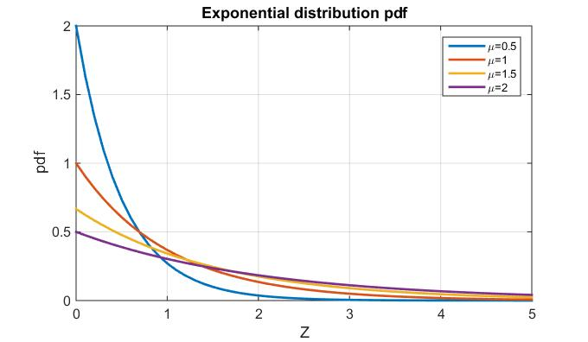

Figure 13: Laplace pdf. With different values of $μ$

## Stable Distribution:

As mentioned before, many financial products exhibit fat tails, including equity indices and corporate bonds. The existence of fat tails cannot be captured by the normal distribution, therefore non-normal distribution(s) are required to explain the tail phenomenon and estimate the probability of extreme events. Stable distributions possess sufficient mathematical properties to be a feasible alternative to normal distribution for estimating and forecasting asset returns. The characteristic function of a stable distribution with distribution function $F$ is given by the following expression:

$$\int{e^{itx}dF\left(x\right)=\left\{\begin{aligned}exp\left\{-σ^{α}{\left|t\right|}^{α}\left[1-iβsign\left(t\right)tan\frac{πα}{2}\right]+iμt\right\}, if α≠1 \\ exp\left\{-σ|t|\left[1+iβ\frac{2}{π}sign\left(t\right)ln⁡|t|\right]+iμt\right\}, if α=1 \end{aligned} (4.14)\right.}$$

where $sign\left(t\right)=\left\{\begin{aligned}1 if t> 0 \\ 0 if t= 0 \\ -1 if t<0\end{aligned}\right.$. The characteristic exponent $α$ is the index of stability and is also referred to as a shape parameter; $β$ is the skewness parameter; $μ$ is a location parameter; and $σ$ is the scale parameter. These four parameters collectively describe the stable distribution (Mittnik and Rachev, 1993).

When the $β$ of a stable distribution is zero, the distribution is symmetric around $μ$. Stable distributions accommodate for skewed distributions when $≠0$, the value of $β$ ranging from -1 to +1. When $β$ is positive, a stable distribution is positively skewed; when $β$ is negative, a stable distribution is negatively skewed. Fat tails indicating a high probability for extreme events with respect to the normal distribution when $α<2$.

The value of $α$ is greater than zero and does not exceed 2. As the value of $α$ approaches zero, the distribution display fat tails and increased peakedness at the origin. When modelling asset returns with stable distributions, the index of stability (*α*) provides important financial insight. Even though the theoretical range of *α* is greater than zero, but less than or equal to 2, not every value in the interval is meaningful from a financial viewpoint. On one hand, if *α* is less than or equal to 1, then the corresponding random variable does not have a finite mean. Any portfolio containing assets, the returns of which follow a stable law with *α* less than or equal to 1, would have infinite expected return and this will not be a meaningful portfolio characteristic; decisions cannot be based on this as diversification is not possible for such a portfolio. In practice when working with financial data, all estimated values of $α$ are usually above 1, and if there is an exception, then the reason is most likely either a data problem or a numerical issue.

The characteristic function of general stable distribution does not have a closed form solution. The closed form solution of a stable distribution is obtained only for three special cases, which are listed below:

1. When $α=2,β=0$ and replacing scale parameter $σ by \sqrt{2}σ$, gives the normal distribution with density function: $f\left(x\right)=\frac{1}{σ\sqrt{2π}}*exp⁡(-\frac{{\left(x-μ\right)}^{2}}{2σ^{2}})$
2. When $α=1,β=0$ produces the Cauchy distribution with much fatter tails than the normal distribution. The density function of Cauchy distribution is $f_{μ,σ}\left(x\right)=\frac{1}{π*σ}{\left(1+{\left(\frac{x-μ}{σ}\right)}^{2}\right)}^{-1}$
3. When $α=0.5,β=1$ returns the Levy distribution with density function $f_{μ,σ}\left(x\right)={\frac{σ}{2π}}^{0.5}*\frac{1}{{\left(x-μ\right)}^{1.5}}*\exp\left(-\frac{σ}{2\left(x-μ\right)}\right) , x> μ$

An interesting property of stable distributions, which is not shared by other probability distributions, is that they provide the generalisation of financial theories based on normal distribution, therefore paving the way for a general framework for financial modelling. This modelling framework is based on two prominent properties namely:

* Stability property: the sum of two independent *α*-stable random variables is the same stable distribution with suitable corrections. This property is coherent with normal distribution.
* Central Limit Theorem: appropriately normalized sums of independent and identically distributed (i.i.d) random variables with finite variance converge weakly to a normal random variable; and with infinite variance, the sums converge weakly to a stable random variable.

## Jump Diffusion Process:

Empirical analysis of stock price movements shows the presence of ‘jumps’ or sudden change in path over time as a result of some internal or external activity. The change in price from one point of time to another consists of two parts: first, the regular changes in price caused by different economic factors, for example, inequality between demand and supply, change in interest rates, amongst others. This component of price change can be modelled by a standard GBM process with constant variance following a continuous sample path. Secondly, the irregular changes in price are caused by irrational behaviour of investors reacting to new information that is unique to that stock price. Intuitively the irregular price changes happen at discrete points in time only, which results in a spike to the continuous path of stock price. The second component of price change can be modelled by a ‘Jump’ process reflecting the abnormal effect on price.

Similar to the way that the continuous movement of prices is modelled by the GBM (Wiener process), so the jump movement in prices can be modelled by Jump-diffusion process based on a Poisson process. A Jump-Diffusion process is a combination of Brownian motion and a Poisson process; the Brownian motion part is applied to accommodate the continuity of data and Poisson process is used to model the fluctuations in prices over a short period of time. Merton (1976) proposed the first jump- diffusion process displaying jumps along with continuous and random increments between the jumps by the model:

$P_{t+δt}=P_{t}\exp\left(μδt+σZ_{t}\sqrt{δt}+\sum_{i=1}^{N_{t}}{Y_{i}}\right) (4.15$)

where $N_{t}$ is a Poisson process with rate λ and $Y_{i}$ has a Gaussian distribution for Merton’s Model (1976) and a double exponential distribution for Kou Model (2002). Hence to model returns using the above Jump-diffusion model, it is imperative to have estimates of five parameters for empirical data. These five parameters are $\left[μ,σ,μ\left(Y_{i}\right),σ\left(Y_{i}\right),λ\right]$.

# Chapter 5 Simulation and MATLAB computation:

## Introduction:

This section introduces the reader to the Monte Carlo method in a financial setting. The benefits and drawbacks of the method are presented, as well as techniques intended to improve the performance of the method. The section is organised in the following manner. First, the Monte Carlo method is examined from a financial perspective. The focus is on asset valuation, and the accuracy of the simulation result is looked into. Second, the issue of how to achieve an accurate result with a limited amount of computing resources is discussed.

## Simulations:

The advanced theory of finance, like many areas where advanced mathematics plays an important part, is undergoing a revolution aided and abetted by the computer and the proliferation of powerful simulation and symbolic mathematical tools. One of the first hurdles faced before adopting stochastic or random models in finance is the recognition that for all practical purposes, the prices of equities in an efficient market are random variables that is while they may show some dependence on fiscal and economic processes and policies; they have a component of randomness that makes them unpredictable. This appears on the surface to be contrary to the assertion that every change in the price of a stock must be driven by some factor in the company or the economy. But we should remember that random models are often applied to systems that are essentially causal when measuring and analysing the various factors influencing the process and their effects is too monumental a task. Exchange rates, interest rates and equity prices are subject to the pressures of a large number of traders, government agencies, speculators, as well as the forces applied by international trade and the flow of information. In the aggregate there is an extraordinary number of forces and information that influence the process. While we might hope to predict some features of the process such as the average change in price (or the volatility), a precise estimate of the price of an asset one year from today is clearly impossible. This is the basic argument necessitating stochastic models in finance. Adoption of a stochastic model does neither imply that the process is pure noise nor that we are unable to forecast. Such a model is adopted whenever we acknowledge that a process is not perfectly predictable and the non-predictable component of the process is of sufficient importance to warrant modelling. Now if we accept that the price of a stock is a random variable, what are the constants in our model? One of the most important modern tools for analysing a stochastic system is simulation. Simulation is the imitation of a real-world process or system. It is essentially a model, often a mathematical model of a process. In finance, a basic model for the evolution of stock prices, interest rates, exchange rates etc. would be necessary to determine a fair price of a derivative security. Simulations, like purely mathematical models, usually make assumptions about the behaviour of the system being modelled. This model requires inputs, often called the parameters of the model and outputs a result which might measure the performance of a system, the price of a given financial instrument, or the weights on a portfolio chosen to have some desirable property. We usually construct the model in such a way that inputs are easily changed over a given set of values, as this allows for a more complete picture of the possible outcomes. Why use simulation? The simple answer; that it transfers work to the computer. Models can be handled which have greater complexity, and fewer assumptions, and a more faithful representation of the real world than those that can be handled tractable by pure mathematical analysis are possible. By changing parameters we can examine interactions, and sensitivities of the system to various factors. Experimenters may either use a simulation to provide a numerical answer to a question, assign a price to a given asset, identify optimal settings for controllable parameters, examine the effect of exogenous variables or identify which of several schemes is more efficient or more profitable. The variables that have the greatest effect on a system can be isolated. We can also use simulation to verify the results obtained from an analytic solution. For example many of the tractable models used in finance to select portfolios and price derivatives are wrong. They put too little weight on the extreme observations, the large positive and negative movements (crashes), which have the most dramatic effect on the results. Is this lack of fit of major concern when we use a standard model such as the Black-Scholes model to price a derivative? Questions such as this one can be answered in part by examining simulations which accord more closely with the real world, but which are intractable to mathematical analysis. Simulation is also used to answer questions starting with “what if”. For example, what would be the result if interest rates rose 3 percentage points over the next 12 months?

Time is required both to construct the simulation, validate it, and to analyse the results. If a reasonably simple analytic expression for a solution exists, it is always preferable to a simulation. While a simulation may provide an approximate numerical answer at one or more possible parameter values, only an expression for the solution provides insight to the way in which it responds to the individual parameters, the sensitivities of the solution.

In constructing a simulation, one should be conscious of a number of distinct steps;

1. Formulate the problem at hand. Why do we need to use simulation?

2. Set the objectives as specifically as possible. This should include what measures on the process are of most interest.

3. Suggest candidate models. Which of these are closest to the real-world? Which are fairly easy to write computer code for? What parameter values are of interest?

4. If possible, collect real data and identify which of the above models is most appropriate. Which does the best job of generating the general?

5. Implement the model. Write computer code to run simulations.

6. Verify (debug) the model. Using simple special cases, insure that the code is doing what you think it is doing.

7. Validate the model. Ensure that it generates data with the characteristics of the real data.

8. Determine simulation design parameters. How many simulations are to be run and what alternatives are to be simulated?

9. Run the simulation. Collect and analyse the output.

10. Are there surprises? Do we need to change the model or the parameters? Do we need more runs?

11. Finally we document the results and conclusions in the light of the simulation results

## Monte Carlo Simulations:

Monte Carlo simulation (statistical simulation), as the name implies, is linked to random phenomena. It is interesting that it is characterised as one of the first computer programming applications. The method was developed in Los Alamos during the Second World War for the purpose of solving complex problems referring to the creation of the atomic bomb, such as calculation of dispersion of neutrons on the nucleus. However, the term itself is not used by full consent. Some authors call any type of software using random numbers Monte Carlo. As in the majority of references in relation with simulation modelling, in this text this term will be used only for static types of simulations by which problems are solved by creating samples from random variable distributions. In such cases, problems might be of either deterministic or of a stochastic character.

The following types of applications of Monte Carlo simulations are differentiated (Kleijnen, 1974):

### Deterministic problems whose solving is hard or expensive:

A typical example of this type is calculation of values of certain integrals that cannot be solved analytically, i.e. whose sub integral function is such that a solution in form of a mathematical expression cannot be found.

### Complex phenomena not known enough:

The second class of problems solved by Monte Carlo simulation refers to phenomena that are known insufficiently to be precisely described. Instead of knowing modes of elements interaction, only probabilities of interaction outcome are known, which are in Monte Carlo simulation used for execution of a series of experiments giving samples of possible states of dependent variables. Statistical analysis of such samples provides a distribution of probabilities of dependent variables of interest. Most frequently social or economic phenomena, such as population growth, economic predictions or risk analysis, are analysed by this approach.

### Statistical problems with no analytical solution:

Statistical problems with no analytical solution are just one of broad classes of problems by solving of which Monte Carlo simulation is used. For example estimation of critical values or the power of testing new hypotheses belongs to this group. Generation of random numbers and variables is also used in problem solving. In case of comparison of various regression methods, Monte Carlo simulation is used for generation of input data, which are then analysed by means of various regression methods, providing estimations of regression parameters of these data. Since the input data are generated by some predetermined parameters, it is possible to compare the quality of various regression methods by accuracy of regression parameter estimations they give to known parameters by means of which the data are generated.

## Monte Carlo in Financial Markets:

The Monte Carlo method was first used to value derivatives by P.P Boyle in 1977. The method is flexible in the sense that it can be applied to differently stated problems and it has the benefit of being well suited to deal with multiple random factors. This often comes in handy. One example is when the underlying asset is a basket of stocks or when volatility or interest rates are random.

The Monte Carlo method is also useful when derivatives are path- dependent. It allows for the model of the underlying asset to include jump processes, a feature that enables more realistic modelling of asset price paths.

The major drawback of Monte Carlo simulation is that it may require a significant amount of computer time to obtain a reliable result. The efficiency can often be improved by using so-called variance reduction techniques

Monte Carlo simulation is a method that aims to obtain statistical estimates, primarily of the risk- neutral expectation of a derivative. The risk- neutral expectation of the derivative is one example of such a measure. When the term statistics is used, it includes the risk- neutral expectation.

The idea of Monte Carlo simulation is simple, yet elegant. Its foundation is the central limit theorem, which is applied to a large number of derivative values. These are obtained by first simulating the path of the underlying asset, using the stochastic differential equation, and then applying the pricing rule for the derivative to that path. Let us first examine how this is done in more detail, and thereafter discuss the theoretical implications of the method.

A Monte Carlo simulation can be viewed as consisting of three phases. In the first phase, the conditions for the simulation are defined. In the second phase, the actual simulation is performed. In the third phase, the resulting statistics are calculated. Below is an account of the three phases, merged together to give a better overview of the steps involved in a simulation.

1. Before the simulation

* A model of the behaviour of the underlying process is defined
* The derivative’s payoff is defined.

1. During simulation, repeat

• Simulate a path of the asset over time according to the given model.

• Calculate the value of the asset, given the simulated path of the underlying process.

* Continue the simulation until a sufficient number of simulations have been performed.

1. Compile statistics from the simulated paths

* Take the average of the estimate as an approximation of the options expected payoff.
* Discount the expected payoff with an appropriate interest rate to achieve the risk- neutral expected pay- off.

As mentioned, the foundation of the Monte Carlo method is the central limit theorem. The value of the asset that results from each simulation can be seen as a draw from a distribution of possible outcomes of the derivative. The distribution has a mean $μ$ and variance σ. If the random number generator used is good, the draws from the distribution does not show any pair wise correlation. That is, the outcomes of the simulations of the derivative are not correlated. We apply the central limit theorem to the averaged sum of the estimates. If we have many estimates of the option value, the central limit theorem tells us that that if we take the average of the estimates, it will converge to the expected value.

For now, let us assume that we somehow have access to a Monte Carlo simulator that allows us to perform a simulation as described above. If we apply the rules of the derivative to a path taken by the underlying asset, we get $n$ different price values $P_{1},P_{2},P_{3}, …,P_{n}$ at times $t_{1},t_{2},t_{3}, …,t_{n}$. Let $P_{i}$ denote the price of the asset for $ith$ path then we have

$$P_{i}=\sum_{k=1}^{n}{P_{k}} (5.1)$$

In our Monte Carlo simulation, we perform n simulations and average the results. Denote that average of the estimates $\hat{P}$. For the average, we have that

$$\hat{P}=\frac{1}{n}\sum_{i=1}^{n}{P_{i}} (5.2)$$

The central limit theorem states that $\hat{P}$ will converge to the true expected value $E\left(P\right)as n→∞.$ It is important to realize that $\hat{P}$ only is an approximation of $E(P)$ for any ﬁnite $n$. The central limit theorem states that the averaged mean $\hat{P}$ exhibits a standard error of size $\frac{σ}{\sqrt{n}}$. The standard error is a measure of the insecurity in the estimate of the asset’s value. From the size of it we can draw two conclusions. First, we can improve the accuracy of our simulation by performing more simulations. Second, since the error decreases as $O(\frac{1}{\sqrt{n}}$), it is possible that many simulations are needed to provide high accuracy.

Every simulation estimate is a result of a number of path constructions and evaluations of those paths. The time required to complete the simulation is very much dependant on the number of paths we simulate. Time is often a scarce resource in the context of Monte Carlo simulations. If possible, we would like to achieve a result faster, given a level of accuracy.

## Random Numbers:

Existence of random values in a simulation model requires mechanisms which can generate values of variables from various probability distributions during simulation experiments (some of these are described before). A series of generated values of a random variable is a sample from the probability distribution describing that variable. We will describe random numbers which make the basis for random variable generation.

## Using random numbers in simulation experiments:

Simulation process models containing components behaving randomly require corresponding methods of generating random numbers (Law and Kelton, 1982; Banks and Carson, 1984). During a simulation experiment, e.g. generation of a great number of servicing time values, demand size or inter arrival times belonging to some probability distributions might be requested. Therefore it is necessary to have an effective and high-quality way of generating values of random numbers and variables. Unfortunately, the term “generation of random variables” is thereby not precise enough, i.e. this term implies generation of numerical values of random variables from corresponding probability distributions of the variable in question. Using random numbers and variables in simulation models enables reproduction of irregular behaviour of system elements without having the model with an excellent detailed description of that behaviour. Random numbers and variables describe irregular behaviour even in a compressed form. The terms random number and random variable must be used very carefully, since it is not easy to say whether a certain series of numbers is random, although some series seems not to be random at all. This question cannot be answered correctly on the basis of knowing the way a series of numbers in question is formed. The only approach that might provide a satisfactory answer is to put that series of numbers under corresponding statistical tests which will prove whether it is a sample of a random number and to which extent. Quality of the random number generator is tested in the same way. Precisely, the term “random number” implies a continuous random variable with the uniform distribution on the interval $[0, 1]$. This distribution will be denoted by $U (0, 1)$. Although this is the simplest continuous distribution, it is extremely important since random variables of all other probability distributions (normal, binomial, etc.) can be obtained by transforming the random variable U(0,1) by means of independent identical distribution.

## Standard Brownian Motion:

A standard Brownian Motion or Wiener process $\left(W_{t},t>0\right)$ is defined as a stochastic process with following properties:

1. Continuous sample paths
2. Independent increments, that is, for each is independent of values such that
3. Stationary Increments, for each depends only on
4. Increments are stationary and normally distributed.

## Geometric Brownian Motion:

The stochastic model to represent stock price using Brownian Motion model is given by:



* α is instantaneous rate of returns
* σ is standard deviation of returns
* W is standard Brownian motion

For any initial value $S(0)$ above mentioned equation has solution



$(5.4)$

With $μ=α+\frac{1}{2}σ^{2}$ is obtained by applying Ito’s lemma.

The basics of quantitative finance still rely heavily in line with rational behaviour of investors and weak form EMH. That is continuous financial returns can be expressed as



where µ is the average returns and  is assumed to be normally independently distributed with zero mean and constant variance. The above equation can be written as



where  is a random number drawn from standardised normal distribution and is a small time step. This equation is deployed to run simulations and construct the modelled returns distribution based on the Geometric Brownian Motion (GBM).Furthermore the continuous time version of the above equation is



Applying Ito’s Lemma the equivalent stochastic differential equation (SDE) form of (3) is expressed as



$(5.8)$

The above model (equations $(5.5), (5.6), (5.7) \& (5.8)$) provides the foundations of classical quantitative finance and further financial modelling rely on this representation. The figure below presents original price series, different simulated paths obtained from equation $(5.6)$ and the average of these simulated paths to understand the Monte Carlo method for Chinese stock market for the period 2006-2007.

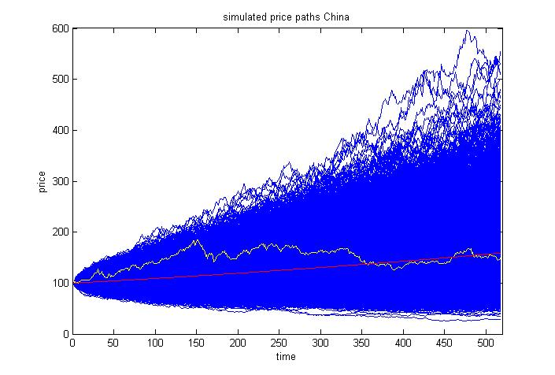

Figure 14: Plot of Chinese stock prices,1000 simulations and the average.

The above figure represents the application of Monte Carlo simulations with yellow curve representing the historic data, blue curves representing the simulated paths and the red curve is the average of all the blue curves. It is evident that the red curve provides a closer approximation of the yellow curve as compared to all the blue ones.

This chapter has two main sections;

1. Modify the GBM to develop a more reliable model for asset pricing
2. Develop a robust simulation mechanism to represent and explain the progress of the GBM modification.

Therefore the research has been moving in both these directions simultaneously, starting from developing the simulations. Although there is an enormous literature and resources exist for Monte Carlo simulations in Financial settings, but I wanted to develop my own simulation method which could be modified for model testing and development. In the beginning, simulations were carried out using VBA Excel, this platform is reliable and convenient for simulations for small datasets but it requires considerable effort and computing power to treat large datasets (more than 500 data points). As large numbers of simulations are produced, processing and storing these huge volumes of data pose a significant challenge. Therefore the project was migrated to MATLAB platform to carry out and storing large volumes of data.

The extreme events in financial markets are caused by severe fluctuations (oscillations) of prices subject to news about that particular stock. The news in this case acts as a potential moving the price up (bubble) or down (burst). These price oscillations before extreme events increase exponentially suggesting the spread of news among traders and its influence on their behaviour. Consequently this triggers a huge discrepancy in demand and supply of the stock price. The essential constituent of the pricing process is time at which price changes due to news feedbacks affecting investor’s behaviours. A financial model is considered reputable if it fulfils the underlying assumptions. One of the key assumptions of GBM is that stock returns are independent of their past values. This assumption seems to hold during stable time period in stock markets; but during a speculative bubble or burst time period these assumptions fail as prices does follow a specific pattern.

Since the randomness or effect of news is modelled as W(t) in the GBM model; therefore a potential parameter is added as function of W(t). This leads to the notion that if stock price can be modelled as a sinusoidal function or if an extra element of Sine or Cosine functions can be added to the GBM model. Note that extra factor has to be scaled to a very small level to customise the effect on overall model. The modified GBM model then become

$s_{t}=s_{0}\exp\left(μ+σW\right)*ksin(W)$

Or

$s_{t}=s_{0}\exp\left(μ+σW\right)*kcos\left(W\right)$ with $k∈\left(0,1\right),W\sim N\left(0,1\right)$

A much more simple and intuitive approach considered is Taylor series expansion of Sinx and Cosx which is;

$$Sinx=x-\frac{x^{3}}{3!}+\frac{x^{5}}{5!}-…for all x$$

$$Cosx=1-\frac{x^{2}}{2!}+\frac{x^{4}}{4!}-…for all x$$

And then including first two terms of each series into GBM model as

$$s_{t}=s_{0}\exp\left(μ+σz*k(x-\frac{x^{3}}{3!})\right) for Sinx$$

And

$$s_{t}=s_{0}\exp\left(μ+σz*k(1-\frac{x^{2}}{2!})\right) for Cosx$$

Only first two terms of each series were considered in each equation above to have minimum effect on model as it is already increasing exponentially. The embedding of first two terms of Taylor series makes the model more coherent with GBM model. To model the historic returns distribution, this research also included a range of other functions including exponential, trigonometric, inverse trigonometric and combination of such functions to capture the true nature of returns distribution but the quest of modifying the GBM proved as challenging as it was at the start. However after extensive efforts for developing the modified GBM with all the different combinations of functions, one function which passed the rigorous workings of fitting to different datasets from different time periods is tangent inverse (atan). The reason for that is the shape of the inverse tangent function which when combined with exponential function scales up the shape within a given interval. The figure below presents a sketch of inverse tangent function to explain this phenomenon.

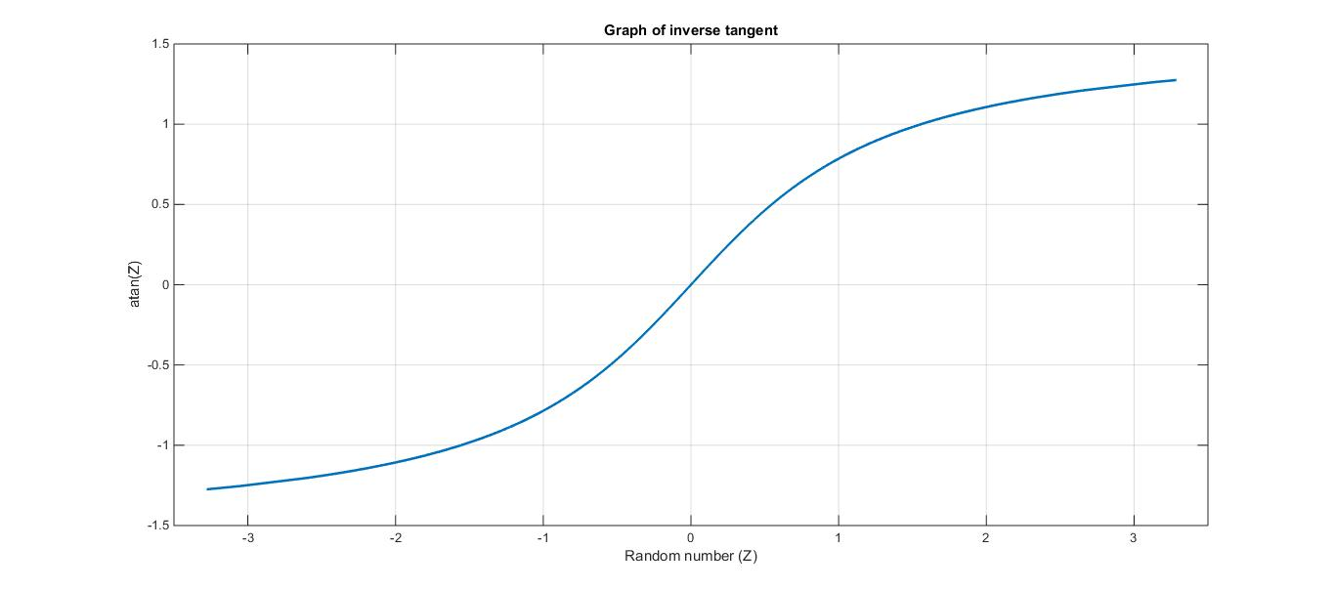

Figure 15: Graph of inverse tangent.

A few examples of the MATLAB codes and illustrating diagrams are presented below to explain the research process (please refer to the appendix for more details)

## The Modified Model:

This study enhances the matching power of the GBM to historical returns distribution by adding a function of Z multiplied by the mean, and a parameter $K$. Of course, when $K=0$ we recover the GBM. In line with $Z_{t}$ being an innovation at time t, we can also loosely consider it to be news generated at time t, with the result that the modified model in its general form is:



$(5.9)$

where equation (5.9) represents a different equation for a different $f(Z_{t})$ and produces a distinct output for various values of $K$. At least 100,000 simulations have been run for various combinations of $f(Z_{t})$ and $K$ and the average of simulated paths taken. These results have then been used to compare the main features of the simulated series against the originals, by applying descriptive statistics and statistical tests including goodness of fit and the Jacque-Bera (JB) test.

The model specified in equation (5.9) will now be referred to as the Modified Brownian Motion Model (MBMM); and it may also be referred to as the Stochastic Mean Model.

The realisation of is dependent on extensive empirical analysis of historical data. The function proposed is:



$(5.10)$

The analysis was performed on various market indices. The software package employed for extensive simulations being MATLAB *(an example of MATLAB code developed for this research is presented in appendix 2)*. Fit for purpose optimal value of parameters $K and c$ for specific data sets are selected using chi-squared goodness-of-fit statistics.

function [y,A]= burst_sim_t(s0,mu,sig,n,T,x)

% Simulates the stock prices following gbm.

% Present output as average of the simulations.

% A = average of n simulated paths over T trading periods.

% rt= log returns of simulated prices.

% s0=initial price

% mu=drift

% sig= dispersion

% T= number of trading periods

% n= number of paths

e=norminv(rand(T,n));

a=zeros(T-1,n);

b=s0*ones(1,n);

sp=cat(1,b,a);

for i=2:T

z=-10.5*(2*exp(-0.5*e(i,:).*e(i,:))-1).*atan(e(i,:));

%-8.9*(5*normpdf(e(i,:))-1).*atan(e(i,:));

sp(i,:)=sp(i-1,:).*exp((mu*(1+z)+sig*(e(i,:))));

% calculate log returns and draw histogram

r=log(sp(2:end,:)./sp(1:end-1,:));

n=hist(r,x);y=mean(n,2);

%s=skewness(r);

%k=kurtosis(r);

end

% Now calculate average of simulated returns and plot

A=mean(r,2);

end

%figure;plot(sp);axis tight

function [ y ] = mbmm(data,n)

%UNTITLED Summary of this function goes here

% s0=initial price

% mu=drift

% sig= dispersion

% T= number of trading periods

% n= number of paths%z=-k*(2*exp(-0.23*e(i,:).*e(i,:))-1).*atan(e(i,:)); %sp(i,:)=sp(i-1,:).*exp((mu*(1+z)+sig*(e(i,:))));

s0=100;

mu=mean(data);

sig=std(data);

[f,x]=hist(data,50);f=f';x=x';

T=numel(data)+1;

e=norminv(rand(T,n));

a=zeros(T-1,n);

b=s0*ones(1,n);

s=cat(1,b,a);

y=zeros(numel(x),40,20);

for c=1:20

for k=1:40

for i=2:T

s(i,:)=s(i-1,:).*exp((mu+abs(mu)*((k-1)*(2*exp(-0.5*0.1*c*e(i,:).*e(i,:))-1).*atan(e(i,:))))+sig*e(i,:));

r=log(s(2:end,:)./s(1:end-1,:));

d=hist(r,x);

g=mean(d,2);y(:,k,c)=g;

end

end

end

%for t=1:20

%my_cell = sprintf( 'c=%s',num2str(t) );xlswrite('year',y(:,:,t),my_cell);

end

%for graph:

%figure;hist(x,f);hold on;plot(x,a,x,b,x,c,...);hold off;shg

function [ y ] = mbmm1(data,n)

%UNTITLED Summary of this function goes here

% s0=initial price

% mu=drift

% sig= dispersion

% T= number of trading periods

% n= number of paths

s0=100;

mu=mean(data);

sig=std(data);

[f,x]=hist(data,50);f=f';x=x';

T=numel(data)+1;

e=norminv(rand(T,n));

a=zeros(T-1,n);

b=s0*ones(1,n);

sp=cat(1,b,a);

y=zeros(numel(x),30,20);

for c=1:20

for k=1:30

for i=2:T

z=-k*(2*exp(-0.5*(0.1*c)*e(i,:).*e(i,:))-1).*atan(e(i,:));

sp(i,:)=sp(i-1,:).*exp((mu*(1+z)+sig*(e(i,:))));

end

r=log(sp(2:end,:)./sp(1:end-1,:));

d=hist(r,x);

g=mean(d,2);y(:,k,c)=g;

end

end

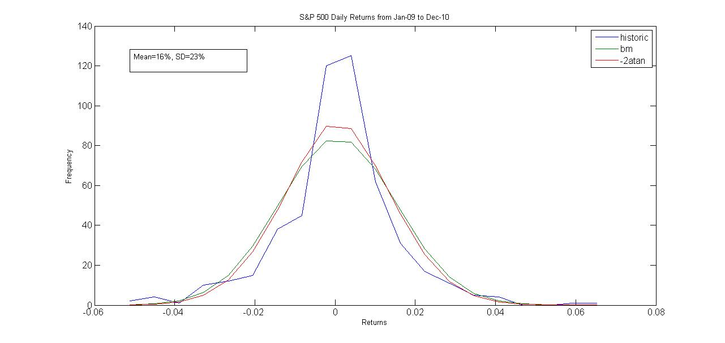

Figure 16: S&P500 from 01-2009 to 12-2010 with GBM and MBMM with -2atan(Z)

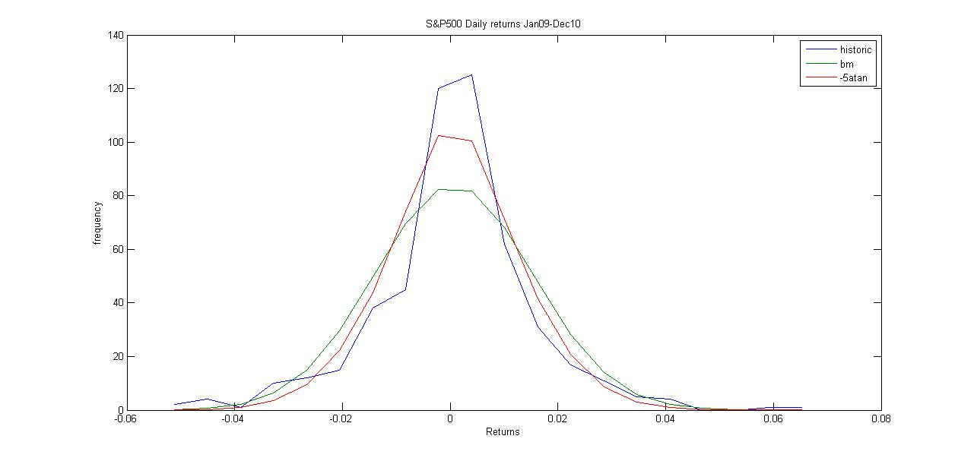

Figure 17: S&P500 from 01-2009 to 12-2010 fitted with GBM and MBMM with -5atan(Z)

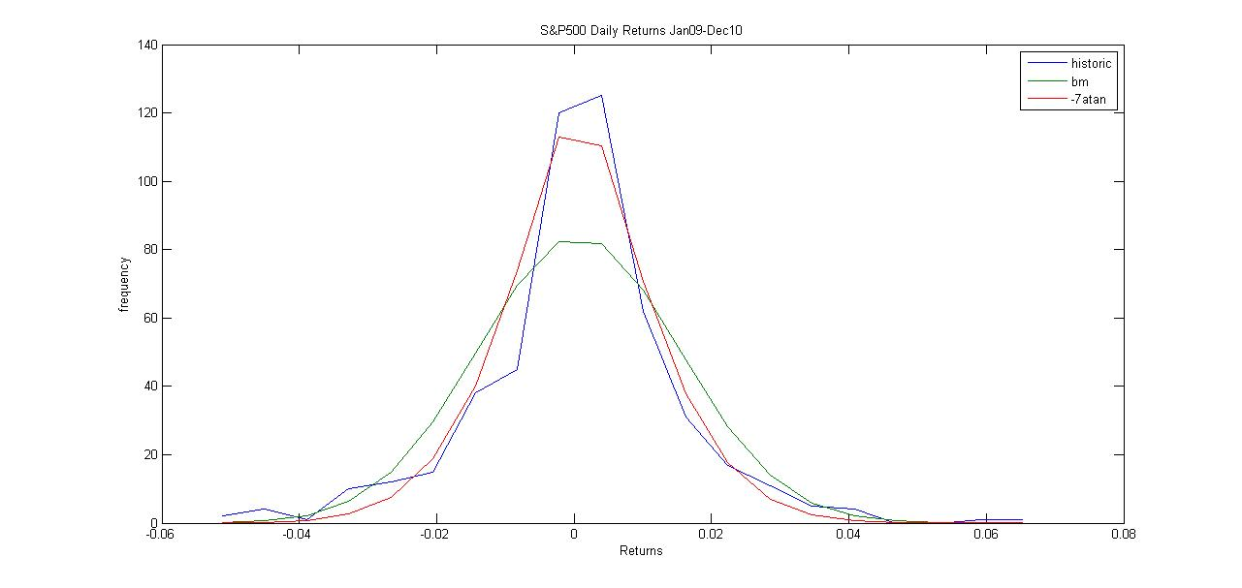

Figure 18: S&P500 from 01-2009 to 12-2010 fitted with GBM and MBMM with -7atan(Z)

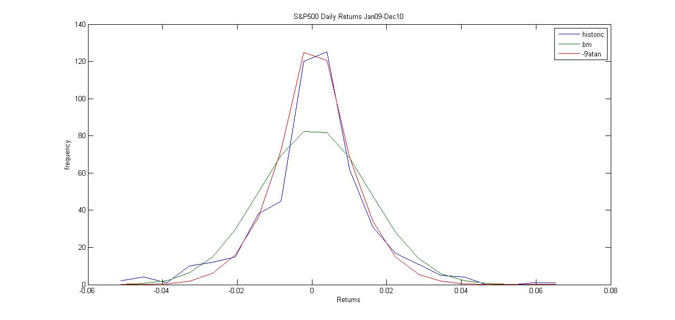

Figure 19: S&P500 from 01-2009 to 12-2010 fitted with GBM and MBMM with -9atan(Z)

## Building the Histogram:

The histogram is the oldest and most popular tool for graphical display of a univariate data set. It is taught in virtually all elementary data analysis courses, and is available in most statistical computing packages. An important parameter that needs to be specified when constructing a histogram is the bin width. This is simply the length of the subintervals of the real line, sometimes called "bins," on which the histogram is based. It is not very difficult to see that the choice of the bin width has an enormous effect on the appearance of the resulting histogram. The choice of a very small bin width results in a jagged histogram, with a separate block for each distinct observation. A very large bin width results in a histogram with a single block. Intermediate bin widths lead to a variety of histogram shapes between these two extremes. Ideally, the bin width should be chosen so that the histogram displays the essential structure of the data, without giving too much credence to the data set at hand. Scott (1992, p. 48) gave an interesting historical account of bin width selection. The earliest published rule for selecting the bin width appears to be that of Sturges (1926). As Scott points out, Sturges's proposal is more of a number of bins rule rather than a bin width rule itself, but essentially amounts to choosing the bin width

$$\hat{h}=\frac{Range of Data}{1+\log_{2}{n}}$$

where n is the sample size. Well-established theory (e.g., Scott 1992) shows that this bin width leads to an over smoothed histogram, especially for large samples. However, Sturges's rule, or variations of it such as that proposed by Doane (1976), is often used in statistical packages as a default. The default bin width used by the popular languages is a modification of Sturges's rule that ensures nice break points between the bins. It could be argued that this situation is somewhat unfortunate because inexperienced users might miss important features in their data sets. Acceptance of this viewpoint implies that default bin widths should be "more scientific," driven by some sort of optimal estimation theory. At the same time one should not lose sight of the simplicity of the histogram, and the advantages of having the choice of the bin width kept really simple as well.

It is a well-established fact that the optimal rate for bin width decay is $n^{\frac{-1}{3}}$.However, it was not until the work of Scott (1979) and Freedman and Diaconis (1981) that the asymptotic effect of the bin width on the mean integrated squared error (MISE) was fully understood. This theory has led to the proposal of several rules of the form $\hat{h}=\hat{C}n^{\frac{-1}{3}}$ for some statistic $\hat{C}$. Another important development is Scott’s (1979) normal reference rule $\hat{h}=3.49\hat{σ}n^{\frac{-1}{3}}$ where $\hat{σ}$ is an estimate of the standard deviation, so named because it is based on calibration with the normal distribution with variance $σ^{2}$. Modifications of this idea to allow for varying degrees of skewness and kurtosis have also been developed by Scott, and were presented and studied in Scott (1992). Although each of these $n^{\frac{-1}{3}}$ rules provides about the right number of bins for each situation, it must be recognized that they are only rough approximations to the MISE optimal bin width and with no large sample consistency properties. It is interesting to note that, although there is a huge body of theory devoted to optimal estimation of common parameters, such as those based on moments, very little exists for estimation of the MISE-optimal bin width (and even less for bin widths that are optimal for other criteria). For example, is it possible to estimate the optimal bin width with root-n consistency, just as with regular parameters?

In view of these obstacles, this research took the approach of using the default MATLAB algorithm for histogram bins for initial analysis. The results were in line with the standard approach, however the output started to be a bit anomalous when the average of a large (100,000 at least) simulations was produced. Major concern in this regard was that MATLAB output for average simulated histogram had quite a few bins with zero frequency which made the subsequent statistical tests difficult.

|  |  |  |  |  |  |  |  |  |
| --- | --- | --- | --- | --- | --- | --- | --- | --- |
| Bins | Historic |  | GBM |  |  | k=1 |  |  |
| -0.06781 | 1 |  | 0 |  |  | 0 |  |  |
| -0.0655 | 0 |  | 0 |  |  | 0 |  |  |
| -0.06319 | 0 |  | 0 |  |  | 0 |  |  |
| -0.06089 | 0 |  | 0 |  |  | 0 |  |  |
| -0.05858 | 0 |  | 0 |  |  | 0 |  |  |
| -0.05628 | 0 |  | 0 |  |  | 0 |  |  |
| -0.05397 | 0 |  | 0 |  |  | 0 |  |  |
| -0.05167 | 0 |  | 0.01 |  |  | 0.01 |  |  |
| -0.04936 | 1 |  | 0.02 |  |  | 0.02 |  |  |
| -0.04706 | 0 |  | 0.03 |  |  | 0.03 |  |  |
| -0.04475 | 2 |  | 0.09 |  |  | 0.09 |  |  |
| -0.04244 | 0 |  | 0.15 |  |  | 0.15 |  |  |
| -0.04014 | 1 |  | 0.28 |  |  | 0.26 |  |  |
| -0.03783 | 1 |  | 0.54 |  |  | 0.54 |  |  |
| -0.03553 | 1 |  | 0.8 |  |  | 0.77 |  |  |
| -0.03322 | 2 |  | 1.49 |  |  | 1.47 |  |  |
| -0.03092 | 3 |  | 2.04 |  |  | 1.96 |  |  |
| -0.02861 | 4 | 11 | 3.51 | 8.38 | 0.819141 | 3.4 | 8.14 | 1.004865 |
| -0.02631 | 4 |  | 4.62 |  |  | 4.54 |  |  |
| -0.024 | 4 |  | 6.76 |  |  | 6.58 |  |  |
| -0.0217 | 5 | 13 | 8.64 | 20.02 | 2.461558 | 8.51 | 19.63 | 2.239272 |
| -0.01939 | 9 | 9 | 11.41 | 11.41 | 0.509036 | 11.07 | 11.07 | 0.387073 |
| -0.01708 | 12 | 12 | 14.8 | 14.8 | 0.52973 | 14.41 | 14.41 | 0.40306 |
| -0.01478 | 10 | 10 | 18 | 18 | 3.555556 | 18.01 | 18.01 | 3.562471 |
| -0.01247 | 16 | 16 | 21.8 | 21.8 | 1.543119 | 21.89 | 21.89 | 1.584838 |
| -0.01017 | 16 | 16 | 25.52 | 25.52 | 3.551348 | 25.44 | 25.44 | 3.502893 |
| -0.00786 | 19 | 19 | 29.66 | 29.66 | 3.831274 | 29.87 | 29.87 | 3.955705 |
| -0.00556 | 24 | 24 | 32.49 | 32.49 | 2.218532 | 32.48 | 32.48 | 2.21399 |
| -0.00325 | 39 | 39 | 35 | 35 | 0.457143 | 35.78 | 35.78 | 0.289782 |
| -0.00095 | 57 | 57 | 35.02 | 35.02 | 13.79556 | 35.4 | 35.4 | 13.17966 |
| 0.00136 | 63 | 63 | 34.77 | 34.77 | 22.92013 | 35.33 | 35.33 | 21.67079 |
| 0.003665 | 48 | 48 | 33.93 | 33.93 | 5.834509 | 34.41 | 34.41 | 5.36728 |
| 0.005971 | 44 | 44 | 31.97 | 31.97 | 4.526772 | 32.27 | 32.27 | 4.263802 |
| 0.008276 | 28 | 28 | 28.16 | 28.16 | 0.000909 | 28.17 | 28.17 | 0.001026 |
| 0.010582 | 20 | 20 | 25.1 | 25.1 | 1.036255 | 25.2 | 25.2 | 1.073016 |
| 0.012887 | 19 | 19 | 22.6 | 22.6 | 0.573451 | 22.43 | 22.43 | 0.524516 |
| 0.015193 | 11 | 11 | 18.49 | 18.49 | 3.034078 | 18.42 | 18.42 | 2.988947 |
| 0.017498 | 11 | 11 | 14.84 | 14.84 | 0.993639 | 14.58 | 14.58 | 0.87904 |
| 0.019804 | 4 |  | 11.32 |  |  | 10.92 |  |  |
| 0.02211 | 8 | 12 | 8.69 | 20.01 | 3.206402 | 8.64 | 19.56 | 2.921963 |
| 0.024415 | 1 |  | 6.94 |  |  | 6.73 |  |  |
| 0.026721 | 0 |  | 4.65 |  |  | 4.53 |  |  |
| 0.029026 | 6 |  | 3.11 |  |  | 3.15 |  |  |
| 0.031332 | 2 |  | 2.19 |  |  | 2.01 |  |  |
| 0.033637 | 3 | 12 | 1.47 | 18.36 | 2.203137 | 1.46 | 17.88 | 1.933691 |
| 0.035943 | 0 |  | 0.9 |  |  | 0.9 |  |  |
| 0.038248 | 0 |  | 0.52 |  |  | 0.53 |  |  |
| 0.040554 | 0 |  | 0.32 |  |  | 0.29 |  |  |
| 0.042859 | 2 |  | 0.18 |  |  | 0.18 |  |  |
| 0.045165 | 2 |  | 0.17 |  |  | 0.17 |  |  |
|  |  |  |  |  |  |  |  |  |

Table(2): Frequency distribution of S&P500 daily returns from 2010-2011

The table above represent the frequency distribution of S&P500 returns for 2010-2011 with first column as bin centres or class mid points, column titled historic is the frequency from original data, similarly GBM represents the frequency from GBM simulations and the column titled “k=1” represents the frequency from modified model for one typical value of the new parameter (this will be explained in detail in the next chapter). Now the resulting graph or histogram from this frequency distribution is according to the definition, however the class at the beginning and the end of distribution with zero frequency pose a challenge for further analysis on this data.

## Goodness of fit:

The goodness of fit for a statistical model describes how well it fits a set of observations; the results summarising any discrepancy between the observed values and the values expected under the statistical model. The chi-square goodness of fit test is applied to binned data (i.e., data put into classes). The chi-square goodness of fit test can be applied either to discrete distributions or continuous ones.

The historic data is represented by a histogram and the frequency of each bin as observed frequency, is noted. Then we model the corresponding expected frequencies from the GBM and MBMM on the same bins, by running extensive simulations and taking the average of these bin heights for these simulations as the expected frequency. Limits of $μ±3σ$ are considered and the bins are customised such that each bin has a frequency of at least 1% of total values in data set. The adjusted frequencies are labelled as customised observed frequency (foc) for historic data and customised expected frequency (fec) for corresponding GBM and MBMM. The goodness of fit statistics for the GBM and the MBMM are calculated using:

$χ^{2}=\sum{\frac{{(f_{oc}-f_{ec})}^{2}}{f_{ec}}} with (n-p-1)$ degrees of freedom,

where $n$ is the number of customised bins in data set and $p$ is the number of parameters being estimated for the data set.

# Chapter 6 Modified Brownian Motion Approach to Modelling Returns Distribution:

## Introduction:

In traditional financial theory with respect to the efficient market hypothesis the main assumption is about the rational expectations of investors with respect to future prices of assets/shares which are assumed to reflect all available information (Fama, 1965, 1970). Accordingly financial theories and models assume that continuously compounded financial returns are normally distributed. However empirical evidence suggests that many financial returns series are leptokurtic. It is well known that many different approaches and methodologies have been applied to investigate the market behaviour, pricing process and to model returns distributions. These include the early approach of Mandelbrot (1963a, 1963b), the employment of stable distributions and jump diffusion models. Extensive literature exists on this; the reader is referred to Mills & Markellos (2008: chapter 7), Rachev *et al*. (2005: chapters 3 and 7) and Birge & Linetsky(2008: chapters 2 and 3) and references contained therein.

The basics of quantitative finance still rely heavily in line with rational behaviour of investors and weak form EMH. That is continuous financial returns can be expressed as



where µ is the average returns and  is assumed to be normally independently distributed with zero mean and constant variance. The above equation can be written as



where  is a random number drawn from standardised normal distribution and is a small time step. This equation is deployed to run simulations and construct the modelled returns distribution based on the Geometric Brownian Motion (GBM).Furthermore the continuous time version of the above equation is



Applying Ito’s Lemma the equivalent stochastic differential equation (SDE) form of (3) is expressed as



$(6.4)$

The above model (equations (6.1), (6.2), (6.3) & (6.4)) provides the foundations of classical quantitative finance and further financial modelling rely on this representation. As mentioned above the problem is that the distribution of returns generated from this GBM model does not match the distribution of historic returns data which often show leptokurtosis. This thesis aims to modify the GBM model for financial returns modelling. The motivation came from an experimental paper (Dhesi *et al*. (2011), *this paper is attached as appendix A*) about semi closed stock market. The model used for the experiment was the GBM model with extra factors of demand and supply embedded into it.

This study enhances the matching power of the GBM to historical returns distribution by adding a function of Z multiplied by the mean and a parameter $K$. Of course when $K=0$ we recover the GBM. In line with $Z_{t}$ being an innovation at time t it can also loosely be considered as news generated at time t. The modified model in its general form is



$(6.5)$

The model specified in equation (6.5) will now be referred to as the Modified Brownian Motion Model (MBMM). It may also be referred to as the Stochastic Mean Model.

This modified specification is **important** as this endogenously generates (not a theoretical exogenously imposed distribution) a distribution, when choosing the appropriate realisation of, that is leptokurtic and hence is appropriate for return distribution. Also it can be noticed that only the normally distributed Z innovation appears in this model compared to the extensive literature on modelling returns distributions using jump diffusion processes which contain normal and Poisson jumps. This shows that the MBMM is more parsimonious and accessible. This modelling process can also be seen as a move from general modelling (GBM) to specific modelling (MBMM) of specific return data sets in specific time periods.

Furthermore this modelling process can supply tentative links to irrational behaviour in finance and also show how contribution to knowledge can be gained in the context of providing forecast models of exceedance correlation between returns and copula theory and application enhancement and subsequent implications to portfolio optimisation. Justification of this paragraph is supplied in the Further Discussion section.

## Analysis and Results:

The realisation of is dependent on extensive empirical analysis of historical data. The function we propose is:



$(6.6)$

The analysis was performed on various market indices. The software package employed for extensive simulations is MATLAB. Fit for purpose optimal value of parameters $K and c$ for specific data sets are selected by chi-squared goodness of fit statistics.

For illustration purposes: Figure (16) below provides a comparison of the returns distribution of Historic data (histogram), GBM (green) and MBBM (red). Daily data set S&P500: 1st Jan.2010- 31st Dec.2011

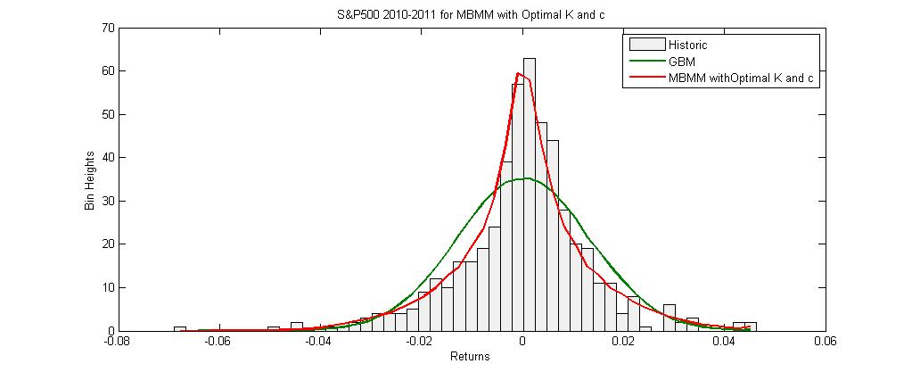

Figure 20: S&P500 with GBM and MBMM (K=-28,c=0.6)

It can be seen in the above figure that the red curve MBMM (with ${ K}_{optimal}=-28, c_{optimal}=0.6$) is very close to the historic histogram as compared to the GBM represented by the green curve. This was further verified by running a chi-square goodness of fit test on historic data (frequency observed) with simulations from the GBM and the MBMM (corresponding expected frequencies).

The historic data is represented into a histogram and the frequency of each bin as observed frequency is noted. Then we model the corresponding expected frequencies from the GBM and MBMM on same bins by running extensive simulations and taking average of these bin heights of these simulations as expected frequency. Limits of $μ±3σ$ are considered and the bins are customised such that each bin has a frequency of at least 1% of total values in data set. The adjusted frequencies are labelled as customised observed frequency (foc) for historic data and customised expected frequency (fec) for corresponding GBM and MBMM. The goodness of fit statistics for the GBM and the MBMM are calculated by $χ^{2}=\sum{\frac{{(f_{oc}-f_{ec})}^{2}}{f_{ec}}} with (n-p-1)$ degrees of freedom. Where $n$ is the number of customised bins in data set and $p$ is the number of parameters being estimated for the data set.

Applying the above mentioned technique, the customised distribution (21 bins in customised distribution) has chi-square total of 77.04 (p value=2.80E-09) for GBM and 14.93 (p value=0.53) for MBMM. Therefore we can infer that the MBMM provides a much better fit to the historical data. Furthermore Kurtosis for the customised historical data is 4.06 and the modelled Kurtosis from MBMM is 3.83

The summary results for MBMM for the subsequent two-year time period i.e. daily S&P500 returns from 1st Jan.2012 to 31st Dec.2013are also presented here. The chi-square total for this data (26 bins in customised distribution) is 32.57 (p value=0.09) for GBM and 19.97 (p value=0.52) for MBMM ($K_{optimal}=-3.5 \& c_{optimal}=0.6$). Kurtosis for the customised historical data is 3.50 and the modelled Kurtosis from MBMM is 3.57.

Naïve forecasting process may be based on using Koptimal and coptimal of the current time series returns distribution for the subsequent time period returns distribution, this will be an improvement on the GBM model.

We also applied the modified model on many other indices and also for different time periods. One notable aspect of this exercise is that optimal $K and c$ values are different for each data set because assets for different time periods and from different markets possess different characteristics. Price movement of assets are influenced by different sets of financial, political and economic factors Cont (2000). Thus MBMM parameters change for different data sets. This is in line that if we consider GBM as general modelling process then the MBMM is specific modelling process. The goodness of fit chi squared value (for optimal $K and c$) for most of the cases gives a p value>0.05.

For diagnostic purposes: the MBMM was applied on daily data as shown in the illustrative study; however the results lead to the question that what will be the outcome if extra function of Z is multiplied by σ instead of µ. The MBMM model was applied on 2-day data (µ and σ still kept at the daily level and as now. The resulting simulation outcome was consistent with those from daily data when $f\left(z\right)$ was multiplied by the mean, however complete lack of fit and inconsistency when $f\left(z\right)$ was multiplied with sigma, confirming the MBMM as a stochastic mean model.

Moreover, the MBMM was transformed into the equivalent SDE version by applying Ito’s Lemma.



$(6.7)$

This may not be in full rigour however this is applicable when $µdt$ is small, as is verified when extensive simulations were run using the discrete form version of equation (6.7) and the results were found to be consistent to those obtained from the exponential form (equation (5)) of MBMM.

The MBMM was also applied on larger daily data set to analyse the performance. The summary results of the 10-year daily data from S&P500 index from 1st Jan.1994 to 31st December 2003 are presented here. This data (75 bins in customised distribution) has chi-square total of 251.37 (p value= 1.04E-21) for GBM and 90.68 (p value=0.05) for MBMM ($K_{optimal}=-10 \& c_{optimal}=0.4$). Kurtosis for the customised historical data is 3.78 and the modelled Kurtosis from MBMM is 3.64.

Furthermore the MBMM was applied on subsequent ten year (1st Jan.2004 to 31st December 2013) turbulent time period to observe the output for optimal values of K and c. This data (50 bins in customised distribution) has chi-squared value of 614.26 (p-value=7.6E-100) for GBM and 88.4(p-value= 0.00012) for MBMM ($K_{optimal}=-30.8 \& c_{optimal}=0.2$). Kurtosis for the customised historical data is 4.95 and the modelled Kurtosis from MBMM is 4.32. A significant reduction in chi-squared value (as can be seen by huge improvement in p-value) indicates that MBMM provides a closer fit to historic data as compared to GBM. Further research is being carried out on how to model highly turbulent time series returns distributions.

Modelling behaviour of MBMM on big (i.e. fifty year) monthly data sets was tested and it is encouraging to see that here again MBMM provides a superior fit. The optimal value of $K$ is again negative with the absolute size being smaller as may be expected.

## Further Discussion:

The continuous and differentiable function for different negative values of $K$ is plotted below. For illustration purposes arbitrarily we have plotted the function for $c=1$.

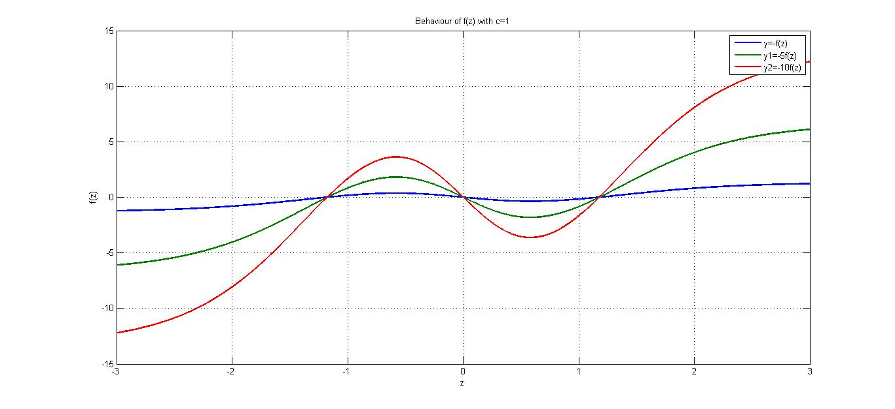

Figure 21: Kf (Z) for different negative values of K. c=1.

The roots of this function depend on the value of the positive parameter c. The bigger the value of c the closer the roots are to the origin. Hence c is the controlling parameter where the modelling the flattening of the tails starts in terms of the number of standard deviation away from the mean. For example if c=1 then the flattening of the tails starts at 1.18 standard deviations away from the mean value. Below a snapshot of the positive tail (empirical, GBM, MBMM) is provided for a specific data set. It can be seen that the MBMM provides a close fit to the **fat** empirical tail.

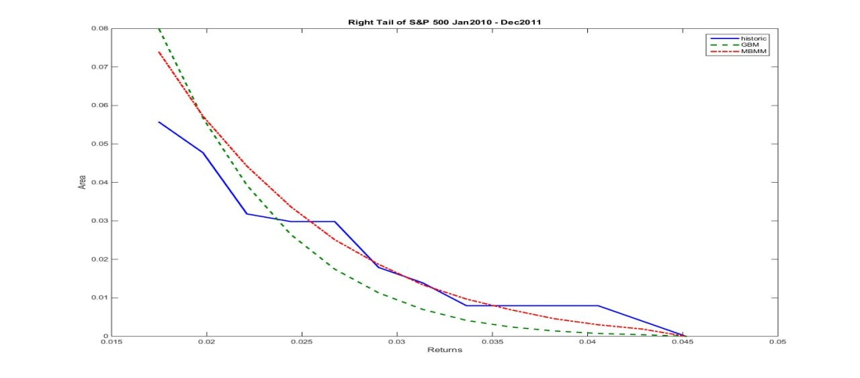

Figure 22:Right Tail of S&P500 for Historic, GBM & MBMM

Now, consider *positive* values of Z at time t (explanation for negative values of Z will follow in a similar but opposite manner). When is small (small in this case implies:  ), this is up to the positive root of , the value of . This in turn has the effect of  from the MBMM to be smaller than for the GBM, which in turn peaks the distribution of  near the mean value. Now if we allow that is the innovation to be perceived as news then the following connection can be made: when the news of the upturn in the market is minimal, not substantial, then in aggregate the movers (investors) of the market perceive that there is sluggishness in the market ( not much push in the market towards the positive direction) become impatient (and hence irrational: call this negative irrationality) and decide to sell the assets that belong to the market, so as to invest their money in alternative products, hence supply outstrips demand and hence the price increase as modelled in the MBMM model diminishes compared to the rational GBM model. Now when becomes positively large (large in this case implies:), this is beyond the positive root of, the value of. This in turn has the effect of  from the MBMM to be greater than for the GBM, which in turn flattens the distribution of  in the tail areas. In this case the market movers perceive that the market is positively bullish and in aggregate herd in an irrational behaviour (positive trading irrationality) to buy into the market, demand outstrips supply and hence the price increase as modelled in the MBMM model inflates compared to the rational GBM model. As may be noted from our illustrative study results from table (1), coptimal=0.6 implies $Z_{root}≅1.5$, $Z_{root}$ may be considered as a transition point.

Furthermore the 180 degree rotational symmetry around the origin (hence the roots will no longer be equidistance from the origin) can be broken to model skewness. This is achieved by introducing a parameter m in the exponential part of the (and not in the arctan(Z)) i.e Z2 changes to (Z-m)2and negative or positive skewness can be modelled with appropriate positive or negative values of m respectively.

In essence the extra function  alongside the parameters $K and c$ model the irrational behaviour of financial market price indices which is not captured by the weak form EMH. In line with general to specific modelling we propose that equations (5), (6) and (7), a parsimonious and accessible modification, be considered as the basis for modelling specific returns distributions in specific time periods with the appropriate optimal parameters.

Although we believe that the MBMM may not change the Black Scholes Option Pricing formula, the MBMM will significantly contribute to other areas of Finance; couple of areas where this applies are outlined below:

Application in Exceedance Correlation:

Longin and Solnik (2001) advocate the use of the ‘exceedance correlation’ to examine the asymmetry in correlation in extreme situations between different stock markets. ‘Exceedance’ refers to the extreme values of the asset distribution and it is defined as values exceeding certain confidence boundries, like 95 percent of the distribution. However, the exceedance correlation so far is only useful to testing the asymmetric correlation for a given empirical period. With the MBMM proposed in this thesis, we may short term forecast the future exceedance correlation i.e. we can run simulations for next t time period price using Equation (6.5) with the optimal K, c value. Then group the simulated values into different bins and compute the group correlations according to:

$$\tilde{ρ}(q_{α})≡\left\{\begin{matrix}correlation \left[X,Y | X≤Q_{x}\left(q_{α}\right)∩Y≤Q_{y}\left(q_{α}\right)\right], forq_{α}≤0.5 \\ correlation \left[X,Y | X>Q_{x}\left(q_{α}\right)∩Y>Q_{y}\left(q_{α}\right)\right], forq_{α}≥0.5\end{matrix} (6.8)\right.$$

Application in Portfolio Optimisation: Mendes and Marques (2012) argue that a better estimation of the portfolio efficient frontier depends on a reliable characterisation of the data underlying multivariate distribution. This requires a proper modelling of the individual assets as a critical step in portfolio management. Authors such as Patton (2004) demonstrate that higher moments improve the portfolio allocation if returns are distributed in a very different way from Normal. Higher moments measurements describe irrational behaviour in financial markets. Patton (2004) proves that higher moments such as skewness and kurtosis significantly affect portfolio allocation and, furthermore, the asymmetry in marginal distribution also affects portfolio management. The Modified Brownian Motion proposed in this thesis better reflect the real distribution of assets returns and also successfully provide an interpretation in relation to irrational behaviour in financial markets. Therefore, the MBMM could promote both the theory and practice of asset pricing and portfolio investment.

The next big question is just as equation (6.1) (ARIMA (0,0,0)) is the financial econometric discrete version of GBM model as described in equation(6.3) and (6.4): what is the financial econometric discretised version of the MBMM presented in equation (6.5) and (6.6)? Answering this would be very fruitful as it would help us understand this model further and be very helpful for financial applications; a couple of these applications are outlined above (exceedance correlation and portfolio optimisation).

# Chapter 7 Discovering the Irrationality behavior function $f(Z)$:

## Retrospective study of $f(Z)$:

The MBMM model developed in previous chapter about modelling returns distributions for financial market indices uses a quite innovative approach for obtaining a better fit. This is achieved by adding an extra stochastic function incorporating a weighting factor (with only two parameters to be estimated) over the well-known Geometric Brownian Motion (GBM). This type of modelling is endogenous and part of some coherent understanding of the market process, i.e. taking into account some irrationality of agents, sometimes accepted “by common knowledge” as a realistic possibility, but rarely included in models.

It can be recalled that Bulkley and Harris (1997) showed that stock price volatility may be due (in part) to a failure of the market to form rational expectations, using data on analysts' expectations of long run earnings growth for individual companies. Simulations provided (on various data sets) in the previous chapter show that this model, for describing agent behaviours, lead to very good fits (tested by chi-square tests) to the empirical returns distributions of various empirical price indices. The fits proposed in previous chapter are far superior compared to those obtained through the ordinary GBM. In particular the MBMM model captures the fat tails and overall leptokurtosis. Therefore, it can be claimed that the model makes a fully pertinent connection between the extra function and irrational behaviour of financial markets. Further justification of this is provided later.

Thus, here, we re-examine the specific role of irrational agent effects on the market following this GBM extension, for short let it be called IFBM (Irrational fractional Brownian motion) model. Rational expectations of investors with respect to future prices of assets/shares are assumed to reflect any available information. This is the essence of the efficient market hypothesis (EMH) (Fama; 1965, 1970).

Most of the studies (Singal, 2004, Frey and Eichenberger, 2002 and Shleifer, 2000) conducted around examining the behaviours of investors were done empirically through the analysis of the financial market and therefore explaining the different anomalies. These “hiccups” have been the main determinant or trigger to serious economic and financial upheavals during the last century. The focus of researchers has been more driven away from a macro level and stressing the importance at investigating the micro-structural aspects of the financial market in order to clearly paint a true picture of the whole financial world. Along these lines of thoughts, studies (Farmer and Joshi, 2002 and Takahashi and Terano, 2003) have been carried out at dissecting the various components of stock markets; these involve the behaviour of agents, the pricing mechanism and the allocation problems that determine the main structure or spine of the financial sphere.

Market microstructure focuses on the detailed mechanics and functioning of the financial markets. It aims at analysing the interconnection of the impacts of the market on prices of assets, volume and the trading behaviour (De Fong and Rindi, 2009). Theories, such as the Walrasian school of thought, stipulate that in perfect markets the Walrasian equilibrium price encapsulates the demand curves of all potential agents in the market. This determination of the equilibrium in the market looking at aggregated demand and supply is aimed at determining the market price. This system clearly looks at how the demand of investors is translated into prices and volumes which enables the financial market to operate.

The study of DeLong *et al.* (1991) analyses the impact of noise traders in the financial markets. The findings point out that the irrational behaviour of noise traders are the main instigators of price volatility in the market which acts for the advantage of other groups of investors. Thus, it is acknowledged that irrational behaviour determine the fluctuations in the movements of prices away from the fundamental/intrinsic value (DeBondt and Thaler, 1987).

Following critiques of the simple model’s assumption that financial markets operate efficiently where all information is publicly available, new models of asset pricing have been developed in order to reflect a more realistic view of the market. As such, the real financial world operates in a structure with the main determinant of asymmetric information which suggests that there are different types of agents in the market with different access to information. The advances in the literature of market microstructure link the new developments in areas encompassing economics of information, rational expectations and imperfect competition to determine the impact of information and how investors update their beliefs accordingly. Thus, the different categories of investors have different motives within the system. Bagehot (1971) distinguishes between those agents that are motivated by liquidity who do not have any private information over others and informed investors with the advantage of private information. Noise traders are classified as being liquidity driven who adjust their portfolios accordingly to areas where they have the perception that they possess current information. The importance or determinant of information asymmetry allows informed traders to benefit from their private information over uninformed agents. This means that a market maker is on average in a less beneficial position compared to informed traders. However this is compensated by advantages market traders have over noise traders which indicates that the spread pertains to an informational component that shapes the market trajectory (price formation). Kyle (1985) provides a model with a single agent who exercises control over information. The trader fully exploits this advantage of information asymmetry before the information is diluted and becomes publicly available. The market maker examines the net order flow in order to determine the appropriate price which represents the expected value of the asset. According to this model, price is determined after orders are placed. Here only market makers are allowed as opposed to the real financial world where traders can set their demands on price. In this model, Kyle shows that there is a rational expectation equilibrium whereby the market prices eventually reflect all available information. Given that the model assumes a normal distribution and continuous quantities of order taking any value over the real line, this framework has a linear regression. Hence, the price at any point in time is the expected value of the asset having a linear projection. This model shows that the market makers merely perform the duty of an order processor, determining the market clearing prices. It is clear that this model is an appropriate extension or enhancement of the simple model; however there are still some important aspects of the financial market that it cannot fully capture. This also involves analysing for example the ‘fat tails’ from the returns of securities where volatility is transmitted or generated. The discussion presented in this section leads the thesis to focus on modifying the Brownian Motion in order to determine a pricing equation that captures these aspects which are lost within an open market situation, thus showing the importance of running experiments within a semi-closed market.

## Structure and parameters

### Stock Market:

The experiment is about simulating the situation of a trading environment which involves the buying and selling of particular assets. The premise of this experiment is to design and simulate the situation of a stock market where agents are asked to buy and sell shares depending on the criteria of the system (demand and supply functions and external factors which are filtered into the system). The simulated stock market (SSM) is agent focused or led which means that the experiment is run without any bias or intervention element. The data are generated endogenously through the process of demand and supply (internal forces) and through some external factors. The market consists of *N* heterogeneous agents, who invest inside the semi-closed market. The composition of the SSM is fairly straightforward and simple as the amount of tradable assets have been limited to only four which comprises of four different sectors representing the whole market. The sectors and market is assumed to be fictitious which means that the agents should not allow the situation in the real market affect their decisions. The sectors are Banking, IT/Telecommunication, Retailing and Industrial. These sectors where not broken down into different companies but were just mentioned to be indices with the prices representing the actual soundness of the sectors.

Banking

IT/Telecom

Retailing

Industrial

Figure 23: Composition of simulated stock market

Semi-closed Experiment:

The agents are introduced to a semi-closed system which means that they need to deal with the internal and external environments. However, it is not an entirely open system which means that the external determinants/forces are being limited under this experiment.

*Trading:*The trading system is through the demand and supply of shares of the different sectors. These are in the form of the shares available to the agents (adjusted daily) and also to their cash flow (remaining from previous trading). Moreover, the agents are not allowed to short sell within the system and allocation of shares is not determined on Bid/Ask limit prices. The prices of the sector shares are computed on the basis of a demand and supply mechanism which is derived through adapting the characteristic of Brownian Motion. Advances in market microstructure along with components of the Brownian Motion were used under such a restrictive system in order to devise an adequate model for determining the current prices of the sectors. This aspect of the pricing mechanism is elaborated in the next section (findings and research).

### Information Criteria:

The news provided to the investors contains a mixture of two forms of news. The first form of information news was endogenously generated through analysing the pricing mechanism as determined through the demand and supply mechanism and imbalances at time t. The second form of news is exogenously generated (and provided) by observing the magnitude and sign of the random element drawn from the normal distribution at time t. Hence, the news parameters which are provided to the participants are and. These are made available at 5pm on the previous day and before 8am which means before the starts of the new trading session. Note that is drawn (randomly) between 5pm on the previous trading time and 8am on the trading period. This element acts as news for the participants to consider. It is subsequently entered into the pricing equation to generate.

## Findings and Remarks

### Allocation problem:

As the semi-closed experiment did not have the option of limiting orders with corresponding highest bids and asks rate, the only possible fair allocation mechanism was developed. This is a very simple and straightforward allocation tool whereby the aggregated demand (D) and supply (S) for each sector *i* at time period *t* are being matched depending on the minimum total of aggregated demand and supply for each sector *i* at time period *t*. These variables were allocated with a corresponding ratio of the minimum total and computed accordingly to provide a rounded fair amount to the agents and subsequently spreadsheet updated on a daily basis.

 if $(7.1)$

 if $(7.2)$

= individual demand of each sector corresponding to agent j at time.

 = individual supply of each sector corresponding to agent j at time.

*Pricing Mechanism:*The main findings from the experiment are the determination of the pricing mechanism which borrows the notion from the Brownian Motion and Random Walk Theory in order to adequately lead to a pricing equation which is applicable to the semi-closed market situation. The different parameters in the system are: the historical growth rate, the general historical volatility of the global market and the transmission coefficient and further to this the aggregate demand (D) in the system, aggregate supply (S) in the system, their adjacent period dynamics and finally a random element.

The pricing mechanism was in particular highly challenging due to the different specificities of the semi-closed market experiment and the assumptions made for the simulated stock market composition. Most of the theories involved in simulated stock markets base their price determination on variables such as best bid, best offer and time of orders (Cappellini and Ferraris, 2007). However, this experiment mainly deals with the properties of demand and supply from order forms. This allows clear emphasis on analysing the trading behaviours of investors and how they response to the evolution in the market.

### Stylised Facts:

The different components and conditions for the pricing mechanism are:

1. The market structure is not a zero-sum market.
2. The price () for the corresponding time is adjusted specifically to the movements of aggregated demand and supply for the whole market which is a feature of the semi-closed laboratory research.
3. Growth in the system is equal to the growth of the global economy if.
4. The volatility in the system is equal to the volatility transmission to the system if.
5. Transmission coefficient to be determined initially by guestimation.
6. The model is determined with reference to an arithmetic version which is deliberately selected to differentiate between the different components affecting the pricing mechanism[1].

Through the experiment the pricing mechanism was determined and tested for its reliability. After several adjustments carried out within a pilot exercise, the pricing of the shares was determined.



$(7.3)$

where:

|  |  |
| --- | --- |
|  | = price of a particular sector *i* at time *t* |
|  | *=* the monthly growth rate of the external market fed inside the system. |
|  | = aggregated demand for sector *i* minus aggregated supply for the same sector at time *t* |
|  | = average of aggregated demand and supply for sector *i* at time *t* |
|  | = a random element (drawn from the normal distribution system) which represent exogenous news provided to the inside sector *i* of the system at time *t* |
|  | = monthly volatility transmission from the external system (the and the transmission coefficient is implicitly embedded inside) |
|  | = the change in between the time *t* and *t-1* |
|  | = the average of the addition of the averages of the aggregated demand and supply for sector *i* at time *t* and *t-1* |

This pricing mechanism incorporates the demand and supply factors within the semi-closed system however with no control on behalf of the participants on the way that the allocation is carried out. The pricing mechanism has its main foundations on various important components which are as follows:

### Demand and Supply:

There are two demand/supply factors within the pricing equation which reflect the behaviour of participants within the semi-closed system. The first one incorporates the effect of daily demand and supply elements of the sector involved along with a loose normalising factor. The second element relates to the impact of the demand and supply and the changes from previous trading time period with a loose normalising factor that reflect the average aggregated addition of demand and supply for a particular sector. This is an important element within the pricing mechanism as it reflects the behaviour of the participants within the system. Hypothetically randomness associated with prices may affect the volume of demand and supply making them dependent on. Therefore, the second factor is added to the which indicates the direct impact of news on the changes of demand and supply.

### News and Dynamics:

The generation of the news which is released every time period within the system is established by the impact of the element and the dynamics of the insider trading. A positive value of indicates a positive exogenous news which may rationally or in an exaggerated manner encourage positive especially if the inside investors are prone to the exogenous news and similarly a negative value may drag down the reflecting the situation and reaction of investors due to news that are not favourable for trading. However, this may not be the case as herding behaviour (opposing the exogenous news) may take hold and the news generated from the inside of the system outweighs theelement news. Various scenarios regarding the dynamics of the investors and the subsequent price modification of the sectors (and the system) are now possible. Experiment 1 provides some evidences that the majority of the time became negative (positive news did not influence in a positive manner). This led investors to sell in a falling market indicating herding behaviour within the various sectors. However, the main aspect of this herding behaviour is that the trading occurred in a falling market. This clearly indicates that collective phenomenon within the system can have a great influence on the pricing mechanism which may not be in the same line with the parameters or indicators in the system.

* 1. *Uncompress time into minute factors:*

The time uncompression within the pricing mechanism leads to

[2]

where:need not be symmetric around the origin when irrational trading is taking place. This leads to the simulation of the pricing mechanism within three distinct trading phenomena – bubble, burst and stable time periods. The time uncompress through simulation results into the opening up of the system (This is equivalent to removing the membrane from our metaphorical “inflated ballon” refered to earlier). Therefore, the three scenarios can now be categorised[3]:

1. Whenover a particular consecutive time (set) period is largely concordant with this reflects the situation of a stable period where theelement translates into a different degree (slope) of impact on the dynamics of.

1

2





Note that case 2 shows that investors are more sensitive to as opposed to case 1. This is highly dependent on the size of the market, the number of players and liquidity. This can be classified as rational behaviour within the market. This can still be classified as a form of rational behaviour within the market, with the basic random walk model being recovered when the slope become zero.

1. Whenover a particular consecutive time period is disconcordant with within a stable period is quite unlikely to occur within a market because of the element of positive information having a negative impact onover the set time period.
2. Whenis largely concordant with positive news or negative news () but not both this may illustrate periods of bubble or burst, here is likely to follow two different excessive paths within a certain time frame which is not explained through rational behaviour.
3. (b)









Case (a) reflects a situation of bubble within the market where positive (implying positive news) leads to a positively “significant”. However a negative will not have a significant impact on. This is of an irrational nature where changes indoes not follow the information channels with the system. The market operates as an entity with only one target which is on the overestimated growth of the sectors. Case (b) indicates the reaction ofwithin a period of burst where a negative have a “significant” negative effect onhowever a positivedoes not have a significant impact on . Case (a) and (b) can be classified as irrational behaviour as concordant behaviour occurs in the first and third quadrant respectively.

***In hindsight: scenarios presented here for  do not provide fit for purpose methods for fitting the empirical returns distribution. The correct  function is presented in chapter 6, “Modified Brownian Motion Approach to Modelling Returns Distribution”.***

## Further Research

Market microstructure is a field which is an aperiodic ebullition with various emphases on determining how irrational trajectory of investors can be linked to the different components of a stock market. The pricing mechanism is one of the main aspects that is examined to see whether it reflects the behaviour of investors. The Brownian Motion which is at the heart of the pricing of shares is being modified to incorporate elements of demand and supply and news feedbacks to reflect the contribution of investors rational and irrational behaviour. The main finding of this thesis is the modified Brownian Motion pricing mechanism which has been experimented within a semi-closed stock market in order to capture the behaviour of investors. The pricing mechanism reflects the changes in demand and supply and also the reactions of the participants to the news feedbacks. The second aspect of this thesis covers the criteria of news feedbacks and how the system reacts to its movement. Two experiments were carried out with distinct results. Experiment 1 shows that investors disassociated themselves from the news feedbacks and sold their shares with a falling market corresponding to an irrational behaviour. On the other hand, Experiment 2 indicates a more rational behaviour of investors in response to news. Finally, the third component investigated is the time uncompress factor within the semi-closed system. Three main time periods were identified (stable, bubble and burst) in order to reflect the reactions of investors to news. The main hypothesis is that a rational reaction is mainly concordant and disconcordant in nature. On the other hand, periods of bubble and turbulence were classified as either largely concordant with positive news or negative news but not both. Investors disassociate themselves with negative news feedbacks in periods of bubbles and with positive news feedbacks in periods of bursts. Subsequently, news and its effects now become part of the model and hence leads to the modified variations of the Brownian Motion as discussed in the previous section.

Further research in terms of the reactions in to changes inprovide an adequate platform to run simulations on the model (by investigating the appropriateand optimising through the parameter) where the return distributions are matched against real-life empirical return distributions which are generated inside periods of boom, burst and stable times. The simulations will be used to measure the degree of irrational trading in time where the return distributions significantly deviate from the ones generated from the basic random walk model. Note thatis the random element in the model, other distributions may correspond; however the factor is hypothesised from the normal random walk model. Furthermore, variations and amendments to the pricing model are being considered. For example, an extra function added to the modified Brownian Motion corresponding to the  arising from the change in news () over consecutive time period may need to be considered for volatility implications.

This is highly related to the news feedback mechanism that investors have been ignoring and following the path of their own irrational trajectory: now to be investigated by identifying the appropriate weightand the appropriate in specific time periods and specific markets.

## Discovering Irrational Behaviour:

As explained in Dhesi and Ausloos (2016), in this section so as to integrate with this research we present (closely following this analysis) a comprehensive summary of the irrational behaviour of investors. Agents’ irrational behaviour is often scorned upon. Under the EMH, the latter categories are called irrational agents. This behavior is not recommended because it is usually “concluded” that the agents would lose money in the long run because of their irrationality, being way off any understanding on how the market evolves. Becker (1962) contends that such agents do not (rationally) intend to maximize their profit! whence, in modern language, their utility function. Prechter (2001) believes that such agents ride social mood waves, - thus are rational without knowing so. Of course, agents can be switching between two trading behaviors, like informed vs. liquidity traders (Ghoulmie, 2004). In fact, previously, DeLong *et al.* (1990) already analysed the impact of noise traders in the financial markets. Their findings pointed out that the irrational behaviors of noise traders are the main instigators of price volatility in the market, whence acting to the advantage of other groups of investors! Thus, it is acknowledged that irrational behaviors determine fluctuations in the movements of prices away from the fundamental/intrinsic value (DeBondt and Thaler, 1987).

Nevertheless there is some evidence that these irrational agents might be able to obtain higher than average returns (see Brock and Hommes; 1997, 1998) for an appropriate discussion). To use “noise”, fractional Brownian motion with a Hurst coefficient (0.5>H>1) rather than the classical Brownian motion has been demonstrated indeed to be very useful for investor strategies as explained in Vandewalle and Ausloos (1997,1998), Ivanova and Ausloos (2001) and Ausloos and Bronlet (2003,2004). These strategies are “very rational”, apparently paradoxical, but, on the contrary, much thought of. Some part of the paradox should be distinguished from so called “irrational expectations”, popularised through irrational exuberance (Shiller, 2000).

To describe the irrational behavior of agents, a so called bounded rationally confident agent model is usually mimicked (Hegselmann and Krause, 2002). It implies an awareness threshold determining the level to which an agent puts a confidence weight. This, necessarily “non-linear model”, leads to avalanches, bubbles, etc.(Emambocus and Dhesi, 2010; Ausloos and Petroni, 2013).

It has been argued that markets are not inherently rational but are driven by fear and greed. Lo (2004,2005) has argued that rational and irrational behavior are opposites sides of the same coin (which does not mean much) and an evolutionary approach can be applied so as to reconcile market efficiency with behavioral alternatives. This provided motivation to develop an adaptive wave alternative for option pricing model (Ivancevic, 2010).

Bearing in mind that the markets are driven by, fear greed and impatience, a different way can be considered within a more direct stochastic (and to a large extent non-adaptive) function as introduced in the GBM evolution equation for the share prices. In the following, in Section II, we re-explain this new model and the new stochastic function theoretical origin. Section III interprets the financial return evolution and inherently explains the modelling of the irrational behaviour of the market. Section IV elucidates how the irrational behaviour of the market can be considered as a non-adaptive “psychological soliton” of the financial markets. Beside in so doing proposing a measure of the irrational force component in a market, further directions in related research are outlined.

## Towards the $f(Z)$ function:

Of course there is a debate as to what is to be considered as rational or irrational behaviour, as briefly outlined in Section I through a few references. In line with the Efficient Market Hypothesis, we attribute rational behaviour of the markets to the notion that the market price incorporates all information rationally and instantly. Thereafter, the irrational component has to be introduced.

Let us start with the usual financial log-returns definition



$(7.5)$

where µ is the average return and  is assumed to be normally independently distributed (NID) with zero mean and constant variance $σ^{2}$ (a “white noise ”), within the underlying assumptions of the error term in the EMH. The above equation can be written as



$(7.6)$

in which  is a random number, drawn from a standardised normal (“Gaussian”) distribution and $δt$ is a small time step. This equation is deployed to model returns distributions based on the Geometric Brownian Motion (GBM), e.g. see Peters (1990) or Paul and Baschnagel (1989). However, the distribution of returns generated from this GBM model does not match the distribution of historic returns data which often show leptokurtosis (Breen *et al.*, 1998; Lux, 1989). Motivated by an experimental paper due to Dhesi *et al. (2011)*, We added a function of the random number  weighted by the mean and an extra parameter $K$, in order to describe the returns distribution through



$(7.7)$

thereby leading indeed to a much better fit to the log-return distributions, in particular in the peak and the tails: (as explained in previous chapter). This modified specification is important as this endogenously generates a distribution which is not arbitrarily exogenously imposed, but demands to choose the appropriate realisation of, that is leptokurtic and hence is appropriate for the returns distributions.

Therefore, this modelling process suggests ways to describe irrational behaviour in finance: details are provided in section III. It should be noticed that only the normally distributed  innovation appears in the model, in contrast to e.g. the numerous models of returns distributions using jump diffusion processes which contain normal and Poisson jumps (Birge and Lintesky, 2008).

The above discrete time evolution of log-returns can be transformed into a stochastic differential equation, by applying Ito’s Lemma:



$(7.8)$

valid when $µdt$ is small, and where . Obviously for, the GBM is recovered.

After much extensive empirical analysis of historical data on various market indices, Dhesi *et al.* (2016) have proposed that as:



$(7.9)$

To let the reader be aware of the role of the parameters $K and c$ a few cases are illustrated on Figs.23-25.

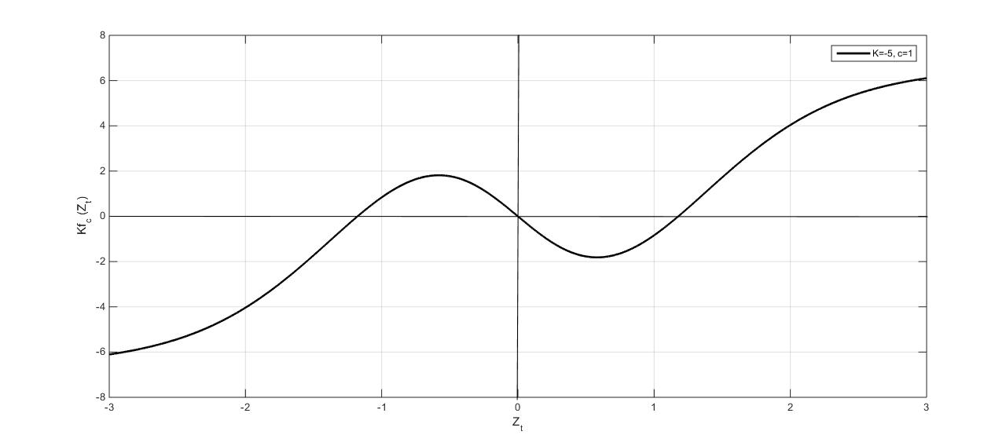

Figure 24: Plot of the information feedback function *K fc (Zt)* for = - 5, c = 1 as a function of 

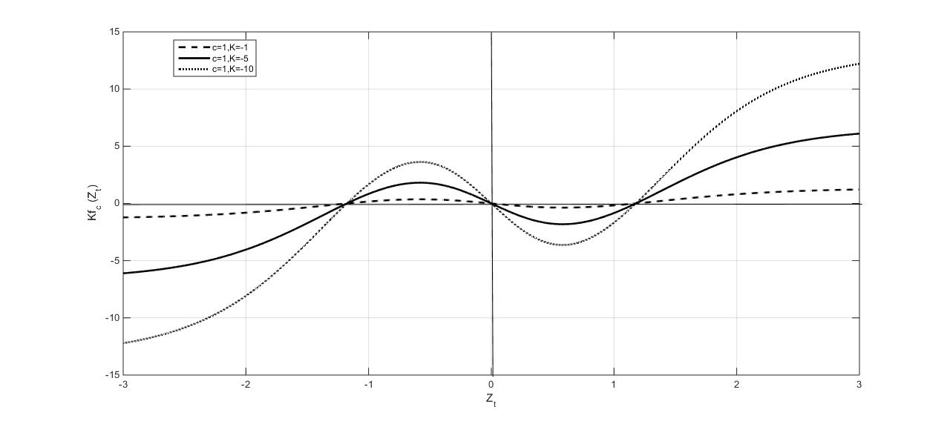

Figure 25: Plot of the information feedback function *K fc (Zt)* for various *K* values = -1, - 5, and – 10, and for *c* = 1 as a function of *Zt*

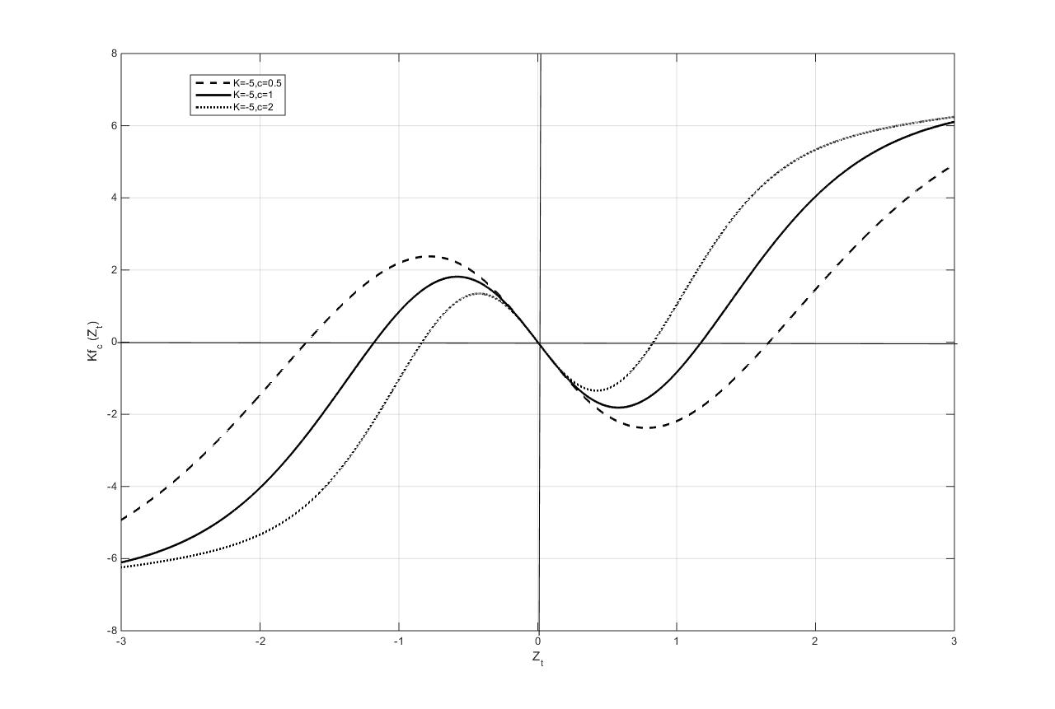

Figure 26:Plot of the information feedback function *K fc (Zt)* for *K* = - 5, and various *c* values : *c* = 0.5, 1, and 2, as a function of *Zt*

Figure 26 allows to illustrate the overall shape of for *c*=1. The non-trivial behaviour allows us to point to a change in curvature and slope near , leading to a local minimum and a local maximum. Figure 24 shows the influence of *K* for a given *c* (=0.5): neither the roots move, nor the local extrema, but their amplitude increases with *K*. Figure 25 shows how the extrema and roots move as a function of *c*. Any reader has observed that for *K* negative, the function has its local minimum for  positive, and its local maximum for  negative. They are of equal magnitude in absolute value. Thus, it seems worth to point out here that the feedback of information function, when multiplied by *K*, is an “irrational feedback” function when *K* < 0, as further developed in Section III.

## Connecting $f(Z)$ with irrational behaviour:

Consider for the sake of discussion that *Zt* corresponds to some financial news or economic information at time particular time *t*. The feeding parameter to the investor is it gathers and provides the additional output beyond the GBM at each time step *t*. Simulations are then performed using the antilog version of Equation (7.8) and returns distribution is modelled though aggregation.

We will term  as the feedback function. This feedback function for negative values of and arbitrarily for *c* = 1 for illustrative purposes is provided in the annotated figure 4. The following analysis of this section, and referring to Equation (7.8), explains that measures and models the irrational feedback behaviour of agents when *K<0.*

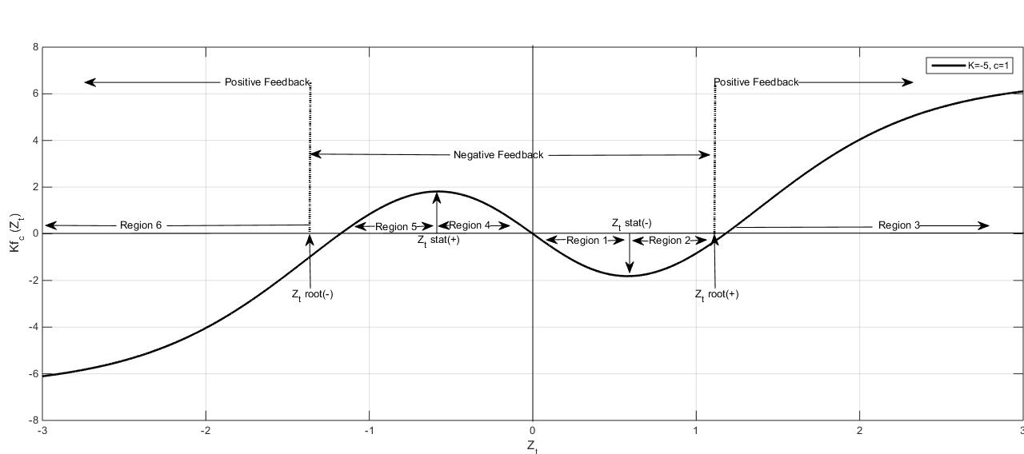

Figure 27:Plot of the information feedback function *K fc (Zt)* for *K* = - 5 and *c* = 1 as a function of , emphasizing the various regions of interest.

Figure 26 contains six regions separated by roots and extrema of . Assuming that we are currently at time  , we will first consider the regions 1, 2 and 3 corresponding to positive values of .

|  |  |  |  |  |  |  |
| --- | --- | --- | --- | --- | --- | --- |
| **Region** | $$Z_{t}$$ | $$δP_{t}$$ $$from GBM$$ | $$Slope$$ $$of Kf_{c}{(Z}_{t})$$ | $$δP_{t}$$ $$from Kf_{c}(Z_{t})$$ | **Price Comparison** | **Feedback Nature** |
| 1 | $$0< Z_{t}<Z_{t,stat(+)}$$ | Positive | $$<0$$ | Negative | $${(P_{t+δt})}_{IFBM}< {(P_{t+δt})}_{GBM }$$ as ${(P_{t+δt})}_{IFBM}\sim P_{t},$ this peaks the returns distribution, price rise in the $IFBM$ is smaller than the $GBM$. | Negative as $Z_{t}Kf_{c}{(Z}_{t})<0$ |
| 2 | $$Z_{t,stat(+)}< Z_{t}<Z_{t,root(+)}$$ | Positive | $$>0$$ | Negative | $${\left(P_{t+δt}\right)}_{IFBM}< {\left(P_{t+δt}\right)}_{GBM }$$ as ${(P_{t+δt})}_{IFBM}\sim P_{t},$ this peaks the returns distribution, price rise in the $IFBM$ is smaller than the $GBM$. | Negative as $Z_{t}Kf_{c}{(Z}_{t})<0$ |
| 3 | $$Z_{t}>Z_{t,root(+)}$$ | Positive | $$>0$$ | Positive | $${\left(P_{t+δt}\right)}_{IFBM}> {\left(P_{t+δt}\right)}_{GBM }$$ as ${(P_{t+δt})}_{IFBM}≠P_{t},$ this flattens the returns distribution, price rise in the $IFBM$ is greater than the $GBM$. | Positive $$Z_{t}Kf_{c}{(Z}_{t})>0$$ |
| 4 | $$Z_{t,stat(-)}< Z_{t}<0$$ | Negative | $$<0$$ | Positive | $${\left(P_{t+δt}\right)}_{IFBM}> {\left(P_{t+δt}\right)}_{GBM }$$ as ${(P_{t+δt})}_{IFBM}\sim P_{t},$ this peaks the returns distribution, price fall in the $IFBM$ is smaller than the $GBM$. | Negative $$Z_{t}Kf_{c}{(Z}_{t})<0$$ |
| 5 | $$Z_{t,root(-)}< Z_{t}<Z_{t,stat(-)}$$ | Negative | $$>0$$ | Positive | $${\left(P_{t+δt}\right)}_{IFBM}> {\left(P_{t+δt}\right)}_{GBM }$$ as ${(P_{t+δt})}_{IFBM}\sim P_{t},$ this peaks the returns distribution, price fall in the $IFBM$ is smaller than the $GBM$. | Negative $$Z_{t}Kf_{c}{(Z}_{t})<0$$ |
| 6 | $$Z_{t}<Z_{t,root(-)}$$ | Negative | $$>0$$ | Negative | $${\left(P_{t+δt}\right)}_{IFBM}< {\left(P_{t+δt}\right)}_{GBM }$$ as ${(P_{t+δt})}_{IFBM}≠P_{t},$ this flattens the returns distribution, price fall in the $IFBM$ is greater than the $GBM$. | Positive $$Z_{t}Kf_{c}{(Z}_{t})>0$$ |

Table(xxx): explanation of $Z_{t}Kf_{c}{(Z}_{t}) in$ price evolution.

Let us first examine the total negative feedback region corresponding to (this is regions 1, 2, 4 and 5). In this feedback region, the product ofandis negative. This region models/measures the sluggishness of the market, when the agents respond in aggregate to the minimal news by reacting in an inverse manner. They are so called contrarians or irrationals. For example, when the upturn in the news is minimal, agents irrationally become impatient, sell the assets and invest in alternative products. Next, consider the two positive feedback regions where the sigmoid function has smoothly taken over and now dominates. The positive feedback region corresponding to large positive *Zt* values and, models/measures the agents riding the wave of euphoria, greed and irrational exuberance: “buy, buy, and buy”. In the other positive feedback region, corresponding to large negative values of *Zt* and, the aggregate fear and panic (“sell, sell and sell”) of the irrational agents is so modelled.

The negative feedback region effectively peaks the returns normal distribution near the origin; the smooth take over by the sigmoid function giving rise to the positive feedback regions flattens the distribution, whence leads to longer tails. This measuring process of the irrational agent behaviour has been found to finely model the leptokurtic distribution of returns.

## Discussion and conclusion: discovering the psychological soliton.

The Adaptive Markets Hypothesis (Lo, 2005) implies that the degree of market efficiency (i.e. the degree of rationality/irrationality) relates to environmental factors and that the violation of rationality is consistent with an evolutionary model of agents adapting to a consistently changing environment via simple heuristics.

In this thesis, we are measuring the degree of irrationality (the degree of market

non- efficiency) using the stochastic function. and *c* are estimated for specific market data sets in specific time periods, hence are specifically and intricately linked with the degree of the environmental factors of the market and time period. However the general shape of is non adaptive. It will persist through time as the markets are to some extent driven by agents who react in terms of impatience, fear and greed and will continue to do so.

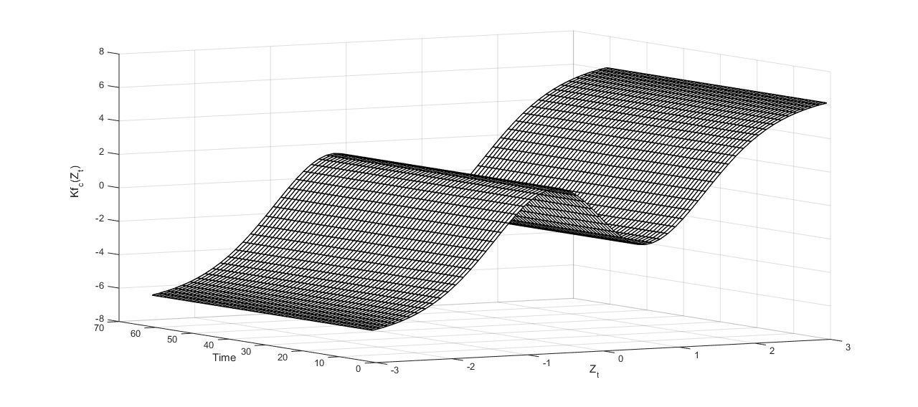Figure 28:Three-dimension figure illustration of with Time and $Z_{t}$

The three-dimensional figure illustrating  , Figure 27, shows that the function maintains its overall shape as it moves in time (time is represented as the third dimension). Hence  behaves as a travelling kink into time (with a sinusoidal shape near the origin) due to the investors’ irrational behaviour. We can now coin thatcorresponds to a “stochastic psychological soliton” for the financial returns on a stock market. There is no need to insist that the roots positioning (dependent on *c*) and the amplitude of the kink (dependent on *K*) might be not constant, but time and case dependent as outlined above. Nevertheless, the theoretical kink characteristics (its critical *Z* value and its amplitude) might be considered as a simple way to characterize and measure the irrational behaviour of an agent, or of a population of agents, pending fits to an overall distribution of returns in a market for such distribution fits.

When analysing regularly spaced periodic time series the financial soliton will feed on this news/innovation at constant velocity. Furthermore now consider the fact that the data fed into the system can be yearly, monthly, weekly, daily or even intraday data. This data will pass through the financial soliton as discussed above, so as to model the best fit returns distribution to empirical data. We suspect that this type of modelling will then also shed knowledge on and connect this soliton structure to the multifractal behaviour of stock markets.

A warning is in order in this conclusion. One should be careful about the rigour of the mathematics and corresponding mathematical properties of solitons: soliton wave pulses are usually bell shaped (strictly categorised by *sechnZ)* or travelling kinks. The present kink shape categorized by  is a mixture of the inverse bell shaped (dark soliton) and the travelling kink shape. In essence we are mixing p.d.f with a c.d.f; i.e. a bell shape with a sigmoid function. Hence due to the shape of the soliton , *K* being negative, it provides the additional output that is of negative feedback when and positive feedback when.

Financial models which incorporate stochastic volatility usually lay foundations on the GBM. However just as the GBM is appropriate to physical sciences (say for example sugar dissolving in water without stirring and at temperature etc.) the correct foundation for further financial modelling is the IFBM , Eqs.(3) and (4),model proposed in this thesis. The IFBM both captures the leptokurtic distribution of asset returns and also provides the measure for this irrational behaviour as captured by the psychological soliton.

Notice in fine that Engle (1982) wrote that “the use of exogenous variables to explain changes in variance is usually not appropriate”; we insist that there is no exogenous variable indeed in the MBMM model in previous chapter nor here above.

## Further connections in Physics:

The term “Soliton” is applied to refer to “solitary-wave pulse” in a wave containing several pulses which is heavily studied in classical non-linear field theory in nuclear and particle physics. Solitons are nonlinear pulses whose amplitude, shape and velocity remain unchanged even after passing through one another. Their stability in collisions comes from the conservation in time of important physical or mathematical properties. For mathematical representation, there are limited options for the pulse shape involving only elementary functions. An exponential function is not localised, because if it decreases exponentially for some $Z > 0$, it will increase exponentially for $Z < 0$. A Gaussian function is localised but differentiating it will generate additional factors that are polynomials of Z. Alternatively, the derivative of an exponential function is still an exponential function multiplied by an appropriate coefficient. Therefore likely options to model a soliton are localised versions of exponential function. The most appropriate functions that are finite everywhere are the hyperbolic functions:

$$g_{n}\left(Z\right)={sech}^{n}\left(Z\right)={[\cosh\left(Z\right)]}^{-n} (7.10)$$

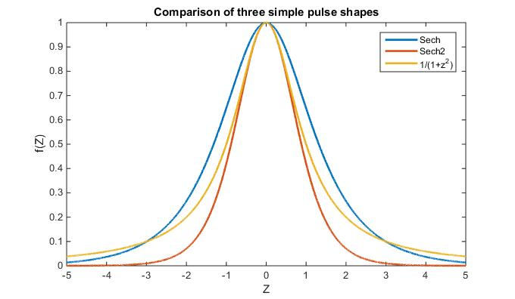

Figure 29: Comparison of three simple pulse shapes

Flood waves called hydraulic jumps in engineering are formed when water is suddenly released from dams or in irrigation canals. The free surface of the released water has an observable front that separates the region to be flooded from that already flooded. The free surface of the flood is usually undulatory, but can be turbulent near the front. Similarly Tsunamis are hydraulic jumps in the ocean caused by earthquakes. These can travel as fast as many airplanes, but not as fast as sound. A travelling kink soliton is an idealised travelling jump in the shape of a smoothed step function that is unchanged in shape as the wave front travels in time. Three simple kink shapes with the same gradient are presented in the figure below.

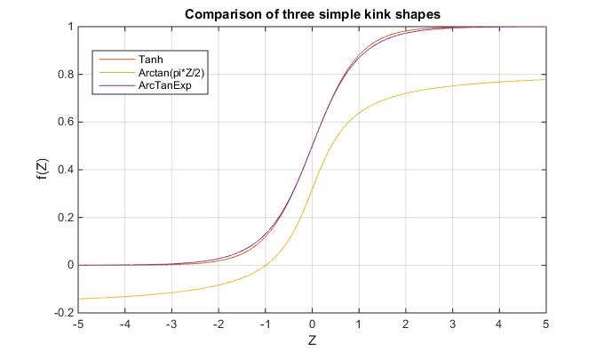

Figure 30: Comparison of three simple kink shapes

# Further Questions and Work:

For ending this conclusion, we can suggest a few questions for further work, expanding the present findings. For example, one can ask

1. What is the differential equation whose solution is *Kfc(Z)*
2. What is the discrete form financial econometrics version of Equation (7.8), as Equation (7.4) is the discrete version of Equation (7.5)
3. Is the IFBM model leading to a better volatility clustering description?
4. Should other non-linear analytic functions similar to Equation(7.9) be considered and why?
5. Can one further consider extensions of the IFBM (i) toward volume distributions, (ii) technical analysis considerations, or (iii) examining soliton-soliton, soliton-antisoliton interactions, on other spaces, (e.g., time, wave vector, and energy ) and (iv) in the vicinity of financial crashes ?

## Development of GARCH Process:

We conclude this work by presenting a brief description of GARCH processes and how it can lead to potential variation of GARCH based on IFBM model. The GARCH process was developed by Bollerslev (1986) and Taylor (1986) which is identical to an ARMA model in terms of efficiency. Due to its characteristics, the GARCH process is most commonly used to analyse economic and financial time series data.

Suppose $ε_{t}$ is represented by a real value of discrete time stochastic process and $I$ be the information set for all the information at time t then the GARCH (generalized autoregressive conditional heteroskedasticity) process developed by Bollerslev (1986) can be described as:

$$ε_{t} ∣ I_{t-1}$$

$$σ_{t}= α_{0}+ \sum_{i=1}^{q}{α_{i}}ε_{t-1}^{2}+ \sum_{i=1}^{p}{β_{i}}σ_{t-1}^{2} (7.11)$$

Where

$$p ≥0 , q>0$$

$$α_{0}>0 , α_{i}≥0 i=1, ….,q$$

$$β_{i}≥0 i=1, ….,p$$

The main essence of ARCH/GARCH processes is the assumption of homoskedasticity. It states that for a least squares model, the mean value of all error terms remains unchanged for any time if squared once. In other words the variance of the error terms does not change with the passage of time.

Whereas heteroskedasticity states that the variance of error terms keeps changing over time for time series data. As a result, the mean value of the error terms can change as well. Alternatively, the data is said to be heteroskedastic if it shows signs of a GARCH sequence. Therefore, for any ordinary least squares regression, the estimates of regression coefficients are unbiased. However standard errors and confidence intervals for the significance of these estimates would become very slim, pretending an artificial accuracy. These hiccups in least squares are corrected by ARCH/GARCH processes; also, these models measure the level of heteroskedasticity.

The basic version of GARCH states that conditional variance changes with the passage of time for a Gaussian distribution and is symmetric in acknowledging the previous changes. This symmetric GARCH is known as the plain vanilla version of GARCH model. Vanilla GARCH model estimates variances and co variances of stock returns by modelling time changing conditional variances. Whereas in ARCH process, the conditional variance changes by time as a function of previous squared deviations from mean, without considering previous variance. Parameter estimation is carried out in GARCH by increasing the value of log likelihood function. These parameters are induced from the underlying distribution for the model (for example normal distribution). Conditional volatility in GARCH is defined as the annualised square root of conditional variance. The conditional variance and volatility are referred to be conditional on the basis that these are conditional on the data set, which provides information till current time.

Another extension of GARCH process named as Normal GARCH is applied to detect volatility clustering in data; however it does not distinguish the leverage effect that is to signal that the market reaction to bad news is greater than to the good news. Asymmetric GARCH model includes an extra parameter to the symmetric GARCH model so that so that it has a system to trap asymmetric volatility response. The GARCH (1, 1) is known as the general volatility model in the GARCH family, which can be modified in a number of ways. For example, parameters are evaluated by maximising likelihood function. Mean reversion effect is same as in the symmetric GARCH model, however response to market disturbance is asymmetric.

But, the GARCH model has its constraints that the conditional variance is dependent on the number of lags of error terms, it does not consider the symmetry of underlying distribution and does not consider the sign of error term. According to Yoon and Lee (2008), “GARCH model can not reflect leverage effects, a kind of asymmetric information effects that have more crucial impact on volatility when negative shocks happen than positive shocks do”. This is why further extensions of GARCH process have been introduced and some of them have been described briefly in the above sentences. These innovative models of GARCH analyse the shape of a distribution, include extra lag terms for errors. Some of these extended GARCH models include:

* Exponential GARCH (EGARCH) developed by Glosten and Rankle (1992)
* GJR-GARCH model
* Asymmetric power ARCH (APARCH)model

## Mathematical representation of GARCH process and Extensions:

To improve the GARCH process, some extensions of GARCH (p, q) have been introduced including exponential GARCH, GJR-GARCH etc. These extended versions of model deal with irregular volatility, mostly used with large data sets including daily or hourly data, with the inclusion of additional lags in model; these extended models accommodate both quick and gradual diffusion of information.

GARCH (1, 1) is a basic GARCH model applied to detect volatility clustering and heteroskedasticity within time series. GARCH (1 ,1) is represented as

$$y_{t}=C+ε_{t} (7.12)$$

That is returns on security $y_{t}$ are equivalent to a constant term and an uncorrelated white noise innovation $ε_{t}$. This model is usually enough to determine the conditional mean of a financial return data. The corresponding variance equation is given by:

$$σ_{t}^{2}=k+G_{1}σ_{t-1}^{2}+A_{1}ε_{t-1}^{2} (7.13)$$

Where

* $σ_{t}^{2}$ represents variance at time t
* $σ_{t-1}^{2}$ represents variance at time t-1
* $ε_{t-1}^{2}$ represents squared error term for time t-1
* $k$ is a constant
* $G and A$ are the weights associated with variance and squared error term for time t-1 respectively

A description of the above variance model can be: $σ_{t}^{2}$ is represented as a sum of weighted average of variance and squared term from previous time period plus a constant term. The error terms in the model are because of random variables, which are supposed to possess a normal distribution. The conditional distribution of GARCH models has been shown to comprise of heavier tail than that of a normal distribution and so it provides a better estimation to original time series.

### GARCH (p, q):

The primary GARCH (p, q) process is a symmetric variance process. It does not consider the sign of error term. A general GARCH (p, q) model consists of two halves. First part represents the mean function given by



$(7.14)$

The above model denotes that Yt follows an ARMA (R, M) process. The other part of process consists of the variance:

$$σ_{t}^{2}=k+\sum_{i=1}^{p}{G_{i}}σ_{t-i}^{2}+\sum_{j=1}^{q}{A_{j}}ε_{t-j}^{2} (7.15)$$

With following limits:

,,,and $$\sum_{i=1}^{p}{G_{i}}+\sum_{j=1}^{q}{A_{j}}<1$$

The procedure of estimation of GARCH (p, q) model is by maximum likelihood function, evaluates the accuracy of estimators predicted by GARCH (p, q) model. Major assumption of maximum likelihood function is that returns are normally distributed with a given mean and variance. The methodology of maximum likelihood function is to develop a likelihood function dependant on the nature of parameters supposed for the underlying distribution. Thus if logarithmic returns have a normal distribution then the corresponding parameters of the model can be evaluated by optimising the likelihood function for time series.

### Exponential GARCH (EGARCH (p, q)):

Nelson (1991) developed the exponential GARCH model which transforms the conditional variance model in terms of logarithm of the variance instead of the variance itself. The rational for this is to make sure the variance remain positive without setting any bounds on the coefficients. The logarithm of a certain value can be negative but the final value of variance will always be positive. EGARCH is an asymmetric GARCH which is better than symmetric GARCH for approximately any security data. The typical EGARCH (p, q) model for the conditional variance of error terms with extra leverage terms is represented by:

$\log{σ_{t}^{2}}=k+\sum_{i=1}^{P}{G_{i}}\log{σ_{t-1}^{2}}+\sum_{j=1}^{Q}{A_{j}}\left[\frac{\left|ε_{t-j}\right|}{σ_{t-j}}-E\left\{\frac{\left|ε_{t-j}\right|}{σ_{t-j}}\right\}\right]+\sum_{j=1}^{Q}{L_{j}}\left(\frac{ε_{t-j}}{σ_{t-j}}\right) (7.16)$

With degrees of freedom *v>2*, where

$$E\left\{\left|z_{t-j}\right|\right\}=E\left\{\frac{\left|ε_{t-j}\right|}{σ_{t-j}}\right\}=\sqrt{\frac{ν-2}{π}}\left(\frac{Γ(\frac{ν-1}{2})}{Γ\left(\frac{ν}{2}\right)}\right)$$

As EGARCH only considers logarithmic conversion so the conditional heteroskedasticity is always positive without any constraints set on the coefficients. Also the conditional heteroskedasticity is dependent entirely on the level of disturbances and presents the influence of shock direction. In the above model, L represents the leverage effect which is generally negative. If the estimate of L is non-zero then there is evidence of irregularity; if estimate of L is less than zero then negative news (ε < 0) will lead to increase in volatility than good news (ε > 0). If the leverage effects are present in data then the estimate of L would be negative and so a negative disturbance will cause a bigger influence on potential volatility as compared to a positive disturbance. A positive estimate of L implies that previous negative disturbances have a deeper influence on present conditional volatility than previous positive disturbances. On the other hand it indicates that good news is causing more changes in volatility than bad news. Another difference of EGARCH with symmetric GARCH and GJR GARCH is that it treats Zt as explanatory variable for disturbance and conditional variance. The symmetric GARCH and GJR GARCH models grant the volatility clustering through combination of weights $G_{j}$ and $A_{j}$. Whereas, in EGARCH only the $G_{j}$ term highlight volatility clustering.

### Asymmetric GARCH model or A-GARCH

The asymmetric GARCH or A-GARCH model is represented by adding an additional parameter to the symmetric GARCH model. The rational for an additional parameter is to detect the asymmetric volatility response. Engle (1990) presented AGARCH process initially and later on discussed by Engle and Ng (1993) improved it. Then the model can be written as

$$σ_{t}^{2}=ω+ α{(ε}_{t-1}^{2}- λ)+ βσ_{t-1}^{2} (7.17)$$

Where, λ represents the extra parameter to detect the leverage effect.

The optimisation of the likelihood function is also valid for parameter estimation of the normal A-GARCH model. However, a point to be considered here is that $σ_{t}$ now depends on the additional parameter λ. The limitations in A-GARCH model, lag, and disturbance parameter on the ARCH constant are the same as $ω>0 , α,β≥0, α+β<1,$ but, there is no limit on λ. If λ > 0 then $(ε_{t-1}- λ)$ will increase when the market shock is negative then when market shock is positive. There will be vice versa situation if λ < 0. Therefore, value of λ is non-negative when the above model is estimated for the asset returns. However, when the above model is estimated for commodity returns the output for value of λ is usually negative.

### A-GARCH Volatility forecasts

Above mentioned model can be helpful to determine the long term variance by using the property $E\left(ε_{t}^{2}\right)= σ_{t}^{2}$ and so assume that $σ_{t}^{2}= {\hat{σ}}^{2}$ for all t. Adapting this approach, above model is also useful to determine the variance of the A-GARCH model:

$${\overline{σ}}^{2} = \frac{ω + λ^{2} α}{1-( α+ β )}. (7.18)$$

After the parameter forecast, the one-step forward variance forecasts through the volatility forecasts is

$${ \hat{σ}}_{T+1}^{2} = \hat{ω}+ \hat{α}{({ \hat{ε}}_{t}- \hat{λ} )}^{2}+ \hat{β}{\hat{σ}}_{T}^{2} (7.19)$$

Hence, the s-step in future prediction from when S > 1, can be written as

$${\hat{σ}}_{T+S+1}^{2} = \hat{ω}+ \hat{α}{ \hat{λ} }^{2}+\left( \hat{α}+ \hat{β} \right){\hat{σ}}_{T+S}^{2} (7.20)$$

Alternatively, the volatility estimates obtained by this model, can be interpreted as average variance for next periods which is in fact the average of s-step in future variance prediction, where S can assume values S= 1,2,3...h. and using the notion of 250 trading days per annum as a proxy of annualising factor, which can be modelled into the volatility. By doing so, the resultant volatility will become the long-term volatility, which will depend on long term variance estimators.

The future estimates of daily volatility can be applied to estimate future average volatilities in classical GARCH or any of its asymmetric extension. To represent A-GARCH model such that it can be applied to model long term volatility, the model can be described as:

$$\left(σ_{t}^{2}- {\overline{σ}}^{2}\right)= θ{\left( ε_{t-1}- λ\right)}^{2}- θ\left({\overline{σ}}^{2}+ λ^{2}\right)+ φ\left(σ_{ti-1}^{2}- {\overline{σ}}^{2}\right) (7.21)$$ Or

$σ_{t}^{2}= \left[ φσ_{t-1}^{2}+ \left(1-φ\right){\overline{σ} }^{2}\right]+ θ \left({\left[ε_{t-1}- λ\right]}^{2}- {\overline{σ}}^{2}- λ^{2}\right).$

Another important characteristic of classical GARCH process, known as mean reverting process, is identical in A-GARCH. But, the response to market anomalies is in asymmetric format. For equity indices, an optimistic shock is assumed to minimise the volatility provided the associated leverage effect is non-negative. However, for symmetric model, there is a completely different story. Similarly a pessimistic shock maximises the volatility in asymmetric model as compared to symmetric model. Also the volatility about reverting towards mean is a function of long-term average effect despite the fact what the magnitude of present volatility is in reinforced case.

### GJR- GARCH:

Another widely used asymmetric GARCH model is known as Glosten-Jagannathan-Runkle GARCH (GJR-GARCH) model developed by Glosten *et al.* (1993). One advantage of GJR-GARCH is that it acknowledges the conditional variance to behave differently to previous negative and positive disturbances by adopting a different approach to EGARCH process. Instead GJR-GARCH is closely linked with the Threshold GARCH (TGARCH) process developed by Zakoian (1994). The variation between these two models is that TGARCH uses the conditional standard deviation rather than conditional variance.

The general *GJR (p, q)* model for the conditional variance of innovations with leverage terms is

$$σ_{t}^{2}=k+\sum_{i=1}^{P}{G_{i}}σ_{t-i}^{2}+\sum_{j=1}^{Q}{A_{j}}ε_{t-j}^{2}+\sum_{j=1}^{Q}{L_{j}S_{t-j}}ε_{t-j}^{2} (7.22)$$

Where ${ S}_{t-j}=1$, if $ε_{t-j}<0, { S}_{t-j}=0$, k≥0 $,$ $G_{i}≥0$, $A_{j}≥0$, $A_{j}+L_{j}≥0$, with constraints

$$\sum_{i-1}^{P}{G_{i}}+\sum_{j-1}^{Q}{A_{j}}+\frac{1}{2}\sum_{j-1}^{Q}{L_{j}}<1$$

Note that there is only one excess ‘leverage’ variable, however the irregular behaviour is described to address the volatility response from negative shocks only. GJR-GARCH is just a substitute to asymmetric GARCH. Asymmetric GARCH which differentiates the impacts of negative shocks and positive shocks to volatility. The choice between GJR-GARCH and Asymmetric GARCH can be very tricky since outcomes from both models are very useful. However it is not advisable to use both simultaneously. Most of the times Asymmetric GARCH is the easiest to evaluate whereas it is a bit challenging to maximise GJR-GARCH process (Alexander, 2008).

## IfBM GARCH:

In line with above equations, this research proposes an initial version of GARCH model based on the IFBM model as follows:

Mean equation:

$$\hat{r_{t}}= μδ_{t}+σZ_{t}\sqrt{δ_{t}}+k\left(2e^{-c\frac{Z^{2}}{2}}-1\right)arctanZ_{t} (7.23)$$

Where $Z_{t}= \frac{ε_{t}-E(ε_{t})}{σ_{t}}$

When $E\left(ε_{t}\right)=0$ we have $Z_{t}= \frac{ε_{t}}{σ_{t}}$

Also $ε_{t}=r_{t}- \hat{r_{t}}$

With $σ_{t}^{2}=α_{0}+α_{1}ε_{t-1}^{2}+ β_{1}σ_{t-1}^{2}$

## The Original ITO Lemma

If $\frac{dp}{p}=\left(σ\right)dz+\left(μ\right)dt$

Consider $f\left(p\right)=\log\left(p\right) ⇒ f^{'}=\frac{1}{p} , f^{''}=-\frac{1}{p^{2}}$,

Take $A=$ $\left(σ\right)p , B=αp Where α=$ $μ+\frac{1}{2}{\left(σ\right)}^{2}$

Apply the above to Ito Lemma:

$df=Af^{'}dz+\left(Bf^{'}+\frac{1}{2}A^{2}f^{''}\right)dt$… (A)

$df=\left(σ\right)p*\frac{1}{p}dz+\left(αp*\frac{1}{p}+\frac{1}{2}{\left(σ\right)}^{2}p^{2}\left(-\frac{1}{p^{2}}\right)\right)dt$

$df=\left(σ\right)dz+\left(α-\frac{1}{2}{\left(σ\right)}^{2}\right)dt$

$df=(μ)dt+\left(σ\right)dz$…(1)

Also $df=\log\left(p\left(t+dt\right)\right)-\log\left(p\left(t\right)\right)$

$df=\log\left(\frac{p\left(t+dt\right)}{p\left(t\right)}\right)$

$df=log⁡(\frac{dp}{p}+1)$…(2)

From (1) and (2)

$$\log\left(\frac{dp}{p}+1\right)= (μ)dt+\left(σ\right)dz$$

$\frac{dp}{p}=\exp{[(μ)dt+\left(σ\right)dz]}-1$

Conversely if

$$\frac{dp}{p}=\exp{[μdt+\left(σ\right)dz]}-1$$

And $α=$ $μ+\frac{1}{2}{\left(σ\right)}^{2}$

Consider $f\left(p\right)=\log\left(p\right)⇒p\left(f\right)=\exp\left(f\right)=\exp\left(\log\left(p\right)\right)=p$

$$⇒ p^{'}=p^{''}=p$$

Also take

Apply Ito Lemma on p(f)

Note:

For

## Modified ITO Lemma with dt

If

Apply Ito’s Lemma with

,

Take

Apply the above to Ito Lemma:

Also

Conversely if

And

Consider

Also take

Apply Ito Lemma on p(f)

## Modified ITO Lemma with √(dt)

If

Apply Ito’s Lemma with

$f\left(p\right)=\log\left(p\right) ⇒ f^{'}=\frac{1}{p} , f^{''}=-\frac{1}{p^{2}}$,

Take $A=$ $\left(σ+θv\left(z\right)\right)p , B=γp Where γ=$ $μ+\frac{1}{2}{\left(σ+θv\left(z\right)\right)}^{2}$

Apply the above to Ito Lemma:

$$df=Af^{'}dz+\left(Bf^{'}+\frac{1}{2}A^{2}f^{''}\right)dt$$

$$df=\left(σ+θv\left(z\right)\right)p*\frac{1}{p}dz+\left(γp*\frac{1}{p}+\frac{1}{2}{\left(σ+θv\left(z\right)\right)}^{2}p^{2}\left(-\frac{1}{p^{2}}\right)\right)dt$$

$$df=\left(σ+θv\left(z\right)\right)dz+\left(γ-\frac{1}{2}{\left(σ+θv\left(z\right)\right)}^{2}\right)dt$$

$$df=μdt+\left(σ+θv\left(z\right)\right)dz$$

Also $df=\log\left(p\left(t+dt\right)\right)-\log\left(p\left(t\right)\right)$

$$df=\log\left(\frac{p\left(t+dt\right)}{p\left(t\right)}\right)$$

$$df=log⁡(\frac{dp}{p}+1)$$

$$\log\left(\frac{dp}{p}+1\right)= μdt+\left(σ+θv\left(z\right)\right)dz$$

$$\frac{dp}{p}=\exp{[μdt+\left(σ+θv\left(z\right)\right)dz]}-1$$

Conversely if

$$\frac{dp}{p}=\exp{[μdt+\left(σ+θv\left(z\right)\right)dz]}-1$$

And $γ=$ $μ+\frac{1}{2}{\left(σ+θv\left(z\right)\right)}^{2}$

Consider $f\left(p\right)=\log\left(p\right)⇒p\left(f\right)=\exp\left(f\right)=\exp\left(\log\left(p\right)\right)=p$

$$⇒ p^{'}=p^{''}=p$$

Also take $A=$ $\left(σ+θv\left(z\right)\right), B=μ$

Apply Ito Lemma on p(f)

$$dp=Ap^{'}dz+\left(Bp^{'}+\frac{1}{2}A^{2}p^{''}\right)dt$$

$$dp=\left(σ+θv\left(z\right)\right)pdz+\left[μp+\frac{1}{2}{\left(σ+θv\left(z\right)\right)}^{2}p\right]dt$$

$$\frac{dp}{p}=γdt+\left(σ+θv\left(z\right)\right)dz$$

# Chapter 8 Modelling and Forecasting the Kurtosis and Returns Distributions of Financial Markets: Irrational Fractional Brownian Motion Model Approach.

## Introduction

Researchers have put much effort into developing ways of accurately modelling the returns distributions for financial market indices. The literature is so enormous that to quote a few papers would lead one to consider that the present authors are biased; thus, it is assumed that the reader is aware that indeed there are many papers available. Nevertheless, let us stress that among the stylized facts of returns distributions in financial markets, one of the most well-known is the early recognized so-called fat tail (Mandelbrot, 1963b). It is still somewhat unclear why a fat tail exists, with some decay exponent values in limited ranges, even in presence of varied volatility occurrences or origins, like time lags (Ausloos and Ivanova, 2003). An often mentioned argument stems from the asymmetry of information, but not easily accepted if one sticks to the “efficient market hypothesis” (EMH) (Borges, 2010; Schinckus *et al*., 2017). Nevertheless, we do assume that an asymmetric information flow exists, not yet discounting an asymmetric time lags for such flows.

A classical Bachelier random walk model would suggest a Brownian motion analogy for the returns *rt* at time *t*, the so-called Geometric Brownian Motion (GBM) (Mandelbrot, 1963b; Mills and Markellos, 2008; Rachev *et al*., 2005; Birge & Linetsky, 2008).



$(8.1)$

where $µ$ is the averaged returns over the time interval [*0, t*], and  is assumed to be normally independently distributed with zero mean and constant variance. The above equation can be written as

$P_{t+δt}=P_{t}exp⁡(μδt+σZ_{t}\sqrt{δt}$) $(8.2)$

where is a random number drawn from the standardised normal distribution, $δt$ is a small-time step and $σ$ is the standard deviation of the returns over the time interval [*0, t*]. This equation is deployed to run simulations and construct the modelled returns distributions based on the GBM.

Usually, the distribution of returns generated from GBM model does not match the distribution of historic returns data which often show leptokurtosis. The usual returns fat-tailed distributions show a power law decay in the tail: if the skewness is greater than 1.0 (or less than -1.0), the skewness is substantial and the distribution is far from symmetrical. Moreover, a flat distribution has a negative kurtosis, while a distribution that is more peaked than a Gaussian distribution has a positive kurtosis (Mills, 1995).

It is widely recognized that the use of distribution high moments, such as skewness and kurtosis, can be important for improving the performance of various fi­nancial models (Mills, 1995; Harvey and Siddique, 1999; Peiró, 1999; Bera and Premaratne, 2001). Responding to this recognition, researchers and practitioners have started to incorporate these high moments into models, mostly using conventional measures, e.g. the sample skewness and/or the sample kurtosis. Models of conditional counterparts of the sample skewness and the sample kurtosis, based on extensions of the generalized autoregressive conditional heteroskedasticity (GARCH) model (Engle, 1982), have also been developed and used; see, for example, Leon *et al*. (2004).

Moments of asset returns of order higher than 2 are important because these permit recognitions of the multi-dimensional nature of the concept of risk (Das and Sundaram, 1999). Such higher order moments have been proved useful for asset pricing, portfolio construction, and risk assessment. See, for example, Hwang and Satchell (1999) and Harvey and Siddique (2000). High order moments that have received particular attention are the skewness and kurtosis, which involve moments of order three and four, respectively. Indeed, it is widely held as a "stylized fact" that the distributions of stock returns exhibit both left skewness and excess kurtosis (fat tails); there is a large amount of empirical evidence to this effect. See for example, Groeneveld and Meeden (1984) or Critchley and Jones (2008).

Furthermore, distributions containing parameters that control skewness and/or kurtosis are attractive since they can accommodate asymmetry and “flexible tail” behaviour (Rubio and Steel, 2015). These distributions are typically obtained by adding parameters to a known symmetric distribution through a parametric transformation. General representations of parametric transformations have been proposed in Ferreira and Steel (2006) as “probability integral transformations”, Ley and Paindaveine (2010) as “transformations of random variables” and Jones (2014a) as “transformations of scale”. Transformations that include a parameter that controls skewness are usually referred to as “skewing mechanisms” (Ferreira and Steel, 2006; Ley and Paindaveine, 2010), while those that add a kurtosis parameter have been called “elongations” (Fischer and Klein, 2004), due to the effect produced on the shoulders and the tails of the distributions. Some members of this class are the Johnson SU family (Johnson, 1949), Tukey-type transformations such as the g-and-h transformation and the LambertW transformation (Hoaglin *et al*., 1985; Goerg, 2011), and the sinh-arcsinh transformation (Jones and Pewsey, 2009). These sorts of transformations are typically, but not exclusively, applied to the normal distribution.

Alternatively, distributions that can account for skewness and kurtosis can be obtained by introducing skewness into a symmetric distribution that already contains a shape parameter. Examples of distributions obtained by this method are skew-t distributions (Hansen, 1994; Fernandez and Steel, 1998a; Azzalini and Capitanio, 2003; Rosco *et al*., 2011), and skew-Exponential power distributions (Azzalini, 1986; Fernandez *et al*., 1995). Other distributions containing shape and skewness parameters have been proposed in different contexts such as the generalized hyperbolic distribution (Barndorff-Nielsen *et al*., 1982; Aas and Haff, 2006), the skew–t proposed in Jones and Faddy (2003), and the α−stable family of distributions. With the exception of the so called “two–piece” transformation (Fernandez and Steel, 1998a; Arellano-Valle *et al.*, 2005), the aforementioned transformations produce distributions with different shapes and/or different tail behaviour in each direction. Surveys on families of “flexible tail” distributions can be found in Jones (2014b) and Ley (2015). Levy processes combined with jump models have been developed and applied for financial asset modelling as in Leon *et al.,* (2002) and Corcuera *et al*., (2005).

Finally, other approaches used to produce so called flexible models are semi-parametric models (Quintana *et al*., 2009) or fully nonparametric models (e.g. kernel density estimators and Bayesian nonparametric density estimation).

Understanding what is happening as well as risk control and management is and continues to be an urgent challenge for investors and researchers alike. One should mention here that numerous problem-solving strategies can be drawn from Operations Research to apply in Finance and related sub-categories. Financial Engineeringtakes on the developing and implementation of innovative ideas for financial products. For example exploring the financial risk of temperature index by Castellano et al. (2018). In PortfolioTheoryminimising risk and maximising returns; (classic optimisation scenario) like Value at Risk (VAR) measure for managing risk (Elliott and Siu 2010). In Financial Instrumentspricing and risk management of complex financial instruments, the seminal Black-Scholes Model and its numerous variations including the one developed by Gueillaume (2018) and Elliott and Siu (2010) is the one of many examples, also application of Monte Carlo simulations (applied in this paper simulate returns ) to analyse the behaviour of these financial instruments. High-Frequency Trading probably the prime example of OR being put into use in Finance. Certain strategies consider optimal order size, optimal trading signal, optimal trading times, etc. to calculate tiny statistical discrepancies in the market and trade on them as explained in Kurrum et al. (2018). Moreover, the Brownian Motion and its different variations/extensions have been extensively applied to model the various operations research, management science and computational problems as highlighted in Ormici et al. (2008), Harrison et al., (1983), Zacharias and Armony, (2016), Lucheroni and Mari, (2018), Miao et al., (2016), Zheng et al. (2016) amongst others.

Moving theories away from classical Geometric Brownian Motion has become a necessity. Financial asset models has been also addressed by the development of Normal Inverse Gaussian Levy Process providing the explanation of the empirical scaling power law as in Barndorff-Nielson ( 1997a, b, 1998), Barndorff-Nielson and Prause (1999). Levy processes combined with jump models have been developed and applied for financial asset modelling as in Leon et al., (2002) and Corcuera et al., (2005). In fact, Levy walks (Mantegna, 1991) were discovered as potential causes ruling the stock market noticing a breaking of the central limit theorem (further to be replaced by the Levy-Khinchine one). This discovery meant that the world could enter an age of significantly increasing risk of financial market investments: not only huge losses but also colossal profits could be possible. The Mantegna discovery (Mantegna, 1991) opened the eyes to non-Gaussian processes on financial markets focusing on the non classical Brownian or non-Wiener random walks. Among these is the identification of empirical regularities and canonical stylized facts (Gencay et al. 2001) bearing upon new scaling laws (Di Matteo et al. 2003, 2005) emphasizing long term memories. Alongside these numerous studies have also applied Fractal Brownian Motion, which takes into account the dependant increments and possesses long-range dependence and self-similarity properties, to model the underlying asset. Some of these works include Castellano et al. (2018), Kloeden et al. (2011), Funahashi and Higuchi (2018), Siu (2012), Elliott and Siu ( 2010), Puu (1992), Tapiero and Valloi (2018) amongst others.

However, recent papers use a quite innovative approach for doing so (Dhesi *et al*., 2011; Dhesi *et al*., 2016; Dhesi and Ausloos, 2016). This is achieved by adding an extra stochastic function, with only two parameters (k and c) to be estimated, to the GBM, incorporating a weighting factor (see equation 5 here below). The introduction of such (up to now) parameters can be easily argued, see below in Sect.1. Interestingly, this type of modelling is endogenous and part of some coherent understanding of the market process, i.e. taking into account some so called irrationality of agents. Feedback and success of “irrational investors” is for example reported in Hiershleifer *et al.,* (2006). Such a psychological behaviour is sometimes accepted as common knowledge that is as a realistic possibility, but rarely included in models.

The Irrational Fractional Brownian Motion (IFBM) modelling captures the fat tails and overall leptokurtosis (Dhesi *et al*., 2016; Dhesi and Ausloos, 2016). Therefore, it can be claimed that the model makes a fully pertinent connection between the extra function and so-called irrational behaviour of financial markets.

In light of such premises, and in view of predicting/explaining the exponent of the fat tails, the chapter is organized as follows. Section 2 briefly outlines the Geometric Brownian Motion model, for completeness, while Section 3 explains the novel Irrational Fractional Brownian Motion model. Section 4 explains the methodology of using the irrational fractional Brownian motion for modelling and forecasting the kurtosis of returns distributions. The fine results obtained from this method are summarized and further discussed in Section 5.

## Geometric Brownian Motion model

Equation (8.2) can be also written as



$(8.3)$

Applying Ito’s Lemma (Merton 1975, Gardiner 1985, Heston 1993), the equivalent form of Equation (3) is expressed as



$(8.4)$

The above model, equations. $(8.1) - (8.4)$, provides the foundations of classical quantitative finance. As mentioned here above, the problem is that the distributions of returns generated from this GBM model does not match the distributions of historic returns data, - which often show leptokurtosis.

## Irrational Fractional Brownian Motion model

Given that market log returns are additive, due to the central limit theorem, one might expect market log returns to be approximately normally distributed. However, this is only the case over the longest of time periods, such as annual returns (Ausloos and Ivanova, 2003). One argument could be as follows. Price-influencing events may be normally distributed, but the likelihood of said events being reported in the news increases with the magnitude of the impact of the event. For the latter distribution, one can factor in the tendency for the media to simplify and exaggerate the news implication. When multiplying the normal distribution by the distribution according to a function modelling, the likelihood/duration/impact of such news reports leads to a much fatter-tailed distribution than a Gaussian (Dhesi *et al*., 2011).

After extensive simulations and analyses, Dhesi *et al*., (2016) proposed the Irrational Fractional Brownian Motion (IFBM): in order to manage such aspects; it reads

$$P_{t+δt}=P_{t}\exp\left(μδt+σZ_{t}\sqrt{δt}+μKf\left(Z_{t}\right)δt\right) (8.5)$$

or

$P_{t+δt}=P_{t}\exp\left(μδt+σZ_{t}\sqrt{δt}-kf\left(Z_{t}\right)δt\right) k=-μK$ $(8.5)$

By comparing equations (4) and (5) one can observe that the GBM modifying function is



$(8.6)$

shown in Figure 1

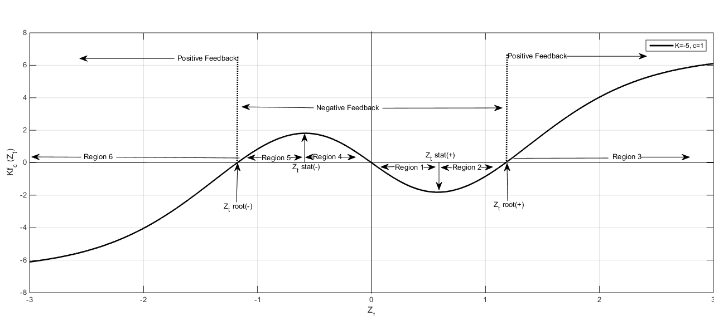Figure 31: Plot of the response/feedback f(Z) function, Equation (6) emphasizing the various regions of interest

There could be many other such non-linear combinations which would generate similar shapes. However, it was found (Dhesi *et al*., 2011) that simulations based on this model (equations. (5) and (6)) provided the best k and c tail parameterization, by using Chi-square test. As an example, Figure 2 illustrates the GBM and IFBM (with optimal k and c) best fitted on two-year daily S&P500 data over 2010-2011.

Figure 32: GBM and IFBM, with optimal k and c ,best fitted two-year daily S&P500 data over 2010-2011.

It can be seen that the (red) IFBM curve is very close to the historic histogram leading to a much better fit than the (green) GBM curve. This was verified by running a chi-square goodness of fit test on the historic data (observed frequency) with respect to simulations from the GBM and the IFBM (corresponding expected frequencies).

One possible explanation as of why GBM is transformed into IFBM can be deduced by looking into the shape of $f(Z)$, on figure 1. For simplicity, we may notate that the values bounded by the Z-roots are “small” values of Z and “large” values to be away from roots in either direction. Therefore, the returns generated by “small” Z-values cause the peak of the distribution as the magnitude of returns is diminished; this can be linked to the negative feedback region *of f(Z)*; on the other hand, the returns generated by “large” Z-values shape the fat tails of the distribution.

## Forecasting Kurtosis and Returns Distribution

As IFBM seems to capture the leptokurtosis or fat tails of returns distributions, a question arises about the link between the distribution kurtosis and the parameters k and/or c.

In order to determine such a link, we present analysis on daily S&P500 index data from 1950 to 2015 as follows. The sample consists of 33 “2-year daily data” non-overlapping windows, from the time interval [1950-2015]. In the notation below “t [1, 33]” refers to the tth data window.

${ln⁡(Kurt}_{t})=1.66+0.078{ln⁡(k}_{t})-0.079{ln⁡(c}_{t})$

standard errors: $\left(0.10\right) \left(0.02\right) (0.03)$

t-statistics: $16.47 4.97 2.74$

The data set is reduced to 32 points[4] (up to 2013) in view of forecasting the kurtosis of 2014-15 and comparing with the actually realized value (refer to Table 1). A significant statistical econometric relationship is found between the logarithmic kurtosis and the logarithmic $k$ and $c$ values as given by:

$\ln\left({Kurt}_{t}\right)=1.66+0.078\ln\left(k_{t}\right)-0.081\ln\left(c_{t}\right)$ $(8.7)$

standard errors: $\left(0.10\right) \left(0.03\right) (0.02)$

t-statistics: $16.05 4.89 2.73$

In order to complete the model and verify its robustness, we explore whether there is an autoregressive process on k and c, i.e. whether future k and c values can be forecasted from the past values.

It is found that a basic time series analysis for values of k does not produce an AR process on k due to a small t-statistics on lagged value of k; one finds

$k_{t}=0.002+0.259k_{t-1}$

Standard errors: $\left(0.0006\right) (0.174)$

t-statistics : $3.02 1.49$

However, it is found that there is an AR process on c with a significant t-statistics test on one period lagged c:

$c_{t}=0.180+0.422c_{t-1}$ $(8.8)$

Standard errors: $\left(0.06\right) (0.17)$

t-statistics : $3.04 2.53$

The non-significance of the AR processes on k proves a stumbling block in using the forecast model equation. (7), which leads to request some further investigation. One possibility is to check the AR process on the ratio k/c, - since c is AR and k is not. This is also inspired by a further analysis of equation. (8.7). This is also confirmed by modelling the logarithmic kurtosis by the logarithmic ratio (k/c), which produces the following results:

$\ln\left({Kurt}_{t}\right)=1.66+0.08ln\left(\frac{k_{t}}{c_{t}}\right)$ (8.9)

The ratio (k/c) when interestingly plotted over time for the sample (see Figure3) produces a picture indicating a smooth pattern with occasional outliers.

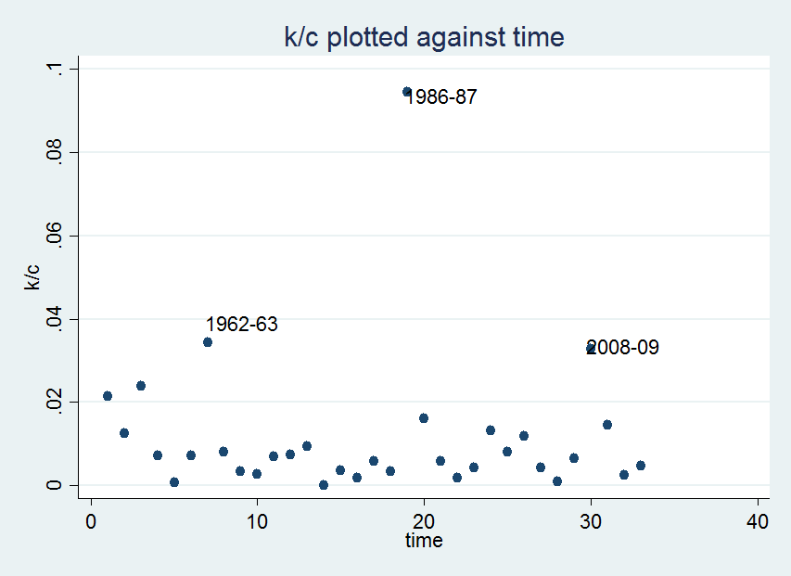 Figure 33: Scatter plot of (k/c) values with corresponding 2-year time periods, between *t* = 1 (for Jan 01, 1950 – Dec 31, 1951) till t= 33 (for Jan 01, 2014- Dec. 31, 2015)

These outliers occur at market crash years, that is the Cuban missile crisis (1962), the financial crisis (1987) and the subprime mortgage crisis (2008), i.e., extreme events indicating an *a priori* unexpected high ratio. This means that extreme events are well modelled by an IFBM with large $\left(\frac{k}{c}\right)$ value. The results are summarised in Table 1.

|  |  |  |  |  |  |  |
| --- | --- | --- | --- | --- | --- | --- |
|  |  |  |  | **Historic** | **GBM** | **IFBM** |
| **Time Window** | **c** | **k** | **k/c** | **Kurtosis** | **Kurtosis** | **Kurtosis** |
| 1950-1951 | 0.1 | 0.002 | 0.0215 | 3.572159 | 2.99851 | 3.63634 |
| 1952-1953 | 0.1 | 0.001 | 0.0125 | 3.728461 | 3.03216 | 3.58129 |
| 1954-1955 | 0.1 | 0.002 | 0.0239 | 5.930774 | 2.98839 | 5.87982 |
| 1956-1957 | 0.3 | 0.002 | 0.0073 | 3.437844 | 2.98328 | 3.60893 |
| 1958-1959 | 0.1 | 8E-05 | 0.0008 | 3.307019 | 2.91947 | 3.12327 |
| 1960-1961 | 0.2 | 0.001 | 0.0071 | 3.581607 | 3.09118 | 3.59623 |
| **1962-1963** | 0.1 | 0.003 | **0.0344** | **4.267800** | 2.88745 | **3.98187** |
| 1964-1965 | 0.1 | 8E-04 | 0.0081 | 3.535882 | 2.90662 | 3.37264 |
| 1966-1967 | 0.4 | 0.001 | 0.0034 | 3.426431 | 2.84707 | 3.26054 |
| 1968-1969 | 0.1 | 3E-04 | 0.0027 | 2.995724 | 2.76098 | 2.83976 |
| 1970-1971 | 0.4 | 0.003 | 0.0069 | 3.440020 | 2.76787 | 3.47213 |
| 1972-1973 | 0.2 | 0.001 | 0.0074 | 3.315984 | 2.87283 | 3.27081 |
| 1974-1975 | 0.1 | 9E-04 | 0.0095 | 3.020921 | 2.88448 | 3.04110 |
| 1976-1977 | 0.1 | 9E-06 | 9E-05 | 2.908024 | 2.86528 | 2.84191 |
| 1978-1979 | 0.3 | 0.001 | 0.0037 | 3.216504 | 2.93092 | 3.23772 |
| 1980-1981 | 0.3 | 6E-04 | 0.0019 | 2.967555 | 2.80431 | 2.91500 |
| 1982-1983 | 0.2 | 0.001 | 0.0059 | 3.139087 | 2.86101 | 3.09164 |
| 1984-1985 | 0.3 | 0.001 | 0.0033 | 3.411969 | 2.84173 | 3.12957 |
| **1986-1987** | 0.1 | 0.009 | **0.0945** | **4.824096** | 2.59039 | **4.54390** |
| 1988-1989 | 0.2 | 0.003 | 0.0160 | 3.953239 | 2.93867 | 3.77569 |
| 1990-1991 | 0.3 | 0.002 | 0.0059 | 3.235887 | 2.91430 | 3.30811 |
| 1992-1993 | 0.7 | 0.001 | 0.0019 | 3.343758 | 2.83918 | 3.24248 |
| 1994-1995 | 0.4 | 0.002 | 0.0042 | 3.564686 | 2.98539 | 3.62970 |
| 1996-1997 | 0.2 | 0.003 | 0.0132 | 3.570610 | 2.96275 | 3.60373 |
| 1998-1999 | 0.3 | 0.002 | 0.0082 | 3.480683 | 3.01699 | 3.45123 |
| 2000-2001 | 0.2 | 0.002 | 0.0119 | 3.319048 | 2.95830 | 3.33218 |
| 2002-2003 | 0.6 | 0.003 | 0.0043 | 3.398068 | 2.90596 | 3.24078 |
| 2004-2005 | 1.1 | 9E-04 | 0.0009 | 3.159916 | 2.97078 | 3.16851 |
| 2006-2007 | 0.5 | 0.003 | 0.0064 | 4.071763 | 2.99778 | 3.80458 |
| **2008-2009** | 0.3 | 0.010 | **0.0328** | **4.320958** | 2.96258 | **4.11278** |
| 2010-2011 | 0.4 | 0.006 | 0.0145 | 3.937480 | 2.84927 | 3.87489 |
| 2012-2013 | 0.6 | 0.001 | 0.0025 | 3.488274 | 2.86441 | 3.25203 |
| 2014-2015 | 0.5 | 0.002 | 0.0048 | 3.639081 | 2.98048 | 3.57924 |
|  |  |  |  |  |  |  |

Table 1: comparison of Kurtosis from historic returns data, with GBM and IFBM; outliers are emphazised and underlined; the corresponding historic kurtosis is clearly much better estimated from the IFBM.

However, there does not seem to be an AR process on (k/c) with insignificant t-stat. In fact, a graph of (k/c) with one period lagged values (see Figure4) presents a fanning out process, hinting the presence of heteroscedasticity like effect. Therefore, we perform the variable transformation to eradicate this heteroscedasticity like effect.

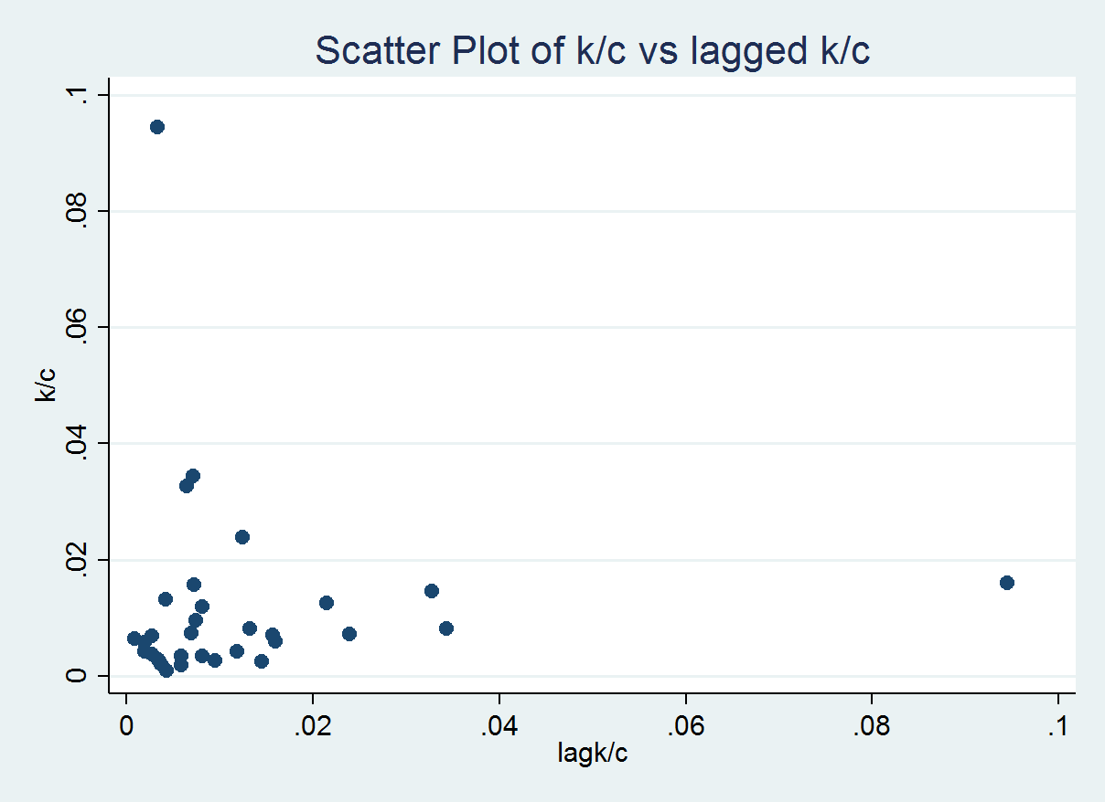

Figure 34: Scatter Plot of k/c versus one period lagged k/c.

In so doing, the transformed version of (k/c) does have an AR process on ratio (k/c) with a significant t-stat of 5.18; the result reads:

$\frac{{\left[k/c\right]}_{t+1}}{\sqrt{{\left[k/c\right]}_{t}}}=0.004{\sqrt{{\left[k/c\right]}_{t}}}^{-1}+0.465\sqrt{{\left[k/c\right]}_{t}}$ $(8.10)$

Applying the 1-step forecast for the kurtosis of 2014-15 using equations (8.8),(8.10) and (8.9) a 3.53 kurtosis value is predicted; this is in very good agreement with the kurtosis equal to 3.58 generated by the IFBM model (see last row of Table 1) for the same time period.

Also since there are AR processes on c and (k/c), thereby meaning that one can forecast c and (k/c) using the 1-step forecast method, one can use these values to forecast k. In other words, we prove that one can forecast the signature of the returns distribution, with known mean and standard deviation, by forecasting the values of k and c. Table 2 presents a comparison of forecast and IFBM simulated values and forecast values of k, c, (k/c) for Jan 01, 2014 - Dec 31, 2015. IFBM simulated values can be seen in the last row of Table 1 and forecast values are obtained from equations (8) and (10).

|  |  |  |
| --- | --- | --- |
|  | **IFBM Simulated Values** | **Forecasted Values from eqs.(8) and (10)** |
| **(k/c)** | 0.00478 | 0.0051 |
| **c** | 0.5 | 0.4332 |
| **k** | 0.002394 | 0.002209 |

Table 2: Comparison: Between simulated values from IFBM(column 2) and forecasted values from equation(8.8) and equation(8.10) (column 3). (Jan 01, 2014 - Dec 31, 2015).

Based on these forecast values, the returns distribution for 2014-15 generates the theoretical distribution displayed in Figure 5. Precisely, the grey bars are the historic returns, while the green distribution represents the GBM values; the red distribution represents the simulated distribution from IFBM (using c and k of the last row of Table 1). It is easily observed that, the blue curve, the forecasted distribution using the forecast values of c and k (second column of Table 2) finely overlaps the simulated distribution.

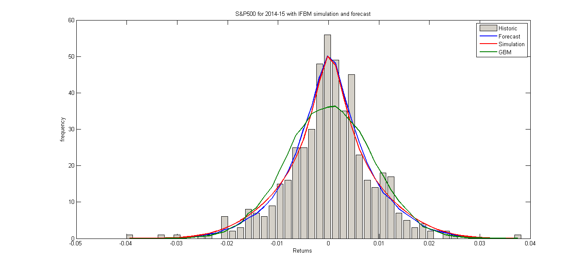Figure 35: Distribution of S&P500 returns for 2014-15 with GBM, IFBM simulation and IFBM forecast.

For a normally distributed data set, the 5% probability in left tail will yield a Z-value (Z measures the number of standard deviations away from the mean value) of -1.64, whereas the historic distribution of S&P500 index for 2014-15 data set has 5% probability to left of -1.86; however by applying IFBM on same data accurately forecasts a 5% Z-value of -1.85 in agreement with historic data.

## Conclusion

In the present thesis, we provide a theoretical analysis and a numerical investigation of financial data in order to demonstrate that the response function so introduced in the IFBM model in order to render the GBM model “more flexible” is of great validity and forecasting power. In particular, the best proof stems in Figure 5 which shows that our methodology, justified in Section 1 and analytically introduced in Section 3, allows to finely forecast returns distributions.

It can be concurred that this process as modelled in equations (8.8),(8.9) and (8.10) significantly adds to the forecasting of financial time series and provides further and novel directions to academics working in this field. Frequency distribution of returns taken ad hoc from the normal distribution or leptokurtic distribution from previous period will inaccurately measure risk signature for the period under forecast investigation. However, this accurate forecasting of the fat tailed frequency distribution for returns provides a major benefit for practitioners, for example, in Value at Risk (VaR) management.

Risk managers will be able to apply the accurate forecasted returns distribution to accurately calculate the p% VaR loss of the desired untraded asset/index.

# References:

Aas, K. and Haff, I. H. (2006). “The generalized hyperbolic skew student’s t-distribution”, Journal of Financial Econometrics, 4, 275–309.

Arellano-Valle, R.B., Gómez, H.W. and Quintana, F.A., (2005). “Statistical inference for a general class of asymmetric distributions”. *Journal of Statistical Planning and Inference*, *128*(2), pp.427-443.

Adrian, T. and Rosenberg, J. (2008). Stock returns and volatility: Pricing the short‐run and long‐run components of market risk. The journal of Finance, 63(6), pp.2997-3030.

Ausloos M and Ivanova, K. (2003). “Dynamical model and nonextensive statistical mechanics of a market index on large time windows”, Physical Review E, 68, 046122.

Ausloos M, Bronlet Ph. (2003). “Strategy for Investments from Zipf Law(s)”. Physica A 2003;324:30-37.

Ausloos M, Bronlet Ph. (2006). “Risk portofolio management under Zipf analysis based strategies, in "Practical Fruits of Econophysics"”, H. Takayasu, Ed. (Springer, Tokyo, 2006) pp. 257-261

Ausloos M, Petroni F.(2013), Threshold Model for Triggered Avalanches on Networks, in "Stock Markets", F. Petroni, F. Prattico and G. D'Amico, Eds. (Nova Sc., New York, 2013) pp. 83-101

Azzalini, A. (1985). “A class of distributions which includes the normal ones”, Scandinavian Journal of Statistics, 12, 171–178.

Azzalini, A. (1986), “Further results on a class of distributions which includes the normal ones”. Statistica, 46, 199–208.

Azzalini, A. and Capitanio, A. (2003). “Distributions generated by perturbation of symmetry with emphasis on a multivariate skew-t distribution”. Journal of the Royal Statistical Society B, 65, 367–389.

Bacry, E., Delour, J. and Muzy, J.F. (2001). Multifractal random walk. Physical Review E, 64(2), p.026103.

Bagehot, W. (1971). The only game in town. *Financial Analysts Journal,* 27, 22.

Bakshi, G., Kapadia, N. and Madan, D. (2003). Stock return characteristics, skew laws, and the differential pricing of individual equity options. The Review of Financial Studies, 16(1), pp.101-143.

Bali, T.G., Mo, H. and Tang, Y. (2008). The role of autoregressive conditional skewness and kurtosis in the estimation of conditional VaR. Journal of Banking & Finance, 32(2), pp.269-282.

Barndorff-Nielsen, O. E. (1997a). Normal inverse Gaussian distributions and stochastic volatility modelling. *Scandinavian Journal of Statistics 24*, 1-13

Barndorff-Nielsen, O. E. (1997b). Processes of normal inverse Gaussian type. *Finance & Stochastics 2*, 41-68.

Barndorff-Nielsen, O. E. (1998). Probability and statistics: self-decomposability, finance and turbulence. In L. Acccardi and C. C. Heyde (Eds.), *Probability Towards 2000*,New York. Springer. Proceedings of a Symposium held 2-5 October 1995 at Columbia University.

Barndorff-Nielsen, O.E., Kent, J., and Sørensen, M. (1982). “Normal variance-mean mixtures and z distributions”. International Statistical Review, 50, 145–159.

Barndorff-Nielson, O. E. and Prause K. (1999) Apparent Scaling. *Finance and Stochastics 5*, (1), 103–113.

Barone‐Adesi, G., Giannopoulos, K. and Vosper, L. (1999). VaR without correlations for portfolios of derivative securities. Journal of Futures Markets, 19(5), pp.583-602.

Barone‐Adesi, G., Giannopoulos, K. and Vosper, L. (2002). Backtesting derivative portfolios with filtered historical simulation (FHS). European Financial Management, 8(1), pp.31-58.

Becker, G. (1962), “Irrational Behaviour and Economic Theory”. Journal of Political Economy 1962; 70:1-13.

Bera, A. K. and Premaratne, G. (2001). “Modeling Asymmetry and Excess Kurtosis in Stock Return Data”, Working Paper, Department of Economics, University of Illinois.

Birge, J. R. and Linetsky V. (2007). “*Handbooks in Operational Research and Management Science”* Vol 15,

Birge, J. R. and Linetsky V., (2007)Eds. Financial Engineering (Elsevier, 2007). pp. 1-1014.

Birge JR, Linetsky V.(2008). “*Handbooks in Operational Research and Management Science”* Vol 15: Financial Engineering (Elsevier, 2008); chapters 2 and 3 and references therein contained).

Black, F. and Scholes, M., (1973). “The pricing of options and corporate liabilities. Journal of Political Economy”, 81(3), 637-654.

Blanchard, O. J. (1989). Speculative Bubbles, Crashes, and Rational Expectations,

*Economics Letters*, 3, 387–389.

Bollerslev, T. and Mikkelsen, H.O. (1996). Modeling and pricing long memory in stock market volatility. Journal of econometrics, 73(1), pp.151-184.

Borges, M.R. (2010) “Efficient market hypothesis in European stock markets”, European Journal of Finance, 16, 711-726.

Bouchaud, J.P. Cont, R. (1998), “A Langevin approach to stock market fluctuations and crashes”. The European Physical Journal B 6,543-550 (1998)

Bouchaud,J.P, Potters,M. (2000) “ *Theory of Financial Risks”*, Cambridge: Cambridge University Press 2000.

Breen W, Glosten LR, Jagannathan R. (1989). “ Economic significance of predictable variations in stock index returns”. Journal of Finance 1989;44:1177—1189.

Brigo, D. and Alfonsi, A., 2005. Credit default swap calibration and derivatives pricing with the SSRD stochastic intensity model. Finance and stochastics, 9(1), pp.29-42.

Brock, W.A., Hommes, C.H., (1997). “A Rational Route to Randomness”. Econometrica 1997;65(5):1059-1095.

Brock, W.A., Hommes, C.H., (1998). “Heterogeneous beliefs and routes to chaos in a simple asset pricing model”. Journal of Economic Dynamics and Control 1998;22:1235- 1274.

Bulkey G, Harris RDF. (1997). “Irrational Analysts’ expectations as a cause of excess volatility in stock prices”. The Economic Journal 1997;107:359-71.

Cappellini, A., Ferraris, G. (2007). “Waiting Times in Simulated Stock Markets”,

Munich Personal RePEc Archive

Castellano, R., Cerqueti, R. and Rotundo, G. (2018). "Exploring the financial risk of a

temperature index: a fractional integrated approach", Annals of Operations Research,

doi:10.1007/s10479-018-3063-0

Chang, T., McLeavey, D., and Rhee, S. (1995). “Short-term abnormal returns of the

contrarian strategy in the Japanese stock market”. *Journal of Business Finance and*

*Accounting* 22, pp. 1035-1048.

Chung, Y.P., Johnson, H. and Schill, M.J. (2006). “Asset pricing when returns are nonnormal: Fama‐french factors versus higher‐order systematic comoments”. The Journal of Business, 79(2), pp.923-940.

Clark, P.K. (1973). “A subordinated stochastic process model with finite variance for speculative prices”. Econometrica: journal of the Econometric Society, pp.135-155.

Cootner, P.H. (1964). “The random character of stock market prices”.

Cont. R. (2001), “*Empirical Properties of Asset Returns: Stylised Facts and Statistical Issues”,* Quantitative Finance, Vol 1,223-226.

Corcuera J M, Nualert D, Schoutens W (2005) Completion of a Levy Market by Power-Jump Assets. Finance and Stochastics 9, (1), 109–127.

Corcuera J M, Nualert D, Schoutens W (2003) Completion of a Levy Market by Power-Jump Assets. Finance and Stochastics

Corrado, C. and Su, T. (1996). “Skewness and Kurtosis in S&P 500 index returns implied by option prices”, Journal of Financial Research, 19, 175-192.

Cox JC, Ingersoll JE and Ross SA (1985). "A Theory of the Term Structure of Interest Rates” . [*Econometrica*](http://en.wikipedia.org/wiki/Econometrica)**53**: 385–407.

Critchley, F. and Jones, M. C. (2008). “Asymmetry and gradient asymmetry functions: Density-based skewness and kurtosis”. Scandinavian Journal of Statistics, 35, 415–437.

Cysneiros, F. J. de A., dos Santos, S. J. P. and Cordeiro, G. M. (2001). “Skewness and Kurtosis for Maximum Likelihood Estimator in one-parameter Exponential Family Models”. Brazilian Journal of Probability and Statistics, 15, 85-105.

Dacorogna, M. M., Gencay, R., Muller, U. A., Olsen, R.B., Pictet, O. V., (2001), “An Introduction to High Frequency Finance”, Academic Press.

Das, S and Sundaram, R. (1999). “Of Smiles and Smirks: A Term Structure Perspective”, Journal of Financial and Quantitative Analysis, 34, 211-239.

Davis, M. and Etheridge, A. (2006)” *Louis Bachelier’s theory of Speculation: The origins of modern finance.”* 1st ed. New Jersey: Princeton

De Jong, F., Rindi, B. (2009). “*The Microstructure of Financial Markets”.* Cambridge,

University Press.

DeBondt, W., Thaler, R. (1987). Further evidence on investor overreaction and stock

Market seasonality. *Journal of Finance*, 42, pp. 557-581.

DeBondt, W., Thaler, R. (1987). “Further evidence on investor overreaction and stock market seasonality”. Journal of Finance 1987;42:557-581.

Delong, J.B., Shleifer, A., Summers, L.H., Waldmann, R.J., (1990). “Positive feedback and destabilizing rational speculation”. Journal of Finance 1990;45:379-95.

Dhesi, G. and Ausloos, M. (2016). “Modelling and Measuring the Irrational behaviour of Agents in Financial Markets: Discovering the Psychological Soliton”. Chaos, Solitons and Fractals, 88, 119-125.

Dhesi G, Shakeel M, Xiao L. (2016). “Modified Brownian Motion Approach to Modelling Returns Distribution”**,** *Wilmott Magazine* ( March,2016) (can also be found on arxiv 1507.02203

Dhesi G, Emambocus MAW, Shakeel MB. (2011). “Semi-Closed Simulated Stock Market: An Investigation of its Components”, *International Finance and Banking Society*  (2011).

Di Matteo, T., Aste, T. and Dacorogna, M.M., (2003), “Scaling behaviours in differently developed markets”. Physica A, 324,183.

Di Matteo, T., Aste, T. and Dacorogna, M.M., (2005), “Long-term Memories of Developed and Emerging Markets: Using the Scaling Analysis to Characterize their Stage of Development”, J. Banking & Finance 29, 827.

Ding, Z. and Granger, C.W. (1996). “Modeling volatility persistence of speculative returns: a new approach”. Journal of econometrics, 73(1), pp.185-215.

Dittrich, Güth and Maciejovsky . (2001). “Overconfidence in Investment Decisions:

An Experimental Approach”. [*CESifo* Working Paper Series No. 626](JavaScript:WinOpen();).

Duchon, J.Robert,R.Vargas,V.(2008),” *Forecasting Volatility with Multifractal Random Walk Model*”, arXiv:0801.4220v1

Dupernex, S. *Why Might Share Prices Follow A Random Walk?* [Online] Available from [www.tcd.ie/Economics/SER/sql/Download.php?key=265](http://www.tcd.ie/Economics/SER/sql/Download.php?key=265)

Elliott, R.J. and Siu, T.K. (2010). “On risk minimizing portfolios under a Markovian

regime-switching Black-Scholes economy”. *Annals of Operations Research*, *176*(1),

271-291.

Emambocus MAW, Dhesi G. (2010). “Bubble and Burst: A Psychoanalytic Perspective on Financial Instability”. Global Economy and Finance Journal 2010;3:…..

Engle RF.(1982). “Autoregressive conditional heteroscedasticity with estimates of the variance of United Kingdom inflation”. Econometrica 1982;50:987—1007.

Engle, R.F., Lilien, D.M. and Robins, R.P. (1987). “Estimating time varying risk premia in the term structure: The ARCH-M model”. Econometrica: journal of the Econometric Society, pp.391-407.

Engle, R.F. and Lee, G. (1999). “A long-run and short-run component model of stock return volatility. Cointegration, Causality, and Forecasting: A Festschrift in Honour of Clive WJ Granger”, pp.475-497.

Engle, R.F. and Ng, V.K. (1993). “Measuring and testing the impact of news on volatility”. The journal of finance, 48(5), pp.1749-1778.

Fama EF. (1965),“The Behaviour of Stock-Market Prices.”Journal of Business 1965;38:34-105.

Fama EF. (1970). “Efficient Capital Markets: A Review of Theory and Empirical Work.” Journal of Finance 1970; 25:383–417.

Farmer, J.D., Joshi, S. (2002). “The price dynamics of common trading strategies”.

*Journal of Economic Behavior and Organization*, 49(2), pp.149–171.

F. Hu and C. Knessl. (2010) “Asymptotics of barrier option pricing under the CEV process.” Appl. Math. Finance, 17(3):261-300, 2010.

Fernandez, C., Osiewalski, J, and Steel, M. F. J. (1995). “Modeling and inference with v-spherical distributions”. Journal of the American Statistical Association, 90, 1331-1340.

Fernandez, C. and Steel, M. F. (1988). “On Bayesian modeling of fat tails and skewness”. Journal of the American Statistical Association, 93(441), 359-371

Ferreira, J. T. A. S. and Steel, M. F. J. (2006). “A constructive representation of univariate skewed distributions”. Journal of the American Statistical Association, 101, 823–829.

Fischer, M. and Klein, I. (2004). “Kurtosis modelling by means of the J-transformation”. Allgemeines Statistisches Archiv, 88, 35–50

Fisher, J.C. and Pry, R.H. (1971). “A simple substitution model of technological change”. Technological forecasting and social change, 3, pp.75-88.

Frey, B.S., Eichenberger, R. (2002). “Economic incentives transform psychological

Anomalies”,*Institute of Empirical Economic Research.*

Funahashi, H. and Higuchi, T. (2018). “An analytical approximation for single barrier

options under stochastic volatility models”. *Annals of Operations Research*, .1-29.

Gajda,J. Wylomanska,A. (2012),” *Geometric Brownian Motion with Tempered Stable Waiting Times*”, Journal of Statistical Physics (2012) 148:296-305

Gardiner, C. (1985). “Stochastic methods. Springer Series in Synergetics” (Springer-Verlag, Berlin, 2009).

Gençay, R., Dacorogna, M., Muller, U.A., Pictet, O. and Olsen, R., (2001). “*An introduction to high-frequency finance”*. Elsevier.

Giot, P. and Laurent, S. (2003). “Value‐at‐risk for long and short trading positions”. Journal of Applied Econometrics, 18(6), pp.641-663.

Goerg, G. M. (2011). “Lambert W random variables – a new generalized family of skewed distributions with applications to risk estimation”. The Annals of Applied Statistics, 5, 2197–2230.

Glosten, L.R., Jagannathan, R. and Runkle, D.E. (1993). “On the relation between the expected value and the volatility of the nominal excess return on stocks”. The journal of finance, 48(5), pp.1779-1801.

González-Rivera, G. (1998). “Smooth-transition GARCH models”. Studies in Nonlinear Dynamics & Econometrics, 3(2).

Groeneveld, R. A. and Meeden, G. (1984). “Measuring skewness and kurtosis”. The Statistician, 33, 391–399.

Ghoulmie, F. (2004). “Switching by agents between two trading behaviors and the stylized facts of financial markets”. Arxiv 0407533 (2004) N.B. This paper has been withdrawn by the author: according to https://jeannicod.ccsd.cnrs.fr/X-CMAP/hal-00002231

Grima,R. Yaliraki,S.N. (2007), “*Brownian motion of an asymmetrical particle in a potential field*”. Journal of Chemical Physics 127,084511 (2007)

Guidolin, M. and Timmermann, A. (2008). “International asset al.location under regime switching, skew, and kurtosis preferences”. The Review of Financial Studies, 21(2), pp.889-935.

Guillaume, T. (2018). “On the multidimensional Black–Scholes partial differential

Equation”. *Annals of Operations Research*, 1-23.

Haas, M. and Pigorsch, C., (2009). “Financial economics, fat-tailed distributions”. In Complex systems in finance and econometrics, Springer, New York, pp. 308-339.

Hahn,M.G. Kobayashi,K. Umarov,S. (2011*),” Fokker Planck Kolmogorov Equations Associated with Time Changed Fractional Brownian Motion*”, American Mathematical Society Vol:139-2, pp. 691-705 (2011).

Hansen, B.E. (1994). “Autoregressive conditional density estimation”. International Economic Review, pp.705-730.

Harrison, J.M., Sellke, T.M. and Taylor, A.J. (1983). “Impulse control of Brownian

Motion”. *Mathematics of Operations Research*, *8*(3), 454-466.

Harvey, C. R. and Siddique, A. (1999). “Autoregressive Conditional Skewness”, Journal of Financial and Quantitative Analysis, 34, 465-487.

Harvey, C. R. and Siddique, A. (2000). “Conditional skewness in asset pricing tests”. Journal of Finance 55, 1263-1295.

Haug, E.G., (2007). The complete guide to option pricing formulas. (McGraw-Hill Companies, New York).

Heston, S.L., (1993). “A closed-form solution for options with stochastic volatility with applications to bond and currency options”. The review of Financial Studies, *6*(2), 327-343.

Hegselmann R, Krause U. (2002). “Opinion Dynamics and Bounded Confidence Models, Analysis and Simulations”. Journal of Artificial Societies and Social Simulation 2002;5(3).

Heston, S.L. (1993). “A closed-form solution for options with stochastic volatility with applications to bond and currency options”. The review of financial studies, 6(2), pp.327-343.

Hirshleifer, D., Subrahmanyam, A., Titman, S., (2006), “Feedback and the success of irrational investors”. Journal of Financial Economics, 81, 311-338.

Higham,D.(2001),” *An Algorithmic Introduction to Numerical Simulation of Stochastic Differential Equations*”, SIAM Reveiew Vol:43, No.3 pp.525-546

Hoaglin, D. C., Mosteller, F., and Tukey, J. W. (1985). “Exploring Data Table, Trends, and Shapes”. (Wiley, New York).

Hull, J. and White, A. (1990). “Pricing interest-rate-derivative securities”. The Review of Financial Studies, 3(4), pp.573-592.

Hwang, S. and Satchell, S. E. (1999). “Modelling emerging market risk premia using higher moments”. International Journal of Finance and Economics, 4, 271-296.

Ivanova K, Ausloos M.(2001). “False euro (FEUR) exchange rate correlated behaviors and investment strategy”. Eur. Phys. J. B 2001;20:537-41

Ivancevic VG. (2010). “Adaptive Wave Alternative to the Black Scholes Option Pricing Model”.Cognitive Computation 2010;2:17-30.

Jensen, M.C., Black, F. and Scholes, M.S. (1972). “The capital asset pricing model: Some empirical tests”.

Johnson, N. L. (1949). “Systems of frequency curves generated by methods of translation”. Biometrika, 36, 149–176.

Jondeau, E. and Rockinger, M., 2003. Conditional volatility, skewness, and kurtosis: existence, persistence, and comovements. Journal of Economic dynamics and Control, 27(10), pp.1699-1737.

Jones, M. C. (2014). “Generating distributions by transformation of scale”. Statistica Sinica, 24(2), 749–771.

Jones, M. C. and Faddy, M. J. (2003). “A skew extension of the t-distribution, with applications”. Journal of Royal Statistical Society, Series B, 65, 159–174.

Jones, M. C. and Pewsey, A. (2009). “Sinh-arcsinh distributions”. Biometrika, 96, 761–780.

Kaffel,B. Abid,F.(2009), “ *A methodology for the choice of the best fitting continuous-time stochastic models of crude oil price*” The Quarterly Review of Economics and Finance 49 (2009) 971–1000

Kaizogi,T.(2000),”*Speculative Bubbles and Crashes in Stock Markets: An Interacting-Agent Model of Speculative Activity*”,arXiv:Cond-mat/0010263v1

Klafter, J., Sokolov, I.M. (2011): “*First Steps in Random Walks: From Tools to Applications*”. Oxford University Press, Oxford (2011)

Kloeden, P.E., Neuenkirch, A. and Pavani, R. (2011). “Multilevel Monte Carlo for

stochastic differential equations with additive fractional noise”. *Annals of Operations*

*Research*, *189*(1), 255-276.

Kotz, S., Kozubowski, T. and Podgorski, K. (2012). “The Laplace distribution and generalizations: a revisit with applications to communications, economics, engineering, and finance”. Springer Science & Business Media.

Kou, S.G. (2002). “A jump-diffusion model for option pricing”. Management science, 48(8), pp.1086-1101.

Kozdron,M.J.(2008),”*Brownian motion and The Heat Equation”,*[Online]. Available from; <http://stat.math.uregina.ca/~kozdron/Research/UgradTalks/BM_and_Heat/heat_and_BM.pdf> [Accessed 03 December 2011]

Kürüm, E., Weber, G.W. and Iyigun, C. (2018). “Early warning on stock market bubbles via methods of optimization, clustering and inverse problems”. *Annals of Operations Research*, *260*(1-2), 293-320.

Leon, J.A., Vives, J., Utzet, F. and Sole J.L. (2002) On Levy processes,

Malliavin calculus and market models with jumps. Finance and Stochastics

6 (2), 197-225.

Leon, A., Rubio, G. and Serna, G. (2004). “Autoregressive Conditional Volatility, Skewness and Kurtosis”, WP-AD 2004-13, Instituto Valenciano de Investigaciones Economicas.

Leon, J.A., Vives, J., Utzet, F. and Sole J.L. (2002) On Levy processes,Malliavin calculus and market models with jumps. Finance and Stochastics, 6 (2), 197-225.

Ley, C. (2015), “Flexible modelling in statistics: Past, present and future,” Journal de la Soci´et´e Fran¸caise de Statistique, 156, 76–96. MR3338241

Ley, C. and Paindaveine, D. (2010). “Multivariate skewing mechanisms: A unified perspective based on the transformation approach”. Statistics and Probability Letters, 80, 1685–1694

Lintner, J. (1965). “Security prices, risk, and maximal gains from diversification”. *The journal of finance*, *20*(4), pp.587-615.

Lo AW. (2004). “The Adaptive Markets Hypothesis: Market Efficiency from an Evolutionary Prespective”. Journal of Portfolio Management 2004;30:15-29.

Lo AW. (2005). “Reconciling Efficient markets with Behavioral Finance: The Adaptive Markets Hypothesis”. J Inves Consult 2005;7:21-44.

Lo, A, W. and Mackinlay, C. (2002) A *Non-Random walk down the Wall Street.* New Jersey: Princeton

Longin, F. and B. Solnik (2001). "Extreme correlation of international equity markets." *Journal of Finance* **56(2)**: 649-676.

Lucheroni, C. and Mari, C. (2018). “Risk shaping of optimal electricity portfolios in the

stochastic LCOE theory”. *Computers & Operations Research*, *96*, 374-385.

Lux Th. (1998). “The socio-economic dynamics of speculative markets: interacting agents, chaos, and the fat tails of return distributions”. Journal of Economic Behavior & Organization 1998;33:143--165.

Malkiel, B.G. (1999). “*A random walk down Wall Street: including a life-cycle guide to personal investing”*. WW Norton & Company.

Mandelbrot B B (1963a) *New Methods in Statistical Economics* Journal of Political Economy, 71, 421–40.

Mandelbrot B B (1963b) *The Variation of Certain Speculative Prices*, Journal of Business, 36, 394–419.

Mantegna, R. N., (1991) “Levy walks and enhanced diffusion in Milan Stock-Exchange”, Physica A, 179, 232.

Markowitz, H. (1952). “Portfolio selection”. *The journal of finance*, *7*(1), pp.77-91.

Merton, R. C., (1975). “An Asymptotic Theory of Growth Under Uncertainty”. The Review of Economic Studies, 42(3), 375-393.

Mendes, B. V. D. & Marques, D. S. (2012). Choosing an optimal investment strategy: The role of robust pair-copulas based portfolios. *Emerging Markets Review,* 13 (4), pp.449-464.

Miao, D.W.C., Lin, X.C.S. and Chao, W.L. (2016). “Computational analysis of a Markovian queueing system with geometric mean-reverting arrival process”. *Computers & Operations Research*, *65*, 111-124.

Mills, T.C., (1995). “Modelling skewness and kurtosis in the London Stock Exchange FT-SE index return distributions”. The Statistician, 44(3), 323-332.

Mills T C, Markellos R N (2008) *The Econometric Modelling of Financial Time Series* (Cambridge University Press, Cambridge, 2008)

Mossin, J. (1966). “Equilibrium in a capital asset market. *Econometrica”: Journal of the econometric society*, pp.768-783.

Mittnik, S. and Paolella, M.S. (2000). “Conditional density and value‐at‐risk prediction of Asian currency exchange rates”. Journal of Forecasting, 19(4), pp.313-333.

Mitton, T. and Vorkink, K. (2007). “Equilibrium underdiversification and the preference for skewness”. The Review of Financial Studies, 20(4), pp.1255-1288.

Nelson, D.B. (1991). “Conditional heteroskedasticity in asset returns: A new approach”. Econometrica: Journal of the Econometric Society, pp.347-370.

Nelson, E. (2001). “*Dynamical Theories of Brownian Motion”,* [Online]. Available from: <http://www.math.princeton.edu/_nelson/books.html> Accessed [08 December 2009].

Neisy,A.Peymany,M.(2011). “*Financial Modelling by Ordinary and Stochastic Differential Equations*”, World Applied Sciences Journal 13 (11):2228-2295,2011.

Norstad, J. *Random Walks,* [Online] Available from <http://homepage.mac.com/j.norstad> [Accessed 02 January 2010]

Ormeci, M., Dai, J.G. and Vate, J.V. (2008). “Impulse control of Brownian motion: the

constrained average cost case”. *Operations Research*, *56*(3), 618-629.

Ornstein, L. S., G. E. Uhlenbeck. (1930). “*On the Theory of the Brownian Motion*”. *Physical Review* 36, no. 5: 823. doi:10.1103/PhysRev.36.823.

Osborne, M.F. (1959). “Brownian motion in the stock market”. *Operations research*, *7*(2), pp.145-173.

Patton, A. J. (2004). "On the out-of-sample importance of skewness and asymmetric dependence for asset al.location." *Journal of Financial Econometrics* **2**(1): 130-168.

Paul W, Baschnagel J. (1989) Stochastic processes. Springer (1989)

Peiró, A. (1999). “Skewness in financial returns”, Journal of Banking and Finance, 23, 847-862.

Peters, E.E. (1999). “Fractal structure in the capital markets”. Financial Analysts Journal 1999;45:32-37

Post, T., van Vliet, P. and Levy, H. (2008). “Risk aversion and skewness preference”. Journal of Banking & Finance, 32(7), pp.1178-1187.

Postali, F., & Pichetti, P. (2006).” *Geometric Brownian Motion and structural breaks in oil Prices : A quantitative analysis*”. Energy Economics, 28, 506–522.

Prechter, R. (2001). “Unconscious Herding Behaviour As the Psychological Basis of Financial Market Trends and Patterns”. The Journal of Psychology and Financial Markets 2001;2(3):120-125.

Puu, T., (1992). “Order and disorder in business cycles”. *Annals of Operations Research*, *37*(1), pp.169-183.

Quintana, F. A., Steel, M. F. J., and Ferreira, J. T. A. S. (2009). “Flexible univariate continuous distributions”. Bayesian Analysis, 4, 497–522.

Rachev S T, Menn C, Fabozzi F J, (2005) *Fat-Tailed and Skewed Asset Returns Distributions* (Wiley and Sons, 2005).

Riskmetrics, T.M. (1996). JP Morgan Technical Document.

Robert, C.B. and Nicholas, J.G. (1974). “A Comparison of the Stable and Student Distributions as Statistical Models for Stock Prices”. Journal of Business, 47, pp.244-80.

Rogers, L.C.G (1997), “Arbitrage with Fractional Brownian Motion”, math. Finance 7(1),95-105

Rogel-Salazar, J., 2013. Introduction to Mathematical Physics: Methods and Concepts, 2nd edn., by Chun Wa Wong: Scope: review. Level: undergraduate.

Rosco, J.F., Jones, M.C. and Pewsey, A., (2011). “Skew t distributions via the sinh-arcsinh transformation”. Test, 20(3), pp.630-652.

Ross, S.A. (2013). “The arbitrage theory of capital asset pricing”. In *HANDBOOK OF THE FUNDAMENTALS OF FINANCIAL DECISION MAKING: Part I* (pp. 11-30).

Rubio, F. J. and Steel, M. F., (2015). “Bayesian modelling of skewness and kurtosis with two-piece scale and shape transformations”. Electronic Journal of Statistics, 9(2), 1884-1912.

Shleifer, A. (2000). “*Clarendon Lectures in Economics: Inefficient Markets”*,Oxford:

Oxford University Press.

Schinckus,C. (2010),”*Is econophysics a new discipline? The neopositivist argument*”, Physica A 12644 pp.1 – 8 (2010)

Schinckus, C., Jovanovic, F. and Ausloos, M. (2016). “On the "usual" misunderstandings between econophysics and finance: Some clarifications on modelling approaches and efficient market hypothesis”, International Review of Financial Analysis, 47, 7-14 .

Shiller, R.J. (2005) *Irrational Exuberance, 2nd ed.* New Jersey : Princeton

Singal, V. (2004). “*Beyond the Random Walk: A Guide to Stock Market Anomalies*

*and Low Risk Investing”*, Oxford: Oxford University Press.

Siu, T.K. (2012). “A BSDE approach to risk-based asset allocation of pension funds

with regime switching”. *Annals of Operations Research*, *201*(1), 449-473.

Tapiero, C.S. and Vallois, P. (2018). “Randomness and fractional stable

distributions”. *Physica A: Statistical Mechanics and its Applications*, *511*, 54-60.

Takahashi, H., Terano, T. (2003). “Agent-Based Approach to Investors' Behavior and

Asset Price Fluctuation in Financial Markets”, *Journal of Artificial Societies and*

*Social Simulation* 6 (3).

Tucker, A.L. (1992). “A reexamination of finite-and infinite-variance distributions as models of daily stock returns”. Journal of Business & Economic Statistics, 10(1), pp.73-81.

Taleb, N.N. (2007) *The Black Swan: The Impact Of Highly Improbable* , London: Allen Lane

Thaler, R.H., Sunstein C.R. (2008). “*Nudge: Improving Decisions About Health,*

*Wealth, and Happiness”*, USA: Yale University Press.

Theodossiou, P. ( 2000). “Skewed generalized error distribution of financial assets and option pricing”.

Vanden, J.M. (2006). “Option coskewness and capital asset pricing”. The Review of Financial Studies, 19(4), pp.1279-1320.

Vandewalle N, Ausloos, M.(1997). “Coherent and random sequences in financial fluctuations”, Physica A 1997;246:454-9.

Vandewalle N, Ausloos, M.(1998). “Multi-affine analysis of typical currency exchange rates”. Eur. J. Phys. B 1998;4:257-61.

Vasicek, O. (1977). “An equilibrium characterization of the term structure”. Journal of financial economics, 5(2), pp.177-188.

Venkataraman, S. (1997). “Value at risk for a mixture of normal distributions: the use of quasi-Bayesian estimation techniques”. Economic Perspectives-Federal Reserve Bank of Chicago, 21, pp.2-13.

Wax, N. (1954). “*Selected Papers on Noise and Stochastic Processes”.* 1st ed. New York:Dover [2]

Wilmott, P.(2006), “*Paul Wilmott on Quantitative Finance*”, John Wiley & Sons Ltd.

Yu, J. (2007). “*Closed-form likelihood estimation of jump-diffusions with an application to the realignment risk of the Chinese Yuan*”. Journal of Econometrics, 141, 1245–1280.

Zacharias, C. and Armony, M. (2016). “Joint panel sizing and appointment scheduling in outpatient care”. *Management Science*, *63*(11), 3978-3997.

Zakoian, J.M. (1994). “Threshold heteroskedastic models. Journal of Economic Dynamics and control”, 18(5), pp.931-955.

Zeytun, S. and Gupta, A. (2007). “A Comparative Study of the Vasicek and the CIR Model of the Short Rate”.

Zheng, M., Wu, K. and Shu, Y. ( 2016). “Newsvendor problems with demand forecast updating and supply constraints”. *Computers & Operations Research*, *67*, 193-206.

# Appendices:

**Appendix 1**

|  |  |
| --- | --- |
| Stable Distributions: |  |
| The Logistic Distribution: | $$f\left(x\right)= \frac{exp⁡(\frac{x-μ}{α})}{α{[1+\exp\left(\frac{x-μ}{α}\right)]}^{2}}$$ |
| The Scaled-t Distribution: | $$f\left(x\right)=\frac{Γ(\frac{v+1}{2})}{Γ(\frac{v}{2})\sqrt{π(v-2)σ^{2}}}*{[1+\frac{{\left(x-μ\right)}^{2}}{\left(v-2\right)σ^{2}}]}^{-\frac{v+1}{2}}$$ |
| The Exponential Power Distribution. |  |
| Mixtures of Two Normal Distributions. | $$f\left(x\right)=\frac{1}{\sqrt{2πσ_{1}^{2}}}exp-\left[\frac{{\left(x-μ_{1}\right)}^{2}}{2σ_{1}^{2}}\right]with probability λ$$ $$f\left(x\right)=\frac{1}{\sqrt{2πσ_{2}^{2}}}exp-\left[\frac{{\left(x-μ_{2}\right)}^{2}}{2σ_{2}^{2}}\right]with probability (1-λ)$$ |
| Weibull Distribution | $$f\left(x;λ,k\right)=\left\{\begin{aligned}\frac{k}{λ}{(\frac{x}{λ})}^{k-1}e^{-{\left(\frac{x}{λ}\right)}^{k} } x ≥0 \\ 0 x<0\end{aligned}\right.$$ |
| Gumbel Distribution | $$f\left(x\right)=\frac{1}{β}exp\left[\frac{x-α}{β}-exp\left(\frac{x-α}{β}\right)\right]$$ |
|  |  |

A brief description of few major returns distributions.

**Appendix 2**

**Matlab Functions**[5]

function [sp,A] = sample_sim_1(s0,mu,sig,n,T )

% Simulates the stock prices following gbm.

% Present output as average of the simulations.

% A = average of n simulated paths over T trading periods.

% rt= log returns of simulated prices.

% s0=initial price

% mu=drift

% sig= dispersion

% T= number of trading periods

% n= number of paths

e=norminv(rand(T,n));

a=zeros(T-1,n);

b=s0*ones(1,n);

sp=cat(1,b,a);

for k=(0:0.001:1)

for i=2:T

z=e(i,:).*(1-0.3*e(i,:).*e(i,:));

sp(i,:)=sp(i-1,:).*(exp((mu+ sig*e(i,:)+k*z)));

end

end;

% calculate log returns and draw histogram

%r=log(sp(2:end,:)./sp(1:end-1,:));

% Now calculate average of simulated returns and plot

A=mean(sp,2);figure;plot(A)

%A(2:end,2)=mean(r,2);

end

e=norminv(rand(T,n));

a=zeros((ceil(T/2)-1),n);

b=s0*ones(1,n);

sp1=cat(1,b,a);

for i=2:ceil(T/2)

sp1(i,:)=sp1(i-1,:).*exp((mu1+ sig1*(e(i,:))));

end

sp2=zeros(T-ceil((T/2)+1),n);

for j=2:(T-ceil((T/2)+1))

sp2(j,:)=sp2(j-1,:).*exp(mu2+sig2*e(j,:));

end

sp=cat(1,sp1,sp2);

% calculate log returns and draw histogram

% Now calculate average of simulated returns and plot

%A=mean(sp,2);figure;plot(sp);axis tight

End

**Appendix 3**

Process illustration for customising the bins.



**Appendix 4**

**Comparison of the MBMM with GBM for different time periods and different data sets.**

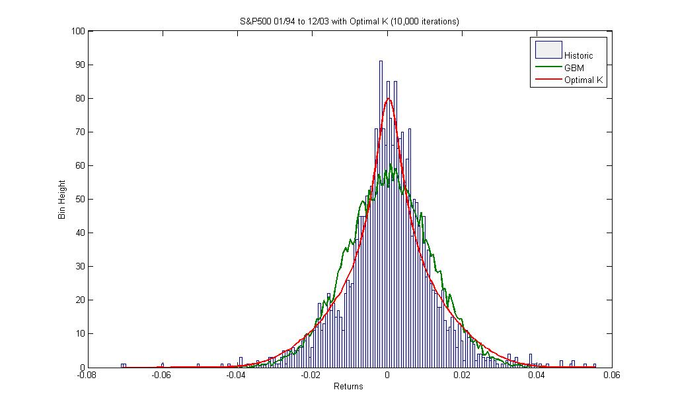

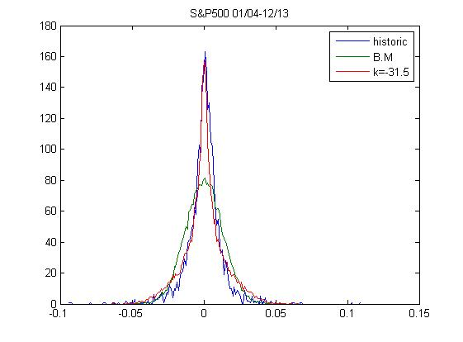

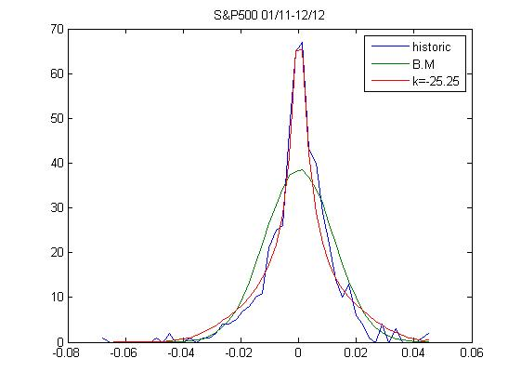



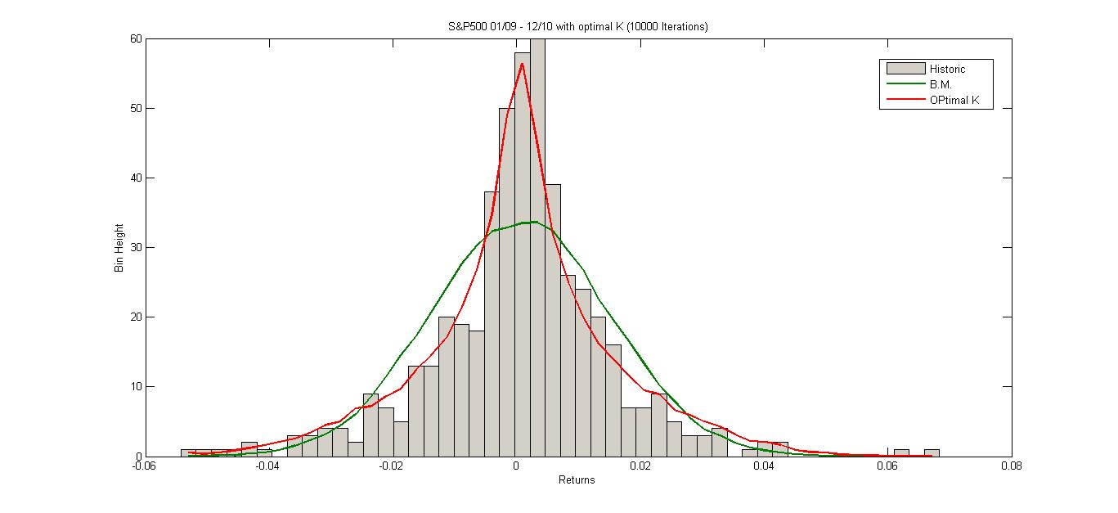

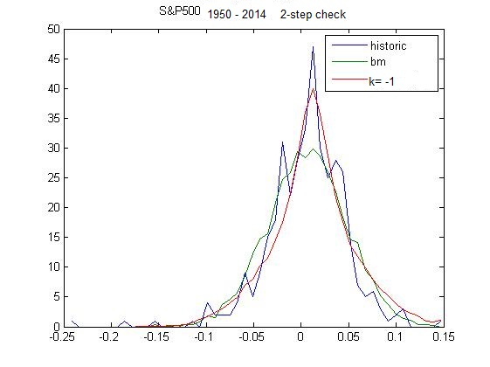

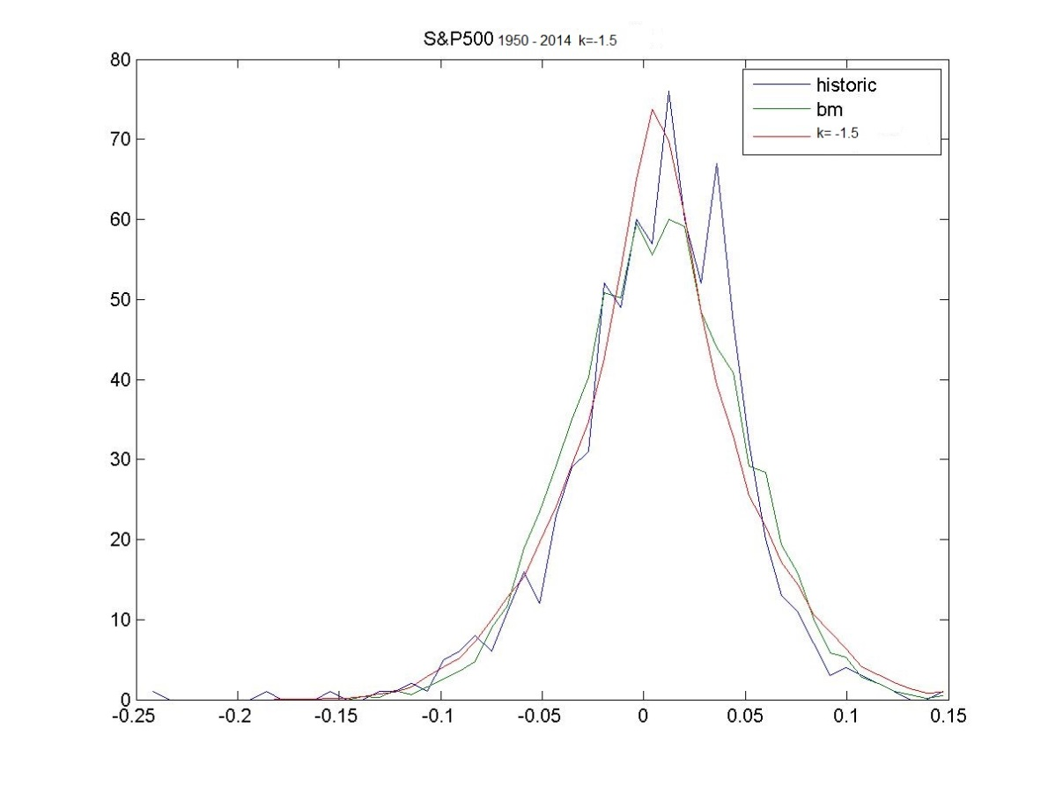

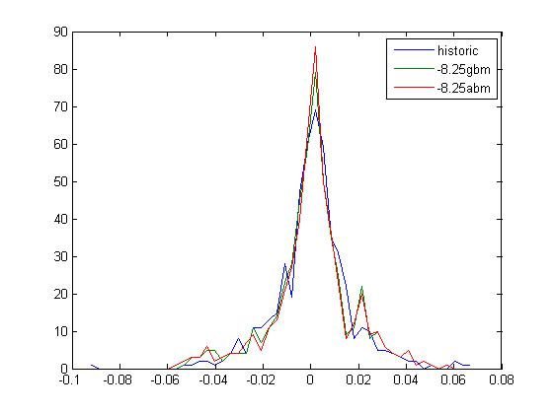

**Appendix 5**

**The Original ITO Lemma**

If $\frac{dp}{p}=\left(σ\right)dz+\left(μ\right)dt$

Consider $f\left(p\right)=\log\left(p\right) ⇒ f^{'}=\frac{1}{p} , f^{''}=-\frac{1}{p^{2}}$,

Take $A=$ $\left(σ\right)p , B=αp Where α=$ $μ+\frac{1}{2}{\left(σ\right)}^{2}$

Apply the above to Ito Lemma:

$df=Af^{'}dz+\left(Bf^{'}+\frac{1}{2}A^{2}f^{''}\right)dt$… (A)

$df=\left(σ\right)p*\frac{1}{p}dz+\left(αp*\frac{1}{p}+\frac{1}{2}{\left(σ\right)}^{2}p^{2}\left(-\frac{1}{p^{2}}\right)\right)dt$

$df=\left(σ\right)dz+\left(α-\frac{1}{2}{\left(σ\right)}^{2}\right)dt$

$df=(μ)dt+\left(σ\right)dz$…(1)

Also $df=\log\left(p\left(t+dt\right)\right)-\log\left(p\left(t\right)\right)$

$df=\log\left(\frac{p\left(t+dt\right)}{p\left(t\right)}\right)$

$df=log⁡(\frac{dp}{p}+1)$…(2)

From (1) and (2)

$$\log\left(\frac{dp}{p}+1\right)= (μ)dt+\left(σ\right)dz$$

$\frac{dp}{p}=\exp{[(μ)dt+\left(σ\right)dz]}-1$

Conversely if

$$\frac{dp}{p}=\exp{[μdt+\left(σ\right)dz]}-1$$

And $α=$ $μ+\frac{1}{2}{\left(σ\right)}^{2}$

Consider $f\left(p\right)=\log\left(p\right)⇒p\left(f\right)=\exp\left(f\right)=\exp\left(\log\left(p\right)\right)=p$

$$⇒ p^{'}=p^{''}=p$$

Also take

Apply Ito Lemma on p(f)

Note:

For

**Modified ITO Lemma with dt**

If

Apply Ito’s Lemma with

,

Take

Apply the above to Ito Lemma:

Also

Conversely if

And

Consider

Also take

Apply Ito Lemma on p(f)

**Modified ITO Lemma with √(dt)**

If

Apply Ito’s Lemma with

$f\left(p\right)=\log\left(p\right) ⇒ f^{'}=\frac{1}{p} , f^{''}=-\frac{1}{p^{2}}$,

Take $A=$ $\left(σ+θv\left(z\right)\right)p , B=γp Where γ=$ $μ+\frac{1}{2}{\left(σ+θv\left(z\right)\right)}^{2}$

Apply the above to Ito Lemma:

$$df=Af^{'}dz+\left(Bf^{'}+\frac{1}{2}A^{2}f^{''}\right)dt$$

$$df=\left(σ+θv\left(z\right)\right)p*\frac{1}{p}dz+\left(γp*\frac{1}{p}+\frac{1}{2}{\left(σ+θv\left(z\right)\right)}^{2}p^{2}\left(-\frac{1}{p^{2}}\right)\right)dt$$

$$df=\left(σ+θv\left(z\right)\right)dz+\left(γ-\frac{1}{2}{\left(σ+θv\left(z\right)\right)}^{2}\right)dt$$

$$df=μdt+\left(σ+θv\left(z\right)\right)dz$$

Also $df=\log\left(p\left(t+dt\right)\right)-\log\left(p\left(t\right)\right)$

$$df=\log\left(\frac{p\left(t+dt\right)}{p\left(t\right)}\right)$$

$$df=log⁡(\frac{dp}{p}+1)$$

$$\log\left(\frac{dp}{p}+1\right)= μdt+\left(σ+θv\left(z\right)\right)dz$$

$$\frac{dp}{p}=\exp{[μdt+\left(σ+θv\left(z\right)\right)dz]}-1$$

Conversely if

$$\frac{dp}{p}=\exp{[μdt+\left(σ+θv\left(z\right)\right)dz]}-1$$

And $γ=$ $μ+\frac{1}{2}{\left(σ+θv\left(z\right)\right)}^{2}$

Consider $f\left(p\right)=\log\left(p\right)⇒p\left(f\right)=\exp\left(f\right)=\exp\left(\log\left(p\right)\right)=p$

$$⇒ p^{'}=p^{''}=p$$

Also take $A=$ $\left(σ+θv\left(z\right)\right), B=μ$

Apply Ito Lemma on p(f)

$$dp=Ap^{'}dz+\left(Bp^{'}+\frac{1}{2}A^{2}p^{''}\right)dt$$

$$dp=\left(σ+θv\left(z\right)\right)pdz+\left[μp+\frac{1}{2}{\left(σ+θv\left(z\right)\right)}^{2}p\right]dt$$

$$\frac{dp}{p}=γdt+\left(σ+θv\left(z\right)\right)dz$$

Appendix for Kurtosis Forecast



Table(1): regression of lnkurt on lnk and lnc.



Table(2): regression of lnkurt on lnk and lnc with 32 values

Table(3): one period VAR on k.

Table(4): one period VAR on c.

Table(5): regression of lnKurt on ln(k/c).

Table(6); Transformed var on (k/c) with no constant

1. Geometric Brownian motion is given as which can be transposed arithmetically aswhere .
2. is implicitly incorporated in 
3. These graphs are sketches for illustration purposes and further to this may not necessarily cross the origin.
4. Equation (8.7) is different from Equation (6), as in Equation (7) only 32 data points rather than 33 data points. The 33rd data point is treated as ex-post such that we can compare the 33rd point data from Table 1 with forecast as shown in Table 2.
5. Above code is one of many and will be updated according to research progress.