The effect of corrosive substances on fingermark recovery: a pilot study

Abstract
Corrosive substance attacks have become a growing issue within the UK. Although most commonly occurring in gang-related offences, there are high profile instances where this type of attack has been used to attack women to disfigure and destroy livelihoods. Despite the increase in such attacks, there has been very little published research into the recovery of forensic evidence from items used in these crimes. The effect of corrosive substances on the recovery of different types of forensic evidence is unknown, and there is no guidance for laboratories processing exhibits contaminated with corrosive substances regarding optimum treatments. This pilot study focused on establishing the effectiveness of a range of fingermark visualisation processes in recovering fingermarks on surfaces exposed to concentrated sulfuric acid (acid) and potassium hydroxide (alkali). Results indicate that on non-porous surfaces vacuum metal deposition and powder suspensions remain effective, and on porous surfaces fingermarks could still be visualised with physical developer. Alkalis were found to be more detrimental than acid environments in this limited study. The results demonstrate that fingermark recovery is still feasible on surfaces exposed to corrosive substances and provides encouragement that treatment protocols could be developed for this type of exhibit.

Keywords:
Corrosive substances, fingermarks, alkali, acid, evidence recovery

- Introduction
1.1 Corrosive substance attacks
Deliberate corrosive substance attacks (DCSA) (often inaccurately called ‘acid attacks’, and sometimes called vitriolage or vitriolism), are defined as the premeditated act of violence of throwing a corrosive substance at a person with the intention of disfiguring them, or to cause grievous bodily harm such as blinding or burns. They are usually associated with countries in the low- or middle-income bracket, however in some parts of the UK such attacks have become an increasing issue in recent years [1,2].
Statistical trends in London and the UK have shown an increasing number of such offences. According to a report by the Evening Standard in 2017, 1,500 corrosive substance related offences had been reported [3]. In response to a Freedom of Information request the Metropolitan Police Service disclosed that there had been 113 recorded corrosive substance related offences between January 1st and April 30th 2017 and that there had been a rise from 166 to 455 offences per year between 2014 and 2016 in London alone. Out of those offences only 52 arrests were made in 2014 and 187 in 2016, leaving 268 offences unsolved in 2016 alone, indicating a real issue [4]. Other researchers suggest that police figures may be an underestimate of the scale of the problem and have explored the advantages and disadvantages of using hospital admissions and media reports as alternative data sources [5].
The data referenced above indicates that in the UK male victims are more common than females (~5:1) and males are also the usual assailants (~16:1), with most offences resulting from gang-based activities [5,6]. A recent report commissioned by the UK Home Office and issued in February 2021 [7] reinforces these earlier figures, finding that 72% of victims and 88% of suspects were male, and both victims and suspects most likely to be aged between 16 to 24.
This contrasts with Bangladesh and India where females are the most common victim and the crime generally arises from relationship, marriage or dowry issues [8]. Corrosive substances have also been used to inflict injuries during political protests or in random criminal acts such as a robbery [9]. However, in the UK there have been high profile cases where attacks are carried out on women to destroy their appearance, for example the case of Katie Piper, whose ex-boyfriend hired someone to attack her with sulfuric acid to disfigure her face and end her modelling career [10]. Katie Piper has since campaigned on the issue of how easy it is to acquire a corrosive substance due to a lack of legislation around their purchase, and on the real challenges faced by all involved in the full recovery of victims from their original attack [11].
There is a low mortality rate associated with corrosive substance attacks and cases not resulting in major injuries are often not reported [1]. The proportion of victims who pursue criminal charges against their perpetrator is thought to be much lower than the total number of cases. There is also a difference between the total number of victims and the number of victims receiving psychological support, with many victims who refuse to be referred on for treatment [9].
Corrosive substance attacks have occurred in many forms, including throwing, spraying and dousing corrosives, all with the intent to cause grievous bodily harm. A variety of different chemicals have been used, ranging from domestic products like bleach, which can cause irritation to the skin, to harsher substances such as sulfuric acid. Acids and alkalis can cause damage to the skin (burns, redness, pain, peeling and blistering), eyes (watering, pain, sores and blistering), mucous membranes and airways (swelling, inflammation, chest pain and breathing difficulty). Most chemicals encountered in corrosive substance attacks can be purchased relatively easily, they are typically domestic cleaning products or used in ‘do it yourself’ (DIY) activities and can therefore be purchased in supermarkets or DIY stores. Other chemicals in a purer or more concentrated form can be purchased online without too many checks or requirements, although a seller does have a duty to report any suspicious purchases such as bulk purchases or frequent repurchasing [3].

1.2 Substances used
The use of a particular corrosive substance reflects its local availability as many substances used have industrial applications and are generally inexpensive, explaining their increased usage as a weapon [1]. According to reports on DCSA it was recorded that concentrated sulfuric acid was one of the most commonly used substances in low- and middle-income countries because it is readily available from most car garages [1]. Other studies have mentioned use of hydrochloric acid, formic acid, nitric acid, alkali or bleach. In the United States, sodium hydroxide is a preferred chemical for perpetrators [9].
The recent report commissioned by the UK Home Office [7] found that in the UK 34% of attacks involved a household product (e.g. bleach), 32% used ammonia, and substances labelled as corrosive acids/alkalis were encountered in 15% of crimes. Variations in the substances used were noted according to crime type and age of perpetrator, with ammonia more common in robberies and household products in domestic violence. Younger suspects (under 24) were more likely to use ammonia or substances labelled as acids/alkalis than a household product.
A chemical analysis of the region of the burn and/or the clothing of the victim offer routes to identify the substance used by the perpetrator. An exact description can depend on the presence of specific characteristics to the burn injury, providing a targeted indication of the acid type (e.g. nitric acid forms yellow stains and produces a garlic odour). The initial evaluation of a wound including pH measurements is therefore crucial for the investigation, but may become challenging due to delays in presentation at a hospital[8]. However, the accurate identification of such substances is difficult and the description "colourless liquid" is recurrent [12], so in many of the cases reported the substances used are still unknown [1].

1.3 Legislation
Laws to specifically address the issues of corrosive substance crimes have previously been introduced in India and Bangladesh [13]. In the UK, legislation was changed in 2018 to include corrosive substances in the definition of "highly dangerous weapons" to adjust the characteristics of the act to the offender's culpability level. Thus, according to the Bladed Articles and Offensive Weapons Definitive Guideline [14], the sentence for possessing and threatening someone with a corrosive substance is the same as with a knife. The Offensive Weapons Act 2019 [15] was enacted to ban the possession of dangerous and offensive weapons in private, and this definition was expanded to include corrosive substances.
Relevant legislation has also been altered to make it harder to purchase corrosive substances, with the British Independent Retailers Association encouraging members to join a voluntary scheme restricting sales of corrosive substances to under 18s [7]. The sale of harmful / dangerous chemicals comes under the Poisons Act 1972 which distinguishes the law between the purchase of regulated (requiring a licence to purchase, own and use) and reportable (requiring retailers to report suspicious or high quantity purchases) substances. Sulfuric acid at a concentration above 15% was added to the list of regulated substances in July 2018 and it has been a criminal offence for members of the public to possess sulfuric acid above this concentration since November 2018. Similarly, products containing sulfuric acid, sodium hydroxide (> 12% concentration), hydrochloric acid (> 10%), ammonium hydroxide (> 10%) and sodium hypochlorite (> 10%) have been added to the list of reportable substances [7].

1.4 Forensic evidence recovery
A multidisciplinary approach has been called for in seeking the reduction of DCSA [16], with the involvement of the public, media, emergency services and police. Although not explicitly stated, there is a potential role for forensic scientists in increasing the number of prosecutions from this type of offence. The recovery of forensic evidence from exhibits that may have been exposed to corrosive substances is a little researched subject.
The studies that have been conducted and reported on corrosive substances have mostly focused on chemical warfare agents and their effect on different types of forensic evidence including DNA, footwear marks and fingermarks [17,18,19]. These studies demonstrated that time of exposure to the chemicals sulfur mustard, sodium z-fluoroacetate, sarin, and diazinon reduced the percentage of DNA that could be extracted, whereas on footwear marks in some cases the enhancement chemicals reacted with the chemical warfare agents, resulting in the destruction of the print. Decontamination chemicals also impacted detrimentally on footwear recovery.
In the equivalent study on latent fingermarks Wilkinson [17] tested marks on a range of surfaces exposed to a variety of agents including hydrogen cyanide, phosgene, chlorine, dimethyl sulfate, methyl fluoroacetate, diazinon, sulfur mustard, Lewisite I, and sarin, followed by development with appropriate processes. It was found that the longer the marks were exposed to chemical warfare agents, the harder it was to subsequently recover them. The most effective process was found to vary according to the type of surface, with successful results being obtained from several processes including powder suspensions on adhesive tape, ninhydrin on porous surfaces, and cyanoacrylate fuming/ basic yellow 40 on non-porous surfaces. Fingermarks exposed to a liquid were significantly harder to recover than marks exposed to a vapour.
Another study by McDonald et al [20], investigated the effects of corrosive chlorine and hydrogen chloride vapours on the recovery of 1-day old latent fingermarks using magnetic powder, ninhydrin and cyanoacrylate fuming. Exposure to high concentrations of hydrogen chloride and chlorine was found to inhibit subsequent enhancement by cyanoacrylate fuming, although this was not seen at lower concentrations (ca. 5 mg m⁻³).
The current study aims to evaluate the effectiveness of a range of fingermark visualisation processes in the recovery of fingermarks from surfaces after exposure to corrosive substances. The objective of this pilot study is to identify processes with the potential to recover fingermarks from items used in corrosive substance attacks. This will provide the starting point for more detailed research that could provide operational guidance for treatment of exhibits associated with these crimes. At present there is little information to assist practitioners investigating corrosive substance attacks and any addition to the knowledge base will be potentially beneficial. The study is considered as a pilot (Phase 1) study under the guidelines for fingermark research developed by the International Fingerprint Research Group (IFRG) [21].

- Experimental methodology
2.1 Surfaces
The surfaces used in this study were chosen to be representative of ‘weapons’ encountered in operational casework by a UK police force investigating corrosive substance attacks. These included ‘squeezy’ bottles (such as water bottles with a drinking nozzle) which could be compressed to produce a jet of corrosive substance, or small glass bottles with a spray attachment (e.g. perfume bottles) that produce a finer spray. Both these container types may also have paper labels attached. These surfaces are consistent with the types of container identified in the 2021 report for the UK Home Office [7].
The surfaces selected for the study were based on this information and are summarised in Table 1.
Table 1. Descriptions and sources of the materials used in the pilot study
Material | Source | Reason for selection
Polyethylene terephthalate (PET) | Bayer | Representative of clear ‘squeezy’ drinking bottles
Glass (microscope slides) | Academy Science | Representative of glass perfume containers
Paper (80 gsm white copy paper) | Steinbeis Evolutionary White | Representative of paper labels

The PET sheet was cut into samples with a size equivalent to the glass microscope slide (75 x 26mm).

2.2 Corrosive substances
The definitions of corrosive substances for this research are based on the Guidance to Regulation (EC) No 1272/2008 on Classification, Labelling and Packaging of substances and mixtures.
This defines a corrosive substance as one that produces destruction of skin tissue in at least one tested animal after exposure up to a 4-hour duration. Corrosive reactions are typified by ulcers, bleeding, bloody scabs and, by the end of observation at 14 days, by discoloration due to blanching of the skin, complete areas of alopecia and scars.
Three subcategories are defined in the Guidance according to the time taken for responses to occur according to Table 2.
Table 2. Definitions of corrosive substances according to Regulation (EC) No 1272/2008
 |  | Corrosive in ≥ 1 of 3 animals
 | Corrosive subcategory | Exposure | Observation
Category 1: Corrosive | 1A | ≤ 3 minutes | ≤ 1 hour
 | 1B | > 3 minutes - ≤ 1 hour | ≤ 14 days
 | 1C | > 1 hour - ≤ 4 hours | ≤ 14 days

Information obtained about the materials used in such attacks indicated that a range of substances were being used and that these were not all acidic in nature. Those that had been encountered included hydrochloric acid (found in industrial cleaning products), sulfuric acid (used in car batteries), sodium hypochlorite (found in bleach), sodium hydroxide (used in drain cleaners) and ammonia.
This pilot study used two corrosive substances, one acid and one alkali. The initial concentrations are given in Table 3:
Table 3. Details of the corrosive substances used in the pilot study
Chemical | Typical concentration in products | Corrosive category | Proposed concentration in study
Sulfuric acid  (H₂SO₄) | 30-50% | 1A | ~30% (4M)
Potassium hydroxide (KOH) | 46-51% | 1A | ~50% (4M)

Concentrated sulfuric acid was obtained from Sigma Aldrich (Gillingham, UK) and diluted with purified water (Elga PureLab) to 4M. Potassium hydroxide pellets were obtained from Acros Organics (Geel, Belgium) and dissolved in purified water to give the required concentration of 4M.
For evaluation of some processes further dilutions (2M, 1M) were also produced for each corrosive substance to establish the effect of concentration on evidence recovery. A precursor study by one of the authors had already explored the effect of concentrations in the range 0.01 – 1M.
A control liquid (purified water) was included in the study to evaluate the effect of the aqueous environment alone. In addition, control samples were used that were not exposed to any liquid.

2.3 Deposition of fingermarks
For this pilot study it was considered more important to assess the effectiveness of the range of fingermark enhancement processes available and therefore a single fingermark donor of generally ‘good’ performance was used. This was to establish whether fingermarks from a good donor could survive exposure to corrosive substances. Covid restrictions on research practices also made working with larger pools of donors problematic at the time of the study. The research was approved through the internal university Ethics process.
It is recognised that further studies would need to include fingermarks from a larger pool of donors of differing deposition qualities [21,22], but it should also be stated that if fingermarks from a ‘good’ donor cannot be recovered then the need for a larger scale study may be negated.
For the non-porous surfaces fingermarks were deposited across the boundary of two slides, so that half the fingermark was deposited on each slide, Figure 1. The donor had not washed their hands for at least 30 minutes and their hands were rubbed together to equalise residues before deposition. All fingers (and thumbs) were used to deposit marks, and a further wait period of 30 minutes and re-rubbing of the hands was used prior to any fingers being used again. One slide was kept as a control (not exposed to any liquid) and the other exposed to the selected concentration of the corrosive substance, shown schematically in Figure 2.
The effect of depletions was also included in the study. Because of the size of the slides it was not possible to place a full depletion series on the slide so marks 1,5 and 10 in the depletion series were deposited on the slide, and marks 2-4 and 6-9 on a piece of paper (left untreated). It is recognised that the use of a porous surface for deposition of interim marks is likely to deplete the fingertip residues more rapidly, but this was thought preferable to using another non-porous surface where residues from previous deposits may be transferred back to the finger, thereby masking the effect of depletion.

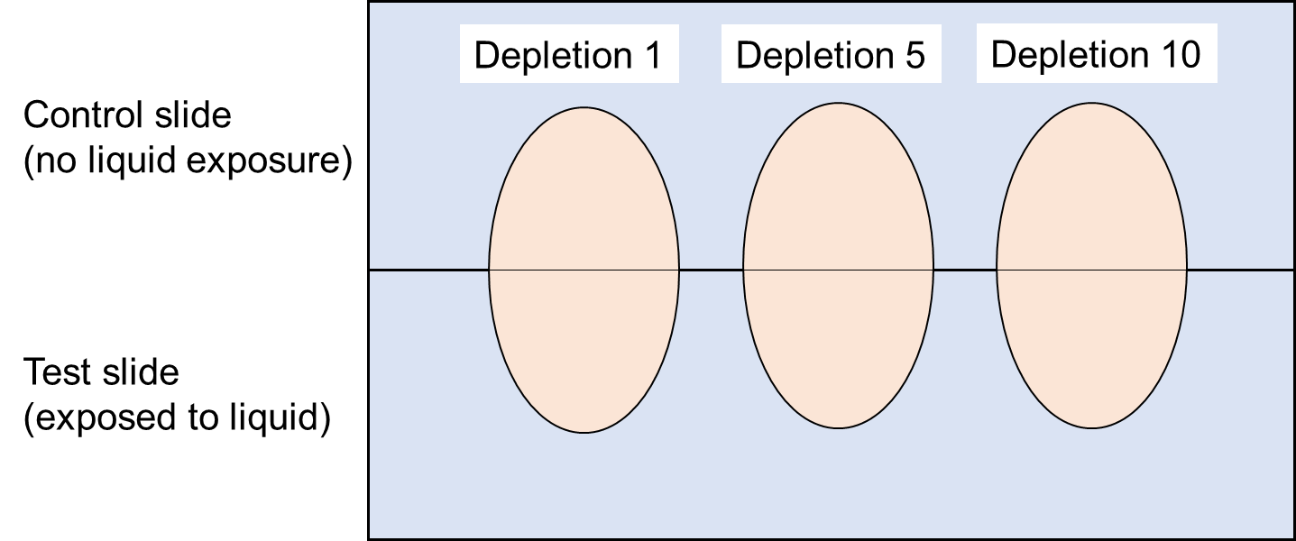
Figure 1. Schematic diagram showing the deposition of fingermarks on non-porous surfaces in this study

For marks deposited on paper, lines were drawn on the sheet of paper and a 6-mark depletion series deposited across the line. The paper was then cut into strips and the full depletion series treated.
In total, 75 fingermarks were deposited on glass substrates and 75 on PET substrates (marks 1, 5, and 10 in the depletion series, exposed to 3 different environments and treated with 7 different processes, with 1M and 2M concentrations for VMD only). 54 marks were deposited on paper (6 mark depletion series, exposed to 3 different environments and treated with 3 different processes).

2.4 Environmental conditioning
Deposited marks were left to age for 1 day in a laboratory prior to exposure to the corrosive substance. They were then exposed to the corrosive substance (or purified water) for a period of 5 minutes, then rinsed with purified water for approximately 30 seconds. The samples were then left to air dry at room temperature and then stored in a laboratory for a further day before being processed using the selected method. The sequence is shown schematically in Figure 2.
The 5 minute exposure period to the corrosive substance was chosen as an estimate of a period a mark on the exterior of a container may be exposed to a liquid splashed onto it before the liquid dried.

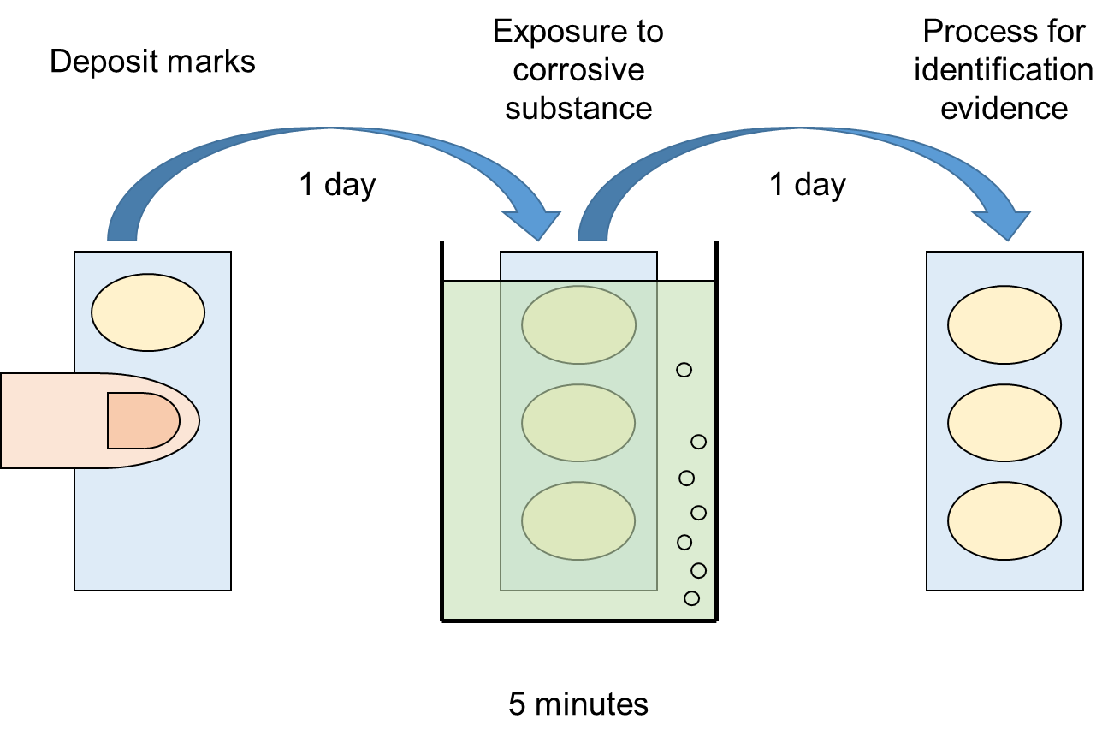
Figure 2. Schematic diagram showing the timescales used for each stage of the experiment

2.5 Processing method
The processes used to treat the samples after their exposure to the respective corrosive substance are summarised in Table 4 below.
Table 4. Summary of the processes used, the surfaces used on, and the source of the formulation
Process | Surfaces used on | Formulation/method used
Powders (black magnetic powder) | PET, glass | Jet Black Magnetic Powder (WA Products, UK)
Powder suspensions (iron oxide-based) | PET, glass | Home Office Fingermark Visualisation Manual [23]
Powder suspensions (carbon-based) | PET, glass | Wet Powder Black (Kjell Carlsson, Sweden)
Cyanoacrylate fuming/Basic Yellow 40 dye | PET, glass | Home Office Fingermark Visualisation Manual [23]
Solvent Black 3 | PET, glass | Home Office Fingermark Visualisation Manual [23]
Vacuum metal deposition (Au/Zn and Ag methods) | PET, glass | Home Office Fingermark Visualisation Manual [23]
Physical developer | Paper | Dstl Newsletter 2020 [24]
Oil Red O | Paper | Honig & Yoak [25]
Iodine fuming | Paper | Manual of Fingerprint Development Techniques, 2ed [26]

These processes were selected because they have been found capable of recovering fingermarks exposed to aqueous environments in some circumstances. Cyanoacrylate fuming/BY40 was included because of better than anticipated performance in a previous study where marks on metal surfaces were exposed to different cleaning methods [27]. Iodine fuming was included because it provides a liquid-free alternative to Oil Red O for targeting sebaceous constituents on porous surfaces.
Cyanoacrylate fuming was conducted in an MVC5000 cabinet (Foster + Freeman, Evesham, UK), and vacuum metal deposition using a West Technology E910 unit (West Technology, Yate, UK).

2.6 Evaluation of graded marks
Because the primary method of evaluating the effect of the different liquid environments on subsequent fingermark visualisation was a side by side comparison of the quality of developed marks, the method chosen in this study was an adaptation of the scale proposed by the University of Canberra [28], Table 5.
Table 5. Adaptation of the University of Canberra grading system used to compare controls with half-marks exposed to liquid
Score | Definition
+2 | Half-impression developed on side exposed to liquid exhibits far greater ridge detail and/or contrast than the corresponding half impression kept under dry, control conditions
+1 | Half-impression developed on side exposed to liquid exhibits slightly greater ridge detail and/or contrast than the corresponding half impression kept under dry, control conditions
0 | No significant difference between the corresponding half impressions
-1 | Half-impression developed on side exposed to liquid exhibits slightly less ridge detail and/or contrast than the corresponding half impression kept under dry, control conditions
-2 | Half-impression developed on side exposed to liquid exhibits much less (or zero) ridge detail and/or contrast than the corresponding half impression kept under dry, control conditions

- Results
3.1 Non-porous substrates
A summary of the comparative scores obtained on the two non-porous substrates using the range of visualisation processes is given in Tables 6-7. Additional observations specific to individual test conditions are included in the tables where appropriate. The scores given represent the median value for the three fingermarks deposited on the slide. It was generally found that the trend observed for the first mark was replicated for subsequent marks in the depletion series.
Table 6. Summary of the effect of liquid environments on the median quality of fingermark depletions developed on glass using different processes
Process | Water | 4M H₂SO₄ | 4M KOH
VMD (Au/Zn) | 0 | 0 | -1
VMD (Ag) | +1 (contrast of ridges vs background reverses) | 0 (contrast of ridges vs background reverses) | -2
Cyanoacrylate fuming/BY40 | -2 | -2 | -2
Powder suspension (carbon-based) | +1 | +1 | -1
Powder suspension (iron oxide-based) | 0 | +1 | -1
Powders (black magnetic powder) | -1 | 0 | -2
Solvent Black 3 | 0 | 0 | -1

Table 7. Summary of the effect of liquid environments on the median quality of fingermark depletions developed on PET using different processes
Process | Water | 4M H₂SO₄ | 4M KOH
VMD (Au/Zn) | +1 Empty marks – Ag VMD required to fill in | 0 Empty marks – Ag VMD required to fill in | -2  Empty marks – Ag VMD required to fill in  Then -1 some faint fragments
VMD (Ag) | +1 | 0 | -2
Cyanoacrylate fuming/BY40 | -2 | -2 | -2
Powder suspension (carbon-based) | 0 | +1 | -1
Powder suspension (iron oxide-based) | 0 | 0 | -1
Powders (black magnetic powder) | -1 | +1 | -2
Solvent Black 3 | 0 | 0 | -1

Both Au/Zn and Ag VMD techniques were found to be effective in visualising fingermarks exposed to some corrosive substances, although results varied according to both the substrate (glass or PET) and the corrosive substance used. Examples of marks developed using VMD are shown in Figures 3 and 4.
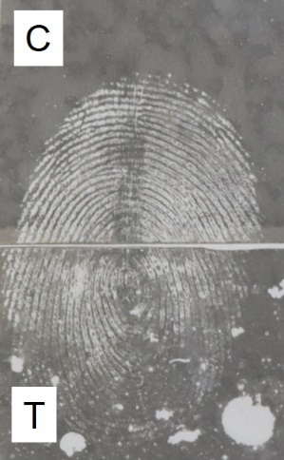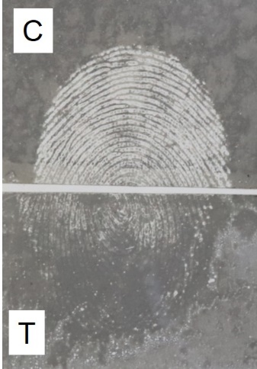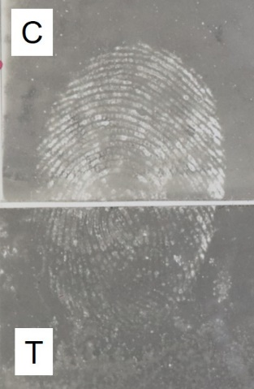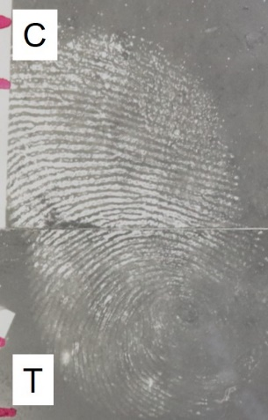
a) b) c) d)
Figure 3. Fingermarks developed on glass using Au/Zn vacuum metal deposition after exposure to corrosive substances, a) 4M sulfuric acid, b) 2M sulfuric acid, c) 1M sulfuric acid, and d) purified water. All fingermarks shown are the 10th mark in the depletion series. C = control sample, T = exposed to test environment

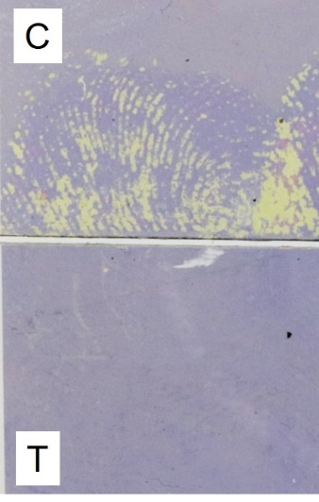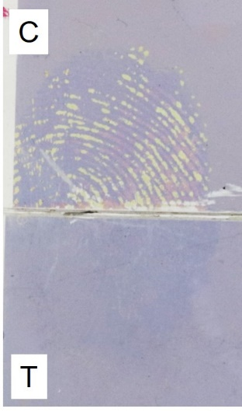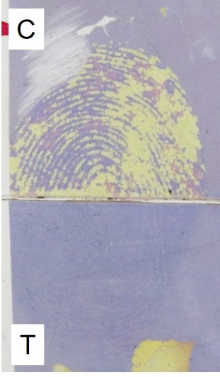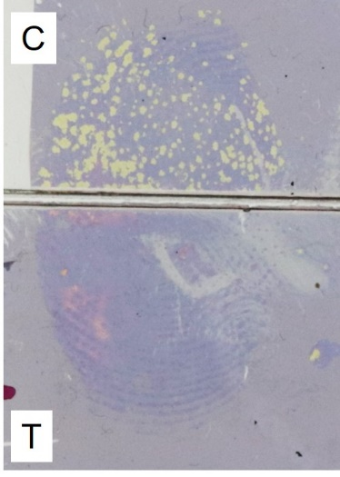
a) b) c) d)
Figure 4. Fingermarks developed on PET using Ag vacuum metal deposition after exposure to corrosive substances, a) 4M potassium hydroxide, b) 2M potassium hydroxide, c) 1M potassium hydroxide, and d) purified water. All fingermarks shown are the 10th mark in the depletion series. C = control sample, T = exposed to test environment
Cyanoacrylate fuming was adversely affected by exposure to all aqueous environments, with no ridge detail being developed on any of the samples of PET or glass, regardless of the liquid used, Figure 5.
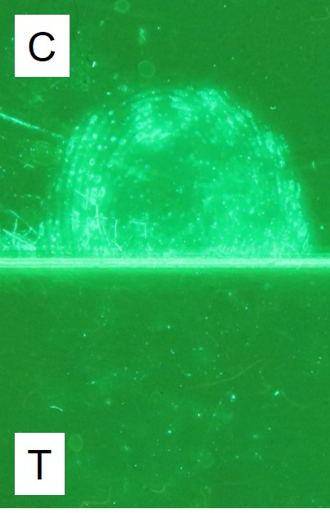
Figure 5. A fingermark developed on PET using cyanoacrylate fuming and basic yellow 40. C = control sample, T = exposed to test environment (purified water)
Powder suspensions also appear to be effective processes in recovery of fingermarks exposed to corrosive substances under certain conditions, an example of the results obtained for iron oxide-based powder suspension on glass being shown in Figure 6.
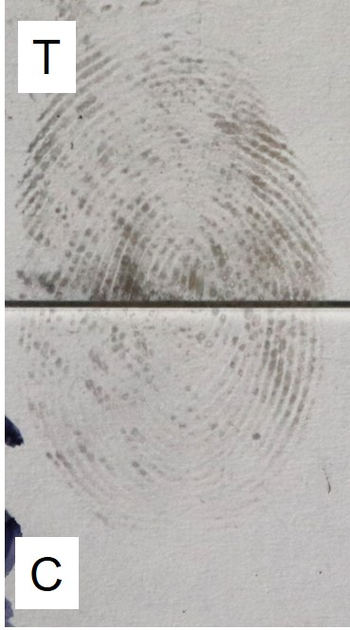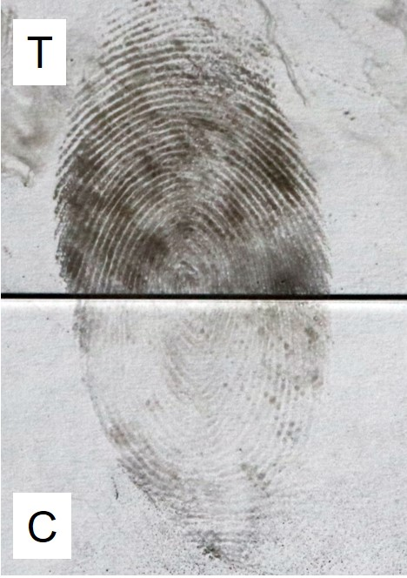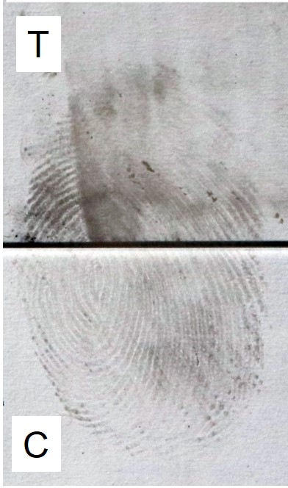
a) b) c)
Figure 6. Fingermarks on glass exposed to corrosive substances visualised using iron oxide-based powder suspension. a) purified water, b) 4M sulfuric acid, and c) 4M potassium hydroxide. C = control sample, T = exposed to test environment
Similar results were obtained for black magnetic powder, Figure 7.
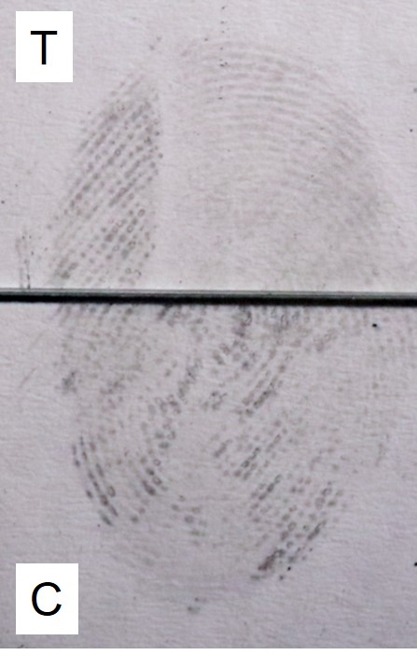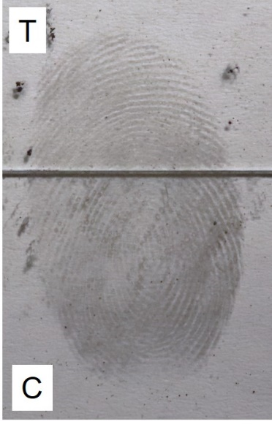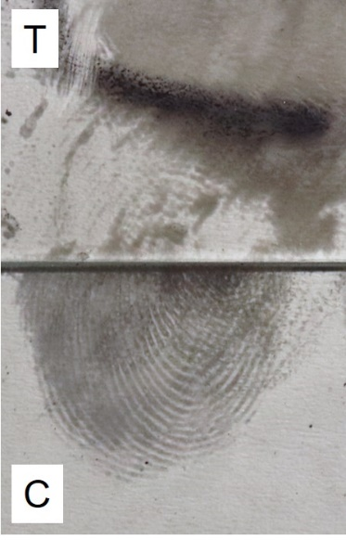
a) b) c)
Figure 7. Fingermarks on glass visualised using black magnetic powder. a) exposed to purified water, b) exposed to 4M sulfuric acid, and c) exposed to 4M potassium hydroxide. C = control sample, T = exposed to test environment
Solvent Black 3 gave poor development of marks overall, although the only environment making a significant difference being potassium hydroxide which was observed to remove the fingermark, Figure 8.
Figure 8. A fingermark developed on PET using Solvent Black 3. C = control sample, T = exposed to test environment (4M potassium hydroxide)

3.2 Porous substrates
A summary of the comparative scores obtained on the paper substrate using the range of visualisation processes is given in Table 8. The scores given represent the median value for the 6 fingermarks deposited on the paper.
Table 8. Summary of the effect of liquid environments on the median quality of fingermark depletions developed on paper using different processes
Process | Water | H₂SO₄ | KOH
Physical developer | 0 | -1 | -1
Oil Red O | 0 | -2  Possible diffusion | -1  Very faint development. Shrinkage of paper
Iodine fuming | -2  No development – paper turns purple | -2  No development – paper turns dark brown | -2  No development – paper turns dark grey/black and shrinks

The only process that developed potentially useful fingermarks was physical developer, with examples of the marks shown in Figure 9.

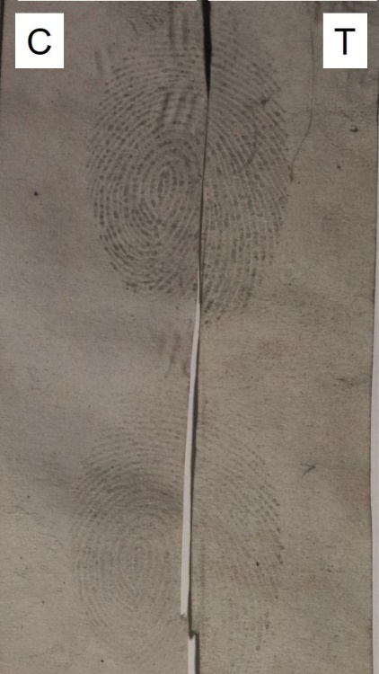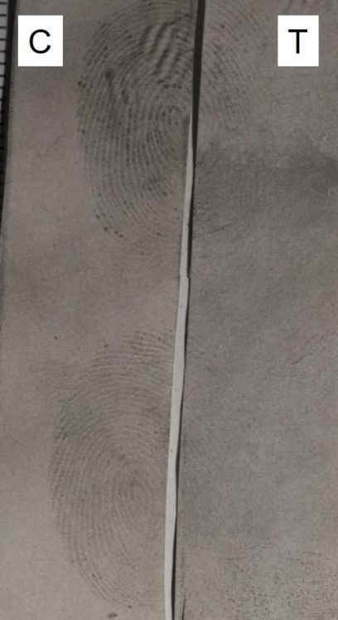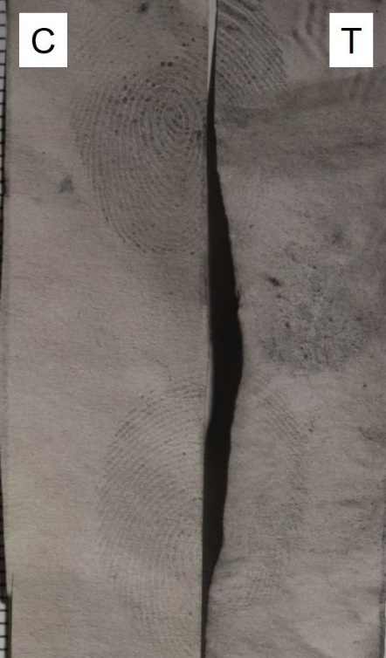
a) b) c)
Figure 9. Fingermarks developed using physical developer after exposure to aqueous environments. Left hand side – control sample, right hand side – exposed to aqueous environment, a) distilled water, b) 4M sulfuric acid, and c) 4M potassium hydroxide. C = control sample, T = exposed to test environment

- Discussion
The effectiveness of Au/Zn and Ag VMD processes was influenced by both the corrosive substance used and the substrate. VMD is known to work on surfaces exposed to water, so the results observed were expected. Fingermarks exposed to sulfuric acid were developed after exposure to all concentrations including 4M. For fingermarks at the beginning of the depletion series sulfuric acid had little detrimental effect, although fingermarks at the end of the depletion series were slightly less well developed after exposure to acid as illustrated in Figure 3.
Potassium hydroxide was observed to be more detrimental, with the magnitude of the impact increasing as amount of deposit decreased (i.e. down the depletion series). This may be because potassium hydroxide can saponify the triglycerides present, removing a fingermark constituent that is generally discriminated by the VMD process. The detrimental effect of potassium hydroxide decreased as the concentration of the alkali solution decreased, Figure 4. For these set of samples the marks become ‘reverse developed’ (i.e. ridges darker than the background) after immersion in the liquid. The ridges themselves are difficult to see in Figure 4 but there is a progressive increase in the depth of colour in the immersed side of the mark as concentration decreases.
The surface the marks have been deposited on influenced which of the VMD processes was more effective. ‘Empty marks’ (development of outlines with no internal features) were observed for Au/Zn deposition on PET, and subsequent application of Ag VMD was required to fill in ridge detail. Ag VMD was therefore the most effective method on this surface. On glass, Au/Zn VMD produced the best result. It should be noted that if marks developed on glass using Ag VMD were not photographed immediately some of the constituents subsequently migrated and this could make ridge detail difficult to see, Figure 10. The migration of thin films of material from the original ridge boundary has been observed by other researchers [29, 30] using microscopy methods.
Figure 10. Examples of fingermarks developed by Ag VMD on glass where subsequent migration of fats has obscured ridge detail
For Ag VMD, exposure to any liquid (even water) changed the appearance of the developed mark. Marks that had not been exposed to liquid generally developed as light ridges against a dark background, whereas those that have been exposed to liquid generally developed as darker ridges against a lighter background (and had much lower contrast). This can be seen in Figure 4d. Such reversal in colour and appearance of marks developed using Ag VMD after water immersion has previously been observed by other researchers [31], although in this case the substrates used were polyethylene and PVC. Chemical changes are clearly occurring in the fingermark and/or on the surface during exposure but further analysis would be required to establish what these are.
Cyanoacrylate fuming was ineffective after the fingermarks had been exposed to aqueous environments, Figure 5. Although not unexpected, this was in contrast to recent observations for fingermarks deposited on metal surfaces [27], where cyanoacrylate fuming was found to continue to develop marks after deliberate cleaning regimes including water and detergent. However, this may be due to the reactive nature of the metal surfaces which may retain reaction products enabling the original ridge detail to be developed. Another factor may have been the relatively short period of time (1 day) the fingermark was on the surface prior to exposure. Moores [32] has previously observed that fingermarks may be more resistant to aqueous environments if they were present for longer periods of time before immersion. This is another factor that would require further research for corrosive substances.
The powder suspension process also was also found to be capable of recovering fingermarks after substrates had been exposed to corrosive substances. Water and sulfuric acid had no detrimental impact on the quality of visualised fingermarks, and it was observed that exposure to sulfuric acid may even improve the contrast of marks processed with iron oxide-based powder suspension, Figure 6. Iron oxide powder suspension has been observed to work better when fingermarks have been aged, or exposed to heat [33], and it is thought that this may be associated with a drying and shrinkage of the fingermark deposit allowing the particles in the suspension to more closely interact with encapsulated eccrine constituents. It is possible that the acid contributes to dehydration of fingermark residues which results in a similar effect.
Although potassium hydroxide did have a slight detrimental impact on the quality of marks, this was not always catastrophic and some ridge detail could still be observed. As discussed above, potassium hydroxide can break down some of the fatty constituents of the fingermark and this may release the encapsulated eccrine constituents thought to influence fingermark development by this method, thus contributing to the reduced quality of the resultant mark. Of the two formulations used, iron oxide-based powder suspension gave better results than the carbon-based formulation and produced marks of better contrast with lower background development.
Black magnetic powder gave similar results to iron oxide-based powder suspension, with water reducing the contrast of the developed mark, sulfuric acid having little effect on glass but slightly enhancing contrast on PET by reducing background development. Potassium hydroxide was observed to be much more detrimental, Figure 7. The reaction between fatty constituents of the mark and potassium hydroxide would remove one of the components that powders could physically adhere to, thus accounting for the reduced quality in the developed mark.
Solvent Black 3 gave poor development of marks overall. This was not unexpected because the fingermarks deposited were not deliberately groomed to be rich in sebaceous material. However, it was possible to see that water and sulfuric acid had little effect on the quality of the marks developed, whereas potassium hydroxide removed any traces of the ridge detail, Figure 8. This observation is also consistent with sebaceous constituents being removed from the fingermark through a reaction with potassium hydroxide.
On porous surfaces the most effective process was physical developer. Although both sulfuric acid and potassium hydroxide were detrimental to fingermark recovery it was still possible to develop ridge detail on paper exposed to both liquids, Figure 9. Dilute acids are used as a pre-treatment in the physical developer process to neutralise alkali fillers in the paper, so it may be expected that acid exposure would be less detrimental, however the relatively high concentration and different acid used in this study may have influenced the results.
Oil Red O is known to develop fingermarks after exposure to water [34] and this was confirmed in this study, but after exposure to sulfuric acid development only diffuse features were seen that did not resemble the original fingermark. Evidence of ridges was seen after exposure to potassium hydroxide but these were extremely faint and would not have been detected unless the original location of the mark was known. The results observed on paper were in contrast to those on non-porous surfaces, where potassium hydroxide was the more damaging of the two corrosive substances used.
Iodine fuming was ineffective. Intense background staining by iodine vapour occurred on all the paper sections exposed to liquid, which obscured any fingermarks that may have been present. The colour of background staining varied according to the liquid it had been exposed to (distilled water – purple, sulfuric acid – dark brown, sodium hydroxide – dark grey). This is a known phenomenon with iodine, where the colour seen is influenced by the solvent environment it is exposed to, and indicates that residual traces of water, sulfuric acid and potassium hydroxide were still present in the paper prior to processing [35]. This dominated over any interaction between iodine and any fats present in the fingermark.
Overall, exposure to potassium hydroxide appeared more detrimental to fingermarks than sulfuric acid. A strong alkali may act to saponify some of the sebaceous constituents present in the fingermark, as well as the aqueous constituent dissolving eccrine material. Concentrated sulfuric acid is not strong enough to dehydrate carboxylic acids, and any fatty acids might survive exposure, which may explain why this corrosive substance was found to cause less damage to fingermark evidence. Potassium hydroxide was also seen to have a greater impact on the paper substrate, where shrinkage and crinkling was observed as the paper dried.

- Conclusions
The results of this pilot study indicate that it is still possible to visualise fingermarks after exposure to acids and alkalis of a reasonably high concentration (4M). This is of potential operational benefit to practitioners processing exhibits from corrosive substance attacks. On non-porous surfaces vacuum metal deposition, powder suspensions and to a lesser extent black magnetic powder continue to be effective, and on porous surfaces marks can still be enhanced using physical developer. These are all processes thought to target combinations of eccrine and sebaceous constituents, which suggests that these multi-constituent developers are preferable in these scenarios.
For the limited range of corrosive substances studied, immersion in alkalis seems to be more detrimental to subsequent fingermark recovery than exposure to acids, which in some cases appeared to enhance the contrast of developed marks.
Although this study is encouraging in demonstrating fingermark recovery is feasible after exposure to corrosive substances, there are many variables that need further study before operational guidance can be provided. These include increasing the pool of donors, different immersion times, different time periods prior to immersion, and increasing the range of corrosive substances (e.g. bleach, hydrochloric acid, ammonia) and their concentrations.

Declarations of interest: none

References
- Moffatt, S. & Rhimes, P. (2020) ‘Deliberate corrosive substance attacks – A systematic review’, Trauma, 22(3), pp. 169–175. doi: 10.1177/1460408620912568.

- Lewis, C.J., Hodgkinson, E.L., & Allison, K.P. (2020) ‘Corrosive attacks in the UK – Psychosocial perspectives and decontamination strategies, Burns, 46(1), pp 213-218 https://doi.org/10.1016/j.burns.2019.06.003.

- Moore-Bridger.B, (2017) ‘Acid attacks soar in London: Everything you need to know about the crime wave’, Evening Standard, 04/07/2017 Available at: https://www.standard.co.uk/news/crime/acid-attacks-soar-in-london-everything-you-need-to-know-about-the-crime-wave-a3588076.html (accessed 28/12/2020)

- Metropolitan Police Service, (2018) Information Rights Unit – Acid attacks recorded in London from 2008 to 2017, Available at: Information Rights Unit - Acid attacks recorded in London from 2008 to 2017 (met.police.uk) (accessed 28/12/2020)

- Nagarajan, M., Mohamed, S., Asmar, O., Stubbington, Y., George, S., & Shokrollahi, K. (2020) ‘Data from national media reports of ‘Acid attacks’ in England: A new piece in the Jigsaw’, Burns, 46(4), pp 949-958 https://doi.org/10.1016/j.burns.2019.10.027.

- Byard, R.W. (2020) ‘The manifestations of acid attacks (vitriolage or vitriolism)’ Forensic Science, Medicine and Pathology, 16, pp 387–388 https://doi.org/10.1007/s12024-020-00241-4

- Hopkins, M., Neville, L., and Sanders, T. (2021) ‘The motivations of offenders who carry and use acid and other corrosives in criminal acts’, School of Criminology, University of Leicester, Research Report 121 (commissioned by the Home Office) https://assets.publishing.service.gov.uk/government/uploads/system/uploads/attachment_data/file/958180/motivations-of-offenders-who-use-corrosives-in-criminal-acts-horr121.pdf [accessed 02/03/2021]

- 2020, Actionaid, Acid Attacks, Available at : https://www.actionaid.org.uk/about us/what-we-do/violence-against-women-and-girls/acid-attacks [accessed 25/06/2021]

- Tan, A., Bharj, A.K., Nizamoglu, M., Barnes, D., & Dziewulski, P. (2015). Assaults from corrosive substances and medico legal considerations in a large regional burn center in the United Kingdom: calls for increased vigilance and enforced legislation. Scars, Burns and Healing. DOI: 10.1177/2059513115612945

- Baruah, B., & Siddika, A. (2017) ‘Acid attacks are on the rise and toxic masculinity is the case,’ The Conversation, 14/08/2017 Available at: http://theconversation.com/acid-attacks-are-on-the-rise-and-toxic-masculinity-is-the-cause-82115 (accessed 28/12/2020)

- Piper, K. E. (2017) ‘A survivor’s perspective of acid attacks in the UK: an open letter from Katie Piper’, Scars, Burns & Healing. doi: 10.1177/2059513117723768.

- Kumar Das, K., Sazzad Khondokar, M., Quamruzzaman, M., Ahmed, S.S., & Peck, M. (2013) ‘Assault by burning in Dhaka, Bangladesh.’ Burns, 39(1), pp 177-183. https://doi.org/10.1016/j.burns.2012.02.032.

- Lipscombe, S., & Hutton, S. (2017) ‘Acid Attacks’, House of Commons library, Number CBP 8041, https://commonslibrary.parliament.uk/research-briefings/cbp-8041/ [accessed 28/12/2020]

- Bladed Article and Offensive Weapons Definitive Guideline, Sentencing Council, 2018 https://www.sentencingcouncil.org.uk/wp-content/uploads/Bladed-Articles-and-Offensive-Weapons-definitive-guideline-Web.pdf [accessed 02/03/2021]

- Offensive Weapons Act 2019 https://www.legislation.gov.uk/ukpga/2019/17/contents/enacted [accessed 08/04/2021]

- Song, M., Armstrong, A., & Murray, A. ‘Acid attacks: Broadening the multidisciplinary team to improve outcomes.’ Burns, 46(3), pp 514-519 https://doi.org/10.1016/j.burns.2019.03.018

- Wilkinson, D. A., Hancock, J., Lecavalier, P., & McDiarmid, C. (2005) ‘The Recovery of Fingerprint Evidence from Crime Scenes Contaminated with Chemical Warfare Agents’, Journal of Forensic Identification, 55(3), pp 326-361

- Wilkinson, D. A., Larocque, S., Lecavalier, P., & Cairns, S. (2005) ‘The Recovery of Footwear Evidence from Crime Scenes Contaminated with Chemical Warfare Agents’, Identification Canada, 28(4), pp4-19

- Wilkinson.D.A., Holst, A.G., De Reuver, L.P.J., Van Krimpen, S. H., & Van Baar, B. M. L. (2007) ‘The Fate of the Chemical Warfare Agent During DNA Extraction’, Journal of Forensic Sciences, 52(6), pp 1-12 DOI: 10.1111/j.1556-4029.2007.00569.x

- McDonald, D., Pope, H., & Miskelly, G. M. (2008) ‘The effect of chlorine and hydrogen chloride on latent fingermark evidence’, Forensic Science International, 179(1), pp 70-77 https://doi.org/10.1016/j.forsciint.2008.04.017

- IFRG. (2014) “Guidelines for the Assessment of Fingermark Detection Techniques,” Journal of Forensic Identification, 64(2), pp.174-200

- Sears, V.G., Bleay, S.M., Bandey, H.L., & Bowman, V.J. (2012) ‘A methodology for finger mark research’, Science & Justice, 52(3), pp 145-160 https://doi.org/10.1016/j.scijus.2011.10.006

- Bandey, H.(ed) (2014) Fingermark Visualisation Manual, ISBN 978-1-78246-234-7 London: Home Office

- Dstl Fingermark Visualisation Newsletter, Publication No. DSTL/PUB126361, October 2020

- Honig, M., & Yoak, J. (2016) ‘Oil red O: a comparative performance study.’, Journal of Forensic Identification, 66(2), pp 118–133

- Kent, T. (ed.) (1998) Manual of Fingerprint Development Techniques, 2nd edition, ISBN 1 85893 972 0. London: Home Office.

- Bleay, S.M., Kelly, P.F., King, R.S.P., & Thorngate, S.G. (2019) ‘A comparative evaluation of the disulfur dinitride process for the visualisation of fingermarks on metal surfaces’, Science & Justice, 59(6), pp 606-621 https://doi.org/10.1016/j.scijus.2019.06.011

- McLaren, C., Lennard, C., & Stoilovic, M. (2010) ‘Methylamine Pretreatment of Dry Latent Fingermarks on Polyethylene for Enhanced Detection by Cyanoacrylate Fuming’. Journal of Forensic Identification, 60 (2), pp 199–222

- Popov, K. T., Sears, V. G., & Jones, B. J. (2017) ‘Migration of latent fingermarks on non-porous surfaces: Observation technique and nanoscale variations’, Forensic Science International, 275, pp 44-56 10.1016/j.forsciint.2017.02.015

- Dorakumbura, B. N., Becker, T. & Lewis, S. W. (2016) "Nanomechanical mapping of latent fingermarks: A preliminary investigation into the changes in surface interactions and topography over time.", Forensic Science International, 267, 16-24 https://doi.org/10.1016/j.forsciint.2016.07.024

- Steiner, R., & Bécue, A. (2018), Effect of water immersion on multi- and mono-metallic VMD, Forensic Science International, 283, pp 118-127

- Moores, E. (2003) The influence of different water environments, exposure times and print age on the quality of latent print development using the cyanoacrylate method, BSc Final Year Project. University of Lincoln.

- Dominick, A. J., Nic Daeid, N. and Bleay, S. M. (2011) ‘The recoverability of fingerprints on nonporous surfaces exposed to elevated temperatures’. Journal of Forensic Identification, 61 (5), pp 520-536

- Beaudoin, A. (2004) ‘New Technique for Revealing Latent Fingerprints
on Wet, Porous Surfaces: Oil Red O’, Journal of Forensic Identification, 54 (4), pp 413–421

- Fairbrother, F. (1947) ‘Colour of Iodine Solutions.’, Nature, 160, pp 87 https://doi.org/10.1038/160087a0

