The Musculoskeletal System

Doreen Crawford and Beth Wilson

Abstract
This continuing professional development article has been written to provide an overview of the developmental anatomy and physiology of the musculoskeletal system of the child. It considers an embryological overview of the system, briefly reviews the essential anatomy and physiology before introducing some of the more common conditions related to the system.

Introduction.
This CPD is intended to provide an overview of the anatomy and physiology of the muscular skeletal system of the child and link these elements to the more common conditions related to this system. The musculoskeletal structure is a living, vibrant and dynamic system, a living skeletal framework is quite unlike the white, dead mineral residue resident in classrooms. The skeleton not only provides the bony framework of the body, which along with the tendons, ligaments and muscles, provide movement and mobility, it has important roles in the manufacturing of blood, body homeostasis and storage of nutrients. During formation, growth and development every bone undergoes a series of changes, initially the rate of growth in childhood is rapid then there are a couple of peaks round puberty. The growth trajectory then slows down and proceeds at a steadier rate until the total skeletal mass reaches its maximum at the end of in the second decade of life, after which there is a gradual reduction (Dixon and Crawford 2012).
Following completion of the CPD the reader should be able to:
- Summarize the embryology of the system
- Identify the main functions of the muscular skeletal system
- Describe some of the more common childhood conditions related to this system and appreciate how children with these conditions are best managed.

Time out one
Make a list of all the muscular-skeletal conditions you have seen and after reading this CPD indicate which are congenital, degenerative, acquired as a result of disease or could be classed as stemming from a traumatic origin.

Essential embryology and growth
Bone is a connective tissue and originates from the trilaminar embryonic disk (Hill 2018). The mesoderm is the precursor to most of the skeleton with the exception of the head where the neural crest also plays a role (Hill 2018). The embryonic skeleton is initially composed of fibrous membrane and hyaline cartilage, then specialist pockets of cells ossify the framework (see table 1). Ossification is the process of converting the cartilaginous framework into bone by depositing minerals such as calcium and it is incomplete at birth.
Two types of embryonic bone formation occur: intramembranous ossification and endochondral ossification. Intramembranous ossification is bone formed within loose fibrous connective tissue, central and in the body of the structure, the bones formed by this process are usually flat, for example the bones of the skull and the clavicles (Dixon and Crawford 2012). Bone formed by endochondral ossification is bone formed within the hyaline cartilage, mainly at the diaphysis/ shaft of the bone, with the exception of the clavicles, all bones below the base of the skull form by endochondral ossification. A primary ossification centre is the first area of a bone to start ossifying.
About the time of birth, a secondary ossification centre appears in each end (epiphysis) of long bones. Periosteal buds carry mesenchyme and blood vessels in, and the process is similar to that occurring in a primary ossification centre. The cartilage between the primary and secondary ossification centres is called the epiphyseal plate, and it continues to form new cartilage, which is replaced by bone, a process that results in an increase in length of the bone. Growth continues until the young person is about 21 years old or until the cartilage in the plate is replaced by bone. The point of union of the primary and secondary ossification centre is called the epiphyseal line (Dixon and Crawford 2012). Throughout life osteogenesis is the process of new bone growth and as indicated above it is most prolific in the first 2 decades of life. Ossification and osteogenesis work synergistically in the process of bone formation, structuring and remodelling.

Why understanding embryology and development matters
It is important to have a working knowledge of the development of the skeletal system and the maturation of bone because congenital orthopaedic birth defects can occur when bone and muscle tissue develops abnormally during foetal development. Although the majority of birth defects are of unknown origin, some common risk factors include:
- Chromosomal and genetic disorders
- Toxins for example alcohol, cigarette smoke, recreational drugs, medications (see maternal medications below), radiation, and chemicals
- Maternal infections during pregnancy, for example Rubella, Pertussis, Cytomegalovirus
- Therapeutic agents used to manage pre-existing maternal conditions such as diabetes, thyroid disease, heart disease, and hypertension can cause abnormalities during early development.

Following birth an epiphyseal line can be mistaken for a fracture (Zember, Rosenberg, Kwong et al) on an X ray and an X ray can help assess the age of a child where accurate birth records are not available (Mughal. Hassan, Ahmed 2014) for example refugee children in times of crisis (Schmeling, Dettmeyer, Rudolf et al 2016). Some skeletal aging methods are controversial (Mughal, Hassan, Ahmed 2014) and there has been some support for the argument that different ethnicities may mature at different rates (Creo and Schwenk 2017). However, one example of fusion used to determine age is using the clavicle bone, which may not be not fully ossified until the young person is 25 years old (Smithsonian Institute, see links).
Examples of skeletal anomalies linked to development table 1.

Table1 embryology and anatomy how altered embryology can impact on the individual.
Age | Anatomical development | Potential defect
Limb overview  Post fertilisation weeks 4−6  week 7 -8  Second trimester  Birth, growth and maturation | During week 4 of development embryonic connective tissue shows signs of differentiation. Explosive period of development and regarded as critically sensitive to external influences.  Limb buds develop, upper extremities with pronated forearms appear and begin to rotate externally.  Formation of the body’s solid framework begins; systematically each cartilage model becomes bone. Primary centres of ossification appear in the diaphysis of most bones.  Secondary centres for ossification are not apparent until the time of birth and not until the first year after birth in the femur. By age 4 ossification occurs in the greater trochanter, and in the lesser trochanter between the ages of 9 and 10 years . Once these areas have ossified, fusion to the diaphysis takes place and ultimately the epiphyseal plates will disappear. There is a growth spurt before puberty but the hormones that appear post puberty are a significant driver in the cessation of growth. | The skeletal framework and the ossification are influenced by genetics. If faulty genes are expressed, then conditions such as Marfans where the long bones overgrow may occur. Achondroplasia is another genetic condition (see section below) and involves the arrest of bone growth. Osteogenesis imperfecta involves the structural integrity of the bone when insufficient or molecularly deficient collagen is laid down (see section below).  Toxins and infections affecting the mother at this point can result in limb defects, one of the most high-profile causes was Thalidomide an anti-sickness drug prescribed in the 1950’s and early 1960’s.  Because of the ossification of foetal bones an anomaly scan at 20 weeks may pick up infants with short long bones and / or disproportional growth including Achondroplasia (Khan and Chew 2018) and also early fractures, if the infant has osteogenesis imperfecta (Solovyov, Goncharova and Zukin 2010)  Precocious puberty and short stature  Turners syndrome and the lack of the ability to use growth hormone appropriately results in short stature unless managed (Gravholt, Andersen, Conway et al 2017).
Vertebrae  Post fertilisation weeks 3−5  Weeks 6−8  The early years  3−6 years  11−13 years  14−16 years  25 years | Early formation of vertebrae with segmentation and chondrification. Two halves of the neural arch start to fuse and form the centrum. The notochord degenerates and disappears when surrounded by the cartilaginous vertebral body. Ossification takes place in several stages a primary ossification centre during foetal life and a secondary ossification centre after puberty (Hill 2018).  After birth the spinal curves start to become fixed. The thoracic curve about the time of birth but the cervical curve only appears when the infant can head lift. The lumbar curve appears when the infant starts to walk usually towards the end of the first year (Bala 2011).  The bony parts of the vertebral arch fuse together during the first 3-5 years, full fusion usually about 6 years.  Puberty  Final height of vertebral column is reached in girls.  Final height of vertebral column is reached in boys.  Ossification complete. | Defects in the fusion of the spinal column may result in a spinal lesion, such as spina bifida. The earlier the failure of fusion occurs, the more severe and complex the lesion is likely to be.  When bony spinal segments or the vertebrae fail to form properly, "extra" segments, or fused vertebrae may occur. The defects in the spine can be minor, involving only one segment of the vertebral column, or the condition can involve nearly every level and result in a more severe deformity. Congenital scoliosis has a high rate of concurrent spinal deformities associated with it, such as kyphosis (an abnormal forward-bending curvature) and lordosis (an abnormal backward-bending curvature), which also occurs independently. Infants with congenital scoliosis have a relatively high rate of other congenital abnormalities, such as anatomical anomalies of the genital-urinary tract or congenital heart defects (see links).  Spinal growth influences the final hight of the individual and the rate of growth can help predict the progress of scoliosis (Shi, Mao, Liu et al 2016).
Pelvis post fertilisation foetal  weeks 8 - 10  second and third trimester  Birth to adult.  Snapshots taken at  7 years  15 years | Ilium, ischium appears.  Pubis aligned.  Under normal circumstances the growth of the femoral head, acetabulum and innominate bone are delayed until the femoral head fits firmly into the acetabulum (Hill 2018).  Primary ossification centres occur in a number of locations before birth however the process of secondary ossification is not complete until adulthood (Hill 2018). By 7 years the ischial and pubic rami fuse and by 15 years a clear difference between the pelvis of male and female (DeSilva and Rosenberg 2017). With the ‘Y’-shaped cartilaginous physis of the three bones fused this process starts soon after puberty. | In bladder exstrophy a midline closure failure has occurred from the umbilicus to the perineum. The bladder mucosa can be seen together with separation of the pubic symphysis, epispadias or bifid genitalia (Rabinowitz and Cubillos 2019).  It is not fully understood what causes developmental hip dysplasia, but the instability varies in degree of severity and can sometimes be identified soon after birth (Payne 2016) see section below.
Foot  week 26  week 30  week 40  1st year | Ossification of calcaneus.  Ossification of talus.  Ossification of cuboid  Bones of tarsus are ossified | The defect commonly known as “club foot” is an umbrella term for a range of orthopaedic conditions some of which have intrauterine origins (Patel and Panchbhavi 2017). Because of the rate of ossification to get best outcome treatment and management needs to be commenced as soon as possible.
Bones of the shoulder  Clavicle  Week 5  Adolescence | The first bone in the skeleton with two centres that rapidly fuse.  Elongation of the sternal end, cartilaginous epiphysis appears and fuses several years later. The clavicle is the last bone to complete growth. | A range of syndromes present with absence or anomalies of the shoulder bones.  Examples include congenital absence of clavicle (cleidocranial dysostosis) which can be a hereditary disorder. A mutation in the CBFA1 gene (located on the short arm of chromosome 6) are usually inherited in an autosomal dominant fashion, although in some cases the cause is not known. This defect results in incomplete formation of the clavicles, as well as other skeletal structures. The entire clavicle may be absent, or simply a small segment of the middle or outer portion may be missing (Kelly 2016).  Sprengel deformity involves a displaced scapula and this can be associated with a range of cosmetic challenges or altered physical abilities, some children do not require surgery and others may be severely affected (Kelly 2016).  Congenital absence of the long bones of the upper limbs do occur, they are rare, and usually associated with toxicity or syndromes (Quinn and Mahat 2019). Treatment and management is individualised and provided in a few specialist centres.  During childhood infection of the bone is a rare but serious condition, osteomyelitis is usually caused by pyogenic organisms. The onset of symptoms is usually less than two weeks. The cause is commonly blood borne, trauma or tracking from other focal infections. The femur and tibia are the most commonly affected bones, but infection of the upper limb long bones does occur. Prompt treatment and management is required and early physiotherapy important to ensure a good outcome (Yeo and Ramachandran 2014).
Scapula  Foetal weeks  6−8  10 years to puberty  Puberty to 25 years | Scapula forms by chondrification of the mesenchyme followed by bony centres appearing in the glenoid angle.  Appearance of the base of the coracoid appears and fuses with the glenoid at puberty.  Secondary centres appear at puberty in acromion, medial border, inferior angle and coracoid, fusing by the age of 25.
Upper limbs  Humerus  Foetal weeks 6−8 | At week 6 the humerus is cartilaginous, primary centre of ossification appears at week 8.
Radius  Foetal weeks 6−8  2 years  4 years  18 years | At week 6 appears in cartilage, primary centre of ossification appears during week 8.  Secondary centre appears.  Radial head appears.  Radial head fuses with shaft.
Ulna  Foetal weeks 6−8  6 years  8−18 years  20 years | At week 6 appears in cartilage, primary centres appear in shaft at week 8.  Head ulna ossifies.  Olecranon epiphysis appears, fusion does not involve articular surfaces.  Head fuses with shaft.
Hand  Foetal weeks 6-8  Year 1  2 years  3 years  4 years  5 years  6 year s  7 years  10 years | Structures designated to become digits differentiate from a hand ray template. The shafts of metacarpals and phalanges ossify, and each carpal bone ossifies from one centre only.  The largest. Carpal ossifies in the first year of life.  Ossification of hamate.  Ossification of triquetal.  Ossification of lunate.  Ossification of trapezium.  Ossification of scaphoid.  Ossification of trapezoid.  Ossification of pisiform. | Failure of the hand to divide normally results in syndactyly the most common limb anomaly (Deune and Gellman 2018). Syndactyly can occur on its own or can be associated with a range of other abnormalities it is also a feature in over 28 syndromes such as Apert (Deune and Gellman 2018).  If possible, treatment is done early usually about two years to maximise functionality of the hand.  The hand X ray can be used to age a child when there is uncertainty.

Table modified from Dixon and Crawford (2012) additional materials from Bala (2011), Mughal, Hassan and Ahmed (2014) Hill (2018) Deune and Gellman (2018). .

Bones
Bones are lightweight in themselves but are said to be as strong as reinforced concrete (Martini and Bartholomew, 2016). They are however more durable than concrete and can be remodelled and shaped both as part of normal growth and medical interventions (Peate and Nair, 2015). Bones comprise of minerals and living tissue which allows for the strong structure but with sufficient pliability to allow remodelling to occur. The ability to hold a structure is as a result of collagen rods in the bone and the “cement” is formed by the minerals (calcium and phosphorus) which emanates from the blood and that set around the collagen to provide the flexibility and strength (Peate and Nair, 2015). Another function of the bones are the production of the cellular components of blood which is referred to as haematopoiesis. The red blood cells, white blood cells and platelets are produced in the bone marrow which is located in the centre of the bones. There are both red and yellow bone marrow found in the centre of the bones. The red bone marrow is mainly found in flat bones and within the epiphysis of long bones. This is where haematopoiesis (the formation of the blood cells) occurs, and the yellow bone marrow found in the diaphysis of long bones is primarily a site for fat storage of adipocytes. The skeleton is divided into the axial section which is comprised of the skull, ribcage and vertebrae and the appendicular which is made up of the bones of the four limbs and pelvis.
Fig 1
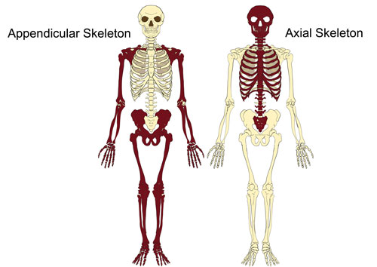
Taken from http://www.teachpe.com/anatomy/skeleton_axial.php will need to be redrawn

Time out 2
In what ways do you think the structures of the bone (flat or long) protects the child or assists in a child’s daily activities of living?

The bones of children
The bones that comprise the skeleton vary in size and shape and are classified into long bones (femur, humerus, tibia, fibula), short bones (carpals, tarsals), flat bones (skull, ribs and pelvis), irregular bones (maxilla) and sesamoid bones (patella) (Gosling et al., 2017). Bones are surrounded by a fine layer of periosteum, a fibrous tissue which allows muscle, tendon and ligaments to attach (Gosling et al., 2017). The periosteum is also the nerve centre of the bone and is the pain centre of fractured bones (Gosling et al., 2017). Bone areas in childhood contain growth plates and these can be clearly seen when the child is X rayed. The diaphysis (shaft of the bone) is separated by the growth plates from the epiphyses located at the distal end of the bone. The diaphysis and epiphyses fuse together when growth is complete to form a metaphysis (Martini and Bartholomew, 2016).

Time out 3
A mother consults you about pains that her son has in his legs. There is no history of injury and other conditions have been excluded as part of an assessment in casualty. How might you explain ‘growth pains’ to the mother using your knowledge of bone development.

The cellular structure of bone
Bone is more dynamic and complex than the examples in the biology laboratory would make it seem. There are four cells that make up the bony matrix; the osteoprogenitor, the osteoblasts, osteocytes and the osteoclasts. The osteoprogenitor cells are the precursor to osteoblasts, they are an immature version of osteoblasts which become under the influence of the growth factors. The osteoblasts are found in the growing areas of the bone, and these are the cells that are responsible for the synthesis of collagen and proteins and these are responsible for the formation of new bone. They osteoblasts are also responsible for the production of the enzyme, alkaline phosphatase which help form the mineral portion of bones and has multiple functions throughout the body (Sharma, Pal and Prasad 2014). The osteoblasts mature into the osteocytes which occupy specific spaces in the bony matrix called lacunae which appear as empty spaces in the bony matrix.

Fig 2 the microscopic appearance of bone
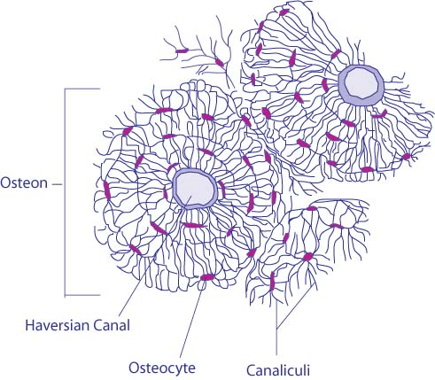
Will have to be redrawn sourced or permissions sought example http://www.lab.anhb.uwa.edu.au/mb140/CorePages/Bone/Bone.htm
https://www.google.co.uk/url?sa=i&rct=j&q=&esrc=s&source=images&cd=&cad=rja&uact=8&ved=2ahUKEwiYtb3prqjmAhUFzIUKHbHVC6IQjhx6BAgBEAI&url=https%3A%2F%2Fteachmeanatomy.info%2Fthe-basics%2Fultrastructure%2Fbone%2F&psig=AOvVaw2jjr8K_0ldwukqBnrB3Ctu&ust=1575973939421396
The osteocytes have branches that reach out to communicate with other osteocytes or osteoblasts giving them a star like appearance (see fig 2). They link and are part of a communication network. The central Haversian canals are also part of a communication network and provide bone with some nutrients and oxygen and drain waste and lymph. The final cell is the osteoclasts, they are derived from monocytes and are responsible for bone reabsorption. They break bone down with the use of tartrate resistant acid phosphatase. There is synergy in the synthesis and life cycle of bone where osteoblasts build up bone and osteoclasts break it down again, as a result bone is constantly being remodelled by the rebuilding by the osteoblasts and the breaking back down by the osteoclasts. Consequently, bone has a significant capability for regeneration and self-repair. However large segment bone defects caused by severe trauma, tumour / infected bone resection, or bone defects because of congenital disease can only be repaired by bone grafting, which is a painful procedure, there is no guarantee that it will take and is not without significant complications (Hatch 2019). Bone researchers have developed a range of biomaterials to support bone repair, these have included bioactive ceramics, biodegradable polymers, and biodegradable metals to try and replicate the complex structure and composition of bone. Such materials need to be light strong and flexible and the fact that there is no one single strand of research may speak volumes as to the technical challenges which need to be addressed. There is also encouraging work based on seed stem cells for bone repair (Gao, Peng, Feng et al 2017).

Joints, Ligaments and tendons
Ligaments and tendons are types of extra strong connective tissue. Ligaments connect bones to other bones and tendons connect muscle to bone. The point at which two bones meet is termed a joint. There are differing types of joints around the body. Synarthroses are where two bones are fused together so the joint is immovable, an example of this is the skull. However, in foetal development and infants the skull is comprised of large plates which permit growth, reflecting brain growth, once completed the plates then fuses and forms a ridged immovable joint. An amphiarthrosis is a joint where there is some movement but also some restriction, for example the vertebral joints. The final type is synovial or diarthrosis of which there are differing types. One is the ball and socket joint which is found in the hip and this has a considerable range of movement (Kishner and Gest 2017a). The hinge joint found in the knee and elbow where the joint moves on one plane only (Kishner and Gest 2017b). Synovial joints are lubricated by synovial fluid which is found surrounding the entire joint. The place where the joints meet is lined by a particular type of smooth cartilage known as articular cartilage. Cartilage has no direct blood supply and therefore has difficulty in repairing itself when damaged (Karuppal 2017).

The importance of muscles.
The skeletal system works intrinsically with the muscular system they are important to allow the body to perform gross motor and fine motor movements. There are three main types of muscle, smooth, cardiac and skeletal. Skeletal muscle is attached to the bones of the body by way of the tendons and causes movement to occur or be held for example during walking or sitting upright and unsupported. Not all skeletal muscles are attached by tendons for example the external oblique on one side of the abdomen is attached to that on the other side by way of a flat fibrous tissue called an aponeurosis. The skeletal muscles are those that can be seen on the body visibly such as the bicep or gluteus maximus. Muscles tend to be named in relation to the bony structures they are attached to or to their action. Unfortunately, this is not always the case and some muscles seem to be named following no logical reason, see fig 3
Fig 3.
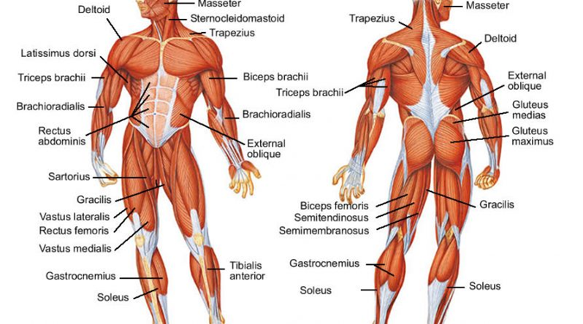
Either a stock photo or a redraw will be required.

Orthopaedic conditions in children.
There are a range of orthopaedic conditions which can be seen in children. Some are the results of a genetic syndrome or an embryological defect, as indicated in table 1. Other conditions which impact on the muscular skeletal system can be acquired as a result of intrapartum hypoxia or haemorrhagic brain injury such as cerebral palsy (Hoda and Kao 2018). Children may also be affected as a result of a disease process such as juvenile arthritis; sometimes there may be more than one reason a child develops a condition such as having a genetic predisposition to a condition and then an environmental trigger sets the scene for the development of the condition. Some forms of idiopathic scoliosis may fit into this category (Mehiman and Goldstein 2017). Muscular skeletal conditions can also be acquired through trauma. Often this trauma is so severe that the injury can include a bone fracture. There are several types of fracture see but with the pliability of a child’s bone, a common one is the greenstick see fig 4 and the section below.

Fig 4 Types of fracture
Fig 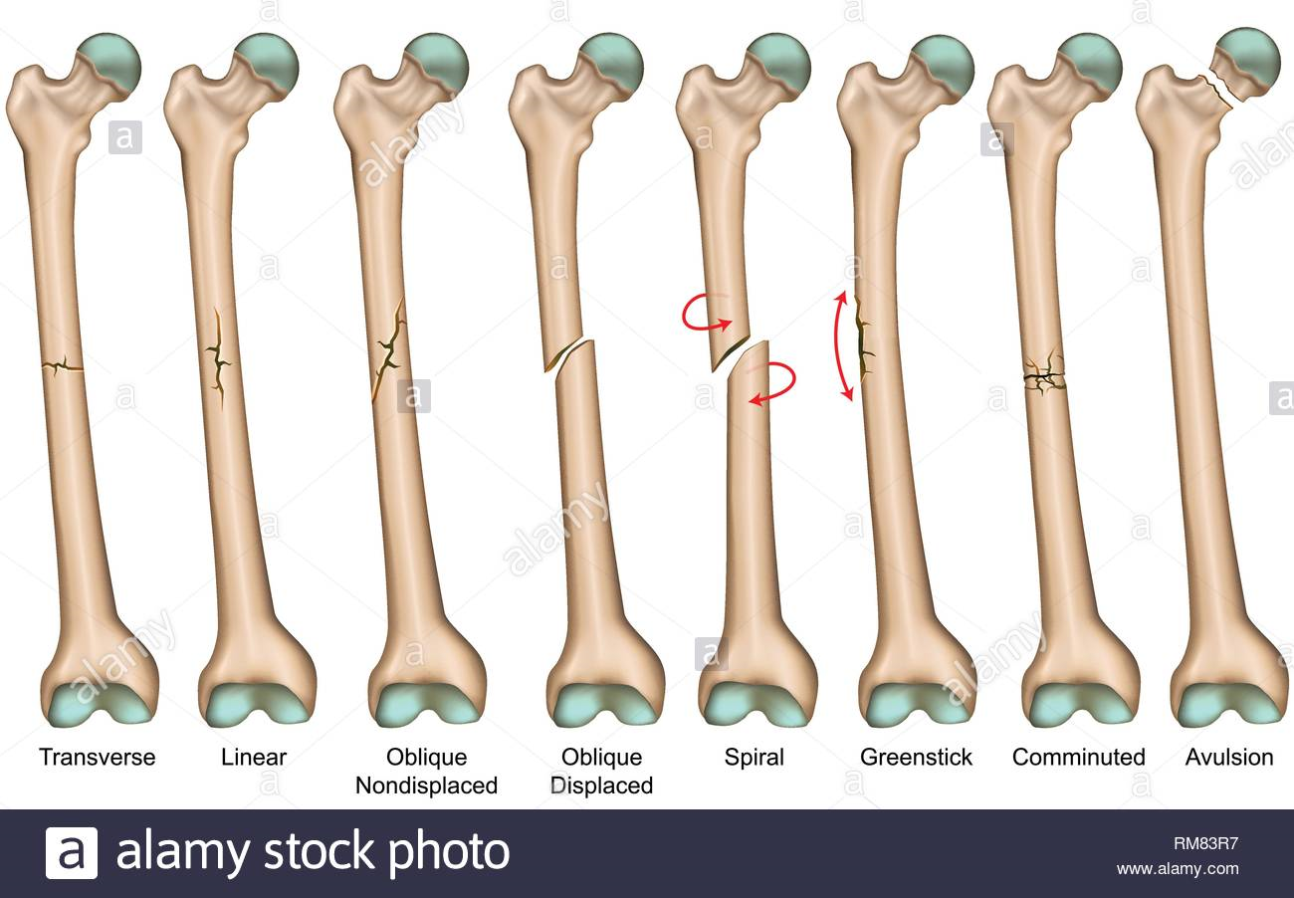 3

This image will need to be redrawn or purchased through a stock photo.
Fractures in children
Fractures are a common childhood injury and can occur as a result of a fall, a road traffic incident or as a result of physical abuse. In infants and toddlers, there are no differences in incidence between the sexes, in children older than 2 years, fractures are more common in boys than in girls (Jagede and Mills 2016). A fracture in a young child can be quite different from that of an adult as the child's bones are less dense and still growing. Because of this the bones are more malleable and tend to bend before breaking (Jagede and Mills 2016). While these may seem less severe, some fractures to children's bones can damage the growth plate and if not treated correctly can lead to asymmetrical growth in that bone.
From a first aid and initial assessment perspective fractures can be displaced, this is when the bone is not aligned, compound, where the bone has broken the skin, or closed where the fracture remains under the skin. Some fractures may seem inconsistent with the history, for example the child may present with the history of a simple fall from a moderate height however the fracture could be spiral where the mechanism of the fracture has been the twisting of the limb see fig 4
Depending on the type of fracture, treatment can be simple immobilisation with a cast or splint. Closed reduction under anaesthetic, where the surgeon will manipulate and reposition without resorting to surgery and open reduction where surgery with pinning and plating as required.

Time out 4 –
Match the following case scenarios to the probable fracture type (see Figure 4).
1 Josh age 9, thinking he was superman, jumped from a considerable height, he landed on both feet, but his ankles are swollen and deformed, he is in severe pain and cannot weight bear.
2 Martha age 16, has had a go karting injury - she collided at some speed with a wall of tyres. It took the fire crew some time to cut her free. On admission to ED she has both thighs covered with sterile dressings applied by the paramedics who tell you she has lost a lot of blood.
3 Timmy age 3, fell from a swing and put his hands out to break his fall, he cried a bit when he was picked up, is now fretful and although interested in toys to distract him is reluctant to use one of his hands.

Osteogenesis imperfecta (OI).
This is also known as brittle bone disease, Vrolik Syndrome and Lobstein Syndrome. It is a genetic condition and it is probable that the inheritance of other closely related disorders will be identified as molecular studies progress and improve understanding (Van Dijk and Sillence 2013). OI is not gender specific and is found in all cultures. As the name may indicate individuals living with this condition have bones that are brittle and are prone to fracture (Crawford and Dearmum 2016). The condition varies in severity. The condition is caused by the absence of collagen in the bone which is the element which contributes to bone structure. This makes the bone extremely weak. There is no cure for this condition, and it is managed by a multidisciplinary team who will look to minimise the potential for fracture (Crawford and Dearmum 2016).
Since the late 1990’s this condition has been managed with Bisphosphonate, this can be given intravenously which is more effective than when given orally. Intravenous pamidronate can increase mineral density and reduce pain. Surgery can be performed with insertion of intramedullary rods to maintain position and function of bones (Great Ormond Street Hospital, 2014).
Physiotherapy can be offered to the child and family to improve muscle strength. When fractures occur a nursing priority would be to assess and manage the child’s pain and provide appropriate analgesics. Other pain relieving techniques would include application of warmth, comfort and distraction. Children in pain may be reluctant to move so avoidance of pressure ulcers is an important consideration (Crawford and Dearnum 2016).
Unfortunately, when children are severely affected and suffer multiple fractures, they may become wheelchair dependant because of the deformities impacting on functionality which occurs (Great Ormond Street Hospital, 2014).

Scoliosis
This condition involves a spinal curve to the side and frequently a twist causing an abnormality of the ribcage see fig 5. There are differing types. Congenital scoliosis is present prior to birth and occurs during the development in the womb where the vertebrae did not form properly (see table 1). Early onset scoliosis occurs when the curvature develops between birth and up to the age of ten years. This is idiopathic in nature in that there is no known cause. Adolescent idiopathic scoliosis occurs between the ages of 10 and 16 and is linked to fast growth during puberty but again this curvature occurs without a given cause. Neuromuscular scoliosis is directly linked to a neurological condition such as cerebral palsy, spina bifida or Duchenne Muscular Dystrophy. This type of scoliosis happens when the nerves and muscles are not functioning properly which leads to weakness in the thorax leading to the curvature. It can be progressive if the disease is degenerative. Syndromic scoliosis can present as part of a syndrome such as Marfans or Ehler-Danlos Syndrome where the connective tissue is impacted. Treatment can be the application of a brace or surgery which involves a spinal fusion where one or two rods are implanted and are linked to the screws on the vertebrae. This is a major surgery and requires good preparation of the child and family, so they are aware of the risks and post-operative care required for this surgery. The outcomes are usually very good (see links).
Fig 5
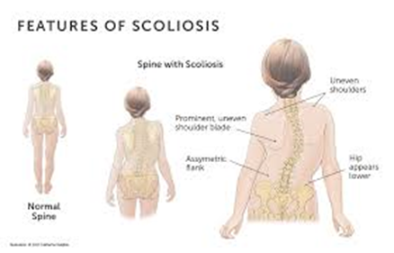
This will require either redrawing or replacing by a stock photo

Juvenile Arthritis
This is one of the most common chronic diseases of childhood (Sherry and Jung 2017) the aetiology is not fully understood but it is thought that genetic susceptibility has a major influence. It is characterised by inflammation of the joints see fig 6. It can present as painful and swollen joints which are warm to the touch. There may be increased fatigue with an intermittent fever and potentially a limp that has no organic cause. There are differing types of juvenile arthritis with the most common being oligoarthritis which affects approximately two thirds of young people presenting. This type tends to affect one or both knees and will resolve leaving very little joint damage. Polyarthritis is the second most common form and causes painful swelling in all the joints including the jaw and neck. This type can continue into adult life and is characterised by remission and relapse. Enthesitis related Juvenile Idiopathic Arthritis affects the point where the tendons attach to the bone and frequently affects the joints of the legs and the spine. Psoriatic arthritis is the combination of the rash that accompanies psoriasis with the inflammation associated with joint pain. This tends to attack the joints of the hand and feet and may persist into adulthood. Systemic onset Juvenile Idiopathic Arthritis presents as joint pain which is part of a febrile illness characterised by tiredness, rash, weight loss and loss of appetite. Although the febrile illness will settle, symptoms of the arthritis may persist for several years (Sherry and Jung 2017),
Treatment revolves around control of the symptoms to enable an active life. Analgesia can be used to control pain and non-steroidal anti-inflammatory drugs can be used to reduce stiffness and swelling. Steroids and biological therapies can also be used to suppress the immune system to reduce the inflammatory response. Physiotherapy and Occupational Therapy can be used to maintain flexibility and movement (Shery and Jung 2017).
Fig 6
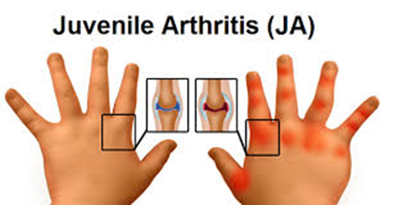
This will require either redrawing or replacing by a stock photo

Congenital hip dislocation or developmental dysplasia of the hip
This is where the joint between the femur and the pelvis does not properly form. The socket of the hip may be too shallow and does not hold the femur in place. For optimal management it is important to identify this condition as soon after birth as possible. It is more common following breech delivery, in multiple births and often runs in families. If untreated it can present as a limp, extreme hip pain and painful joints. Treatment in early life is a fabric splint known as a Pavlik harness, see fig 7. It secures the hips in a stable position and allows for normal development. After six months of age, surgery may be required which involves fixing the femur more fully into the socket (see NHS Choices 2018).
Fig 7
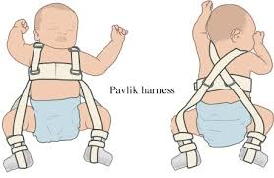
Image will have to be redrawn

Skeletal dysplasia including Achondroplasia.
There are a large number of conditions and disorders which are characterised by short stature. Short stature is defined as being more than 3 standard deviations below the mean height for age. If the short stature is proportional, the condition may be due to an endocrine or metabolic disorder which may be chromosomal, or a non-skeletal dysplasia possibly as a result of a genetic defect (Chen and Rohena 2015). Infants and children who have a disproportionately short stature may have skeletal dysplasia (osteochondrodysplasic). Skeletal dysplasias are a heterogeneous group of more than 200 disorders characterized by abnormalities of cartilage and bone growth, resulting in abnormal shape and size of the skeleton and disproportion of the long bones, spine, and head (Chen and Rohena 2015).
Achondroplasia is one of the more common skeletal dysplastic conditions Achondroplasia can be inherited as an autosomal dominant genetic condition (Ornitz and Legeai-Mallet 2017). An autosomal genetic condition means that if the gene is present it will be expressed and if a parent has the gene there is a 50% chance of passing the condition on to their children. Although most children with Achondroplasia have parents of average height the condition occurs because of a sporadic genetic mutation and this is responsible for 75-80% of affected children, essentially the gene affects growth and the child is identified at birth. Advancing paternal age has been implicated as a causative factor in the incidence of mutation. If both parents are affected by Achondroplasia the outcome for the infant can be very poor with a high infant mortality (Crawford and Dearmum 2016, Ornitz and Legeai-Mallet 2017).
Antenatal screening can identify Achondroplasia before birth. The use of prenatal ultrasound can measure the length of the foetal bones and the foetal DNA can be sampled to detect the presence of the gene. At present there is no pharmacological treatment for Achondroplasia, growth hormone has been tried, but has not been particularly successful (Harada, Namba, Hanioka et all 2017), researchers have also tried blocking the receptor plates of growth plates, but this has not been tried in humans at the time of writing (Ornitz and Legeai-Mallet 2017). In some cases, bone lengthening techniques have been successful, but there is no one preferred method. The process is also complex, painful and can mean a long rehabilitation process which can affect a child’s relationships, schooling etc. (Crawford and Dearmum 2016).
Fig 8
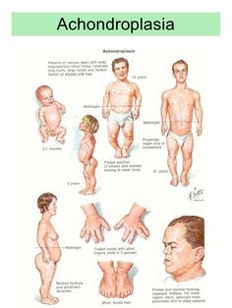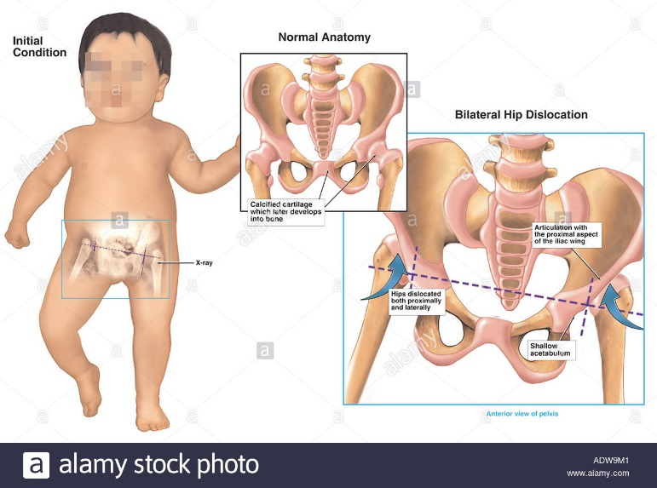
These will need to be purchased or redrawn.

Conclusion
This CPD has offered an overview of the muscular-skeletal system of the child and provided examples of a few related orthopaedic conditions. It has considered the embryology and summarised the basic anatomy and physiology, but it has not provided an exhaustive review. The reader is advised to expand their knowledge by reading an anatomy and physiology book of their choice and to follow up on the links and resources provided.

References and links
Please note - The resource Medscape is free to health care professionals but does require the reader to register. The process takes minutes however it is advised that the applicant select the alert options best suited to their interests.
Bala U. (2011) Development of the human skeletal system. https://skeletalsystemdev.weebly.com/vertebral-column.html Accessed July 2018
Chen H. and Rohena L. (2015) Skeletal Dysplasia. https://emedicine.medscape.com/article/943343-overview#a4 Accessed July 2018
Crawford D. and Dearmum A. (2016) Achondroplasia. A-Z Syndromes. Nursing Children and Young People. 28 (6) 15
Crawford D. and Dearmum A. (2016) Brittle Bone Disease. A-Z Syndromes. Nursing Children and Young People. 28 (7) 17
Creo A. and Schwenk W. (2017) Bone Age: A Handy Tool for Pediatric Providers. Pediatrics.140 (6):e20171486. https://pediatrics.aappublications.org/content/140/6/e20171486.long accessed June 2019.
DeSilva J. and Rosenberg K. (2017). Anatomy, Development, and Function of the Human Pelvis. The anatomical record. https://onlinelibrary.wiley.com/doi/full/10.1002/ar.23561 accessed July 2018
Deune G. and Gellman H. (2018). Syndactyly. https://emedicine.medscape.com/article/1244420-overview#a5 Accessed August 2018
Dixon and Crawford (2012) Paediatric Intensive Care Nursing. Wiley-Blackwell.
Gao C. Peng S. Feng P. and Shuai C. (2017) Bone biomaterials and interactions with stem cells. Bone Research 5 https://www.nature.com/articles/boneres201759#f1 accessed June 2019.
Gosling, J.A., Harris, P.F., Humpherson, J.R., Whitmore, I., and Willan, P.L.T. (2017) Human Anatomy , Color Atlas and Textbook. 6th edn. Elsevier Ltd: Philadelphia.
Gravholt C. Andersen N. Conway O. et al (2017). Clinical practice guideline for the care of girls and women with Turner syndrome. https://turnersyndromefoundation.org/wp-content/uploads/2017/07/Clinical-Practice-Guideslines-International-G1-2017.full_.pdf last accessed December 2019.
Great Ormond Street (2014) Osteogenesis Imperfecta. Available at: http://www.gosh.nhs.uk/medical-information/osteogenesis-imperfecta (Accessed: 15 February 2018).
Harada D. Namba N. Hanioka Y. et all (2017) Final adult height in long-term growth hormone-treated achondroplasia patients. Eur J. Pediatrics 176 (7) 873-879
Hatch D. (2019) Bone grafting. Ortho bullets https://www.orthobullets.com/basic-science/9011/bone-grafting accessed December 2019
Hill M. (2018) Embryology https://embryology.med.unsw.edu.au/embryology/index.php/Main_Page Accessed July 2018.
Hoda A.and Kao A. (2018). Cerebral Palsy. Medscape https://emedicine.medscape.com/article/1179555-overview accessed December 2019
Jagede T. and Mills T. (2016). Forearm Fractures in Emergency Medicine. Medscape https://emedicine.medscape.com/article/824949-overview accessed December 2019
Karuppal R. (2017). Current concepts in the articular cartilage repair and regeneration. J Orthop. 14 (2) 1-3
Kelly D. (2016). Congenital Anomalies of the Trunk and Upper Extremity. https://musculoskeletalkey.com/congenital-anomalies-of-the-trunk-and-upper-extremity/ accessed December 2019.
Kishner S. and Gest T. (2017b). Knee Joint Anatomy. https://emedicine.medscape.com/article/1898986-overview last accessed December 2019
Kishner S. and Gest T. (2017a). Hip Joint Anatomy. Medscape https://emedicine.medscape.com/article/1898964-overview last accessed December 2019
MacGregor J. (2008). Introduction to the Anatomy and Physiology of Children. Routledge.
Martini, F.H. and Bartholomew, E.F. (2016) Essentials of Anatomy and Physiology, Global Edition. Pearson Education Limited: Essex
Mehiman C. and Goldstein J. (2017) Idiopathic Scoliosis. https://emedicine.medscape.com/article/1265794-overview#a4 Accessed August 2018
Mughal A. Hassan N, Ahmed A. (2014) Bone age assessment methods: A critical review. Pak J Med Sci 30 (1) 211-215 http://dx.doi.org/10.12669/pjms.301.4295 accessed June 2019.
NHS Choices (2018) Developmental dysplasia of the hip. https://www.nhs.uk/conditions/developmental-dysplasia-of-the-hip/ Accessed august 2018
Ornitz D. and Legeai-Mallet L. (2017) Achondroplasia: Development, Pathogenesis, and Therapy. DEVELOPMENTAL DYNAMICS 246: (4) 291–309. https://www.ncbi.nlm.nih.gov/pmc/articles/PMC5354942/ accessed June 2019.
Patel M. and Panchbhavi V. (2017) Clubfoot. https://emedicine.medscape.com/article/1237077-overview#a4 Accessed August 2018.
Payne J. (2016) Developmental Dysplasia of the Hip https://patient.info/doctor/developmental-dysplasia-of-the-hip-pro Accessed 2018.
Peate, I and Nair, M (2017) Fundamentals of Anatomy and Physiology: for Nursing and Healthcare Students. 2nd edn. Wiley Blackwell: Chichester
Quinn M. and Mahat G. (2019) Congenital upper limb deficiency: A case report. Contemporary Paediatrics. https://www.contemporarypediatrics.com/pediatrics/congenital-upper-limb-deficiency-case-repor last accessed December 2019
Rabinowitz R. and Cubillos J. (2019). Bladder Anomalies. https://www.msdmanuals.com/professional/pediatrics/congenital-renal-and-genitourinary-anomalies/bladder-anomalies#v28385907 last accessed December 2019
Schmeling A. Dettmeyer R. Rudolf E. et al (2016) Forensic Age Estimation. Methods, Certainty, and the Law. Deutsches Arzteblatt International. 113 (40 44-50 https://www.ncbi.nlm.nih.gov/pmc/articles/PMC4760148/ Accessed July 2018
Sharma U. Pal D. and Prasad R (2014) Alkaline Phosphatase: An Overview. I J Clinical Biochemestry. 29 (3) 269-278 https://www.ncbi.nlm.nih.gov/pmc/articles/PMC4062654/ last accessed December 2019
Sherry D. Jung L. (2017) Juvenile Idiopathic Arthritis. https://emedicine.medscape.com/article/1007276-overview Accessed August 2018
Shi B. Mao S. Liu Z. et al (2016). Spinal growth velocity versus height velocity in predicting curve progression in peri-pubertal girls with idiopathic scoliosis. https://bmcmusculoskeletdisord.biomedcentral.com/articles/10.1186/s12891-016-1221-6 last accessed December 2019
Smithsonian National Museum of Natural History. Young or old? https://anthropology.si.edu/writteninbone/young_old.html Accessed July 2018
Solovyov O. Goncharova Y. and Zukin V. (2010) Osteogenesis imperfecta. The Fetus .net https://sonoworld.com/fetus/page.aspx?id=2807 Accessed 2018.
Van Dijk F. Sillence D. (2013). Osteogenesis imperfecta: Clinical diagnosis, nomenclature and severity assessment. Am J Med Genet Part A 167A (5) 1178 https://www.ncbi.nlm.nih.gov/pmc/articles/PMC4314691/ accessed June 2019
Yeo A. and Ramachandran M. (2014) Acute haematogenous osteomyelitis in children. BMJ 348 (7942) 28-33
Zember J. Rosenberg Z. Kwong S. et a (2015) Normal Skeletal Maturation and Imaging Pitfalls in the Pediatric Shoulder. RadioGraphics. https://pubs.rsna.org/doi/full/10.1148/rg.2015140254 accessed December 2019.

Open links
Anatomy and Physiology of the appendicular skeleton https://courses.lumenlearning.com/suny-ap1/chapter/development-of-the-appendicular-skeleton/ Accessed July 2018
Congenital Scoliosis (Pediatric). https://www.columbiadoctors.org/condition/congenital-scoliosis-pediatric last accessed December 2019
Mohammed T. and Alsaad D. The skeleton https://www.slideshare.net/ananthatiger/lecture-12-the-skeleton-embryology-pdf last Accessed August 2018
Orthopaedic Surgery Medscape https://emedicine.medscape.com/orthopedic_surgery follow the links to paediatrics and ongoing link to achondroplasia, hip, limp and fracture.
Little People UK (2015) Achondroplasia. Available at: http://littlepeopleuk.org/information-about-dwarfism-conditions/types-of-dwarfism/achondroplasia (Accessed: 12 February 2018).
NSPCC and Cardiff University (2012) Fractures in children: Core info leaflet. NSPCC Available online at: https://www.nspcc.org.uk/globalassets/documents/advice-and-info/core-info-fractures-children.pdf Accessed on: 16th June 2018
Scoliosis Association (UK) (2018) What is Scoliosis? Available at: http://www.sauk.org.uk/scoliosis-information/what-is-scoliosis (Accessed: 15 February 2018).
The Perthes Association (2011) What is Perthes Disease? Available at: https://www.perthes.org.uk/what-is-perthes-disease/ (Accessed: 12 February 2018).
Typical fractures seen in children slideshow. https://reference.medscape.com/features/slideshow/pediatric-fractures accessed December 2019

