Biodiesel production from waste cooking oil via supercritical methanol: optimisation and kinetic reactor simulation
Omar Aboelazayem ^{a,b} Mamdouh Gadalla ^{b} and Basudeb Saha ^{a,1}
ª School of Engineering, London South Bank University, 103 Borough Road, London, SE1 0AA, UK.
^{b} Department of Chemical Engineering, The British University in Egypt, Misr-Ismalia Road, El-Shorouk City 11837, Cairo, Egypt.

ABSTRACT
Biodiesel production using supercritical methanol in the absence of catalyst has been analysed by studying the main factors affecting biodiesel yield. A quadratic polynomial model has been developed using Response Surface Methodology (RSM). Box-Behnken Design (BBD) has been used to evaluate the influence of four independent variables i.e. methanol to oil (M:O) molar ratio, temperature, pressure and time on biodiesel yield. The optimum biodiesel yield is 91% at M:O molar ratio, temperature, pressure and reaction time of 37:1, 253.5ºC, 198.5 bar and 14.8 minutes, respectively. Overall reaction kinetics has been studied at optimum conditions concluding a pseudo first order reaction with reaction rate constant of 0.0006s⁻¹. Moreover, thermodynamics of the reaction has been analysed in the temperature range between 240 and 280ºC concluding frequency factor and activation energy of 4.05s⁻¹ and 50.5kJ/mol, respectively. A kinetic reactor has been simulated on HYSYS using the obtained kinetic data resulting in 91.7% conversion of triglycerides (TG) with 0.2% relative error from the experimental results.

KEYWORDS
Biodiesel, Supercritical Transesterification, Optimisation, Response Surface Methodology, Kinetic Reactor, HYSYS Simulation.

HIGHLIGHTS
- Study of overall transesterification reaction kinetics.
- Optimisation by Response Surface Methodology enhanced biodiesel yield.
- Simulation of kinetic reactor based on experimental data.
- Physiochemical properties of produced biodiesel showed good agreement with EN14214 standard.

1. INTRODUCTION

Fossil fuels including coal, natural gas and petroleum products are the main sources of energy, however, there is increasing concern regarding dependence on these fuels. It is generally accepted that burning fossil fuels is contributing to climate change and their reserves are finite. In addition the instability of the world oil production has been considered as one of the major global problems in recent years [1]. Therefore, it is increasingly necessary to develop renewable energy resources to replace the fossil sources.
Biofuels have been considered as an efficient replacement for fossil fuels mainly in the transportation sectors. The first generation of diesel engines were designed to be operated by vegetable oils. However, petro-diesel has been considered as an efficient replacement due to its lower viscosity and physical properties similarity to the vegetable oil. Modern direct injection diesel engines require low viscosity oil. Although, using crude vegetable oil in diesel engines would cause deposits formation, which may lead to engine damage in the long term. Vegetable oil viscosity can be reduced by many techniques, the most commonly used technique is transesterification reaction which converts the TG present in the vegetable oil to fatty acid methyl esters (FAME), which has similar fuel properties to petro-diesel [2].
Biodiesel is defined as a mono alkyl ester of long chain fatty acid derived from vegetable oil or animal fats. Production techniques include acidic, basic and non-catalytic transesterification processes. Selection of the production method is based on the properties of the crude vegetable oil including water content and total acid value [3].
Base catalysed process technology is very sensitive to the FFA concentration and water content of the feedstock. Saponification reaction might occur between the base catalyst and FFA present in the feedstock forming soap which could prevent biodiesel separation and hence lowering its yield [4].
Heterogeneous base catalysed technique has been used to reduce the cost of catalyst separation. However, using heterogeneous catalyst required special units for catalyst preparation and requires feedstock with very low concentration of water due to its sensitivity [4].
Non-catalytic supercritical methanol technology is a transesterification method that is not subject to any of the previously mentioned restrictions. Supercritical methanol process has been designed to produce biodiesel from low quality crude vegetable oil with high total acid value and water content. Esterification reaction is enhanced to convert the FFA in the low-quality feedstock to FAME. Saka and Kusdiana [5] were the first researchers to produce biodiesel under supercritical conditions. They reported biodiesel production with 95% yield within 2 minutes at 350ºC, 450 bar and M:O molar ratio of 42:1. It has been concluded that within the extreme conditions of biodiesel production, thermal decomposition for the FAME results in low quality biodiesel. Accordingly, lowering the reaction conditions is the key factor for production of high quality biodiesel [6]. The reaction temperature is an important parameter for the supercritical production of biodiesel. Reaction temperature directly affects the stability of the produced FAME. Imahara et al. [7] have reported that at very high temperature reactions, FAME shows stability up to 270ºC, while beyond this temperature FAME starts to decompose due to isomerisation from cis-form to trans-form.
Abbreviations
RSM: response surface methodology; BBD: Box-Behnken design; M:O: methanol to oil ratio; TG: triglycerides; FAME: fatty acids methyl esters; WCO: waste cooking oil; ANOVA: analysis of variance; MeOH: methanol; DG: diglycerides; MG: monoglycerides; GL: glycerol; BD: biodiesel; TAN: total acid number.

At supercritical methanol reaction, waste cooking oil (WCO) is considered an ideal feedstock for biodiesel production. WCO required pre-treatment to be used for either homogenous or heterogeneous base catalysed processes while in supercritical methanol process it could be used without any pre-treatments. Feedstock pre-treatment process using conventional catalysed technology includes blending of a high FFA feedstock with other lower FFA feedstock to obtain acceptable concentration of FFA. Moreover, feedstock could be pre-treated using adsorbents to extract FFAs from oil where spent adsorbents could be disposed of in a landfill. Another pre-treatment approach is to convert FFAs to their potassium salt by neutralisation reaction and could be removed by either water washing or centrifuge. In conclusion, low quality feedstocks with high FFA concentration requires any of the previously mentioned pre-treatment techniques to avoid converting FFAs to soap during biodiesel production, which then results in difficulties during downstream processing of the final product [8].

Selecting WCO reduces the cost of the feedstock and eliminates any considerations of the competition with food industry [9]. Tsai et al.[10] have concluded that WCO recorded better results than the refined cooking oil using supercritical methanol transesterification. They reported that using WCO at 300ºC and 100 bar in 4 minutes the biodiesel yield was 65%. However, using refined sunflower oil required 40 minutes to achieve the same yield. They explained that the presence of FFA at higher concentration in WCO feedstock enhances FAME production using supercritical methanol since both esterification and transesterification reaction take place in parallel during the reaction time. Ghoreshi and Moein [11] concluded that the optimum conditions for biodiesel production within the supercritical methanol process at 271ºC, 231 bar, 20.4 minutes and 33.8:1 M:O molar ratio resulting in 95.7% yield.
An economic feasibility and profitability study has been reported comparing both homogenous alkaline and supercritical methanol production plants. Each process has been designed to produce 4000 tonnes of biodiesel annually. The process economics has been analysed using Aspen In-Plant Cost Estimator. The study concluded that base catalysed process showed lower total capital investment. However, supercritical methanol process was more economically preferable providing higher net present value, lower manufacturing cost and higher discounted cash flow rate of return [12].

In this study, RSM using BBD has been used to optimise production of biodiesel from the WCO using carbon dioxide gas as a co-solvent. The independent variables in the modelling process are M:O molar ratio, temperature, pressure and time. Biodiesel yield has been considered as the dependent response variable. Analysis of Variance (ANOVA) has been used to analyse the significance of the statistically developed regression model which represents the dependant variable function of all the independent variables. Physiochemical properties of the produced biodiesel have been analysed and compared to the biodiesel standard EN 14214. Kinetics of the overall transesterification reaction has been studied concluding the relevant kinetic and thermodynamics reaction constants. Finally, a kinetic reactor for the transesterification reaction has been simulated using HYSYS simulation programme based on the experimentally kinetic data.
2. MATERIAL AND METHODS

2.1. Materials
WCO has been supplied by Uptown Biodiesel Ltd., UK. Methanol 99% (MeOH) was purchased from Fisher Scientific, UK. The standard methyl esters used for preparing calibration curves and the heptadecanoic acid methyl ester used as an internal standard have been purchased from Sigma-Aldrich, UK. The liquid CO₂ cylinder (99.9%) equipped with a dip tube has been purchased from BOC Ltd., UK.

2.2. Experimental Setup
WCO has been filtered to remove the suspended particles from the cooking process. The supercritical reaction of biodiesel production was carried out in a 100-mL high pressure reactor made of stainless steel (model 49590, Parr Instrument Company, USA) which was fitted with a thermocouple (type J), heating mantle, controller (model 4848) and a mechanical stirrer. Figure 1 shows a schematic for the experimental setup. The oil and methanol with a specific molar ratio were added to the reactor then heated with continuously stirring at constant rate of 300 rpm to the target temperature. Then, supercritical fluid pump (model SFT-10, Analytix Ltd., U.K) was used to compress CO₂ to the targeted pressure from the cylinder to the reactor. The reaction heating process started before pressurising since the vaporised methanol build-up pressure inside the reactor where the remaining pressure was obtained using pressurised carbon dioxide gas. The time required to reach the reaction conditions was about 15 minutes. The reaction time was considered once the reactor reached the targeted temperature and pressure. After the reaction time, the reactor was quenched using an ice bath to stop the reaction. The reactor was then depressurised and the reaction product separated using a centrifuge (1500 rpm, 3 min per cycle) to biodiesel and glycerol. The biodiesel was then heated to 80ºC for 30 minutes to recover the unreacted methanol using distillation. Finally, the pure biodiesel properties were analysed and compared with the European biodiesel standard (EN14214). The yield of the produced biodiesel has been calculated by using equation (1) [13].

BD yield (%) = $\frac{Total weight of methyl esters }{Total weight of waste oil used} ×100$ (1)

Thermocouple
Gas Inlet Valve
Stirring System
Pressure Regulator
Sampling Valve
Pressure Gauge
Moveable Head
Impeller shaft
Heating Mantle
Socket
CO₂ Cylinder

Figure 1. Schematic of the experimental setup
2.3. Experimental Design
RSM is a multivariate method which is capable of developing a model representing the reaction dependant response function in the experimental studied independent variables [14]. RSM has been developed to conclude the optimum conditions for biodiesel production by studying the relationship of each variable and the response yield. The experimental runs have been operated based on 4 independent variables including M:O molar ratio, temperature, pressure and time, which were labelled as A, B, C, D respectively. Three levels for each variable have been coded as -1, 0, 1 as shown in Table 1. BBD is one of the RSM techniques that are used to study the main effect of process variables on the response. It also studies the effect of the variables interactions on the response [15].
Biodiesel yield has been selected as the response for this study. In order to minimise the effect of unexplained inconsistency in the responses, the experiments have been completed in a randomised order [16]. Twenty-nine runs have been performed in a randomised way and their response has been calculated from the experimental results using equation 1 as shown in Table 2 (Actual BD Yield).

Table 1. Experimental design variables and their coded levels
Factor | Code | Levels
 |  | -1 | 0 | +1
M:O (molar ratio) | A | 20 | 31 | 42
Temperature (ºC) | B | 240 | 260 | 280
Pressure (bar) | C | 180 | 220 | 260
Time (min) | D | 12 | 22 | 32

Table 2. Experimental design matrix with the actual and predicted yields
Run | M:O molar ratio (A) | Temperature (ºC) (B) | Pressure (bar) (C) | Time (min) (D) | Actual BD Yield % | Predicted BD Yield %
1 | 31 | 260 | 220 | 22 | 96 | 94.2
2 | 20 | 260 | 220 | 32 | 85 | 84.208
3 | 31 | 280 | 220 | 12 | 91 | 90.083
4 | 20 | 280 | 220 | 22 | 85 | 85.375
5 | 42 | 260 | 260 | 22 | 92 | 91.916
6 | 31 | 260 | 220 | 22 | 93 | 94.2
7 | 31 | 260 | 260 | 12 | 88 | 88.208
8 | 42 | 240 | 220 | 22 | 87 | 87.208
9 | 31 | 240 | 260 | 22 | 85 | 84.541
10 | 42 | 260 | 220 | 32 | 92 | 91.375
11 | 31 | 260 | 220 | 22 | 94 | 94.2
12 | 20 | 260 | 220 | 12 | 82 | 82.208
13 | 20 | 260 | 180 | 22 | 81 | 80.916
14 | 31 | 280 | 220 | 32 | 90 | 90.083
15 | 42 | 260 | 220 | 12 | 91 | 91.375
16 | 31 | 240 | 220 | 32 | 84 | 84.75
17 | 31 | 280 | 260 | 22 | 91 | 90.875
18 | 20 | 240 | 220 | 22 | 79 | 79.041
19 | 42 | 280 | 220 | 22 | 93 | 93.541
20 | 31 | 260 | 260 | 32 | 89 | 89.208
21 | 20 | 260 | 260 | 22 | 84 | 84.25
22 | 31 | 260 | 220 | 22 | 94 | 94.2
23 | 31 | 260 | 180 | 12 | 85 | 85.375
24 | 31 | 240 | 220 | 12 | 83 | 82.75
25 | 31 | 240 | 180 | 22 | 82 | 81.708
26 | 31 | 260 | 180 | 32 | 86 | 86.375
27 | 31 | 260 | 220 | 22 | 94 | 94.2
28 | 31 | 280 | 180 | 22 | 88 | 88.041
29 | 42 | 260 | 180 | 22 | 90 | 89.583
Where, BD means Biodiesel.

2.4 Statistical Analysis
The general quadratic equation has been used to define the model as shown in equation (2).
$Y=b_{o}+\sum_{i=1}^{n}{b_{i}X_{i}}+\sum_{i=1}^{n}{b_{ii}X_{i}^{2}}+\sum_{i=1}^{n-1}{\sum_{j=2}^{n}{b_{ij}}X_{i}X_{j}}+ ℇ$ (2)
Where Y is the dependent response, b_{o} is the model coefficient constant, b_{i}, b_{ii}, b_{ij}, are coefficients for intercept of linear, quadratic, interactive terms respectively, while X_{i}, X_{j} are independent variables (i≠j). The model adequacy has been checked by coefficient of correlation (R²), adjusted coefficient of determination (R²_{adj}) and the predicted coefficient of determination (R²_{pred}). Investigation of the statistical significance has been analysed using ANOVA by calculating the Fisher’s F-test at 95% confidence level.
Numerical optimisation of the reaction conditions has been concluded based on certain variables restrictions. The restrictions of the optimisation process have been set for minimising temperature, pressure and time while targeting to maximising biodiesel yield response.
Design of experiments, regression analysis, graphical analysis and numerical optimisation has been performed using Design Expert 10 software (Stat-Ease Inc., Minneapolis, MN, USA). Statistical significance of the results has been presented by p-value, where the result is considered to be significant when p-value is < 0.05. Predicted yields in the last column of Table 2, have been concluded from the developed model in equation 7 which is discussed in the results section.

2.5. Reaction Kinetics
Supercritical transesterification reaction kinetics is complex since the reaction mechanism involves transferring TG to diglycerides (DG) then to monoglycerides (MG) and finally to glycerol (GL). Esterification reaction of FFA to FAME has not been considered during the calculation since the FFA concentration is insignificant in the feedstock (TAN= 0.8 mg KOH/ g oil). For simplifying the transesterification reaction complex behaviour, the following means have been applied in the reaction kinetics modelling with respect to the formation of fatty acid methyl esters (FAME) [17].

- The overall supercritical transesterification reaction is irreversible.
- The change in concentration of methanol is ignored throughout the reaction since the amount of M:O molar ratio in supercritical reaction is adequately high relative to the stoichiometric amount of methanol consumed by TG.
- Glycerol-methanol side reaction is ignored.

The kinetic and thermodynamic data of the overall reaction, including reaction rate constant (k), activation energy and frequency factor, have been calculated according to the following equations [11].

-r_{TG} = - ${d[TG]}/{dt}$ = k [TG] (3)

[TG] = [TG]_{o} (1-X) (4)

$X= 1- \frac{\left[TG\right]}{\left[TG\right]o}=1- \frac{\left[TG\right]o-{\left[FAME\right]}/3}{\left[TG\right]o}= \frac{[FAME]}{3\left[TG\right]o}$ (5)

$k=A e^{\frac{-E}{RT}}$ (6)

Where X, A and E are the conversion of TG, frequency factor and activation energy, respectively.

2.6. Physiochemical Properties
WCO feedstock properties have been calibrated as shown in Table 3. The produced purified biodiesel from supercritical transesterification reaction using the optimum condition has been analysed for evaluating its physical and chemical properties. The results have been compared with the European standard of biodiesel, EN14214. The analysed properties have been replicated twice and the final results have been obtained as an average of the two results. The standard density has been measured based on ASTM D4052 method, while the kinematic viscosity has been measured according to ASTM D445 method. Total acid number (TAN) of the produced biodiesel has been calibrated according to ASTM D974 method.
Table 3. Properties of WCO feedstock
Test | Calibration Method | Result
Kinematic viscosity at 40ºC | ASTM D-445 | 54.2 cSt
Density at 15ºC | ASTM D-4052 | 0.883g/cm³
TAN | ASTM D-974 | 0.8 mg KOH/g oil

2.7. Gas Chromatography Analysis
Fatty acids composition of the WCO has been analysed by converting them to methyl esters according to BS EN ISO 12966-2:2011 as shown in Table 4. The WCO and the produced samples have been analysed for methyl esters content using gas chromatograph (GC) (Thermo- Scientific, Trace 1310) equipped with a capillary column (TR-BD 30 m × 0.25 mm × 0.25 μm) and flame ionisation detector (FID). Both injector and detector temperatures have been adjusted at 250ºC. Helium has been used as the carrier gas. The temperature programme has begun from 60°C and held for 2 min. Then it ramped with 10°C/min to 200°C and directly ramped with 1°C/min to 210°C. Finally, the temperature was increased to 240°C with a ramp rate of 20°C/min and remained for 7 minutes.

Table 4. Composition of the fatty acids in WCO
Fatty Acid | Wt (%)
Palmitic | 7.07
Oleic | 62.63
Linoleic | 23.26
Arachidonic | 7.04

2.8. Kinetic Reactor Simulation
Aspen HYSYS simulation programme Version 8.8 has been used for simulating the biodiesel reactor (Aspen Technology Inc., USA). The WCO used in the reaction has represented by triolien (C₅₇H₁₀₄O₆) component from HYSYS components library as it represents the main composition of the oil. Consequently, methyl-oleate (C₁₉H₃₆O₂), which is also available in the HYSYS components library has been considered as the product of the transesterification reaction. Since the transesterification reaction includes highly polar components i.e. methanol and glycerol, the non-random two liquid (NRTL) thermodynamic activity model has been used as the fluid package of the reactor simulation [18]. Continuous stirred tank reactor (CSTR) has been chosen to represent the continuous reaction. In this study, a CSTR kinetic has been simulated to represent realistic results based on the input kinetic data. Kinetic data and thermodynamics parameters required for simulating the reactor i.e. reaction rate constant (k) and the activation energy (E), have been determined from the experimental work of this study.

3. RESULTS AND DISCUSSION

3.1. Model Fitting and Adequacy Checking
The predicted model has been examined for adequacy to report any errors associated with the normality assumptions. After performing the 29 experiments as shown in Table 2, and evaluating biodiesel yield (reaction response) for each run, the response analysis using BBD has been applied. Design Expert software generated a regression equation representing an empirical relationship between the response variable and the reaction parameters. The generic quadratic equation shown in equation (7) which represents equation (2) has been used to obtain a polynomial regression model by fitting the experimental results.

Y = β_{o} + β₁ X₁ + β₂ X₂ + β₃ X₃ + β₄ X₄ + β₁₂ X₁X₂ + β₁₃ X₁X₃ + β₁₄ X₁X₄ + β₂₃ X₂X₃ + β₂₄ X₂X₄ + β₃₄ X₃X₄ +β₁₁ X₁² + β₂₂ X₂² + β₃₃ X₃² + β₄₄ X₄² (7)

According to the data obtained from experimental results, a polynomial equation as showed in equation (8) has been concluded where Y is the dependant variable (biodiesel yield); A, B, C and D are the independent variables (M:O molar ratio, temperature, pressure and time respectively). Predicted model has been validated at M:O molar ratio (20:1-42:1), temperature (240-280ºC), pressure (180-260 bar) and time (12-32 minutes).

Y = 94.2 + 4.08 A + 3.17 B+1.42 C + 0.50 D - 0.25 AC - 0.50 AD - 0.50 BD - 3.77 A2 - 4.14 B2 -3.77 C2 - 3.14 D2 (8)

ANOVA has been applied to examine the significance of the model parameters at 95% confidence level. The significance of each parameter has been determined by F-test and p-value. The higher the value of F-test and the smaller the p-value, the more significance of the corresponding parameter [19].
ANOVA has been used to validate the RSM model coefficient using F-test and p-value, these values have been concluded as 65.40 and <0.0001, respectively as shown in Table 5 which prove that the developed quadratic model is statistically significant with 95% confidence level. Lack-of-fit analysis is one of the adequacy checking techniques which measures the failure of the regression model to represent the experimental data points [14].
Lack-of-fit value of the model has been concluded to be 0.942 (not significant), which illustrate that the model has been representing most of the experimental data successfully. The determination coefficient values, R² and R²_{adj}, which measure the reliability of the model fitting, have been calculated to be 0.9849 and 0.9699, respectively. These values indicate that only 0.0151 of the total variation has not been well clarified by the developed model, which ensure the model fitting to the experimental data.
The model performance has been observed using different techniques. A plot of the predicted versus experimental result of the biodiesel yield (Figure 2) showed high correlation and reasonable agreement. The good estimate for the response values from the model is clearly concluded from the similarity between the predicted and actual experimental results as shown in Figure 2. In addition, a plot of residual distribution versus predicted response has been presented to check the fitting performance of the model as shown in Figure 3. Residual value is defined as the difference between predicted and experimental values of the response variable. The plot confirms that the quadratic model adequately represents the experimental data as the distribution is not following a specified trend with respect to the predicted values of the response variable. Moreover, the perturbation plot represents the effect of each variable on the reaction response as shown in Figure 4. The curvature of the variables from the centre point indicates the significance of each variable which confirms the statistical results obtained from ANOVA as shown in Table 5. Sharp curvature of the independent variables, e.g. M:O molar ration (A), temperature (B) and pressure (C) indicates their highly significance as concluded from the ANOVA results. It also represents the effect of each variable, where for M:O molar ratio the plot indicates that it has progressively increasing effect on biodiesel yield until reaching the central point where it slightly decreases after this point.

Table 5. Analysis of variance for response surface developed model
 | Sum of square | df | Mean Square | F Value | p-value | Significance
Model | 580.97 | 14 | 41.49 | 65.4 | 2.785E-10 | HS
A-M:O | 200.08 | 1 | 200.08 | 315.32 | 5.356E-11 | HS
B-Temperature | 120.33 | 1 | 120.33 | 189.64 | 1.568E-09 | HS
C-Pressure | 24.08 | 1 | 24.08 | 37.95 | 2.473E-05 | HS
D-Time | 3 | 1 | 3 | 4.72 | 0.04 | S
AB | 0 | 1 | 0 | 0 | 1 | NS
AC | 0.25 | 1 | 0.25 | 0.39 | 0.54 | NS
AD | 1 | 1 | 1 | 1.57 | 0.23 | NS
BC | 0 | 1 | 0 | 0 | 1 | NS
BD | 1 | 1 | 1 | 1.57 | 0.23 | NS
CD | 0 | 1 | 0 | 0 | 1 | NS
A² | 92.02 | 1 | 92.02 | 145.03 | 8.933E-09 | HS
B² | 111.26 | 1 | 111.26 | 175.35 | 2.616E-09 | HS
C² | 92.02 | 1 | 92.02 | 145.03 | 8.933E-09 | HS
D² | 64.02 | 1 | 64.02 | 100.89 | 8.838E-08 | HS
Residual | 8.88 | 14 | 0.63
Lack of Fit | 4.08 | 10 | 0.41 | 0.340278 | 0.9240384 | NS
Pure Error | 4.8 | 4 | 1.2
Where HS: Highly Significant, S: Significant and NS: Not Significant

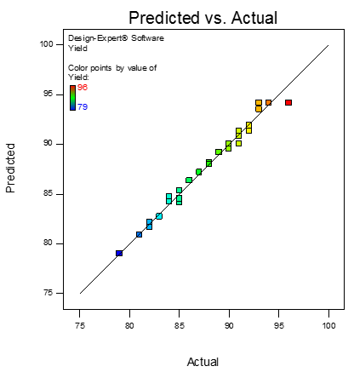
Figure 2. Actual experimental data versus predicted model
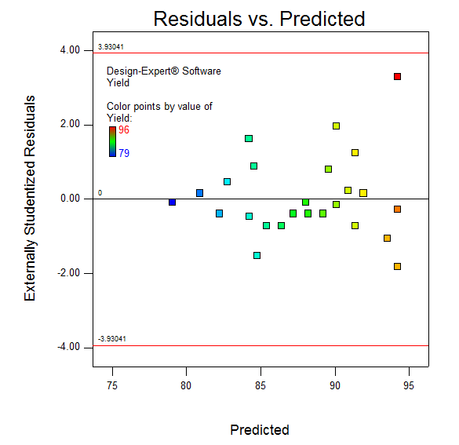
Figure 3. Residuals versus predicted response
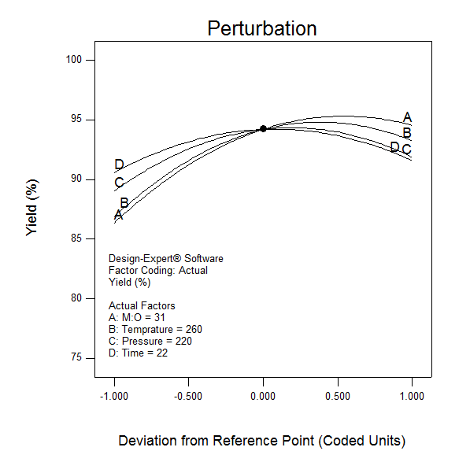
Figure 4. Perturbation Plot

3.2. Effect of Process Variables
The 3D-surface and contour plots of the biodiesel yield versus interaction of two independent variables are shown in Figures 5 and 6. In each plot, the two remaining independent variables were kept constant in their centre points.

3.2.1 Effect of methanol to oil molar ratio
Experimental runs have been carried out at M:O molar ratio between 20:1 and 42:1 in order to study the effect of their variation on the yield of biodiesel. Based on the ANOVA results presented in Table 5, M:O molar ratio parameter shows highly significant effect on the process response. At constant temperature (260ºC) the yield of biodiesel is 95.5% at a M:O molar ratio of 37:1, however it decreases to 92% at a M:O molar ratio of 42:1. It is shown in Figure 5, that an increase in M:O molar ratio from 20:1 to 37:1, increases the biodiesel yield. However, biodiesel yield decreases slightly at higher M:O molar ratio values (more than 37:1). Ghorieshi and Moein [11] reported similar phenomena at high M:O molar ratio. They reported that at M:O molar ratio higher than 34:1, the biodiesel yield starts to decrease slightly.

High excess of methanol lowers the critical temperature of the reaction products as methanol has lower critical condition compared to the reaction mixture components. Lowering the critical temperature of the product enhance FAME decompositions and hence reducing biodiesel yield. Moreover, FAME decomposition can enhance glycerol-methanol side reaction [20].
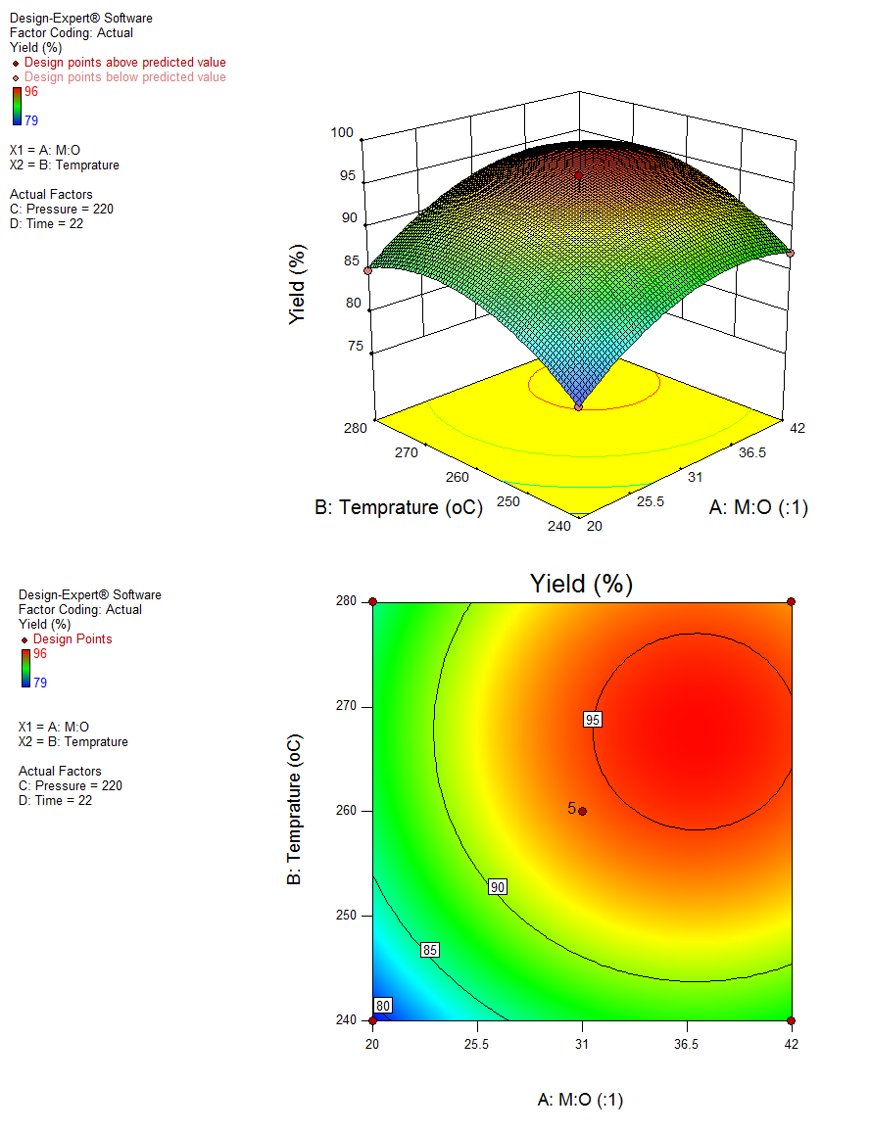

Figure 5. 3-D and contour graphs showing the effect of methanol ratio and temperature versus yield
3.2.2 Effect of reaction temperature

ANOVA results presented in Table 5 show highly significant effect of reaction temperature on the process response. It is clearly shown in Figure 5 that a directly proportional relation exists between temperature and biodiesel yield within the temperature range between 240ºC and 270ºC. However, biodiesel yield decrease slightly at higher temperature values (more than 270ºC) due to the decomposition of the produced FAME. The same observation has been reported by Ghoreishi and Moein [11]. They have observed that at a higher reaction temperature than 271ºC, biodiesel yield starts to decrease.

3.2.3 Effect of reaction pressure
The co-solvent, carbon dioxide gas, has been used to pressurise the reaction. Using carbon dioxide as a co-solvent for the reaction enhances the solubility of methanol in oil [21]. As shown in Figure 6, reaction pressure is directly proportional with the biodiesel yield in the range of 180 to 230 bar. It has been observed that beyond 230 bar the biodiesel yield starts to decrease slightly. Kurniawan et al. [22] reported that the pressure effect on the supercritical transesterification using compressed nitrogen gas for jatropha oil is directly proportional until 220 bar and beyond that value the pressure has no effect on the biodiesel yield.
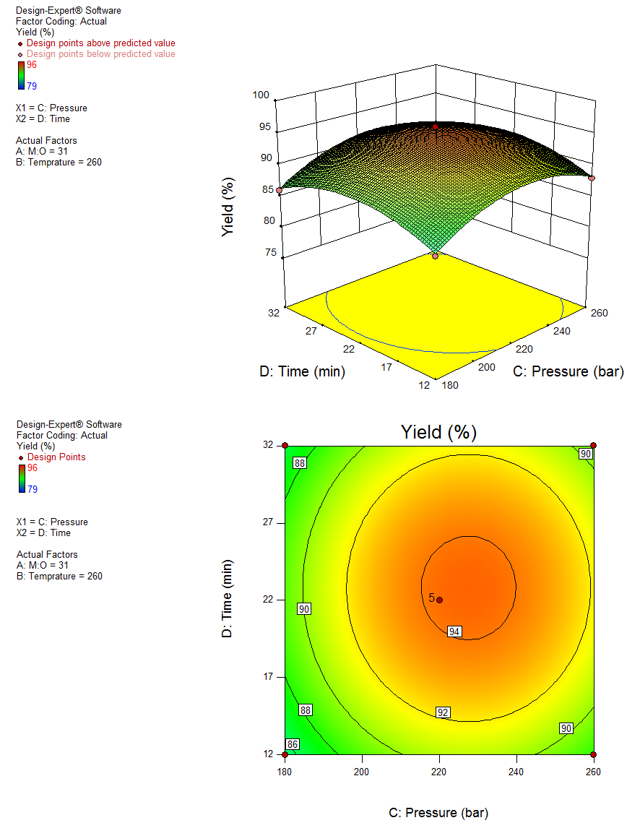

Figure 6. 3-D and contour graphs showing the effect of pressure and time on yield
3.2.4 Effect of reaction time
In this study, reaction time has been calculated once the mixture reaches the specified reaction conditions for a consistent comparison between the experiments without considering the reactions that might occur during the start-up. Reaction time has concluded a directly proportional relationship to the biodiesel yield within the range of 12 to 24 minutes as shown in Figure 6. Biodiesel yield in the reaction that occurs in longer period than 24 minutes has been observed to decrease. This phenomenon has been reported by He et al. [23]. They have explained the decrease in the yield of biodiesel is due to the loss of unsaturated FAME, especially under higher temperature.

3.3. Optimisation of Reaction Variables
Optimisation process of the supercritical methanol transesterification reaction has been carried out to define the optimum values for the independent variables affecting the dependant response variable. Design Expert software has been used to develop the numerical optimisation step by combining the desirability of each independent variable into single value and then search for optimum values for the response goals. Accordingly, in order to conclude the optimum conditions of the independent variables, a set of targets must be defined on the software to guide the optimisation process [24].
Targets of the independent variables have been set based on environmental and economic considerations. For the highly energy consuming variables including temperature (B), pressure (C) and time (D) they have been set to be minimised with highly importance. While M:O molar ratio (A), has been targeted to be between the range of minimum and maximum levels without restrictions since the excess of methanol could be recovered and reused in a new transesterification reaction. Finally, the dependent response variable which is the biodiesel yield has been set to be maximised to achieve the highest yield within the independent variables targets restrictions.
The numerical optimisation technique concluded that the maximum yield that can be reached with minimum reaction temperature, pressure and time is 91% at a M:O molar ratio of 37:1, reaction temperature of 253.5ºC, reaction pressure of 198.5 bar in 14.8 minutes.

3.4. Optimum Conditions Validation
In order to validate the optimal response values of the predicted quadratic equation, experiments have been performed at optimum condition i.e., M:O molar ratio of 37:1, reaction temperature 253ºC, reaction pressure of 199 bar and reaction time of 15 minutes. The experimental results showed similar response value to the predicted optimal response of 91.5% with relative error of 0.54%. The similarity between the experimental response results and the predicted optimal response confirms and verifies the accuracy and adequacy of the optimisation technique occurred by the predicted quadratic model.

3.5. Kinetics of the Reaction
The validated quadratic model developed by RSM has been considered for predicting the experimental results required for reaction kinetics calculations. The fact which confirmed that the molecular weight of TG is three times that of FAME as shown in equation (9) has been considered for conversion calculations without analysing the final concentration of TG [11]. Temperature range between 240ºC and 280ºC and reaction time from 12 to 20 minutes have been used to obtain the required kinetic data. To simplify the kinetic analysis, the kinetic data has been studied only for the overall transesterification reaction and the change in methanol concentration throughout the reaction has been ignored. Thus, the reaction order has been considered to be pseudo first order, where the rate of the reaction is a function of TG only as shown in equations (3) to (5).

$X= \frac{[FAME]}{{3[TG]}_{o}}= \frac{{m_{FAME}}/{M_{FAME}}}{{{3m}_{{TG}_{o}}}/{M_{TG}}}= \frac{{m_{FAME}}/{{3M}_{FAME}}}{{m_{{TG}_{o}}}/{M_{TG}}}≈ \frac{m_{FAME}}{m_{{TG}_{o}}}=Y$ (9)

Where X and Y represent the conversion and yield of biodiesel, respectively.
A graphical plot between │ln (1-Y)│ versus time within time range from 720 to 1200 seconds while keeping the other variables constant at the optimum conditions concluded a straight line with R² = 0.9832, which illustrates that our basis of pseudo first order reaction is correct. This conclusion has been confirmed by Ong et al. [17]. They have stated that generally supercritical transesterification reactions can be considered as pseudo-first order reactions. From the straight line, reaction rate constant (k) at the optimum conditions has been concluded from the slope, which is 0.0006 s⁻¹.

In order to determine full analysis for the kinetic data, the reaction thermodynamic parameters have been considered in the study. Activation energy and frequency factor have been calculated using Arrhenius equation as shown in equation (6). Consequently, a graphical relation between (ln k) and (1/T) has been obtained to fit a straight line with R²=0.971 resulting of activation energy and frequency factor of 50.5 kJ/mol and 4.05 s⁻¹, respectively for the overall transesterification reaction. Ang et al. [25] reported that transesterification reaction from cerbera odollam oil resulted in activation energy of 40 kJ/mol in the temperature range from 320 to 400ºC. They have studied the detailed transesterification reaction steps. They have concluded that the reaction of TG to DG is the rate-limiting step and that the reaction is endothermic. They have also concluded lower activation energies for different reaction steps. In this study, activation energy recorded a higher value as it represents the energy required for the overall reaction which is responsible to convert TG to GL and FAME.
Ciftici and Temelli [26] reported that enzymatic transesterification reaction of corn oil using supercritical carbon dioxide concluded pseudo second-order reaction with activation energy and frequency factor of 72.9 kJ/mol and 1.77×10¹¹ L/mol.min. Their studied reaction conditions were within temperature range between 40 to 60ºC and under high pressure within 100 to 300 bar.
Ghoreishi and Moein [11] concluded that the activation energy for WCO was 31.71 kJ/mol and frequency factor of 3.37 s⁻¹ within temperature range from 240-280ºC. They have concluded lower activation energy since they have used WCO with FFA content of 5.65% (w/w) compared to 1.59% (w/w) for the WCO used in this study. These results confirm the conclusion by Tsai et al. [10] that FFA content enhance biodiesel production from WCO under supercritical methanol conditions.

3.6 Physiochemical Properties of the Produced Biodiesel
The purified biodiesel produced at the optimum conditions (M:O molar ratio of 37:1, reaction temperature of 253ºC, reaction pressure of 199 bar and reaction time of 15 minutes) has been analysed to ensure that its properties rely within the European Biodiesel Standard, EN14214.

Standard density of the produced biodiesel has been concluded to be 887 kg/m³, which relies within the range of the European standard as shown in Table 6. Viscosity is the most important physical property of the biodiesel since it affects the atomisation of fuel being injected into the combustion engine chamber [27]. Table 6 shows the produced biodiesel properties and the European biodiesel standard acceptable range. Most of the physiochemical properties of the produced biodiesel are within the European standard, which ensures the quality of the produced biodiesel. A typical chromatogram of methyl esters in the optimum biodiesel sample is shown in Figure 7.

Table 6. Comparison between produced biodiesel properties and European biodiesel standard EN14214
Test | Unit | Produced biodiesel | Biodiesel (EN14214)
Density at 15ºC | kg/m³ | 887 | 860 - 900
Kinematic viscosity at 40ºC | cSt | 4.63 | 3.5 - 5
TAN | mg KOH/ g oil | 0.09 | < 0.5
Pour point | ºC | -6 | N/A
Flash point | ºC | 161 | > 101
Cetane number |  | 59 | > 51

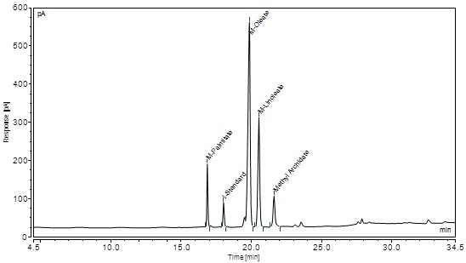
Figure 7. Gas chromatogram of methyl esters in the product sample

3.7. Reactor Simulation
HYSYS simulating programme has been used to simulate the biodiesel reactor at the concluded optimal conditions. In order to identify M:O molar ratio, the feed stream has been defined with a molar flow rate of 10 kmol/hr of triolien mixed with 370 kmol/hr of methanol resulting in 380 kmol/hr feed stream. Temperature and pressure have been identified to the feed stream with 253.5ºC and 198.5 bar, respectively as shown in Table 6 and Figure 8. Transesterification reaction has been introduced to the simulator using the balanced stoichiometric reaction. Reaction kinetic parameters have been used to simulate the reactor. Activation energy and frequency factor have been identified based on the experimental results.

According to the concluded kinetic data, the kinetic reactor has operated successfully and simulates the reaction with 91.7% conversion of TG. However, the experimental reaction at the same conditions results in 91.5% conversion of TG, which concludes that the relative error between the simulated and experimental conversion is 0.2%. The kinetic reactor ensures the accuracy of the kinetic calculations and the model predicted optimisation. In addition, the reactor simulation showed that the reaction is endothermic as a reduction in temperature from 253 ºC to 168ºC for the feed and product streams labelled by stream (101) and stream (102), respectively as shown in Table 7.

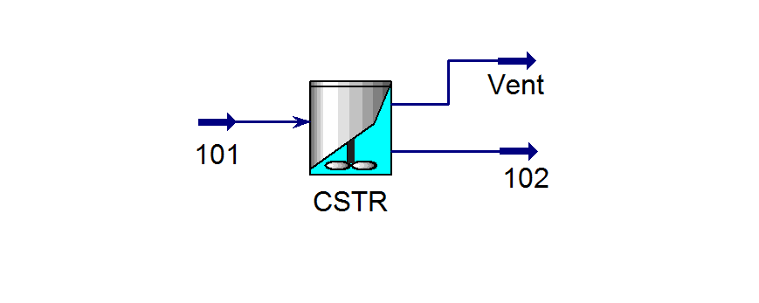
Figure 8. Simulated biodiesel CSTR reactor using supercritical methanol

Table 7. Streams data of the simulated CSTR reactor
Name | 101 | 102
Temperature (ºC) | 253.5 | 168
Pressure [bar] | 198.5 | 198.5
Molar Flow [kgmole/h] | 380 | 380
Mole fractions
Triolien | 0.0263 | 0.002
Methanol | 0.9737 | 0.9013
M-Oleate | 0 | 0.0724
Glycerol | 0 | 0.0241

4. CONCLUSIONS

The production of biodiesel from WCO using supercritical methanol has been successfully studied. Reaction variables and operating conditions of the reaction have been analysed. A quadratic polynomial model has been developed demonstrating the biodiesel yield function in four independent variables. It has been concluded that the optimum biodiesel yield is 91% at M:O molar ratio of 37:1, reaction temperature of 253.5ºC, reaction pressure of 198.5 bar in 14.8 minutes reaction time. The optimisation result has been validated experimentally resulting in biodiesel yield of 91.5%, which shows the adequacy of the predicted optimum conditions with 0.54% relative error from the experimental results. Kinetic calculations of the overall reaction concluded the reaction rate constant of 0.0006 s-¹ at the optimum conditions. Activation energy and frequency factor have been found to be 4.05s⁻¹ and 50.5 kJ/mol, respectively. The calculated kinetic data have been used to simulate a kinetic reactor on HYSYS which have been simulated with TG conversion of 91.7% with 0.2% relative error from the experimental results. This study clearly demonstrates that transesterification reaction using supercritical methanol enhances biodiesel production without the need of catalyst.

ACKNOWLEDGMENT

The authors acknowledge The British University in Egypt (BUE) and London South Bank University (LSBU) for funding this research.

REFERENCES

[1] D. Wen, H. Jiang, K. Zhang, Supercritical fluids technology for clean biofuel production, Prog. Nat. Sci. 19 (2009) 273–284. doi:10.1016/j.pnsc.2008.09.001.
[2] K.F. Haigh, S.Z. Abidin, G.T. Vladisavljević, B. Saha, Comparison of Novozyme 435 and Purolite D5081 as heterogeneous catalysts for the pretreatment of used cooking oil for biodiesel production, Fuel. 111 (2013) 186–193. doi:10.1016/j.fuel.2013.04.056.
[3] S.Z. Abidin, K.F. Haigh, B. Saha, Esterification of free fatty acids in used cooking oil using ion-exchange resins as catalysts: An efficient pretreatment method for biodiesel feedstock, Ind. Eng. Chem. Res. 51 (2012) 14653–14664. doi:10.1021/ie3007566.
[4] S. Semwal, A.K. Arora, R.P. Badoni, D.K. Tuli, Biodiesel production using heterogeneous catalysts, Bioresour. Technol. 102 (2011) 2151–2161. doi:10.1016/j.biortech.2010.10.080.
[5] S. Saka, D. Kusdiana, Biodiesel fuel from rapeseed oil as prepared in supercritical methanol, Fuel. 80 (2001) 225–231. doi:10.1016/S0016-2361(00)00083-1.
[6] D. Kusdiana, S. Saka, Effects of water on biodiesel fuel production by supercritical methanol treatment, Bioresour. Technol. 91 (2004) 289–295. doi:10.1016/S0960-8524(03)00201-3.
[7] H. Imahara, E. Minami, S. Hari, S. Saka, Thermal stability of biodiesel in supercritical methanol, Fuel. 87 (2008) 1–6. doi:10.1016/j.fuel.2007.04.003.
[8] A. Tafesh, S. Basheer, Pretreatment Methods in Biodiesel Production Processes, in: Z. Fang (Ed.), Pretreat. Tech. Biofuels Biorefineries, Springer Berlin Heidelberg, Berlin, Heidelberg, 2013: pp. 417–434. doi:10.1007/978-3-642-32735-3_18.
[9] M.M. Gui, K.T. Lee, S. Bhatia, Feasibility of edible oil vs. non-edible oil vs. waste edible oil as biodiesel feedstock, Energy. 33 (2008) 1646–1653. doi:10.1016/j.energy.2008.06.002.
[10] Y.-T. Tsai, H. Lin, M.-J. Lee, Biodiesel production with continuous supercritical process: Non-catalytic transesterification and esterification with or without carbon dioxide, Bioresour. Technol. 145 (2013) 362–369. doi:10.1016/j.biortech.2012.12.157.
[11] S.M. Ghoreishi, P. Moein, Biodiesel synthesis from waste vegetable oil via transesterification reaction in supercritical methanol, J. Supercrit. Fluids. 76 (2013) 24–31. doi:10.1016/j.supflu.2013.01.011.
[12] S. Lee, D. Posarac, N. Ellis, Process simulation and economic analysis of biodiesel production processes using fresh and waste vegetable oil and supercritical methanol, Chem. Eng. Res. Des. 89 (2011) 2626–2642. doi:10.1016/j.cherd.2011.05.011.
[13] J. Van Gerpen, Biodiesel processing and production, Fuel Process. Technol. 86 (2005) 1097–1107. doi:10.1016/j.fuproc.2004.11.005.
[14] J. Yuan, J. Huang, G. Wu, J. Tong, G. Xie, J. Duan, M. Qin, Multiple responses optimization of ultrasonic-assisted extraction by response surface methodology (RSM) for rapid analysis of bioactive compounds in the flower head of Chrysanthemum morifolium Ramat., Ind. Crops Prod. 74 (2015) 192–199. doi:10.1016/j.indcrop.2015.04.057.
[15] M. Khajeh, Optimization of microwave-assisted extraction procedure for zinc and copper determination in food samples by Box-Behnken design, J. Food Compos. Anal. 22 (2009) 343–346. doi:10.1016/j.jfca.2008.11.017.
[16] H. Jaliliannosrati, N.A.S. Amin, A. Talebian-Kiakalaieh, I. Noshadi, Microwave assisted biodiesel production from Jatropha curcas L. seed by two-step in situ process: Optimization using response surface methodology, Bioresour. Technol. 136 (2013) 565–573. doi:10.1016/j.biortech.2013.02.078.
[17] L.K. Ong, A. Kurniawan, A.C. Suwandi, C.X. Lin, X.S. Zhao, S. Ismadji, Transesterification of leather tanning waste to biodiesel at supercritical condition: Kinetics and thermodynamics studies, J. Supercrit. Fluids. 75 (2013) 11–20. doi:10.1016/j.supflu.2012.12.018.
[18] Y. Zhang, M.. Dubé, D.. McLean, M. Kates, Biodiesel production from waste cooking oil: 1. Process design and technological assessment, Bioresour. Technol. 89 (2003) 1–16. doi:10.1016/S0960-8524(03)00040-3.
[19] N.S. El-Gendy, S.F. Deriase, A. Hamdy, The Optimization of Biodiesel Production from Waste Frying Corn Oil Using Snails Shells as a Catalyst, Energy Sources, Part A Recover. Util. Environ. Eff. 36 (2014) 623–637. doi:10.1080/15567036.2013.822440.
[20] P. Hegel, A. Andreatta, S. Pereda, S. Bottini, E.A. Brignole, High pressure phase equilibria of supercritical alcohols with triglycerides, fatty esters and cosolvents, Fluid Phase Equilib. 266 (2008) 31–37. doi:10.1016/j.fluid.2008.01.016.
[21] H. Han, W. Cao, J. Zhang, Preparation of biodiesel from soybean oil using supercritical methanol and CO2 as co-solvent, Process Biochem. 40 (2005) 3148–3151. doi:10.1016/j.procbio.2005.03.014.
[22] A. Kurniawan, L. Ong, C. Lin, X. Zhao, S. Ismadji, Catalyst-free biodiesel production: Transesterification of jatropha oil using supercritical methanol, Chemeca 2012 Qual. Life through Chem. Eng. 23-26 Sept. 2012, Wellington, New Zeal. (2012) 832.
[23] H. He, T. Wang, S. Zhu, Continuous production of biodiesel fuel from vegetable oil using supercritical methanol process, Fuel. 86 (2007) 442–447. doi:10.1016/j.fuel.2006.07.035.
[24] N.S. El-Gendy, A.A.S.A. El-Gharabawy, S.S. Abu Amr, F.H. Ashour, Response surface optimization of an alkaline transesterification of waste cooking oil, Int. J. ChemTech Res. 8 (2015) 385–398.
[25] G.T. Ang, S.N. Ooi, K.T. Tan, K.T. Lee, A.R. Mohamed, Optimization and kinetic studies of sea mango (Cerbera odollam) oil for biodiesel production via supercritical reaction, Energy Convers. Manag. 99 (2015) 242–251. doi:10.1016/j.enconman.2015.04.037.
[26] O.N. Ciftci, F. Temelli, Enzymatic conversion of corn oil into biodiesel in a batch supercritical carbon dioxide reactor and kinetic modeling, J. Supercrit. Fluids. 75 (2013) 172–180. doi:10.1016/j.supflu.2012.12.029.
[27] B. Sajjadi, A.A.A. Raman, H. Arandiyan, A comprehensive review on properties of edible and non-edible vegetable oil-based biodiesel: Composition, specifications and prediction models, Renew. Sustain. Energy Rev. 63 (2016) 62–92. doi:10.1016/j.rser.2016.05.035.

SUPPORTING INFORMATION

The simulation of the kinetic reactor has been performed in a sequence as shown below:
- Translating the WCO into known chemical component based on the experimental analysis.
- Defining the chemical components of the feed stream out of the HYSYS library, in addition to hypothetical components.
- Describing the equation of state or activity model for physical properties and thermodynamic calculations.
- Assuming basis for both WCO and methanol feed streams and their conditions.
- Selecting proper reactor capable for the required reaction.
- Defining volume of reactor based on the basis flowrate and the reaction time.
- Define the stoichiometric reaction for the reactor.
- Define the experimentally obtained kinetic and thermodynamic data required for kinetic reactor operation.
- Simulate and obtain results from the reactor as a basis for further validation.

