Towards a Novel Acoustic Absorber Using a Magnetically Induced Geometric Nonlinearity in an Elastic Membrane

Douglas John Shearerª, Stephen Danceª, Luis Gomez-Agustinaª, Justin Randell^{b},

a) The Acoustics Group, School of the Built Environment and Architecture, London South Bank University, United Kingdom.
b) School of Arts and Creative Industries, London South Bank University, United Kingdom.
Summary
Research on Energy Pumping based on the idea of nonlinear energy sinks exploiting Targeted Energy Transfer (TET) between a linear system and a nonlinear attachment has been successfully applied in vibration control. . The same approach promise the development of a novel passive, broadband dissipative mechanism with many potential acoustic applications such as in spaces for music practice and reproduction. This paper introduces and outlines ongoing research into the potential usability of the TET as a sound absorption mechanism using elastic membranes Initial experimental investigations have shown potential as a sound absorber that has a narrow dynamic range Results on early experimental work will be presented on the geometric nonlinearity imposed upon an elastic membrane by means of an electromagnet.
PACS no. 43.20, 43.25.Ed,43.25.Ts, 43.35.Mr, 43.40.Dx

1 Introduction
The sound field at low frequencies in untreated small rooms is typically dominated by modal colouration as has been understood since the early days of Acoustics research [1].In spaces such as music practice and rehearsal rooms, this colouration manifests itself as a loss of clarity in bass instruments and unevenness in musical lines in the bass register. In spaces used for reproduction of popular music, this can be even more pronounced as the low frequency performance of loudspeakers has improved with time, subwoofers have become the norm, and music producers have responded with more bass heavy recordings and styles. The initial scope of applications for the prospective absorber takes in music spaces for both amplified and acoustic sources [2].

1.1 Low-frequency Effects In Music Rooms
Where acoustic music instruments are the sound sources, the space’s reverberation can provide loudness support for the instruments and indeed can contribute enhance their natural character. However the excitation of room modalities, and subsequent low frequency decays have a key role in masking and Lombard effects which can reduce clarity in musical passages. [3]

Standard design recommendations for music rooms, in music education spaces [4] recommend a midrange reverberation time (RT) for a given room volume. In this case, the recommendation also allows for a progressive bass rise below 500Hz of as much as 160% of the midrange value at 63Hz, (see Figure 1) and as has been noted, a certain amount of bass rise has commonly been tolerated or even cultivated in music spaces [5]. More recent work advises a flat reverberation/decay time across all frequencies, or even a bass dip to ensure clarity at low frequencies [3] [6].

Fazenda et al [7] conducted psychoacoustic tests into perception of modal decay and its effect on music. They showed that the threshold of perception of modal decays is mostly independent of frequency above 63Hz, but rises sharply below this figure. Moreover, modal effects were less noticeable to
Figure 1: Recommended % increase in RT at lower frequencies in music rooms. From BB93 [4]
subjects presented with musical passages as stimuli than artificial ones. (See )
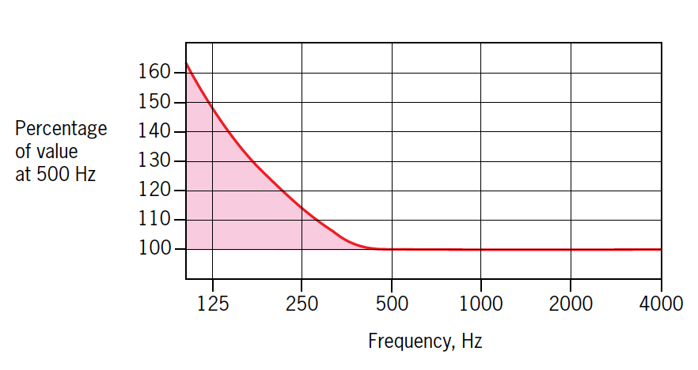
So, given that the recommended RT of a small-medium music room might be in the order of 1 second, [4], if bass rise is present then the RT at 125Hz could be up to 1.5 seconds. This is well within the zone for modal decay artefacts being
Figure 2: Map of perceptual regions of modal decay for both artificial and musical stimuli. From Fazenda et al. [7]
audible in the music as shown by Fazenda et al.

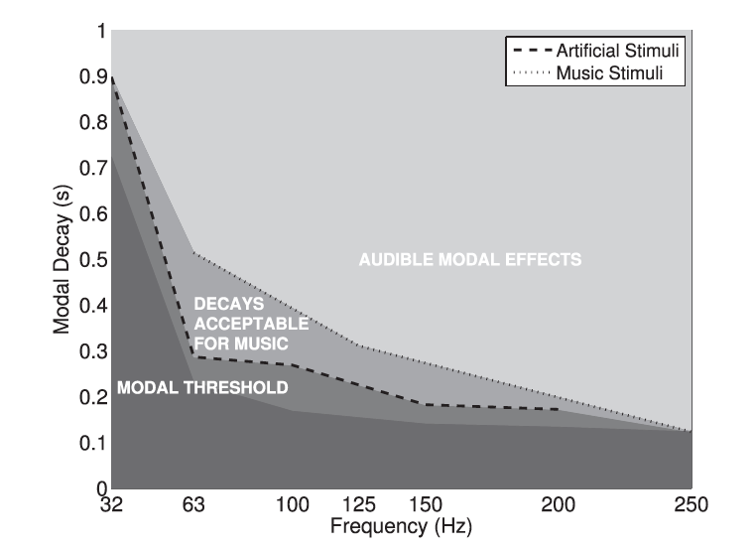
1.2 Classic modal control approaches
The remedies for such effects include the selection of room dimensions which create a more even modality [8], and careful placement of low frequency sound sources in the room; not such a viable option for classical musicians[9]
In addition, a variety of sound treatments are possible. Porous absorber can be used for low frequencies, but only if a great depth of absorbent material is used, although there are some examples of extending this capability using waveguide geometries [10]. Traditional passive resonant acoustic absorbers can be classified into two broad groups; Helmholtz and membranes. Helmholtz resonators are unsuited to the lowest frequency range due to size constraints. Membrane absorbers can target this range but are also large. Their reliance on classical resonance means that only a narrow frequency range can be targeted, with several required to target the dominant modes of any practical space.

Active approaches use arrays of loudspeakers to introduce a sound equal to the source but out of phase with it, to partially cancel modality. These can be very effective when well designed but can be expensive to implement and sensitive spatially. [11]

In the emerging field of meta-materials, many approaches such as phononic crystals utilise periodicity and hence do not offer the broadband solution required in music rooms. [12]

Thus, there is still a need for a compact, lightweight and inexpensive broadband sound absorption solution.

2 Targeted Energy Transfer (TET)
The dynamic behaviour of many common physical systems fall outside the scope of classical linear approaches. These nonlinear systems began to be considered more often in the middle of the last century, and the field has expanded since the 90s when interest in the subject was revived, and much research has followed. [13]

From this early research work came Targeted Energy Transfer (TET), first proposed by Vakakis and Gendelman et al in [14] and [15] and Kerschen et al [16] in the early 2000s. TET concerns the energy transfer between a linear dynamic system and an essentially nonlinear attachment. This nonlinearity can cause, in certain vibrational regimes, a one-directional transfer of energy into the nonlinear system rather than the usual equal exchange between the two systems. Thus, the nonlinear attachment can be caused to act as a Nonlinear Energy Sink (NES) and this “energy pumping” from the linear system to the NES offers a new way to absorb sound.

2.1 TET in Acoustics
Research into TET has mostly focused on vibration, notably seismic mitigation for buildings and control of vibrations due to aerodynamic forces in aircraft and space structures. However, Cochelin et al [17] conducted research into the application of TET for an acoustics. They showed early evidence of energy pumping in a sound field using elastic membranes under large deformations, This work was extended by Bellet et al [18] to incorporate multiple membranes to extend the working dynamic range of operation Mariani et al [19] used a repurposed loudspeaker driver cone outside the limit of its linearity as their NES.
2.2 TET Main Features
The TET mechanism is characterised in several ways.
Being a nonlinear behaviour, there is an energy threshold, below which the mechanism is inactive. Likewise, at higher energies, the energy pumping becomes less thus the dynamic range of operation is a key design parameter.

TET theoretically promises to exhibit a wide-band of operation. An absorber of this type would not require much tuning in terms of frequency response but of dynamic response; this is the amount of incident energy required to energise it. Hence

it has a strong response to transient energy.

These features make it of interest in music rooms; since music contains much transient energy, especially if percussion is strongly featured, and the modality of a normal parallelepiped room exhibits many modal frequencies simultaneously. The key being that the sound source is not of a single frequency, but many.

3 Magnetic Membranes
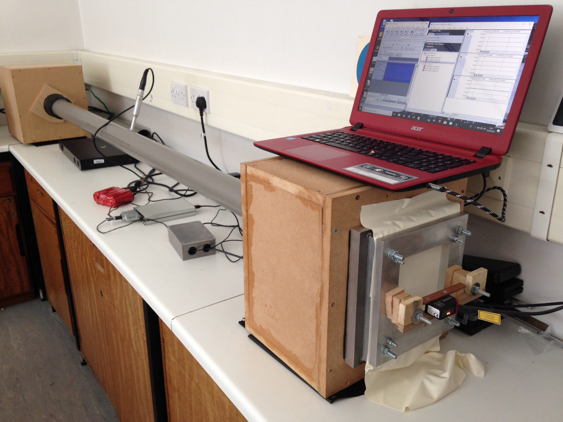
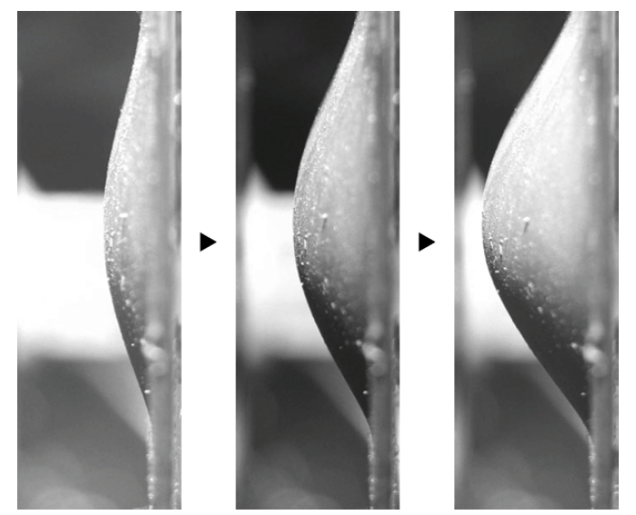
The current focus of the ongoing research explores the possibility of incorporating soft

Figure 3:Doming geometric nonlinearities in a soft magnetic elastomer membrane in the presence of a magnetic field. From Raikher et al [20]
magnetorheological elastomers (SME’s) as the material for membranes in TET absorbers. SMEs are elastomers with an additional filler of soft magnetic particles. This formulation is then cured in the presence of a magnetic field, aligning the magnetic domains within the material. When the cured membrane is again exposed to an external magnetic field, these domains return to their alignment and thus deform the membrane, a characteristic which has been explored by previous researchers [20]. This doming behaviour comprises a desirable geometric nonlinearity - incorporating the entire membrane. It is proposed that their use could allow an external magnetic field to act to modify the response of the TET absorber as part of an active control measure in two ways; by applying damping to the system, and secondly by increasing the geometric nonlinearity of the membrane.

4 Experimental work
4.1

Method and approaches

The initial tests undertaken at this time were based on the TET work of CNRS, and a similar test apparatus was constructed with theirs [17] [18] [19] taken as a model. This comprises a 2m long pipe with a loudspeaker driver unit at one end contained in a solid and sealed box acting as the cabinet for the driver unit The other end of the pipe attaches to a sample mounted in a clamp via a coupling box. This acts as a simple one-dimensional acoustic system for the required tests.

Figure 4: Experimental setup, after [17] [18] [19]
Three measurements taken were the input signal to the loudspeaker, the pressure at the centre of the pipe and the membrane displacement taken using a Micro-Epsilon optoNCDT 1420 laser displacement sensor. Together these are connected to a BMCM USB16 DAQ running BMCM’s NextView logging software via a PC laptop. Raw data was imported into MATLAB for analysis.

The resonant frequency of the pipe itself was tested by using a polished ceramic tile as a rigid reflective sample. This showed a natural resonance of 84.5Hz. This test was repeated at several energy levels to confirm the linearity of the acoustic system in the absence of the nonlinear attachment. See
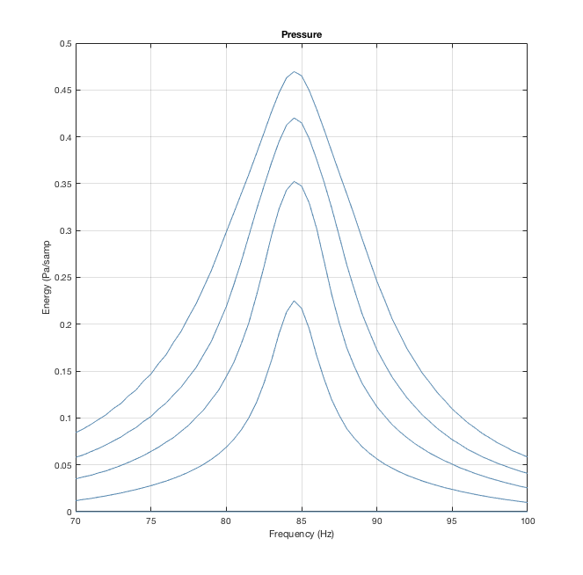
Figure 5: Natural frequency of 84.5Hz of the linear system with rigid attachment in the sample holder.
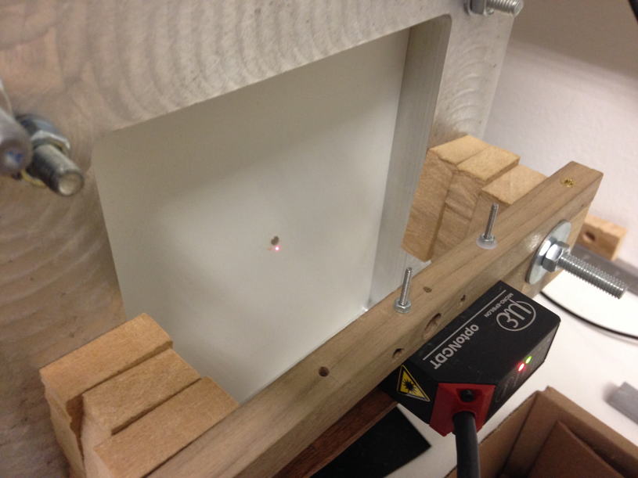
Calibration of the pressure measurement, using a Behringer ECM8000 microphone and Fame MIC10 preamp was undertaken in the anechoic chamber at London South Bank University by comparison with a Norsonic 140 sound level meter. The reference sound source was a JBL subwoofer sound source playing a sine tone at 80Hz, considered centre of the frequency range of interest. The laser sensor is factory-calibrated and can track a dynamic target up to 400Hz with good accuracy sufficient for the frequency range of interest for these tests. Calibration and zero-phase filtering of HF noise and extreme low frequencies (below 5Hz) was incorporated into the file-import script of a MATLAB toolbox for analysis of results which has been developed.

4.2 Membrane

The membrane material used in these initial tests was a widely commercially available silicone-based latex with thickness 0.22mm. Sample size was 140x120mm and samples were given an axial pre-stress of 0.9Mpa. They were secured in a specially constructed aluminium clamp secured on the face of coupling box. Samples were conditioned under tension for 24 hours to minimise creep effects. More thorough, standardised tensile creep tests are underway in accordance with ISO899. [21]

4.3 Measurement procedure
Measurement runs consisted of series of sine tones of fixed level but increasing in frequency in increments of (normally) 0.5Hz between 70 and 100Hz. This test was repeated, decreasing the signal playback level in 3dB increments across a 25dB range of interest. Each frequency pulse is windowed at the start and end over 3 wavelengths to avoid broadband excitation at onset and cessation [22]. This test format was used as it provides both a free response (immediately after the cessation of the pulse) and a steady state response (the last part of the pulse before cessation when the dynamic response caused by the onset has stabilised). A MATLAB script was created to generate these test signals in .wav format and they were replayed via Audacity sound editing software amplified through a suitable audio amplifier.

A 1kHz synchronisation tone is also generated at the start of each run and this is used to time align the respective test runs for analysis. A further script extracts the steady state and free responses captured
Figure 6: Membrane with attached Neodymium magnet – Electromagnet not pictured.
by the pressure transducer and laser displacement sensor. Further MATLAB scripts generate time- frequency and phase plots as well as other analytical parameters.

4.4 Magnetic Materials
Early experimental work on this research is directed towards the use of permanent and electromagnets to tune the response of TET absorbers by modifying the restoring force on the elastic membrane. An initial test was conducted to observe how the dynamics of the membrane can be potentially manipulated with an external magnetic field. To this end, a small magnet was added to the test samples as an added mass. This approach could provide some idea of membrane behaviour under magnetic displacement provided the added mass was small compared to that of the membrane – to this end a Neodymium N42 magnet with mass 0.17g was added to the membrane, whose mass was 1.96g.

The external magnetic field was generated firstly by a permanent neodymium disc magnet mounted directly opposite the membrane’s added magnet. This arrangement produced very rich and unstable dynamics, due to rotational and lateral motion of the membrane’s attached magnet. In fact, no meaningful measurement could be taken with this arrangement with our single point laser displacement sensor.
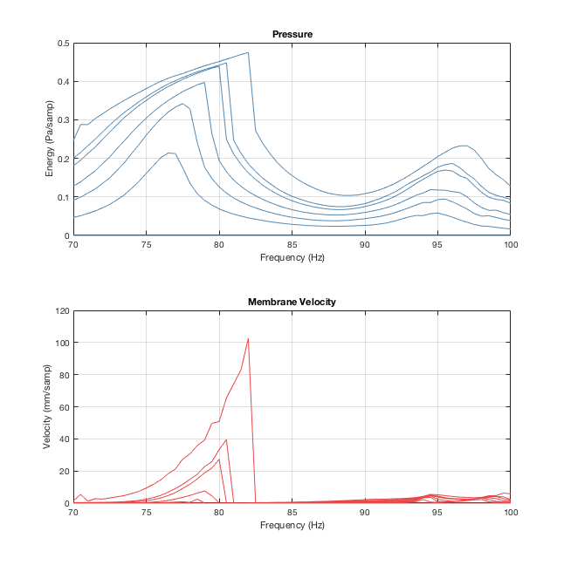
However, it was considered that this amounted to a different class of dynamic behaviour, as the geometric nonlinearity of the deformed membrane
Figure 7: Pressure and Membrane velocity frequency response – added magnet on membrane but no external magnet present.
and that of the attraction forces between the magnets served to be in dynamic opposition, and

changing the distance between magnet and membrane dramatically changed the nature of the latter’s dynamics and so this could be an avenue of future research.
The next tests swapped the disc type magnet for a toroidal permanent magnet, so the membrane’s motion occurred within an even magnetic field. In this manner, the motion of the membrane was much more stable and even across the membrane, and it was considered that displacement measurements in
this configuration were sufficiently representative of the motion of the membrane.
A toroidal electromagnet was constructed by winding around 900 turns of 0.25mm magnet wire around a 58x14mm ferrite core. It’s output was estimated at 475Amp-turns when powered by 4x9V batteries. When used, it became apparent that it’s performance was comparable with the permanent magnet already in use and so the latter was used for this test.

5 Results
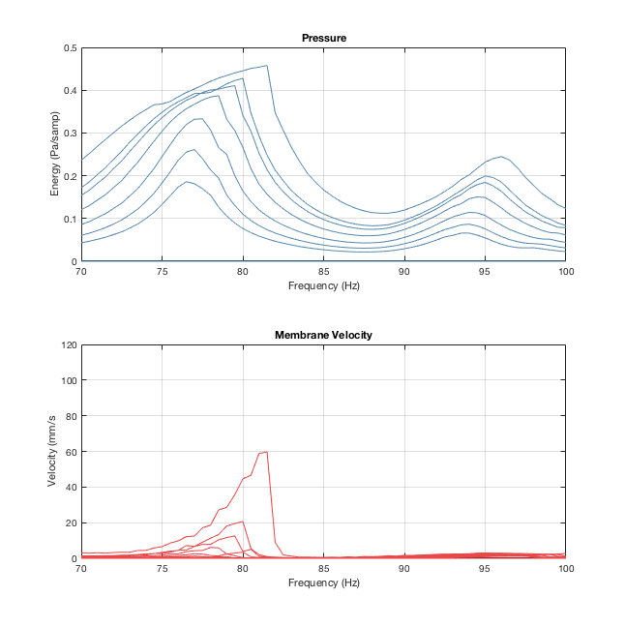
Results are expressed as an estimated nonlinear
Figure 8: Pressure and Membrane velocity frequency response – added magnet on membrane and added external magnetic field

frequency response for the square of pressure values in the decay at a particular frequency-level combination, and the corresponding cumulative membrane velocity through each decay.
The addition of the external magnetic force clearly applied a damping effect on the membrane. This in itself should raise the threshold of the onset of TET according to numerical models. [23]
The effect on the pressure within the tube is less dramatic, but the external magnetic field has slightly reduced the energy-frequency nonlinearity of the pressure.

6 Analysis and discussion
This brief initial test has shown that electromagnets could be used for manipulating the dynamics of a nonlinear absorbing membrane and could be incorporated into an active optimization strategy. Damping was shown to be the dominant contribution from the application of the external magnetic field and reduction in material nonlinearity was small.

7 Future work

A subsequent test was carried out with a series of small magnets attached across the surface of the membrane. As previously, the resulting dynamics were uneven across the membrane and a meaningful measurement could not be taken. In addition, the
added mass of the magnets in this case was enough to dominate the dynamics of the system and so be out of step with the stated aims. This test did however demonstrate that the external magnetic field was only even within a small area in the centre of the membrane. The next stage of research will require a more rigorously designed electromagnet which can provide an even field across the membrane surface.
Experience needs to be gained in the manufacture
of elastomer membranes with added soft magnetic filler as described in Raikher et al [20]. When suitable samples are available, it is hoped to bring these two interesting developments together to create a system for controlling the absorption of TET –based acoustic absorbers.

These hybrid absorbers will then be tested in a reverberation room and an ordinary music room with both artificial and music signals. The modality in a room is of course more complex, with three dimensions and multiple modal frequencies being excited in turn by non-monotonic sources such as music.

Further work must also determine the best placement of this class of absorber in a room. Shao et al and Wu et al [23], [24] performed numerical simulations of such absorbers inside a cavity, which can be used as a basis for larger spaces such as music rooms. Their work indicates that the location of the absorber is key to their effectiveness, and that they should be mounted away from the nodal points of the acoustic mode of the space. They provide a method to estimate the TET onset threshold of the absorber and note that this threshold increases with damping to the system.

8 Challenges and limitations
This class of novel absorber throws up a number of challenges. Firstly, neither the source sound nor the response of the absorber is dynamically static, so quantifying their effectiveness in terms useful to an acoustic designer is challenging. Also a practical absorber using the TET principle and using elastomer membranes would have to address shortcomings regarding their durability and integrity stability. Existing elastomers are susceptible to degradation over time, whether exposed to the elements or not. [25] [26]

There is also no standardised test methodology for measuring absorption within most of the frequency range of interest . It is speculated here that Zha and Fuchs’s modal decay-based variation [27] of the sound absorption measurement in reverberation chambers standard ISO354 [28] could be used as may some other recent approaches [29]. However, none of those test procedures accounts for the sound level dependency of this type of absorber. Any test of this type would have to be repeated over the dynamic range of projected use.

Acknowledgement
This project is partially funded by the Royal Academy of Music, London, UK.

References

[1] | P. M. Morse and R. H. Bolt, “Sound Waves in Rooms,” Reviews of Modern Physics, vol. 16, no. 2, pp. 69-150, 1st 4 1944.
[2] | P. D. Pestana, Z. Ma, J. D. Reiss, A. Barbosa and D. A. A. Black, “Spectral Characteristics of Popular Commercial Recordings 1950-2010,” in 135th AES Conference, New York, NY, USA, 2013.
[3] | H. V. Fuchs and X. Zha, “Requirement for Low-Frequency Reverberation in Spaces for Music: Part 1: Smaller Rooms for Different Uses,” Psychomusicology, Music, Mind and Brain, vol. 25, no. 3, pp. 272-281, 2015.
[4] | Department for Education and Skills, “Building Bulletin 93: Acoustic design of schools,” The Stationary Office, London.
[5] | M. Barron, Auditorium acoustics and architectural design, 2nd ed., London & New York: Spon Press, 2010, p. 30.
[6] | N. W. Adelman-Larsen, “Possible acoustic design goals in very large venues hosting live music concerts,” in Auditorium Acoustics, Paris 2015, 2015.
[7] | B. M. Fazenda, M. Stephenson and A. Goldberg, “Perceptual thresholds for the effects of room modes as a function of modal decay,” Journal of the Acoustical Society of America, vol. 137, no. 3, pp. 1088-1098, March 2015.
[8] | T. J. Cox and P. D'Antonio, “Determining optimum room dimensions for critical listening environments: A new methodology,” in AES Convention 110, 2001.
[9] | T. Welti and A. Devantier, “Low-frequency optimization using multiple subwoofers,” Journal of the Audio Engineering Society, vol. 54, no. 5, pp. 347-364, May 2006.
[10] | S. Torres-Guijarro, A. Pena, A. Rodriguez-Molares and N. Degara-Quintel, “A study of wideband absorbers in a non-environment control room: characterisation of the sound field by means of p-p probe measurements,” Acta Acustica with Acustica, vol. 97, pp. 1-11, 2011.
[11] | P. A. Nelson and S. J. Elliot, Active control of sound, Elsevier, 1991.
[12] | A. Khelif, Y. Achaoui and B. Aoubiza, “Locally resonant structures for low frequency surface acoustic band gap applications,” in Acoustic metamaterials: Negative refraction, imaging, lensing and cloaking, Dordrecht, Springer, 2013.
[13] | G. Kerschen, M. Peeters, J. C. Golinval and A. F. Vakakis, “Nonlinear normal modes, part 1: a useful framework for the structural dynamicist,” Mechanical Systems and Signal Processing, vol. 23, no. 1, 2009.
[14] | O. Gendelman, L. I. Manevitch, A. F. Vakakis and R. M'Closkey, “Energy pumping in nonlinear mechanical oscillators- Part I—Dynamics of the underlying hamiltonian systems,” Journal of Applied Mechanics, vol. 68, no. 1, pp. 34-41, 2001.
[15] | A. F. Vakakis and O. Gendelman, “Energy pumping in nonlinear mechanical oscillators: Part II—Resonance capture,” Journal of Applied Mechanics, vol. 68, no. 1, pp. 42-48, January 2001.
[16] | G. Kerschen, Y. S. Lee, A. F. Vakakis, D. M. McFarland and L. A. Bergman, “Irreversible passive energy transfer in coupled oscillators with essential nonlinearity,” SIAM Journal of Applied Mathematics , vol. 66, no. 2, pp. 648-679, 6th January 2006.
[17] | B. Cochelin, P. Herzog and P.-O. Mattei, “Experimental evidence of energy pumping in acoustics,” Comptes Rendus Mechanique, vol. 334, September 2006.
[18] | R. Bellet, B. Cochelin, P. Herzog and P.-O. Mattei, “Experimental study of targeted energy transferfrom an acoustic system to a nonlinear membrane absorber,” Journal of Sound and Vibration, vol. 329, pp. 2768-2791, 18th February 2010.
[19] | R. Mariani, B. Bellizzi, B. Cochelin, P. Herzog and P. O. Mattei, “Toward an adjustable nonlinear low frequency acoustic absorber,” Journal of Sound and Vibration, vol. 330, pp. 5245-5258, 2011.
[20] | Y. L. Raikher, O. V. Stolbov and G. V. Stepanov, “Shape instability of a megnetic elastomer membrane,” Journal of physics D: Applied Physics, vol. 41, 2008.
[21] | British Standards Institute, “Plastics-Determination of creep behaviour: Part 1: Tensile creep,” BSI, London, 2017.
[22] | A. Goldberg, “Windowed sine bursts: in search of optimal test signals for detecting the threshold of audibility of temporal decays,” in AES 126th Convention, Munich, 2009.
[23] | J. Shao and X. Wu, “Parameters design of a nonlinear membrane absorber applied to an acoustic cavity,” in Inter-Noise 2014, Melbourne, 2014.
[24] | X. Wu, J. Shao and B. Cochelin, “Study of targeted energy transfer inside three- dimensional acoustic cavity by two nonlinear membrane absorbers and an acoustic mode,” Journal of Vibration and Acoustics, vol. 138, 2015.
[25] | D. Guitierrez-Lemini, Engineering viscoelasticity, New York: Springer, 2014.
[26] | U. Giese, “Aging behaviour of elastomers,” in Encyclopaedia of polymeric nanomaterials, S. Kobayashi and K. Müllen, Eds., Berlin Heidelberg, Springer-Verlag, 2015.
[27] | X. Zha, H. V. Fuchs, C. Nocke and X. Han, “Measurement of an effective absorption coefficient below 100 Hz,” Acoustics Bulletin, pp. 5-10, january/February 1999.
[28] | BS ISO 354: 2003: Measurement of sound absorption in a reverberation room, British Standards Institute, 2003.
[29] | M. Schlosser and O. Turecek, “Measurement of sound absorption coefficient at low frequencies in reverberation chamber,” in Inter-Noise, Hamburg, 2016.

