# DETERMINING PRIORITIES IN INTRODUCING ACCESSIBILITY MEASURES FOR PERSONS WITH REDUCED MOBILITY (PRM) CASE STUDY: DEVELOPMENT OF AN ASSESSMENT TOOL WITHIN THE LONDON UNDERGROUND NETWORK

Sean Patrick Butler

CPC Project Services

Dr Nader Saleh-Matter

London South Bank University

# Abstract

**Project Idea:** Inaccessibility and mobility impairments affects millions of Persons of Reduced Mobility (PRM), within their daily lives as the current aged transport infrastructure remains largely inaccessible for PRMs and requiring major investment to provide reasonable accessibility measures to meet their needs. Currently, development of business cases for transport projects do not consider the quantified network effects of accessibility measures being added (or removed) from stations. This is because a quantified accessibility network assessment is not available to industry.

**Purpose and Objectives:** This study aims to develop a quantitative assessment tool to support the decision on where, in the current network, to introduce accessibility measures, exploring the effects of implementing accessibility measures on the overall journey time of PMRs. The study had the following objectives:

1. To appraise the current systems available in the market place that allows users to assess a transport network;

2. To appraise the existing methods addressing inaccessibility in a transport network to understand their impact;

3. To create a user-friendly assessment tool that can allow users to add accessibility measures to a network and analyse the effects to journey time and distance;

4. To validate the developed assessment tool through a case study assessment.

**Findings and Originality:** This case study assessment validates the need for industry to adopt the new assessment tool in order to provide quantified accessibility data within a network to decision makers and industry. This information alongside existing data used by decision makers will lead to a more effective process for industry, an efficiency in capital/operational expenditure and provide the social benefits anticipated by the accessibility projects/programmes.

**Conclusion and Policy Implications:** This study suggests addressing the issue of inaccessibility on a network through a new strategy and programme of work that switches from focusing on reviewing the capital savings and journey benefits provided to individual stations when accessibility measures are provided, into reviewing the impacts on the rest of the network within its decision and funding processes. This can be achieved through the use of the new assessment tool developed in this study.

# Literature Review

## Political

Over the last 50 years the United Kingdom (UK) has undergone a radical transformation of its legalisation to remove inequality. Successive governments have removed social injustice and promoted equality through numerous Acts of parliament that have continuously been proposed, amended, amalgamated and reviewed.

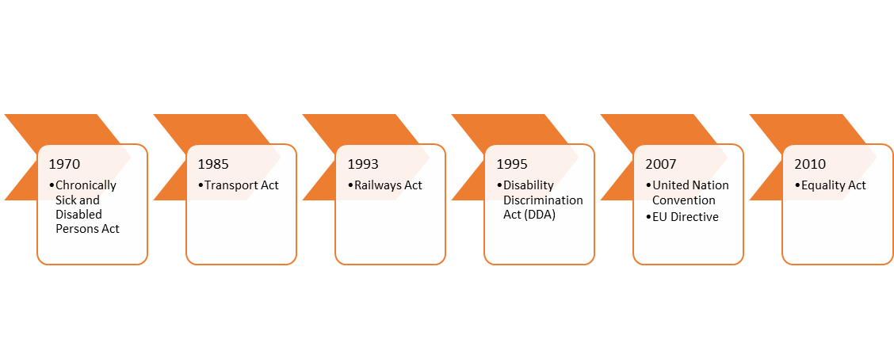An evolution of legalisation from the Chronically Sick and Disabled Persons Act (1970) through to the introduction of the Equality Act (2010), see Figure 1, has developed the civil and legal rights of disabled persons in the United Kingdom. The Equality Act made ‘disability’ a protected status meaning reasonable adjustment is required to ensure they are not discriminated against.

Figure 1 - Evolution of key disability legalisation

The common definition of Persons of Reduced Mobility (PRM’s) within the UK rail industry is from the 2008 European Union directive1. This is a wholesome definition as it includes those who have permanent physical or mental disabilities as well as those who are restricted by age or a temporary physical disability.

At present there are no legal metrics in the UK that determine what a *‘reasonable adjustment’* is. Therefore *‘reasonable’* is determined on a case by case basis and, ultimately, is left to the experience, expertise and knowledge of individuals to define what they believe to be a reasonable adjustment for a given situation.

A House of Lords Select Committee report strongly suggested in their report that accessibility should be a primary driver for future investment within railway infrastructure and that training of staff should be a legal requirement.

## Data

* + 1. Disability Data

Transport for London report that “…Ninety per cent of disabled Londoners report that their disability limits their ability to travel...” (Transport for London, 2015e). This study disagrees with statement as it conforms to the medical model of disability3 therefore the statement is misinterpreted. The author’s belief is that a social model4 approach should be taken as disabled persons limited by the current infrastructure and measures in place.

Figure 2 - Frequency of Tube Use

On first glance Figure *2* would seem to support the medical mobility of disability rather as the tube is not the preferred mode of transport for those persons with a disability or limited mobility as its frequency is very low. Table 1, demonstrates only eleven stations provide lift access with just six stations whose lifts are fully accessible. Therefore, upon inspection of both Figure 2 and Table 1 this supports the authors’ belief that the social model should be followed. This is because ridership and frequency levels are low due to the existing infrastructure actual being a barrier to those with a disability.



Table 1 - Breakdown of station database accessibility

* + 1. European Metros Comparison

This study has undertaken research to determine how the London Underground system compares to another European Metro system. This is because London wants to become one of the most accessible systems in the world. Table 2 shows the accessibility of European metros however this study does not consider constraints such as number of stations, station locations, and investment programmes etc.

Figure 3 - European Metros Accessibility Comparison

The figure above highlights that London Underground is not the most accessible metro system as only twenty seven percent of the network can provide step free access. Other European metros outperform London Underground such as Barcelona and Milan who achieve a ninety and seventy-one percentage of stations that have step free access.

## Transport for London Policy

* + 1. Current Policy

London Underground, a subsidiary of Transport for London, who are accountable to the Mayor of London for all accessibility issues in regards to the Underground Network. London Underground has recently updated their business case policy in respect to accessibility investment to ensure “…maximize net social benefit within available funds….” please refer to Figure *4* below. This is due to the regular financial investment London Underground receives from the United Kingdom Government being significantly reduced in the coming years.

Within the old policy success was determined by the quality and high level benefits of the business case rather than the accessibility scheme itself. Whereas the new policy, though it is step in the right direction, only focuses on the accessibility scheme within the context on the external influences having a major impact upon the decision of investment. This paper argues that the policy should be based upon quantitative accessibility benefits instead of qualitative assessment with the external influences being secondary to a data driven approach.

Figure 4 - London Underground updated Policy for accessibility investment

* + 1. Current Methods

London Underground has produced and uses a suite of simulation models that are used to model travel the Greater London area. This information is used to forecast the long term impacts of schemes in London. Two of the most applicable models to this study are the Railplan and LTS models. This study has reviewed these models to provide comments and comparison in Table 3 and below.

Therefore, London Underground cannot currently easily, quickly and accurately provide quantitative network wide impacts and benefits of introducing a new accessibility measure into the London Underground network. Understanding this information is crucial in comparing schemes to choose the optimal scheme that provides the greatest network benefits rather than focusing on the local, individual station impacts and benefits.

This identifies a gap within the industry that a network wide analytical approach and tool is required.



Table 3 - Comparison of London Underground applicable Models

## Summary

In summary, this literature review has identified through the themes of legalisation, data and policy that an issue exists within the current approach we use in industry to address inaccessibility within railway networks.

At present legalisation cannot hold anyone accountable for not providing access as metrics for ‘reasonable’ do not exist. This leads to medical model of disability being documented and believed rather than the social model of disability, which when applied has tremendous results as seen by some of our European counterparts. Hence policy and investment has been driven by what we believe we can justify as being an correct informed rather that an analytical approach.

Hence, the authors believe a novel assessment tool is required to demonstrate the strategic benefits for investing in accessibility schemes. The network wide savings in journey time and distance when a specific new accessibility measure(s) is added or removed from a specific station(s) are the two critical benefits required as these are not currently quantified

# Methodology

## Purpose of the study

The purpose of this study is to develop a novel assessment tool in which can address the three areas highlighted in Figure *5*. This would use a computer based system to create a virtual rail network that is representative of the existing network. This would method of analysis enable it to be adaptable, user friendly and time saving hence when adding accessibility measures it can be assessed.

This would enable users to assess the network for a range of scenarios such as a short term closure of an accessibility measure due to maintenance, a longer term closure due to an upgrade(s), to assess a future year of the network or compare two programmes of work to determine which would provide the net distance and time savings.

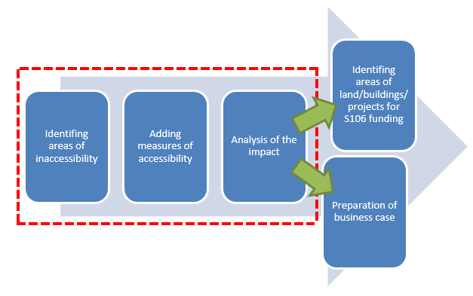

Figure 5 - Purpose of the novel assessment tool

The outputs that will be assessed in this study are the time and distance metrics when accessibility measures are added. This is because this data is not currently provided within a business case. This paper believes investment decisions into accessibility schemes should be based on this data as it the only metric when included with the external factors listed in Figure *4* above that ensures compliance with the Equality Act and ‘*Reasonable adjustment’.*

## Modelling the Network

Table *4* below outlines the desirable criteria this study wanted from the assessment tool. A number of various and existing systems were considered against the criteria to ensure that the tool would be suitable. This outcome of qualitative review determined that a Microsoft excel would be the most suitable platform to model and assess the network for this study.



Table 4 - Comparison of platforms against the design criteria

To be able to assess the network as a whole it was identified that the best approach would be to develop a matrix that included all of the case study stations. This is because one of the objectives is to ascertain network wide effects.

This study had information regarding the location of each station; it had information regarding the accessibility measures in place and the existing distance between stations with the measure and those stations without. It was decided that a matrix for each operational measure was required to enable a review and analysis of the effects of the implementation of each type of measure across the network.

To increase efficiency of the process of assessing the effects of adding or removing operational measures from the network and displaying results, two Excel VBA Macros were created. This would enable users to simply pick an operational accessibility measure to either add or remove to the network and select the single macro, to assess one station against the network or, the workbank macro to assess the successive placement of accessibility measures at the most beneficial station on the remaining network until the network has all the measure active at the stations.

This novel assessment tool currently can assess seven different accessibility options, please refer to Figure 6 below. These are the seven measures currently documented within the case study network. However as new measures are introduced to the network this tool can be quickly updated to include new measures.

Figure 6 - Accessibility measures within the novel assessment tool

## Model Validation

The final step of this study is to validate the novel assessment tool against an existing programme of works. Validation is required to provide confidence within the tool and the in the accuracy of the results.

This validation exercise will assess the London Underground Programme of stations against the assessment tool programme of stations to understand if a greater level of walking and time savings can be achieved.

|  |  |  |  |
| --- | --- | --- | --- |
| **No of Stations** | **Programme to provide measure** | **Stations** | **Year of measures becoming operational** |
| 1 | SFA | Tower Hill | 2015 |
| 2 | SFA | Vauxhall | 2015 |
| 3 | SCU | Tottenham Court Rd | 2016 |
| 4 | SCU | Bond Street | 2017 |
| 5 | SFA | Barbican | 2018 |
| 6 | XRL | Moorgate | 2018 |
| 7 | XRL | Paddington | 2018 |
| 8 | SFA | Victoria | 2018 |
| 9 | SCU | Elephant & Castle | 2020 |
| 10 | SCU | Bank | 2021 |
| 11 | SCU | Holborn | 2023 |

Table 5 - London Underground Programme of Stations; 2015-2024

Table 5 above is the London Underground programme of stations, as listed in, are to be provided with step free access through the installation of new lifts and escalators between 2015 – 2024. All of these stations are major Central London stations that are situated within Zone One of the London Underground network.

Therefore, within this validation exercise we have chosen Zone One of the London Underground network as the case study area. We have also has selected and applied the lifts and escalator accessibility measure to be assessed between the two station programmes.

To obtain the results for the London Underground programme of stations we simply selected each station from Table 5 within the tool, applied the accessibility measure, ran the single macro and obtained the journey time and distance savings. We repeated this step for each station in the programme whilst ensuring the predeceasing stations in the programme had the measure applied. We applied the assessment tool in this method as it is representative of the availability of the accessible measure within Zone One of London Underground Network. The result of this assessment creates baseline data that can be used to compare the current strategy of accessibility investment.

The assessment tool programme of stations was generated by applying the workbank macro within the tool. This meant the tool was applying the accessibility measure to all the stations to identify the station that provided the greatest time and distance savings. Once, the tool had cycled through all the stations and found the greatest saving, it would log this station, ensure the measure was applied at this station and then try to identify the next station within Zone One that provided the greatest saving.

To enable a comparison to the London Underground programme of stations we extracted the first eleven stations within the assessment tool programme of stations.

# 4.0 Results

The following section will review the results of the novel assessment tool and will compare them with the London Underground programme of stations works to provide step free access, as per the model validation methodology described in section 3 above.

## 4.1 London Underground programme, model outputs

|  |  |  |  |  |
| --- | --- | --- | --- | --- |
| **Station ID** | **Station order to place measure** | **Walking Distance Saving (m)** | **Walking Time Saving (minutes)** | **Number of Passengers at Station** |
| 1 | Tower Hill | 27906 | 166 | 36,533 |
| 2 | Vauxhall | 2395 | 14 | 44,776 |
| 3 | Tottenham Court Road | 30226 | 180 | 60,219 |
| 4 | Bond Street | 19694 | 117 | 63,047 |
| 5 | Barbican | 8301 | 49 | 19,762 |
| 6 | Moorgate | 8260 | 49 | 59,770 |
| 7 | Paddington | 13761 | 82 | 76,360 |
| 8 | Victoria | 4989 | 30 | 130,316 |
| 9 | Elephant & Castle | 3097 | 18 | 29,476 |
| 10 | Bank | 1752 | 10 | 123,097 |
| 11 | Holborn | 2056 | 12 | 57,005 |
| **Total** | | 122436 | 729 | 700,361 |

Table 6- Assessment output of LU programme of stations 2015 - 2024

## 4.2 Assessment Tool Programme of stations, model outputs

|  |  |  |  |  |
| --- | --- | --- | --- | --- |
| **Station ID** | **Station order to place measure** | **Walking Distance Saving (m)** | **Walking Time Saving (minutes)** | **Number of Passengers at Station** |
| 1 | Marble Arch | 41405 | 246 | 25,987 |
| 2 | St. Paul's | 35916 | 214 | 28,391 |
| 3 | Goodge Street | 12222 | 73 | 14,154 |
| 4 | High Street Kensington | 11273 | 67 | 21,034 |
| 5 | Aldgate | 4577 | 27 | 12,779 |
| 6 | Hyde Park Corner | 4191 | 25 | 7,451 |
| 7 | Covent Garden | 3639 | 22 | 27,850 |
| 8 | Borough | 3598 | 21 | 8,317 |
| 9 | Edgware Road (Cir) | 3326 | 20 | 11,820 |
| 10 | Queensway | 2775 | 17 | 10,722 |
| 11 | Pimlico | 2376 | 14 | 18,448 |
| **Total** | | 125297 | 746 | 186,953 |

Table 7 - Assessment Output of Workbank macro station 2015-2024

## 4.3 Discussion

These results initially suggest the novel assessment tool programme of stations for scenario 1 provides slightly greater output than those produced by the LU programme of stations. With the assessment tool programme of stations providing an additional seventeen minutes or 2861 metres of savings when compared to London Underground programme of stations.

The first clear difference between the London Underground programme stations and the programme of stations produced by the assessment tool, via the workbank macro, is that neither programmes contain the same stations, both are completely different. This paper earlier discussed the alternative drivers within London Underground that are used to support business cases and programmes of work, whilst the assessment tool’s only driver is identify the greatest network savings.

The number of passengers who could benefit from the implementation of the accessibility measure in the London Underground programme of stations is far greater than the assessment tool programme of stations. It is over factor of three times greater. This is because the London Underground Programme of stations are either interchange hubs, major national rail terminuses or both. Though the assessment tool results are Zone One stations they do not have the same passenger demand, for example Pimlico has just over eighteen-thousand passengers a day whilst Holborn on the London Underground programme of stations has fifty-seven thousand.

In figures 9 and 10 below, they compare the distance and time savings between each induvial station within the two station programmes. The first two stations with the measure being applied in the assessment tool programme, Marble Arch and St. Pauls, presents a vastly significant saving increase compared to the London Underground programme of stations. However, the London Underground programme of stations between stations three to seven in its programme eclipses those savings by the assessment tool when the accessibility measure is applied.

The walking distance and time saving for each successive station in the assessment tool programme of station is lower than those stations earlier in the programme. The reduction in savings between stations is not proportional. This indicates the assessment tool is identifying the greatest possible network savings available when applying an accessibility measure. Whilst the London Underground programme of stations walking distance and time saving for each successive station fluctuates. This is reflective of the policy described in section 2.3 as the key driver is not accessibility.

Figure 9 - Comparison of LU and Tool programme of station 2015-2024; Walking distance savings

Figure 10 - Comparison of LU and Tool programme of station 2015-2024; walking time savings

Figure 11 - Comparison of LU and Tool programme of station between 2015 -2024; Cumulative Time Savings

However, Figure 11 demonstrates the cumulative walking time savings for each of the programme of stations. The gradient of the assessment tool programme of suggests it can provide an initial greater saving than the London Underground programme of stations. This indicates the assessment tool is correctly identifying stations with the greatest inaccessibility.

This is supported by the gradient of the assessment tool steadily decreasing the end of its programme of stations. This is because the range of walking time between stations with and without the accessible measure is significantly reduced; meaning the walking time savings for each individual station is lowered. This is seen in figures 9 and 10 as the walking distance and time savings of each station in the assessment tool stations programme are significantly lower.

Whereas the London Underground programme of stations cumulative walking time savings gradient is staggered in Figure *11*. This suggests that application of the accessibility measure to each station in the London Underground programme of stations does not provide the greatest savings for the network.

When the results are reviewed in its entirety the London Underground programme of stations and the assessment tool programme of stations produce similar savings. But if we review the relationship between the time savings and number of stations, the assessment tool can generate greater time savings with the accessibility measures applied at fewer stations. For example, the assessment tool can generate a four-hundred and sixty minute time saving from the first two stations. Whereas the London Underground programme of stations only achieves this amount of time saving through applying the accessibility measure at four stations.

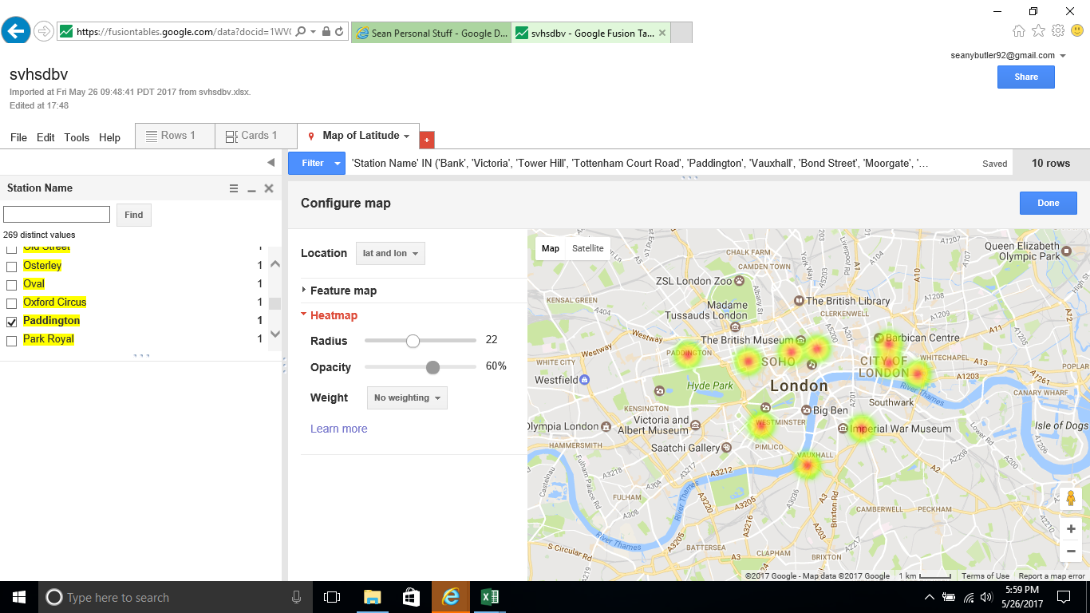

Figure 12 - Heatmap of the London Underground Programme of stations

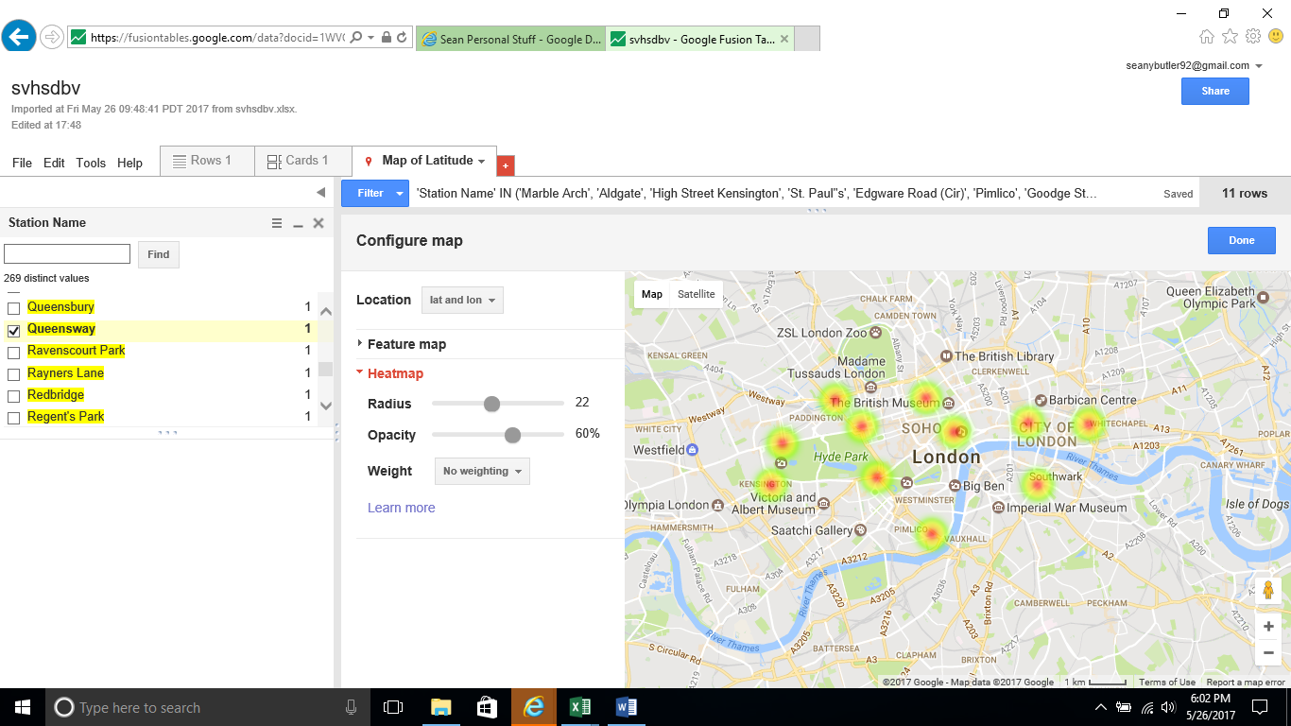

Figure 13 - Heatmap of the Novel Assessment Tool Programme of stations

Figures 12 and 13 above demonstrate this difference between each programme of stations. Figure 12 is the London Underground programme of stations heatmap which shows that the some of the within this programme are very much in close proximity to one another, meaning large parts of Zone 1 of the London Underground network do not benefit from the investment and remain inaccessible. Whereas in Figure 13 is a more of geographical mix across Zone 1 of the London Underground network , driven by areas of the Zone 1 of the London Underground network that are inaccessible due to the accessibility measure not being in place of these stations.

# 5.0 Conclusion

In conclusion, this paper has successfully produced, developed and validated a user friendly novel assessment tool that enables users to manipulate and analyse both the local and network impacts of introducing a new accessibility measure into a station.

This paper has reviewed the legal, social, economical and political drivers and impacts that exist within the theme of accessibility. It has identified that current policy, tools and strategy used within the railway industry leads to accessibility investment not being driven by the existing inaccessibility issues. This is caused by industry and market place not having tool available that enables a network wide impact assessment to be undertaken whose primary factor is identifying areas of inaccessibility.

This tool has been developed against desirable criteria being set to ensure this tool overcomes some of the short falls that existing similar tools have. The tool has since been validated via case study to determine whether it can provide a different and greater strategy of accessibility investment. Using the current London Underground strategy of accessibility investment of lifts and escalators the tool was able to assess this strategy to determine a base line. The tool was then able to create its own accessibility investment strategy by generating a programme of stations.

The results and comparison between the London Underground programme of stations and the tool’s programme of stations demonstrates that though a similar total network saving can be achieved the tool can more effectively resolve the issue of inaccessibility. It is more effective because it successfully identifies areas of network with the worst accessibility and focuses on addressing these areas. As a result, the tool can deliver network savings sooner than the current London strategy. This could present significant savings in respect to costs and time to a metro operator such as London Underground.

However, the accessibility tool strategy and programme of stations is limited that it can not review the results in context to the environmental and social constraints or benefits unlike the London Underground strategy. This is demonstrated through the number of passengers that could benefit from accessibility measures being applied is far greater in the London Underground programme of stations rather than the assessment tool programme of stations.

Overall, this paper has successfully met its objectives of producing a novel tool that can undertake a quantitative assessment to enable an understanding of the possible impacts and benefits for persons with reduced mobility.

# 6.0 Next Steps

This novel assessment tool can be further developed by expanded the tool to include other metro’s and rail work networks in London such as the London Overground, Docklands Light Railway or Network Rail/ Train Operating companies (TOC’s) stations.

It could also be expanded to include more accessible measures that support persons with reduced mobility. Such as those persons with visual impairment so require audio measures on station platforms to support them

The tool could be used in the preparation of business cases to demonstrate the network wide benefit by investing an accessibility measure at that station. It equally could be used to compare business cases to determine investment decisions based upon the accessibility benefits that they could provide. Please refer to Figure *14* below.

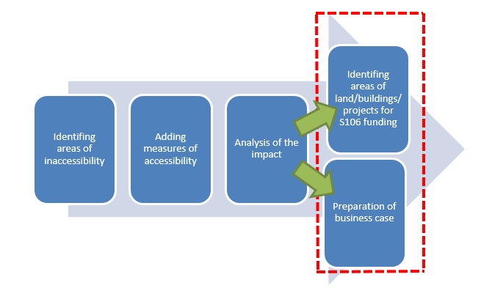

Figure 14 - Potential future uses of the novel assessment tool

The novel assessment tool could also being expand its data set to include property and land assets. This would align to the current London Underground policy and Strategy of using S106 planning order to obtain funds for accessibility investment as it would correlate nearby property and land to the London Underground station. This would give stations the means to obtain accessibility investment by either a number of property and land in close proximity or property and land of significant value nearby.

# Bibliography

|  |
| --- |
| * Top of Form * Top of Form * Top of Form * Bottom of Form * Bottom of Form * Bottom of Form |
| * *Access For All - A-Z of station improvements,* (No Date) Available from http://www.networkrail.co.uk/improvements/access-for-all/stations [Accessed 01 April 2016] |
| * *Accessibility in Metro de Madrid*, (No date) Available from: https://www.metromadrid.es/en/accesibilidad/accesibilidad_metro/index.html [Accessed 01 March 2016] |
| * *Accessible transport*, (No date) Available from: http://www.tmb.cat/en/transport-accessible [Accessed 01 March 2016] |
| * *Chronically Sick and Disabled Persons Act 1970*, (c.44). London: HMSO. |
| * *Disability Discrimination Act 1995*, (c.50). London: HMSO. |
| * Edwards (2015) *Cuts to the London transport grant to hit from 2018* Available from: http://www.bbc.co.uk/news/uk-england-london-34923879 [Accessed 25 November 2015] |
| * *Equality Act 2010 and Disability Committee; Tuesday 3 November 2015 Meeting started at 3.30pm, ended 5.03pm* (2015) [Online video] Available from: http://parliamentlive.tv/Event/Index/708f5c7d-8dfb-4048-a867-af18dfe83cfb [01/04/2016] |
| * *Equality Act 2010*, (c.15). London: HMSO. |
| * *European Commission (2008/164/EC) 21 December 2007* concerning the technical specification of interoperability relating to ‘persons with reduced mobility’ in the trans-European conventional and high-speed rail system |
| * *Four decades since Alf Morris' landmark disability act* , (2010), Available from: http://news.bbc.co.uk/local/manchester/hi/people_and_places/newsid_8697000/8697567.stm [Accessed 01 November 2016] |
| * *Glossary*, (No date) Available from: https://tfl.gov.uk/info-for/urban-planning-and-construction/planning-with-webcat/glossary [Accessed 30 October 2015] |
| * Greater London Authority (2009) *Mayor's Transport Strategy*. Available from https://www.london.gov.uk/sites/default/files/transport-strategy.pdf [Accessed 01 November 2015] |
| * Greater London Authority (2014) *Accessibility of London Underground Stations.* Available from http://data.london.gov.uk/dataset/accessibility-london-underground-stations [Accessed 11 November 2015] |
| * Greed, C (2011) Planning for sustainable transport or for people’s needs, *Proceedings of the Institution of Civil Engineers -Urban Design and Planning,* Paper 1000033, pp 219-229, DOI: http://dx.doi.org/10.1680/udap.10.00033 |
| * *History of Madrid Metro*, (No date) Available from: https://www.metromadrid.es/en/conocenos/quienes_somos/Historia/ [Accessed 01 March 2016] |
| * HM Government (2010): *Approved Document M: The Buildings Regulations 2010 Access to and use of buildings.* Newcastle: NBS |
| * Institution of Civil Engineers (2013) *Realising a world class infrastructure: ICE’s guiding principles of asset management.* Available from: https://www.ice.org.uk/disciplines-and-resources/best-practice/realising-a-world-class-infrastructure [Accessed 24 February 2016] |
| * *London Underground trips take four times longer for disabled* (2016) Available from: http://www.bbc.co.uk/news/uk-england-london-36082430 [Accessed 22 April 2016] |
| * Miller, E (2014) Handbook of Microsimulation Modelling, *Contributions to Economic Analysis, Volume 293 pp. 385-420 [Accessed date 02 January 2016]* |
| * Parliament. House of Lords (2016) *Committee on the Equality Act 2010 and Disability: The Equality Act 2010: the impact on disabled people*. London : HMSO (HL 2015-2016 (117)) |
| * Pickard and Sullivan (2015) *TfL faces £700m a year cut in state subsidy by turn of the decad*e Available from:http://www.ft.com/intl/cms/s/0/b7392524-8923-11e5-90de-f44762bf9896.html [Accessed 12 November 2015] |
| * *Plan Interactif*, (No date), Available from: http://www.ratp.fr/plan-interactif/carteidf.php?lang=uk [ Accessed 01 March 2016] |
| * *Promoting London* (No Date), Available from: https://www.london.gov.uk/what-we-do/business-and-economy/promoting-london/promoting-london [Accessed 01 April 2016] |
| * *Railways Act 1993*, (c.43). London: HMSO. |
| * Thind, R *Understanding the Equality Act: information for disabled students*, (2015), Available from: http://www.disabilityrightsuk.org/understanding-equality-act-information-disabled-students#eight [Accessed 10 March 2016] |
| * *Transport Act 1985*, (c.67). London: HMSO. |
| * Transport for London (2012) *Taking forward the Mayor’s Transport Strategy Accessibility Implementation Plan.* Available from: http://content.tfl.gov.uk/taking-forward-the-mts-accessibility-implementation-plan-march-2012.pdf [Accessed 11 November 2015] |
| * Transport for London (2013) *Business Case Development Manual.* Available from: https://www.whatdotheyknow.com/request/guidelines_for_cost_benefit_anal [Accessed 16 November 2015] |
| * Transport for London (2014a) *London’s Public Transport Assignment Model (LTS)*. Available from: http://content.tfl.gov.uk/londons-public-transport-assignment-model-LTS.pdf [Accessed 02 February 2016] |
| * Transport for London (2014b) *London’s Public Transport Assignment Model (Railplan)*. Available from: http://content.tfl.gov.uk/londons-public-transport-assignment-model-railplan.pdf [Accessed 02 February 2016] |
| * Transport for London (2015a) *Avoiding the stairs tube guide* http://content.tfl.gov.uk/avoiding-stairs-tube-guide.pdf [Accessed 11 November 2015] |
| * Transport for London (2015b) *Rail and Underground New ‘Affordable’ Step-Free Access Programme*. Available from: https://www.google.co.uk/search?q=Rail+and+Underground+New+%E2%80%98Affordable%E2%80%99+Step-Free+Access+Programme&sourceid=ie7&rls=com.microsoft:en-GB:IE-Address&ie=&oe=&gfe_rd=cr&ei=eZ8kV6m-FeHt8weIwa2gBQ&safe=active&gws_rd=ssl [Accessed 12 December 2015] |
| * Transport for London (2015c) *Step Free Tube Guide* http://content.tfl.gov.uk/step-free-tube-guide-map.pdf [Accessed 11 November 2015] |
| * Transport for London (2015d) *Your Accessible Network. Available from http://content.tfl.gov.uk/your-accessible-transport-network-3-main-document.pdf [Accessed 1 February 2016]* |
| * Transport for London (2015e) *travel-in-London-understanding-our-diverse-communities*. Available from: https://tfl.gov.uk/cdn/static/cms/documents/disabled-people.pdf [ Accessed 01 December 2015] |
| * Transport for London (2015f) *Station capacity upgrade programme* Available from: https://tfl.gov.uk/modes/tube/?cid=tube [ Accessed 01 December 2015] |
| * Transport for London (No Date) Available from https://tfl.gov.uk/maps [Accessed 01 November 2015] |
| * *Universal Accessibility Master Plan*, (2010), Available from:http://www.tmb.cat/ca/c/document_library/get_file?uuid=ca166ad5-a99b-4e7f-acf9-c2796242ad4f&groupId=10168 [ Accessed 01 March 2016] |

# Notes

1 Person with reduced mobility means any person whose mobility when using transport is reduced due to any physical disability (sensory or locomotory, permanent or temporary), intellectual disability or impairment, or any other cause of disability, or as a result of age, and whose situation needs appropriate attention and adaptation to his or her particular needs of the service made available to all passengers’ (European Commission 2008/164/EC, c15, p.4).

2 ‘The Equality Act 2010: the impact on disabled people’.

3 ‘Under the medical model, these impairments or differences should be 'fixed' or changed by medical and other treatments, even when the impairment or difference does not cause pain or illness. The medical model looks at what is 'wrong' with the person, not what the person needs. It creates low expectations and leads to people losing independence, choice and control in their own lives.’ ‘The social model of disability says that disability is caused by the way society is organised, rather than by a person’s impairment or difference. It looks at ways of removing barriers that restrict life choices for disabled people. When barriers are removed, disabled people can be independent and equal in society, with choice and control over their own lives.’

4 The social model of disability says that disability is caused by the way society is organised, rather than by a person’s impairment or difference. It looks at ways of removing barriers that restrict life choices for disabled people. When barriers are removed, disabled people can be independent and equal in society, with choice and control over their own lives.’