Journal of Prescribing Practice
A-Z of Prescribing for children

Kate Davies
Associate Professor, Paediatric Prescribing & Endocrinology
London South Bank University

B – British National Formulary for Children (BNFc)

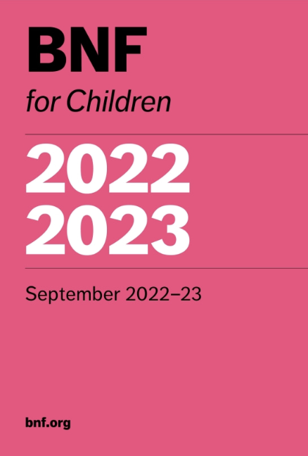

The British National Formulary (BNF) was first published in 1949, as a result of wartime formularies, with new editions being published every three years until the mid 1970s (Wade 1993). Then, the pharmaceutical industry began to publish the ‘Monthly Index of Medical Specialities’ (MIMS) every month, providing more up to date information for Doctors – no non-medical prescribers then! However, the BNF format was re-evaluated and re-formed, and new editions have been published every six months since 1981. This new format included drug monographs for all licensed medications, as well as some unlicensed drugs and, since 1999, NICE (then the National Institute of Clinical Excellence) have been utilising the BNF to create guidelines, alongside evidence based practice (Ogden 2017).

However, in 2005, the British National Formulary for Children (BNFc) was launched. Paediatric healthcare professionals know that caring for children is challenging in a variety of ways, and that they are not just ‘little adults’. Children – especially neonates – differ greatly to adults in their response to drugs. In the neonatal period, for example, the risks of toxicity are increased by a reduced drug clearance, so a working knowledge of differing pharmacokinetic changes as children grow and develop is paramount. Yet most children’s doses of medications are still extrapolated from adult drug studies (O'Hara 2016).

Lack of paediatric clinical trials has been recently highlighted, and – because of this – many drugs used in children – and again, especially in neonates – is often ‘off label.’ The term ‘off label’ is used to describe licensed medications for unauthorized indications – like age groups, dose, dosage forms, or routes of administration (Belayneh, Abatneh et al. 2022). Off label use is seen commonly amongst prescribing for children, sometimes up to 95% of all inpatients (Meng, Zhou et al. 2022).

Fewer licenced medications for children also result in a reduced amount of adequate formulations suitable for children. Specialised paediatric centres – until 2005 – formed their own formularies, including major London hospitals, Liverpool, and the north of England (Kendall and Mehta 2006).

Medicines for Children was launched by the Royal College of Paediatrics and Child Health (RCPCH) and the Neonatal and Paediatric Pharmacy Group (NNPG) in 1999 (Kendall and Mehta 2006). It was used throughout hospitals, in secondary and tertiary care, but uptake in primary care was not so successful. Therefore, in 2005, the BNFc was born, after a call for a paediatric specific editorial team was made, to ensure regular and clinically evidence based practice.

The BNFc – in contrast to the BNF – is published annually, every September. The editors do stress that it is important to use the most up to date BNFc in clinical practice, and any changes made can be found in new published editions, in a specific section.

Similar to the BNF in that cautions, contraindications and side effects are listed, the BNFc also focuses on drug dosages specific to age, body weight and – at times – body surface area (Novak 2006). Again, this means not forgetting neonates, where drug dosages can vary between premature infants and term babies, or from a week old baby to a 4 week old baby.

Recognition is also given – where relevant – to the most appropriate formulation for a child, depending on their age and age appropriate pharmacokinetics. For example, when referring to antibiotics: older children may be able to switch from intravenous antibiotics to oral antibiotics more readily than neonates can, due to variable absorption in the neonatal period.

Knowledge of adverse effects of medications in the developing child is also noted: dexamethasone, for example, should not be used in neonates with chronic lung disease due to the potential for adverse neurological events (Joint Formulary Committee, 2022/2023), or the lowest dose of prednisolone should be used where clinically relevant due to its’ known growth suppressing effects (Allen 2015).

Replacing Medicines for Children with the BNFc to maintain clinically evidence based standards in line with the RCPCH and NPPG was clearly the way forward (Elias-Jones and Rylance 2005). Yet, it is not just the paper version that is used in clinical practice: in line with the BNF, the BNFc is also available digitally, either online or via an app, which is fully functional online. It is easy to switch between the two, and the ‘adult’ BNF is colour coded blue, and the BNFc pink, to represent children (Porter 2022). Drug monographs are easily accessible, including detail on action statements, dose and indications, and unlicensed use. One principle advantage of the digital format is that clinical content is updated monthly, and this has been heralded as preferable by medical and non-medical prescribers alike, by ensuring clinical accuracy, and thereby reducing medico-legal risk. Teaching non-medical prescribing students does now focus on not just the paper version, but how to navigate the digital version: imperative for a time-restricted pharmacology exam.

The success of the BNFc has clearly been evidenced by its’ constant need for updating and expansion of drugs that are included, and both the BNF and the BNFc continue with their monthly newsletter, where healthcare professionals can sign up to receive emails, enabling them to keep up to date with the latest drugs and any significant changes made. There is no doubt that the BNFc is here to stay, and it is exciting to envisage where the next steps will be taken.

The next A-Z article – C – will be focusing on Concordance.

875 words

Weblinks:
www.pharmaceuticalpress.com/bnf-publications

References

Allen, D. B. (2015). "Inhaled corticosteroids and growth: still an issue after all these years." J Pediatr 166(2): 463-469.
Belayneh, A., E. Abatneh, D. Abebe, M. Getachew, B. Kebede and B. Dessie (2022). "Off-label medication use in pediatrics and associated factors at public hospitals in east Gojjam zone, Ethiopia." SAGE Open Medicine 10: 1 - 9.
Elias-Jones, A. and G. Rylance (2005). "The launch of the British National Formulary for Children." Arch Dis Child 90(10): 997-998.
Joint Formulary Committee (2022 / 2023)
Kendall, M. J. and D. K. Mehta (2006). "Sick children deserve a better deal." Lancet 367(9507): 281-283.
Meng, M., Q. Zhou, W. Lei, M. Tian, P. Wang, Y. Liu, Y. Sun, Y. Chen and Q. Li (2022). "Recommendations on Off-Label Drug Use in Pediatric Guidelines." Front Pharmacol 13: 892574.
Novak, B. (2006). "The British National Formulary for Children: an important milestone." Nurse Prescribing 4(2): 53.
O'Hara, K. (2016). "Paediatric pharmacokinetics and drug doses." Aust Prescr 39(6): 208-210.
Ogden, J. (2017). "The British National Formulary: past, present and future." Prescriber 28(12): 20 - 24.
Porter, S. (2022). "Using the British National Formulary app to support safe prescribing: a practical guide." Journal of Prescribing Practice 4(10): 440 - 450.
Wade, O. L. (1993). "British National Formulary: its birth, death, and rebirth." BMJ 306: 1051 - 1054.

