METHODS TO ASSESS ENERGY USAGE IN FOOD COLD STORES
Evans, J.A.ª; Foster, A.Mª., Huet, J-M.^{b}; Reinholdt, L.^{b}; Fikiin, K.^{c}; Zilio, C.^{d}; Houska, M.^{e}; Landfeld, A.^{e}, Bond, C.^{f}; Scheurs, M.^{g}; and van Sambeeck, T.W.M.^{h}
ª Faculty of Engineering, Science and the Built Environment, London South Bank University, Langford, Bristol, BS40 5DU, UK. Tel: +44117928 9300, Email: j.a.evans@lsbu.ac.uk
^{b} Danish Teknologisk Institut, Kongsvang Allé 29, 8000 Aarhus C, Denmark.
^{c} Technical University of Sofia, 1000, 8 Kliment Ohridsky Str., Sofia, Bulgaria.
^{d} University of Padova - Dept. of Industrial Engineering, Via Venezia, 1, I-35131, Padova, Italy.
^{e} Food Research Institute Prague, Radiova str. 7, 102 31 Prague 10, Czech Republic.
^{f} Carbon Data Resources Ltd, Carbon House, 15 The Batch, Batheaston, Bath, Somerset, BA1 7DR, UK.
^{g} Catholic University College Limburg, Campus Diepenbeek, Agoralaan Gebouw B, 3590 Diepenbeek, Belgium.
^{h} Cold Chain Experts in ColdstoreExpertiseCenter, Van Dongenshoeve 10, 8052 BJ Hattem, The Netherlands.

ABSTRACT
A mathematical model was applied to predict energy used by cold stores. This was compared with actual energy consumption data collected in a survey of cold stores. The model was used to investigate different usage scenarios and varied ambient conditions around the chilled and frozen cold stores. This indicated that many chilled and frozen stores had very high usage and/or inefficient refrigeration systems. Less than 13% of chilled and 12% of frozen stores used less energy than an efficiently used store with an efficient refrigeration system. The model indicated that smaller stores of less than 25,000 m³ tended to use more energy than the model predicted, even at the least efficient, highest usage scenario. With further validation the model could be used to benchmark the energy usage of cold stores and help identify where energy savings could be best achieved.

INTRODUCTION
All chilled and frozen food and temperature controlled pharmaceutical products are stored in a cold store at least once during their journey from production to the consumer. Chilled stores generally maintain products at temperatures between -1 and 10°C whereas frozen stores generally maintain product at below -18°C. The cold store market is extremely diverse consisting of small stores of 10-20 m³ up to large warehouses of hundreds of thousands of cubic meters. All cold stores have the function of storing a product at the correct temperature and to prevent quality loss as economically as possible. In Europe there are approximately 1.7 million cold stores totalling 60-70 million m³ of storage volume. Of these, 67% are small stores with a volume of less than 400 m³ (Mudgal, et al. 2011).
There are few published surveys comparing the performance of more than a few cold stores. Surveys also rarely differentiate between type of store, storage temperature, location, room size or room function. In 2002 the IIR estimated that the Specific Energy Consumption (SEC) of cold stores was between 30 and 50 kWh m⁻³ year⁻¹ (Duiven and Binard 2002). The minimum value from this study was similar to values from a study carried out in the Netherlands by Bosma (1995) which found energy consumption of cold stores to be 35 kWh m⁻³ year⁻¹. In the UK ETSU (1994) also found that stores consumed at minimum 34 kWh m⁻³ year⁻¹ but that consumption could also be up to 124 kWh m⁻³.year⁻¹. Other studies in the USA by (Elleson & Freund (2004) and Singh (2006) found SECs of between 19 and 88, and 15 and 132 kWh m⁻³ year⁻¹ respectively. In one of the most comprehensive recent surveys carried out in New Zealand by (Werner, et al. 2006) the performance of 34 cold stores was compared. The SECs recorded varied from 26 to 379 kWh m⁻³ year⁻¹ demonstrating that there was a large variation in energy consumed by cold stores. Savings of between 15 and 26% were found to be achievable by applying best practice technologies. This large range in performance was also found by Carlsson-Kanyama & Faist (2000) who report data from BELF (1983) for energy use for freezers per litre net volume per day to be 1.0 kJ (equivalent to 101 kWh m⁻³ year⁻¹) when food was stored in rooms of 10,000 m³ whereas in rooms of 10 m³ the energy was 15 kJ (equivalent to 1520 kWh m⁻³ year⁻¹). In both surveys the range between best and worst was 15.
Limited information has been published on throughputs and storage and often information is difficult to compare due to the metrics used by the authors. Carlsson-Kanyama & Faist (2000) report energy used for long-term cold storage of apples may vary between 0.9 - 1.7 kJ electricity per kg per day. Swain (2010) reported figures for potato storage collected over a 3 year period from 8 stores as being between 0.1 and 0.29 kWh tonne-¹ day⁻¹. On average the energy ranged from 0.12 to 0.15 kWh tonne⁻¹ day⁻¹ within each of the 3 years where monitoring took place. The results showed a massive difference in energy consumption between the best and worse stores. It should be noted that the data included all energy used and that in cold weather, potato farmers need to heat stores to maintain the potatoes at the usual storage temperatures of 3°C. In addition there was no information presented on store temperatures and so the stores that appear most efficient may be those that stored the potatoes at a higher temperature.
Previous detailed audits carried out on a small number of cold stores have confirmed that energy consumption can vary considerably and that this was due to a variety of factors (Evans and Gigiel 2007) (Evans and Gigiel 2010) (Evans et al. 2014). These surveys also demonstrated that energy savings of around 30-40% were achievable by optimising usage of the stores, repairing current equipment and by retrofitting of energy efficient equipment.
Although the performances of cold stores have been compared in a number of surveys the reasons for the variations that have been found have not been understood. This paper uses a mathematical model to compare the performance of cold stores under varied usage scenarios to compare the results to data collected in a large survey of cold stores.

MATERIALS AND METHODS

Survey data
Data was collected as part of a survey of cold store energy performance. Although a large range of parameters were collected the main parameters used for the analysis in this paper were: temperature of the store, volume of the store and energy usage per year. Further details of the data collection can be found in Evans, et al. (2014).

Mathematical model
A mathematical model of cold store energy use was developed to predict energy used by cold stores. The model is more fully described in Foster, et al. (2013). The model was steady state, therefore all heat loads were averaged over one day. The cold store was modelled as a fully sealed rectangular box with one entry door. The cold store had enough thermal mass such that door openings did not change the temperature in the cold store. The temperature of the ambient air outside the cold store was not changed by the door openings. There was only one layer of insulation on the walls, roof and floor. Any metal cladding was ignored as the resistance to heat transfer from this was considered negligible. The luminous flux from the lights was divided by the area of the floor and walls to give a uniform luminance. The thermal mass of the forklift trucks were ignored. Therefore if they moved from a warm environment into the store, they did not give up this heat to the store. Energy from fork lift trucks did not include charging the batteries. Any product which changed temperature when loaded into the store did not have a latent load (e.g. freezing and thawing), only a sensible load.
Data was input via a spread sheet. The inputs included;
• Information about each wall (including ceiling and floor) of the cold store, e.g. face area, whether it was in the sun, outside ambient or internal and the type, colour and thickness of the insulation.
• The size of the door, its opening schedule, whether it was protected (e.g. by strip or curtains), amount of traffic through the door and the outside conditions.
• The refrigeration system, refrigerant, type of condenser, condenser ambient, efficiency of compressor and number of compression stages.
• Heat loads inside the store from forklifts, lights, personnel, product, defrosts and evaporator fans.
• Electrical loads from lights, defrosts, evaporator fans and condenser fans.
From these data a steady state heat load was calculated for the cold store. An electrical energy of the compressor was derived from the heat load using a calculated COP. The energy of the compressor E_{comp} was calculated using the formula given in Cleland (1994) (eq. 1).
$E_{comp }= \frac{[Q.(T_{c}-T_{e} )]}{\left[\left(273+ T_{e}\right){(1-α.x)}^{n}μ_{c}\right]}$ (1)
Where Q was the total heat load on cold store, T_{c} was the condensing temperature, T_{e} was the evaporating temperature, α was an empirical constant for different refrigerants, x was the fractional vaporisation on expansion from liquid to saturation at the discharge, n was the stage coefficient and μ_{c} was the isentropic efficiency of the compressor
The electrical power of the condenser and evaporator fan motors, E_{motor} was calculated from eq. (2).
$E_{motor}=\frac{N_{motor}P_{o}}{μ_{motor}}$ (2)
Where N_{motor} was the number fan motors, P_{o} was the output power (shaft) of fan motor and μ_{motor} was the efficiency of the fan motor. For electric defrosts, the electrical power of the defrost heater was given by eq. (3).
$E_{def}=\frac{1}{μ_{D}}\frac{\left\{\left[m_{DO. }\left(X_{o}- X_{i}\right).L_{f}.D_{DO}.N_{DO}\right]+\left(m_{WL}.L_{f}\right)\right\}}{\left(24 . 3600\right)}$ (3)
Where m_{DO} was the mass flow through an open door, X_{o} and X_{i} were the concentration of water in air outside and inside the cold the store, L_{f} was the latent heat of fusion for water, D_{DO} was the duration of each door opening, N_{DO} was the number of door openings per 24 hours, m_{WL} was the weight loss from product and packaging and μ_{D} was the defrost efficiency. Where the defrost was either hot gas or passive then E_{def} = 0.
The electrical power of the lamps E_{L} was given by eq. (4).
$E_{L}=L . \frac{A_{f}}{e_{L}}$ (4)
Where L was the Luminous flux required, A_{f} was the floor area and e_{L} was the efficacy of the lamps.
If floor heating, E_{f}, used recovered heat then E_{f} =0.
This electrical energy was added to all other electrical energies from fans, lights, defrost heaters, floor heating etc.
To better understand the variations in the collected survey data, 8 usage scenarios were modelled over a range of store volumes between 10 and 350,000 m³ (Table 1). The geometry of the store modelled was 5 m height with width and depth equal in all cases. For each scenario a chilled store at 2°C and a frozen store at
-23°C were modelled at the average annual temperature for the store location (based on data from weatherbase (LLC, Canty and Associates 2013)). The 8 scenarios ranged from a scenario with high efficiency where all heat loads were minimised to a scenario with an inefficient store with high heat loads from infiltration, lighting, fans, people, forklifts and external radiation.
Parameters for each scenario were selected based on information collected from energy audits carried out by Evans, et al. (2014). These represented a change from what would be the most efficient configuration to the worst configuration that would be feasibly possible. Full details of the assumptions made for each of the 8 scenarios are listed in Table 1.
Table 1. Assumptions used in model.
Scenario 1 | External walls | All walls shaded. All walls light coloured
 | Wall insulation | Polyurethane, 100 mm for chilled stores 150 mm for frozen stores
 | Air around store | Still
 | Under floor heating | None
 | Refrigeration system | R717 (ammonia), 2 compression/1 expansion stage, high isentropic efficiency (0.7). Evaporative condenser
 | Defrosts | Off-cycle defrost for chilled stores, electric for frozen stores
 | Product heat load | None
 | Fork lift heat load | None
 | Personnel heat load | None
 | Lighting heat load | None
 | Infiltration heat load | None
 | Evaporator/condenser fan power | Created from correlation from Evans et al. 2013b
Scenario 2 | As Scenario 1, except:
 | Product heat load | Food loaded at 1°C above store temperature  Product density = 250 kg m⁻³, product weight loss = zero  Chilled stores: 25% of total mass loaded each day.  Frozen stores: 10% of total mass loaded each day.
 | Fork lift heat load | 1 per 40,000 m³ store volume, size=medium, electric, operated 12h per day
 | People heat load | 2 persons per forklift truck, 2 hours per day, person in store for short periods
 | Lighting heat load | Fluorescent lights, 50 lumens.W⁻¹, 500 lux, operational 12 hours per day
 | Infiltration heat load | Door height 2.5 m, width 2 m minimum, if > 50,000 m³ store volume then door width = store volume/10,000, door opening time = 30 sec, volume of traffic during door opening = medium, door seal = good, strip curtains on door  48 door openings per day for chilled store, 24 for frozen store
Scenario 3 | As scenario 2, except:
 | Refrigeration system | Medium isentropic efficiency (0.6)
Scenario 4 | As scenario 3, except:
 | Fork lift heat load | 1 per 40,000 m³ store volume, size=medium, electric, operated 24h per day
 | People heat load | 2 persons per forklift truck, 6 hours per day, person in store for short periods
 | Lighting heat load | Fluorescent lights, 50 lumens.W⁻¹, 500 lux, operational 24 hours per day
 | Infiltration heat load | No door protection  96 door openings per day for chilled store, 48 for frozen store
Scenario 5 | As scenario 4, except:
 | Product heat load | Food loaded at 5°C above store temperature
Scenario 6 | As scenario 5, except:
 | Refrigeration system | Low isentropic efficiency (0.5)
Scenario 7 | As scenario 6, except:
 | External walls | All walls non shaded. All walls dark coloured
 | Refrigeration system | Air cooled condenser
 | Infiltration heat load | Volume of traffic during door opening = low, door seal = poor  192 door openings per day for chilled store, 96 for frozen store
Scenario 8 | As scenario 7, except:
 | Wall insulation | Glass/mineral wool
 | Evaporator/condenser fan power | Doubled
 | Infiltration heat load | 384 door openings per day for chilled store, 192 for frozen store
 | Lighting heat load | Fluorescent lights, 30 lumens.W⁻¹
 | Product heat load | Food loaded at 10°C above store temperature

RESULTS

Predicted cold store energy performance
Predicted and measured energy uses for the 8 scenarios are presented in Figure 1 (chilled stores) and Figure 2 (frozen stores). The performance of the low use, efficient refrigeration system modelled in scenario 1 was only achieved by 3.2% of the chilled stores and 2.4% of the frozen stores in the survey (Figure 3). In contrast 88.9% of chilled and 96% of frozen stores performed better than that predicted for the high usage, inefficient refrigeration system scenario in scenario 8.
Ambient conditions around the store had greater influence on frozen stores than chilled stores. This was due to the greater temperature difference between ambient and store temperature for freezers. Ambient temperature had a greater impact on energy use when usage of the store was high and this was mainly due to door openings.
Although each scenario in the sequence increased the usage and inefficiency of the store certain assumptions had a greater effect than others. In particular efficiency of the refrigeration system (and in particular the use of evaporative condensers) had a major impact on energy use. Product, lighting and fan heat loads also had a major impact on energy use. Wall shading and colour, air flow around the store, personnel and fork lift heat load had minimal impacts at the levels modelled. Infiltration load was only of significance when the door was not protected and the number of door openings was high. As defrosts were related to moisture ingress into the store the impact of defrosts was similar to that of the infiltration loads.

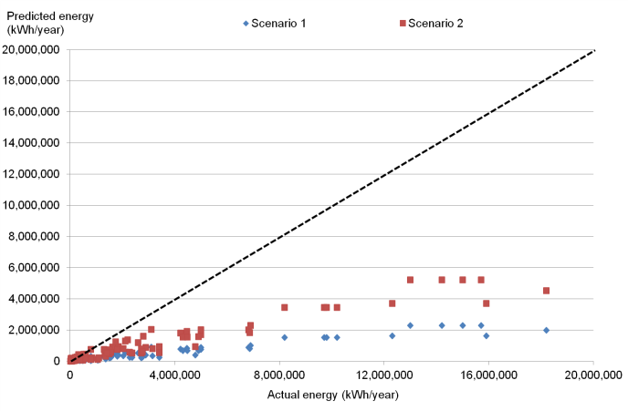 | 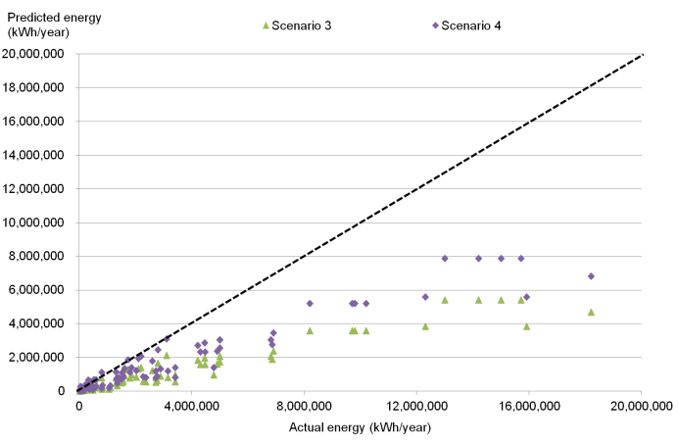
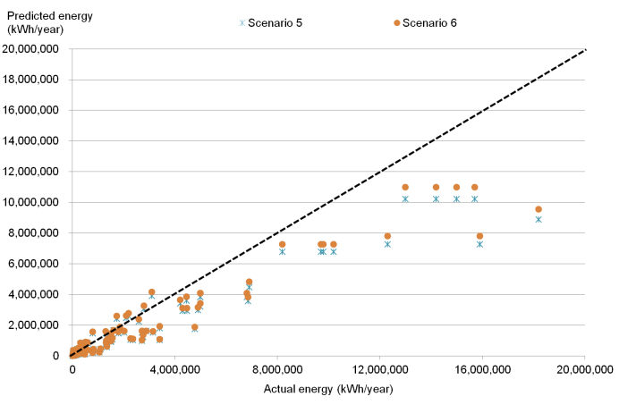 | 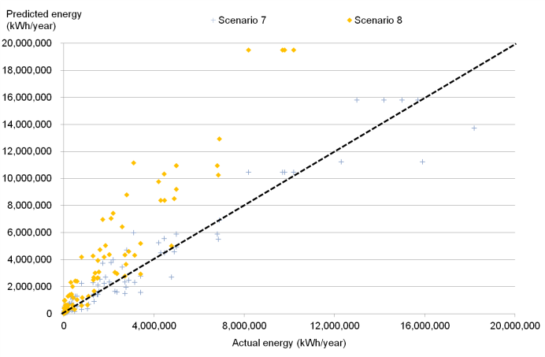
Figure 1. Predicted and measured energy compared for the 8 chilled store scenarios (dashed line shows x=y, indicating that points for cold stores above the dashed line use less energy than the model predicted).
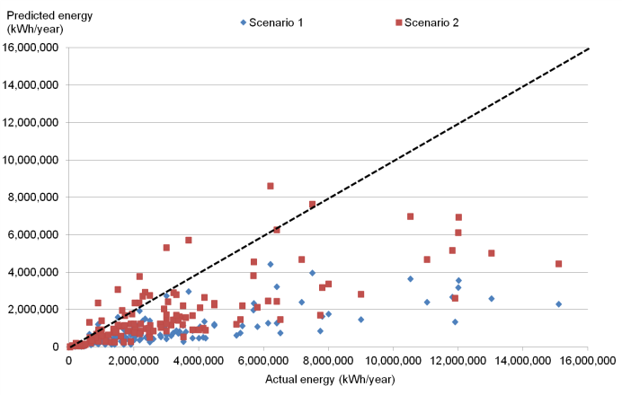 | 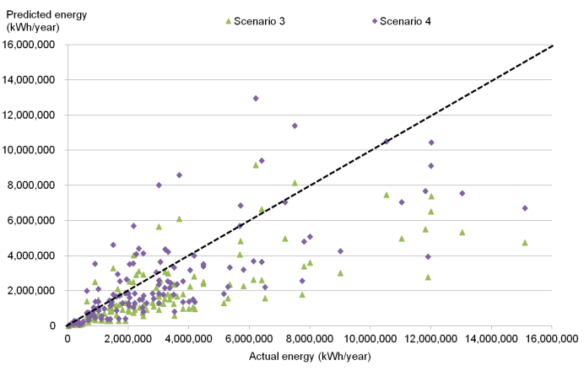
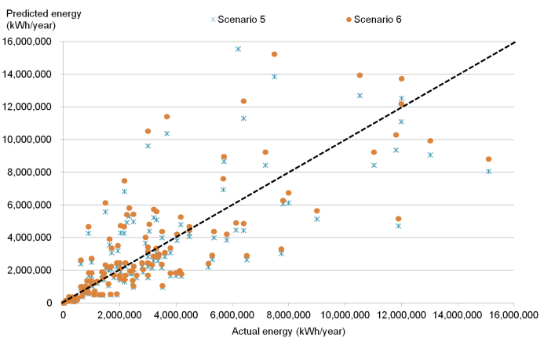 | 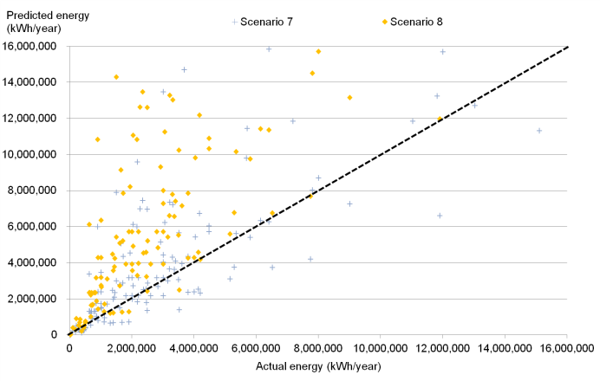
Figure 2. Predicted and measured energy compared for the 8 frozen store scenarios (dashed line shows x=y, indicating that points for cold stores above the dashed line use less energy than the model predicted).

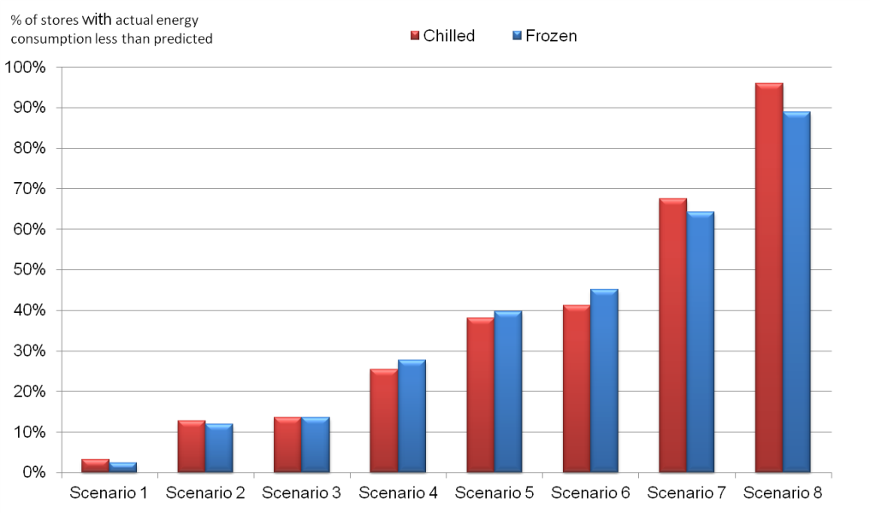
Figure 3. Percentage of stores achieving equal to, or less than, the predicted energy consumption in each modelled scenario.

Effect of store volume
The stores that used more energy than predicted were investigated. Although detailed information on all stores was not available it was noticeable that for both chilled and frozen stores, smaller stores tended to use more energy than predicted. Figure 4 shows the actual energy used by chilled and frozen stores compared to the predicted energy use for scenario 8. In both cases the stores that used more energy than the model predicted were all less than 100,000 m³, with most being less than 25,000 m³. This might indicate that smaller stores have less efficient components and the impact of larger surface area to volume may have an influence.

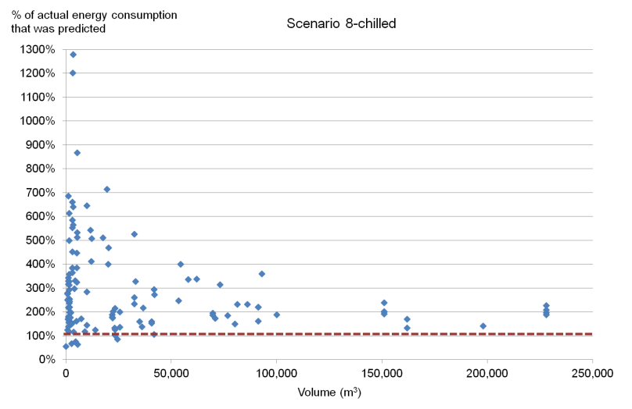 | 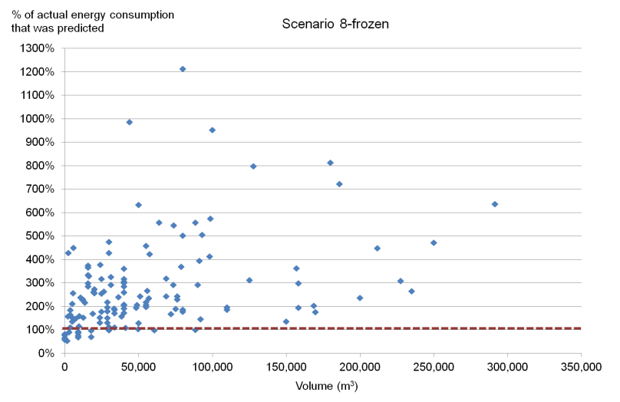
Figure 4. Volume of cold stores compared to percentage of actual energy consumption predicted by the model for scenario 8 (a value of less than 100% on the y axis denotes that the store used more energy than was predicted in scenario 8).

DISCUSSION
The energy consumption data for cold stores collected in the survey showed that there was large variability in their energy use. Work to audit cold stores Evans, et al. (2014) and understand why energy consumption varied so considerably between stores demonstrated that there was no single contributing factor that could reduce energy consumption. Therefore it is difficult to identify one or a small number of factors that influence energy use. The mathematical model was used to attempt to understand some of this variability.
Although the scenarios modelled are not necessarily exact in terms of real life usage, they do show (from scenario 1 to 8) the impact of increasing usage and reducing efficiency of the refrigeration system. The model requires further detailed validation before the results can be fully claimed to be accurate but within the scenarios modelled, and the real life data from the survey, the range in predications seem realistic.
If with further work the model can be validated it could then be used to model specific cold stores and to predict a range in energy usage that could be used to create an energy label or benchmark for cold stores. This would seem to particularly relevant for smaller stores where energy use was considerably higher in many cases than the worst case scenario modelled (scenario 8).

CONCLUSION
Much of the variation in cold store performance can be explained by the store usage, the efficiency of the refrigeration system and ambient conditions surrounding the store. The mathematical model provided a better understanding of the variations in cold store energy consumption. The model was shown to be a useful tool to estimate energy use of a cold store and provided a mechanism to generate metrics that can be used to assess efficiency of a cold store. With further detailed validation the model could be used to benchmark cold stores and identify stores where significant energy savings could be achieved.

AKNOWLEDGEMENT
The authors would like to thank EACI (Executive Agency for Competitiveness and Innovation) for funding this work and in particular the project officer, Christophe Coudun for his help in managing the project.

REFERENCES
1 BELF, Bundesministerium für Ernährung, Landwirtsch. Energie und Ernährungswirtschaft. Teil I: Bericht über die Energiesituation im Ernährungsgewerbe, Teil II Energieverbrauch für die Herstellung ausgewählter Lebensmittel. Reihe A: Angewandte Wissenschaft, Heft 285. Münster-Hiltrup, Landwirtschaftsverlag Gm, 1983.
2 Bosma, J. “Inventory study of the energy conservation potential in cold storage insulations in the Netherlands.” Proc. 19th International Congress of Refrigeration, vol. II, 382-391. 1995.
3 Carlsson-Kanyama, A, and M Faist. Energy Use in the Food Sector: A data survey. Environmental Strategies Research Group / Swiss Federal Institute of Technology, 2000.
4 Cleland, A C. “Polynomial curve-fits for refrigerant thermodynamic properties: extension to include R134a.” Rev. Int. Froid, 1994: 17(4):245-249.
5 Duiven, J E, and P Binard. “Refrigerated storage: new developments.” Bulletin of the IIR No. 2002-2 (2002).
6 Elleson, J S, and S W Freund. Benchmarking the Energy Performance of Industrial Refrigeration Systems. Interim Draft Report, Industrial Refrigeration Consortium, College of Engineering, University of Wisconsin- Madison, US, 2004.
7 ETSU. Energy Consumption Guide 37: Cold storage sector. ,. UK: Energy Efficiency office, Department of the Environment, 1994.
8 Evans, J A, and A J Gigiel. “Reducing energy consumption in cold storage rooms.” IIR ICCC. Cambridge, 2010.
9 Evans, J A, and A J Gigiel. “Reducing the energy consumption in cold stores.” The 22nd IIR International Congress of Refrigeration. Beijing, 2007.
10 Evans, J A, et al. “Assessment of methods to reduce the energy consumption of food cold stores.” Applied Thermal Engineering 62 (2014): 697-705.
11 Foster, A, C Zilio, C, M Corradi, L Reinhold, and J Evans. “Freely available cold store energy models.” Paris: 2nd IIR Conference on Sustainability and the Cold Chain, 2013.
13 LLC, Canty and Associates. weatherbase. 2013. http://www.weatherbase.com/ (accessed July 16, 2013).
14 Mudgal, S, B Tinetti, J Bain, R Cervantes, and A de Prado Trigo. “Preparatory study for Eco-design requirements for EuPs, Lot 1. Task 2: Economic and market analysis.” 2011.
15 Singh, R P. Benchmarking study of the refrigerated warehousing sector in California. Public Interest Energy Research Program, California Energy Commission, 2006.
16 Swain, J. Reducing the Energy Cost of Potato Storage (Final Report), Report No. 2010/14. British Potato Council, 2010.
17 Werner, S R, F Vaino, I Merts, and D J Cleland. “Energy use in the New Zealand cold storage industry.” IIR-IRHACE Conference. Auckland, 2006.

