Experimental investigation of liquid viscosity's effect on the flow behaviour and void fraction in a small diameter bubble column: how much do we know?
M. Abdulkadir*¹, O.T. Kajero², D. Zhao³, A. Al–Sarkhi⁴, A. Hunt⁵
¹Chemical Engineering Department, Federal University of Technology, Minna, Niger State, Nigeria
²Chemical and Process Engineering, University of Surrey, Guildford GU2 7XH, Surrey, United Kingdom
³School of Engineering, London South Bank University, London, United Kingdom
⁴Mechanical Engineering Department, King Fahd University of Petroleum and Minerals, Dhahran, Saudi Arabia
⁵Atout Process Limited, Bridport, United Kingdom

*Email address of the corresponding author: mukhau@futminna.edu.ng
Abstract:
The viscosities of heavy oils and bitumen are significantly above those of water and light crude oil and are found in the oil and gas, polymer, metallurgical, and process industries. Unfortunately, little research attention has been given to the void fraction, and the behaviours of such flows as bubbles rise over them in bubble columns. How the liquid viscosity influences the behaviour of these flows and void fraction were examined using the electrical capacitance tomography (ECT), level swell technique and visual technique with a high-speed camera. It was found that: an excellent agreement was achieved within ±10% for comparison between the obtained void fraction using both techniques for all the liquid viscosities considered. In contradiction to previous findings, an increase in liquid viscosity provokes a corresponding increase in the void fraction, yet the influence is seen to reverse for gas superficial velocities beyond 0.25 m/s. In concordance with Mori et al. (1999)'s observations, a liquid viscosity increment brings about a corresponding decrease in the bubble frequency. The Taylor bubble's rise velocity was heavily dependent on the liquid viscosity range, whereby increases in liquid viscosity bring about a rise in the flow distribution coefficient. The bubble drift velocity, on the contrary, reduces with increasing liquid viscosity.

Keywords: Void fraction, liquid viscosity, flow behaviour, level swell, ECT, Bubble column

- Introduction
The motion of long, bullet-shaped bubbles, also known as Taylor bubbles, rising in stagnant heavy crude oils has a significant industrial relevance due to its numerous applications related to heat and mass transfer process units, transportation of hydrocarbon pipelines, geological studies and nowadays even in the exponentially growing field of microflow systems (Deckwer (1992); Fabre and Line, 1992; Ghosh and Cui (1999); Taha and Cui (2002); Angeli and Gavriilidis (2008); Boltes et al. (2008); Suckale et al., 2010). The viscosities of heavy crude oils and bitumen are significantly higher than those of water and light crude oil and are found in the oil and gas, polymer, metallurgical, and process industries. According to Dusseault (2001), the viscosity of Venezuela's Orinoco extraordinary-heavy crude oils ranges from 1000 to 5000 mPa.s, whereas the Canadian extraordinary-heavy crude oil has a viscosity up to 5000–10000 mPa.s, nearly the same as molasses. In the flow of such heavy crude oils in bubble columns, the hydrodynamics of the gas–viscous liquid flows are dependent on the liquid viscosity, column diameter, nozzle or orifice diameter, gas superficial velocity, and other factors. Kovats et al. (1992) reported that the mass transfer efficiency of bubble columns depends on the fluid's viscosity; hence, it becomes imperative to study how the liquid viscosity in particular influences specific properties in bubble columns, especially the void fraction and flow behaviour.
The study on how the liquid viscosity influences the void fraction has been quite contentious. Most researchers agree that increasing liquid viscosity promotes a decrease in void fraction owing to the presence of a vast population of fast-moving large bubbles with short retention times in the bed (Kastanek et al., 1993; Deckwer and Schumpe, 1993; Kantak et al., 1995; Zahradnik et al., 1997; Ruzicka et al., 2003). Conversely, the positive impact of liquid viscosity on void fraction has also been reported by Weiss et al. (1985), Kuncova and Zahradnik (1995) and Pioli et al. (2012). The disagreement on the influence of liquid viscosity is reviewed here.
Hughmark and Pressburg (1961) utilized liquids of relatively low viscosity <152 mPa.s in small diameter pipes (< 51 mm) to study how the liquid viscosity influences void fraction. They found a monotonical decrease in void fraction with increasing liquid viscosity. Later, Eissa and Schugerl (1975) used a 159 mm diameter column and found that for < 40 mPa.s liquid viscosities, void fraction increased to a maximum value with a subsequent decrease as the viscosity increased. They reported an increase in void fraction because of an increase in liquid viscosity from 1 to about 11 mPa.s, giving a maximum value at a viscosity of 3 mPa.s with a sharp decrease at higher gas superficial velocities. They also observed an almost constant void fraction within a viscosity of 11 to 39 mPa.s that decreases with increasing gas superficial velocity. They claimed that this was due to the hindering effect of the motion of gas bubbles in viscous liquids, wherein the drag forces in low liquid viscosities were relatively weak to cause strong coalescence. They concluded that the stronger coalescence provoked by, the higher drag forces lead to lower void fractions. Bach and Pilhofer (1978) reported a similar behaviour. Hikita and Kikukawa (1974) also reported how the liquid viscosity influences void fraction by utilizing an air–cane sugar solution system of viscosity of 0.70–13.80 mPa.s in two bubble columns of 100 and 190 mm internal diameters. They found that an increment in liquid viscosity promotes a decrease in void fraction.
In 1985, Weiss et al. examined how the liquid viscosity influences void fraction by employing silicone oil of viscosity 9.2–1670 mPa.s in a 15.1 mm internal diameter bubble column. They found that an increment in liquid viscosity brings about a corresponding increase in void fraction. Thus, this contrasts with most researchers like Eissa and Schugerl (1975) and Bach and Pilhofer (1978), who claimed that the void fraction reaches a maximum value at constant gas superficial velocity as a consequence of an increment in liquid viscosity to nearly 3 mPa.s. They maintained that the decrease after the maximum value is due to bubble coalescence initiation in higher viscosity liquids. They concluded that this could be responsible for the maximum void fraction seen by Eissa and Schugerl (1975) and Bach and Pilhofer (1978). Weiss et al. (1985) concluded that both authors failed to spot the maximum void fraction but only observed the overall slowly decreasing trend. They reasoned that their observations and other researchers' difference is probably due to the difference in the pipes' diameter.
Kuncova and Zahradnik (1995) suggested that the increase in void fraction because of an increase in gas superficial velocity for viscous liquids could majorly be due to an increase in bubble size resulting from the build-up coalescence provoked by significant drag forces. They also pointed out that the contribution from minute bubbles to the overall void fraction may not be neglected for higher liquid viscosities. Kuncova and Zahradnik (1995) concluded that sufficient time should be allowed during experiments for the void fraction to reach an equilibrium value, reflecting the contribution from large and small bubbles. Figure 1 illustrates the total void fraction data of Kuncova and Zahradnik (1995) against the superficial gas velocity. The figure is for various aqueous solutions of saccharose with viscosities of 30 to 110 mPa.s. It confirms the effect of liquid viscosity on void fraction, whereby the total void fraction increases with an increase in liquid viscosity.
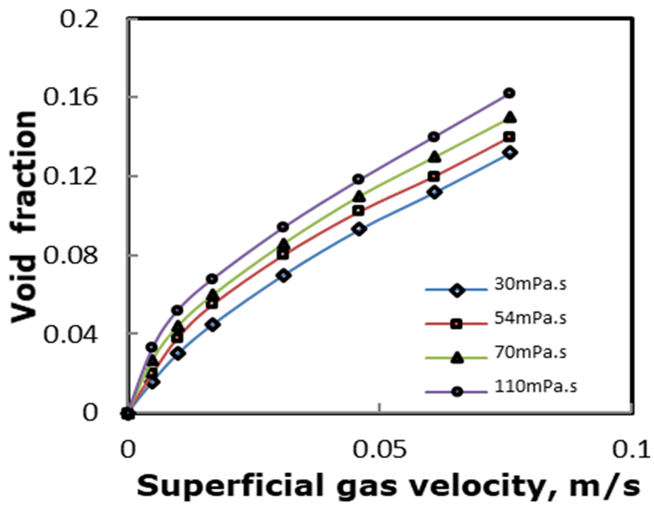
Figure 1: Kuncova and Zahradnik (1995) 's void fraction data for wet solutions of saccharose

Urseanu et al. (2003) interrogated the effect of the liquid viscosity on void fraction in two bubble columns with internal diameters of 150 and 230 mm. They achieved this by utilizing nitrogen–Tellus oil and nitrogen–glucose oil with viscosities of 70 and 550 mPa.s, respectively, as the system fluid. They reported that an increment in the liquid viscosity brings about a corresponding decrease in the total void fraction because of a significant reduction in the highly viscous liquids' dense phase. Ruzicka et al. (2003) stated that the established increases and decreases associated with the heterogeneous void fraction were observed in their 140 mm diameter column. They concluded that there was an increase in void fraction for < 3 mPa.s liquid viscosities, a decrease for 3 to 30 mPa.s moderate liquid viscosities, and an increase for higher liquid viscosity of > 30 mPa.s.
Liu et al. (2005) examined the effect of liquid viscosity on void fraction in bubble columns and found that the void fraction became more inhomogeneous due to high turbulent intensities for higher liquid viscosities. Later, Zhang et al. (2008) determined the limiting velocities of the bubbles in various sucrose and glycerol solutions and saw that an increment in liquid viscosity favours a decrease in the bubble’s velocity. They stated that the small bubbles significantly contributed to void fraction for liquid viscosities higher than 30 mPa.s. They reported that a rise in liquid viscosity increases the total void fraction. They concluded that this is true for liquid viscosities from 30 to110 mPa.s.
According to Monahan and Fox (2007), numerous studies have examined bubble columns' hydrodynamic behaviour in air–water systems for industrial processes using organic solvents. Hence, it is vital to develop experimental approaches to investigate the significance of liquid properties on bubble columns' hydrodynamic characteristics. Consequently, Pioli et al. (2012) investigated magmatic fluids' flow behaviour with viscosities in the range of 6.5–300 Pa. s in a 240 mm diameter bubble column with a mix of water and glucose syrup. They reported an increasing void fraction because of rises in both the liquid viscosity and gas superficial velocity.
Rollbusch et al. (2015) and Yan et al. (2020) reported that the knowledge of how the liquid viscosity influences void fraction is vital in safe operation, design optimization, and scale-up bubble column reactors. The knowledge of how the liquid viscosity influences void fraction was documented by Rollbusch et al. (2015) and Yan et al. (2020). They reported that such a knowledge is vital in safe operation, design optimization, and bubble column reactors’ scale-up. Yan et al. (2020) concluded that liquid properties such as liquid viscosity, specific heat capacity, surface tension, liquid density, and electrical conductivity influence the bubbles distribution and void fraction in a bubble column. Amongst these parameters, the liquid viscosity and surface tension are the two essential parameters that influence bubble columns' fluid dynamics. Kajero et al. (2018) studied how the liquid viscosity influences the flow patterns in a 50 mm internal diameter bubble column comprising liquid viscosities within 5 to 5000 mPa.s. They reported a predominance of slug flow with an increment in liquid viscosity and noted a drop in both the void fraction drop in the liquid slugs and Taylor bubbles. However, their work did not explain how the liquid viscosity influences void fraction and the flow behaviour.
Besagni et al. (2015; 2016; 2017; 2019) and Besagni and Inzoli (2017) have profoundly studied these subjects within the last few years. Their study confirmed the bubbly flow pattern's balance with many small bubbles in the low liquid viscosities due to the dual influence of liquid viscosity leading to an imbalance with a decrease in void fraction and larger bubbles in medium and high liquid viscosities. The impact of the interfacial bubble properties, according to them, are responsible for the lessening or favouring of the merging of the bubbles mechanisms. Kovats et al. (2020) experimentally examined the impact of liquid viscosity and surface tension on mass transfer and bubble dynamics by employing optical measurement techniques. They prepared a working fluid with a viscosity range of 0.86–9.29 mPa.s and surface tension range of 44.8–72.24 mN/m by mixing glycerol–water mixtures with surfactant sodium dodecyl sulphate (SDS). They confirmed the dual impact of viscosity on the bubble column dynamics earlier reported by Besagni et al. (2017).
Kajero et al. (2020) described how the liquid viscosity influences the rise velocity of the Taylor bubble using a 50 mm internal diameter column. The range of the liquid viscosities covered is 5-5000 mPa.s. They matched their electrical capacitance tomography (ECT) data results with the data gathered from the manual time series, the images recorded by high-speed camera, and data derived from the empirical correlations/models. Unfortunately, their analysis did not establish a relationship connecting the Taylor bubble's rise velocity with the gas superficial velocity. They also did not evaluate and analyze the distribution coefficient and the drift velocity for the four liquid viscosities under consideration. The drift flux approach was not used in evaluating the drift velocity, an essential parameter for mechanistic models used for gas–liquid flow analysis. According to Bohm et al. (2014), liquid viscosity variation accordingly transforms the bubble rising behaviour and that the meandering track of big bubbles becomes tighter with an increase in liquid viscosity.
Table 1: Summary of the experimental conditions: range of variables covered reported in the literature on the effect of liquid viscosity on void fraction
Author | Pipe or column diameter, mm | Gas–liquid system; temperature (ºC) and pressure (Pa) | Range of U_{SG} (m/s); range of U_{SL} (m/s) | Range of liquid properties: density (kg/m³), viscosity (mPa.s) and surface tension (N/m)
Hughmark and Pressburg (1961) | 25.4 | Air–water, saturated aqueous solution of sodium carbonate, kerosene, trichloroethylene, and two oils; | –; – | –; 5.8–28.6; –
Ellis (1965) | 160 | Air–water, aqueous glycerol and aqueous isopropanol solution; 298; 101.3 | 0.002–0.006; – | 982–1201; 1–39; 0.051–0.072
Hikita and Kikukawa (1974) | 100 and 190 | Air–water and aqueous sugar solution; 285.5–293; 101.3 | 0.043–0.338; – | 1000–1233; 1–19; 0.038–0.075
Eissa and Schugerl (1975) | 160 | Air–water, aqueous glycerol and aqueous isopropanol solution; 298; 101.3 | 0.002–0.006; – | 982–1201; 1–39; 0.051–0.072
Bach and Pilhofer (1978) | 159 | Air–aqueous glycerin solution | 0–0.1; – | –; 1–39; –
Weiss et al. (1985) | 15.1 | Nitrogen–silicone oil; –; 101.3 | 0.001–0.055; – | 812–975; 0.92–1670; 0.00092–1.67
Kantanek et al. (1993) | 150 and 300 | Air–water, aqueous glycerol solution; 285.5; 101.3 | 0.0–0.3; – | –; 1–1070; 0.022–0.073
Kuncova and Zahradnik (1995) | 152 | Air–aqueous solutions of saccharose | 0.009–0.092; – | –; 1–110; –
Kantak et al. (1995) | 150 and 250 | Air–alcohol, aqueous ethanol, aqueous butanol; –; – | 0.01–0.18; 0.005–0.03 | 993.7–1000; 3–40; 0.0571–0.0693
Zahradnik et al. (1997) | 140, 150 and 290 | Air–distilled water and tap water, aqueous solutions of electrolytes and aliphatic alcohols and aqueous butanol, aqueous solutions of saccharose; 298; 101.1 | 0.031–0.2; – | –; 3–110; 0.051–0.072
Ruzicka et al (2003) | 140 | Air–water, aqueous solution of glycerol | 0–0.14; – | –; 1–22; –
Urseanu et al. (2003) | 150 and 230 | Air–water, aqueous glycerol solution; 285.5; 101.3 | 0.007–0.15; – | 867–1380; 70–550; 0.031–0.076
Liu et al. (2005) | 0.5 and 2 | Air–deionized water, glycerin solution; 298; 101.3 | 0.007–0.15; – | 997–1184; 0.95–24.8; 0.0663–0.072
Han and Al-Dahhan (2007) | 162 | Air–water; 298; 101.3 | 0.01–0.60; – | 997; 0.89; 0.072
Zhang et al. (2008) | Side length = 0.2 m and height = 0.6 m | Air–glycerin solution, sucrose solution; 294–296; 101.3 | –; – | 1183–1308.4; 6.05–775; 0.0625–0.0812
Boltes et al. (2008) | 55 | Water–dodecane; 303; – | –; – | 750–999; 1000–1420; 0.0256–0.0642
Pioli et al. (2012) | 240 | Air–water, glucose syrup; –; – | Air–water: 0.01–1.9; –  Air–glucose syrup: 0.01–0.7; – | 1000–2800; 650–300, 000; 0.07–0.4
Azzopardi et al. (2014) | 240 | Air–glucose syrup; –; – | 0.01–0.7; – | 1450; 300, 000; 0.08
Rollbusch et al. (2015) | 160, 300 and 330 | Nitrogen–deionized water, aqueous solution of ethanol and acetone and pure acetone and cumene; 293–344; 10.13–364.68 | Air–water: 0.01–1.9; –  Air–syrup: 0.01–0.7; – | 767–998; 0.32–1; 0.022–0.074
Besagni et al. (2015) | 240 | Air–deionised water; 293; 116.5 | 0.0087–0.24; 0, -0.04, -0.08 | 1000; 1; 0.072
Besagni et al. (2016) | 240 | Air–deionised water; 295; 101.3 | 0.0037–0.0074; 0 | 1000; 1; 0.072
Besagni et al. (2017) | 240 | Air–water, monoethylene glycol solutions; 298.15; 101.3 | 0.004–0.2; – | 997.086–1094.801; 0.90–7.97; 0.0502–0.0715
Besagni and Indoli (2017) | 240 | Air–tap water, aqueous solutions of NaCl, water–ethanol mixture and solutions of water–monoethylene glycol; 298.15; 101.3 | 0.007–0.15; – | Air–EtOH: 997.086–996.2; 0.8903–0.917; 0.07067–0.0715  Air–MEG: 997.086–1094.801; 0.8903–7.9655; 0.0502–0.0715
Kajero et al. (2018) | 50 | Air–silicone oil; 298; 101.3 | 0.02–0.361; – | 915–970; 5–5000; 0.0195–0.0214
Besagni et al. (2019) | 240 | Air–deionized water, aqueous solutions of NaCl, ethanol mixture; 298.15; 101.3 | 0.004–0.23; –(0 and -0.0846) | –; –; –
Kovats et al. (2020) | 140 | Air–glycerol water mixtures, surfactant sodium dodecyl sulphate (SDS); –; – | 0.00072–0.0014; – | –; 0.86–9.29; 0.0448–0.07224
Yan et al. (2020) | 165 and 300 | Air–mixture of SEBS-1650 and cyclohexane solvent and a mixture of oleic acid and water; 298; 100 and 500 | 0.03–0.25; – | 766.9–998.2; 1–75.2; 0.0145–0.072
Current Study | 50 | Air–silicone oil; 298; 101.3 | 0.02–0.361; – | 915–970; 5–5000; 0.0195–0.0214

Table 1 shows that numerous research works have addressed the influence of fluid properties on void fraction and flow behaviour. However, no study, to the best of our knowledge, has specifically employed advanced instrumentation, electrical capacitance tomography (ECT), to interrogate how the liquid viscosity influences void fraction within a wide viscosity range. At present, Azzopardi et al. (2014), Kajero et al. (2018) and Kajero et al. (2020) are the only investigators who have utilised the ECT to study fluid dynamics in a bubble column. Azzopardi et al. (2014) focused on the properties of large bubbles, while Kajero et al. (2018) and Kajero et al. (2020) studied flow patterns and the Taylor bubbles rise velocity, respectively. In this work, three non-intrusive techniques are utilised to measure the void fraction, rising bubble velocities and frequency in a stagnant liquid in a vertical column: the electrical capacitance tomography, level swell technique and the visualisation technique with a high-speed camera. The parameters measured by these techniques are presented and discussed to examine the void fraction and flow behaviour of bubbles rising through bubble columns with the liquids having a range of viscosities from 5 to 5000 mPa.s.
2.0 Experimental Arrangements
Figure 2 displays a representation illustration of the experimental facility used in the present work. This bubble column has been used in previous gas–viscous (silicone oil) flow studies by Kajero et al. (2012; 2018; 2020). The range of viscosity of silicone oil employed in this work is 5-5000 mPa.s. The physical properties of gas–viscous liquids used are shown in Table 2.
Table 2: The properties of the gas–viscous liquids, the Eotvos, Morton, and the inverse viscosity numbers at a temperature and pressure of 1 bar ºC, respectively
Fluid | Viscosity, mPa.s | Density, kg/m³ | Surface tension, mN/m | Relative Permittivity | Eotvos number (Eo) | Mortons number (Mo) | Inverse viscosity number (N_{F})
Silicone oil | 5 | 915 | 19.7 | 2.60 | 1139 | 8.8×10⁻⁷ | 6408
 | 100 | 965 | 20.9 | 2.74 | 1132 | 0.1114 | 338
 | 1000 | 970 | 21.2 | 2.76 | 1122 | 1061 | 34
 | 5000 | 970 | 21.4 | 2.76 | 1112 | 644965 | 7
Air | 0.018 | 1.18 |  | 8.9×10⁻¹²
The vertical transparent acrylic column is 1.6 m long and has an internal diameter of 50 mm according to Kajero et al. (2012). Air was dispersed to the liquid via a single nozzle gas distributor with an orifice diameter of 6.8 mm located at the bottom of the column (Kajero et al. (2012) and Kajero et al., 2020). The gas flow into the column was controlled by valve V1. Valve V2, on the other hand, was employed to drain out liquid from the column (Kajero et al., 2012). According to Kajero et al. (2012), the gas nozzle was attached to the Solartron Mobrey flow meter (model: K5011927/2/JC/300) to quantify the volumetric flow rate of the gas. The pressure of the gas was monitored by a pressure gauge linked to the flow meter. A phantom high-speed video camera according to Kajero et al. (2012) was employed to capture the flow behaviour in the column. The frequency of 1000 pictures per second (pps) and exposure time of 100 µs, according to Kajero et al. (2012), were used. The recorded images have a resolution of 512 by 512 pixels. The reader is referred to Kajero et al. (2012; 2018; 2020) for details of the experimental facility. Also, the flow behaviour and liquid holdup/void fraction data were gathered using both the electrical capacitance tomography (ECT) instrument and the Level Swell measuring technique.
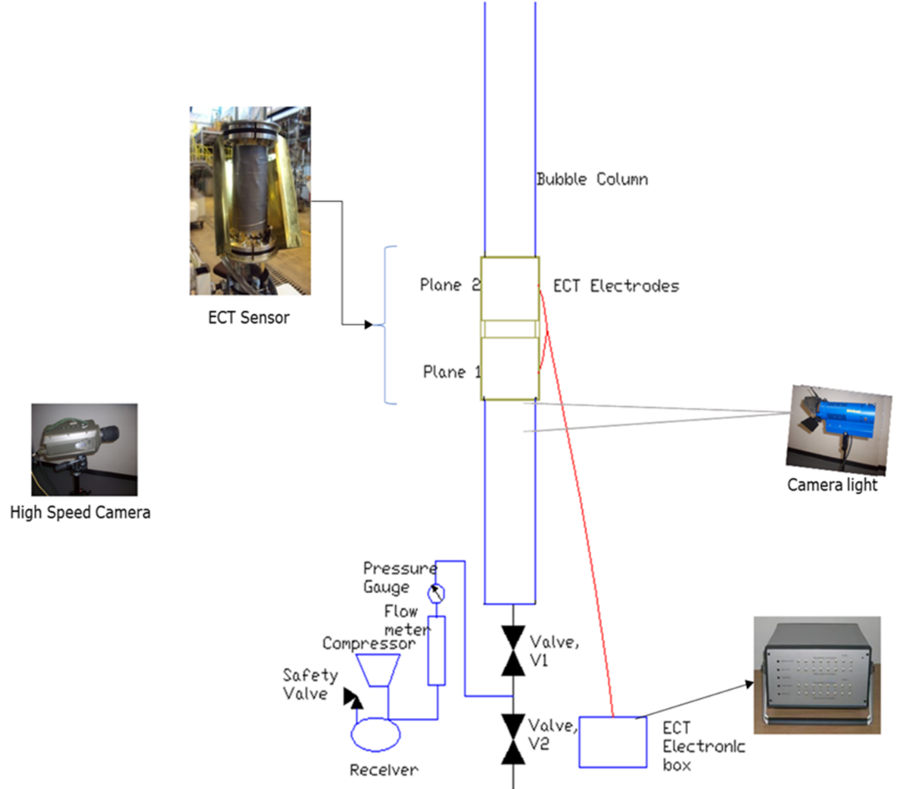
Figure 2: Schematic representation of the 50 mm internal diameter experimental bubble column facility deployed in this work

The ECT has twin planes made up of 8-electrodes that comprises measurement and driven guard electrodes with dimensions of 2×8×29 mm (Kajero et al., 2012). The twin planes are separated by a distance of 30 mm. According to Kajero et al. (2012), the signals from the electrodes were fed to a processor box connected to the ECT processor box. The processor provides 28 measurements sent to the computer for image reconstruction (Kajero et al., 2012). Liquid holdups were extracted from these reconstructed images. For specifics of the ECT procedure, the reader is referred to Abdulkadir et al. (2014b; 2016; 2018; 2020). In this work, the ECT was situated at approximately 0.8 m beyond the gas orifice, while, on the other hand, the still liquid level was positioned at about 0.095 m above the ECT sensor, similar to Kajero et al. (2018; 2020). It is worth mentioning that there is the possibility that the flow scenario is not developed.

The name "level swell" was derived from the swell or rise in the liquid level when the gas is introduced into the stagnant liquid in the column. This swell or rise is due to the formation of gas void in the liquid. It can also be defined as the relative vertical expansion of a two-phase region due to the presence of gas void. The level swell is the difference between the new liquid height after the gas was introduced and the height of initial stagnant liquid in the column. Figure 3 shows the variation in the liquid's height due to an increase in gas superficial velocity.
H_{o}
H_{min}
H_{avg}
H_{max}
Maximum and minimum
height due to fluctuations caused
By large bubbles bursting
On the surface of the liquid
Figure 3: Maximum, minimum, and average height due to fluctuations on the surface of the liquid in the column

From Figure 3, H_{min} and H_{max} are the minima and maximum heights achieved, respectively, during level swell due to periodic fluctuations, H_{avg} is the average of both the minimum and maximum values, and H_{o} is the initial height of the liquid.
The bursting of large bubbles on the liquid’s surface was observed to bring significant challenges with determining the liquid level. This problem became more severe at the higher gas superficial velocities as the large bubbles subsequently burst on the liquid surface. The problem was overwhelmed using the following concepts:
A maximum height was achieved when the large Taylor bubble's nose rose to the top of the liquid surface while its tail was buried in the liquid. On the other hand, the liquid level dropped to a minimum value because of the Taylor bubble bursting into smaller bubbles. Matsen et al. (1969) used the maximum height in the determination of the void fraction while, on the other hand, Ueda and Koizumi (1993) and Azzopardi et al. (2014) used the average height from both the maxima and minima of the fluctuated mixture level. Ueda and Koizumi (1993) and Azzopardi et al. (2014) pointed out that the two-phase mixture level swelled and was accompanied by periodic fluctuations as gas superficial velocity increased. They reported that the use of the maximum height led to much higher void fractions as compared with the ECT data. They concluded that a significant disparity was observed between the two methods - ECT and level swell when the average of both the minimum and maximum liquid heights was used to calculate the void fraction. In the present experimental work, this minimum height was taken as the new liquid height. Hence, the new liquid height was taken after the Taylor bubbles rise and collapse on the liquid surface. The void fraction was hence calculated from the level well results using equation (2). The ECT instrument provided the liquid holdup of the gas–viscous liquid mixture from which the void fraction was derived.

$ε_{B}= \frac{V- V_{o}}{V}$ (1)
At constant cross-sectional area of column, void fraction is given as:
$ε_{B}=\frac{H- H_{o}}{H}$ = $\frac{∆H}{H}$ (2)
Where $ε_{B}$ = void fraction; V = volume of the aerated column; V_{o} = volume of the gas–free liquid; H_{o} = initial liquid height before the gas is injected; H = minimum level after the gas bubbles burst into the surface, and ∆H = the difference between the liquid levels
In conclusion, the cross-sectional average void fraction from the ECT is the part of the region filled by the gas in the gas–viscous liquid mixture relative to the sensor cross-sectional section. In contrast, the volumetric average void fraction from level swell is the void fraction relative to the column's total height.
2.1 Measurement uncertainty of void fraction obtained using the ECT and level swell techniques
Tables 3 and 4 show the uncertainty, otherwise called the standard deviation in the ECT and level swell technique at a 0.028 m/s gas superficial velocity for 5, 100, 1000, and 5000 mPa.s liquid viscosities due to inconstancies of the individual void fraction about the average. Each experimental run was repeated three times to determine the standard deviation. The standard deviation, s of the measured void fraction, was determined from equation (3).
$s=\sqrt{\frac{\sum{{(ε_{i}-\overline{ε})}^{2}}}{N-1}}$ (3)
Where,
$\overline{ε}$ represents average void fraction
$ε_{i}$ represents individual void fraction
Table 3: Uncertainty in the measured void fraction obtained using the ECT and level swell technique data at 0.028m/s gas superficial velocity and liquid viscosities of 5, 100, 1000 and 5000 mPa.s

Liquid viscosity, mPa.s | Void fraction measurement uncertainty obtained using the ECT | Void fraction measurement uncertainty obtained using the level swell technique
5 | 0.11$±$0.4% | 0.13$±$0.9%
100 | 0.11 $±$1.0% | 0.10 $±$0.9%
1000 | 0.13 $±$1.5% | 0.16 $±$1.1%
5000 | 0.20 $±$ 1.6% | 0.27 $±$ 0.7%

Table 3 shows that the calculated s of void fraction from the ECT measurement progresses from 0.4 to 1.6% with increasing liquid viscosity. The s of the void fraction from the level swell technique, on the contrary, increased from 0.9 to 1.1% and then decreased to 0.7%.
Following Drosg (2007), the reproducibility or precision of the data, σ is obtained from:
$σ= s/\sqrt{N}$ (4) where, N = number of experimental data points.
Table 4 summarizes the reproducibility of the data measured by the ECT and level swell technique for 5, 100, 1000, and 5000 mPa.s liquid viscosities at a gas superficial velocity of 0.028 m/s. As given by Tomoflow electronics, the repeatability of the ECT instrument, TFLR 5000–20 standards, is 0.2%. The experimental data from the two methods are compared against a system error. The result of the comparison is shown in the table. It shows that the uncertainty of the experimental results is in satisfactory range.
Table 4: Repeatability of the measured data

Viscosity, mPa.s | ECT (%) | Level swell (%) | TFLR 5000–20 standard (%)
5 | 0.1 | 0.2 | 0.2
100 | 0.3 | 0.2
1000 | 0.4 | 0.3
5000 | 0.3 | 0.2

3.0 Results and discussion
The void fractions obtained using the ECT and the level swell technique are reported in this section at a gas superficial velocity of 0.02–0.361 m/s for various 5, 100, 1000, and 5000 mPa.s liquid viscosities in a 50 mm bubble column.
3.1 Comparison between the ECT and level swell void fraction results
As the liquid surface was unstable, care was taken to record the average increased level. The determined void fraction from the ECT's output shown in Figure 4 is comparable to the data from the level swell measurements. The figure shows excellent agreement within ±10% between the obtained void fraction using the ECT and level swell techniques for all the liquid viscosities considered except in a few highlighted areas in red presented in Figure 4(a, b) that are within ±20%.
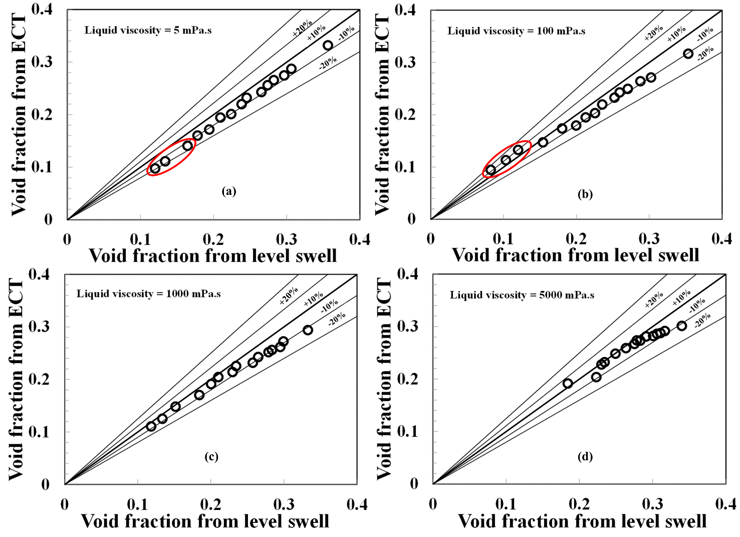
Figure 4: Comparison between ECT and Level Swell for different liquid viscosities
3.2 Average void fraction
a) Flow behaviour using the time trace (series) of void fraction:
The time series of measured void fraction from the ECT can be employed to explain the flow behaviour. Figure 5(a–d) reveals how the liquid viscosity influences the void fraction data at a 0.361 m/s gas superficial velocity. Figure 5a shows that coalescence is limited when the liquid viscosity is 5 mPa.s, and the significant drag force decreases the rise velocity of the Taylor bubble thereby, provoking an increase in the void fraction. Also, large bubbles of various sizes are observed. Furthermore, the lengths of the Taylor bubbles and liquid slugs are nearly equivalent. When the liquid viscosity increases to 100 mPa.s, the bubbles' size, liquid slugs, and Taylor bubbles lengths, as seen in Figure 5b, have no significant difference from those seen in Figure 5a.
When the liquid viscosity is increased to 1000 mPa.s as shown in Figure 5c, the tendency for the bubbles to coalesce predominates, producing big bubbles, ascending in the column at a higher velocity, consequently decreasing the void fraction. The figure also confirms that the bubbles have become more even, as shown in Figures 6 and 7. On the other hand, the liquid slugs for the case of liquid viscosity of 1000 mPa.s have become shorter compared to the liquid slugs for the liquid viscosities of 5, 100, and 5000 mPa.s. It is worth mentioning that there is still a variety of bubbles. In contrast, for liquid viscosity of 5000 mPa.s, the bubbles have grown markedly longer and bigger, and the liquid slugs, contrarily, have evolved shorter compared to the earlier two cases, 5 and 100 mPa.s liquid viscosities. The noted trend shown in Figure 5(c–d) indicates that the liquid viscosities of 1000 and 5000 mPa.s increases the probability for the coalescence of small minute bubbles in the column, thereby becoming a gigantic bubble. This behaviour coincides with Yan et al. (2020) conclusions; they observed that many large bubbles are available in the medium-high liquid viscosity column under the same operating conditions compared to the low viscosity column.
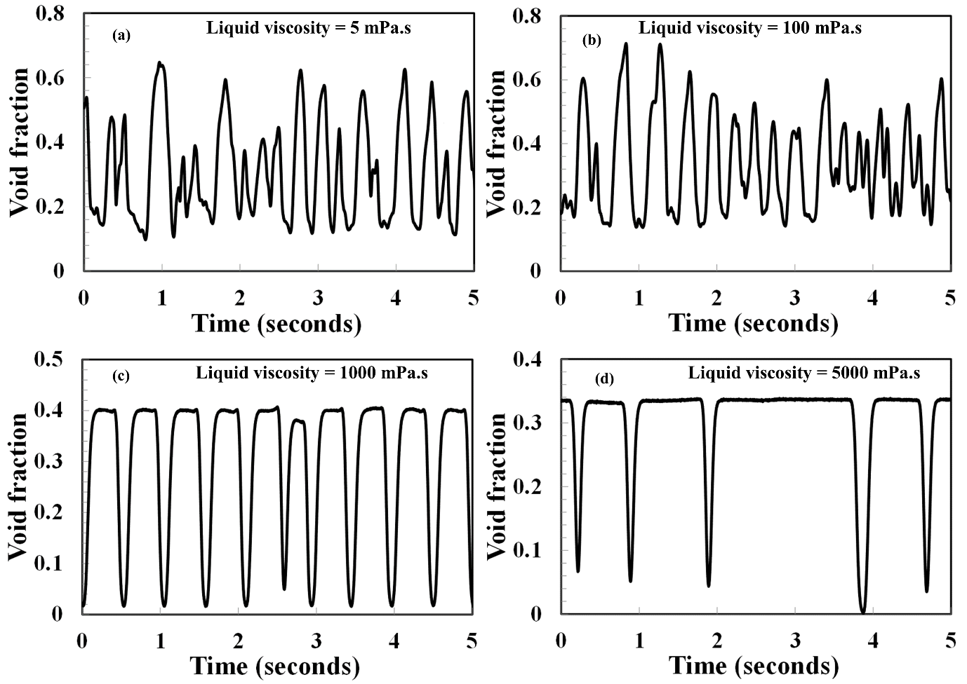
Figure 5: Time trace (series) of average void fraction at a gas superficial velocity of 0.36 m/s and for liquid viscosities (mPa.s) of (a) 5 (b) 100 (c) 1000 (d) 5000

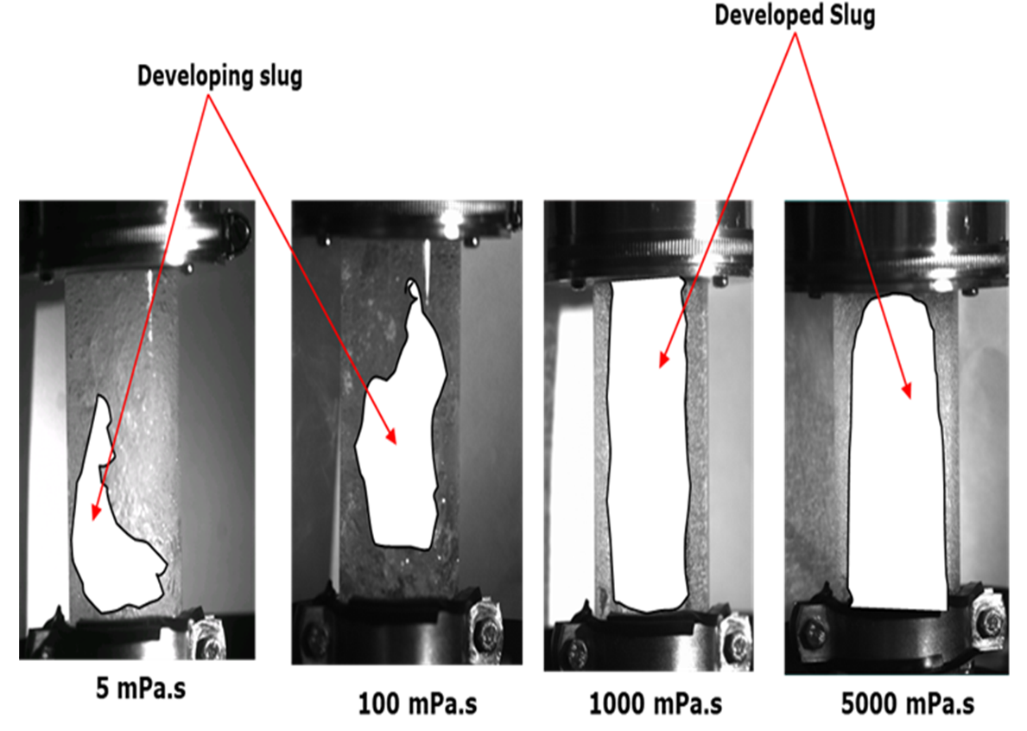
Figure 6: The high-speed camera still images revealing developments in-bubble size
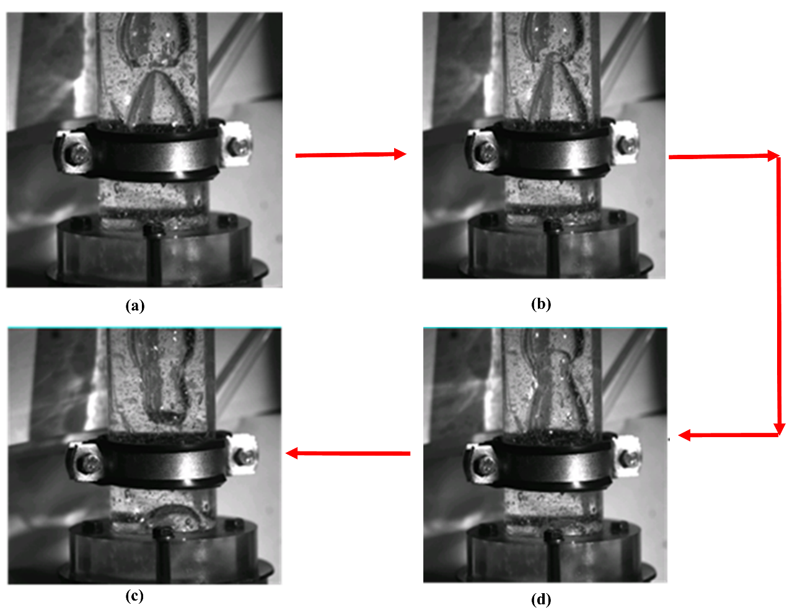
Figure 7: Coalescence in 1000 mPa.s liquid viscosity

b) Weighing the difference between the obtained void fraction using the ECT and the void fraction using the level swell technique
It is worth mentioning that in the present experiments involving viscous silicone oil of varying viscosity, it was observed that for virtually all the superficial velocities considered, the gas moves essentially in large (Taylor) bubbles that fill a substantial part of the column's cross-section. Small bubbles are created: (i) when two Taylor bubbles coalesce and (ii) most ordinarily, at the erupting of bubbles at the upper surface of the liquid. The formed bubbles, which are negligible in size (according to Azzopardi et al., 2017), are called tiny bubbles. They are rarely visible to the naked eye. Much more striking is the light scattering effect: the transparent silicone oil at the start resembles milk in colour or consistency. The silicone oil matching milk colour began at the upper section of the column and, beyond about an hour of constant activity, spread to the entire column. See page 20.
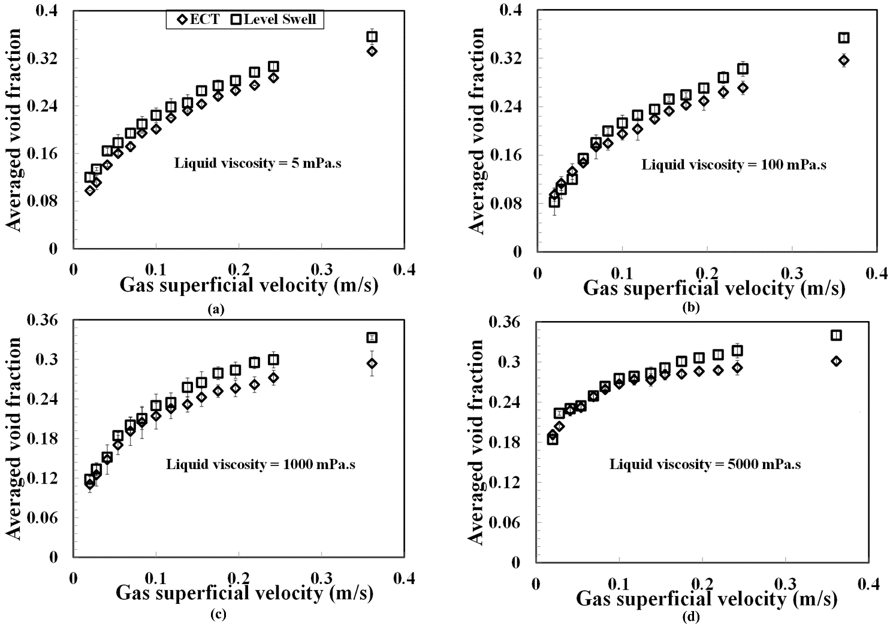Figure 8: Comparison between the ECT and level swell technique. The standard deviation is represented as error bars

Figure 8(a–d) shows that the void fraction from the ECT and level swell technique agree with each other within ±5%, especially at gas superficial velocities lesser than 0.15 m/s. On the other hand, the determined void fraction from the level swell technique is more noticeable at higher gas superficial velocities than those obtained from ECT. Ueda and Koizumi (1993) reported a similar observation. The degree of agreement reduces with an increment in the gas superficial velocity. Notwithstanding, there is much higher uncertainty in the level swell measurement at these higher gas superficial velocities. According to Azzopardi et al. (2017), the gradual draining wall film and the silicone oil resembling milk colour make a recording of the average location of the top surface highly uncertain.

c) How the gas superficial velocity and liquid viscosity influences void fraction
Figure 9(a–d) demonstrates the impact of gas superficial velocity on void fraction under various liquid viscosities. The figure shows that void fraction is expanding with increasing gas superficial velocity but less sensitive to changes in liquid viscosity from 5 and 1000 mPa.s and become nevertheless markedly sensitive at a higher liquid viscosity of 5000 mPa.s.
Figure 9: The effect of gas superficial velocity and liquid viscosity on void fraction using the ECT. The error bar represents the standard deviation

Figure 9 shows that the average void fraction converges with increasing gas superficial velocity and becomes almost equal at a 0.25 m/s gas superficial velocity for all the liquid viscosities studied. The average void fraction at the highest gas superficial velocity of 0.361 m/s decreases with increasing liquid viscosity. The observed increase is consistent with Weiss et al. (1985) 's findings; they observed increases in the void fraction as liquid viscosity increases for a small diameter vertical pipe of 15.1 mm. The observed decrease, on the other hand, in the void fraction agrees with the conclusions of Ellis (1965), Eissa and Schugerl (1975), Bach and Pilhofer (1978), who used pipe diameters larger than 50 mm. The difference between the findings of the present study and that of reported works could be because:
- The bubble columns have different internal diameters.
- Different liquid viscosities were used.
Table 5 presents the details between the findings of the present study and those of the reported works:
Table 5: Comparison of current study with previous published works on the effect of liquid viscosity on void fraction
Author | Pipe or column diameter, mm | Range of viscosities (mPa.s) | Density (kg/m³) and surface tension (N/m) | Eotvos number, Eo | Mortons number, Mo | Dimensionless inverse viscosity number, N_{f} | Effect on void fraction
Hughmark and Pressburg (1961) | 25.4 | 5.8–28.6 | – and – | – | – | – | An increment in liquid viscosity provokes a corresponding drop in void fraction.
Hikita et al. (1980) | 100 and 190 | 0.70–13.80 | 998 and 0.072 | 1360– 4909 | 2.63×10⁻⁸ | 17, 586 | An increment in liquid viscosity provokes a corresponding drop in void fraction.
Ellis (1965), Eissa and Schugerl (1975), and Bach and Pilhofer (1978) | 159 | 1–39 | 982–1201and 0.052–0.072 | 4137– 4775 | 7.4×10⁻⁸– 0.0608 | 1039–34, 828 | 1–3 mPa.s: Void fraction increases and gets to a maximum at 3 mPa.s. 3 ≤ µ ≤ 11 mPa.s: Void fraction decreases with increasing liquid viscosity  11–39 mPa.s: Almost constant slow rate of void fraction decrease
Kuncova and Zahradnik (1995) | 152 | 1–110 | – and – | – | – | – | µ = 1 to 3 mPa.s: An increment in liquid viscosity provokes a corresponding rise in void fraction.  µ ≈ 3 mPa.s: Void fraction reaches a maximum  µ > 3 mPa.s: An increment in liquid viscosity provokes a corresponding drop in void fraction.  30 ≤ µ ≤ 110 mPa.s: An increment in liquid viscosity provokes a corresponding rise in void fraction.
Ruzicka et al (2003) | 140, 0-0.14 m/s | 3–30 | – and – | – | – | – | µ < 3 mPa.s: An increment in liquid viscosity provokes a corresponding rise in void fraction.  3 < µ <30 mPa.s: An increment in liquid viscosity provokes a corresponding drop in void fraction.  µ > 30 mPa.s: An increment in liquid viscosity provokes a corresponding rise in void fraction.
Urseanu et al (2003) | 150 and 230 | 70–550 | 867–1380 and 0.031–0.076 | 6137–9423 | 7.9–2045 | 142–414 | An increment in liquid viscosity provokes a corresponding drop in void fraction.
Current Study | 50 | 5–5000 | 915–970 and 0.0195–0.0214 | 1112–1151 | 8.27×10⁻⁴– 6.26×10⁸ | 1.22–1165 | An increment in liquid viscosity provokes a corresponding rise in void fraction, yet the influence is seen to reverse for gas superficial velocities beyond 0.25 m/s.

It can be concluded, therefore, that the Eo, Mo and N_{f} obtained from the literature as shown in Table 5 are (1360–9423), (7.4×10⁻⁸–2.63×10⁸) and (142–34828), respectively. While, on the other hand, the Eo, Mo and N_{f} determined from the present study are (1112–1151), (8.27×10⁻⁴–6.26×10⁸) and (1.22–1165), respectively.
d) Comparison between experimental void fraction against the void fraction obtained from theoretical models:
The average void fraction models proposed by de Cachard and Delhaye (1996), Degaleesan (1997), a modified version of the Viana et al. (2003), and the drift flux model of Zuber and Findlay (1965), representing equations (5), (13), (14) and (25), respectively, are as follows:
de Cachard and Delhaye (1996) model:
The averaged void fraction, $ε,$ is determined from:
$ε= \frac{U_{SG}}{V_{G}}= \frac{U_{SG}}{C_{o}U_{m}+ V_{o} }$ (5)
Where,
U_{m,} V_{o}, and V_{G} represent the mixture, drift and actual gas velocities, respectively
$U_{m}= U_{SG}+ U_{SL}=U_{SG}$; $U_{SL}$ is the liquid superficial velocity which is zero here since the liquid is stagnant
C₀ represents the distribution coefficient
U_{SG} represents the gas superficial velocity
$V_{o}= Γ {(Dg)}^{1/2}$ (6)
$Γ=0.345 (1-e^{-\frac{0.01N_{f}}{0.345}})\left[1-e^{(3.37-B_{o})/p}\right]$ (7)
$N_{f}$ is the inverse dimensionless viscosity defined as:
$N_{f}$=${\left[\frac{\left(ρ_{L}-ρ_{G}\right)ρ_{L}gD^{3}}{μ_{L}^{2}}\right]}^{1/2}$ (8)
The Bond number, B_{o} is determined from:
$B_{o}=\frac{g\left(ρ_{L}-ρ_{G}\right)D^{2}}{σ}$ (9)
D and g represent the internal pipe diameter and the value of gravitational acceleration, respectively
$ρ_{L}$ and $ρ_{G}$ represent the liquid and gas densities, respectively
$σ$ and $μ_{L}^{2}$$μ_{L}$ represent surface tension and liquid viscosity, respectively
Condition for p:
p = 10 for $N_{f}$ > 250 (10)
p = 69(${N_{f})}^{-0.35}$ for 18 <$N_{f}$<250 (11)
p = 25 for $N_{f}$<18 (12)
The correlation of Degaleesan (1997):
Degaleesan (1997) developed a correlation based on literature and her air–water system data at atmospheric pressure in different column diameters. Her proposed correlation in the CGS unit is as follows:
$ε=0.07U_{SG}^{0.474-0.000626D}$ (13)
Modified form of the Viana et al. (2003) model:
The averaged void fraction is determined from:
$ε= \frac{U_{SG}}{V_{G}}= \frac{U_{SG}}{C_{o}U_{m}+ V_{G} }$ (14)
Where,
$V_{G}=\left\{ 2.29\left[1- \frac{20}{E_{o}} \left(1- e^{-0.0125E_{o}}\right)\right]\right\}J+ \sqrt[Fr]{Dg}$ (15)
Fr = L[R; E,F,G, J] ≡ $\frac{E}{{\left(1+{\left(\frac{Re}{F}\right)}^{G}\right)}^{J}}$ (16)
Where Re is the Reynolds number
E = L[$E_{o};e,f, g, h]$ = $\frac{e}{{\left[1+ {\left(\frac{E_{o}}{f}\right)}^{g}\right]}^{h}}$ (17)
F = L[$E_{o};i, j, k, l]$ = $\frac{i}{{\left[1+ {\left(\frac{E_{o}}{j}\right)}^{k}\right]}^{l}}$ (18)
G = L[$E_{o};m,n,o, p]$ = $\frac{m}{{\left[1+ {\left(\frac{E_{o}}{n}\right)}^{o}\right]}^{p}}$ (19)
J = q/G (20)
and the parameters (e, f,.., p) are:
e = 0.34; f = 14.793; g = -3.06; h = 0.58; i = 31.08; j = 29.868; k = -1.96; l = -0.49; m = -1.45; n = 24.867; o = -9.93; p = -0.094; q = -1.0295
$C_{o}=2.29\left[1- \frac{20}{E_{o}} \left(1- e^{-0.0125E_{o}}\right)\right]$ for laminar flow (21)
$C_{o}=\frac{logRe+0.309}{\log{Re-0.743}}\left[1- \frac{2}{E_{o}} \left(3- e^{-0.025E_{o}}\log{Re}\right)\right]$ for turbulent flow (22)
$Re= \frac{ρ_{L}{DU}_{m}}{v_{L}}$ (23)
$E_{o}= \frac{ρ_{L}D^{2}g}{µ}$ (24)
Drift flux model of Zuber and Findlay (1965):
The average void fraction is determined from equation (25)
$ε= \frac{U_{SG}}{V_{G}}= \frac{U_{SG}}{C_{o}U_{m}+ V_{DG} }$ (25)
Where,
V_{DG} represent the drift velocity
C_{o} and V_{DG} are determined from the slope and intercept from the plot of V_{G} against mixture velocity, U_{m}.
Figure 10(a–d) and Table 6 compare the present experimental void fractions determined by ECT and level swell technique with those predicted by empirical correlations of de Cachard and Delhaye (1996), Degaleesan (1997), drift flux model of Zuber and Findlay (1965) and the modified form of the Viana et al. (2003) model.
The average relative error defined in equation (26) is used as a tool for the comparison.
$\% Average relative error= \frac{|{\left({}_{B}\right)}_{experiment }- {\left({}_{B}\right)}_{theory }| }{{\left({}_{B}\right)}_{experiment }} 100$ (26)
Where,
($ε_{B}$) _{experiment} is the void fraction determined from experiments and ($ε_{B}$) _{theory} is the void fraction obtained using reported models
A reasonably good agreement within ±5% is seen as shown in Figure 10 (a–b) between experiments and the predicted values by de Cachard and Delhaye (1996), Degaleesan (1997), and the modified form of the Viana et al. (2003) models. However, the empirical correlations by de Cachard and Delhaye (1996) and the modified form of the Viana et al. (2003 predict void fraction excellently within ±2%. This is not surprising because the equations proposed by them are dependent on the liquid viscosity, density and surface tension. On the other hand, the prediction by the correlation of Degaleesan (1997), which is independent of liquid viscosity, density and surface tension, show a reasonably good agreement within ±10%.
Figure 10: Matching the obtained void fraction from experiments (ECT and level swell techniques) with the void fraction predicted by the drift-flux, Degaleesan (1997), de Cachard and Delhaye (1996) and modified form of the Viana et al. (2003) models. The error bar represents the standard deviation

Table 6: Comparison between experiments, ECT and level swell technique, against the models/correlations of de Cachard and Delhaye (1996), Degaleesan (1997) and modified form of the Viana et al. (2003)

Viscosity (mPa.s) | % Average relative error
 | de Cachard and Delhaye (1996) and ECT | de Cachard and Delhaye (1996) and level swell | Modified form of the Viana et al. (2003) and ECT | Modified form of the Viana et al. (2003) and level swell | Degaleesan (1997) and ECT | Degaleesan (1997) and level swell
5 | 8.7 | 9.9 | 8.8 | 9.7 | 12.6 | 13.2
100 | 12.0 | 4.9 | 12.1 | 4.9 | 15.0 | 5.3
1000 | 18.2 | 13.9 | 16.8 | 12.6 | 9.2 | 6.5
5000 | 38.2 | 32.5 | 64.2 | 57.9 | 32.2 | 30.7

The degree of matching between experiments and the predicted values, however, weakens with an increase in the liquid viscosity from 1000 to 5000 mPa.s. Figure 10c shows that the Degaleesan (1997) correlation demonstrates a superior prediction of void fraction within ±10% for the 1000 mPa.s liquid viscosity. An examination of the void fraction trend for the 5000 mPa.s (Figure 10d) reveals that all the four correlations under consideration here are unable to predict void fraction.
Figure 10 (a–d) and Table 6 show that the drift flux model does not fit the experimental data and is thus not recommended for applications involving liquids with viscosities ranging from 5 to 5000 mPa.s.
3.3 How the liquid viscosity influences bubble frequency:
The bubble frequency was determined using the power spectral density (PSD) methodology described in Abdulkadir et al. (2014b) by examining the oscillations in the time trace of void fraction. Figure 11 reveals that the bubble frequency generally increases, decreases, and maintains an almost uniform profile with an increase in the gas superficial velocity. The increase in bubble frequency can be attributed to the intensified breakup of the large bubbles into smaller ones due to decreased bubble stability. Conversely, the observed decreases in the bubble frequency are primary caused by an increase in bubble size due to the higher coalescence promoted by large drag forces. The almost uniform profile is an indication that the gas superficial velocity has a minor influence on the bubble frequency.
Figure 11: How the gas superficial velocity influences bubble frequency for various liquid viscosities. The error bar represents standard deviation

An increase in the liquid viscosity from 5 to 5000 mPa.s, as shown in Figure 11, causes the surface tension force to increase owing to viscous effects. As a result, the bubble size increases through an increase in the level of bubbles cohesion and so an increase in the neighbourhood to which the bubbles agglomerate due to coalescence. Consequently, this brings about a decrease in bubble frequency with an increase in liquid viscosity. This observation matches the Mori et al. (1999) conclusion; they reported that the bubble frequency also reduces with increasing liquid viscosity.
3.4 Flow behaviour using the dimensionless groups Froude, Eotvos, and inverse viscosity numbers
The rise velocity of the Taylor bubble in a stagnant liquid, according to Wallis (1969), Viana et al. (2003), Joseph (2003), and Azavedo et al. (2020), depends on three dimensionless groups: the Eotvos number Eo, Froude number F_{r}, and the inverse viscosity number N_{f}. The authors explained the condition that one of these groups dictates the flow behaviour. Viscosity dictates a Taylor bubble's motion moving in a vertical column or tube when N_{f} < 2 and Eo > 40, and inertia favours when N_{f} >300 and Eo > 40. They concluded that surface tension dictates when the bubble is stationary, which happens when Eo < 3.37. According to White and Beadmore (1962), viscous effects dominate when N_{f}² > 3×10⁵. It is worthy of mention that Wallis (1969) initially determined the control of the Taylor bubble's rise by inertial and viscous forces.
The Fr, Eo, and N_{f} are represented by equations 27, 24, and 28, respectively. The determined values of Fr, Eo, and N_{f} are presented in Table 7 to help in the explanation of flow behaviour.
$Fr=\frac{U_{SG}}{\sqrt{gD}}$ (27)
(28)
Table 7: Flow behaviour using dimensionless numbers
Viscosity, mPa.s | Eotvos number (Eo) | Mortons number (Mo) | Inverse viscosity number (N_{f}) | The square of the inverse viscosity number (N_{f}²) | Comments
5 | 1139 | 8.8×10⁻⁷ | 6408 | 4.1×10⁷ | Eo > 40 and N_{f} > 300
100 | 1132 | 0.1114 | 338 | 1.1×10⁵ | Eo > 40 and N_{f} > 300
1000 | 1122 | 1061 | 34 | 1.156×10³ | Eo > 40, N_{f} < 300, and N_{f}² < 3×10⁵
5000 | 1112 | 644965 | 7 | 4.9×10 | Eo > 40, N_{f} < 300, and N_{f}² < 3×10⁵

Table 7 shows that the flows for the 5 and 100 mPa.s liquid viscosities are governed by inertia effects. On the other hand, the categorization of the flow behaviour for the 1000 and 5000 mPa.s liquid viscosities using the three dimensionless groups is not clear. This is so because the Nf's value shown in Table 7 is less than 300 but bigger than 2. Hence, necessitating the usage of the criterion provided by White and Beadmore (1962) using the square of the inverse viscosity number. The flow is, therefore, governed by viscous effects according to Table 7.
3.5 How the liquid viscosity influences the rise velocity of the Taylor bubble:
The rise velocity of the Taylor bubble comprises two principal parts: the maximum mixture velocity (which in this work is the ultimate gas superficial velocity for a stagnant liquid) and the bubbles drift velocity depicted in equation (29), as suggested by Nicklin et al. (1962).
The rise velocity of the Taylor bubble as indicated by Nicklin et al. (1962) is given as:
$U_{N}= C_{o}U_{m}+ V_{gD}$ (29)
$U_{m} = U_{SG}$ (Here, $U_{SL}$ which is the liquid superficial velocity and is zero since the liquid is stagnant)
Equation (29) thus becomes Equation (31)
$U_{N}= C_{o}U_{SG}+ V_{gD}$ (30)
The values of C₀ and V_{gD} are obtained from Figure 12, a U_{N} plot against U_{SG} using equation (30). The U_{N} is obtained through cross-correlating the time series of void fraction data out of the 2 ECT planes separated by 30 mm. Figure 12 shows that V_{gD}, for the ECT data, is the y-intercept. At the same time, the line's slope provides the C₀. Also shown is the prediction of equation (35) with U_{N} = 1.2 m/s and V_{gD} = 0.2351 m/s. Nicklin et al. (1962) proposed the values in 1962.

Figure 12: Experimentally measured Taylor bubble's rise velocity against the gas superficial velocity for various liquid viscosities. The error bar represents the standard deviation

If the Taylor bubble’s rise velocity is made linear versus the gas superficial velocity, the slope C₀ and the intercept V_{gD} are found to be:
C₀ = 1.08 and the intercept V_{gD} = 0.49 m/s for the 5 mPa.s.
C₀ = 1.18 and the intercept V_{gD} = 0.49 m/s for the 100 mPa.s.
C₀ = 1.32 and the intercept V_{gD} = 0.23 m/s for the 1000 mPa.s.
C₀ = 1.61 and the intercept V_{gD} = 0.13 m/s for the 5000 mPa.s.
The correlating lines pertaining to the graph thus have the following relationships
$U_{N}=1.08U_{SG}+0.49=1.08U_{SG}+0.70\sqrt{gD}$ for the 5 mPa.s (31)
$U_{N}=1.08U_{SG}+0.49=1.08U_{SG}+0.70\sqrt{gD}$ for the 100 mPa.s (32)
$U_{N}=1.32U_{SG}+0.23=1.32U_{SG}+0.33\sqrt{gD}$ for the 1000 mPa.s (33)
$U_{N}=1.61U_{SG}+0.13=1.61U_{SG}+0.19\sqrt{gD}$ for the 5000 mPa.s (34)
$U_{N}=1.2U_{SG}+0.2451=1.2U_{SG}+0.35\sqrt{gD}$ Nicklin et al. (1962) correlation (35)
The prediction shows different agreement levels with the experimental data, which is not surprising because:
(1) the influence of liquid viscosity on C₀ is not pronounced at 5 and 100 mPa.s liquid viscosities shown in Figures 12 and 13a. As a result, the flow is inertia controlled, as indeed confirmed in Table 7. The obtained flow distribution coefficient values for these liquid viscosities are near 1.2, obtained using equation (35) for a maximum velocity of fully developed turbulent flow. On the other hand, for a 1000 mPa.s liquid viscosity, the influence of liquid viscosity on C₀ is becoming noticeable. For a 5000 mPa.s liquid viscosity, due to the laminarization of the flow, the flow is consequently governed by viscous effects as predicted in Table 7; the distribution coefficient is 1.61, which is close to the proposed value of 2.0 by many authors such a Nicklin et al. (1962) and Viana et al. (2003) for laminar flow. Kouba (1987) concluded using experiment that for some flow situations, C₀ might be as high as 1.8.
(2) The non-zero intercept shown in Figure 12 is associated with the bubbles drift velocity. According to Benjamin (1968), the appearance of drift velocity results from gravity currents, and that it depends on the pipe's internal diameter. The encountered large values of bubble drift velocity, V_{gD}, shown in Figure 14b for 5 and 100 mPa.s liquid viscosities may be associated with the lower flow resistance at these liquid viscosities than the other liquid viscosities.
Figure 13: How the liquid viscosity influences the (a) flow distribution coefficient and (b) drift velocity. The error bar represents the standard deviation
The result in Figures 12 and 13, including Table 8, show that the drift velocity is independent of liquid viscosity for 5 and 100 mPa.s. Here, the drift coefficient is 0.7 for the two liquid viscosities, which corresponds to a drift velocity of $0.7\sqrt{gD}=0.49 m/s$. Interestingly, the dependency of drift velocity on liquid viscosity becomes apparent at higher liquid viscosities of 1000 and 5000 mPa.s and shows that the drift velocity declines with an increase in the liquid viscosity. This observation is in agreement with the conclusions of Zukoski (1966), Alves et al. (1993), and Gokcal et al. (2009).
Table 8: Summary of some critical works on drift velocity
S/N | Author | Pipe diameter and flow orientation | Fluid system | Viscosity (mPa.s) | Drift coefficient
1 | Zukoski (1966) | 0.5 to 17.8 and inclined upward flow | Water, carbon tetrachloride, mercury, glycerine, and ethyl alcohol | 1, 0.91, 1.5, 950, 1.095 | 0.345
2 | Alves et al. (1993) | 5.1 and inclined upward flow | Kerosene | 1.6 | 0.3537
3 | Gokcal et al. (2009) | 5.08, 7.62, and 15.24 and inclined upward flow in bubble columns | Water and viscous oil | 1 to 1237 | 0.364
4 | Current study | 5 and vertical upward flow in a bubble column | Silicone oil | 5 to 5000 | 0.7 for the 5 and 100 mPa.s liquid viscosities  0.33 for the 1000 mPa.s liquid viscosity  0.19 for the 5000 mPa.s liquid viscosity

The values of drift velocity seen in this study are $0.33\sqrt{gD}=0.23 m/s$ and $0.19\sqrt{gD}=0.13 m/s$ for the higher liquid viscosities of 1000 and 5000 mPa.s, respectively. The observed drift coefficient value of 0.33 for the liquid viscosity of 1000 mPa.s is close to the value obtained by Zukoski (1966), Alves et al. (1993), and Gokcal et al. (2012). The three authors shown in Table 7 obtained $0.364\sqrt{gD}$, $0.3537\sqrt{gD}$, and $0.345\sqrt{gD}$, respectively. On the other hand, the drift coefficient is 0.19 for the liquid viscosity of 5000 mPa.s, which is very small compared to the three reported values. This is not surprising because, for this liquid viscosity, the gas bubbles' resistance to intrusion into the stagnant liquid increases, and consequently, the drift velocity is small.
In conclusion, liquid viscosity's influence on the Taylor bubble's rise velocity strongly depends on the liquid viscosity range.
3.6 Drift Flux Analysis:
Many pieces of research have utilized the drift flux method provided by Zuber and Findlay (1965) to study vertical upward flows (Ishii, 1977, Collins et al. (1978), Kataoka and Ishii (1987), Hibiki and Ishii (2002), Goda et al. (2003) and Abdulkadir et al., 2014a; 2018). More limited research attention, on the contrary, was given to highly viscous stagnant liquids (Viana et al., 2003; Nogueira et al. (2006); Jeyachandra et al. (2012); Moreiras et al. (2014); Lizarraga–Garcia et al., 2017) owing to an insufficient database. The drift flux approach provided an understanding of the gas–viscous liquids' behaviour in a bubble column. The approach depicted in equation (36), according to Abdulkadir et al. (2014a; 2014b), links the actual gas velocity, V_{G}, and the gas superficial since the liquid superficial velocity = 0 m/s employing two drift-flux parameters, C₀ and V_{gD}.
$V_{G}=\frac{U_{SG}}{ε}=C_{0}U_{m}+V_{gD}=C_{0}U_{SG}+V_{gD}$ (36)
Figure 14: Average actual gas velocity against gas superficial velocity for liquid viscosities (mPa.s) of (a) 5 (b) 100 (c) 1000 and (d) 5000. The error bar represents standard deviation

Figure 14 represents a plot of average bubble swarm velocity, otherwise called the actual gas velocity against gas superficial velocity for 5, 100, 1000, and 5000 mPa.s liquid viscosities and the corresponding best fit, straights lines that are the best approximations of the given data. The average actual velocity of the bubble swarms V_{G} was determined by dividing the gas superficial velocity U_{SG} by the void fraction.
As expected, a linear relationship subsists between V_{G} and U_{SG}, covering the scope of the considered liquid viscosities. The graph shows that C_{o} and V_{gD}, representing the slope and intercept, respectively, are gathered from the current experimental data as:
For the 5 mPa.s, 2.61 and 0.21, respectively.
For the 100 mPa.s, 2.76 and 0.22, respectively.
For the 1000 mPa.s, 3.07 and 0.15, respectively.
For the 5000 mPa.s, 3.21 and 0.053, respectively.
Thus, the straights lines that are the best approximations of the present data have the following relationships
$V_{G}=2.61U_{SG}+0.21$ for the 5 mPa.s (37)
$V_{G}=2.76U_{SG}+0.22$ for the 100 mPa.s (38)
$V_{G}=3.07U_{SG}+0.15$for the 1000 mPa.s (39)
$V_{G}=3.21U_{SG}+0.053$ for the 5000 mPa.s (40)
The determined C₀ value of > 2.0 shows that all the considered liquid viscosity conditions are within the laminar flow regime.

4.0 Conclusion
Air and stagnant silicone oil within a range of liquid viscosity of 5-5000 mPa.s in a bubble column with a small internal diameter of 50 mm were employed to investigate how the gas superficial velocity and liquid viscosity influences the flow behaviour and void fraction using the electrical capacitance tomography (ECT), level swell measuring technique and visual technique with a high-speed camera. The essential conclusions are as follows:
- The standard deviation of the ECT measurement increases with increases in the liquid viscosity from 0.4 to 1.6%. In contrast, it increases from 0.9 to 1.1% and decreases to 0.7% with an increment in liquid viscosity for the level swell technique. The calculated repeatability values of the measured ECT and level swell techniques void fractions were close to the standard value of 0.2% provided by TFLR 5000–20.
- In support of the findings of Yan et al. (2020), many large bubbles are available in the high viscosity column of 5000 mPa.s under the same operating conditions than in the lower viscosity columns of 5, 100, and 1000 mPa.s.
- The average void fraction obtained from the level swell technique was more significant at higher gas superficial velocities than those obtained using the ECT. This observation corroborates the findings of Ueda and Koizumi (1993).
- In contradiction to previous findings, an increment in liquid viscosity provokes a corresponding rise in void fraction, yet the influence is seen to reverse for gas superficial velocities beyond 0.25 m/s.
- A reasonably good agreement within ±5% was found for the matching of the void fraction values acquired using the ECT and level swell technique for liquid viscosities of 5 and 100 mPa.s with the values predicted by the drift flux, de Cachard and Delhaye (1996), Degaleesan (1997) and the modified form of the Viana et al. (2003) correlations. A significant discrepancy was observed between experiments and the three reported correlations for liquid viscosity of 5000 mPa.s.
- In concordance with Mori et al. (1999)'s observations, a liquid viscosity increment brings about a corresponding decrease in the bubble frequency.
- The Taylor bubble’s rise velocity is heavily reliant on the liquid viscosity range. The distribution coefficient rises with increments in the liquid viscosity, whereas the drift velocity contracts with gains in the liquid viscosity. Similar observations were found using the drift flux approach.
This investigation has contributed a more fundamental understanding of how the gas superficial velocity and liquid viscosity influence void fraction and the flow behaviour in a small diameter bubble column and how these parameters act following different flow conditions.
References
Abdulkadir, M., Hernandez–Perez, V., Kwatia, C.A., and Azzopardi, B. J., 2018. Interrogating flow development and phase distribution in vertical and horizontal pipes using advanced instrumentation. Chemical Engineering Science 186, 152–167.
Abdulkadir, M., Hernandez-Perez, V., Lowndes, I. S., Azzopardi, B. J., and Brantson, E. T., 2014a. Detailed analysis of phase distributions in a vertical riser using wire mesh sensor (WMS). Experimental Thermal and Fluid Science 59, 32–42.
Abdulkadir, M., Hernandez–Perez, V., Lowndes, I. S., Azzopardi, B. J., and Dzomeku, S., 2014b. Experimental study of the hydrodynamic behaviour of slug flow in a vertical riser. Chemical Engineering Science 106, 60–75.
Abdulkadir, M., Hernandez–Perez, V., Lowndes, I. S., Azzopardi, B. J., and Sam–Mbomah, E., 2016. Experimental study of the hydrodynamic behaviour of slug flow in a horizontal pipe. Chemical Engineering Science 156, 147-161.
Abdulkadir, M., Jatto, D.G., Abdulkareem, L.A., and Zhao, D., 2020. Pressure drop, void fraction and flow pattern of vertical air–silicone oil flows using differential pressure transducer and advanced instrumentation. Chemical Engineering Research and Design 48, 3063–3070.
Alves, I.N., Shoham, O., and Taitel, Y., 1993. Drift velocity of elongated bubbles in inclined pipes. Chemical Engineering Science 186, 152–167.
Angeli, P., Gavriilidis, A., 2008. Hydrodynamics of Taylor flow in small channels: A review. Proceedings of the Institution of Mechanical Engineers Part C: Mechanical Engineering Science 222, 737-751.
Azavedo, M.B., Faccini, J.L.H., and Su, J., 2020. Experimental study of single Taylor bubbles rising in vertical and slightly deviated tubes. Experimental Thermal and Fluid Science 116, 110109.

Azzopardi, B.J., Pioli, L, and Abdulkareem, L.A., 2014. The properties of large bubbles rising in very viscous liquids in vertical columns. International Journal of Multiphase Flow 67, 160–173

Bach, H. F., and Pilhofer, T., 1978. Variation of gas hold-up in bubble columns with physical properties of liquids and operating.

Benjamin, T.B, 1968. Gravity currents and related phenomena. Journal of Fluid Mechanics 31, 209-248
Besagni, G., Brazzale, P, Fiocca, A., and Inzoli, F., 2016. Estimation of bubble size distributions and shapes in two-phase bubble columna using image análisis and optical probes. Flow Measurement and Instrumentation 52, 190–207.

Besagni, G., Gallazzini, L., and Inzoli, F., 2019. On the scale-up criterio for bubble columns. Petroleum 5, 114–122.

Besagni, G., Guedon, G.R., and Inzoli, F., 2015. Annular gap bubble column: experimental investigation and computational fluid dynamics modelling. Journal of Fluids Engineering 138, 011302.
.
Besagni, G., and Inzoli, F., 2017. The effect of liquid pase properties on bubble columna fluid dynamics: gas holdup, flow regime transition, bubble size distributions and shapes, interfacial areas and foaming phenomena. Chemical Engineering Science 170, 270–296.

Besagni, G., Inzoli, F., De Guido, G., and Pellegrini, L.A., 2017. The dual effect of viscosity on bubble column hydrodynamics. Chemical Engineering Science 158, 509–538.

Bohm, L., Kurita, T., Kimura, K., and Kraume, M., 2014. Rising behaviour of single bubbles in narrow rectangular channels in Newtonian and non-Newtonian liquids. International Journal of Multiphase Flow 65, 11–23

Boltes K., Caro A., Lenton P., Rodriguez A., and Garcia-Calvo E., 2008. Gas–liquid mass transfer in oil–water emulsions with an airlift bioreactor. Chemical Engineering and Processing 47, 2408–2412.
Collins, R., De Moraes, F. F., Davidson, J. F., and Harrison, D., 1978. The motion of a large gas bubble rising through liquid flowing in a tube. Journal of Fluid Mechanics 89, 497-514.
de Cachard F., and Delhaye J.M., 1996. A slug-churn flow model for small diameter airlift pumps. International Journal of Multiphase flow, 627–649.
Deckwer, W.D., 1992. Phase holdups and mass transfer in bubble column reactors. John Wiley and Sons, New York.
Deckwer W.D. and Schumpe A., 1993. Improved tools for bubble column reactor design and scale-up. Chemical Engineering Science 48, 889–911.
Degaleesan, S., 1997. Fluid dynamic measurements and modelling of liquid mixing in bubble columns. DSc Thesis, Washington University, St. Louis.

Drosg M., 2007. Dealing with uncertainties, A Guide to Error Analysis. Springer.

Dusseault, M.B., 2001. Comparing Venezuelan and Canadian heavy oil and Tarsands. Calgary, Canada: Canadian International Petroleum Conference.

Eissa, S. H., and Schugerl, K., 1975. Holdup and backmixing investigations in cocurrent and countercurrent bubble columns. Chemical Engineering Science 30, 1251.

Ellis, J. E., 1965. The liquid volume fraction in vertically upward gas–liquid flow. Proceedings of a Symposium on Two–Phase Flow, Department of Chemical Engineering, University of Exeter, England 2, B101–B140.

Fabre, J., and Line, A., 1992. Modelling of two-phase slug flow. Annual Review of Fluid Mechanics 24, 21-46
Ghosh, R., and Cui, Z.F., 1999. Mass transfer in gas-sparged ultrafiltration: upward slug flow in tubular membranes. Journal of Membrane Science 162, 91-102
Goda, H., Hibiki, T., Kim, S., Ishii, M., and Uhle, J., 2003. Drift-flux model for downward two-phase flow. International Journal of Heat and Mass Transfer 46, 4835-4844.
Gokcal, B., Al–Sarkhi, A, and Sarica, C., 2009. Effects of high oil viscosity on drift velocity for horizontal and upward inclines pipes. SPE Projects, Facilities and Construction 4, 32–40.
Han, L., and Al-Dahhan, M., 2007. Gas–liquid mass transfer in a high pressure bubble column reactor with different sparger designs. Chemical Engineering Science 62, 131-139
Hikita, H., Asai, S., Tangiwa, K., Segawa, K., and Kitao, M., 1980. Gas holdup in bubble columns. Chemical Engineering Journal 20, 59-67
Hikita, H., and Kikukawa, H., 1974. Liquid–phase mixing in bubble columns: effect of liquid properties. Chemical Engineering Journal 8, 191–197.

Hughmark, G. A., and Pressburg B. S., 1961. Holdup and pressure drop with gas–liquid flow in a vertical pipe. AlChE Journal 7, 677.

Ishii, M., 1977. One-dimensional drift-flux model and constitutive equations for relative motion between phases in various two-phase flow regimes. Argonne National Laboratory, III (USA).
Jeyachandra, B.C., Gokcal, B., Al–Sarkhi, A., Sarica, C., and Sharma, A.K., 2012. Drift velocity closure relationships for slug two-phase high viscosity oil flow in pipes. SPE Journal 17, 474–482.

Joseph, D.D., 2003. Rise velocity of a spherical cap bubble. Journal of Fluid Mechanics 488, 213–223.

Kajero, O.T., Abdulkadir, M., Abdulkareem, L. A., and Azzopardi, B. J., 2020. The effect of liquid viscosity on the rise velocity of Taylor bubbles in small diameter bubble columna. Vortex Dynamics, IntechOpen, 1-24.

Kajero, O.T., Abdulkadir, M., Abdulkareem, L. A., and Azzopardi, B. J., 2018. Experimental study of viscous effects on flow pattern and bubble behaviour in small diameter bubble column. Physics of Fluids 30, 093101.

Kajero, O.T., Azzopardi, B. J., and Abdulkareem, L. A., 2012. Experimental investigation of the effect of liquid viscosity on slug flow in small diameter bubble columns. EPJ Web of Conferences 010.

Kantak, M.V., Hesketh, R.P., and Kelkar, B.G., 1995. Effect of gas and liquid properties on gas phase dispersion in bubble columns, Chemical Engineering Journal 59, 91–100.
Kastanek F., Zahradnik J., Kratochvil J., Cermak J., 1993. Chemical reactors for gas–liquid systems. Ellis Horwood, Chichester, UK.
Kataoka, I., and Ishii, M., 1987. Drift flux model for large diameter pipe and new correlations for pool void fraction. International Journal of Heat and Mass Transfer 30, 1927–1939.
Kouba, G. E., 1987. Horizontal slug flow modelling and metering. PhD thesis, University of Tulsa
Kuncova, G., and Zahradnik, J., 1995. Gas holdup and bubble frequency in a bubble column reactor containing saccharose solutions. Chemical Engineering Process 34, 25–34.
Kovats, S.P., Thevenin, D, and Zahringer, K., 2020. Influence of viscosity and surface tension on bubble dynamics and mass transfer in a model bubble column. International Journal of Multiphase Flow 123, 103174

Liu, Z., Zheng, Y., Jia, L., and Zhang, Q., 2005. Study of bubble induced flow structure using PIV. Chemical Engineering Science 60, 3537–3552.

Lizarraga–Garcia, E., Buongiorno, J., Al–Safran, E., and Lakehal, D., 2017. A broadly applicable unified closure relationship for Taylor bubble rise velocity in pipes with stagnant liquid. International Journal of Multiphase Flow 89, 345–358.

Matsen, J.M., Hovmand, S., and Davidson, J.F., 1969. Expansion of fluidized beds in slug flow. Chemical Engineering Science 24, 1743–1754.

Monahan, S.W., and Fox, R.O., 2007. Linear stability analysis of a two-fluid model for air–water bubble columns. Chemical Engineering Science 62, 3159–3177.

Moreiras, J., Pereyra, E., Sarica, C., and Torres, C.F., 2014. Unified drift velocity closure relationship large bubbles rising in stagnant viscous fluids in pipes. Journal of Petroleum Science and Engineering 124, 359–366.

Mori, K, Kondo, Y., Kaji, M, Yagishita, T, 1999. Effects of liquid viscosity on characteristics of waves in gas–liquid two-phase flow (characteristics of huge waves and disturbance waves). JSME International Journal 42, 658–666.

Nicklin, D. J., Wilkes, J. O., and Davidson, J. F., 1962. Two-phase flow in vertical tubes. Transaction of Institution of Chemical Engineers, 40, 61- 68
Nogueira, S., Riethmuller, M.L., and Campus, J.B.L.M., 2006. Flow in the nose región and annular film around a Taylor bubble rising through vertical columns of stagnant and flowing Newtonian liquids. Chemical Engineering Science 61, 845–857.

Pioli, L., Bonadonna, C., Azzopardi, B.J., Phillips, J., and Ripepe, M., 2012. Experimental constraints on the outgassing dynamics of basaltic magmas. Journal of Geophysics Research Solid Earth 117, B03204.

Rollbusch, P., Becker, M, Ludwig, M, Bieberle, A., Grunewald, M., Hampel, U., and Franke, R., 2015. Experimental investigation of the influence of column scale, gas density and liquid properties on gas holdup in bubble columns. International Journal of Multiphase Flow 75, 86–106.

Ruzicka, M.C., Drahos, J., Mena, P.C., Teixeira J.A., 2003. Effect of viscosity on homogeneous-heterogeneous flow regime transition in bubble columns. Chemical Engineering Journal 96, 15–22.
Suckale, J., Hager, B.H., Elkins-Tanton, L.T., and Nave, J.-C., 2010. It takes three seconds to tango: 2. Bubble dynamics in basaltic volcanoes and ramifications for modelling normal Strombolian activity. Journal of Geophysical Research 115, B07410
Taha, T., and Cui, Z.F., 2002. CFD modelling of gas-sparged ultrafiltration in tubular membranes. Journal of Membrane Science 210, 13-27
Ueda, T., and Koizumi, Y., 1993. Two-phase mixture level swell in vertical pipes. International Journal of Multiphase Flow 19, 1–13.

Urseanu M.I., Guit R.P.M., Stankiewicz A., Van Kranenburg G., and Lommen J.H.G.M., 2003. Influence of operating pressure on the gas hold-up in bubble columns for high viscous media. Chemical Engineering Science 58, 697–704.

Viana, F., Pardo, R., Yanez, R., Trallero, J.L., and Joseph, D.D., 2003. Universal correlation for the rise velocity of long gas bubbles in round pipes. Journal of Fluid Mechanics 4894, 379–398.
Wallis, G.B., 1969. One-dimensional two-phase flow. McGraw–Hill Book Co., New York.
Weiss, R.G., Foster, N.R., and Clark, K.N., 1985. The effect of liquid viscosity on void fraction in a vertical pipe. The Canadian Journal of Chemical Engineering 63, February.

White, E. T. and Beardmore, R. H., 1962. The velocity of rise of single cylindrical air bubbles through liquids contained in vertical tubes. Chemical Engineering Science 17, 351-361.
Yan, P., Jin, H., He, G., Guo, X., Ma, L., Yang, S., and Zhang, R., 2020. Numerical simulation of bubble characteristics in bubble columns with different liquid viscosities and Surface tensions using a CFD-PBM coupled model. Chemical Engineering Research and Design 154, 47–59.

Zahradnik, J., Fialová, M., Růžička, M., Drahoš, J., Kaštánek F., and Thomas, N.H., 1997. Duality of the gas–liquid regimes in bubble column reactors. Chemical Engineering Science 52, 3811–3826.
Zhang, L., Yang, C., and Mao, Z.-S, 2008. Unsteady motion of a single bubble in highly viscous liquid and empirical correlation of drag coefficient. Chemical Engineering Science 63, 2099–2106.

Zuber, N., and Findlay, J. A., 1965. Average volumetric concentration in two-phase flow systems. Journal of Heat Transfer, Transactions of ASME 87, 453-468.
Zukoski, E.E., 1966. Influence of viscosity, surface tension and inclination angle on motion of long bubbles in closed tubes. Journal of Fluid Mechanics 25, 821–837.

Figure Captions:
Figure 1: Kuncova and Zahradnik (1995) 's void fraction data for wet solutions of saccharose
Figure 2: Schematic representation of the 50 mm internal diameter experimental bubble column facility deployed in this work
Figure 3: Maximum, minimum, and average height due to fluctuations on the surface of the liquid in the column
Figure 4: Comparison between ECT and Level Swell for different liquid viscosities
Figure 5: Time trace (series) of average void fraction at the gas superficial velocity of 0.36 m/s and for liquid viscosities (mPa.s) of (a) 5 (b) 100 (c) 1000 (d) 5000
Figure 6: The high-speed camera still images revealing developments in-bubble size

Figure 7: Coalescence in 1000 mPa.s liquid viscosity
Figure 8: Comparison between the ECT and level swell technique. The standard deviation is represented as error bars
Figure 9: The effect of gas superficial velocity and liquid viscosity on void fraction using the ECT. The error bar represents the standard deviation
Figure 10: Matching the obtained void fraction from experiments (ECT and level swell techniques) with the void fraction predicted by the drift-flux, Degaleesan (1997), de Cachard and Delhaye (1996) and modified form of the Viana et al. (2003) models. The error bar represents the standard deviation
Figure 11: How the gas superficial velocity influences bubble frequency for various liquid viscosities. The error bar represents standard deviation
Figure 12: Experimentally measured Taylor bubble's rise velocity against the gas superficial velocity for various liquid viscosities. The error bar represents the standard deviation

Figure 13: How the liquid viscosity influences the (a) flow distribution coefficient and (b) drift velocity. The error bar represents the standard deviation
Figure 14: Average actual gas velocity against gas superficial velocity for liquid viscosities (mPa.s) of (a) 5 (b) 100 (c) 1000 and (d) 5000. The error bar represents standard deviation

Table Captions:
Table 1: Summary of the experimental conditions: range of variables covered reported in the literature on the effect of liquid viscosity on void fraction
Table 2: The properties of the gas–viscous liquids, the Eotvos, Morton, and the inverse viscosity numbers at a temperature and pressure of 1 bar ºC, respectively
Table 3: Uncertainty in the measured void fraction obtained using the ECT and level swell technique data at 0.028m/s gas superficial velocity and liquid viscosities of 5, 100, 1000 and 5000 mPa.s
Table 4: Repeatability of the measured data
Table 5: Comparison of current study with previous published works on the effect of liquid viscosity on void fraction
Table 6: Comparison between experiments, ECT and level swell technique, against the models/correlations of de Cachard and Delhaye (1996), Degaleesan (1997) and modified form of the Viana et al. (2003)
Table 7: Flow behaviour using dimensionless numbers
Table 8: Summary of some critical works on drift velocity

