NONLINEARITIES IN THE EXCHANGE RATE PASS-THROUGH:

THE ROLE OF INFLATION EXPECTATIONS

Christina Anderl
London South Bank University

Guglielmo Maria Caporale
Brunel University London

September 2022

Abstract
This paper investigates nonlinearities in the exchange rate pass-through (ERPT) to consumer and import prices by estimating a smooth transition regression model with different inflation expectations regimes for five inflation targeting countries (the UK, Canada, Australia, New Zealand and Sweden) and three non-targeters (the US, the Euro-Area and Switzerland) respectively over the period January 1993-August 2021. Both market and survey measures of inflation expectations are used as the transition variable, and the nonlinear model is also assessed against a benchmark linear model. The pass-through to both consumer and import prices is found to be stronger in the nonlinear model and in some cases is close to being complete. Also, it is stronger in regime 2, i.e. when markets and consumers expect high inflation rates in the future; this suggests that anchoring inflation expectations helps to reduce the ERPT. Finally, inflation expectations appear to affect the ERPT more in inflation targeting countries.

Keywords: Exchange rate pass-through; Smooth transition regression; Nonlinearities; Inflation expectations
JEL Classification: C22, F31, F41

Corresponding author: Professor Guglielmo Maria Caporale, Department of Economics and Finance, Brunel University London, Uxbridge, UB8 3PH, UK. Email: Guglielmo-Maria.Caporale@brunel.ac.uk; https://orcid.org/0000-0002-0144-4135

Introduction

A crucial issue in international economics is the extent to which changes in the exchange rate are transmitted to consumer and import prices, which is known as the exchange rate pass-through (ERPT). The literature on this topic is extensive and has used a variety of methods, including simple univariate linear regression models which assess the pass-through to a single price category (Bailliu and Fujii, 2004; Ca'Zorzi et al., 2007; Takhtamanova, 2010) and VAR specifications which account for different types of underlying exchange rate shocks (Ito and Sato, 2008; Aleem and Lahiani, 2014b; Tunc and Kilinc, 2018); it has generally found a relatively small response of prices to exchange rate changes with some degree of variation in their elasticities across countries and over time (Bailliu and Bouakez, 2004; Campa and Goldberg, 2005; Goldberg and Campa, 2010; Bussière et al., 2014); more recently, it has also provided evidence of nonlinearities and asymmetries in the ERPT (Devereux and Yetman, 2010; Shintani et al., 2013; Kiliç, 2016).

Understanding how prices react to changes in the exchange rate is particularly important for monetary authorities whose mandate is to achieve price stability, for instance in the context of an inflation targeting regime. The ERPT is in fact one of the factors affecting inflation that have been identified in the literature (Campa and Goldberg, 2005; Cheikh and Rault, 2016) in addition to changes in policy rates (Hofmann and Mizen, 2004; Golinelli and Rovelli, 2005; Kwapil and Scharler, 2010), inflation expectations (Castelnuovo and Surico, 2010; Feldkircher and Siklos, 2019), etc. However, as shown by some other studies (Taylor, 2000; Choudhri and Hakura, 2001), it can also be the case that anchoring inflation expectations reduces the impact of international shocks on inflation, and thus a higher ERPT might be associated with lower levels of central bank credibility (De Mendonça and Tiberto, 2017; Gayaker et al., 2021). Surprisingly, only a few studies have analysed this issue empirically (Kabundi and Mlachila, 2019; Cuitiño et al., 2022). Therefore the present paper aims to fill this gap by providing some more comprehensive evidence on the role of inflation expectations (which are obviously affected by central bank credibility) in determining the dynamic behaviour of the ERPT.

More specifically, our analysis focuses on five countries with inflation targeting regimes, namely the UK, Canada, Australia, New Zealand and Sweden, and for comparison purposes also on three economies with alternative monetary regimes, namely the US, the Euro-Area and Switzerland, over the period from January 1993 to August 2021. The five inflation targeting countries under examination have been the first to adopt this type of monetary framework and have generally been successful in stabilising inflation despite experiencing a stronger pass-through of exchange rate changes to import prices than non-targeters (Dodge, 2002; Allsopp et al., 2006). To investigate the degree of ERPT to consumer and import prices under different inflation expectations regimes a Smooth Transition Regression model is estimated with inflation expectations as the transition variable, which has not been done in previous studies of the ERPT allowing for nonlinearities. Specifically, the adopted regime-switching framework allows us to distinguish between periods when markets and consumers expect inflation to increase or decrease respectively in the future, and thus to shed light on possible differences between the transmission mechanism of international shocks to inflation between low and high central bank credibility regimes. Both market and survey measures of inflation expectations are considered as a robustness check.

The remainder of the paper is structured as follows: Section 2 briefly reviews the relevant literature; Section 3 outlines the econometric models used for the analysis; Section 4 discusses the data and the empirical results; Section 5 offers some concluding remarks.

Literature Review

The literature examining the ERPT is extensive. Early studies tested the theoretical framework underlying the exchange rate pass-through and found that it is incomplete owing to pricing-to-market (Krugman, 1986; Betts and Devereux, 1996) and imperfect competition (Menon, 1995; Gron and Swenson, 1996). More recent empirical work has considered differences in the response of firms to cost shocks and related real rigidities in pricing (Burstein and Gopinath, 2014), the role of currency choice (Gopinath et al., 2010; Devereux et al., 2015), and differences in the size and pricing behaviour of heterogeneous firms (Atkeson and Burstein, 2008; Berman et al., 2012); these papers have produced mixed results regarding the degree of ERPT.

Various studies have found that the inflation environment has an impact on the ERPT. For instance, it appears that the ERPT to consumer prices declined in the 1990s as a result of the price stabilisation policies adopted by many developed countries (Taylor, 2000; Bailliu and Fujii, 2004; Takhtamanova, 2010). The hypothesis that a weaker ERPT reflects a low inflationary environment was confirmed empirically by Choudhri and Hakura (2006) using data for 71 countries with different inflation targeting regimes. Supportive evidence was also found for the case of emerging markets, which experience a similar decline in the ERPT for lower levels and greater stabilisation of the inflation rate (Mihaljek and Klau, 2008; Winkelried, 2014).

Surprisingly, only a handful of studies have allowed for nonlinearities when analysing the ERPT and have reported different results depending on the country considered; for instance, Przystupa and Wróbel (2011) found a linear and weak pass-through to consumer prices in both the short and the long run in Poland, whilst Yanamandra (2015) concluded that in India the pass-through to import prices is nonlinear and full at both time horizons. Junttila and Korhonen (2012) estimated nonlinear Threshold and Smooth Transition models with stochastic inflation as the transition variable and showed that the elasticity of the pass-through is affected by the adoption of an inflation targeting regime. Odria et al. (2012) found that in the case of Peru this increased exchange rate volatility but reduced the ERPT; in addition, the latter was found to be different before and after inflation targeting was adopted in the context of a time-varying VAR model. Aleem and Lahiani (2014a) estimated a Threshold Vector Autoregression (TVAR) specification for the ERPT in Mexico and found that exchange rate shocks have a significant effect on domestic prices only if the inflation rate exceeds its threshold value. Using a semi-structural VAR model, Aleem and Lahiani (2014b) showed that a credible monetary policy aimed at controlling inflation reduces the ERPT, which declined in Latin American and East Asian countries after the adoption of inflation targeting.

Nonlinearities and the role of the inflation environment were investigated by Cheikh (2012) in a Smooth Transition model for 12 Euro-Area countries; he found a stronger pass-through in the case of high-inflation regimes. This result was confirmed by Cheikh and Louhichi (2016) in the context of a panel threshold model with three regimes including 63 countries. Kiliç (2016) obtained similar result by estimating a Logistic Smooth Transition Model with exchange rate appreciation and the past inflation rate as transition variables for six major economies. Baharumshah et al. (2017) used instead a Markov-switching framework to investigate the ERPT in the case of the Asian inflation targeting countries and found that it is low and incomplete when inflation uncertainty is low. These findings suggest that policymakers should pursue a low inflation target, since the resulting lower pass-through increases international competitiveness.

De Mendonça and Tiberto (2017) used a System GMM framework for 114 developing countries and showed that higher central bank credibility (measured as the difference between the inflation target and inflation expectations) reduces the exchange rate transmission of shocks to inflation and its volatility. López-Villavicencio and Mignon (2017) showed through GMM estimation of a panel model for 14 emerging countries that the ERPT declines with greater inflation stability (specifically, with the adoption of an inflation targeting framework). Kabundi and Mlachila (2019) reached the same conclusion for South Africa, and Cheikh and Zaied (2020) also found that a low-inflation regime and a credible monetary policy reduces the transmission of exchange rate shocks by estimating a panel smooth transition model for some European transition economies. Finally, Nasir et al. (2020) modelled the exchange rate pass-through to inflation expectations using a NARDL (Nonlinear Autoregressive Distributed Lag) framework for a small open inflation targeting economy, namely the Czech Republic, and showed that the real exchange rate has an asymmetric effect on inflation expectations.

On the whole, the studies discussed above confirm the importance of nonlinearities and of the inflation environment for the ERPT; however, as already mentioned, none of them investigate directly the possible impact of inflation expectations on the ERPT, which is instead the focus of the analysis below.

Empirical Framework

3.1 The Linear ERPT Model

We begin with the estimation of a standard linear benchmark ERPT regression model, which takes the following form:

$$\begin{aligned}{∆p}_{t}=α_{1}+δ_{1}{∆p}_{t-1}+φ_{1}{∆s}_{t}+θ_{1}{∆q}_{t}+λ_{1}{∆p}_{t}^{*}+μ_{1}{\left(y-\overline{y}\right)}_{t}+ε_{t}\#\left(1\right)\end{aligned}$$

where $p_{t}$ stands for domestic consumer or import prices, $s_{t}$ is the nominal effective exchange rate, $q_{t}$ is the real effective exchange rate, $p_{t}^{*}$ is a measure of foreign prices, ${\left(y-\overline{y}\right)}_{t}$ is the output gap, $∆$ is the difference operator and $ε_{t}$ are the innovations. A similar model is specified by Takhtamanova (2010) and Baharumshah et al. (2017). The short-run ERPT coefficient $φ_{1}$ is generally bounded between $0$ and 1 (Cheikh, 2012). The corresponding long-run coefficient can be calculated as $σ_{1}=\frac{φ_{1}}{(1-δ_{1})}$. The output gap reflects demand conditions and is measured by using the Hodrick-Prescott Filter. The model is estimated by Ordinary Least Squares (OLS) and its data congruency is assessed by performing a number of misspecification tests, more specifically the Breusch-Godfrey LM test for serial correlation, the Breusch-Pagan test for heteroscedasticity and the Jarque-Bera test for normality of the residuals.

3.2 The Smooth Transition ERPT Model

Smooth Transition Regression models are ideally suited for estimating nonlinear regime-switching dynamics with a continuous transition between regimes; they have recently been used in some studies on the ERPT (Juntilla and Korhonen, 2012; Bussiere, 2013; Shintani et al., 2013; Kiliç, 2016). The standard representation for such a model is the following:

$$\begin{aligned}y_{t}=β_{1}y_{t-1}+β_{2}y_{t-1}∙G\left(z_{t-d}, γ, c\right)+u_{t}\#\left(2\right)\end{aligned}$$

where $β_{1}$ and $β_{2}$ are the parameter vectors of the linear and nonlinear components, respectively, $y_{t}$ is a vector of endogenous variables, and $u_{t}$ is a vector of white noise disturbances. $G\left(z_{t-d}, γ, c\right)$ is the transition function which is bounded between 0 and 1 and depends on the transition variable $z_{t-d}$, the slope parameter $γ$ and the location or threshold parameter $c$, which determines the threshold value. The transition variable $z_{t-d}$ is an exogenous variable with a delay parameter $d$. The transition regimes are determined as follows:

$$\begin{aligned}y_{t}=\left\{\begin{aligned}β_{10}+β_{20}y_{t-1}+u_{1t} if z_{t-d}≤c \\ β_{11}+β_{21}y_{t-1}+u_{2t} if z_{t-d}>c\end{aligned}\right\}\#\left(3\right)\end{aligned}$$

The model allows the transition to occur smoothly as a function of transition variable $z_{t-d}$ and the corresponding transition function can either be logistic or exponential (Escribano and Jordá, 2001). The logistic transition function takes the following form:

$$\begin{aligned}G\left(z_{t-d}, γ, c\right)={\left[1+\exp\left\{-γ\left(z_{t-d}-c\right)\right\}\right]}^{-1}\#\left(4\right)\end{aligned}$$

where the parameter $c$ indicates the threshold between two regimes $G\left(z_{t-d}, γ, c\right)=0$ and $G\left(z_{t-d}, γ, c\right)=1$. For values of the transition variable around the threshold parameter $c$, the logistic transition function takes the value of 0.5; instead, for large negative values of the transition variable it approaches zero. For $γ→∞$, the transition occurs discontinuously and the model becomes a threshold model.

The exponential transition function has the following form:

$$\begin{aligned}G\left(z_{t-d}, γ, c\right)=\left[{\{1+\exp{(-γ \left(z_{t-d}-c\right))\}}}^{-1}-\frac{1}{2}\right]\#\left(5\right)\end{aligned}$$

The exponential function changes symmetrically around the threshold parameter $c$, while the logistic function changes monotonically. Therefore, the interpretation of the results differs depending on which type of transition function is used. While the logistic model is able to describe asymmetric behaviour between negative and positive deviations of $z_{t-d}$ from $c$, the exponential model allows for symmetric behaviour of negative and positive deviations, but considers the distance of $z_{t-d}$ from $c$. Therefore, the logistic model specifically accounts for asymmetries in the pass-through resulting from an increase or decrease in inflation expectations, while in the exponential model the pass-through is affected by the magnitude of inflation expectation changes. For this reason, it is interesting to test for both logistic and exponential transition functions to capture the pass-through dynamics.

The specific Smooth Transition ERPT model we estimate is the following:

$$\begin{aligned}∆p_{t}=[α_{1}+δ_{1}∆p_{t-1}+φ_{1}{∆s}_{t}+θ_{1}{∆q}_{t}+λ_{1}{∆p}_{t}^{*}+μ_{1}{(y-\overline{y})}_{t}]+ \\ + [α_{1}+δ_{1}∆p_{t-1}+φ_{1}{∆s}_{t}+θ_{1}{∆q}_{t}+λ_{1}{∆p}_{t}^{*}+μ_{1}{(y-\overline{y})}_{t}]∙G_{t}+ε_{t}\#\left(6\right)\end{aligned}$$

where all variables are defined as before. For the transition variable $z_{t-d}$ we use in turn two measures of inflation expectations, namely a market measure derived from the yield curve and a survey one obtained from consumer expectations surveys. The model allows the coefficients to change smoothly between low and high expected inflation regimes and can provide useful insights into the regime-dependent ERPT dynamics.

3.3 Tests for Smooth Transition-type Nonlinearity

There exist several tests for smooth transition-type nonlinearity. A common approach is to test the hypothesis $H_{0}:β_{1j}=β_{2j}=β_{3j}=0$ by estimating the following type of generic auxiliary regression for different delay parameters $d$:

$$\begin{aligned}y_{t}=β_{0}+{\sum_{j=0}^{k}{β_{1j}}∆y}_{t-j}z_{t-d}+{\sum_{j=0}^{k}{β_{2j}}∆y}_{t-j}z_{t-d}^{2}+{\sum_{j=0}^{k}{β_{3j}}∆y}_{t-j}z_{t-d}^{3}+η_{t}\#\left(7\right)\end{aligned}$$

Equation$(7)$ is a 3rd order Taylor rule expansion based on the model in equation $(2)$. If linearity is rejected for more than one value of the delay parameter $d$, the model with the minimum rejection value should be selected. We estimate models with delay parameters $d∈\left\{1, 2, …, 6\right\}$. Once the linear hypothesis is rejected, one should proceed to test for the type of transition function by using the following set of hypotheses developed by Teräsvirta (1994):

$$\begin{aligned}H_{01}:β_{3j}=0\#\left(8\right)\end{aligned}$$
$$\begin{aligned}H_{02}:β_{2j}=0 | β_{3j}=0\#\left(9\right)\end{aligned}$$
$$\begin{aligned}H_{03}:β_{1j}=0 | β_{3j}=β_{2j}=0\#\left(10\right)\end{aligned}$$

The decision rules for choosing between a logistic and an exponential transition function are as follows: if $H_{01}$ is rejected, a logistic model should be chosen, while if $H_{02}$ is rejected, an exponential model is more appropriate. A logistic (exponential) transition function should be chosen if $H_{01}$ can (cannot) be rejected after $H_{02}$ could not be rejected.

However, the Teräsvirta (1994) testing procedure suffers from various shortcomings. More precisely, a false rejection of the exponential specification might occur since a 4th order expansion generates non-zero 3rd order terms when $c=0$. In addition, the potentially asymmetric data distribution between regimes might make it difficult to differentiate between a logistic transition function with a threshold value of zero and an exponential transition function. Escribano and Jordá (2001) propose a modification to the Teräsvirta (1994) method, which is based on a 4th order Taylor expansion and tests the following two hypotheses:

$$\begin{aligned}H_{0E}:β_{2j}=β_{4j}=0\#\left(11\right)\end{aligned}$$
$$\begin{aligned}H_{0L}:β_{1j}=β_{3j}=0\#\left(12\right)\end{aligned}$$

An exponential transition function should be selected if the minimum p-value corresponds to $H_{0E}$, while a logistic transition function should be selected if the minimum p-value corresponds to $H_{0L}$. We use the Escribano-Jordá test to determine the most appropriate transition function for our models.

3.4 Misspecification Tests for Smooth Transition Models

Eitrheim and Teräsvirta (1996) developed several parametric misspecification tests for smooth transition models which have the advantage that they do not suffer from power distortions. The first is an LM test of no remaining nonlinearity, which tests the hypothesis of no presence of any additional nonlinear structure against an additive nonlinear component of logistic or exponential form. The second is an LM test of parameter constancy of the error covariance matrix, which allows the parameters to change smoothly over time. The third is an LM test of serial independence against an $MA(q)$ as well as an $AR(q)$ error process.

Data and Empirical Results

4.1 Data Description

We use monthly data from January 1993 to August 2021 for five countries that identify themselves as inflation targeters, namely the UK, Canada, Australia, New Zealand and Sweden; we also estimate the ERPT for three countries which have targeted the inflation rate at times, but do not officially identify themselves as inflation targeters, namely the US, the Euro-Area and Switzerland. The choice of countries is also determined by the availability of both market and survey inflation expectations data.

The Consumer Price Index (CPI) data for the UK, Canada, Sweden, the US, the Euro-Area and Switzerland are obtained from the OECD database, while the CPI series for Australia and New Zealand are taken from the Australian Bureau of Statistics and from Statistics New Zealand, respectively. The source for the import price index data for Canada, the US and the Euro-Area is the Federal Reserve Bank of St Louis Import Price Indexes Database. For Switzerland the corresponding series is obtained from the Swiss Federal Statistical Office, with December 2010 as the base year, whilst for Sweden it is taken from the Statistics Sweden Producer and Import Price Index database. The UK series is the Price Index for Total Imports series obtained from the Office for National Statistics Producer Price Inflation dataset. The series for Australia is the Import Index Numbers series obtained from the Australian Bureau of Statistics International Trade Price Indices database, while the series for New Zealand is the Import Price Index series obtained from the Overseas Trade Dataset provided by the Reserve Bank of New Zealand. Foreign Prices are computed from the OECD Producer Price Index for Economic Activities obtained from the Federal Reserve Bank of St Louis Economic Database.

The nominal and real effective exchange rate data are obtained from the Bank for International Settlements and are the Monthly Average Exchange Rate Narrow Indices for all countries. The output measure used to estimate the output gap is in all cases the OECD Normalised Seasonally Adjusted GDP series, which is obtained from the Federal Reserve Bank of St Louis Economic Research Database. The survey inflation expectations data are obtained from the Federal Reserve Bank of St Louis Consumer Opinion Surveys for Consumer Prices and the Future Tendency of Inflation for the UK, Australia, Sweden, the US, the Euro-Area and Switzerland. For New Zealand, the corresponding data are taken from the Monetary Conditions Survey published by the Reserve Bank of New Zealand and for Canada from the Canadian Survey of Consumer Expectations produced by Open Canada. Market inflation expectations are computed as the difference between nominal and inflation-indexed government bond yields at a 10-year maturity, which represents the break-even inflation rate. The nominal bond rate data are taken from the Federal Reserve Bank of St Louis economic database for all countries. The data for inflation-indexed bond yields for the UK are obtained from the Bank of England, those for Australia from the Reserve Bank of Australia, and those for Canada, New Zealand, Sweden, the Euro-Area and Switzerland from Bloomberg. For the US the 10-year break-even inflation rate is taken from the Federal Reserve Bank of St Louis database. Natural log-transformations of all variables are used for the analysis.

4.2 Linear ERPT Regression Model Results

The results for the linear ERPT regressions are reported in Table 1. The short-run ERPT coefficients range between 0.232 and 0.698. There seems to be no large difference between the pass-through to consumer prices and that to import prices; in both cases the pass-through is incomplete. Similarly, there is no significant difference between inflation targeting and non-targeting countries in terms of the degree of pass-through.

Table 1. Linear ERPT Regression Model Results
 | UK | Canada | Australia | New Zealand | Sweden | US | Euro-Area | Switzerland
 | Consumer Prices
$$α_{1}$$ | 0.301*** | 0.510 | 0.210*** | 0.156*** | 0.114 | 0.203*** | 0.262*** | -0.0628
 | (0.0712) | (0.634) | (0.0572) | (0.0546) | (0.0883) | (0.0676) | (0.0863) | (0.0712)
$$δ_{1}$$ | 0.0620 | 0.173*** | 0.178*** | 0.0145 | 0.0329 | 0.475*** | 0.0377 | 0.220***
 | (0.0735) | (0.0576) | (0.0568) | (0.0365) | (0.0582) | (0.0551) | (0.0588) | (0.0671)
$$φ_{1}$$ | 0.459*** | 0.570** | 0.549*** | 0.494** | 0.602*** | 0.257** | 0.376* | 0.578***
 | (0.174) | (0.248) | (0.154) | (0.244) | (0.206) | (0.0726) | (0.206) | (0.201)
$$θ_{1}$$ | -0.480*** | 0.639** | 0.330*** | 0.352* | -0.539*** | -0269*** | -0.414** | -0.597***
 | (0.175) | (0.273) | (0.111) | (0.212) | (0.193) | (0.086) | (0.201) | (0.195)
$$λ_{1}$$ | 0.0568*** | 0.169** | 0.273 | 0.0285 | 0.0420* | 0.0296* | 0.0518** | 0.0398**
 | (0.0184) | (0.0825) | (0.197) | (0.156) | (0.0240) | (0.0176) | (0.0229) | (0.0181)
$$μ_{1}$$ | -0.803 | -0.109 | 0.431 | 0.108 | 2.746 | -5.975 | -1.365 | -8.704
 | (0.714) | (0.137) | (0.948) | (0.722) | (5.793) | (7.184) | (7.839) | (6.653)
$$R^{2}$$ | 0.637 | 0.669 | 0.822 | 0.311 | 0.498 | 0.6257 | 0.419 | 0.726
Adjusted $R^{2}$ | 0.475 | 0.507 | 0.663 | 0.143 | 0.333 | 0.5230 | 0.251 | 0.565
$$σ_{1}$$ | 0.489 | 0.689 | 0.668 | 0.502 | 0.623 | 0.489 | 0.391 | 0.741
 | Import Prices
$$α_{1}$$ | 0.290*** | 0.642 | 0.187*** | -0.8242*** | -0.212 | 0.4061*** | -0.0954 | -0.498***
 | (0.0944) | (1.878) | (0.0586) | (0.0192) | (0.233) | (0.0619) | (0.108) | (0.140)
$$δ_{1}$$ | 0.0523 | 0.0852*** | 0.165*** | 0.188*** | 0.00614 | 0.0758*** | 0.152*** | 0.264***
 | (0.0637) | (0.0112) | (0.0572) | (0.0597) | (0.0595) | (9.90e-05) | (0.0529) | (0.0551)
$$φ_{1}$$ | 0.455*** | 0.638*** | 0.497*** | 0.342*** | 0.232* | 0.280*** | 0.524** | 0.698**
 | (0.172) | (0.167) | (0.167) | (0.0585) | (0.132) | (0.0234) | (0.265) | (0.279)
$$θ_{1}$$ | -0.720*** | -0.0110 | 0.291** | -0.275*** | -0.109*** | -0.320*** | -0.00999 | -0.102***
 | (0.0237) | (0.0216) | (0.119) | (0.0511) | (0.012) | (0.0251) | (0.256) | (0.0279)
$$λ_{1}$$ | -0.0588 | 0.181** | 0.406** | 0.250*** | 0.202*** | 0.00063** | 0.134*** | 0.131***
 | (0.301) | (0.0884) | (0.195) | (0.0661) | (0.0652) | (0.00031) | (0.0306) | (0.0367)
$$μ_{1}$$ | 0.403*** | -0.630** | 0.672 | -0.534* | -0.188 | 0.0853 | -0.374*** | -0.296**
 | (0.001) | (0.291) | (0.914) | (0.310) | (0.153) | (0.117) | (0.102) | (0.131)
$$R^{2}$$ | 0.901 | 0.863 | 0.610 | 0.511 | 0.2546 | 0.993 | 0.330 | 0.682
Adjusted $R^{2}$ | 0.743 | 0.683 | 0.448 | 0.358 | 0.2416 | 0.993 | 0.319 | 0.632
$$σ_{1}$$ | 0.480 | 0.697 | 0.595 | 0.421 | 0.233 | 0.303 | 0.618 | 0.948
${∆p}_{t}=α_{1}+δ_{1}{∆p}_{t-1}+φ_{1}{∆s}_{t}+λ_{1}{∆p}_{t}^{*}+θ_{1}{∆q}_{t}+μ_{1}{\left(y-\overline{y}\right)}_{t}+ε_{t}$
*significant at 10%; **significant at 5%; ***significant at 1%
The long run ERPT coefficient is calculated as $σ_{1}=\frac{φ_{1}}{(1-δ_{1})}$.

Our estimates of the pass-through to import prices are similar for most countries to those reported by Campa and Goldberg (2005), whilst the corresponding coefficients measuring the impact on consumer prices tend to be larger than previously found for both inflation targeting and non-targeting countries (see, for instance, Nogueira Junior, 2007; Ortega and Osbat, 2020; Phuc and Duc, 2021). Finally, the long-run ERPT is generally larger than the short-run one.

Table 2 reports misspecification tests for the linear models; the results suggest that most of them suffer from either heteroscedasticity or serial correlation and thus are not data congruent. Next, we test for nonlinearities and then estimate Smooth Transition ERPT models with inflation expectations as the transition variable.

Table 2. Misspecification Tests for the Linear Model
 | Serial Correlation | Heteroscedasticity |  | Normality | Serial Correlation | Heteroscedasticity |  | Normality
 | Consumer Prices |  |  |  | Import Prices
UK | 0.0001*** | 0.5335 |  | 0.0198** | 0.6878 | 0.1154 |  | 0.5733
Canada | 0.0025*** | 0.2077 |  | 0.2717 | 0.0015*** | 0.1886 |  | 0.0000***
Australia | 0.0000*** | 0.0000*** |  | 0.0000*** | 0.0000*** | 0.0001*** |  | 0.0000***
New Zealand | 0.0000*** | 0.0004*** |  | 0.0246** | 0.3662 | 0.2060 |  | 0.0000***
Sweden | 0.2219 | 0.1179 |  | 0.0290** | 0.1271 | 0.0473** |  | 0.1531
US | 0.0000*** | 0.0001*** |  | 0.0000*** | 0.0000*** | 0.0000*** |  | 0.0000***
Euro-Area | 0.0004*** | 0.0000*** |  | 0.0023*** | 0.7782 | 0.0217** |  | 0.1082
Switzerland | 0.9374 | 0.2904 |  | 0.0144** | 0.1863 | 0.1908 |  | 0.0001***
*significant at 10%; **significant at 5%; ***significant at 1%
Breusch-Godfrey LM Test for serial correlation:  $H_{0}:no serial correlation$  $H_{1}:serial correlation$ |  |  | Breusch-Pagan Test for heteroscedasticity:  $H_{0}:constant variance$  $H_{1}:no constant variance$ |  |  |  | Jarque-Bera Test for normality:  $H_{0}:normality$  $H_{1}:no normality$

4.3 Nonlinearity Tests and Smooth Transition ERPT Model Results

Below we report the results of the Escribano-Jordá test along with the properties of the selected transition function in Table 3. As can be seen, the null hypothesis of linearity is rejected in all cases, which suggests that a nonlinear model with a smooth transition between regimes is more appropriate to capture the dynamics in the data. The differences in the parameters of the transition function between countries may reflect country-specific differences in inflation expectations.

Table 3. Nonlinearity Tests and Parameters of the Transition Functions
 | $$H_{0E}$$ | $$H_{0L}$$ | $$γ$$ | $$c$$ | $$d$$ | $$H_{0E}$$ | $$H_{0L}$$ | $$γ$$ | $$c$$ | $$d$$
 | Consumer Prices
 | Market Expectations |  |  |  |  | Survey Expectations
UK | 0.000*** | 0.000*** | 13.999 | -0.446 | 2 | 0.000*** | 0.000*** | 23.848 | 0.282 | 4
Canada | 0.019** | 0.000*** | 6.046 | 0.143 | 1 | 0.010** | 0.000*** | 9.990 | -0.123 | 4
Australia | 0.270 | 0.000*** | 134.192 | 0.041 | 3 | 0.152 | 0.000*** | 16.374 | -0.313 | 3
New Zealand | 0.006*** | 0.033** | 163.543 | 0.069 | 3 | 0.023** | 0.000*** | 13.920 | 0.378 | 1
Sweden | 0.028** | 0.317 | 58.592 | -0.267 | 4 | 0.007*** | 0.099* | 47.443 | -0.058 | 4
US | 0.615 | 0.039** | 41.394 | 0.335 | 2 | 0.001*** | 0.233 | 17.136 | 0.224 | 1
Euro-Area | 0.000*** | 0.000*** | 5.546 | -0.321 | 1 | 0.044** | 0.006*** | 14.814 | 1.930 | 3
Switzerland | 0.037** | 0.028** | 7.725 | 0.128 | 1 | 0.467 | 0.005*** | 19.726 | 3.577 | 1
 | Import Prices
 | Market Expectations |  |  |  |  | Survey Expectations
UK | 0.463 | 0.002*** | 11.918 | 0.574 | 1 | 0.025** | 0.473 | 0.688 | 3.501 | 4
Canada | 0.030** | 0.144 | 2.245 | 0.611 | 1 | 0.053* | 0.031** | 17.119 | 2.138 | 1
Australia | 0.035** | 0.013** | 29.063 | 0.374 | 3 | 0.119 | 0.036** | 27.452 | 1.531 | 4
New Zealand | 0.015** | 0.160 | 2.563 | 0.169 | 1 | 0.038** | 0.016** | 22.382 | 0.404 | 1
Sweden | 0.061* | 0.028** | 9.147 | 1.106 | 2 | 0.000*** | 0.002*** | 10.078 | 0.162 | 3
US | 0.000*** | 0.000*** | 4.721 | 0.204 | 1 | 0.000*** | 0.000*** | 15.039 | 4.831 | 1
Euro-Area | 0.491 | 0.007*** | 75.507 | -0.064 | 1 | 0.756 | 0.006*** | 26.956 | 3.282 | 3
Switzerland | 0.382 | 0.048** | 92.279 | 2.499 | 3 | 0.711 | 0.002*** | 0.154 | 49.399 | 2
*significant at 10%; **significant at 5%; ***significant at 1%
Escribano-Jordá Test Hypotheses:
$H_{0E}:β_{2j}=β_{4j}=0$
$H_{0L}:β_{1j}=β_{3j}=0$
Based on the transition function $G\left(z_{t-d}, γ, c\right)$ with slope parameter $γ$, location parameter $c$ and delay parameter $d$.

The results of the Smooth Transition Models for inflation targeting countries are reported in Tables 4 and 5, with the transition variables being market expectations and survey expectations respectively. The short run pass-through is stronger in the linear model, with coefficients ranging from 0.072 to 0.984 when market expectations are used as the transition variable and from 0.091 to 0.844 when survey expectations are included instead; in some countries (Australia and Sweden) it is almost complete when inflation expectations are considered. The short-run pass-through is estimated to be stronger in regime 2, i.e. when future inflation is expected to be high, regardless of whether market expectations (including those of all financial market participants) or survey expectations (including those of consumers only) are used. This suggests that exchange rate changes are transmitted more strongly onto consumer and import prices when inflation expectations are not anchored. Therefore it appears that central banks can reduce the ERPT by appropriately managing them.

Table 4. Smooth Transition ERPT Regression Model Results using Market Expectations for Inflation Targeting Countries
 | UK |  | Canada |  | Australia |  | New Zealand |  | Sweden
 | R1 | R2 | R1 | R2 | R1 | R2 | R1 | R2 | R1 | R2
 | Consumer Prices
$$α_{1}$$ | 8.472** | -7.936** | 0.285** | -0.177 | -0.003 | 0.006 | -0.010 | 0.016* | 4.428 | -1.676
 | (3.646) | (3.652) | (0.139) | (0.289) | (0.002) | (0.005) | (0.007) | (0.009) | (5.524) | (5.699)
$$δ_{1}$$ | -0.262 | 1.080*** | 0.325*** | -0.379* | -0.066 | -0.486*** | 0.269 | -0.699** | 0.910*** | -0.251
 | (0.199) | (0.201) | (0.111) | (0.210) | (0.053) | (0.145) | (0.262) | (0.298) | (0.209) | (0.212)
$$φ_{1}$$ | 0.261*** | 0.431*** | 0.156 | 0.468** | 0.250*** | 0.688*** | 0.367 | 0.165*** | 0.103 | 0.147**
 | (0.040) | (0.041) | (0.098) | (0.193) | (0.078) | (0.205) | (0.380) | (0.042) | (0.073) | (0.074)
$$θ_{1}$$ | -0.078** | 0.074** | -0.065 | 0.226 | 0.011*** | -0.007*** | 0.008*** | -0.001 | -0.148* | 0.166*
 | (0.033) | (0.033) | (0.069) | (0.172) | (0.001) | (0.002) | (0.002) | (0.003) | (0.084) | (0.084)
$$λ_{1}$$ | 0.204*** | -0.191*** | 0.047 | -0.034 | 0.0002 | 0.0008 | -0.0006 | 0.001 | 0.129 | -0.099
 | (0.052) | (0.052) | (0.035) | (0.080) | (0.0005) | (0.0013) | (0.0012) | (0.002) | (0.106) | (0.109)
$$μ_{1}$$ | -1.927*** | 1.956*** | -2.079* | 2.956 | -0.099 | 0.150 | -0.751 | 1.228 | 3.079 | -2.478
 | (0.088) | (0.088) | (1.206) | (2.586) | (0.298) | (0.623) | (0.757) | (0.973) | (2.334) | (2.386)
$$R^{2}$$ | 0.872 |  | 0.631 |  | 0.486 |  | 0.500 |  | 0.728
Adjusted $R^{2}$ | 0.866 |  | 0.588 |  | 0.461 |  | 0.476 |  | 0.710
$$σ_{1}$$ | 0.354 | 0.399 | 0.231 | 0.754 | 0.268 | 0.463 | 0.502 | 0.548 | 1.144 | 0.118
 | Import Prices
$$α_{1}$$ | 3.548*** | 0.395 | -1.391** | 1.415** | -0.005** | 0.007 | -4.688 | -6.956 | 0.467*** | 0.709
 | (0.262) | (0.295) | (0.575) | (0.623) | (0.002) | (0.009) | (4.052) | (5.863) | (0.133) | (1.117)
$$δ_{1}$$ | 0.0111*** | 0.0001 | 0.816*** | -0.533*** | -0.066 | -0.249 | -0.146 | -0.131 | 0.944*** | -0.234
 | (0.0004) | (0.0004) | (0.186) | (0.201) | (0.055) | (0.169) | (0.138) | (0.187) | (0.014) | (0.161)
$$φ_{1}$$ | 0.159 | 0.444** | 0.322 | 0.100 | 0.283*** | 0.931*** | 0.072 | 0.765*** | 0.145*** | 0.984**
 | (0.159) | (0.180) | (0.332) | (0.402) | (0.084) | (0.239) | (0.159) | (0.175) | (0.048) | (0.397)
$$θ_{1}$$ | 0.143 | -0.526*** | 0.447 | -0.221 | 0.010*** | -0.006*** | 0.108 | -0.706*** | -0.192*** | -0.902
 | (0.133) | (0.158) | (0.350) | (0.424) | (0.001) | (0.002) | (0.140) | (0.151) | (0.049) | (0.630)
$$λ_{1}$$ | -0.0017** | 0.0011 | 0.922*** | -0.987*** | 0.001 | -0.00008 | 0.382** | -0.181 | 0.001*** | 0.001
 | (0.0007) | (0.0009) | (0.345) | (0.374) | (0.001) | (0.0018) | (0.191) | (0.236) | (0.0004) | (0.002)
$$μ_{1}$$ | -0.462 | 0.979*** | -2.922*** | 2.936** | -0.066 | 0.270 | -1.682 | -1.160 | -0.054 | 0.219
 | (0.319) | (0.372) | (1.050) | (1.142) | (0.324) | (0.771) | (6.901) | (9.403) | (0.510) | (0.349)
$$R^{2}$$ | 0.996 |  | 0.368 |  | 0.346 |  | 0.227 |  | 0.995
Adjusted $R^{2}$ | 0.996 |  | 0.338 |  | 0.315 |  | 0.169 |  | 0.995
$$σ_{1}$$ | 0.161 | 0.444 | 1.750 | 0.214 | 0.303 | 1.240 | 0.084 | 0.880 | 2.589 | 1.285
$∆p_{t}=\left[α_{1}+δ_{1}∆p_{t-1}+φ_{1}{∆s}_{t}+θ_{1}{∆q}_{t}+λ_{1}{∆p}_{t}^{*}+μ_{1}{\left(y-\overline{y}\right)}_{1}\right]+[α_{1}+δ_{1}∆p_{t-1}+φ_{1}{∆s}_{t}+θ_{1}{∆q}_{t}+λ_{1}{∆p}_{t}^{*}+μ_{1}{(y-\overline{y})}_{t}]∙G_{t}+ε_{t}$
R1 = Regime 1
R2 = Regime 2
*significant at 10%; **significant at 5%; ***significant at 1%
The long run ERPT coefficient is calculated as $σ_{1}=\frac{φ_{1}}{(1-δ_{1})}$ in each regime.

The short run pass-through to import prices is stronger than that to consumer prices – as expected, since the latter contains more non-tradable components. These findings are similar to those of other authors (Bacchetta and Van Wincoop, 2003; Ito and Sato, 2008; Saha and Zhang, 2013). As for the coefficient on the output gap, this should be positive and significant in the high inflation (expectations) regime (Baharumshah et al., 2017); this is the case for most countries in our sample, which suggests that demand conditions, alongside the exchange rate, play a role in determining consumer and import prices. Finally, similarly to the linear model, the pass-through is stronger in the long run than in the short run.

Table 5. Smooth Transition ERPT Regression Model Results using Survey Expectations for Inflation Targeting Countries
 | UK |  | Canada |  | Australia |  | New Zealand |  | Sweden
 | R1 | R2 | R1 | R2 | R1 | R2 | R1 | R2 | R1 | R2
 | Consumer Prices
$$α_{1}$$ | 3.567** | -3.118* | -1.511 | 3.053 | 0.007 | -0.009 | -6.176 | 7.274 | 1.671*** | -1.292
 | (1.469) | (1.726) | (2.588) | (2.785) | (0.005) | (0.006) | (6.845 | (6.905) | (0.637) | (10.475)
$$δ_{1}$$ | 0.583*** | 0.357*** | 0.727*** | -0.161 | -0.200* | 0.082 | -0.054 | 0.779** | 0.620*** | 0.236**
 | (0.076) | (0.089) | (0.085) | (0.106) | (0.116) | (0.132) | (0.355) | (0.360) | (0.073) | (0.114)
$$φ_{1}$$ | 0.750** | 0.660** | 0.211 | 0.520*** | 0.127*** | 0.844*** | 0.290 | 0.328** | 0.450** | 0.691**
 | (0.309) | (0.263) | (0.584) | (0.028) | (0.205) | (0.228) | (0.321) | (0.124) | (0.220) | (0.317)
$$θ_{1}$$ | -0.024 | 0.024 | 0.175*** | -0.183*** | 0.005*** | 0.006*** | -0.241 | 0.270 | 0.870 | 0.949
 | (0.017) | (0.020) | (0.062) | (0.065) | (0.002) | (0.002) | (0.264) | (0.266) | (1.530) | (2.533)
$$λ_{1}$$ | 0.065*** | -0.060*** | 0.130*** | -0.105*** | -0.0008 | 0.001 | 0.207*** | -0.174** | 0.071** | -0.060
 | (0.015) | (0.017) | (0.030) | (0.032) | (0.0011) | (0.001) | (0.066) | (0.069) | (0.028) | (0.042)
$$μ_{1}$$ | -2.402*** | 2.775*** | -6.094 | 7.994 | 0.948* | -1.421** | -3.224 | 3.648 | -6.565 | 2.617***
 | (0.838) | (8.836) | (11.800) | (12.506) | (0.540) | (0.664) | (3.626) | (3.699) | (6.647) | (0.967)
$$R^{2}$$ | 0.844 |  | 0.594 |  | 0.402 |  | 0.713 |  | 0.753
Adjusted $R^{2}$ | 0.837 |  | 0.575 |  | 0.374 |  | 0.699 |  | 0.737
$$σ_{1}$$ | 1.799 | 1.026 | 0.773 | 0.620 | 0.159 | 0.919 | 0.307 | 1.484 | 1.184 | 0.904
 | Import Prices
$$α_{1}$$ | 3.742*** | 0.046 | 1.783 | -8.175 | 2.616*** | 1.497 | 1.485 | -2.485** | -9.278 | 3.038***
 | (0.198) | (0.337) | (2.717) | (6.338) | (0.237) | (4.794) | (1.192) | (1.257) | (6.576) | (1.015)
$$δ_{1}$$ | 0.0109*** | 0.0004 | 0.518*** | -0.116 | 0.626*** | 0.231 | -0.827** | -0.229 | -1.180*** | 0.211
 | (0.0003) | (0.0005) | (0.073) | (0.118) | (0.037) | (0.550) | (0.327) | (0.336) | (0.093) | (0.159)
$$φ_{1}$$ | 0.440*** | 0.547*** | 0.281 | 0.695** | 0.470*** | 0.302** | 0.317** | 0.463*** | 0.091 | 0.303***
 | (0.122) | (0.196) | (0.212) | (0.274) | (0.050) | (0.122) | (0.148) | (0.067) | (0.065) | (0.100)
$$θ_{1}$$ | -0.490*** | 0.529*** | -0.298 | 0.566** | 0.275*** | 0.704 | -0.433 | 0.567 | -0.966*** | 0.051
 | (0.119) | (0.181) | (0.229) | (0.215) | (0.033) | (0.749) | (0.468) | (0.487) | (0.178) | (0.327)
$$λ_{1}$$ | -0.0002 | -0.0008 | 0.177 | -0.131 | -0.001 | 0.032 | -0.101 | 0.402 | 0.009 | 0.539***
 | (0.0009) | (0.0013) | (0.112) | (0.243) | (0.001) | (0.021) | (0.302) | (0.318) | (0.131) | (0.202)
$$μ_{1}$$ | 0.612** | -0.729* | -1.338 | -2.324** | 0.240 | -3.935 | 5.481 | -3.815 | -2.652 | 1.752
 | (0.258) | (0.407) | (3.581) | (0.919) | (0.308) | (8.137) | 20.346 | (20.778) | (2.593) | (4.412)
$$R^{2}$$ | 0.996 |  | 0.348 |  | 0.824 |  | 0.566 |  | 0.640
Adjusted $R^{2}$ | 0.996 |  | 0.318 |  | 0.815 |  | 0.546 |  | 0.623
$$σ_{1}$$ | 0.445 | 0.547 | 0.583 | 0.560 | 1.257 | 0.393 | 1.832 | 0.601 | 0.506 | 0.384
$∆p_{t}=\left[α_{1}+δ_{1}∆p_{t-1}+φ_{1}{∆s}_{t}+θ_{1}{∆q}_{t}+λ_{1}{∆p}_{t}^{*}+μ_{1}{\left(y-\overline{y}\right)}_{1}\right]+[α_{1}+δ_{1}∆p_{t-1}+φ_{1}{∆s}_{t}+θ_{1}{∆q}_{t}+λ_{1}{∆p}_{t}^{*}+μ_{1}{(y-\overline{y})}_{t}]∙G_{t}+ε_{t}$
R1 = Regime 1
R2 = Regime 2
*significant at 10%; **significant at 5%; ***significant at 1%
The long run ERPT coefficient is calculated as $σ_{1}=\frac{φ_{1}}{(1-δ_{1})}$ in each regime.

Table 6 reports the results of the Smooth Transition ERPT model for non-targeting countries.
The short-run ERPT coefficient ranges from 0.165 to 0.745 when market expectations are the transition variable and from 0.119 to 0.974 when survey expectations are used instead. These findings suggest that the pass-through becomes slightly weaker in non-targeting countries when inflation expectations are taken into account and that inflation expectations affect more the ERPT in countries that have officially adopted an inflation targeting regime.

Table 6. Smooth Transition ERPT Regression Model Results using Market and Survey Expectations for Non-Targeting Countries
 | US |  | Euro-Area |  | Switzerland |  | US |  | Euro-Area |  | Switzerland
 | R1 | R2 | R1 | R2 | R1 | R2 | R1 | R2 | R1 | R2 | R1 | R2
 | Market Expectations
 | Consumer Prices |  |  |  |  |  | Import Prices
$$α_{1}$$ | -2.851 | 3.438 | -0.317*** | 0.523*** | 3.164 | 8.836 | -0.232 | 0.265 | 0.036** | -0.071*** | 3.604*** | 2.069**
 | (2.012) | (2.144) | (0.066) | (0.085) | (5.162) | (9.747) | (0.365) | (0.390) | (0.017) | (0.022) | (0.812) | (1.046)
$$δ_{1}$$ | 0.331*** | 0.016 | 0.533*** | 0.337** | 0.639*** | -0.228* | 1.045*** | -0.045 | 0.992*** | 0.015*** | 0.164*** | 0.139
 | (0.116) | (0.134) | (0.143) | (0.168) | (0.083) | (0.122) | (0.029) | (0.032) | (0.003) | (0.005) | (0.059) | (0.271)
$$φ_{1}$$ | 0.213*** | 0.188** | 0.619*** | 0.745*** | 0.685*** | 0.210*** | 0.350*** | 0.197*** | 0.299* | 0.165 | 0.291*** | 0.573***
 | (0.068) | (0.075) | (0.133) | (0.176) | (0.060) | (0.068) | (0.121) | (0.042) | (0.169) | (0.218) | (0.079) | (0.076)
$$θ_{1}$$ | 0.026 | -0.028 | 0.659*** | -0.819*** | -0.040 | -0.848 | 0.001 | -0.008 | -0.0113 | 0.046 | -0.678*** | -1.755*
 | (0.018) | (0.019) | (0.135) | (0.175) | (1.583) | (3.173) | (0.054) | (0.059) | (0.162) | (0.212) | (0.148) | (0.924)
$$λ_{1}$$ | -0.039 | 0.044 | 0.149*** | -0.171*** | -0.002 | 0.132** | -0.004** | 0.005** | 0.0004* | 0.0006** | 0.961*** | 0.385
 | (0.071) | (0.075) | (0.031) | (0.039) | (0.033) | (0.064) | (0.002) | (0.002) | (0.0002) | (0.0003) | (0.196) | (1.174)
$$μ_{1}$$ | -9.333*** | 9.533*** | -10.163 | 14.994* | 2.269** | -4.478** | -3.352*** | 3.421*** | -0.307*** | 0.192*** | -1.917*** | -6.770**
 | (3.024) | (3.313) | (6.641) | (8.198) | (0.945) | (1.815) | (0.569) | (0.592) | (0.066) | (0.084) | (0.655) | (3.242)
$$R^{2}$$ | 0.315 |  | 0.851 |  | 0.595 |  | 0.996 |  | 0.999 |  | 0.270
Adjusted $R^{2}$ | 0.282 |  | 0.843 |  | 0.565 |  | 0.996 |  | 0.999 |  | 0.236
$$σ_{1}$$ | 0.318 | 0.191 | 1.325 | 1.124 | 1.898 | 0.272 | 0.335 | 0.206 | 0.301 | 0.168 | 0.348 | 0.666
 | Survey Expectations
 | Consumer Prices |  |  |  |  |  | Import Prices
$$α_{1}$$ | -3.434 | 5.481 | 0.300** | -0.351** | 1.475 | -0.608 | 0.313*** | 0.267 | 0.049 | 0.371*** | 4.168** | -1.591
 | (6.098) | (8.523) | (0.151) | (0.155) | (1.393) | (1.486) | (0.076) | (1.034) | (0.042) | (0.109) | (1.713) | (2.694)
$$δ_{1}$$ | 0.181 | 0.396** | 0.257* | 0.654*** | 0.775*** | -0.0338 | 0.958*** | -0.211*** | 0.978*** | -0.044** | -0.003 | 0.361**
 | (0.133) | (0.154) | (0.155) | (0.159) | (0.196) | (0.208) | (0.009) | (0.074) | (0.006) | (0.018) | (0.117) | (0.180)
$$φ_{1}$$ | 0.149** | 0.373*** | 0.957 | 0.974 | 0.614** | 0.756 | 0.119*** | 0.278*** | 0.181*** | 0.470*** | 0.602*** | 0.779**
 | (0.069) | (0.037) | (0.582) | (0.593) | (0.237) | (0.532) | (0.020) | (0.020) | (0.050) | (0.154) | (0.222) | (0.329)
$$θ_{1}$$ | 0.562 | -1.456 | -0.658 | 0.686 | -3.981 | 4.118 | 0.095*** | 0.432*** | 0.195*** | 0.434*** | -1.056*** | 0.941*
 | (2.314) | (3.324) | (0.535) | (0.547) | (5.057) | (5.338) | (0.019) | (0.130) | (0.049) | (0.149) | (0.366) | (0.545)
$$λ_{1}$$ | 0.170*** | -0.209*** | 0.147*** | -0.120** | 0.059 | 0.012 | 0.0010*** | 0.008*** | 0.0003* | 0.002*** | 1.611*** | -1.383**
 | (0.053) | (0.061) | (0.047) | (0.050) | (0.130) | (0.134) | (0.0002) | (0.002) | (0.0002) | (0.0004) | (0.436) | (0.677)
$$μ_{1}$$ | 9.546 | -1.998 | 7.125*** | -7.293*** | 6.696 | -2.802 | -0.060 | -2.604*** | 0.071 | -0.470*** | -3.242** | 1.200
 | (16.826) | (2.0925) | (2.324) | (2.341) | (27.839) | (2.893) | (0.090) | (0.896) | (0.069) | (0.133) | 1.376 | (2.056)
$$R^{2}$$ | 0.302 |  | 0.837 |  | 0.622 |  | 0.996 |  | 0.999 |  | 0.266
Adjusted $R^{2}$ | 0.269 |  | 0.829 |  | 0.597 |  | 0.996 |  | 0.999 |  | 0.231
$$σ_{1}$$ | 0.182 | 0.618 | 1.288 | 2.815 | 2.729 | 2.852 | 2.833 | 0.352 | 0.185 | 0.492 | 0.604 | 1.219
$∆p_{t}=\left[α_{1}+δ_{1}∆p_{t-1}+φ_{1}{∆s}_{t}+θ_{1}{∆q}_{t}+λ_{1}{∆p}_{t}^{*}+μ_{1}{\left(y-\overline{y}\right)}_{1}\right]+[α_{1}+δ_{1}∆p_{t-1}+φ_{1}{∆s}_{t}+θ_{1}{∆q}_{t}+λ_{1}{∆p}_{t}^{*}+μ_{1}{(y-\overline{y})}_{t}]∙G_{t}+ε_{t}$
R1 = Regime 1
R2 = Regime 2
*significant at 10%; **significant at 5%; ***significant at 1%
The long run ERPT coefficient is calculated as $σ_{1}=\frac{φ_{1}}{(1-δ_{1})}$ in each regime.

4.4 Model Misspecification Tests

Finally, we report the results of various diagnostic tests in Table 7 below. As can be seen, there is no evidence of misspecification and therefore one can conclude that the estimated models are data congruent.

Table 7. Misspecification Tests for the Nonlinear Model
 | No remaining nonlinearity | Parameter Constancy |  | Serial Correlation | No remaining nonlinearity |  | Parameter Constancy | Serial Correlation
 | Consumer Prices
 | Market Expectations |  |  |  | Survey Expectations
UK | 0.0517* | 0.3515 |  | 0.1040 | 0.1695 |  | 0.0749* | 0.2284
Canada | 0.0780* | 0.8449 |  | 0.3942 | 0.8620 |  | 0.1658 | 0.6571
Australia | 0.1047 | 0.1128 |  | 0.4129 | 0.4456 |  | 0.1057 | 0.0400**
New Zealand | 0.2404 | 0.2869 |  | 0.1855 | 0.1495 |  | 0.7705 | 0.9982
Sweden | 0.1173 | 0.0565* |  | 0.1203 | 0.5419 |  | 0.1921 | 0.6063
US | 0.8085 | 0.8364 |  | 0.7646 | 0.8303 |  | 0.3360 | 0.0924*
Euro-Area | 0.0805* | 0.0871* |  | 0.8954 | 0.4645 |  | 0.0187** | 0.4365
Switzerland | 0.3724 | 0.1830 |  | 0.4458 | 0.6731 |  | 0.2440 | 0.9832
 | Import Prices
 | Market Expectations |  |  |  | Survey Expectations
UK | 0.7345 | 0.0673* |  | 0.7190 | 0.3612 |  | 0.4089 | 0.6741
Canada | 0.6840 | 0.1477 |  | 0.8814 | 0.7745 |  | 0.0777* | 0.0707*
Australia | 0.1490 | 0.2629 |  | 0.0170** | 0.8208 |  | 0.6131 | 0.4800
New Zealand | 0.5305 | 0.7994 |  | 0.6353 | 0.1669 |  | 0.9122 | 0.6099
Sweden | 0.8413 | 0.4407 |  | 0.7290 | 0.2377 |  | 0.3129 | 0.2145
US | 0.2050 | 0.2688 |  | 0.7601 | 0.1364 |  | 0.5379 | 0.0402**
Euro-Area | 0.1831 | 0.2294 |  | 0.0547* | 0.9153 |  | 0.8216 | 0.8973
Switzerland | 0.5043 | 0.3800 |  | 0.3640 | 0.5475 |  | 0.1156 | 0.7994
*significant at 10%; **significant at 5%; ***significant at 1%
Lagrange Multiplier (LM) test of no remaining nonlinearity:  $H_{0}:no remaining nonlinearity$  $H_{1}:remaining nonlinearity$ |  |  | Lagrange Multiplier (LM) test of parameter constancy:  $H_{0}:parameter constancy$  $H_{1}:no parameter constancy$ |  |  | Lagrange Multiplier (LM) Test of serial correlation:  $H_{0}:no serial correlation$  $H_{1}:serial correlation$

Conclusions

This paper analyses the exchange rate pass-through to consumer and import prices under different regimes characterised by low and high inflation expectations by estimating a Smooth Transition ERPT Regression Model with inflation expectations as the transition variable. The analysis was conducted for five countries which identify themselves as inflation targeters (the UK, Canada, Australia, New Zealand and Sweden) and for three countries which instead have adopted alternative monetary policy regimes (the US, the Euro-Area and Switzerland) using monthly data from January 1993 until August 2021. Both a market measure and a survey measure of inflation expectations were used as the transition variable in the nonlinear model, which was assessed against a benchmark linear model.

The main findings can be summarised as follows. First, there is evidence of nonlinearities and regime-dependence in the ERPT to both consumer and import prices; more precisely, the pass-through coefficients in the nonlinear models are larger than those in the linear ones and in some cases the pass-through is close to being complete. Second, prices are estimated to be more responsive to exchange rate changes when markets and consumers expect inflation to be high in the future, suggesting that managing inflation expectations can reduce the ERPT. Third, the EPRT to import prices is stronger than that to consumer prices, which also include non-tradables. Finally, the ERPT in the nonlinear model is stronger in the inflation targeting countries, which suggests that the role of inflation expectations becomes more important for the pass-through when that type of monetary framework is adopted. More specifically, anchoring inflation expectations and thus achieving low and stable inflation also appears to increase international competitiveness, which provides an additional reason for monetary authorities to aim for price stability through inflation targeting.

References

Aleem, A. and Lahiani, A., 2014a. A threshold vector autoregression model of exchange rate pass-through in Mexico. Research in International Business and Finance, 30, pp.24-33.
Aleem, A. and Lahiani, A., 2014b. Monetary policy credibility and exchange rate pass-through: Some evidence from emerging countries. Economic Modelling, 43, pp.21-29.
Allsopp, C., Kara, A. and Nelson, E., 2006. United Kingdom inflation targeting and the exchange rate. The Economic Journal, 116(512), pp.F232-F244.
Álvarez, L.J. and Gómez-Loscos, A., 2018. A menu on output gap estimation methods. Journal of Policy Modeling, 40(4), pp.827-850.
Atkeson, A. and Burstein, A., 2008. Pricing-to-market, trade costs, and international relative prices. American Economic Review, 98(5), pp.1998-2031.
Bacchetta, P. and Van Wincoop, E., 2003. Why do consumer prices react less than import prices to exchange rates?. Journal of the European Economic Association, 1(2-3), pp.662-670.
Baharumshah, A.Z., Soon, S.V. and Wohar, M.E., 2017. Markov-switching analysis of exchange rate pass-through: Perspective from Asian countries. International Review of Economics & Finance, 51, pp.245-257.
Bailliu, J. and Bouakez, H., 2004. Exchange rate pass-through in industrialized countries. Bank of Canada Review, 2004 (Spring), pp.19-28.
Bailliu, J. and Fujii, E., 2004. Exchange rate pass-through and the inflation environment in industrialized countries: An empirical investigation. Bank of Canada, Working Paper No. 2004-21.
Berman, N., Martin, P. and Mayer, T., 2012. How do different exporters react to exchange rate changes?. The Quarterly Journal of Economics, 127(1), pp.437-492.
Betts, C. and Devereux, M.B., 1996. The exchange rate in a model of pricing-to-market. European Economic Review, 40(3-5), pp.1007-1021.
Burstein, A. and Gopinath, G., 2014. International prices and exchange rates. In Handbook of International Economics, Vol. 4, pp. 391-451. Elsevier.
Bussiere, M., 2013. Exchange rate pass‐through to trade prices: The role of nonlinearities and asymmetries. Oxford Bulletin of Economics and Statistics, 75(5), pp.731-758.
Bussière, M., Delle Chiaie, S. and Peltonen, T.A., 2014. Exchange rate pass-through in the global economy: the role of emerging market economies. IMF Economic Review, 62(1), pp.146-178.
Campa, J.M. and Goldberg, L.S., 2005. Exchange rate pass-through into import prices. Review of Economics and Statistics, 87(4), pp.679-690.
Castelnuovo, E. and Surico, P., 2010. Monetary policy, inflation expectations and the price puzzle. The Economic Journal, 120(549), pp.1262-1283.
Ca'Zorzi, M., Hahn, E. and Sánchez, M., 2007. Exchange rate pass-through in emerging markets, European Central Bank, Working Paper No. 739.
Cheikh, B., 2012. Nonlinearities in exchange rate pass-through: Evidence from smooth transition models. Economics Bulletin. 32(3), pp. 2530-2545.
Cheikh, N.B. and Louhichi, W., 2016. Revisiting the role of inflation environment in exchange rate pass-through: A panel threshold approach. Economic Modelling, 52, pp.233-238.
Cheikh, N.B. and Rault, C., 2016. Recent estimates of exchange rate pass-through to import prices in the euro area. Review of World Economics, 152(1), pp.69-105.
Cheikh, N.B. and Zaied, Y.B., 2020. Revisiting the pass-through of exchange rate in the transition economies: New evidence from new EU member states. Journal of International Money and Finance, 100, p.102093.
Choudhri, E.U. and Hakura, D.S., 2006. Exchange rate pass-through to domestic prices: does the inflationary environment matter?. Journal of International Money and Finance, 25(4), pp.614-639.
Cuitiño, M.F., Medina, J.P. and Zacheo, L., 2022. Conditional exchange rate pass-through and monetary policy credibility: Insights from Uruguay and Chile. Economic Modelling, 114, p.105926.
De Mendonça, H.F. and Tiberto, B.P., 2017. Effect of credibility and exchange rate pass-through on inflation: An assessment for developing countries. International Review of Economics & Finance, 50, pp.196-244.
Devereux, M.B., Tomlin, B. and Dong, W., 2015. Exchange rate pass-through, currency of invoicing and market share. National Bureau of Economic Research, NBER Working Paper Series, w21413.
Devereux, M. and Yetman, J., 2010. Price adjustment and exchange rate pass-through. Journal of International Money and Finance, 29(1), pp.181-200.
Dodge, D., 2002. Inflation targeting in Canada: Experience and lessons. The North American Journal of Economics and Finance, 13(2), pp.113-124.
Eitrheim, Ø. and Teräsvirta, T., 1996. Testing the adequacy of smooth transition autoregressive models. Journal of Econometrics, 74(1), pp.59-75.
Escribano, A. and Jordá, O., 2001. Testing nonlinearity: Decision rules for selecting between logistic and exponential STAR models. Spanish Economic Review, 3(3), pp.193-209.
Feldkircher, M. and Siklos, P.L., 2019. Global inflation dynamics and inflation expectations. International Review of Economics & Finance, 64, pp.217-241.
Gayaker, S., Ağaslan, E., Alkan, B. and Çiçek, S., 2021. The deterioration in credibility, destabilization of exchange rate and the rise in exchange rate pass-through in Turkey. International Review of Economics & Finance, 76, pp.571-587.
Goldberg, L.S. and Campa, J.M., 2010. The sensitivity of the CPI to exchange rates: Distribution margins, imported inputs, and trade exposure. The Review of Economics and Statistics, 92(2), pp.392-407.
Golinelli, R. and Rovelli, R., 2005. Monetary policy transmission, interest rate rules and inflation targeting in three transition countries. Journal of Banking & Finance, 29(1), pp.183-201.
Gopinath, G., Itskhoki, O. and Rigobon, R., 2010. Currency choice and exchange rate pass-through. American Economic Review, 100(1), pp.304-36.
Gron, A. and Swenson, D.L., 1996. Incomplete exchange-rate pass-through and imperfect competition: The effect of local production. The American Economic Review, 86(2), pp.71-76.
Hofmann, B. and Mizen, P., 2004. Interest Rate Pass‐Through and Monetary Transmission: Evidence from Individual Financial Institutions' Retail Rates. Economica, 71(281), pp.99-123.
Ito, T. and Sato, K., 2008. Exchange rate changes and inflation in post‐crisis Asian Economies: Vector Autoregression Analysis of the exchange rate pass‐through. Journal of Money, Credit and Banking, 40(7), pp.1407-1438.
Junttila, J. and Korhonen, M., 2012. The role of inflation regime in the exchange rate pass-through to import prices. International Review of Economics & Finance, 24, pp.88-96.
Kabundi, A. and Mlachila, M., 2019. The role of monetary policy credibility in explaining the decline in exchange rate pass-through in South Africa. Economic Modelling, 79, pp.173-185.
Kiliç, R., 2016. Regime-dependent exchange-rate pass-through to import prices. International Review of Economics & Finance, 41, pp.295-308.
Krugman, P., 1986. Pricing to market when the exchange rate changes. National Bureau of Economic Research, NBER Working Paper Series, w1926.
Kwapil, C. and Scharler, J., 2010. Interest rate pass-through, monetary policy rules and macroeconomic stability. Journal of International Money and Finance, 29(2), pp.236-251.
López-Villavicencio, A. and Mignon, V., 2017. Exchange rate pass-through in emerging countries: Do the inflation environment, monetary policy regime and central bank behavior matter?. Journal of International Money and Finance, 79, pp.20-38.
Menon, J., 1995. Exchange rate pass‐through. Journal of Economic Surveys, 9(2), pp.197-231.
Mihaljek, D. and Klau, M., 2008. Exchange rate pass-through in emerging market economies: what has changed and why?, Bank for International Settlements, BIS Papers no 35.
Nasir, M.A., Huynh, T.L.D. and Vo, X.V., 2020. Exchange rate pass-through & management of inflation expectations in a small open inflation targeting economy. International Review of Economics & Finance, 69, pp.178-188.
Nogueira Junior, R.P., 2007. Inflation targeting and exchange rate pass-through. Economia Aplicada, 11, pp.189-208.
Odria, L.R.M., Castillo, P. and Rodriguez, G., 2012. Does the exchange rate pass-through into prices change when inflation targeting is adopted? The Peruvian case study between 1994 and 2007. Journal of Macroeconomics, 34(4), pp.1154-1166.
Ortega, E. and Osbat, C., 2020. Exchange rate pass-through in the euro area and EU countries. Banco de Espana Occasional Paper, (2016).
Phuc, N.V. and Duc, V.H., 2021. Macroeconomics determinants of exchange rate pass-through: new evidence from the Asia-Pacific region. Emerging Markets Finance and Trade, 57(1), pp.5-20.
Przystupa, J. and Wróbel, E., 2011. Asymmetry of the exchange rate pass-through: An exercise on polish data. Eastern European Economics, 49(1), pp.30-51.
Saha, S. and Zhang, Z., 2013. Do exchange rates affect consumer prices? A comparative analysis for Australia, China and India. Mathematics and Computers in Simulation, 93, pp.128-138.
Shintani, M., Terada-Hagiwara, A. and Yabu, T., 2013. Exchange rate pass-through and inflation: A nonlinear time series analysis. Journal of International Money and Finance, 32, pp.512-527.
Takhtamanova, Y.F., 2010. Understanding changes in exchange rate pass-through. Journal of Macroeconomics, 32(4), pp.1118-1130.
Taylor, J.B., 2000. Low inflation, pass-through, and the pricing power of firms. European Economic Review, 44(7), pp.1389-1408.
Teräsvirta, T. (1994). Specification, estimation, and evaluation of smooth transition autoregressive models. Journal of the American Statistical Association, 89, pp.208–218.
Tunc, C. and Kilinc, M., 2018. Exchange Rate Pass‐Through In A Small Open Economy: A Structural Var Approach. Bulletin of Economic Research, 70(4), pp.410-422.
Winkelried, D., 2014. Exchange rate pass-through and inflation targeting in Peru. Empirical Economics, 46(4), pp.1181-1196.
Yanamandra, V., 2015. Exchange rate changes and inflation in India: What is the extent of exchange rate pass-through to imports?. Economic Analysis and Policy, 47, pp.57-68.

Appendix

Figure 1: Transition Functions for the UK
ERPT to Consumer Prices  Transition Variable: Market Expectations | ERPT to Consumer Prices  Transition Variable: Survey Expectations
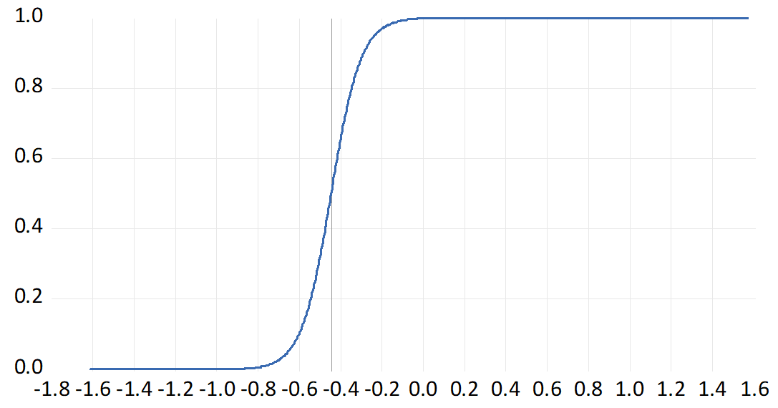 | 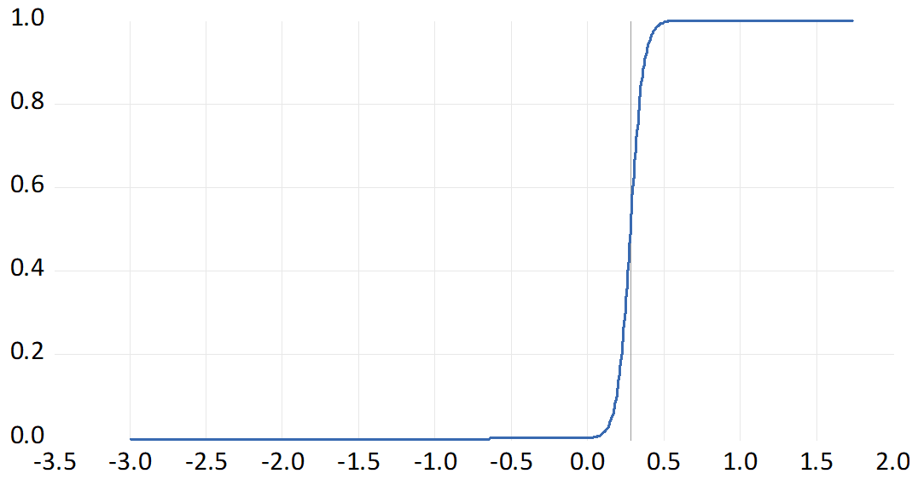
ERPT to Import Prices  Transition Variable: Market Expectations | ERPT to Import Prices  Transition Variable: Survey Expectations
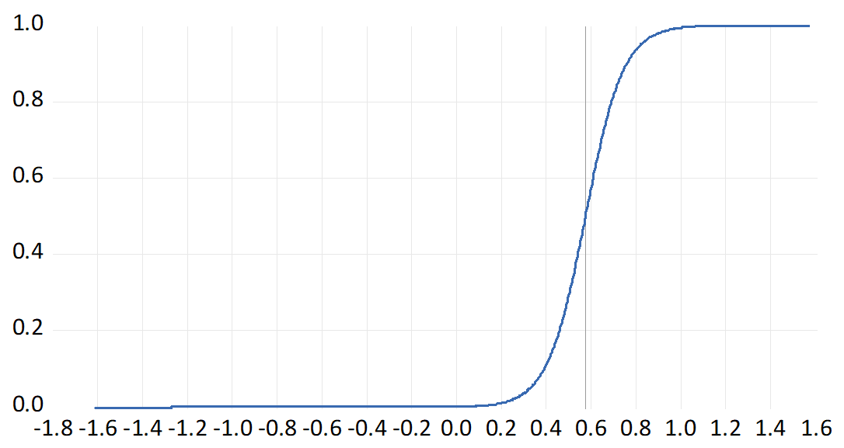 | 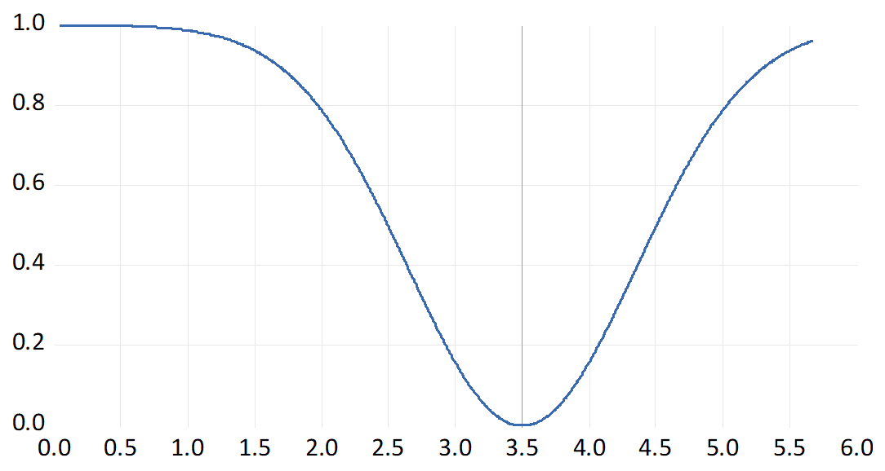

Figure 2: Transition Functions for Canada
ERPT to Consumer Prices  Transition Variable: Market Expectations | ERPT to Consumer Prices  Transition Variable: Survey Expectations
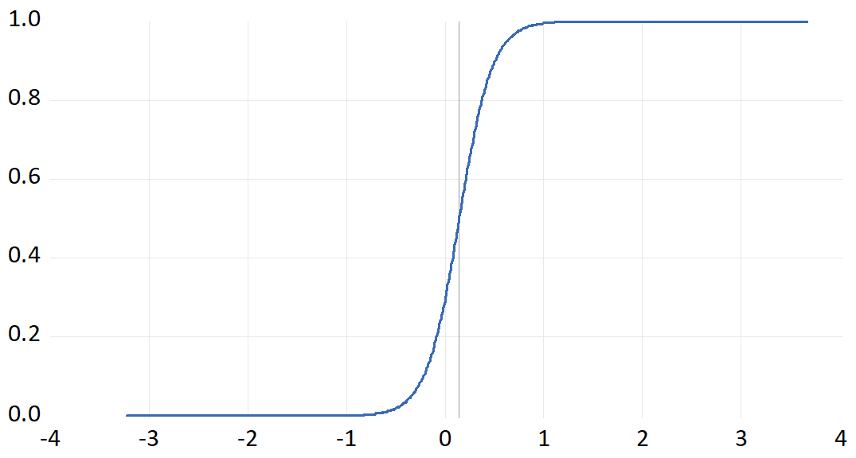 | 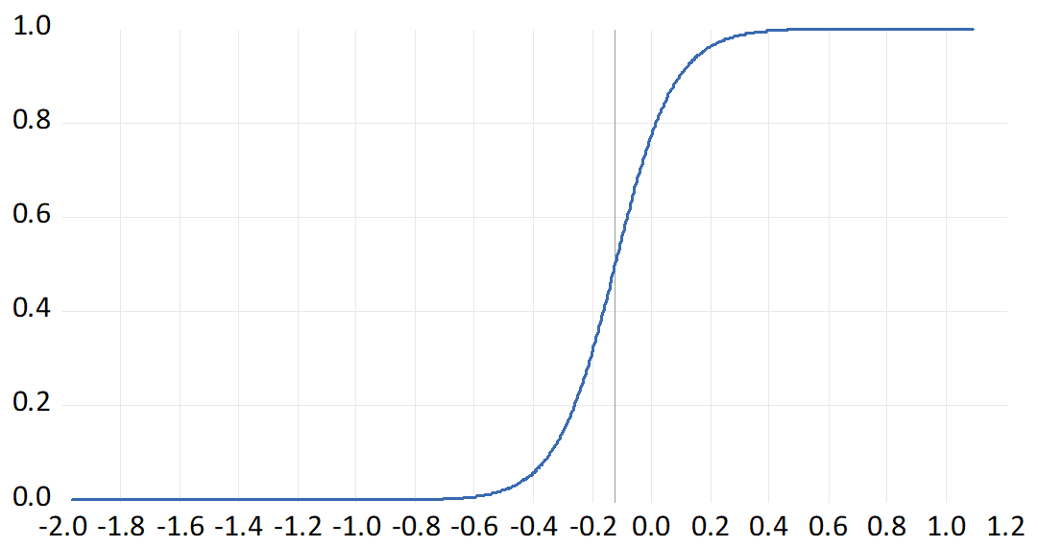
ERPT to Import Prices  Transition Variable: Market Expectations | ERPT to Import Prices  Transition Variable: Survey Expectations
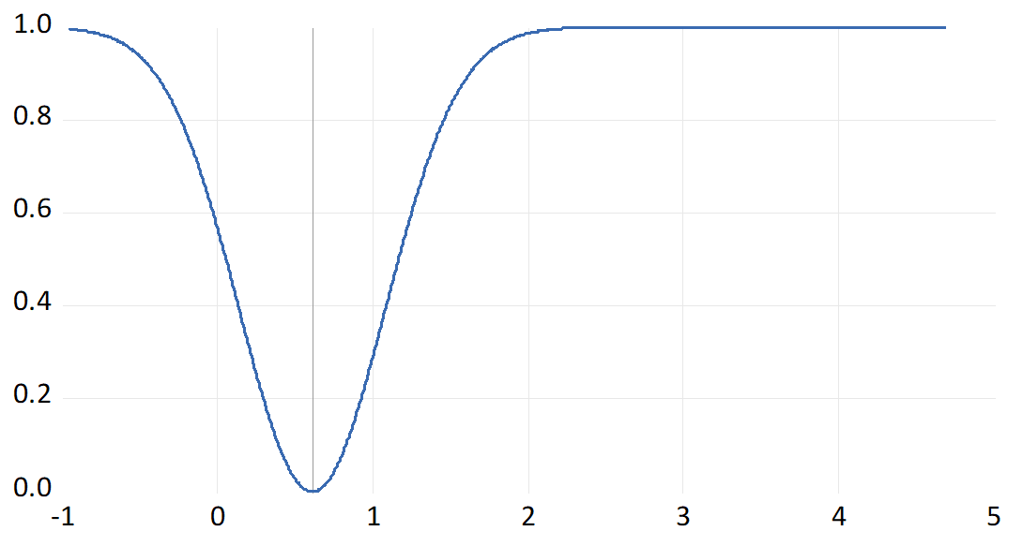 | 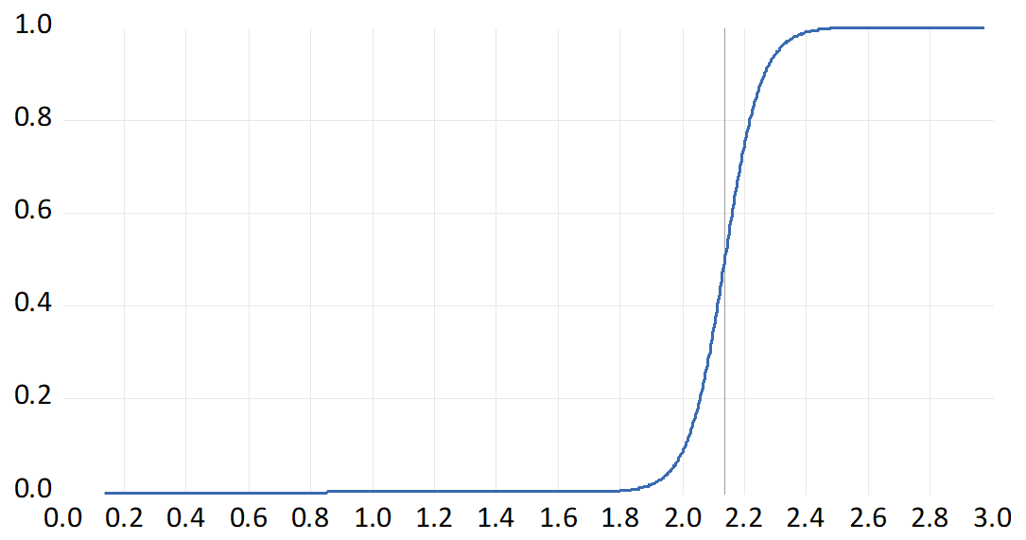

Figure 3: Transition Functions for Australia
ERPT to Consumer Prices  Transition Variable: Market Expectations | ERPT to Consumer Prices  Transition Variable: Survey Expectations
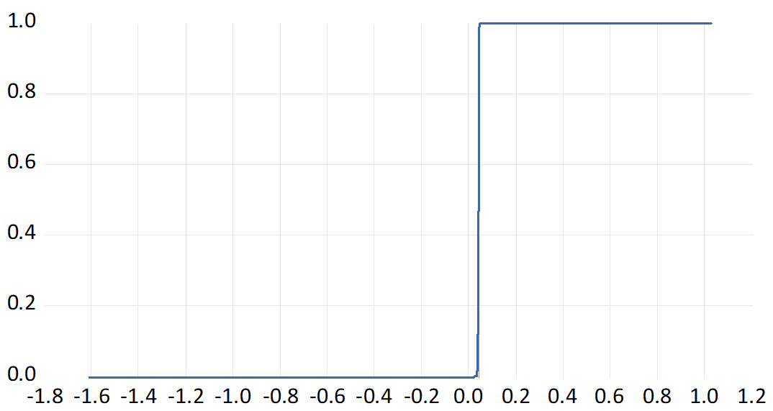 | 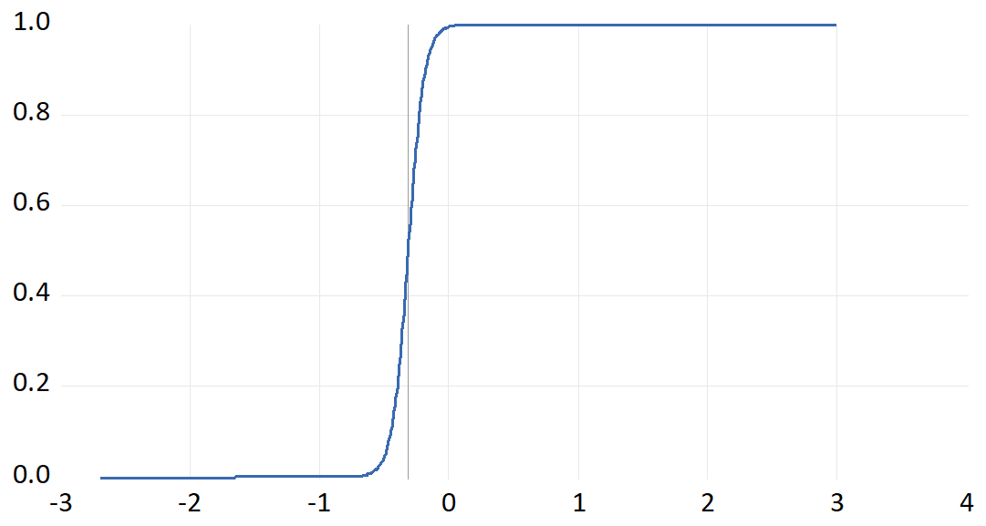
ERPT to Import Prices  Transition Variable: Market Expectations | ERPT to Import Prices  Transition Variable: Survey Expectations
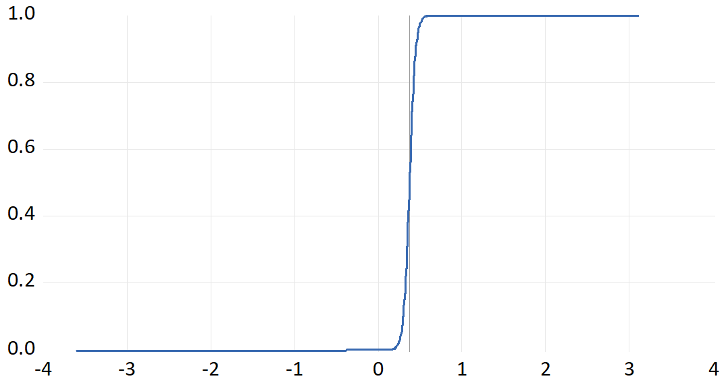 | 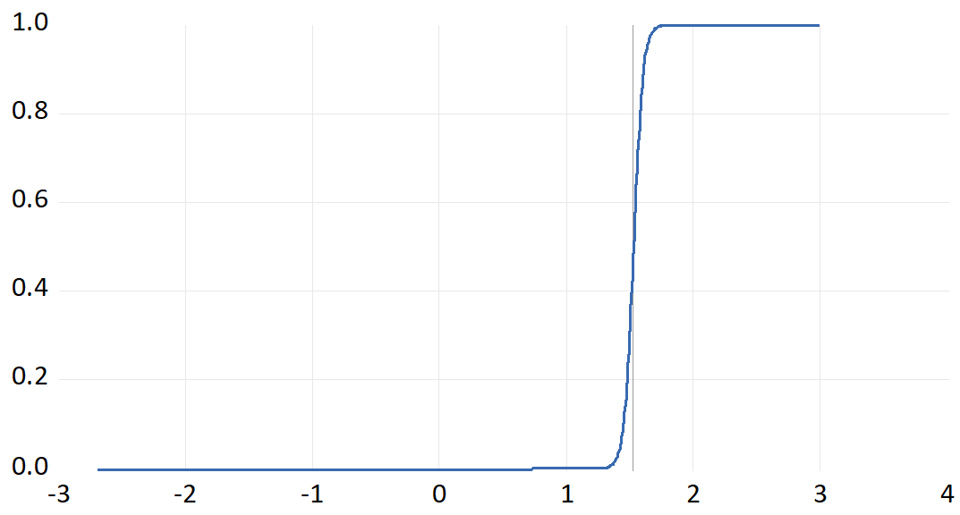

Figure 4: Transition Functions for New Zealand
ERPT to Consumer Prices  Transition Variable: Market Expectations | ERPT to Consumer Prices  Transition Variable: Survey Expectations
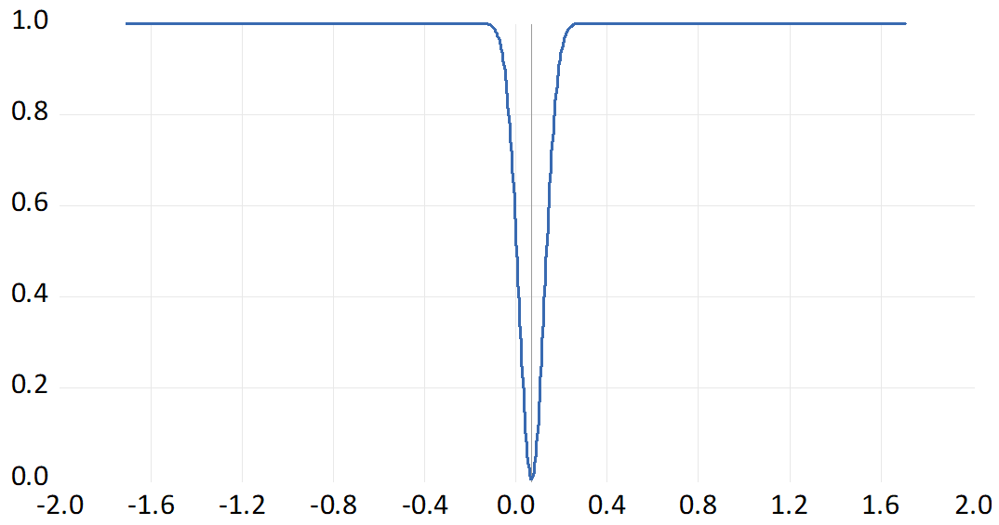 | 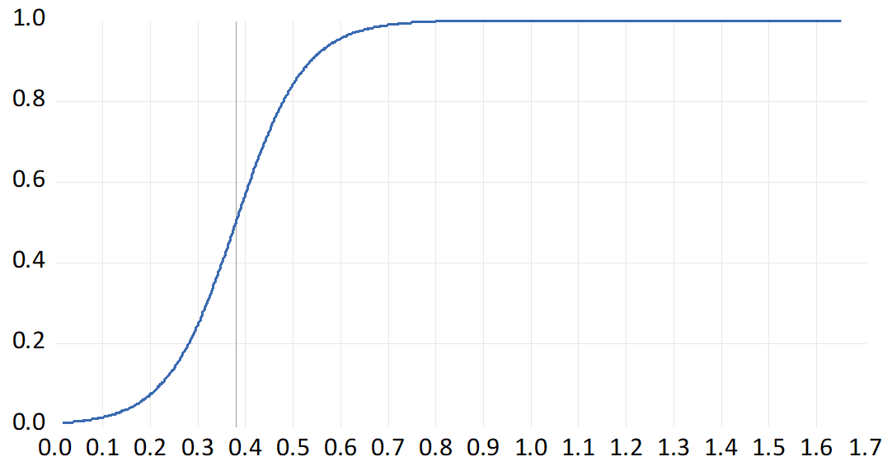
ERPT to Import Prices  Transition Variable: Market Expectations | ERPT to Import Prices  Transition Variable: Survey Expectations
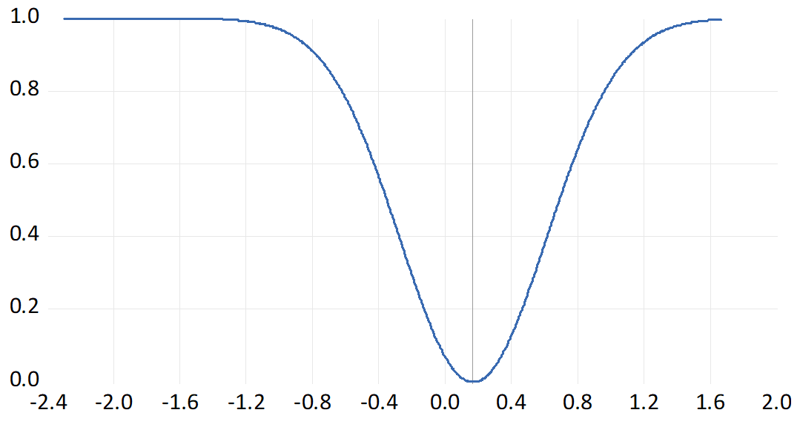 | 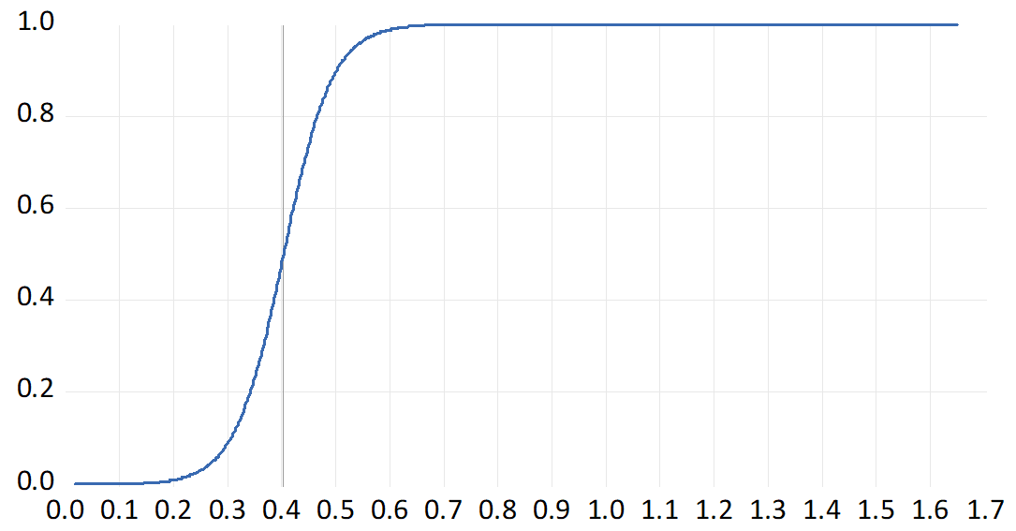

Figure 5: Transition Functions for Sweden
ERPT to Consumer Prices  Transition Variable: Market Expectations | ERPT to Consumer Prices  Transition Variable: Survey Expectations
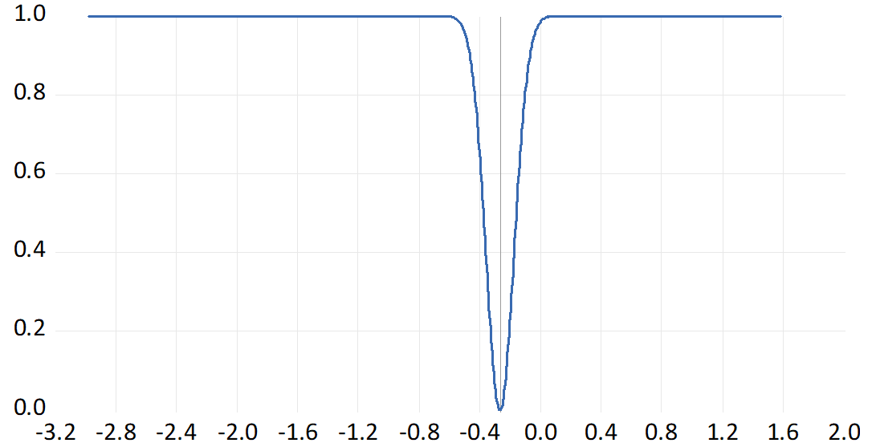 | 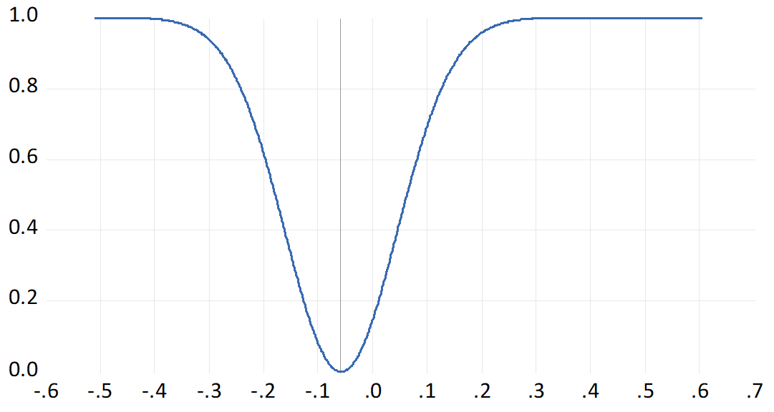
ERPT to Import Prices  Transition Variable: Market Expectations | ERPT to Import Prices  Transition Variable: Survey Expectations
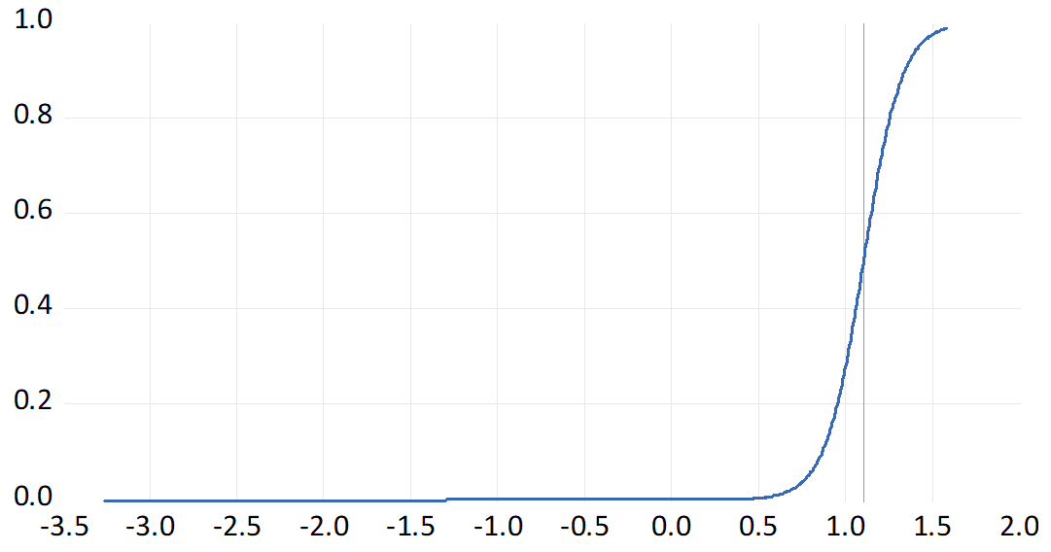 | 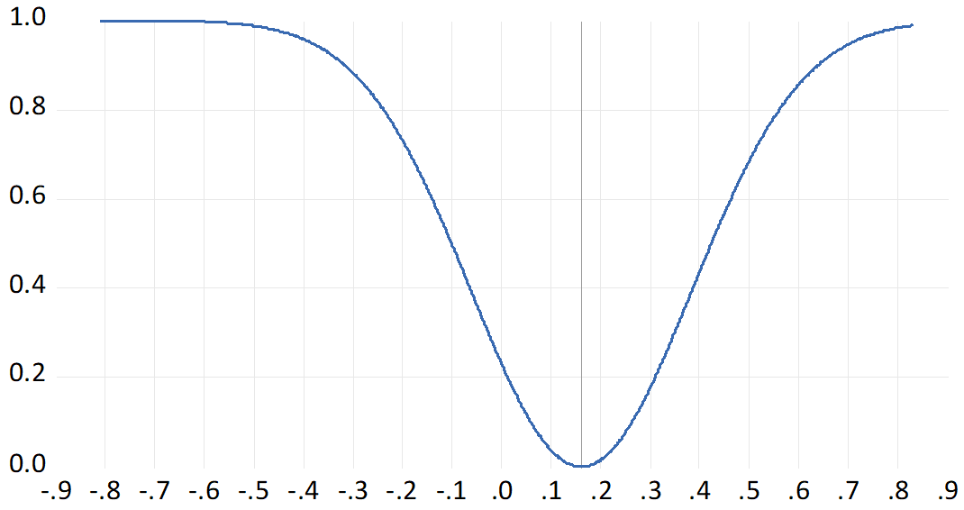

Figure 6: Transition Functions for the US
ERPT to Consumer Prices  Transition Variable: Market Expectations | ERPT to Consumer Prices  Transition Variable: Survey Expectations
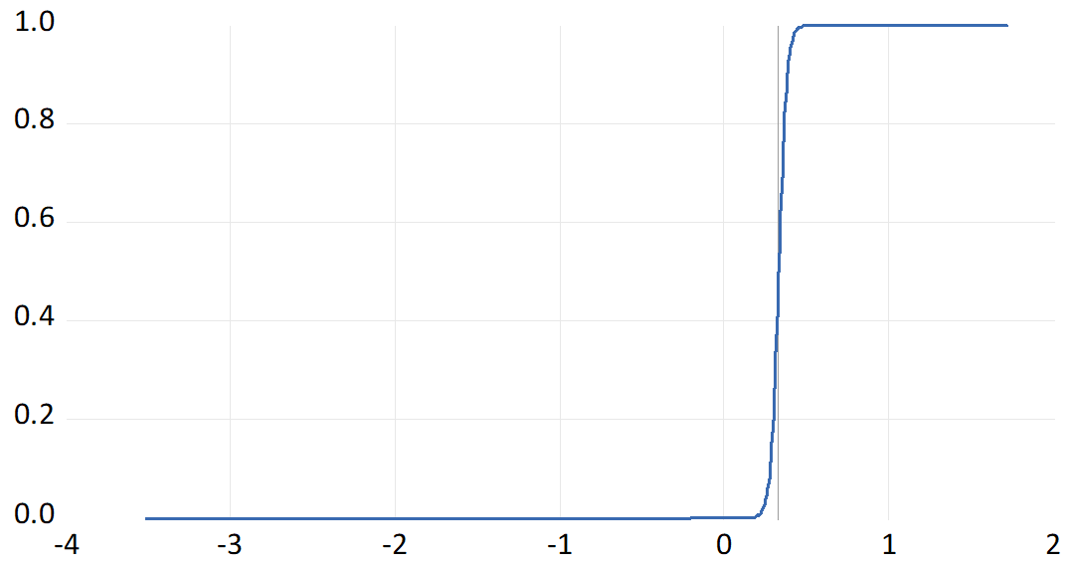 | 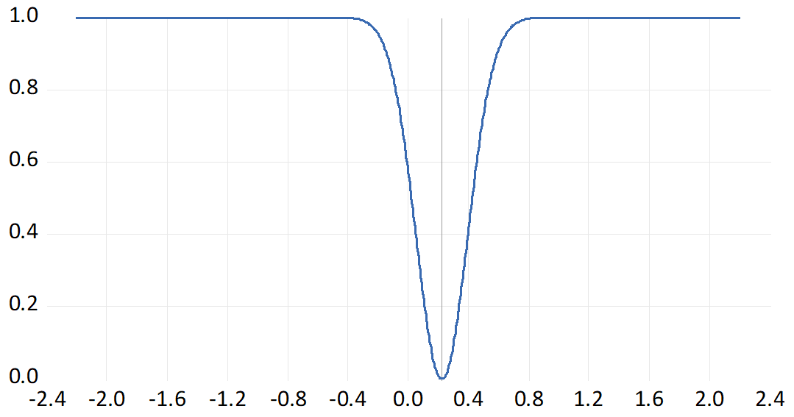
ERPT to Import Prices  Transition Variable: Market Expectations | ERPT to Import Prices  Transition Variable: Survey Expectations
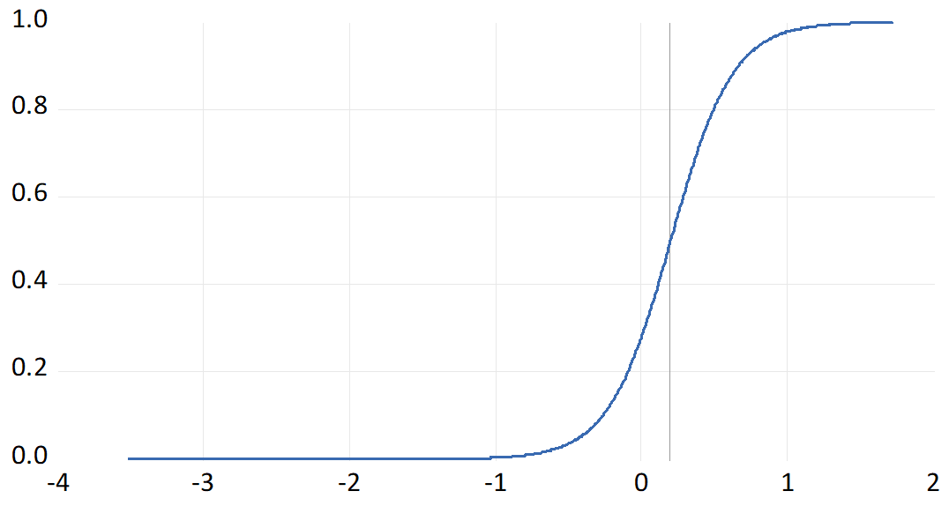 | 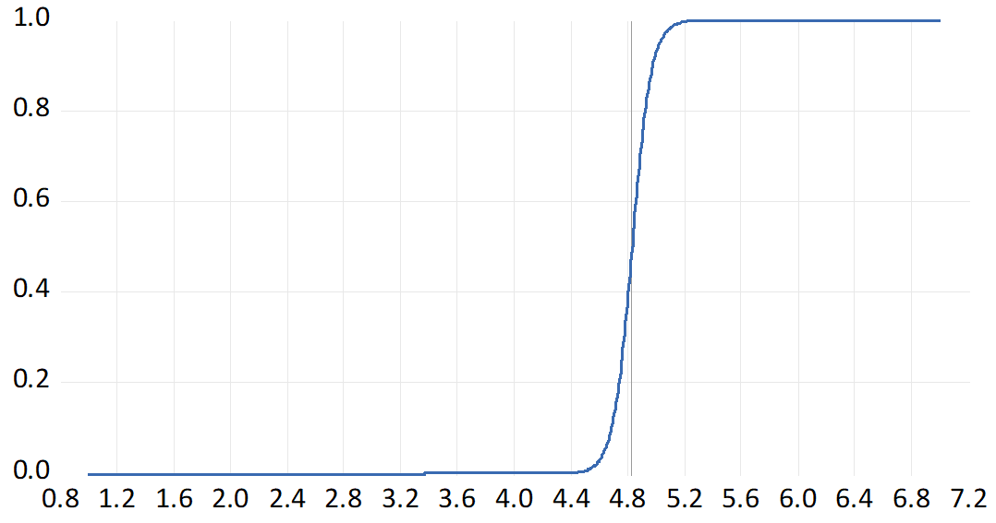

Figure 7: Transition Functions for the Euro-Area
ERPT to Consumer Prices  Transition Variable: Market Expectations | ERPT to Consumer Prices  Transition Variable: Survey Expectations
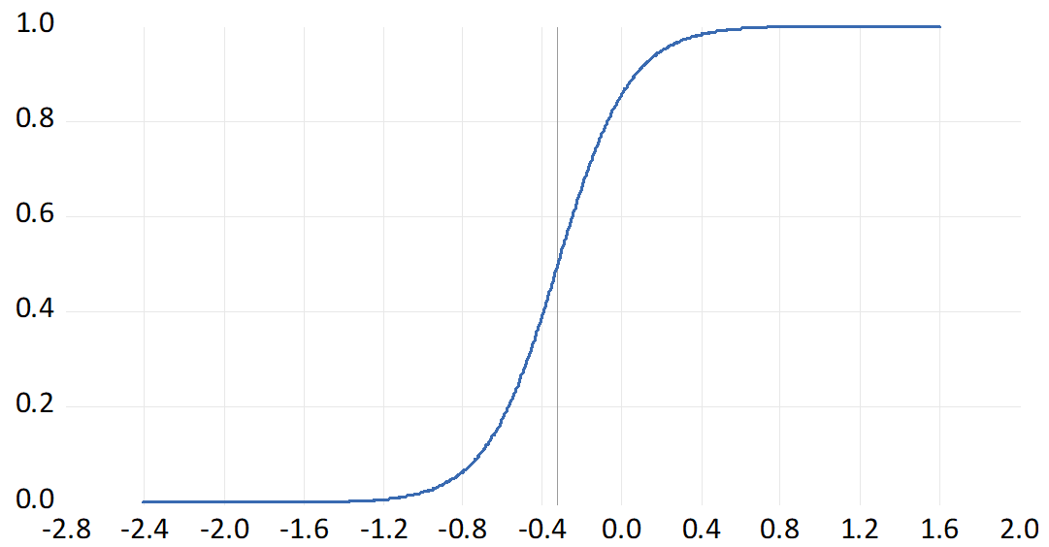 | 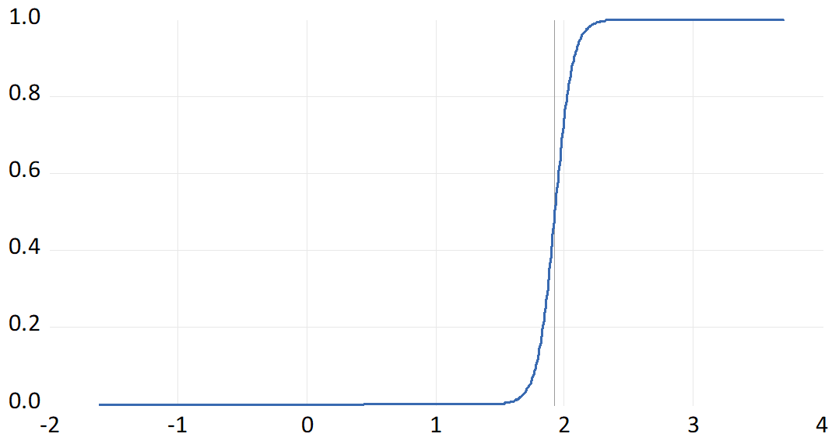
ERPT to Import Prices  Transition Variable: Market Expectations | ERPT to Import Prices  Transition Variable: Survey Expectations
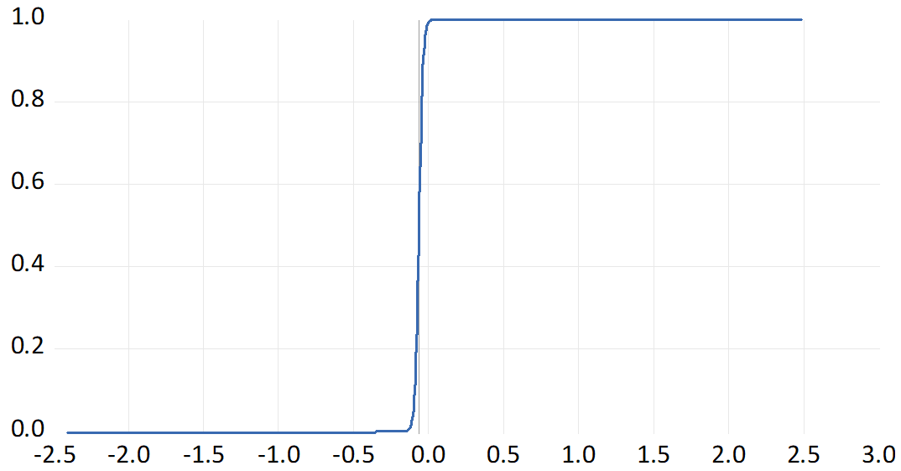 | 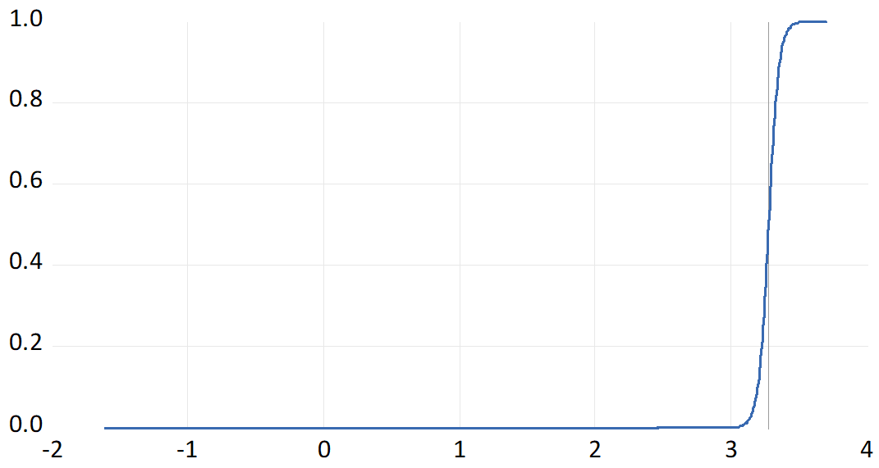

Figure 8: Transition Functions for Switzerland
ERPT to Consumer Prices  Transition Variable: Market Expectations |  | ERPT to Consumer Prices  Transition Variable: Survey Expectations
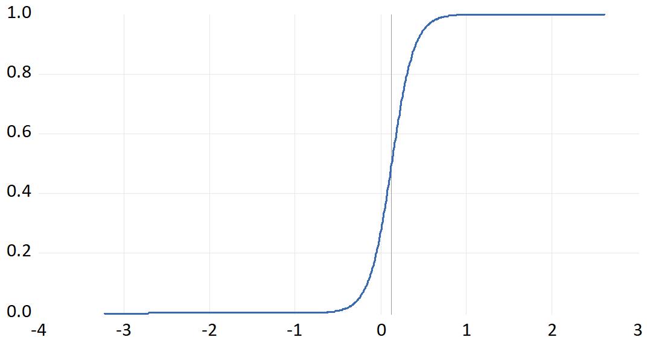 |  | 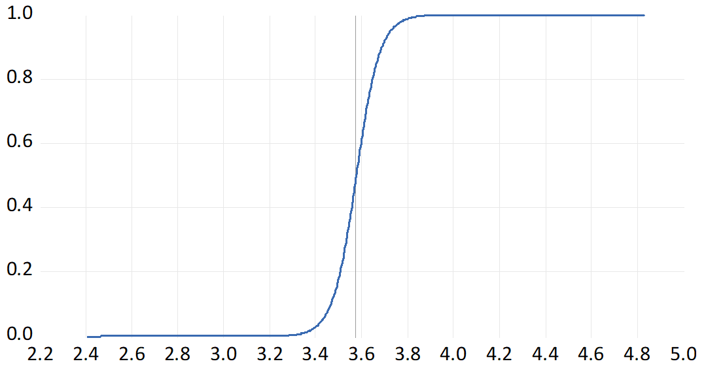
ERPT to Import Prices  Transition Variable: Market Expectations |  | ERPT to Import Prices  Transition Variable: Survey Expectations
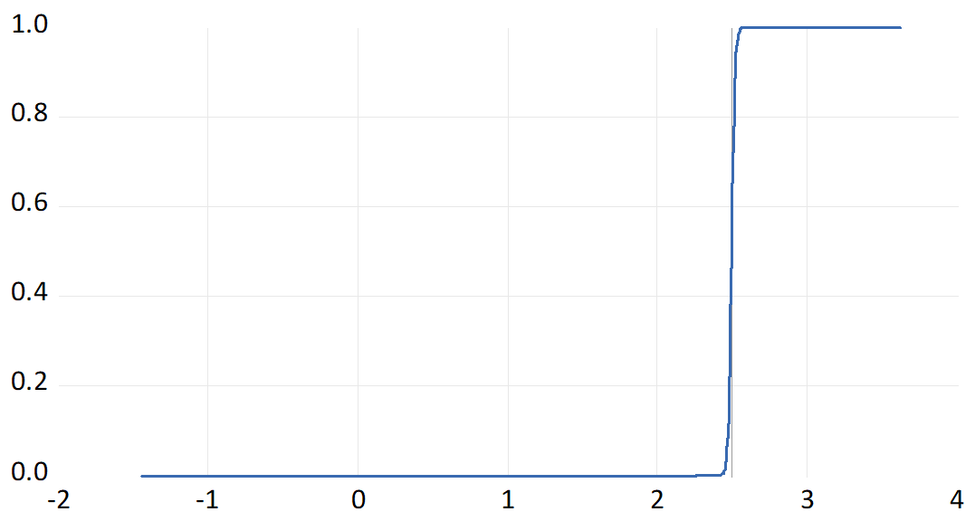 | 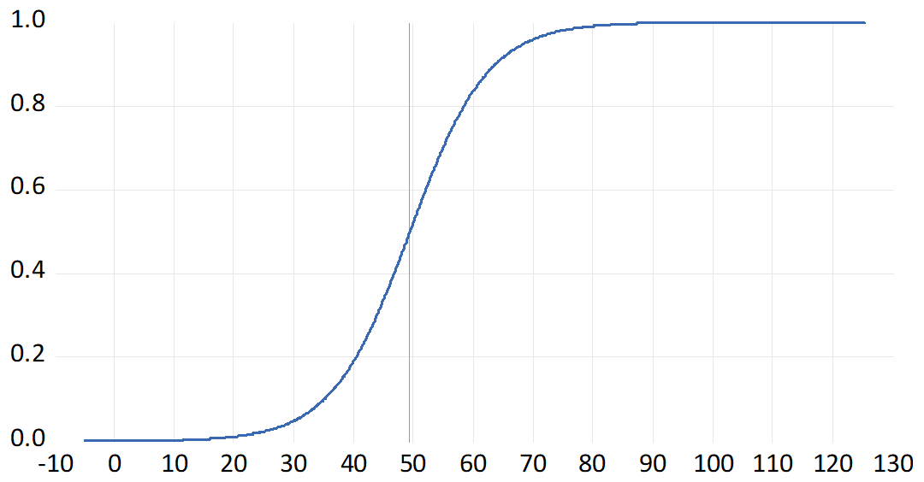

The coefficient $φ_{1}$ represents the elasticity of prices to exchange rate changes and measures the degree of ERPT. If $φ_{1}<1$, the pass-through is said to be incomplete, with a value of $φ_{1}=0$ indicating pure local currency pricing. A complete pass-through occurs when $φ_{1}=1$, while if $φ_{1}>1$, the ERPT is more than complete (Yanamandra, 2015).
The Hodrick-Prescott Filter is widely used in the literature to calculate the output gap (Álvarez and Gómez-Loscos, 2018); it allows to separate the cyclical component of the series from its trend.
Smooth Transition Models also nest Threshold-type Models, which allows a consideration of both classes of models on the basis of the value of the transition parameter.
The countries which identify themselves as inflation targeters adopted their inflation targeting regimes in the early 1990s. A sample starting in January 1993 therefore includes the entire inflation targeting period for these countries without having to account for the regime shift resulting from the adoption of inflation targeting. Furthermore, inflation expectations survey data are not available for all the countries in our sample prior to this date.
The corresponding transition functions are reported in Figures 1 to 8 in the Appendix.

