Pd(II) and Pt(II) chalcone complexes. Synthesis, spectral characterization, molecular modeling, biomolecular docking, antimicrobial and antitumor activities

Mohamed Gaber^{a,}*, Hoda A. El-Ghamry^{a,b}, Mohamed A. Mansour^{c}

- Chemistry Department, Faculty of Science, Tanta University, Tanta, Egypt

- Department of Chemistry, Faculty of Applied Science, Umm Al–Qura University, Makkah, Saudi Arabia

- Biochemistry Division, Department of Chemistry, Faculty of Science, Tanta University, Tanta 31527, Egypt

Keywords:

Chalcones

Pd(II)

Pt(II) complexes

Spectra

Thermal analysis

Molecular docking

Anticancer

Antimicrobial

ABSTRACT

Pd (II) and Pt(II) complexes of (E)-3-(4-(dimethylamino)phenyl)-1-(pyridin-2-yl) prop-2-en-1-one (L) and its Pd (II) and Pt(II) formulated as [Pt(L¹)₂] Cl₂. 2H₂O, [Pd (L¹)₂] Cl₂ 0.5H₂O, [Pd (L¹)₂] (AcO)₂ CH₃OH have been synthesized. Elemental analyses, molar conductance, thermal technique, molecular modeling, IR and electronic spectral measurements were used to verify the structures of the complexes. The titled ligand behaves as a neutral bidentate ligand coordination via pyridine nitrogen and carbonyl oxygen atoms. These complexes have square planar geometry. The kinetic and thermodynamic parameters of the decomposition steps were evaluated. The in-vitro antimicrobial and antitumor activities of the investigated compounds were screened against different microorganisms and the human hepato-cellular carcinoma cells, HEPG2, respectively. The data showed that the metal complexes have more antimicrobial and antitumor activities than the ligand itself. Molecular docking studies were performed by Docking Server and SwissDock using X-ray crystallographic structures of the proteins (3t88, 4m01, 4ynt, 1zap & 121P) from Protein Data Bank (PDB). The ligand and possibly its complexes showed favorable binding with the receptors of the microorganisms (3t88, 4m01, 4ynt, 1zap) and H-ras oncoprotein. Hence, our results present the synthesized complexes as potential antimicrobial and anticancer drug candidates. © 2017 Elsevier B.V. All rights reserved.

1. Introduction

Platinum (II) complexes such as cis-platin, carboplatin, oxali-platin have been extensively used as anticancer drugs. The most striking example is cis-platin, however it has encountered many side effects. Due to the accompanied severe side effects, drug resistance and the limited spectrum of tumors, great efforts have been made to synthesize several transition metal complexes to replace the conventional chemotherapy with low doses and high efficacy. Special attention in this regard has been given to palladium (II) complexes. Due to the structural and thermody-namic analogy between Pt(II) and Pd(II) complexes, a number of palladium (II) complexes with their potential antitumor properties have been reported [1–26]. Recent studies on the design of less toxic and more selective metal-based antitumor drugs are directed to the biologically interesting ligands. The nature of the ligands and

- Corresponding author.

E-mail addresses: mabuelazm@science.tanta.edu.eg, mabuelazm@hotmail.com

(M. Gaber).

the metal coordination pattern play an important role for the antitumor properties of the complexes. With this regard, chalcone derivatives are very interesting ligand candidates due to their broad spectrum of biological activities and potential applications such as anti-bacterial, anti-inflammatory, antitumor, antimalarial, as well as antioxidant properties [27–32]. Hence, in the current study, the transition metal complexes of chalcones and related compounds have been studied due to their applications in catalytic and biological field [33–43]. Literature reports on the mechanism of DNA photocleavage in the presence of metal complexes revealed that both superoxide anion radical and singlet oxygen may play an important role [44–46].

We described here the synthesis of Pd(II) and Pt(II) complexes of the titled chalcone compound (Fig. 1). The structures of the metal complexes were proposed on the basis of elemental analyses, spectral and molecular modeling as well as the thermal measurements. The antibacterial activities of the synthesized compounds were screened in vitro against gram-positive bacteria and gram-negative bacteria as well as antifungal activity against the two fungal strains Aspergillus flavus and Candida albicans. The

Fig. 1. The structure of the chalcone compound (L).
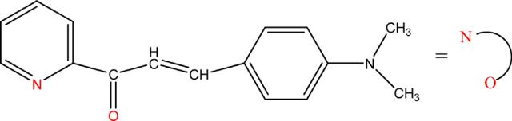

antitumor activity was studied against the human hepatocarci-noma cells HEPG2. Molecular docking analysis was performed to test the ligand for its inhibitory activity on the receptor of Escherichia coli (3t88), Staphylococcus aureus adhesion protein (4m01), Aspergillus flavus FAD glucose dehydrogenase (4ynt) and secreted aspartic protease from Candida albicans (1zap). Besides, to elucidate the proposed mechanism of the antitumor activity of the ligand, molecular docking was performed against the oncogenic protein H-ras (PDB: 121p). Different parameters like FullFitness, Gibbs free energy (DG), free energy of binding, inhibition constant (Ki), total energy of Vander Waals force, hydrogen bond, dissolve energy, electrostatic energy, total intermolecular energy, frequen-cy of binding, ligand bond, non-ligand bond, hydrogen bond, and its length were investigated. The complete interaction profile (hydrogen bonds, polar, hydrophobic, pi-pi, cation-pi and others), and hydrogen bonding interactions (HB plot) were also studied.

2. Experimental

2.1. Chemicals

All materials used in the present work were of analytical grade and used as received. K₂PtCl₄, K₂PdCl₄ and Pd(AcO)_{2,} metal salts were used for the preparation of the complexes C1, C2 and C3, respectively. Chalcone compound (Fig. 1) was synthesized and characterized according to the method reported previously [34,40].

2.2. Synthesis of metal complexes

A solution of each metal ion (0.01 mol) in 10 ml ethanol was slowly added to a solution of the chalcone derivative (0.01 mol) dissolved in the same solvent (20 ml) in the molar ratio 1:2 (M:L). The formed mixtures were then refluxed under stirring for 3 h upon which the solid products were separated on hot. The precipitated chelates were then filtered off, washed successively with ethanol and at last dried in desiccators over silica gel. The structures of the complexes are shown in Fig. S1.

Complex 1: C1 [Pt(L¹)₂] Cl₂ .2H₂O: Anal. Calcd. For (C₃₂H₃₆Cl₂ PtN₄O₄) (FW: 806.64): C, 47.65; H, 4.50; N, 6.95; found: C, 47.89; H, 4.25; N, 6.85%.

Complex 2: C2 [Pd (L¹)₂] Cl₂ 0.5H₂O: Anal. Calcd. For (C₃₂H₃₃Cl₂ PtN₄O_{2.5}) (FW: 690.96): C, 55.62; H, 4.81; N, 8.11; found: C, 55.33; H, 4.70; N, 7.98%.

Complex 3: C3 [Pd (L¹)₂] (AcO)₂ CH₃OH: Anal. Calcd. For (C₃₇H₄₂N₄O₇ Pd) (FW: 761.17): C, 58.38; H, 5.56; N, 7.36; found: C, 58.21; H, 5.45; N, 7.28%.

2.3. Measurements

Microanalyses (C, H and N content) were performed using Heraeus CHN elemental analyzer. The electron impact mass spectra were recorded using a Finnigan MAT8222 spectrometer at 70 eV. The IR spectra were measured by the aid of Perkin Elmer 1430 spectrophotometer within 4000–200 cm ¹ as KBr discs. Shimadzu 240 UV–vis spectrometer was used for the electronic spectral studies. Computerized Shimadzu TG-50 thermal analyzer

was applied for the thermal analysis (TGA) at 25–800 C and 10 C/ min heating rate using nitrogen gas as inert atmosphere. Molar conductivities in DMF (10 ³ M) at 25 C were recorded by the aid of conductance bridge of the type 523 conductivity bridge.

2.4. Molecular docking using docking server

Molecular Docking calculations were performed by the Docking Server software [47]. The empirical charges were calculated by MOPAC2009 (J. P. Stewart, Computer code MOPAC2009, Stewart Computational Chemistry, 2009) and then added to the ligand atoms. Non-polar hydrogen atoms were merged, and rotatable bonds were defined in the docking process. The calculations were carried out to test the ligand with the receptor of Escherichia coli (3t88), Staphylococcus aureus adhesion protein (4m01), Aspergillus flavus FAD glucose dehydrogenase (4ynt), secreted aspartic protease from Candida albicans (1zap) and the oncogenic protein H-ras (121p) models. AutoDock tools [48] were used to add essential hydrogen atoms, Kollman united atom type charges, and solvation parameters. Autogrid program [48] was used to generate affinity (grid) maps of 20 20 20 Å grid points and 0.375 Å spacing. In order to calculate the van der Waals and the electrostatic terms, autoDock parameter set- and distance-dependent dielectric functions were used, respectively. The Lamarckian genetic algorithm (LGA) and the Solis & Wets local search method [49] were used to perform the docking simulations.

2.5. Molecular modeling using SwissDock

In order to further confirm the docking analysis, we used SwissDock service based on the docking software EADock DSS [50]. This online service was selected as it has a friendly interface with the facility to input desired protein (from Protein Data Bank; PDB) and ligand structures (from Zinc database) directly, modify docking parameters, and visualize most favorable clusters. Besides, results can be viewed in UCSF Chimera package. A grid ((Box size: 40 40 40) and box center: 0.38 2.98 20.51 for x,y, and z, respectively) was designed in which many binding modes were generated for the most favorable bindings according to their binding energies. Their CHARMM energies were estimated on the grid [51] and binding modes were scored using their FullFitness and clustered. Then, clusters were ranked according to the average FullFitness of their elements [52]. Results of the SwissDock service were visualized by UCSF Chimera package [53] and images obtained were presented in the results.

2.6. Biological activity

Disc diffusion method [54] was employed to evaluate the antimicrobial activities of the synthesized compounds. A newly synthesized suspension solution of spore of the interested microorganisms (0.5 ml of 10 cells/ml) was added to 9.5 ml of melting sterile Sabouraud's dextrose medium or nutrient agar medium (for fungi and bacteria),respectively, at 45 C. Regular cellulose filter paper discs (6 mm diameter) were prepared under aseptic conditions. Each disc was saturated with 20 mg of each tested suspended material. All plates were incubated at 27 C for 48 h and 32 C for 24 h for fungi and bacteria, respectively. Then the average diameters (mm) of inhibition zones were measured.

2.6.1. MIC determination

Half-fold serial dilutions were made for selected complexes to prepare 6.25, 12.5, 25, 50 and 100 mg/ml in distilled water. Zero concentration was considered as a negative control. A previously prepared pure spore suspension of each test microorganism (0.5 ml of about 10⁶ cells/ml) was added to 9.5 ml of each

concentration in sterile test tubes, incubated at 27 C for 3 days and at 32 C for 24 h for fungi and bacteria, respectively. The optical density of growth was measured at 620 nm for each incubated mixture, results were represented graphically, and MIC was recorded for each tested material [55].

2.7. Measurement of potential cytotoxicity by SRB assay

HEPG2 Human cancer cell line was obtained frozen in liquid nitrogen ( 180 C) from the American Type Culture Collection. Skehan et al. method [56] was applied for Potential cytotoxicity of the compounds. Cell was plated in 96-multiwell plate (10⁴ cells/ well) for 24 h before treatment with the compound to allow attachment of cell to the wall of the plate. Different concentrations of the tested compounds (0, 5, l2.5, 25 and 50 mg/ml) were added to the cell. The cell was incubated for 48 h and maintained in an atmosphere containing 5% CO₂ at 37 C. After 48 h, the cell was fixed, washed and stained with the protein-binding dye Sulfo-Rhodamine-B (SRB) [57]. The excess amount of stain that present was eliminated by washing with acetic acid solution and attached stain was recovered with Tris-EDTA buffer. The intensity of the color was measured in an ELISA reader. Potential cytotoxicity of the complexes under study was measured in (Pharmacology Unit, Cancer Biology Department, National Cancer Institute, Cairo University). Doxorubicin was used as standard cytotoxins.

2.8. DPPH radical scavenging

1 mg of the investigated samples and ascorbic acid (as reference) were dissolved in DMSO (1 ml). 250 ml of each solution was added to 1 ml DPPH/DMSO solution (6 mg/50 ml). The total volume was completed to 3 ml with DMSO. The mixture was incubated for 30 min at room temperature. Absorbance was measured at 517 nm. The blank sample containing the same amount of DMSO and DPPH solution was prepared. The experiment was performed three times. The scavenging potential was compared with a solvent control (0% radical scavenging) and ascorbic acid. Radical scavenging activity was calculated by applying the following equation:

% decrease in absorbance = [(X Y)/X] 100

Where: X and Y are the absorbance of blank sample and tested sample, respectively.

2.9. Molecular modeling and quantum chemical parameters

The theoretical parameters are used to characterize the molecular structure of the investigated complexes. The geometries of the complexes were optimized by hyper chem. 8.03 Molecular Modeling and Analysis Program [58] by the molecular mechanics calculations (PM3).

3. Results and discussion

3.1. Characterization of the solid complexes

3.1.1. Analytical data

Structure elucidation of Pd(II) and Pt(II) complexes was accomplished by elemental analyses, IR, electronic spectra and conductance measurements as well as thermal analysis (TGA). The analytical data are in a good matching with the proposed structure. The solid metal chelates are air stable in and easily soluble in DMF and DMSO. For complexes C1 and C2, the presence of Cl ions outside the coordination sphere was confirmed by the chemical reaction with AgNO₃ where the white preciptate of AgCl was

observed. For complex C3, the addition of FeCl₃ solution to complex solution gave the red brown coloration confirming that the acetate ions are present outside the coordination sphere. The molar conductance values of Pd(II) and Pt(II) complexes in 10 ³ M DMF as solvent are 83.9, 81.2 and 77.5 ohm ¹ cm² mol ¹ for complexes C1, C2 and C3, respectively. These values revealed that all the complexes are electrolytes in nature i.e. the counter ions present outside the coordination sphere of the metal complexes

- These data indicated that the complexes are formed in 1:2 (M: L) with the formula [ML₂]X₂.nH₂O, where M = Pd²⁺ and Pt²⁺; L represents the ligand; X = Cl for complexes C1 and C2; X = AcO for complex C3; n = 2, 0.5 and 1 for complexes C1, C2 and C3, respectively.

3.1.2. Spectral studies

The binding mode of the chalcone compound to the metal ion was assessed by comparing the position of the ligand characteristic bands with that of the metal chelates (Table 1). In the complexes spectra it was found that the band characteristic for C¼O bond was shifted to lower frequency compared with its position the free ligand indicating the coordination of the carbonyl oxygen to the metal ion. This shift is mainly due to weakening of the double bond between carbon and oxygen. The stretching vibration of the C¼N bond of the pyridine ring in the complexes spectra underwent downfield shift in its position comparing with the free chalcone confirming the coordination of the pyridine nitrogen atom to the metal ion. The involvement of both carbonyl oxygen and pyridine nitrogen in complex formation was further supported by the occurrence of non-ligand bands in the chelates spectra in the ranges 597–630 and 555–560 cm ¹ corresponding to M ! N and M ! O bond, respectively. These results indicated that the chalcone ligand behaved as neutral bidentate ligand coordinating via the pyridine nitrogen and carbonyl group oxygen atoms.

The electronic spectra of the complexes were recorded as Nujol mull. The band at 358 and 360 nm in the spectra of Pt(II) complex C1 and Pd(II) complex C2, respectively, are assignable to a combination of ¹A_{1g} !¹E_{g} and MLCT indicating square planar geometry around the metal center [60], as expected. The broad bands observed at 580 and 570 nm are assigned to (¹A_{1g} ! ¹B_{1g}) transition for complexes C2 and C3, respectively, confirming the expected square planar geometry [61].

The constitution and purity of the prepared complexes are confirmed using the electron impact mass spectrometry (EI). Fig. S2 represents the mass spectrum of C1, as a representative example. The EI mass spectra of the metal complexes showed the molecular ion peaks at m/z = 804, 691 and 761 for complexes C1– C3, respectively, which are highly comparable with the molecular mass of the respective metal complexes. The fragmentation pathways of the metal complexes are shown in Schemes S1–S3.

3.1.3. Thermal analysis and kinetic parameters

The thermal stability of the synthesized metal chelates was studied using TG technique (Fig. S3). The degradation steps, temperature ranges, percentages of the lost weights in addition to the decomposition products are depicted in Table S1. The metal percentages of the complexes were calculated from the residual

Table 1

IR spectral bands of the chalcone ligand and its metal complexes.

Comp. | n (H₂O) | n (C¼O) | n (C¼N) | n (M O) | n (M N)
L1 | – | 1650 | 1611 | – | –
C1 | 3449 | 1630 | 1601 | 630 | 555
C2 | 3450 | 1608 | 1600 | 662 | 558
C3 | 3445 | 1629 | 1600 | 597 | 560

metal oxides formed as a final product. The thermal decomposition of complexes (C1–C3) comprises three steps.

For Pt(II) complex C1 the first degradation step occurred within 30–87 C range with mass loss 3.98% (cal. 4.46%), corresponding to the volatilization of hydrated water molecule. The second step appeared at 87–316 C with mass loss 13.93% (cal. 14.3%) due to elimination of Cl + N(CH₃)₂ moiety. The third step (appearing at 316–428 C) with mass loss 43.11% (cal. 43.62%), represented the degradation of the organic ligand with formation of PtO + 8C as final products. For complex C2, the first step appeared at 30–85 C with mass loss 1.48% (cal. 1.3%) correspond to elimination of molecule of hydration water. The second step appeared at 163–

- C with mass loss 14.85% (cal. 14.47%) which can be attributed to the loss of chloride anions and 2CH_{3.} The third step appearing at

- –447 C with mass loss of 54.74% (cal. 54.49%) corresponded to the degradation of the chalcone moiety with the formation of PdO + 7C as residue at the end of heating process. The thermal degradation of Pd(II) complex C3 showed first step at 25–76 C with mass loss 3.84% (cal. 4.2%) which corresponded to elimination of lattice methanol molecule. The second step at 76–283 C with mass loss 31.72% (cal. 31.34%) and assigned to elimination of N (CH₃)₂, C₆H₅ and two acetate anions. The third step appearing at

- –423 C with mass loss 36.66% (cal 37.42%) correspond to further decomposition of the organic ligand with formation of PdO + 7C. The kinetic parameters of decomposition process of the complexes namely, activation energy (E), the order (n) and pre-
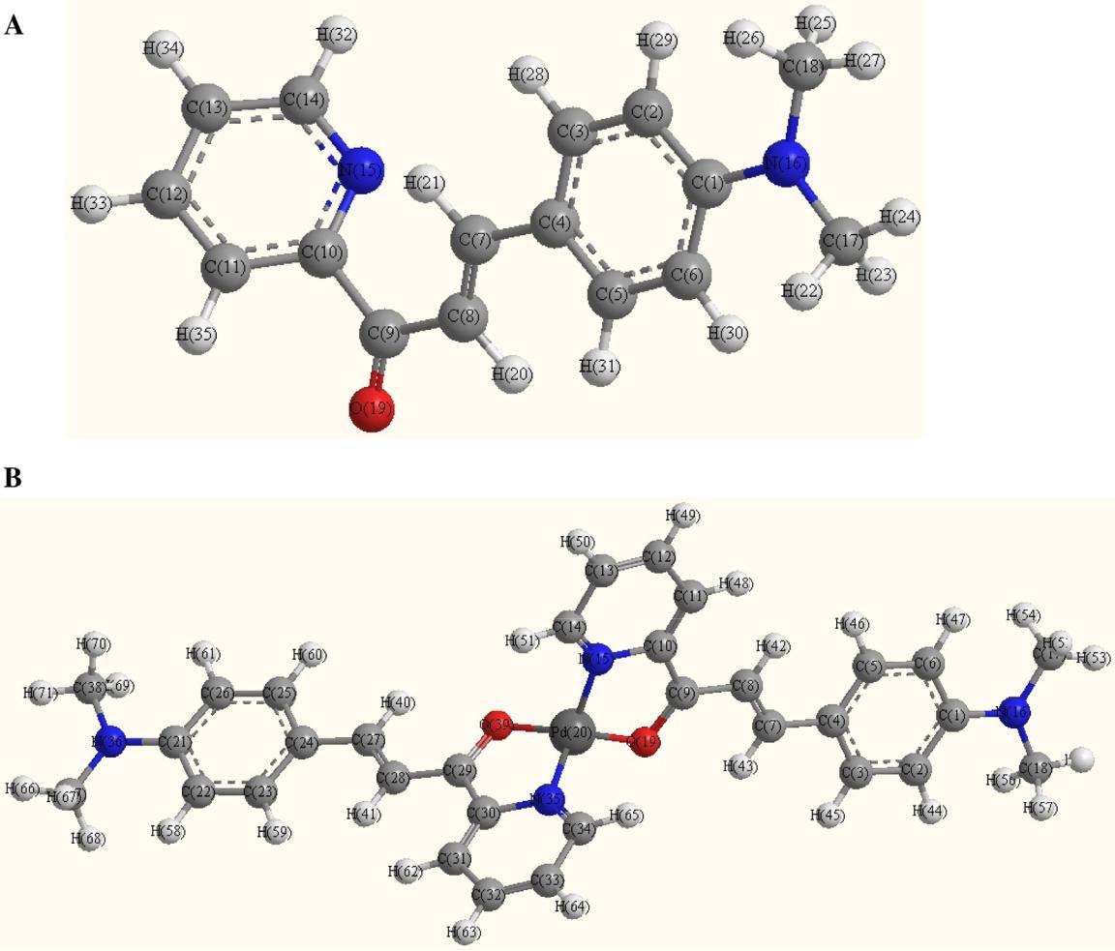

exponential factor (A), as well as the thermodynamic parameters (enthalpy DH, entropy DS and free energy of the decomposition DG) were evaluated graphically applying Coats–Redfern relations

- The linearization curves (Fig. S4) of the Coats–Redfern method are shown in Supplementary data. The calculated values of n, E, A, DS, DH and DG for the each step are represented in Table S2. According to the data obtained, the following remarks can be pointed out:

1 The high values of (DE) reflected the high stability of the investigated complexes due to their covalent character [63].

2 The positive sign of DG for the investigated metal complexes revealed that all the decomposition steps are non-spontaneous processes.

3 The negative values of DS indicated a more ordered activated complex than reactant and/or the reaction was slow [64].

- The positive values of DH* means the endothermic decomposi-tion processes.

3.2. Molecular modeling

Many attempts to prepare crystals for X-ray crystallography were unsuccessful. The computational strategy in this manuscript is to determine the geometry of Pd(II) complex. Thus, molecular modeling calculations were considered.

Fig. 2. The modeling structures of the ligand (A) and its Pd(II) complex C2 (B).

3.2.1. Geometrical optimization

The optimized geometries and atoms numbering of the ligand and its Pd(II) complex are shown in Fig. 2. The optimized lengths of bonds in addition to bond angles (Supplementary materials) are listed in TableS S3 & S4.

The elongation of the bond lengths for the C¼O and C N of the pyridine moiety indicated that these bonds become weaker due to the formation of Pd O and Pd N bonds. M O bond length is shorter than M N bond length showing that the bond length obeyed the order M N > M O. The Pd-N_{py} bond length (1.9859, 1.9711) is in agreement with the reported values [65] observed for Pd(II) complexes. C8 C9, C9 C10, C28 C29 and C29 C30 bond lengths become shorter confirming the participation of O and N atoms in complex formation. The bond length of CH¼CH (C7 C8, C27 C28) decreased in complex formation. The bond angles in complex lie in the range of square planar geometry. The C10 C9 O19 and C30 C29 O39 angles change from 117.95 to 121.36 and 120.26 , respectively, due to the formation of O19 Pd20 N15 and O39 Pd20 N35 ring.

3.2.2. Molecular parameters

Quantum chemical parameters of compounds such as the energy of the highest occupied molecular orbital, E_{HOMO}, energy of the lowest unoccupied molecular orbital, E_{LUMO}, energy gap (D E) electronegativity (x), chemical potentials (P_{i}), dipole moment (m), hardness (h), softness (s), additional electronic charge (DN_{max}) have been calculated according to the equations in the literature [66–68]. The data are listed in Table 2. Fig. 3 shows the HOMO and LUMO molecular orbitals of the ligand and its Pd(II) complex. The energy components are listed in Table 3. The energies of the HOMO and LUMO are negative which indicate that the compounds under investigation are stable [69]. The calculated energy of E_{LUMO} level shows that ligand ( 3.334) has lower energy of E_{LUMO} than the complex ( 1.105). The calculated HOMO-LUMO energy gap or energy separation (DE) of the ligand (5.666) is lower than that of the complex.(6.186). The calculated HOMO-LUMO energy gap or energy separation (DE) is related to polarizability, softness and charge migration during the enzyme-drug interaction. As the value of (DE) decrease (Pd 6.186 ! Lig. 5.666), softness (Pd 0.3223 ! Lig. 0.35), anticancer (IC50, Pd 3.98 ! Lig. 6.53), and antibacterial activity (Pd 15 ! Lig. 11), of the compound increased.

The binding energy of complex ( 7.748 103 k cal/ mol) is

higher than that of the ligand ( 3.684 10 k cal/mol) indicating the higher stability of the formed metal complex. The negative binding energy indicated that the complexation process is energetically favorable. The negative value of enthalpy change (DH) indicated that the interaction between the ligand and Pd(II) ion is exothermic. The dipole moment is important physical quantity which reflects the ability of interaction of the molecules with the surrounding environment. The dipole moment of complex (5.788) is higher than that of the ligand (3.421). Thus, Pd(II) complex is the promising structure for antitumor agent. The positive electrophilicity index value indicates the molecule capable of accepting electrons from the environment.

3.3. Docking analysis

The free energy of binding, inhibition constant (Ki), total estimated energy of vdW + Hbond + desolv(EVHD), electrostatic energy, total intermolecular energy, frequency of binding, and interact surface area parameters were evaluated to estimate the favorable binding of the ligand to the protein. Table 4 shows the complete profile of these parameters of the ligand for its interaction with receptor of Escherichia coli (3t88), Staphylococcus aureus adhesion protein (4m01), Aspergillus flavus FAD glucose dehydrogenase (4ynt) and secreted aspartic protease from Candida albicans (1zap). One of the most favorable bindings of the ligand was its binding with 3t88 protein with estimated free energy of binding-4.07 kcal/mol, and total intermolecular energy was of 5.27 kcal/mol. The ligand showed the inhibition constant (ki) of

1.04 mM. Fig. 4 shows the binding of the ligand to the protein 3t88. A 2D plot was generated where ligand bond, non-ligand bond, and hydrogen bonds along with their length were mentioned (Fig. 6). A HB plot [70,71]. was generated to mention interactions with different amino acids of the protein (Fig. 5). In the studies by Swiss Dock, FullFitness and Gibbs free energy (DG) of each run (250 runs) of the docking were evaluated. Favorable binding modes were scored based on FullFitness and cluster formation. Ranking of the cluster was performed using the value of FullFitness. Table 5 exhibited the clustering results obtained from the docking of the ligand into 3t88 protein. The ligand showed FullFitness of

1339.98 kcal/mol and estimated DG of 6.85 kcal/mol for the most favorable interaction.

Based on the results of docking studies, it has been clearly expressed that the ligand and possibly its complexes showed favorable binding with 3t88, 4m01, 4ynt, 1zap. Hence, the ligand can be potential inhibitor to the pathogenic microorganisms like bacteria and fungi. This interaction could deactivate or kill the microorganisms. The characteristic feature of the ligand was represented in the presence of several active sites available for hydrogen bonding interaction. This theoretical analysis proposes the high biological activity of the organic ligand towards different bacteria or fungi.

The RAS oncogenes (HRAS, NRAS and KRAS) comprise most frequently mutated class of oncogenes in human cancers (33%), stimulating intensive effort in developing anti-Ras inhibitors for cancer treatment. The protein-ligand interaction studies play a vital role in the structure based drug design in dry lab. Here, we show molecular modeling with docking results of the ligand as inhibitor of H-ras. The ligand showed favorable interaction binding with H-ras (121p) (Fig. 7) with estimated free energy of binding

4.12 kcal/mol, and total intermolecular energy was of 5.25 kcal/ mol (Table 6). A 2D plot was generated in which ligand bond, non-ligand bond as well as hydrogen bonds along with their length were mentioned (Fig. 9). A HB plot was generated to mention interactions with different amino acids of the protein (Fig.8).

FullFitness and Gibbs free energy (DG) of each run (250 runs) of the docking were estimated by SwissDock. Table 7 exhibited the clustering results obtained from the docking of the ligand into 121p

Table 2

The calculated quantum chemical parameters for the ligand and its Pd(II) complex C2.

Compd | ^{E}HOMO ^{eV} | ^{E}LUMO ^{eV} | DE | x eV | h eV | s eV ¹ | Pi eV | v | D^{N}max
 |  |  | eV
L | 9.000 | 3.334 | 5.666 | 6.167 | 2.833 | 0.353 | 6.167 | 6.71 | 2.177
C2 | 7.291 | 1.105 | 6.186 | 4.189 | 3.093 | 0.323 | 4.189 | 2.84 | 1.354
DE = E_{LUMO} | E_{HOMO}, h = DE/2; s = 1/h; Pi = (E_{HOMO} + E_{LUMO})/2; x = |  |  | Pi; v.

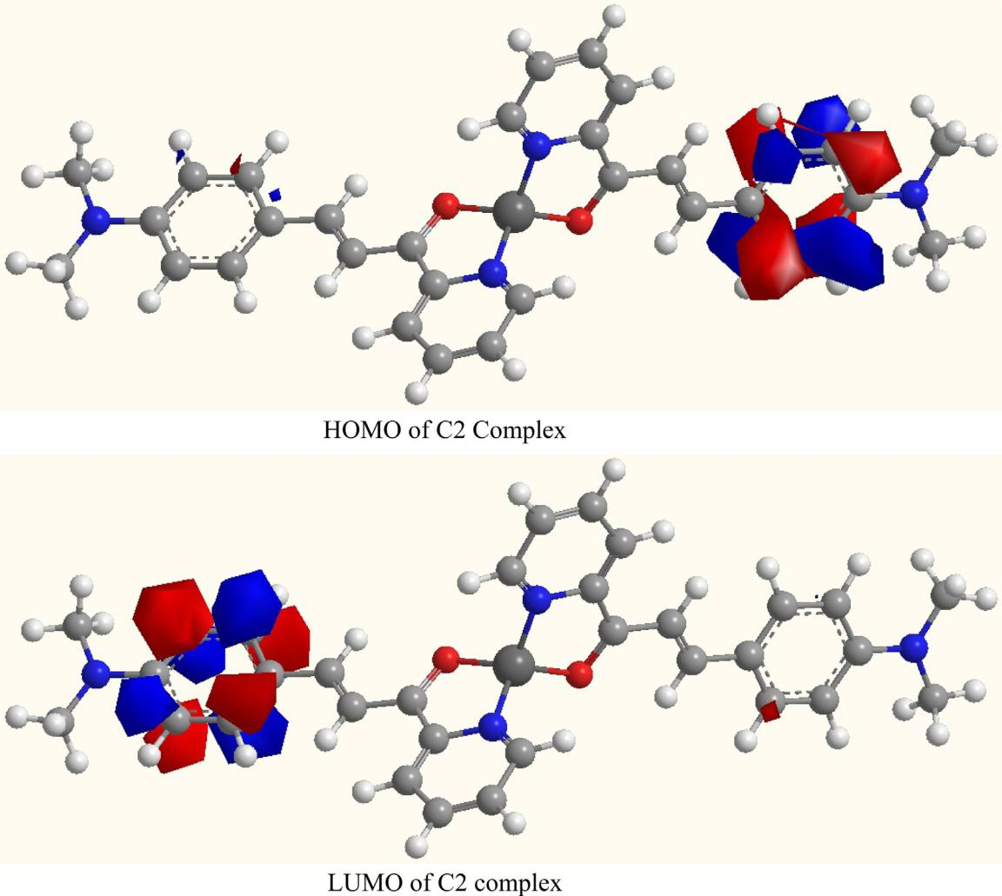

Fig. 3. The HOMO-LUMO of the ligand and its Pd(II) complex.

Table 3

Some energetic properties of the ligand and it complex C2.

The assignment of the theoretical parameters | L | C2
Total energy Kcal/mol | 62634.4 | 151264.40
Binding energy Kcal/mol | 3684.294 | 7748.354
Electronic Energy Kcal/mol | 434645.63 | 1499067.46
Heat of Formation Kcal/mol | 169.136 | 48.5079
Dipole moment (Debye) | 3.421 | 5.788
HOMO (ev) | 9.000 | 7.291
LUMO (ev) | 3.334 | 1.105

protein. The ligand showed FullFitness of 1136.96 kcal/mol and estimated DG of 6.32 kcal/mol for the most favorable interaction. Based on these analyses, the observed antitumor activity of the ligand and its complexes toward the proliferation rate of HepG2 cancer cells is proposed to be via H-ras inhibition.

Cancer cells are surviving against apoptosis through the expression of membrane-associated antioxidant enzymes like catalase and superoxide dismutase. Exogenous singlet oxygen derived from the compounds in the current study with photo-sensitizing ability upon UV–vis absorption can cause local inactivation of the protective catalase. These events lead to the generation of secondary extracellular singlet oxygen, reactivation of intracellular apoptosis-inducing signaling and death of cancer

Table 4

Energy values obtained for the molecular docking of the ligand with receptor of Escherichia coli (3t88), Staphylococcus aureus adhesion protein (4m01), Aspergillus flavus FAD glucose dehydrogenase (4ynt) and secreted aspartic protease from Candida albicans (1zap).

Protein | Est. free energy of binding | Est. inhibition constant |  |  | vdW + Hbond + desolv | Electrostatic energy | Total intemolec. energy | Frequency | Interact.
PDB | (kCal/mol) | (Ki) (mM) |  |  | energy (kCal/mol) | (kCal/mol) | (kCal/mol) |  | surface
3t88 | 4.07 | 1.04 |  |  | 5.14 | 0.13 | 5.27 | 70% | 689.219
4m01 | 2.75 | 9.71 |  | 3 | 3.68 | 0.20 | 3.88 | 30% | 614.193
4ynt | 6.91 | 8.56 | 10 |  | 8.07 | 0.01 | 8.08 | 10% | 720.623
1zap | 5.20 | 155.3 | 10 | 3 | 6.25 | 0.07 | 6.31 | 40% | 715.623

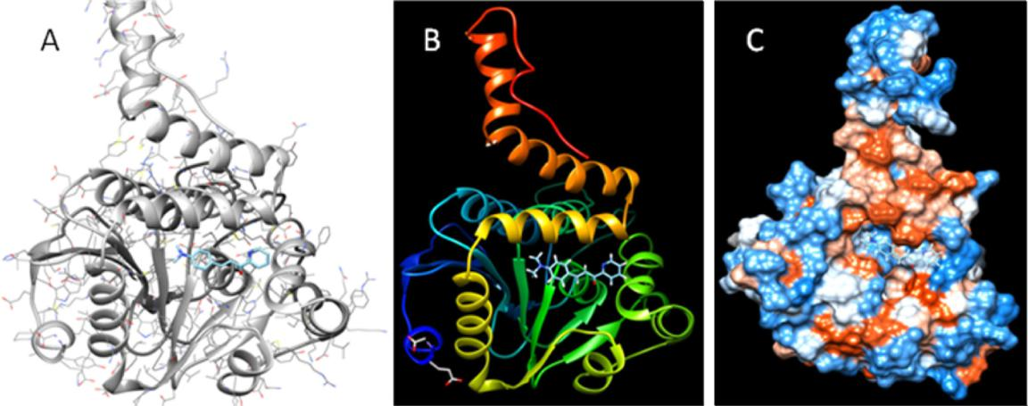

Fig. 4. The ligand in interaction with receptor of Escherichia coli (3t88). (A) Interaction between the ligand and 3t88 protein in ribbon and atom structure. (B) Hydrophobicity surface of the protein docked with the ligand is shown with colors ranging from dodger blue for the most hydrophilic to white at 0.0 to orange red for the most hydrophobic.

- The ribbon style of the docked protein is shown with coil, helix and strand. (For interpretation of the references to colour in this figure legend, the reader is referred to the web version of this article.)

cells. It seems that the action of the researched compounds as antimicrobial agents is based on the same principle. Giving the power of singlet oxygen to disintegrate the bacterial cytoplasmic membrane leading to destruction of the bacterial colonies. This hypothesis explains the observed anti-tumor, anti-bacterial and oxidative impact of these compounds on the cancer cells and different microbes [72,73].

3.4. Antibacterial activity

Biological activity of the investigated compounds (ligand and its metal complexes) was screened in-vitro against Gram positive bacteria (S. aurens) and Gram-negative bacteria (E. coli) by disc diffusion method [57]. The inhibition zone diameters are listed in
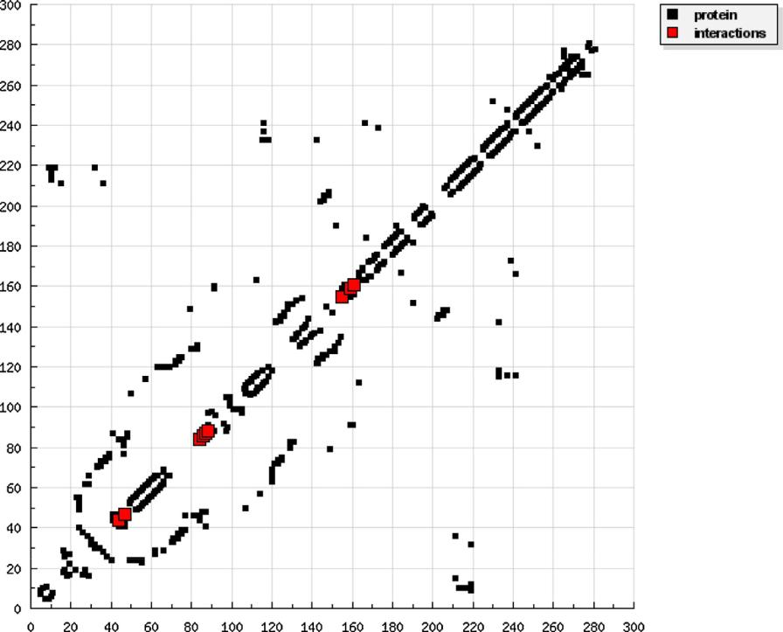

Table 8 and represented graphically in Fig. 10. These compounds showed better antibacterial activity against Gram-negative bacte-ria. The results shown in Fig. 10 indicated that most complexes exhibited remarkable increase in activity than the parent ligand. Such increased activity of the metal complexes can be explained according to Tweedy,s chelation theory [74]. Chelation reduce the polarity of the metal ion due to the partial sharing of its positive charge with the donor group and possible p-electron delocaliza-tion through the whole chelate ring system that is formed during complex formation. This process increases the lipophilic ability of the metal atom and consequently increasing the hydrophobic ability and liposolubility of the complex supporting its permeation through the lipid layers of the microorganism, thus destroying them more aggressively. The antibacterial activity of the

Fig. 5. HB plot of interaction between the ligand and receptor of Escherichia coli (3t88).

8

Fig. 6. 2D plot of interaction between the ligand and receptor of Escherichia coli (3t88).
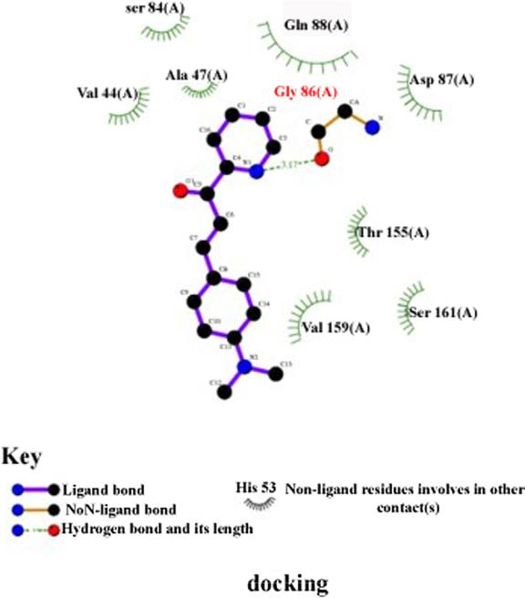

complexes can be ordered as C3 > C1 > C2 suggesting that the lipophilic behavior increases in the same order.

The complexes under investigation have: (i) The same donating atoms which are N/O with the same coordination number. (ii) The same chelate effect (all form two five membered chelating rings).

- The same oxidation number in their complexes (M⁺²). Therefore, the more effective factors are the nature of the central atom and the type of counter ions. The results, also, indicated that the complexes are more active against gram-negative than Gram-positive bacteria. The antibacterial results of the complex C3 was considered the most active compound. Therefore, the MIC screening of this complex was carried out. The MIC values were found to be 31 and 28 mg/ml against the microorganisms C. albicans and E. coli, respectively. These results indicated that C3 is more active against E coli than C. albicans.

3.5. Antifungal activity

The in-vitro antifungal activity of the ligand and its metal complexes was tested against A. flavus and C. albicans. The data of preliminary screening tests are listed in Table 8 and shown in Fig. 10. The ligand (L) and its metal complex C2 have no effect against A. flavus. Complex C3 expressed a remarkable antifungal activity against C. albicans and A. flavus. The increased antifungal activity of some metal complexes may attribute to their high penetrating ability to the fungi cell wall [75].

Table 5

Clustering results obtained from the docking of the ligand into receptor of Escherichia coli (3t88) by SwissDock.

Receptor | No. of SwissDock clusters | Cluster Rank | FullFitness (kcal/mol) | Estimated DG (kcal/mol)
3t88 | 40 (250 runs) | 1 | 1339.98 | 6.85
 |  | 2 | 1337.67 | 6.65
 |  | 3 | 1336.14 | 6.69
 |  | 4 | 1333.63 | 6.65
 |  | 5 | 1333.63 | 6.65
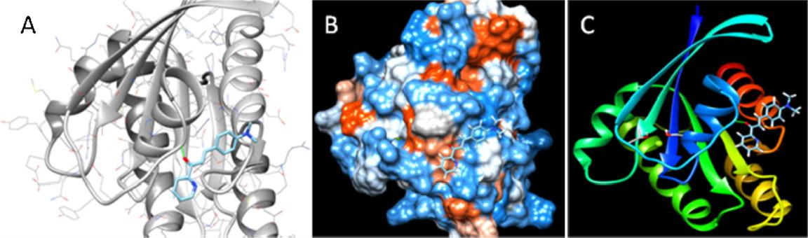

Fig. 7. The ligand in interaction with H-ras (121P). (A) Interaction between the ligand and H-ras protein in ribbon and atom structure (intermolecular H-bond in yellow). (B) Hydrophobicity surface of the protein docked with the ligand is shown with colors ranging from dodger blue for the most hydrophilic to white at 0.0 to orange red for the most hydrophobic. (C) The ribbon style of the docked protein is shown with coil, helix and strand. (For interpretation of the references to colour in this figure legend, the reader is referred to the web version of this article.)

Table 6

Energy values obtained for the molecular docking of the ligand against H-ras (PDB: 121P) in cancer.

Protein | Est. free energy of binding | Est. inhibition constant | vdW + Hbond + desolv | Electrostatic energy | Total intemolec. energy | Frequency | Interact.
PDB | (kCal/mol) | (Ki) (mM) | energy (kCal/mol) | (kCal/mol) | (kCal/mol) |  | surface
H-ras | 4.12 | 952.52 10 ³ | 4.89 | 0.36 | 5.25 | 40% | 677.049

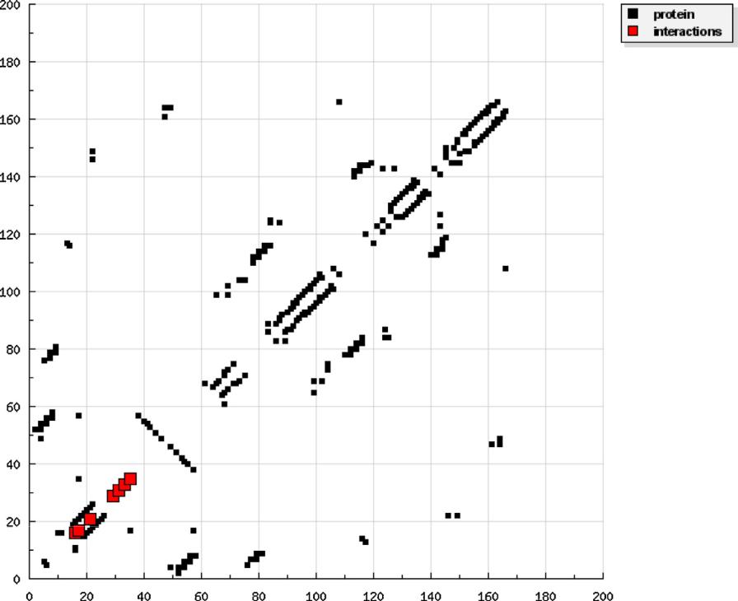

Fig. 8. HB plot of interaction between the ligand and H-ras (121P).

3.6. Anticancer activity

The antitumor efficiency of the chalcone compound and its Pd

- and Pt(II) chelates was determined in-vitro against the liver carcinoma cell line, HEPG2. The results of cytotoxic activity, compared with two standard drugs, are expressed as IC₅₀ which is the concentration required inhibiting a 50% of the cell growth
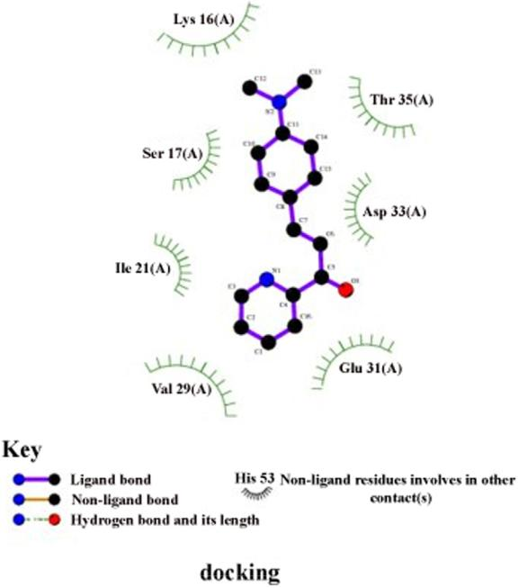

Fig. 9. 2D plot of interaction between the ligand and H-ras (121P).

when the cells are exposed to the compounds, Table 9. The concentration response profiles for the investigated compounds are given in Fig. 11. The cytotoxicity of the compounds against HEPG2 cell line is ordered in the sequence C1 > standard > C2 > L > C3 compared with the standard drugs, doxorubicin. According to Shier [76] compounds with IC₅₀ within the range of 10–25 mg/ml are considered weak anticancer drugs, while those of IC₅₀ between 5 and 10 mg/ml are moderate and compounds of activity below 5.00 mg/ml are considered strong agents. Based on these facts, it is clear that the Pt(II) complex C1 and Pd(II) complex C2 exhibited excellent anticancer activity. The Pd(II) complex C3 exhibited a weak antitumor activity while the ligand exhibited medium activity according to Shier scale. The Structure-activity relation-ships for the tested compounds confirmed the following:

- The activity of the Pd(II) complexes C2 and C3 can be ascribed to the difference in liability between the counter ion (chloride anions for C2 and acetate anions for C3) that alter the biochemical properties of these complexes [10] i.e the Pd(II) complexes were affected by the nature of the anion and the inhibitory activity was found to be increasing in the order: Pd(II) complex C2 > Pd(II) complex C3; meaning that the chloride ion increased the anticancer activity compared with the acetate ion.

- Pt(II) complex C1 with higher molar conductivity exhibited higher antitumor activity than Pd(II) complex C2. This repre-sents that the type of the metal ion may be responsible for the variation in efficiency [77]. The slightly higher toxicity of Pt(II) complex C1 (IC₅₀ = 3.08 mg/ml) than the Pd(II) complex C2 (IC₅₀ = 3.98 mg/ml) occurs because of the ligand-exchange kinetics. The hydrolysis of leaving ligands in Pt(II) compounds is quite slow compared with that of Pd(II) compounds which give them a high kinetic stability and results in ligand-exchange reactions of minutes to day, rather than microseconds to seconds for many other coordination compounds [78].

Table 7
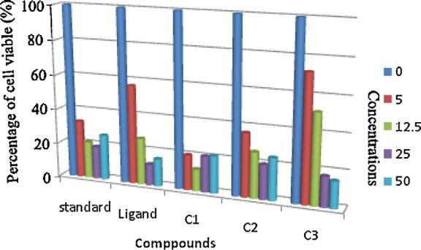

Clustering results obtained from the docking of the ligand into H-ras (121p) by

SwissDock.

Protein | No. of SwissDock | Cluster | FullFitness | Estimated
 | clusters | Rank | (kcal/mol) | DG (kcal/mol)
H-ras (121p) | 45 (250 runs) | 1 | 1136.96 | 6.32
 |  | 2 | 1136.96 | 6.32
 |  | 3 | 1135.81 | 6.28
 |  | 4 | 1133.90 | 6.17
 |  | 5 | 1133.90 | 6.17

Table 8

Antibacterial and antifungal results of the ligand (L) and its metal complexes.

 | inhibition Zone diameter (mm)
Comp. | a | b | C | d
L1 | 11 | 0 | 13 | 11
C1 | 12 | 9 | 13 | 12
C2 | 11 | 0 | 12 | 11
C3 | 15 | 9 | 14 | 13

- C. albicans, (b) A. flavus, (c) E. coli and (d) S. aureus.
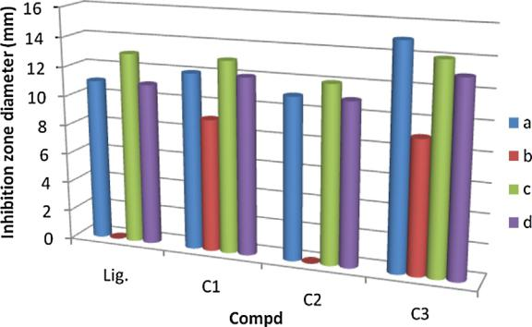

Fig. 10. Effect of ligand and its metal complexes toward (a) C. albicans, (b) A. flavus,

- E. coli and (d) S. aureus.

Table 9

IC₅₀ values calculated from the in vitro antitumor activities against HEPG2 cell line and antioxidant results against DPPH.

Compound | IC₅₀ (mg/mL) | IC₅₀ (mg/ml)
 | HEPG2 | DPPH
L1 | 6.53 | 43.92
C1 | 3.08 | 48.92
C2 | 13 | 63.54
C3 | 3.98 | 20.02
Doxª | 3.1 | –

- Doxorubicin; standard cytotoxin drug.

Fig. 11. Effect of chalcons ligand and its Pt(II) and Pd(II) complexes as surviving fraction of HEPG2 tumor cell.
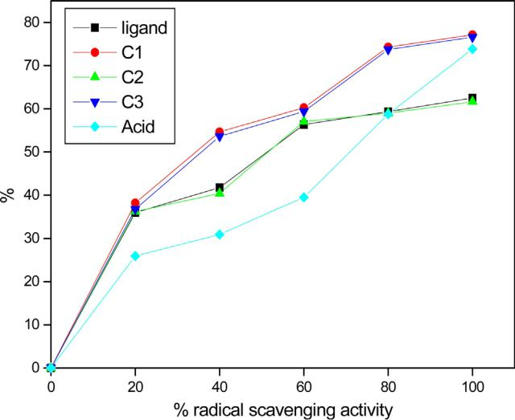

Fig. 12. The scavenging activity of the ligand and its complexes.

3.7. Antioxidant

Pd(II), Pt(II) chelates in addition to the chalcone compound were screened for their antioxidant activity. The radical scavenging ability of these compounds was evaluated versus the DPPH stable free radical, Fig. 12. The DPPH assay of these compounds shown in Table 9 indicated that complexes C1-C3 exhibited higher antioxi-dant activity compared to the standard, ascorbic acid. The IC₅₀ values of complexes C1-C3 indicated that the compounds showed antioxidant activity in the order C1 > C3 > C2 i.e complex C1 showed a higher antioxidant activity compared to complexes C2 and C3. Also, the scavenging effect of the metal complexes is lower compared to the free ligand.

4. Conclusion

- The obtained results indicated that the metal complexes C1 and C2 are more effective than the chalcone ligand towards the tested cell line. This indicated that the complexation to the metal ion enhanced the anticancer behaviour. This may be attributed to the increase in conjugation in the ligand moiety on complexation [79]. On the other hand, the Pd(II) complex C3 exhibited less activity than the ligand. The reason of such decreased activity is ambiguous indicating that relationship between structure and activity is extremely complex.

We have reported the synthesis of Pt(II) and Pd(II) chalcone complexes. The structural characterization of the synthesized compounds was made by using the elemental analyses, spectro-scopic methods, conductance studies and thermal analysis. The chalcone ligand behaved as a neutral bidentate ligand through oxygen and nitrogen atoms of carbonyl and azomethine groups, respectively. Square planar geometry for the complexes was reported. All complexes are electrolytes. The biological activity screening showed that the complexes have increased activity compared with the ligand against the tested bacteria and fungi.

The cytotoxicity of the ligand and its complexes against HEPG2 cancer cell line has been studied. Pt(II) complex C1 exhibited excellent anticancer activity which is more active even than the slandered drug (doxorubicin). A structure-reactivity relationship was proposed to evaluate the activity of prepared compounds. The radical scavenging ability of the studied compounds was tested against the DPPH stable free radical. The DPPH assay indicated that complexes C1-C3 exhibited higher antioxidant activity compared to the standard (ascorbic acid). IC₅₀ values showed antioxidant activity in the order C1 > C2 > C3 i.e complex C1 showeda higherantioxidant activity compared to complexes C2 and C3. The metal complexes have less scavenging effect compared to the free ligand. Molecular Docking studies were performed in DockingServer and SwissDock. X-ray crystallographic structures of the proteins were retrieved from Protein Data Bank (PDB), and used as drug target protein. Molecular visualizationwas performed usingUCSF Chimera. The ligandshowed favorable binding with the bacterial receptor protein 3t88 and the oncogene protein H-ras. Conclusively our results strongly suggest that the ligand is a potent anti H-ras agent as ascertained by its potential interaction with H-ras. This scientific hypothesis might provide a better insightto control carcinogenesis as well as to control solid cancer growth and metastasis.

Acknowledgements

The authors would like to express their thanks to Tanta University (Grant No: Tu 03-13-01) for this project financial support. The authors also extend their gratitude to Prof. Dr Tarek Mostafa for his help in the evaluation of the results of antioxidant efficiency.

References

- A.S. Abu-Surrah, H. Al-Sa'doni, M.Y. Abdalla, Cancer Ther. 6 (2008) 1.

- E.J. Gao, C. Liu, M.C. Zhu, H.K. Lin, Q. Wu, L. Liu, Anti Cancer Agents Med. Chem. 9 (2009) 356.
- P.I. da, S. Maia, A.G. de, A. Fernandes, J.N. Silva, A.D. Andricopulo, S.S. Lemos, E.S. Lang, U. Abram, V.M. Deflon, J. Inorg. Biochem. 104 (2010) 1276.
- J. Schulz, A.K. Renfrew, I. Cisarova, P.J. Dyson, P. Stepnicka, Appl. Organomet. Chem. 24 (2010) 392.
- E. Gao, M. zhu, Y. Huang, L. Liu, H. Liu, F. Liu, S. Ma, C. Shi, Eur. J. Med. Chem. 45 (2010) 1034.
- F. Rocha, C. Barra, A. Netto, A. Mauro, I. Carlos, R. Frema, S. Ananias, M. Quilles,

  - Stevanato, M. da Rocha, Eur. J. Med. Chem. 45 (2010) 1698.

- M. Juribasic, K. Molcanov, B. Kojic-Prodic, L. Bellotto, M. Kralj, F. Zani, L. Tusek-Bozic, J. Inorg. Biochem. 105 (2011) 867.
- A.I. Matesanz, J. Perles, P. Souz, Dalton Trans. 41 (2012) 12538.

- K. Karami, M. Hosseini kharat, H. Sadeghi-Aliabadi, J. Lipkowski, M. Mirian, Polyhedron 50 (2012) 187.
- H. El-Boraey, Spectrochim. Acta A 97 (2012) 255.

- N.T. Abdel Ghani, A.M. Mansour, Eur. J. Med. Chem. 47 (2012) 399;

  - Mansour, M. Mohamed, Inorg. Chim. Acta 423 (2014) 373;

  - Mansour, N. Abdel-Ghani, Inorg. Chim. Acta 438 (2015) 76.

- N. Cutillas, G.S. Yellol, C. de Haro, C. Vicente, V. Rodriguez, J. Ruiz, Coord. Chem. Rev. 257 (2013) 2784.
- A. El-Husseiny, H. Hassan, Spectrochim. Acta A 103 (2013) 232.

- N. Ozbek, S. Alyar, H. alyar, E. Sahin, N. Karacan, Spectrochim. Acta A 108 (2013) 123.

- M. Jagadeesh, H. Rashmi, Y. Rao, A.S. Reddy, B. Prathima, P. Devi, A.V. Reddy, Spectrochim. Acta A 115 (2013) 583.
- J. Zhang, L. wang, S.Y. Liu, F. Zhang, J. Du, L. Li, S. Wang, S. Li, G. Zhou, Russ. J. Coord. Chem. 40 (2014) 115.
- D.L. Stojkovic, V.V. Jevtic, G.P. Radic, D.V. Todorovic, M. Petrovic, M. Zaric, I. Nikolic, D. Baskic, S.R. Trifunovic, J. Inorg. Biochem. 143 (2015) 111.
- M. Gaber, H. El-Ghamry, S.K. Fathalla, Spectrochim. Acta A 139 (2015) 396.

- D. Gutierrez, S. Bernes, G. Herna-ndez, O. Portillo, G. Moreno, M. Sharma, P. Sharma, R. Gutierrez, J. Coord. Chem. 68 (2015) 3805.

- D. Ajloo, M. Moghadam, K. Ghadimi, M. Ghadamgahi, A. Saboury, A. Divsalar,

  - Sheikh-Mohammadi, K. Yousefi, Inorg. Chim. Acta 430 (2015) 144.

- H. Pruchnik, T. Lis, M. Latocha, A. Zielinska, F.P. Pruchnik, J. Inorg. Biochem. 156 (2016) 14.
- M. Zhu, X. Cui, S. Zhang, L. Liu, Z. Han, E. Gao, J. Inorg. Biochem. 157 (2016) 34.

- B. Mavroidi, M. Sagnou, M. Paravatou-Petsotas, M. Pelecanou, Inorg. Chim. Acta 444 (2016) 63.
- M. Amir, S. Khan, F. Hayat, A. Hassan, I. Butler, Z. Rehman, Inorg. Chim. Acta 451 (2016) 31.
- C. Barra, F. Rocha, L. Morel, A. Gautier, S. Garrido, A. Mauro, R. Frem, A. Netto, Inorg. Chim. Acta 446 (2016) 54.
- A. Al-Dawood, N. El-Metwaly, H. El-Ghamry, J. Mol. Liq. 220 (2016) 311.

- L. Via, G. Gia, G. Chiarelotto, M. Ferlin, Eur. J. Med. Chem. 44 (2009) 2854.

- Z. Ratkovic, Z. Juranic, T. Stanojkovic, D. Manojlovic, R. Vukicevic, N. Radulovic,

  - Joksovic, Bioorg. Chem. 38 (2010) 26.

- L. Tavares, S. Johann, T. Alves, J. Guerra, Eur. J. Med. Chem. 46 (2011) 4448.

- M. Abdel-Aziz, S. Park, G. Abuo-Rahma, M.A. Sayed, Y. Kwon, Eur. J. Med. 69 (2013) 427.
- P. Singh, A. Anand, V. Kumar, Eur. J. Med. Chem. 85 (2014) 758.

- D. Mahapatra, S. Bharti, V. Asati, Eur. J. Med. Chem. 98 (2015) 69.

- M. Kaveri, R. Prabhakaran, R. Karvembu, K. Natarajan, Spectrochim. Acta A 61 (2005) 2915.
- M. Gaber, S.A. El-Daly, Y.S. El-Sayed, J. Mol. Struct. 922 (2009) 51.

- M. Muthukumar, P. Viswanathamurthi, J. Coord. Chem. 63 (2010) 1263.

- P. Rishikesh, S. Dubey, R. Gaur, R. Koiri, B. Maurya, S. Trigun, L. Mishra, Polyhedron 29 (2010) 1055.
- M. Kalanithi, M. Rajarajan, P. Tharmaraj, C. Sheela, Spectrochim. Acta A 87 (2012) 155.

- J. Da Silva, A. Recio Despaigne, S. Louro, C. Bandeira, E. Souza-Fagundes, H. Beraldo, Eur. J. Med. Chem. 65 (2013) 415.
- M.E. Aly, H. Fodah, S. Saleh, Eur. J. Med. Chem. 76 (2014) 517.

- M. Gaber, S. Al-Daly, T. Fayed, Y. El-Sayed, J. Lumin. 157 (2015).

- Y.S. El-Sayed, M. Gaber, Spectrochim. Acta A 137 (2015) 423.

- A.K. Singh, G. Saxena, S. Dixit, Hamidullah, S.K. Singh, S.K. Singh, M. Arshad, R. Konwar, J. Mol. Sturct. 1111 (2016) 90.
- R. Krikavová, J. Vanco,9 Z. Trávnícek,9 J. Hutyra, Z. Dvorák, J. Inorg. Biochem. 163 (2016) 8.
- Y. Kumar, C. Devi, N. Deepika, N. Gabra, N. Jain, A. Srishailam, K. Reddy, S. Satyanarayana, Transition Met. Chem. 38 (2013) 811–819.
- R. Alizadeh, M. Afzal, F. Arjmand, Spectrochim. Acta A 131 (2014) 625–635.

- D. Li, J. Tian, W. Gu, X. Liu, H. Zeng, J. Inorg. Biochem. 105 (2011) 894–901.

- Z. Bikadi, E. Hazai, J. Cheminf. 1 (2009) 15.

- G.M. Morris, D.S. Goodsell, et al., J. Comput. Chem. 19 (1998) 1639.

- F.J. Solis, R.J.B. Wets, Minimization by random search techniques, Math. Oper. Res. 6 (1981) 19.
- A. Grosdidier, V. Zoete, O. Michielin, SwissDock, a protein-small molecule docking web service based on EADockDSS, Nucleic Acids Res 39 (2011) W270– W277.

- A. Grosdidier, V. Zoete, O. Michielin, J. Comput. Chem. 32 (2011) 2149.

- A. Grosdidier, V. Zoete, O. Michielin, Proteins 67 (2007) 1010.

- E. Pettersen, T. Goddard, C. Huang, G. Couch, D. Greenblatt, E. Meng, T. Ferrin, J. Comput. Chem. 25 (2004) 1605.
- T. Pridham, L. Lindenfelser, O. Shotwell, F. Stodola, R. Benedict, C. Foley, P. Jacks,

  - Zaumeyer, W. Perston, J. Mitchell, Phytopathology 46 (1956) 568.

- S. Shadomy, I. Epsinel, R. Cartwright, Laboratory studies agents: susceptibility

test and bioassays, in: A. Lennette, W. Balows, H. Hausler, S. Shadomy (Eds.), Manual of Clinical Microbiology, 4th ed., Little Brown Co., Boston, 1985.
- P. Skehan, R. Storeng, J. Natl. Cancer Inst. 82 (1990) 1107.

- National committee for Clinical laboratory standards, NCCLS Approval Standard Document M2-A7, National committee for Clinical laboratory standards, Vilanova, PA, 2000.
- HyperChem, Release 8.03 for Windows, Molecular modeling system, Hypercube.

- W.J. Geary, Coord. Chem. Chem. 7 (1971) 81.

- A.B.P. Lever, Inorganic Electronic Spectroscopy, second ed., Elsevier, Amsterdam, 1982, pp. 544.
- O.A. Ali, Spectrochim. Acta A 121 (2014) 188.

- A.W. Coats, J.P. Redfern, Nature 201 (1964) 68.

- M. Gaber, Y. El-Sayed, K. El-Baradie, R. Fahmy, Spectrochim. Acta A 107 (2013) 359;

  - Gaber, Y.S. El-Sayed, K. El-Baradie, R. Fahmy, J. Mol. Struct. 1032 (2013) 185.

- M. Gaber, H. El-Ghamry, F. Atlam, S. Fathalla, Spectrochim. Acta A 137 (2015) 919.

- N. Abdel Ghani, A. Mansour, Spectrochim. Acta A 81 (2011) 529.

- R. Pearson, J. Org. Chem. 54 (1989) 1423.

- S. Sagdinc, B. Koksoy, F. Kandeirli, S. Bayari, J. Mol. Struct. 917 (2009) 63.

- J. Padmanabhan, R. Parthasarathi, V. Subramanian, J. Phys. Chem. A 111 (2007) 1358.

- T.A. Yousef, O.K. Alduaij, S.A. Ahmed, G.M. Abu El-Reash, O. El-Gammal, J. Mol. Struct. 1119 (2016) 351.
- Z. Bikadi, L. Demko, E. Hazai, Functional and structural characterization of a protein based on analysis of its hydrogen bonding network by hydrogen bonding plot, Arch. Biochem. Biophys. 461 (2007) 225–234.

- I. McDonald, J. Thornton, Satisfying hydrogen bonding potential in proteins, J. Mol. Biol. 238 (1994) 777–793.

[72] | G. Bauer, The antitumor effect of singlet oxygen, Anticancer Res. 36 (2016) | [76] | W.T. Shier, Mammalian Cell Culture on $5 a Day: A Lab Manual of Low Cost
 | 5649–5663. |  | Methods, University of the Philippines, Los Banos, 1991.
[73] | M. DeRosa, R. Crutchley, Photosensitized singlet oxygen and its applications, | [77] | X. Riera, V. Moreno, C. Ciudad, V. Noe, M. Font-Bardia, X. Solans, Bioinorg.
 | Coord. Chem. Rev. 233 (234) (2002) 351–371. |  | Chem. Appl. 2007 (2007) 1.
[74] | B.G. Tweedy, Phytopathology 55 (1964) 910. | [78] | J. Reedijk, Inorg. Chim. Acta 198 (1992) 873.
[75] | R. John, A. Sreekanth, V. Rajakannan, T.A. Ajith, M.R. Kroup, Polyhedron 23 | [79] | K. Dhahagani, S. Kumar, G. Chakkaravarthi, K. Anitha, J. Rajesh, A. Ramu, G.
 | (2004) 2549. |  | Rajagopal, Spectrochim. Acta A 117 (2014) 87.

