The Role of Dynamic Contrast Enhanced MRI perfusion imaging in post treatment surveillance of patients with high grade gliomas

Laura Elin Pigott¹; Laura Mancini²; Sotirios Bisdas³
1: London South Bank University, Institute of Health and Social Care. Lysholm Department of Neuroradiology & Neurosurgery, Queen Square Institute of Neurology, University College London. London, UK
2: Lysholm Department of Neuroradiology & Neurosurgery, University College London. Department of Brain Repair and Rehabilitation, UCL Queen Square Institute of Neurology, London, UK
3: Lysholm Department of Neuroradiology & Neurosurgery, University College Hospital London, London, UK

Abstract
Neuroimaging is a valuable diagnostic and surveillance tool for high-grade gliomas. Dynamic Contrast Enhanced Magnetic Resonance Imaging (DCE-MRI) is a perfusion imaging technique, which can quantitatively evaluate tumour biology, concentrating mostly on the microcirculation and the enhancement patterns in the surrounding tissue. This retrospective observational study consisted of 48 post-treatment patients having been diagnosed with high-grade glioma of the brain. Measurements were taken using DCE-MRI at baseline and at 3-month, 6-month, 9-month and 12-month follow-ups. Perfusion maps, BF, AUC, Ktrans, Kep, Ve and Vp, were generated and processed using commercially available software. Eight survival analysis models differentiated progression from stable disease and pseudo-progression from true progression, across the 6- and 12-month timepoints. Models 1 through 4 assessed disease progression based on the initial baseline scan, while models 5 through 8 assessed progression based on the baseline and the 3-month DCE-MRI scan. All survival analysis models were statistically significant with high sensitivity and specificity. The starting hypotheses were verified, (1) DCE-MRI proved an accurate and clinically useful tool in the surveillance of high-grade gliomas, by differentiating, clearly and accurately, between tumour growth and treatment related changes, such as pseudo-progression. (2) The addition of the secondary DCE-MRI assessment enhanced the survival analysis prediction and subsequently the accuracy of the prognosis.
Key words: Glioma, Brain Cancer, DCE-MRI, Advanced Neuroimaging.

1.Introduction
1.1. High-grade gliomas and the role of neuroimaging
The most common malignant brain tumours are gliomas, which account for eighty percent of all malignant primary central nervous system tumours (Colman, 2020). The incidence rate of high-grade, aggressive brain tumours is steadily rising, with survival rates averaging approximately 1 year, indicating that there is a need for a more proactive response during treatment and prevention (Philips et al., 2018).
Currently, the gold standard of imaging techniques for the surveillance and management of high-grade gliomas is T1-weighted magnetic resonance imaging (MRI) with contrast and T2 or FLAIR (Sharma, et al, 2017). However, this post-contrast method only indirectly reveals the biological activity of a tumour (Brandsma et al., 2009; Malara and Donato, 2019), being non-specific and unreliable in predicting subsequent tumour behaviour. The identification of disease progression can be confounded by pseudo-progression, which can be defined as a treatment related response seen in the tumour or the surrounding area. This response produces an increase of enhancement or oedema on an MRI scan indistinguishable from changes caused by true progression (Brandsma and van den Bent, 2009). True progression and pseudo-progression can currently only be differentiated with certainty after 6, 9 or 12 months, when a true progression would continue to increase in size whilst a pseudo-progression would decrease in size. As a result, the radiologic distinction is inherently retrospective based on serial MRI scans (Fink, et al, 2011).

1.2 The use of Dynamic contrast-enhanced MRI thus far
Dynamic contrast enhanced magnetic resonance imaging (DCE-MRI) has been established as a method to quantitatively evaluate tumour biology, concentrating mostly on the microcirculation and the enhancement patterns in the surrounding tissue. The use of DCE-MRI neurovascular assessment could potentially distinguish between tumour growth and treatment related-changes, such as pseudo-progression (Nam et al., 2017). The ability to establish dissimilarities between true progressive disease and treatment related changes surrounding the disease was first determined by dynamic susceptibility contrast MRI (Barajas et al., 2008; Barajas et al., 2009; Young et al., 2013; van Dijken et al., 2019).
Perfusion imaging, specifically DCE-MRI, has been established to differentiate progressive or recurrent disease from stable disease (Seeger et al., 2013). However, as most MR imaging modalities can detect this differentiation, a quintessential area of focus has been the differentiation of pseudo-progression and true progression. Some studies which evaluated the feasibility and validity of any differentiation between pseudo-progression and true progression, determined that DCE-MRI may indeed prove useful when determining disease status (Bisdas et al., 2011; Narang et al., 2011; Bisdas et al., 2014; Chung et al., 2013; Suh et al., 2013; Park et al., 2015; Thomas et al., 2015; Yun et al., 2015; van Dijken et al., 2017; Zakhari et al., 2019).

1.3 Study objectives
Currently, DCE-MRI is the standard approach for the observation of cancers in many body organs (Onishi et al., 2020; Song et al., 2020; Zhu et al., 2021). Its use has not yet been standardised for the surveillance of brain tumours, although this application has been proved feasible (Anzalone et al., 2018). This study’s objective is to examine the usefulness, accuracy, and diagnostic role of DCE-MRI in the surveillance of patients with high-grade gliomas and associate the imaging findings to the clinical data. Additionally, this study aims to evaluate the added predictive and diagnostic value of implementing a secondary DCE-MRI exam after three months from the baseline DCE-MRI. The added value of the second DCE-MRI scan will be measured regarding survival prediction and differentiation between true progression and pseudo-progression. The primary hypothesis of this study is that the DCE-MRI would prove to be an accurate and clinically useful tool in the surveillance of high-grade gliomas, by being able to depict the differences, clearly and accurately, between tumour growth and treatment related changes, such as pseudo-progression. A further hypothesis is that the addition of the secondary DCE-MRI assessment will enhance the survival analysis prediction and subsequently the accuracy of the prognosis.

2. Methods and Materials

2.1 Patient selection and criteria
The study was approved by the National Hospital for Neurology and Neurosurgery and University College London institute of Neurology Joint Ethics Committee. Strict confidentiality and anonymity guidelines were adhered to. Patients were retrospectively selected from the University College London Hospitals Electronic Health Records in accordance to the following inclusion criteria: a) patients had undergone image-guided gross total tumour resection or tissue biopsy for histological examination of the mass b) histologically confirmed high-grade glioma (grade III or IV), in accordance with the World Health Classification (WHO) specifications, at the date of the first DCE-MRI; c) baseline measurement was obtained between the timeframe 2015 to 2020; d) patients underwent chemoradiation protocol in accordance with NICE guidelines and when clinically necessary adjuvant chemotherapy treatments (National Institute for Health and Care Excellence, 2018); e) patients subsequently developed a progressively contrast-enhanced enlarging region within the field of interest, identified in two or more consecutive MRI examinations; f) participants underwent, in addition to the baseline DCE-MRI scan, at least one additional DCE-MRI examination.
48 patients with a mean age of 49.85 ± 12.81 years met these inclusion criteria and were analysed within the time constraints of the study. Of the 48 patients, 28 were males and 20 were females. Baseline DCE-MR images were obtained from all patients. Additionally, follow-up DCE-MRI scans were obtained at the 3-month, 6-month, 9-month, and 12-month follow-ups. The median time to follow up after baseline for the individual timepoints were: 2.7, 3.7, 8.9, and 12.3 months respectively.

2.2 Neuroimaging processing and analysis
MRI data were acquired on two types of scanners, a GE 1.5T and a Siemens 3T scanner, therefore the acquisition parameters, were slightly different. For DCE-MRI, 3D post-contrast T1-weighted images were acquired.
The perfusion MR analysis was performed using commercially available software. Pre-processing was conducted in accordance with literature (Brix et al., 1991; Jansen et al., 2017).
The generation of the perfusion maps is based on the extended Tofts model (Tofts et al., 1999). Six parametric perfusion maps were generated per scan: (1) the blood flow (BF) map, which establishes the volume of blood passing through a fixed amount of tissue per unit of given time (Bonekamp, Degaonkar and Barker, 2011), (2) the Ktrans map (a kinetic parameter), which is the volume transfer rate and determines blood flow of the tissue and vessel permeability, (3) the Ve map, which is the volume of the extravascular, extracellular space and is a marker of cell density, (4) the Kep map (a kinetic parameter), which is the transfer rate constant extracellular extravascular space to the plasma, (5) the Vp map, which is the fractional volume of the plasma space, and reflects the distribution of contrast agent within a tissue voxel (Bazyar et al., 2016; Jansen, 2016), and lastly (6) the AUC map, which is not dependent on model selection or AIF, reflects permeability and perfusion, which are both associated with prognosis (Choi et al., 2017). The region of interest (ROI) mask was defined manually, using the pixel editing tool on the resampled structural data.

Table 1: Models: This table identifies relevant information to the study.
Model | Disease status | Time point | Maps included in the model | Model equation | Threshold  Sensitivity  Specificity | p-value | Median survival time, high perfusion (months) | Median survival time, low perfusion (months)
Model 1 | Stable/regression vs progression | 6 months | Baseline: Ve, Vp | model_1 = .07711* age_baseline+ .0090714 * Baseline_VeMap + .5687629 * Baseline_VpMap | 5.79  81%  68% | <0.0001 | 3.7 | 6.2
Model 2 | Stable/regression vs progression | 12 months | Baseline: Ve, Vp | model_2 = .0837632 * age_baseline + .0036835 * B_VeMap + .7076702 * B_VpMap | 6.24  74%  72% | <0.0013 | 3.1 | 10.5

Model 3 | True progression vs pseudo progression | 6 months | Baseline: BF, Ktrans, Ve, Vp | model_3 = .0771591 * age_baseline - .0129942 * B_Bfmap + 1.2373 * BP_K21map + .0040047 * B_VeMap + .1464732 * B_VpMap | 4.32  77%  65% | <0.0027 | 4.1 | 6
Model 4 | True progression vs pseudo progression | 12 months | Baseline: Vp | model_4 = .0421877 * age_baseline + .4490081 * B_VpMap | 3.07  85%  75% | <0.003 | 3.9 | 7.8
Model 5 | Stable/regression vs progression | 6 months | Baseline: Ve, Vp  3-months: BF, Kep, Vp | model_5 = .100202 * age_baseline + .0198866 * B_VeMap + .4017944 * B_VpMap + .0004573 * m3_Bfmap + .3613811 * m3_K21map + 3.02e-07 * m3_VpMap | 8.2  91%  78% | <0.0071 | 4.7 | 6
Model 6 | Stable/regression vs progression | 12 months | Baseline: Ve, Vp  3-months: Kep, Vp | model_6 = .1209808 * age_baseline + .0049757 * B_VeMap + .6778823 * B_VpMap + .3699599 * m3_K21map + .1394876 * m3_VpMap | 9.48  82%  81% | <0.0001 | 3.7 | >12
Model 7 | True progression vs pseudo progression | 6 months | Baseline: BF, Kep, Ve  3-months: Vp | model_7 = .0670389 * age_baseline - .0132765 * B_Bfmap + .699975 * BP_K21map + .0048207 * B_VeMap + .1705033 * B_VpMap - .0509623 * m3_VpMap | 4.02  80%  76% | <0.0001 | 3.3 | 6.4
Model 8 | True progression vs pseudo progression | 12 months | Baseline: Vp  3-months: Kep, Vp | model_8 = 1.069261 * age_baseline + 1.363248 * B_VpMap + 1.3278 * m3_K21map + 1 * m3_VpMap | 66.51  50%  81% | <0.0001 | 3.4 | 7.8

2.3 Assessment of the disease state
To assess the cases and categorise them into groups of stable or responding, progression and pseudo-progression, the percent change of the volume of the ROIs was evaluated using the equation: 100*(V_{t2}-V_{t1})/V_{t1} for each of the subsequent time points; t1 was determined as baseline, and t2 the second timepoint in which the percent change was to be evaluated. This percent change was used to assess if the disease was progressing, by having a percent change more than or equal to 25%, remaining stable, by holding a percent change between 0% and 25% or regressing by exhibiting a negative percentage change. Pseudo-progression was determined by presenting as regression after a period of progression. The survival analysis which was used classified the patients at 6 and 12 months in two ways: (1) stable/responding disease vs progressive disease; (2) true-progressive disease vs pseudo-progression.

2.4 Statistical analysis
The data was tested objectively for normality, equality in disease status and for relevant correlations (Rebekić et al., 2015; Sheard, 2018). A survival analysis assessment was performed, to identify which baseline and 3 months information would predict progression and pseudo-progression at the 6- and 12-month time points. A threshold was established and divided the patients into two groups, patients with high perfusion values and patients with low perfusion values, where the median survival time could be established, and the cumulative progression based on the perfusion values could be graphed using the Kaplan-Meier survival analyses (Etikan, 2018).
Eight models were generated, as detailed in Table 1. Models 1 to 4 only considered baseline DCE-MRI maps, whist models 5 to 8 included DCE-MRI maps at both baseline and 3-months. Models 1, 2, 5 and 6 differentiated stable/regression disease from pseudo-progression, whilst models 3, 4, 7 and 8 differentiated true progression from pseudo-progression. Models 1, 3, 5, and 7 assessed the survival at 6 months, whilst models 2, 4, 6, and 8 assessed the survival at 12 months. The DCE-MRI maps that were significant in the univariate Cox proportional hazard regression and were therefore included in the model, are detailed in Table 1. For all models the time of progression was set at the earliest time point with the outcome of progression for models 1, 2, 5, 6 and with the outcome of true progression for the models 3, 4, 7, 8.

3. Results
3.1 Patient characteristics
As demonstrated in table 1 48 patients met the inclusion criteria and were analysed within the time constraints of the study. The mean age of the patients was 49.85 ± 12.81 years, with a range of 24-76, with 58% of patients being male and 42% being female. Seven of the 48 patients presented with grade III tumours, one patient was ungradable, and the remaining patients presented with grade IV.

3.2 Pseudo-progression vs Progression
This study aside from differentiating between progression and stable disease also distinguished true progression from pseudo-progression. At the 6-month follow up there were 15 patients with enhancing lesions on their follow-up scans. 47% of those cases were determined to be pseudo-progressive. Furthermore, at the 12-month follow-up out of the 13 patients remaining 46% of the progressive cases were deemed to be pseudo-progression.

3.3 Significance of perfusion maps
The two-sample Wilcoxon rank-sum (Mann-Witney) test, for not normally distributed data, was insignificant, which signifies that the individual maps cannot distinguish between progression and stable disease or true progression and pseudo-progression. The correlations between BF and AUC, Ktrans and BF, Ktrans and AUC, Ve and BF, Ve and AUC, Ve and Ktrans, in addition to Ve and Kep are significant (P < 0.005), however the relationships between the remaining maps were not significantly correlated.

3.4 Survival analysis models
The Wilcoxon–Breslow–Gehan test conveyed that the probability for all models were statistically significant (table 1). The Kaplan-Meier survival curve for each model can be visualised in figures 1 to 8. Models 1, 2, 5, and 6 evaluated the difference between stable or regressing disease and progression, while models 3, 4, 7, and 8 differentiated between true progression and pseudo-progression. The sensitivity and specificity can be appreciated in Table 1.
Model 1  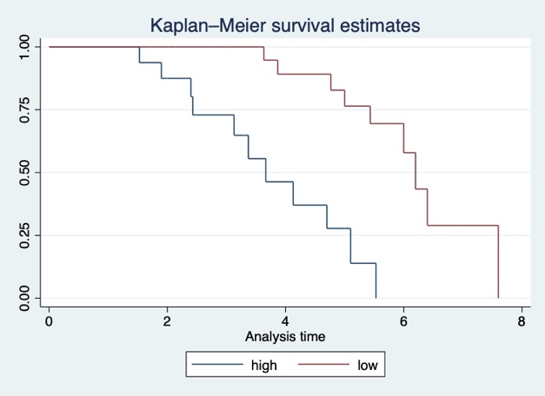 | Model 5  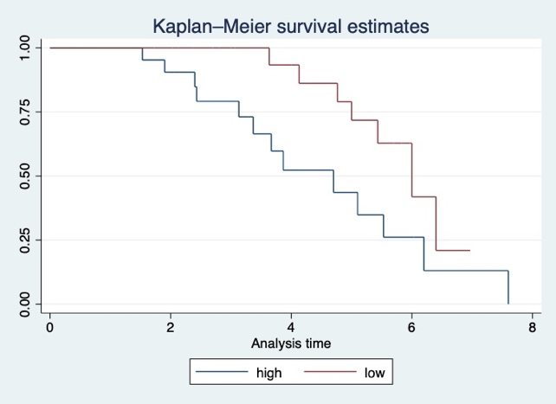
Model 2  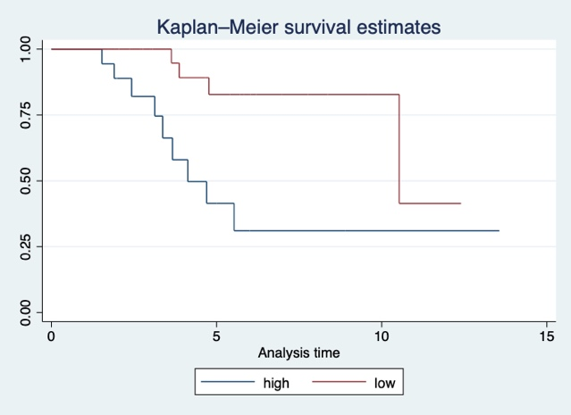 | Model 6  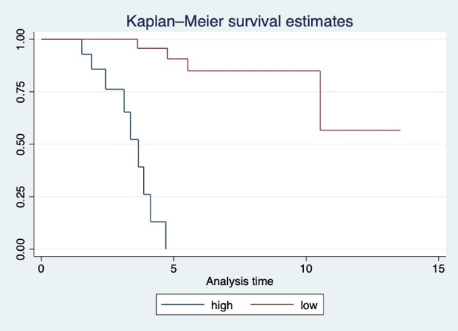
Figure 1: Kaplan-Meier survival estimates 0=progression, 1=stable disease or regression. The analyses time is in months. The blue line indicates the group of patients with high perfusion values and the red line indicates the group of patients with low perfusion values.
Model 3  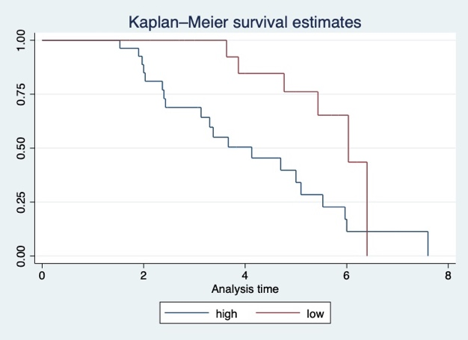 | Model 7  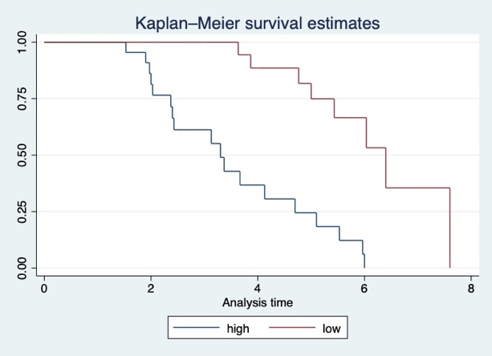
Model 4  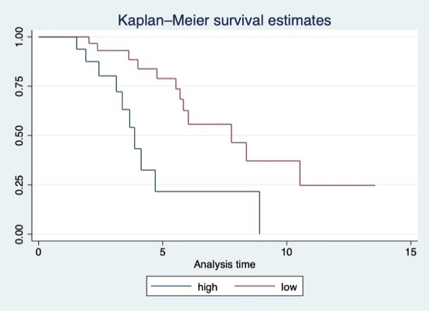 | Model 8  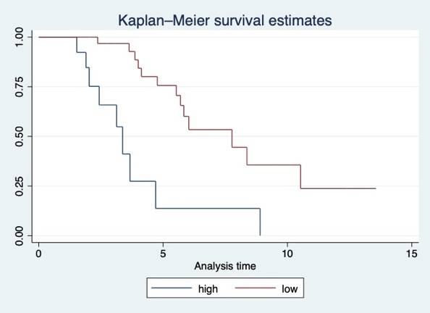
Figure 2: Kaplan-Meier survival estimates 0=true progression, 1=pseudo-progression or stable disease. The analyses time is in months. The blue line indicates the group of patients with high perfusion values and the red line indicates the group of patients with low perfusion values.

The comparison of Model 1 and Model 5 suggests the use of the baseline and 3-month DCE-MRI assessments combined provides a more accurate measurement of progression (higher sensitivity and specificity in Model 5, Table 1). Although both models evaluated identical patients during the same timeframe, the time to progression for patients with high perfusion values was 1.1-month later in Model 5 when compared to Model 1. The findings of Model 6 are similar to the findings of Model 2, which did not incorporate the perfusion maps of the 3-month measurement during the survival analysis, thus suggesting that the differentiation of stable disease and disease change or progression at 12 months is not dependant on a second assessment with DCE-MRI. The two models predict a different median survival time for the patients with low perfusion: 10.5 months for Model 2 and more than 12 months for Model 6.
Moreover, models 5 and 6 had a higher sensitivity and specificity than models 1 and 2, suggesting a more accurate prediction of progression (differentiating it from stable/regressing disease) at both 6 months and 12 months when 3-months measurements are included in the models. Model 7 also had higher sensitivity and specificity than Model 3, however, Model 8, when compared to Model 4, produced a lower sensitivity, but a higher specificity. This indicates that the incorporation of the 3-month follow-up for the prediction of true progression (differentiating form pseudo-progression) was beneficial at 6 months, but it was not beneficial at 12 months.

4. Discussion
This study utilises DCE-MRI for not only the baseline measurement, but all the implemented follow-ups. At the time of research, no other studies of this kind had been published. Previously conducted studies used DCE-MRI to evaluate the tumour at baseline for diagnostic purposes or at a follow-up timepoint for surveillance purposes to distinguish between progression and pseudo-progression (Bisdas et al., 2011; Narang et al., 2011; Larsen et al., 2012; Choi et al., 2013; Suh et al., 2013; Hamilton et al., 2014; Shin et al., 2014; Alcaide-Leon et al., 2015; Arevalo-Perez et al., 2015; Yun et al., 2015; Thomas et al., 2015; Abbasi et al., 2017; Zhang et al., 2017; Rowe et al., 2018; van Dijken et al., 2019; Zakhari et al., 2019; Filice, Ortenzia and Crisi, 2021).
This study found that all models were statistically significant, thus showing that perfusion parameters can accurately and consistently distinguish tumour progression from stable disease and true progression from pseudo-progression. This supports the first hypothesis stating that the DCE-MRI is an accurate and clinically useful tool in the surveillance of high-grade gliomas, by being able to depict the differences, clearly and accurately, between tumour growth and treatment related changes, such as pseudo-progression.
Furthermore, another finding was that the models using the 3-month DCE-MRI measurement in addition to the baseline measurements were statistically significant and had higher sensitivity and specificity, when compared to the models which only utilised the baseline DCE-MRI scan. This was true for the prediction of progression vs stable/regressing disease at both 6 months and 12 months and for the prediction of true progression vs pseudo-progression at 6 months. Thereby, supporting the second hypothesis that the use of the measurements from the secondary DCE-MRI scan will enhance diagnostic accuracy and subsequently more reliable results. Higher specificity but lower sensitivity was observed including the 3 months maps for the prediction of true vs pseudo-progression at 12 months, suggesting that the inclusion of the 3 months follow-up is more relevant for short term prediction than for long term predictions.
This study highlights and demonstrates the importance and relevance of longitudinal perfusion timepoints during the surveillance of high-grade gliomas. Furthermore, as reported in the results, models 5, 6, and 7 had a higher sensitivity and specificity than models 1, 2, and 3. However, interestingly, model 8 reported a lower sensitivity than model 4, which connoted that the use of the baseline measurement alone is sufficient when establishing true progression with the use of DCE-MRI. Additionally, it is important to bring light to the result of specificity in model 8, as this was higher when compared to model 4. This finding is momentous, as it indicates that the consecutive use of DCE-MRI and the incorporation of the 3-month measurement can accurately differentiate between true progression and pseudo-progression during the 12-month post-treatment surveillance of patients with high-grade gliomas.

4.1 Clinical application of DCE-MRI
DCE-MRI is not a widely used method of MRI for the management of high-grade gliomas. The use of conventional MRI is preferred when diagnosing and observing the tumour, with advanced imaging techniques, such as MR perfusion and MR spectroscopy, being considered for uncharacteristic outcomes of the conventional MRI (Stupp et al., 2014; NICE guideline, 2021).
However, DCE-MRI can more accurately determine microvascular permeability and quantitatively assess the blood brain barrier in comparison to the more widely available DSC-MRI. Furthermore, the higher spatial resolution provided by DCE-MRI allows for differentiation of artefacts, such as air, bone, and blood interfaces (Dongas et al., 2018). Moreover, previous research (Narang et al., (2011), Larsen et al., (2012), Bisdas et al., (2014), Suh et al., (2013), Hamilton et al., (2014), Yun et al., (2015), Thomas et al., (2015), Filice, Ortenzia and Crisi, (2021)) as well as this current study suggest that DCE-MRI has the potential or ability to differentiate pseudo-progression from true progression or recurring disease. This distinguishment is highly important, as clinical decisions regarding the continuations of treatment or disease status can be affected.

4.2 Limitations
Despite these interesting and optimistic results, some difficulties arise during the clinical application of DCE-MRI, as there are variations across institutions that cannot be accounted for in the realm of theoretical research. Some of these disparities can be seen relating to (i) MR scanners, (ii) imaging acquisition protocols, (iii) contrast administration, (iv) method of post-processing, (Zhang et al., 2017). Additionally, the lack if standardisation when post-processing and quantifying the images presents a disadvantage, as the optimal pharmacokinetic model is not known, leading to disparities in the measurements of the perfusion maps. This has already been determined for the Ktrans map (Sourbron and Buckley, 2013). The limitations relating to methodology of this study include the single-arm design, which had a smaller than desired sample size.

4.3 Future direction
This study adds to the existing literature and previous research, which have evaluated the effectiveness of DCE-MRI for the surveillance of high-grade gliomas, the diagnostic accuracy for progressive disease and the differentiation of pseudo-progression from true progression.
In future studies, it would be interesting to determine the prevalence of patients with pseudo-progression, as determined by the DCE-MRI assessments, who also underwent immunotherapy. This could verify the results seen in previous studies that evaluated the cause of pseudo-progression and the diagnostic accuracy of DCE-MRI, such as the meta-analysis conducted by Zhang et al., (2022). Additionally, further studies must be conducted, not only assessing the effectiveness of DCE-MRI for the observation and management of high-grade gliomas, but also into the model analysis in order to provide solid solutions and standardisation to overcome the challenges that DCE-MRI faces in a clinical setting.

Reference list
Abbasi, A.W., Westerlaan, H.E., Holtman, G.A., Aden, K.M., van Laar, P.J. and van der Hoorn, A. (2017). Incidence of Tumour Progression and Pseudoprogression in High-Grade Gliomas: a Systematic Review and Meta-Analysis. Clinical Neuroradiology, 28(3), pp.401–411.
Anzalone, N., Castellano, A., Cadioli, M., Conte, G.M., Cuccarini, V., Bizzi, A., Grimaldi, M., Costa, A., Grillea, G., Vitali, P., Aquino, D., Terreni, M.R., Torri, V., Erickson, B.J. and Caulo, M. (2018). Brain Gliomas: Multicenter Standardized Assessment of Dynamic Contrast-enhanced and Dynamic Susceptibility Contrast MR Images. Radiology, 287(3), pp.933–943.
Arevalo-Perez, J., Peck, K.K., Young, R.J., Holodny, A.I., Karimi, S. and Lyo, J.K. (2015). Dynamic Contrast-Enhanced Perfusion MRI and Diffusion-Weighted Imaging in Grading of Gliomas. Journal of Neuroimaging, 25(5), pp.792–798.
Barajas, R.F., Chang, J.S., Segal, M.R., Parsa, A.T., McDermott, M.W., Berger, M.S. and Cha, S. (2009). Differentiation of Recurrent Glioblastoma Multiforme from Radiation Necrosis after External Beam Radiation Therapy with Dynamic Susceptibility-weighted Contrast-enhanced Perfusion MR Imaging. Radiology, 253(2), pp.486–496.
Barajas, R.F., Chang, J.S., Sneed, P.K., Segal, M.R., McDermott, M.W. and Cha, S. (2008). Distinguishing Recurrent Intra-Axial Metastatic Tumor from Radiation Necrosis Following Gamma Knife Radiosurgery Using Dynamic Susceptibility-Weighted Contrast-Enhanced Perfusion MR Imaging. American Journal of Neuroradiology, 30(2), pp.367–372.
Bazyar, S., Ramalho, J., Eldeniz, C., An, H. and Lee, Y.Z. (2016). Comparison of Cerebral Blood Volume and Plasma Volume in Untreated Intracranial Tumors. PLOS ONE, 11(9), p.e0161807.
Bisdas, S., Naegele, T., Ritz, R., Dimostheni, A., Pfannenberg, C., Reimold, M., Koh, T.S. and Ernemann, U. (2011). Distinguishing Recurrent High-grade Gliomas from Radiation Injury. Academic Radiology, 18(5), pp.575–583.
Bisdas, S., Smrdel, U., Bajrovic, F.F. and Surlan-Popovic, K. (2014). Assessment of Progression-Free-Survival in Glioblastomas by Intratreatment Dynamic Contrast-Enhanced MRI. Clinical Neuroradiology, 26(1), pp.39–45.
Bonekamp, D., Degaonkar, M. and Barker, P.B. (2011). Quantitative cerebral blood flow in dynamic susceptibility contrast MRI using total cerebral flow from phase contrast magnetic resonance angiography. Magnetic Resonance in Medicine, 66(1), pp.57–66.
Brandsma, D. and van den Bent, M.J. (2009). Pseudoprogression and pseudoresponse in the treatment of gliomas. Current Opinion in Neurology, 22(6), pp.633–638.
Brix, G., Semmler, W., Port, R., Schad, L.R., Layer, G. and Lorenz, W.J. (1991). Pharmacokinetic Parameters in CNS Gd-DTPA Enhanced MR Imaging. Journal of Computer Assisted Tomography, 15(4), pp.621–628.
Choi, H.S., Kim, A.H., Ahn, S.S., Shin, N., Kim, J. and Lee, S.-K. (2013). Glioma Grading Capability: Comparisons among Parameters from Dynamic Contrast-Enhanced MRI and ADC Value on DWI. Korean Journal of Radiology, 14(3), p.487.
Chung, W.J., Kim, H.S., Kim, N., Choi, C.G. and Kim, S.J. (2013). Recurrent Glioblastoma: Optimum Area under the Curve Method Derived from Dynamic Contrast-enhanced T1-weighted Perfusion MR Imaging. Radiology, 269(2), pp.561–568.
Colman, H. (2020). Adult Gliomas. CONTINUUM: Lifelong Learning in Neurology, 26(6), pp.1452–1475.
Etikan, İ. (2018). Choosing statistical tests for survival analysis. Biometrics & Biostatistics International Journal, 7(5).
Filice, S., Ortenzia, O. and Crisi, G. (2021). How tissue T1-variability influences DCE-MRI perfusion parameters estimation of recurrent high-grade glioma after surgery followed by radiochemotherapy. Acta Radiologica, p.028418512110359.
Fink, J., Born, D. and Chamberlain, M.C. (2011). Pseudoprogression: Relevance With Respect to Treatment of High-Grade Gliomas. Current Treatment Options in Oncology, 12(3), pp.240–252.
Hamilton, J.D., Lin, J., Ison, C., Leeds, N.E., Jackson, E.F., Fuller, G.N., Ketonen, L. and Kumar, A.J. (2014). Dynamic Contrast-Enhanced Perfusion Processing for Neuroradiologists: Model-Dependent Analysis May Not Be Necessary for Determining Recurrent High-Grade Glioma versus Treatment Effect. American Journal of Neuroradiology, 36(4), pp.686–693.
Jansen, J.F. (2016). Texture analysis on parametric maps derived from dynamic contrast-enhanced magnetic resonance imaging in head and neck cancer. World Journal of Radiology, 8(1), p.90.
Larsen, V.A., Simonsen, H.J., Law, I., Larsson, H.B.W. and Hansen, A.E. (2012). Evaluation of dynamic contrast-enhanced T1-weighted perfusion MRI in the differentiation of tumor recurrence from radiation necrosis. Neuroradiology, 55(3), pp.361–369.
Malara, N. and Donato, G. (2019). Blood-Brain Barrier Breakdown by Combined Detection of Circulating Tumor and Endothelial Cells in Liquid Biopsy. Liquid Biopsy.
Narang, J., Jain, R., Arbab, A.S., Mikkelsen, T., Scarpace, L., Rosenblum, M.L., Hearshen, D. and Babajani-Feremi, A. (2011). Differentiating treatment-induced necrosis from recurrent/progressive brain tumor using nonmodel-based semiquantitative indices derived from dynamic contrast-enhanced T1-weighted MR perfusion. Neuro-Oncology, 13(9), pp.1037–1046.
NICE guideline (2021). Recommendations | Brain tumours (primary) and brain metastases in adults | Guidance | NICE. [online] www.nice.org.uk. Available at: https://www.nice.org.uk/guidance/ng99/chapter/recommendations#management-of-glioma.
Onishi, N., Sadinski, M., Hughes, M.C., Ko, E.S., Gibbs, P., Gallagher, K.M., Fung, M.M., Hunt, T.J., Martinez, D.F., Shukla-Dave, A., Morris, E.A. and Sutton, E.J. (2020). Ultrafast dynamic contrast-enhanced breast MRI may generate prognostic imaging markers of breast cancer. Breast Cancer Research, 22(1).
Park, J.E., Kim, H.S., Goh, M.J., Kim, S.J. and Kim, J.H. (2015). Pseudoprogression in Patients with Glioblastoma: Assessment by Using Volume-weighted Voxel-based Multiparametric Clustering of MR Imaging Data in an Independent Test Set. Radiology, 275(3), pp.792–802.
Philips, A., Henshaw, D.L., Lamburn, G. and O’Carroll, M.J. (2018). Authors’ Comment on “Brain Tumours: Rise in Glioblastoma Multiforme Incidence in England 1995–2015 Suggests an Adverse Environmental or Lifestyle Factor.” Journal of Environmental and Public Health, [online] 2018, pp.1–3. Available at: https://www.hindawi.com/journals/jeph/2018/2170208/.
Pope, W.B. (2015). Genomics of Brain Tumor Imaging. Neuroimaging Clinics of North America, 25(1), pp.105–119.
Rebekić, A., Lončarić, Z., Petrović, S. and Marić, S. (2015). PEARSON’S OR SPEARMAN’S CORRELATION COEFFICIENT - WHICH ONE TO USE? Poljoprivreda, 21(2), pp.47–54.
Ribas, A. and Wolchok, J.D. (2018). Cancer immunotherapy using checkpoint blockade. Science, [online] 359(6382), pp.1350–1355. Available at: https://science.sciencemag.org/content/sci/359/6382/1350.full.pdf.
Rowe, L.S., Butman, J.A., Mackey, M., Shih, J.H., Cooley-Zgela, T., Ning, H., Gilbert, M.R., Smart, D.K., Camphausen, K. and Krauze, A.V. (2018). Differentiating pseudoprogression from true progression: analysis of radiographic, biologic, and clinical clues in GBM. Journal of Neuro-Oncology, 139(1), pp.145–152.
Seeger, A., Braun, C., Skardelly, M., Paulsen, F., Schittenhelm, J., Ernemann, U. and Bisdas, S. (2013). Comparison of Three Different MR Perfusion Techniques and MR Spectroscopy for Multiparametric Assessment in Distinguishing Recurrent High-Grade Gliomas from Stable Disease. Academic Radiology, 20(12), pp.1557–1565.
Sharma, M., Juthani, R.G. and Vogelbaum, M.A. (2017). Updated response assessment criteria for high-grade glioma: beyond the MacDonald criteria. Chinese Clinical Oncology, 6(4), pp.37–37.
Sheard, J. (2018). Quantitative data analysis. Research Methods, pp.429–452.
Shin, K.E., Ahn, K.J., Choi, H.S., Jung, S.L., Kim, B.S., Jeon, S.S. and Hong, Y.G. (2014). DCE and DSC MR perfusion imaging in the differentiation of recurrent tumour from treatment-related changes in patients with glioma. Clinical Radiology, 69(6), pp.e264–e272.
Song, X., Ren, J.-L., Zhao, D., Wang, L., Ren, H. and Niu, J. (2020). Radiomics derived from dynamic contrast-enhanced MRI pharmacokinetic protocol features: the value of precision diagnosis ovarian neoplasms. European Radiology, 31(1), pp.368–378.
Sourbron, S.P. and Buckley, D.L. (2013). Classic models for dynamic contrast-enhanced MRI. NMR in Biomedicine, 26(8), pp.1004–1027.
Stupp, R., Brada, M., van den Bent, M.J., Tonn, J.-C. . and Pentheroudakis, G. (2014). High-grade glioma: ESMO Clinical Practice Guidelines for diagnosis, treatment and follow-up. Annals of Oncology, 25, pp.iii93–iii101.
Suh, C.H., Kim, H.S., Choi, Y.J., Kim, N. and Kim, S.J. (2013). Prediction of Pseudoprogression in Patients with Glioblastomas Using the Initial and Final Area Under the Curves Ratio Derived from Dynamic Contrast-Enhanced T1-Weighted Perfusion MR Imaging. American Journal of Neuroradiology, 34(12), pp.2278–2286.
Thomas, A.A., Arevalo-Perez, J., Kaley, T., Lyo, J., Peck, K.K., Shi, W., Zhang, Z. and Young, R.J. (2015). Dynamic contrast enhanced T1 MRI perfusion differentiates pseudoprogression from recurrent glioblastoma. Journal of Neuro-Oncology, 125(1), pp.183–190.
Tofts, P.S., Brix, G., Buckley, D.L., Evelhoch, J.L., Henderson, E., Knopp, M.V., Larsson, H.B., Lee, T.Y., Mayr, N.A., Parker, G.J., Port, R.E., Taylor, J. and Weisskoff, R.M. (1999). Estimating kinetic parameters from dynamic contrast-enhanced T(1)-weighted MRI of a diffusable tracer: standardized quantities and symbols. Journal of magnetic resonance imaging : JMRI, [online] 10(3), pp.223–32. Available at: https://www.ncbi.nlm.nih.gov/pubmed/10508281 [Accessed 12 Jan. 2020].
van Dijken, B.R.J., van Laar, P.J., Holtman, G.A. and van der Hoorn, A. (2017). Diagnostic accuracy of magnetic resonance imaging techniques for treatment response evaluation in patients with high-grade glioma, a systematic review and meta-analysis. European Radiology, 27(10), pp.4129–4144.
van Dijken, B.R.J., van Laar, P.J., Smits, M., Dankbaar, J.W., Enting, R.H. and van der Hoorn, A. (2019). Perfusion MRI in treatment evaluation of glioblastomas: Clinical relevance of current and future techniques. Journal of Magnetic Resonance Imaging, [online] 49(1), pp.11–22. Available at: https://www.ncbi.nlm.nih.gov/pmc/articles/PMC6590309/ [Accessed 16 Apr. 2020].
Young, R.J., Gupta, A., Shah, A.D., Graber, J.J., Chan, T.A., Zhang, Z., Shi, W., Beal, K. and Omuro, A.M. (2013). MRI perfusion in determining pseudoprogression in patients with glioblastoma. Clinical Imaging, 37(1), pp.41–49.
Yun, T.J., Park, C.-K., Kim, T.M., Lee, S.-H., Kim, J.-H., Sohn, C.-H., Park, S.-H., Kim, I.H. and Choi, S.H. (2015). Glioblastoma Treated with Concurrent Radiation Therapy and Temozolomide Chemotherapy: Differentiation of True Progression from Pseudoprogression with Quantitative Dynamic Contrast-enhanced MR Imaging. Radiology, 274(3), pp.830–840.
Zakhari, N., Taccone, M.S., Torres, C.H., Chakraborty, S., Sinclair, J., Woulfe, J., Jansen, G.H., Cron, G.O., Thornhill, R.E., McInnes, M.D.F. and Nguyen, T.B. (2019). Prospective comparative diagnostic accuracy evaluation of dynamic contrast-enhanced (DCE) vs. dynamic susceptibility contrast (DSC) MR perfusion in differentiating tumor recurrence from radiation necrosis in treated high-grade gliomas. Journal of Magnetic Resonance Imaging, 50(2), pp.573–582.
Zhang, J., Liu, H., Tong, H., Wang, S., Yang, Y., Liu, G. and Zhang, W. (2017). Clinical Applications of Contrast-Enhanced Perfusion MRI Techniques in Gliomas: Recent Advances and Current Challenges. Contrast Media & Molecular Imaging, 2017, pp.1–27.
Zhang, J., Wang, Y., Wang, Y.,Xiao, H., Chen, X., Lei, Y., Feng, Z., Ma, X., Ma, L. (2022). Perfusion magnetic resonance imaging in the differentiation between glioma recurrence and pseudoprogression: a systematic
review, meta-analysis and meta-regression. Quantitative Imaging in Medicine and Surgery, 12, pp.4805-4822
Zhu, G., Luo, J., Ouyang, Z., Deng, Y., Guan, Y., Du, G. and Zhao, F. (2021). The Assessment of Prostate Cancer Aggressiveness Using a Combination of Quantitative Diffusion-Weighted Imaging and Dynamic Contrast-Enhanced Magnetic Resonance Imaging. Cancer Management and Research, 13, pp.5287–5295.

