Ultrasound Super-Resolution Imaging for the Differentiation of Thyroid Nodules: A Feasibility Study
Ge Zhang^{1,2†}, Jing Yu^{1†}, Yu-Meng Lei¹, Jun-Rui Hu³, Hai-Man Hu⁴, Sevan Harput⁵, Zhen-Zhong Guo², Xin-Wu Cui⁶, Hua-Rong Ye^{1*}
1 Department of Medical Ultrasound, China Resources & Wisco General Hospital, Wuhan University of Science and Technology, Wuhan, China
2 Hubei Province Key Laboratory of Occupational Hazard Identification and Control, Wuhan University of Science and Technology, Wuhan, China
3 Department of Chemistry and Chemical Engineering, Queen’s University Belfast, Belfast, UK
4 Department of Electrical and Electronic Engineering, Hubei University of Technology, Wuhan, China
5 Department of Electrical and Electronic Engineering, London South Bank University, London, UK
6Department of Medical Ultrasound, Tongji Hospital, Tongji Medical College, Huazhong University of Science and Technology, Wuhan, China
†These authors have contributed equally to this work Email: zhang.ge1@qq.com/yehuarong@hotmail.com

Abstract—Super-resolution imaging technique has shown the capability to break the diffraction limit of ultrasound to image microvessels. The purpose of this study was to assess its feasibility and value in the differentiation of thyroid nodules. In this study, 24 cases of thyroid nodules were examined by B- mode, color Doppler flow imaging and contrast-enhanced ultrasound. Super-resolution imaging was conducted to depict the microvasculature with finer details. Microvascular flow rate (MFR) as well as micro-vessel density (MVD) in thyroid nodules were calculated. MFR and MVD were used to distinguish benign from malignant thyroid nodules. Pathological results were considered as the gold standard. Our findings demonstrated that SRI could visualize human thyroid nodule microvessels in finer details and obtain useful clinical information, such as MVD and MFR to aid in differential diagnosis. The results showed that the mean MFR of benign thyroid nodules was 16.76 ± 6.82 mm/s, while the mean MFR of malignant thyroid nodules was 9.86 ± 4.54 mm/s. The mean value of MVD in benign thyroid nodules was 0.78, while that in the malignant thyroid nodules was 0.59. MFR and MVD in the benign thyroid nodules were significantly higher than those in malignant thyroid nodules (p < 0.01). This study demonstrated the feasibility of ultrasound super-resolution imaging to visualize the microvessels of human thyroid nodules. Important imaging markers, such as MVD and MFR, can be obtained from SRI to provide more useful clinical information. It showed a great potential to be a new method to aid in the differential diagnosis of thyroid nodules.

Keywords—Thyroid Nodule, Super-Resolution, Ultrasound Imaging, Microbubble, Contrast-Enhanced Ultrasound component
still need to be explored to acquire MVD of thyroid nodules non-invasively.
As a widely used blood flow imaging method, color Doppler flow imaging (CDFI) is only sensitive to relatively fast flow velocity (>1 cm/s) in relatively large vessels [4]. Since the diffraction limit of ultrasound applications, contrast-enhanced ultrasound (CEUS) is not sufficient to show the microvascular system and the microvascular flow rate (MFR) within the microvessels at the capillary level [5].
Inspired by optical super-resolution imaging (SRI), ultrasound (US) SRI bypassed the compromise between penetration and resolution of conventional US imaging. Spatially isolated microbubbles can be localized and displacement can be tracked at a subwavelength resolution by injecting low concentrations of microbubble contrast agent [6,7]. US SRI and super-resolved velocity maps (SRVM) can be generated at the sub-micron scale which bridging the gap between different imaging techniques and histopathology [8,9]. Further, a number of clinical parameters such as MVD and MFR, are available to assist clinicians in their decision-making.
There were no studies on SRI in the differentiation of benign and malignant thyroid nodules. The purpose of this study was to investigate whether SRI could image microvessels of thyroid nodules. The MFR and MVD in the thyroid region were further measured to explore new technical methods for the identification of benign and malignant thyroid nodules.

- INTRODUCTION
The main purpose of thyroid nodule diagnosis is to differentiate benign from malignant nodules. Uncertainty still exists in the diagnosis of thyroid nodules only by ultrasonographic features. Vascular distribution as well as blood characteristics within the nodule are widely recognized to act an important role in characterizing tumor characteristics [1]. Microvessel density (MVD) is considered the gold standard for evaluating tumor angiogenesis [2]. MVD obtained by immunohistochemical staining of CD31 and CD34 in 122 thyroid nodules with different pathological types showed that the MVD of benign thyroid nodules was higher than that of malignant thyroid nodules [3]. However, obtaining MVD in this way is invasive, and new approaches
- METHODS
- Clinical Data Acquisition
Solid or solid predominant (more than 75% solid component )thyroid nodules with a maximum diameter of
> 5 mm were eligible for inclusion in the study. Patients with any of the following: Calcified nodules with large posterior acoustic shadows; previous thyroid medication, surgery or radiation; hyperthyroidism, thyroiditis were precluded.
A total of 24 thyroid nodules of 24 patients were included in the study. Routine B-mode, color Doppler, CEUS and US- guided biopsy were performed to obtain pathological results. All 12 patients with malignant thyroid nodules underwent further surgical resection to obtain postoperative pathological

results. SonoVue (Bracco, Milan, Italy) was chosen as the contrast agent.
Mindray Resona 9s (Mindray Bio-Medical Electronics Co. Ltd., Shenzhen, China) and an L14-5WU line array probe (bandwidth 4 - 14 MHz) were used for data acquisition. B-mode and CEUS dataset were obtainedd for SRI with only 0.1mL microbubble solution injected prior to the clinical routine CEUS scan. Thousands of frames of US images of thyroid nodules was obtained for SRI analysis. Based on the pathological findings, quantify the metrics obtained from ultrasound SRI. A frame rate of 80 Hz and mechanical index (MI) of 0.08 were adopted during the CEUS examinations. The other imaging parameters were set on the US system as follows: gain 10 dB, dynamic range 100.
- Ultrasound Imaging Processing
The super-localization processing was conducted offline via MATLAB (MathWorks Inc., Natick, MA, USA). A previous established two-stage motion correction [10,11] was applied to correct the tissue motion during the scanning.
For each dataset, singular value decomposition (SVD) processing technique was adopted to filter out the tissue signal and retain the microbubble signals. Super-Localization processing was conducted on each frame after setting an image pixel value threshold to reject the noise and detect potential microbubble signals. Each observed point spread function (PSF) was compared with a calibration PSF according to their area (A), intensity (I), and shape/eccentricity (E). These parameters were used to discard potential non-microbubble signals and noises. All the observed PSFs with the corresponding three attributes were summarized into three matrices. All the values were normalized in each matrix. The location of each spatially isolated microbubbles was calculated by the “centroid” method. The centroid of each localized microbubble was computed by its intensity-weighted center of mass. All the localizations from all the images were assembled into the final SRI [12].
To compute the super-resolved microvascular flow rate (MFR) in super-resolved velocity map (SRVM), the tracking method computes the best correlated bubble signals within a search window between neighboring images. Briefly, each microbubble detected in the image H and each of the microbubbles in the image H+1 was recorded within a search window. Since the frame rated of 80 Hz used, 800 micrometers was set as the maximum search window so that flow rate up to 15 mm/s can be tracked. For each signal in the frame H, a paired signal in the image H+1 was identified if they have the maximum normalized cross-correlation value above a determined threshold of 0.8. The distribution of microvascular flow rate was visualized by the histogram of microbubble velocities.
The MVD was defined as tracked microbubble area divided by the region of interest (ROI) area. The ROI was manually selected on both the B-mode image and the corresponding SRI.
- RESULTS
- Ultrasound Images of Thyroid Nodules
Various imaging techniques were conducted to image the microvasculature of thyroid nodules. Representative benign (A-E) and malignant (F-J) thyroid nodule multimodal images were present in Figure 1. Enlarged sections of the thyroid
nodules inside the white boxes in Figure 1 were showed in Figure 2.
For CDFI mode, both benign and malignant thyroid nodules have various blood flow patterns, including speckled, short-line, branched, and tortuous. In addition, CDFI can only show large vessels with relatively fast blood flow. However, microvascular flow and MFR in the microvessels can be showed in finer detail compared with CDFI (B&E and G&J). In SRVM, red and blue represents relatively high and low traffic respectively.
For CEUS mode, benign thyroid nodules mainly showed an iso-enhancement pattern, while malignant thyroid nodules tended to show a hypo-enhancement pattern. Microvasculature cannot be well visualized on CEUS due to the inherent limitation of transmission frequency. However, SRI can picture the microvasculature of the thyroid nodule with more detail. SRI can cearly depicted two adjacent micro-vessels which cannot be observed on CEUS as demonstrated in Figure 1 (H-I) and 4 (H-I). In addition, the tortuosity of individual microvessels can be clearly displayed by SRI because the higher image resolution of SRI is beneficial to distinguish adjacent microvessels. However, using CEUS alone to observe the tortuosity of a single microvessel is challenging because the contrast signals of two adjacent microvessels may overlap into a larger vessel as shown in Figure 2 (C&D and H&I).
- Quantification of Ultrasound Super-Resolution Imaging
After obtaining super-resolution maps, the MFR and MVD of benign and malignant thyroid nodules were calculated respectively. The results showed that both MFR and MVD in the benign thyroid nodules were significantly higher than those in malignant thyroid nodules. The data showed that the mean MFR of benign thyroid nodule areas was 16.76 ± 6.82 mm/s, while the mean MFR of malignant thyroid nodules was 9.86 ± 4.54 mm/s. The mean MVD was
0.78 for benign thyroid nodules and 0.59 for malignant thyroid nodules.
- CONCLUSION
US SRI has successfully visualized finer microvascular details within human thyroid nodules with submicron image resolution and obtained important imaging markers such as MFR and MVD in the thyroid nodule region. The results showed that the mean values of MFR and MVD in benign thyroid nodules were significantly higher than those in malignant thyroid nodules. In addition to traditional B-mode, CEUS, and CDFI techniques, this work provides a new imaging method in differentiating benign and malignant thyroid nodules. With further validation in larger samples, our US SRI-based microhemodynamic analysis of thyroid nodules may provide great support for clinical decision- making.
ACKNOWLEDGMENT
The authors would like to thank Prof. Meng-Xing Tang from Imperial College London, UK for the completion of this study. This work was supported by the Key Research and Development Project of Hubei Province (No.2020BCB022), the National Natural Science Foundation of China (No. 82071953), the joint fund project of the Hubei Provincial Health and Family Planning Commission (No.WJ2019H197) and Hubei Province Key Laboratory of Occupational Hazard Identification and Control, Wuhan University of science and technology (No: 0HIC2019G08).

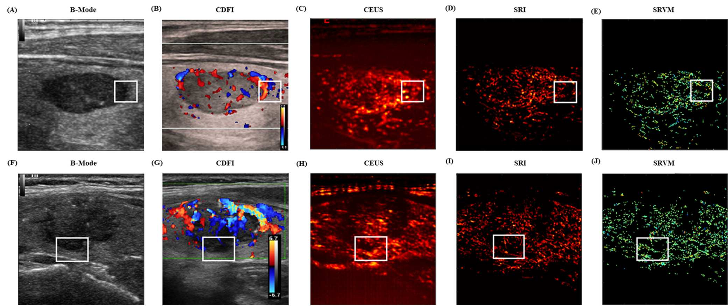
Fig.1. US images of the representative benign and malignant thyroid nodules. (A) B-mode image of the benign thyroid nodule.
(B) CDFI images shows the flow within the benign thyroid nodules. (C) CEUS image shows the accumulation of microbubbles along the frames within the benign thyroid nodule. (D) SRI shows the microvasculature within the benign thyroid nodule. (E) SRVM shows the flow velocity within the benign thyroid nodule. (F) B-mode image of the malignant thyroid nodule. (G) CDFI images shows the flow within the malignant thyroid nodules. (H) CEUS image shows the accumulation of microbubbles along the frames within the malignant thyroid nodule. (I) SRI shows the microvasculature within the malignant thyroid nodule.
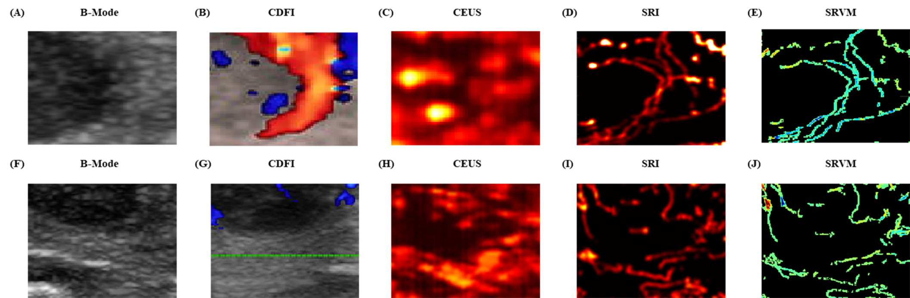
(J) SRVM shows the flow velocity within the malignant thyroid nodule.

Fig.2. Zoomed-in sections showing the detailed comparisons of benign and malignant thyroid nodules between (A&F) B- mode images, (B&G) CDFI images, (C&H) CEUS images, (D&I) SRI and (E&J) SRVM as the white boxes indicated in Figure 1.

REFERENCES
- L. Zhang, J. Gu, Y. Zhao, M. Zhu, J. Wei, and B. Zhang, "The role of multimodal ultrasonic flow imaging in Thyroid Imaging Reporting and Data System (TI-RADS) 4 nodules," Gland Surg, vol. 9, no. 5, pp. 1469-1477, Oct 2020.
- N. Weidner, J. P. Semple, W. R. Welch, and J. Folkman, "Tumor angiogenesis and metastasis--correlation in invasive breast carcinoma," N Engl J Med, vol. 324, no. 1, pp. 1-8, Jan 3 1991.
- Jiang J, Shang X, Zhang H, Ma W, Xu Y, Zhou Q, et al. Correlation between maximum intensity and microvessel density for differentiation of malignant from benign thyroid nodules on contrast- enhanced sonography. J Ultrasound Med. 2014;33(7):1257-63.
- Huang C, Zhang W, Gong P, Lok UW, Tang S, Yin T, et al. Super- resolution ultrasound localization microscopy based on a high frame- rate clinical ultrasound scanner: an in-human feasibility study. Phys Med Biol. 2021;66(8).
- Brown J, Christensen-Jeffries K, Harput S, Zhang G, Zhu J, Dunsby C, et al. Investigation of Microbubble Detection Methods for Super-
Resolution Imaging of Microvasculature. IEEE Trans Ultrason Ferroelectr Freq Control. 2019;66(4):676-91.
- Errico C, Pierre J, Pezet S, Desailly Y, Lenkei Z, Couture O, et al. Ultrafast ultrasound localization microscopy for deep super-resolution vascular imaging. Nature. 2015;527(7579):499-502.
- Demene C, Robin J, Dizeux A, Heiles B, Pernot M, Tanter M, et al. Transcranial ultrafast ultrasound localization microscopy of brain vasculature in patients. Nat Biomed Eng. 2021;5(3):219-28.
- Zhu J, Rowland EM, Harput S, Riemer K, Leow CH, Clark B, et al. 3D Super-Resolution US Imaging of Rabbit Lymph Node Vasculature in Vivo by Using Microbubbles. Radiology. 2019;291(3):642-50.
- Harput S, Christensen-Jeffries K, Ramalli A, Brown J, Zhu J, Zhang G, et al. 3-D Super-Resolution Ultrasound Imaging With a 2-D Sparse Array. IEEE Trans Ultrason Ferroelectr Freq Control. 2020;67(2):269-77.
- Zhang G, Harput S, Hu H, Christensen-Jeffries K, Zhu J, Brown J, et al. Fast Acoustic Wave Sparsely Activated Localization Microscopy (fast-AWSALM): Ultrasound Super-Resolution using Plane-Wave

Activation of Nanodroplets. IEEE Trans Ultrason Ferroelectr Freq Control. 2019.
- Demene C, Deffieux T, Pernot M, Osmanski BF, Biran V, Gennisson JL, et al. Spatiotemporal Clutter Filtering of Ultrafast Ultrasound Data Highly Increases Doppler and fUltrasound Sensitivity. IEEE Trans Med Imaging. 2015;34(11):2271-85.
- Harput S, Christensen-Jeffries K, Brown J, Li Y, Williams KJ, Davies AH, et al. Two-Stage Motion Correction for Super-Resolution Ultrasound Imaging in Human Lower Limb. IEEE Trans Ultrason Ferroelectr Freq Control. 2018;65(5):803-14.

