EBN Opinion
This article summarises a recent EBN Twitter Chat on the topic of optimising palliative and end-of-life care services for people living in care home settings. The Twitter-Chat was led by Joanne Agnelli (@joanneagnelli), Jessie McGreevy (@mcgreevyjessie) and Monica Diamond (@momodiamond1) from Four Seasons Health Care (@FourSeasonsHCUK). A Storify® version of the Twitter Chat can be found at: http://bit.ly/1IofYKg. The pre-chat Blog can be found at: http://bit.ly/1cv9cqc.
Optimising Palliative and End-of-Life Care within Care Home Settings
Background
The World Health Organisation (WHO) has defined palliative care as an approach that improves the quality of life of patients and their families facing the problems associated with life-threatening illness, through the prevention and relief of suffering by means of early identification and impeccable assessment and treatment of pain and other problems, physical, psychosocial and spiritual (WHO, 2015). Globally, it is estimated that every year over 20 million people will require palliative care at the end of life. Of these 69% are adults over 60 years old. This older population, who make up the vast majority of residents within care home settings, are more likely to have co-morbidities such as cardiovascular diseases, cancer, chronic obstructive pulmonary disease and dementias which will require a palliative approach (Department of Health [DH], 2008).
Key Messages from the Twitter Chat (#ebnjc)
Participants agreed that knowledge about the difference between "palliative care" and "end-of-life care" was important. Good palliative care focuses on advance care-planning about decisions, timely discussion about future care wishes and patient education about the journey ahead. The end-of-life phase is usually defined as the last 6 months of a person’s life but communication about palliative care should begin before this phase (Russell, 2015).
Participants acknowledged that while improvements in palliative care are noted outside of the oncology setting, that disease such as COPD, heart failure and dementia still lagged considerably behind. These long-term conditions are important to acknowledge as many people living in care homes live with these conditions, particularly dementia (de Brito and Gomes, 2015).
The practice of advance care-planning was advocated by a number of participants. Advance care-planning is a way to give a voice to the future wishes of a person while they still have capacity (Harrison-Dening et al, 2011). The difficulty with advance care-planning is that often healthcare professionals, care partners and residents do not want to discuss death. These are barriers which need to be overcome as we all play a role in normalising the dying process. Participants agreed that discussions about future care, including death, should take place as close to care home admission as possible.
The importance of communication is a key theme throughout this twitter-chat. To summarise, all healthcare professionals have a role in communicating openly about palliative and future end-of-life care (Twycross, 2002). In order to guide nurses in practice the participants championed the Gold Standards Framework (2015) as a tool that can be used to enable nurses to deliver excellence in palliative care.
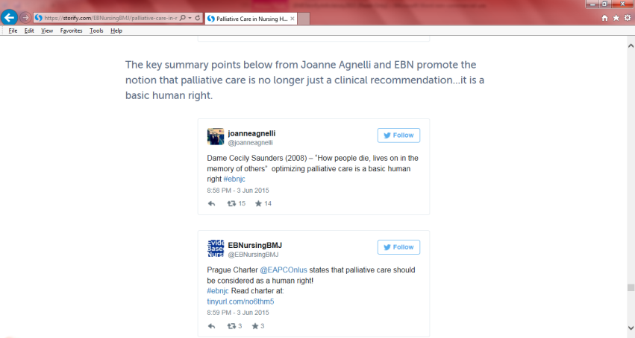
What can you do?
Palliative care is considered as a human right for all people living with incurable life-threatening illness (European Association for Palliative Care [EAPC], 2013). With this is in mind, care home nurses should strive to offer palliative care for all their residents who live with illnesses like dementia, cardiovascular disease and non-malignant respiratory disease. Ideally communication about palliative care should be commenced in a timely manner and therefore as close to diagnosis, or care home admission, as possible so that future life and care preferences can be sought from the person at the very beginning of their journey.
References
de Brito and Gomes, B. (2015) ‘Non-cancer palliative care in the community needs greater interprofessional collaboration to maintain coordinated care and manage uncertainty’, Evidence-Based Nursing, 18, (3), pp. 79.
Department of Health (DH) (2008) End of life care strategy. Department of Health: London.
European Association for Palliative Care (2013) Palliative care: A human right. International Association for Hospice and Palliative Care: EAPC Prague Charter.
Gold Standards Framework (2015) http://www.goldstandardsframework.org.uk/ (Accessed 14.08.2015)
Harrison-Dening, K., Jones L and Sampson EL. (2011) ‘Advance care planning for people with dementia: a review’, International Psychogeriatric, 23, (10), pp. 1535-1551.
Russell, S. (2015) ‘Do definitions of palliative care matter?’ International Journal of Palliative Nursing, 21, (4), pp. 160-1
Twycross, R. (2002) Introducing Palliative Care. (4th edition) Radcliffe Medical Press: Oxon, England.
World Health Organisation (WHO) (2015) WHO definition of palliative care. WHO: Geneva http://www.who.int/cancer/palliative/definition/en/ (Accessed 14.08.2015)

