Optimizing the room temperature binder free TiO₂ paste for high efficiency flexible polymer dye sensitized solar cells

D. Kishore Kumar,^{1*} Min-Hung Hsu,¹ A. Ivaturi,² Baixin Chen,¹ Nick Bennett,¹ and H. M. Upadhyaya³
¹Energy Conversion Lab (ECL), Institute of Mechanical Process and Energy Engineering, School of Engineering and Physical Sciences, Heriot-Watt University, Riccarton, Edinburgh, EH14 4AS UK.
²Department of Pure and Applied Chemistry, University of Strathclyde, Glasgow, G1 1XL, UK.
³Advanced Materials Centre, School of Engineering, London South Bank University, 103, Borough Road, London, SE10 AA, UK.

*Corresponding author: nanokishore@gmail.com
Abstract
Binder free TiO₂ paste is prepared using tert-butyl alcohol in dilute acidic conditions at room temperature for flexible polymer dye sensitized solar cells (DSSC). The present paper reports the detailed studies carried out to elucidate the importance of stirring times during the paste preparation on the final device performance. The maximum conversion efficiency of 4.2 % was obtained for flexible DSSCs fabricated on ITO/PEN substrates using TiO₂ paste prepared from an optimum stirring time of 8 hours. The effect of optimum stirring times on the device characteristics has been understood in terms of the detailed morphology and surface area measurements.
Key words: tert-butyl alcohol, binder free TiO₂ paste, ITO/PEN substrate, flexible DSSC.

- Introduction
Dye sensitized solar cells (DSSC) have attracted both academic and industrial interests following the invention of O’Regan and Gratzel in 1991. The key features involved in the development of DSSC are low cost and high photoconversion efficiency. Efficiency of state of the art of DSSC fabricated on a FTO glass substrate is 14.3 % which is comparable to amorphous silicon cells. The architecture of the DSSC comprises of three components, namely dye coated mesoporous semiconducting metal oxide, deposited on a transparent conductive oxide (TCO) substrate, a sensitizer dye, platinum coated TCO, and iodine/triiodide redox electrolyte., Usually TiO₂ paste is deposited on a TCO glass substrate and subjected to annealing above 500 °C in order to facilitate inter particle necking and removal of binders present in the paste.
On comparison with rigid substrates, panels made from flexible substrates have an advantage during the installation process of panels over the roofs with flat or curved surfaces because of light weight, and roll-to-roll method. These flexible polymer substrates could be moulded into different shapes and portable panels as power sources for electronic devices such as mobile phones, cameras and etc. Till date, the highest efficiency 9.3 % is achieved using PET (polyethylene terephthalate) nonwoven fabric and polyvinylidene fluoride as composite porous membrane as separator in the polymer DSSC. Previous best efficiency photoconversion efficiency of 9.1 % has been reported using trilayered TiO₂ film on a titanium (Ti) foil. Whereas, the photoconversion efficiency of 8.1 % and 7.6 % were achieved with cells of active area of 0.25 cm² and 1.111 cm² respectively, with TiO₂ nanoparticles on flexible ITO/PEN (tin doped indium oxide/polyethylene naphthalate) substrates reported with water based TiO₂ paste. Fabrication of nano TiO₂ thin films on the flexible substrates is a major challenge due to the limitation of high temperature treatment. This inhibits the use of organic binders in the paste preparation. The high temperature treatment removes organics binders, improves the necking between the TiO₂ nanoparticles and in turn improves the performance of the device.
Cracks have been observed among the TiO₂ films which are prepared by the binder free paste which in turn increases the electrical resistivity. Moreover, the absence of organic binders results in poor inter-particle necking due to the limitation of thermal treatment and poor adhesion due to the hydrophobic nature of polymer flexible substrates. The adhesion of the films are also decreased which results in poor electrical contact between the TiO₂ film and substrate. Apart from the TiO₂ films, due to the permeable nature of these plastic substrates, leads to the absorption of moisture and oxygen hinder the efficiency of devices. These limitations could be overcome by adopting techniques like mechanical compression, hot compression, microwave irradiation, chemical sintering, and etc. in the preparation of TiO₂ films and paste preparation.
The formation of cracks could be avoided by proper dispersion of TiO₂ nanoparticles. Ball-milling is one of the important techniques adopted by many researchers for the making of well dispersed TiO₂ paste. Highly viscous paste is mandatory for the screen printing but they need organic binders whereas, low viscous TiO₂ pastes are prepared using either ethanol or water based for polymer flexible substrate. The viscosity of these paste could be increased by the addition of ammonia or hydrochloric acid., The addition of titanium monomers in small quantities during paste preparation increases the viscosity of the paste and also helps in the TiO₂ particle connectivity.,,
Doctor blade method is the most common method employed for the film preparation using binder free TiO₂ paste. Direct deposition methods such as spray deposition, chemical vapour deposition, pulse laser deposition, electrodeposition, and electrophoretic deposition, are used for the TiO₂ film deposition on polymer flexible substrates. Additional steps are needed to improve the inter-particle necking between the TiO₂ nanoparticles with good mechanical stability and adhesion of films without damaging the conductive layer of the polymer flexible substrates. Low temperature TiO₂ paste is prepared by mixing TiO₂ nanoparticles with absolute ethanol or de-ionized water or tert-butanol or all three components mixed together., Among the flexible polymer substrates, polyethylene naphthalate (PEN) can withstand heat resistance up to 200 °C and has more advantages than polyethylene terephthalate (PET). But the efficiencies of the flexible DSSC are low when compared with DSSC fabricated on glass substrates. In the Table 1, the details of the polymer flexible substrates prepared by different pre- and post- treatments are mentioned with photoconversion efficiencies.
Table 1: Details of states of the art of polymer flexible DSSC prepared by different types of low temperature TiO₂ pastes and processing of TiO₂ films.

S.No | Components of paste | Pre treatment | Deposition technique | Post treatment | Efficiency% | Ref
1 | TiO₂ + water | None | Doctor blade | Mechanical compression | 8.1 | ¹⁴
2 | TiO₂ beads | TiCl₄ treatment | Doctor blade | CIC pressing | 7.5
3 | P25 TiO₂ + EtOH | None | Doctor blade | CIC pressing | 6.3
4 | P25 TiO₂ + EtOH + Iodine + acetylacetone + acetone + water | None | Electrophoretic deposition | compression | 6.2
5 | P25 TiO₂ + EtOH | Acid, base treatment | Doctor blade | None | 5 | ²²
6 | P25 TiO₂ + EtOH + Water | None |  | None | 4.9 | ²³
7 | P25 TiO₂ + EtOH | Ball milling |  | None | 4.2 | ²⁷

In literature, many reports are available for the fabrication of flexible polymer DSSC using low temperature TiO₂ paste. To the best of our knowledge, no studies are available on the effect of stirring times. In this work, we report the importance of stirring times during the paste preparation on the device performance of the flexible DSSCs fabricated on flexible ITO/ PEN substrates using binder free TiO₂ paste preparation. An interesting and industrially important optimisation of stirring times in the paste preparation steps has been observed and has been reported in this study.
2. Experimental section
2.1. Binder free TiO₂ paste preparation
The paste was prepared in 10 mL glass vial using PTFE magnetic beed of dimensions 3 x 7mm on a magnetic stirrer. In the preparation of binder free TiO₂ paste, 0.2 g of P25 nanoparticles (AEROXIDE® TiO₂ P25, Evonik) were added to the mixture of 1.4 mL of tert-butanol (Sigma-Aldrich), 0.5 mL DI water and 0.2 mL of 0.05 M HNO₃ (Fisher) solution as reported in previous literature.
The contents were stirred at 120 rpm at room temperature until a uniform homogenous paste was formed. The glass vial was sealed till the completion of paste making by the stirring process. In order to elucidate the stirring times for the optimal performance for the photoconversion parameters, the paste preparation stirring times are varied from 6h, 8h, 10h, 12h, 15h and 24 h. The schematic representation of the paste preparation was shown in Fig. 1.
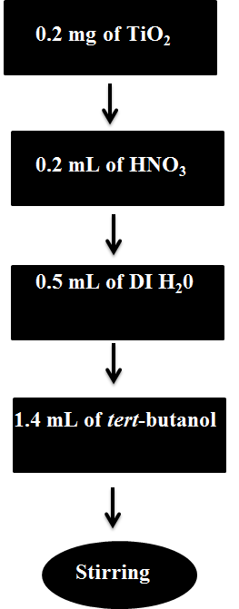
Fig. 1: Schematic representation of the room temperature TiO₂ paste preparation.
2.2. Fabrication of dye sensitized solar cells
The TiO₂ films were prepared by spreading binder free TiO₂ paste on flexible ITO/PEN substrates (Peccells, Japan) by the doctor blade method using Scotch tape as a mask to delineate the active area of the TiO₂ film. The TiO₂ films were dried in air for 10 min after each coating. Another set of TiO₂ films are prepared by the same manner but after drying subjected to flash annealing at 175 °C for 2 min after each coating. The TiO₂ films obtained from air drying were labelled as RT-S6, RT-S8, RT-S10, RT-S12, RT-S15, and RT-S24 and TiO₂ films obtained from flash annealing are labelled as 175-S6, 175-S8, 175-S10, 175-S12, 175-S15, and 175-S24, for stirring times 6 h,10 h, 12 h, 15 h and 24 h respectively. All films were soaked in the freshly prepared 0.1mM ethanolic N719 dye (Dyesol) solution for 20 h. The fabrication of the cell was completed by sealing with platinum coated ITO/PEN (Peccells, Japan) as counter electrode with 25 µm Surlyn sealant (Solaronix, SA) as spacer between the electrodes. A hole was punched on the counter electrode to facilitate the injection of electrolyte. The cell was subjected to vacuum to remove the trapped air from the TiO₂ film which helps to spread the electrolyte into the pores of the dye sensitized TiO₂ films. The electrolyte consisted of 0.4 M lithium iodide, 0.4 M tetrabutylammoniumiodide, 0.04 M iodine, and 0.3 M methyl benzimidazole in a mixture of acetonitrile and 3-methoxy propionitrile (MPN) of ratio of 1:1 (v/v).
2.3. Characterization techniques
To understand the effects of longer stirring times of TiO₂ pastes on the device performance detailed Brunauer, Emmett and Teller (BET) measurements were carried out. The TiO₂ powder obtained from the dried paste is used for the BET measurements. First a known weight of the TiO₂ powder was transferred into a quartz reactor and subjected to degassing at 200 °C in helium gas environment. After cooling, the reactor was connected with gas mixture of 30 % nitrogen and 70 % helium and immersed into a liquid nitrogen container until the completion of adsorption process. Later the liquid nitrogen container was removed and the sample was tested for gas desorption process. After the completion of adsorption and desorption, the amount of nitrogen adsorption on the surface of TiO₂ was calibrated by injecting a known amount of nitrogen gas into the reactor.
Field emission gun scanning electron microscopy (FEG-SEM; FEI Quanta 3D FEG) was used to characterize the microstructure and morphology of TiO₂ films. The photovoltaic performances of the DSSCs were measured by computer-controlled digital source meter (Keithley 2400) under simulated AM1.5G irradiation from a solar simulator (92250 A, Newport, USA). The incident to photoconversion efficiency (IPCE) was recorded with Spectral response SR300/150C (Optosolar, Germany). Electrochemical impedance spectroscopy (EIS) measurements were carried out using potentiostat (Metrohm Autolab PGSTAT30) equipped with FRA2 module in the faraday cage. The frequency range explored was from 10⁶ Hz to 10⁻¹ Hz with amplitude of 50 mV under a dark condition.
3. Results and Discussions
3.1. Brunauer, Emmett and Teller (BET) measurements.
The surface area of all TiO₂ powders obtained from the BET measurements is tabulated in Table. 2. It is evident from, tabulated BET measurements, stirring times doesn’t make appreciable changes in the surface area.
Table 2: Results of BET measurements of TiO₂ paste.
Sample | Stirring time (hrs) | BET surface area (m²/g)
S6 | 6 | 63.4
S8 | 8 | 70.8
S10 | 10 | 59.5
S12 | 12 | 61.1
S15 | 15 | 69.5
S24 | 24 | 64.5

3.2. Morphology studies by FEG-SEM,
FEG-SEM studies were carried out to evaluate the impact of stirring times on the microstructure of the TiO₂ films coated on ITO/PEN substrates with binder free paste. The thickness of the TiO₂ film is calculated from the SEM micrographs and found to be about 10.80 μm. Cracks have been observed on the TiO₂ films and they are marked with red circles on the micrographs of 2.1(b) and 2.1(d). When compared with 8 h paste, cracks have been found on the TiO₂ film made from 15 h paste. The cross-section images of the TiO₂ films are recorded as shown in 2.1(a) and 2.1(c). A close observation on cross-sectional micrographs, owing to flocculation of particles, lumps have been noticed, which are shown in Fig. 2.1(a) and 2.1(c). More lumps have been observed in 15h stirring paste.
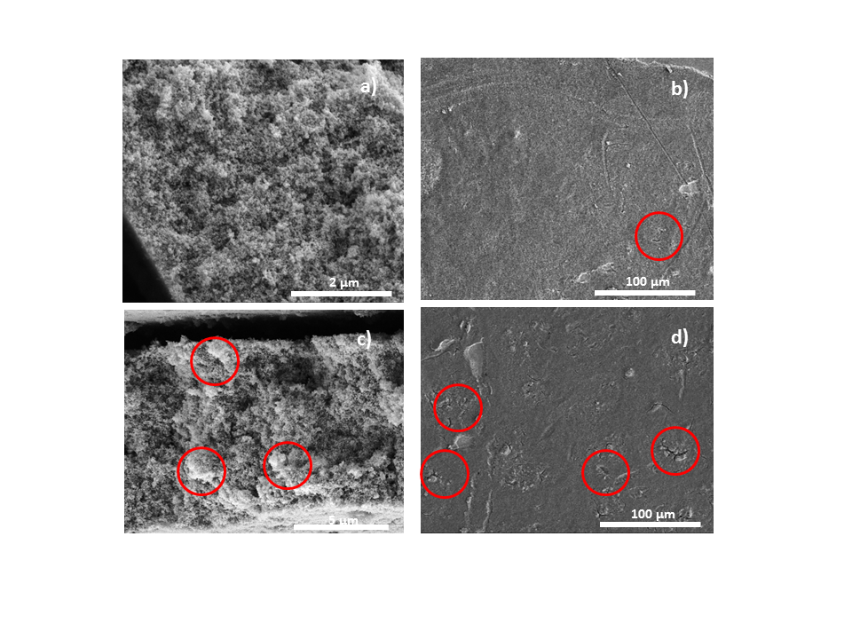Fig. 2: Cross sectional SEM micrographs of TiO₂ films prepared using a) 8 h paste and c) 15 h paste and plain view SEM micrograph of TiO₂ films prepared using b) 8 h paste and d) 15 h paste.
3.3. J-V characteristics.
To study of effect of stirring times on the performance of photoconversion efficiencies, the stirring times of the paste preparation are varied from 6 h to 24 h. Fig. 3 shows the J-V characteristics of the cells fabricated where the TiO₂ films are dried in air. The cells fabricated with TiO₂ films using binder free TiO₂ paste (stirring 6 h) are dried at room temperature exhibited showed photoconversion efficiency of 2.88 % where as photoconversion efficiency of 2.4 % is reported using same binder free paste as previously.⁴⁰ From the J-V characteristics shown in Fig. 3, it is found that after increased stirring times, the performance of the solar cell begin to decrease.
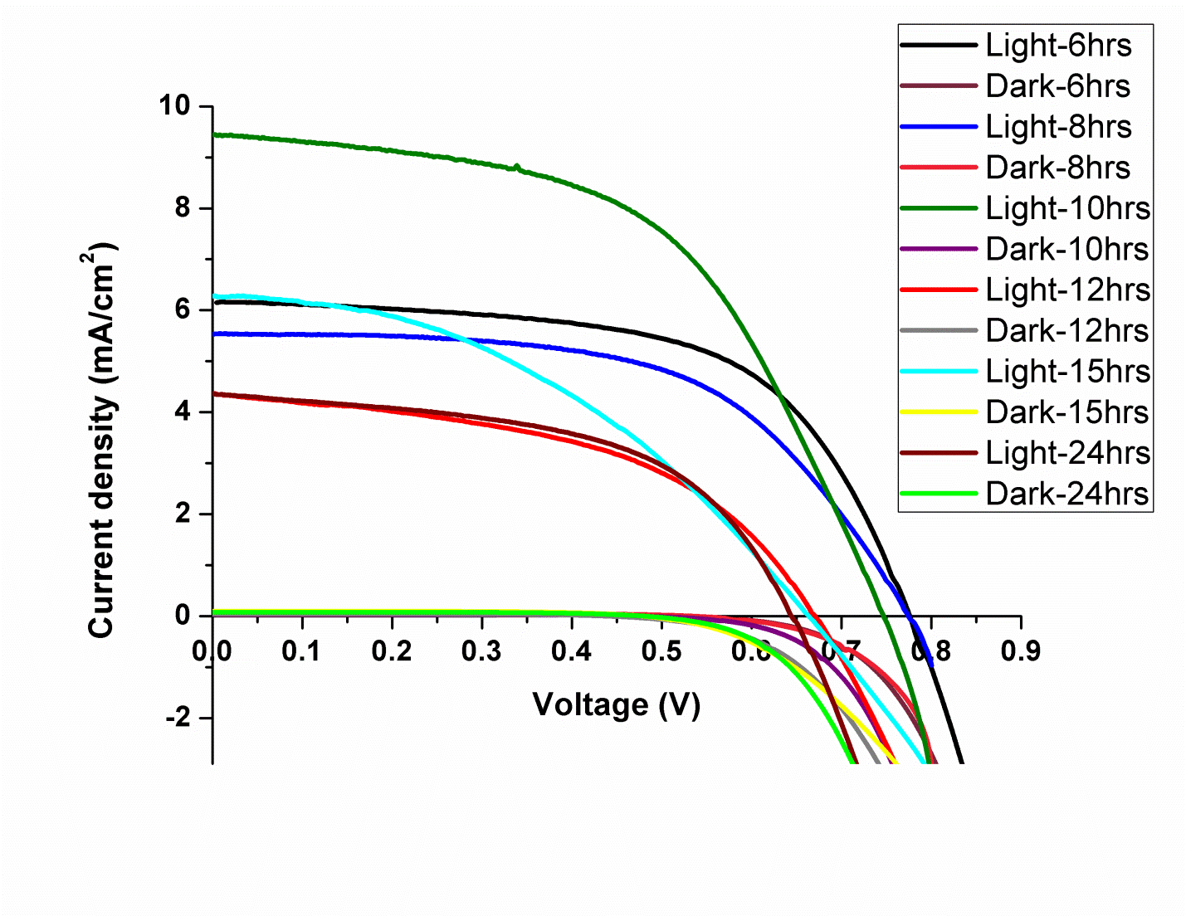
Fig. 3: J-V characteristics of cells fabricated by TiO₂ films dried at room temperature.
The Fig. 4 shows the J-V characteristics of the cells fabricated after flash annealing of 2 min. A significant improvement has been observed in terms of photoconversion efficiencies for the DSSC devices made with the TiO₂ films, which are subjected to flash annealing for 2 min at 175 °C. A trend is observed from 6 h paste to 24 h paste. Initially the photoconversion efficiency increased where the stirring times are increases from 6 h to 8 h and later decreases as the stirring time increases from 10 h to 24 h. The photovoltaic parameters of the flexible DSSC fabricated using TiO₂ films dried at room temperature and flash annealing at 175 °C for 2 min are tabulated in table. 3.
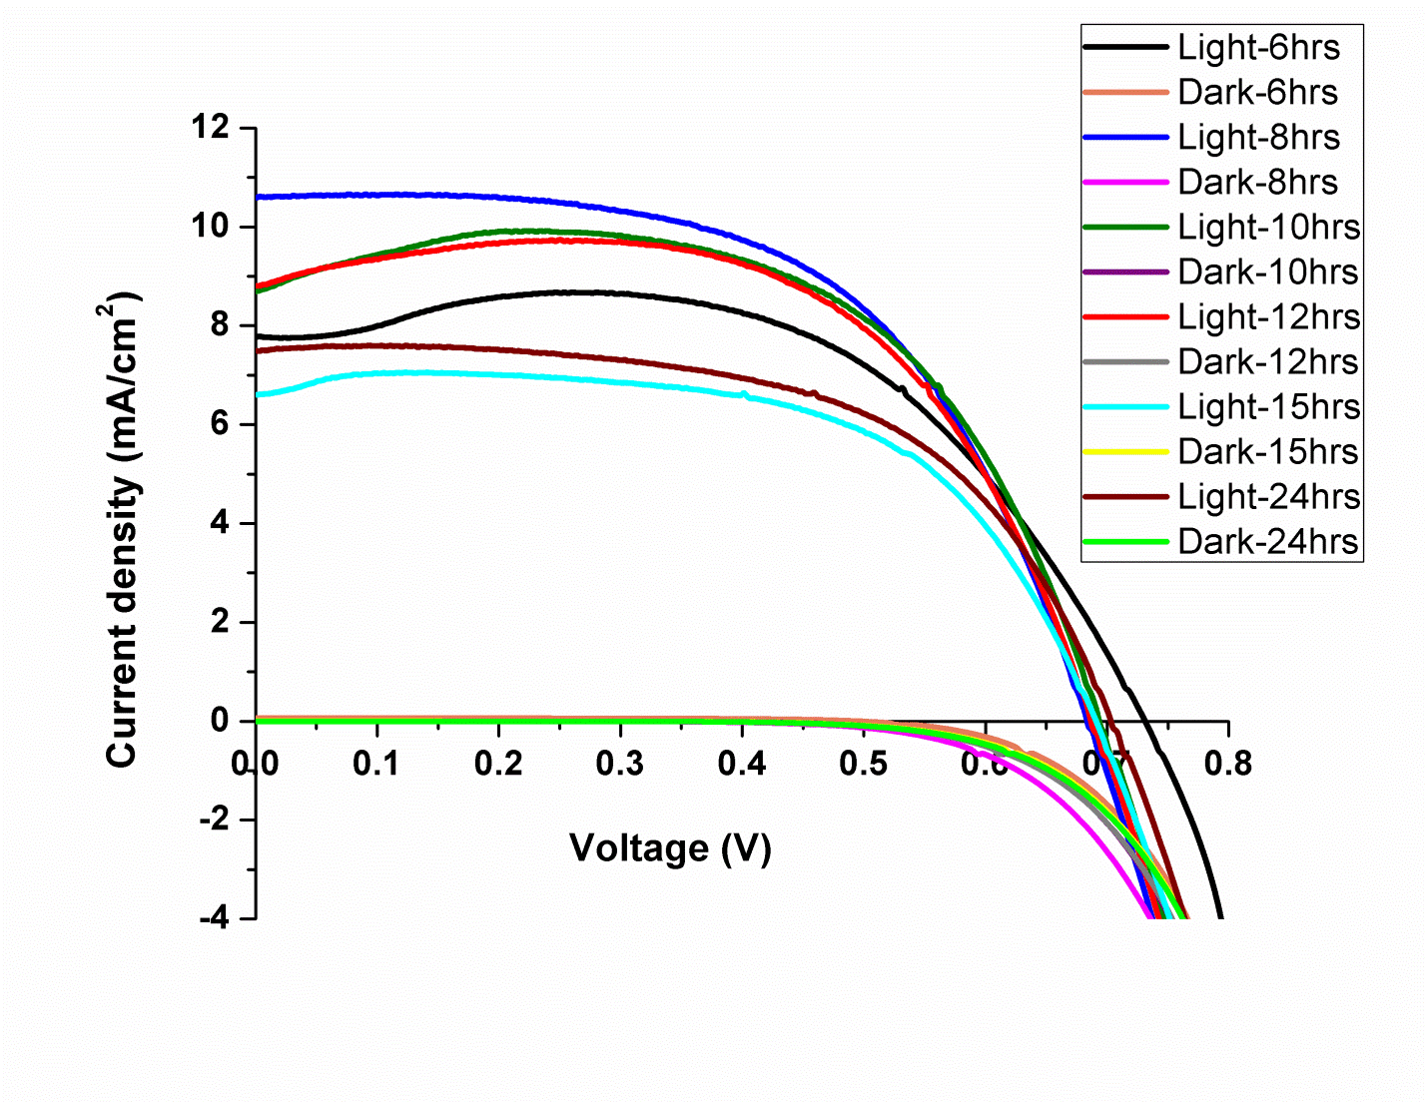
Fig. 4: J-V characteristics of cells fabricated after flash annealing of TiO₂ films at 175 °C for 2 min.
The J-V graphs were showing inconsistent behaviour in Fig. 4. One the possible reason for such behaviour can be attributed to flash annealing of TiO₂ films at 175 °C. When PEN/ITO substrates are subjected to heat treatment, there is no change in the sheet resistance up to 240 °C but these polymer substrates undergoes thermal deformation above 150 °C. The difference in the linear thermal expansion and internal stress between the ITO and polymer leads ITO films bending convexly. This effect is seen in the I-V curves, the curve goes up and down. The champion cell exhibits an efficiency of 4.2 % for 8 h stirring paste. The photovoltaic parameters of the champion cell were open circuit voltage (V_{oc}) of 0.682 V, short circuit current (J_{sc}) of 10.67 mA/cm² and fill factor of 57.6 %. The maximum quantum efficiency observed from IPCE at 550 nm (corresponding to the absorption maxima of the N719 dye) is 53 %. The IPCE spectrum is shown in Fig. 5.
Table 3: Photovoltaic parameters of cells prepared from TiO₂ films dried at room temperature and annealed at 175 °C for 2 minutes.
Sample | V_{oc}(V) | J_{sc} (mA/cm²) | FF (%) | η (%) | Time (h)
RT-S6 | 0.71 | 6.17 | 60.3 | 2.88 | 6
RT-S8 | 0.7 | 5.55 | 57.8 | 2.47 | 8
RT-S10 | 0.7 | 9.45 | 53.7 | 3.78 | 10
RT-S12 | 0.72 | 4.4 | 49.2 | 1.64 | 12
RT-S15 | 0.7 | 6.31 | 42.1 | 1.99 | 15
RT-S24 | 0.73 | 4.38 | 54.1 | 1.72 | 24
175-S6 | 0.73 | 8.68 | 57.2 | 3.62 | 6
175-S8 | 0.68 | 10.67 | 57.6 | 4.20 | 8
175-S10 | 0.69 | 9.93 | 59.7 | 4.09 | 10
175-S12 | 0.68 | 9.74 | 60.5 | 4.01 | 12
175-S15 | 0.7 | 7.06 | 56.8 | 2.95 | 15
175-S24 | 0.7 | 7.61 | 58.5 | 3.13 | 24
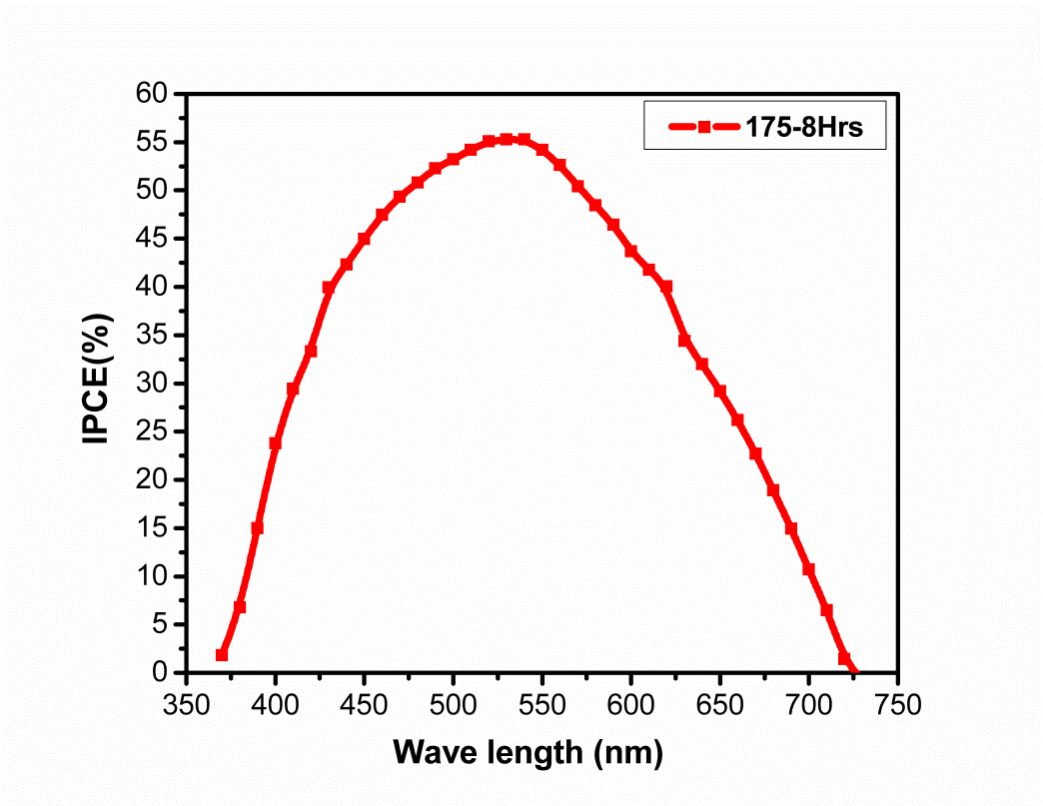
Fig. 5: represents the Incident to photon conversion efficiency of champion cell made from 8h paste.
The trend of the photoconversion efficiencies of the DSSCs fabricated with TiO₂ layers annealed at 175 °C as a function of the stirring times is shown in Fig. 6. It is observed that the efficiency initially increases upon increasing the stirring times from 6 h to 8 h and later decreases as stirring time is increased to 24 h.
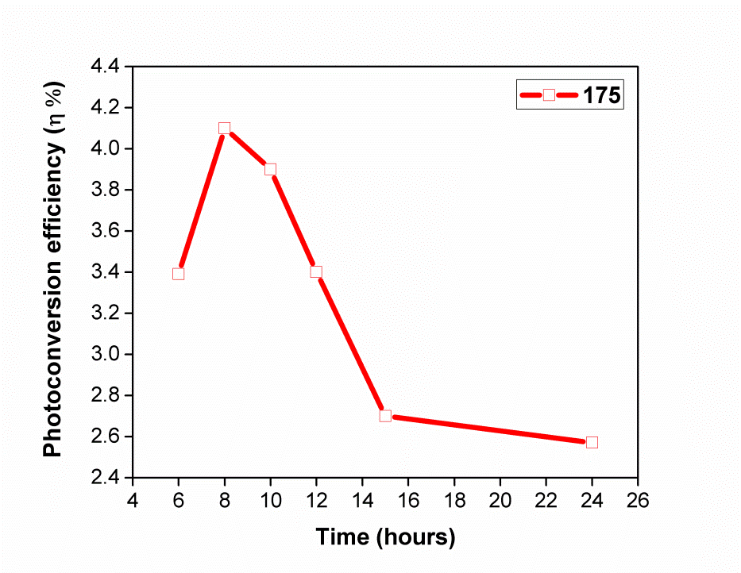
Fig 6: Photoconversion efficiencies (η) of DSSCs fabricated from TiO₂ layers annealed at 175 °C as a function of stirring times of paste preparation

3.4. Memory effects studies
The DSSCs prepared with flash annealed TiO₂ films, exhibit photoconversion efficiencies of 8 h and10 h pastes were almost the same and similarly, the photoconversion efficiencies of 15 h and 24 h paste were also same. Hence, in this case study 8 h and 15 h pastes were used to study the memory effects. The pastes prepared fifty days prior were used to fabricate the cells. The J-V measurements were shown in Fig. 7 and photoconversion parameters were shown in table. 4. The results were promising and indicate that the paste is durable and stable, an industrially important aspect.
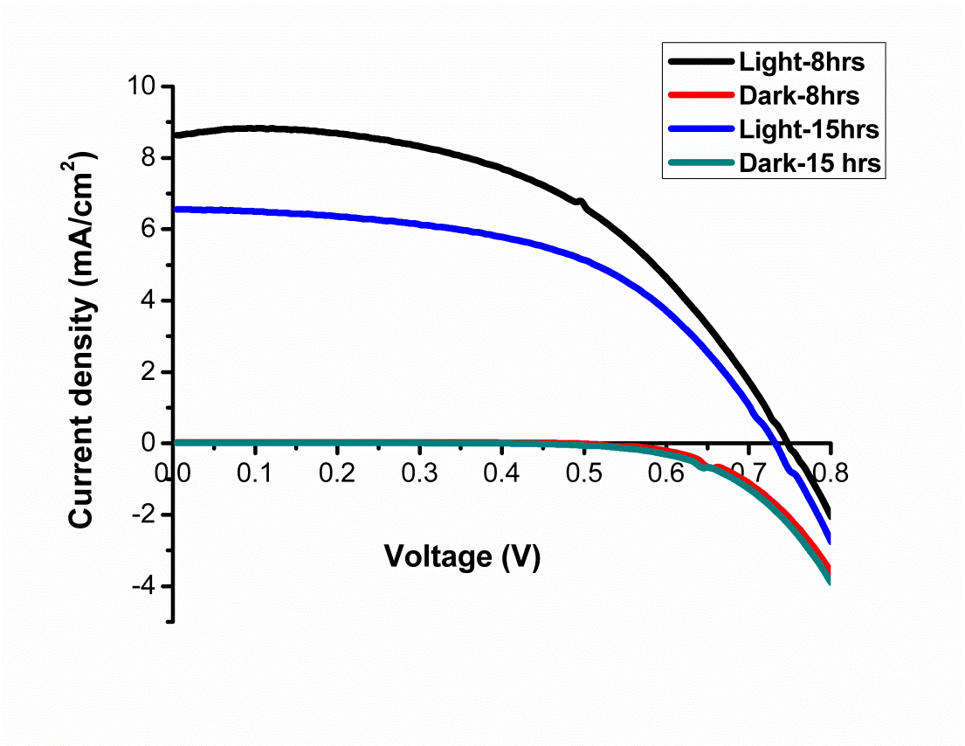
Fig. 7: J-V characteristics of 8 h and 15 h pastes (paste is prepared 50 days prior to cells fabrications).
Table 4: Photovoltaic parameters of cells prepared from old TiO₂ paste annealed at 175 °C.
Sample | V_{oc} (V) |  | J_{sc} (mA/cm²) |  | FF (%) |  | η (%) |  | % change in η | Time (h)
 | day1 | day50 | day1 | day50 | day1 | day50 | day1 | day50
175-S8 | 0.68 | 0.7 | 10.7 | 8.84 | 57.6 | 51.6 | 4.2 | 3.4 | 20% | 8
175-S15 | 0.7 | 0.69 | 7.1 | 6.56 | 56.8 | 53.8 | 2.95 | 2.55 | 14% | 15

From the Table 4, it is evident that decrease in efficiency of 50 days old samples is less for 175-S15 (14 % of efficiency decrease in 50 days). Whereas, 175-S8 sample shows more decrease in efficiency (20 % of efficiency decrease in 50 days). The observed decay could be due to aging effect, which resulted in the paste started sticking to the walls of the container. This in turn attributed to the agglomeration of the particles in the colloidal solution of the paste.
3.5. Impedance spectroscopy.
Electrochemical Impedance spectroscopy (EIS) is a powerful technique for the analysis of charge transport and recombination of electrons in all electrical devices. In order to investigate, the interfacial charge transfer processes within the DSSC devices, EIS measurements were recorded in the dark with an applied open circuit voltage of -0.7 V. Since, the photoconversion efficiencies of 8 h and 10 h paste were almost the same and similarly, the photoconversion efficiencies of 15 h and 24 h paste were also same, hence EIS measurements were done for 8 h and 15 h pastes. The results were shown in Fig. 8. The transport properties of the electron in various interfaces can be investigated using Nyquist plots in DSSC. From Nyquist plots, the first semicircle at high frequencies was related to the redox reaction of electrons at the counter electrode (commonly platinum), second semicircle was related to the electron transfer between the interface of metal oxide/electrolyte and third semicircle at lower frequencies was comprised of electron diffusion in the electrolyte.
From the Fig. 8, it is evident that 8 h paste accelerated the interfacial charge transfer and reduced the recombination of electron-hole pair when compared with 15 h paste. These results resembles in terms of improved efficiency. A Bode plot recorded in dark with respective to open circuit voltage of device fabricated with 8 h and 15 h pastes, from which the electron life time is calculated using the expression τ = 1/2πf_{max}. The electron life time of 8 h and 15 h pastes are 43.1 ms and 124.8 ms.
a)
b)

Fig. 8: a) Nyquist plot and b) Bode phase plot of 8 h and 15 h paste.

From the results, it is evident that cells prepared from the TiO₂ paste stirred for 8 - 10 h showed better efficiencies when compared with the longer durations of stirring. From the BET measurements, it is evident that longer stirring time is leading to a decrease in surface area indicating flocculation of nanoparticles leading to formation of agglomerations. The presence of agglomerates in the TiO₂ films results influences dye loading which in turn results in low current generation and hence reduced efficiencies. The cracks observed in the SEM micrographs of the films prepared from TiO₂ pastes stirred for longer durations support the presence of agglomerated particles leading to stresses. It implies that stirring for long hours doesn’t help in the device performance. One of the possible reasons might be coagulation of nanoparticles which in turn leads to formation of agglomerates which is evident from cross sectional SEM micrographs. Agglomerates causes to less dye loading and results in poor current generations and thus low efficiencies.
4. Conclusions
In summary, we investigated the role of stirring times for the preparation of binder free TiO₂ pastes successfully. From the J-V measurements, it is evident that 8 h stirring time showed good photoconversion efficiency of 4.2 %. Memory effect studies indicate that paste is durable and stable for longer time. Impedance measurements reveal that recombination rates of 8 h paste is less when compared with 15 h paste. In other words, this result helps in the development of industrial prospects of flexible DSSC.
Acknowledgement
The authors thank the EPRSC-DST APEX consortium grant number EP/H040218/1 for the financial support.
Declaration of interests:
The authors declare no competing interests.
References

O'Regan B and Gratzel M 1991 A low-cost, high-efficiency solar cell based on dye-sensitized colloidal TiO2 films Nature 353 737-740
Kakiage K, Aoyama Y, Yano T, Oya K, Fujisawa J and Hanaya M 2015 Highly-efficient dye-sensitized solar cells with collaborative sensitization by silyl-anchor and carboxy-anchor dyes Chem. Commun. 51 15894-15897
Ojeda M, Kumar D K, Chen B, Xuan J, Mercedes Maroto-Valer M, Leung D Y C and Wang H 2017 Polymeric Templating Synthesis of Anatase TiO2 Nanoparticles from Low‐Cost Inorganic Titanium Sources Chemistry Select 2 702-706
Barbe C J, Arendse F, Comte P, Jirousek M, Lenzmann F, Shklover V and Gratzel M 1997 Nanocrystalline Titanium Oxide Electrodes for Photovoltaic Applications J. American Ceramic Soc. 80 3157- 3171
Aghazada S and Khaja Nazeeruddin M K 2018 Ruthenium Complexes as Sensitizers in Dye-Sensitized Solar Cells Inorganics 6 52-34
Ding H, Zhang S, Chen J-T, Hu X-P, Du Z-F, iu Y-X, Zhao D-L, 2015 Reduction of graphene oxide at room temperature with vitamin C for RGO–TiO2 photoanodes in dye-sensitized solar cell Thin Solid Films 584 29- 36
Zhang X, Yang H, Xiong H M, Li F Y and Xia Y Y 2006 A quasi-solid-state dye-sensitized solar cell based on the stable polymer-grafted nanoparticle composite electrolyte J. Power Sources 160 1451-1455
Jhong H R, Wong D S, Wan C C, Wang Y Y and Wei T C 2009 A novel deep eutectic solvent-based ionic liquid used as electrolyte for dye-sensitized solar cells Electrochem. Commun. 11 209-211
Ito S, Murakami T N, Comte P , Liska P, Grätzel C, Nazeeruddin M K, Grätzel M 2008 Fabrication of thin film dye sensitized solar cells with solar to electric power conversion efficiency over 10% Thin Solid Films 516 4613-4619
Song L, Zhou Y, Guan Y, Du P, Xiong J, Ko F 2017 Branched open-ended TiO2 nanotubes for improved efficiency of flexible dye-sensitized solar cells J. Alloys and Comp. 724 1124-1133
Qi J, Xiong H, Zhang J, Zhang Q, Li Y, Wang H 2017 Effects of release agents on the film morphology of TiO2 photoanodes for FDSSCs by the roll-to-roll method J. Alloys and Comp. 702 366-371
Kim G H and Hong S H 2018 Porous composite separator membranes of dye sensitized solar cells with flexible substrate for their improved stability J. Mater Sci. 53 12365-12373
Wu W-Q, Xu Y-F, Rao H-S, Su C-Y and Kuang D-B 2014 Trilayered Photoanode of TiO2 Nanoparticles on a 1D–3D Nanostructured TiO2-Grown Flexible Ti Substrate for High-Efficiency (9.1%) Dye-Sensitized Solar Cells with Unprecedentedly High Photocurrent Density J. Phys. Chem. C 118 16426-16432
Yamaguchi T, Tobe N, Matsumoto D, Nagai T, Arakawa H 2010 Highly efficient plastic-substrate dye-sensitized solar cells with validated conversion efficiency of 7.6% Solar Energy Materials & Solar Cells 94 812-816
Latthe S S, Liu S, Terashima C, Nakata K and Fujishima A 2014 Transparent, Adherent, and Photocatalytic SiO2-TiO2 Coatings on Polycarbonate for Self-Cleaning Applications Coatings 4 497-507
Yugis A R, Mansa R F, Sipaut C S 2015 Review on Metallic and Plastic Flexible Dye Sensitized Solar Cell IOP Conf. Series: Mater. Sci. and Eng. 78 012003
Meen T H, Tsai J K, Tu Y S, Wu T C, Dung Hsu W and Chang S-J 2014 Optimization of the dye-sensitized solar cell performance by mechanical compression Nanoscale Res. Lett. 9, 523-8
Song L, Zhai J, Dua P, Xiong J, Ko F 2018 A novel bilayer photoanode made of carbon nanotubes incorporated TiO2 nanorods and Mg2+ doped TiO2 nanorods for flexible dye-sensitized solar cells Thin Solid Films 646 44-52
Uchida S, Tomiha M, Takizawa H, Kawaraya M 2004 Flexible dye-sensitized solar cells by 28 GHz microwave irradiation J. Photochem. and Photobio. A: Chem. 164 93- 96
Li Y, Yoo K, Lee D-K, Kim J Y, Son H J, Kim J H, Lee C-H, Míguez H and Ko M J 2015 Synergistic strategies for the preparation of highly efficient dye-sensitized solar cells on plastic substrates: combination of chemical and physical sintering, RSC Adv. 5 76795-76803
Pasquier A D, Stewart M, Spitler T, Coleman M 2009 Aqueous coating of efficient flexible TiO2 dye solar cell photoanodes Solar Energy Materials and Solar Cells 93 528- 535
Weerasinghe H C, Franks G V, Plessis J D, Simon G P, Cheng Y-B 2010 Anomalous rheological behavior in chemically modified TiO2 colloidal pastes prepared for flexible dye-sensitized solar cells J. Mater. Chem. 20 9954- 9961
Weerasinghe H C, Sirimanne P M, Franks G V, Simon G P, Cheng Y B 2010 Low temperature chemically sintered nano-crystalline TiO2 electrodes for flexible dye-sensitized solar cells J. Photochem. and Photobio. A: Chem. 213 30- 36
Kijitori Y, Ikegami M, Miyasaka T 2007 Highly Efficient Plastic Dye-sensitized Photoelectrodes Prepared by Low-temperature Binder-free Coating of Mesoscopic Titania Pastes Chem. Lett. 36 190-191
Zhang D, Yoshida T, Minoura H 2002 Low Temperature Synthesis of Porous Nanocrystalline TiO2 Thick Film for Dye-Sensitized Solar Cells by Hydrothermal Crystallization Chem. Lett. 31 874-875
Zhang D, Yoshida T, Furuta K, Minoura H 2004 Hydrothermal preparation of porous nano-crystalline TiO2 electrodes for flexible solar cells J. Photochem. and Photobio. A: Chem. 164 159-166
Weerasinghe H C, Sirimanne P M, Simon G P, Cheng Y B 2009 Fabrication of efficient solar cells on plastic substrates using binder-free ball milled titania slurries J. Photochem. and Photobio. A: Chem. 206 64-70
Halme J, Saarinen J, Lund P 2006 Spray deposition and compression of TiO2 nanoparticle films for dye-sensitized solar cells on plastic substrates Solar Energy Materials and Solar Cells 90 887–899
Miyasaka T, Murakami T N 2004 The photocapacitor: An efficient self-charging capacitor for direct storage of solar energy Appl. Phys. Lett. 85 3932
Pan H, Ko S H, Misra N, Grigoropoulos C P 2009 Laser annealed composite titanium dioxide electrodes for dye-sensitized solar cells on glass and plastics Appl. Phys. Lett. 94 071117
Bittner F, Oekermann T and Wark M 2018 Scale-Up of the Electrodeposition of ZnO/Eosin Y Hybrid Thin Films for the Fabrication of Flexible Dye-Sensitized Solar Cell Modules, Materials 11 232-19
Chiu W-H, Lee K-M, Hsieh W-F 2011 High efficiency flexible dye-sensitized solar cells by multiple electrophoretic depositions J. Power Sources 196 3683- 3687
Brown T M, De Rossi F, Di Giacomo F, Mincuzzi G, Zardetto V, Reale A and Di Carlo A 2014 Progress in flexible dye solar cell materials, processes and devices J. Mater. Chem. A 2 10788- 10817
Upadhyaya H M, Hirata N, Haque S A, de Paoli M-A, Durrant J R 2006 Kinetic competition in flexible dye sensitised solar cells employing a series of polymer electrolytes Chem. Commun. 0 877-879
Ito S, Ha N-L C, Rothenberger G, Liska P, Comte P, Zakeeruddin S M, Péchy P, Nazeeruddin M K, Grätzel M 2006 High-efficiency (7.2%) flexible dye-sensitized solar cells with Ti-metal substrate for nanocrystalline-TiO2 photoanode Chem. Commun. 0 4004-4006
Zardetto V, Brown T M, Reale A and Carlo A D 2011 Substrates for flexible electronics: A practical investigation on the electrical, film flexibility, optical, temperature, and solvent resistance properties J. Poly. Sci. B: Poly. Phys. 49 638-648
Huang F, Chen D, Li Q, Caruso R A, Cheng Y-B 2012 Construction of nanostructured electrodes on flexible substrates using pre-treated building blocks Appl. Phys. Lett. 100 123102-5
Weerasinghe H C, Sirimanne P M, Simon G P and Cheng Y-B 2012 Cold isostatic pressing technique for producing highly efficient flexible dye‐sensitised solar cells on plastic substrates Prog. In Photovoltaics: Res. & Appl. 20 321- 332
Grinis L, Kotlyar S, Ruhle S, Grinblat J, Zaban A 2010 Conformal Nano‐Sized Inorganic Coatings on Mesoporous TiO2 Films for Low‐Temperature Dye‐Sensitized Solar Cell Fabrication Adv. Funct. Mater. 20 282-288
Agarkar S A, Dhas V V, Muduli S and Ogale S B 2012 Dye sensitized solar cell (DSSC) by a novel fully room temperature process: a solar paint for smart windows and flexible substrates RSC Adv. 2 11645- 11649
Zardetto V, Brown,T M, Reale, A, Carlo A D 2011 Substrates for Flexible Electronics: A Practical Investigation on the Electrical, Film Flexibility, Optical, Temperature, and Solvent Resistance Properties, J. POLY. SCI. B: POLY. PHYS. 49 638–648
van de Lagemaat J, Park N-G and Frank A J 2000 Influence of Electrical Potential Distribution, Charge Transport, and Recombination on the Photopotential and Photocurrent Conversion Efficiency of Dye-Sensitized Nanocrystalline TiO2 Solar Cells: A Study by Electrical Impedance and Optical Modulation Techniques J. Phys. Chem. B 104 2044-2052
Lin M Y, Lindsay H M, Weitz D A, Ball R C, Klein R, Meakin P 1989 Universality in colloid aggregation Nature 339 360- 362 List of figures: Fig. 1: Schematic representation of the room temperature TiO₂ paste preparation. Fig. 2: Cross sectional SEM micrographs of TiO₂ films prepared using a) 8 h paste and c) 15 h paste and plain view SEM micrograph of TiO₂ films prepared using b) 8 h paste and d) 15 h paste. Fig. 3: J-V characteristics of cells fabricated by TiO₂ films dried at room temperature. Fig. 4: J-V characteristics of cells fabricated after flash annealing of TiO₂ films at 175 °C for 2 min. Fig. 5: represents the Incident to photon conversion efficiency of champion cell made from 8h paste. Fig 6: Photoconversion efficiencies (η) of DSSCs fabricated from TiO₂ layers annealed at 175 °C as a function of stirring times of paste preparation. Fig. 7: J-V characteristics of 8 h and 15 h pastes (paste is prepared 50 days prior to cell fabrication). Fig. 8: a) Nyquist plot and b) Bode phase plot of 8 h and 15 h paste. List of tables: Table 1: Details of states of the art of polymer flexible DSSC prepared by different types of low temperature TiO₂ pastes and processing of TiO₂ films. Table 2: Results of BET measurements of TiO₂ paste. Table 3: Photovoltaic parameters of cells prepared from TiO₂ films dried at room temperature and annealed at 175 °C for 2 minutes. Table 4: Photovoltaic parameters of cells prepared from old TiO₂ paste annealed at 175 °C.

