Opportunities and challenges for implementing smart local energy systems in cities and towns, demonstrated through case studies
Catarina Marques, PhD Chris Dunham, MSc Phil Jones, MSc

Helen Turnell, PhD Akos Revesz, PhD Graeme Maidment, PhD
ABSTRACT
Smart local energy systems (SLES) that integrate heat, power and mobility vectors are part of the UK strategy to reach net zero carbon by 2050. This paper investigates the opportunities and challenges for implementing SLES in cities and towns through case studies in two very different locations in the UK: London and the West Midlands. The blueprint for the GreenSCIES SLES was developed in Islington, London, and consists of a 5th generation ambient loop district heat network with electric vehicles, storage and solar PV. This network allows for heat sharing between buildings and applications for heat recovery from local sources.
A second case study explored the opportunities and challenges for improving a previously proposed conventional 3rd generation district heat network, which connects new developments and existing local authority high-rise apartments in the West Midlands, using the GreenSCIES blueprint. The initial design was expanded to include more existing domestic and non-domestic properties. The study evaluated heat recovery from industrial processes, inter-seasonal thermal storage in the aquifer and considered the opportunity for adding electric vehicle charging points along the network route. The results show a way to decarbonise heat across the whole area and provide a path to enable the electrification of transport.
INTRODUCTION
In 2019, the UK Government passed legislation to deliver net zero carbon emissions by 2050. The new target will require a significant reduction compared to the previous target of at least 80% reduction from 1990 levels (GOV.UK, 2019a). Local authorities throughout the UK have since declared climate emergencies and pledged to reach net zero carbon emissions much earlier than 2050, with the London Borough of Islington aiming to be carbon neutral by 2030 (LBI, 2020) and the West Midlands Combined Authority by 2041 (WMCA, 2021). Achieving these ambitious targets will require an integrated approach to the way we use and generate energy and deploy technology on a large scale. Heating and transport are the highest carbon emitters representing 37% and 27% of the UK total emissions respectively (GOV.UK, 2018a), and hence are key sectors to decarbonize. Currently, heat is primarily produced by fossil fuels as most residential homes in the UK are heated by gas-fired boilers. From 2025, new homes in the UK will be banned from installing gas boilers and clean technology such as air source heat pumps, powered by electricity, will be used instead (Gov.UK, 2019b). The UK has significantly reduced the electrical grid carbon intensity, through the generation of clean renewable electricity mainly from wind and solar renewable energy systems. Decarbonising the electricity system presents many opportunities to improve the way we heat and cool our homes and businesses, power appliances and industry, and fuel our vehicles. Electric cars are becoming widely available, and electricity is being used to power buses, vans and taxis. Low carbon heating and cooling using heat pumps offers significant environmental benefits over conventional heating or cooling systems such as gas boilers and chillers.
Heat pumps connected in a district heat network enable the sharing of heat between different applications or between buildings in a neighbourhood. Sharing (prosuming) of heat in this way provides the opportunity to deliver extremely efficient, low-grade carbon, bivalent cooling and heating between buildings. In addition, heat pumps also present the opportunity to utilise heat from secondary and renewable sources such as heat from datacentres, canals, railway tunnels, industrial processes and sewage systems, which would otherwise be wasted.
District Heating Networks (DHNs) have traditionally used a centralised energy centre where the heat generated is supplied to multiple buildings in a neighbourhood via a network of insulated pipes carrying either hot or chilled water (GOV.UK, 2018b). DHNs up to the 3rd generation are at 60 - 90°C [140 – 194ºF] and 4th generation at 45 to 60°C [113 to 140ºF]. The more recent 5th generation networks are ambient loops with an low-grade temperature (13 to 25°C) [55 to 77ºF]. These 5th generation district heating and cooling (5DHC) networks comprise decentralised energy centres with heat pumps, PV generation, Electric Vehicles (EVs) and Vehicle-to-Grid (V2G) charging/storage (Revesz et al., 2021). In V2G systems, electric vehicles with bi-directional charging can store electricity generated from renewable energy sources and discharge electricity back into the grid or the energy centre during peak times. Using an artificial intelligence system to switch the flexible system assets such as the heating or cooling heat pumps and batteries in reaction to the electricity grid requirements and tariffs provides significant opportunities for demand side response.
Innovative 5th generation energy networks have great potential to become the most efficient local energy systems of the future, but there are very few 5DHC networks worldwide (Buffa et al., 2019) and there is limited information, innovation, knowledge and skills around these. 5DHC low grade temperature networks are best implemented where there is a balance of heating and cooling demands, and can offer high CoP’s, and the more the prosuming the greater the benefit. The low-grade temperature ‘ambient loop’ also offers a more direct opportunity to capture low temperature waste heat streams that even a 4DH scheme could not (Revesz et al., 2020).
In the UK only 2% of the overall heating demand is supplied by district heat networks (GOV.UK, 2018c), London is above average with 6% of its energy demand supplied by local networks (GLA, 2018). By 2025, it is expected that 25% of the heat and power used in London will be generated via localised decentralised energy systems and DHNs connecting to zero carbon and waste energy sources are key to achieve this target (GLA, 2018).
Currently most 3rd and 4th generation DHNs use gas fired combustion-based CHP systems whereby reciprocating engines burn fuel to turn generators and produce electricity, heat exchangers then recover heat from the engine and deliver it to the DHN. The advantage of CHP systems is that by capturing and using heat that would otherwise be wasted, and by avoiding distribution losses, CHP can achieve efficiencies of over 80%, compared to 50% for traditional power generation technologies (i.e., conventional large power station electricity generation and an on-site boiler) (EPA, 2020). However, carbon savings from CHP systems have significantly declined as the electricity grid has decarbonized. CHP can also have a major impact on air pollution as burning fuels generates oxides of Nitrogen (NOx) as well as smaller amounts of fine particulate matter (PM₁₀ and PM_{2.5}) (Ricardo Energy & Environment, 2018). Converting 3rd and 4th generation DHNs into low carbon 5th generation decentralized energy networks is not practical due to the significantly different pipework architecture. However, ‘connecting’ 3rd and 4th generation DHN to a 5th generation scheme is entirely possible and can be achieved by using a heat pump to upgrade/transfer heat from a 5DHC scheme into a 3DH scheme. Marques et al. (2021) investigated connecting 3rd and 5th generation networks by replacing the existing CHP unit in the 3DH network with a heat pump connected to the 5DHC ambient loop. The results indicated a 90% and 42% reduction on NOx and CO₂ emissions respectively, in the integrated 3rd/5th generation network compared to the original 3DH network.
This paper investigates the opportunities and challenges for developing smart local energy systems (SLES) in cities and towns through two case studies in two locations in the UK: London and Smethwick in the West Midlands. In London, the GreenSCIES SLES consists of a 5th generation ambient loop district heat network with heat recovery from a data centre with inter-seasonal storage in the London aquifer, solar PV generation and electric vehicles. This GreenSCIES concept was then applied to Smethwick to improve a proposed 3rd generation DHN, which connects new developments with existing local authority buildings. The original network was significantly expanded to recover waste heat from thermal processes in a local foundry, a hospital and a supermarket, supplying heat to domestic and non-domestic properties in the area. Inter-seasonal thermal storage in the Smethwick aquifer was also explored along with the opportunity for adding electric vehicle-charging points along the network route. The paper describes the techno-economic models developed to estimate the CO₂ emissions, operating surplus and CAPEX of the Smethwick network over a baseline scenario with gas boilers and air source heat pumps.
5th generation energy network - greenscies concept
The GreenSCIES 5th generation Smart Local Energy System concept is illustrated in Figure 1. 5th generation schemes require a balancing mechanism to keep the ambient loop stable e.g. to counteract high winter heat demands and in GreenSCIES this will be provided by boreholes using aquifer water to provide inter-seasonal warm and cold thermal storage. The ambient loop will also allow interchange of heating and cooling between buildings, usually referred to as prosuming. The greater sharing (prosuming) between heating and cooling demands in buildings, the greater the economic and carbonomic savings. Local power is generated with solar photovoltaics (PV) and electric vehicles provide low carbon mobility. The system has several decentralised energy centres across the network that function as a ‘micro-grid’ flexing the heat pumps, PV and electric vehicle batteries in relation to the electricity grid demand and tariffs.
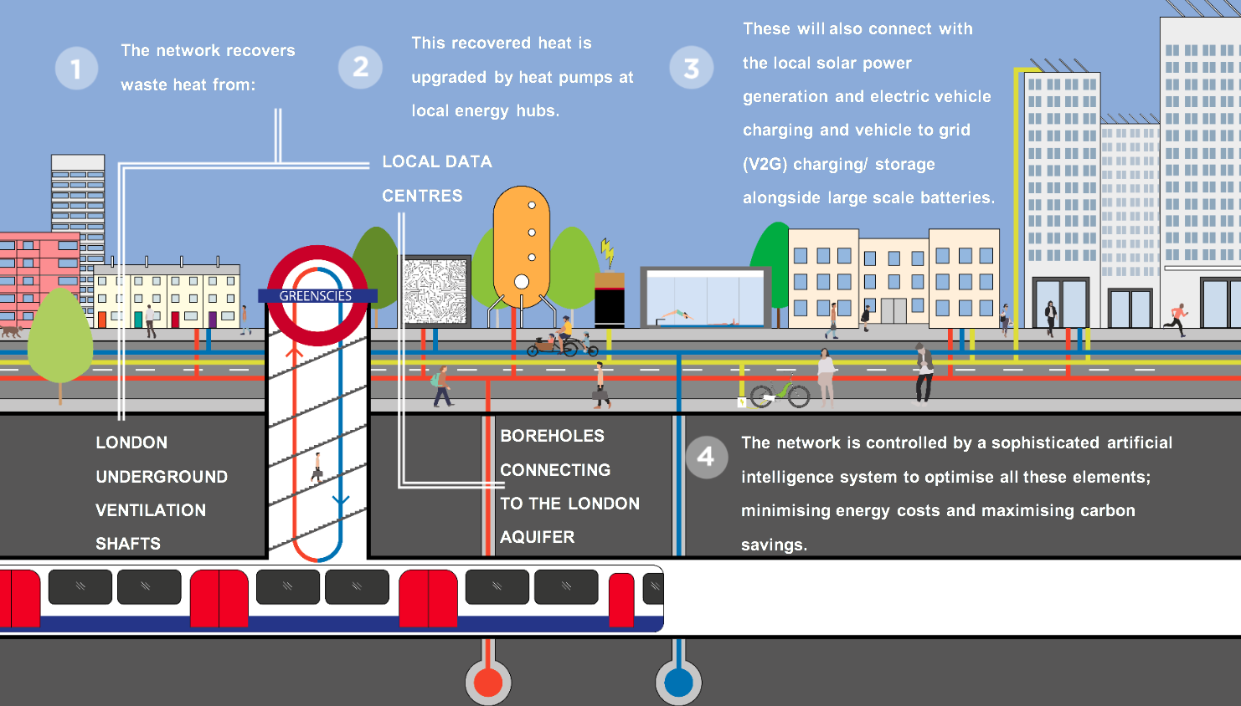
Figure 1: GreenSCIES concept design (Marques et al. 2021)
GreenSCIES concept applied in London
Extensive heat mapping was carried out to assess the heating and cooling density across a wide area in the London borough of Islington (LBI). This identified the local areas with the large heat sources such as data centres and the London Underground ventilation shafts, which are low grade heat sources promising for a 5DHC scheme.
Data centres. At least 1.5% of the electricity demand in the UK comes from data centres (Davies et al., 2016). Heat recovery from this source is particularly feasible due to their constant load throughout the year. A scheme centered around a data centre was then taken forward to detailed design, connecting 402 domestic properties and 8 businesses. The key ‘anchor loads’ are housing estates managed by LBI, currently supplied by centralized gas boilers, which are easy to connect to a heat network. The scheme also connects a university campus, a library and a theatre.
The total heat demand of the network is 10,5 GWh [358,580 thm] and the cooling demand is 9,3 GWh [315,758 thm], with the data centre accounting for 95% of the total cooling demand. The scheme connects six energy centres, fitted with individual heat pumps (600 to 2600 kW_{th}), thermal storage (80 to 210 m³) [17598 to 46194 gal], 610 kWpk solar PV generation and 49 electric vehicle chargers. Overall, the GreenSCIES-Islington scheme provides an internal rate of return over a 40-year period of 10% (with 50% grant funding) and the CO₂ savings are 5000 Tonnes per year, a 80% reduction over a base case with gas boilers, chillers and petrol/diesel vehicles (Revesz et al. 2021).
4th Generation Smethwick network
The second case study was in Smethwick, a town in the West Midlands. This area was the focus of a feasibility study in 2018, which investigated connecting 674 new homes and 3 existing tower blocks with 270 dwellings. The total heat demand was approximately 6,772 MWh (231,069 thm) with a peak demand of 2.9 MW. Water sourced heat pumps (WSHPs) were proposed to recover heat from the canal located next to the new developments, with an estimated 2 MW maximum capacity due to the flow rate and temperature difference of the canal.
GreenSCIES concept applied in Smethwick
In order to apply the GreenSCIES concept in Smethwick the red line boundary around the new developments was extended to investigate additional heat sources and connection to existing properties. This is very much GreenSCIES thinking, seeking out heat opportunities that can help supply a heat network. Options for integrating electric vehicles within the red line boundary were also explored. Figure 2 shows the original Smethwick heat network and the proposed red line boundary for applying the GreenSCIES concept. The main opportunities for the heat network are to connect the hospital, a supermarket in the South and a foundry in the North (main waste heat source). This would be mainly a 3DH network (75°C) [167ºF] connecting existing buildings with some cooling supply to the hospital and supermarket. The new developments would be supplied by a 4DH network (60°C) [140°F]. The opportunity to store heat in the aquifer was also investigated and data from the British Geological Survey shows that the Smethwick aquifer is highly productive with a yield of 12.5 l/s (198 gpm), indicating that the aquifer is good for ground water sourced heat pumps.
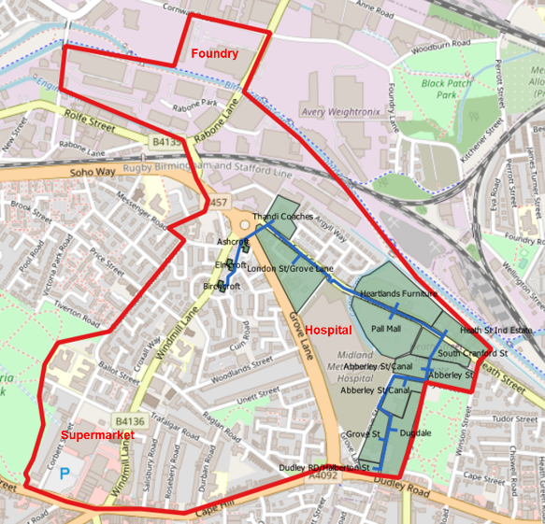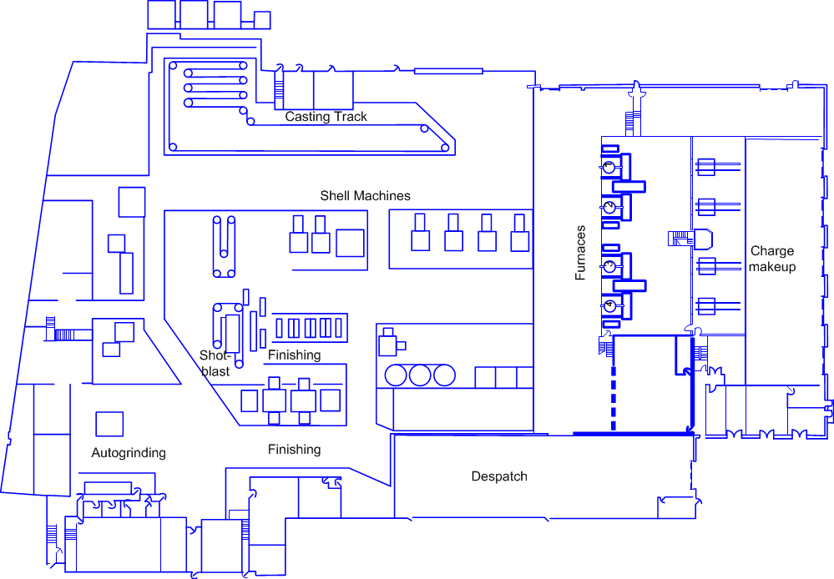
Figure 2: Smethwick red line boundary (and original 2018 proposed scheme) Figure 3: Foundry plant layout
Heat recovery opportunities
The hospital heating demand is 14.5 GWh/yr (494,760 thm/yr) generated by four gas boilers and a CHP unit, the cooling demand is 4.5 GWh/yr (153,546 thm/yr) produced by five chillers. The supermarket heating and cooling demand are 0.87 and 1.56 GWh/yr (29,686 and 53,229 thm/yr) respectively. The GreenSCIES proposal is to install two energy centres (at the hospital and the supermarket), both with 3 MWth heat pumps recovering heat from the chilled water systems with boreholes connecting to the aquifer for thermal storage supplying 3,128.7 MWh (106,755 thm) to each energy centre. Both sites are prime candidates for both electric vehicle charging and solar PV generation.
Industrial heat. In the UK 70% of the energy consumption in industry comes from thermal processes, which include high and low temperature processes, drying/separation and space heating (Woolley et al. 2018). Integrating industrial heat into district heat networks can both improve industrial processes and reduce their energy consumption, whilst meeting local buildings heat demand. The iron foundry in the Smethwick red line boundary produces parts for the automotive industry; the foundry plant layout is shown in Figure 3. The process for producing crankshafts consists of the following steps: melting of metals in the four 8 MW induction furnaces, shell mould casting for making the part shape, pouring of the molten metal into moulds, cooling of the mould, casting removal, surface cleaning and finishing. Figure 4 shows the casting process, casting moulds and the steel shot, which is used to dissipate the heat from the cast. The steel shot is recycled throughout the process and it gets progressively hotter (from 20 to 150°C [68 to 302°F]), which has a detrimental effect on the cooling rate of the cast. Overall, the cast moulds spend 1.5h in the casting track where they lose the remaining heat. The main heat recovery opportunities are from the casting track, the steel shot and some locations in the factory where the ambient temperature reaches 48°C (118°F).
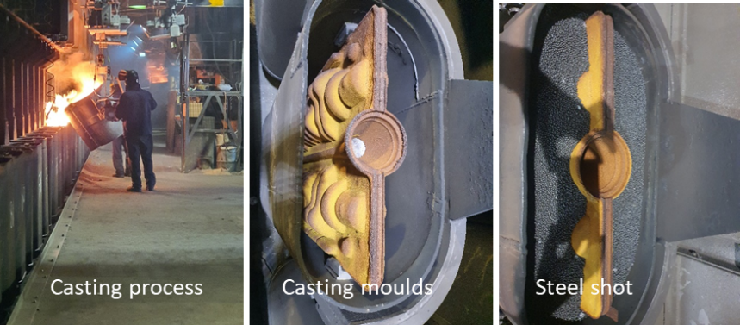
Figure 4: Foundry casting process

A third energy centre would be placed at the foundry, housing two 6 MWth heat pumps, one recovering heat from the foundry and the other from the aquifer. The 4DH heat network would be developed in 10 phases connecting the buildings in the following sequence: (1) Hospital; (2) Tower blocks; (3) Supermarket cluster including non-domestic properties; (4) Foundry and light industrial properties; (5) to (7) New Build homes; (8) to (10) existing domestic properties within the red line boundary. Figure 5 shows two phases of the heat network build-out sequence.
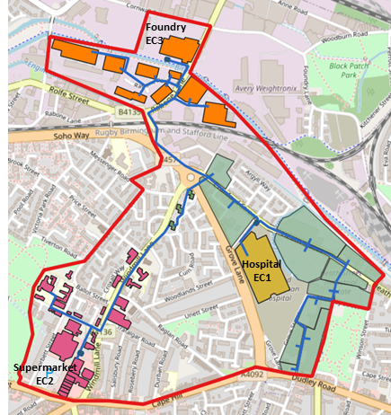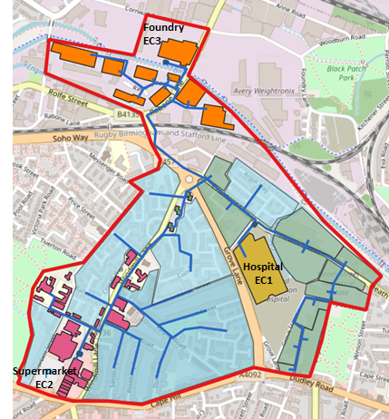
Figure 5: Smethwick heat network phases 7 (left) and 10 full build-out (right)

In phase 10 the GreenSCIES-Smethwick network connects 3,168 domestic properties and over 70 businesses. The total heating and cooling demand is 57.2 GWh/yr and 6 GWh/yr respectively (1,951,744 and 204,728 thm/yr).
Techno-economic model assumptions
Techno-economic modelling was undertaken to determine the operational expenditure, CO₂ emissions, internal rate of return over a 40-year period and net present value over a base case (gas boilers in existing properties up to 2029 and air source heat pumps for new build homes). EnergyPro (EMD, 2014) was the modelling tool employed, it uses half hourly supply/demand data alongside electricity tariffs, control strategies and demand side management. EnergyPro can optimize the operation of any combination of energy supply and demand in accordance with the weather, maintenance costs, fuel prices, taxes, subsidies, etc. The financial assumptions included the UK spot market electricity import and export prices and Climate Change levies for 2019. Western Power Distribution DUoS for the red, amber and green tariffs were applied to the hospital, supermarket and industrial properties, the tower blocks used the economy 7 tariff with day and night rates and a standard flat residential tariff was used for the remaining properties. Carbon factors were based on diminishing figures using predicted figures published by GOV.UK (2019c). Technical modelling assumptions for the base case and GreenSCIES-Smethwick network are summarized in Table 1.

Table 1. Techno-economic model technical assumptions
Year | Phase | Description | Base Case | GreenSCIES
2022 | 1 | Hospital | Boilers 2029; ASHPs from 2030;  CHP; Chillers; Thermal stores | EC1: Heat Pump; Aquifer cold well;  CHP; Thermal stores
2023 | 2 | Tower blocks | Electric storage heaters;  Thermal storage
2024 | 3 | Supermarket cluster | Boilers to 2029; ASHPs from 2030; Electric Chillers | EC2: Heat Pump;  Aquifer cold well
2025 | 4 | Foundry and Industrial park | Boilers to 2029; ASHPs from 2030 | EC3: Heat recovery heat pump
2026 | 5 | New Build  1, 2 and 3 | Air Source Heat Pumps
2028 | 6
2030 | 7 |  |  | EC3: Aquifer heat pump
2029 | 8 | Existing domestic properties A, B and C | Boilers to 2029; ASHPs from 2030  Domestic hot water cylinders
2030 | 9
2031 | 10
Techno-economic model results
Figure 6 shows the GreenSCIES-Smethwick heat network generation by source and Figure 7 compares the carbon emissions in the base case against the GreenSCIES scheme.
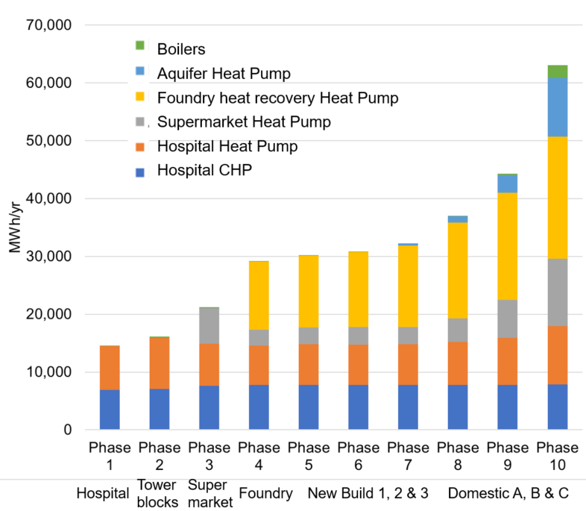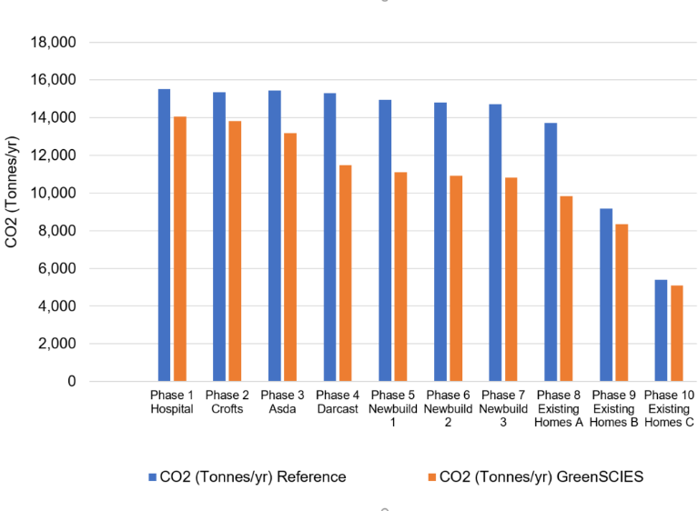
Figure 6: GreenSCIES network generation by source Figure 7: CO₂ emissions

Phase 1 helps to decarbonize the hospital without displacing the CHP and phase 2 helps to replace the tower blocks night storage heaters. The heat pump at the supermarket is only fully utilized in phases 3 and 10 (when all domestic properties are connected) as the foundry heat recovery and aquifer heat pumps supply most of the heat source until phase 9. The CO₂ emissions are up to 40% lower on the GreenSCIES-Smethwick scheme in some phases, but gradually reduce from 2030 when the counter-factual changes from gas boilers to air source heat pumps.
Capital expenditure for the proposed GreenSCIES-Smethwick network
The capital expenditure (CAPEX) of the proposed GreenSCIES-Smethwick network was estimated taking into account the cost of the heat network pipework, boreholes, water-sourced heat pumps, heating and cooling building services, metering, source connections, thermal storage, anticipated road/bridge crossings and a contingency fund for the design and commission of the network. Figure 8 shows the CAPEX breakdown for the whole system in phase 10.
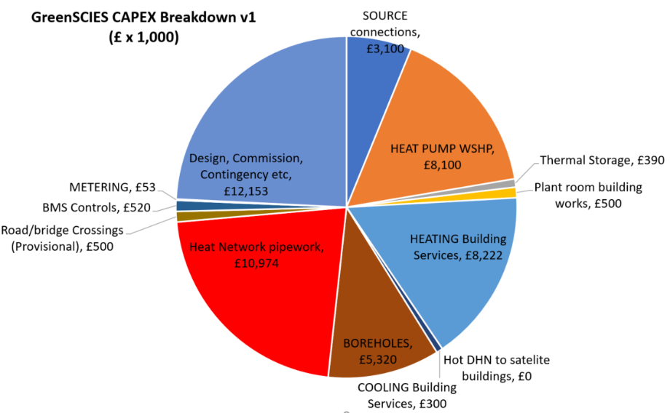
Figure 8: CAPEX for the GreenSCIES-Smethwick network
The total CAPEX for the GreenSCIES network is £50,133,000 [$69,697,353], with the heat network pipework and the design, commission and contingency representing 22% and 24% of the total capital cost respectively.
Table 2 summarizes the techno-economic results and the CAPEX for the base case and GreenSCIES network.

Table 2. Summary of initial techno-economic and CAPEX results
Phase | IIR (40 years) | NPV (£ x 1000)  (40 yrs) Improvement over base case | Operating Surplus  (£ x 1000) GreenSCIES | CO₂ Savings (Tonnes/yr) GreenSCIES | CAPEX  (£ x 1000)  Base case | CAPEX  (£ x 1000)  GreenSCIES
(1) Hospital | -10% | -3,157 | -29 | 1,460 | £3,500 | £4,524
(2) Tower blocks | 2% | -1,434 | 69 | 1,532 | £4,215 | £5,368
(3) Supermarket cluster | -2% | -6,985 | 55 | 2,252 | £1,890 | £6,397
(4) Foundry & industrial | -3% | -14,205 | 230 | 3,799 | £5,180 | £12,386
(5) New build 1 | -2% | -13,379 | 274 | 3,831 | £1,107 | £1,181
(6) New build 2 | -2% | -13,365 | 301 | 3,880 | £421 | £1,058
(7) New build 3 | -2% | -14,061 | 274 | 3,875 | £1,492 | £1,841
(8) Existing domestic A | -1% | -11,720 | 422 | 3,880 | £8,009 | £9,251
(9) Existing domestic B | 5% | 8,423 | 564 | 816 | £10,180 | £2,307
(10) Existing domestic C | 12% | 25,311 | 896 | 316 | £16,690 | £5,620
Total |  |  |  | 25,643 | £52,684 | £50,133

The GreenSCIES-Smethwick network has a comparable (or lower) total CAPEX than the base case by year 10, as the cost of retrofitting all properties with ASHPs is considerable, assuming domestic and commercial ASHPs retrofit costs at £11,000/home [$15,262/home] and £250/kWth [$347/kWth] respectively. In previous phases, the investment is higher in the GreenSCIES scheme, particularly when the energy centres are connected to the network.
Mobility and renewable energy integration options
Mobility can electrically interface in three ways with a 3rd/4th/5th generation Smart Local Energy System:
- Connected using vehicle-to-grid: bi-directional chargers are connected into the network at a standalone cluster or within the energy centre. Energy can flow to the vehicle or back to the building;
- Smartly connected: uni-directional chargers are connected into the network. Energy can only flow into the vehicle, but the timing and rate of energy supply can Optimised for price, reducing building rate at peak time;
- Shared civils: No energy supplied to buildings on the network but increased value, due to shared trenching for heat network and power supply to charging points along the network route.
In Smethwick options, 2 and 3 above are the most viable and it is also possible to install charging infrastructure at public buildings and pair it with solar PV and batteries.
Opportunities and challenges for Smart Local Energy Systems
Table 3 summarizes the opportunities and challenges for implementing SLES in cities and towns.

Table 3. Opportunities and challenges for SLES
Opportunities | Challenges
Waste heat recovery | Permanence of heat source
Prosuming/combined heating and cooling (5DHC schemes) | Gas is much cheaper than electricity
Revenue from flexibility (generation and demand) | High cost of networks (high digging costs)
Avoided grid reinforcement (due to flexibility) | Policy support
Integration of heat, power and transport | Lack of models forecasting the future in a broad scope
Addressing climate Change | Ownership and business model
Addressing fuel poverty (comparable energy bills) | Uncertainty around connection rates
Electrification of transport | Lack of consumer awareness
Local employment | Skills shortage
CONCLUSION
This paper investigated opportunities and challenges for implementing Smart Local Energy Systems through two case studies in Islington (London) and Smethwick.
In Islington, the 5th generation decentralized network has a balanced heating and cooling demand, which allows for prosuming between buildings. The opportunity for electric vehicle and V2G integration behind the meter is higher in 5DHC networks as they have more energy centres than 3DH schemes, although both can benefit from the shared civils for the district heat network and charging infrastructure.
In Smethwick the heating demand is nearly ten times higher than the cooling demand thus a 3DH centralized network was modelled with heat recovery from the foundry. With this limitation, the GreenSCIES thinking was applied on a much larger scale and it showed CO₂ savings in every phase of the network build-out plan, with a total of 25,600 tonnes of carbon saved by year 10 compared to the baseline scenario with gas boilers and air source heat pumps. The overall profit of the scheme is £25m ($32m) after 10 years. The next steps are to estimate the EV charging opportunities and PV potential in Smethwick and update the techno-economic and CAPEX models.
Overall, both 3DH and 5DHC networks show clear benefits over the base case, reducing carbon emissions and providing a pathway towards net zero carbon cities, enabling local authorities to meet their targets.
ACKNOWLEDGMENTS
The authors would like to acknowledge the funding from Innovate UK (105840) and all GreenSCIES project partners: London Borough of Islington, West Midlands Combined Authority, Building Low Carbon Solutions, Carbon Descent Projects, Transport for London, EON, Cullinan Studio, Grid Edge, Carbon Data Resources, Hanger 19, CENEX, Silver Energy Management Solutions, Consortio and Repowering London.
references
Buffa, S., Cozzini, M., D’Antoni, M., Baratieri, M., Fedrizzi, R. 2019. 5th generation district heating and cooling systems: A review of existing cases in Europe, Renewable and Sustainable Energy Reviews 104:504-522.
Davies, G. F., Maidment, G. G., Tozer, R. M. (2016) Using data centres for combined heating and cooling: An investigation for London, Applied Thermal Engineering 94:296–304.
EMD. 2014. EnergyPro - Simulate, analyse and optimize operations of energy plants, EMD International A/S. Available from: https://www.emd.dk/energypro [Accessed 14.01.2019].
Environmental Protection Agency (EPA). 2020. Combined Heat and Power (CHP) Partnership. Available from: https://www.epa.gov/chp/what-chp [Accessed 01.08.2020].
EMD. 2014. EnergyPro - Simulate, analyse and optimize operations of energy plants, EMD International A/S. Available from: https://www.emd.dk/energypro [Accessed 14.01.2019].
Greater London Authority (GLA), 2018. London Environment Strategy, London City Hall. Available from: https://www.london.gov.uk/what-we-do/environment/london-environment-strategy [Accessed 01.08.2020].
GOV.UK. 2019a. UK becomes first major economy to pass net zero emissions law, GOV.UK. Available from: https://www.gov.uk/government/news/uk-becomes-first-major-economy-to-pass-net-zero-emissions-law [Accessed: 27.06.21].
GOV.UK. 2019b. Spring Statement 2019: what you need to know, GOV.UK. Available from: https://www.gov.uk/government/news/spring-statement-2019-what-you-need-to-know [Accessed: 26.06.2019].
GOV.UK. 2019c. Carbon valuation, GOV.UK. Available from: https://www.gov.uk/government/publications/valuation-of-energy-use-and-greenhouse-gas-emissions-for-appraisal [Accessed 25.04.2021].
GOV.UK. 2018a. Clean growth – Transforming heating, overview of current evidence. Available from:
https://assets.publishing.service.gov.uk/government/uploads/system/uploads/attachment_data/file/766109/decarbonising-heating.pdf [Accessed 28.06.2021].
GOV.UK. 2018b. What is a heat network? Available from: https://assets.publishing.service.gov.uk/government/uploads/system/uploads/attachment_data/file/696273/HNIP_What_is_a_heat_network.pdf [Accessed 01.07.2020].
GOV.UK. 2018c. Heat Networks Investment Project, Introduction to the Scheme. Available from: https://www.gov.uk/government/publications/heat-networks-investment-project-hnip-scheme-overview [Accessed 01.08.2020].
London Borough of Islington. 2020. Vision 2030: Creating a Net Zero Carbon Islington by 2030. Available from: https://www.islington.gov.uk/~/media/sharepoint-lists/public records/Communications/Publicity/Publicconsultation/20192020/20200327IslingtonZeroCarbonStrategy20201 [28.06.2021].
Marques C., Dunham C., Jones, P., Matabuena R., Revesz A., Lagoeiro H., Maidment G. 2021. Integration of high temperature heat networks with low carbon ambient loop systems. 2021 ASHRAE Winter Conference.
Revesz, A., Jones, P., Dunham, C., Davies, G., Marques, C., Matabuena, R., Scott, J., Maidment, G. 2021. Developing novel 5th generation district energy networks, Energy 201.
Revesz, A., Marques, C., Davies G., Matabuena R., Jones P., Dunham C., Maidment G. 2020. Initial assessment of a 5th generation district energy network in central London. ASHRAE Transactions. 126, pp. 491-499.
Revesz, A., Jones, P, Dunham C., Riddle A., Gatensby N., Maidment G. 2021. Decentralised heat pumps and thermal stores for 5th generation district heating and cooling networks. 2021 CIBSE Technical Symposium.
Ricardo Energy & Environment. 2018. Pilot study on the air quality impacts from Combined Heat and Power in London, Available from: https://www.london.gov.uk/sites/default/files/pilot_study_on_the_air_quality_impacts_from_combined_heat_and_power_in_london.pdf [Accessed 01.08.2020].
West Midlands Combined Authority. 2021. Five Year Plan 2021-26. Available from: https://www.wmca.org.uk/media/4871/wm-net-zero-fyp-summary-tech-report.pdf [Accessed 03.06.2021].
Woolley E., Luo Y., Simeone A. 2018. Industrial waste heat recovery: A systematic approach. Sustainable Energy Technologies and Assessments. 29, pp. 50-59.

