Locomotor stability in able-bodied trunk-flexed gait across uneven ground

Soran AminiAghdam^{1*}, Roy Müller², Reinhard Blickhan³

^{1,2, 3} Department of Motion Science, Institute of Sport Science, Friedrich-Schiller-University Jena, Seidelstrasse 20, 07749 Jena, Germany

^{1, 2} Department of Neurology/Department of Orthopedic Surgery,
Klinikum Bayreuth GmbH, HoheWarte 8, 95445 Bayreuth, Germany

* Corresponding author E-mail:
soran.aminiaghdam@uni-jena.de
Phone: +493641-945714, Fax: +493641 945702

Co-authors’ E-mails:
² roy.mueller@klinikum-bayreuth.de, ³ reinhard.blickhan@uni-jena.de

Abstract
This study aimed to explore the control of dynamic stability of the imposed trunk-flexed gaits across uneven ground. For ten young healthy participants, we compared the anteroposterior margin of stability (MoS) and lower limb joint kinematics at foot-contact during accommodating a consecutive stepdown and step-up (10-cm visible drop) to that of level steps while maintaining four postures: regular erect, ~30°, ~50° and maximal trunk flexion from the vertical. Two-way repeated measures ANOVAs revealed no significant step × posture interactions for the MoS (p = .187) and for the parameters that contributed to the MoS calculation (p > .05), whereas significant interactions were found for the hip flexion, hip position (relative to the posterior boundary of the base of support) and the knee flexion. The main effect of step (p = .0001), but not posture (p = .061), on the MoS was significant. Post hoc tests, compared with the level step, showed that the decreased magnitude of the MoS during stepping down (p = .011) — mainly due to a further forward displacement of the center of mass position (p = .006) — significantly increased in the immediate following step-up (p = .002) as a consequence of a substantial increase in the base of support (p = .003). In the stepdown versus level step, the hip and knee flexions as well as the hip position did not significantly change in the trunk-flexed gaits (p > .05). In the step-up, the knee flexion increased (except for the gaits with the maximum trunk flexion), whereas other kinematic variables remained unchanged. Quantifying the step-to-step control of dynamic stability in a perturbed walking reflected continuous control adaptations through the interaction between gait and posture. In fact, the able-bodied participants were able to safely control the motion of the body’s CoM with the combination of compensatory kinematic adjustments in lower-limb and adaptations in stepping pattern.
Keywords:
Dynamic Stability; Margin of Stability; Trunk-flexed Gait; Uneven Walking

- Introduction
The control of human bipedal locomotion is required not only to generate safe and efficacious gait patterns, but also to cope with environmental challenges such as steps, slopes, or uneven ground as well as with intrinsic demands like alterations in the postural configuration. This necessitates effective postural adaptations and locomotor adjustments to assure dynamic gait stability. To achieve successful movement behaviors when encountering perturbations to regular gait pattern, both the reactive, feedback-based responses, and predictive, feedforward-driven gait adjustments are critical to modify the state of the center of mass (CoM) in relation to the base of support (BoS) based on the nature and the extent of disturbances (Haeufle, et al., 2018; Lam, Anderschitz, & Dietz, 2006; Marigold & Patla, 2002; McCrum, et al., 2016; Pai, et al., 2003; Pavol, Runtz, & Pai, 2004). Failure to accommodate such disturbances may yield loss of balance control and, thus, a higher risk of falls. In this framework, by exposing the regular gait to either or both of induced external (e.g. uneven ground) and internal perturbations (e.g. trunk flexion) in the experiments may help to gain insight into the boundaries of adaptability within human locomotor system. The gait analysis e.g. over uneven ground surfaces allows researchers to replicate a more real-world setting within the laboratory.
The human trunk is suggested to serve as a reference in the control of both posture and movement (Massion, et al., 1997; Mouchnino, Aurenty, Massion, & Pedotti, 1993). In human locomotion with an erected posture, a vaulting action of the whole-body CoM over the supporting limb resembles an inverted-pendulum (Cavagna, Heglund, & Taylor, 1977). However, the pendulum behavior may vary with changes in the posture due to e.g. a forward lean of the trunk. Given the substantial mass contribution of trunk to the total body mass, understanding the impact of the trunk posture on gait, particularly under perturbed conditions, is of clinical importance since frequently aging and some pathological conditions are accompanied by various degrees of anterior–posterior deviation of the trunk angle (de Groot, et al., 2014; Müller, Ertelt, & Blickhan, 2015; Nair, et al., 2017; Nair, W. Bohannon, Devaney, & Livingston, 2015; Sarwahi, Boachie-Adjei, Backus, & Taira, 2002). On the other hand, the forward momentum at foot-contact generated by a forward pitching motion of the upper-body must be controlled during safe locomotion, which becomes more challenging during stepping down (Novak, Komisar, Maki, & Fernie, 2016). This is due to a higher velocity of the CoM, leading to an enhanced forward displacement of the vertical projection of the CoM (Bosse, et al., 2012). Hence, alterations in the trunk orientation and in the ground level are known to individually or collectively perturb human locomotion (Aminiaghdam, Blickhan, Muller, & Rode, 2017; Aminiaghdam & Rode, 2017).
The ability to attenuate the trunk flexion and to adopt an appropriate stepping strategy are important components in controlling the dynamic stability of gait. The extent of such ability has a direct impact on the compensatory stepping responses necessary to avoid falling (Grabiner, et al., 2008). Therefore, the efficacy of the stepping responses can be more accurately assessed by a kinematic metric that is determined by both step and trunk kinematics. The dynamic stability may not be sufficiently characterized by considering the vertical projection of the whole-body CoM relative to the boundary of the BoS. By including the horizontal velocity of the whole-body CoM for the assessment of the dynamic stability, the succeeding position of the whole-body CoM is introduced to the calculation (Pai & Patton, 1997). As an individual outcome metric, the dynamic margin of stability (MoS) considers both position and velocity of the CoM (Hof, Gazendam, & Sinke, 2005) and allows a step-to-step quantitative analysis of dynamic control of the CoM. This measure extends the static stability, indicating to what extent an inverted pendulum is close to falling and, thus, may manifest a control strategy (Bruijn, Meijer, Beek, & Van Dieën, 2013). The positive values of the MoS reflect a more stable body position, whereas the negative values indicate an unstable body position, such that balance control requires compensatory postural adjustments and/or motor actions.
Despite a considerable body of literature, mostly in the experimental context, on the MoS, there is a lack of studies on the imposed trunk-flexed gaits and stability and more importantly, less studies have investigated how adaptability of such motor tasks emerge in response to an external perturbation (i.e., uneven ground surface induced by a 10-cm visible drop). A study by Saha et. al. (2008) noted that the stability of level walking with an induced trunk flexion can be achieved at the cost of compensatory lower-limb kinematic adaptations, affecting the state of the CoM (vertical position, velocity, and acceleration). These kinematic adaptations were found to alter the profile of vertical ground reaction forces. As a supplementary approach to this study, we aimed to explore the simultaneous effects of the trunk flexion angle and uneven ground on the dynamic control of stability in able-bodied participants to determine whether the effects of trunk-flexed gaits on the MoS are step-specific (i.e., a consecutive stepdown—step-up versus level step). Walking with sagittal trunk flexion was expected to be associated with compensatory kinematic adaptations in the lower-limbs across steps. To attenuate the simultaneous perturbing effects of the uneven ground and trunk flexion on the dynamic stability in able-bodied gait, we hypothesized: a) minimized between-step lower-limb kinematic changes at foot-contact during the trunk-flexed gaits; b) increased base of support by the trailing limb, leading to greater margins of stability in the following recovery step-up

- Methods

Participants
Ten (50% female) healthy volunteers (mean ± SD; age = 25 ± 3.25 years, height = 168.72 ± 7.42 cm, mass = 66.08 ± 7.12 kg) with no history of orthopedic, musculoskeletal and neurological disorders participated in this study. Prior to participation, all participants signed informed consent. Data collection was conducted at the Laboratory of Biomechanics of the Institute of Sport Sciences within Friedrich-Schiller-University Jena. The experimental protocol was approved by the local Ethics Committee of the above-mentioned university (3532-08/12) and conducted in accordance with the Declaration of Helsinki.
  - Experimental design and measurements
Eight infrared Qualisys motion capture cameras (MCU1000, Qualisys, Gothenburg, Sweden), sampling at 240 Hz, were used to collect kinematic data. Three consecutive force platforms (9285BA, 9281B, 9287BA, Kistler, Winterthur, Switzerland) were embedded in the center of a 12m-long walkway to measure ground reaction forces (GRF) at 1000 samples/s. GRF and kinematic data were synchronized using the Kistler’s external trigger and BioWare data acquisition software. The raw coordinate data were filtered using a fourth-order low-pass, zero-lag Butterworth filter with 12 Hz cut-off frequency. The instants of touchdown at each ground contact was determined by a vertical GRF threshold of 0.03 body weight. The International Society of Biomechanics joint coordinate standards (Wu, et al., 2002; Wu, et al., 2005) were applied.
Participants were instructed to walk at their normal walking speed across level and uneven (with a 10-cm visible drop in the center) walkways under four sagittal posture conditions: regular erect trunk (RE; 7.70 ± 3.08), 32.4 ± 7.20 of trunk flexion (TF1), 47.2 ± 6.30 of trunk flexion (TF2), and 71.7 ± 7.80 of trunk flexion (TF3) from the vertical (Soran Aminiaghdam, et al., 2017; Aminiaghdam, Rode, Muller, & Blickhan, 2017) (Fig. 1). Following the completion of walking trials on a level walkway, the participants walked across uneven walkway where the height-adjustable force plate was lowered by 10-cm to simulate a drop in the ground surface. For the inter-individual consistency in the target trunk postures, the participants were instructed to bend from the hips (S. Aminiaghdam, et al., 2017). The trunk angle was calculated between the line connecting the L5 to the C7 proc. spinosus and the vertical (S. Aminiaghdam, et al., 2017; Muller, Tschiesche, & Blickhan, 2014). While there was no comparison for TF3, the adjustable-height cardboard templates were used by a second examiner for the visual comparison of walking with TF1 and TF2 prior to and during gait. The templates were mounted on a wall parallel to the walkway at the starting point and in the middle of the walkway. Sufficient practice trials were allowed to participants for familiarization with the walking procedures. The order of walkway setups and the repetition of each trunk postures were remained fixed, but the sequence of the flexed trunk postures was randomized per participant. Each participant performed a minimum of eight successful trials per posture in which each single force plate was struck fully only by one foot.
  - Data analysis and statistics
We employed the body segmental analysis — using the anthropometric tables of Zatsiorsky–Seluyanov modified by De Leva (De Leva, 1996) — to determine the position of the CoM based on a thirteen-body segment model, defined by 21 retro-reflective surface markers (14-mm). The markers were placed on the following bony landmarks: fifth metatarsal heads, lateral malleoli, lateral epicondyles of femurs, greater trochanters, anterior superior iliac spines, posterior superior iliac spines, L5-S1 junction, lateral humeral epicondyles, wrists, acromioclavicular joints, seventh cervical spinous process and middle of the forehead. The anterior–posterior MoS (Hof, et al., 2005) was calculated at foot-contact by subtracting the extrapolated CoM from the anterior boundary of the base of support (BoS; the distance between the projections of the toe markers of the leading and trailing foot to the ground at foot-contact of the leading foot) during an unperturbed step on the level surface and perturbed consecutive stepdown and step-up (uneven walking) while adopting RE, TF1, TF2 and TF3 postures in ongoing gait (Fig. 1):
MoS = BoS_{AP} – X_{CoM}
where MoS indicates the margin of stability in the anterior–posterior direction, BoS_{AP} is the anterior boundary of the base of support, and X_{CoM} is the position of the extrapolated center of mass in the anterior–posterior direction. X_{CoM} was defined as follows:
$${\text{X}}_{\text{CoM }}\text{= }{\text{P}}_{\text{CoM} }\text{+ }\frac{{\text{V}}_{\text{CoM}}}{\sqrt{\text{g/l}}}$$
where P_{CoM} represents anterior-posterior component of the projection of the CoM to the ground, V_{CoM} is the anterior-posterior velocity of the CoM, g is acceleration due to gravity, and ‘l’ is the distance between the CoM and the ankle (pendulum length). Hip (Hip_{FC}), knee (Knee_{FC}) and ankle (Ankle_{FC}) joint angles were computed at foot-contact in the sagittal plane across each step. Additionally, we determined the anterior-posterior distance between the anterior-posterior component of the projection of the hip joint position and the posterior boundary of the BoS (P_{hip}).
Two-way repeated measures ANOVA with step (unperturbed step during level walking, perturbed consecutive stepdown and step-up during uneven walking) and posture (RE, TF1, TF2 and TF3) as factors were used for normally distributed data sets to examine the step- and posture-related differences in the MoS, and the parameters that contributed to the MoS calculation (BoS_{AP}, X_{CoM}, P_{CoM},V_{CoM} and $\sqrt{\text{g/l}}$term), as well as in the lower-limb kinematic variables (Hip_{FC}, Knee_{FC}, Ankle_{FC} and P_{hip}) at foot-contact. When a significant interaction effect was found between the step and posture, separate one-way ANOVAs were employed to test the between-posture differences across each step, as well as the between-step differences across each posture (simple main effects) in the dependent variables of interest using the Bonferroni adjustments for multiple comparisons. In case of a non-significant interaction, the main effects of the posture (data pooled from all three steps) and step (data pooled from all four postures) were evaluated on each dependent variable of interest using one-way ANOVAs with the Bonferroni adjustments for multiple comparisons. The significance level was α = 0.05. Results are presented as mean and standard deviation.

Results

The data analyzed comprises 640 trials with a total of 2560 step cycles. All participants were successful on every trial in maintaining their stability (no falls) while traversing the travel path with and without drop.

  - Margin of stability (MoS) parameters

No step × posture interaction was found for the MoS (p = .187), indicating that the effects of posture on the MoS were not step-specific. Similarly, there were no step × posture interaction for the parameters that contributed to the MoS calculation (p > .05).
While no significant main effects of step were detected on the X_{CoM} (p = .299) and V_{CoM} (p = .261), the post-hoc tests demonstrated a significant decrease and increase in the MoS (p = .011) (Fig. 2A) and P_{CoM} (p = .006) (Fig. 2D), respectively, in the stepdown versus level step. A greater forward shift in the CoM position (P_{CoM}) was therefore responsible for a reduced MoS. In the step-up compared with the level step, the MoS (p = .002) (Fig. 2A), BoS (p = .003) (Fig. 2B) and the $\sqrt{\text{g/l}}$ term (p = .010) (Fig. 2F) significantly increased. Therefore, an enlarged BoS (Fig. 2B) and a shorter pendulum length, as reflected in a greater $\sqrt{g/l}$term, contributed to a demonstrated significant increase in the MoS. For posture factor, increasing trunk flexion was associated with an increase only in the $\sqrt{g/l}$ term (p = .0001) (Fig. 2F).

  - Lower-limb kinematics

ANOVA revealed step × posture interaction for the Hip_{FC} (p = .0001) (Fig. 3A) and Knee_{FC} (p = .003) (Fig. 3C), but not for the Ankle_{FC} (p = .325), indicating step-specific effects of posture on Hip_{FC} and Knee_{FC}. Post-hoc tests revealed between-step changes in the Hip_{FC} merely during RE walking (p < .05), and a systematic within-step increase in the Hip_{FC} (p < .0001) (Figs. 3A and 4A-C), as trunk flexion angle increased (Figs. 3A and 4C). Except for the TF3 gait (p = 1.00), a significantly increased Knee_{FC} was found during the step-up compared to the level step in the walking postures (p < .05) (Figs. 3C and 4C). No significant between-posture changes in the Knee_{FC} were observed across steps (p > .05) (Figs. 3C and 4A-C). Additionally, a step × posture interaction was detected for the P_{hip} (p = .001) (Fig. 3B). Post-hoc tests revealed a significant decrease in the P_{hip} only in the stepdown, indicating a more posterior shift in the hip joint position with increasing trunk flexion (Fig. 3B). Furthermore, while trunk-flexed gaits represented no between-step changes in the P_{hip} (p > .05), this value increased in the stepdown versus level step (p = .006) and decreased significantly in the step-up versus stepdown (p = .016) in RE walking (Fig. 3B).

Discussion

This study aimed to examine the dynamic stability of able-bodied locomotion in response to a two-fold perturbation, namely alterations in the posture configuration and ground level surface. In line with our hypothesis, the simultaneous perturbing effects of an increased forward trunk flexion and uneven ground on the dynamic stability at foot-contact were attenuated by the combination of a) the compensatory kinematic adaptations in lower-limb (i.e., increased joint flexion angles and hip posterior shift) and observed minimized between-step changes with an increase of trunk flexion angle, and b) an increased base of support by the trailing limb, leading to greater margins of stability in the following recovery step-up. Despite the prominent alterations in the sagittal trunk geometry, the participants successfully modulated their dynamic stability, as judged from reduced posture-related changes in the magnitudes of the MoS.
The able-bodied participants in this experimental setup were found to be successful in arresting the forward acceleration of the upper-body mass. Increasing sagittal trunk flexion angle was associated with higher rates of the CoM’s velocity (V_{CoM}) at foot-contact of all measured step types; however, the changes were not statistically significant in trunk-flexed gaits compared with upright gait (Fig. 2E). During stepping down, a decreased magnitude of the MoS compared with the level step was due to a forward displacement of the CoM position (P_{CoM}), as other parameters of the MoS displayed no significant changes. This becomes even further important once one stepping into a hole. In fact, an unchanged base of support during steeping down did not allow for creating greater stability margins for the CoM. Under such circumstances, the stability of the system would contingent upon the compensatory strategies such as a proper foot placement of the trailing limb in a swift manner. In a study by Hurt et. al. (Hurt, Rosenblatt, Crenshaw, & Grabiner, 2010), 53% of variance in foot placement was predicted by the trunk state. This was due to the fact that the trunk accounts for a large proportion of the total body mass, and the control of such large segment is fundamental for dynamic stability of gait (MacKinnon & Winter, 1993).
Furthermore, increasing trunk flexion angle was associated with a systematic posterior shift in the hip position during stepping down. Such kinematic adaptations in the hip (e.g. the posterior shift in TF3 gait increased by ~9.5 cm from RE gait) may have contributed to the attenuation of the forward acceleration of the CoM, induced through both sustained anterior tilt of the trunk and downward motion of the body. Similarly, Saha et al. (Saha, Gard, & Fatone, 2008) showed that the preservation of dynamic stability in bent postures during level walking necessitates a more crouched leg posture during the stance phase, and a posterior shift in the position of pelvis.
Although drop or curb negotiation may require different motor and postural control from that necessary for stair gaits, the forward acceleration of the trunk (large mass) must be similarly controlled in each step while stair descending. During the stair descent task in the older versus younger adults (Bosse, et al., 2012), a reduced ability in arresting a higher velocity of the CoM due to age-related detrimental changes (e.g. diminished limb strength and muscle power) (Novak & Brouwer, 2011) leads to a further forward displacement of the CoM position, which eventually place them at a greater risk of falling. In contrast, the participants in our study were found to control the velocity of the CoM in a complex locomotor task of stepping over a curb with the trunk tilted forward, possibly at the cost of applying greater moment in the legs (Novak, et al., 2016). Furthermore, the ankle and knee joints did not demonstrate significant flexions at foot-contact during stepping down in the trunk-flexed gaits compared with that of RE gait. This might be due to an attempt to enlarge the BoS while the hip is located posterior with respect to the CoM. However, the knee joint became more flexed with increasing trunk flexion angle and the tendency remained in place for the rest of the stance. In our previous study (AminiAghdam & Blickhan, 2018), we revealed that during uneven walking, in the presence of bent postures, the able walkers strived to control stability by adjusting the spatial parameters of the step (i.e. step width, step and stride length) to the extent comparable to that of regular upright walking. However, to prevent falling over such adjustments required significant adaptations in the temporal parameters of gait such as a higher cadence and swift step by the trailing leg.
A threatened stability in the 10-cm stepdown was immediately compensated for in the following recovery step-up with 10-cm elevation. In fact, a greater magnitude of the MoS was significantly determined by the elongation of the BoS and partially by a slight increase in the magnitude of the $\sqrt{\text{g/l}}$term. In the post-perturbation step, greater margins for the control of the CoM’s motion were achieved. At foot-contact, between-step lower limb kinematic comparisons revealed an increased flexion in knee joint, except for the TF3 gait, compared with that of level steps, whereas no between-posture changes in knee joint kinematics took place. In addition, a shorter pendulum length (l) due to foot-contact on an elevated surface caused a greater magnitude of the $\sqrt{\text{g/l}}$term, which, in turn, contributed to a smaller magnitude of the extrapolated CoM (X_{CoM}), reflected in an improved MoS. We argue that the feed-forward control during the trunk-flexed gaits, driven by the awareness of the perturbations (i.e. alterations in posture and level surface), enabled compensatory kinematic adjustments in lower limb (a) to maintain the CoM within the BoS comparable to that of upright walking, and (b) to adjust the stepping pattern to meet the environment-induced challenges. These adaptations were geared to counteract the movement before a toppling occurs. In our previous study (AminiAghdam & Blickhan, 2018), we represented how the stability of the trunk-flexed versus upright gaits necessitates a faster propulsion of the trailing limb to surmount the drop in ongoing gait. Van Dieen et al. (van Dieën, et al., 2007) reported that ability to make a rapid step of the trailing limb can compensate for an inadequate step length of the perturbed leading limb in able-bodied walking in an unexpected versus expected stepdown during ongoing walking. While their experimental setup was different from ours in terms of the perturbation exposure, the both studies highlight the reactive recovery role of the trailing limb in controlling dynamic stability. Notably, predictive and recovery mechanisms underlying dynamic stability (e.g. modulation of the stepping pattern and generation of the necessary reversing moments) being exploited by fall-prone cohorts may differ from those employed by healthy, young adults in balance-compromised locomotion.

  - Limitation and conclusion
First, due to limitations of our experimental setup (i.e. only a visible 10-cm changes in the ground level surface), while the sequence of flexed trunk orientations was randomized per participant, the order of level and uneven setups as well as the repetitions of gaits with each trunk postures were fixed. Second, besides the lack of unexpected changes during ongoing overground walking, a restricted measurement volume (i.e. three consecutive steps) did not allow the analysis of the recovery gait patterns in the subsequent steps. Furthermore, our analysis was limited to a single elevated recovery step (i.e.,10-cm step-up) and therefore since the locomotor adaptations may have been facilitated by such characteristic of the setup, the future works should include more experiments like a permanent stepdown in order to get further insight into the recovery responses. Hence, further conclusions on the dynamics of stepping down with altered trunk orientation require more information on the subsequent steps, the effect of unexpected changes in the ground surface and the permanent stepdown. Third, the trunk postures were pre-determined by the study protocol and, thus, the observed gait behaviors may differ from those induced by age or pathology. Considering the above-mentioned limitations, generalization of the results should thus be undertaken with appropriate caution.
In summary, our findings imply how the able-bodied locomotion is capable of exploiting both the predictive and adaptive compensatory kinematic adjustments to improve stability in response to the simultaneous postural and environmental threats. A step-to-step control of dynamic stability in perturbed walking reflected continuous control adaptations through the interaction between gait and posture. In fact, with the combination of compensatory kinematic adjustments in lower-limb and adaptations in stepping pattern, the able-bodied participants were able to safely control the motion of the body’s CoM. Although the young, healthy adults demonstrated the ability to accommodate the strenuous task of walking across uneven ground while proceeding to the maximum possible sagittal trunk flexion, further studies are required to test the stability of gait in the fall-prone populations (e.g. older adults) exhibiting altered trunk orientations.

Conflict of interest statement
The authors have no conflicts of interest to declare.

Acknowledgments
This work was supported by the Berufsgenossenschaft Nahrungsmittel und Gastgewerbe (BGN) [grant number 1.1.4.2.18].

References
AminiAghdam, S., & Blickhan, R. (2018). The effects of an expected twofold perturbation on able-bodied gait: Trunk flexion and uneven ground surface. Gait & posture, 61, 431-438.
Aminiaghdam, S., Blickhan, R., Muller, R., & Rode, C. (2017). Posture alteration as a measure to accommodate uneven ground in able-bodied gait. Plos One, 12, e0190135.
Aminiaghdam, S., & Rode, C. (2017). Effects of altered sagittal trunk orientation on kinetic pattern in able-bodied walking on uneven ground. Biology Open, 6, 1000-1007.
Aminiaghdam, S., Rode, C., Muller, R., & Blickhan, R. (2017). Increasing trunk flexion transforms human leg function into that of birds despite different leg morphology. J Exp Biol, 220, 478-486.
Bosse, I., Oberländer, K. D., Savelberg, H. H., Meijer, K., Brüggemann, G.-P., & Karamanidis, K. (2012). Dynamic stability control in younger and older adults during stair descent. Human movement science, 31, 1560-1570.
Bruijn, S., Meijer, O., Beek, P., & Van Dieën, J. (2013). Assessing the stability of human locomotion: a review of current measures. Journal of the Royal Society Interface, 10, 20120999.
Cavagna, G. A., Heglund, N. C., & Taylor, C. R. (1977). Mechanical work in terrestrial locomotion: two basic mechanisms for minimizing energy expenditure. American Journal of Physiology-Regulatory, Integrative and Comparative Physiology, 233, R243-R261.
de Groot, M. H., van der Jagt-Willems, H. C., van Campen, J. P., Lems, W. F., Beijnen, J. H., & Lamoth, C. J. (2014). A flexed posture in elderly patients is associated with impairments in postural control during walking. Gait Posture, 39, 767-772.
De Leva, P. (1996). Adjustments to Zatsiorsky-Seluyanov's segment inertia parameters. Journal of biomechanics, 29, 1223-1230.
Grabiner, M. D., Donovan, S., Bareither, M. L., Marone, J. R., Hamstra-Wright, K., Gatts, S., & Troy, K. L. (2008). Trunk kinematics and fall risk of older adults: translating biomechanical results to the clinic. Journal of Electromyography and Kinesiology, 18, 197-204.
Haeufle, D. F., Schmortte, B., Geyer, H., Müller, R., & Schmitt, S. (2018). The benefit of combining neuronal feedback and feed-forward control for robustness in step down perturbations of simulated human walking depends on the muscle function. Frontiers in Computational Neuroscience, 12, 80.
Hof, A., Gazendam, M., & Sinke, W. (2005). The condition for dynamic stability. Journal of biomechanics, 38, 1-8.
Hurt, C. P., Rosenblatt, N., Crenshaw, J. R., & Grabiner, M. D. (2010). Variation in trunk kinematics influences variation in step width during treadmill walking by older and younger adults. Gait & posture, 31, 461-464.
Lam, T., Anderschitz, M., & Dietz, V. (2006). Contribution of feedback and feedforward strategies to locomotor adaptations. Journal of Neurophysiology, 95, 766-773.
MacKinnon, C. D., & Winter, D. A. (1993). Control of whole body balance in the frontal plane during human walking. Journal of Biomechanics, 26, 633-644.
Marigold, D. S., & Patla, A. E. (2002). Strategies for dynamic stability during locomotion on a slippery surface: effects of prior experience and knowledge. Journal of Neurophysiology, 88, 339-353.
Massion, J., Popov, K., Fabre, J.-C., Rage, P., & Gurfinkel, V. (1997). Is the erect posture in microgravity based on the control of trunk orientation or center of mass position? Experimental Brain Research, 114, 384-389.
McCrum, C., Epro, G., Meijer, K., Zijlstra, W., Brüggemann, G.-P., & Karamanidis, K. (2016). Locomotor stability and adaptation during perturbed walking across the adult female lifespan. Journal of Biomechanics, 49, 1244-1247.
Mouchnino, L., Aurenty, R., Massion, J., & Pedotti, A. (1993). Is the trunk a reference frame for calculating leg position? Neuroreport, 4, 125-127.
Müller, R., Ertelt, T., & Blickhan, R. (2015). Low back pain affects trunk as well as lower limb movements during walking and running. Journal of biomechanics, 48, 1009-1014.
Muller, R., Tschiesche, K., & Blickhan, R. (2014). Kinetic and kinematic adjustments during perturbed walking across visible and camouflaged drops in ground level. J Biomech, 47, 2286-2291.
Nair, P., Bohannon, R. W., Devaney, L., Maloney, C., & Romano, A. (2017). Reliability and validity of nonradiologic measures of forward flexed posture in Parkinson disease. Archives of physical medicine and rehabilitation, 98, 508-516.
Nair, P., W. Bohannon, R., Devaney, L., & Livingston, J. (2015). Measurement of anteriorly flexed trunk posture in Parkinson's disease (PD): a systematic review. Physical Therapy Reviews, 20, 225-232.
Novak, A., & Brouwer, B. (2011). Sagittal and frontal lower limb joint moments during stair ascent and descent in young and older adults. Gait & posture, 33, 54-60.
Novak, A., Komisar, V., Maki, B., & Fernie, G. R. (2016). Age-related differences in dynamic balance control during stair descent and effect of varying step geometry. Applied ergonomics, 52, 275-284.
Pai, Y.-C., & Patton, J. (1997). Center of mass velocity-position predictions for balance control. Journal of Biomechanics, 30, 347-354.
Pai, Y.-C., Wening, J., Runtz, E., Iqbal, K., & Pavol, M. (2003). Role of feedforward control of movement stability in reducing slip-related balance loss and falls among older adults. Journal of Neurophysiology, 90, 755-762.
Pavol, M. J., Runtz, E. F., & Pai, Y.-C. (2004). Young and older adults exhibit proactive and reactive adaptations to repeated slip exposure. The Journals of Gerontology Series A: Biological Sciences and Medical Sciences, 59, M494-M502.
Saha, D., Gard, S., & Fatone, S. (2008). The effect of trunk flexion on able-bodied gait. Gait & posture, 27, 653-660.
Sarwahi, V., Boachie-Adjei, O., Backus, S. I., & Taira, G. (2002). Characterization of gait function in patients with postsurgical sagittal (flatback) deformity: a prospective study of 21 patients. Spine (Phila Pa 1976), 27, 2328-2337.
van Dieën, J. H., Spanjaard, M., Konemann, R., Bron, L., & Pijnappels, M. (2007). Balance control in stepping down expected and unexpected level changes. Journal of biomechanics, 40, 3641-3649.
Wu, G., Siegler, S., Allard, P., Kirtley, C., Leardini, A., Rosenbaum, D., Whittle, M., D D’Lima, D., Cristofolini, L., & Witte, H. (2002). ISB recommendation on definitions of joint coordinate system of various joints for the reporting of human joint motion—part I: ankle, hip, and spine. Journal of Biomechanics, 35, 543-548.
Wu, G., Van der Helm, F. C., Veeger, H. D., Makhsous, M., Van Roy, P., Anglin, C., Nagels, J., Karduna, A. R., McQuade, K., & Wang, X. (2005). ISB recommendation on definitions of joint coordinate systems of various joints for the reporting of human joint motion—Part II: shoulder, elbow, wrist and hand. Journal of biomechanics, 38, 981-992.

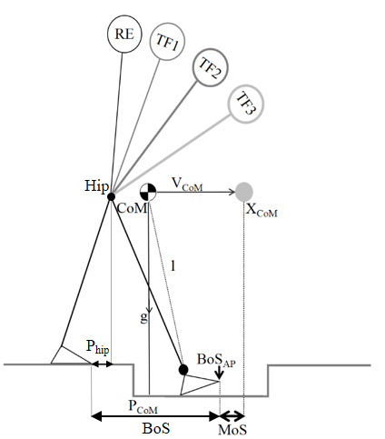
Fig. 1. Schematic illustration of the inverted pendulum model during locomotion. P_{CoM} represents the horizontal (anterior–posterior) component of the projection of the CoM to the ground, V_{CoM} is the horizontal velocity of the CoM (anterior–posterior), g is acceleration due to gravity and l is the pendulum length (i.e. the distance between the CoM and the center of the ankle joint in the sagittal plane). MoS was defined as the horizontal distance between the anterior boundary of the BoS_{AP}, defined by the leading toe marker and the X_{CoM}. P_{hip} represents is the horizontal distance between the anterior-posterior component of the projection of the hip joint position and the posterior boundary of the BoS.
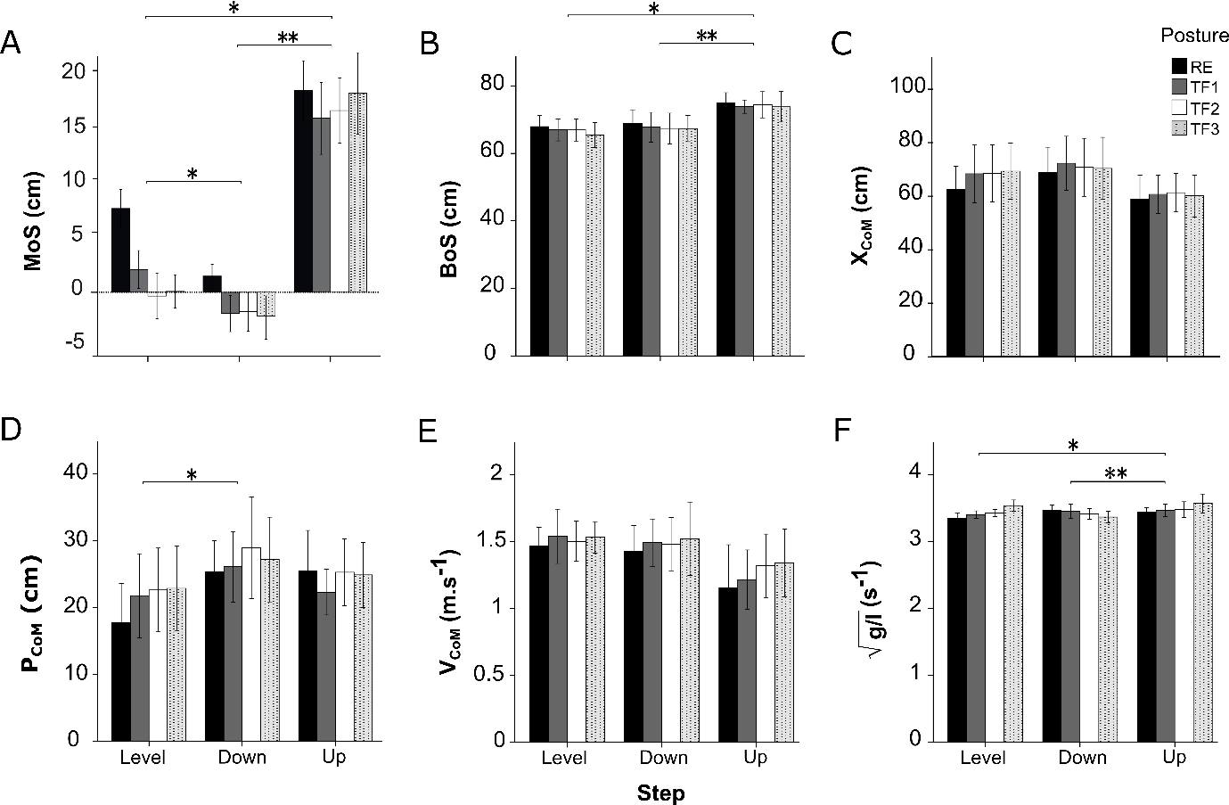
Fig. 2. Margin of stability (MoS) analysis at foot-contact (mean and SD). (A) margin of stability (MoS), (B) base of support (BoS), (C) extrapolated center of mass position (X_{CoM}), (D) center of mass position (P_{CoM}), (E) velocity of center of mass (V_{CoM}) and (F) $\sqrt{\text{g/l}}$term. Error bars denote standard deviation. Significant differences from level step and stepdown are indicated with ‘*’, and ‘**’, respectively (p < 0.05; Bonferroni post-hoc test). RE, regular erect trunk; TF1, ~30° trunk flexion; TF2, ~50° trunk flexion; TF3, maximal trunk flexion. BoS_{AP}, X_{CoM} and P_{CoM} were calculated in reference to the posterior boundary of the base of support (toe marker of the trailing limb) at foot-contact of the leading leg.

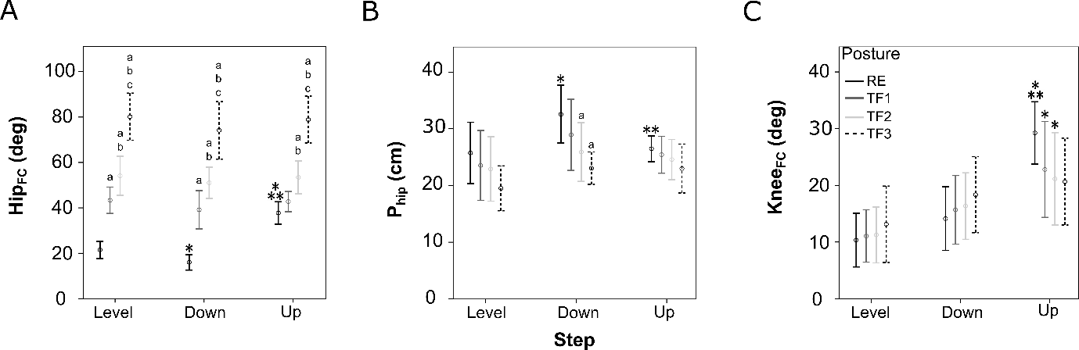
Fig. 3. step × posture interaction. Shown are step × posture interaction on the (A) hip flexion angle (Hip_{FC}), (B) anterior-posterior distance of the projection of the hip joint position (P_{hip}), and (C) knee flexion angle (Knee_{FC}) at foot-contact. Significantly differences from RE, TF1 and TF2 postures within each step are indicated with ‘a’, ‘b’ and ‘c’, respectively. For each posture, ‘*’, and ‘**’indicate significantly differences from the level step and stepdown, respectively (p < 0.05; Bonferroni post-hoc test). RE, regular erect trunk; TF1, ~30° trunk flexion; TF2, ~50° trunk flexion; TF3, maximal trunk flexion.

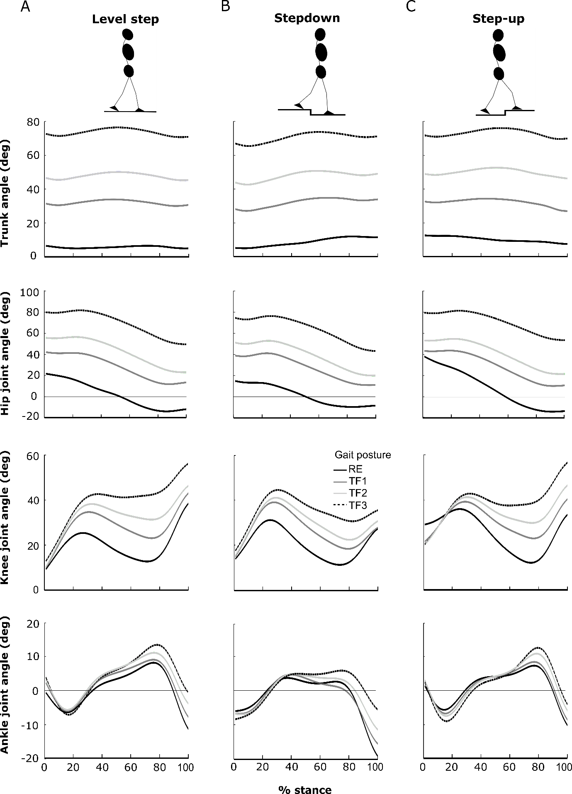
Fig. 4. Ensemble-averaged trunk and lower limb joint kinematics in sagittal plane. Angular displacements of the trunk, hip, knee and ankle normalized to the stance phase during (A) level step, (B) stepdown, and (C) step-up while walking with RE, TF1, TF2 and TF3 postures. RE, regular erect trunk; TF1, ~30° trunk flexion; TF2, ~50° trunk flexion; TF3, maximal trunk flexion.

