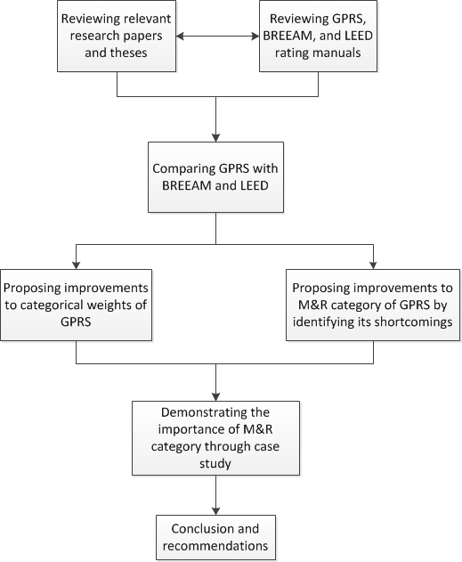
Figure 1. Research flowchart

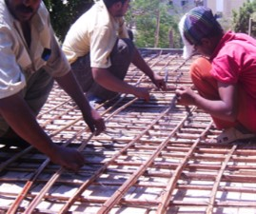
Figure 2. Slab reinforcement
Source: (Daoud, 2013)

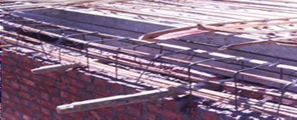
Figure 3. Beam reinforcement
Source: (Daoud, 2013)

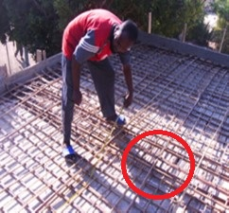
Figure 4. Intermediate beam
Source: (Daoud, 2013)

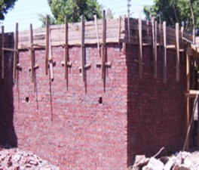
Figure 5. Final constructed building
Source: (Daoud, 2013)

