PEGylation enhances the antibacterial and therapeutic potential of amphibian host defence peptides
Sarah R. Dennison^{1*}, Subrayal M. Reddy², Leslie H G Morton³, Frederick Harris³, Kamal Badiani⁴ and David A Phoenix⁵
¹School of Pharmacy and Biological Sciences, University of Central Lancashire, Preston PR1 2HE, UK
² Chemistry Division, School of Natural Sciences, University of Central Lancashire Preston PR1 2HE, UK
³School of Natural Sciences, University of Central Lancashire Preston PR1 2HE, UK
⁴Pepceuticals Limited, 4 Feldspar Close, Warrens Park, Enderby, Leicestershire, LE19 4JS, UK;
⁵Office of the Vice Chancellor, London South Bank University, 103 Borough Road, London
SE1 0AA, UK.
*Corresponding Author
To whom correspondence should be addressed: Dr. S. R. Dennison. School of Pharmacy and Biological Sciences, University of Central Lancashire, Preston PR1 2HE, UK
E-mail: srdennison1@uclan.ac.uk.

ABSTRACT
Aurein 2.1, aurein 2.6 and aurein 3.1 are amphibian host defence peptides that kill bacteria via the use of lytic amphiphilic α-helical structures. The C-terminal PEGylation of these peptides led to decreased antibacterial activity (Minimum Lethal Concentration (MLCs) ↓ circa one and a half to threefold), reduced levels of amphiphilic α-helical structure in solvents (α-helicity ↓ circa 15.0%) and lower surface activity (Δπ ↓ > 1.5 mN m⁻¹). This PEGylation of aureins also led to decreased levels of amphiphilic α-helical structure in the presence of anionic membranes and zwitterionic membranes (α-helicity↓ > 10.0 %) as well as reduced levels of penetration (Δπ ↓ > 3.0 mN m⁻¹) and lysis (lysis ↓ > 10.0%) of these membranes. Based on these data, it was proposed that the antibacterial action of PEGylated aureins involved the adoption of α-helical structures that promote the lysis of bacterial membranes, but with lower efficacy than their native counterparts. However, PEGylation also reduced the haemolytic activity of native aureins to negligible levels (haemolysis ↓ from circa 10% to 3% or less) and improved their relative therapeutic indices (RTIs ↑ circa three to sixfold). Based on these data, it is proposed that PEGylated aureins possess the potential for therapeutic development; for example, to combat infections due to multi-drug resistant strains of S. aureus, designated as high priority by the World Health Organization.

KEYWORDS
Aureins, C-terminal PEGylation, α-helical, amphiphilic, membrane interactions, haemolysis, Circular Dichroism, Langmuir Blodgett monolayers.

1.0 INTRODUCTION

Currently, one of the biggest causes of death, worldwide, is bacterial infections [1], which has been exacerbated by the emergence of pathogenic strains with multiple drug resistance (MDR), rendering many treatment options ineffective [2]. A potential solution to this problem is host defence peptides (HDPs), which are multifunctional molecules of the innate immune system that serve a variety of biological functions [3, 4], including the exertion of potent action against bacteria [5]. Some HDPs are anionic [6], but in general, these peptides are cationic, allowing them to selectively target bacterial cells, which carry a net negative surface charge, in contrast to healthy eukaryotic cells, which carry no net surface charge [7]. HDPs are also amphiphilic, which promotes the ability of these peptides to kill target bacterial cells via mechanisms involving translocation of the plasma membrane to attack a variety of internal targets and / or permeabilization of the plasma membrane itself [8, 9]. The relatively non-specific modes of action used by these mechanisms and their targeting of multiple sites appears to underpin the broad selectivity shown by HDPs against diverse MDR forms of bacterial pathogens [10]. The non-specific nature and multiplicity of the targets used by these mechanisms has also led to the general view that these peptides are much less likely to induce resistance in target cells, as compared to conventional antibiotics, which generally exert their activity at a single site of action [11]. Based on these observations, a number of HDPs have been developed for medical use and are in various stages of clinical trials as antibacterial compounds [12-14].

Despite their clear therapeutic relevance, a number of factors have prevented HDPs from achieving their full potential, and in particular, undesirable pharmacokinetic properties of these peptides, such as systemic toxicity, proteolytic susceptibility and rapid clearance, have generally restricted their application to local delivery [9, 12]. A major example is omiganan which is derived from the bovine HDP, indolicidin, [15] and is currently being evaluated for use in topical gels as a long-term treatment for rosacea, after successfully completing phase III clinical trials [16]. Most recently, the designed HDPs, horine and verine, have been reported to display systemic efficacy in murine models that was comparable to conventional antibiotics, indicating that they may have the potential to provide novel treatments for systemic bacterial infections in the future [17].

A variety of strategies to circumvent the undesirable pharmacokinetic properties of HDPs have been investigated [3, 12, 18-20], including the addition of a polyethylene glycol (PEG) chain to these peptides, which was shown to have the general effect of enhancing their metabolic stability [18, 21]. PEGylation of HDPs has also been found to enhance their overall pharmacodynamic properties by reducing their cytotoxicity and improving their selectivity for microbial and cancer cells. Currently, the general consensus of opinion is that essentially, PEGylated HDPs retain the mechanisms of action used by the native peptides but with a decreased potency towards target cells [18, 20, 21]. For example, the bovine HDP, Bac7(1–35), and its PEGylated counterpart appeared to be internalized into Escherichia coli by the transporter protein SbmA, although the transport of PEGylated Bac7(1–35) was less efficient due to its size, leading to a loss of antibacterial efficacy [22]. In the case of the cruatacean HDP, tachyplesin 1, and analogues of the amphibian HDP, magainin 2, the peptidoglycan layers of target bacteria appeared to act as permeability barriers to their larger PEGylated counterparts, leading to a decreased ability to kill bacteria via membrane permeabilization [23, 24].

There has clearly been some progress in understanding the effects of PEGylation on the membrane interactive mechanisms used by HDPs in their antimicrobial action, although this is limited, in part, due to the relatively small number of PEGylated HDPs that have been subject to major investigations (Table 1). In response, the present study has used a variety of biophysical techniques to investigate the effect of C-terminal PEGylation on the antibacterial activity and mechanisms used by aurein 2.1, aurein 2.6 and aurein 3.1 [25]. These peptides belong to the aurein family of HDPs, which were first reported in 2000, when they were isolated from the skin secretions of the closely related Australian Bell Frogs, Litoria aurea and Litoria raniformis [25]. Sequencing showed members of the aurein family to be close homologues, whilst biological assays showed them to possess activity against a variety of clinically relevant Gram-positive bacteria and Gram-negative bacteria [25, 26]. In general, these peptides have been extensively studied, but there appear to have been only a few investigations focusing on aurein 2.6 and aurein 3.1, and the present work would appear to be the first characterization of aurein 2.1 [27, 28]. This work showed that C-terminally PEGylated aurein 2.1, aurein 2.6 and aurein 3.1 exhibited a preference for Gram-positive bacteria and a membranolytic mode of action that was similar to their native counterparts but with reduced antibacterial efficacy. However, PEGylation also reduced the haemolytic activity of aurein 2.1, aurein 2.6 and aurein 3.1 to negligible levels and greatly enhanced their relative therapeutic indices, and based on these data, it is proposed that PEGylated aureins possess the potential for therapeutic development as medically relevant, antibacterial agents.

Table 1. Representative, major PEGylated HDPs
PEGylated HDPs | Major biological activity studied | Key references
P18  (cecropin A / magainin 2 hybrid) | Anticancer | [29]
Bac7(1–35)  (derivative of Bac7) | Antibacterial | [22]
KYE28 and variants  (derived from human heparin cofactor II) | Antibacterial | [30, 31]
LL-37 derivatives | Antibacterial | [32]
Tachyplesin I | Antibacterial | [24, 33]
Magainin 2 analogues | Antibacterial | [23, 33]
Nisin A | Antibacterial | [34]
CaLL  (cecropin A / LL-37 hybrid) | Antibacterial | [35, 36]
SET-M33L (synthetic) | Antibacterial | [37, 38]
MA  (melittin derivative) | Antibacterial | [39]
Granulysin derivatives | Antibacterial | [40]
MK5E  (Magainin 2 derivative) KLAL (synthetic) | Antibacterial | [41]
Nano-BA_{12K}  (bacitracin A derivative) | Antibacterial | [42]
Human α-defensin 1 | Inactive | [43]

2.0 MATERIALS AND METHODS
2.1 Materials
Dimyristoyl phosphatidylglycerol (DMPG) and dimyristoyl phosphatidyethanolamine (DMPE) were obtained from Avanti Polar Lipids, Inc (Alabaster, AL) and 2, 2, 2-trifluoroethanol (TFE) (HPLC grade), along with all other solvents, were acquired from VWR (Leicestershire, UK). Ethylenediaminetetraacetic acid (EDTA), phosphate buffered saline (PBS) and 4-(2-hydroxyethyl)-1-piperazineethanesulfonic acid (HEPES) were purchased from SIGMA-ALDRICH (UK). Calcein was supplied by Alfa Aesar and all other reagents were acquired from Fisher Scientific (UK). All buffers were prepared using ultra-pure water (resistivity 18 MΩcm).

2.2 The synthesis of aureins and their PEGylated isoforms
Aurein 2.1, aurein 2.6 and aurein 3.1, along with their PEGylated isoforms, were synthesized using Fmoc solid phase peptide synthesis strategies. Essentially, the sequences of aurein 2.1, aurein 2.6 and aurein 3.1 were obtained from Rozek et al.,[25] and all peptides were synthesized on a Symphony X peptide synthesizer at 120-µmol scale using a fivefold excess of Fmoc-amino acids relative to the solid support Fmoc-Rink amide resin (TentaGel® R RAM resin). Deprotection was achieved using piperidine / N,N-dimethylformamide (DMF) (20%, v/v) and couplings were performed using 1:1:2 amino acid / 1H-Benzotriazolium 1-[bis(dimethyl-amino)methylene]-5-chloro-hexafluorophosphate (1-),3-oxide (HCTU) / N,N-Diisopropylethylamine (DIPEA) in DMF. The PEGylated isoforms (Figure 1) were synthesized by coupling Fmoc-(PEG)₂-COOH (13 atoms) (Novabiochem®. CAS 867062-95-1, molar mass 443.5 g/mol) to the rink amide resin directly, employing the same coupling strategy as for the non-PEGylated material. The TentaGel® R RAM resin is functionalized with a modified Rink Amide linker and was used directly during the solid phase construction of peptide amides. The resin particle size found to be most suitable for these peptide syntheses was 90 µm. Standard Fmoc-deprotection and coupling steps with incoming activated amino acids were performed to synthesize the overall desired peptides. The peptide resin was cleaved under acid cleavage conditions to furnish crude peptides, which were isolated and purified by reverse phase HPLC using a C-18 reverse phase column. Cleavage of the desired peptides from the solid support was performed by the addition of a cleavage cocktail containing: Trifluoroacetic acid (TFA) / H₂O / Triisopropylsilane (TIS) (95:3:2, v/v). The isolated crude peptides were individually purified by semi-preparative HPLC using a Phenomenex C-18 reverse semi-preparative column to furnish the desired peptides. All peptides were characterised for purity by analytical reverse phase HPLC on a Phenomenex C-18 analytical column and MALDI-TOF mass spectrometry to determine the mass integrity. The molecular masses of aurein 2.1, aurein 2.6 and aurein 3.1 were 1.61 kDa, 1.63 kDa and 1.74 kDa, respectively, as previously reported [25]. The molecular masses of PEGylated aurein 2.1, aurein 2.6 and aurein 3.1 were were 1.81 kDa, 1.83 kDa and 1.94 kDa, respectively, confirming the addition of a 0.2 kDa ‘-NH-(PEG)₂-CONH₂’ moiety in each case.

Figure 1. PEGylated aureins. The aureins and their PEGylated isoforms used in this study were supplied and synthesized by Pepceuticals (UK), as described above, and their structures are depicted in Figure 1. The molecular masses of aurein 2.1, aurein 2.6 and aurein 3.1 were 1.61 kDa, 1.63 kDa and 1.74 kDa whilst those of their PEGylated isoforms were 1.81 kDa, 1.83 kDa and 1.94 kDa, respectively, confirming the addition of a 0.2 kDa ‘-NH-(PEG)₂-CONH₂’ moiety.
2.3 The antibacterial activity of aureins and their PEGylated isoforms
The antibacterial activity of aurein 2.1, aurein 2.6, aurein 3.1 and their PEGylated isoforms (Figure 1) was determined using a panel of organisms that included the Gram-positive bacteria Micrococcus luteus (strain NCIMB 196), Staphylococcus aureus (strain NCIMB 6571), Staphylococcus epidermis (strain NCIMB 8558), Streptococcus mutans (strain NCIMB 11723) and Bacillus subtilis (strain NCIMB 8054); and the Gram-negative organisms, Pseudomonas aeruginosa (strain NCIMB 10848), Escherichia coli (strain W3110), Enterobacter aerogenes (strain NCIMB 10102) and Proteus vulgaris (strain NCIMB 4175). Each of these bacterial strains was taken from a frozen stock (-80 °C), inoculated into 10 ml aliquots of sterile Nutrient broth and incubated in an orbital shaker (100 rpm and 37˚C) until the exponential phase was reached (OD = 0.6; λ = 600 nm). These bacterial cultures were then centrifuged at 15000 × g and 4 °C for 10 mins using a bench top centrifuge and the resultant cell pellet washed 3 times in 1 ml aliquots of 25% strength Ringers solution (RS), before being resuspended in 1 ml of 25 % strength RS. For antibacterial assay, these samples were further diluted with 25 % strength RS to achieve a bacterial density of 10⁶ CFU ml⁻¹. Then, 10 μl aliquots of these cell suspensions were taken and inoculated individually with 1 ml of each aurein and PEGylated aurein studied here in RS to give final peptide concentrations of 3.90 μM to 1.0 M. These samples were incubated overnight at 37 °C and as a control, each bacterial culture was similarly treated but in the absence of peptide. After incubation, 10 µl aliquots of the control samples and bacterial cultures that had been treated with aureins and their PEGylated isoforms were spread onto the surface of Nutrient agar plates and incubated at 37 °C for 12 hours. The plates were then viewed and the lowest peptide concentration yielding no bacterial growth was identified as the minimal lethal concentration (MLC) of each aurein and their PEGylated isoforms. These experiments were repeated four times and the average MLCs determined [44].

2.4 Hydrophobic moment plot and helical wheel analysis of aureins
The sequences of aurein 2.1, aurein 2.6 and aurein 3.1 (Figure 1, Figure 3, [25]) were analysed according to hydrophobic moment methodology, which essentially treats the hydrophobicity of successive amino acids in a sequence, as vectors and then sums these vectors in two dimensions, assuming an amino acid side chain periodicity of 100° [45]. The methodology then uses the mean hydrophobic moment, < μ_{H} >, to quantify the amphiphilicity of an α-helical sequence, and the mean hydrophobicity, < H >, of the sequence to measure its affinity for the membrane interior [46]. For this analysis, < μ_{H} > and < H > were computed using the normalized consensus hydrophobicity scale of Eisenberg et al., (1982) and a moving window of 11 residues [45], and then plotted as data points [< μ_{H} >, < H > ] on the hydrophobic moment plot diagram of Eisenberg et al. [47]. The sequences of aurein 2.1, aurein 2.6 and aurein 3.1 were modelled as a two-dimensional axial projection taken perpendicular to the α-helical long axis and assuming an amino acid periodicity of 100° according to the helical wheel analysis of Schiffer and Edmundson [48] and using Heliquest software (available online at http://heliquest.ipmc.cnrs.fr/)[49].

2.5 The conformational behaviour of aureins and their PEGylated isoforms
Secondary structure analysis of aurein 2.1, aurein 2.6 and aurein 3.1 and their PEGylated isoforms (Figure 1) was performed using a J-815 spectropolarimeter (Jasco, UK) at 20 °C, as previously described [50]. These peptides (0.1 mg ml⁻¹) were dissolved in a TFE and PBS (10 mM, pH 7.5) mixture (50.0% v/v) or suspensions of small unilamellar vesicles (SUVs) to maintain a peptide to lipid ratio of 1:100. To prepare SUVs, DMPG and DMPE were separately dissolved in chloroform and dried under N₂ gas before being vacuum-dried for 4 hours, after which the resulting lipid films were rehydrated for an hour using PBS (10 mM, pH 7.5). These suspensions were vortexed for 5 minutes, sonicated for 30 mins and then subjected to 3 cycles of freeze-thawing. SUVs were then extruded 11 times through a 0.1 µm polycarbonate filter using an Avanti polar lipids min-extruder apparatus. Far UV (180 nm to 260 nm) CD spectra were recorded at 20 °C using 0.5 nm intervals, a bandwidth of 1 nm, a scan speed of 50 nm min⁻¹ and a 10 mm path-length cell. Ten scans per sample were performed and averaged. The % α-helical content of HDPs was estimated using the method previously described by Forood et al., [51]. These experiments were repeated four times and the % α-helicity averaged.

2.6 The surface activity and monolayer interactions of aureins and their PEGylated isoforms
The surface activity of aurein 2.1, aurein 2.6 and aurein 3.1 and their PEGylated isoforms was investigated at 20 °C using a 15 cm² Teflon Langmuir trough, which was equipped with a Wilhelmy plate. A Hamilton microsyringe was used to inject peptide via an injection port into the PBS (10 mM, pH 7.5) subphase to give final peptide concentrations ranging between 1.0 μM to 7 μM. The adsorption of peptides at the air / water interface was monitored by increases in surface pressure for 60 min and were plotted as a function of peptide concentration. These experiments were repeated four times and the maximal surface pressure changes averaged.

The ability of aurein 2.1, aurein 2.6 and aurein 3.1 and their PEGylated isoforms to insert into monolayers formed from either DMPG or DMPE at constant area was determined using a 601M Langmuir Teflon trough (Biolin Scientific\KSV NIMA, Coventry, UK). Surface pressure (π) was measured using a Wilhelmy wire attached to a microbalance. Monolayers of either DMPG or DMPE were formed by spreading solutions of these lipids in chloroform (1 mg ml⁻¹) dropwise onto an air / PBS (10 mM, pH 7.5) interface using a Hamilton microsyringe. The solvent was allowed to evaporate off and then these monolayers were compressed by two moveable Derlin barriers with a velocity of 10 cm² min⁻¹ to a starting surface pressure of 30 mN m⁻¹ which corresponds to the packing density of naturally occurring membranes [52, 53]. Once monolayers were stable at this starting pressure, the barrier position was kept constant and peptides were injected into the subphase to give a final peptide concentration of 4 µM. Surface pressure increases were recorded as a function of time and all experiments were carried out at 20 °C. These experiments were repeated four times and the maximal surface pressure changes averaged.

Pressure-area isotherms of aurein 2.1, aurein 2.6 and aurein 3.1 (Figure 1) were performed on a Langmuir film balance (Biolin Scientific\KSV NIMA, Coventry, UK) equipped with Derlin moveable barriers and a Wilhelmy method using a Whatman’s CH1 filter paper plate and microbalance. For these experiments, 1.79 × 10¹⁵ molecules of each peptide were separately spread from methanolic solution onto a PBS (10 mM, pH 7.5) subphase. To generate pressure-area isotherms for these HDPs, these monolayers were allowed to stabilize for 30 min. and were then compressed at a rate of 0.27 nm² min⁻¹ until collapse pressure was observed. Isotherms were then analysed to determine the extrapolated areas of aurein 2.1, aurein 2.6 and aurein 3.1 at a surface pressure of π = 0 mN m⁻¹, which provides a measure of the mean monolayer surface area per aurein molecule. The molecular areas of these peptides were computed using the sequences shown in Figure 1 and previously published methodologies [53]. All experiments were conducted at 20.0 °C, repeated four times and the data averaged.

2.7 The membranolytic and haemolytic ability of aureins and their PEGylated isoforms
The membranolytic ability of aurein 2.1, aurein 2.6 and aurein 3.1 and their PEGylated isoforms (Figure 1) was determined using a dye release assay as previously described [54]. Essentially, chloroformic solutions of either DMPG or DMPE (7.5 mg ml⁻¹) were dried under N₂ gas and kept under vacuum for at least 12 hours to ensure complete removal of the solvent. The resulting lipid films were then hydrated with 1 ml of HEPES (5.0 M, pH 7.5) containing calcein (70.0 mM) and the suspension vortexed for 5 min before being sonicated for 30 min, which was followed by 3 cycles of freeze-thawing to maximize calcein encapsulation. Calcein encapsulated in SUVs was then separated from the free dye by elution with HEPES (5.0 mM, pH 7.5) down a Sephadex G75 column (SIGMA, UK) that had been rehydrated overnight in HEPES (20.0 mM, pH 7.5), NaCl (150 mM) and EDTA, (1.0 mM). The calcein release assay was performed by combining 25 µl of calcein encapsulated in SUVs with 50 µl of peptide (10 µM), which was then made up to a final volume of 1 ml with 20.0 mM HEPES, 150.0 mM NaCl and 1.0 mM EDTA (pH 7.4). The fluorescence intensities of calcein were monitored at 20 °C using an FP-6500 spectrofluorometer (JASCO, UK), with an excitation wavelength of 490 nm and emission wavelength of 520 nm. The fluorescence intensity induced by the addition of 10 μl of Triton X-100 (10.0 %, v/v) to calcein encapsulated in SUVs was taken to represent 100 % dye release and was used to calculate the relative % release of calcein from vesicles by aurein 2.1, aurein 2.6, aurein 3.1 and their PEGylated isoforms. These experiments were repeated four times and the % lysis averaged.

The haemolytic activity of aurein 2.1, aurein 2.6, aurein 3.1 and their PEGylated isoforms was measured using Columbia Blood agar base (Oxoid) plates that were supplemented with 5.0% sheep’s red blood cells (Fisher, UK). Essentially, holes were created in the blood agar plates using a punch of size 3 mm, and into each of these holes, 50 µl of each peptide in PBS (10 mM, pH 7.5) was added to give concentrations ranging from 3.12 µM to 1000 µM. The diffusion zones achieved by PBS (10 mM, pH 7.5) were taken to represent zero haemolysis and that of 0.1% Triton X-100 was taken to indicate 100 % haemolysis. The diameter of the haemolysis produced by each peptide after incubation at 37 °C for 24 hours was measured using a precision ruler and these data used to determine the % haemolysis relative to that of 0.1% Triton X-100, all as previously described [55, 56]. These experiments were repeated four times and the % haemolysis averaged.

To compare and gain insight into the efficacy of aurein 2.1, aurein 2.6, aurein 3.1 and their PEGylated isoforms, a relative therapeutic index (RTI) was defined for these peptides. According to this definition, the therapeutic effect of these peptides was taken to be their high lytic activity towards SUVs formed from DMPG, thereby providing a measure of their antibacterial activity. The toxic effect of these peptides was then taken to their maximal levels of haemolysis and their RTI defined as the ratio of their antibacterial activity to their haemolytic activity.

3.0 RESULTS
3.1 The antibacterial activity of aureins and their PEGylated isoforms
The activity of aurein 2.1, aurein 2.6, aurein 3.1 and their PEGylated isoforms against a panel of bacteria was determined using a Nutrient agar plate assay. Aurein 2.1, aurein 2.6 and aurein 3.1 showed potent activity against Gram-positive bacteria that ranged between 25 µM and 50 µM, and weaker action against Gram-negative organisms that varied between 40 µM and 100 µM (Table 2), which is consistent with previous studies [57]. The PEGylated isoforms of aurein 2.1, aurein 2.6 and aurein 3.1 also showed a preference for activity against Gram-positive bacteria, but for all organisms studied, the activity of these PEGylated peptides was lower than in the case of the corresponding, native aureins. The activity of PEGylated aurein 2.1, aurein 2.6 and aurein 3.1 against Gram-positive ranged between 40 µM and 80 µM and that against Gram-negative organisms varied between 80 µM and 200 µM (Table 2).

Table 2. The activity of aureins and their PEGylated isoforms against bacteria
 | Aurein  2.1 | Aurein 2.1-PEG | Aurein 2.6 | Aurein 2.6-PEG | Aurein 3.1 | Aurein 3.1-PEG
 | MLC (µM)
Gram-positive
bacteria
M. luteus | 25 | 50 | 25 | 60 | 80 | 80
S. aureus | 30 | 30 | 25 | 50 | 50 | 50
S. epidermis | 20 | 30 | 30 | 50 | 50 | 80
S. mutans | 25 | 30 | 25 | 40 | 50 | 50
B. subtilis | 30 | 20 | 30 | 50 | 50 | 80
Gram-negative
bacteria
P. aeruginosa | 40 | 50 | 50 | 80 | 80 | 100
E. coli | 50 | 60 | 60 | 100 | 80 | 100
E. aerogene | 50 | 50 | 50 | 100 | 80 | 100
P. vulgaris | 100 | 100 | 100 | 150 | 150 | 200

3.2 Properties of aureins and their PEGylated isoforms at an air / aqueous interface
CD conformational analysis showed that in PBS (10.0 mM, pH 7.5), aurein 2.1, aurein 2.6 and aurein 3.1 displayed spectra that revealed only low levels of α-helical structure (< 15.0%) and the presence of predominantly random coil conformations, indicative of poor folding in aqueous solution (Figure 2A). However, hydrophobic moment analysis predicted that these HDPs possessed the potential to form strongly amphiphilic α-helical structure at an interface with < μ_{H} > = 0.57 for aurein 2.1, < μ_{H} > = 0.56 for aurein 2.6 and < μ_{H} > = 0.60 for aurein 3.1 (Figure 3). These predictions were confirmed by conformational analysis of these HDPs in the presence of a TFE and PBS (10 mM, pH 7.5) mixture (50.0% v/v), which is a solvent mixture well known for its ability to mimick the ansiotropic environment of interfaces [58]. Spectra derived from this analysis revealed that aurein 2.1, aurein 2.6 and aurein 3.1 formed high levels of α-helical structure in this solvent mixture with levels that ranged between 75.6% and 77.9% (Table 3, Figure 2B). These data are consistent with previous studies on both these peptides [27] and other aureins [59-61], and reflect the generally high capacity of peptides in the aurein family to form α-helical secondary structure [4, 62]. Theoretical analysis also predicted that these peptides would be highly surface active (Figure 4), which was confirmed by Langmuir-Blodgett trough experiments showing that aurein 2.1, aurein 2.6 and aurein 3.1 exhibited maximal surface activities at an air / PBS (10.0 mM, pH 7.5) interface that varied between π = 29.0 mN m⁻¹ and π = 37.5 mN m⁻¹ (Table 3, Figure 4). Compression isotherms were derived for monolayers of these peptides at an air / PBS (10.0 mM, pH 7.5) interface and at the lift off surface pressure, π = 0 mN m⁻¹, which corresponds to maximal surface activity [53]. Their molecular areas were determined, as described above, and were found to be 3.5 nm² for both aurein 2.1 and aurein 2.6, and 3.7 nm² for aurein 3.1 (Table 3, Figure 5). Based on these molecular areas, surface active aureins would be predicted to possess α-helical structure that is orientated approximately parallel to the plane of the interface, such that its hydrophilic face resides in the aqueous phase and its hydrophobic face projects into the surrounding air, as reported for other aureins [53, 59, 63, 64].
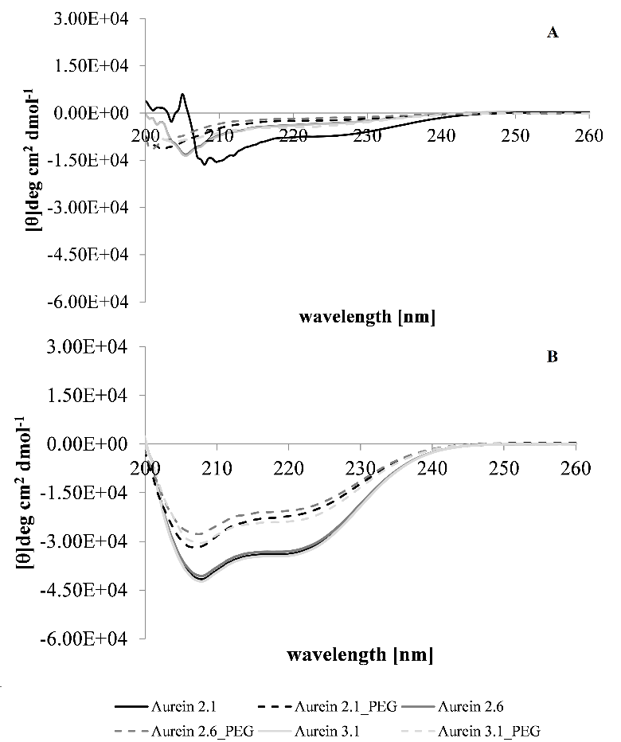
Figure 2. Conformational behaviour of aureins and their PEGylated isoforms in solvents. CD conformational analysis showed that aurein 2.1, aurein 2.6, aurein 3.1 and their PEGylated isoforms displayed similar spectra in PBS (10 mM, pH 7.5), exhibiting a strong negative band at around 200 nm, indicating high levels of random coil conformations and poor folding in aqueous solution. These spectra also exhibited a weak negative band between 210 nm and 220 nm, indicating very low levels of α-helical structure that were less than 15.0 % (Figure 2A). In a TFE and PBS (10 mM, pH 7.5) mixture (50.0% v/v), aurein 2.1, aurein 2.6, aurein 3.1 and their PEGylated isoforms also displayed similar spectra with two minima at 210 nm and 222 nm, indicating high levels of α-helical structure. The levels of this α-helical structure varied between 75.6% and 77.9% in the case of native aureins and between 59.2 % and 63.7 % in the case of their PEGylated counterparts (Figure 2B). The individual levels of α-helical structure indicated for peptides by these charts were determined, as described above, and are shown in table 3 along with their standard deviations.
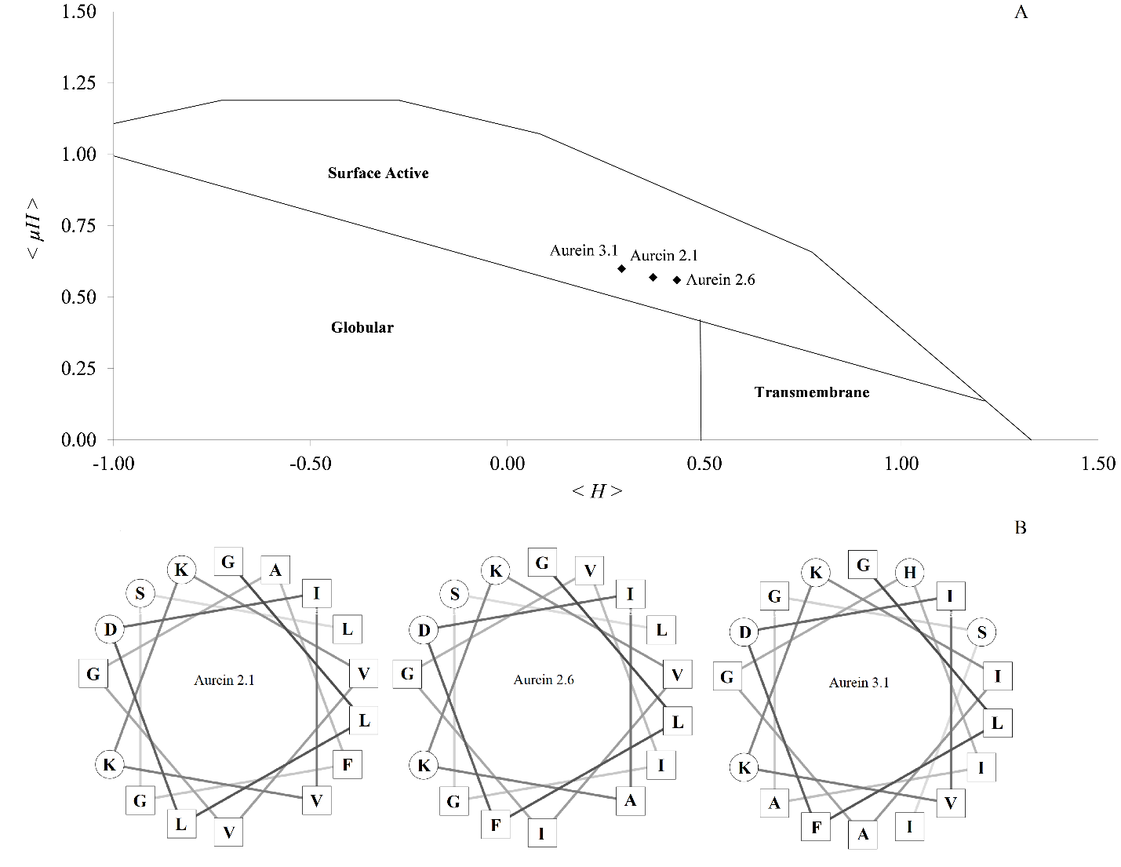
Figure 3. Hydrophobic moment plot analysis of aureins. In Figure 3A, hydrophobic moment plot methodology was used to analyse aurein 2.1, aurein 2.6 and aurein 3.1, which yielded values for the hydrophobic moment, < μ_{H} >, of 0.57, 0.56 and 0.60 for these peptides respectively, which in turn predicted that, in an α-helical conformation, these peptides would be strongly amphiphilic. The corresponding values for the hydrophobicity, < H > , of aurein 2.1, aurein 2.6 and aurein 3.1 were 0.37, 0.43 and 0.29, respectively. These values of < μ_{H} > and < H > were used as coordinates to plot data points on the hydrophobic moment plot diagram and each of these data points lay in the area demarking surface activity, predicting that these aureins would be active at an interface [65]. In Figure 3B, helical wheel analysis was used to model the sequences of aurein 2.1, aurein 2.6 and aurein 3.1 as two-dimensional axial projections, which revealed a clear segregation of hydrophilic and hydrophobic amino acid residues, consistent with their predicted amphiphilicity. In each case, these HDPs have a well-defined hydrophilic face (residues in circles), which includes multiple lysine, glycine and polar residues, and a hydrophobic face (residues in squares), which is rich in leucine, isoleucine, phenylaniline and valine residues [48].

CD analysis of PEGylated aurein 2.1, aurein 2.6 and aurein 3.1 in PBS (10.0 mM, pH 7.5), showed that these peptides were also not well folded in water and exhibited spectra that were similar to those of native aureins, characterized by predominantly random coil conformations and only low levels of α-helical structure that were less than 15.0 % (Figure 2A). In the case of a TFE and PBS (10 mM, pH 7.5) mixture (50.0% v/v), these PEGylated HDPs also exhibited similar spectra to those of native aureins but with levels of α-helical structure that varied between 59.2 % and 63.7 % (Table 3, Figure 2B). These data indicated that the PEGylation of aurein 2.1, aurein 2.6 and aurein 3.1 had induced a general decrease in their α-helicity of circa 15.0% in this solvent mixture (Table 3, Figure 2B), and similar results have been demonstrated for other HDPs [41]. Langmuir-Blodgett trough experiments showed that the PEGylation of aurein 2.1, aurein 2.6 and aurein 3.1 had also led to reductions in the activity of these peptides at an air / buffer (PBS, 10.0 mM, pH 7.5) interface with maximal surface activities that varied between π = 27.4 mN m⁻¹ and π = 29.1 mN m⁻¹ (Table 3, Figure 4). These results showed that PEGylation had generally decreased the capacity of the aureins studied here for activity at an air / aqueous interface by greater than 1.5 mN m⁻¹ (Table 3, Figure 4), and comparable data has been previously reported [42]. Taken in combination, these results suggest that the PEGylation of aurein 2.1, aurein 2.6 and aurein 3.1 induced a loss of α-helical structure in these peptides that led to changes in their packing characteristics at an air / water interface, thereby promoting reduced surface activity.
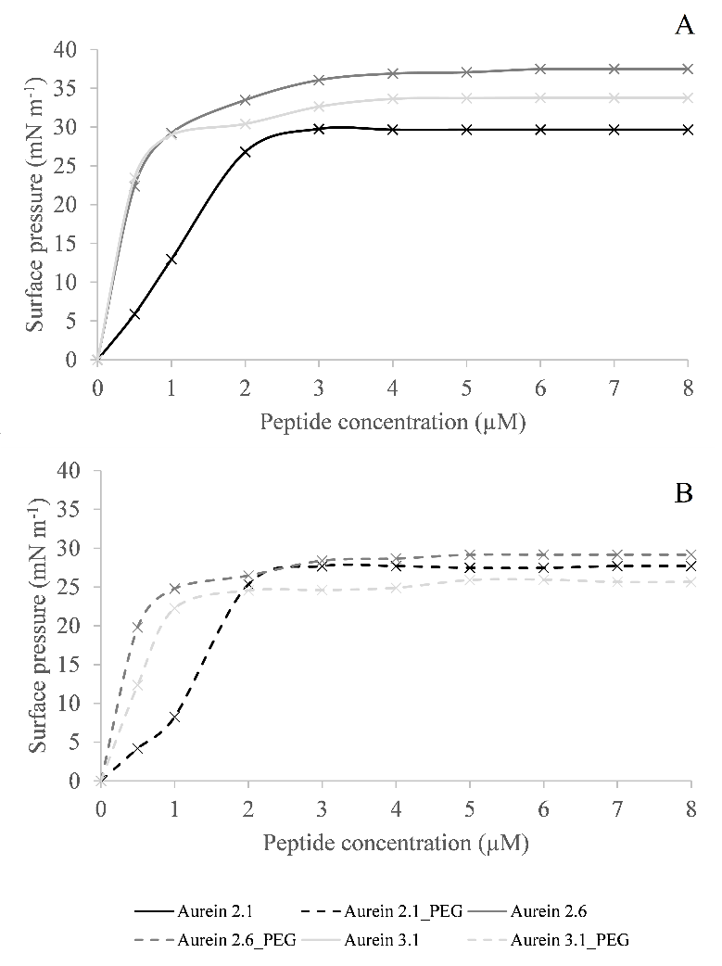
Figure 4. Activity of aureins and their PEGylated isoforms at an air /aqueous interface. Langmuir-Blodgett trough experiments showed that aurein 2.1, aurein 2.6 and aurein 3.1 displayed activity at an air / buffer (PBS, 10 mM, pH 7.5) interface with maximal surface activities that varied between π = 29.0 mN m⁻¹ and π = 37.5 mN m⁻¹ (Figure 4A). In contrast, the PEGylated isoforms of these peptides displayed maximal surface activities that varied between π = 27.4 mN m⁻¹ and π = 29.1 mN m⁻¹, representing a decrease of greater than 1.5 mN m ⁻¹ (Figure 4B). The individual maximal increases in surface pressure indicated for peptides by these charts were determined, as described above, and are shown in Table 3 along with their standard deviations.
Figure 5. Compression isotherm analysis of aureins. Langmuir-Blodgett trough experiments were used to generate compressions isotherm for aurein 2.1, aurein 2.6 and aurein 3.1, which showed that these peptides formed stable monolayers. Under compression, the isotherms of these monolayers showed collapse surface pressures of π = 32.0 mN m⁻¹, π = 37.0 mN m⁻¹ and π = 36.9 mN m⁻¹, respectively. Analysis of these isotherms showed that the extrapolated areas of these peptides at a surface pressure of π = 0 mN m⁻¹, which provides a measure of the mean monolayer surface area per aurein molecule, was 3.5 nm² for aurein 2.1 and aurein 2.6, and 3.7 nm² for aurein 3.1. The values of these molecular areas are close to those computed for the molecular cross-sectional areas of these peptides about the α-helical long axis, which were 3.6 nm² for aurein 2.1 and aurein 2.6, and 3.8 nm² for aurein 3.1.

Table 3. Properties of aureins and their PEGylated isoforms at an air / water interface
Peptides | α-Helicity  (%) |  | Surface activity (π)  (mN m-¹) | Peptides | α-Helicity  (%) |  | Surface activity (π)  (mN m-¹)
 | PBSª | TFE / PBSª |  |  | PBSª | TFE / PBS
Aurein 2.1 | 12.3 ± 1.2 | 77.9 ± 1.6 | 29.0 ± 0.6 | Aurein 2.1-PEG | 7.2 ± 1.4 | 63.7 ± 0.8 | 27.4 ± 0.7
Aurein 2.6 | 10.4 ± 1.0 | 75.6 ± 1.2 | 37.5 ± 1.3 | Aurein 2.6-PEG | 5.1 ± 1.2 | 59.2 ± 1.1 | 29.1 ± 0.2
Aurein 3.1 | 10.8 ± 1.4 | 76.5 ± 1.6 | 33.7 ± 0.5 | Aurein 3.1-PEG | 13.3 ± 1.1 | 59.5 ± 1.2 | 25.9 ± 0.35
ªIn Table 3, PBS refers to phosphate buffered saline (10.0 mM, pH 7.5) and TFE / PBS refers to a 50.0% (v/v) mixture of 2, 2, 2-trifluoroethanol and PBS. All experimentally determined data are shown with their standard deviation.

3.3 Properties of aureins and their PEGylated isoforms at a membrane interface
The activity of aurein 2.1, aurein 2.6, aurein 3.1 and their PEGylated isoforms at an air / aqueous interface suggested the potential for lipid interaction, and to investigate this possibility, the associations of these peptides with lipid membranes were studied [46, 53]. It is well established that PG and PE species are the major anionic and zwitterionic lipids, respectively, found in bacterial membranes [7, 66] and it is common practice to use these lipids to represent these membranes [52, 53]. CD analysis showed that aurein 2.1, aurein 2.6 and aurein 3.1 underwent structural changes from predominantly random coil conformations (Figure 2A) to display spectra indicating the adoption of α-helical structure in the presence of both DMPG and DMPE SUVs (Figure 6), which is consistent with theoretical predictions (Figure 2). Analysis of these spectra showed that the α-helicity of these peptides was lower than in the case of a TFE and PBS (10 mM, pH 7.5) mixture (50.0% v/v) (Table 3) and ranged between 48.9 % and 66.6% for SUVs formed from DMPG (Table 4, Figure 6A), and between 34.3 % and 47.9 % for those formed from DMPE (Table 4, Figure 6B). These levels of α-helical structure are consistent with previous reports [27] and generally comparable to those adopted by other aureins [63, 67, 68]. Aurein 2.1, aurein 2.6 and aurein 3.1 induced maximal surface pressures in monolayers formed from DMPG that varied between π = 9.8 mN m⁻¹ and π = 12.0 mN m⁻¹, and between π = 7.7 mN m⁻¹ and π = 8.5 mN m⁻¹ in those formed from DMPE (Table 4, Figure 7). These peptides also induced levels of lysis that varied between 59.6% and 71.3% in the case of SUVs formed from DMPG and between 31.7% and 40.6% in the case of those formed from DMPE (Table 4). Comparable levels of membrane interaction have been shown for other aureins and HDPs [68-70] and in combination, these data show that the aureins studied here adopted high levels of lipid interactive, α-helical structure (Table 4, Figure 6) and have a strong propensity to penetrate and lyse both anionic and zwitterionic lipid membranes (Table 4, Figure 7). These observations clearly suggested that this propensity is driven by the strongly amphiphilic nature of the α-helical structure formed by these peptides and similar structure / function relationships underpin the membranolytic mechanisms of most α-helical HDPs [7, 20, 66]. Based on this structure / function relationship, the high amphiphilicity of aurein 2.1, aurein 2.6 and aurein 3.1 (< μ_{H} > values > 0.5, Figure 3A), would drive the interactions of these peptides with anionic lipid membranes. Essentially, the non-polar face of these α-helical peptides would promote hydrophobic interactions with the acyl chain region of these membranes that are concomitantly stabilized by electrostatic associations between the polar face of these aureins and the membrane lipid head-group region (Figure 3B) [7, 20, 66]. In contrast, the ability of aurein 2.1, aurein 2.6 and aurein 3.1 to interact with zwitterionic lipid membranes would be primarily driven by the high hydrophobicity of these peptides (< H > values > 0.25, Figure 3) promoting interactions with the acyl chain region of these membranes [7, 20, 66].

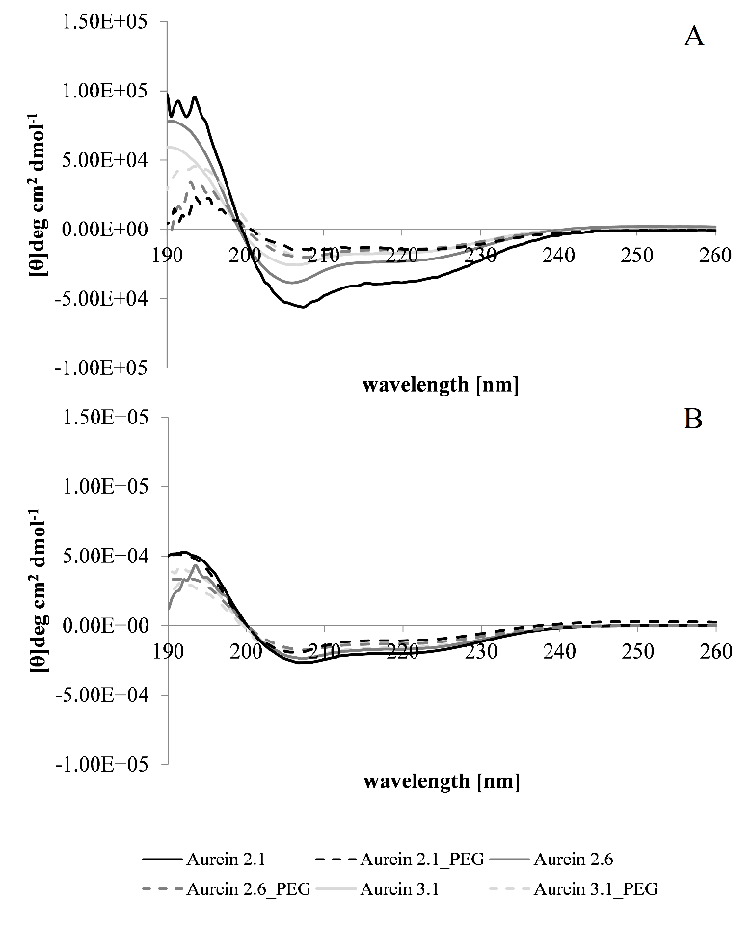

Figure 6. Conformational behaviour of aureins and their PEGylated isoforms in the presence of membranes. CD conformational analysis showed that in the presence of membranes formed from DMPG, aurein 2.1, aurein 2.6 and aurein 3.1 and their PEGylated isoforms displayed spectra with a double minimum between 208 nm and 222 nm and a positive band at 193 nm, indicating α-helical structure (Figure 6A). Analysis of these spectra revealed that for native aureins, the levels of this structure varied between 48.9 % and 66.6%, and in the case of their PEGylated isoforms, between 37.9% and 44.2% (Figure 6A). For membranes formed from DMPE, aurein 2.1, aurein 2.6 and aurein 3.1 and their PEGylated isoforms displayed spectra with similar characteristics to those for DMPG, which again indicated α-helical structure (Figure 6B). However, the levels of this α-helical structure were lower than that in the case of DMPG, varying between 34.3% and 47.9% for native aureins, and between 24.7% and 33.1% in the case of their PEGylated isoforms (Figure 6B). The individual levels of α-helical structure indicated for peptides by these charts were determined, as described above, and are shown in Table 4 along with their standard deviations.
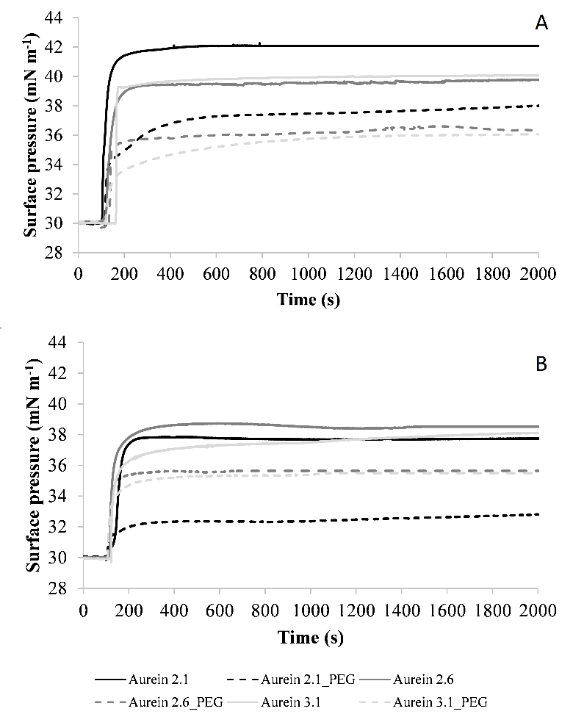
Figure 7. Lipid monolayer interactions of aureins and their PEGylated isoforms. Langmuir-Blodgett trough experiments showed that native aureins induced maximal surface pressures in monolayers formed from DMPG that varied between π = 9.8 mN m⁻¹ and π = 12.0 mN m⁻¹, and in the case of their PEGylated isoforms, between π = 6.3 mN m⁻¹ and π = 7.9 mN m⁻¹ (Figure 7A). For monolayers formed from DMPE, native aureins induced maximal surface pressures that ranged between π = 7.7 mN m⁻¹ and π = 8.5 mN m⁻¹, and in the case of their PEGylated isoforms, between π = 2.8 mN m⁻¹ and π = 5.3 mN m⁻¹ (Figure 7B). The individual maximal increases in surface pressure indicated for peptides by these charts were determined, as described above, and are shown in Table 4 along with their standard deviations.

Table 4. The properties of aureins and their PEGylated isoforms in the presence of membranes.
Peptides |  | α-Helicity  (%) |  |  |  | Monolayer penetration (π)  (mN m⁻¹) |  |  | Vesicle lysis  (%)
 |  | DMPG |  | DMPE |  | DMPG | DMPE |  | DMPG | DMPE
Aurein 2.1 |  | 66.6 ± 1.7 |  | 47.9 ± 0.9 |  | 12.0 ± 0.5 | 7.7 ± 0.5 |  | 59.6 ± 1.1 | 31.7 ± 1.1
Aurein 2.6 |  | 48.9 ± 1.5 |  | 37.5 ± 1.4 |  | 9.8 ± 0.5 | 8.5 ± 0.6 |  | 62.6 ± 1.2 | 35.5 ± 1.3
Aurein 3.1 |  | 56.1 ± 0.7 |  | 34.3 ± 1.2 |  | 9.9 ± 0.6 | 8.0 ± 0.5 |  | 71.3 ± 0.9 | 40.6 ± 1.1
Aurein 2.1-PEG |  | 44.2 ± 1.2 |  | 33.1 ± 1.6 |  | 7.9 ± 0.4 | 2.8 ± 0.4 |  | 44.5 ± 0.6 | 21.6 ± 1.4
Aurein 2.6-PEG |  | 37.9 ± 1.2 |  | 25.6 ± 1.0 |  | 6.5 ± 1.4 | 5.3 ± 0.4 |  | 45.3 ± 0.8 | 25.1 ± 1.3
Aurein 3.1-PEG |  | 41.9 ± 1.2 |  | 24.7 ± 0.8 |  | 6.3 ± 1.2 | 5.2 ± 0.3 |  | 42.0 ± 1.1 | 20.5 ± 0.9
Peptide | Haemolysis (%) |  | RTI ª |  | Peptide |  |  | Haemolysis (%) |  | RTI ª
Aurein 2.1 | 11.0 ±  0.1 |  | 5.4 |  | Aurein 2.1-PEG |  |  | 3.0 ±  0.3 |  | 14.8
Aurein 2.6 | 9.2 ±  0.1 |  | 6.8 |  | Aurein 2.6-PEG |  |  | 1.0 ±  0.2 |  | 45.3
Aurein 3.1 | 8.2 ±  1.1 |  | 8.7 |  | Aurein 3.1-PEG |  |  | 1.0 ±  0.1 |  | 42.0
ª In Table 4, RTI refers to the relative therapeutic index of aureins and their PEGylated isoforms, which was defined as the ratio of their lytic activity towards SUVs formed from DMPG to their haemolytic activity, as described above. All experimentally determined data are shown with their standard deviation.
Data presented for the membrane interactions of aurein 2.1, aurein 2.6 and aurein 3.1 also revealed that these peptides adopted levels of α-helical structure in the case of SUVs formed from DMPE that were lower by over 10.0% as compared to those formed from DMPG (Table 4, Figure 6). These results indicated a stronger interaction with anionic lipid than with zwitterionic lipid, which was consistent with previous work [27] and was reflected in the ability of aurein 2.1, aurein 2.6 and aurein 3.1 to interact with membranes (Table 4, Figure 6). Compared to DMPG, the penetration of DMPE monolayers by aurein 2.1, aurein 2.6 and aurein 3.1 was decreased by over 1.0 mN m⁻¹ (Table 4, Figure 7) and their lysis of DMPE SUVs was diminished by greater than 25.0% (Table 4). In combination, these data clearly suggest that the greater ability of aurein 2.1, aurein 2.6 and aurein 3 to interact with anionic membranes over zwitterionic membranes is primarily driven by the greater ability of these former membranes to induce amphiphilic α-helical structure in these peptides (Table 4, Figure 6).

To assess the impact of PEGylation on the membrane interactions of aureins, a series of experiments corresponding to those described above were conducted using PEGylated aurein 2.1, aurein 2.6 and aurein 3.1. These PEGylated peptides underwent conformational changes to adopt α-helical structure that ranged between 37.9% and 44.2.1% in the case of SUVs formed from DMPG (Table 4, Figure 6A), and between 24.7% and 33.1% in the case of those formed from DMPE (Table 4, Figure 6B), and comparable levels of α-helical structure have been reported for other PEGylated HDPs in the presence of membranes [23, 24]. PEGylated aurein 2.1, aurein 2.6 and aurein 3.1 also showed the capacity to penetrate monolayers and induce the lysis of SUVs formed from these lipids. These peptides exhibited maximal surface pressures in monolayers formed from DMPG that varied between π = 6.3 mN m⁻¹ and π = 7.9 mN m⁻¹, and between π = 2.8 mN m⁻¹ and π = 5.3 mN m⁻¹ in the those formed from DMPE (Table 4, Figure 7). PEGylated aureins also induced levels of lysis that varied between 42.0 % and 45.3% in the case of SUVs formed from DMPG, and between 20.5% and 25.1% in the case of those formed from DMPE (Table 4): comparable membrane lysis has been reported for other PEGylated HDPs [23, 41].

In combination, these data clearly suggested that, similarly to native aureins, PEGylated aurein 2.1, aurein 2.6 and aurein 3.1 have a strong propensity to penetrate and lyse both anionic and zwitterionic lipid membranes (Table 4, Figure 7) and that this propensity is driven by the possession of an amphiphilic, α-helical structure (Table 4, Figure 6). However, compared to native aureins, these data also indicated a general decrease of over 10.0% in the levels of α-helical structure adopted by PEGylated aurein 2.1, aurein 2.6 and aurein 3.1 in the presence of SUVs formed from either DMPG or DMPE (Table 4, Figure 6). These data mirror the effects of PEGylation on the conformational behaviour of native aureins in aqueous TFE (Table 3, Figure 2B) and similar reductions in α-helicity at a membrane interface have been reported for other HDPs upon PEGylation [23, 24, 33]. Compared to native aureins, PEGylated aurein 2.1, aurein 2.6 and aurein 3.1 showed a general reduction in their levels of penetration into monolayers formed from either DMPG or DMPE, which was over 3.0 mN m⁻¹ (Table 4, Figure 7). Relative to native aureins, these PEGylated peptides also showed a general reduction in their levels of lysis with SUVs formed with either DMPG or DMPE, which was greater than 10.0% (Table 4) and comparable reductions in membrane lysis have also been reported for other HDPs upon PEGylation [41]. These data clearly showed that the PEGylation of aureins has decreased their general ability to interact with both anionic and zwitterionic membranes, which in the case of these latter membranes paralleled data for the lytic action of these peptides against erythrocytes (Table 4). The membranes of erythrocytes are zwitterionic [7, 66] and native aureins induced levels of haemolysis that ranged between 8.2% and 11.0% whilst PEGylated aureins induced lower levels of haemolysis that ranged between 1.0% and 3% (Table 4). These results clearly indicate that the aureins studied here have a very low affinity for erythrocytes that is further reduced when these peptides are PEGylated and similar results have been reported for other HDPs [31, 39-41]. Taken together, these data clearly showed that the PEGylation of these aureins had reduced their ability to adopt amphiphilic, α-helical structure. These data also strongly suggested the loss of this secondary structure was a major driver in reducing the ability of these peptides to interact with membranes.

Nonetheless, PEGylated aurein 2.1, aurein 2.6 and aurein 3.1 appeared to have maintained the ability shown by their native counterparts to interact more strongly with anionic membranes than zwitterionic membranes. In comparison with SUVs formed from DMPG, the levels of α-helical structure adopted by PEGylated aureins in the presence of SUVs formed from DMPE membranes were decreased by greater than 10.0% (Table 4). These PEGylated peptides also showed corresponding reductions in their penetration of monolayers formed from DMPE, which were lower by over 1.0 mN m⁻¹, and in their lysis of SUVs formed from this lipid, which were decreased by greater than 20.0% (Table 4). In combination, these data indicate that, similarly to native aureins, a major driver in the preference of their PEGylated isoforms for anionic membranes is the greater ability of these membranes to induce amphiphilic α-helical structure in these latter peptides (Table 3, Figure 6). Taken overall, the results presented in this study clearly show that similarly to their native isoforms, PEGylated aurein 2.1, aurein 2.6 and aurein 3.1 use a mode of membranolytic mode of action, but with lower efficiency, which is consistent with reports from studies on other PEGylated HDPs [18, 20, 21]. To gain insight into the overall efficacy of the peptides studied here, RTIs were defined for PEGylated aureins and their native counterparts, which showed that for native aureins, these indices varied between 5.4 and 8.7 (Table 4). However, the PEGylated isoforms of these peptides showed RTIs that varied between 14.8 and 45.3, indicating that, based on this measure, these peptides possessed a circa three to sixfold higher therapeutic efficacy than their native counterparts (Table 4).

4.0 Discussion
The family of aureins have been extensively studied [25, 26]; however, the use of polymer conjugation to enhance the pharmacokinetic and pharmacodynamic properties of these peptides has been the focus of only a few major investigations [71, 72]. This work showed that the attachment of hyperbranched polyglycerol to aurein 2.2 and its derivatives produced membranolytic peptides with the potential for in vivo antibacterial application [71, 72]. In response, the present study has shown that C-terminally PEGylated aurein 2.1, aurein 2.6 and aurein 3.1 possess strong antibacterial activity, although the level of this activity was reduced as compared to that in the corresponding cases of the native peptides (Table 2). However, PEGylated aurein 2.1, aurein 2.6 and aurein 3.1 were also found to have much lower levels of haemolytic activity than their native counterparts. which resulted in RTIs that were greatly increased (Table 4). These observations are indicative of enhanced therapeutic efficacy and clearly suggested that PEGylated aureins possessed the potential for development to serve medically relevant purposes. Indeed, these peptides showed a strong preference for Gram-positive bacteria (Table 2) and these organisms are listed as high priority by the World Health Organization (WHO) in the search for novel antimicrobial strategies to combat infections due to MDR pathogens [73]. In particular, PEGylated aureins showed efficacy against S. aureus (Table 2) and various pathogenic strains of this organism have been designated as high priority by the WHO [73], primarily due to the ability of these organisms to resist almost all common antibiotics, necessitating an urgent need for new drugs to treat their infections [74, 75].

The potential medical relevance of PEGylated aurein 2.1, aurein 2.6 and aurein 3.1 clearly suggested that these peptides should be further characterized, and they were found to adopt α-helical structure and to exhibit activity at an air / aqueous interface (Table 3, Figure 4). It is well established that the ability to adopt this secondary structure facilitates the partitioning of HDPs into the hydrophobic and hydrophilic compartments of biological interfaces [7, 20, 66]. However, the levels of this α-helical structure and surface activity were reduced in comparison to the corresponding cases with native aureins (Table 3, Figure 4), which appeared to be promoted by conformational changes induced by their attached PEG chains (Table 3, Figure 2). This structural modification led to a loss of α-helical structure and similar results have been reported for other HDPs at an aqueous interface, such as the maiganin 2 derivative, MK5E, and the synthetic HDP, KLAL (Table 1). For these latter peptides, loss of α-helical structure appeared to result from steric effects induced in their conformational behaviour by their bulky C-terminal PEG chains [41]. Such effects are believed to result from the large hydrodynamic radius of solvated PEG molecules, which is up to tenfold higher than that of globular proteins with similar molecular masses [18, 76, 77]. It seems likely that similar mechanisms of steric hindrance promote the loss of α-helicity observed for aurein 2.1, aurein 2.6 and aurein 3.1 (Table 3, Figure 2); for example, the PEG chains attached to these peptides could potentially disrupt intramolecular hydrogen bonding involving their C-terminal amide moiety. Studies on aurein 2.6 and aurein 3.1 have shown that these hydrogen bonds play a key role in stabilizing α-helix formation by these peptides and that loss or disruption of this hydrogen bonding leads to reduced α-helicity [27]. The ability of PEG chains to influence the conformational behaviour of aurein 2.1, aurein 2.6 and aurein 3.1 also suggested that PEGylation may induce changes to their packing characteristics at an air / water interface, thereby promoting reduced surface activity. Indeed, it seems likely that the bulky nature of PEG chains could contribute directly to the disruption of interfacial packing by these peptides and reductions in their surface activity.

Activity at an air / aqueous interface is generally indicative that HDPs have the potential to interact with the interface of lipid membranes [46], which has been demonstrated for other PEGylated HDPs [42]. Consistent with these observations, PEGylated aurein 2.1, aurein 2.6 and aurein 3.1 were found able to adopt amphiphilic α-helical structure and to interact with both anionic and zwitterionic lipid membranes formed from bacterial lipids (Table 4, Figure 6). However, no clear pattern of differences in these abilities was discernible between these PEGylated peptides; for example, PEGylated aurein 2.1 showed the highest levels of α-helical structure observed for both DMPG and DMPE membranes, yet PEGylated aurein 2.6 demonstrated the highest ability to induce the lysis of these membranes (Table 4, Figure 6). In general, PEGylated aurein 2.1, aurein 2.6 and aurein 3.1 showed comparable efficacy in both their ability to form α-helical structure and to interact with lipid membranes (Table 4), which, in part, most likely reflects the close homology and structural similarities between these peptides (Figure 1, Figure 3) [25].

A clear result from the present work was that the C-terminal PEGylation of aurein 2.1, aurein 2.6 and aurein 3.1 induced a loss of α-helical structure by these peptides that led to decreases in their ability to interact with membranes. Essentially, this loss of secondary structure would be expected to reduce the ability of these peptides to engage in the electrostatic associations necessary to interact with the lipid head-group region of membranes and the hydrophobic interactions required to promote penetration of its apolar core [7, 20, 66]. A number of factors based on the physiochemical properties of PEG molecules would seem to have the potential to contribute to this disruption of membrane association. For example, the bulky PEG chains possessed by aurein 2.1, aurein 2.6 and aurein 3.1 could block interactions between their positively charged residues and the lipid head-groups of membranes, thereby decreasing their ability to target and bind to anionic membranes. The PEG chains of these HDPs are directly attached to their C-terminal amide moiety, which is positively charged (Figure 1), whilst their polar face includes a number of positively charged residues (Figure 3A), and in the case of HDPs, these structural features facilitate the targeting and binding of anionic components in bacterial membranes [7, 66]. Blocking mechanisms of this nature have been reported to have similar effects on the membrane targeting and binding of the N-terminally PEGylated HDP, human α-defensin 1 (HNP1) [43], and C-terminally PEGylated magainin 2 analogues [23, 33, 78]. A major possibility is that the PEG chains attached to aurein 2.1, aurein 2.6 and aurein 3.1 could disrupt not only the intramolecular hydrogen bonding mediated by the C-terminal amide moiety of these HDPs but also hydrogen bonds between this moiety and membrane lipid headgroups. Studies on aurein 2.6 and aurein 3.1 have shown that, in conjunction, these intramolecular and intermolecular hydrogen bonds form a network that plays a key role in stabilizing α-helical structure formed by these peptides in the presence of membranes [27]. The loss of α-helical structure induced by loss or disruption of this hydrogen bonding network could promote a decrease in the amphiphilic characteristics of these peptides and a reduced capacity to penetrate and lyse membranes (Table 3). PEG-mediated losses of amphiphilic α-helical structure have been reported to have similar effects on the ability of magainin 2 analogues to engage in membrane insertion and lysis [23, 33, 78]. Steric blocking of amphiphilic characteristics by PEG chains also appears to impede membrane binding, penetration and lysis by non α-helical HDPs, including HNP1 [43], and tachyplesin I [24, 33], which possess β type structures that are stabilized by intramolecular disulphide bonds [79, 80]. In these cases, PEGylation did not alter the secondary structure of these peptides but appeared to directly mask the electrostatic associations and hydrophobic interactions required for efficient membrane interaction by these peptides [24, 33, 43]. However, the PEGylation of HDPs can also lead to other outcomes; for example, when incorporated into microgels, levels of α-helical structure were increased by the addition of various N-terminal PEG chains to KYE28 (Table 1), which is an HDP derived from human heparin cofactor II [30]. Increases in levels of α-helical structure were also induced by the attachment of N-terminal PEG chains to CaLL, which is a hybrid of the insect HDP, cecropin A, and the human HDP, LL-37 hybrid (Table 1), and it was suggested that these PEG chains may have stabilized the α-helicity and ordered conformations of the peptide [35]. In these latter studies, the major effect induced by these PEG chains appeared to be the direct steric blocking of membrane binding and insertion by the peptide [35] and it seems possible that similar effects could contribute to the decreased lipid affinity shown by PEGylated aurein 2.1, aurein 2.6 and aurein 3.1.

Another clear result from the present work was that, similarly to their native isoforms, PEGylated aurein 2.1, aurein 2.6 and aurein 3.1 used a membranolytic mode of action and exhibited a preference for anionic lipid membranes over zwitterionic lipid membranes (Table 3), which is a general characteristic of HDPs [9, 20, 66]. Typically, the plasma membranes of bacteria are anionic, primarily due to the presence of negatively charged lipids, which endows aureins and other cationic HDPs with a high affinity for these membranes that promotes their targeting and binding [7, 66]. Indeed, it is well established that the levels of anionic lipid found in Gram-positive bacteria are generally much higher than those found in Gram-negative organisms, which are predominantly formed from zwitterionic lipid [7, 66]. In combination, these observations clearly suggest that the higher affinity shown by PEGylated aureins for anionic lipid membranes over zwitterionic lipid membranes will make a major contribution to the preference of these peptides for action against Gram-positive bacteria as compared to Gram-negative organisms (Table 2). However, regardless of bacterial type, in most cases, the binding of HDPs to bacterial membranes leads to permeabilization or lysis, and a number of models to describe these processes have been proposed, primarily the, barrel stave pore, toroidal pore and carpet mechanisms [7, 20, 66]. The specific mechanisms of membrane interaction used by the PEGylated aureins studied here appear not to have been investigated, but as described above, it is generally believed that PEGylated HDPs essentially retain the mode of action used by their native isoforms [18, 20, 21, 81]. It seems unlikely that the aureins studied here would utilize the barrel stave pore mechanism, given their length of sixteen residues (Figure 1, Figure 3). It is well established a minimum of circa 22 residues are required to span a bilayer, as would be the case with barrel stave pores [66, 82]. There is growing evidence that aurein 2.6, aurein 3.1 may utilise a toroidal pore type mechanism [27, 83-86] and studies on other HDPs that use this mechanism have shown that it is basically retained by their PEGylated isoforms, typically, tachyplesin 1 [24, 33] and magainin 2 analogues [23, 24]. In the case of these magainin analogues, it appeared that their PEG chains can extrude into the aqueous phase and clog pores, contributing to reduced membrane lysis by these peptides, and it is conceivable that similar effects could play a role in the membrane interactions of the PEGylated aureins studied here [23, 33]. It has also been suggested that aurein 2.6 and aurein 3.1 may use a tilted mechanism of membrane interaction. According to this mechanism, the C-terminal amide of these peptides associates with the lipid headgroup region and they destabilize membrane structure by penetrating the bilayer at a shallow angle between 30° and 60°. There is evidence to suggest that isolated PEG chains show no great propensity to penetrate biological membranes and tend to associate with the membrane headgroup region [87]. In this scenario, the PEG chains of aurein 2.6 and aurein 3.1 could effectively help localize their C-terminus to the membrane surface regions, which would fit with the tilted mechanism proposed for these peptides. However, it would seem that this C-terminal localization would also have the effect of limiting the access of aurein 2.6 and aurein 3.1 to deeper regions of the membrane, which could also fit with use of the carpet mechanism [7, 66]. According to this mechanism, HDPs increasingly carpet the bilayer surface, which leads to transient lesions in the membrane, the formation of micelles and ultimately, the lysis of target bacterial cells [7, 66]. However, as described above, the effects of PEGylation on the membrane interactions of HDPs are not always predictable and it may be that PEGylated aureins achieve their membranolytic action using mechanisms that differ to their native isoforms [30, 35].

Underpinning the selectivity of HDPs, these peptides generally have a low affinity for the membranes of erythrocytes and other mammalian cells, which are electrically neutral due to the presence of high levels of zwitterionic lipids and cholesterol [7, 66]. In general, PEGylation further reduces the toxicity of HDPs to mammalian cells, although the opposite outcome has been reported [18, 20, 21, 81, 88]. For example, PEGylated derivatives of the human HDP, granulysin, were toxic to human peripheral blood mononuclear cells, showing increased lysis of these cells, as compared to that of their native isoforms [40]. Aurein 2.1, aurein 2.6 and aurein 3.1 possessed a very low ability to lyse erythrocytes that was reduced to negligible levels when these peptides were PEGylated (Table 3). Clearly, a major contribution to this decreased haemolytic activity is likely to be made by the reduced ability of aurein 2.1, aurein 2.6 and aurein 3.1 to interact with zwitterionic membranes upon PEGylation (Table 3, Figure 7); indeed, it is well established that species of PE are components of erythrocyte membranes [7, 66]. However, a number of other factors have the potential to contribute to the PEG-mediated decreases in affinity for erythrocyte membranes observed for aurein 2.1, aurein 2.6 and aurein 3.1. These factors include the presence of cholesterol in these membranes [7, 66] and the extracellular matrix possessed by red blood cells [89, 90]. Haemolysis by HDPs appears to be inhibited by cholesterol through the modulation of membrane fluidity [91], as demonstrated for aurein 1.2 [92], and similar mechanisms could contribute to the low levels of haemolytic activity observed here for both native and PEGylated aureins. However, it seems likely that the bulky nature of PEG chains would render these PEGylated peptides more susceptible to this cholesterol mediated action than their native counterparts. The extracellular matrix of erythrocytes appears to inhibit haemolysis by HDPs by a process of entrapment involving high affinity interactions between its anionic components and the cationic residues of these peptides [93]. Again, it seems possible that similar mechanisms could contribute to the low levels of haemolytic activity observed here for both native and PEGylated aureins; however, the bulky nature of PEG chains could also enhance the entrapment of these PEGylated peptides by sterically hindering their passage through the glycocalyx and other layers of erythrocytes.

- Conclusions
PEGylated aurein 2.1, aurein 2.6 and aurein 3.1 have strong antibacterial activity, particularly against Gram-positive bacteria, and low toxicity to mammalian, which gives them enhanced efficacy compared to their native isoforms (Table 4). Their selectivity for bacterial cells and the relatively non-specific mode of membranolytic action used by PEGylated aurein 2.1, aurein 2.6 and aurein 3.1 endows these peptides with characteristics that are highly desirable for development as medically relevant, antibacterial agents [7, 66]. Indeed, there have been relatively few major studies on PEGylated HDPs as potential antibacterial agents, (Table 1) and there is clearly scope for the development of PEGylated aureins to serve in this capacity, which is particularly relevant given the current, rapid emergence of bacteria with MDR [2]. As discussed above, there are a number of mechanisms by which their attached PEG chains may influence the selective membranolytic action of aurein 2.1, aurein 2.6 and aurein 3.1, and it has previously been suggested that optimization of PEGylation parameters can improve the efficacy of HDPs [94]. It is well established that varying the parameters of attached PEG chains, such as length and site of conjugation, can modulate the pharmacodynamic properties and pharmacokinetic profiles of HDPs [31, 34, 39]. For example, increasing the length of PEG chains attached to KYE28 (Table 1) led to a minor decrease in antibacterial activity, but also to a strong decrease in haemolysis and improved selectivity for bacteria in infected blood [31]. The PEG chains attached to aurein 2.1, aurein 2.6 and aurein 3.1 possess only 3 repeating units and are relatively short in length (Figure 1). It would seem therefore that there is high potential for the use of a similar length optimization process to improve the performance of these peptides in a variety of therapeutically and biotechnically relevant scenarios. For example, using this approach has led to the development of PEGylated HDPs as constituents of inhaled therapeutic agents to treat pulmonary infections [35, 37] and as components of prodrugs to deliver these peptides in anticancer therapy [29, 88]. Further uses of PEGylated HDPs are incorporation into surface bound microgels and direct immobilization onto surfaces via PEG chains for local delivery and purposes ranging from treating wounds to combating bioﬁlm infections [30, 95-99]. Clearly, the PEGylation of HDPs is a process that offers flexibility in both the functionalization of these peptides and their potential applications. Based on these observations, it is proposed that aurein 2.1, aurein 2.6 and aurein 3.1 merit further investigation into the effects of PEGylation on their mode of membranolytic action and their biological activities, particularly in relation to their antimicrobial function.

Author Contributions
The manuscript was written through contributions of all authors. All authors have given approval to the final version of the manuscript.
Notes
The authors declare no competing financial interest.

ABBREVIATIONS
CD, circular dichroism; DIPEA, N,N-Diisopropylethylamine; DMPE dimyristoyl phosphatidylethanolamine; DMF, N,N-dimethylformamide; DMPG, dimyristoyl phosphatidylglycerol; EDTA, ethylenediaminetetraacetic acid; HCTU, 1H-Benzotriazolium 1-[bis(dimethyl-amino)methylene]-5-chloro-hexafluorophosphate (1-),3-oxide; HDPs, host defence peptides; HEPES, 4-(2-hydroxyethyl)-1-piperazineethanesulfonic acid; < H >, hydrophobicity; < µH >, hydrophobic moment; MDR, multiple drug resistance; PBS, phosphate buffered saline; PEG, polyethylene glycol; TIS, Triisopropylsilane; TFA, Trifluoroacetic acid; TFE, 2, 2, 2-trifluoroethanol; WHO, World Health Organization.

REFERENCES
1. Shahpar, C., et al., Protecting the world from infectious disease threats: now or never. BMJ Glob Health, 2019. 4(4): p. e001885.
2. Vivas, R., et al., Multidrug-Resistant Bacteria and Alternative Methods to Control Them: An Overview. Microb Drug Resist, 2019. 25(6): p. 890-908.
3. Mookherjee, N., et al., Antimicrobial host defence peptides: functions and clinical potential. Nat Rev Drug Discov, 2020. 19(5): p. 311-332.
4. Wang, G., X. Li, and Z. Wang, APD3: the antimicrobial peptide database as a tool for research and education. Nucleic Acids Res, 2016. 44(D1): p. D1087-93.
5. Wang, J., et al., Antimicrobial peptides: Promising alternatives in the post feeding antibiotic era. Med Res Rev, 2019. 39(3): p. 831-859.
6. Harris, F., S.R. Dennison, and D.A. Phoenix, Anionic antimicrobial peptides from eukaryotic organisms. Curr Protein Pept Sci, 2009. 10(6): p. 585-606.
7. Ciumac, D., et al., Membrane targeting cationic antimicrobial peptides. J Colloid Interface Sci, 2019. 537: p. 163-185.
8. Felício, M.R., et al., Peptides with Dual Antimicrobial and Anticancer Activities. Front Chem, 2017. 5: p. 5.
9. Rončević, T., J. Puizina, and A. Tossi, Antimicrobial Peptides as Anti-Infective Agents in Pre-Post-Antibiotic Era? Int J Mol Sci, 2019. 20(22).
10. Mwangi, J., et al., Antimicrobial peptides: new hope in the war against multidrug resistance. Zool Res, 2019. 40(6): p. 488-505.
11. Lewies, A., L.H. Du Plessis, and J.F. Wentzel, Antimicrobial Peptides: the Achilles' Heel of Antibiotic Resistance? Probiotics Antimicrob Proteins, 2019. 11(2): p. 370-381.
12. Divyashree, M., et al., Clinical Applications of Antimicrobial Peptides (AMPs): Where do we Stand Now? Protein Pept Lett, 2020. 27(2): p. 120-134.
13. Koo, H.B. and J. Seo, Antimicrobial peptides under clinical investigation. Peptide Science, 2019. 111(5): p. e24122.
14. Dijksteel, G.S., et al., Review: Lessons Learned From Clinical Trials Using Antimicrobial Peptides (AMPs). Frontiers in Microbiology, 2021. 12(287).
15. Melo, M.N., D. Dugourd, and M.A. Castanho, Omiganan pentahydrochloride in the front line of clinical applications of antimicrobial peptides. Recent Pat Antiinfect Drug Discov, 2006. 1(2): p. 201-7.
16. van Zuuren, E.J., et al., Rosacea: New Concepts in Classification and Treatment. American journal of clinical dermatology, 2021. 22(4): p. 457-465.
17. Lakshmaiah Narayana, J., et al., Two distinct amphipathic peptide antibiotics with systemic efficacy. Proc Natl Acad Sci U S A, 2020. 117(32): p. 19446-19454.
18. Forde, E. and M. Devocelle, Pro-moieties of antimicrobial peptide prodrugs. Molecules, 2015. 20(1): p. 1210-27.
19. Gao, Y., et al., The Modification and Design of Antimicrobial Peptide. Curr Pharm Des, 2018. 24(8): p. 904-910.
20. Kumar, P., J.N. Kizhakkedathu, and S.K. Straus, Antimicrobial Peptides: Diversity, Mechanism of Action and Strategies to Improve the Activity and Biocompatibility In Vivo. Biomolecules, 2018. 8(1).
21. Malmsten, M., Interactions of Antimicrobial Peptides with Bacterial Membranes and Membrane Components. Curr Top Med Chem, 2016. 16(1): p. 16-24.
22. Benincasa, M., et al., PEGylation of the peptide Bac7(1-35) reduces renal clearance while retaining antibacterial activity and bacterial cell penetration capacity. Eur J Med Chem, 2015. 95: p. 210-9.
23. Imura, Y., M. Nishida, and K. Matsuzaki, Action mechanism of PEGylated magainin 2 analogue peptide. Biochimica et Biophysica Acta (BBA) - Biomembranes, 2007. 1768(10): p. 2578-2585.
24. Imura, Y., et al., Action mechanism of tachyplesin I and effects of PEGylation. Biochimica et Biophysica Acta (BBA) - Biomembranes, 2007. 1768(5): p. 1160-1169.
25. Rozek, T., et al., The antibiotic and anticancer active aurein peptides from the Australian Bell Frogs Litoria aurea and Litoria raniformis the solution structure of aurein 1.2. Eur J Biochem, 2000. 267(17): p. 5330-41.
26. Xu, X. and R. Lai, The chemistry and biological activities of peptides from amphibian skin secretions. Chem Rev, 2015. 115(4): p. 1760-846.
27. Mura, M., et al., The effect of amidation on the behaviour of antimicrobial peptides. Eur Biophys J, 2016. 45(3): p. 195-207.
28. Wang, J., et al., The cooperative behaviour of antimicrobial peptides in model membranes. Biochim Biophys Acta, 2014. 1838(11): p. 2870-81.
29. Kelly, G.J., et al., Polymeric prodrug combination to exploit the therapeutic potential of antimicrobial peptides against cancer cells. Organic & Biomolecular Chemistry, 2016. 14(39): p. 9278-9286.
30. Nordström, R., et al., Microgels as carriers of antimicrobial peptides – Effects of peptide PEGylation. Colloids and Surfaces A: Physicochemical and Engineering Aspects, 2019. 565: p. 8-15.
31. Singh, S., et al., Effects of PEGylation on membrane and lipopolysaccharide interactions of host defense peptides. Biomacromolecules, 2014. 15(4): p. 1337-45.
32. Gong, Y., et al., Releasable and traceless PEGylation of arginine-rich antimicrobial peptides. Chem Sci, 2017. 8(5): p. 4082-4086.
33. Han, E. and H. Lee, Effects of PEGylation on the binding interaction of magainin 2 and tachyplesin I with lipid bilayer surface. Langmuir, 2013. 29(46): p. 14214-21.
34. Guiotto, A., et al., PEGylation of the antimicrobial peptide nisin A: problems and perspectives. Farmaco, 2003. 58(1): p. 45-50.
35. Morris, C.J., et al., Pegylation of antimicrobial peptides maintains the active peptide conformation, model membrane interactions, and antimicrobial activity while improving lung tissue biocompatibility following airway delivery. Antimicrob Agents Chemother, 2012. 56(6): p. 3298-308.
36. Fox, M.A., et al., Design and characterization of novel hybrid antimicrobial peptides based on cecropin A, LL-37 and magainin II. Peptides, 2012. 33(2): p. 197-205.
37. Brunetti, J., et al., In vitro and in vivo efficacy, toxicity, bio-distribution and resistance selection of a novel antibacterial drug candidate. Sci Rep, 2016. 6: p. 26077.
38. Falciani, C., et al., Site-specific pegylation of an antimicrobial peptide increases resistance to Pseudomonas aeruginosa elastase. Amino Acids, 2014. 46(5): p. 1403-7.
39. Zhang, G., et al., Modification of antimicrobial peptide with low molar mass poly(ethylene glycol). J Biochem, 2008. 144(6): p. 781-8.
40. da Silva, A.P., et al., In vitro and in vivo antimicrobial activity of granulysin-derived peptides against Vibrio cholerae. J Antimicrob Chemother, 2008. 61(5): p. 1103-9.
41. Bagheri, M., M. Beyermann, and M. Dathe, Immobilization reduces the activity of surface-bound cationic antimicrobial peptides with no influence upon the activity spectrum. Antimicrob Agents Chemother, 2009. 53(3): p. 1132-41.
42. Hong, W., et al., Insights into the antibacterial mechanism of PEGylated nano-bacitracin A against Streptococcus pneumonia: both penicillin-sensitive and penicillin-resistant strains. Int J Nanomedicine, 2019. 13: p. 6297-6309.
43. Wu, Z., et al., Impact of pro segments on the folding and function of human neutrophil alpha-defensins. J Mol Biol, 2007. 368(2): p. 537-49.
44. Dennison, S.R. and D.A. Phoenix, Influence of C-terminal amidation on the efficacy of modelin-5. Biochemistry, 2011. 50(9): p. 1514-23.
45. Eisenberg, D., R.M. Weiss, and T.C. Terwilliger, The helical hydrophobic moment: a measure of the amphiphilicity of a helix. Nature, 1982. 299(5881): p. 371-4.
46. Phoenix, D.A. and F. Harris, The hydrophobic moment and its use in the classification of amphiphilic structures (Review). Molecular Membrane Biology, 2002. 19(1): p. 1-10.
47. Eisenberg, D., et al., Analysis of membrane and surface protein sequences with the hydrophobic moment plot. Journal of Molecular Biology, 1984. 179(1): p. 125-142.
48. Schiffer, M. and A.B. Edmundson, Use of helical wheels to represent the structures of proteins and to identify segments with helical potential. Biophys J, 1967. 7(2): p. 121-35.
49. Gautier, R., et al., HELIQUEST: a web server to screen sequences with specific alpha-helical properties. Bioinformatics, 2008. 24(18): p. 2101-2.
50. Greenfield, N.J., Using circular dichroism spectra to estimate protein secondary structure. Nature protocols 2006. 6(1): p. 2876–2890.
51. Forood, B., E.J. Feliciano, and K.P. Nambiar, Stabilization of alpha-helical structures in short peptides via end capping. Proc Natl Acad Sci U S A, 1993. 90(3): p. 838-42.
52. Dennison, S.R., F. Harris, and D.A. Phoenix, Chapter Three - Langmuir–Blodgett Approach to Investigate Antimicrobial Peptide–Membrane Interactions, in Advances in Planar Lipid Bilayers and Liposomes, A. Iglič and C.V. Kulkarni, Editors. 2014, Academic Press. p. 83-110.
53. Dennison, S.R., F. Harris, and D.A. Phoenix, A Langmuir approach using on monolayer interactions to investigate surface active peptides. Protein Pept Lett, 2010. 17(11): p. 1363-75.
54. Dennison, S.R. and D.A. Phoenix, Influence of C-Terminal Amidation on the Efficacy of Modelin-5. Biochemistry, 2011. 50(9): p. 1514-1523.
55. Caruso, G., Maricchiolo, G., Genovese, L., Pasquale, F., Caruso, R., Denaro, M. G., … Lagana, P., Comparative study of antibacterial and haemolytic activities in sea bass, European eel and blackspot seabream. The Open Marine Biology Journal, 2014. 8: p. 10-16.
56. Peskova, M., et al., An enzymatic assay based on luciferase Ebola virus-like particles for evaluation of virolytic activity of antimicrobial peptides. Peptides, 2017. 88: p. 87-96.
57. Wenzel, M., et al., Antimicrobial Peptides from the Aurein Family Form Ion-Selective Pores in Bacillus subtilis. Chembiochem, 2015. 16(7): p. 1101-8.
58. Buck, M., Trifluoroethanol and colleagues: cosolvents come of age. Recent studies with peptides and proteins. Q Rev Biophys, 1998. 31(3): p. 297-355.
59. Dennison, S.R., L.H. Morton, and D.A. Phoenix, Role of molecular architecture on the relative efficacy of aurein 2.5 and modelin 5. Biochim Biophys Acta, 2012. 1818(9): p. 2094-102.
60. Madanchi, H., et al., Alignment-based design and synthesis of new antimicrobial Aurein-derived peptides with improved activity against Gram-negative bacteria and evaluation of their toxicity on human cells. Drug Dev Res, 2019. 80(1): p. 162-170.
61. Pan, Y.-L., et al., Characterization of the Structure and Membrane Interaction of the Antimicrobial Peptides Aurein 2.2 and 2.3 from Australian Southern Bell Frogs. Biophysical Journal, 2007. 92(8): p. 2854-2864.
62. Fernandez, D.I., J.D. Gehman, and F. Separovic, Membrane interactions of antimicrobial peptides from Australian frogs. Biochimica et Biophysica Acta (BBA) - Biomembranes, 2009. 1788(8): p. 1630-1638.
63. Mura, M., et al., Aurein 2.3 functionality is supported by oblique orientated α-helical formation. Biochim Biophys Acta, 2013. 1828(2): p. 586-94.
64. Dennison, S.R., et al., A study on the interactions of Aurein 2.5 with bacterial membranes. Colloids Surf B Biointerfaces, 2009. 68(2): p. 225-30.
65. Eisenberg, D., R.M. Weiss, and T.C. Terwilliger, The hydrophobic moment detects periodicity in protein hydrophobicity. Proc Natl Acad Sci U S A, 1984. 81(1): p. 140-4.
66. Phoenix, D.A., S.R. Dennison, and F. Harris, Models for the Membrane Interactions of Antimicrobial Peptides, in Antimicrobial Peptides. 2013, Wiley. p. 145-180.
67. Fernandez, D.I., et al., Membrane defects enhance the interaction of antimicrobial peptides, aurein 1.2 versus caerin 1.1. Biochim Biophys Acta, 2013. 1828(8): p. 1863-72.
68. Dennison, S.R., et al., Biophysical investigation into the antibacterial action of modelin-5-NH(2). Soft Matter, 2019. 15(20): p. 4215-4226.
69. Malik, E., et al., Biophysical studies on the antimicrobial activity of linearized esculentin 2EM. Biochimica et Biophysica Acta (BBA) - Biomembranes, 2020. 1862(2): p. 183141.
70. Dennison, S.R., et al., A Novel Form of Bacterial Resistance to the Action of Eukaryotic Host Defense Peptides, the Use of a Lipid Receptor. Biochemistry, 2013. 52(35): p. 6021-6029.
71. Kumar, P., et al., Conjugation of aurein 2.2 to HPG yields an antimicrobial with better properties. Biomacromolecules, 2015. 16(3): p. 913-23.
72. Kumar, P., et al., Antimicrobial Peptide-Polymer Conjugates with High Activity: Influence of Polymer Molecular Weight and Peptide Sequence on Antimicrobial Activity, Proteolysis, and Biocompatibility. ACS Appl Mater Interfaces, 2017. 9(43): p. 37575-37586.
73. WHO. Global Priority List of Antibiotic-Resistant Bacteria to Guide Research, Discovery, And Development of New Antibiotics. 2017 [cited 2021 10.08.]; Available from: http://www.who.int/mediacentre/news/releases/2017/bacteria-antibiotics-needed/en.
74. Guo, Y., et al., Prevalence and Therapies of Antibiotic-Resistance in Staphylococcus aureus. Frontiers in Cellular and Infection Microbiology, 2020. 10(107).
75. Lee, A.S., et al., Methicillin-resistant Staphylococcus aureus. Nature Reviews Disease Primers, 2018. 4(1): p. 18033.
76. D'Souza A, A. and R. Shegokar, Polyethylene glycol (PEG): a versatile polymer for pharmaceutical applications. Expert Opin Drug Deliv, 2016. 13(9): p. 1257-75.
77. Harris, J.M. and R.B. Chess, Effect of pegylation on pharmaceuticals. Nature Reviews Drug Discovery, 2003. 2(3): p. 214-221.
78. Lee, H., Molecular Modeling of PEGylated Peptides, Dendrimers, and Single-Walled Carbon Nanotubes for Biomedical Applications. . Polymers, 2014. 6(3): p. 776-798.
79. Edwards, I.A., et al., Structure–Activity and −Toxicity Relationships of the Antimicrobial Peptide Tachyplesin-1. ACS Infectious Diseases, 2017. 3(12): p. 917-926.
80. Fruitwala, S., D.W. El-Naccache, and T.L. Chang, Multifaceted immune functions of human defensins and underlying mechanisms. Semin Cell Dev Biol, 2019. 88: p. 163-172.
81. Hu, C., et al., Design and Modification of Anticancer Peptides. Drug Designing: Open Access, 2016. 5(3): p. 1-10.
82. Bahar, A.A. and D. Ren, Antimicrobial peptides. Pharmaceuticals (Basel), 2013. 6(12): p. 1543-75.
83. Chen, R. and A.E. Mark, The effect of membrane curvature on the conformation of antimicrobial peptides: implications for binding and the mechanism of action. Eur Biophys J, 2011. 40(4): p. 545-53.
84. Cheng, J.T., et al., Effect of membrane composition on antimicrobial peptides aurein 2.2 and 2.3 from Australian southern bell frogs. Biophys J, 2009. 96(2): p. 552-65.
85. Cheng, J.T., et al., The importance of bacterial membrane composition in the structure and function of aurein 2.2 and selected variants. Biochim Biophys Acta, 2011. 1808(3): p. 622-33.
86. Kim, C., et al., Evidence of pores and thinned lipid bilayers induced in oriented lipid membranes interacting with the antimicrobial peptides, magainin-2 and aurein-3.3. Biochim Biophys Acta, 2009. 1788(7): p. 1482-96.
87. Dutheil, D., et al., Polyethylene glycols interact with membrane glycerophospholipids: is this part of their mechanism for hypothermic graft protection? J Chem Biol, 2009. 2(1): p. 39-49.
88. Deslouches, B. and Y.P. Di, Antimicrobial peptides with selective antitumor mechanisms: prospect for anticancer applications. Oncotarget, 2017. 8(28): p. 46635-46651.
89. Mohandas, N. and P.G. Gallagher, Red cell membrane: past, present, and future. Blood, 2008. 112(10): p. 3939-48.
90. Lux, S.E.t., Anatomy of the red cell membrane skeleton: unanswered questions. Blood, 2016. 127(2): p. 187-99.
91. Brender, J.R., A.J. McHenry, and A. Ramamoorthy, Does cholesterol play a role in the bacterial selectivity of antimicrobial peptides? Front Immunol, 2012. 3: p. 195.
92. Shahmiri, M., M. Enciso, and A. Mechler, Controls and constrains of the membrane disrupting action of Aurein 1.2. Scientific Reports, 2015. 5(1): p. 16378.
93. Harris, F., et al., On the selectivity and efficacy of defense peptides with respect to cancer cells. Med Res Rev, 2013. 33(1): p. 190-234.
94. Matsuzaki, K., Control of cell selectivity of antimicrobial peptides. Biochim Biophys Acta, 2009. 1788(8): p. 1687-92.
95. Nyström, L., et al., Peptide-Loaded Microgels as Antimicrobial and Anti-Inflammatory Surface Coatings. Biomacromolecules, 2018. 19(8): p. 3456-3466.
96. Borro, B.C., R. Nordström, and M. Malmsten, Microgels and hydrogels as delivery systems for antimicrobial peptides. Colloids and Surfaces B: Biointerfaces, 2020. 187: p. 110835.
97. Andrea, A., N. Molchanova, and H. Jenssen, Antibiofilm Peptides and Peptidomimetics with Focus on Surface Immobilization. Biomolecules, 2018. 8(2).
98. Nordström, R. and M. Malmsten, Delivery systems for antimicrobial peptides. Adv Colloid Interface Sci, 2017. 242: p. 17-34.
99. Silva, R.R., et al., Chemical immobilization of antimicrobial peptides on biomaterial surfaces. Front Biosci (Schol Ed), 2016. 8: p. 129-42.

