Visualisation of latent fingermarks on polymer banknotes using copper vacuum metal deposition: A preliminary study

Lloyd W L Davis, Paul F Kelly, Roberto S P King and Stephen M Bleay

# Abstract

The UK’s recent move to polymer banknotes has seen some of the currently used fingermark enhancement techniques for currency potentially become redundant, due to the surface characteristics of the polymer substrates. Possessing a non-porous surface with some semi-porous properties, alternate processes are required for polymer banknotes. This preliminary investigation was conducted in to the recovery of fingermarks from polymer notes *via* vacuum metal deposition using elemental copper. The study successfully demonstrated that fresh latent fingermarks, from an individual donor, could be clearly developed and imaged in the near infrared. By varying the deposition thickness of the copper, the contrast between the fingermark minutiae and the substrate could be readily optimised. Where the deposition thickness was thin enough to be visually indistinguishable, forensic gelatin lifters could be used to lift the fingermarks. These lifts could then be treated with rubeanic acid to produce a visually distinguishable mark. The technique has shown enough promise that it could be effectively utilised on other semi- and non-porous substrates.

# Introduction

The United Kingdom’s decision to change from traditional cotton paper banknotes to a biaxially orientated polypropylene (BOPP) polymer type note has three principal benefits. Being plastic, they are more resistant to dirt making them a cleaner alternative. They are harder to counterfeit due to the incorporation of advanced security features and they are more durable, meaning that, long-term, they are cheaper and more environmentally friendly. Despite polymer banknotes being non-porous, they also exhibit semi-porous qualities due to the printing materials and surface coatings used. In turn, this has the tendency to result in increased absorption/wicking of a fingermark residue from the surface. This, coupled with the fact that the notes often have complex designs and fluorescent security features, means that most traditional non-porous fingerprint techniques encounter difficulties developing marks on such substrates.

Many countries around the world have already introduced polymer banknotes in to circulation, with Australia being the first to do so in 1988. The main difficulty with polymer banknotes in terms of latent fingermark enhancement is that, although the base polymer is BOPP with an opacifying layer, changes to printing and overcoating layers introduce variables that may alter the effectiveness of the detection sequence. Accordingly, numerous fingermark enhancement investigations have been conducted since their introduction. In 1999, Flynn *et al.* trialled a number of fingermark enhancement techniques that were, at the time, commonly employed for fingermark enhancement on non-porous substrates and found that the majority were only effective in developing marks for a short time post-deposition. Cyanoacrylate fuming (CAF) and vacuum metal deposition (VMD) were found to be the most successful of the techniques investigated, although results were often limited by the area of the polymer note being treated. Enhancement was found to be improved when a combination of the two was used [1]. When treating polymer banknotes, it was found that fingermarks which were present on the untreated transparent security window area were developed to a greater degree than those on the printed areas [1-4]. In accordance with these findings, and following further evaluation, the processes CAST (Centre for Applied Science and Technology) currently recommend for Biaxially Orientated Polypropylene (BOPP) banknotes are depicted in Figure 1, although the effectiveness of Powder Suspension followed by Basic Violet 3 is unknown [5].

Visual Examination

Superglue Fuming

Vacuum Metal Deposition

Powder Suspension

Superglue Fluorescent Dye Staining

Basic Violet 3

Fluorescence Examination

Figure 1: BOPP Recommended Process Chart [5]

From an operational standpoint, fingermarks which have been developed on multi-coloured or heavily patterned substrates can be difficult to visualise where the ridge flow crosses these areas. Recent pertinent advances in fluorescent fingerprint powders have shown that exploitation of fluorescence in the near infrared (NIR) regions of the spectrum can be extremely beneficial in circumventing such issues. King *et al*. were able to show that by mixing non-toxic and naturally occurring *spirulina platensis* into a fingerprint powder and utilising its inherent IR fluorescence *via* blue/red excitation, the UV/visible security features of polymer banknotes that often interfere with conventional imaging could be overcome with IR fluorescence examination [6]. In addition, problematic backgrounds which often make it difficult to see developed marks due to their complexity and multi-colour were mitigated *via* imaging at these longer wavelengths. The same authors subsequently developed a tailored cuprorivaite based fingerprint powder which exhibits unique NIR – NIR fluorescence and helps further reduce background artefacts during the IR fluorescent examination given the longer excitation and emission wavelengths being employed [7].

Chadwick *et al*. have also looked at imaging latent fingermarks in this region of the spectrum *via* modification to commercially available fingerprint powders using styryl dyes [8], although availability and cost of the dye material are a factor to be considered. The use of upconversion powders, such as that by Ma *et al.*, has been suggested as an alternative method to help overcome problematic backgrounds [9]. Tahtouh *et al*. also utilised IR imaging in the form of Fourier transform infrared (FTIR) to enhance fingermarks on a number of substrates, including polymer banknotes, which contained untreated and cyanoacrylate treated fingermarks [10]. Such a process, however, requires expert operator input and can be largely time consuming.

Vacuum metal deposition is a thin-film deposition technique in which source metal is evaporated in a vacuum, in order to coat a substrate. The technique has been long established in industrial application of metal coatings to the likes of glass for making mirrors. The use of VMD as a tool for the forensic enhancement of latent fingermarks was first proposed in 1964 by Tolansky, however it would be nearly a decade later until the method would gain enough credibility to be seriously considered as a viable development technique [11]. The treatment involves placing the article to be enhanced inside the deposition chamber at high vacuum, typically <3 x 10-4 mbar. The chamber also contains filaments for the containment of the metal to be deposited and a window to allow the operator to view the deposition process. The most commonly used metals in the VMD treatment of latent fingermarks are gold/zinc, whereby gold is applied first, followed by zinc.

Over the last decade and a half VMD has been the focus of many studies involving fingermark deposits on fabrics. These studies applied traditional gold/zinc [12] and silver [13] on dark fabrics to varying degrees of success. Further studies on fabric compared VMD and superglue fuming, which proved VMD to be more effective at developing fingermarks [14]. Despite the recent resurgence in VMD work and the price of VMD chambers dropping substantially over the last decade, very little has emerged recently comparing the efficiency of VMD in developing latent fingermarks on polymer banknotes, and other polymer substrates in general [15-21].

The element chosen for deposition during this study was copper; this was partly due to its ability to react with rubeanic acid and produce a coloured complex as demonstrated during previous work conducted by Kelly *et al*. [22]. Their work explored novel detection methods for metals that may be conducive to Heritage Crime[1] and exploited a gelatin lifting procedure whereby the presence of metal residues on the hands of an individual could be easily and noninvasively detected and mapped out. Another reason for choosing copper as the source metal for this study was its previously successful VMD trial on a limited number of polymer substrates, none of which were polymer banknotes [23]. Here, It was found to be more successful than the traditional gold/zinc and silver processes on certain polymer types, such as PVC-based cling films.

This preliminary study addresses the direct utilisation of a copper source for the enhancement of latent fingermarks on polymer banknotes and explores the benefits of complimentary imaging and post-treatment processing to further enhance the VMD treated samples.

# Materials and Methods

A West Technology Systems Limited VMD560CX VMD system was employed for all VMD treatments. This medium sized unit has a viewing window and a computerised screen with pressure gauge which facilitated process optimisation and efficient reproducibility. An Intellimetrics IL150 film thickness monitor (QCM) was used to accurately monitor and measure the thickness of the metals being deposited. The banknotes, a biaxially orientated polypropylene polymer type, used throughout the study were new and untouched sample test notes provided by the Bank of England. Approximately 24 notes and 240 fingermarks were processed in total during the course of this study.

Fingermarks were deposited upon the surface of each banknote by one male donor Two rows of five marks were deposited; the latent fingermarks along the upper row were loaded with sebaceous content from brief wiping of the fingertips along the forehead and side of nose. The lower row contained natural latent fingermarks that were deliberately unadulterated in any way. Each fingermark was from a separate finger and the marks were approximately 1 day old.

The elemental copper used took the form of an insulated copper wire (1.0 mm diameter, Scientific Wire Company). The copper was deposited under the same deposition conditions as routinely utilised for gold; chamber pressure ≤3 x 10-4 mbar. The source boat temperature was raised until the filament was glowing to allow evaporation of copper. Since very little copper was required during each experiment, one copper sample was used throughout the investigations. The film thickness of the deposited copper varied throughout the investigation from 0.2 nm to 3.0 nm, *vide infra*.

For the purpose of lifting from the VMD treated substrates, white gelatin lifters were employed (BVDA – B155000). These lifts were subsequently treated by spraying with a rubeanic acid solution (0.1 w/v), prepared from dithiooxamide (Sigma Aldrich – 379387) in absolute ethanol. The solution was sprayed using an ECOSPRAY (Labo Chimie, France).

Two imaging systems were used: a desktop Crime-lite Imager (Foster + Freeman Ltd, Evesham, UK) fitted with either 25 mm or 35 mm lens. Vis/IR illumination was provided *via* an integrated 80W halogen light source and imaging achieved using 780nm or 850nm long-pass camera filters directly in front of a 5MP vis/IR monochromatic camera. A DCS-5 (Foster + Freeman Ltd, Evesham, UK) was also employed which comprised a modified Nikon D810 camera fitted with a 105mm macro lens and similar long-pass filters. Illumination on this system was achieved using either a Polytec 150W halogen bright field fibre optic ring light or a Crime-lite 82S IR (800-900nm) (Foster + Freeman Ltd, Evesham, UK).

## Sample Treatment

Once treated in the VMD chamber, the notes were visually inspected. Following visual inspection, the notes had a gelatin lifter applied to their surface for 1-2 minutes. Care should be taken to avoid air bubbles which can interfere with the ridge flow of the lifted fingermark. Once removed, the gel was sprayed with rubeanic acid, and left to dry.

## Sample Imaging

Sample illumination and imaging was initially achieved using an 80W halogen light source which outputs light over a broad spectral range (400-1000nm), including the near infrared. Visualisation was achieved using a NIR long-pass 780nm camera filter which allowed only Infrared radiation to pass to the IR sensitive camera. In the context of this substrate type the background of each banknote almost completely disappears and the fingermark ridge detail becomes more visible.

The process of steps taken is shown in Scheme 1.



Polymer Banknote with Latent Prints

VMD Treated Polymer Banknote

Fingermarks Developed *via* Rubeanic Acid

Gel Lift

Fingermarks Imaged *via* Infrared

Scheme 1: Process of treatments used on polymer banknotes*

*Vietnamese Polymer Banknote Used For Display Purposes Only

# Results

The ease of visual examination (visual contrast) depended largely on the deposition thickness of the copper. Banknotes deposited with copper to a film thickness below 1.6nm afforded no visual appearance of fingermarks, due to the copper layer appearing transparent to the naked eye.

Figure 2: Copper deposition thickness of; (A) 1.7nm as viewed under 80W Halogen light source (B&W), (B) 1.7nm viewed under 80W Halogen light source with 780nm long-pass filter, image inverted, (C) 2.1nm as viewed under 80W Halogen light source (B&W), (D) 2.1nm viewed under 80W Halogen light source with 780nm long-pass filter, image inverted, (E) 3.0nm as viewed under 80W Halogen light source (B&W) and (F) 3.0nm viewed under 80W Halogen light source with 780nm long-pass filter, image inverted. (A-F) all imaged using the Crime-lite imager.

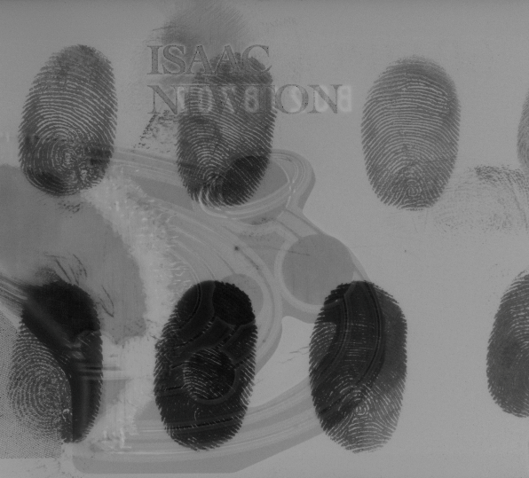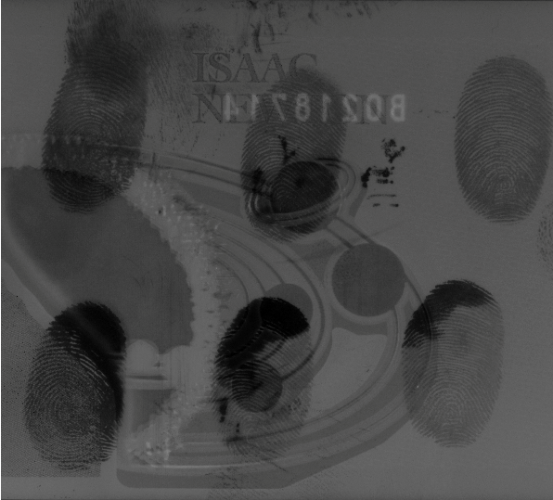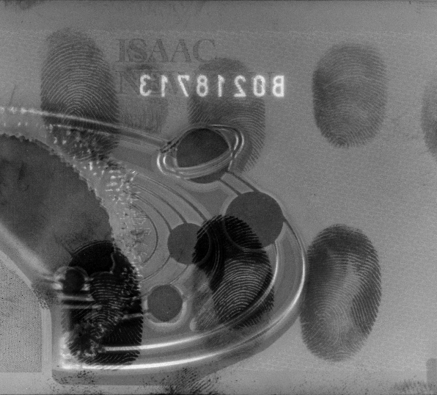

**A**

**B**

**C**

**D**

**E**

**F**

However, as the deposition thickness layer increased it became easier to observe the location of marks, as the copper layer became more opaque, even if ridge detail could not be discerned under visual examination (Figures 2 & 3).

Figure 3: Copper deposition thickness of; (A) 2.5nm as viewed under 80W Halogen light source (B&W), (B) 2.5nm viewed under 80W Halogen light source with 780nm long-pass filter, image inverted, (C) 2.5nm as viewed under 150W Halogen light source (B&W), (D) 2.5nm viewed under 150W Halogen light source with 780nm long-pass filter, image inverted. (A&B) imaged using Crime-lite Imager, (C&D) imaged using DCS-5 & Nikon D810 camera.

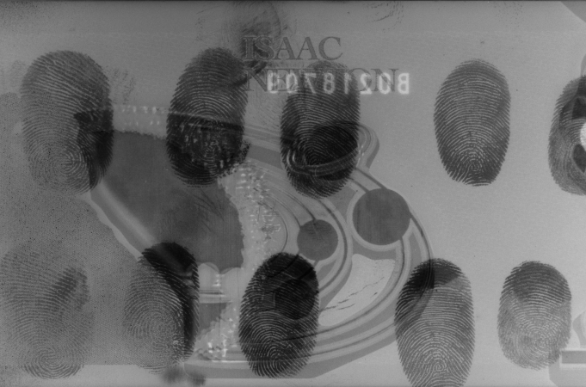

**A**

**B**

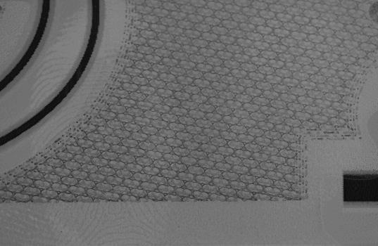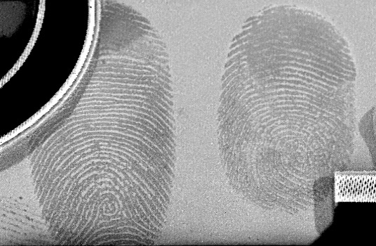

**C**

**D**

After the visual inspection, the notes had a gelatin lifter applied to their surface, once removed; the gel was sprayed with rubeanic acid, which resulted in the fingermark ridges containing copper deposits becoming visible in the form of polymeric copper rubeanate (Scheme 2).





$$C{u^{2}}^{+} +$$

$$EtOH$$

Scheme 2: The formation of Copper Rubeanate

The copper rubeanate presents as dark green, making visualisation on the white gelatin lifter easier with the naked eye (Figure 4).

Figure 4: (A) Gelatin lift from polymer note after application for 1 minute, (B) Gelatin lift from polymer note after application for 2 minutes

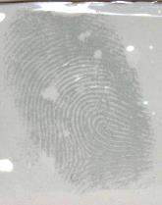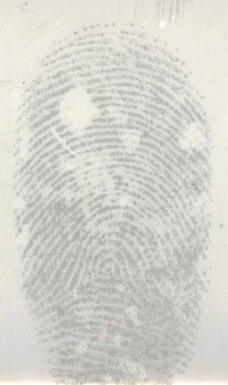

**A**

**B**

# Discussion and Conclusions

The main objective of the study was to evaluate whether copper could be utilised to develop fingermarks on a polymer banknote and subsequent imaging for clarity, with the additional aim to lift with a forensic gelatin lifter to be treated with rubeanic acid. The decision to utilise gel lifts treated with rubeanic acid was twofold; recent work conducted at Loughborough University has been very successful, and the ability to lift and treat non-invasively [22]. Using the filament temperature dial on the VMD, it was possible to control the amount of copper deposited on the polymer note surface. The amount deposited was checked using the Intellimetrics IL150 quartz crystal growth rate monitor. The starting thickness was 0.2nm, increasing in 0.2 - 0.3nm increments to 2.1nm at which point the increments increased to 0.5nm to a maximum thickness of 3.0nm per test sample.

The tests undertaken highlighted that while the deposition thickness of the copper impacted visual fingermark observation on the substrate surface, there was marginal difference when viewed under reflected infrared conditions. The thicker the copper deposition layer, the better the contrast between the ridge detail and the substrate to an extent. Samples with 3.0nm of copper deposited upon their surface began to exhibit overdevelopment which presented as the ridges leaching into each other. This technique is of particular use when developing marks on a substrate with a ‘busy’ and patterned background.

Fingermarks visualised by infrared imaging presented as negative marks, whereas the gel lifted marks presented as positive. We theorise this is due to the way the elemental copper interacts with the fingermark residues and the underlying substrate, *vide infra*.

When copper is deposited over the surface it begins to form nuclei, the morphology of which is largely dependent on the nature of the surface on which they are being deposited on to. Areas where the substrate is clean and free from contaminants form small tightly packed nuclei. However, areas that have fatty residues from latent fingermarks, act differently. The copper diffuses into the fat and forms larger nuclei that are more disperse (Figure 5), in a similar way as it does with gold [24, 25].

Fingermark

Large, disperse copper nuclei migrated into fingermark

Small, densely packed copper nuclei

Substrate

Figure 5: Schematic diagram of copper deposition on polymer banknote surface

As the thickness of the copper layer increases, the areas where the nuclei are more densely packed reflect the infrared radiation. Conversely, the areas where the copper nuclei have moved into the fingermark residue, and are more disperse, are more transmissive and thus reflect the IR radiation *via* the original substrate beneath. These differences in the infrared radiation absorption and reflection mechanisms provide a clear, enhanced contrast between the fingermark region and the substrate itself.

The application of a white gelatin lifter to the copper VMD treated substrate (Figure 6) for up to two minutes allows for the selective transfer of copper from the fingermark region. We surmise that this is due to the fact the small tightly packed nuclei are adhering to the substrate surface more strongly and resist removal better than the large nuclei present within the fingermark residues.

Substrate

White gelatin lifter pressed down onto the surface

Figure 6: Schematic diagram of application of gelatin lifter to VMD treated banknote surface

Since the fingermark residue is situated upon the polymer note surface, it is removed easily by the gelatin lifter (Figure 7).

Substrate

Copper nuclei transferred onto gelatin lift in fingermark residue

Copper nuclei remaining on original substrate

Figure 7: Schematic diagram of copper infused fingermark residue removal from polymer banknote *via* gelatin lifter

Once sprayed with the rubeanic acid solution, the copper contained within the fingermark residue becomes visible almost immediately (Figure 8). The background of the gelatin lifter remains unstained, provided the gel is not in contact with the copper VMD treated sample for too long. If the gel is left in contact with the substrate for an excessive amount of time, background staining can be observed after treatment with rubeanic acid and may interfere with the developed ridge detail, thereby hindering visualisation.

Fingermarks containing copper nuclei enhanced with rubeanic acid

Figure 8: Schematic diagram of copper containing fingermarks treated with rubeanic acid

This technique has the potential to be beneficial on many fronts; by depositing very thin films of copper and contrast observing using reflected IR the risk of overdevelopment when using the VMD is reduced. The use of a thin inconspicuous film coating means that treated notes may potentially re-enter into circulation rather than having to be destroyed, thus contributing to the longevity of the note and reducing overall costs associated with replacing unusable notes. It is a one-step deposition, as opposed to the traditional gold/zinc two-step process, thereby reducing treatment times.

Once lifted and treated, the visible fingermarks on the gelatin lifters show little difference in intensity regardless of the thickness deposition of the copper. This again ties in with reducing risks of overdevelopment and reintroducing notes back in to circulation. This is beneficial to laboratories which may possess VMD capabilities but no IR imaging facility, as they can still utilise the technique and by adding an additional step can visualise the fingermarks *via* rubeanic acid in lieu of IR photography. However, infrared imaging would still be recommended.

It was observed that the substrate surface shows less reflection with thicker layers of copper. As the deposition thickness increases the background substrate absorbs more of the IR illumination giving the background a darker appearance. Conversely, the areas with fingermark residues which have less copper within them allows the underlying substrate to reflect IR back to the camera, thereby increasing the contrast between the two.

This new method of visualising VMD treated polymer banknotes could be easily facilitated in laboratories which already utilise IR imaging equipment and possess a VMD system. These initial trials have shown that this technique can successfully enhance fresh fingermarks on polymer banknotes and has the potential to be as effective on other semi- and non-porous substrates.

Further work would extend to investigations using a larger sample group and would incorporate aging/weathering and handled polymer banknote studies to determine process sensitivity and the effect of typical wear on the development process. In addition, comparison studies between copper and the traditional gold/zinc process would be explored on polymer banknotes as well as other polymer substrates in general.

# References

1. J. Flynn, M. Stoilovic, and C. Lennard, *Detection and enhancement of latent fingerprints on polymer banknotes: a preliminary study.* Journal of Forensic Identification, 1999. **49**(6): p. 594.

2. N. Jones, M. Kelly, M. Stoilovic, C. Lennard, C. Roux, *The development of latent fingerprints on polymer banknotes.* Journal of Forensic Identification, 2003. **53**(1): p. 50.

3. D. Wilkinson, R. Lam, T. Tse, B. Pynn, *Recommended Protocols for Fingerprint Detection on Canadian Polymer Banknotes-Part I: Chemical Development.* J. Forensic Ident, 2014. **64**(4).

4. R. Lam, *Recommended Protocols for Fingerprint Detection on Canadian Polymer Banknotes--Part II: Photography, Lighting, and Digital Enhancement Techniques.* Journal of Forensic Identification, 2014. **64**(4): p. 402.

5. H.L. Bandey, *Fingermark Visualisation Manual.* Home Office Centre for Applied Science and Technology (CAST): Sandridge, UK, 2014.

6. R.S.P. King, P.M. Hallett, and D. Foster, *Seeing into the infrared: A novel IR fluorescent fingerprint powder.* Forensic Science International, 2015. **249**(0): p. e21-e26.

7. R.S.P. King, P.M. Hallett, and D. Foster, *NIR−NIR fluorescence: A new genre of fingermark visualisation techniques.* Forensic Science International, 2016. **262**: p. e28-e33.

8. S. Chadwick, P. Maynard, P. Kirkbride, C. Lennard, A. McDonagh, X. Spindler, C. Roux, *Styryl dye coated metal oxide powders for the detection of latent fingermarks on non-porous surfaces.* Forensic Science International, 2012. **219**(1–3): p. 208-214.

9. R. Ma, E. Bullock, P. Maynard, B. Reedy, R. Shimmon, C. Lennard, C. Roux, A. McDonagh, *Fingermark detection on non-porous and semi-porous surfaces using NaYF4:Er,Yb up-converter particles.* Forensic Science International, 2011. **207**(1–3): p. 145-149.

10. M. Tahtouh, J.R. Kalman, C. Roux, C. Lennard, B.J. Reedy, *The detection and enhancement of latent fingermarks using infrared chemical imaging.* Journal of Forensic Sciences, 2005. **50**(1): p. 64-72.

11. S.M. Bleay, V.G. Sears, H.L. Bandey, A.P. Gibson, V.J. Bowman, R. Downham, L. Fitzgerald, T. Ciuksza, J. Ramadani, C. Selway, *Fingerprint Source Book*. Home Office Centre for Applied Science and Technology (CAST). 2012. <https://www.gov.uk/government/publications/fingerprint-source-book> [Accessed 26th January 2016]

12. J. Fraser, K. Sturrock, P. Deacon, S.M. Bleay, D.H. Brenmer, *Visualisation of fingermarks and grab impressions on fabrics. Part 1: Gold/zinc vacuum metal deposition.* Forensic Science International, 2011. **208**(1–3): p. 74-78.

13. S. Knighting, J. Fraser, K. Sturrock, P. Deacon, S.M. Bleay, D.H. Brenmer, *Visualisation of fingermarks and grab impressions on dark fabrics using silver vacuum metal deposition.* Science & Justice, 2013. **53**(3): p. 309-314.

14. J. Fraser, P. Deacon, S.M. Bleay, D.H. Brenmer, *A comparison of the use of vacuum metal deposition versus cyanoacrylate fuming for visualisation of fingermarks and grab impressions on fabrics.* Science & Justice, 2014. **54**(2): p. 133-140.

15. N. Jones, D. Mansour, M. Stoilovic, C. Lennard, C. Roux, *The influence of polymer type, print donor and age on the quality of fingerprints developed on plastic substrates using vacuum metal deposition.* Forensic Science International, 2001. **124**(2–3): p. 167-177.

16. N. Jones, M. Stoilovic, C. Lennard, C. Roux, *Vacuum metal deposition: developing latent fingerprints on polyethylene substrates after the deposition of excess gold.* Forensic Science International, 2001. **123**(1): p. 5-12.

17. N. Jones, M. Stoilovic, C. Lennard, C. Roux, *Vacuum metal deposition: factors affecting normal and reverse development of latent fingerprints on polyethylene substrates.* Forensic Science International, 2001. **115**(1–2): p. 73-88.

18. R. Downham, S. Mehmet, and V. Sears, *A Pseudo-Operational Investigation into the Development of Latent Fingerprints on Flexible Plastic Packaging Films.* Journal of Forensic Identification, 2012. **62**(6).

19. R. Downham, S. Kelly, and V.G. Sears, *Feasibility Studies for Fingermark.* Journal of Forensic identification, 2015. **65**(2): p. 139.

20. C. Fairley, S.M. Bleay, V.G. Sears, N. NicDaeid , *A comparison of multi-metal deposition processes utilising gold nanoparticles and an evaluation of their application to ‘low yield’ surfaces for finger mark development.* Forensic Science International, 2012. **217**(1–3): p. 5-18.

21. B.J. Jones, R. Downham, and V.G. Sears, *Nanoscale Analysis of the Interaction Between Cyanoacrylate and Vacuum Metal Deposition in the Development of Latent Fingermarks on Low-Density Polyethylene*.* Journal of Forensic Sciences, 2012. **57**(1): p. 196-200.

22. S.M. Bleay, L.E. Grove, P.F. Kelly, R.S.P. King, K. Mayse, B.C. Shah, R. Wilson, *Non-invasive detection and chemical mapping of trace metal residues on the skin.* RSC Advances, 2014. **4**(37): p. 19525-19528.

23. D. Philipson and S. Bleay, *Alternative metal processes for vacuum metal deposition.* Journal of Forensic Identification, 2007. **57**(2): p. 252.

24. P.T. Stroud, *Some Comments on Finger Print Development by Vacuum Deposition*, in *AWRE Report Nuclear Research Note 5/71*1971, Atomic Weapons Research Establishment: Aldermaston.

25. P.T. Stroud, *Further Comments on Finger Print Development by Vacuum Deposition*, in *AWRE Report Nuclear Research Note 10/72*1972, Atomic Weapons Research Establishment: Aldermaston.

26. M. Coombes, D. Bradley, L. Grove, S. Thomas, C. Young, *The extent of crime and anti-social behaviour facing designated heritage assets.* 2012. Report (English Heritage).

27. L. Grove and S. Thomas, *Heritage Crime: Progress, Prospects and Prevention*. 2014: Palgrave Macmillan.

1. Heritage crime has been defined as any offence which harms the value of heritage assets and their settings to this and future generations [26]. More information on heritage crime can be found in “Heritage Crime: Progress, Prospects and Prevention” by L. Grove and S. Thomas [27]