Supermarket energy use and greenhouse gas emissions – technology options review

Evans, J.A.^{(*)}, Maidment, G.G.^{(**)}, Brown, T.^{(*)}, Hammond, E. ^{(*)} and Foster, A.M.^{(*)}

Faculty of Engineering, Science and the Built Environment, London South Bank University

^{(*)} Langford, Bristol, BS40 5DU, UK
Email: j.a.evans@lsbu.ac.uk

^{(**)} 103 Borough Road, SE1 OAA, UK

ABSTRACT
Refrigeration is the largest load in a supermarket, accounting for 50-60% of the electricity consumption. Supermarket refrigeration systems also generate greenhouse gas emissions directly, through refrigerant leakage. Technologies that can save direct and indirect emissions in a typical baseline UK supermarket were examined and the application timescales and cost per tonne of CO₂ abated were calculated using a model of the supermarket. Using the model, the technologies that could save the most carbon were identified. The work examined 81 different technologies and their potential to save direct and indirect emissions in supermarkets. Results from the work have shown that most technologies either save CO_{2e} emissions from reduction in energy or from reduction in refrigerant leakage, only a few technologies demonstrated savings from both.

INTRODUCTION
The food chain is responsible for greenhouse gas (GHG) emissions through direct (refrigerant CO_{2e} emissions) and indirect (CO_{2e} emissions from electricity generation) effects. The impact of direct emissions compared to the effect of indirect emission can vary depending on country. In countries where there is a high level of renewable energy or nuclear energy, the emissions associated with energy generation are low. Therefore the relative effect of refrigerant leakage is high. This can influence policy and actions to reduce emissions country by country. Overall the cold chain is believed to be responsible for approximately 2.4% of GHG emissions (Garnett, 2007). In the developed world, emissions post farm gate are thought to be responsible for approximately half the total food chain emissions (Garnett, 2010).
Detailed estimates of what proportion of indirect CO_{2e} emissions are related to refrigeration processes are unclear and often contradictory. Efforts to determine how much energy is used in each sector of the food industry for refrigeration are often hampered by the apparent lack of measured data and limited availability of process throughput data (Swain, 2006). The exception to this is retail refrigeration, where a greater level of data is available due to higher levels of energy monitoring. Overall figures would indicate that in the food cold chain (excluding domestic refrigeration) approximately 50% of the energy is associated with retail and catering refrigeration and 50% with chilling, freezing and storage (Market Transformation Programme, 2006).
Information on direct emissions in the food cold chain is mainly available from supermarkets. Data covering more than one sector of the food cold chain have been reported by several authors (Heap, 2001; RAC, 2005; MTP, 2008). Heap (2001) estimated that 56% of all food cold chain CO_{2e} emissions emanated from supermarkets and that 28% of CO_{2e} emissions from supermarkets were from refrigerant loss. RAC (2005) estimated that supermarket systems had losses of 30% of refrigerant per year. The MTP (2008) combined figures from several sources and suggested that refrigerant losses from supermarkets ranged from 9-25%. Due to pressure from regulations and environmental lobbying groups, the leakage of refrigerant from supermarkets has reduced in recent years. In addition many supermarkets have begun moving to lower Global Warming Potential (GWP) refrigerants and so these figures may be higher than achieved currently.
There are many technologies that can be applied by supermarkets to reduce direct and indirect emissions. This paper examines the technologies available and applies them to a typical medium sized UK supermarket to determine which technologies have the best potential to save carbon emissions. The work follows on from previous work to develop a refrigeration road map for supermarkets (Carbon Trust, 2012). In this work the refrigeration technologies that have potential to reduce carbon emissions have been updated and examined in greater detail and a level of confidence applied to the results.

MATERIALS AND METHODS

Baseline store.
The baseline store was located in the UK and was an intermediate age, medium sized store (floor area of 6290 m²). The store contained low temperature (LT) and medium temperature (MT) cabinets fed by LT and MT packs. The LT cabinets were cooled by 2 packs. The MT cabinets were cooled by 4 packs. The refrigerant used for both MT and LT packs was R404A. The estimated energy used by each cabinet item is shown in Table 1.
It should be noted that all savings were calculated for each individual technology and that there may be interactions between technologies in cases where more than one option could be applied. Therefore, it should not be assumed that the CO₂e savings shown for each technology would be cumulative.
Table 1. Energy used by cabinets in the baseline store, split into component items.
Item | kW
Compressors | 67.74
Condenser fans | 10.33
Evaporator fans | 5.17
Defrost heaters | 3.97
Trim heaters | 11.91
Lights | 3.93
Total | 103.04

Sources of information for the technologies.
Information was obtained from a range of sources, including academic publications, sales information and consultation with industry. This information was used to identify the carbon emissions savings, relative cost and limits to commercial maturity of the technologies. For the purposes of this work the term ‘technology’ has been used to cover both technical options and non-technological behavioural changes such as training and maintenance improvements.

Factors assessed.
Each technology was evaluated for the annual CO_{2e} emissions savings that could be achieved when the technology was applied to the baseline supermarket. The analysis undertaken, considered the potential to reduce the emissions from the refrigeration system and cabinets, and did not include, walk in cold stores, lighting or heating, ventilation and air conditioning (HVAC), apart from where these technologies impacted on, or were used by, the refrigeration system or cabinets. In addition, the boundary for all calculations was restricted to the supermarket refrigeration system (including all the refrigerated cabinets), and did not include any emissions saved or generated outside of this envelope, e.g. HVAC.
The work examined 81 different technologies and their potential to save direct and indirect CO₂e emissions.

Calculation of indirect emissions.
The yearly indirect CO₂e emissions of the baseline store refrigeration system were calculated by multiplying the yearly energy consumption of the refrigeration system by a CO_{2e} conversion factor of 0.46219 (Defra, 2015). In all payback calculations, a cost for energy of £0.12 (GBP) per kilowatt hours (kW.h) was used (based on information on energy cost from the baseline supermarket). To allow the effect of technologies to direct emissions to be evaluated, the total energy consumption of the baseline store was broken down into components parts, and the effect of the technologies evaluated on each of these component parts.
The refrigeration system was first divided based on cabinet type categories (cat) (in brackets the EN2953 cabinet classification) as shown below:
- Remote chilled multi-deck (VC2)
- Remote chilled roll-in (VC3)
- Remote frozen HGD/well (VF1)
- Remote FGD (VF4)
- Integral chilled (VC2+HC1,4)
- Integral FGD (VF2)
- Professional (catering) cabinets
Each of the categories was then broken down into the individual refrigeration components (com) as below:
- Compressors
- Condenser fans
- Evaporator fans
- Defrost heaters
- Trim heaters
- Lights
The total energy consumption of the baseline store was:
$$P=\sum_{cat=1}^{7}{{\left(\sum_{com=1}^{6}{P_{com}}\right)}_{cat}}$$
Where:
P = total power of the baseline store
$\left(\sum_{com=1}^{6}{P_{com}}\right)$ = total power for each cabinet category
P_{com} = power of each of the components
cat (subscript) = component categories
The component powers are defined in the following sections.
Remote cabinets
Compressors
The compressor power of each category of remote cabinet was calculated by taking the duty of the refrigerated cabinets in that category and dividing by the COP of the refrigeration compressor packs which supplied those cabinets.
The duty of the cabinets was provided for EN23953 climate class 3 conditions (25°C, 60% RH). As the store operated at a lower temperature and humidity, the duty for each cabinet needed to be reduced to reflect real store conditions. Based on work by Mousset and Libsig (2011) the duty for each cabinet was reduced by 40% to reflect store conditions.
The design COP of the LT and MT refrigeration systems were based on the COP for each refrigeration pack from manufacturers’ data at the store design conditions (condensing temperature of approximately 40ºC). As the store design conditions were different from the real conditions (due to change in ambient temperature and therefore condensing temperature) the COPs were adjusted by adjusting the design COP by a coefficient. This coefficient was the ratio of the Carnot COP at design condensing temperature to real condensing temperature. The real condensing temperature was assumed to be the mean yearly ambient temperature in Birmingham plus 10ºC. The mean condensing temperature (23ºC) took into account the current refrigeration systems operation where condensing temperature was not allowed to reduce below 22°C.

Condenser fans
The condenser fan motor power was 3% of the heat rejected by the condenser. This was taken from one set of pack data and applied to all other packs where data was not supplied.
All data for power used by the evaporator fans, defrost heaters, trim heaters and lighting were supplied by the supermarket refrigeration contractors.
Evaporator fans
The evaporator fan motors were 60 W per 2.5 m of frozen cabinet and 38 W per 2.5 m of chilled cabinet.
Defrost heaters
All chilled cabinets in the baseline store operated using passive (off-cycle) defrosts. Frozen cabinets defrosted for 35 minutes every 12 hours. The power for defrosts per 2.5 m section of cabinet was 2.21 kW for FGD cabinets and 3.10 kW for HGD/well cabinets.
Trim heaters
Chilled cabinets in the baseline store did not have trim heaters. The frozen cabinets had 805 W per 2.5 m section of cabinet and the heaters operated for 40% of the time based on a humidistat control.
Lights
Cabinet lighting in the LT cabinets was on 100% of the time . The lighting in the MT cabinets was on for 17 hours of the day. When operating the cabinet lighting consumed 44 W per 2.5 m cabinet section.Integral cabinets
The total energy consumption of each of the integral cabinets was either taken from manufacturers specifications or estimated based on the category and size of the cabinet.
The proportion of power for each refrigeration component for the chilled VC2 and frozen FGD cabinets was considered the same as for the remote cabinets of the same category. The professional cabinets were all considered to be chilled. The proportion of power assigned to each component came from test data from the authors.
Validation
The calculated total power of the refrigeration system for the store was compared with the total power of the 9 refrigeration electricity meters in the store. The total estimated power was 8.7% lower than the average electricity meter power over a year. It should be noted that it was not possible to be entirely sure what equipment was connected to each of the electricity meters, and therefore the refrigeration energy from the meters can only be considered an estimate.

Calculation of direct emissions.
The total refrigerant charge for the supermarket cabinets was 889 kg and was divided as follows:
R404A (remote cabinets) 867 kg (GWP=4,200)
R404A (integral cabinets) 18 kg (GWP=4,200)
R134a (integral cabinets) 3 kg (GWP=1,360)
R600a (integral cabinets) 1 kg (GWP=20)
GWP was for 100 year (UNEP, 2014)
The refrigeration systems were defined as:
- LT remote packs
- MT remote packs
- LT integral cabinets
- MT integral cabinets
The direct emissions were obtained by multiplying the mass of refrigerant in the system by the GWP of the refrigerant and the % leakage rate per year. The % leakage rates of the remote refrigeration plant (MT and LT) were considered as 6.1% per year. This was calculated by taking the mass of refrigerant charged (from the F-gas records) over a 20 month period and adjusting to a 12 month period and dividing this by the total charge of refrigerant in the store.
For the integral cabinets (MT and LT) the leakage rate was assumed to be 1.5% based on data from Defra (2011).
The total direct emissions of the baseline store, D was
$$D=\sum_{s=1}^{4}{D_{s}}$$
Where:
D_{s} = the direct emissions of each of the systems.

Estimate benefits of technologies
Each of the technologies was assessed for its potential to save direct and indirect emissions. Indirect savings were attributed to each cabinet component for each cabinet category. Savings in direct emissions were attributed to each refrigeration system (remote LT, MT and integral LT, MT).
From this, a set of coefficients was created which would be multiplied by the emissions. A coefficient of 1 meant no savings and a coefficient of 0 meant 100% savings. For the indirect emissions the total power of the baseline store with the technology applied, P_{T}, was defined by:
$$P_{T}=\sum_{cat=1}^{7}{{\left(\sum_{com=1}^{6}{P_{com}}C_{I}\right)}_{cat}}$$
Where:
C_{I} = the indirect emissions coefficient.
For the direct emissions the total direct emissions D_{T}, of the baseline store with the technology was defined by:
$$D_{T}=\sum_{s=1}^{4}{D_{s}}C_{D}$$
Where:
C_{D} was the direct emissions coefficient.

Presentation of CO_{2e} savings.
Where potential savings were varied, minimum and maximum savings for each technology were calculated. The technologies were presented in graphs showing the CO_{2e} saving potential. In addition the technologies were presented in ‘bubble charts’ showing the CO_{2e} saving potential related to the implementation timescale and payback period. Those technologies having the most CO_{2e} savings potential, the shortest payback time and the shortest implementation period are those that are most likely to be of most interest initially to supermarkets (the largest bubbles closest to the zero intercept of the graph).

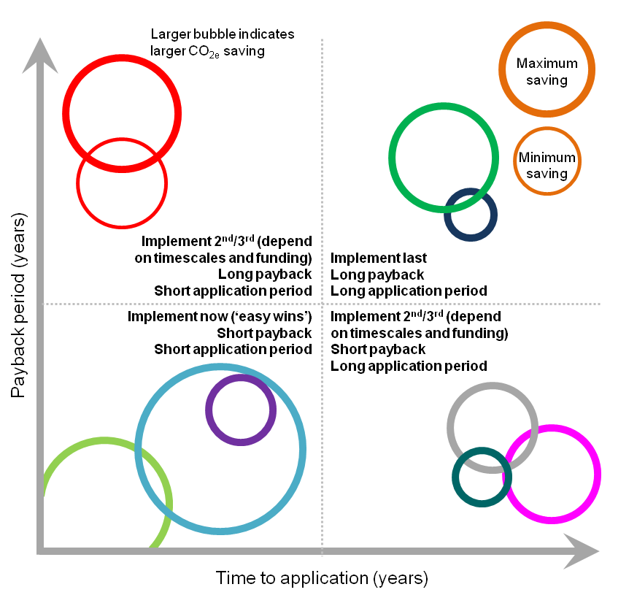
Figure 1. Bubble chart schematic.

RESULTS
A number of technologies were considered but were not included in the graphs due to either the baseline supermarket already having applied the technologies or there being insufficient evidence to be able to quantify the savings that the technologies could achieve (Table 2).
Table 2. Technologies excluded from analysis.
Already applied in baseline supermarket | Insufficient evidence
Anti-sweat heaters  DC (EC) evaporator fans  Distributed system  Lighting - cabinets (LED)  Pipe insulation  Minimising pipe pressure drops | Absorption  Adsorption  Improved cabinet loading  Improved cabinet location  Improved cabinet temperature control  Diagonal compact fans  Dual port TEV  Dynamic demand  Electronic expansion valves  Enhanced internal heat transfer (micro-fins)  Heat exchanger rifling  High-efficiency compressors  Polygeneration  Radiant reflectors  Training and maintenance  Ultrasonic defrosting of evaporators

Cabinet technologies.
Cabinet technologies were divided into those that could be applied to the current cabinets and those that could only be applied to new cabinets. Figure 2 shows results for current cabinets and Figure 3 shows the results for new cabinets. In all cases the additional cost to apply the technology was included in the payback calculations. For example for cabinet selection it was assumed that only the additional cost to purchase higher efficiency cabinets was taken into account as it was assumed that in a retrofit or new supermarket, cabinets would need to be purchased irrespective of their performance.

Refrigeration system technologies.
Refrigeration system technologies were divided into those that could be applied to the current system and those that could only be applied to a new system. Figure 4 shows the results for the current refrigeration system and Figure 5 shows the results for a new refrigeration system.

Other technologies.
Other technologies assessed that could save carbon emissions in the baseline supermarket are shown in Figure 6.

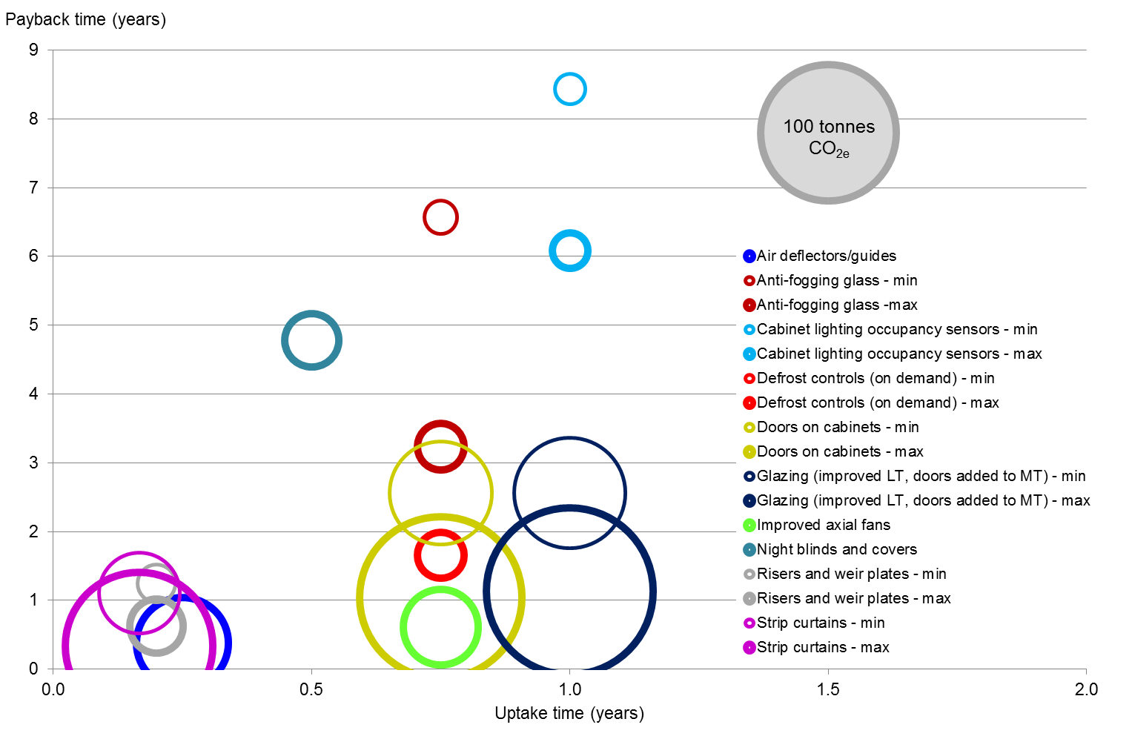

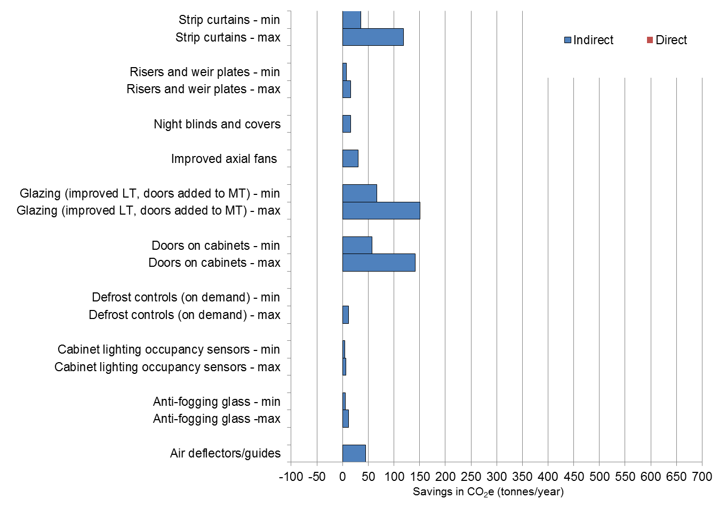
Figure 2. Technologies that could be applied to current cabinets.

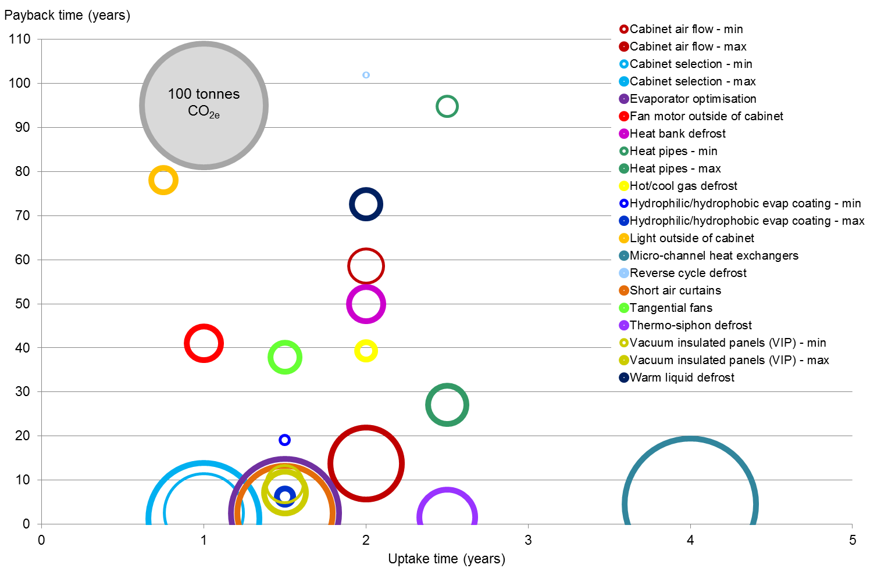

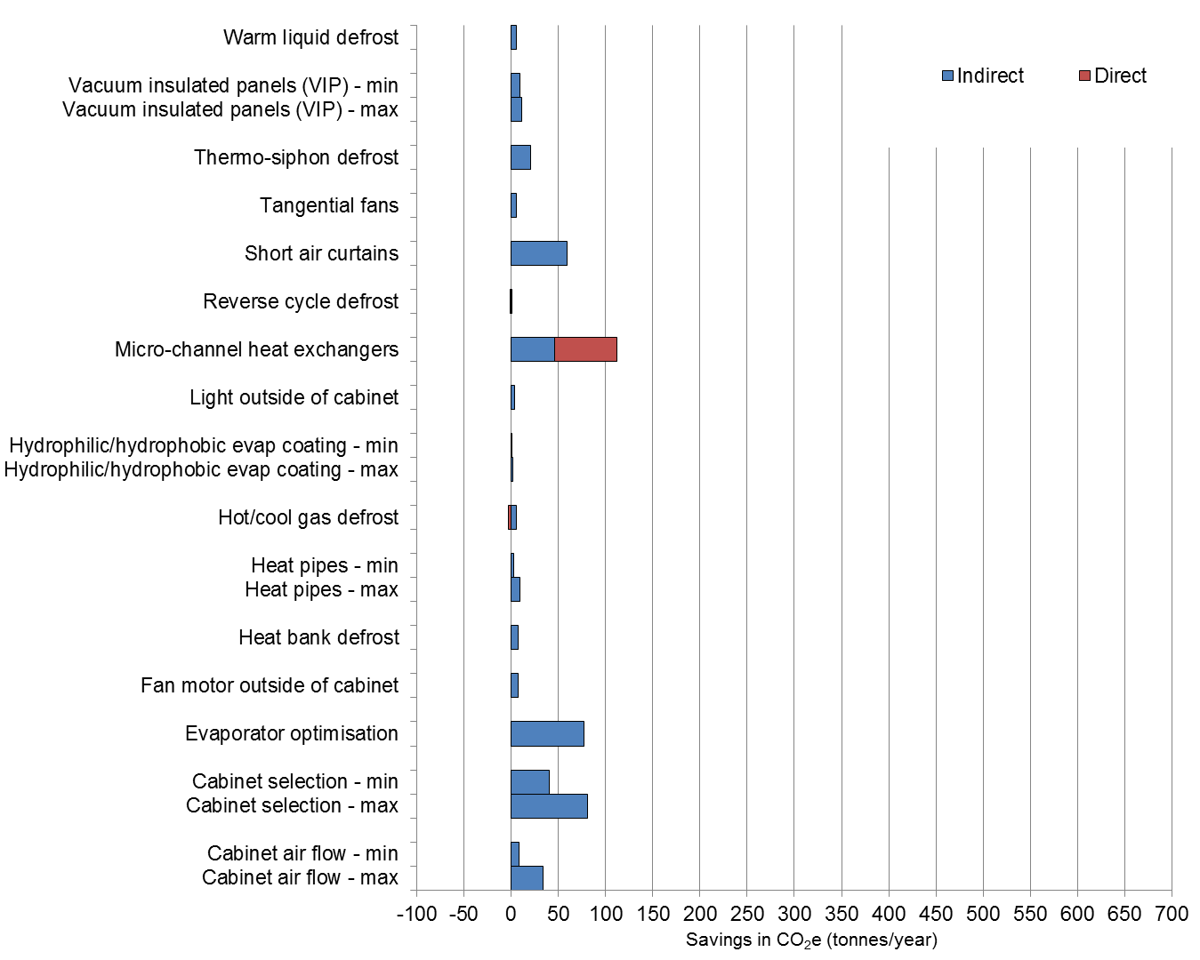
Figure 3. Technologies that could be applied to new cabinets.

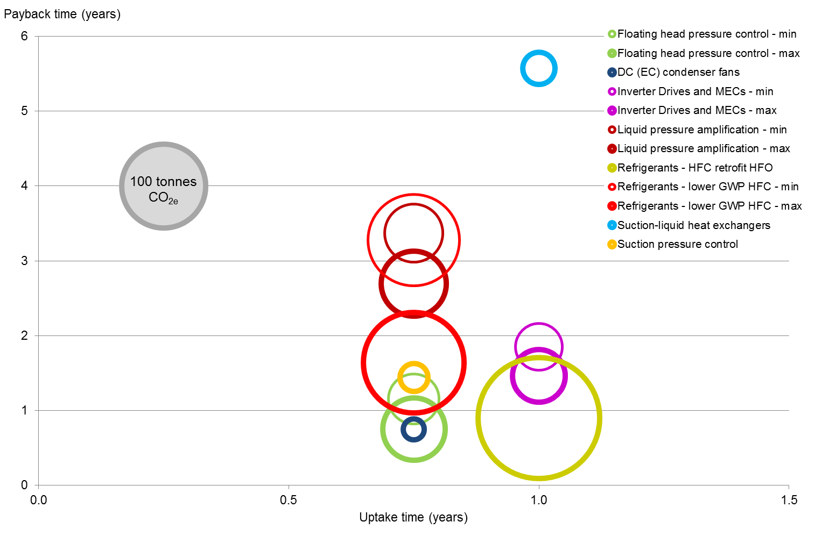

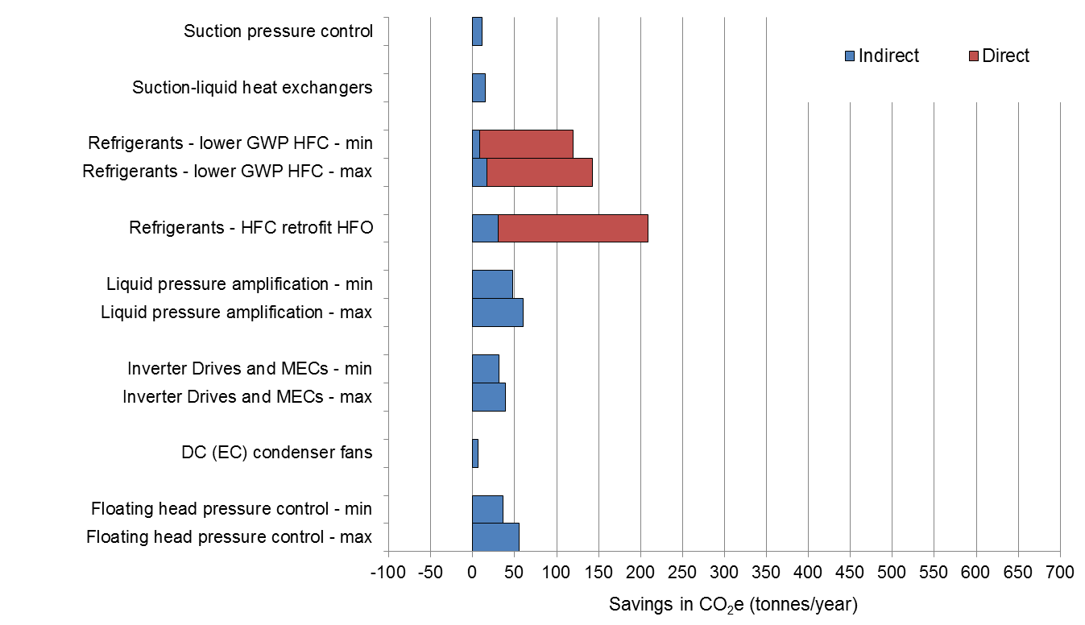
Figure 4. Technologies that could be applied to current refrigeration systems.

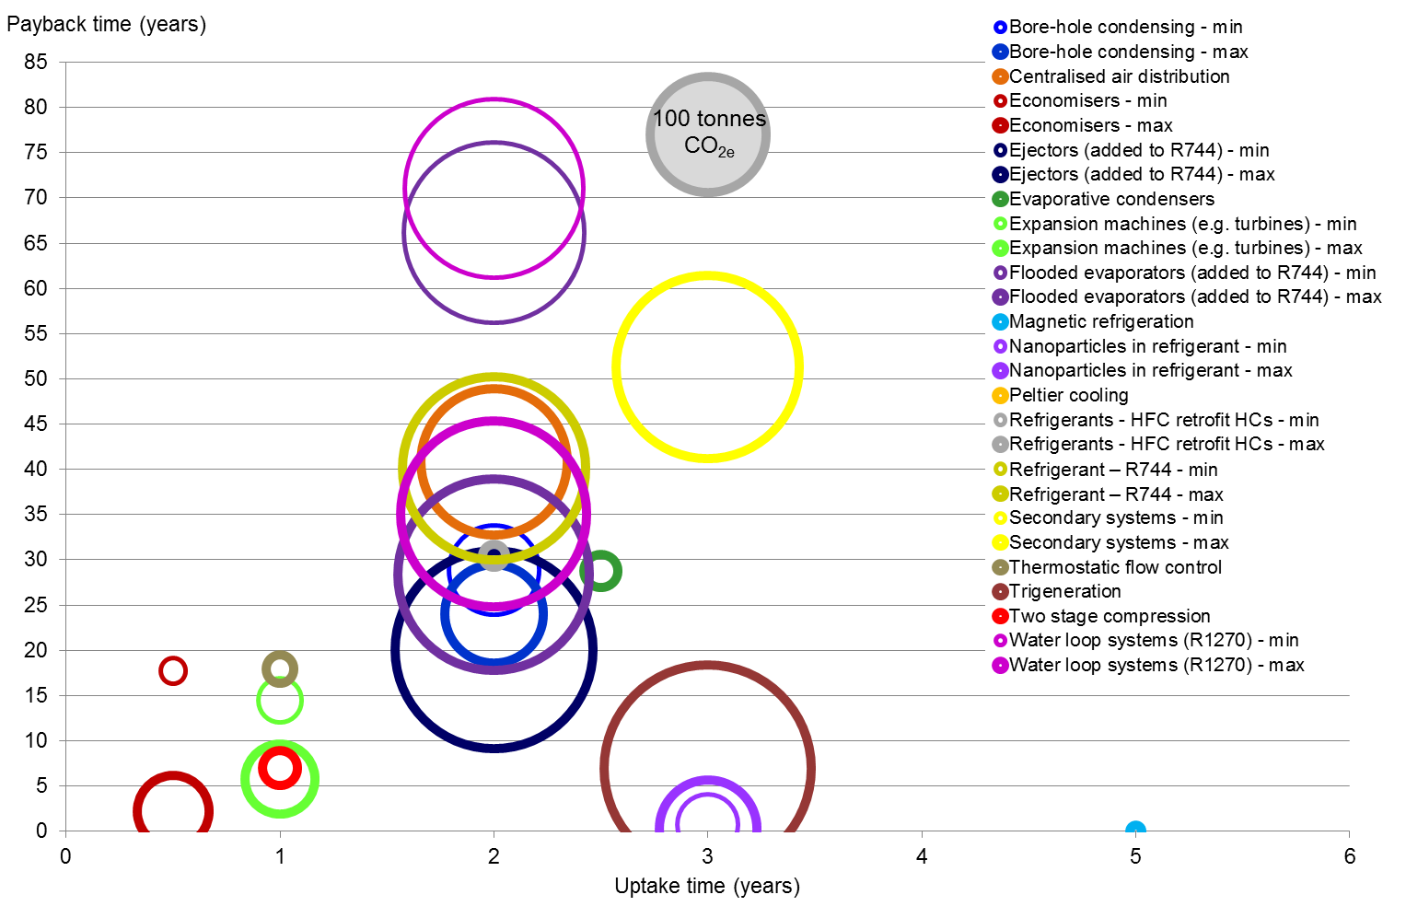
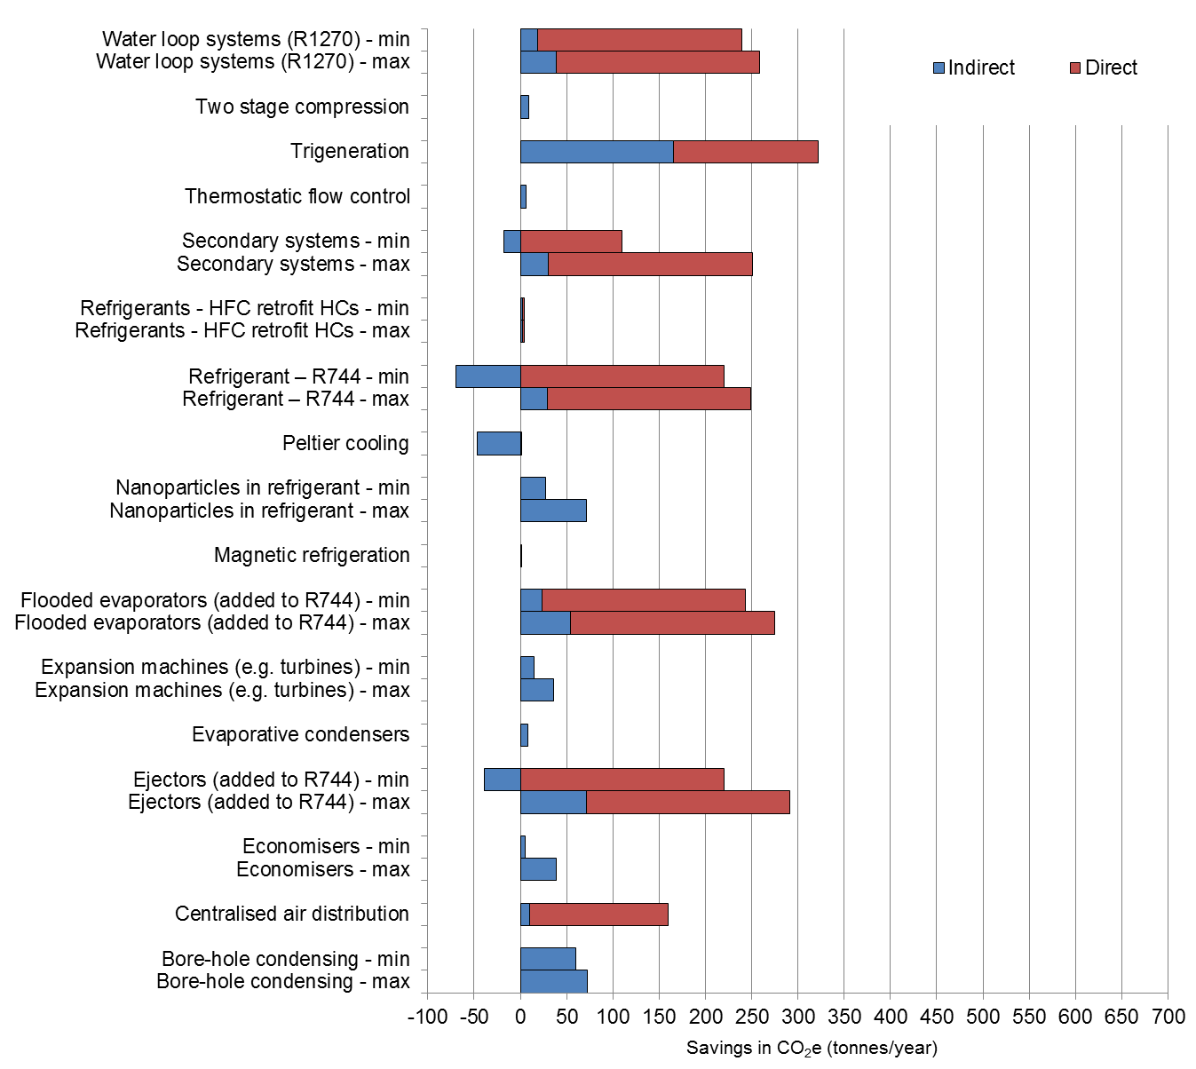
Figure 5. Technologies that could be applied to new refrigeration systems.
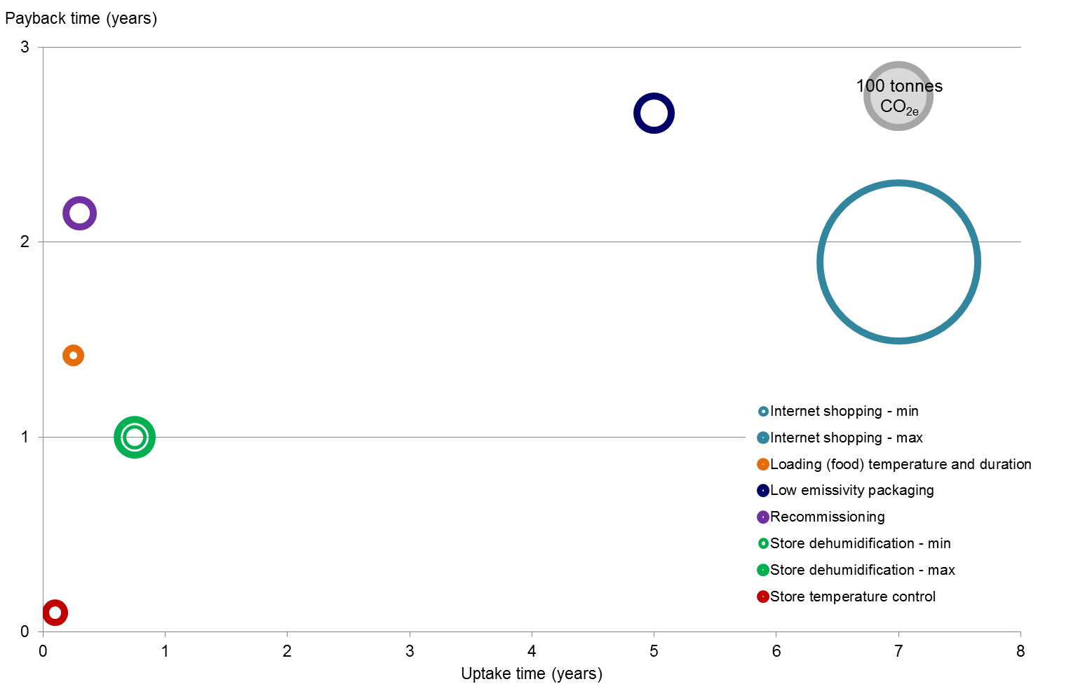

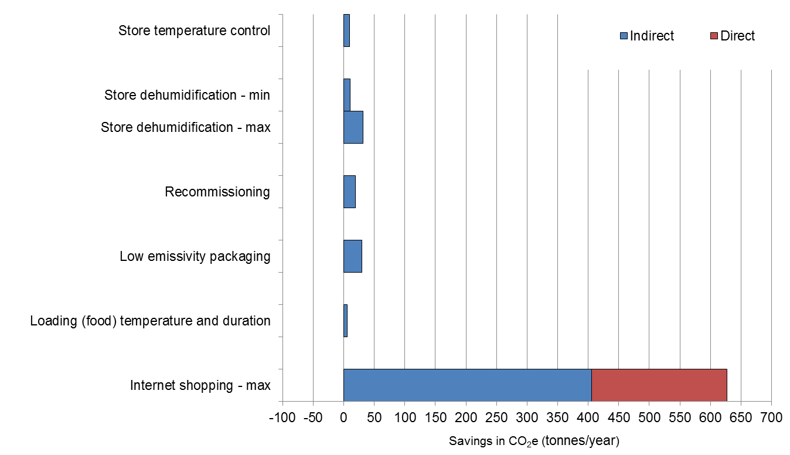
Figure 6. Other technologies assessed.

DISCUSSION
The assessment of carbon savings in the baseline store demonstrated that considerable savings (over 300 tonnes CO_{2e} p.a.) could be achieved with a single technology. Most of the carbon savings associated with cabinets was related to indirect emissions. All retrofit refrigeration system technologies had some indirect savings with some refrigerant technologies adding direct savings. With new refrigeration systems the direct carbon savings tended to be greater, although almost all technologies demonstrated indirect savings.
For retrofitting to current cabinets the greatest savings could be achieved by fitting doors (between 57.5 and 141.9 tonnes CO_{2e}/year which could be increased to between 66.7 and 151.2 CO_{2e}/year if improved glazing was also fitted to these doors and the freezer cabinets). Paybacks of between 1 and 2.6 years with relatively short uptake times were possible. Strip curtains were also an option to reduce emissions but were unlikely to be acceptable to the supermarket. Air deflectors were estimated to save 45.3 CO_{2e}/year and so would be a good option if doors were not acceptable to the supermarket. Paybacks and uptake time for deflectors were shorter than for the addition of doors (less than 1 year payback and less than 6 months application time).
For new cabinets the best option was to select the most energy efficient cabinets available currently. The calculations were based on paying £250 more per cabinet for a better performing model which included better currently available components integrated through robust testing and development. If looking for further improvements, evaporator optimisation and new evaporator technologies or the use of short air curtains were attractive options.
The greatest savings in emissions for the current refrigeration plant were related to alternative refrigerants. Using lower GWP HFC refrigerants, it is possible to save up to 142.9 CO_{2e}/year and the use of HFOs 208.4 CO_{2e}/year. Application times were less than 1 year and paybacks between 1 and 2 years. A large proportion of these savings were from reductions in direct emissions. For new refrigeration systems the use of trigeneration and water loop systems looked the most attractive options to save emissions. The use of R744 with or without ejectors and the use of secondary systems also had high emissions savings.
It should be noted that the savings for each of the technologies cannot be added together. For example if doors were put on cabinets there would be a reduction in compressor energy, therefore an additional technology which reduced compressor energy would have a lower emissions saving than if applied alone. Further work is ongoing to look at application of multiple technologies and the impact this will have on carbon emissions.

CONCLUSIONS
Considerable carbon savings could be achieved in the baseline supermarket. This was related to both direct and indirect savings. Opportunities for carbon saving in cabinets tended to be greater when considering retrofit options but these were primarily related to the use of doors or strip curtains. The levels of CO_{2e} savings were greater for new refrigeration systems than for retrofitting. Cabinet technologies tended to save indirect emissions whereas the largest savings in refrigeration system emissions was through a reduction in direct emissions.

Acknowledgements: The authors acknowledge the funding for this work through the i-STUTE EUED energy centre.

REFERENCES
Carbon Trust (2012). Refrigeration Road Map (CTG021).
Defra (2011). Guidelines to Defra/DECC’s GHG conversion factors for company reporting: methodology paper for emission factors. [Online] Available from www.defra.gov.uk [Accessed 14 January 2015].
Defra (2015). Government conversion factors for company reporting. http://www.ukconversionfactorscarbonsmart.co.uk/ [Accessed January 2016].
Garnett, T. and Jackson T. (2007). Frost Bitten: an exploration of refrigeration dependence in the UK food chain and its implications for climate policy. 11th European Round Table on Sustainable Consumption and Production, Basel, Switzerland, June 2007.
Garnett, T. (2010). Where are the best opportunities for reducing greenhouse gas emissions in the food system (including the food chain)? Food Policy (2010), doi:10.1016/j.foodpol.2010.10.010.
Heap, R.D. (2001). Refrigeration and air conditioning – the response to climate change. Bulletin of the IIR - No 2001-5.
Market Transformation Programme (2006). Sustainable products 2006: Policy analysis and projections.
Mousset, S. and Libsig, M. (2011). Energy consumptions of display cabinets in supermarket. ICR 2011, August 21 -26 -Prague, Czech Republic.
MTP (Market Transformation Programme) (2008). BNCR36. Direct Emission of refrigerant gasses.
RAC (Refrigeration and Air Conditioning Magazine) Conference June 2005.
Swain, M. J. (2006). Improving the energy efficiency of food refrigeration operations. IChemE Food and Drink Newsletter, 4 Sept. 2006.
UNEP (2014). Report of the Refrigeration, air conditioning and heat pumps Technical options committee - 2014 Assessment. ISBN: 978-9966-076-09-0.

