Coding and Decoding Stereoscopic Film Compression by Multiwavelet Transform

Nada Alramahi,
School of Engineering,
London South Bank University
nadaalramahi@yahoo.com

Martin Bush,
School of Engineering,
London South Bank University
martin.bush@lsbu.ac.uk

M. Rafiq Swash,
Dept of Electronic and Computer Engineering,
Brunel University London
rafiq.swash@brunel.ac.uk

Abstract

This paper proposes a Multiwavelet Transform Algorithm (MWT) to fully utilize the spectral and spatial correlation in the 3D spectroscopic film [1]. A practical lossy compression concept and corresponding compression ratio and quality requirements are submitted to the multiple bands of the frames to construct the film [2]. The MLWT bands image compression technique depend on the contour and edge feature of the multiple band images in the same district [3]. The removal correlation method of the multiple band images contour features is a coding method for the multiple band images [4]. The MWT analysis is discussed and the fast-algorithmic model is designed. The compression and reconstruction the procedure results are the 16-band images that may obtain a compression ratio over the lossy requirements [5]. This compression method has enhanced the quality of reconstruction frames to the requirement of lossy with the high compression ratio [5]. Consequently, the proposed coding and decoding compression technique is achieved efficient transmission for minimum bandwidth usage as well as for the storage usage reduction of 3D stereoscopic film down to 38.19% with dimension [1812,1080] frame.

Keywords: Stereoscopic Film; Film Compression; Multiwavelet (MWT); Inverse Multiwavelet (IMWT); broadcasting time; Compressibility ratio.

- Introduction

The 3D stereoscopic film used many frames must be stored and retrieved, the frames must be small adequate to be transferred quickly [6], which affect these methods actual application in the field of remote sensing. The remote sensing images have a higher spatial resolution in wider coverage areas, and a number of spectral bands, their accessibility are hindered by the size of images. To alleviate these limitations, the image data should be compressed to coding the images then decoding it when need retrieved [7] [8]
The compression 3D stereoscopic film is categorized into Lossy compression which is channel compression and lossless compression which is data compression [9]. Usually, the lossless database coding based on statistics has low compression ratio and the Multiwavelet compression will reach a high compression ratio. The MWT exploits the spectral and spatial correlation in the data. To adopt to the local edge characteristics of the multispectral image, the MWT multiple bands images compression technique route is proposed based on the shape and edge feature of the multiple band images in the same region, and remove correlation method of the multiple band images shape feature keeping using MWT analysis and relative quantification coding methods to different wavelet coefficient based on edge preservation is presented to code the multiple band images [10]. The compression and reconstruction experiment results to the 16-band images of the imaging spectrum sensor which show that this compression technique can improve the quality of reconstruction images to the requirement of lossy with the high compression ratio but need much more CPU time.

- Correlation Analysis of Multispectral Images

The primary focus of this processing to compress the stereoscopic film sequence image, side-by-side by parallel cameras Fig. 1, stereoscopic this means at last two RGB images are necessary for the production of one 3D image [11] [12] [13]. These images are referred to as a left frame and right frame. All the individual frames are still images contribute to the depth perception so that can deal with the signal of the images to succeed of compression.

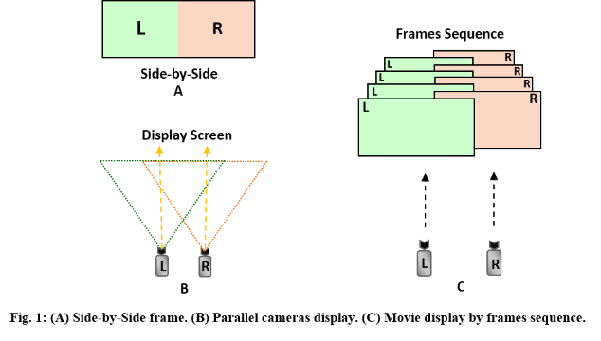

The compression technique of multispectral images is an urgent problem for the remote sensing image storage, image database, and transmission. Different kinds of images have the different redundancy characteristic. The multispectral have two kinds of redundancy: spatial redundancy and spectrum redundancy.
The spatial redundancy presents the correlation of the neighbour pixels in some specific band which is similar to single band remote sensing image and the compression can be realized through general compression algorithms. The spectrum redundancy is including the statistic redundancy and structure redundancy. Thus, the multispectral images compression focuses on both the pixel correlation between neighbour pixels and edge structure of some object in different band images [14] [15].
Comparing to the common single band remote sensing image, the character of the spatial correlation among the multispectral images is the mode localization. The multispectral images are a group of images to the same region in different bands. Each band has an image while the imaging objects are the same. And the compression algorithm proposed in this processing focus on this spectrum redundancy by using Multiwavelet Transform.

- Multiwavelet Transform (MWT)

The consists of performing classic dyadic 2D Multiwavelet transforms MWT decomposition on each frame plane for coding colour images, each colour plane can be treated separately from the other. Multiwavelet transforms made a significant contribution in the area of signal and image processing including image coding. The principle behind the Multiwavelet transform is to hierarchically decompose an input signal into a series of successively lower resolution reference signals and their associated detail signals.
In the Multiwavelet transform domain, there are first and second low-pass coefficients followed by first and second high pass filter coefficients Practical image subband coding techniques mostly use separable decomposition, i.e., the one-dimensional filter is used in order to separate the frequency bands both horizontally and vertically. Finally, the multiwavelet case the image is split into sixteen sub-images as demonstrated in Fig. 2. The main purpose behind using the subband coding technique for digital image applications is the acquisition of a set of sub-sampled frequency bands where each band contains various structural features of the original image. The base band of the image presents a smaller replica of the original signal which consists of all the low-frequency components that are of major perceptual importance.

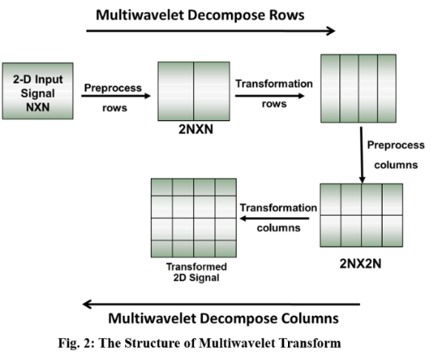

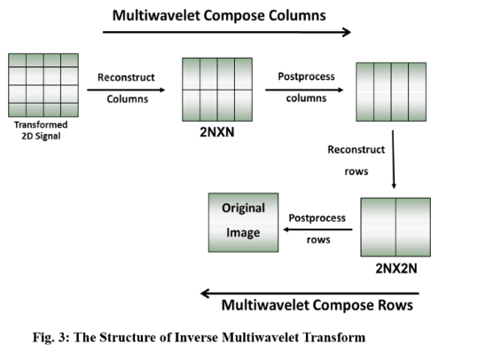

In Multiwavelets has shown how a single level of decomposition is done. In practice, which more than one decomposition is performed on the image data [5], Fig. 2. Successive iterations are performed on the low pass coefficients from the previous stage to further reduce the number of low pass coefficients. Since the low pass coefficients contain most of the original signal energy, this iteration process yields better energy compaction.
Image decompression, or reconstruction, is achieved by carrying out the above steps in reverse and inverse order [5]. Thus, to restore the original image, the compressed image is decoded, de-quantized, multiwavelets compression by performing Multiwavelet Transform (MWT) and Inverse Multiwavelet Transform (IMWT) used in the decompression part, Fig. 3.

- Theory of Multiwavelet

As in the scalar wavelet case, the theory of multiwavelet is based on the idea of multiresolution analysis (MRA) [5]. The difference is that multiwavelets have several scaling functions [5]. The standard multiresolution has one scaling function φ (t), we say that a scaling function φ (t) generates a multiresolution analysis (MRA) if:

• The translates φ (t − k) are linearly independent and produce a basis of the subspace V0;

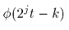
• The dilates generate subspace , , such that:
… (1)
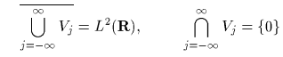
… (2)

• There is one wavelet w (t) that translates into w (t − k) are independent and produce a basis of the "detail" subspace W0 to give V1:
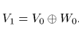
… (3)
For multiwavelets, the notion of MRA is the same except that now a basis for V0 is generated by translates of N scaling functions:
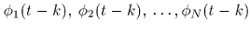

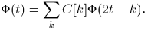
The vector will satisfy matrix dilation equation:
… (4)

The coefficients C[k] are N by N matrices instead of scalars. Associated with these scaling functions are N wavelets,

satisfying the matrix wavelet equation;
... (5)
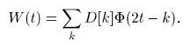

In practice multiscaling and wavelet functions often have multiplicity r=2. An important example was constructed by Geronimo, Hardin and Massopust, which will be referred to as the GHM system. For the GHM multiscaling functions there are two scaling functions φ1 (t), φ2 (t) and the two wavelets w1(t), w2(t).

The dilation and wavelet equations for this system have four coefficients:

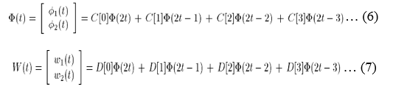

To compute wavelet coefficients corresponding to a signal S (t) one usually uses the cascade algorithm and iterates the low pass filter with down sampling. In the "multi" case the situation does not change. Corresponding to each multiwavelet system is a matrix-valued Multirate filter bank, or multifilter.
A multiwavelet filter bank has N x N matrices. The resulting 2- channel, 2 x 2 matrix filter bank operates on two input data streams, filtering them into four output streams, each of two. Each row of the multifilter is a combination of two ordinary filters, one operating on the first data stream and the other operating on the second.
Equations (8) and (9) are the discrete multiwavelet decomposition algorithm, and equation (10) is the reconstruction algorithm:
… (8)
C _{J-1}(K)=$\sqrt{2}$ $\sum_{k}{H(K)}$C_{J}(2t-K)
… (9)
D _{J-1}(K)=$\sqrt{2}$ $\sum_{k}{G(K)}$C_{J}(2t-K)
… (10)

C _{J}(K)=$\sqrt{2}$ $\sum_{k}{(H(K)}$^{T}C_{J-1}(2t-K)+G(K)^{T} D _{J-1}(2t-K))

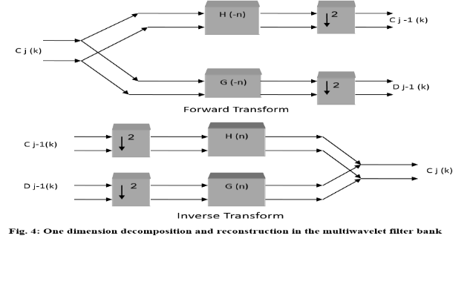
Fig. 4 depicts a 1-level sub band decomposition and reconstruction framework for MWT. Where the first part represents a 1-level multiwavelet decomposition, where a vector input stream is decomposed by a matrix low pass filter H, and a matrix high pass filter G, to generate the next lower resolution. Sub sampling follows this by a factor of two to preserve compact representation of the input signal. For octave bandwidth decomposition, only the low pass sub lower resolution. The second part shows the corresponding 1-level multiwavelet reconstruction. The sub bands are first up sampled by a factor of two before they are filtered by the synthesis matrix to recover the original vector stream.

- Coding and Decoding using MWT and IMWT

Multiwavelet Transform is used in the 2D image compression but in this works on 3D stereoscopic film which composes huge numbers of 3D frames and each one has two RGB left and right frames. That mean MWT process each frame three times for Red, Green then Blue. MWT operates on NxN matrix, where N must be power of two so it will be resized to fulfil the power of two condition (1080x1080) dimensions.
Consequently, each matrix from the RGB frame will process in MWT sequentially to be decomposed for a certain number of iterations, the benefit gained in energy compaction becomes rather negligible compared to the extra computational effort. The Multiwavelet decompositions iterate on the low pass coefficients from the previous decomposition to three matrixes of RGB frame will be coding. This step will do it for all the frames of film to coding and be easy to transmit.
To display the film should decode so the decoding will use IMWT to composition the frame again. So each matrix from the result Multiwavelet RGB frame will reprocess in IMWT to reconstruct the original frame. The new frame result from the IMWT is like the original frame but the quality is better because indeed well-suited to present smooth and textured region of images with multi-band wavelet can express edge or object geometric feature more accurately, as shown in Fig. 5.

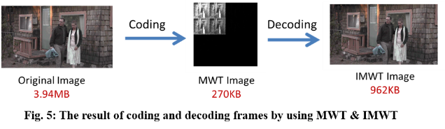

- Coding and Decoding Algorithms

6.1 Coding Algorithm Fig. 6:

- Resize to new (1080x1080) pixel dimension for all frames to be processed with MWT, after equally divided matrix dimension.
- Read the three matrices of the RGB frame to process in MWT sequentially.
- The result of MWT to each matrix is 16 sub-band with size 270 KB.
- Repeat steps 1 to step 3 for all the frames of the film.
- All the frames of the film will be coding. The compress and coding frame will be just 51.58% from the original frame to transmit.

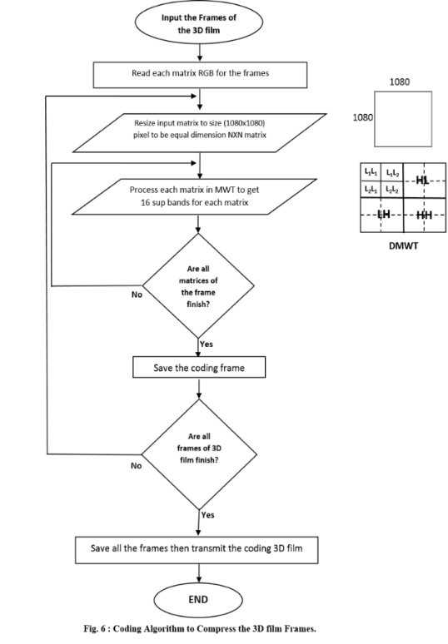

  - Decoding Algorithm Fig. 7:

- Read the three matrices of the RGB frames.
- Reprocess the matrices of each RGB frame in IMWT to reconstruct the original frame.
- Repeat step 2 to all the film frames.
- Decode all the film frames in size (1080X1080).
- Resize the frame to the original dimension (1920X1080).
- The size of the new frame is 1.5 MB compared to the original frame size of 3.94 MB.
- Reconstruct the film from the new compressed frame.
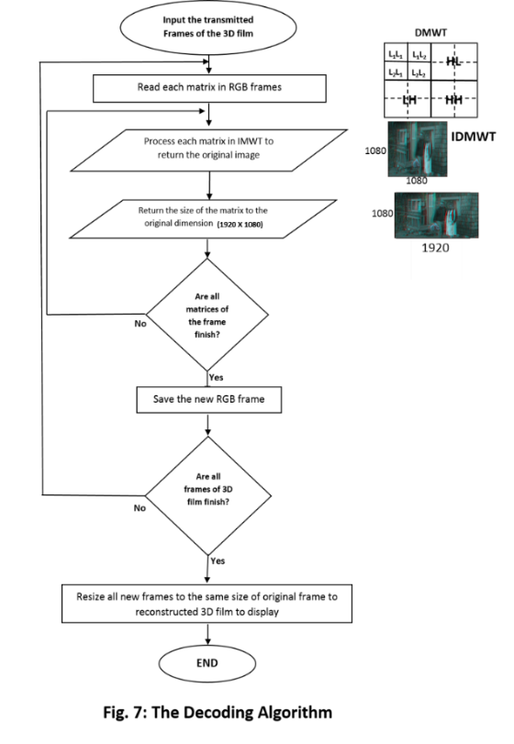

7. Results and Discussion

Study provides additional evidence with respect the result by calculate Peak Signal to Noise Ratio (PSNR) and Mean Square Error (MSE) are used to comparing the squared error between the original image and the reconstructed image. However, there is an inverse relationship between PSNR and MSE higher PSNR value indicates the higher quality of the image, the mean square error between the two signals is thus defined as:
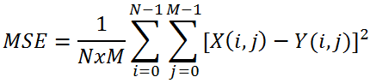
… (6)

The more Y is similar to X, the more MSE is small. Obviously, the greatest similarity is achieved when MSE equal to 0, PSNR is so defined as:

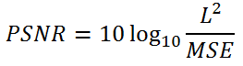
… (7)

The result for PNSR is ( 87.968 ) and for MSE is (1.0463e-04 ). The size of original RGB frame [1920,1080] is 3.94 MB (4,141,754 bytes), while the result of the coding image by MWT is 270KB (276,795 bytes,) so it is just 6.68% to transmitting. Although, the result of decoding image by IMWT is 1.50 MB (1,581,774 bytes), which is just 38.19% with dimension [1920,1080] to display.

The IMWT reconstruct the different quantification policy is design to RGB frames coefficient to obtain compression. While the real problem of the film compression is decoding the images lose the quality not as like as the normal that cause not well display of film. To exam the quality of the compress frame will calculate how many bits per pixel, where the pixel of images can give improved color quality and can lead to improving color correction, chroma removal, filtering, scaling, compositing, and anti-aliasing at video resolution so if the bit rate increases, the results in improvement in the quality of the reconstructed.

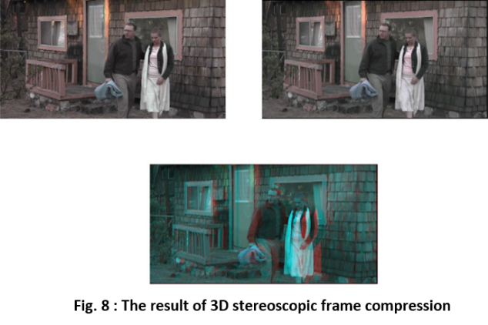

To see the effectiveness of this compression technique will calculate how many Bits per pixel for the both images are: -
Bits per pixel = Size of the compressed image in bits / Total number of pixel
(8)

The result is for the original frame is 15.978bpp, but for the new frame is 6.466 bpp, , as shown in Fig. 8.

- Conclusion

In this paper, the DMT and IDMT transformation are proposed to compress the 3D stereoscopic frames. The Multiwavelet Transform is multi-band wavelets analyse and it can obtain edge and structure feature with higher accuracy. The results show that the performance of the orthogonal filter for the compression of the 3D stereoscopic film gives better performance than the other coding and decoding compression methods.

- References

[1] | W. Lu and T. Yap-Peng , "Color filter array demosaicking: new method and performance measures," IEEE Transactions on Image Processing, vol. 12, no. 10, pp. 1194-1210, 2003.
[2] | I. E. Richardson, "Video codec design," in Developing image and video compression systems, John Wiley & Sons, 2002.
[3] | R. Achanta, S. Hemami, F. Estrada and S. Susstrunk, " Frequency-tuned salient region detection. In Computer vision and pattern recognition," in cvpr 2009. IEEE conference, 1597-1604, 2009.
[4] | M. Deshmukh and U. Bhosle, "A survey of image registration," International Journal of Image Processing (IJIP), vol. 5, no. 3, p. 245, 2011.
[5] | N. Al-Ramahi, H. Al-Bayatti and M. Alfaouri, "Novel Techniques for Face Recognition Identification and Labeling," International Journal of Soft Computing, vol. 2, no. 1, pp. 129-37, 2007.
[6] | R. Hardie, K. Barnard and E. Armstrong, "Joint MAP registration and high-resolution image estimation using a sequence of undersampled images," IEEE Transactions on Image Processing, vol. 6, no. 12, pp. 1621-1633, 1997.
[7] | W. Jiang and et al., "Two-Step Coding for High Definition Video Compression," in 2010 Data Compression Conference, Snowbird, UT, 2010.
[8] | K. R. Kolhe and et al., "High Performance Lossless Multimedia Data Compression through Improved Dictionary," International Journal of Computer Applications, vol. 10, no. 1, pp. 29-35, November 2010.
[9] | B. Sukhwani and et al., "High-Throughput, Lossless Data Compresion on FPGAs," in 2011 IEEE 19th Annual International Symposium on Field-Programmable Custom Computing Machines, Salt Lake City, UT, 2011, pp. 113-116.
[10] | A. Wang, P. Liu and Y. Chen , "Multiwavelet-Based Region of Interest Image Coding," in 2009 2nd International Congress on Image and Signal Processing, Tianjin, 2009, pp. 1-4.
[11] | S. K. Hasan, FPGA implementations for parallel multidimensional filtering algorithms, Newcastle Upon Tyne, UK: University of Newcastle, 2013.
[12] | S. Haan, "Performance-vetted 3-D MAC processors for parallel volumetric convolution algorithm: A 256×256×20 MRI filtering case study," in 2016 Al-Sadeq International Conference on Multidisciplinary in IT and Communication Science and Applications (AIC-MITCS), Baghdad, 2016.
[13] | "Performance-Aware Architectures for Parallel 4D Color fMRI Filtering Algorithm: A Complete Performance Indices Package," IEEE Transactions on Parallel and Distributed Systems, vol. 27, no. 7, pp. 2116-2129, July 1 2016.
[14] | Y. C. Shen and et al., "Efficient Real-Time Distributed Video Coding by Parallel Progressive Side Information Regeneration," IEEE Sensors Journal,, vol. 17, no. 6, pp. 1872-1883, March15, 2017..
[15] | C. A. Aslam and et al., "Edge-Based Dynamic Scheduling for Belief-Propagation Decoding of LDPC and RS Codes," IEEE Transactions on Communications, vol. 65, no. 2, pp. 525-535, Feb. 2017.
[16] | X. Liu and et al., "Data-Driven Soft Decoding of Compressed Images in Dual Transform-Pixel Domain," IEEE Transactions on Image Processing, vol. 25, no. 4, pp. 1649-1659, April 2016.

