J. Tenholt ^{a,*}, S. Adam ª, M. Laun ª, C. Schiefer ^{b}, C. Terschüren ^{c} , V. Harth ^{c} , K. Karamanidis ^{d}, U. Hartmann ª, D. Friemert ª
*Corresponding author: J. Tenholt, Department of Mathematics and Technology, Koblenz University of Applied Sciences, Remagen, Germany, Tel: 0049 1573 5601028, E-mail: jtenholt@hs-koblenz.de
U. Hartmann, S. Adams, M.Laun, D.Friemert: Department of Mathematics and Technology, Koblenz University of Applied Sciences, Remagen, Germany
C. Schiefer: Institute for Occupational Safety and Health, Sankt Augustin, Germany
C. Terschüren, V. Harth: University Medical Centre Hamburg- Eppendorf (UKE), Institute for Occupational and Maritime Medicine (ZfAM), Hamburg, Germany
K. Karamanidis: Sport and Exercise Science Research Centre, School of Applied Sciences, London Southbank University, London, United Kingdom

ªDepartment of Mathematics and Technology, Koblenz University of Applied Sciences, Joseph-Rovan-Allee 2, 53424 Remagen, Germany
^{b}Institute for Occupational Safety and Health, Sankt Augustin, Germany
^{c}University Medical Centre Hamburg-Eppendorf, Institute for Occupational and Maritime Medicine (ZfAM), Hamburg, Germany
^{d}Sport and Exercise Science Research Centre, School of Applied Sciences, London South Bank University, London, United Kingdom
∗ Corresponding author:
Jakob Tenholt
Koblenz University of Applied Sciences
Joseph-Rovan-Allee 2, 53424 Remagen, Germany
E-mail: jtenholt@hs-koblenz.de

Influences of smart glasses on postural stability under single- and dual-task conditions for ergonomic risk assessment

Influences of smart glasses on postural stability

Abstract

Head worn displays have become increasingly popular at workplaces in logistics and assembly lines in recent years. Such displays are expected to improve productivity and safety at the workplace. However, their impact on balance in the workforce is still an open research question. Therefore, we investigated the influence of the Vuzix M400 and Realwear HMT1 smart glasses on postural stability. A laboratory study was conducted with eleven subjects. Balance parameters were recorded during bilateral quiete stance, together with parameters of cognitive load. The two different smart glasses used in this study were compared with a monitor and a tablet under single-task-conditions and while performing a spatial 2-back task. As balance parameters, the prediction ellipse and sample entropy in anteroposterior as well as mediolateral direction of the center-of-pressure data were examined. No significant differences were observed in the cognitive task performance between the devices. The prediction ellipse of the smart glasses was smaller than the tablets, but larger than the smartboard. The dynamic of sample entropy data suggests that the use of the spatial 2-back task induces postural sway in the subjects. This effect was most profound when looking at the monitor and least recognizable in the data of the tablet.

Keywords: center-of-pressure; cognitive-load; head worn displays; prediction ellipse; sample entropy

Abbreviations:

AP, anteroposterior
COP, center-of-pressure
ML, mediolateral
PE, prediction ellipse
rmANOVA, repeated measures ANOVA
SampEn, sample entropy

Introduction
Smart glasses are currently being used in a variety of applications in medicine and robotics, as well as urban planning and civil engineering [1]. However, their impact on postural stability is still an open research question. Occupational accidents resulting from people slipping, tripping and falling account for 22,3% of all reported accidents in Germany in 2020 [2]. An underlying reason for these accidents is the loss of balance [3-4]. Limited postural control is associated with an increased risk of falling and resulting injuries [4-6]. Most studies that have been carried out so far, focused on the impact of smart glasses on productivity as well as their applications in clinical rehabilitation programs [4, 7]. In clinical applications, training methods using smart glasses to support balance and gait training achieved better results than conventional displays [4, 8-9]. One Study which has been published recently, shows that smart glasses as well as handheld displays diminished the participants’ ability to use stability control mechanisms effectively, after external disturbances [10]. However, the influence of smart glasses on postural stability remains uninvestigated. Since the eyes are part of the postural control system, visual interference can affect postural control and thus postural stability [11]. Standing upright is not a completely automated process and requires cognitive resources [12, 14]. Dual-task studies have been designed in order to investigate postural stability during cognitive load [12-14]. This concept assumes, that postural control and cognitive tasks compete for limited cognitive resources and thus impede each other. Subjects in posturographic dual-task measurements are asked to perform a cognitive task whilst standing as motionless as possible [12, 14]. Current research suggests that a second task improves postural control up to the point, where the task demands to much cognitive domain, so that subjects neglect postural control which leads to impaired postural stability [12, 15-16]. Impaired postural stability as well as a degrading cognitive task performance during dual-task conditions suggests decreased postural control and therefor a higher risk of falling [15-17]. One of the measurements which is used to investigate postural stability is the center-of-pressure (COP), which represents the point at which the ground reaction force is applied in order to stand in an upright position. This point moves over time, and its dynamics can be used to derive further parameters in order to investigate postural control [14, 17-19]. To find out how smart glasses affect postural stability the present study compares two monocular smart glasses with a smartboard and a tablet during single- and dual-task conditions. The conducted statistical analysis was designed to detect, whether the influence on postural control is dependent on the device used, or whether dual-task conditions influence postural stability the same across all display formats. In order to investigate these differences, we analyzed the prediction ellipse (PE) and sample entropy (SampEn) of the COP data, as well as parameters of cognitive load caused by the secondary task executed during the trials.
Materials and methods
Subjects
Eleven healthy subjects, six males and five females, voluntarily participated in this study. Prior to the measurements, all participants signed a written informed consent, and the study has been approved by the local ethics committee. On average the subjects were 22.4 ± 2 years old, 178.3 ± 8.6 cm in height and 72.3 ± 12.4 kg in weight.

Experimental design and task description

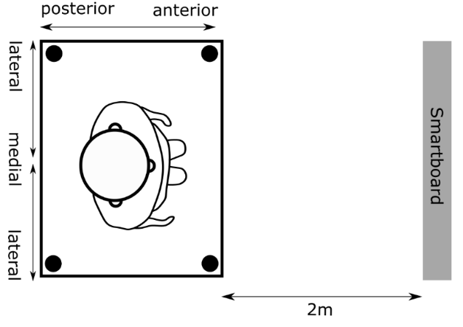
To investigate the effect of smart glasses on postural stability, the present study compared two pairs of smart glasses with a monitor and a tablet. The monitor used was the "SMART Board 6065 interactive flat panel" (Smart Technologies Inc., Calgary, Canada). The tablet used was the Lenovo Tab M100 (Lenovo, Quarray Bay, Hong Kong). To mimic industrial tablets, the weight of the tablet was increased, and a strap was added on the back. The smart glasses used were the Vuzix M400 (Vuzix Corp., Rochester, United States) and the Realwear HMT1 (Realwear Inc., Vancouver, Canada). A spatial 2-back working memory task was used in which a blue square jumps back and forth within a 3x3 grid at intervals of 1.5s [20]. During the task, subjects had to recognize the moments in time at which the square jumps back to its previous position. The length of the task was 90s and a total of 10 targets had to be recognized by the subjects during each trial. The force plate "FP 4060-05-PT-1000" manufactured by Bertec (Bertec Corp., Columbus, United States) was used to record the COP at a frequency of 1000Hz. Before the first measurement, the cognitive task was practiced three times by the subjects to minimize learning effects during the measurements. The order of investigated display systems and executed tasks was randomized between the subjects, so that the sequence in which the devices and tasks where measured was evenly distributed throughout the study. Before the first measurement, subjects were asked to stand on the force plate in a relaxed, upright, bilateral position to mark the position of their heels on the force plate. This ensured that the standing position remained unchanged between measurements. The first task condition consists of the postural single-task, in which participants were asked to stand upright as still as possible, while the display under investigation was turned off. The second task conducted during the study was the cognitive single-task. Participants conducted the 2-back task on the respective display whilst sitting on a chair. The cognitive-postural dual-task is the final task condition which was investigated. The cognitive task and “motionless” standing had to be performed simultaneously. Each of these task conditions lasted 90s and was repeated three times to increase the reliability of the COP data and its validity [17]. After each of the task conditions had been repeated three times, a two-minute break was taken before the next display system was measured. This procedure was repeated until all four display systems were measured. The positions in which the subjects stood on the force plates as well as the plane at which the task was presented during the trials is displayed in Figure 1.
(A)
(B) (C)
Figure 1: Position of the subjects during the postural single-task as well as the cognitive-postural dual-task conditions on the force plates with the marked display plane in front of them. (A) Shows the setup for the measurement of the smartboard, (B) shows the measurement of the tablet and (C) the measurements of the two smart glasses

Parameters

The first parameter we investigated in this study is the PE, which is used to quantify postural fluctuations. An increased ellipse area, which is caused by larger sway and fluctuations in the COP movement, is associated with poorer postural control [3, 15, 21-22]. The ellipse area is calculated as follows:
$A= π⋅a⋅b$ (1)
Here, a and b represent the two principal axes of the ellipse. For calculating these two main axes, the eigenvalues $λ_{1,2}$ of the covariance matrix S of the X and Y coordinates of the COP data sets are needed, which are defined as follows:
$S= \left[\begin{matrix}s_{x}^{2} & s_{y,x} \\ s_{x,y} & s_{y}^{2}\end{matrix}\right]$ (2)
$λ_{1,2}=\frac{1}{2}⋅\left[s_{x}^{2}+s_{y}^{2}±\sqrt{{\left(s_{x}^{2}-s_{y}^{2}\right)}^{2}+4⋅s_{xy}^{2}} \right]$ (3)
The two principal axes are then calculated using the following formula:
$a,b=\sqrt{\frac{2*\left(n+1\right)*(n-1)}{n*(n-2)}*F_{\left(1-α\right),2,n-2}*λ_{1,2}}$ (4)
With the help of a and b, the area of the PE is calculated according to equation 1 [22]. As the PE only illuminates spatial aspects of COP dynamics, it is appropriate to investigate other aspects of postural control. For this purpose, the SampEn of the COP data in anteroposterior (AP) as well as mediolateral (ML) directions were evaluated. With the help of the SampEn it is possible to gain a deeper insight into the control mechanisms responsible for postural control. Complex types of variability often characterize healthy physiological systems [18]. Disease and aging lead to more regular and less complex parameter dynamics. In this context, SampEn provides information about the regularity of a time series of the measured quantity. Lower SampEn values are associated with increased regularity and lower complexity of the data set, and therefor worsened postural control, regardless of how the COP data arranges itself spatially [19]. The SampEn of a dataset of length N, is the negative logarithm of the conditional probability that two similar sequences of length m with a divergence of r at most, remain similar for the length m+1. For this purpose, the data set is divided into vectors of length m and m+1. Then, each vector is compared with all other generated vectors of the same length, except itself. All successful comparisons are finally added up [23].
$SampEn\left(m,r,N\right)= -log\frac{\sum_{i=1}^{N-m}{\sum_{j=1,j≠i}^{N-m}{\left[\left|x_{m+1}\left(j\right)- x_{m+1}\left(i\right)\right|<r\right]}}}{\sum_{i=1}^{N-m}{\sum_{j=1,j≠i}^{N-m}{\left[\left|x_{m}\left(j\right)- x_{m}\left(i\right)\right|<r\right]}}}$ (5)
Beside the investigation of postural parameters, we also analyzed the cognitive performance of the subjects depending on display and task condition. In order to be able to evaluate the quality of task completion, the performance rate, number of errors as well as average reaction time were recorded. The performance rate is the amount of correctly recognized targets divided by the number of targets in a given task. A worsened performance rate, increased number of errors and increased reaction time indicate a decreased task performance and limited postural control [12-14]. For each target, the subjects were given a tolerance of 0.5 s to detect the targets. Together with a display period of 1.5 s, this results in a period of 2 s in which a target can be recognized.

Data Analysis

At the beginning of data processing, the COP data was filtered using a sixth-order Butterworth low-pass filter at a cutoff frequency of 6Hz [12]. To eliminate filter artifacts at the beginning and end of the data set, the first and last 500 data points of the COP coordinates were deleted from the data sets. Finally, the data set was reduced from a sampling frequency of 1000Hz to 20Hz. High sampling rates lead to artificially higher frequencies in the COP data, which distort the data [22]. A recording frequency of 20Hz is also recommended when using the SampEn to increase the time interval between data points [18]. After data processing, the PE was calculated for a significance level
$α$ =0.05. SampEn was calculated for the order m=3, a tolerance of r=0.2, and a time delay of τ =5. If the time delay is chosen too small, the parameter of the SampEn loses its ability to reveal long-term correlations within a data set [18].

Statistics

To evaluate the recorded parameters, a 2x4 repeated measures ANOVA (rmANOVA) was performed. The data sets were checked for sphericity beforehand. In the subsequent comparisons, distribution-dependent t-tests or Wilcoxon tests were performed. Likewise, the observed effects were analyzed with the help of $η_{p}^{2}$ , Cohen’s d, and the Bravais-Pearson correlation coefficient r. All statistical tests were performed for a significance level of α=0.05.
Due to the explorative character of the conducted study, the results of the contrast comparisons are presented both with and without the Bonferroni correction. The evaluation of task performance is purely descriptive.

Results
For the cognitive task, the subjects detected 94.3 % of the targets, made 0.129 errors per measurement and needed 0.904s to detect a target. No noticeable differences were observed when differentiating between the display systems or task conditions. The results of the rmANOVA investigation of the COP data are shown in the following table:

Table 1. Results of the repeated measures ANOVA, it is apparent that the used ddevice had a significant effect on the prediction ellipse, while for sample entropy a significant interaction between display and task condition can be observed
Parameter | Degrees of freedom | F-Value | P-Value | $$η_{p}^{2}$$
Prediction ellipse
Task  Display  Task*Display | 1  3  3 | 0.405  5.836  2.573 | .539  .003*  .073 | .039  .369  .205
Sample entropy anteroposterior
Task  Display  Task*Display | 1  3  3 | 1.689  1.125  4.447 | .223  .355  .011* | .145  .101  .308
Sample entropy mediolateral
Task  Display  Task*Display | 1  3  3 | 4.593  2.001  6.942 | .058  .135  .001* | .315  .167  .410
*significant results are marked with a star, and the row in which significant results are displayed is printed bold

For the PE, the rmANOVA revealed a significant effect of the display systems on the COP data (F(3, 30)=5.836, p=0.003, η_{p}²=0.369). When looking at the data set of the SampEn in ML and AP direction, a different pattern emerges. Neither the statistical tests on the task, nor on the type of display devices yielded significant results. However, a significant interaction between display and task could be observed in AP (F(3, 30)=4.447, p=0.011, η_{p}²=0.308) as well as ML directions (F(3, 30)=6.942, p=0.001, η_{p}²=0.41). For the PE, contrast comparisons were performed following the rmANOVA.
The results of the contrast comparisons of the PE are shown in the following table and to further illuminate these differences in more detail, the data sets are also displayed in figure 2 using a violin plot.

Table 2. Results of the pairwise comparisons of each display device for the prediction ellipse size, the tablet has a significantly bigger ellipse area than the smartboard before and after Bonferroni correction, the comparison between M400 and the tablet loses its significance after correction, which is also apparent for the comparison of the Smartboard with the HMT1
Display 1 | Display 2 | Difference  (Display 1 – Display 2) | SE | p-value | p-value  after Bonferroni corrrection | Effect size (d or r)
Smartnoard | Tablet ª  M400  HMT1 | -13.127  -5.098  -11.482 | 4.281  4.363  4.136 | 0.001* ª  0.27  0.02* | 0.006* ª  1  0.117 | -0.763 ª  -0.316  -0.668
Tablet ª | M400  HMT1 | 8.029  1.644 | 2.04  2.765 | 0.014* ª  0.656 | 0.084 ª  1 | 0.589 ª  0.115
M400 | HMT1 | -6.384 | 2.965 | 0.057 | 0.34 | -0.33
ª for the tablet a normal distribution couldn’t be assumed which is why in those cases a Wilcoxon test was performed and effect size calculated using the Bravais-Pearson correlation coefficient r instead of Cohen’s d; *significant results are marked with a star
SE, Standard Error.

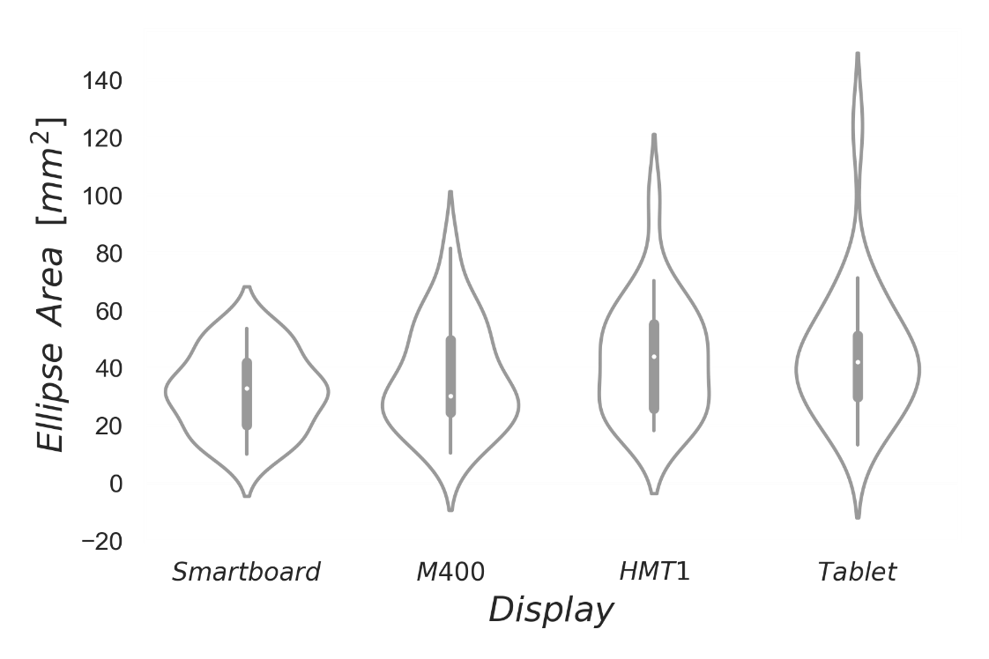
Figure 2: Violinplots of the pairwise comparisons of the ellipse area of the prediction ellipse for each display device: Smartboard, Vuzix M400, Realwear HMT1 and Tablet are grouped along the X-Axis and the median of each dataset is marked within each box, the whiskers represent the 95% confidence intervals. The diamonds represent datapoints which lie further than 2 standard deviations from the mean value of the given dataset.

By pairwise comparisons the data set can be divided into two groups. Both the Smartboard (p=0.001, r=-0.763) and M400 (p=0.014, r=-0.589) exhibited significantly smaller PE than the tablet before Bonferroni correction, with the difference between Tablet and Smartboard being the only on which remains significant after correction. The comparison between Smartboard and HMT1 also reached the targeted significance level (p=0.02, d=-0.668). However, after the correction the significance level dropped below 0.05.
The comparison between M400 and HMT1 was just not significant at p=0.057. When examining the SampEn, a significant interaction effect could be observed for both AP (p=0.011, η_{p}²=.41, d=1.33) and ML (p=0.001, η_{p}²=.308, d=1.67) COP motion. To further investigate this dynamic, line plots for the interaction between task condition and display device are examined in the following passage. Since a normal distribution cannot be assumed for a large part of the SampEn data sets, confidence intervals are not presented. The SampEn dynamic in AP direction is displayed in Figure 3

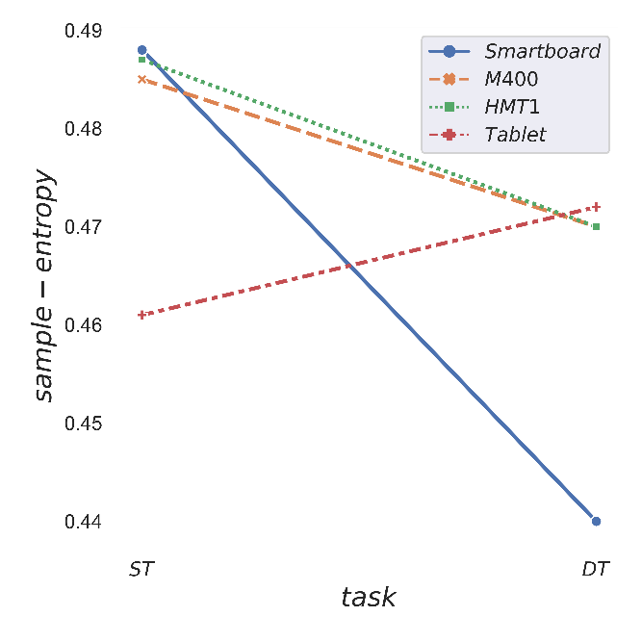
Figure 3: Sample entropy of center-of-pressure data in anteroposterior direction. On the Y-Axis the sample entropy of the given dataset is displayed, while the X-Axis contains the two task conditions, ST stands for single-task and DT for dual-task

Within single-task condition, two groups can be distinguished from each other: the Smartboard, HMT1 and M400 have a higher SampEn value of just under 0.49, and thus a higher complexity of their data sets than the tablet, with just under 0.46. Looking at the dual-task condition, a different picture emerges. While the SampEn values for the tablet increase by 0.011, they drop for all three other display systems, compared to the single-task condition. This effect is strongest for the Smartboard.

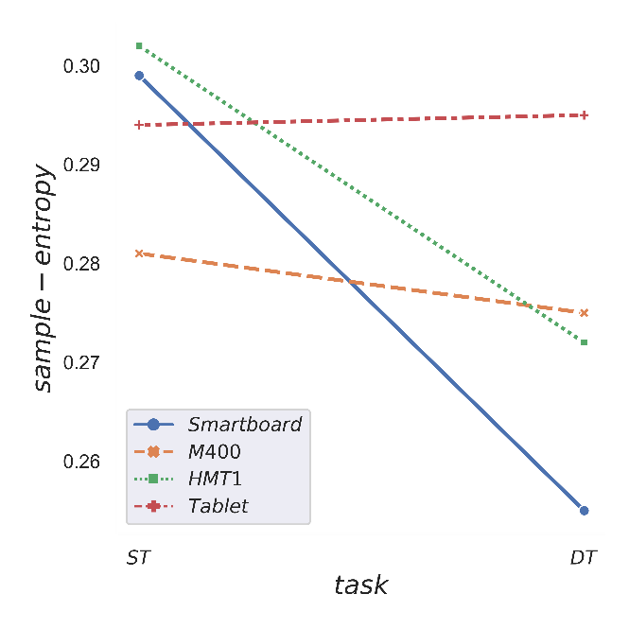
Figure 4: Sample entropy of center-of-pressure data in mediolateral direction. On the Y-Axis the sample entropy of the given Data set is displayed, while the X-Axis contains the two task conditions, ST for single-task and DT for dual-task.

In ML direction the data is less clear, although some similarities are noticeable (Figure 4). Both the HMT1 and the Smartboard show the highest SampEn values under single-task conditions, and the Tablet also tends to belong to the group of higher complexity within the single-task conditions. This is not the case with the M400 with a value of 0.281 under single-task conditions, it forms the group with less complex data. Within the dual-task condition, the Smartboard again, exhibits the lowest SampEn value, with 0.255. M400 and HMT1 make up the second group whose SampEn values are 0.275. Under dual-task conditions the Tablet presents the highest SampEn value, at 0.295, and thus the highest complexity.
Discussion
The aim of the conducted Study was to analyse the impact of different display devices on postural stability. As previously reported in the results, a significant effect of the display devices used was observed for PE (p=.003, η_{p}²=.369, d=1.53). Differences between the display devices were also found in the subsequent contrast comparisons. It is apparent from the data, that the Smartboard and M400 have had a lower impact on postural control than the HMT1 and Tablet when considering PE, since an enlarged ellipse area is associated with worsened postural control [12, 22]. It is also noticeable that both smart glasses seem to have a different influence on the subjects' PE area. Especially the comparison with the Smartboard suggests that the HMT1 has a stronger influence on the postural control. M400 and Smartboard were undistinguishable, and the comparison between M400 and HMT1 failed to reach a significance level. Since these differences appear to be independent from the given task condition, the observed difference in PE area seems to stem from the different ways the devices are used. The M400 is worn like a normal pair of glasses while the HMT1 is equipped with 2 Straps, one above and one behind the head of the subjects. The enlarged ellipse area of the tablet can be explained by the weight of the tablet, as well as the fact that a different body position needs to be adopted in order to look at the displayed information, while holding the tablet in one hand. Looking at the data of the SampEn, a more complex picture emerges. The complexity of the datasets of the smartboard drops the most out of all devices used between single-task and dual-task conditions, in both directions. In AP direction both smart glasses display a similar behavior, even though the amount of complexity loss is less profound than the smartboards. Solely the complexity of the tablets data increases in both directions. However, whether this observation can be explained by the fact that the tablet has a lower influence on the postural control under dual-task conditions and in general is questionable. The task used in this study, uses a square on which subjects are asked to focus on during measurements moves within their respective field of view. It is possible that the rhythmic movement of the square within the 3x3 grid induced rhythmic postural fluctuations within the subjects, which affected the movement of the COP [24], because postural control, postural sway and the movement of the COP depend on the visual reference and its alterations [11, 24]. Looking at the smart glasses, this effect is less noticeable, than for the smartboard.
A possible reason for this might be the way the data is displayed on the glasses. While the movement of the square is perceived by both eyes when using the smartboard and the tablet, the smart glasses only display their information in front of the wearer's right eye. This allows the left eye to continue to focus on a fixed visual reference point, which might reduce the effect of the moving square on COP data. However, due to the lack of data regarding the influence of smart glasses on postural control, this hypothesis cannot be verified within the scope of this study and requires further investigation. When using the tablet, a different head positioning must be adopted by the subjects, since they must look down to see what is displayed on the tablet. Due to this change in body position, the movement of the square during the task does not seem to have any influence on the complexity of the datasets. Similarly, it has already been shown in several studies that postural control improves under dual-task conditions [12-13], which would stand in contrast to the results of this study, especially the smartboard. Our analysis revealed no significant differences in task performance between single-task and dual-task, the same applies to the display devices. One possible explanation is that the task used was not sufficiently challenging for the subjects to demand their cognitive resources to such an extent that changes in task performance would occur under dual-task conditions. In this case, the interval between the individual steps of the task could have been reduced and the number of targets increased. However, in a study carried out by Huxhold et al. no difference in task performance was found between single-task and dual-task when examining a younger study population.
Here, the young subjects (average age: 24.52 years) were able to recognize approximately 95% of the targets [12], which is consistent with the results of the present study. At 22.46 years, the age average of the test subjects is lower than that of the working population in Germany, which in 2017 had an average age of 44.1 years [25]. Since postural control decreases with increasing age [5, 19] and the influence of dual-task measurements on postural control is also age-dependent [12-14], this discrepancy must be considered in order not to draw false conclusions, when evaluating the influence of smart glasses on postural control.
Additionally, it should be mentioned, that the present study is a laboratory study, which reproduces real situations only to a limited extent. Nevertheless, it is possible to use laboratory studies as a basis for further investigations.
Conclusions
We were able to investigate the influence of different display systems on the postural control of young subjects using force plates. The presented data suggests that smart glasses have a smaller effect on the postural control than an imitation of currently used industrial tablets. This effect was most noticeable in the PE with the M400. The spatial movement of the square during the cognitive task affected the SampEn values of the smart glasses as well as the smartboard, leading to a reduction in complexity and thus to SampEn values, which are -according to classical interpretation- associated with worsened postural control. The hypothesis that the task used, rather than the display system, caused the SampEn to decrease under dual-task conditions for the M400, HMT1 and the smartboard requires further investigation. In summary, it was possible to demonstrate the influence of different display systems on postural control during quite bipedal stance with the help of the study conducted. In general, Smartboard, M400 and HMT1 seemed to affect the subjects’ postural control less than the tablet, although the data was not unambiguous for each parameter. To gain a more complete picture of how the display device affects postural control and stability, further research is needed examining other smart glass models, tasks, and age groups.

References
- Mekni, M., & Lemieux, A.. Augmented Reality: Applications, Challenges and Future Trends. Applied computer and applied computational science 2014;20:205-214.
- Deutsche Gesetzliche Unfallversicherung. Arbeitsunfallgeschehen 2020. 2021
- Simeonov, P., & Hsiao, H. Height, surface firmness, and visual reference effects on balance control. Injury Prevention 2001;7:i50-i53.
- Yoo, H. N., Chung, E., & Lee, B. H.. The Effects of Augmented Reality-based Otago Exercise on Balance, Gait, and Falls Efficacy of Elderly Women. Journal of Physical Therapy Science 2013; Volume 25, Issue 7:797-801.
- Granacher, U., Bridenbaugh, S. A., Muehlbauer, T., Wehrle, A., & Kressig, R. W.. Age-Related Effects on Postural Control under Multi-Task Conditions. Gerontology 2011;57:247-255
- Melzer, I., Benjuya, N., & Kaplanski, J.. Postural stability in the elderly: a comparison between fallers and non-fallers. Age and ageing 2004; 33(6):602-607.
- Kim, S., Nussbaum, M. A., & Gabbard, J. L.. Influences of augmented reality head-worn display type and user interface design on performance and usability in simulated warehouse order picking. Applied ergonomics 2019;74:186-193.
- Lee, B. H.. Augmented reality-based postural control training improves gait function in patients with stroke: Randomised controlled trial. Hong Kong Physiotherapy Journal 2014;20:1e7.
- Papegaaij, S., Morang, F., & Steenbrik, F.. Virtual and augmented reality based balance and gait training. White Paper 2017. Amsterdam: Motek.
- Weber, A., Werth, J., Epro, G., Friemert, D., Hartmann, U., Lambrianides, Y., Seeley, J., Nickel, P., & Karamanidis, K.: Head-Mounted and Hand-Held Displays Diminish the Effectiveness of Fall-Resisting Skills. Sensors 2022, 22(1), 344.
- Púčik, J., Šaling, M., Lukáč, T., Ondráček, O., & Kucharík, M.. Assessment of visual reliance in balance control: an inexpensive extension of the static posturography. Journal of Medical Engineering 2014.
- Huxhold, O., Li, S. C., Schmiedek, F., & Lindenberger, U.. Dual-tasking postural control: aging and the effects of cognitive demand in conjunction with focus of attention. Brain research bulletin 2006;69(3):294-305.
- Strobach, T., Wendt, M., & Janczyk, M. Multitasking: Executive functioning in dual-task and task switching situations. Frontiers in psychology 2018;9:108.
- Condron, J. E., & Hill, K. D.. Reliability and validity of a dual-task force platform assessment of balance performance: effect of age, balance impairment, and cognitive task. Journal of the American Geriatrics Society 2002;50(1):157-162.
- Lemay, J. F., Gagnon, D. H., Nadeau, S., Grangeon, M., Gauthier, C., & Duclos, C.. Center-of-pressure total trajectory length is a complementary measure to maximum excursion to better differentiate multidirectional standing limits of stability between individuals with incomplete spinal cord injury and able-bodied individuals. Journal of neuroengineering and rehabilitation 2014;11(1):1-11.
- Palmieri, R. M., Ingersoll, C. D., Stone, M. B., & Krause, B. A.. Center-of-pressure parameters used in the assessment of postural control. Journal of sport rehabilitation 2002;11(1):51-66.
- Lafond, D., Corriveau, H., Hébert, R., & Prince, F.. Intrasession reliability of center of pressure measures of postural steadiness in healthy elderly people. Archives of physical medicine and rehabilitation 2004;85(6):896-901.
- Pecchia, L., Montesinos, L., & Castaldo, R.. On the use of approximate entropy and sample entropy with centre of pressure time-series. Journal of NeuroEngineering & Rehabilitation 2018;15(1).
- Strang, A. J., & DiDomenic, A. T.. Postural control: Age-related changes in working-age men. Professional Safety 2010;55(12):27-32.
- Layden, E. A. (2018). N-Back for Matlab. G-Node Open Data. DOI: https://doi.org/10.12751/g-node.f87128
- Baloh, R. W., Fife, T. D., Zwerling, L., Socotch, T., Jacobson, K., Bell, T., & Beykirch, K.. Comparison of static and dynamic posturography in young and older normal people. Journal of the American Geriatrics Society 1994;42(4):405-412.
- Schubert, P., & Kirchner, M.. Ellipse area calculations and their applicability in posturography. Gait & Posture 2014;39(1):518-522.
- Delgado-Bonal, A., & Marshak, A.. Approximate entropy and sample entropy: A comprehensive tutorial. Entropy 2019;21(6):541.
- Glasauer, S., Schneider, E., Jahn, K., Strupp, M., & Brandt, T.. How the eyes move the body. Neurology 2005;65(8):1291-1293.
- Statistisches Bundesamt (2018, November 16). Erwerbstätige im Durchschnitt 44 Jahre alt [press release]. Retrieved from https://www.destatis.de/DE/Presse/Pressemitteilungen/2018/11/PD18_448_122.html

Table Legend

Table1: Results of the repeated measures ANOVA, it is apparent that the used ddevice had a significant effect on the prediction ellipse, while for sample entropy a significant interaction between display and task condition can be observed

Table 2: Results of the pairwise comparisons of each display device for the prediction ellipse size, the tablet has a significantly bigger ellipse area than the smartboard before and after Bonferroni correction, the comparison between M400 and the tablet loses its significance after correction, which is also apparent for the comparison of the Smartboard with the HMT1
Figure Legend

Figure 1: Stance Position of the Subjects on the force plates for each display device (A) Smartboard, (B) Tablet, (C) smart glasses

Figure 2: Violinplots of the Datasets of each display device for prediction ellipse area. Along the Y-Axis the prediction ellipse area is plotted against the display devices, which are grouped along the X-Axis. Each box represents the 95% Confidence interval, within each box the median is marked with a line and outliners, which lay further than 2 standard deviations from the mean are marked with a diamond.

Figure 3: Lineplot for the interaction of sample entropy between task condition and display device of center-of-pressure data in anteroposterior direction. On the Y-Axis the sample entropy of the given Data set is displayed, while the X-Axis contains the two task conditions, ST for single-task and DT for dual-task.

Figure 4: Lineplot for the interaction of sample entropy between task condition and display device of center-of-pressure data in mediolateral direction. On the Y-Axis the sample entropy of the given Data set is displayed, while the X-Axis contains the two task conditions, ST for single-task and DT for dual-task.

