Lead limb loading during a single-step descent in persons with and without a transtibial amputation in the trailing limb

Sarah C. Moudy^{a,b}*, Neale A. Tillinª, Amy R. Sibley^{a,c}, Siobhán Strikeª

ªUniversity of Roehampton, Department of Life Sciences, London, UK
^{b}Present address: University of North Texas Health Science Center, Texas College of Osteopathic Medicine, Fort Worth, TX, USA
^{c}Present address: London South Bank University, School of Health and Social Care, London, UK

*Corresponding author:
Email: Sarah.Moudy@unthsc.edu
Address: 3400 Camp Bowie Blvd., Fort Worth, TX, USA 76107

Abstract Word Count: 249/250
Main Text Word Count: 3287/4000

Declarations of interest: None

Abstract
Background: Decreased mechanical work done by the trailing limb when descending a single-step could affect load development and increase injury risk on the leading limb. This study assessed the effect of trailing limb mechanics on the development of lead limb load during a step descent by examining individuals with unilateral transtibial amputations who are known to exhibit reduced work in the prosthetic limb.
Methods: Eight amputees and 10 able-bodied controls walked 5m along the length of a raised platform, descended a single-step of 14cm height, and continued walking. The intact limb of amputees led during descent. Kinematic and kinetic data were recorded using integrated motion capture and force platform system. Lead limb loading was assessed through vertical ground reaction force, and knee moments and joint reaction forces. Sagittal-plane joint work was calculated for the ankle, knee, and hip in both limbs.
Findings: No differences were found in lead limb loading despite differences in trail limb mechanics evidenced by amputees performing 58% less total work by the trailing (prosthetic) limb to lower the centre of mass (P=0.004) and 111% less for propulsion (P<0.001). Amputees descended the step significantly slower (P=0.003) and performed significantly greater lead limb ankle work (P=0.017). After accounting for speed differences, initial loading at the knee was significantly higher in the lead limb of amputees versus controls.
Interpretation: Increasing lead limb work and reducing forward velocity may be effective compensatory strategies to limit lead limb loading during a step descent, in response to reduced trailing limb work.

Keywords: Joint loading, Biomechanics, Below-knee amputee, Raised surface, Stepping
- Introduction
A step descent, typically used to step off a kerb, is an important functional task regularly performed in daily living. Descending a single-step requires the trailing limb to safely control the lowering of the centre of mass (CoM), provide propulsion for forward progression, and transfer load to the lead limb to maintain walking. The functional requirement to ensure ongoing horizontal walking distinguishes the single-step descent from stair descent which requires continued vertical displacement of the CoM. In comparison to level-walking, a single-step descent is performed with greater vertical displacement of the CoM. Unless increased negative work during the descent is evoked in the trailing limb to reduce the lowering velocity, the vertical velocity at touchdown will be attenuated by the leading limb during initial stance. Thus, ineffective trailing limb mechanics may increase the kinetic energy that must be absorbed by the leading limb (Donelan, Kram, & Kuo, 2002b) and subsequently influence the load experienced.
Previous single-step descent research has inferred the importance of the trailing limb mechanics on lead limb loading. Healthy, able-bodied individuals who performed a toe-contact strategy with the leading limb, compared to a heel initial contact, completed 29% less total work in the trailing limb when lowering the CoM, 21% less work during propulsion in the trailing limb, and 33% more work in the leading limb when loading (Moudy et al., 2019). Further, a toe-contact strategy has been associated with reduced peak vertical ground reaction force (vGRF) and knee external flexor moment (KFM) (van Dieën et al., 2008), and lower vGRF and knee external adduction moment (KAM) loading rates (Moudy et al., 2019). These studies focused on the influence of lead limb descent mechanics on load, yet it is equally plausible that trailing limb mechanics play a role in lead limb load development.
Individuals with unilateral transtibial amputations (ITTAs) using passive energy storage and return prostheses have altered trailing limb mechanics as the prosthesis is unable to mimic the functionality of an intact ankle joint (Powers et al., 1997, Schmalz, Blumentritt, & Marx, 2007). Further, previous research in ITTA level-walking gait has found that reduced prosthesis push-off work is associated with increased intact limb and joint loading (Grabowski and D’Andrea, 2013, Morgenroth et al., 2011) which is thought to place this limb at a 22-27% increased risk of developing degenerative knee joint diseases compared to able-bodied individuals (Griffin and Guilak, 2005, Struyf et al., 2009). The limitations of the passive prosthesis have been shown to affect the mechanics of the trail and lead limb. This effect is mitigated through the use of myoelectric powered prostheses further indicating the role of the trailing limb ankle on the performance of a task (Culver, Bartlett et al. 2018, Pickle, Wilken et al. 2014, Alimusaj, Fradet et al. 2009). Thus, ITTAs using passive prostheses could be a good model to assess the effects of reduced trailing limb function on the load experienced in the leading limb independent of descent strategy.
It is possible that load development is not affected by trailing limb mechanics alone. Other factors that may be influenced by trailing limb mechanics and have a subsequent effect on load development are lead limb mechanics and speed. Even when using the same descent strategy (i.e. lead limb toe or heel strategy), it is possible that lead limb mechanics could differ in response to reduced trailing limb function as another approach to limit lead limb load. Thus, it is important to still consider lead limb mechanics as a mechanism to effect lead limb loading. Further, if compensatory mechanisms elsewhere in the kinematic chain are unable to accommodate the reduced capacity of the trailing prosthetic ankle joint, it is possible that forward velocity may be reduced to maintain limb and joint loading at a lower level rather than depend on the joint mechanics alone to reduce load (Browne and Franz, 2017, Donelan, Kram, & Kuo, 2002a, Lelas et al., 2003). Forward velocity has been found to decrease when performing a toe- compared to a heel-contact strategy (van Dieën et al., 2008), reductions in walking speed have been adopted to improve dynamic stability (Browne and Franz, 2017), and to decrease joint force loading (Thoma, McNally et al. 2017, Zeni, Higginson 2009). It is well documented that ITTAs walk at a slower speed compared to able-bodied individuals (Murray, Gaffney et al. 2017, Wezenberg, van der Woude, Lucas H et al. 2013), thus, it is possible that ITTAs may also reduce forward velocity in order to complete the step descent safely and limit lead limb loading in response to reduced trailing limb mechanics.
The purpose of this study was to explore how the factors of trailing limb descent mechanics, speed, and lead limb mechanics effect lead limb loading. The study utilised ITTAs as a model of reduced trailing limb functionality and compared lead limb loading to age, sex, and activity-level matched able-bodied individuals performing the same descent strategy. It was hypothesised that ITTAs would experience increased lead limb knee joint loading and knee moments. It was also hypothesised that trailing limb negative work would be significantly reduced in ITTAs, ITTAs would perform the descent slower compared to control participants, and lead limb mechanics would not differ between groups indicating the effect of trailing limb mechanics on lead limb load development.
- Methods
Ethical approval was obtained from the University of Roehampton’s Ethics Committee (LSC 16/176) and the National Health Services Health Research Authority (17/NW/0566). Participants were recruited through word of mouth, flyers, and community events. Eight male recreationally-active ITTAs and 22 able-bodied age, sex, and activity-level matched controls provided written informed consent to participate in this study. All ITTAs included in the study wore their prescribed daily passive energy storage and return type prostheses, were graded at a K3/K4 level, >6 months’ post-amputation (range: 1.5-29 years), and had amputations that were traumatic in nature. Participants were excluded if they had sustained a musculoskeletal injury in the previous 6-months or were outside the age range of 18-50 years, to minimise any possible confounding impact of age-related muscular decline (Thompson et al. 2013, LaRoche et al. 2011).
Data were collected from twelve Vicon Vantage V5 camera (200Hz; Vicon, Oxford, UK) synchronised with three force platforms (1000Hz; 9281C Kistler, Hampshire, UK). Thirty-nine markers (14 mm in diameter) were placed in accordance to the lower- (Davis et al. 1991) and upper-body Plug-In-Gait marker set. The shank, ankle, and foot markers were placed on the prosthetic in corresponding positions to those on the intact limb (Kent and Franklyn-Miller, 2011, Rusaw and Ramstrand, 2010, Rusaw and Ramstrand, 2011). While the generated model will not necessarily fully replicate the function of the prosthesis, this placement enables the mobility and work done to be adequately quantified. Only one participant wore a blade type prosthetic (Endolite Blade XT) with a heel counter. The foot and shank markers for this participant were placed in corresponding positions to the intact limb on the heel counter and socket, respectively. The ankle marker was placed at the apex of the curve to enable the motion and work done in the curve to be associated with the 'ankle'. Prior to collecting data, participants performed a warm-up routine involving walking the length of the laboratory (15 m), including stepping up and down the step platform, until they felt comfortable in the environment. Data collection consisted of walking at a self-selected habitual pace along a 5m in length custom-made raised single-step platform, stepping down from a height of 14 cm, and continuing to walk until reaching the end of the laboratory (Figure 1). No handrails were present. Participants repeated the step descent until 5 successful trials were obtained defined as full contact of both feet on the force platforms. On average, participants performed 10 step descent trials. Force platforms were placed as depicted in Figure 1 to collect data from both the trailing and leading limbs. No instruction was provided on how to descend the step. The starting position on the step platform for ITTA participants was adjusted such that the intact limb led during descent. Control participants were not instructed on which limb to lead with during descent, and the lead limb defined in this study was the first limb chosen to lead during descent.
Data were filtered using a fourth-order Butterworth filter with cut-off frequencies of 10 Hz and 200 Hz, respectively. Kinetic features were calculated using inverse dynamics from the Vicon Plug-In Gait dynamic model. Loading features were extracted for the leading limb only and included the vGRF, KAM, KFM, and the anterior-posterior, medial-lateral, and compressive knee joint reaction forces for the duration of the braking phase. The braking phase was defined from initial contact of the leading limb to the zero-crossing point in the anterior-posterior GRF. These data were time-normalised to 100% of the braking phase and normalised by mass.
Whole-body temporal-spatial parameters of speed and step length were calculated using a custom MATLAB code (R2017a, The Mathworks Inc., Natick, MA). Forward velocity was calculated as the change in horizontal displacement of the CoM to best reflect walking speed from initial contact of the trailing limb toe marker on the step platform to toe-off of the leading limb toe marker on the ground divided by the time taken to complete. Step length was calculated as the horizontal distance between toe markers at the point of initial contact of the leading limb.
To confirm reduced trailing limb work was performed in ITTAs and to examine any changes in the leading limb mechanics, lower-limb sagittal plane joint work was calculated for both the trailing and leading limbs as the area under the power-time curve. The trailing limb joint work was calculated separately for each subphase. These two trailing limb subphases represent the phases in which the majority of the phase consisted of lowering the CoM (subphase 1) and propulsion for continued forward progression (subphase 2) (van Dieën, Spanjaard et al. 2008, Moudy, Tillin et al. 2019, van Dieën, Spanjaard et al. 2007, Jones, Twigg et al. 2006, Murray, Gaffney et al. 2017). Lowering of the CoM was defined from the first positive point in the anterior-posterior GRF of the trailing limb on the step platform to initial contact of the leading limb. The propulsive subphase was defined as the double support phase ending with toe-off of the trailing limb. The leading limb joint work was calculated for the duration of the braking phase. Last, total joint work was calculated as the sum of the absolute positive and negative work performed at each joint.

2.1. Statistical Analysis
All ITTA participants performed a toe-contact descent strategy (n = 8). Therefore, only the able-bodied controls who utilised this strategy were used for comparison (n = 10) to understand the role of the trailing limb when other factors were consistent between groups. All data were normally distributed as determined by the Shapiro-Wilk test of normality for the discrete features (P > 0.05) and based on normality tests in statistical parametric mapping for loading waveform features (P > 0.05). Loading waveforms (vGRF, KAM, KFM) were analysed using statistical parametric mapping (Pataky 2012) independent t-tests between ITTAs and toe-contact controls. Independent t-tests were also performed to determine differences between groups in trailing and leading limb joint mechanics (joint and total work and temporal-spatial parameters). Last, to determine if lead limb loading was affected by differences in forward velocity, point-by-point analyses of covariance (ANCOVA) were additionally performed with speed as a covariate on the loading waveforms. By performing both t-tests and ANCOVAs, it can be determined whether a feature of interest is independent of speed or could be affected by changes in speed. Statistical significance was set to P < 0.05.

Results
There were no significant differences between groups for age, height, or mass (Table 1).

3.1. Loading Differences
There were no significant differences between ITTA and control groups for any of the loading waveforms throughout the braking phase. After covarying for speed, the intact limb of ITTAs experienced a significantly greater KFM (P = 0.031) and anterior knee joint reaction force (P = 0.030) from 7-8% of the braking phase compared to the control group (Figure 2†).

3.2. Movement Differences
Forward velocity was significantly slower in the ITTA group than the control group (P = 0.003). The ITTA group also performed the step descent with a significantly shorter step length (P = 0.025; Table 1).
The total negative work completed by the trailing prosthetic limb (ITTA) during single support (subphase 1) was significantly reduced, by 58% compared to the control group (P = 0.004; Figure 3A). The negative work completed by the prosthetic limb in ITTAs was significantly lower at the ankle joint (P < 0.001) and hip joint (P = 0.013), and significantly greater at the knee joint (P = 0.013). The prosthetic trailing limb primarily utilised the knee joint (78%), while the control group utilised the ankle joint (70%) when lowering the CoM during single support (Figure 3B).
The total absolute work completed during double support (subphase 2) in the prosthetic trailing limb of ITTAs was significantly lower than the controls (111%, P < 0.001; Figure 3A). Individual joint work done in the ITTA group was significantly lower at the ankle (P < 0.001), knee (P = 0.005), and hip (P < 0.001) joints compared to the control group. Both ITTAs and controls utilised the ankle joint to the greatest extent (52-67%) followed by the knee (27%) then the hip joint (6-21%; Figure 3B) for continued forward progression.
The total negative work completed in the leading limb was not significantly different between groups (P = 0.208) although the ITTA group performed 15% greater total work on average than the control group (Figure 3A). The intact limb of ITTAs completed significantly greater work at the ankle joint (P = 0.017). No significant differences were present for the individual joint work at the knee (P = 0.580) or hip (P = 0.519) joints. Both the ITTA and control groups utilised the ankle joint as the primary shock absorber (78-80%), followed by the knee (13-14%), then the hip (5-9%; Figure 3B).

Discussion
This study aimed to investigate the effect of trailing limb mechanics, speed, and leading limb mechanics on lead limb loading patterns by examining ITTA step descent strategies. Contrary to the first hypothesis, ITTAs did not experience significantly greater load or perform significantly greater total work in the leading intact limb. In partial agreement with the second hypothesis, ITTAs evidenced significantly reduced prosthetic limb total joint work in both trailing limb subphases and performed the step descent at a significantly slower speed, yet ITTAs performed significantly greater lead limb ankle joint work. After covarying for differences in speed, lead limb loading was significantly greater at initial KFM and anterior knee joint reaction peaks in ITTAs. This suggests that a slower speed may have been chosen by ITTAs to descend the step to mitigate high loading.
The trailing limb mechanics differed significantly between groups in both subphases. ITTAs utilised a different mechanistic approach to lower the CoM by primarily utilising the knee joint, whereas the same mechanistic approach was utilised for propulsion in both groups (Figure 3B). During single support, the total joint work completed in the trailing limb of ITTAs to lower the CoM was significantly reduced compared to controls. This was primarily driven by the significantly less work done at the prosthetic ankle joint and hip joint (Figure 3B). In contrast, 70% of the work to lower the CoM in the control group was performed by the ankle joint. ITTAs partially compensated for the reduced prosthetic ankle work by performing greater work at the knee joint. It is also possible that contralaterally the significantly greater lead limb ankle joint work occurring during double support aided in lowering the CoM safely (Figure 3A). During the propulsive phase (subphase 2), significantly reduced propulsive work was done in the prosthetic trailing limb at all lower-limb joints. When examining the overall contribution of each joint to the total work done, the majority of propulsion was generated by the prosthetic ankle joint in ITTAs possibly as a result of the dynamic elastic response passive prosthetic componentry, whereas the control group coordinated the total work done with the knee and hip joints (Figure 3B). Thus, ITTAs may focus more on safely lowering the CoM vertically than continuing forward progression due to the reduced trailing limb functionality.
Despite significant reductions in trailing limb work in ITTAs, there was a non-significant increase in lead limb total work by 15%, which was dominated by significantly increased lead limb ankle joint work compared to controls (Figure 3A). The toe-contact strategy may have been performed by ITTAs in order to utilise the functionality of the intact lead limb by re-distributing the between-limb work demand (Barnett, Polman et al. 2014). In agreement with this, Schmalz et al. (2007), examining stair descent, found that the leading intact limb exhibited greater ankle plantarflexion immediately prior to initial contact thereby increasing the length of the limb to aid in lowering the CoM. While Schmalz et al. (2007) did not assess the trailing limb mechanics, the results from the current study suggest that the increased intact leading ankle joint work (Figure 3A) was possibly required to lower the CoM safely due to the reduced work performed by the trailing prosthetic limb. It is therefore likely that the limb lengthening mechanism was utilised in the ITTA group to aid in lowering the CoM by controlling the downward momentum and enhancing gait stability (Barnett, Polman, & Vanicek, 2014, van Dieën et al., 2007, van Dieën and Pijnappels, 2009).
The results of this study show that while there were differences in the trailing limb mechanics between groups, there were no differences in lead limb loading patterns until speed was accommodated in the analysis. It is likely that performing the step descent at a slower speed (Table 1) aided in partially maintaining limb and knee joint load in ITTAs similar to that experienced by control participants. After speed covariation, the leading (intact) limb of ITTAs was found to have significantly greater KFM and anterior knee joint reaction force at the first peak in the waveform (Figure 2). This signifies that if both groups had performed the step descent at the same speed, the ITTA group would have experienced a greater magnitude of load at this initial peak in the leading limb. It is possible that a toe-contact strategy performed with increased ankle joint work may not be enough to reduce limb and joint loading and reductions in forward velocity may be required to limit the load experienced when limitations in the trailing limb are present. These data also suggest that the effect of trailing limb mechanics on the lead limb could be mitigated by modifying speed.
This study attempted to examine the specific effect of reduced trailing limb functional capacity on lead limb loading by controlling for other confounding features, e.g. age, sex. This could suggest that differences in lead limb mechanics and loading are at least in part due to the trailing limb mechanics. Further studies could assess other confounding features such as step length, muscular strength, and prosthetic componentry that may additionally account for variance in the lead limb mechanics and loading.
A limitation of this study is the small sample size and that only males volunteered to participate. This may limit the generalisation of the findings. Another possible limitation is the use of speed as a covariate as speed is largely associated with movement mechanics and subsequently limb loading. It has been argued that covarying for speed may remove meaningful differences in joint degeneration as speed and disease state both change as degeneration progresses (Astephen Wilson, 2012). The cause-effect relationship of speed with loading and mechanics is difficult to define. It is possible that ITTAs reduced their forward velocity because the prosthetic limb was unable to quickly perform the descent. Conversely, speed may have been reduced as a mechanism to limit load. Nevertheless, the findings of this study and others (Thoma et al., 2017, Zeni and Higginson, 2009) suggest that speed is an important mechanism in attenuating load.

Conclusion
Trailing limb mechanics appear to have minimal effect on lead limb loading when stepping down from a single-step during ongoing walking evidenced by no significant differences in the leading limb and knee joint loading waveforms throughout the braking phase between the intact limb of ITTAs and toe-contact controls. This occurred despite significant reductions in the prosthetic trailing limb’s capacity to lower the CoM and propel the CoM to continue forward progression. The ITTA group performed the step descent at a slower speed and utilised an adapted toe-contact strategy (increased ankle joint work) which, given the limitations from the prosthetic trailing limb, could have aided in reducing the load experienced throughout the braking phase. This is evidenced by finding significant differences in load after speed covariation. These differences were restricted to the first initial peak for KFM and anterior knee joint reaction force. When leading with the intact limb, utilisation of a toe-contact strategy and reductions in forward velocity may be effective approaches to reduce the load experienced while compensating for limitations present in the trailing limb.

Table 1. Participant demographics and whole-body temporal-spatial parameters (mean ± SD) for the ITTA (n = 8) and toe-contact control (n = 10) groups. All participants were male.
 | ITTA | Toe- Contact Control | P-value
Age (years) | 40.0 ± 9.0 | 35.7 ± 6.4 | 0.254
Mass (kg) | 84.5 ± 18 | 88.4 ± 8.9 | 0.546
Height (cm) | 177 ± 7.4 | 180 ± 6.2 | 0.423
Forward velocity (m/s) | 1.14 ± 0.2 | 1.37 ± 0.1 | 0.003
Step Length (m) | 0.63 ± 0.09 | 0.72 ± 0.07 | 0.025

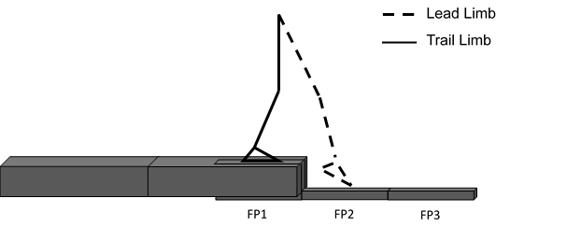
Figure 1. Depiction of step platform. Three force platforms are denoted and a visualisation of a toe-contact strategy is included with the defined lead and trail limb. The final section of the step platform included a separate box that attached individually to the force platform to ensure good force data were collected.
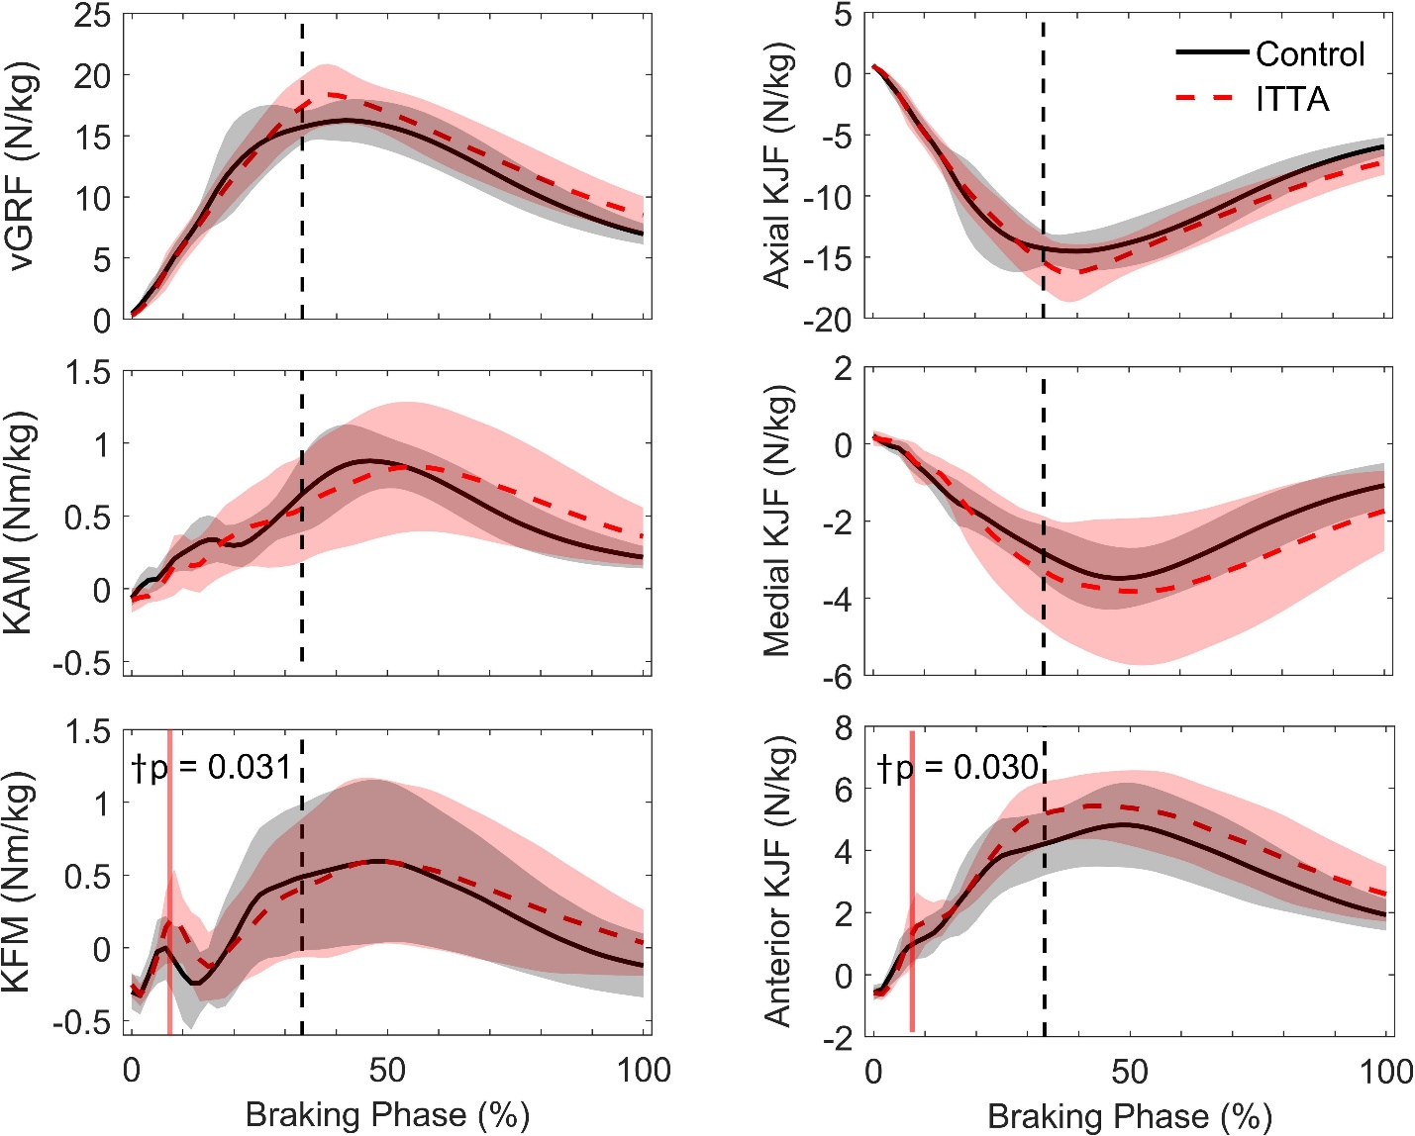
Figure 2. Lead limb loading waveforms. Loading waveforms in the intact limb of ITTAs (red dashed line) and leading limb of the control group (black solid line) for the duration of the braking phase are presented. Shaded regions represent 1 standard deviation. The phases of significant difference are highlighted vertically in red †that became significant after covarying for speed. The black vertical dashed line represents the average time point at which the end of the double support phase occurred across all participant trials. KJF = knee joint reaction force
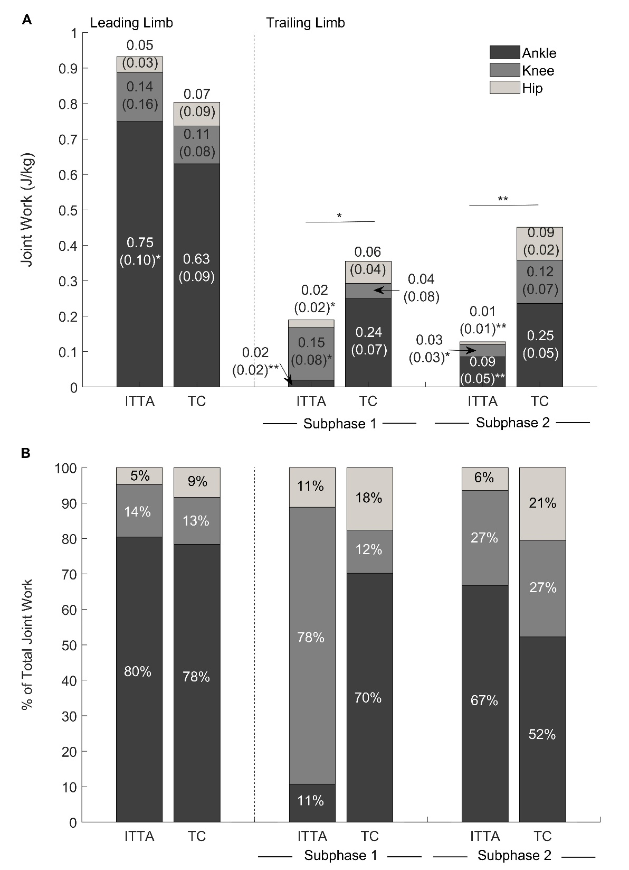
Figure 3. Leading and trailing limb joint work. A) Absolute values of the positive and negative joint work completed and B) percentage joint contribution relative to the total joint work completed in the ankle, knee, and hip joints for the leading limb (LL) and trailing limb (TL) subphases in the ITTA and toe-contact control (TC) groups.
References
Alimusaj, M., Fradet, L., Braatz, F., Gerner, H.J., Wolf, S.I., 2009. Kinematics and kinetics with an adaptive ankle foot system during stair ambulation of transtibial amputees. Gait Posture. 30, 356-363.
Astephen Wilson, J.L., 2012. Challenges in dealing with walking speed in knee osteoarthritis gait analyses. Clinical Biomechanics. 27, 210-212.
Barnett, C., Polman, R., Vanicek, N., 2014. Longitudinal changes in transtibial amputee gait characteristics when negotiating a change in surface height during continuous gait. Clin. Biomech. 29, 787-793.
Culver, S., Bartlett, H., Shultz, A., Goldfarb, M., 2018. A stair ascent and descent controller for a powered ankle prosthesis. IEEE Transactions on Neural Systems and Rehabilitation Engineering. 26, 993-1002.
Davis, R.B., Ounpuu, S., Tyburski, D., Gage, J.R., 1991. A gait analysis data collection and reduction technique. Human movement science. 10, 575-587.
Jones, S.F., Twigg, P.C., Scally, A.J., Buckley, J.G., 2006. The mechanics of landing when stepping down in unilateral lower-limb amputees. Clin. Biomech. 21, 184-193.
Kent, J., Franklyn-Miller, A., 2011. Biomechanical models in the study of lower limb amputee kinematics: a review. Prosthet. Orthot. Int. 35, 124-139.
LaRoche, D.P., Millett, E.D., Kralian, R.J., 2011. Low strength is related to diminished ground reaction forces and walking performance in older women. Gait Posture. 33, 668-672.
Moudy, S., Tillin, N.A., Sibley, A.R., Strike, S., 2019. Foot strike alters ground reaction force and knee load when stepping down during ongoing walking. Gait Posture.
Murray, A.M., Gaffney, B.M., Davidson, B.S., Christiansen, C.L., 2017. Biomechanical compensations of the trunk and lower extremities during stepping tasks after unilateral transtibial amputation. Clin. Biomech. 49, 64-71.
Pataky, T.C., 2012. One-dimensional statistical parametric mapping in Python. Comput. Methods Biomech. Biomed. Engin. 15, 295-301.
Pickle, N.T., Wilken, J.M., Aldridge, J.M., Neptune, R.R., Silverman, A.K., 2014. Whole-body angular momentum during stair walking using passive and powered lower-limb prostheses. J. Biomech. 47, 3380-3389.
Rusaw, D., Ramstrand, N., 2010. Sagittal plane position of the functional joint centre of prosthetic foot/ankle mechanisms. Clin. Biomech. 25, 713-720.
Rusaw, D., Ramstrand, N., 2011. Motion-analysis studies of transtibial prosthesis users: a systematic review. Prosthet. Orthot. Int. 35, 8-19.
Schmalz, T., Blumentritt, S., Marx, B., 2007. Biomechanical analysis of stair ambulation in lower limb amputees. Gait Posture. 25, 267-278.
Thoma, L., McNally, M., Chaudhari, A., Best, T., Flanigan, D., Siston, R., Schmitt, L., 2017. Differential knee joint loading patterns during gait for individuals with tibiofemoral and patellofemoral articular cartilage defects in the knee. Osteoarthritis and cartilage. 25, 1046-1054.
Thompson, B.J, Ryan, E.D., Sobolewski, E.J., Conchola, E.C. and Cramer, J.T., 2013. Age related differences in maximal and rapid torque characteristics of the leg extensors and flexors in young, middle-aged and old men. Experimental gerontology, 48(2), pp. 277-282.
van Dieën, J.H., Pijnappels, M., 2009. Effects of conflicting constraints and age on strategy choice in stepping down during gait. Gait & Posture. 29, 343-345.
van Dieën, J.H., Spanjaard, M., Konemann, R., Bron, L., Pijnappels, M., 2007. Balance control in stepping down expected and unexpected level changes. Journal of Biomechanics. 40, 3641-3649.
van Dieën, J.H., Spanjaard, M., Könemann, R., Bron, L., Pijnappels, M., 2008. Mechanics of toe and heel landing in stepping down in ongoing gait. Journal of Biomechanics. 41, 2417-2421.
Wezenberg, D., van der Woude, Lucas H, Faber, W.X., de Haan, A., Houdijk, H., 2013. Relation between aerobic capacity and walking ability in older adults with a lower-limb amputation. Arch. Phys. Med. Rehabil. 94, 1714-1720.
Zeni, J.A., Higginson, J.S., 2009. Differences in gait parameters between healthy subjects and persons with moderate and severe knee osteoarthritis: A result of altered walking speed? Clinical Biomechanics. 24, 372-378.

