Instagram and Successful Fashion Promotion

Author Mr Greg Tallent
London South Bank University, London, United Kingdom
greg.tallent@lsbu.ac.uk
December 2015

Abstract

Instagram is an effective way for companies to communicate directly with their customers, promote various events and initiatives, and build brand awareness. The fashion industry, in particular, has successfully embraced this platform and now uses it in strategic ways to achieve clear objectives. A recent example is Mishanonoo.com who showed their New York Fashion Week SS16 collection as an #instashow on Instagram.
This research investigates customer engagement as determined by the record of interactions on images presented by fashion brands on Instagram. The data is obtained from the Instagram API.
It uses a data-driven ratio analysis to show how the number of likes and comments made by users against images on Instagram demonstrates successful promotional campaigns by major fashion brands as evidenced by website statistics. This strength of user interaction is a result of the quality and style of images posted and an analysis of the visual aesthetic by a major fashion brand, Caroline Herrera, presented.
The study highlights the importance of marketers to gauge the user response to the promotional campaigns running on social media platforms. It is argued that the opportunities presented by social media require the organisation become a social enterprise, that is, in frequent and entertaining communication with its customers.

Keywords: social media, engagement, organisations, instagram, marketing, networks, api, Caroline Herrera

Introduction 3
Instagram Marketing in the Fashion Industry 4
Conversations on Instagram 4
Conceptual Framework 5
Research Problem and Questions 5
Methodology 6
Data Analysis and Discussion 6
Conclusion 8
Limitations and Further Research 9
Bibliography 10
Appendix 1 11
Chart Showing Top 100 Images Ordered by Highest Likes-Over-Followers Ratio 11
Appendix 2 15
Table of Ratios – Ordered by Highest Likes-Over-Followers Ratio 15

Introduction
Social media networking is now the most popular online activity and a large part of this interaction involves sharing content on platforms such as Instagram. As a visual medium, this platform now has over 300 million members who share more than 70 million photos and videos each day (Beese, 2015). Opportunities have arisen for a whole new area of peer interaction of both a social and a commercial nature.
Among these opportunities is the possibility of inexpensive and regular communication by companies with its customers. The approach taken by leading companies has shifted from a traditional one-to-many communication (TV, radio, print) to a one-to-one approach. Procter & Gamble Chairman Bob McDonald says:
Any medium that helps us create a one on one relationship with any consumer is what we want to do. An endpoint of marketing is a one-to-one relationship with any consumer. Digital allows that relationship. I want a one on one relationship with 7,000,000,000 people - where we can customise the offering. (Woodcock et al., 2011)
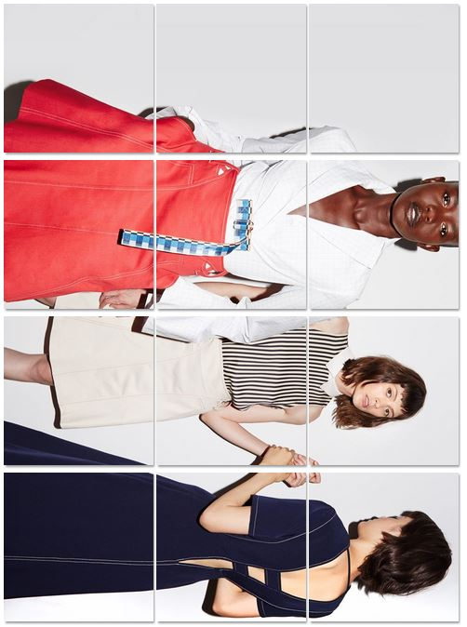
Instagram is a progressive platform as its features are continually being extended, for example, it has recently started offering advertising to large brands, and its audience is increasing. It is able to capture real ‘life’ moments by anyone with a cell phone, and allows unique experiences to be shared quickly and easily. For example, the fashion designer Misha Nonoo achieved almost 3000 followers in two days when she showed her SS16 collection at New York Fashion Week in September 2015.
Misha Nonoo’s Spring Summer 2016 collection as an #instashow on Instagram
One distinct and important feature of Instagram is that it is predominantly a mobile platform. Posts to the service can only be made on a mobile device, and as almost everyone with spending capacity in the Western world now has a cell phone it still has significant growth potential.
This visual social application offers the ability to post pictures and 15-second videos wherever there is a mobile connection. The users of this social media are mostly females between the ages of 18-29 (37%) and 30-49 (17%) and are mostly urban and youthful (Duggan and Smith, 2013).
Instagram gives fashion companies a creative and inclusive approach to enhancing brand awareness and developing relationships with customers. For example, Top Shop, a brand name clothing company in the UK has 5.8 million followers. The company posts pictures of new collections and also short video clips daily (Topshop, 2015). The platform is a strategic communication tool for the company and is used to strengthen relationships with their customers.

Instagram Marketing in the Fashion Industry
More than half of online fashion retailers are certain that Instagram is the next big social network to impact e-commerce for the reason that these companies prefer strategies focusing on visual portfolio and brand awareness, instead of simply financing ad hoc campaign promotions (Lazazzera, 2015).
Instagram shows heavy use in fashion, with 65% of leading brands already having an active account, and 19% of those brands with more than 100,000 followers. The brands that are active post photos or videos at least once a week (Whiting and Despande, 2014).
Thus, Instagram is the most important social media marketing platform for fashion brands. Louis Vuitton, Victoria Beckham and Chanel each have over 6 million followers. While these statistics are not as large in comparison to the number of likes that those same brands have attracted (or purchased) on their Facebook pages - Louis Vuitton, for instance, has 17 million Facebook likes - they signal a real opportunity for brands to make an impression on an audience hungry for compelling visual content. According to a recent report by Exane BNP Paribas on luxury fashion brands, Instagram produces significantly higher consumer engagement at 93 percent - measured as the combination of likes and comments - than posts on either Facebook (6 percent) or Twitter (1 percent) (Sherman, 2015).

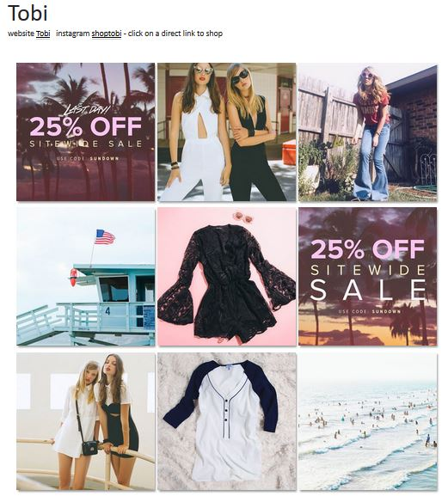
Conversations on Instagram
Fashion brand Tobi promoted on Instagram
Companies strive to increase online traffic and ultimately their brand loyalty and sales. Customers connect with people, not the company. To connect as an individual you need to have real conversations, and have something to bring to the table that is valuable to the party on the receiving end.
The company therefore needs to create content that speaks to the different people they are hoping to connect with. Consistently reaching out and regularly posting will help build a community. Individual posts should share helpful content, information, facts, insight, trends, and relevant initiatives, and those posts should spark conversations through open and inviting dialogue.
Responsiveness is a required part of a conversation. A company needs to respond to their customer’s comments. On Instagram, a company can comment on their posts, for example the fashion brand Mango uses comments on almost half of their posts (59%) (Cukul, 2015). This gives visitors something to talk about and share with others and the company becomes part of the conversation.
Through these conversations, social media provides not only a source of market information, but gives the customer a voice. Users can ‘like’ images put out by the brand, comment on these, and share them with other people. Brands, in turn, can utilise social media to obtain ‘live’ information about consumer behaviour. In general, content on social media has to be directed to the customer, and importantly, comments made by customers should be read and responded to.

Conceptual Framework
As the fashion industry has embraced social media (and this earlier than other sectors), customer engagement (CE) with brands is now stronger than ever. To understand the nature of this engagement, research has taken a psychological approach to study the interaction between company and consumer. The engagement concept originated in psychology, sociology and organisational behaviour research:
Customer engagement is a psychological state that occurs by virtue of interactive, co-creative customer experiences with a focal agent/object (e.g., a brand) in focal service relationships. (Brodie et al., 2011).
The advertising Research Foundation acknowledges there is no single theory to explain engagement or how it works. Currently, engagement definitions include such concepts as attention, perception, emotion and social relations (Nelson-Field and Taylor, 2012). Further, this engagement occurs under different contexts, for example, at work, play or in various social situations, and as such, exists as a dynamic, interactive process that create value. CE also exhibits other relational concepts such as involvement, attachment and loyalty.
For the purposes of this paper, we take CE to be a multidimensional concept subject to specific expressions of relevant cognitive, emotional and/or behavioural dimensions (Brodie et al., 2011), which, taken together, forms the engagement the user has with the brand.
The record of this engagement is shown by the likes, comments and shares against each image posted by the brand. Any such action shows there exists some attachment to the brand. The strength or intensity of this attachment can be measured by the number of such actions and will determine the success or otherwise of the brand’s promotional material.
Finally, as the user is reacting to an image, the data may also suggest why some images succeed and others do not. Thus a qualitative review of the images that achieve the most promotion is also possible.

Research Problem and Questions
Instagram is a business tool that has already demonstrated great potential to influence customer behaviour and increase sales. With the numbers of followers for high fashion brands reaching in the millions, it is clear that there are huge benefits to be gained by using this tool.
However, measuring the effectiveness of social media is still in its infancy (Smith, 2013). More research needs to be done to understand and measure this engagement between customers and brand promotion. The measures below are used to determine the strength of engagement between the user and the brand, to determine if this engagement translates into successful promotion, and to provide a qualitative review of the images used by the brand.
- To determine if there is a correlation between the ratios of likes-over-followers and comments-over-followers.
- Whether user generated content, that is, the number of likes and comments, is related to the effectiveness of the brand promotion.
- To suggest a qualitative review of images that are succeeding on Instagram.

Methodology
On Instagram, customer engagement is essentially a response to an image posted by a fashion brand. Understanding this consumer behaviour should rely on data that comes from Instagram itself, and so the Application Programming Interface provided by Instagram is used to obtain the data for analysis. A nonprobability sample was obtained, and since Instagram is not geographically constrained the sample is expected to be international.
User interaction on this platform is predominantly through the number of likes and comments that are seen against each image (users also share the images with their followers but this is less frequent and is not taken into account in this research). This data provides information on the promotional value of the brand image. When there are many likes and comments against an image it is clear that there is a stronger engagement or, in business terms, stronger promotion.
For purposes of validity of this research, the following conditions have been used:
- There are different follower numbers on each brand due to how long they have been using Instagram, how frequently they post, and how much their images are appreciated by users. Consequently, to be able to compare brand against brand, we need to take the ratios of likes-over-followers and comments-over-followers.
- Only brands with follower counts of over 20,000 were considered. This was to ensure that the numbers in the snapshot, although changing after that snapshot date (followers would interact with the posts after data capture), would not change appreciably and so the ratios would remain approximately the same to ensure a correct analysis.
- A sample size of 215 images was obtained over that period and the top 100 images in order of the highest likes-over-followers ratio were considered.
- The data was collected over a period of several weeks, and the snapshot taken on the December 13, 2015.
The tables in the appendices show the data capture on that date, and the trends and relationships between variables.

Data Analysis and Discussion
The first objective was to determine if there is a correlation between the ratios of likes-over-followers and comments-over-followers. If so, that is, a significant number of users make both likes and comments, then there is a strong attachment to that image.
The 215 sample was plotted in descending order of likes-over-followers and the corresponding ratio of comments-over-followers also plotted. The graph shown below is plotted on a logarithmic scale to allow comparison. It is clear that as the number of likes falls, so does the number of comments against the same image. In other words, as a corollary, the more emotional attachment there is, the more a user is inclined to comment.

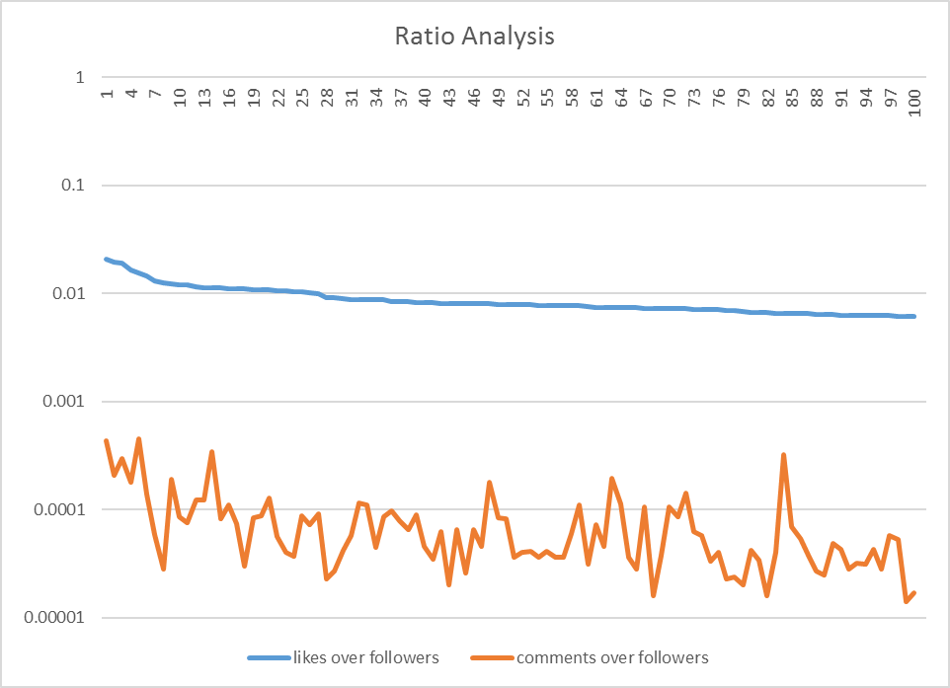

The second objective was to determine whether user generated content, that is, the number of likes and comments, is related to the effectiveness of the brand promotion. An increase in traffic to the website of the fashion brand would show effective brand promotion.
The chart below shows that site visits to www.carolinaherrera.com, last updated December 10, 2015, has been increasing steadily over the past few months. Although no referral statistics from Instagram to its website are available for the brand, it can be argued that as there is an increase in site visits over the same period, there is definite promotional value in the Instagram posts. (Carolinaherrera.com site overview, 2015)

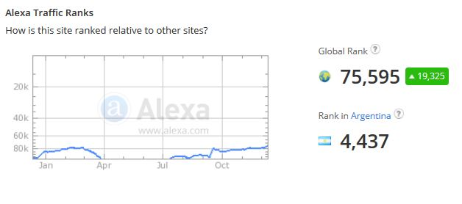
The third objective was to present a qualitative review of images that succeed on Instagram. The chart in Appendix 1 shows the images, in descending order of the highest likes-over-followers ratio. It also shows the ratio of likes and followers and the total number of likes on the snapshot date.
Four out of the top five images in order of highest likes-over-followers ratio (below) are from the Carolina Herrera brand and show elegant yet wearable dresses in various contexts.

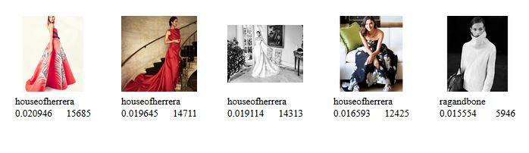
It appears that the more ‘edgy’ or ‘contemporary’ images (also shown in the appendix) have lower ratios and are not so favoured by the majority of users.

Conclusion
Social media allows conversations between companies and their customers, as well as encouraging customers to share their thoughts on news, trends and events with others. This is particularly useful/relevant in the fashion industry which can be seen as more image enhancing rather than need satisfying. In this sector, social media is used to create an interest in and a desire for products and services, usually by promoting an aesthetic and lifestyle attractive to customers. It is now a key component of its advertising campaigns.
The motivation of this research was to develop a data-derived analysis of the behaviour of customers on Instagram. The visual nature of this social platform encourages customer engagement and triggers cognitive, emotional and/or behavioural reactions in consumers. Businesses such as Carolina Herrera (and many others) use this platform to reach out to a global audience. Interaction by the consumer indicates an attachment to the fashion brand.
This paper shows that such engagement - the likes and comments against each image - is significant in successful promotions and would translate into purchases by customers. It also demonstrates that Instagram users are receptive to visually pleasing branded content.
Instagram use brings two clear advantages to a fashion company. Firstly, it can convert the costly process of finding customers to a more efficient and effective ‘two-way street’ where customers can find the firm as well. Secondly, having found customers, social media can allow the firm to engage them in ways that both encourage loyalty and manage expectations, which has an impact on the bottom line.
It is important to recognise that this research also shows that the opportunities presented by social media require the organisation become a social enterprise, that is, in frequent and entertaining communication with its customers. Instagram is a very effective platform to achieve this.

Limitations and Further Research
The scope of this research was limited to Instagram, however, it is likely that similar research would show the same observations apply to other social media as well such as Facebook and Twitter.
It is interesting to note that the response rate of just over 2% of likes-over-followers is the highest achieved (see Appendix 2). More research should be conducted to determine why this is the case, and how it compares with other social media platforms.
The 215 sample size of this study was relatively small; a larger sample, say over 1000, is recommended for replication of studies on this and other visual social media.
More data should be collected on the psychological aspect of engagement with images to obtain a deeper assessment of the underlying reasons and motivations.
Given the rapidly changing nature of social media, where the relationships between participants are evolving, any such research needs to be reviewed on a regular basis.

Bibliography
Beese, J. (2015) ‘Strategy & Leadership’, 22 January. Available at: http://sproutsocial.com/insights/5-instagram-stats/ .
Brodie, R., Hollebeek, L., Juric, B. and Ilic, A. (2011) ‘Customer Engagement: Conceptual Domain, Fundamental Propositions, and Implications for Research’, Journal of Service Research, 14(3).
Carolinaherrera.com site overview (2015) Available at: http://www.alexa.com/siteinfo/carolinaherrera.com (Accessed: 15 December 2015).
Cukul, D. (2015) ‘Fashion Marketing in Social Media: Using Instagram for Fashion Branding’, Proceedings. p. 116.
Gladwell, M. (2000) The Tipping Point: How Little Things can make a Big Difference. New York, NY: Little Brown and Company.
Lazazzera, R. (2015) How To Build A Massive Following On Instagram. Available at: http://shopify.com/blog/14288561-how-to-build-a-massive-following-on-instagram (Accessed: 15 December 2015).
Nelson-Field, K. and Taylor, J. (2012) ‘Facebook fans: A fan for life?’, Admap, .
Sherman, L. (no date) Inside Fashion’s Instagram Wars. Available at: http://www.businessoffashion.com/articles/intelligence/fashion-instagram-brands-social-media-proenza-schouler-calvin-klein .
Smith, S. (2013) ‘Conceptualising and evaluating experiences with brands on Facebook’, International journal of market research, 55(3), p. 357; 357.
Topshop (@topshop) â€¢ Instagram photos and videos (no date) Available at: https://www.instagram.com/topshop/ (Accessed: 17 December 2015).
Whiting, A. and Despande, A. (2014) ‘Social Media Marketing: A Myth or a Necessity’, Journal of Applied Business and Economics, 16(5).
Woodcock, N., Green, A. and Starkey, M. (2011) ‘Social CRM as a business strategy’, Journal of Database Marketing & Customer Strategy Management, 18(1), p. 50. doi: 10.1057/dbm.2011.7.

Appendix 1

Chart Showing Top 100 Images Ordered by Highest Likes-Over-Followers Ratio
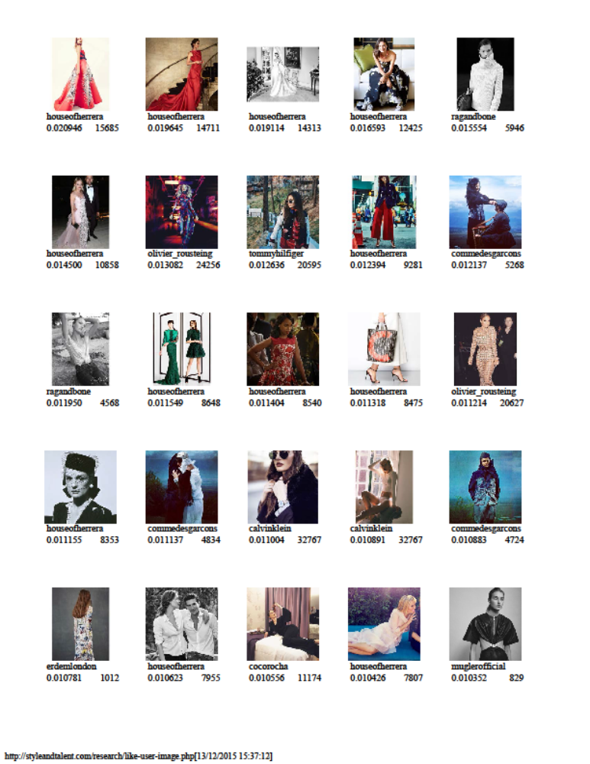
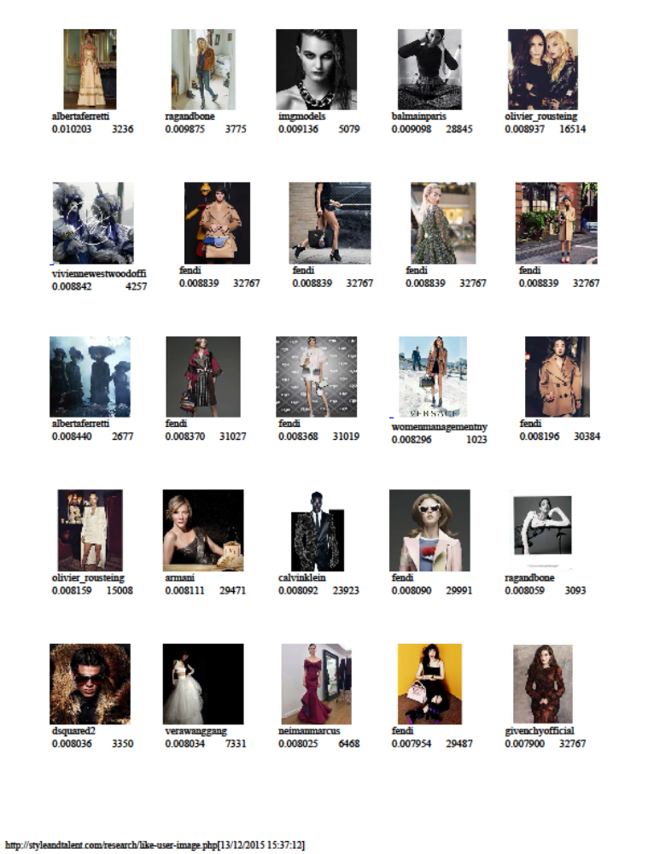
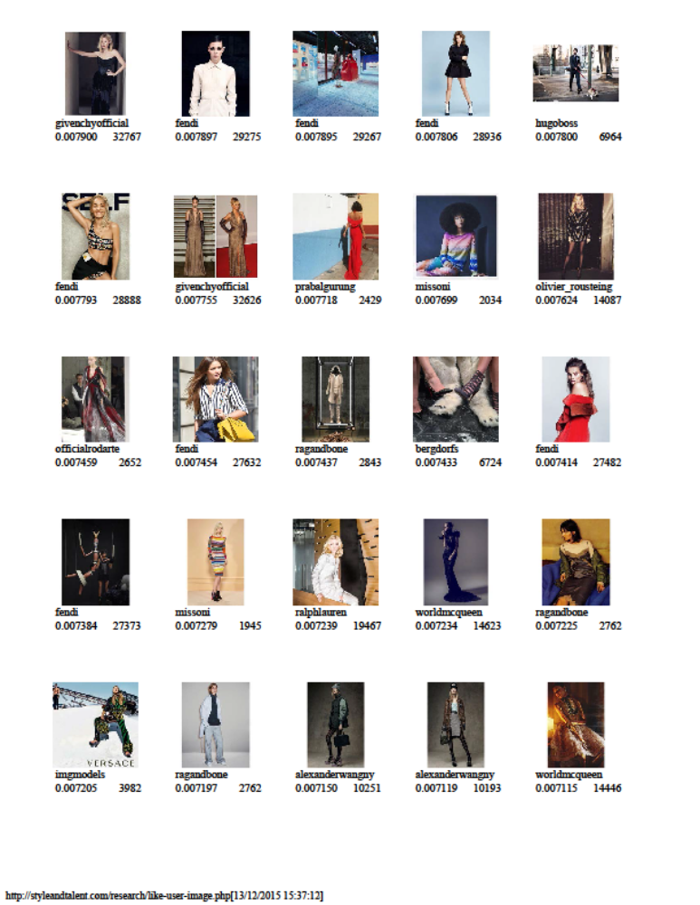
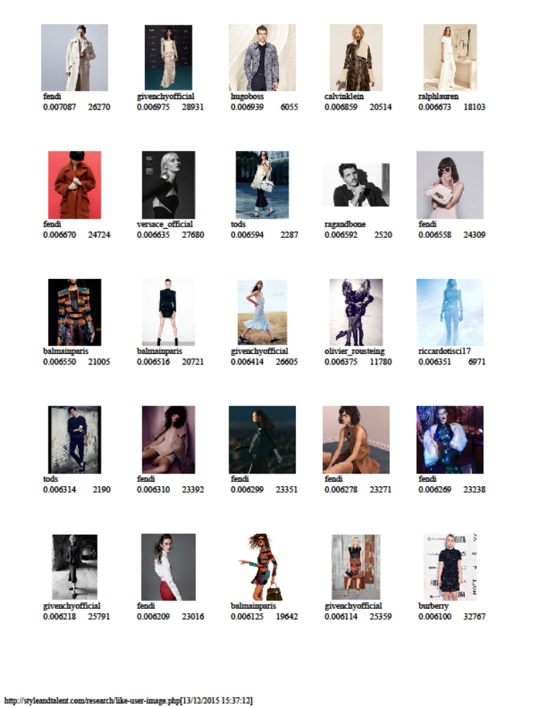

Appendix 2

Table of Ratios – Ordered by Highest Likes-Over-Followers Ratio
username followers likescount comment likes_over_followers comments_over_followers
houseofherrera 748831 15685 322 0.020946 0.00043
houseofherrera 748831 14711 155 0.019645 0.000207
houseofherrera 748831 14313 221 0.019114 0.000295
houseofherrera 748831 12425 133 0.016593 0.000178
ragandbone 382274 5946 172 0.015554 0.00045
houseofherrera 748831 10858 104 0.0145 0.000139
olivier_rousteing 1854080 24256 109 0.013082 0.000059
tommyhilfiger 1629812 20595 46 0.012636 0.000028
houseofherrera 748831 9281 142 0.012394 0.00019
commedesgarcons 434057 5268 37 0.012137 0.000085
ragandbone 382274 4568 29 0.01195 0.000076
houseofherrera 748831 8648 91 0.011549 0.000122
houseofherrera 748831 8540 92 0.011404 0.000123
houseofherrera 748831 8475 255 0.011318 0.000341
olivier_rousteing 1839339 20627 150 0.011214 0.000082
houseofherrera 748831 8353 83 0.011155 0.000111
commedesgarcons 434057 4834 32 0.011137 0.000074
calvinklein 2977750 32767 88 0.011004 0.00003
calvinklein 3008521 32767 253 0.010891 0.000084
commedesgarcons 434057 4724 38 0.010883 0.000088
erdemlondon 93871 1012 12 0.010781 0.000128
houseofherrera 748831 7955 42 0.010623 0.000056
cocorocha 1058519 11174 42 0.010556 0.00004
houseofherrera 748831 7807 28 0.010426 0.000037
muglerofficial 80083 829 7 0.010352 0.000087
albertaferretti 317168 3236 23 0.010203 0.000073
ragandbone 382274 3775 35 0.009875 0.000092
imgmodels 555905 5079 13 0.009136 0.000023
balmainparis 3170487 28845 86 0.009098 0.000027
olivier_rousteing 1847814 16514 78 0.008937 0.000042
viviennewestwoodoffi 481426 4257 28 0.008842 0.000058
fendi 3706967 32767 431 0.008839 0.000116
fendi 3706967 32767 407 0.008839 0.00011
fendi 3706966 32767 167 0.008839 0.000045
fendi 3706990 32767 316 0.008839 0.000085
albertaferretti 317168 2677 31 0.00844 0.000098
fendi 3706967 31027 293 0.00837 0.000079
fendi 3706990 31019 244 0.008368 0.000066
womenmanagementny 123313 1023 11 0.008296 0.000089
fendi 3706967 30384 170 0.008196 0.000046
olivier_rousteing 1839339 15008 64 0.008159 0.000035
armani 3633588 29471 227 0.008111 0.000062
calvinklein 2956496 23923 58 0.008092 0.00002
fendi 3706990 29991 242 0.00809 0.000065
ragandbone 383776 3093 10 0.008059 0.000026
dsquared2 416849 3350 27 0.008036 0.000065
verawanggang 912529 7331 42 0.008034 0.000046
neimanmarcus 806010 6468 144 0.008025 0.000179
fendi 3706967 29487 313 0.007954 0.000084
givenchyofficial 4147924 32767 341 0.0079 0.000082
givenchyofficial 4147924 32767 150 0.0079 0.000036
fendi 3706967 29275 148 0.007897 0.00004
fendi 3706990 29267 151 0.007895 0.000041
fendi 3706967 28936 135 0.007806 0.000036
hugoboss 892871 6964 37 0.0078 0.000041
fendi 3706967 28888 135 0.007793 0.000036
givenchyofficial 4207078 32626 151 0.007755 0.000036
prabalgurung 314713 2429 19 0.007718 0.00006
missoni 264183 2034 29 0.007699 0.00011
olivier_rousteing 1847814 14087 57 0.007624 0.000031
officialrodarte 355558 2652 26 0.007459 0.000073
fendi 3706990 27632 169 0.007454 0.000046
ragandbone 382274 2843 74 0.007437 0.000194
bergdorfs 904575 6724 103 0.007433 0.000114
fendi 3706966 27482 132 0.007414 0.000036
fendi 3706967 27373 103 0.007384 0.000028
missoni 267214 1945 28 0.007279 0.000105
ralphlauren 2689301 19467 43 0.007239 0.000016
worldmcqueen 2021336 14623 77 0.007234 0.000038
ragandbone 382274 2762 41 0.007225 0.000107
imgmodels 552681 3982 47 0.007205 0.000085
ragandbone 383776 2762 54 0.007197 0.000141
alexanderwangny 1433733 10251 91 0.00715 0.000063
alexanderwangny 1431737 10193 82 0.007119 0.000057
worldmcqueen 2030289 14446 66 0.007115 0.000033
fendi 3706967 26270 148 0.007087 0.00004
givenchyofficial 4147924 28931 97 0.006975 0.000023
hugoboss 872551 6055 21 0.006939 0.000024
calvinklein 2991019 20514 61 0.006859 0.00002
ralphlauren 2712979 18103 115 0.006673 0.000042
fendi 3706967 24724 126 0.00667 0.000034
versace_official 4171527 27680 68 0.006635 0.000016
tods 346835 2287 14 0.006594 0.00004
ragandbone 382274 2520 124 0.006592 0.000324
fendi 3706967 24309 260 0.006558 0.00007
balmainparis 3207046 21005 174 0.00655 0.000054
balmainparis 3179986 20721 122 0.006516 0.000038
givenchyofficial 4147924 26605 110 0.006414 0.000027
olivier_rousteing 1847813 11780 47 0.006375 0.000025
riccardotisci17 1097651 6971 54 0.006351 0.000049
tods 346835 2190 15 0.006314 0.000043
fendi 3706967 23392 105 0.00631 0.000028
fendi 3706990 23351 120 0.006299 0.000032
fendi 3706990 23271 114 0.006278 0.000031
fendi 3706990 23238 159 0.006269 0.000043
givenchyofficial 4147924 25791 118 0.006218 0.000028
fendi 3706967 23016 213 0.006209 0.000057
balmainparis 3207047 19642 169 0.006125 0.000053
givenchyofficial 4147924 25359 58 0.006114 0.000014
burberry 5371473 32767 90 0.0061 0.000017

