The importance of Heat Pump COP in the Economics of 5th Generation Heating and Cooling Networks

Akos Revesz, PhD Henrique Lagoeiro, PhD Catarina Marques, PhD
Phil Jones, MSc Chris Dunham, MSc Graeme Maidment, PhD
ABSTRACT
This paper describes the investigation of heat pumps for GreenSCIES, a 5th Generation heat network in Islington, London. The paper describes the GreenSCIES concept integrating Mobility, Power and Heat into a local energy system. At the heart of the system is a 5th generation heat network, which utilises an ambient heat network to capture secondary heat and share heat between different applications. The GreenSCIES network, technology utilised and buildings connected are described. Heat pumps are used to amplify the temperature of the ambient loop to deliver heat at the required temperature in connected buildings. A number of different heat pumps using different refrigerants and configurations were appraised in this study. This considered the performance, safety, environmental impact, operational and capital expenditure point of view. The study shows the importance of heat pump COP on the economics of operating the system and suggests innovative series arrangements in order to improve performance and economics.
INTRODUCTION
The role of district heating and cooling in meeting Net Zero
In 2019, the UK Government committed to reduce its carbon emission to Net Zero by 2050 (GOV.UK, 2019). In order to meet that goal in time, the government announced, in April 2021, the world’s most ambitious climate change target into a law to reduce emissions by 78% by 2035 compared to 1990 levels (GOV.UK, 2020). Heating of buildings is one of the major contributors to greenhouse gas emissions and therefore, decarbonisation of the sector is a critical in order to meet climate targets, as recognised by the UK Government’s Heat and Buildings Strategy (GOV.UK, 2021a). The combination of heat pumps and heat networks offers a major pathway to decarbonise heat in buildings. The UK’s Climate Change Committee estimates that around 18% of UK heat will need to come from heat networks by 2050 if the UK is to meet its carbon targets cost-effectively (CCC, 2020). A recent government report has indicate that heat networks could provide up to 95 TWh [324 MMDth] of of thermal energy per year by 2050, which would represent approximately 20% of the UK’s domestic heating demand (GOV.UK, 2021b). Therefore, the UK Government has provided technical and project management support through its Heat Networks Delivery Unit (HNDU) for a number of years. This has supported heat mapping, detailed feasibility studies and project development works for over 100 projects. BEIS is currently investing up to £320M [$384M] through the existing Heat Networks Investment Project (HNIP), using grants and loans to accelerate the growth of the market (GOV.UK, 2018). This scheme will come to an end in 2022 but will be followed by a further £270M [$324M] in funding from 2022 through the new Green Heat Network Fund (GOV.UK, 2022).
The latest generation of energy networks – project GreenSCIES
There is also a clear move to reduce temperatures in heat networks. The generation of energy networks has been illustrated and the benefits of the latest generation of networks, 5th generation (5G) ultra-low temperature, also called ‘ambient loop’ has been described by Revesz et al. (2020), Jones (2019) and Buffa et al. (2019).
The 5G concept includes decentralised energy centres and heat pumps in each building. Ambient loops can share heating and cooling with even greater carbon savings than 3rd and 4th generation low temperature networks, as reported by Marques et al. (2020). They can also utilise low temperature waste heat sources more effectively, such as that from data centres, sewage treatment plants, electrical substations, and underground railways.
A good example of a 5G scheme is Project GreenSCIES, which is a detailed design study to develop a Smart Local Energy System (SLES) for a large community in the London Borough of Islington (Islington Council, 2020). The project is funded by Innovate UK, part of UK Research and Innovation (UKRI), through the Government's Industrial Strategy Challenge Fund on Prospering from the Energy Revolution. Results from the concept design stage of the project showed the scheme has the potential to reduce carbon emissions by 80% (over conventional systems). This will tend to 100% as the grid decarbonising further. The fundamental aim of the project is to develop a construction ready design for a scheme that tackles fuel poverty by providing significant reduction on consumer bills, delivers large reductions in air pollution, and improves local skills, jobs and economies. The GreenSCIES Future Plan covers a large proportion of Islington; however, the focus of this paper is on a smaller sub-scheme called New River. Both the Future Plan and New River sub-schemes are shown Figure 1. Even the smaller constutible “New River” scheme will save more 5,000 tons of CO2e annually. This is a major decarbonisation solution suitable for large cities across the world.
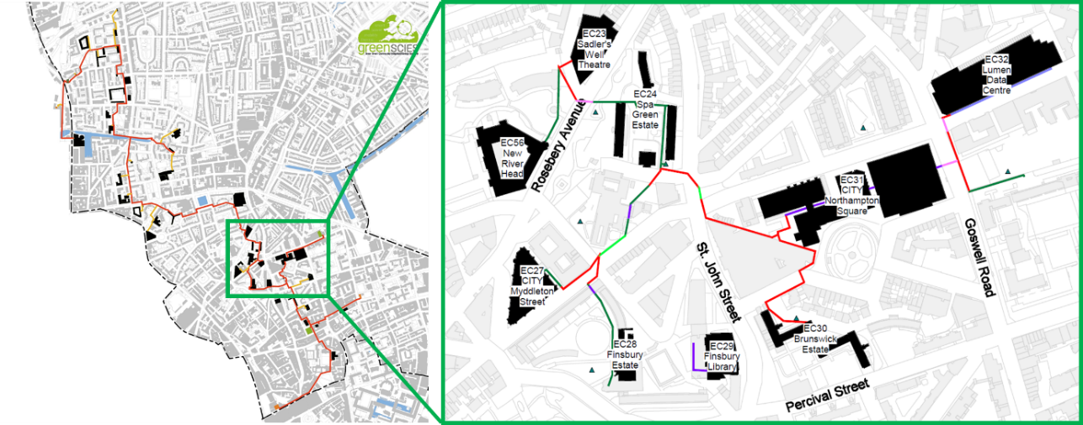
Figure 1. GreenSCIES Future Plan (left) and the New River Scheme (right).
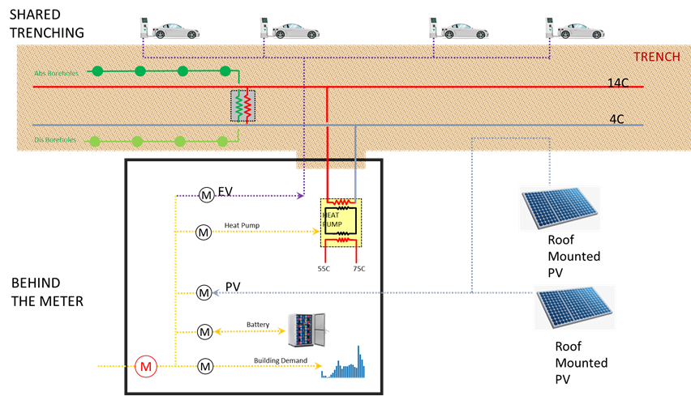
Figure 2. GreenSCIES: Mobility, Power and Heat integration behind the meter, and the shared trenching concept.
The greenscies concept
System Integration
The GreenSCIES concept integrates Mobility Heat & Power (MPH) energy vectors. The integration is achieved at each decentralised energy centre – using a “behind the meter” approach, i.e. all the assets like EV chargers, PV systems and heat pumps are sub-metered behind the main meter. The concept for energy system integration is shown in Figure 2. This approach allows the monitoring and control of assets from the perspective of metering power flow, enabling the generation of revenue from their flexible operations and energy service provision. It can also be seen in Figure 2 that the integration involves the physical sharing of infrastructure between the vectors, i.e. using the same trench for the ambient loop and borehole pipes, EV charge post cables and power cables. The techno-economic benefits of energy system integration are detailed in Revesz et. al. (2020). This paper focusses on the heating and cooling aspects of the scheme, in particular the heat pump selection and the importance of COP.
The operation of the ambient loop
From a heating and cooling perspective, the scheme can essentially be summarised as using data centre heat recovery to supply heat demands in all the remaining buildings. Or to describe this in another way, sharing (prosuming) between the data centre cooling and the heat demands. Figure 3 illustrates this concept. It can be seen that the waste heat recovered from the data centre is distributed in the warm ambient loop header at approximately 13°C [55°F]. Each of the decentralised heat pumps at the individual customer’s energy centres then supplies low carbon heat to end-users at either 65 or 75°C [149°F or 167°F]. The cooling (which is the by-product of heating) from the heat pumps is transported back to the data centre through the cold header of the network. The data centre chilled water system circuits operate between temperatures of 9°C and 14°C [48°F and 57°F].
The hydraulic concept is based on a two-pipe ambient loop radial network connecting to customers and energy sources through dedicated energy centres containing heat pumps or heat exchangers. The network will be configured as a radial bi-directional flow system, with a warm pipe and a cold pipe, consisting of a spine with branch connections linking individual customers and energy sources to the main spine. The warm and cold pipes are intended to operate as low loss headers, with modest flow velocities and pressure drops at the design condition. Design velocities are envisaged to be between 1.5 to 2 m/s [4.9 to 6.5 ft/s] in order to provide an optimal balance between investment and operating costs over the life of the project. The hydraulic design is subject to ongoing optimisation.
Temperatures within the warm and cold pipes will vary according to the energy balance across the system. However, it is important to maintain a balanced heat and coolth flow across the network to maximise economic and carbon benefits. The introduction of interseasonal storage can then make use of the local aquifer, achieving Aquifer Thermal Energy Storage (ATES), which provides a novel way of delivering a balancing mechanism. It can be seen in Figure 2 that the ATES system in GreenSCIES is being achieved through the formation of warm and cold borehole wells providing long-term thermal energy storage capacity. During periods when customer demand for high temperature heat is less than the data centre demand for cooling, heat recovered from the data centre will be injected into the aquifer hot store.
The provision of cooling to the data centre is the central part of the economic considerations. Therefore, the data centre heat exchanger will be configured as the primary cooling customer and will normally be given preferential access to coolth over the borehole and other cooling customers connected to the network. Daily imbalances between high temperature heat demand and data centre cooling demand require careful balancing. Reversing flow through borehole wells to meet these short-term variations is not an option, since the thermal inertia of system is too high to make this effective. In order to ensure un-interrupted cooling supply, the GreenSCIES design proposes to configure the largest heat pump on the network to have the facility to operate as a water-cooled chiller (referred to as A-loop) at times when there is no or insufficient customer demand for high grade heat. During these times, the heat pump will condition the ambient loop cold side through the evaporator circuit and reject condenser heat into the aquifer. The switchover arrangement between the heat pump and A-loop chiller operation is described in Figure 3. Results of techno-economic investigations showed that this configuration significantly improves financial returns.
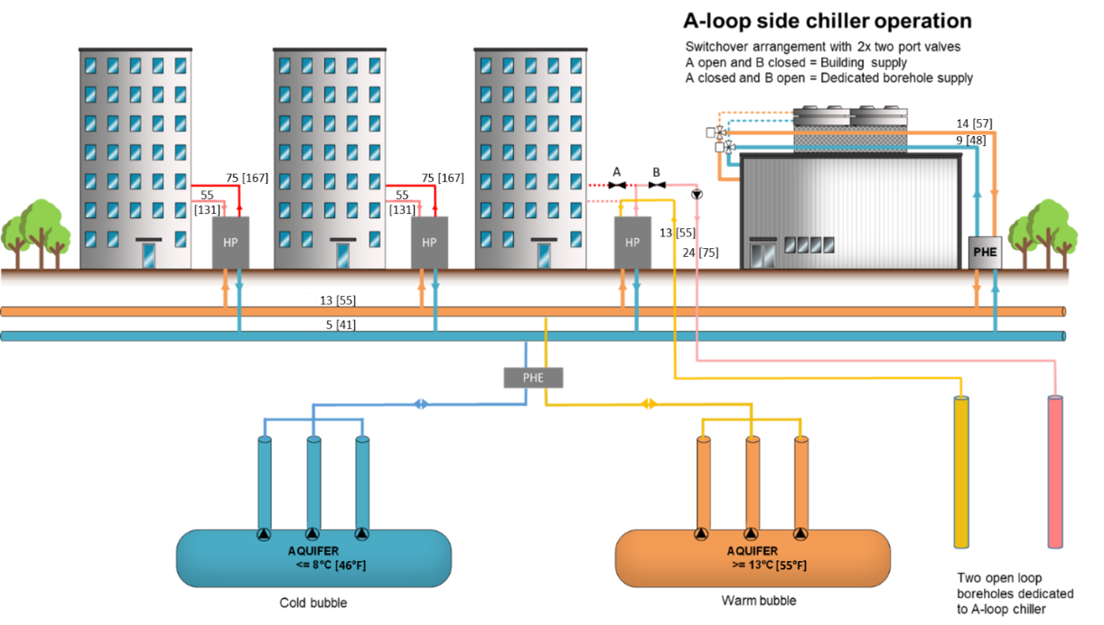
Figure 3. The ATES concept with an A-loop chiller.
THermal demands and component selection
Heating and cooling demands of the New River Scheme
Figure 4 shows the combined heating and cooling demand data for the New River Scheme. The data centre has approximately 3 MW [10.2 MMBTU/h] constant cooling demand across the year (topped up with some of the buildings cooling demand in the summer period). Where possible, data was gathered from actual half-hourly gas and electricity data. Where this was not available, annual consumption was used and profiled according to a combination of weather data and a typical profile shape for that building type developed from previous work. The breakdown of the annual heat and coolth demand for each of the Energy Centres (EC) together with the selected heat pump capacities for each of them are shown in Table 1.
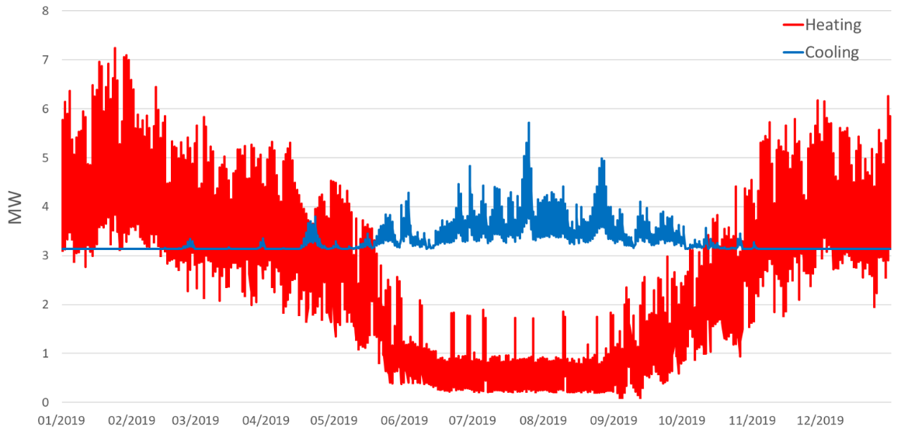
Figure 4. Combined heating and cooling demand of the New River Scheme.
Table 1. Energy Centres and annual heat demands for the New River Scheme.
Buildings | Annual Heat Demand
Sadler's Wells Theatre (incl. NRH) | 2,182 MWh [7,445 Dth]
Spa Green Estate (incl. Huw Myddelton School) | 2,718 MWh [9,274 Dth]
CUL Myddelton Street (incl. Rosberry Hall) | 1,946 MWh [6,640 Dth]
Finsbury Estate (incl. Library) | 4,534 MWh [15,471 Dth]
Brunswick Estate | 3,338 MWh [11,390 Dth]
CUL Northampton Square (incl. Bunhill DH connection) | 8,665 MWh [29,566 Dth]
Heat pump selection
As part of the heat pump selection, a number of heat pump options have been compared and evaluated. Table 2 shows the different options appraised based upon a 1 MW [3.4 MMBTU/h] heat output capacity from five different manufacturers. This figure shows a range of single and two-stage compressor configurations and different refrigerants.
Table 2. A list of the different options evaluated as part of the heat pump appraisal.
 | Option 1 | Option 2 | Option 3 | Option 4 | Option 5
Manufacturer | A | B | C | D | E
System type | Single stage | Two stage | Single stage  economised | Two stage | Two stage
Refrigerant | R1234ze | R1234ze | R515b | R717 | R290
GWP | 7 | 7 | 293 | 0 | 3
Refrigerant type | A2L | A2L | A1 | B2L | A3
COP @ 75/55 | 2.36 | 2.71 | 2.9 | 3.0 | 3.17
COP @ 65/35 | 3.0 | 3.0 | 3.44 | 3.98 | 3.91
CAPEX  (1 MW HP only)  [3.4 MMBTU/h] | £174,000  [$208,878] | £160,000  [$192,072] | £228,000  [$273,702] | £480,000 at 75°C  [$576,216 at 167°F]  £408,000 at 65°C  [$489,783 at 149°F] | £580,976 at 75°C  [$697,432 at 167°F]  £393,000 at 65°C  [$471,776 at 149°F]

For each of the options compared in Table 2, the normal supply/return temperature used from/to the heat pump was 75/55°C [167/131°F]. We also investigated a scenario where the heat pump can operate in weather compensated mode (or a scenario where radiators are replaced for larger ones) in the scheme down to 65/45°C [149/113°F].
It can be seen in Table 2 that the natural refrigerant options ammonia (R717) and hydrocarbons (R290) perform well on COP but are capital intensive at more than 2 times the capital cost of the cheapest units. The lowest capital cost models have low COP. The mid-range option 3 has relatively good COP and medium capital cost. This is achieved through the use of an economiser and low approach temperatures on both condensers and evaporators. It also uses R515b – a non-flammable, nontoxic (A1) refrigerant which minimizes plant room costs associated with the options using mildly flammable (A2L) (R1234ze), high toxicity/low flammability (B2L) (Ammonia) and high flammability (A3) (hydrocarbon) refrigerants. In the cases of R1234ze, ammonia and hydrocarbons the additional CAPEX requirements i.e. leak detection, ammonia de-risking, emergency ventilation, etc. could be significant and have been included in the analysis later on. Table 2 also gives the GWP of all the refrigerant options and the highest GWP is for R515b, which is 293 and relatively low.
Table 3 shows the calculated performance for each option over a 20-year life cycle using broad assumptions relating to the cost of energy and carbon. The table assumes that the heat pump is used bivalently and delivers heating and cooling and sums the cost of electricity to run the heat pump, the CAPEX cost, and the energy cost saved in delivering cooling required. Option 3, which had a relatively high COP but relatively low CAPEX cost, was the most cost-effective solution over 20 years. This was predominantly due to the high COP, not at the expense of capital cost.
Table 3. Summary of results from the heat pump appraisal.
 | Option 1 | Option 2 | Option 3 | Option 4 | Option 5
Supply temperature | 75°C  [167°F] | 75°C  [167°F] | 75°C  [167°F] | 75°C  [167°F] | 75°C  [167°F]
COP | 2.36 | 2.71 | 2.90 | 3.00 | 3.17
Thermal energy per year | 12,793 MWh  [43,652 Dth] | 12,793 MWh  [43,652 Dth] | 12,793 MWh  [43,652 Dth] | 12,793 MWh  [43,652 Dth] | 12,793 MWh  [43,652 Dth]
Cooling delivered  per year | 7,372 MWh  [25,154 Dth] | 8,072 MWh  [27,543 Dth] | 8,382 MWh  [28,601 Dth] | 8,529 MWh  [29,102 Dth] | 8,757 MWh  [29,880 Dth]
Electricity saved  annually for cooling | 2,948 MWh  [10,059 Dth] | 3,228 MWh  [11,014 Dth] | 3,352 MWh  [11,437 Dth] | 3,411 MWh  [11,639 Dth] | 3,502 MWh  [11,949 Dth]
Annual electricity  input to the HP | 5,420 MWh  [18,494 Dth] | 4,720 MWh  [16,105 Dth] | 4,411 MWh  [15,051 Dth] | 4,264 MWh  [14,549 Dth] | 4,035 MWh  [13,768 Dth]
20 years electricity  input to HP | 108,415 MWh  [369,927 Dth] | 94,413 MWh  [322,151 Dth] | 88,227 MWh  [301,043 Dth] | 85,286 MWh  [291,008 Dth] | 80,712 MWh  [275,401 Dth]
20 years electricity  cost of running HP | £11.5M  [$13.8M] | £10.0M  [$12.0M] | £9.4M  [$11.3M] | £9.0M  [$10.8M] | £8.6M  [$10.3M]
20 years savings  in cooling | 58,977 MWh  [201,238 Dth] | 64,578 MWh  [220,349 Dth] | 67,052 MWh  [228,791 Dth] | 68,229 MWh  [232,807 Dth] | 70,058 MWh  [239,048 Dth]
20 years savings  in cooling | £6.28M  [$7.54M] | £6.80M  [$8.16M] | £7.14M  [$8.57M] | £7.27M  [$8.73M] | £7.46M  [$8.96M]
Capital cost per  capacity (HP only) | £174/kW  [$61/MBTUh⁻¹] | £160/kW  [$56/MBTUh⁻¹] | £228/kW  [$80/MBTUh⁻¹] | £480/kW  [$169/MBTUh⁻¹] | £581/kW  [$204/MBTUh⁻¹]
Total CAPEX (sum of  HP capacity) plus  £100k [$120k]  per plant room for  ammonia | £0.76M  [$0.91M] | £0.70M  [$0.84M] | £1.00M  [$1.20M] | £2.21M  [$2.65M] | £2.55M  [$3.06M]
Sum of costs  (20 year plus CAPEX) | £6.03M  [$7.24M] | £3.88M  [$4.66M] | £3.25M  [$3.90M] | £4.02M  [$4.83M] | £3.69M  [$4.43M]

In addition to the initial appraisal, a further investigation was carried out to explore performance improvements of the heat pumps. This investigation considered the performance of multiple heat pumps operating with condensers in series. The main thrust of this study was to exploit the opportunity that heat pump COP increases when temperature lift is reduced. A number of series connected combinations were investigated and these were assembled based on the capacity ranges available from the pre-selected manufacturer (option 3 in Table 1). These are shown in Figure 5.
This investigation showed that arranging multiple heat pumps with condensers and evaporators in series, COP could be improved significantly, by nearly 30% compared to the single heat pump option. This is because second and third stage condensers and evaporators allow the heat pump to operate at lower temperature lifts and pressure ratios increasing the COP. Apart from the COP, the major advantage with arranging multiple units in series are resiliency and flexibility in maintenance. It is possible to take one machine out for maintenance and run the other one for a lot of the year. There is an additional capital cost and space requirements associated with multiple heat pumps and further work will value the life cycle cost including the equipment and plant room costs.
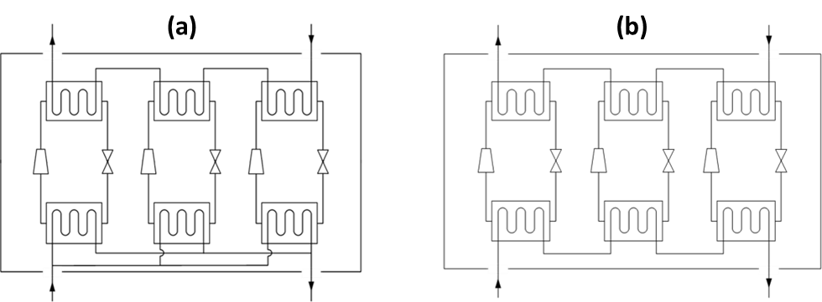
Figure 5. Heat pumps with condensers in series (a) and with evaporators in series (b).
CONCLUSIONs and next steps
This investigation has compared different heat pump configurations for a novel SLES based upon a 5th generation ambient loop concept, which enables the sharing/prosuming of energy between local buildings with high heat demands and a data centre with a significant cooling load. This study evaluated different refrigerant options and cycle configurations based on life cycle costs. The results shown in Tables 2 and 3 demonstrate that refrigerants with high toxicity or flammability have additional CAPEX requirements associated with safety equipment, which makes them costlier over their lifetime despite their high achievable COPs. Option 3 achieved the lowest life cycle costs, as it would have a relatively good COP, higher than options 1 and 2, whilst keeping CAPEX requirements at a medium level. The investigation also indicated how new heat pump arrangements, connecting condensers and evaporators in series, can improve system COP by nearly 30%. This investigation has highlighted some of the challenges and considerations that must be appreciated when implementing a SLES from a heating and cooling perspective. The key insights and conclusions from this study are summarised below:
• The electricity grid is decarbonising and the heating sector is changing rapidly. The combination of heat pumps and heat networks offers a major pathway to decarbonise heat in buildings.
• InnovateUK have provided funding for the GreenSCIES project to lead the way and provide detailed design on an innovative SLES that can provide huge carbon savings.
• Initial results showed that the GreenSCIES concept with large decentralised heat pumps and thermal stores in a 5th generation heat network can be viable with significant OPEX cost savings and carbon savings, whilst providing affordable warmth to residents.
• The GreenSCIES consortium are at the forefront of new applications where heat/coolth can be shared across ultra-low temperature networks and these new approaches present even greater opportunities to move closer to net-zero carbon.
• Large heat pump technology is readily available and offers very large carbon emissions reductions.
• A number of heat pump options from five different manufacturers have been investigated and compared. One option using R515b a low GWP “A1” class refrigerant produces a good COP at relatively low capital cost and delivers the lowest life cycle cost over time.
• Spatial integration of large decentralised heat pumps and thermal stores into existing plant rooms can be challenging but with clever and innovative design is doable.
• There are number of obstacles to roll out schemes like New River. One of the biggest barrier is that the UK has the highest spark gap (i.e. the difference between the price of gas and the price of electricity making heat pump based solutions difficult to compete with fossil fuel based systems. Rebalancing of gas and electricity prices is crucial to meet net-zero targets.
ACKNOWLEDGeMENTS
The authors would like to acknowledge the support from InnovateUK and GreenSCIES partners.
REFERENCES
Buffa, S., Cozzini, M., D’Antoni, M., Baratieri, M. & Fedrizzi, R. 2019. 5th generation district heating and cooling systems: a review of existing cases in Europe. Renewable and Sustainable Energy Reviews 104, 504-22.
The Climate Change Committee (CCC). 2020. Sixth Carbon Budget. Available online: https://www.theccc.org.uk/publication/sixth-carbon-budget/ [Accessed 24 June 2021].
Islington Council. 2020. Vision 2030: Building a Net Zero Carbon Islington by 2030. Available online: https://www.islington.gov.uk/~/media/sharepoint-lists/public-records/energyservices/businessplanning/strategies/ 20202021/20201209vision2030islingtonzerocarbonstrategy1.pdf [Accessed 21 July 2022].
Jones, P. 2019. A roadmap to achieve 5th generation heat networks in the UK, 2019. Proceedings form the CIBSE Technical Symposium, Sheffield, UK.
Marques, C., Dunham, C., Matabuena, R., Revesz, A., Maidment, G., Jones, P. & Lagoeiro, H. 2021. Integration of High Temperature Heat Networks with Low Carbon Ambient Loop Systems. Proceedings of the ASHRAE Winter Conference, USA, 9 – 11 February, 2021.
Revesz, A., Jones, P., Dunham, C., Davies, G., Marques, C., Matabuena, R., Scott, J. & Maidment, G. 2020. Developing novel 5th generation district energy networks. Energy 201: 117389.
UK Government (GOV.UK). 2018. Department for Business, Energy & Industrial Strategy (BEIS) – Heat Networks Investment Project, Introduction to the Scheme. Available online: https://www.gov.uk/government/publications/heat-networks-investment-project-hnip-scheme-overview [Accessed 21 November 2021].
UK Government (GOV.UK). 2019. UK becomes first major economy to pass net zero emissions law. Available online: https://www.gov.uk/government/news/uk-becomes-first-major-economy-to-pass-net-zero-emissions-law [Accessed 21 July 2022].
UK Government (GOV.UK). 2020. Department for Business, Energy & Industrial Strategy (BEIS) – Digest of UK Energy Statistics 2020. Available online: https://www.gov.uk/government/statistics/digest-of-uk-energy-statistics-dukes-2020 [Accessed 18 August 2021].
UK Government (GOV.UK). 2021a. Department for Business, Energy & Industrial Strategy (BEIS) – Heat and Buildings Strategy. Available online: https://www.gov.uk/government/publications/heat-and-buildings-strategy [Accessed 26 October 2021].
UK Government (GOV.UK). 2021b. Department for Business, Energy & Industrial Strategy (BEIS) – Opportunity areas for district heating networks in the UK. Available online: https://www.gov.uk/government/publications/opportunity-areas-for-district-heating-networks-in-the-uk-second-national-comprehensive-assessment [Accessed 23 June 2022].
UK Government (GOV.UK). 2022. Department for Business, Energy & Industrial Strategy (BEIS) – Green Heat Network Fund (GHNF). Available online: https://www.gov.uk/government/publications/green-heat-network-fund-ghnf [Accessed 21 July 2022].

