Experimental investigation on semicircular, triangular and rectangular shaped absorber of solar still with nano-based PCM

Hamid Reza Goshayeshi ¹, Issa Chaer², Metkel Yebiyo³, Hakan F. Öztop⁴
¹Department of Mechanical Engineering
Azad University, Mashhad Branch, Mashhad, Iran
²⁻³The school of Built Environment and Architecture,
London South Bank University, SE1 0AA, London, United Kingdom
⁴Department of Mechanical Engineering, Technology Faculty, Fırat University, Elazig, Turkey
Corresponding Author: E-mail: goshayshi@yahoo.com

Abstract
This paper shows the results of a novel research conducted with the overall aim of developing a system that can provide continuous desalination. Productivity enhancement of solar stills is regarded as the main purpose of the investigators in desalination field. This paper represents the experimental results in a new approach of paraffin + graphene oxide nanoparticles mixture. The paraffin mixture in a semicircular, triangular and rectangular absorber with paraffin +graphene oxide of 0.1, 0.3 and 0.5 wt% has been investigated. The finding indicated that for all absorbers, the use of paraffin + graphene oxide in higher weight fractions enhances daily freshwater production.
The results showed that the thermal performances are greater applying graphene oxide + paraffin of 0.5%wt with semicircular absorber compared to triangular and rectangular absorber. The achievement of the present paper can be implemented to design more efficient absorbers for solar still parts.

Key Words: Solar Still, Paraffin with graphene oxide, Different shapes, Rectangular, Triangular, Semicircular, Absorbers.
Nomenclature
b Constant of Brownian motion (5 x 10⁴)
c_{p} Heat capacity (J kg⁻¹ K⁻¹)
d_{np} Diameter of nanoparticles (nm)
f Liquid fraction
k Thermal conductivity (W m⁻¹ K⁻¹)
K Constant of Boltzmann (1.381 x 10⁻²³ J K⁻¹)
w Width (m)
T Temperature (°C or K)
h Coefficient of heat transfer (Wm⁻² K⁻¹)
h_{w} Coefficient of heat transfer due to wind (W m⁻² K⁻¹)
L Latent heat of water vaporization (kJ kg⁻¹)
$\dot{m}$_{e,w} Fresh water (kgm⁻² day⁻¹)
Greek symbols
γ Brownian motion parameter
$ρ$ Density (kgm⁻³)
$μ$ Dynamic viscosity (kgm⁻¹ s⁻¹)
$∅$ Volume fraction of nanoparticles
Subscripts
a Ambient air
b Basin
cond Conduction
conv Convection
np Nanoparticles
nepcm Nanoparticle-enhanced phase changed materials (Nano + PCM)
pcm Phase changed materials
e Evaporation
i Inner
g Glass
l Liquid
p Plate
r Radiation
ref Reference
w Water

1. Introduction
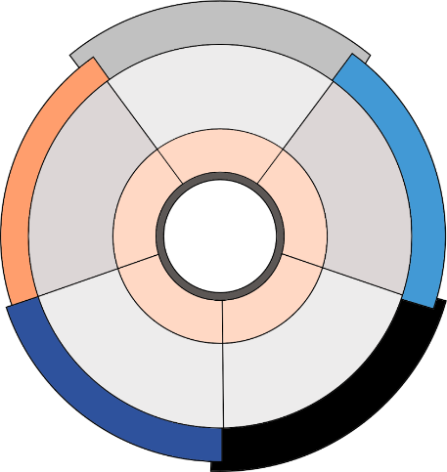
Due to various applications of phase change materials (PCMs), these materials were of high importance for researchers in recent years [1–4], especially for solar stills [5-6]. Paraffin has been selected the most popular PCMs owing to its low vapor pressure in melting and higher latent heat of fusion, but the paraffin thermal conductivity is low [7]. The problem can be solved by adding nanofluid such as paraffin oxide to paraffin. Figure 1 illustrates Properties of diverse kinks of graphene.
Main
Features
Low Price
High Shape
Stability
Preparation:
-Direct Mixing
-Impregnation
High Shape
Stability
High Thermal
Conductivity
Preparation: Direct Mixing
High Shape
Stability
Filler
Interaction
With PCM
Anti-corrosion
coating
High Shape
Stability
Properties of Graphene
High Shape
Stability
Strong
Preparation:
-Hydrothermal
-Impregnation
High Thermal
Conductivity
Preparation:
- Polymerization
- Pickering Route
k =3100 (W/m. K)

K=3000W/m. K
k =3200 (W/m.K)

k= 3250 W/m. K
k= 2900 W/m.K
Featured
Reported
Properties
Extended GO
Grapheme
Reduced graphene
Grapheme oxide
Graphene-sheet

Fig. 1 Properties of different kinks of graphene.

Phase change materials can be classified into three main groups. The main group related to this paper is liquid- solid group which can be divided into two groups, small molecular components and polymers.
Small molecular components can be categorized according to their chemical nature as organic and inorganic. Organic can be organized as: mainly paraffin or non-paraffin like polymers.
To solve the problem of low thermal conductivity of PCM, three different methods including geometry modification, adding nanoparticles and metal foam were studied by Li at al. [8]. Different nanoparticles concentrations and metal foam porosities were examined. It was found out by adding 5% copper nanoparticles, the melting/solidification time reduces. They also found by adding a 95% porous metal foam, the melting/solidification time reduced.
According to the results of Ebrahimnataj Tiji et al. [9] the presence of fins was significantly efficient in making up the stored energy inside the PCM. The use of fins results in a 20% enhancement in the room’s mean temperature compared with the non-finned case.
Carbon nanotube nanofluid and also different nanoparticle types, under magnetic field has been investigated by Selimefendigil et al. [10]. They found out by increasing of concentration of nanofluids under magnetic field the heat transfer coefficient would be increased to 25%.
Hayder at al. [11] introduced a novel approach for improving melting of PCM by incorporating uniform Joule heat generation with the porous structure compared to central heat generation. Different cases based on the heater-in foam configuration under the same heat generation rate were numerically verified and compared with the case of using the central heating element. The results showed that the uniform heat generation from the porous structure can substantially reduce the melting time.
Transient solidification within a wavy duct which was under the effect of outer side airflow was simulated by Hajizadeh et al. [12]. Histories of temperature and heat flux were reported in outputs. They found out utilizing wavy duct and Nanoparticle-Enhanced Phase Changed Materials (NEPCM) could help the solidification and enhanced the rate of process about 38%.
Chamkha at al. [13] investigated the flow and heat transfer of PCMs embedded in metal-foams heatsink under pulse heating conditions. The outcomes showed that the higher the pulse power, the higher the heatsink efficiency.
Talebizadeh Sardari et. al. [14] investigated the effect of metal foams + PCMs and they evaluated the discharging mechanism in a PCM to air heat exchanger for the purpose of space heating using a composite of copper foam and PCM. The results showed the significant advantages of composite heat exchanger compared with a PCM only case.
Mixed convection in a phase change material filled square cavity under the effect of a rotating cylinder was numerically investigated by Selimefendigil & Öztop [15]. It was observed that rotating cylinder parameters could be used to control the heat transfer and melting process in the cavity.
The melting process of a PCM inside an inclined compound enclosure filled with a porous medium was theoretically addressed using a novel deformed mesh method by Mehryan at al. [16]. The effect of the porous layer thickness on the phase change heat transfer of PCM was investigated. The outcomes showed that the rates of melting and heat transfer are enhanced as the thickness of the porous layer increases.
Talebizadeh Sardari at al. [17] used different metal foam with the PCM. Their results showed the porous-PCM provided an almost constant temperature during the discharging process. Increasing the metal foam porosity resulted in shorter charging/discharging time.
Effects of various pertinent parameters such as PCM height, PCM length, and solid nanoparticle volume fraction on the fluid flow and thermal characteristics were numerically analyzed by Selimefendigil at al. [18]. It was found that when the height of the PCM is increased, local and average Nusselt number reduced.
Many papers have recently focused on using paraffin + nanoparticles in desalination. Table 1 shows some researcher work on solar still with PCM + nanofluids.

Table 1 Work of previous researchers on solar still using paraffin added nanofluid
Author | PCM used | Used nanoparticles | Results
Wang et al. [19]  (2009) | Paraffin solid and liquid | Multi-Walled Carbon Nanotubes (MWNCT) | Paraffin was mixed with Multi-Walled Carbon Nanotubes (MWNCT) creates Nanoparticle-Enhanced Phase Changed Materials (NEPCM). They showed that by using NEPCM the thermal conductivity has been increased.
Arasu et al. [20]  (2013) | Paraffin wax | Alumina | They have carried out a series of numerical studies on heat transfer during melting of paraffin with nanoalomina and found out by using lower volumetric concentration of alumina in paraffin high energy storage could be achieved.
,Li, et al.[21]  (2014) | Liquid  paraffin | Expanded graphite | The aim of the study was to numerically assess the capability of heat transfer enhancement for liquid paraffin by adding expanded graphite. As the result higher thermal conductivity was achieved.
Sahan et al. [22]  (2015) | Solid paraffin | Fe₃O₄ | The finite element method was used to solve  the governing equations. The accuracy of the results was verified by comparison to the  benchmark solutions. The average Nusselt number in the enclosure, as an indicator of the heat transfer performance, is analyzed.
Nourani, et al. [23]  (2016) | Paraffin | Al₂O₃ | The heat transfer in the cavity is enhanced when a higher fraction $∅$ of the NEPCM is used and  a fraction of 4% provides the highest heat transfer. Increasing the volume fraction of  nanoparticles from 2% to 5% enhanced the average Nusselt number by 21%.
Karaipekli et al.[24]  (2017) | Paraffin | Carbon nanotubes | By adding carbon nanotubes with concentration of 2% to paraffin as a PCM, 15% higher thermal conductivity was achieved.
Rufuss et al. [25]  (2017) | Paraffin | Nanoparticles | They studied the effects of water depth, wind speed, ambient temperature and solar radiation intensity, PCM and nanoparticles on the productivity of the solar still.
Arıcı etal.  [26]  (2017) | Paraffin | Al₂O₃ | Melting of paraffin wax with Al₂O₃ nanoparticles in a partially heated and cooled square cavity was investigated numerically. The effect of nanoparticle concentrations and orientation of the activated walls together with the temperature of the hot wall on the melting process and stored energy was investigated.
Kabeel et al. [27]  (2020) | Paraffin wax | Graphene oxide | Paraffin wax + graphene oxide has been used in tubular solar still and the improvement was 52%.
Although many researches have focused on thermal enhancement of nanofluids by adding more nanomaterials to the base fluid [28-36], present study has concentrated on using paraffin with dispersed graphene oxide with different concentrations to improve the productivity of a solar still. Hashem Zadeh et al. [37] showed that adding nano-particles to the pure PCM reduces the volume fraction of the PCM and thus decreases the overall latent heat capacity of the storage. On the other hand, the effective thermal conductivity of the storage increases.
The thermal and dynamic behavior of a suspension comprising NEPCMs particles in a square cavity with a time-varying hot wall temperature was investigated by Hajjar et al. [38]. Due to temperature difference, a buoyancy-driven flow was created in the cavity. The equations governing flow and heat transfer inside the cavity were formulated in the dimensionless form.
The melting process of a PCM inside an inclined compound enclosure partially filled with a porous medium was theoretically addressed using a novel deformed mesh
method by Mehryan et al. [39]. The outcomes showed that the rates of melting and heat transfer
were enhanced as the thickness of the porous layer increases. The melting rate was the highest when the inclination angle of the enclosure was 45°. An increase in the wall thickness
improved the melting rate.
Melting flow and heat transfer of electrically conductive phase change materials subjecting to a variable magnetic field were addressed in a cavity enclosure by Ghalam baz et al. [40]. The results were investigated for the melting behavior of PCM by the study of Hartmann number and the location of the magnetic source. Outcomes showed that after the initial stages of the melting, the effect of the presence of a magnetic field became significant.
The novelty of this investigation is examining different shapes of the absorber for solar still and try to increase the productivity by the following methodologies:
- Choosing the best shape of the absorber for different absorber plates (semicircular and triangular and rectangular absorber)
2) The melting of paraffin with a semicircular, triangular and rectangular absorber with graphene oxide has been investigated.
3) Graphene oxide with three different weight fractions (0.1, 0.3 and 0.5wt%) has been investigated.
4) The thermal performances of paraffin oxide with graphene in different concentrations for semicircular absorber, triangular and rectangular absorber will be investigated.
The outcome of this investigation may find applications to develop highly efficient solar stills to secure more drinkable water in warm, dry lands. Looking into the available literature, it can be seen that no paper has been published related to comparison of a semicircular, triangular and rectangular absorber using paraffin +graphene oxide.

2. Materials and methods
To find out the density(ρ), specific heat capacity (c_{p}) and latent heat (L) of graphene oxide+ paraffin, we use the below equations [41]:
$$ρ_{nepcm}=∅_{np}ρ_{np}+\left(1-∅_{np}\right)ρ_{pcm} (1)$$
$${\left({ρc}_{p}\right)}_{nepcm}=∅_{np}{\left(c_{p}\right)}_{np}+\left(1-∅_{np}\right){\left({ρc}_{p}\right)}_{pcm} (2)$$
$${\left(ρL\right)}_{nepcm}=\left(1-∅_{np}\right){\left(ρL\right)}_{pcm} \left(3\right)$$
The dynamic viscosity and thermal conductivity (k) of nano + PCM can be found from [5]:
$$μ_{nepcm}=0.983μ_{pcm} exp\left(12.959∅_{np}\right) (4)$$
$$k_{nepcm}=\frac{k_{np}+{2k}_{pcm}-2\left(k_{pcm}-k_{np}\right)∅_{np}}{k_{np}+2k_{pcm}+\left(k_{pcm}-k_{np}\right)∅_{np}}k_{pcm}+fbγ∅_{np}ρ_{pcm}C_{p,pcm}\sqrt{\frac{KT}{ρ_{np}d_{np}}}f\left(T,∅_{np}\right) (5)$$
$$γ=8.4407{\left({100∅}_{np}\right)}^{-1.07304} (6)$$
f is a function, which can be defined as [42]:
$$f\left(T,∅_{np}\right)=\left(28.217×{10}^{-3}∅_{np}+3.917×{10}^{-3}\right)\frac{T}{T_{ref}}$$
$$+\left(-30.669×{10}^{-3}∅_{np}-3.91123×{10}^{-3}\right) (7)$$
In this equation b is the constant of Brownian motion which is equal to 5 x 10⁴, K shows the constant of Boltzmann which is equal to 1.381 x 10⁻²³ J K⁻¹. d_{np} shows the diameter of nanoparticle (59 x 10⁻⁹ m) and T_{ref} shows the reference temperature which is 298.15 K and T is the average temperature of nanoPCM [20].
.2.1 Thermophysical Properties
Paraffin wax (industrial grade) purchased from Merck company (Gernsheim, Germany), with melting temperature of 44 °C was employed as the PCM. Also, graphene oxide nanomaterial was purchased from US Research Nanomaterials, Inc. to be used as an additive to PCM to improve its thermal performance. Thermal properties of PCM and graphene oxide have been shown in Table 2.
Table 2 Thermal properties of Paraffin and graphene oxide [43].
Thermophysical Property | Paraffin | Graphene Oxide
Density (kg m⁻³) | 802 | 3600
Specific heat (J kg⁻¹ K⁻¹) | 2320 (liquid) | 765
Thermal conductivity (W m⁻¹ K⁻¹) | 0.23 (liquid) | 3000
Dynamic viscosity (kg m⁻¹ s⁻¹) | 1.3×10⁻³ | –
Thermal expansion coefficient (K⁻¹) | 9.1×10⁻⁴ | 1.25×10⁻⁵
Latent heat (kJ kg⁻¹) | 226 | –
Melting temperature (°C$)$ | 44 | –

2.2 Preparation of the nanofluid
Preparation steps of paraffin/ graphene oxide has been show in Fig. 2. The paraffin liquid with density of 802 kg m⁻³, thermal conductivity of 0.23 W m⁻¹ K⁻¹, dynamic viscosity of 9.1×10⁻⁴ kg m⁻¹ s⁻¹, latent heat of 26 kJ kg⁻¹, melting temperature of 44°C has been used. The amount of utilized PCM below each plate was 2.2 kg. Among the variety of PCMs proposed, paraffin wax has been considered the most prospective, because of its desirable characteristics, including significant latent heat of fusion and chemical stability. The absorbers gain the input heat during the day so paraffin wax can change from solid to liquid. In this investigation graphene oxide with the weight percent of 0.1, 0.3 and 0.5 was used It is clear paraffin starts to melt during the day time and this melting can increase after 14 o'clock until 19 o'clock.

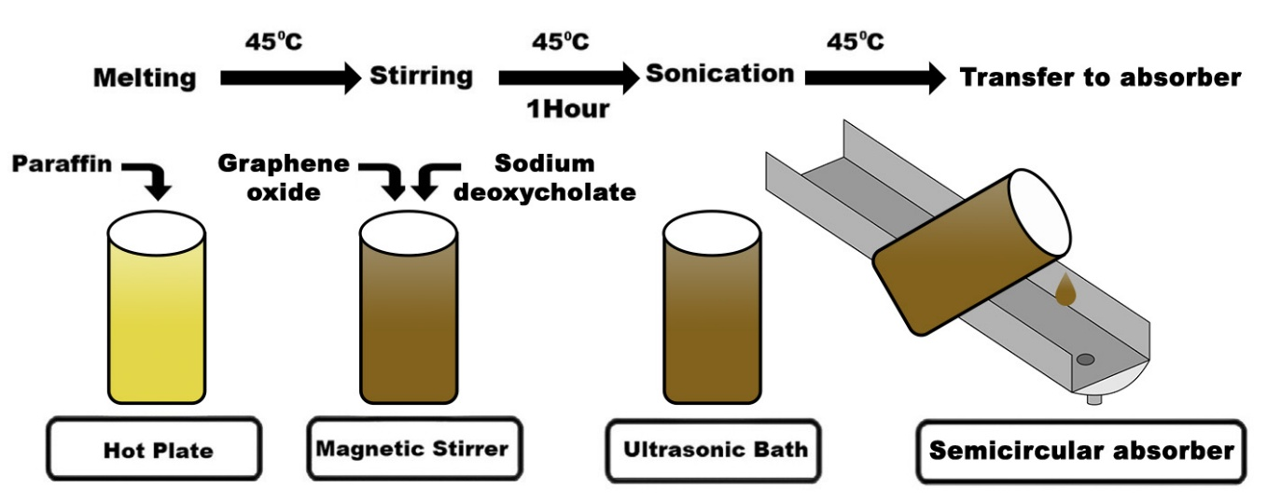
Fig. 2 Scheme for the sample preparation steps of paraffin/ graphene oxide.
The photographic views of samples with different concentration of graphene oxide can be seen in Fig. 3. For increase the disperse of graphene oxide in paraffin graphene oxide sodium deoxycholate has been added to paraffin liquid as a surfactant [29,30]. The stability of the graphene oxide + paraffin + sodium deoxycholate was check for 2 hours and no change was observed. Among different pH values nanofluid with 8 pH is more stable, so in this study a nanofluid with pH of 8 was used [44].
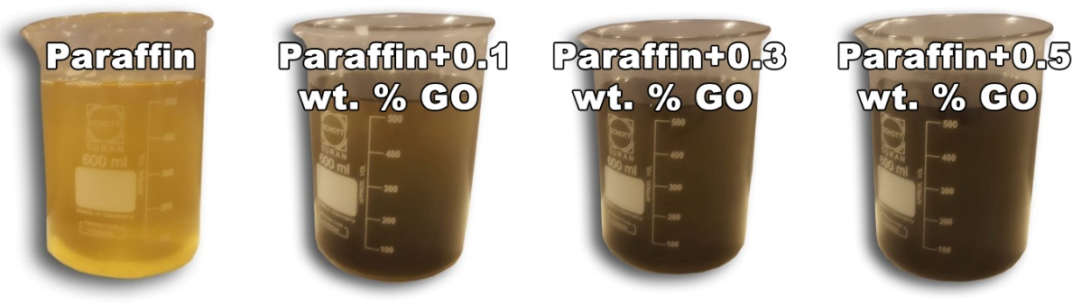
Fig. 3 Photographic views of samples with different concentration of graphene oxide.

2.3. Experimental methodology
An inclined stepped-type solar still with black painted metal basin has been used in the experiment with seven steps from 5 a.m. to 7 p.m. during June 2019– July 2019. Fig. 4 shows different kinds of absorbers used in the experiments. Because of preventing heat loss from the absorbers, the external parts were covered by polyurethane foam (PUF). These assumptions were done during the experimental study:
1. When the paraffin is liquid, thermal properties are changed linearly.
2. Steady state was assumed.
3. For the three kinds of absorber, the bottom side and the walls are well insulated.
4. In his process some factor like temperature and inlet mass are constant.
5. The heat transfer was assumed to imposed by constant heat flux and the heat transfer by convection and radiation take a place from top to bottom of the absorber with isolated walls.
This paper may be useful guide for investigators towards a short overview of PCM science and technology current status. Fig. 4 shows different kinds of the absorber for our experiments
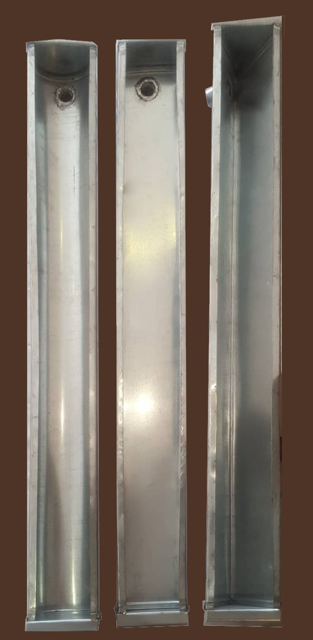
Fig. 4 Different kinds of absorbers used in the experiments.

Fig. 5 shows the schematic of semicircular absorber. Table 3 shows design parameters for the studied solar still.
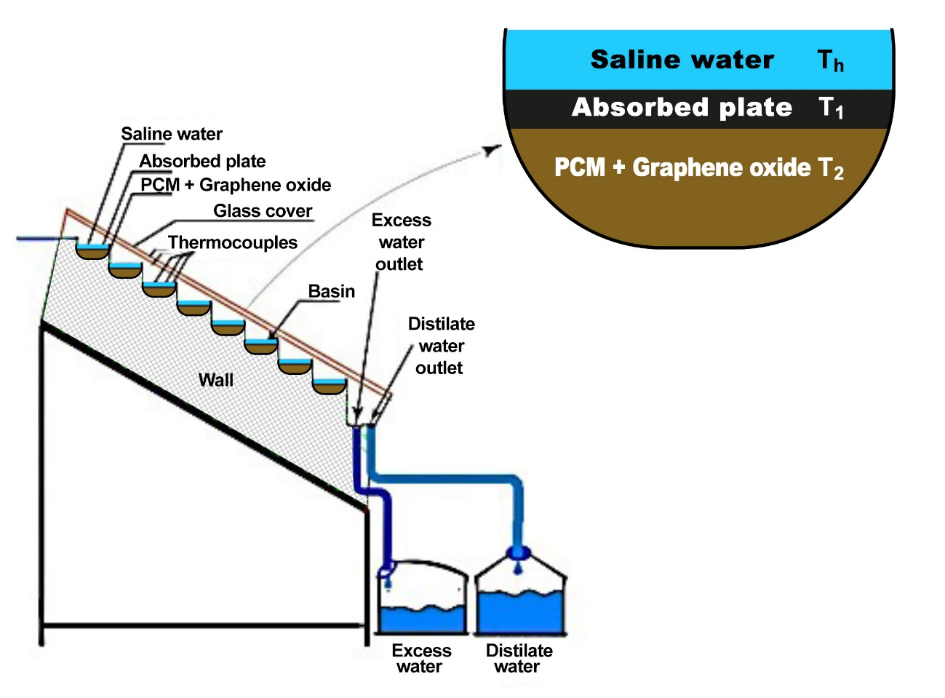
Fig. 5 Schematics of solar still with semicircular absorber.
Table 3. Design parameters for the studied solar still.
Parameters | Dimensions
Length of tank | 600 mm
Width of tank | 400 mm
Height of tank | 2800 mm
Inclination angles | 32.5°
Length of the glass covers | 1300 mm
Width of the glass covers | 1000 mm
Thickness of the glass covers  Number of absorber plates | 4 mm  8

2.4 Accuracy
During this experimental investigation several parameters were measured. Nine thermocouples in different parts of solar still have been used. Temperature of water desalination (T_{w}), inner surface of the glass (T_{gi}), ambient air (Ta) and 6 thermocouples were used to measure the temperature in different parts of absorbers(T_{b}) by 12 channels portable data logger which are connected to a PC. Solar radiation was measured by a solarimeter and also the distilled water measured by a measuring jar [31-32].

2.5 Uncertainties
Errors of the measuring instruments are displayed in Table 4. These errors have been indicated, based on the manufacturer’s specifications.
Table 4. The accuracies of various measurement instruments.
No. | Instrument | Range | Accuracy
1 | Solarimeter | 0–900 W m⁻² | ±4 W m⁻²
2 | Thermocouple | 0–300 °C | ±1 °C
3 | Thermometer | 0–95 °C | ±0.1 °C
5 | Measuring jar | 0–1000 mL | ±9 mL

Fig. 6 shows the schematic of flat, semicircular, triangular and rectangular solar absorber plate. It should be mentioned that semicircular, triangular and rectangular absorbers designed to have the same volume and made from Galvanized sheet steel which is a strong, sturdy material used in many industries.
.
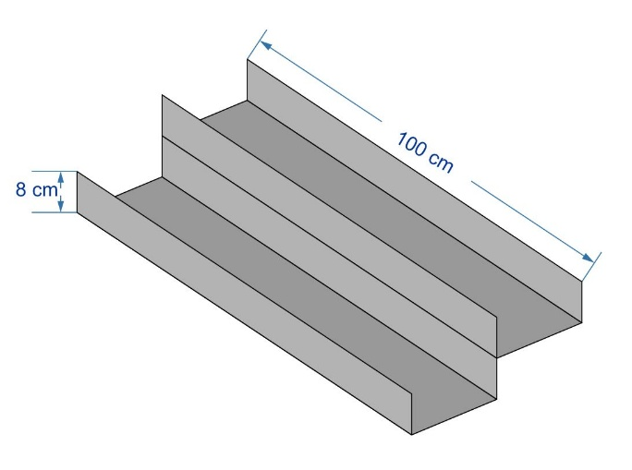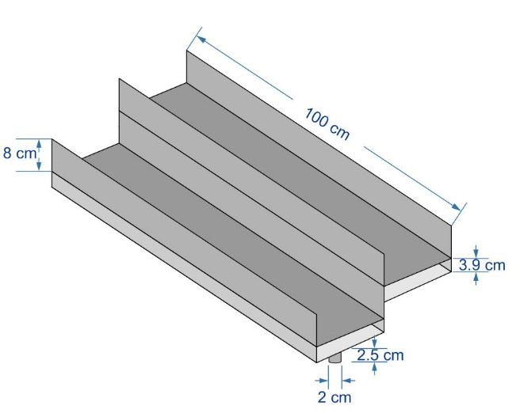
- Simple plate b) Rectangular absorber
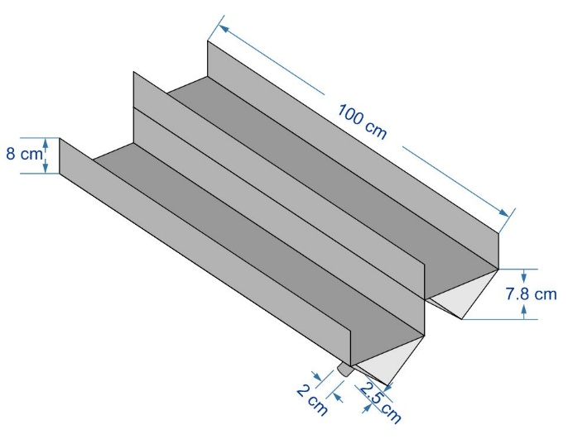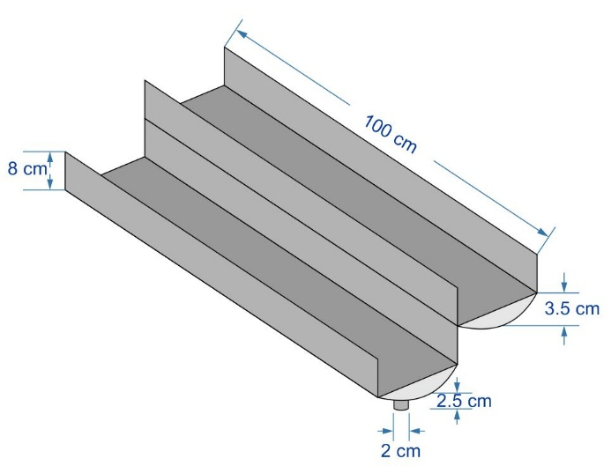
c)Triangular absorber d) Semicircular absorber
Fig. 6 Schematic of absorbers used in our experiments.
Fig. 7 shows solar radiation data for city of Mashhad (Iran) with latitude of 36.31°[33].

Fig. 7 Solar radiation data on 15 June 2019 gathered by a pyrometer in Mashhad with latitude of 36.31°.
Semicircular absorber has not been reported to be used as an absorber in field of solar still. The dynamic behavior of the heat transfers by conduction, convection and radiation can be effected by the geometry of the absorbers. A semicircular absorber can be seen in Fig. 8a. Inside the absorber, conduction and convection and radiation dominate the heat transfer process. In the beginning of the process conduction is important and then convection and radiation dominates the process [23-24].
Fig. 8b shows our triangular absorber. Melting in triangular absorber with the same volume is very similar to semicircular and rectangular absorber.
According to Fig. 8c the heat transfer was assumed to be imposed by constant heat flux and the heat transfer by conduction, convection and radiation take a place from top to bottom of the absorber with isolated walls [43].

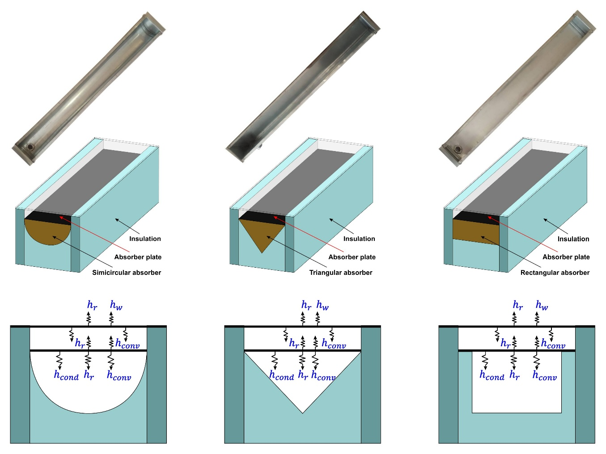
a) b) c)
Figure 8: a) Semicircular absorber b) Triangular absorber c) Rectangular absorber.

3. Results and discussion
This study was done to examine the thermal performance of Paraffin + graphene oxide in different absorbers in desalination unit. As can be seen from the Fig. 9, water temperature with PCM + graphene oxide is much higher after 1 p.m., during the day time. However, it is reduced around 4 p.m. and again increases around 6 p.m. After that and due to sunset, the temperature is decreased sharply. It should be noted that the ambient temperature during the day time varied from 15 °C to 40 °C.

Fig. 9 Water temperature with rectangular absorber.
According to Fig. 10, because of using triangular absorber in our solar still the higher inner glass temperature as a result of higher water temperature were achieved. As the results the performance of the solar still has been increased because of the higher temperature difference between inner glass and water. This increase is about 10%.

Fig. 10 Water temperature with triangular absorber.

According to Fig. 11, the performance of the solar still has been increased because of the higher temperature difference between inner glass and water. This increase is about 20%. As the result of having higher temperature difference faster evaporation occurred. Hence 10% higher distilled yield is obtained as compared to triangular absorber and also 20% distilled yield is achieved compared to rectangular absorber. The finding indicated that for all absorbers, the use of paraffin + graphene oxide in higher weight fractions, also enhances daily freshwater production.

Fig. 11 Water temperature with semicircular absorber.

Figs. 12, 13 and 14 illustrate daily freshwater production per day time for rectangular, triangular and semicircular absorbers. These figures show that by changing the shape of the absorber from rectangular to triangular, achieved fresh water was 10% higher and also from triangular absorber to semicircular 10% higher fresh water gained. The results showed that the geometry of the absorbers is an important factor and semicircular absorber shape can be influenced more for mixture of paraffin +graphene oxide flow as the results achieving more temperature gradients. The results demonstrated that this design of absorber causes a significant improvement in heat transfer due to a better mixing. In comparison to water, nanofluids have higher viscosities and thermal conductivities, and consequently demonstrate improved conductive and convective heat transfer performance [45].

Fig. 12 Daily freshwater production with rectangular absorber.

Fig. 13 Daily freshwater production with triangular absorber.

Fig. 14 Daily freshwater production with semicircular absorber.
Fig. 15 shows distilled yield with time of the day per kg/m² hr for rectangular, triangular and semicircular absorbers with 0.5 wt%. graphene oxide. The amount of produced water is important to find out the performance of solar stills. Because of different shape of absorbers in our experiment, we have different volume of distilled water. The maximum productivity was 1.55 kg/m² hr at 15h with semicircular absorber and 1.48 kg/m² hr at 15h with triangular absorber and 1.3 kg/m² hr at 15h with rectangular absorber.

Fig. 15 Productivity with time of the day (kg/m² hr).

4. Conclusions
The main aim of this work is to investigate the effects of the graphene oxide-nanofluids’ productivity of solar still in different shapes of absorbers. A novel design is performed, and its thermal efficiency is analyzed. This paper shows the results of a novel research conducted with the overall aim of developing a system that can provide continuous desalination, that would have real world application and benefits and the results of the paper:
- Selecting different shapes of absorbers, rectangular, triangular and simicircular absorber with the same volume has been investigated in this paper.
- Desalination with semicircular absorber showed an average of 20% improvement in the water productivity as compared to rectangular absorber with 10% improvement compared to triangular absorber.
- The maximum productivity was 1.55 kgm⁻² hr⁻¹ at 15h with semicircular absorber and 1.48 55 kgm⁻² hr⁻¹ at 15h with triangular absorber and 1.3 55 kgm⁻² hr⁻¹ at 15h with rectangular absorber.
- To improve the productivity yield, investigation should focus on increasing of heat transfer coefficient by using fin in semicircular, triangular and rectangular vertical or horizontal fins.
- The results showed that the geometry of the absorbers is an important factor and semicircular absorber shape can be affected more for mixing of paraffin +graphene oxide flow; as the results achieving more temperature gradients. The results of the present paper can be implemented to design more efficient absorbers for solar still parts.

As a future work, the flow of nanofluid such as Fe₃O₄ under constant or variable magnetic field for semicircular, triangular and rectangular absorber can be examined.

REFERENCES
1. Chen Y, Nguyen D, Shen M, Yip M, Tai N. Thermal characterizations of the graphite nanosheets reinforced paraffin phase change composites. Composites: Part A, 2015;44: 40-46.
2. Wahid M A. An overview of phase change materials for construction architecture thermal management in hot and dry climate region. Applied Thermal Engineering. 2017;112: 1240-1259.
3. Weiguang S, Darkwa J, Kokogiannakis G. Review of solid–liquid phase change materials and their encapsulation technologies. Renewable and Sustainable Energy Reviews. 2015;48: 373-391.
4. Hassab, M A. Effect of volume expansion on the melting process’s thermal behavior. Applied Thermal Engineering. 2017; 115:350-362.
5. Safaei M R, Goshayeshi H R, Chaer I, Solar still efficiency enhancement by using graphene oxide/paraffin composite, International journal of Energies, 2019.
6. Goshayeshi H R., Safaei M.R. Effect of absorber plate surface shape and glass cover inclination angle on the performance of a passive solar still. International Journal of Numerical Methods for Heat & Fluid Flow. 2019.
7. Chen Y, Nguyen D, Shen M, Yip M, Tai N. Thermal characterizations of the graphite nanosheets reinforced paraffin phase change composites. Composites: Part A, 2015; 44: 40-46.
8. Li Z, Shahsavar A, Al-Rashed A, Talebizadehsardari P. Effect of porous medium and nanoparticles presences in a counter-current triple-tube composite porous/nano-PCM system. Applied Thermal Engineering. 2019. https://doi.org/10.1016/j.applthermaleng.2019.114777.
9. Ebrahimnataj Tiji M, Yousefzadeh R, Eisapour M, Azadian M, Talebizadehsardari P. A numerical study of a PCM-based passive solar chimney with a finned absorber. Journal of Building Engineering. 2020. https://doi.org/10.1016/j.jobe.2020.101516.
10. Selimefendigil F, Oztop H F. Hydro-thermal performance of CNT nanofluid in double backward facing step with rotating tube bundle under magnetic field. International Journal of Mechanical Sciences. 2020 https://doi.org/10.1016/j.ijmecsci.2020.105876.
11. Hayder I, Talebizadehsardari P, Mahdi J, Arshad A, Sciacovelli A, Giddings D. Improved melting of latent heat storage via porous medium and uniform Joule heat generation. Journal of Energy Storage. 2020; 31:101747.
12. Hajizadeh M R, Selimefendigil F, Muhammad T, Ramzan M, Babazadeh H, Li Z. Solidification of PCM with nano powders inside a heat exchanger. Journal of Molecular Liquids 2020; 306 :112892.
13. Chamkha A, Veismoradi A, Ghalambaz M, Talebizadehsardari P. Phase change heat transfer in an L-Shape heatsink occupied with paraffincopper metal foam. Applied Thermal Engineering. 2020.
14. Talebizadeh Sardari P, Giddings D, Grant D, Gillott M, Walker G S. Discharge of a composite metal foam/phase change material to air heat exchanger for a domestic thermal storage unit. Renewable Energy. 2019. https://doi.org/10.1016/j.renene.2019.10.084.
15. Selimefendigil F, Öztop H F. Mixed convection in a PCM filled cavity under the influence of a rotating cylinder. Solar Energy. 2019; 24.
16. Mehryan S, Vaezi M, Sheremet M, Ghalambaz M. Melting heat transfer of power-law non-Newtonian phase change nano-enhanced n-octadecane-mesoporous silica (MPSiO2). International Journal of Heat and Mass Transfer. 2020; 151: 119385.
17. Talebizadeh Sardari P, Babaei-Mahani R, Giddings D, Yasseri S, Moghimi M A, Bahai H. Energy recovery from domestic radiators using a compact composite metal Foam/PCM latent heat storage. Journal of Cleaner Production. 2020; 257:120504.
18. Selimefendigil F, Hakan F. Oztop H O, Chamkha A J. Natural convection in a CuO–water nanofluid filled cavity under the effect of an inclined magnetic field and phase change. Journal of material (PCM) attached to its vertical wall, Thermal Analysis and Calorimetry. 2019; 135:1577–1594.
19. Jifen W, Huaqing X, Zhong X. Thermal properties of paraffin based composites containing multi- walled carbon nanotubes. Thermochimica Acta 2009; 488: 39-42.
20. Arasu A V, Sasmito A P, Mujmdar A S. Numerical performance study of paraffin wax dispersed with alumina in a concentric pipe latent heat storage system. Thermal Science, 2013; 17:419-430.
21. Li Z, Sun W G, Wang G, Wu Z.G. Experimental and numerical study on the effective thermal conductivity of paraffin/expanded graphite composite. Solar Energy Materials & Solar Cells. 2014 ;128: 447-455.
22. Sahan N, Fois M, Paksoy H. Improving thermal conductivity phase change materials-A study of paraffin nanomagnetite composites. Solar Energy materials & Solar Cells. 2015;137: 61-67.
23. Nourani M, Hamdami N, Keramat J, Moheb A, Shahedi M. Thermal behavior of paraffin- nano-Al₂O₃ stabilized sodium stearoyl lactylate as a stable phase change material with high thermal conductivity. Renewable Energy88 2016;474-482.
24. Karaipekli A, Bicer A, Sati A, Tyagi V. Thermal characteristics of expanded perlite/ paraffin composite phase change material with enhanced thermal conductivity using carbon nanotubes. Energy Conversion and Management. 2017; 134: 373-381.
25. Rufuss D, Iniyan S, Suganthi L, Davies PA. Nanoparticles enhanced phase change material (NPCM) as heat storage in solar still application for productivity enhancement. Energy procedia 2017; 141: 45-49.
26. Arıcı M, Tütüncü E, Kan M, Karabay H. Melting of nanoparticle-enhanced paraffin wax in a rectangular enclosure with partially active walls. International Journal of Heat and Mass Transfer. 2017; 104: 7–17.
27. Kabeel A E, Sathyamurthy R, Manokar A, Sharshir S, Essa F, Elshiekh A. Experimental study on tubular solar still using Graphene Oxide Nano particles in Phase Change Material (NPCM's) for fresh water production. Journal of Energy Storage. 2020; 28:101204.
28. Selvan C, Mohan D, Harish S. Thermal conductivity of ethylene glycol and water with graphene nonoplatelets. Thermochimica Acta. 2016;642: 32-38.
29. Mahdi, J M, Nsofor, E C. Solidification of a PCM with nanoparticles in triplex-tube thermal energy storage system. Applied Thermal Engineering 2016, 108, 596-604. doi:https://doi.org/10.1016/j.applthermaleng.2016.07.130.
30. Kabeel A E, Abdelgaied M, Eisa A. Effect of graphite mass concentration in a mixture of graphite nanoparticles and paraffin wax as hybrid storage materials on performance of solar still. Renewable Energy. 2019; 132:119-128.
31. Sahan N, Fois M, Paksoy H. Improving thermal conductivity phase change materials-A study of paraffin nanomagnetite composites. Solar Energy Materials & Solar Cells. 2015;137: 61-67.
32. Sampathkumar K, Senthilkumar P. Utilization of solar water heater in a single basin solar still- An experimental study. Desalination, 2012; 297:8-19.
33. Mohammadi K, Khorasanizadeh H. A review of solar radiation on vertically mounted solar surfaces and proper azimuth angles in six Iranian major cities. Renewable and Sustainable Energy Reviews. 2015; 47: 504-518.
34. Panchal H, Patel S. An extensive review on different design and climatic parameters to increase distillate output of solar still. Renewable and Sustainable Energy Reviews, 2017; 69: 750-758.
35. Dhaidan S, Khodadadi J M. Melting and convection of phase change materials in different shape containers: A review. Renewable and Sustainable Energy Reviews. 2015; 43: 449-477.
36. Yang Y, Zhao R, Zhang T, Zhao K, Xiao P, Ma Y, Ajayan P M, Shi G, Chen Y, Graphene-based standalone solar energy converter for water desalination and purification, ACS Nano. 2018;12:829-835.
37. Hashem Zadeh S M, Mehryan S.A.M., Ghalambaz M, Ghodrat M, Young J, Chamkha A. Hybrid thermal performance enhancement of a circular latent heat storage system by utilizing partially filled copper foam and Cu/GO nano-additives. Energy. 2020; 213:118761.
38. Hajjar A, Mehryan S A M, Ghalambaz M. Time periodic natural convection heat transfer in a nano-encapsulated phase-change suspension. International Journal of Mechanical Sciences. 2019, doi: https://doi.org/10.1016/j.ijmecsci.2019.105243.
39. Mehryan S A M, Ayoubi-Ayoubloo K, Shahabadi M, Ghalambaz M, Talebizadehsardari P, Chamkha A. Conjugate Phase Change Heat Transfer in an Inclined Compound Cavity Partially Filled with a Porous Medium: A Deformed Mesh Approach. Transport in Porous Media. 2020; 132:657–681.https://doi.org/10.1007/s11242-020-01407-y.
40. Ghalam baz M, Hashem Zadeh S M, Mehryan S A M, Pop I, Wen D. Analysis of melting behavior of PCMs in a cavity subject to a non-uniform magnetic field using a moving grid technique. Applied Mathematical Modelling· 2019.
41. Chen Z, Peng J, Chen G, Hou L, T. Yu, Y. Yao, H. Zheng, Analysis of heat and mass transferring mechanism of multi-stage stacked-tray solar seawater desalination still and experimental research on its performance, Solar Energy. 2017;142: 278-287.
42. Selimefendigil F, Öztop HF, Al-Salem K. Natural convection of ferrofluids in partially heated square enclosures. Journal of Magnetism and Magnetic Materials 2014;372:122-133.
43. Safaei M R, Goshayeshi H R, Issa Chaer. Solar Still Efficiency Enhancement by Using
Graphene Oxide/Paraffin Nano-PCM. International Journal of Energy. 2019;12: 2002, https//dig.org/10.3390/en12102002.
44. Askari S, Koolivand H, Pourkhalil M, Lotfi, R, Rashidi A. Investigation of Fe3O4/Graphene nanohybride heat transfer properties: Experimental approch. International Communications in Heat and Mass Transfer. 2017: 30-39.
45. Oztop HF, Abu-Nada E. Numerical study of natural convection in partially heated rectangular enclosures filled with nanofluids. International Journal of Heat and Fluid Flow 2008;29:1326-1336. 45. Davari H, Goshayeshi H R, Oztop H F, Chaer I. Experimental investigation of oscillating heat pipe efficiency for a novel condenser by using Fe₃O₄ nanofluid. Journal of Thermal Analysis and Calorimetry. 2019;113: 1-10.

