Visualising the past – an evaluation of processes and sequences for fingermark recovery from old documents

Abstract
This study aimed to collect data on the effectiveness of most of the fingermark visualisation reagents currently used on porous surfaces on fingermarks aged for up to 90 years, significantly extending the timescales for which such information exists. A limited subset of the variables associated with processing of old fingermarks was explored, with a focus on the use of 1,8 diazafluoren-9-one (DFO), 1,2-indandione, ninhydrin, and physical developer. These techniques were used in sequence on batches of cheques between 11 and 32 years old, and on documents dating from the 1920s and 1940s. The potential for applying a physical developer enhancement process (blue toning) as the final step in the sequence was also explored. The benefits of using processing sequences on porous items were clearly demonstrated, with all processes in the sequence adding value in terms of additional marks found on the cheques up to 32 years old. In addition, physical developer was found to be capable of developing fingermarks up to 90 years old, whereas the amino acid reagents appear less effective on documents of 70 years and older. An experimental physical developer formulation with reduced environmental impact was found to be as effective as the existing process in these experiments. Blue toning was found to visualise an additional 10-25% of marks, and its wider use after silver-based deposition processes is recommended based on the evidence from this study.
Keywords: Old documents; fingermark; processing sequence; physical developer; blue toning

Introduction
The discovery of fingerprints on ancient artefacts and other significant items such as artwork is often a source of media interest. Fingerprint impressions left in ancient Japanese pottery were said to be one of the inspirations for Henry Faulds to begin his research into fingerprints [1]. Fingermark traces have been found on 3000-year-old Egyptian sarcophagi [2], and partial finger and palm marks of artists including da Vinci, Turner and Pollock found on paintings and drawings have been used to link and authenticate artwork [3]. In all these cases the fingermarks in question are already visible to the eye, either because they are in a contaminant such as ink or pigment, or because they have been left as impressions in a soft medium such as paint.
However, it is possible that in many of these scenarios there may also be latent fingermarks present. Although development of such latent fingermarks is unlikely to be pursued from a historical perspective because of the damage it may cause to the articles, such marks may be highly relevant if exhibits are being reviewed as part of a criminal investigation. The question of how old a latent fingermark can be and yet still be developed using conventional fingermark visualisation techniques is one that needs answering. For example, would it still be possible to develop a fingermark on the letters purporting to be from Jack the Ripper, the perpetrator of murders committed in and around the Whitechapel district of London in 1888?
Since the advent of DNA, much has been made of its use in cold case reviews, where advances in technology have made reassessment and re-treatment of items a successful means of identifying suspects and bringing criminals to justice many years after a crime has been committed [4]. Similarly, such reassessment has enabled wrongful convictions to be overturned [5]. However, during cold case reviews fingerprint evidence is rarely considered in the same way. There may be fingermarks developed soon after the crime was committed that were not matched at the time but may subsequently provide a ‘hit’ when resubmitted for search many years later, and there are several examples of this [6-7]. What is less well explored is the possibility of using advances in the methods used for fingermark visualisation to re-process items. If applied in the right way, previously undeveloped fingermarks could be found which may open up fresh investigative leads.
In order for this to have a chance of success, the investigator needs several pieces of information:
- How long after deposition is it realistically possible to expect a fingermark to survive?
- On which surfaces are fingermarks most likely to survive for long periods?
- Which fingermark visualisation processes are most effective in developing old fingermarks?
- Which processes were used at the time of the original investigation, and are there any processes that are now available that could develop additional marks?
Investigators should also consider parallel advances in imaging technology, where more recently accessible methods such as multispectral imaging [8], infrared reflection [9] and careful use of Fast Fourier transforms [8] all have the potential to reveal additional detail in a previously unidentifiable fingermark.
In the context of fingermark visualisation, there have been studies and case reports that demonstrate that ‘older’ fingermarks can be detected. Batey et. al. [10] reported a 6-year old fingermark being developed on a plastic bag using vacuum metal deposition, Cohen et. al. [11] showed that fingermarks several years old could still be developed on window frames using powders. The authors are also aware of other cases where marks approaching 20 years old have been developed using vacuum metal deposition and powder suspensions. These cases demonstrate that fingermarks can survive several years on non-porous surfaces, where the mark remains on the surface of the exhibit and remains vulnerable to abrasion and other potentially degrading environments. It is feasible that on porous surfaces, where the fingermark residue is absorbed into the substrate, the fingermark may be more protected and could therefore survive even longer.
Researchers of reagents for use on porous surfaces and into fingermark composition have stated that amino acid reagents such as 1,2-indandione, DFO and ninhydrin will continue to develop fingermarks on older paper items [12,13]. This has been practically demonstrated in a pseudo-operational trial environment where Marriott et. al. [14] tested sequential processing routines on 5-year old university exam papers and showed that the amino acid reagents continued to perform well on documents of this age, with physical developer developing an appreciable quantity of additional marks when used sequentially after them.
Of the other reagents proposed for use on porous surfaces, the performance of Oil Red O has been shown to drop off significantly when marks are older than 4 weeks [15], possibly associated with degradation of some of the sebaceous constituents targeted by this reagent. However, there are exceptions to this general rule and Oil Red O has been successfully used to develop fingermarks on a 21-year old document [16]. It is generally believed that the most effective reagent for use on old documents is physical developer, although there are no comprehensive reported studies that test the performance of different reagents over extended time periods. It is also worth noting that processes that do not develop older marks are of equal interest for operational casework. This is because there are many scenarios where only the marks deposited during recent handling will be of interest and the development of pre-existing fingermarks may complicate the investigation.
The principal aim of this study is to collect data on the effectiveness of most of the reagents currently used on porous surfaces for fingermarks aged for up to 90 years, significantly extending the timescales for which such information exists. It will explore a limited subset of the variables associated with processing of old fingermarks and will focus on the processes used for development of marks on porous items, DFO, 1,2-indandione, ninhydrin, and physical developer. It will also provide information about the merits of applying these techniques in sequence, and the potential benefits of applying a physical developer enhancement process (blue toning) as the final step in the sequence.

Methods and materials
Substrates
Several sources of porous substrates were available to the researchers during the course of this study, which commenced in 2003, resumed briefly in 2013, and was completed in 2018. This enabled documents ranging from 11 to 91 years old to be processed as part of the study, allowing general trends in process effectiveness to be observed over a significant time scale. The sources used included:
1920s documents: The source was a range of documents from a ledger containing correspondence and invoices from the period 1927 – 1933 and believed not to have been handled in the intervening period. The ledger had been kept indoors, but until 1990 had been in a house that had not been centrally heated and therefore the temperature/humidity history of the items was unknown.
1940s documents: The source was a range of documents taken from a bill spike found in an attic during a house clearance, dating from the period 1945-1948. The method of storage (on a bill spike) meant that it was extremely unlikely that any of the documents in the centre of the stack of documents on the spike had been touched in the years since. Again, the temperature/humidity history of the items was unknown.
1980s/1990s cheques: The source was a quantity of used cheques from various UK banks. The articles collected had been provided to the department for the purposes of crime investigation research and consisted of cheques passed through the UK banking system, typically after completion of investigations by the bank into fraudulent transactions. Most of the cheques had been donated over a period of time and therefore the cheques within the batches spanned different years and designs of cheque. The cheques have since been destroyed to comply with the subsequently enacted General Data Protection Regulation (GDPR) legislation.
All the cheques were provided in sealed clear bags and had not been handled since they were delivered to site. The cheques had also been stored within cardboard boxes in a cupboard, minimising any exposure to direct sunlight.
The ages of the cheques available for the study and the banks that they originated from are shown in Table 1.
Name of Bank | Date(s) of Cheque(s)
Natwest | 1991 - 1995
Co-op | 1990 - 1997
Midland | 1987, 1993
Barclays | 1986
Table 1. The sources and ages of the batches of cheques used throughout this study.
The cheques for this experiment were stored inside a dark cupboard when not being treated. This was to both preserve fingermarks by reducing the risk of contamination from other sources and minimising chemical degradation by exposure to ultraviolet radiation and visible wavelengths of light.
Chemicals and formulations
The exact source of chemicals for the solutions used for treating exhibits in 2003 and 2013 was not recorded at the time, however the formulations used remained consistent throughout the study and are given in Tables 2-10.
The chemical suppliers for the solutions used in 2018 are also given in Tables 2-10 below.
Chemical | Chemical Grade | Quantity | Supplier
1,8-Diazafluoren-9-one | >99% | 0.25g | Sigma Aldrich
Acetic acid | Analytical ≥99.7% | 20 mL | Sigma Aldrich
Methanol | Analytical ≥99.7% | 30 mL | Sigma Aldrich
HFE7100 | As supplied | 725 mL | 3M Novec
HFE71DE | As supplied | 275 mL | 3M Novec
Table 2. Formulation of DFO working solution. Chemical suppliers for 2018 solutions only [17].

Chemical | Chemical Grade | Quantity | Supplier
Ninhydrin | >99% | 5g | Sigma Aldrich
Acetic acid | Analytical ≥99.7% | 5 mL | Sigma Aldrich
Ethyl acetate | Analytical ≥99.7% | 2 mL | Sigma Aldrich
Ethanol | Analytical ≥99.7% | 45 mL | Hayman
HFE 7100 | As supplied | 1 L | 3M Novec
Table 3. Formulation of ninhydrin working solution. Chemical suppliers for 2018 solutions only [17].

Chemical | Chemical Grade | Quantity | Supplier
1,2-Indandione | >99% | 0.25g | BVDA chemicals
Acetic acid | Analytical ≥99.7% | 10 mL | Sigma Aldrich
Ethyl acetate | Analytical ≥99.7% | 45 mL | Sigma Aldrich
Methanol | Analytical ≥99.7% | 45 mL | Sigma Aldrich
HFE 7100 | As supplied | 1 L | 3M Novec
Zinc chloride stock |  | 1 mL | Made in house to formulation in Table 5
Table 4. Formulation of 1,2-indandione working solution. Chemical suppliers for 2018 solutions only [18].

Chemical | Chemical Grade | Quantity | Supplier
Zinc chloride | Reagent grade ≥98% | 0.1g | Sigma Aldrich
Acetic acid | Analytical ≥99.7% | 1 mL | Sigma Aldrich
Ethyl acetate | Analytical ≥99.7% | 4 mL | Sigma Aldrich
Table 5. Formulation of zinc chloride working solution. Chemical suppliers for 2018 solutions only [18].

Chemical | Chemical Grade | Quantity | Supplier
Maleic acid | ReagentPlus™ ≥99.0% | 25g | Sigma Aldrich
Water (purified) | Grade 2 | 1 L | Sartorius (supplied via laboratory reverse osmosis system)
Table 6. Formulation of maleic acid pre-wash solution for physical developer. Chemical suppliers for 2018 solutions only [17].

Physical developer working solution (Synperonic N-based)
Chemical | Chemical Grade | Quantity | Supplier
Iron(III) nitrate nonahydrate | ACS reagent | 30g | Merck
Ammonium iron(II) sulphate hexahydrate | BioUltra ≥99.0% | 80g | Sigma Aldrich
Citric acid anhydrous | Redi-Dry ACS reagent ≥99.5% | 20g | Sigma Aldrich
Silver nitrate | ACS reagent | 10g | Merck
Stock detergent | As supplied | 40 mL | Made in house (see Table 8)
Water (purified) | Grade 2 | 950 mL | Sartorius (supplied via reverse osmosis system)
Table 7. Formulation of Synperonic N-based physical developer working solution and chemical suppliers for 2018 solutions [17].

Chemical | Chemical Grade | Quantity | Supplier
n-Dodecylamine acetate | As supplied | 2.8g | Pfaltz & Bauer
Synperonic N | As supplied | 2.8g | BDH Chemicals
Water (purified) | Grade 2 | 1 L | Sartorius (supplied via laboratory reverse osmosis system)
Table 8. Formulation of Synperonic N-based stock detergent solution. Chemical suppliers for 2018 solutions only [17].

Chemical | Chemical Grade | Quantity | Supplier
Iron(III) nitrate nonahydrate | ACS reagent | 30g | Merck
Ammonium iron(II) sulphate hexahydrate | BioUltra ≥99.0% | 80g | Sigma Aldrich
Citric acid anhydrous | Redi-Dry ACS reagent ≥99.5% | 20g | Sigma Aldrich
Silver nitrate | ACS reagent | 10g | Merck
Stock detergent | As supplied | 50 mL | Made in house (see Table 10)
Water (purified) | Grade 2 | 950 mL | Sartorius (supplied via laboratory reverse osmosis system)
Table 9. Formulation of DGME-based physical developer working solution. Chemical suppliers for 2018 solutions only [19].

Chemical | Chemical Grade | Quantity | Supplier
n-Dodecylamine acetate | As supplied | 1.5g | Pfaltz & Bauer
Decaethylene glycol mono-dodecyl ether (DGME) | As supplied | 1.25g | Sigma Aldrich
Water (purified) | Grade 2 | 1 L | Sartorius (supplied via laboratory reverse osmosis system)
Table 10. Formulation of DGME-based stock detergent solution. Chemical suppliers for 2018 solutions only [17].
The blue toning solution used for physical developer enhancement was Fotospeed BT20 Blue Toner (Fotospeed, Corsham, UK), which consisted of a 3-part toner kit with 150 mL of each constituent mixed with 750 mL of water to give 1200 mL of blue toning solution. This amount was suitable for the treatment of 100 cheques (approximately equivalent to 25 A4-sized documents). This is an iron-based blue toner which works by replacing some of the elemental silver with iron, which then reacts to give ferric ferrocyanide (Prussian Blue).
Processing conditions:
DFO and 1,2-indandione
Articles processed using DFO were passed through a shallow trough containing the DFO working solution, allowed to dry in a fume cupboard, then heated for 20 minutes in a Heraeus D-6450 oven at 100°C. The processing conditions used for 1,2-indandione were similar, except that the heating time in the oven was reduced to 10 minutes.
Ninhydrin
Articles treated with ninhydrin were processed in a similar way, except that after the dipping and drying stage articles were heated for 5 minutes in a Weiss-Gallenkamp FDC 018 chamber at 80°C and 65% relative humidity. For the articles processed in 2003, a previous model of the same chamber (Sanyo Gallenkamp) was used instead, although the temperature and humidity conditions used during processing remained the same.
Physical developer
Articles processed with both physical developer formulations were first placed into a dish containing maleic acid pre-wash and left in the dish until bubble formation from the paper was observed to have ceased. They were then transferred to a dish containing the physical developer working solution and the development of any marks and the background of the paper was monitored. When it was considered that optimum contrast had been obtained between the mark and the background (typically after 10-20 minutes) the article was transferred to a water wash bath and progressively moved through two further water wash baths and into a print washer (a shallow tray traditionally used for washing of wet photographic prints under a continuous flow of water). The time in each wash bath was approximately 5 minutes, with a longer dwell time (>10 minutes) in the print washer. Once it was considered that all residual traces of physical developer solution had been removed from the article it was placed on tissue paper to dry.
Physical developer enhancement
Physical developer enhancement was conducted by first wetting the articles in a dish of water, then transferring the article to a dish containing the blue toning solution. After approximately 3 minutes the article was transferred to a water wash bath for approximately 5 minutes and then into a print washer for >10 minutes. Once it was considered that all residual traces of blue toner solution had been removed from the article it was placed on tissue paper to dry.

Experimental method
Because of the time period (15 years) that experiments were conducted over, it was not possible to use exactly the same equipment to process and examine all of the articles. Each experiment detailed below should therefore be considered primarily as a ‘stand alone’ exercise, however because there are commonalities between many aspects of the experiments it is considered valid to look at general trends in results to see if these are replicated across the period of the work.
Experiment 1: Investigation of the effectiveness of processing sequences on cheques and 1940s documents (conducted 2003)
The principal objective of this experiment was to investigate the cumulative benefits of using each process in the sequential processing routine for porous surfaces. A secondary objective was to conduct an initial assessment of the effects of fingermark age on the effectiveness of those processes.
The cheques used in this experiment were 11-17 years old and the documents were 55-57 years old at the time of processing.
The methodology adopted for the work was that of a pseudo-operational trial, a Phase 3 study as defined in the IFRG research guidelines [20].
For this experiment 100 cheques were used, 25 from each of four different UK banks (Barclays, Co-Op, Midland and Natwest). Each batch of 25 cheques was selected to have typically 2 and no more than 4 cheques from a range of different bank accounts, giving 11-12 ‘cases’ per batch.
Twelve 1940s documents dating between 1946-1948 were also randomly selected for processing.
The cheques and the 1940s documents were treated using the sequence DFO-ninhydrin-physical developer.
After processing with DFO, the samples were examined using an Integrated Rapid Imaging System (IRIS) digital workstation (PSDB, Sandridge, UK). High intensity lighting for fluorescence examination was provided from a Quaser 2000 (Mason Vactron, Evesham, UK) with excitation using the 473-548 nm filter and emission being viewed through a 3mm Schott OG570 filter.
Fingermarks which either contained 8 or more identifiable points i.e. bifurcation, ridge ending etc, or more than ~64 mm² continuous ridge detail, were circled with a coloured pencil and counted. The total number of samples that contained ‘identifiable’ marks (as defined by the criteria above) was also counted. This measure has been established through previous conversations with fingerprint identification specialists as one that can be used by a non-specialist to record marks that would generally be considered sufficient for comparison. The cheques were then placed into an envelope and stored for 14 days, because amino acids may react with the developing reagent at different rates and it is possible for additional fingermarks to be found on re-examination.
After this period the samples were re-examined under IRIS to observe if any additional identifiable marks had developed. IRIS was set up as previously described. Any extra marks meeting the assessment criteria were circled using a different coloured pencil. The extra marks were then counted up and the new total number of positive cheques was recorded.
The samples were then treated with ninhydrin and examined under white light within a day of treatment. Any additional fingermarks developed using ninhydrin were circled with another different coloured pencil and the number of extra fingermarks and positive cheques were counted and recorded. This was repeated after a further 14 days storage in an envelope.
As the final stage in the sequence the samples were treated with physical developer and left to dry overnight at room temperature. The cheques were examined the following day under a magnifier and white light to observe whether further identifiable marks (i.e. 8 points or more) had been developed. Additional marks and numbers of cheques were marked up and recorded as above.

Experiment 2: Investigation of the effectiveness of processing sequences and alternative PD formulations on cheques, 1920s and 1940s documents (commenced 2013 and completed 2018)
The original objective of this experiment was to extend the age range of the fingermarks used to test the effectiveness of the different reagents DFO, ninhydrin and physical developer by repeating Experiment 1 using an equivalent batch of cheques and a further set of 1940s documents, which by this time had been stored for a further 10 years. The opportunity was also taken to incorporate some 1920s documents into the experiment, thus extending the age range of the fingermarks that would potentially be developed even further. The cheques, 1940s documents and the 1920s documents were treated using the sequence DFO-ninhydrin-physical developer.
The cheques used for the 2013 study consisted of a batch of 100 cheques that had been originally selected in 2003, and were chosen to be as equivalent to the 2003 batch as possible in terms of banks, number of cheques and bank accounts (i.e. there were the same number of cheques from the same sources in both 2003 and 2013 batches).
Twenty documents dating between 1945-1948 and ten documents dating between 1927-1930 were also selected for processing from the material available.
After the initial processing stage with DFO the articles were examined using fluorescence examination, initially using a green 532 nm Coherent Tracer laser, followed by a further examination with a yellow 577 nm Coherent Tracer laser. In some cases the higher wavelength examination may reduce background fluorescence and allow more marks to be seen. The lasers have greater output power than the Quaser system used in 2003 and output at a single wavelength instead of over a wavelength range. The number of fingermarks developed and positive cheques were marked up and recorded as for Experiment 1, and the cheques and documents stored in sealed envelopes.
Due to other work priorities, this experiment was paused after initial processing of the articles with DFO in 2013 and their examination using the lasers. Prior to commencing any further work, the articles that had been treated with DFO and stored for 5 years were re-examined using a green Crimelite 82S (Foster + Freeman, Evesham, UK) in combination with a OG590 viewing filter. Any additional areas of ridge detail were marked up and recorded. The articles were then processed with ninhydrin and examined 1 and 14 days after treatment as described in Experiment 1.
On resumption of the experiment in 2018, it was decided to continue with the DFO-ninhydrin-physical developer sequence, but to use the physical developer stage as a way to compare the relative effectiveness of two different physical developer formulations (with Synperonic N-based and DGME-based stock detergent solutions) on old documents.
Before processing with physical developer, the batch of 100 cheques was split into two equivalent batches, one to be processed with the existing formulation using a stock detergent solution incorporating Synperonic N, and the other with a new formulation using a stock detergent based on DGME. The DGME formulation is being assessed because Synperonic N is no longer available due to concerns over its impact on the environment. Evaluation of alternative formulations across a range of operationally representative scenarios is therefore required. The selection of the batches took two things into consideration:
- equal split of cases between the two processes (i.e. for batches with 2 cheques from each bank account, 1 cheque was treated with PD (DGME) and the other with PD (Synperonic N), for batches with 3 cheques the third cheque was cut in half and one half treated with each PD process),
- the number of potentially identifiable marks already recorded at the end of the ninhydrin processing stage. The aim was to achieve 2 batches that would have the same number of cheques from each account holder, and roughly equivalent cumulative numbers of marks developed by the processing sequence prior to physical developer.
The 1940s and 1920s documents were cut into equal halves in varying orientations (diagonal, vertical, horizontal) to produce to equivalent batches of documents.
Each batch was then processed using the designated formulation of physical developer, and additional fingermarks were marked up and recorded using the same method as outlined in experiment 1.

Experiment 3: Investigation of the effectiveness of 1,2-indandione processing sequences and alternative PD formulations on cheques (conducted 2018)
The objective of Experiment 3 was to obtain data on the effectiveness of 1,2-indandione on old cheques to enable a comparison with previous results using DFO, and to compare the relative effectiveness of two different physical developer formulations (with Synperonic N-based and DGME-based stock detergent solutions) as the final stage in the 1,2-indandione-ninhydrin-physical developer sequence.
The cheques used for the 2018 study consisted of a batch of 96 cheques (24 from each bank) selected from the original stocks of cheques. It was not possible to source cheques from the same bank accounts as those used in the 2003 and 2013 studies, and the limited number of Co-Op cheques remaining meant that single cheques from certain bank accounts had to be used in order to make up the batch of 24.
The cheques were treated using the sequence 1,2-indandione-ninhydrin-physical developer using the same methodology outlined in Experiment 2, with articles treated with 1,2-indandione being examined using the same lighting conditions used for DFO. The articles were again subdivided into two equivalent batches before processing with physical developer, enabling a further comparison of the Synperonic N and DGME-based formulations.

Experiment 4: Investigation of the effectiveness of physical developer enhancement using blue toner on cheques, 1920s and 1940s documents (conducted 2018)
The objective of Experiment 4 was to explore the effectiveness of the ‘blue toning’ physical developer enhancement process in revealing additional marks at the end of processing sequences.
All of the material from Experiments 1, 2 and 3 that had been treated with physical developer was processed with blue toner followed by examination under white light, and the number of additional marks revealed on cheques was recorded.

Photography
Photography of selected fingermarks from different stages of the processing sequences was conducted using a Canon EOS D30 DSLR camera fitted with a 50mm macro lens (Experiment 1, 2003), or a Sony α77 DSLR fitted with a 50mm macro lens (Experiments 2, 3 and 4, 2013 and 2018).

Results and discussion
Experiment 1: Investigation of the effectiveness of processing sequences on cheques and 1940s documents
The cumulative total of fingermarks found on the cheques as they progressed through the DFO-ninhydrin-physical developer processing sequence is recorded in Table 11 and shown graphically in Figure 1. Table 11 also records the number of new marks found at each stage, whether this is after treatment with a new process or after re-examination of previously treated items after an additional period of storage. It should be noted that only the number of additional marks found at each stage of the sequence was recorded, the number of marks from the previous process that disappeared at each stage was not. However, the use of a cumulative total is considered valid because this represents the number of fingermarks a fingerprint laboratory would mark up and submit to an identification bureau during the course of a processing sequence.
Process | Time between treatment and examination | Cumulative number of fingermarks/ (additional marks found at each stage) |  |  |  | Cumulative number of fingermarks across all cheques  /(additional marks found at each stage)
 |  | Barclays | Co-Op | Midland | NatWest
DFO | 0 days | 45 | 10 | 28 | 30 | 113
DFO | 14 days | 51 (+6) | 14 (+4) | 29 (+1) | 49 (+19) | 143 (+30)
Ninhydrin | 0 days | 59 (+8) | 20 (+6) | 34 (+5) | 61 (+12) | 174 (+31)
Ninhydrin | 14 days | 61 (+2) | 22 (+2) | 35 (+1) | 72 (+11) | 190 (+16)
Physical developer | 1 day | 87 (+26) | 53 (+31) | 56 (+21) | 85 (+13) | 281 (+91)
Table 11. Cumulative number of fingermarks developed on cheques from different sources by the processes in the DFO-ninhydrin-physical developer sequence.

Figure 1. Cumulative number of fingermarks developed on cheques from different sources by the processes in the DFO-ninhydrin-physical developer sequence
Although all the processes in the sequence add value in terms of the number of marks developed, it appears the most significant increases are produced by the first process in the sequence (DFO) which developed 113 marks after initial treatment and a further 30 after another 14 days, and the last (physical developer) which developed an additional 91 marks. This is not surprising because both DFO and ninhydrin are primarily amino acid reagents and target similar constituents of the fingermark, so although ninhydrin will react with residual amino acids and certain compounds that do not react with DFO, it may not develop significant numbers of additional marks. Physical developer is not an amino acid reagent, and therefore is capable of developing marks that have quite different compositions from those detected with DFO and ninhydrin. In addition, physical developer may provide better contrast between the fingermark and the background, where marks developed using DFO or ninhydrin may be obscured by background fluorescence or by the coloured background, Figure 2.
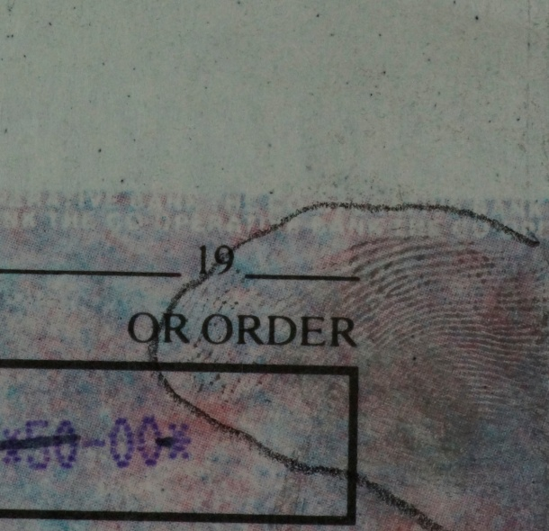
- b)
Figure 2. Examples of cheques where background printing may cause issues in visualising marks, a) background fluorescence from a Natwest cheque, potentially obscuring DFO marks, and b) coloured/patterned background printing on a Co-Op cheque, potentially obscuring ninhydrin marks but with a physical developer mark readily visible
The results also reinforce the fact that the reaction rates of DFO and ninhydrin with amino acids can differ, and there is merit in re-examining exhibits several days after treatment because additional marks may appear. However, it is recognised that this may not be practical in many operational scenarios where it may be more important to obtain results quickly.
Because studies of this type can sometimes be skewed by a small number of articles that contain a far greater number of marks than the others, the results were also assessed in terms of the numbers of ‘positive cheques’, i.e. the number of cheques on which one or more identifiable marks were developed. This analysis is shown in Table 12.
Process | Time between treatment and examination | Cumulative number of positive cheques/ (additional marks found at each stage) |  |  |  | Cumulative number of positive cheques (100 max.)/(additional cheques at each stage)
 |  | Barclays | Co-Op | Midland | NatWest
DFO | 0 days | 16 | 6 | 11 | 12 | 45
DFO | 14 days | 16 (0) | 6 (0) | 12 (+1) | 15 (+3) | 49 (+5)
Ninhydrin | 0 days | 16 (0) | 8 (+2) | 13 (+1) | 17 (+2) | 54 (+5)
Ninhydrin | 14 days | 16 (0) | 10 (+2) | 13 (0) | 17 (0) | 56 (+2)
Physical developer | 1 day | 22 (+6) | 18 (+8) | 18 (+5) | 17 (0) | 75 (+19)
Table 12. Cumulative number of ‘positive cheques’ from different sources where marks were developed by the processes in the DFO-ninhydrin-physical developer sequence
These results show similar trends in that the largest benefits are seen from initial application of DFO and the final treatment with physical developer. Although no new marks were found on any previously negative NatWest cheques, it can be seen from Table 11 above that 13 marks were still developed on this type of substrate. Ninhydrin is still effective in adding to the number of positive cheques, but less so than the other processes.
The age of the cheques used (11-17 years) in this experiment did not appear to impact upon the effectiveness of DFO or ninhydrin. The cheques used in this experiment were taken from the same boxes of 1980s/1990s material that had also been used in work conducted in the 1990s, when the cheques were only 1-5 years old. At that time, the cheques were used in evaluation of CFC-free formulations of DFO and ninhydrin, including those ultimately used in the current study [21]. By comparing the results from the current experiment with that from the 1990s, it was found that the number of marks recovered using DFO-ninhydrin in 2003 was actually greater than that recovered in the 1990s. Although results cannot be directly compared because the bank accounts the cheques were selected from were different (i.e. the original donors and those likely to have handled them vary significantly) and the light sources used in examination had changed, results suggest that there is no significant drop off in performance of the amino acid reagents over this time interval.
To establish whether all the reagents continued to develop fingermarks on significantly older documents, the results obtained from the 1940s documents were reviewed. On these documents DFO proved ineffective in developing any ridge detail. Ninhydrin did develop some fragments of ridge detail, although these were very faint and hard to image.
Physical developer was the most effective process on documents of this age and produced excellent ridge development in some cases. The best results were obtained on an electricity bill dated 1948 on which 10 separate regions of ridge detail were developed. Of these, three contained sufficient ridge detail to be considered potentially identifiable, Figure 3.
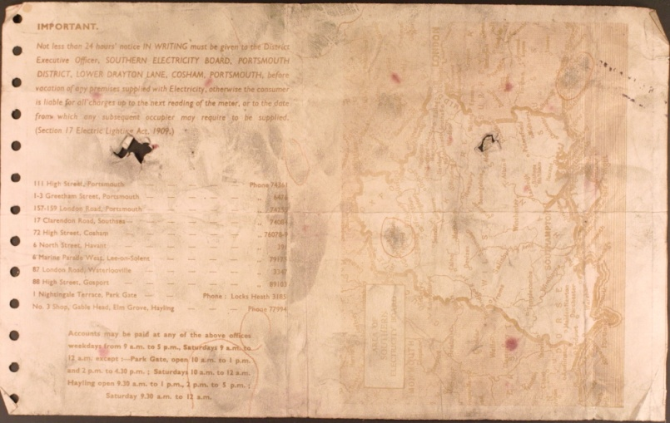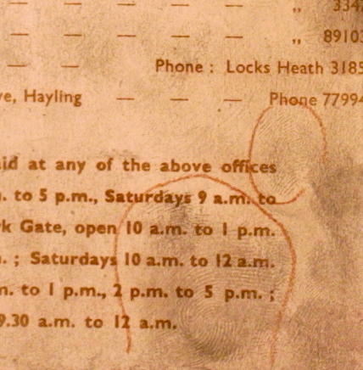
- b)
Figure 3. Development of fingermarks on a 1948 electricity bill using physical developer, a) overview of the document showing regions of development, b) close-up of a fingermark showing ridge detail

Experiment 2: Investigation of the effectiveness of processing sequences and alternative PD formulations on cheques, 1920s and 1940s documents
The cumulative total of fingermarks found on the cheques as they progressed through the DFO-ninhydrin-physical developer processing sequence is recorded in Table 13 and shown graphically in Figure 4. The number of additional marks developed by each physical developer is recorded separately, but is also added together to give an overall total for the number of additional marks developed by the physical developer process (regardless of which formulation was used).
Process | Time between treatment and examination | Cumulative number of fingermarks/ (additional marks found at each stage) |  |  |  | Cumulative number of fingermarks across all cheques  /(additional marks found at each stage)
 |  | Barclays | Co-Op | Midland | NatWest
DFO | 0 days | 48 | 6 | 27 | 34 | 115
DFO | 5 years | 69 (+21) | 20 (+14) | 48 (+20) | 45 (+11) | 182 (+67)
Ninhydrin | 0 days | 85 (+16) | 28 (+8) | 55 (+7) | 51 (+6) | 219 (+37)
Ninhydrin | 14 days | 88 (+3) | 28 (0) | 61 (+6) | 53 (+2) | 230 (+11)
Physical developer (Synperonic N) | 1 day | 97 (+9) | 35 (+7) | 65 (+4) | 63 (+10) | 296 (+66)
Physical developer (DGME) | 1 day | 111(+14) | 39 (+4) | 73 (+8) | 73 (+10)
Table 13. Cumulative number of fingermarks developed on cheques from different sources by the processes in the DFO-ninhydrin-physical developer sequence, incorporating results from two different formulations of physical developer (50 cheques processed using DGME and 50 with Synperonic N formulations)

Figure 4. Cumulative number of fingermarks developed on cheques from different sources by the processes in the DFO-ninhydrin-physical developer sequence, incorporating results from two different formulations of physical developer (50 cheques processed using DGME and 50 with Synperonic N formulations)
It can be seen that the trends observed are similar to those seen in Experiment 1, with all processes in the sequence having an added benefit. The number of marks recovered using DFO and ninhydrin on the Co-Op cheques was lower than that on cheques from other banks in both experiments. This may be because of the more highly patterned background of the Co-Op cheques, making developed marks more difficult to discriminate. The background printing also fluoresced for some of the Co-Op cheques, possibly contributing to the lower results observed for DFO. A further factor in the differences between the cheques from different banks could be that the paper used almost certainly comes from different suppliers, each of whom will add their own proprietary dyes and pigments to make them sensitive against any oxidizing and reducing chemicals used for forgery. These chemicals may interact with the fingermark residue, potentially resulting in changes in composition and changes in reactivity with the different fingermark developers, and this interaction is also likely to differ for cheques from different banks.
In terms of the total number of fingermarks recovered (281 from the 2003 batch, 296 from the 2013/2018 batch), there is little difference in the results between the experiments, and the slightly greater number of fluorescent marks found in the later experiment may be due to improvements in output power of the light sources used. However, this could also be due to inherent variability in sweat of the people handling the cheques, or indeed the number of fingermarks deposited on them. Because these batches of cheques were selected to be equivalent to each other, donor variability has been minimised as much as possible for an operational trial of this type. The close equivalence of the number of marks developed in both experiments suggests that ageing of the cheques for an additional 10-15 years has had minimal (if any) impact on the effectiveness of DFO, ninhydrin and physical developer. It should be noted again that only the number of additional marks found at each stage of the sequence was recorded, the number of marks from the previous process that disappeared at each stage was not.
The observation that each process in the sequence continues to add value to the marks recovered is again reinforced by the results of the numbers of positive cheques, Table 14.
Process | Time between treatment and examination | Cumulative number of fingermarks/ (additional marks found at each stage) |  |  |  | Cumulative number of positive cheques (100 max.)/(additional cheques at each stage)
 |  | Barclays | Co-Op | Midland | NatWest
DFO | 0 days | 17 | 5 | 10 | 13 | 45
DFO | 5 years | 22 (+5) | 12 (+7) | 19 (+9) | 17 (+4) | 70 (+25)
Ninhydrin | 0 days | 23 (+1) | 15 (+3) | 19 (0) | 17 (0) | 74 (+4)
Ninhydrin | 14 days | 23 (0) | 15 (0) | 19 (0) | 17 (0) | 74 (0)
Physical developer (Synperonic N) | 1 day | 24 (+1) | 18 (+3) | 20 (+1) | 17 (0) | 83 (+9)
Physical developer (DGME) | 1 day | 25 (+1) | 19 (+1) | 21 (+1) | 18 (+1)
Table 14. Cumulative number of ‘positive cheques’ from different sources where marks were developed by the processes in the DFO-ninhydrin-physical developer sequence, incorporating results from two different formulations of physical developer (50 cheques processed using DGME and 50 with Synperonic N formulations)
The progressive increase in the number of positive cheques throughout the sequence shows that results are not skewed by a limited number of cheques with high numbers of marks (for example one heavily handled paper item can occasionally have >50 marks on it), and new fingermarks are also being developed on articles where no marks have previously been found.
A potential issue with this experiment was the 5-year gap between the initial examination after DFO and the re-examination before the experiment restarted. It was noted that after 5 years of storage the developed marks were far more strongly coloured than is usually observed with the DFO process and many were clearly visible as reddish-pink ridges. When conducting the second fluorescence examination it was evident that many additional marks had developed over the 5-year period, although it should be noted that a different light source was used. Some allowance should be given to subjectivity during grading and differences between the different members of staff making the assessments in 2013 and 2018 (the trends in marks found on different types of cheque are likely to be the same for different staff, but the overall number considered worth recording may vary), but several marks found in 2018 and not in 2013 were readily visible and would have been marked up by any examiner. The reaction rate of DFO is known to be slow [22], and this experiment demonstrates that marks progressively develop over timescales extended beyond the current period of a couple of days before ninhydrin is applied. It may therefore be expected that a greater proportion of amino acids would have reacted during the 5 year period with the consequence that ninhydrin would be reduced in effectiveness when used as the next process in the sequence. This was not seen in the results, with ninhydrin continuing to develop additional marks in similar numbers to those seen in Experiment 1.
The final element of the tests on cheques was to compare the effectiveness of the two physical developer formulations. In terms of the additional marks developed on the two equivalent batches of 50 cheques, 36 marks were developed using the DGME-based formulation (an increase of 34%), and 30 marks were developed using the Synperonic N-based formulation (an increase of 27%). This indicates that the DGME-based formulation is performing at least as well as the Synperonic N-based formulation on articles of this age and type and shows promise for introduction for use on operational casework. However, this should be qualified by the fact that more data would be required to draw firm conclusions, extending the trial across a broader range of paper types
The results from the 1920s and 1940s documents were consistent with observations on 1940s documents in Experiment 1. On the 1920s documents, no areas of fluorescent ridge detail were developed with DFO, although one area was noted where an apparent fingermark was revealed by the background fluorescence of the paper, Figure 5a. On the 1940s documents, 4 areas of fluorescent ridge detail were detected but all of these were fragmentary and mostly insufficient for identification, Figure 5b.
- b)
Figure 5. Fingermarks found on old documents after processing with DFO, a) dark, absorbing fingermark on 1920s document revealed by background fluorescence of paper, and b) fragment of fluorescent ridge detail on a 1940s document.
Subsequent processing with ninhydrin did not develop any additional marks characteristic of those conventionally developed by the process. On the 1920s documents, there were 4 areas that were a very pale purple in colour that were suggestive of handling, but these had no ridge detail. In addition, there were some regions of very intense purple development in areas where contact may be expected, but again these were highly diffuse and did not contain any ridge detail, Figure 6a. Similar features were seen on the 1940s documents, but only one area was developed where ridge detail could be distinguished, and this was a dark blue in colour, Figure 6b.
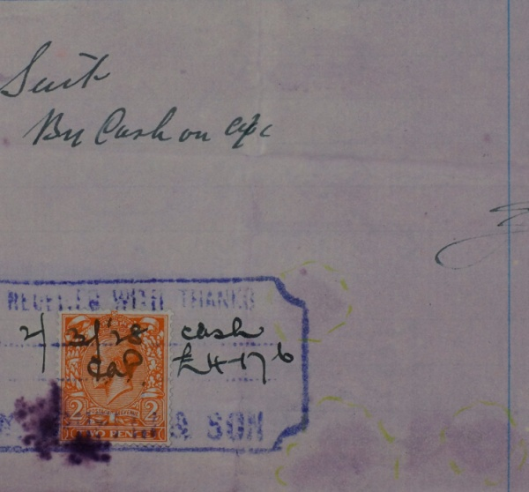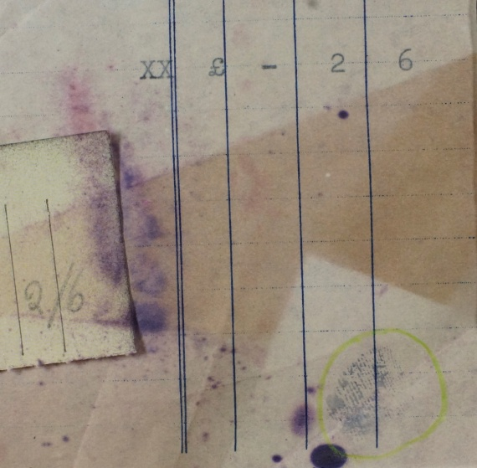
- b)
Figure 6. Fingermarks found on old documents after processing with ninhydrin, a) faint contact areas on a 1920s document and a more intense area of development at the corner of the stamp, and b) a dark blue area of developed ridge detail on a 1940s document.
Despite the low success rate with the amino acid reagents, physical developer was still capable of developing additional areas of ridge detail. On the 1920s documents physical developer produced 9 fingermarks (5 with the DGME-based formulation and 4 with the Synperonic N-based formulation), and on the 1940s documents physical developer produced 13 fingermarks (8 with the DGME-based formulation and 6 with the Synperonic N-based formulation). Examples are shown in Figure 7.
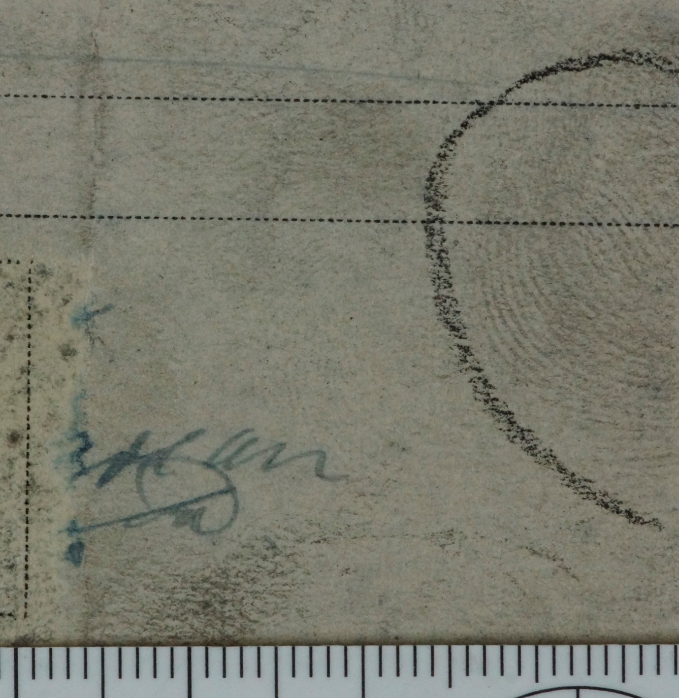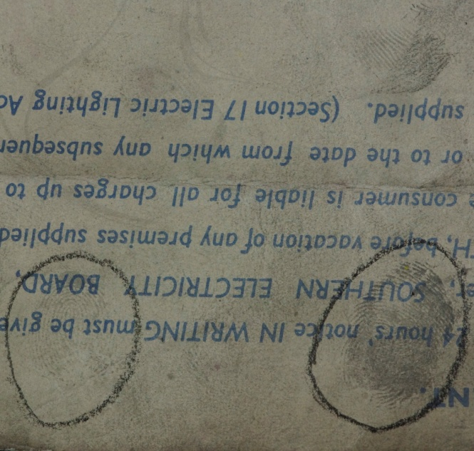
a) b)
Figure 7. Fingermarks found on old documents after processing with physical developer, a) on a 1920s receipt, and b) on a 1940s electricity bill.
It was not possible to distinguish between the sections of documents known to be developed by different physical developer formulations by eye, Figure 8, and this, combined with the fact that the number of additional marks developed by each formulation is broadly similar on cheques and old documents, indicates that the formulations are of similar effectiveness on this type of document.

Figure 8. A 1920s document processed using DGME-based physical developer (left hand side) and Synperonic N-based physical developer (right hand side) showing no perceptible difference in level of development between the two sides.

Experiment 3: Investigation of the effectiveness of 1,2-indandione processing sequences and alternative PD formulations on cheques
The cumulative total of fingermarks found on the cheques as they were treated with the 1,2-indandione-ninhydrin-physical developer processing sequence is recorded in Table 15 and shown graphically in Figure 9. Again, the number of additional marks developed by the different physical developer formulations is recorded separately, but then summed to provide the number of additional marks found by the physical developer process overall.
Process | Time between treatment and examination | Cumulative number of fingermarks/ (additional marks found at each stage) |  |  |  | Cumulative number of fingermarks across all cheques  /(additional marks found at each stage)
 |  | Barclays | Co-Op | Midland | NatWest
1,2 indandione | 0 days | 43 | 26 | 19 | 26 | 114
1,2 indandione | 14 days | 61 (+18) | 48 (+22) | 28 (+9) | 39 (+13) | 176 (+62)
Ninhydrin | 0 days | 75 (+14) | 58 (+10) | 34 (+5) | 52 (+13) | 219 (+43)
Ninhydrin | 14 days | 83 (+8) | 62 (+4) | 41 (+7) | 58 (+6) | 244 (+25)
Physical developer (Synperonic N) | 1 day | 92 (+9) | 73 (+9) | 48 (+7) | 72 (+14) | 322 (+78)
Physical developer (DGME) | 1 day | 106 (+14) | 80 (+7) | 59 (+11) | 77 (+5)
Table 15. Cumulative number of fingermarks developed on cheques from different sources by the processes in the 1,2-indandione-ninhydrin-physical developer sequence, incorporating results from two different formulations of physical developer (50 cheques processed using DGME and 50 with Synperonic N formulations)

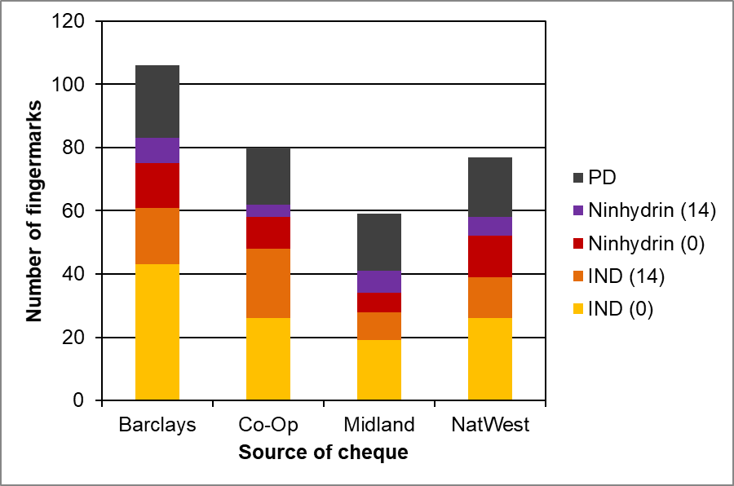
Figure 9. Cumulative number of fingermarks developed on cheques from different sources by the processes in the DFO-ninhydrin-physical developer sequence, incorporating results from two different formulations of physical developer (50 cheques processed using DGME and 50 with Synperonic N formulations)
As found in Experiments 1 and 2, every process in the sequence is shown to have an added benefit, with 1,2-indandione and physical developer providing the biggest increases in number of marks found. The number of marks found by 1,2-indandione on day 0 (114) is very similar to the number found by DFO in the previous two experiments (113 and 115). However, the results cannot be regarded as truly comparable because the bank accounts that the cheques were selected from are different in the 2018 study to those used in 2003 and 2013 and will have been handled by different people to different extents. It is generally accepted that 1,2-indandione is a superior reagent to DFO on more recently deposited marks but it is not yet known whether the performance of the two reagents drops off at a similar rate as marks become older. It is, however, evident that 1,2-indandione is still capable of developing fingermarks on documents of this age (21 – 32 years old). The replacement of DFO in the sequence by 1,2-indandione does not appear to adversely affect the number of marks subsequently developed using ninhydrin or physical developer. The number of marks developed by this sequence (322) was the highest overall, but as stated earlier this may be due to the cheques coming from different sources rather than any increase in effectiveness of any process in the sequence.
As for both previous experiments the number of articles that identifiable fingermarks are recovered on also increases as more processes are used, and this can be seen in the results of the numbers of positive cheques, Table 16.
Process | Time between treatment and examination | Cumulative number of positive cheques/ (additional marks found at each stage) |  |  |  | Cumulative number of positive cheques (96 max.)/(additional cheques at each stage)
 |  | Barclays | Co-Op | Midland | NatWest
1,2 indandione | 0 days | 19 | 13 | 11 | 17 | 60
1,2 indandione | 14 days | 21 (+2) | 20 (+7) | 14 (+3) | 20 (+3) | 75 (+15)
Ninhydrin | 0 days | 22 (+1) | 21 (+1) | 15 (+1) | 22 (+2) | 80 (+5)
Ninhydrin | 14 days | 22 (0) | 21 (0) | 17 (+2) | 22 (0) | 82 (+2)
Physical developer (Synperonic N) | 1 day | 22 (0) | 21 (0) | 18 (+1) | 23 (+1) | 85 (+3)
Physical developer (DGME) | 1 day | 22 (0) | 21 (0) | 19 (+1) | 23 (0)
Table 16. Cumulative number of ‘positive cheques’ from different sources where marks were developed by the processes in the 1,2-indandione-ninhydrin-physical developer sequence, incorporating results from two different formulations of physical developer
Considering the relative performance of the two different physical developer formulations on the two batches of 48 cheques, 37 marks were developed using the DGME-based formulation (an increase of 30%), and 41 marks were developed using the Synperonic-based formulation (an increase of 33%). When taken in combination with the results from Experiment 2 it appears that there is little difference in the effectiveness of the two formulations, with each formulation developing on average an additional 30% of marks when used at the end of a processing sequence. This again indicates that the DGME-based formulation shows potential to replace the existing Synperonic N formulation (which will soon be unavailable because of its impact on the environment) for operational work. As previously stated, further data would be required to show that these trends are replicated on other types of porous substrate.

Experiment 4: Investigation of the effectiveness of physical developer enhancement using blue toner on cheques, 1920s and 1940s documents
The use of blue toning after physical developer was found to be effective in visualising a significant amount of additional marks. The increase in number of marks seen on the cheques is summarised in Table 17, as is the percentage increase in number of marks associated with the blue toner process.
Experiment | Type of cheque | Total number of marks on cheque after physical developer | Total number of marks after physical developer enhancement (blue toner) | % additional marks from blue toner
Experiment 1 (2003) | Barclays | 87 | 101 | 16
 | Co-Op | 53 | 66 | 25
 | Midland | 56 | 67 | 19
 | NatWest | 85 | 95 | 12
Experiment 2 (2013/2018) | Barclays | 111 | 126 | 14
 | Co-Op | 39 | 68 | 74
 | Midland | 73 | 85 | 16
 | NatWest | 73 | 89 | 22
Experiment 3  (2018) | Barclays | 106 | 119 | 12
 | Co-Op | 80 | 98 | 22
 | Midland | 59 | 73 | 24
 | NatWest | 77 | 85 | 10
Table 17. The number of additional marks visualised on cheques using blue toner, showing results from different banks and different batches of cheques
It can be seen that the use of blue toner typically increased the number of marks visualised by 10-25% (with one ‘out-lier’ of 74%). The highest percentage increases tended to be observed on Co-Op cheques, including the outlier of 74%, which were the most coloured and patterned cheque designs used in the study, a factor that may have made marks developed using ninhydrin and physical developer more difficult to see.
There were typically three means by which additional marks were detected after treatment with blue toner:
- Marks that were initially too faint to see after physical developer becoming visible because of an increased contrast between the ridges and the background
- Marks running across coloured, patterned backgrounds becoming visible because the blue ridges provide better colour contrast with the background than the original pale grey (the dominant factor on Co-Op cheques)
- Certain marks in regions of heavy, overlaid fingermark deposition being more heavily stained than others, making their ridge flow easier to discern.
Examples of these are shown in Figure 10.
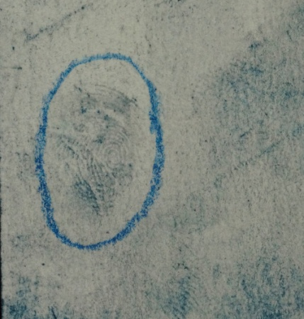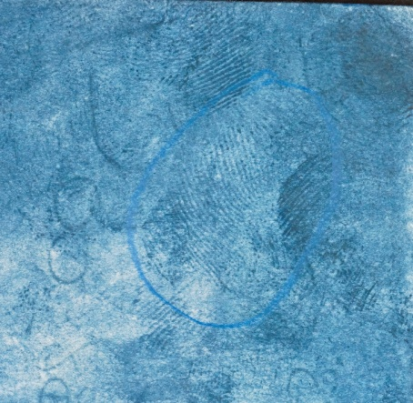
- b) c)
Figure 10. Examples of fingermarks visualised on cheques using blue toner, a) a faint mark increased in contrast, b) a mark running across a coloured background, and c) selective staining of marks in a region of heavy, overlaid deposition
Blue toning was equally effective on old documents. On the 1920s documents, 8 additional regions of ridge detail were found after blue toning, and on the 1940s documents, an additional 13 regions were visualised. Examples are shown in Figure 11.
- b)
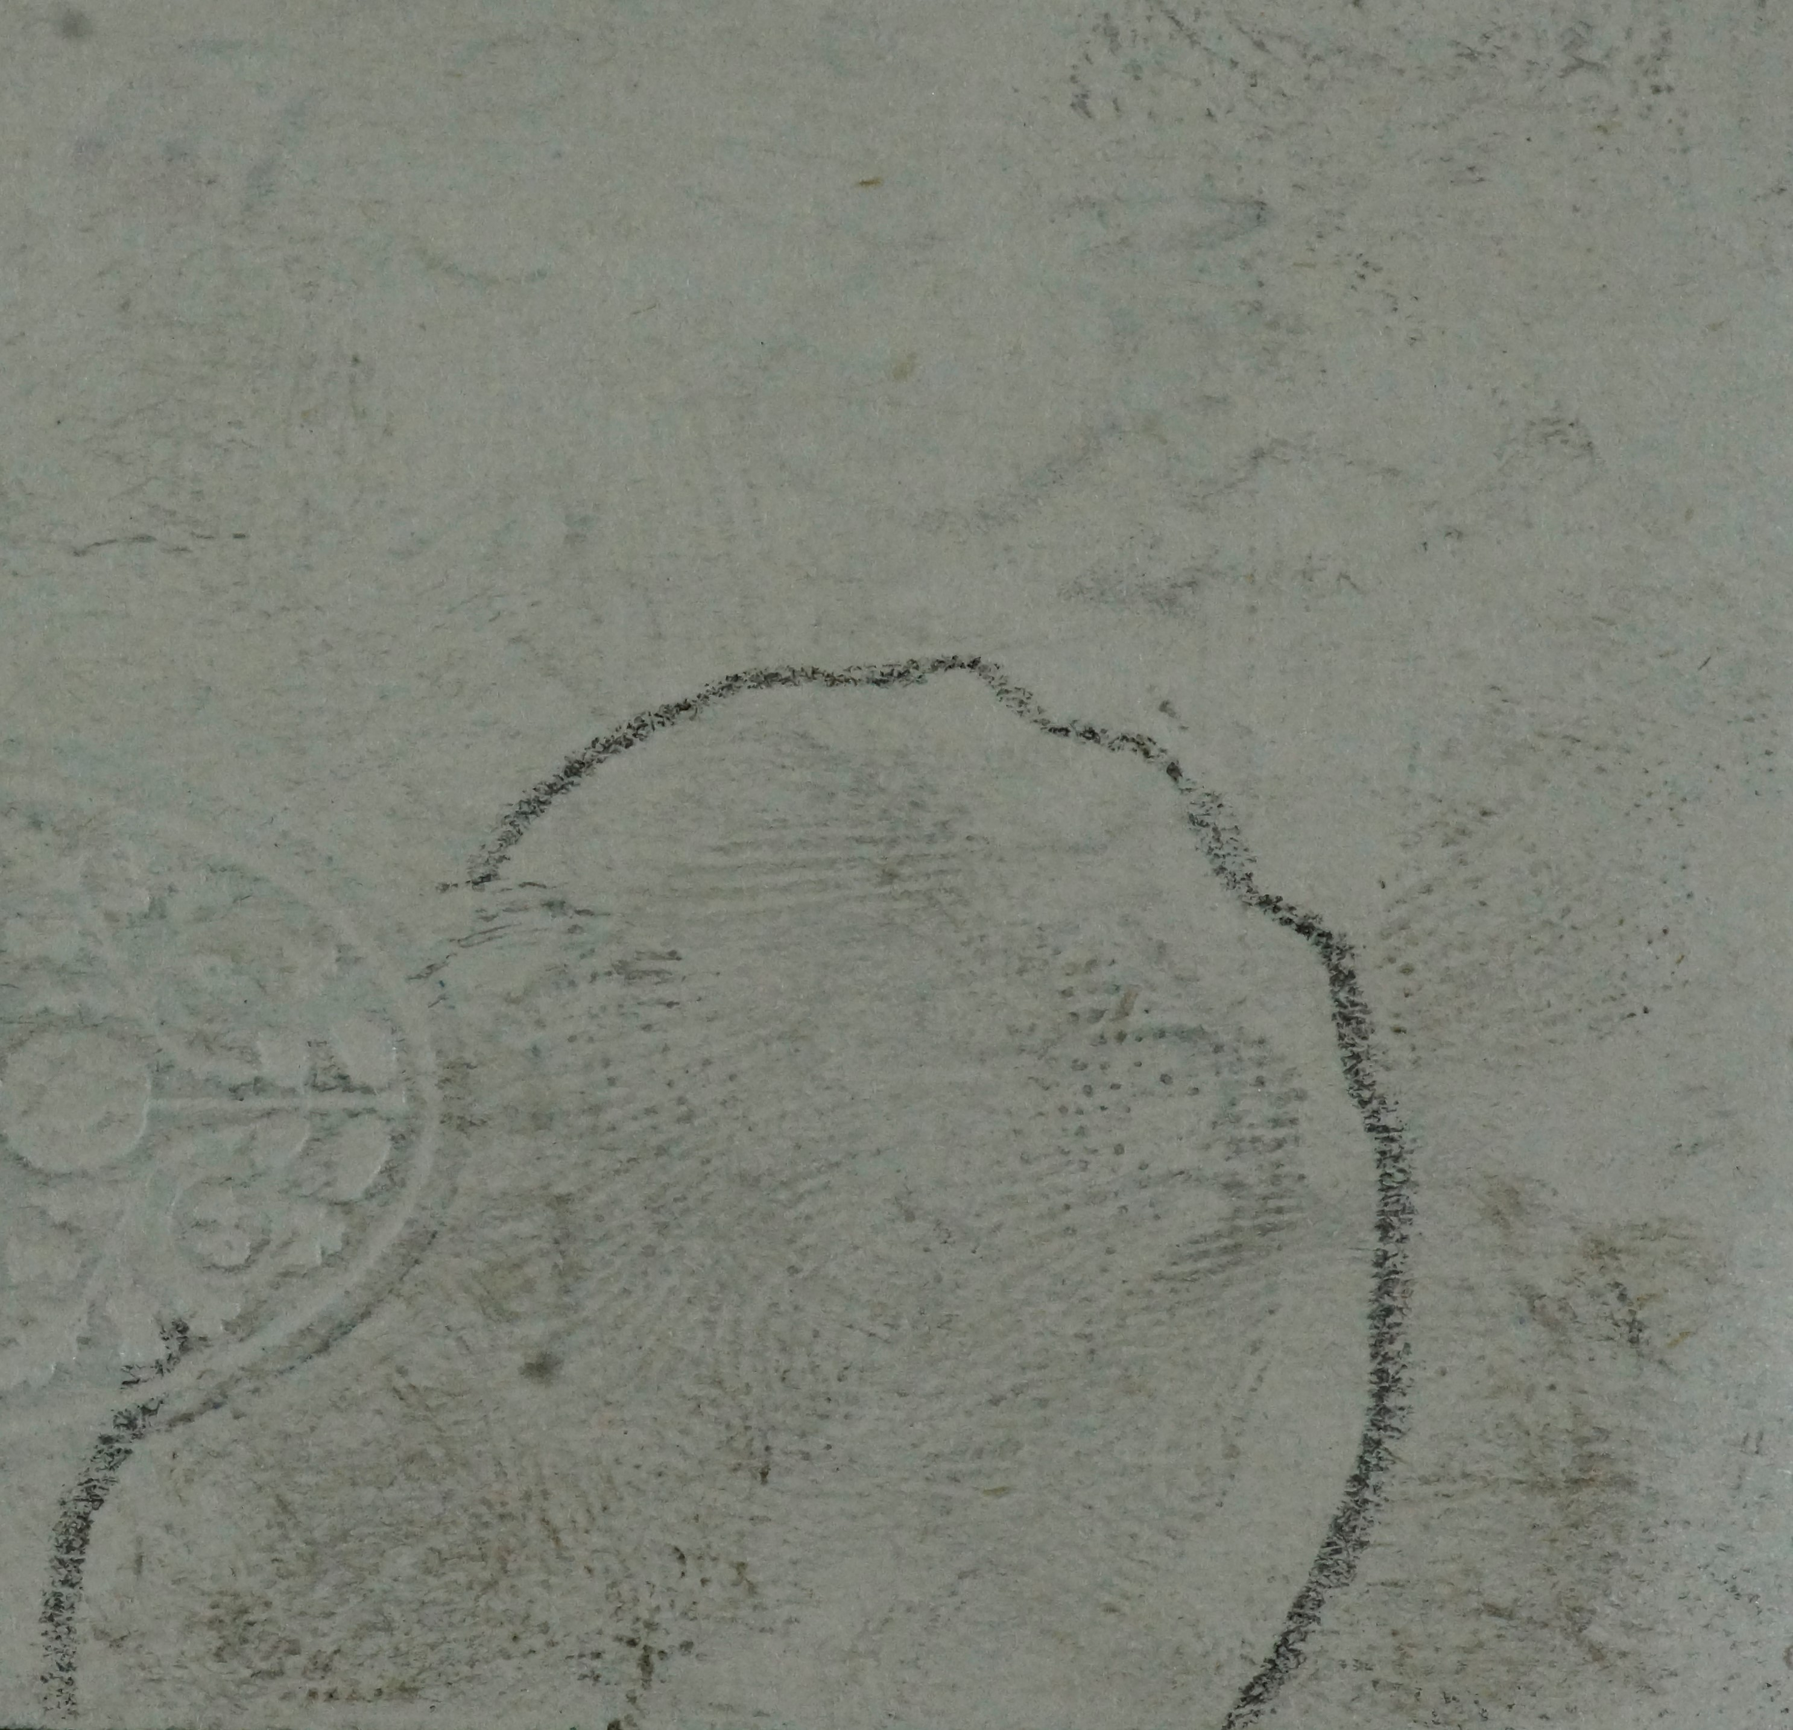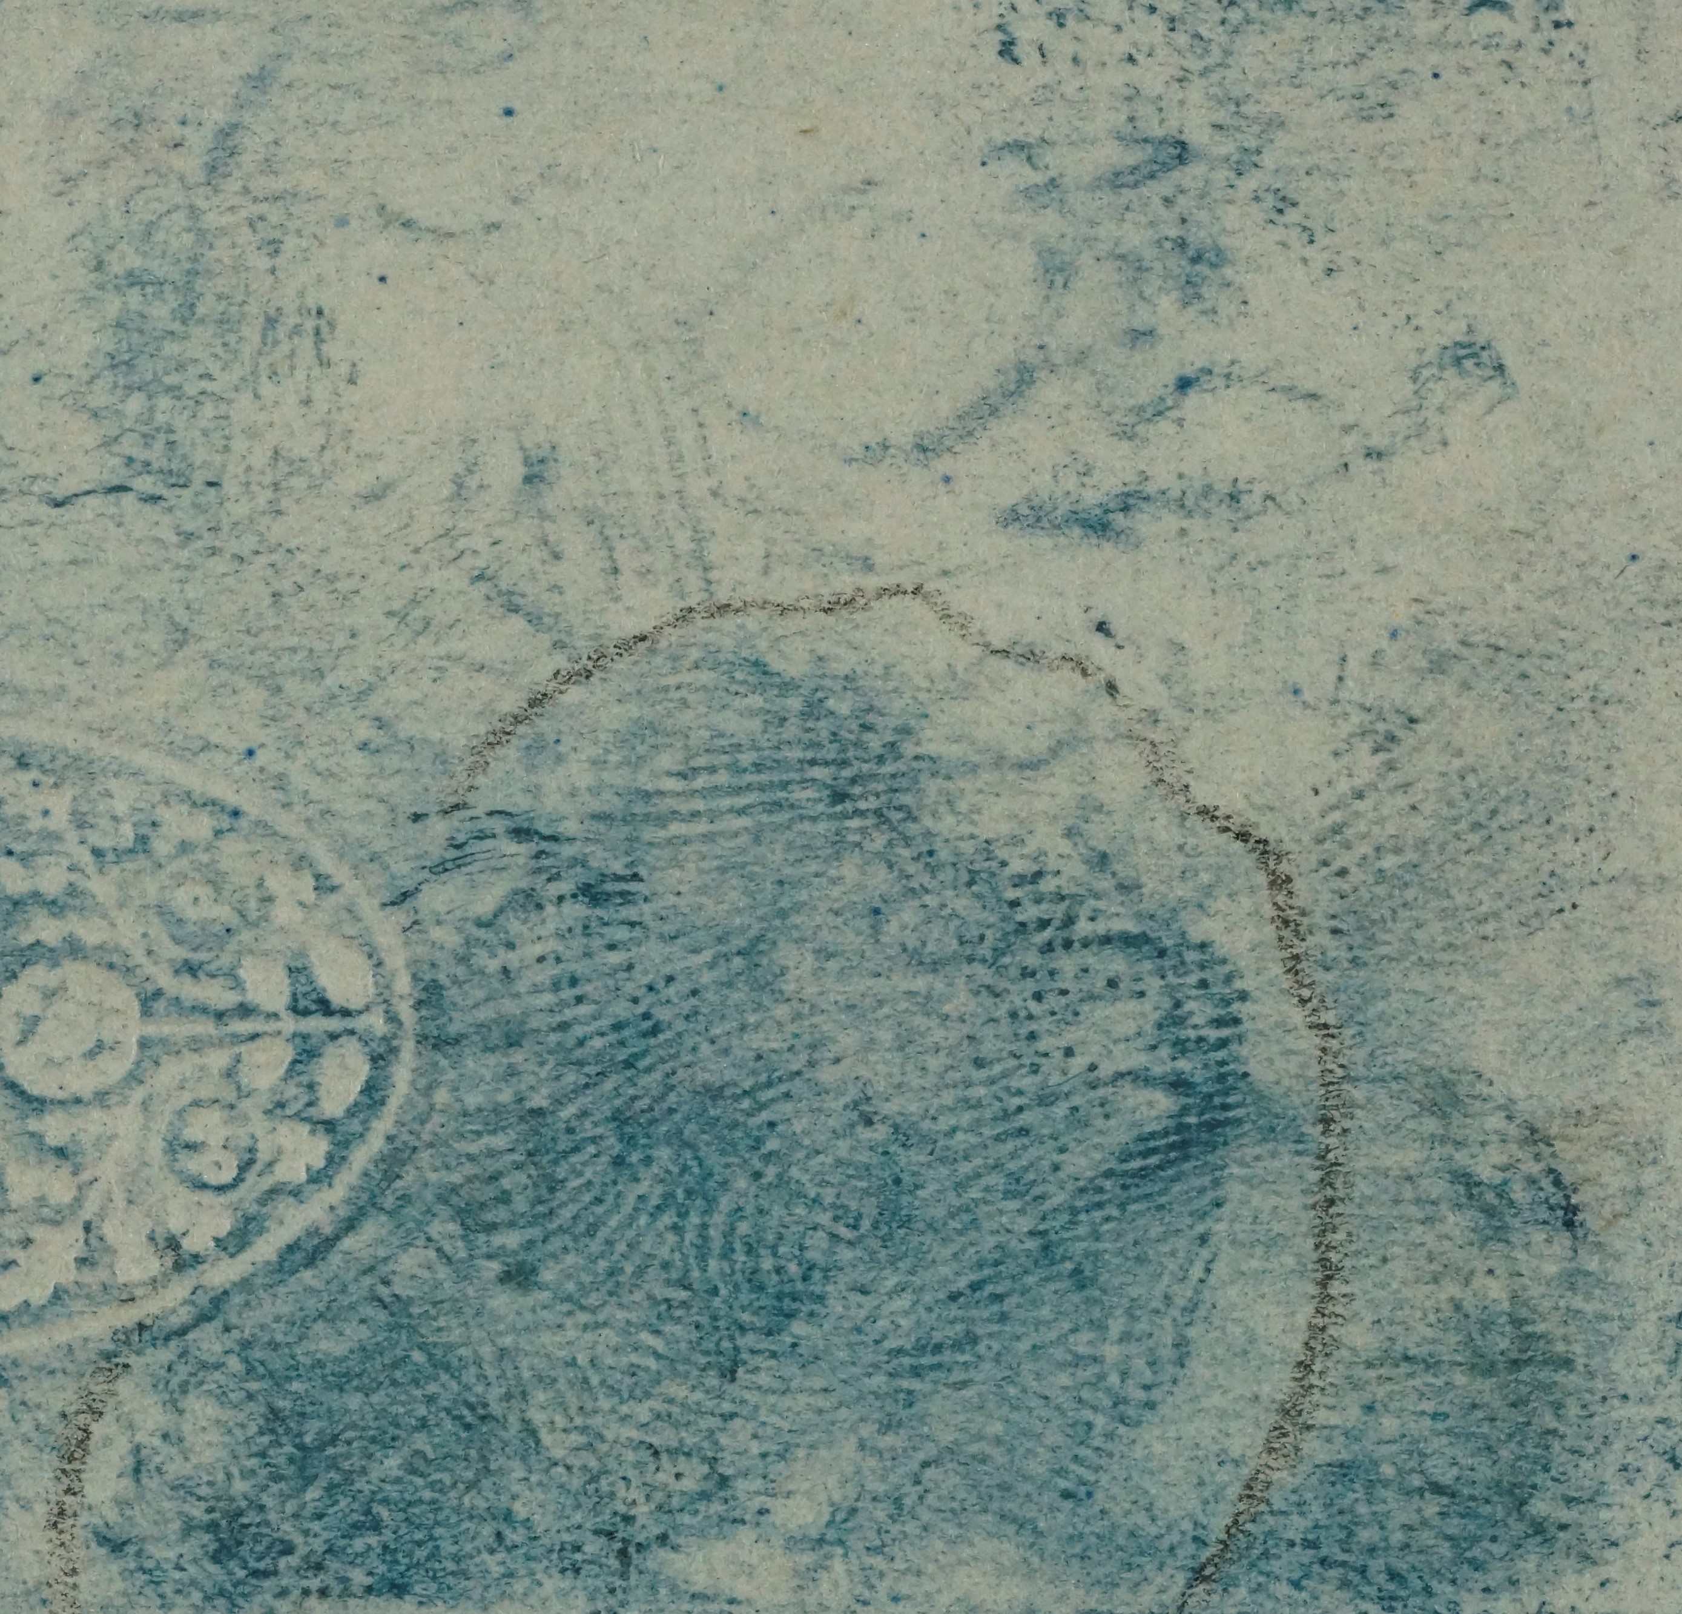
c) d)
Figure 11. Fingermarks visualised by blue toning on old documents, a) a 1920s typed letter, and b) a 1920s printed receipt, c) a physical developer mark on a 1940s document before toning, and d) after toning showing increase in contrast
This is the first time that the effectiveness of blue toner has been evaluated in a study of this scale, and the number of additional marks found indicates that it should be more widely recommended for used after physical developer.

Conclusions
Several conclusions can be drawn from the results obtained in the study.
Firstly, the benefits of carrying out sequential processing on porous items were reinforced, because it can be seen that each process in the sequence was capable of developing a significant number of additional marks. By using sequential processing, the proportion of cheques yielding ‘identifiable’ fingermarks (as defined by the criteria set out in the experimental method) was shown to increase from 30-60% after a single process to 75-85% at the end of the sequence.
It is also concluded that the use of blue toning for enhancement of faintly developed marks from physical developer should be promoted. This process is only rarely used at present because there has been no published study into its effectiveness for potential end users to refer to. This work has shown that the process has clear operational benefits, visualising an additional 10-25% of marks in this study. The blue toning process should also be compared to and/or used in combination with the infrared reflection process to increase the recovery of physical developer marks.
Physical developer is a highly effective treatment for old documents and has been shown to continue to develop fingermarks that are up to 90 years old. It should therefore be considered as a potential treatment in any cold case review involving paper/porous evidence where this process has not been previously applied.
The amino acid reagents 1,2-indandione, DFO and ninhydrin have been shown to develop fingermarks on documents up to 33 years old that have been kept in controlled environments. They were found to be considerably less effective on older documents where the environmental exposure conditions were unknown and repeated increases in humidity probably cause progressive diffusion of amino acids. The natural moisture contents of the different papers may also contribute to the results observed. This means that in such situations, physical developer (which is relatively unaffected by such conditions) should always be applied as a sequential treatment.
The effectiveness of physical developer as a final treatment in a sequence appears to be unaffected by whether 1,2-indandione or DFO is used as the initial process in that sequence, and there is no noticeable difference in performance between the existing Synperonic N-based formulation and the proposed DGME-based formulation [19] of physical developer on old documents. The DGME-based formulation therefore shows promise as a potential replacement for Synperonic N-based physical developer.
However, some of these conclusions should be caveated with the fact that only cheques were used in the main parts of the study, and other types of paper may behave differently. Any further work should consider inclusion of aged paper from other sources to see if these trends are more broadly replicated.

References
- Faulds H, ‘Dactylography, or the Study of Finger-prints’ Halifax, Milner and Co.: London, 1912

- https://www.independent.co.uk/news/science/three-thousand-year-old-fingerprints-discovered-on-ancient-egyptian-coffin-lid-a6887976.html (accessed 17/05/2018)

- Biro, P P, ‘Forensics and Microscopy in Authenticating Works of Art’, In Focus, Issue 1, March 2006, DOI: 10.22443/rms.inf.1.3

- https://www.computerweekly.com/news/2240082908/Police-to-reopen-4000-cold-cases-with-DNA-database (accessed 11/10/2018)

- https://wrongfulconvictionsblog.org/2012/07/19/another-dna-exoneration-for-the-uk/ (accessed 11/10/2018)

- https://www.fbi.gov/news/stories/30-year-old-murder-solved (accessed 10/06/2018)

- https://archives.fbi.gov/archives/news/stories/2010/october/latent_102510/latent_102510 (accessed 10/06/2018)

- Comber B, Payne G, Lennard C, ‘Chapter 16: Digital Imaging’, in Ramotowski, R, ‘Advances in Fingerprint Technology, 3rd edition’, CRC Press, Boca Raton, 2013

- Bandey H, Bleay S, Bowman V, Fitzgerald L, Gibson A, Hart A, Sears V, ‘Fingerprint imaging across EM spectrum’, Imaging Science J, vol 54, (2006), p211-219

- Batey, G. W., Copeland, J., Donnelly, D. L., Hill, C. L., Laturnus, P. L., McDiarmid, C. H., Miller, K. J., Misner, A. H., Tario, A. and Yamashita, A. B. (1998) ‘Metal deposition for latent print development’, J. Forens. Ident., vol. 48 (2), p 165.

- Cohen, Y, Rozen, E, Azoury, M, Elad, M L, ‘Survivability of latent fingerprints part 1: Adhesion of latent fingerprints to smooth surfaces’, J. Forensic Ident. vol 62(1), 2012, p47-53

- Hansen D, ‘The development of novel ninhydrin analogues’, Chem. Soc. Rev. 2005, vol 34, p408-417

- Girod A, ‘Composition of fingermark residue: A qualitative and quantitative review’, Forensic Science International, 2012, vol223, p10-24

- Marriott C, Lee R, Wilkes Z, Comber B, Spindler X, Roux C, Lennard C, ‘Evaluation of fingermark detection sequences on paper substrates’, Forensic Science International, vol 236, 2014, p30-7

- Salama J, Aumeer-Donovan S, Lennard C, Roux C, ‘Evaluation of the fingermark reagent Oil Red O as a possible replacement for physical developer’, J. Forensic Identification, vol 58(2), 2008, p203-237

- Beaudoin A, ‘Oil Red O: Fingerprint development on a 21 year old cold case’, J. Forensic Identification, vol 61(1), 2011, p50-9

- Bandey H., ‘Fingermark Visualisation Manual 1st edition’, Home Office. 2014

- Nicolasora N, Downham R, Hussey L, Luscombe A, Mayse K, Sears V, ‘A Validation Study of the 1,2-Indandione Reagent for Operational Use in the UK: Part 1 – Formulation Optimization’, Forensic Science International, accepted for publication, 2018

- Thomas-Wilson A, Guo Z-Y, Hussey L, Sears V, Hillman A R, Coulston J, ‘Reformulation of the physical developer reagent’, paper in preparation

- International Fingerprint Research Group, ‘Guidelines for the assessment of Fingermark detection Techniques’, J. Forensic Identification, vol 64(2), 2014, p174-200

- Sears.V.G, Hewlett.D.F, "DFO Formulations In Non-Ozone Depleting Solvents," Identification Canada, Vol 26 (1), 2003, pp. 4-12.

- Hardwick, S., Kent, T., Sears, V. and Winfield, P. (1993) ‘Improvements to the Formulation of DFO and the Effects of Heat on the Reaction with Latent Fingerprints’, Fingerprint Whorld, vol. 19 (73), pp 65–69

