**APPLICATION OF SHORT AIR CURTAINS IN RETAIL DISPLAY REFRIGERATORS**

E. Hammond *(a,b), C. Marques (a), L. Ketteringham(b)

(a) Department of Engineering, London South Bank University, 103 Borough Road, London, SE1 0AA, UK

(b) ECH Engineering Ltd., Unit 10, Cattlemarket Business Park, Chew Road, Winford, Bristol, BS40 8HB, UK

* Corresponding author. Department of Engineering, London South Bank University, 103 Borough Road, London, SE1 0AA, UK. E-mail: e.hammond@lsbu.ac.uk

**ABSTRACT**

In Europe, Ecodesign and Energy Labelling regulations for refrigerated retail display cabinets will come into force in January 2017 and manufacturers are seeking new technologies to maximise the efficiency of their products.

Conventional multi deck cabinets have a single column of cold air from the top to the bottom of the merchandising envelope. The colder, denser air causes a stack effect and pressure builds at the base of air curtain causing cold air spillage from the cabinet and compromising temperature stability and energy efficiency.

By contrast, with short air curtains the merchandising envelope can be divided into separate cells between shelves. The smaller cells have a shorter air column and independent management of air movement. The net result is a substantial reduction in cold air spillage from the case and improved temperature stability.

This paper presents a technical and performance comparison between short air curtain technology and conventional cabinets.

Keywords: Retail Display Refrigerator, Energy Reduction, Air Curtain.

# INTRODUCTION

Whilst environmentally conscious shoppers have been advocates of doors on refrigerated cabinets in supermarkets for a considerable time, research into the use of doors has presented conflicting arguments regarding their benefits and challenges; it is well reported that doors are not a one-size-fits-all solution.

Shoppers were interviewed at the stores of three leading supermarkets in the Cheltenham and Gloucester (South West England) area over a one week period during February 2013 (Milnes, 2013) (The Grocery Trader, 2013), and (ACR News, 2013). Half of those customers questioned stated that they would prefer to shop from cabinets without glass doors but it was the under 40s who most strongly believed it would be more difficult to shop from cabinets with glass doors; 42.5% of all surveyed thought it would be difficult or very difficult to shop from cabinets with glass doors, for the under 40s this figure rose to 56%. This could be an indication that speed and convenience is a strong driver for younger shoppers; of those surveyed 43% shopped from cabinets with glass doors once a month or less. But 88% of those surveyed rated “clear display of merchandise” as important; unsolicited comments regarding condensation on glass doors obscuring visibility of merchandise were received.

One trade press article concluded that the warmer aisles, better preservation of the food and energy savings meant that the door installations were considered to have been a success in the majority of cases. However, the article went on to say that the doors slowed re-stocking and were later removed from snacking aisles of high footfall stores because they overly restricted the shoppers’ access (Insight, 2011).

An open refrigerated merchandising solution with a similarly low energy to doors has become the Holy Grail of retail refrigeration; this paper tests short air curtains as a viable alternative to doors.

Research by Hammond (2010) concluded that it was advantageous from an energy efficiency viewpoint to use multiple short air curtains rather than one single long curtain to seal the open front of a vertical multi-deck display cabinet. Previous research by Axell (2002), Schuster and Krieger (2007) and Stribling *et al.* (1995 ) also implied there was scope practically to do this. Axell (2002) investigated curtain height and its effect on the air curtain and did conclude: “...for the same height/width ratio, a short air curtain is more efficient than a high air curtain…”.

A common way to distribute cool air in a multi deck display cabinet is through perforated plates in the rear of the cabinet, and in the front of the cabinet is an air curtain. Air is blown out of the back panel between the shelves to cool the load and stabilise the air curtain and enable a lower discharge velocity to be used for the air curtain. Typically the air velocity between the shelves will be 0.05 to 0.4 m.s-1, 3 to 5 times less than that of the air curtain (Axell, Fahlen, & Tuovinen, 1999).

Conventional wisdom stated that: "Air emerging from the rear duct will have a stabilising effect on the air curtain. However, a well-stacked shelf will hinder this and the curtain would decay rapidly before reaching the bottom of the display case." (Axell, Fahlen, & Tuovinen, 1999). There are two significant points here. The first is that the back flow stabilises a slow air curtain, the second is that bad loading of a shelf will prevent the cabinet from maintaining the desired product storage temperature.

Back panel flow effectively creates a low velocity curtain over the stored product on each shelf; and the low velocity enables minimal entrainment and minimal cooling duty. However, a weak spot will always exist at the underside of each shelf, affecting the shelf below; this is a particular problem for the top shelf. Negatively buoyant spilled air from the tiers above each shelf, or in the case of the top shelf, the air curtain, prevents infiltration of this air into the cabinet to enable the cabinet to maintain the cold storage temperature inside. Were a cabinet to have only back panel flow, the top shelf could never maintain the desired product storage temperature. Significant research has been carried out to determine the ratio of back panel flow to air curtain flow. Gray *et al.* (Gray, Luscombe, Mclean, Sarathy, Sheahen, & Srinivasan, 2008) claims that 70 % of the air circulated should be used to supply the curtain and 30 % of the flow should be discharged through the back panel for the best results.

Gray (Gray, Luscombe, Mclean, Sarathy, Sheahen, & Srinivasan, 2008) also noted that a large amount of air supplied directly onto the shelves increased air spillage, and that the "weak curtain" resulting could not prevent infiltration at the top tiers. Work by Stribling *et al.,* (Stribling, Tassou, & Marriott, 1995 )(Stribling, Tassou, & Marriott, 1995 b) also investigated the effect of reducing the air curtain flow rate by 50 % and 100 %, forcing the remaining cooling air flow through the back panel on cabinet performance. Stribling concluded that the low velocity air curtain provided inadequate resistance to infiltration of room air due to a lack of momentum. Utilising high volume flows through the back panel of the cabinet yielded good results with a 3.5 % decrease in heat transfer across the curtain compared with the original design; suggesting that there would be potential to develop a vertical cabinet without a single continuous vertical air curtain over its full height.

Whilst an air curtain has been found to be essential, back panel flow is only a means to enable slower and therefore more efficient air curtains to be used. Back panel flow is strongly affected by shelf loading and cannot on its own maintain product temperature within a cabinet. Furthermore, it supplies the coldest air directly onto the stored product where the heat gain is least, which is not conducive to providing tight storage temperature control.

If short air curtains were to be utilised, a stable air curtain can be created using a slow velocity and so the problematic back panel flow can be eliminated. The elimination of back panel flow would then enable tighter temperature control independently of cabinet loading (ACR News, 2013). Axell (2002) made similar observations: “…the arrangement of blowing cold air from the rear duct is not the optimal way of cooling product in an open display case, as the cold air emerging from the rear duct impinges on the coldest of the products on the shelf. Back panel flow is unreliable and is not suited to varying product loading patterns”.

Short air curtain technology works by dividing the case’s merchandising envelope into separate air flow managed cells with short, low pressure air columns. Each cell has its own air curtain which is more efficient than the full height air curtain on a conventional multi-deck case (Figure 1). The net result is less pressure on the air curtain of each cell and a substantial reduction in cold air spillage from the case (Wood, 2013). As a result, energy efficiency is improved and cold aisle syndrome is reduced.



Figure 1. Aircell®, short air curtain concept cabinet (left) and air flow detail (right).

Temperature control is also further enhanced by eliminating the back panel air flow (The Grocery Trader, 2013) which makes conventional cabinets so susceptible to loading dependent performance variation. Independent tests have shown that temperature fluctuations of just 2.8K can be achieved in an Aircell (ACR News, 2013) (Food and Drink International, 2013).

Short air curtain technology has been presented in the trade press as an alternative to doors (ACR News, 2013). It promises similar energy savings (circa. 30%) to fitting doors and tighter temperature control than conventional cabinets and reduction in cold aisle syndrome. Because the cabinet remains fully open fronted, the energy saving measure of short air curtains does not introduce a physical barrier to sales.

Since short air curtain technology is not yet in production, a prototype cabinet was constructed for this trial to compare the performance of a completely Conventional, narrow multi-deck refrigerated cabinet to one modified to use short air curtains. The re-design and conversion was carried out by ECH Engineering Ltd. (Bristol) and Adande Refrigeration Ltd. (Lowestoft).

# Materials and Method

A 2500mm Narrow Multi deck cabinet was tested for temperature stability in an EN23953 compliant test chamber.

This paper summarises 24h of data, recorded from 11th May to 12th May 2015, after the cabinet was pulled down and brought to a stable condition. At least 24h of stable operation was observed before the reported period.

The test aimed to achieve M2 product temperatures (-1 to +7°C) in a class 3 ambient (25°C / 60% RH).

Any reference to EN23953 hereafter is a reference to the BS EN ISO 23953-2:2005+A1:2012 standard for refrigerated display cabinets.

Alongside the test of the conventional cabinet, a second cabinet was modified to include short air curtains before being subjected to the same product loading and testing as the conventional cabinet (described below).

The conversion of the cabinet included alterations to convert every other shelf to a ducted shelf. The rear duct was divided to provide supply and return air which was delivered to or collected from the fronts of the ducted shelves. Guide vanes were used to enable a balance re-distribution of the air from the ducts at the rear of the cabinet. For simplicity of the base design, the evaporator was replaced by two shorter evaporators and the fans were replaced by 12V DC, 120mm Sunon fans.

## The test room

The test room complied with the EN23953 specification:

Temperature control within 1°C, measured at control point above test cabinet.

Humidity control within 3%, measured at control point above test cabinet.

Air flow through the test room between 0.1 and 0.2 m/s recorded at all measurement locations (according to EN23953) within the empty test chamber prior to testing.

The ambient conditions during testing were controlled to 25 ±1°C and 60 ±3% RH (climate class 3).

Ambient conditions were recorded using a PT100 temperature probe and a Tecnologic humidity sensor located at the monitoring location described by EN23953 (centreline of cabinet, 300mm forward of supply air grille and 150mm vertically above the supply air grille).

Cooling duty was monitored and calculated using a cooling duty metering system by ECH Engineering Ltd., Bristol. The refrigerant mass flow, pressure and temperature measurements were measured on the common liquid and suction line to the cabinet rather than the two bays independently; this was considered to be a reasonable simplification given as both bays also operated from the same controller with the liquid solenoid valves wired in parallel. Data was monitored by the system at 1 second intervals with the time averaged data recorded at 10 second intervals.

## Cabinet loading

The loading of the cabinet comprised a combination of 2 litre water bottles and foam board for loading and M-packs for temperature measurement (Figure 2).

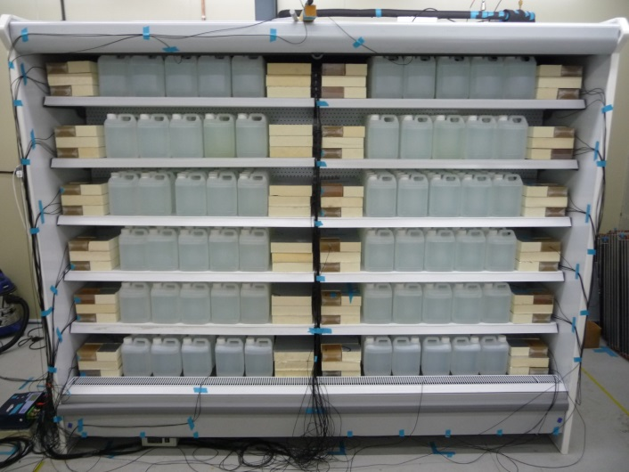 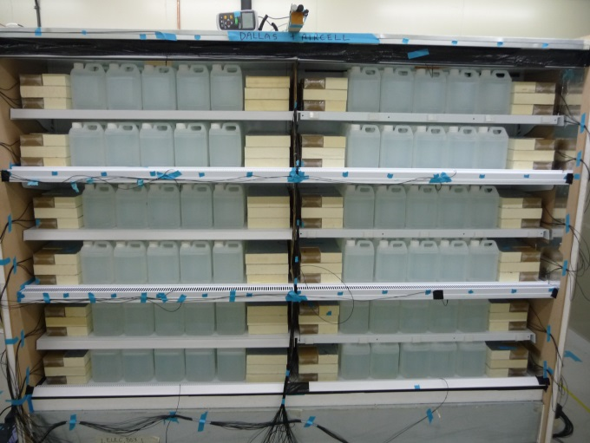

Figure 2: Photograph of cabinets loading during the test; conventional cabinet on (left) and short air curtain cabinet (right).

Temperatures of the (72 off) 500g Tylose M-packs were measured using PT100 probes embedded in the geometric centre of the M-packs. The probes were calibrated shortly before the test and had accuracy better than ±0.5°. Values were recorded at 1 minute intervals using a Datataker data logging system (DT80 unit plus two CEM20 units) and two Grant Squirrel 2040 units.

As per the order specifications, this loading is a deviation from the EN23953 standard in that the measurement points were above and beyond the standard requirements (measurement points on all shelves) and that foam board and water bottles were used between the Tylose M-packs.

## Commissioning

The cabinets were installed on a remote pack operating with R404a refrigerant. A proprietary controller was used to control the cabinet from a single supply air temperature probe in the left hand bay. The expansion valve was a Danfoss externally balanced TEV. Evaporating temperature was regulated using an EPR set for -8°C for the conventional cabinet and -3°C for the short air curtain cabinet.

The cabinet was run in the test chamber until at least 24 hours of stability was observed (at least 24 hours of steady cycling of all measured temperatures, according to EN ISO 23953-2:2005+A1:2012, section 5.3.2.5). The test was started after this point, and the following 24 hours of stable data are reported in these results. Controller parameters used can be found in Table 1 below.

Table 1. Controller settings used in the baseline cabinet

|  |  |  |  |
| --- | --- | --- | --- |
| Parameter | Description | Conventional | Aircell |
| SP | Set point | 0.0 | 0.5 |
| r0 | Hysteresis | 1.5 | 5 |
| d0 | Defrost interval | 4 | 3 |
| d2 | Defrost termination temperature | 8.0 | 6.0 |
| d3 | Maximum defrost duration | 30 | 18 |

# Results

## Product Temperatures

Figures 3 and 4 show the M-packages temperatures in the conventional and Aircell cabinet respectively.

|  |  |
| --- | --- |
| Figure 3: M-pack temperatures for the conventional cabinet. | Figure 4. : M-pack temperatures for the Aircell cabinet |

Table 2 compared the temperature performance of the conventional cabinet with the long air curtain with the Aircell cabinet with short air curtains.

Table 2. Comparing temperature performance for each cabinet

|  |  |  |  |
| --- | --- | --- | --- |
|  | **Minimum (°C)** | **Maximum (°C)** | **Average (°C)** |
| Conventional cabinet | -0.5 | 9.0 | 3.2 |
| Short air curtain cabinet | 3.8 | 6.9 | 5.3 |

## Energy Consumption

Table 3 compared the energy consumption of both cabinets.

Table 3. Comparing the energy consumption of the two cabinets.

|  |  |  |  |  |
| --- | --- | --- | --- | --- |
|  | **Average Duty (kW)** | **REC (kWh/24h)** | **DEC (kWh/24h)** | **TEC/TDA** |
| Conventional cabinet | 4.24 | 47.63 | 0.19 | 11.58 |
| Short air curtain cabinet | 3.04 | 30.54 | 0.14 | 7.319 |

# Conclusion

Short air curtains can be implemented on conventional open fronted display cabinets to reduce energy consumption and improve produce temperature control.

A reduction of 28.3% in heat gain was achieved with a 35.9% reduction in REC.

Temperature control improvement resulted in a reduction in product temperature range from 9.5K to 3.1K (67% tighter).

# Discussion

It is believed by the authors, based on work by Hammond (Hammond, 2010), that the improvement in temperature control results from the elimination of back panel flow. Whereas energy savings are largely due to the improved integrity of the shorter curtains compared to the conventional arrangement of a single long curtain supported by back panel flow.

# Acknowledgements

Adande Refrigeration (Lowestoft, UK) for funding the development of Aircell® short air curtain technology and much of this project.

ECH Engineering (Bristol, UK) for use of their design, development and test facility as part of this project.

# Bibliography

ACR News. (2013, April). Glass doors still a barrier to sales. *ACR News - April Digital Edition*, p. 5.

ACR News. (2013, July). Putting product temperature on hold. *ACR News - July Digital Edition*, p. 26.

Axell, M. (2002). *Vertical display cabinets in supermarkets - Energy Efficiency and the influence of air flows.* Goteborg: Chalmers University of Technology.

Axell, M., Fahlen, P., & Tuovinen, H. (1999). Influence of air distribution and load arrangements in display cabinets. *20th International Congress of Refrigeration.* Sydney.

BS EN ISO 23953-2:2005+A1:2012 Refrigerated display cabinets - Part 1 Classification, requirements and test conditions

Food and Drink International. (2013, June). Aircell maintains chilled food for longer. *Food and Drink International - June Edition*, p. 4.

Fricke, B., & Becker, B. (2010a). Doored Display Cases: They Save Energy, Don't Lose Sales. *ASHRAE Journal*, 18-26.

Gray, I., Luscombe, P., Mclean, L., Sarathy, P., Sheahen, P., & Srinivasan, K. (2008). Improvement of Air Distribution in Refrigerated Vertical Open Front Remote Supermarket Display Cases. *International Journal of Refrigeration*, 902 - 910.

Hammond, E. (2010). *Retail display refrigeration: Effect of reducing air curtain length on heat transfer through vertical curtains.*

Insight. (2011, October). *Tesco to trial doors on chillers in supermarkets following c-store success.* Retrieved November 4, 2013, from Insight Research - Global Convenience Store Focus: http://www.globalcstorefocus.com/cgi-bin/newsletter.pl?edition=201110&this_page=14

Jamieson, A. (2008, October 25). Asda comes in from the cold with fridge doors to save energy. *Telegraph*.

Markusson, C., & Rolfsman, L. (2013). Retrofitting An Existing Supermarket Refrigeration System For Higher Energy Efficiency. *2nd IIR International Conference on Sustainability and the cold chain.* Paris.

Milnes, J. (2013, April 2). *Glass: Is the case now closed?* Retrieved November 26, 2013, from Refrigeration and Air Conditioning Magazine: http://www.racplus.com/features/glass-is-the-case-now-closed/8645058.article

Pearce, F. (2009, October 1). Supermarkets get cold feet over fridge doors. *The Guardian*.

Schuster, M., & Krieger, T. (2007). Open Vertical Cabinet (Multi-Deck) With Sequential Air Curtain For Better Temperature and Merchandizing Performance. *22nd International Congress of Refrigeration.* Beijing: International Institute of Refrigeration.

Stribling, D., Tassou, S. A., & Marriott, D. (1995 ). Optimisation of the Design of Refrigerated Display Cases Using Computational Fluid Dynamics. *Proceedings of the Institute of Refrigeration* (pp. 96: p 7.1 - 7.10). Institute of Refrigeration.

Stribling, D., Tassou, T., & Marriott, D. (1995 b). *The use of CFD in the minimisation of air overspill from refrigerated display cases.* Chartered Institute of Building Services Engineers.

The Grocery Trader. (2013, June). Aircell Maintains The Quality And Appearance Of Chilled Food For Longer. *Grocery Trader - June Digital Edition*, p. 3.

The Grocery Trader. (2013, April). The Case For Glass Doors On Refrigerated Cabinets Is Closed. *Grocery Trader - April Digital Edition*, p. 2.

Wood, I. (2013, June). Energy efficient retail refrigeration. *FMCG News*, p. 18.