On the Optimization of Distributed Magnetic Traps in MRI Coils Decoupling

Danilo Brizi¹, Nunzia Fontana², Filippo Costa¹, Gianluigi Tiberi³, Agostino Monorchio¹²
¹ Department of Information Engineering, University of Pisa, Pisa, Italy, danilo.brizi@ing.unipi.it, filippo.costa@iet.unipi.it, agostino.monorchio@unipi.it
² Consorzio Nazionale Interuniversitario per le Telecomunicazioni (CNIT), Pisa, Italy, nunzia.fontana@cnit.it
³ Fondazione Imago 7, Pisa, Italy, g.tiberi@iet.unipi.it

Abstract—A systematic procedure for the design of printed filters aimed at decoupling Magnetic Resonance Imaging (MRI) loops is presented. The filter (distributed magnetic trap) consists of spiral resonators, it is passive and conformal to the geometry of the antennas to be decoupled. The proposed design method begins from the estimation of the analytical mutual coupling between the MRI loops under the magneto-static approximation. From such analysis, a criterion for optimizing the distributed magnetic trap in terms of number of spiral resonators is proposed and applied at higher frequency. A Dual Tuned coil is employed as test case.

Keywords— mutual coupling; decoupling; Magnetic Resonance Imaging (MRI) coils; distributed magnetic traps filter; spiral resonators (SRs).
- INTRODUCTION
In many applications of Magnetic Resonance Imaging (MRI), which use arrays of radiating elements, mutual coupling is a major concern. Here the mutual coupling between elements of an array constituted by two loops tuned at different frequencies is investigated. In literature, many works underlines the importance of minimizing the coupling, especially in the field of Magnetic Resonance at 7T, in order to enhance the Signal Noise Ratio (SNR) of the image. In some works, they use
- MUTUAL COUPLING ESTIMATION AND COMPENSATION
The procedure here proposed consists of the following steps:
- Maximize the magnetic flux generated by the passive parasitic element by using resonant spiral resonators (SRs) at the frequency where the decoupling is desired.
- Analytically estimate the original mutual coupling between the two MR coils.
- Analytically estimate the mutual coupling between one of the MR coils and the single SR.
- Evaluate the ratio between the mutual coupling evaluated in point 2 and in point 3 to calculate the required number of SRs to be placed in the DMT in order to decouple the MR coils and in order to compensate the mutual coupling estimated in point 2.
The analytical estimation of mutual coupling performed at points 2 and 3, has been accomplished through the method described in [4]. In particular, under the magneto-static hypothesis, it is possible to apply the Biot-Savart formulation for the computation of the magnetic field produced by a coil, i.e.:
–→ → μ –→ '
4π ∫ –→ 3
r'

fed parasitic resonant dipoles in order to reduce the coupling between the elements of a MRI array [1]. In other works, they use passive parasitic magnetic loops, which are not conformal
B(r) = ⁰
Idl × r
(1)

with the original structure of the array to be decoupled [2]. Other research groups propose array of passive and parasitic magnetic loops able to decouple the elements of an MR array in parallel transmission [3]. The main controversial aspect is that the design procedure is often based on a qualitative approach followed by a blind full-wave optimization to find a suitable design of the filter. To the best of our knowledge, a simple and systematic procedure useful for the optimization of the number of the used resonating loops is not currently available. Here, we propose a
where μ₀ is the magnetic permeability of the vacuum, I is the current amplitude flowing in the coil, dl is an infinitesimal element of the coil wire and r' is the distance between a generic point of the space and the infinitesimal element dl . Additionally, the mutual coupling coefficient between a generic coil j and a coil i can be expressed as the magnetic flux through the coil j induced by the coil i:

procedure to design a passive distributed magnetic trap filter (DMT) made of spiral resonators (SRs) printed on the original
dielectric substrate of the array (two concentric surface loops).
Mij = Φij Ii
(2)

From the analytical estimation of the mutual coupling between the coils to be decoupled, as well as the mutual coupling between the parasitic element (SR) and one loop, we are able to estimate the number of SRs to insert in DMT in order to decouple the MR loops.
Now, supposing a unit current in the coil Ii , the mutual coefficient Mij is simply the flux of the magnetic field analytically calculated from eq. (1). In the following Section, we show how the results now obtained in the quasi-static regime can

be conveniently employed at higher frequency, providing an efficient design methodology.
- VALIDATION OF THE METHOD: MAGNETIC RESONANCE DUAL TUNED COIL AS TEST CASE
In order to validate the method, as test case, we considered a Dual Tuned (DT) coil in the un-loaded condition. The DT coil (Fig. 2a) consists of two concentric and coplanar loops resonant at two different Larmor frequencies, i.e. 1H and 23Na, at 7T [5]. We could tune the 1H loop (external) and the 23Na loop (internal) to the desired frequencies when they are standalone. The desired resonance frequencies (298 MHz and 78.8 MHz) have been obtained by a set of capacitances. However, when the loops are placed together, the mutual coupling produces a relevant upshift of the resonance frequency of the 1H and a negligible shift of the resonance frequency of the 23Na [6]. Therefore, in order to decouple the two coils we optimized the distributed magnetic trap filter by adopting the method presented in Section II. The correct resonance frequency of the single SR of the DMT filter (Fig.1) is equal to the resonance frequency of the 1H loop (298 MHz). With N = 6, w = s = 0.127 mm, lx = 6.6514 mm, ly = 13.6514 mm, we obtained a SR resonance frequency equal to 301 MHz [7].
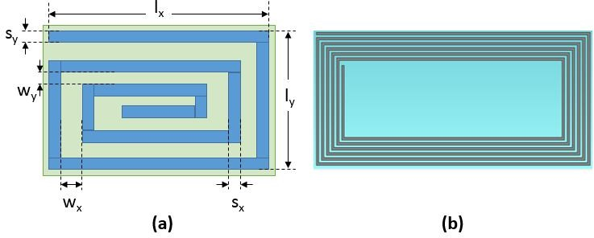
Fig. 1. Spiral resonators of the studied distributed magnetic trap filter for the considered test case: (a) geometrical model; (b) numerical cad model.

The mutual coupling between the coils has been estimated as described in Section II, and it is equal to 117 nH. Similarly, we also estimated the mutual coupling between the single SR and the 1H loop, obtaining 32.6 nH. The ratio between these two mutual coupling values (about 4) gave the correct number of SRs to be inserted between the coils in order to compensate the mutual coupling. Afterwards, we inserted the DMT filter (comprising four designed SRs) into the DT coil as shown in Fig. 1b. We maintained the SRs as separated as possible from each other so to consider negligible the mutual coupling between the SRs. The placement of the distributed magnetic field filter reduces the upshift of the 1H resonance frequency and does not impact on the 23Na loop resonance frequency [8]. A relevant decoupling between the coil loops can been demonstrated in a specific matching and tuning condition of the dual tuned coils. One problem in analyzing the coupling between two coils operating at different frequencies is the fact that they are not matched simultaneously. The low value of the S21 parameter is mainly due to the port mismatch instead of a real absence of coupling. For this reason, in order to consider the maximum coupling between the two coils (worst-case coupling condition), we forced the simultaneous conjugate matching of the two ports for each frequency of the entire interested bandwidth (as shown in Fig. 3). As highlighted in Fig. 3 (solid line) the distributed designed magnetic traps placed in the gap between the coils (Fig. 2b), has a remarkable impact on the coupling at the working frequency of the 1H coil.

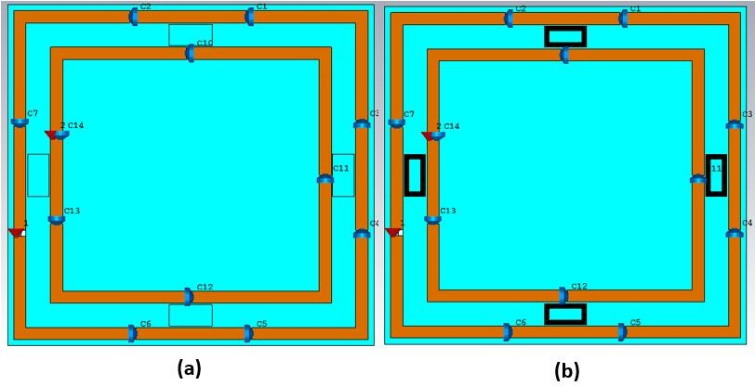
Fig. 2. 3D numerical models of the analyzed configurations obtained with CST Studio Suite 2016: (a) without distributed magnetic trap; (b) with distributed magnetic trap.

Simultaneous conjugate matching
-5
d u
 |  |  |  |  |  |  | With With | Distribute out Distrib | Magnetic ted Magnet | Traps  ic Traps

-10
Generalized S21 [dB]

-15

-20

-25

-30

-35
250 260 270 280 290 300 310 320 330 340 350
frequency [MHz]

Fig. 3. Generalized S21 dB parameter of the analyzed configurations in simultaneous conjugate matching condition.

- CONCLUSION
We proposed a physics based criterion for getting insight the coupling mechanisms between two interleaved MRI coils with distributed magnetic trap filters used for near-field coils decoupling. Based on the presented simplified approach, the filter has been therefore optimized in terms of resonance frequency and number of unit cells in order to compensate Mij. We validated the method for a DT coil, obtaining a remarkable decoupling of the coils at the desired frequency.
REFERENCES
- Ashraf Abuelhaija, Stephan Orzada, and Klaus Solbach, “Parasitic Element Based Decoupling of 7 Tesla MRI Coil Array”, Antennas & Propagation Conference (LAPC), Loughborough, 2015.
- Elodie Georget et al., “Stacked magnetic resonators for MRI RF coils decoupling”, Journal of Magnetic Resonance, vol. 275, p. 11-18, Feb. 2017.
- I. R. O. Connell, et al., “MRI RF Array Decoupling Method With Magnetic Wall Distributed Filters,” IEEE Transactions on Medical Imaging, vol. 34, no. 4, pp. 825–835, Apr. 2015.
- Y. Cheng, Y. Shu, “A New Analytical Calculation of the Mutual Inductance of the Coaxial Spiral Rectangular Coils”, IEEE Transactions on Magnetics, vol. 50, no. 4, April, 2014 .
- J. D. Kaggie, et al., “7 T Sodium/Proton Knee Imaging: First Results, in ISMRM UHF Symposium”, Heidelberg, Germany, p.21, 2016.
- M. Alecci et al., “Pratical design of a 4 Tesla double-tuned RF surface coil for interleaved 1H and 23Na MRI of rat brain”, Journal of Magnetic Resonance 181, pp. 203-211, 2006.
- F. Bilotti, A. Toscano, “Design of spiral and multiple split-ring resonators for the realization of miniaturized metamaterial samples, IEEE Transactions on Antennas and Propagation, Vol. 55, NO.8, August 2007.
- N. Fontana, F. Costa, G. Tiberi, L. Nigro, A. Monorchio, “Distributed trap FSS filter for dual tuned RF MRI coil decoupling at 7.0T”, International Conference on Electromagnetics in Advanced Applic. (ICEAA), 2017.

