Chapter 10 Waving Not Drowning: Understanding consumer behaviour in the age of big data

Helen Powell
&
Katy Parsons A Black Swan: Thought Piece

Introduction: The historical challenges of knowing the consumer
The Ethics of Advertising by F.P.Bishop (1949), and more specifically the chapter entitled ‘Advertising Psychology’, provides an interesting starting point for exploring the historical challenges of knowing the consumer. Of note to this introduction is how Bishop’s work encapsulates, at an early juncture in the history of modern advertising, a fundamental split in how the industry should both understand and address the consumer. Bishop draws on the role of emotion in the decision-making process, placing emphasis when conducting consumer research on the role of human “moods”. What makes this testing for advertisers, Bishop argues, is the recognition that humans are “moving targets” for “the average man is not the same in all circumstances” (1949: 55). This is a highly influential observation in that it specifically recognises the role affect can play in relation to decision making and that frequently “reason does not prompt or impel us to action” (ibid: 64). In this way Bishop uses this text to defend advertising against a circulating but contrasting position, one held by an intellectual elite that is worried by “the crudity of methods employed” and indeed fearful the masses be “overwhelmed by the tidal wave of mass emotionalism” advertising imagery might engender (ibid. 67). Back in 1949 Bishop recognised the need for a multiplicity of research methods based on the values of “reasoned argument” but at the same time recognising the unaccountable force of feelings. Bishop’s observations provide us with a synopsis of a series of inextricably linked challenges that modern advertising faced, and indeed continues to face, that grapple with the drivers of how we choose.

A significant step in managing this conundrum came with the introduction of the role of the account planner within the modern full service agency and is accredited to Stanley Pollitt, of Boase Massimi Pollitt, traditionally regarded as the founder of the discipline who coined the term back in 1968. Acknowledgment is also attributed to Stephen King and Tony Stead of JWT (Tungate 2007: 88). For decades this has remained a pivotal role, consistently referred to as ‘the voice of the consumer in the agency’. Working with a fusion of quantitative and qualitative data, the work of the account planner has been based on a series of questions whereby to understand the consumer is to enhance the chances of engagement in brand communication. Integral questions orbit around people’s feelings about a brand; the causal factors of such perceptions; and how this is different from feelings engendered by competitors or new entrants to the market, for example. However, this has continued to remain an extremely challenging occupation on the basis that “people are complex, emotional and highly irrational” (Kocek, 2013: 29). Offline and online tools are now at the dispense of the account planner and extend beyond the enduring focus group, whereby open-ended questions coupled with human interaction generate key insights within a controlled environment, often with the client present but not visible to participants. Social media monitoring allows for online conversations and behavioural patterns to be explored and mapped in real time through a virtual window as a means to engage with the decision making process as it happens. Whilst both limited and skewed by those actually online at the point of researching, it opens up an insight into natural connectivity between participants rather than relying on the more steered probes of the focus group moderator.

At the more granular level, software such as Google analytics functions in following our data footprints as it seeks to both build customer profiles and develop insights into the drivers of the decision-making process. Again, this can be monitored and acted upon as it happens or over a longer-time frame for “online communication create a textual trail of the conversations audiences have about a brand or media property which may be archived indefinitely for all to see” (Jenkins, Ford and Green, 2013: 75). As a result netnography is born.

Understanding the decision-making process in the contemporary marketplace
The symbolic value of brands has not declined, as explored in chapter 3; rather what we are seeing is that opportunity to purchase, once tied to income and other demographic factors such as class and age, has made their consumption patterns more complex. One of the outcomes of the first recession of the twenty-first century was that to counter the austerity measures that were impacting middle-class spending, brands created “artificial market segments” whereby “bifurcation separated the middle-class into high-end consumer and low-end bargain hunters” (Gabay, 2015: 7). However the ramifications of such moves in the production of this hybrid, Janus-headed subject introduced both an enhanced complexity to the notion of target audiences and acute difficulties in establishing brand loyalty. As a result what we can identify today across Europe is the substantiation of the ‘hybrid consumer’, “middle-income consumers…who avoid the ‘boring middle’ which offers little added value – that is, neither great prices nor unbeatable quality.” (Ehrnrooth and Gronroos, 2013: 1794). The downfall of BHS in 2016, having first appeared on the British High Street in 1928, is testament to this trend. Other middle of the road brands are in trouble. The struggle of Next in the UK in the first quarter of 2017 has been well publicised. Chief executive Lord Wolfson blamed Millennials and commented that profits were down due to a “generational shift away from owning ever more ‘stuff’ to spending on memorable experiences such as eating out with friends.” (Prynn and Hutchison, 2017: 10) We are also seeing new alliances or partnerships engendered to create experiences greater than the sum of their parts. As the early department store can be positioned as an initial example of the experience economy, embracing restaurants and tea rooms so that consumers would spend longer in the building, so bookstore Waterstones and Costa Coffee partner to mutual benefit. Consumer compromise is evident, however, and lies within the service sector: mobile phone operators and short-haul air travel, for example, are deemed worthy of trading down due to the lack of discernable difference in standards (Ehrnrooth and Gronroos, 2013). So determining consumption patterns on class lines becomes problematic but what are the implications of an aging population? The over 55’s are an extremely complicated category. There are many ages and life stages between your ‘50s and reaching 100. We have a pensions crisis across developed economies in that preparedness for retirement is being sidetracked by a ‘living in the now’ mentality. As people live longer so they self-identify with a younger generation investing in tech, clothing and holidays and indeed are not initially included as being part of the brand’s intended target market. This can produce major challenges for brands for whilst the older may wish to look younger, much to L’Oreal’s benefit, this ubiquity of dress and style is not necessarily acceptable to all, as Marks and Spencer’s profits have testified.

As a result, consumer research becomes ever more valued. For as consumption on traditional demographic lines becomes more fluid so A WARC Best Practice Paper (2016) adds additional factors into the mix. WARC defines the consumer decision making process as one:
by which consumers identify their needs, collect information, evaluate choices, and, finally, make a purchase decision. These actions are determined by psychological and economic factors and can be influenced by environmental factors such as cultural, group and social values.
As noted, prior to the arrival of the internet the focus group was instrumental to the work of the account planner but its logic and dynamic is now under scrutiny for there is “no way of knowing how much answers are influenced by surroundings, other people present or the desire of participants to say the right thing” (Burcher 2012, 39). A focus group I conducted just prior to the Brexit vote brought up exactly these issues as the ‘remain’ contingent dominated the conversation and the two who initially articulated their will to ‘leave’ were almost forced into a silence of shame. In relation to traditional survey methods, similar issues arise: what we put on paper when focusing on the question in hand is driven by our rational thoughts and feelings, or indeed by a sense of impression management gravitating around what the expected answers ought to be. Trump’s US Presidential victory proved the polls wrong again in this way.

It is not as though there haven’t been any initiatives at seeking to ‘know’ and to frame contemporary consumer behaviour: even the UK Government has recently attempted this exercise. Back in 2015 the Department for Business, Innovation and Skills published its ‘Consumer Empowerment Survey’ based on 6,024 interviews with adults across the period October 2014 to January 2015. It sought “to gain a better understanding of attitudes, motivations and behaviours … and to build a stronger picture about their characteristics and engagement levels: particularly those consumers in vulnerable situations and/or on low incomes.” (Williams et al, 2015: 5) Contextually, the study specifically sought to explore the constitution and dynamics of the neo-liberal market place and to examine if the conditions for it to “flourish” were in place. As a result, five groups were identified:
- ‘Constrained strugglers’ (17%) are “the least empowered segment” who lack confidence and negotiation skills and limited financial resources.
- ‘Consciously unengaged’ (15%) are older and financially comfortable and who evidence “lack of interest in a conscious choice” coupled with the fact that “they just do not want to spend time shopping”.
- ‘Worried indecisives’ (22%) are younger females concerned about making the right choice. Their low levels of confidence see them turn to “trusted sources” for support including “friends, family and consumer experts” in that order.
- ‘Traditional value-seekers’ (24%) are “older, possibly retired and financially doing well”. Cash rich and time rich, they shop around to get the best deal. They tend not be early adopters and “like to stick with the brands they know”.
- ‘Leading Edgers’ (22%) are “the most empowered of all the segments” for this group have high qualifications are financially sound and have higher internet usage than the other segments and use it to shop around online. They are early adopters, are not brand loyal and are keen to share their views and experiences on purchase. (Williams et al, 2015)

A second typographical model that has been developed by the Euromonitor Passport team (2016) seeks to explore ‘Consumer Shopper Types’ internationally, on a country-by-country basis. Moving beyond typical demographic-based segmentation, such as age or gender, here consumers are based on shared shopping habits and preferences in order to understand their behaviour more effectively. Again for the UK, five types of shopper profile were identified.

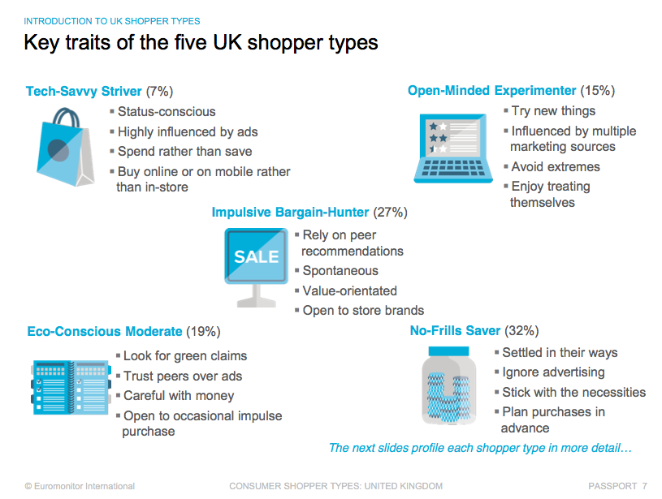

Through examining these profiles it becomes recognisable that if data is managed beyond demographic profiling, consumer behaviour can be clustered around a number of different, more insightful, sets of categories such as whether someone is driven by ‘status anxiety’ or not; are they brand loyal; and to what extent are they captivated by impulse buys. A further interesting insight is revealed in terms of drivers of influences, as outlined in the chart below.

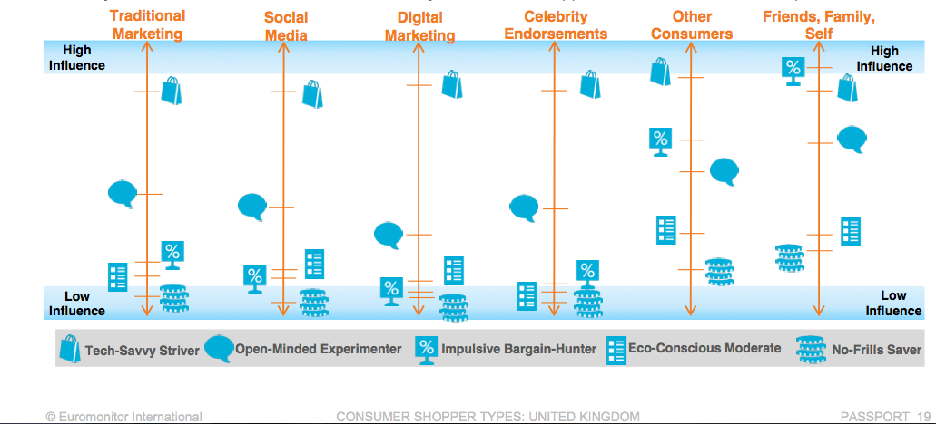

The fact that typologies are required to garner together sets of behaviours in an attempt to know is interesting as it demonstrates how the subject position of the consumer is in itself not a given but “the outcome of multiple social and cultural processes” (Ariztia, 2015: 145) that themselves are subject to ongoing transformations and influences. That is to say, any typology crafted only speaks to the moment of its categorisation and the knowledge which such typologies contain only address what we can know and understand at that time. This speaks to the changing nature of campaign identities and how such creative work recognises that consumers’ relationships to brands can remain in flux, that the initial connectivity a consumer feels towards a product is never a given. Furthermore, brand campaigns legitimate consumer activity by evidencing that behaviours are not isolated but rather speak to particular sets of social and cultural needs that brands tap into. In this way agencies work with the concept of “insight”, namely that which is “buried deep in the consumer and becomes self-evident after a process of professional work” (Ariztia, 2015: 150). When operating at its most effective, it can lead to a consumer soliloquising “this brand understands me” (ibid.: 151). As a result advertising’s role here is about alignment. As evidenced in the typologies above, how can the qualities of a brand speak to the specific nuances of consumer groups? In essence, “the ability to keep this version of the consumer and his/her selected qualities lined up with those of the goods is regarded as one of the central aspects of strategic advertising work” (Ariztia, 2015: 155).

Methods of understanding consumer behaviour: The rise of digital analytics and big data
A decade ago ‘knowing’ relied on a fusion of focus groups, survey data from Nielsen and TGI and competitive and retail analysis but the “feedback loop” (Burcher, 2012: 36) now provided by the internet is offering up in real time new data sources driven by search. Indeed as Burcher argues (ibid.) “search engine use gives a good insight into the public psyche” with each click leaving a trace, a digital footprint, if you like. As mobile devices and digital platforms become ever more consolidated into our everyday lives and the internet has “evolved from a business tool to an extension of man” (Law, 2013: 17) so brands need to understand how they are used by consumers in a more integrated manner as they oscillate across device, platform and media. Much consumer data is now highly temporally sensitive. Location-based marketing, for example, works out of location services, thus bringing ‘Minority Report’ scenes to life on a street near you. With further reference to temporal immediacy, programmatic advertising relies on algorithms to determine in real time whether or not to engage a consumer through the automatic, customised delivery of ads. These rely on direct-response KPIs such as click rates and view rates. Yet this is coupled with the rise of the more knowing consumer: knowing here in the sense that they recognise that data they provide can generate more effectively personalised/curated promotion: but this does not guarantee that they wish to receive such communication. Therefore in terms of the turn to understand the consumer in the last decade, new methods have been sought which come out of an exploration of bringing together programmatic algorithms and richer consumer data, amassed into what has been termed ‘big data’, and used by brands to transform insights into opportunities and competitive advantage. For example, Tesco gathers 5 billion pieces of shopper information per week (Kendall, 2015: 312). Big data’s appeal is generated out of the sheer quantity that can be captured, albeit unstructured, and its ability to be operationalised in real time through the rise of the smartphone with GPS and internet connectivity. However, the key question here is what to do with big data now that we have it? We need to think carefully about what is being analysed: the search terms used; the pages visited; time spent online; and how this leads to action.

And yet we should never think about big data as replacing that which went before. It should always be seen as allowing us to obtain a fuller picture of the market as a whole, providing additional context rather than a magic bullet. Operating most effectively at the micro level, through clicks and comments, it has the ability to evidence behaviour effectively and efficiently. In this context, its advantage over previous research methods lies in the fact that data can be captured in real time, rather than relying on the power, or honesty, of consumer recall. However, where is the context? How does one particular click sit in relation to documenting a particular behavioural pattern? Evidently we are able to capture and store larger data sets than ever before and using statistical modelling and infographics we can scale down and represent what is indeed being captured. Here big data can add value and tied to the rise of the demographically challenging consumer documented previously, surely the more we know the more effective the targeted creative response? For whilst big data can provide a mapping of consumer activity, what it lacks is any sense of context: a joining of the dots. It seemingly fails to offer commentary on why a consumer behaved in a particular way: either rationally or irrationally. It cannot predict behaviour. It cannot humanise it. Therefore, the most significant problem with big data is that it is “machine intelligence and not the social intelligence of participants.” (Jenkins, Ford and Green, 2013: 176) That is to say, people become data sets rather than perceived as complex beings making choices and decisions based on a fusion of rational and irrational thought. For search may be driven by dreams and desires rather than the hard reality of it leading to potential action. Furthermore, how do brand mentions correlate with brand feelings. To ‘like’ a brand is very much a level playing field: how do we really get to know how a consumer perceives that brand as part of the lived experience? However the appeal of big data to advertising agencies is clear to see. Data mediates risk: the more quantity of data, the more we must know. But is it rich data? Big data might enable the identification of trends at the macro level but what of the smaller points of indecision: how can we capture that moment as we hover, deliberate, decide?

An introduction to behavioural economics
Behavioural economics is rooted in behavioural decision theory. Underpinned by the concept of biases it sits in opposition to classical economics which does not think of us as human beings who act rationally and irrationally when faced with choice. Decision-making is a complex activity, frequently managed by breaking each thought process down into smaller pieces or stages which can function as an effective coping mechanism. As a result, this can then be difficult to observe from the outside, let alone predict future patterns, due to these high degrees of fragmentation and flux in our procedural ordering.

In Thinking, Fast and Slow (2011) Daniel Kahneman provides us with a model of how we think through choice underpinned by the recognition of consciousness being divided into two ‘Systems’: System 1 and System 2. In so doing he evidences how we come to rely on intuition and mental shortcuts which, when operational, lead to the production of biased decisions. We find making choices a difficult process and as a result rely on System 1 which operates rapidly and automatically, using heuristics (habits, the invisible infrastructure of our daily life) to guide our decision-making. This does not, however, necessarily mean that we always make the best decisions, but for the large part they are deemed adequate. For example, we draw upon the ‘affect heuristic’ whereby particular emotions are conjured up when we think about a particular object, or by extension, brand. Here we make choices based on often irrational and spontaneous decisions of how something makes us feel.

From a historical perspective, this has been articulated as the ‘affective choice model’ (Mittal, 1988 in Elliott, 1998) whereby choice arises based on the symbolic meanings of goods and our reasons for choosing are often “unable to be verbalised” (Elliott, 1998: 96). Increasingly as time poor consumers we rely more on the irrational, hedonic and instantaneous world of feelings over the rational world of logic and problem solving when faced with choice. So we recognise immediately specialist brands as being the best in the field and therefore are prepared to pay much more for them. This is one of the key difficulties challenger brands face. However, effective advertising from challenger brands can change our perceptions. Indeed, supermarket interlopers Aldi and Lidl increasingly are capturing market share as 12% of the grocery market in the UK went to these discounters in the first quarter of 2017. In essence this means that “£1 of every £8 spent” was taken by these brands (Clarke, 2017: 16).

In contrast, System 2 is slower, more logical and analytical and is highly effective in problem solving exercises but rarely used in relation to consumption and the choices we make. “Think of the two systems as agents with their individual abilities, limitations and functions” (Kahneman, 2011: 21). System 2 is only called upon when System 1 falters. As Yakob (2015: 35) articulates this can then take us back to some of the key problems experienced with traditional data-gathering around consumer behaviour: “the conditions of research activate System 2 thinking, when purchase decision will usually run through System 1.” This point of view is enhanced by Pete Buckley, Head of Strategy at MEC UK, one of the world's leading advertising media planning agencies with expertise in digital media and social media marketing. Buckley (in Kendall 2015: 203) states:
Marketing, market research and advertising are still firmly rooted in System 2 thinking. Advertising objectives continue to focus around the need to communicate a message that is persuasive, has cut-through and delivers recall – all objectives being directly targeted at System 2 rather than trying to appeal to System 1.
Let us return to heuristics for a moment to illustrate this statement. When we make the majority of our decisions we do so under conditions of time poverty: as a result brands allow us to develop habits that present short cuts to choice. In relation to the decision-making process Kahneman (2011) refers to the ‘availability heuristic’ which centres on how things that come to mind first are deemed to be the most important.

However as Zajonc (1980, in Elliott 1998: 104) commented we often in practice seek to fuse Systems 1 and 2. Whilst our feelings may guide our initial judgements, after the fact we may justify such choices through secondary revisions. This can be accounted for by “attempts to cope with post-decisional and/or post-purchase feelings of guilt, anxiety and regret.” (ibid.) In summary, the choice architecture of System 1 is emotionally driven and hence non-linear in form. Aligned with Freud’s work on dreams (1899) and the ordering of material on waking, only later do we seek to attempt cognitive processing as a method of justification for the choices made. It is such revisions that make it difficult to understand from a market research point of view the decision-making process of any consumer. Working with examples from Thinking, Fast and Slow (2011: 323) will allow for closer examination of how we make choices in situ and how Systems 1 and 2 are operationalised. Interestingly, and somewhat poignantly, as this book is written in London in 2017, Kahneman chooses as his object of study a city on high terrorist alert. In terms of how people behave in such an extraordinary context he argues:
System 2 may ‘know’ that the probability is low, but this knowledge does not eliminate the self-generated discomfort and the wish to avoid it. System 1 cannot be turned off. The emotion is not only disproportionate to the probability, it is also insensitive to the exact level of probability.
This is how terrorism works. In contrast, a second example draws on the ordinary and the mundane and helps us explain why we buy lottery tickets, week after week (Kahneman, 2011: 323). The probability of winning the lottery is low, System 2 would reveal. However, System 1 is fuelled by our emotions and fantasies and a global identification with the tagline “Your ticket to dream” (Australia), “It could be you” (UK) and “Tata Ma Chance, Tata Ma Millions” (South Africa).

What can behavioural economics teach advertising?
In summary, behavioural economics challenges the rational actor presumption that underpins classical economics. That is to say, that people act rationally all of the time, trying to get the most for least effort and always acting in their best interests. As Sutherland (in Samson, 2014), vice-chairman of Ogilvy Group UK, and significant proponent of the merits of behavioural economics points out, advertising too since Packard has been “pretending” that it also works “exclusively within the realm of conscious awareness” positioning the consumer as a rational individual with stable preferences. Rather choice often gravitates around uncertainty and is very much shaped by context, emotional and temporal. These are key challenges that brand advertising does not readily take into account. Advertising has much to learn from behavioural economics as it seeks to bring together the rationality of economics with the more irrational forces of psychology. It draws on how decision-making can be heavily influenced by context:
including the way in which choices are presented to us. Behaviour varies across time and space, and it is subject to cognitive biases, emotions and social influences. Decisions are the result of less deliberative, linear and controlled processes than we would like to believe. (Samson, 2014)
Rory Sutherland (2016) argues that there is more to human behaviour than utility maximization and that it is here that understanding the role of unconscious forces has a significant part to play. Indeed, the application of the tools of behavioural economics to advertising is now highly appropriate as the kinds of problems advertisers face are more varied, indeed behavioural in nature, than ever before. In particular it can enable us to delve deeper in to how choices are made and how advertising can “help people make good decisions without curtailing their freedom” through the application of the concept of “nudge” (Kahneman, 2011: 413). For one of the critical elements that it seeks to shed light on is habit forming and how cycles of behavioural patterns can be broken. One tool to break habit is that of ‘framing’: namely how information is presented can impact outcomes. Changing the order of items on a menu forces us to engage with choice differently. In terms of advertising copy, we might think again when something has a 95% success rate, for example rather than a 5% failure rate. In this way, advertising can creatively and indeed cost-effectively speak to change by finding ways to reframe the problem and then get people to rely less on habit and instinct (System 1) instead reconsidering their behaviours by thinking more slowly and thoughtfully about their actions (System 2). These small details, or nudges, have the potential to change opinions.

Therefore, behavioural economics, when applied to advertising practices and creative approaches that seek to guide consumer choice, becomes a useful tool to both understand and influence consumer behaviour by focusing upon decision-making processes. It taps into choice as a non-rational activity and then draws attention to the need to explore how consumers behave within any purchasing scenario. In this way promotion can be used to ‘nudge’ consumers along particular decision-making paths.

Concluding Thoughts: The Need for Triangulation
To know the consumer remains challenging and there is no magic bullet, even with the rise of sophisticated analytical tools. What our digital footprint might reveal is an ideal self, the inverse of a rational actor. For to search is also to daydream. As the British sociologist Colin Campbell once noted most consumer activity goes on in our heads and “wanting rather than having is the main focus of pleasure-seeking” (1987:85). So whilst we have more data available to us than ever that is not enough of a step forward on its own: it only really acquires value when it is made meaningful. The mechanisms by which consumers make choices are never stable or constant: therefore they can never be captured by one method alone. More needs to be done to explore how consumption is tied to affect and how affect is conjured up by determining what matters at the level of the individual and the social.

In order that this might happen, the agency world itself is becoming more complex and diversified. It is more difficult than ever to define or label an advertising agency and what it does based on past descriptors – especially as they now work across categories. So for example, in the case of two media agencies, Digital Innovation Agency, R/GA “help clients innovate by combining creativity with the power of disruptive technology” (www.rga.com) whilst at MediaCom (www.mediacom.com):

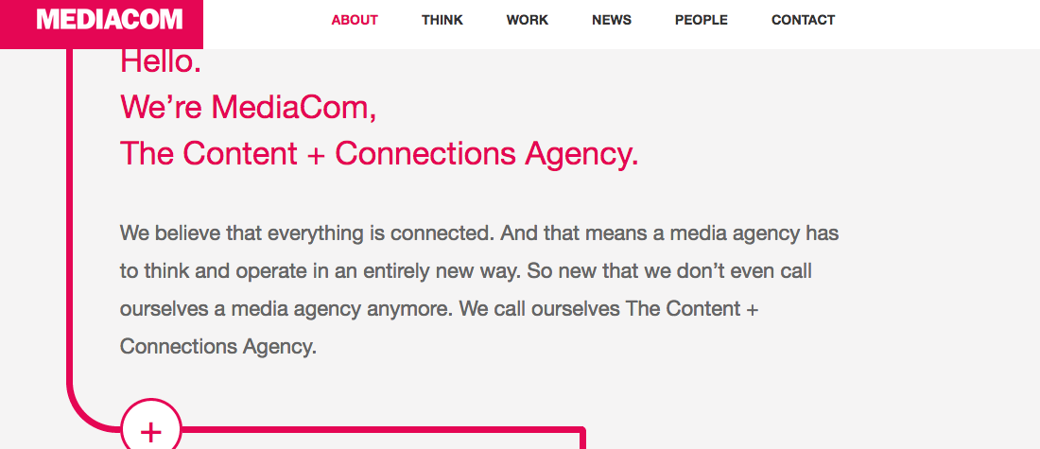

The balance of power is shifting away from the creative epicentre as the definition of creativity becomes more fluid and flexible, running through creative, media planning and media buying agencies. In view of this, the IPA (2015) in a report entitled ‘The Future of Marketing and Agencies: The next 10 years for consumer engagement’ has predicted a “dynamic landscape” being carved out in the years ahead (See Hull in this volume). Increasingly new players enter the frame as we witness the organic growth of agencies in terms of niches and specialisms and Black Swan is one such example. As their website indicates (http://www.blackswan.com) they operate in the field of applied prediction marketing, establishing their USP as one whereby: “We predict consumer behaviour for our clients, From the huge mass of data available today, And help brands outsmart their competition.”
Kkkkkkk

BLACK SWAN THOUGHT PIECE
KATY PARSONS

“A Black Swan - an unpredictable event in a moment of disruption.”
(Steve King, CEO Black Swan)

COMPANY PROFILE
- Founded 2011
- 250+ employees
- 9 offices worldwide – incl. London, New York & Cape Town
- Client Base incl. PepsiCo, Unilever, Disney & Samsung
- Awards: The Sunday Times Tech Track “one to watch” 2014; The Sunday Times UK’s Fastest Start-Up 2015; The Sunday Times UK’s Fastest Exporter 2016
BUSINESS CONTEXT

The fruits of the information society are easy to see, with a cellphone in every pocket, a computer in every backpack, and big information technology systems in back offices everywhere…not only is the world awash with more information than ever before, but that information is growing faster.
(Mayer-Schönberger and Cukier, 2013: 6)

The capabilities of large organisations to implement technology and build in-house expertise to aggregate, structure and utilise large volumes of disparate data is limited due to their size and complex structures. As a result, these same organisations are losing market share to innovative start-ups, small and agile enough to react quickly to change and are reaping the benefits of successfully deploying big data infrastructure quickly. In 2011, Steve and Hugo (the now co-founders of Black Swan) were sat in a pub in Canada, working on a brand problem.

“We were trying to get hold of some data and it was proving impossible”
(Hugo Amos, Co-founder Black Swan)

It was then that they had their light bulb (‘Black Swan’) moment; what if a brand could have all the relevant data connected to it in one place? If they could relate their media spend to their sales data, understand what consumers were saying about their brand against their marketing campaign rollouts, then this would be incredibly beneficial. These datasets were living in silos and by bringing it together into one platform, its value could be increased exponentially.

On the back of a beer mat, they drew up the data sources they would like to connect and 6 years later, we at Black Swan are continuing to build out that platform and its capabilities.

It’s reported that by 2018, over half of large organizations globally, will compete using advanced analytics and proprietary algorithms, causing the disruption of entire industries (Gartner, 2016). At Black Swan, we are equipping our brands with the tools and expertise to compete and prosper in this landscape of disruption.

WHAT WE DO AND HOW WE DO IT
From weather data to search behaviour, social conversation to government statistics or private source, such as store level sales, data underpins everything we do. We therefore place huge importance in finding new and interesting sources that we can harness; and work out unique deals that enable us to utilise the data in the most efficient and economical way, exclusively for our clients. Here at Black Swan, we view the internet as the world’s largest focus group and it’s changing the way brands both collect data and connect with consumers. Previously, we only ever had snippets of consumer conversations to make sense of, and never the full story. Today, we have the opportunity to gain the whole picture and it’s more real than ever. We’re not forcing the agenda, instead we’re able to pick up on natural, unprompted emotion and it’s making sense of that which is meaningful for our brands.

Once identified, the data is then enriched with our proprietary software, algorithms and unique methodology that enables accurate trend evaluation. Combine that with our world class data science and consultancy services, our experience and expertise in the field and a platform that enables not only efficient deployment of predictive models but self-service visualisations and applications; and the outputs and insights of our work become incredibly powerful.

The Black Swan mission is to harness a multitude of the most relevant data sources, make sense of them and bring that insight into the context of our client’s own business performance. This enables us to spot patterns and make predictions of what’s going to be important to our clients tomorrow, to inform long-term decision- making and optimise business advantage. We help our brands make better and more relevant products and provide those products to the right people, at the right time and in the right place.

A SHORT CASE STUDY

Aim: To understand and map the global landscape of ‘better for you’ snacks based on social and non-social conversations, across 7 key strategic markets.

Output: Developed and quantified ideation platforms that balanced global brand relevance and local nuance. Used our innovation expertise to humanise the data into a series of product and communication concepts for conventional testing.

Result: 75% of concepts moved through testing as top, or outstanding in market testing*

*Client’s predefined testing metrics.

“Today marked a spectacular end to our journey. The heavy lifting is done and I cannot express how thrilled I am with the end results. Black Swan has proven to GSG innovation the power of big data! This was my first time leveraging social listening as a key driver of innovation and without a doubt I am convinced that we will do product innovation differently thanks to this great body of work. Your work has not only helped this project but has implications to project planning for our global R&D team, WESA innovation and our brand positioning.”
(Insight and Innovation Director, Global FMCG)

INDUSTRY CHALLENGES
Naturally, in a sector as new and unprecedented as ours, there are many challenges to overcome. The three that we view to be the most significant are explored below.

The first is navigating the paradigm shift. Brands are afraid of change and can over estimate how complicated our new methodologies are. Data and automation is essentially transforming every facet of a marketing organisation. From how you generate insight, build marketing plans and run advertising campaigns, to how you measure their performance and operate your supply chain. All of this is possible, but it might not be possible immediately. Getting clients to buy into the vision, embrace the culture change and come on that journey with us is one of our greatest tests. Black Swan is at the pinnacle of this apex of change and if we get it right we will be able to forge a new path for brands and their consumers.

The second is the reclamation of data. As consumers become more aware of the value of their own information we are likely to experience a reclamation of data and privacy. At Black Swan, we’re not interested in personally identifiable information (or PII), it’s the aggregate view and the evolution of trends that we deem valuable; but with new forms of social media appearing every day, each with new restrictions and limitations on their data, it is something we must be aware of. As a company, we recognise it is a privilege to hear what people are talking about and we have a responsibility to consumers to behave in the right way. It’s also important that we encourage our clients to demonstrate value to consumers in exchange for their data. We have set our own guidelines and processes to ensure we have the right procedures in place and that all parties are protected.

Finally, the need to stay at the cutting edge. As brands begin to see the tangible value in harnessing data, they are setting about building their own ‘in house’ capabilities: hiring data scientists, analysts, wranglers and people who are attuned to turning data into actionable insights. What elevates us is we benefit from servicing lots of different clients from a breadth of industries, meaning we are continually learning and building our expertise. We are subject to pressure by clients but not constrained by them. This variation in project challenges allows us to attract and keep the best talent through the diversity of our work. In the same way that many clients outsource their creative, we must continue to stretch ourselves to ensure we offer something unique and special that’s difficult to replicate internally.

At the heart of our business we have a data science and engineering pedigree as well as an insights and innovation pedigree. We’re not a data science company trying to deliver insights and marketing solutions and we’re not an insight and innovation company trying to provide data science solutions. We’re one in the same. There has been a deployment gap existent in the sector where companies have invested heavily in data but have failed to successfully deploy the technology against business benefit. This failing has come from one of two scenarios. Either, a technology company has tried to deliver insight and marketing solutions and failed to understand what brands and marketers want, or a marketing and insights company, has delivered on those outputs but has no idea how to take on the technical challenge. At Black Swan, both core elements are inherent to us and that is what makes us different, and what makes us successful.

QUESTIONS
- Why are traditional demographics less useful today in predicting consumer behaviour?
- Design your own questionnaire and use your findings to produce a consumer typology based on 5 key headings. Design an infographic to display your results.
- What are the advantages and disadvantages of big data in the work of the account planner?
- How does behavioural economics make us think differently about the decision making process with specific reference to brand preferences?
- In what sense might Black Swan be seen as a disrupter to the traditional agency world? What other forms of niche agency do you see as being established in the next 10 years and why?

BIBLIOGRAPHY:

Ariztia, T. (2015) ‘Unpacking Insight: How consumers are qualified by advertising agencies’, Journal of Consumer Culture, vol. 15 (2), pp. 143 – 162.

Bishop, F.P. (1949) The Ethics of Advertising. London: Robert Hale Ltd.

Burcher, N. (2012) Paid, Owned, Earned: Maximizing Marketing Returns in a Socially Centred World. London: Kogan Page.

Campbell, C. (1987) The Romantic Ethic and the Spirit of Modern Consumerism. London: Blackwell.

Clarke, J. (2017) ‘Aldi and Lidl capture record market share’, Metro (London), March 8, p. 16.

Ehrnrooth, H. and Gronroos, C. (2013) ‘The Hybrid Consumer: Exploring hybrid consumption behaviour’, Management Decision, vol.51 (9), pp. 793 – 820.

Elliott, R. (1998) ‘A Model of Emotion-Driven Choice’, Journal of Marketing Management, vol. 14, pp. 95-108.

Euromonitor Passport (2016) ‘Consumer Shopper Types: United Kingdom’, June. London: Euromonitor International.

Gabay, J. (2015) Brand Psychology: Consumer perceptions, corporate reputations. London: Kogan Page.

Gartner (2016) ‘Business Intelligence and Analytics Summit’, 29 February – 1 March. London, UK.

IPA (2015) The Future of Marketing and Agencies, The Next 10 Years for Consumer Engagement. London: IPA.

Jenkins, H., Ford, S. and Green, J. (2013) Spreadable Media: Creating value and meaning in a networked culture. New York: New York University Press.

Kahneman, D. (2011) Thinking, Fast and Slow. London: Penguin.

Kendall, N. (2015) What is a 21st Century Brand? London: IPA.

Kocek, C. (2013) The Practical Pocket Guide to Account Planning. West Chester, PA: Yellow Bird Press.

Law, A. (2013) Implosion: What the internet has really done to culture and communication. London: LID Publishing Ltd.

Mayer-Schönberger, V. and Cukier, K. (2013) Big Data, A Revolution That Will Transform How We Live, Work and Think. London: John Murray.

Prynn, J. and Hutchison, C. (2017) ‘Next boss: We’re losing sales because people don’t want to buy more stuff’, Evening Standard, 23 March, p.10

Samson, A. (ed.) (2014) The Behavioural Economics Guide. Foreward by: G. Loewenstein and R. Sutherland. Accessed at: www. Behaviouraleconomics.com/beguide2014.pdf. Accesssed: 30/12/2016.

Tungate, M. (2007) Adland: A Global History of Advertising, London: Kogan Page.

WARC (2016) ‘What we know about consumer decision making’, WARC Best Practice Paper, August. Accessed at: www.warc.com. Accessed: 9/12/16.

Williams, B., Bhaumik, C. and Silk, A. (2015) ‘Consumer Empowerment Survey’, Department for Business, Innovation and Skills. Accessed at: www.gov.uk/bis. Accessed: 3/2/17.

Yakob, F. (2015) Paid Attention: Innovative Advertising for a Digital World. London: Kogan Page.

