Running head: RETROSPECTIVE AND PROSPECTIVE EVALUATIONS

Retrospective and Prospective Evaluations of Mammography Screening Narratives:
The Role of Own Experience

Silvio Aldrovandi, Emma Bridger and Daniel Knowles
Department of Psychology, Birmingham City University, Birmingham, UK

Marie Poirier
Department of Psychology, City University London, UK

Declaration of interests: None
This research did not receive any specific grant from funding agencies in the public, commercial, or not-for-profit sectors.
Funding statement: No funding was obtained to conduct this study

Address correspondence to: Silvio Aldrovandi, Department of Psychology, Birmingham City University, 4 Cardigan Street, Birmingham, B4 7BD, United Kingdom. Telephone: +44(0)121 3316547. Email: Silvio.Aldrovandi@bcu.ac.uk
Abstract
We investigated the role of previous experience when providing summary judgments of mammography narratives. A total of 807 women who either did or did not have previous experience of a mammogram were presented with a written description of a mammography visit. We manipulated the presentation position of a negative element within the narrative in order to alter its accessibility in memory and determine whether the latter impacted equally on two types of summary judgments. After the narrative presentation, participants were asked to provide both retrospective and prospective evaluations, that is summary judgments about the described event and an appraisal of the likelihood of participating in future instances of such event, respectively. A recency effect was observed only for retrospective but not for prospective evaluations. When examined only for the sub-set of women who had undergone a mammography visit themselves, prospective evaluations were shown to be predicted by the reported quality of the mammography participants experienced themselves. The findings support and extend the accessibility model of emotional self-report and suggest that own experience leaks into evaluations of hypothetical scenarios by selectively impacting on prospective evaluations.
Keywords: retrospective evaluation, prospective evaluation, order effect, accessibility, mammography visit

How do we evaluate events? Research in the area has examined how we assess sequentially presented information—including information about events that are experienced by other people—as well as events that we experience over time. Findings suggest that people can provide summary assessments that are unitary and coherent, even if the information or experience itself typically varies in quality over time (e.g., Fredrickson, 2000). Two main categories of summary assessments have been studied; retrospective evaluations (henceforth RE) are offered in hindsight and provide an overall impression of the experienced information or event (e.g., Langer et al., 2005). Prospective evaluations (henceforth PE) represent judgments about the anticipated quality of a to-be-experienced event; the measurement can also be operationalized by assessing the willingness to repeat the experience or not (e.g., Redelmeier et al., 2003). Investigating both RE and PE in medical settings is especially important as patients have been shown to forgo important appointments due to unpleasant memories of prior similar events, in particular routine mammogram screening (e.g., Elwood et al., 1998; Whelehan et al., 2013).
Importantly, research has shown that RE can be significantly biased in various ways, as evidenced by phenomena such as duration neglect (e.g., Ariely & Zakay, 2001), the Peak-End rule (e.g., Fredrickson & Kahneman, 1993) and primacy and recency effects (e.g., Hogarth & Einhorn, 1992). The latter refer to the inflated impact on RE of the first or last few relevant elements within the assessed event. For example, in an oft-cited clinical study, Redelmeier et al. (2003) showed that adding an extra period of low-level pain can actually improve the evaluation of a painful medical screening procedure. Patients undergoing a colonoscopy were randomly assigned to either a control group, who underwent the standard procedure, or an experimental group. In the latter condition, the procedure was extended by leaving the apparatus in place for an average two minutes after the clinical examination was completed. This added experience was mildly uncomfortable – but less painful than the actual procedure. Strikingly, the patients in the experimental group rated the colonoscopy as a whole as less painful than patients in the control group – indicating a recency effect in RE.
Understanding RE biases is important, as research has shown that PE are determined by RE (e.g., Kahneman et al., 1993). The willingness to partake in an experience or not is known to be influenced by PE and research has shown that RE of similar experiences feed into PE. For example, in the above-described study by Redelmeier et al. (2003), the patients from the experimental group, who endured reduced pain in the final moments of their colonoscopy, were significantly more likely to attend future recommended screenings, thus corroborating the link between RE and PE.
Research has also shown, however, that RE and PE can diverge (e.g., Levine et al., 2018). For example, Soman (2003) showed RE and PE of the same experience may produce opposite outcomes depending on the position, within the sequence of events, of a negative element. It is thought that presentation order effects differentially impact RE and PE because of the different temporal distance between negative instances and the point at which summary evaluations are elicited (Soman, 2003).
The Role of Accessibility
The above findings can be explained by the accessibility model of emotional self-report (Robinson & Clore, 2002). This model posits that accessibility determines the type of information that is relied upon in order to form a summary judgment. According to the model’s dominance principle, accessibility of information is hypothesized to be hierarchical, whereby people prefer to access the most specific information they can (experiential information) and then resort to the next most specific information (episodic and then semantic, in turn) if the former is inaccessible. In fact, people are rarely able to utilize online experiential information (i.e., data from the current event that is being experienced), and thus summary evaluations often hinge on episodic (i.e., recollection of specific moments) and semantic information. The latter can manifest either as situation-specific (e.g., “public speaking is stressful”) or identity-related beliefs (e.g., “I am a stressed person”; cf. Robinson & Clore, 2002, p.938). Relatedly, time of judgment matters according to the accessibility model (Robinson & Clore, 2002) because of the rapid decrease in the accessibility of many elements of information in memory (e.g., Rubin & Wetzel, 1996). As information in memory is hypothesized to be accessed in a hierarchical manner (from online experiential, to episodic, to semantic), judgments elicited at a later stage are likely to rely more heavily on semantic rather than episodic information while the reverse is true of judgments required very soon after an event.
The divergence between RE and PE is therefore explained by the accessibility model (Robinson & Clore 2002) because in the former, people may have the chance to rely on episodic information, while this would be much less likely for the latter. When examining PE, the accessibility model has tended to focus on people’s generic predictions about their emotions in the future (e.g., “How will you feel when X happens?”; cf. Robinson & Clore, 2002, p.943). In these situations, the authors argue that people cannot access the type of episodic detail that supports RE and thus must rely on semantic information.
What is not typically considered in the accessibility model, however, is that levels of previous experience can vary and that these variations may interact with recently presented information to impact on PE. If this is the case, then episodic or semantic information from previous experience may trump recently presented material while forming PE.
In this study, we directly assessed the influence of prior experience by examining summary evaluations about a hypothetical mammogram visit provided by women who either did or did not have previous experience of a mammogram. When people are asked to evaluate the quality of hypothetical experiences or events experienced by a hypothetical character (e.g., Liersch & McKenzie, 2009; Soman, 2003), they may rely on their relevant or similar experiences which would have enhanced accessibility (relative to the information available to individuals without relevant experience). Thus, assessments based on previous experience may leak into summary evaluations of related scenarios and influence their formation. In essence, we aim to determine to what extent own experience can differently impact on RE and PE.
According to Robinson and Clore’s (2002) accessibility model, biases in RE can be based on information retrieved from episodic memory or they can originate from more generalized beliefs (semantic memory): The former would be biases attributable to the quality of the information retrieved from the experience, whilst the latter would be biases introduced by the retrieval of more general knowledge such as situation-specific or identity-related beliefs. Moreover, the accessibility model (Robinson & Clore, 2002) posits that RE and PE can hinge on different sources of information—more specifically, episodic information is predicted to impact RE but not PE (Robinson & Clore, 2002). Thus, testing RE and PE with the same hypothetical scenario allows for a further test of the accessibility model: in contrast to previous tests of the model, participants have the chance to rely on the just-experienced episodic information for both types of summary assessments.
The Present Study
In order to examine the impact of previous experience on both RE and PE (for a study on RE only, see Chajut et al., 2014), we tested a sample of women who previously had a mammogram or not, and asked them to provide both RE and PE of a scenario involving a hypothetical mammography appointment. The scenario included events that varied in quality or valence – some more positive and others less so. For both RE and PE, we manipulated the presentation order of these elements (e.g., Aldrovandi et al., 2015). Our aim was to determine if information in more salient positions (i.e., at the beginning or end) had more impact on evaluations than the same information in less salient positions (i.e., in the middle).
We also tested whether the predictions of the accessibility model (Robinson & Clore, 2002) can be extended to narrower prospective judgment prompts (i.e., the willingness to repeat a just-described event), where recent episodic information is accessible, compared to more general predictions about future emotions (e.g., “how will you feel a month from now”; Robinson & Clore, 2002; p.938).
Method
Participants
A total of 807 women took part in an online study. Age ranged from 18 to 78 (M = 44.52, SD = 13.50) and most of the participants (87.61%) indicated that English was their first language. Participants were granted i-points® for their participation. Choice of sample size was based on the experimental design, an anticipated small effect size (Aldrovandi et al., 2015; Experiment 4) and α = .05. We aimed to recruit at least 791 participants to achieve a priori power = .95 (Faul et al., 2007).
Design and Materials
Participants were required to read about a hypothetical mammography visit. The type of scenario was manipulated between-subjects as participants were presented with either a Start, Middle, End or Control scenario (see Electronic Supplementary Material, ESM1). Each scenario consisted of eight segments, with each one sequentially presented on screen. The length of each segment ranged from 35 to 40 words, with the total number of words for the scenarios well-matched, ranging from 292 to 306.
The scenario manipulation was operationalized by altering the presentation position of negative and neutral events. The negative events described different dimensions of the mammography, namely an unfavorable perception of staff (“the examiner did not seem confident and she was distracted”) and a painful experience (“The compression was painful and seemed to last for a long time”). Conversely, neutral events covered different elements designed not to elicit an emotional reaction (“I went to the main hospital reception, and I told the woman behind the counter my surname.”) The Start scenarios included the two negative events presented in the first two screens, followed by six neutral narratives. The Middle scenarios had the two negative events presented in the fourth and fifth screens, whilst in the End stories the negative events were presented in the last two slides. Control stories included eight neutral narratives.
Procedure
Participants were randomly allocated to one of the scenario types; in the case of the different versions of the Control stories, random allocation was implemented as well. Introductory screens provided instructions relating to the task and gathered demographic data. Participants were then told that they would read about a breast cancer screening visit experienced by a woman; they were asked to read the descriptions carefully and to imagine undergoing the visit they were reading about. Participants were also told that at the end of the study they would be asked their opinion about the visit.
Participants were informed that the scenario was presented as text on the screen and that, because the description could not fit into a single screen, it was broken down into eight sections, presented one at a time. Participants were then asked to provide RE judgments by using a 0-100 rating scale anchored at 0 = very dissatisfied and 100 = very satisfied. RE were elicited by asking: “How satisfied would you be with the visit as a whole?” Participants were encouraged to use the whole range in their responses.
Next, participants provided PE by answering the question “After such a visit, how likely would you be to come back for another routine screening?”; they used a 0-100 scale anchored at 0 = very unlikely and 100 = very likely. Finally, in order to test participants’ previous experience of mammography, they were asked to answer the question “Have you attended a breast cancer screening appointment?” If participants answered positively to this question, they were asked to answer the question “Thinking back to the last screening appointment you experienced, how satisfied were you with it?”; again, they used a 0-100 scale anchored at 0 = very dissatisfied and 100 = very satisfied. Finally, participants were asked a series of six multiple choice questions (MCQs) in order to test whether they were attentive during the presentation of the scenarios (see ESM2 for additional detail.)
Results
We first analyzed data from all the participants in order to investigate whether having experienced a mammogram impacted on RE and PE. We then carried out additional analyses only on those participants who had undergone a mammography themselves in order to more specifically test how the retrieved quality of own experience moderated summary evaluations.
Data check
A total of 38 participants were excluded from the analyses on the basis of two criteria established a priori. Six participants (0.74% of the sample) were excluded as their participation’s duration was over three standard deviations from the mean – they took over 1 hour and 30 minutes whilst the average completion was just short of nine minutes. An additional 32 participants (3.97%) were excluded as they answered incorrectly two or more multiple choice check questions. These exclusions did not statistically alter the results as the outcomes were the same when all participants were included in the analyses. These exclusions did not hinder the overall balance between group sizes, as 201 participants were exposed to the Start stories, 190 to the Middle stories, 200 to the End stories and 178 to the Control stories. A total of 329 participants indicated they underwent mammography previously while 440 indicated they had not. The latter group included women who were significantly younger (M = 36.27, SD = 9.30) compared to the former (M = 55.71, SD = 9.58); thus, age was included as a variable in the analyses.
Parametric assumptions were not met; inspection of distributions revealed some scores to be either platykurtic—k = -1.01 and k = -1.10, both SE(k) = 0.18 for RE and PE, respectively—or leptokurtic, k = 3.87, SE(k) = 0.21 for satisfaction with own mammography visit. Negative skew was also observed for satisfaction with own visit, s = -2.09, SE(s) = 0.11. Equivalent non-parametric and additional analyses were run, too, and returned the same outcomes (see ESM3).
The RE and PE for the three different versions of the Control scenarios were analyzed. A MANOVA was run on PE and RE using Control scenario version (1, 2 and 3) as the between-subjects measure. The analysis yielded no significant effect of Control scenario version, F(4, 350) = 1.87, p = .115, indicating that the simple re-ordering of the narratives did not impact on RE and PE.
Finally, we checked for the degree of association between variables that were measured through the same value range (0-100). Correlations were moderate to strong but did not suggest that potential issues could arise due to multicollinearity (see Table 1 below).
Table 1. Pearson’s r correlation coefficients between RE, PE (n = 769) and satisfaction with own mammography (n = 329).

 |  | 1 | 2
1. RE
2. PE |  | .612
3. Satisfaction with own mammography |  | .242 | .458
Note. All ps < .001

Figure 1 shows RE and PE as a function of scenario type and whether participants underwent a previous mammography visit or not. A 2 (previous mammography: yes vs. no) × 4 (scenario type: Start, Middle, End, and Control) between-subjects MANCOVA on RE and PE with age as the covariate was run. The effect of age as a covariate was not significant, F < 1.
The main effects of previous mammography, F(2, 759) = 5.32, p = .005, η_{p}² = .014, and scenario type, F(6, 1520) = 53.2, p < .001, η_{p}² = .173, were both significant; their interaction effect was not, F < 1.

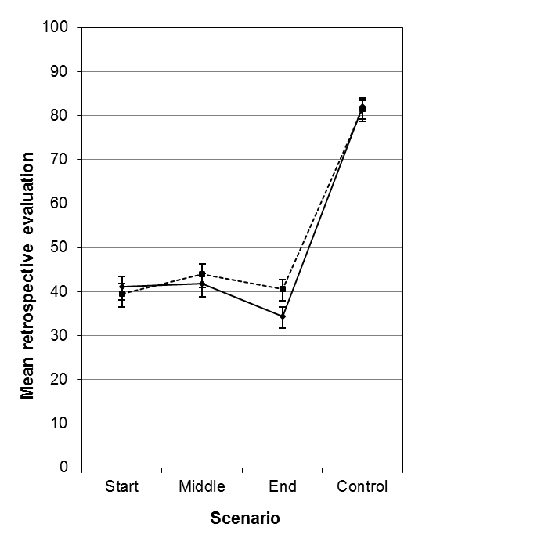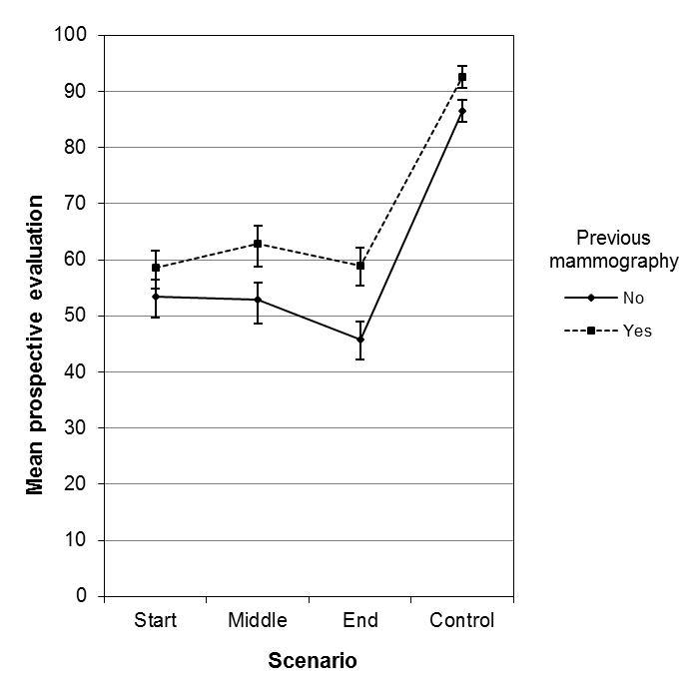
Figure 1. Mean retrospective (RE; left panel) and prospective evaluations (PE; right panel) as a function of scenario type and having undergone a previous mammography (yes vs. no). Error bars indicate SEM.

Effect of previous mammography
The multivariate main effect of previous mammography was followed with separate ANOVAs on RE and PE, which revealed that the main effect of previous mammography was significant for PE, F(1, 760) = 10.52, p = .001, η_{p}² = .014—as participants who underwent a previous mammography (M = 67.32, SD = 35.02) offered higher evaluations than those who did not (M = 59.31, SD = 34.23; d = 0.21)—but not for RE, F(1, 760) = 1.68, p = .196.
Order effects
Follow-up separate ANOVAs were run to break down the multivariate main effect of scenario type and they revealed that the main effect of scenario type was significant for both RE, F(3, 760) = 131.0, p < .001, η_{p}² = .341, and PE, F(3, 760) = 53.1, p < .001, η_{p}² = .173. Planned comparisons on RE revealed that satisfaction ratings were highest for the Control scenarios, all ps < .001. A recency effect was observed as satisfaction for End scenarios was lower than for Middle scenarios, p = .032, d = 0.22 (Start scenarios did not differ from the other two scenario types, ps > .234). The same analysis on PE revealed only that Control scenarios attracted the highest ratings, all ps < .001, but no order effects were observed, all other ps > .091.
The above findings thus indicate that (1) PE were significantly predicted by having experienced a previous mammogram across scenario types and (2) a recency effect on RE was observed regardless of previous experience.
The role of quality of previous experience
To follow-up the main effect of previous experience on PE, data from those participants who had previously experienced a mammogram themselves (n = 329) was further analyzed through a one-way ANCOVA on PE with scenario type as the between-subjects factor and satisfaction with previous mammography as the covariate. The significant main effect of scenario type, F(3, 323) = 19.45, p < .001, η_{p}² = .153, revealed no order effects as Start, Middle and End scenarios did not differ between each other, all ps > .177; Control scenarios were rated significantly higher than the other three scenario types, all ps < .001.
Satisfaction with own mammography significantly (and positively, r = .458, p < .001) predicted PE, F(1, 323) = 86.38, p < .001, η_{p}² = .211. These findings show that PE for those participants who underwent a mammography were predicted by the quality of their previous experience and were not influenced by order effects.
Discussion
In this study we observed diverging patterns for RE and PE. A recency effect was observed for RE. On the other hand, participants’ own mammography experience—and its quality—determined PE, for which no serial order effects were observed.
The RE results are consistent with the accessibility model of emotional self-report (Robinson & Clore, 2002). Order of presentation of recent episodic information impacted on RE of a hypothetical scenario as demonstrated by the observed recency bias. As participants who experienced a mammography themselves displayed the same bias in RE, accessible, just-experienced episodic information was prioritized in summary assessments as per the dominance principle (Robinson & Clore, 2002).
On the other hand, PE task instructions appeared to cue different information. No presentation order effects were observed and the determining factor for PE was previous experience. For those participants who had previously undergone a mammogram, the retrieved quality of that experience was a predictor of PE about a related hypothetical scenario. This finding suggests that when eliciting PE, the quality of previous experience leaked into summary evaluations and determined the participants’ willingness to come back for a repeat mammogram screening. An important question revolves around the nature of the information retrieved from previous experience, as the current paradigm and data do not allow us to determine whether this effect is due to episodic or semantic information; relatedly, timing—and thus recency—of the previously experienced mammography was not assessed. As PE were significantly higher for participants who had experienced a mammography themselves and the retrieved satisfaction with their mammography was rather high (M = 83.96, SD = 23.54 on a 0-100 scale), it could be proposed that the type of accessed information was episodic in nature, given that participants appeared to recall very satisfactory elements experienced previously. However, this proposition is limited by the possibility that group effects could drive the above pattern. A related concern is that these effects may reflect the systematic age differences between the two groups, although the analyses showed that when age was included alongside own experience, only the latter impacted the outcomes.
Retrieved semantic information could underpin the above association as beliefs relating to the utility of mammography screening could explain both the increased willingness to return for a following screening and the high quality of the retrieved information about own experience; further empirical work is required to directly address this question. It is nonetheless important to observe that in the present study, participants were asked to think about the likelihood of repeating the experience on the basis of the description of the scenario they were just presented with (“After such a visit, how likely would you be to come back for another routine screening?”) We acknowledge the limitation of using a one-item measure—this feature being true also for RE and reported satisfaction with own previous mammography—as it also does not allow to assess the granularity of participants’ PE (e.g., intention to return to the same facility for further screening or more general intention to undergo another mammogram). However, the instructions used in this study to elicit PE can be considered narrower compared to those described in Robinson and Clore (2002; e.g., “How will you feel next week”; p.938) as they asked participants to rely on just-experienced episodic information when constructing PE; nonetheless, retrieved information from own experience significantly contributed to PE.
In the current task, it was not possible for the time at which RE and PE were elicited to moderate the impact of previous experience. This is because RE and PE were elicited near in time and thus it can be argued that the memory trace of the just-experienced episodic information should be of similar quality at both points. This finding supports Chajut et al. (2014), who observed that previous experience reduced the impact of episodic bias in RE, but only after a considerable retention interval (two months): When RE were elicited nearer in time, previous experience had no effect in moderating RE biases. Relatedly, Geng et al. (2013) explored Peak-End effects and concluded that over long retention intervals (between three and seven weeks) people were influenced by both semantic and episodic information in their RE, whilst they relied only on the latter over short retention intervals. The outcomes of this study are aligned to these findings as we did not observe a moderating effect of prior experience on RE biases after a very short delay. The present evidence suggests that reconstructive memory does not impact on RE when episodic information about the just-experienced event is rather easily accessible (Robinson & Clore 2002). It should be noted that in Chajut et al.’s (2014) study, participants offered RE about an event they experienced themselves (i.e., giving birth), whilst in the present study the target event was the description of a mammogram experienced by a hypothetical woman. Thus, the above conclusion holds even when participants are asked to evaluate events that are hypothetical in nature.
In conclusion, we observe that, in the case of a hypothetical scenario, relevant previous experience leaks into summary evaluations by determining PE. We also find support for the dominance principle (Robinson & Clore, 2002) as just-experienced episodic information impacts on RE. We argue that a memory-based approach to summary evaluations (see also Montgomery & Unnava, 2009) offers important insight for applied settings as it suggests that the way in which screening appointments unfold is important, as the last moments influence how women will remember the quality of the whole mammography. This perspective also suggests that women’s likelihood of complying with subsequent screening invitations is strongly influenced by the remembered quality of a previous assessment: Women who underwent a (favorably remembered) mammography themselves reported higher PE compared to those women who experienced no mammogram before.
Electronic Supplementary Material

ESM1. Materials (ESM1_Materials.docx). The document describes the scenarios and their narratives. The colors refer to the three main sections of the scenario: Orange = M, mammography, yellow = W, wait, and light blue = H, history (white narratives were ‘fillers’)

ESM2. Additional methodological detail (ESM2_Additional methodological detail.docx). We further describe the strategy followed to create narrative stimuli, details about timing and participants' response mode, and attention check items.

ESM3. Additional analyses (ESM3_Additional analyses.docx). We present the outcome from parametric and non-parametric regression analyses

References
Aldrovandi, S., Poirier, M., Kusev, P., & Ayton, P. (2015). Retrospective evaluations of sequences: Testing the predictions of a memory-based analysis. Experimental Psychology, 62, 320–334. https://doi.org/10.1027/1618-3169/a000301
Ariely, D., & Zakay, D. (2001). A timely account of the role of duration in decision making. Acta Psychologica, 108, 187–207. https://doi.org/10.1016/s0001-6918(01)00034-8
Chajut, E., Caspi, A., Chen, R., Hod, M., & Ariely. D. (2014). In pain thou shalt bring forth children: The Peak-and-End rule in recall of labor pain. Psychological Science, 25, 2266–2271. https://doi.org/10.1177%2F0956797614551004
Chapman, G. B., & Johnson, E. J. (2002). Incorporating the irrelevant: Anchors in judgments of belief and value. In T. Gilovich, D. Griffin, & D. Kahneman (Eds.), Heuristic and Biases (pp. 120– 138). New York: Cambridge University Press. https://doi.org/10.1017/CBO9780511808098.008
Elwood, M., McNoe, B., Smith, T., Bandaranavake, M., & Doyle, T. C. (1998). Once is not enough: Why some women do not continue to participate in a breast cancer screening programme. The New Zealand Medical Journal, 111, 180–183.
Faul, F., Erdfelder, E., Lang, A. G. & Buchner, A. (2007). G*Power 3: A flexible statistical power analysis program for the social, behavioral, and biomedical sciences. Behavior Research Methods, 39, 175–191. https://doi.org/10.3758/BF03193146
Fredrickson, B. L. (2000). Extracting meaning from past affective experiences: The importance of peaks, ends, and specific emotions. Cognition and Emotion, 14, 577–606. https://doi.org/10.1080/026999300402808
Fredrickson, B. L., & Kahneman, D. (1993). Duration neglect and in retrospective evaluations of affective episodes. Journal of Personality and Social Psychology, 65, 45–55. https://doi.org/10.1037//0022-3514.65.1.45
Geng, X., Chen, Z., Lam, W., & Zheng, Q. (2013). Hedonic evaluation over short and long retention intervals: The mechanism of the peak–end rule. Journal of Behavioral Decision Making, 26, 225–236. https://doi.org/10.1002/bdm.1755
Hogarth, R. M., & Einhorn, H. J. (1992). Order effects in belief updating: The belief-adjustment model. Cognitive Psychology, 24, 1–55. https://doi.org/10.1016/0010-0285(92)90002-J
Kahneman, D., Fredrickson, B. L., Schreiber, C. A., & Redelmeier, D. A. (1993). When more pain is preferred to less: Adding a better end. Psychological Science, 4, 401–405. https://doi.org/10.1111%2Fj.1467-9280.1993.tb00589.x
Langer, T., Sarin, R. K., & Weber, M. (2005). The retrospective evaluation of payment sequences: Duration neglect and Peak-and-End effects. Journal of Economic Behavior and Organization, 58, 157–175. https://doi.org/10.1016/j.jebo.2004.01.001
Levine, L. J., Lench, H. C., Karnaze, M. M., & Carlson, S. J. (2018). Bias in predicted and remembered emotion. Current Opinion in Behavioral Sciences, 19, 73–77. https://doi.org/10.1016/j.cobeha.2017.10.008
Liersch, M. J, & McKenzie, C. R. M. (2009). Duration neglect by numbers – And its elimination by graphs. Organizational Behavior and Human Decision Processes, 108, 303–314. https://doi.org/10.1016/j.obhdp.2008.07.001
Montgomery, N. V., & Unnava, H. R. (2009). Temporal sequence effects: A memory framework. Journal of Consumer Research, 36, 83–92. https://doi.org/10.1086/595278
Redelmeier, D. A., Katz, J., & Kahneman, D. (2003). Memories of colonoscopy: a randomized trial. Pain, 104, 187–194. https://doi.org/10.1016/s0304-3959(03)00003-4
Robinson, M. D., & Clore, G. L. (2002). Belief and feeling: Evidence for an accessibility model of emotional self-report. Psychological Bulletin, 128, 934–960. https://doi.org/10.1037/0033-2909.128.6.934
Rubin, D. C., & Wetzel, A. E. (1996). One hundred years of forgetting: A quantitative description of retention. Psychological Review, 103, 734–760. https://doi.org/10.1037/0033-295X.103.4.734
Soman, D. (2003). Prospective and retrospective evaluations of experiences: How you evaluate it depends on when you evaluate it. Journal of Behavioral Decision Making, 16, 35–52. https://doi.org/10.1002/bdm.431
Van Overwalle, F., & Labiouse, C. (2004). A recurrent connectionist model of person impression formation. Personality and Social Psychology Review, 8, 28–61. https://doi.org/10.1207%2FS15327957PSPR0801_2
Whelehan, P., Evans, A., Wells, M., & MacGillivray, S. (2013). The effect of mammography pain on repeat participation in breast cancer screening: A systematic review. The Breast, 22, 389–394. https://doi.org/10.1016/j.breast.2013.03.003
Zauberman, G., Diehl, K., & Ariely, D. (2006). Hedonic versus informational evaluations: Task dependent preferences for sequences of outcomes. Journal of Behavioral Decision Making, 19, 191–211. https://doi.org/10.1002/bdm.516

