Measuring the Capacity Utilization of China's Transportation Industry under Environmental Constraints
Jingxiao Zhang ¹, Wenyi Cai ², Simon P Philbin ³, Hui Li ⁴, Qing-Chang Lu ⁵, Pablo Ballesteros-Pérez ⁶, Guo-liang Yang ⁷
¹ Professor, School of Economics and Management, Chang’an University, Shaanxi Xian, P.R .China, 710064, zhangjingxiao@chd.edu.cn
² Lecturer, School of Economics and Management, Chang’an University, Shaanxi Xian, P.R. China, 710064, wenyi424@163.com
³ Professor, Nathu Puri Institute for Engineering and Enterprise, London South Bank University, London, United Kingdom, philbins@lsbu.ac.uk
⁴ Associate Professor, School of Civil Engineering, Chang’an University, Shaanxi Xian, P.R. China, 710061, lihui9922@chd.edu.cn
⁵ Professor, School of Electronic and Control Engineering, Chang’an University, Shaanxi Xian, P.R. China, 710064, qclu@chd.edu.cn
⁶ Senior researcher, Departamento de Ingeniería Mecánica y Diseño industrial, Escuela Superior de Ingeniería, Universidad de Cádiz, Spain, pablo.ballesteros@uca.es
⁷ Researcher, Institutes of Science and Development, Chinese Academy of Sciences, Beijing, China, glyang@casipm.ac.cn

Corresponding Author:
Jingxiao Zhang, Professor, School of Economics and Management, Chang’ an University, Shaanxi Xian, PR China, 710064, Email: zhangjingxiao964@126.com

Conflicts of Interest: The authors declare no conflict of interest for the order and cooperation.

Measuring the Capacity Utilization of China's Transportation Industry under Environmental Constraints

Abstract
The transportation industry is challenged by the need for capacity optimization, energy saving and decreasing emissions. Improving our understanding of capacity utilization is important for achieving a strong transportation system. This article analyzes the relationship between carbon dioxide emissions and final energy consumption in the transportation industry. The capacity utilization of China's transportation industry in the period 2011-2017 is explored by two improved DEA-based difference methods. They assess the status quo of China’s capacity utilization and explores effective mechanisms to increase it. In addition, the rationale and accuracy of both measurement models are analyzed. Results show that: (1) the relationship between CO2 emissions and final energy consumption can be taken advantage of to improve the accuracy of capacity utilization measurements. (2) China's transportation industry has suffered from the underutilization of capacity, especially in the past three years. (3) Regional differences in capacity utilization are significant, being Southwestern China the region that has most seriously underutilized its capacity. (4) Promoting transportation technology innovation and more rational transportation resources planning are two key mechanisms to improve capacity utilization. This paper broadens our research knowledge of the transportation industry by proposing new measurement approaches for capacity utilization. These can be used to implement more effective and targeted policies, better allocate production resources, and closely monitor capacity utilization.

Keywords:
Transportation industry; capacity utilization; environmental constraints

1 Introduction
In the post-financial crisis era, the global economy has shown a trend of a significant slowdown in potential growth capacity due to structural changes in the elements supporting economic growth. In order to effectively cope with the downward pressure on the world economy, some countries including China have adopted large-scale economic stimulus measures to tap the potential of sustainable economic development (Xu, 2019; Yuan et al., 2010). However, such measures implemented by governments can sometimes suffer negative consequences from excessive industrialization. These include irreversible damage to the environment as well as infrastructure overcapacity (Wu and Ning, 2018). Overcapacity has negatively impacted the international capital markets, disrupted the orderly operation of some market economies, and hindered economic growth (Zhang et al., 2020). To alleviate infrastructure overcapacity, many countries have implemented a series of measures oriented to economic restructuring. These include promoting industrial optimization and upgrading, and further developing tertiary and service industries (Song, 2017; Ye et al., 2013).
As a leading service industry in the economic system, the transportation sector can be considered as the backbone of the development of the tertiary industry (Taylan and Demirbas, 2016). The transportation industry is undergoing a period of change associated with the need of decarbonization (Ahmadi, 2019) and digitalization (Shah et al., 2019). This technology adoption in the transportation industry can be ‘technology push’ and ‘market pull’ (Lorentz et al., 2015). Especially in recent years, the application and popularization of big data and the new generation of information technology (IT) have endowed the transportation industry with a renewed production momentum. Moreover, various countries across the world, including those from Europe and the United States have accelerated the research and development of intelligent transportation systems (Gupta and Cohn, 2012; Yangxin et al., 2017). Therefore, it is essential to remove the low-end production capacity of the transportation industry to achieve a higher level of development. The environmental pollution associated with the development of transportation cannot be ignored either. According to data from the International Energy Agency (IEA) in 2011, transportation is the second largest source of CO₂ emissions in the world (IEA, 2011). In 2016, transportation industry CO₂ emissions accounted for 24% of the global total (IEA, 2018). Furthermore, many transportation systems have issues regarding wasted capacity or the opposite: overcapacity (Chebbi and Chaouachi, 2016). It can be ascertained then that the transportation industry faces challenges of capacity optimization, energy conservation and emissions reduction.
Accurate determination of capacity utilization (CU) is essential for capacity optimization. Under environmental constraints, it is very important to construct a universal capacity utilization evaluation and measurement framework. As a representation of the efficiency of production capacity, CU is an important index to evaluate the performance and development level of the transportation industry (Yang and Fukuyama, 2018). Most research on transportation industry performance evaluation has focused on transportation efficiency and energy efficiency (Okada, 2012; Omrani et al., 2019; Palander, 2017; Wang and He, 2017). Very limited attention has been granted to CU. Yet, Fevolden (2015) suggests that research on CU in secondary and tertiary industries cannot be ignored. The basis of CU research in the transportation industry predominantly lies in the measurement and analysis of CU indices. Therefore, developing accurate measurement methods is paramount. CU measurement methods in the manufacturing and coal industries are relatively mature (Liu, 2011; Song et al., 2016b; Zhang et al., 2018b). These industries approximate CU by the ratio of true product output versus the theoretical output. However, this method of measuring CU by output only is not applicable to the transportation industry. This as the transportation industry is characterized by service attributes and an output that is more complex to analyze.
Data envelopment analysis (DEA) is a quantitative analysis method for evaluating the differential efficiency of a series of objects by constructing a linear programming model (Charnes et al., 1978). With this aim, Fare (1989) proposed a basic DEA model that could be used for the measurement of CU. Due to the special advantages in handling multiple inputs as well as multiple outputs (Charnes et al., 1978), DEA is suitable to the capacity utilization analysis of industries with complex outputs such as the transportation industry. Many scholars since have indeed used DEA to conduct empirical research on capacity utilization (Arfa et al., 2017; Karagiannis, 2015; Lindebo et al., 2007; Wang et al., 2019). However, these studies mostly consider input factors, such as capital, manpower, and technology. They neglect the impact of environmental constraints on resource usage, such as final energy consumption and CO₂ emissions on CU. Final energy consumption is the amount of energy that is directly consumed in production activities excluding transformation and loss (IEA, 2004). With the increasing energy crisis and air pollution problems, the study of the CU of the transportation industry cannot ignore the influence of environmental factors.
Furthermore, the implementation of China's Belt and Road Initiative (BRI) is creating a new pattern for the development of the world economy. This initiative is promoting international cooperation regarding joined production capacity. As a priority area of the BRI, China's transportation industry has also ushered in new country-level development opportunities (Jiang et al., 2018). At present, China's transportation industry is not facing an urgent need for capacity optimization. However, in the long run, a sharp increase in final energy consumption and CO₂ emissions is expected (Huang et al., 2019). In order for China to achieve the strategic goal of building a country-wide major transportation network, it is critical to improve its CU and promote the development of green transportation systems.
Consequently, this paper aims to construct a universal CU evaluation framework from the perspective of environmental constraints. As such, this framework incorporates the variables of CO₂ and final energy consumption. The framework is applied to explore the CU of China's transportation industry in the period 2011-2017. Using the proposed improved DEA-based difference method, the CU is characterized by the difference between the actual output and the optimal potential output produced by various input resources. Simultaneously, the current status of CU in the transportation industry is also determined and the factors that influence CU analyzed.
Hence, this research study provides a reliable method for accurately measuring the transportation industry’s CU taking environmental constraints into account. Furthermore, the study reveals the potential impact of changes of input resources on capacity utilization in different regions. This application provides a useful reference for enhanced planning and resource allocation for the transportation industry. The study also enables the formulation of region-specific CU-improvement strategies. These will be allow establishing an integrated transportation CU monitoring system.
The rest of the article is summarized as follows. The next section provides an introduction to the research methodology. It includes the description of two improved DEA-based difference methods, our proposed CU index, as well as the evaluation system and data sources. The third section analyzes the CU levels of China's transportation industry. The fourth section discusses the CU values measured by the two DEA-based methods and proposes some management recommendations. Finally, the fifth section includes the conclusions and future research.

2 Methodology
Data Envelopment Analysis (DEA) is a non-parametric quantitative analysis technique proposed by Charnes et al. in 1978 (Charnes et al., 1978). It uses linear programming to evaluate the relative effectiveness among different but comparable research objects of the same type (also called the decision making units or DMU). DEA does not need to conduct dimensional processing on data, nor does it need any weight assumptions. Therefore, it has special advantages when dealing with the comparison of units which depend on multiple inputs and produce multiple outputs (Banker, 1984). DEA has wide applications in performance evaluation of industry and production management settings (Haugland et al., 2007; Zhu, 2014).
By considering environmental constraints and the characteristics of the transportation industry has enabled us to propose two improved DEA difference methods. These two methods are used to explore the CU of the transportation industry in 30 provinces and cities in China from 2011 to 2017. Hence, the transportation industry of these 30 Chinese provinces and cities are the research objects (the DMUs). The 2011-2017 transportation industry data is mainly sourced from the China Statistical Yearbook (NBS, 2012-2018), the China Energy Statistical Yearbook (NBSMEP, 2012-2018), and statistical yearbooks of those 30 provinces and cities. Only a few provinces and cities had some missing data in individual years. In those years we resorted to interpolation from neighbor years to replace them.

2.1 Method I: General form difference method
The transportation industry of 30 provinces and cities in China constitute the DMUs（q=$1,…,Q$）. As the transportation industry makes use of various input resources to provide transportation services for society, the resulting environmental pollution problems caused by such economic growth cannot be ignored. Hence, we set the following input-output variables: fixed input a, variable input e, desired output p, and undesired output c. Based on this assumption, the transportation industry production possibility set is expressed as:
$$T=\left\{\left(a,e,p,c\right)|\left(a,e\right)can produce \left(p,c\right)\right\} （1）$$
This reflects the premise that when the transportation industry uses fixed and variable inputs for transportation, the sector produces not only a desired output but also some undesired output. This approach is similar to the generalized CU index proposed by Yang et al. (2018). Also, by assuming a joint weak disposability (JWD) attribute and introducing an emissions reduction factor $ω$ as in Shephard (1974), the desired output and undesired output can be reduced at the same time, as follows:
$$JWD:\left(a,e,p,c\right)∈T and 1≥ω≥0→ \left(a,e,ωp,ωc\right)∈T （2）$$
Hence, let $a,e,p,c$ be the DMUs observation variables, and $λ_{q}$ be the vector of the variable intensity. Considering variable returns to scale (VRS), the following set of DEA production possibilities is established:
$$T=\left\{\left(a,e,p,c\right)\left|\left.\left.{\begin{aligned}a≥\sum_{q=1}^{Q}{a_{q}λ_{q},} \\ e≥\sum_{q=1}^{Q}{e_{q}λ_{q},} \\ p≤\sum_{q=1}^{Q}{{ω_{q}p}_{q}λ_{q},}\end{aligned} \atop \begin{aligned}c=\sum_{q=1}^{Q}{{ω_{q}c}_{q}λ_{q},} \\ \sum_{q=1}^{Q}{λ_{q}=1,} \\ λ≥0, 1≥ω_{q}≥0, ∀q \end{aligned}}\right|\right\}（3）\right.\right.$$
Regarding the direction distance function, the direction vector $t=\left(t^{p},t^{c}\right)$ is introduced as in Chung et al. (1997) and Färe et al. (2006). The direction vector is in charge of modelling an increase in the desired output and a decrease in the undesired output. The corresponding linear changes by resorting to the direction vector t are $b_{q}=ω_{q}λ_{q} ,d_{q}=\left(1-ω_{q}\right)λ_{q}=λ_{q}-b_{q}, λ_{q}=b_{q}+d_{q}, \sum_{q=1}^{Q}{λ_{q}}=\sum_{q=1}^{Q}{\left(b_{q}+d_{q}\right)=1}$. This allows deriving the measurement model from the General differences method:
$$θ\left(a_{l},e_{l},p_{l},c_{l}:t\right)=max\left\{α\left|\left.\left.{\begin{aligned}a_{l}≥\sum_{q=1}^{Q}{a_{q}\left(b_{q}+d_{q}\right),} \\ e_{l}≥\sum_{q=1}^{Q}{e_{q}\left(b_{q}+d_{q}\right),} \\ p_{l}+αt^{p}≤\sum_{q=1}^{Q}{p_{q}b_{q}, }\end{aligned} \atop \begin{aligned}c_{l}-αt^{c}=\sum_{q=1}^{Q}{c_{q}b_{q},} \\ \sum_{q=1}^{Q}{\left(b_{q}+d_{q}\right)=1,} \\ b_{q}+d_{q}≥0 , \sum_{q=1}^{Q}{b_{q}}≤1,∀q \\ b_{q}≥0 ,d_{q}≥0, ∀q, α free\end{aligned}}\right|\right\}（4）\right.\right.$$
$$\hat{θ}\left(a_{l},e_{l},p_{l},c_{l}:t\right)=max\left\{α\left|\left.\left.{\begin{aligned}a_{l}≥\sum_{q=1}^{Q}{a_{q}\left(b_{q}+d_{q}\right),} \\ δ_{l}^{e}e_{l}≥\sum_{q=1}^{Q}{e_{q}\left(b_{q}+d_{q}\right),} \\ p_{l}+αt^{p}≤\sum_{q=1}^{Q}{p_{q}b_{q}, }\end{aligned} \atop \begin{aligned}c_{l}-αt^{c}=\sum_{q=1}^{Q}{c_{q}b_{q},} \\ \sum_{q=1}^{Q}{\left(b_{q}+d_{q}\right)=1,} \\ {δ_{l}^{e}≥0, b}_{q}+d_{q}≥0 , \sum_{q=1}^{Q}{b_{q}}≤1,∀q \\ b_{q}≥0 ,d_{q}≥0, ∀q, α free\end{aligned}}\right|\right\}（5）\right.\right.$$
Compared with formula (4), equation (5) introduces $δ_{l}^{e}$. Variable $δ_{l}^{e}$ can realize a change of variable input $e_{l}$, meaning a correction the input $e_{l}$ under the optimal situation of potential output. If * represents the optimal solution, combined with the original input $e_{l}$, the modified variable input $e_{l}^{*}$ can be obtained by:
$$e_{l}^{*}=e_{l}*δ_{l}^{e*} （6）$$
Hence, $θ\left(a_{l},e_{l},p_{l},c_{l}:t\right)$ and $\hat{θ}\left(a_{l},e_{l},p_{l},c_{l}:t\right)$ represent the output distance functions of the l^{th} transportation industry when variable inputs are restricted and unrestricted, respectively. According to the definition of capacity utilization, the CU index of the l^{th} transportation industry (the 30 Chinese provinces and cities from 2011 to 2017) will be the difference between $\hat{θ}$ and $θ$, as:
$$CU=\hat{θ}-θ （7）$$

2.2 Method II: Variable-link form difference method
In the actual production process of the transportation industry, a large consumption of energy leads to an increase in undesired output. Therefore, based on the General differences method, the relationship link between the variable inputs directly related to the undesired output is increased. Considering this relationship allows us to more realistically reflect the actual production situation of the transportation industry. Using $e^{c} and c^{e}$ respectively to represent the variable input and undesired output with their relationship link, the production possibilities set can be expressed as:
$$T=\left\{\left(e^{c},c^{e},a,e,p\right)|\left(e^{c},a,e\right)can produce \left(c^{e},p\right)\right\} （8）$$
Also, by following the joint weak disposability attribute (JWD), the linking relationship of variables is realized through an enlargement factor $σ$, as follows:
$$JWD:\left(e^{c},c^{e},a,e,p\right)∈T and σ≥1→ \left({σe}^{c},{σc}^{e},a,e,p\right)∈T （9）$$
Analogously, let $e^{c},c^{e},a,e,p$ be the observation variables of the DMUs, and $λ_{q}$ be the vector of the intensity variable. Considering variable returns to scale (VRS) too, the following set of DEA production possibilities is established:
$$T=\left\{\left(e^{c},c^{e},a,e,p\right)\left|\left.\left.{\begin{aligned}e^{c}≥\sum_{q=1}^{Q}{σ_{q}e_{q}^{c}λ_{q},} \\ c^{e}=\sum_{q=1}^{Q}{{σ_{q}c}_{q}^{e}λ_{q},} \\ a≥\sum_{q=1}^{Q}{a_{q}λ_{q},}\end{aligned} \atop \begin{aligned}e≥\sum_{q=1}^{Q}{e_{q}λ_{q},} \\ p≤\sum_{q=1}^{Q}{p_{q}λ_{q},} \\ \sum_{q=1}^{Q}{λ_{q}=1,} \\ λ≥0, σ_{q}≥1, ∀q \end{aligned}}\right|\right\}（10）\right.\right.$$
In a similar way, the direction vector $t=\left(t^{p},t^{c}\right)$ is introduced, and the corresponding linear changes are made through $d_{q}=σ_{q}λ_{q} , b_{q}=\left(1-σ_{q}\right)λ_{q}=λ_{q}-d_{q}, and λ_{q}=b_{q}+d_{q}, \sum_{q=1}^{Q}{λ_{q}}=\sum_{q=1}^{Q}{\left(b_{q}+d_{q}\right)=1}$ to establish the following measurement model of the Variable-link form difference method:
$$∂\left( e_{l}^{c},c_{l}^{e},a_{l},e_{l},p_{l}:t\right)=max\left\{α\left|\left.\left.{\begin{aligned}e_{l}^{c}≥\sum_{q=1}^{Q}{e_{q}^{c}d_{q},} \\ c_{l}^{e}-αt^{c}=\sum_{q=1}^{Q}{c_{q}^{e}d_{q},} \\ a_{l}≥\sum_{q=1}^{Q}{a_{q}\left(b_{q}+d_{q}\right),}\end{aligned} \atop \begin{aligned}e_{l}≥\sum_{q=1}^{Q}{e_{q}\left(b_{q}+d_{q}\right),} \\ p_{l}+αt^{p}≤\sum_{q=1}^{Q}{p_{q}\left(b_{q}+d_{q}\right),} \\ \sum_{q=1}^{Q}{\left(b_{q}+d_{q}\right)=1,} \\ b_{q}+d_{q}≥0,d_{q}≥0,b_{q}≤0 ∀q,α free\end{aligned}}\right|\right\}\right.\right.（11）$$

$$\hat{∂}\left( e^{c},c^{e},a,e,p:t\right)=max\left\{α\left|\left.\left.{\begin{aligned}{δ_{l}^{ec}e}_{l}^{c}≥\sum_{q=1}^{Q}{e_{q}^{c}d_{q},} \\ c_{l}^{e}-αt^{c}=\sum_{q=1}^{Q}{c_{q}^{e}d_{q},} \\ a_{l}≥\sum_{q=1}^{Q}{a_{q}\left(b_{q}+d_{q}\right),}\end{aligned} \atop \begin{aligned}δ_{l}^{e}e_{l}≥\sum_{q=1}^{Q}{e_{q}\left(b_{q}+d_{q}\right),} \\ p_{l}+αt^{p}≤\sum_{q=1}^{Q}{p_{q}\left(b_{q}+d_{q}\right),} \\ δ_{l}^{ec}≥0 ,δ_{l}^{e}≥0, \sum_{q=1}^{Q}{\left(b_{q}+d_{q}\right)=1,} \\ b_{q}+d_{q}≥0,d_{q}≥0,b_{q}≤0 ∀q,α free\end{aligned}}\right|\right\}\right.\right.（12）$$
Similarly, the introduction of ${δ_{l}^{ec} and δ}_{l}^{e}$ in formula (12) can realize a change of linking variable input $e_{l}^{c}$ in variable input $e_{l}$. Hence, ${δ_{l}^{ec} and δ}_{l}^{e}$ respectively represent the correction coefficient linking variable input $e_{l}^{c}$ and variable input $e_{l}$ under the optimal situation of potential output. Using * again to represent the optimal solution, combined with the original link variable input $e_{l}^{c}$ and variable input $e_{l}$, the modified link variable input $e_{l}^{c*}$ and variable input $e_{l}^{*}$ can be obtained by:
$$\left\{\begin{aligned}e_{l}^{c*}=e_{l}^{c}*δ_{l}^{ec*} \\ e_{l}^{*}=e_{l}*δ_{l}^{e*} \end{aligned}\right. （13）$$
Similarly,$∂\left( e_{l}^{c},c_{l}^{e},a_{l},e_{l},p_{l}:t\right)$ and $\hat{∂}\left( e_{l}^{c},c_{l}^{e},a_{l},e_{l},p_{l}:t\right)$ respectively represent the output distance functions of the l^{th} transportation industry when variable inputs are restricted and unrestricted. Consequently, the CU index of the l^{th} transportation industry measured by Variable-link difference method will be expressed as the difference between $\hat{∂}$ and $∂$:
$$CU=\hat{∂}-∂ （14）$$

2.3 Determination of the CU index
According to the expressions of the CU index, the determination of the CU status of the DMUs is as follows. When a DMU makes full use of fixed inputs for the capacity output, their CU value is 0. When a DMU capacity is underutilized, the CU>0, which is the consequence of two possible cases: (1) DMU faces insufficient capacity due to underutilization of fixed inputs; (2) DMU faces overcapacity due to excessive use of fixed inputs. Hence, for DMUs that do not fully utilize fixed inputs, if their variable inputs are appropriately increased, the capacity output will be improved. Whereas, for DMUs that overuse fixed inputs, that excessive use of fixed inputs must be reduced.
Furthermore, by referring to the findings of Kirkley et al. (2002) and Yang and Fukuyama (2018) combining the characteristics of the improved measurement model, this research study sets the following: If CU> 0, $δ_{l}^{ec}$≥1（∀l）and $δ_{l}^{e}$≥1（∀l）can be satisfied at the same time, it can be determined that the current DMU faces overcapacity. For DMUs without overcapacity, Equation (14) can be changed to:
$$\hat{∂}=CU+∂ （15）$$
Based on this proposition, further analysis can be undertaken. CU = 0 means that the current DMU only faces a limitation of the production technology level. However, since CU>0, due to the underutilization of fixed inputs and the limitation of the production technology level, the current DMU faces capacity underutilization.

2.4 Data and variables
The transportation industry of 30 provinces and cities in China have been selected as the research object from 2011 to 2017. Tibet, Macau, Hong Kong and Taiwan were not included due to incomplete data sets. The transportation industry, as defined by the Chinese National Bureau of Statistics, is composed of transportation, post and storage. Consequently, only relevant variable data were collected. Additionally, due to the large remit of air transportation, it was difficult to capture all relevant data such as the mileage of various provinces and cities. Hence, the transportation industry referred to in this article includes three transportation modes: railway, waterway and highway transportation.
A CU evaluation framework of the transportation industry including both desired and undesired outputs has been established considering the performance of this industry through correlation with real data. Namely, this research selects four input variables. One is a fixed input: the length of transport routes. The other three are variable inputs: the number of employed people in transportation industry, the fixed assets investment and the final energy consumption. Additionally, three output variables considered desired output are considered: Passenger-Kilometers, Freight Ton-Kilometers and the gross product of the transportation industry. Finally, CO₂ is identified as an undesired output. See Table 1 for further details.
Table 1.
Variables included in the CU evaluation index system
Variables | Types | Units | Reference
$a_{1}=$Length of transport routes | Fixed input | ${10}^{4}$ km | (Jain et al., 2008; Liu et al., 2017)
$e_{1}=$Number of employed people of transportation industry | Variable input | ${10}^{4}$ people | (Chang et al., 2013; Feng and Wang, 2018; Jain et al., 2008; Song et al., 2015; Wu et al., 2016)
$e_{2}=$The fixed assets investment of Transportation industry | Variable input | ${10}^{8}$ CNY | (Chang et al., 2013; Feng and Wang, 2018; Jain et al., 2008; Song et al., 2015)
$e^{c}=$Final energy consumption of transport industry | Linked variable input | ${10}^{4}$ tons | (Chang et al., 2013; Feng and Wang, 2018; Shang et al., 2017; Wu et al., 2016)
$p_{1}=$Passenger-Kilometers | desired output | ${10}^{8}$ passenger-km | (Liu et al., 2017; Wu et al., 2016)
$p_{2}=$Freight Ton- Kilometers | desired output | ${10}^{4}$ ton-km | (Liu et al., 2017; Wu et al., 2016)
$p_{3}=$The gross product of transportation industry | desired output | ${10}^{8}$ CNY | (Feng and Wang, 2018; Shang et al., 2017; Song et al., 2015)
$c^{e}=$Carbon dioxide emissions from the transportation industry | Linked undesired output | ${10}^{4}$ tons | (Chang et al., 2013; Feng and Wang, 2018; Liu et al., 2017; Song et al., 2015; Wu et al., 2016)
The following summary provides a description of the variables and data sources:
$a_{1}=$Length of transport routes. It refers to the mileage of the three transportation modes (railways, inland waterways and highways) within a certain period. This variable reflects the development of the transportation industry.
$e_{1}=$ Number of people employed in the transportation industry. It refers to the total number of employees in the transportation industrial sector at the end of each year, including those in the transportation industry, postal services, and storage. It is the most basic factor that measures transportation trade.
$e_{2}=$ Fixed assets investment of the transportation industry. This refers to all expenses and related workloads involved in the acquisition of fixed assets and construction projects in the transportation industry in a certain period of time. This variable is characterized by currency and can directly reflect the capital investment of the transportation industry in that period.
$e^{c}=$Final energy consumption of transportation industry. It refers to the consumed amount of various types of energy by the transportation industry in a certain period of time. This variable deducts the conversion to secondary energy and losses, and is converted into quantity of standard coal. It attempts to reflect the extent of energy consumption in the transportation industry.
$p_{1}=$Passenger-Kilometers. It is the sum of the products of the passengers quantity by their corresponding transportation distances in a certain period of time. It reflects the basic situation of the actual output of the transportation industry.
$p_{2}=$Freight Ton-Kilometers. Analogous to the previous index, it is the sum of the products the goods quantity by their corresponding transportation distance in a certain period of time. It also reflects the actual output of the transportation industry.
$p_{3}=$Gross product of the transportation industry.It refers to the final result of the production activities and services engaged with the transportation industry within a certain period. It is a direct reflection of the economic value that the transportation industry can create.
$c^{e}=$Carbon dioxide emissions from the transportation industry. This study resort to the top-down calculation method for estimating carbon emissions published in the 2006 IPCC Guidelines for National Greenhouse Gas Inventories (IPCC, 2006). The basic calculation formula is:${CO}_{2}=\sum_{j=1}^{n}{F_{j}}×{NCV}_{j}×{CEF}_{j}×{COF}_{j}×{44}/{12}$. In this expression, the carbon emission factor (${CEF}_{j}$) is provided by the IPCC; the final energy consumption ($F_{j}$) and the net calorific value of various energy sources (${NCV}_{j}$) values are provided by the China Energy Statistics Yearbook (NBSMEP, 2012-2018). The carbon oxidation factor (${COF}_{j}$) is based on the values used by other researchers when calculating China's CO2 emissions (e.g. (Emrouznejad and Yang, 2016; Zhang et al., 2020; Zhang et al., 2018a)) . Detailed coefficients for calculating CO2 emissions from different energy sources can be found in Table A.3 of the Appendix.

3 Results

3.1 CU results for China's transportation industry
This research study has estimated the CU values for China's transportation industry during the period 2011-2017, which are based on two measurement models. Adopting the measurement results of Method II as an illustrative example, Figure 1 clearly reflects the CU value of China's transportation industry every year and the average CU value. The average CU value of China's transportation industry was 0.0260, quite close to zero. This highlights that China's transportation industry has almost made full use of its input resources for capacity output and there is a small opportunity for further improvement. Furthermore, the CU value of China's transportation industry in 2011, 2015, 2016 and 2017 was higher, with all these years exceeding the CU average value during the study period. The highest CU value in 2017 was 0.0397, and the lowest CU value in 2014 was 0.0086.
Adopting the CU value of 2014 as the critical point, the change of the CU value of China's transportation industry in the period 2011-2017 can be divided into two phases. The CU value of China's transportation industry in 2011-2014 is associated with the first phase, where the CU value dropped from 0.0322 to 0.0086, thereby indicating that the CU level of the transportation industry had continued to increase during this period. In 2014, variable inputs were almost all used for capacity output. The CU value of China's transportation industry in 2015-2017 is associated with the second phase, where the CU value rose to 0.0397. Although the CU value in 2016 was lower than the CU value in 2015, the overall trend was increasing. This position indicates that the level of capacity output of the transportation industry using input resources during this period had decreased, and the CU needs to be further improved.
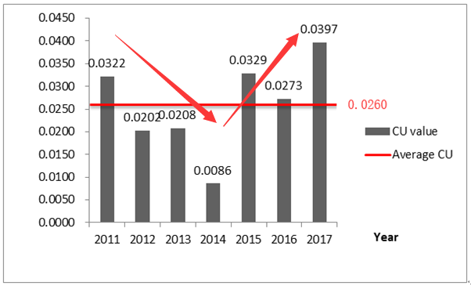
Figure 1 The average CU value of the transportation industry changed from 2011 to 2017

The annual distribution of CU values in the transportation industry of 30 provinces and cities in China is provided in Figure 2. This analysis intuitively highlights that in the period 2011-2017, the CU values of Hebei, Hainan, Sichuan, Qinghai, and Ningxia were all 0 (see average map at the bottom of Figure 2). This indicates that the transportation industries in these five provinces and cities had fully utilized their production potential and maximized the use of variable inputs for capacity output.
Conversely, the CU value of the remaining 25 provinces and cities exceeds 0. This means that the production potential of transportation in most areas of China has not been fully developed, and the level of CU also has room for improvement. The output capacity can be effectively improved by rationally adjusting the allocation of input resources. This is also the case of China's national-level transportation industry.
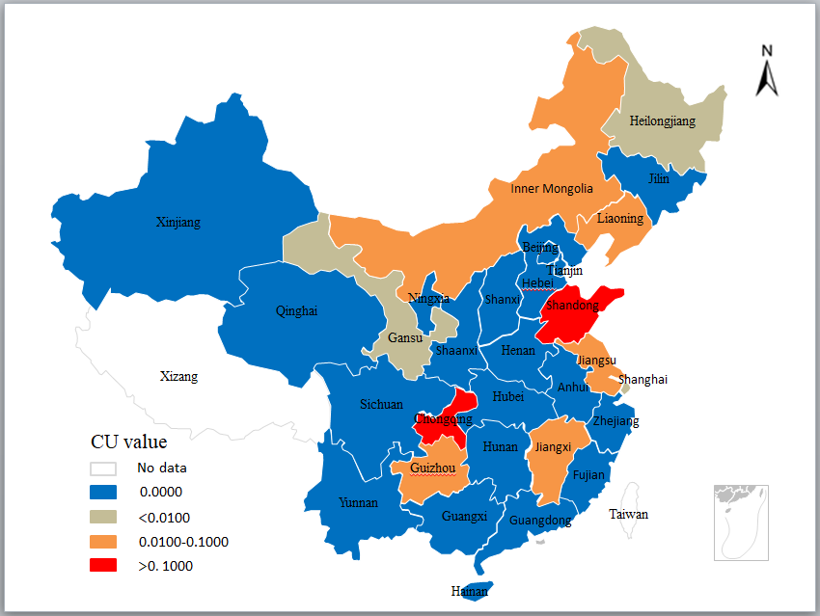
（2011）
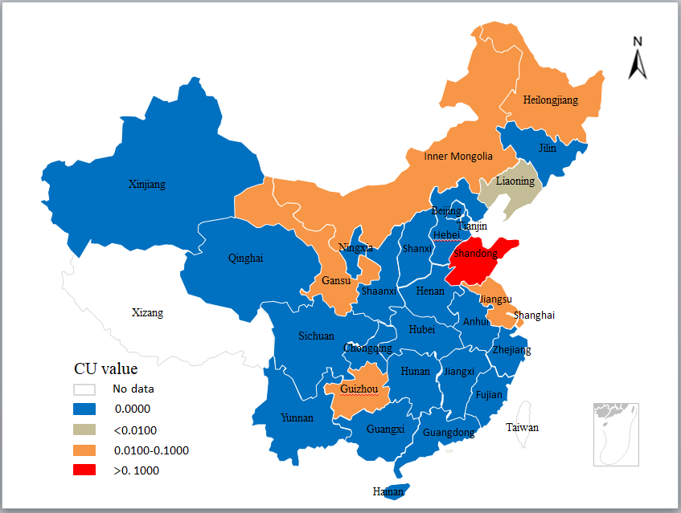
（2012）
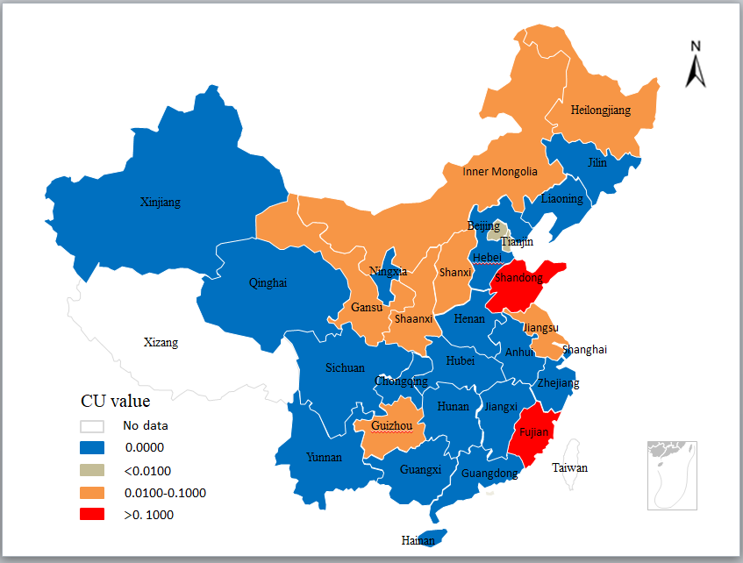
（2013）
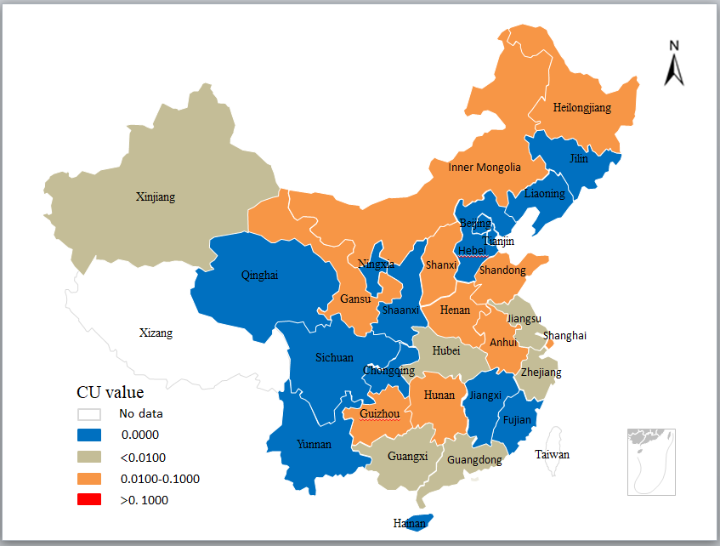
（2014）
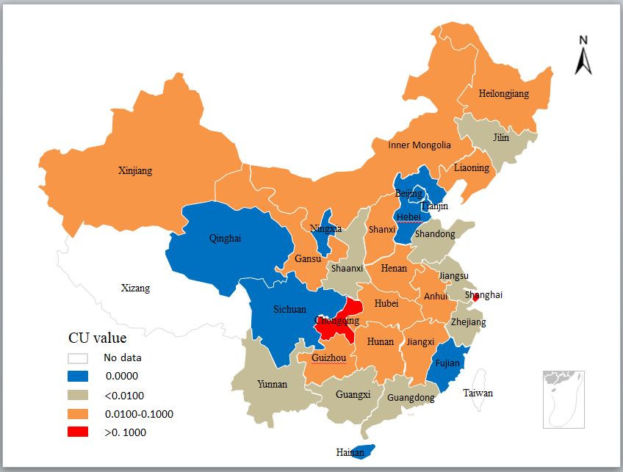
（2015）
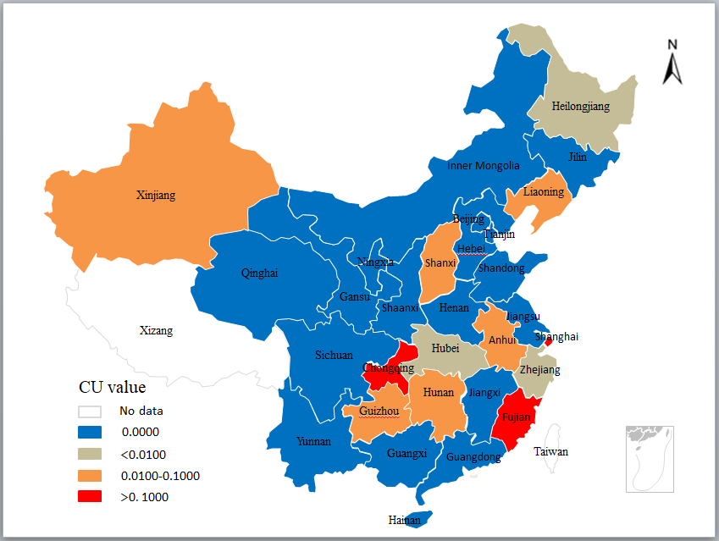
（2016）
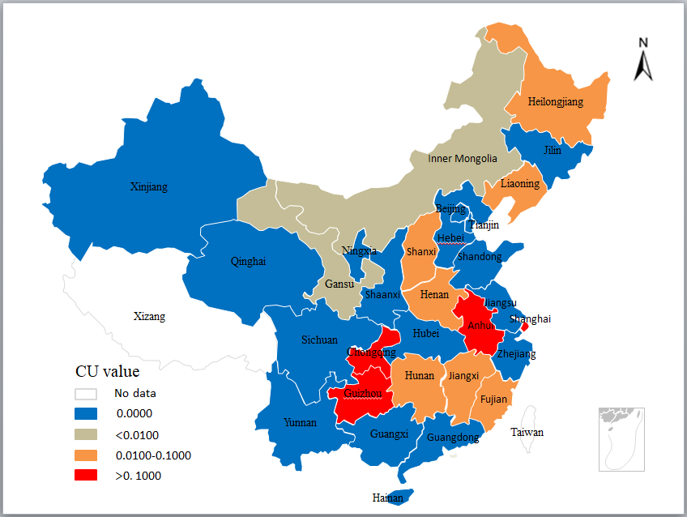
（2017）
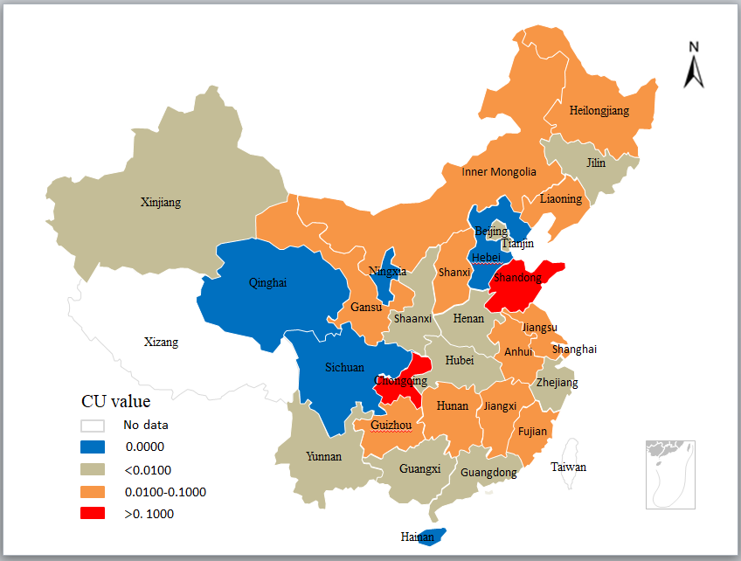
（CU average during 2011-2017）
Figure 2. CU value of China's transportation industry in each year and the average CU value of 2011-2017

3.2 CU results for China's regional transportation industry
The transportation industry is a core driver of economic development and regional linkages. The differences in geographical location, natural resource endowment and technological level have made the economic development levels of China's various regions show significant regional differences. The strengthening of economic links between regions has provided indeed support for China's economic growth.
Following the principles of regional economic development, the distribution of natural resources, and drawing on the research of Wang and Wei (2014), this research study divided China into eight economic regions. The division of regions, CU values and rankings of each region during the study period are shown in Table 2.
Figure 3 shows the average CU values of China's eight economic regions from 2011 to 2017. According to Table 2 and Figure 3, it is obvious that the average CU value in Southwestern China, China's northern coastal areas, and China's eastern coastal areas exceeds 0.03. This highlights that three regions have not made full use of input resources to support capacity output, and there is still scope for progress. The average CU value during the study period in Southwestern China was the highest of the regions, being 0.0573. This means that compared to other regions, the underutilization of capacity of the transportation industry in the Southwestern region is the most serious. The average CU values in Northwestern China, Northeastern China, and the Central Yellow River region were lower, all below 0.0150. This means that these three regions have higher levels of CU. Among them, the average CU value during the study period in Northwestern China was the lowest, only 0.0036, indicating that the potential for the transportation industry was almost fully utilized. Furthermore, the average CU values of the Central Yangtze River region and China's southern coastal areas were 0.0214 and 0.0210, respectively, indicating that the potential for the transportation industry for these two regions had not been fully developed, and consequently there is significant room for further progress.
In the context of an apparent unbalanced economic development of the eight regions in China, the level of CU is also significantly heterogeneous. Therefore, targeted management measures should be formulated to reduce the imbalance across regions and achieve an overall increase of the CU for China's transportation industry. According to Figure 3, the underutilization of capacity issue in the Southwestern China region is the most serious. Although the Central Yangtze River region has not faced a severe capacity underutilization problem, the CU values in the Anhui region during the study period also exceeded 0. Therefore, this research study adopts Guizhou in Southwestern China and Anhui in the Central Yangtze River region as representative examples, and measures their CU values by the Method II to explore in detail some potential mechanisms to improve the CU level.
Table 3 provides the original input data （represented by $e_{1}^{c},e_{1},e_{2}$） of Guizhou during 2011-2017, and the correction coefficients of linked variable inputs and variable inputs (represented by ${δ_{l}^{ec*},δ}_{l}^{e*},δ_{2}^{e*}$) when the potential output is optimal. The corresponding corrected input data (represented by ${e_{l}^{c*},e}_{l}^{*},e_{2}^{*}$) can be calculated by formula (13). The detailed data results are shown in Table 3.
First of all, combined with the determination of the CU index, it can be observed that the transportation industry in Guizhou only faces the problem of insufficient capacity due to underutilization of fixed inputs. There is no problem of overcapacity. Table 3 shows that compared with the original data, the level of employment in the transportation industry after the correction has increased significantly, which indicates that a reasonable increase in human resources will help further increase the production potential of the transportation industry in Guizhou. In addition, revised fixed assets investment has decreased. Except for 2017, the final energy consumption has increased slightly, whereas in the other years it has decreased to varying degrees. This phenomenon also reflects the need to strengthen the management and control of capital inputs and final energy consumption of the transportation industry, while fully tapping the potential of transportation in Guizhou.
Table 4 provides the analysis of CU results for the transportation industry in Anhui. The data in Table 4 is a reflection of the correction factor for Anhui's transportation industry's input resources from 2011 to 2013, which is 1, and Figure 2 also shows that during this period, the CU value is 0. This means that from the year 2011 to 2013, the transportation industry in Anhui made full use of fixed input resources for capacity output, with an optimal level of CU. In addition, Table 4 reflects that the transportation industry of Anhui’s linked variable input and variable input correction coefficients were greater than 1 during the period 2014-2017.
Figure 2 also shows that during this period, the CU value exceeds 0. According to the determination of the CU index, it can be observed that during the period 2014-2017, Anhui faced the problem of overcapacity due to excessive use of fixed inputs. In the current scenario, the revised final energy consumption, number of employed people, and fixed asset investment in Table 4 do not represent the optimal allocation of input resources for the transportation industry located in the Anhui region. On the contrary, in view of the current problem of overcapacity, the scale of fixed inputs should be appropriately controlled to avoid excessive use of input resources, thereby achieving the overall goal of enabling de-capacity. Therefore, in the implementation process of a supply-side structural reform, it is particularly important to implement strong policy control measures and focus on improving the production management capability of the transportation industry.

Table 2.The average regional CU of China's transportation industry from 2011 to 2017
No |  | Name of the Regions |  | Included provinces and cities |  | 2011 | 2012 | 2013 | 2014 | 2015 | 2016 | 2017 | Average Value | Rank
 | 1 |  | Northwestern China |  | Xinjiang, Ningxia, Qinghai, Gansu | 0.0004 | 0.0031 | 0.0036 | 0.0032 | 0.0103 | 0.0036 | 0.0006 | 0.0036 | 8
 | 2 |  | Central Yellow River |  | Shanxi, Inner Mongolia, Shaanxi, Henan | 0.0042 | 0.0040 | 0.0152 | 0.0170 | 0.0217 | 0.0065 | 0.0184 | 0.0124 | 6
 | 3 |  | China's northern coastal areas |  | Beijing, Shandong, Hebei, Tianjin | 0.1061 | 0.1116 | 0.0315 | 0.0034 | 0.0004 | 0.0000 | 0.0000 | 0.0361 | 2
 | 4 |  | China's northern coastal areas |  | Jilin, Heilongjiang, Liaoning | 0.0053 | 0.0114 | 0.0183 | 0.0157 | 0.0174 | 0.0098 | 0.0077 | 0.0122 | 7
 | 5 |  | Southwestern China |  | Chongqing, Guangxi, Yunnan, Guizhou, Sichuan | 0.0743 | 0.0052 | 0.0062 | 0.0058 | 0.0892 | 0.0849 | 0.1356 | 0.0573 | 1
 | 6 |  | Central Yangtze River |  | Anhui, Jiangxi, Hunan, Hubei | 0.0212 | 0.0000 | 0.0000 | 0.0127 | 0.0439 | 0.0156 | 0.0563 | 0.0214 | 4
 | 7 |  | China's eastern coastal areas |  | Shanghai, Zhejiang, Jiangsu | 0.0170 | 0.0240 | 0.0172 | 0.0104 | 0.0593 | 0.0517 | 0.0504 | 0.0329 | 3
 | 8 |  | China's southern coastal areas |  | Hainan, Fujian, Guangdong | 0.0000 | 0.0000 | 0.0950 | 0.0016 | 0.0020 | 0.0354 | 0.0130 | 0.0210 | 5

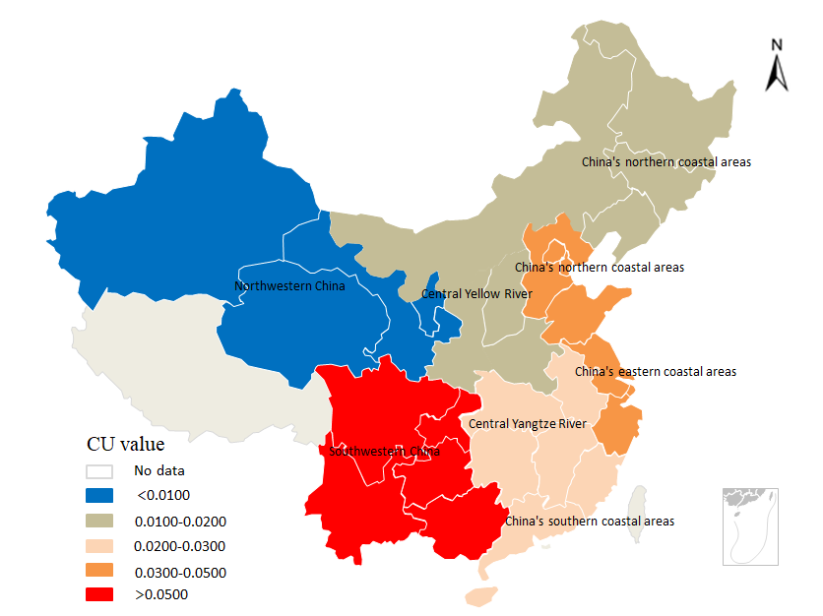

Figure 3. 2011 - 2017 average CU values distribution in China's Transportation Industry

Table 3. Guizhou's revised optimal variable input
Guizhou | 2011 | 2012 | 2013 | 2014 | 2015 | 2016 | 2017
$$e_{1}^{c}$$ | 572.57 | 610.45 | 665.41 | 711.87 | 778.49 | 857.42 | 785.01
$$e_{1}$$ | 9.70 | 9.10 | 11.30 | 11.10 | 11.60 | 12.00 | 12.20
$$e_{2}$$ | 588.90 | 756.20 | 1020.00 | 1319.90 | 1588.90 | 1779.90 | 2334.30
$$δ_{1}^{ec*}$$ | 0.8687 | 0.9206 | 0.8950 | 0.8859 | 0.9789 | 0.9284 | 1.1036
$$δ_{1}^{e*}$$ | 1.1870 | 1.4105 | 1.5065 | 1.5884 | 1.7182 | 1.5490 | 1.4291
$$δ_{2}^{e*}$$ | 0.9590 | 0.8924 | 0.8274 | 0.7728 | 0.9192 | 0.7228 | 0.7040
$$e^{c*}$$ | 497.39 | 561.98 | 595.54 | 630.65 | 762.06 | 796.03 | 866.34
$$e_{1}^{*}$$ | 11.51 | 12.84 | 17.02 | 17.63 | 19.93 | 18.59 | 17.44
$$e_{2}^{*}$$ | 564.76 | 674.83 | 843.95 | 1020.02 | 1460.52 | 1286.51 | 1643.35
Note: $e_{1}^{c},e_{1}and e_{2}$ represent the original input of Guizhou’s final energy consumption, number of employed people and fixed assets investment. $δ_{1}^{ec*},δ_{1}^{e*}and{ δ}_{2}^{e*}$ are the correction coefficients of final energy consumption, number of employed people and fixed assets investment calculated by formula (12) respectively. $e^{c*},e_{1}^{*}and e_{2}^{*}$ are the corresponding corrected input data, which can be calculated by formula (13): $e_{l}^{c*}=e_{l}^{c}×δ_{l}^{ec}$. For example, the value of $e^{c*}$ in Guizhou in 2011 was 497.39, which was obtained by $497.39=572.57×0.8687$.

Table 4. Anhui's revised optimal variable input
Anhui | 2011 | 2012 | 2013 | 2014 | 2015 | 2016 | 2017
$$e_{1}^{c}$$ | 761.92 | 851.04 | 922.26 | 1032.63 | 1052.17 | 1080.05 | 1149.88
$$e_{1}$$ | 16.70 | 16.30 | 22.00 | 21.70 | 22.30 | 22.90 | 24.20
$$e_{2}$$ | 464.80 | 585.80 | 830.20 | 1136.70 | 1350.90 | 1628.50 | 1667.80
$$δ_{1}^{ec*}$$ | 1.0000 | 1.0000 | 1.0000 | 1.2714 | 1.1848 | 1.1769 | 1.1010
$$δ_{1}^{e*}$$ | 1.0000 | 1.0000 | 1.0000 | 1.4029 | 1.4157 | 1.2696 | 1.0398
$$δ_{2}^{e*}$$ | 1.0000 | 1.0000 | 1.0000 | 1.9041 | 1.6337 | 1.2301 | 1.3258
$$e^{c*}$$ | 761.92 | 851.04 | 922.26 | 1312.89 | 1246.61 | 1271.11 | 1266.02
$$e_{1}^{*}$$ | 16.70 | 16.30 | 22.00 | 30.44 | 31.57 | 29.07 | 25.16
$$e_{2}^{*}$$ | 464.80 | 585.80 | 830.20 | 2164.39 | 2206.97 | 2003.22 | 2211.17
Note: $e_{1}^{c},e_{1}and e_{2}$ represent the original input of Anhui's final energy consumption, number of employed people and fixed assets investment. $δ_{1}^{ec*},δ_{1}^{e*}and{ δ}_{2}^{e*}$ are the correction coefficients of final energy consumption, number of employed people and fixed assets investment calculated by formula (12) respectively. $e^{c*},e_{1}^{*}and e_{2}^{*}$ are the corresponding corrected input data, which can be calculated by formula (13): $e_{l}^{c*}=e_{l}^{c}×δ_{l}^{ec}$. For example, the value of $e^{c*}$ in Anhui in 2014 was 1312.89, which was obtained by $1312.89=1032.63×1.2714$.

4 Discussion
This research study has utilized the method I: general form difference method to explore the CU of the transportation industry. In order to verify the rationality of the two measurement models and further analyze the differences between the corresponding sets of measurement results, the CU values obtained by the two measurement methods were used as the research object, and the differences between the two are plotted by drawing a kernel density map. The result is shown in Figure 4.
The determination of the CU index clearly stipulates: CU = 0, indicating that the DMU made full use of the fixed input resources for capacity output, with an optimal level of CU. When CU> 0, this indicates that the potential of transportation of the DMU has not been fully developed. It can be observed from Figure 4 that during the study period, the proportion of provinces and cities with the optimal CU level as measured by the method II is higher. Whereas the proportion of provinces and cities that have not achieved their full production potential measured by method I is higher. Additionally, regarding the largest CU value, that measured in method I is much larger than the one from method II.
According to analysis of the overall distribution trend, the CU value curve measured by method II is roughly the same in different years, and so is the CU value curve measured in method I. This reflects the rationality and stability of the two measurement models. During the study period, the distribution of CU values measured by Method I was more scattered, while the distribution of CU values measured by Method II was more concentrated, and this phenomenon was most obvious in 2014. In addition, during the study period, the peaks of the CU value curve measured by method II are all to the left of the peaks of the CU value curve measured by method I, and are close to 0, which means that the CU value measured by method II is generally lower than the CU value measured by method I. This also clearly reflects that when compared with the results measured without considering the ariable link, the CU status measured by a variable-link form difference method is more optimistic.
It can also be observed that adding the variable input link related to the undesired output to the differences measurement model (method I) can more fully reflect the characteristics of the data variables. This can cause significant changes in the CU index, but in the CU index measurement process for the transportation industry, linking energy consumption with CO₂ emissions not only clarifies the source of undesired output, it also reduces the difference between the actual output and the optimal potential output. Indeed, some scholars have observed similar results in the measurement research of CU index for the manufacturing industry (Yang et al., 2018). Therefore, it is necessary to establish the link between the two variables in the measurement model. Yang and Fukuyama (2018) also confirmed the necessity to add this link to the measurement of regional production potential in China. In our case, adding a link between energy consumption and CO₂ emissions when calculating the optimal potential output using a difference measurement model means that some constraints are added in the process of finding the optimal output. This entails that the calculated optimal potential output values decrease. Hence, adding this variable link relationship to the differences measurement model not only reflects better the actual transportation process, it also optimizes the structure of the measurement model. The latter is helpful to improve the rationality and accuracy of the CU index.
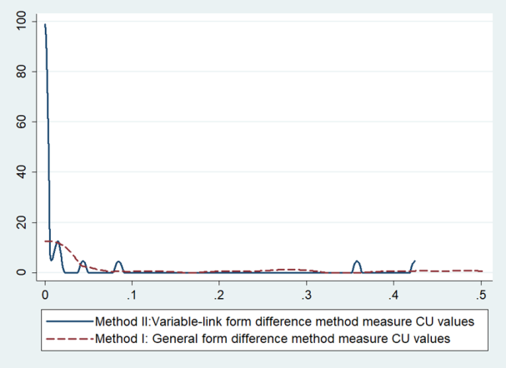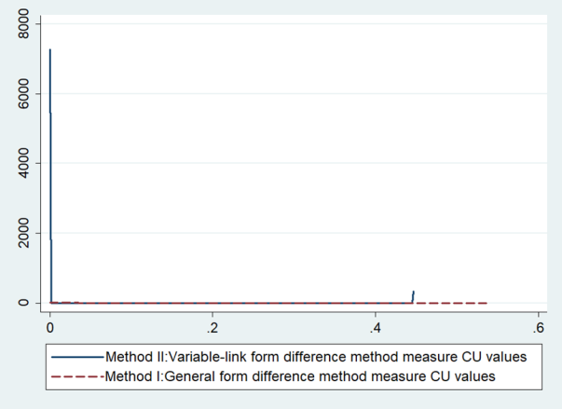
（2011） （2012）
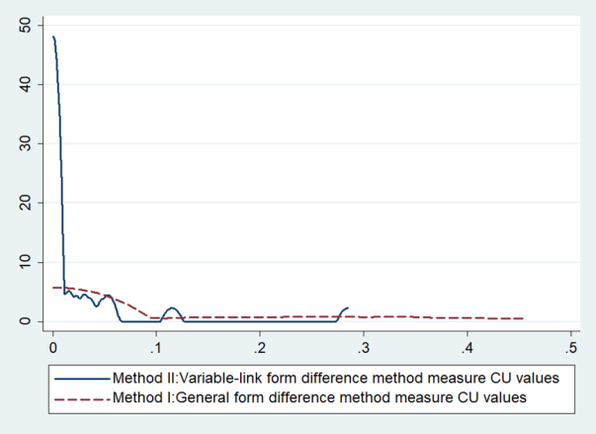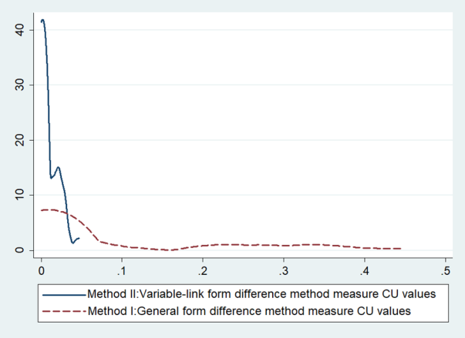
（2013） （2014）
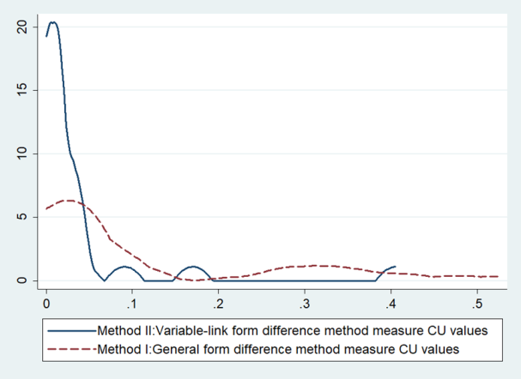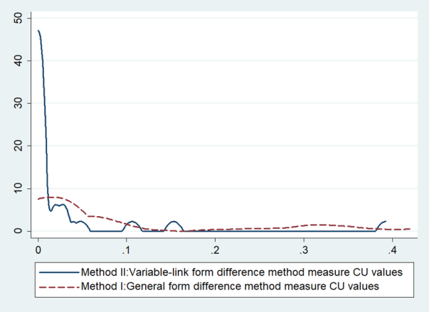
（2015） （2016）
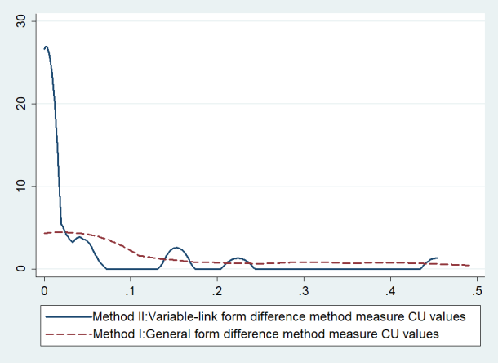
（2017）
Figure 4. Comparison of CU values measured by Method I and Method II
According to the results of this empirical research, the CU value of China's transportation industry in the period 2011-2017 can be divided into two phases. The CU value in the period 2011-2014 can be associated with the first phase, where the CU value decreased, which means that the production potential of all the regions has significantly improved during this period, and the overall CU level of the transportation industry has improved.
In 2014, the transportation industry almost made full use of variable inputs for capacity output. This may be due to the release of the “Twelfth Five-Year Plan for Comprehensive Transportation System Planning” in July 2012 (StateCouncil, 2012), which strongly promoted the establishment of a comprehensive transport network that met the needs of social development. In August 2013, the “Ministry of Transport's Guide on Improving Transportation Services” were also proposed (StateCouncil, 2013). The latter further encouraged the optimization and organization of the regional transport industry structure and the improvement of transport service levels. Arguably, as a result, the CU level of the whole transportation industry improved significantly in the year after (2013).
Next, the CU value of China's transportation industry in the period 2015-2017 can be associated with the second phase. In this second phase, there was a rise in the CU index meaning that regional differences in CU levels increased significantly. The consequence was that the overall CU level of the transportation industry was reduced. This may be attributed to two major reasons:
(1) The limited level of production technology. The Chinese government pushed for the modernization of transportation. However, differences in geographical location, natural resources and other factors resulted in significant development differences at the regional level. For example, the Southwestern region of China is the region with the most severe problem of capacity underutilization. In this region, information blockage, resource endowment, and underdeveloped transportation infrastructure have all led to a low level of production technology. This hinders the overall improvement of the CU at a national level.
(2) An imbalance in economic development. It can be observed that globalization has brought both opportunities and challenges for China's economic development. Additionally, intensification of China's economic downturn in 2015 further exacerbated regional economic differences. The imbalance in economic development has caused some inconsistencies in national and regional investment levels in the transportation infrastructure too. This leads to an increase in regional differences in CU, and the issue of underutilization of capacity is further highlighted.
According to previous analyses, we can propose some targeted policy recommendations to promote an improvement of the transportation industry CU:
- Establish a comprehensive monitoring system for capacity utilization in the national transportation industry.
In the current age of information, Huang et al. (2017) and Avdoshin and Pesotskaya (2018) believe that promoting the so called ‘informationization’, as well as digitalization of transportation management is the only way to modernize it. In order to formulate targeted measures to address the issue of underutilization of capacity, it is important to ascertain first its ongoing status in each province. Therefore, it is necessary to promote synchronous development of transportation facilities. Therefore, it is necessary to promote synchronous development of the monitoring system and transportation facilities through strengthening the data collection system of the transportation industry's resource supply, transportation services and pollution discharge information, as well as enabling comprehensive oversight of the transportation industry CU monitoring system.
（2）Build a “Belt and Road” interconnected transportation channel.
The strategic development of the BRI is not only a lever to boost China's sustainable development, but also a communication channel between other countries. It is argued that the transportation industry should seize the development opportunities offered by the BRI through the technical advantages of China's transportation infrastructure. Hence, China should strengthen the interconnection of land, air and sea transportation with other countries along the BRI. It is also recommended to encourage international production cooperation, overseas countries included.
- Balance regional differences and formulate differentiated regional transportation development strategies.
Li et al. (2019) pointed out that the formation of a transportation network compatible with regional economic development, geographical environment and transportation demand is the foundation of a strong transportation industry. Song and Liu (2016a) and Xiaohong and Jie (2017) also emphasized that China's regional transportation development should be coordinated. Thus, the way to a balanced development of the CU in the transportation industry lies in formulating targeted transportation development policies. In the case of Southwestern China where the CU is most severe for example, the coverage of the transportation network should be expanded, mostly with the construction of western railway lines. In the case of China's northern and eastern coastal areas, where CU also has significant potential for improvement, their privileged geographical location should be taken advantage of by establishing digital transportation networks and improving the quality of current transportation services.
（4）Undertake the planning of transportation resources and promote innovation and development of transportation technology.
In the long term, improving the transportation technology and optimizing resources allocation are fundamental to solve the problem of insufficient capacity utilization. Indeed, Ziwei (2018) believed that prioritizing the implementation of traffic resource control policies could facilitate the construction of modern transportation systems. Regarding funding, the transportation industry of all provinces and cities should be supported by credit funds for policy and development from financial institutions. Hence, it is proposed to broaden the capital channels of the transportation industry and improve their utilization efficiency. Regarding human resources, the transportation industry also needs to train skilled workers in modern technologies and strengthen their international exchange with other countries. It is further proposed to strengthen the incentive policies and optimize the labor structure of the transportation industry. Moreover, in the context of deepening the development of green transportation, the transportation industry should increase the promotion and application of clean fuel vehicles and ships, such as those powered from electrical energy and natural gas, and promote establishment of a low-carbon and efficient green transportation system (Feng and Wang, 2018; Marquis, 2012). Adopting a strategy of focusing on the reasonable allocation of transportation resources, through the deep integration of advanced technology and transportation, should stimulate further innovation in transportation technology.

5 Conclusions
The transportation industry of any country links the production, exchange, distribution and use of social production activities. It is key to allocating and optimizing the use of resources while strengthening the links between regional economies. However, the development of the transportation industry is also facing worldwide problems of environmental pollution. Hence, based on the perspective of environmental constraints, exploring the capacity utilization (CU) of the transportation industry is an important prerequisite to achieve capacity optimization and promote greener and more efficient industrial development.
In order to accurately reflect the actual transportation industry CU status, this research has considered the environmental pollution caused by transportation, and established a CU evaluation index that includes energy consumption and CO₂ emissions. The CU of China's transportation industry in the period 2011-2017 has been measured through the use of two improved DEA-based difference methods. Simultaneously, the status quo of CU has been assessed at the national and regional levels. This research study has considered a series of influencing factors of CU, and explored effective mechanisms to increase it. Hence, this study expands the existing knowledge on measurement models of CU, that also allow formulating targeted capacity utilization improvement strategies. In doing so, it also has the potential for establishing of a comprehensive transportation industry CU monitoring system. The main research conclusions of this study are as follows:
(1) The results of CU measured by the two DEA-based difference models are coherent and stable. Adding a direct link between variable input and undesired output in the model can not only truly reflect the production characteristics of the transportation industry, but also make the measurement model structure more optimized, thereby further improving the accuracy of the CU index measurement.
(2) The average CU value of China's transportation industry during the period 2011-2017 is 0.0260, with 2014 as the critical point, thereby showing a trend to first decline and then increase. This means that China's transportation industry does have the underutilization of capacity, especially in the past three years.
(3) Regional differences in CU levels in the transportation industry are significant. During the study period, compared with the CU levels in Northeastern China and Northwestern China, the issue of underutilization of capacity in Southwestern China was the most serious.
(4) Promoting the development of transportation technology innovations and optimizing transportation resources use are key mechanisms to improve the CU. The government and each region should formulate specific measures to optimize the CU based on the current CU status of each region, so as to improve the overall CU level of the national transportation industry.
In the implementation of supply-side structural reforms, adopting targeted policies is also key to build an integrated transportation system and promoting social and economic development. Establishing a comprehensive transportation industry CU monitoring system in various regions will allow the government to implement surgical measures for CU improvement. This will allow them to balance the differential economic development of the various regions and better allocate the economic resources invested in transportation. Thus, in regions where the issue of underutilization of capacity is more serious, it is necessary to improve the CU level by better planning the limited transportation input resources, improving the use of transportation capital, and training high-tech industry workers. There is also a need to foster research and technological innovation to improve the overall development of the transportation industry.
This research study has two main limitations. First, the study uses DEA-based difference methods on 30 provinces and cities assuming these decision-making units (DMUs) are independent from each other. However, these DMUs are not completely independent. Due to the potential for collaborative production methods of the transportation industry, exchanges and cooperation in various Chinese regions have been promoted. As a result, the economic development of these collaborating regions has been closely related. This may have caused some minor deviations in the calculation of the CU indices in some provinces and cities. From the perspective of spatial econometrics, though, exploring CU in the transportation industry still is a relatively unchartered area of research.
Second, due to restrictions of data availability, this article only estimates CO₂ emissions generated by the consumption of major energy sources, such as gasoline and natural gas. This simplification may have also caused some deviations from the actual levels of China's transportation industry CO₂ emissions. Similarly, this research study only established a CU evaluation system using CO₂ emissions as the undesired output. However, in real contexts, sulfide and nitride compounds produced by energy consumption, even the noise generated by transportation, also cause air pollution. Therefore, future research on transportation CU measurement should consider improving the evaluation index system proposed here by adding other representative variables.

Data available
Data can be obtained from the corresponding author. This study aims to measure the capacity utilization of China's transportation industry from 2011 to 2019. As the 2018 data needs to be obtained from the 2019 statistical yearbook, and the 2019 China Energy Statistical Yearbook and the 2019 statistical yearbooks of some provinces and cities have not yet been released, the 2018 capacity utilization data is temporarily missing. Similarly, the capacity utilization data for 2019 cannot be measured temporarily. The follow-up of this study will query and calculate the research data as soon as the relevant yearbook is released, and timely supplement the results of the 2018 and 2019 capacity utilization data.

Acknowledgments
This research is supported by the National Natural Science Foundation (NSFC, No.71671181, No.71971029); National Social Science Fund Post-financing projects (No.19FJYB017); Humanity and Social Science Program Foundation of the Ministry of Education of China (No.17YJA790091); List of Key Science and Technology Projects in China’s Transportation Industry in 2018-International Science and Technology Cooperation Project (No.2018-GH-006, No.2019-MS5-100). The sixth author also acknowledges the Spanish Ministries of Science and Innovation, and Universities for his Ramon y Cajal contract (RYC-2017-22222) co-funded by the European Social Fund.

Appendix
Table A.1 Calculation results of CU values using General form difference method in 30 provinces and cities in China from 2011 to 2017
Provinces/Cities | 2011 |  |  | 2012 |  |  | 2013 |  |  |  | 2014
 | $$θ$$ | $$\hat{θ}$$ | CU | $$θ$$ | $$\hat{θ}$$ | CU | $$θ$$ |  | $$\hat{θ}$$ | CU | $$θ$$ | $$\hat{θ}$$ | CU
Beijing | 0.0000 | 0.0000 | 0.0000 | 0.0275 | 0.1352 | 0.1077 | 0.0000 |  | 0.0000 | 0.0000 | 0.0000 | 0.0000 | 0.0000
Tianjin | 0.0000 | 0.0000 | 0.0000 | 0.0000 | 0.0000 | 0.0000 | 0.0000 |  | 0.0000 | 0.0000 | 0.0000 | 0.0000 | 0.0000
Hebei | 0.0000 | 0.0000 | 0.0000 | 0.0000 | 0.0000 | 0.0000 | 0.0000 |  | 0.0000 | 0.0000 | 0.0000 | 0.0000 | 0.0000
Shanxi | 0.4227 | 0.4227 | 0.0000 | 0.4230 | 0.4230 | 0.0000 | 0.3146 |  | 0.4388 | 0.1241 | 0.2943 | 0.5189 | 0.2246
Inner Mongolia | 0.0000 | 0.5044 | 0.5044 | 0.0000 | 0.5377 | 0.5377 | 0.0000 |  | 0.4005 | 0.4005 | 0.0000 | 0.4445 | 0.4445
Liaoning | 0.1555 | 0.1614 | 0.0059 | 0.0000 | 0.0000 | 0.0000 | 0.0000 |  | 0.0000 | 0.0000 | 0.0000 | 0.0928 | 0.0928
Jilin | 0.3552 | 0.3552 | 0.0000 | 0.3034 | 0.3034 | 0.0000 | 0.3041 |  | 0.3192 | 0.0151 | 0.3724 | 0.3912 | 0.0188
Heilongjiang | 0.4907 | 0.5215 | 0.0309 | 0.3753 | 0.4969 | 0.1216 | 0.2986 |  | 0.5043 | 0.2057 | 0.3185 | 0.5529 | 0.2344
Shanghai | 0.0000 | 0.0000 | 0.0000 | 0.0000 | 0.0000 | 0.0000 | 0.0000 |  | 0.0000 | 0.0000 | 0.0000 | 0.0000 | 0.0000
Jiangsu | 0.0000 | 0.0000 | 0.0000 | 0.0000 | 0.0000 | 0.0000 | 0.0000 |  | 0.0000 | 0.0000 | 0.0000 | 0.0000 | 0.0000
Zhejiang | 0.0190 | 0.0498 | 0.0308 | 0.0980 | 0.0989 | 0.0009 | 0.0000 |  | 0.0000 | 0.0000 | 0.0000 | 0.0676 | 0.0676
Anhui | 0.0000 | 0.0000 | 0.0000 | 0.0000 | 0.0000 | 0.0000 | 0.0000 |  | 0.0000 | 0.0000 | 0.0000 | 0.0000 | 0.0000
Fujian | 0.3005 | 0.3038 | 0.0032 | 0.2746 | 0.2802 | 0.0055 | 0.0000 |  | 0.2948 | 0.2948 | 0.2381 | 0.2421 | 0.0040
Jiangxi | 0.0000 | 0.1182 | 0.1182 | 0.0000 | 0.0240 | 0.0240 | 0.0000 |  | 0.0000 | 0.0000 | 0.0000 | 0.0076 | 0.0076
Shandong | 0.0000 | 0.0000 | 0.0000 | 0.0000 | 0.0000 | 0.0000 | 0.0000 |  | 0.0000 | 0.0000 | 0.0969 | 0.0969 | 0.0000
Henan | 0.0000 | 0.0000 | 0.0000 | 0.0000 | 0.0000 | 0.0000 | 0.0000 |  | 0.0000 | 0.0000 | 0.0000 | 0.0000 | 0.0000
Hubei | 0.4000 | 0.4190 | 0.0190 | 0.3473 | 0.3579 | 0.0106 | 0.2821 |  | 0.2821 | 0.0000 | 0.2735 | 0.2774 | 0.0039
Hunan | 0.0942 | 0.1152 | 0.0209 | 0.0081 | 0.0081 | 0.0000 | 0.0000 |  | 0.0000 | 0.0000 | 0.0000 | 0.0187 | 0.0187
Guangdong | 0.0000 | 0.0000 | 0.0000 | 0.0000 | 0.0000 | 0.0000 | 0.0000 |  | 0.0000 | 0.0000 | 0.0000 | 0.0000 | 0.0000
Guangxi | 0.2341 | 0.2341 | 0.0000 | 0.1975 | 0.1975 | 0.0000 | 0.2069 |  | 0.2178 | 0.0109 | 0.3245 | 0.3273 | 0.0028
Hainan | 0.0000 | 0.2788 | 0.2788 | 0.0000 | 0.3633 | 0.3633 | 0.0000 |  | 0.4571 | 0.4571 | 0.0000 | 0.3291 | 0.3291
Chongqing | 0.0000 | 0.4058 | 0.4058 | 0.3651 | 0.3899 | 0.0248 | 0.3938 |  | 0.3938 | 0.0000 | 0.4772 | 0.5121 | 0.0349
Sichuan | 0.2867 | 0.2867 | 0.0000 | 0.1968 | 0.1968 | 0.0000 | 0.0472 |  | 0.0472 | 0.0000 | 0.2341 | 0.2341 | 0.0000
Guizhou | 0.0000 | 0.2806 | 0.2806 | 0.0000 | 0.2881 | 0.2881 | 0.0000 |  | 0.1910 | 0.1910 | 0.0000 | 0.2379 | 0.2379
Yunnan | 0.6556 | 0.6556 | 0.0000 | 0.5806 | 0.5806 | 0.0000 | 0.5295 |  | 0.5295 | 0.0000 | 0.5781 | 0.5793 | 0.0012
Shaanxi | 0.4250 | 0.4250 | 0.0000 | 0.3526 | 0.3526 | 0.0000 | 0.1775 |  | 0.1775 | 0.0000 | 0.1843 | 0.1892 | 0.0049
Gansu | 0.1118 | 0.1663 | 0.0545 | 0.0515 | 0.0871 | 0.0356 | 0.0521 |  | 0.1215 | 0.0693 | 0.0956 | 0.1365 | 0.0409
Qinghai | 0.0000 | 0.4589 | 0.4589 | 0.0000 | 0.3874 | 0.3874 | 0.0000 |  | 0.3374 | 0.3374 | 0.0000 | 0.3531 | 0.3531
Ningxia | 0.0000 | 0.2146 | 0.2146 | 0.0000 | 0.3055 | 0.3055 | 0.0000 |  | 0.2816 | 0.2816 | 0.0000 | 0.3248 | 0.3248
Xinjiang | 0.4741 | 0.4741 | 0.0000 | 0.3907 | 0.3961 | 0.0054 | 0.3425 |  | 0.3428 | 0.0003 | 0.4105 | 0.4151 | 0.0045
Provinces/Cities | 2015 |  |  | 2016 |  |  | 2017
 | $$θ$$ | $$\hat{θ}$$ | CU | $$θ$$ | $$\hat{θ}$$ | CU | $$θ$$ | $$\hat{θ}$$ |  | CU
Beijing | 0.0000 | 0.0000 | 0.0000 | 0.0000 | 0.0000 | 0.0000 | 0.0000 | 0.3510 |  | 0.3510
Tianjin | 0.0000 | 0.0000 | 0.0000 | 0.0000 | 0.0000 | 0.0000 | 0.0000 | 0.0000 |  | 0.0000
Hebei | 0.0000 | 0.0000 | 0.0000 | 0.0000 | 0.0000 | 0.0000 | 0.0000 | 0.0000 |  | 0.0000
Shanxi | 0.2002 | 0.5004 | 0.3002 | 0.1484 | 0.4292 | 0.2808 | 0.0000 | 0.3821 |  | 0.3821
Inner Mongolia | 0.0000 | 0.5256 | 0.5256 | 0.2642 | 0.2642 | 0.0000 | 0.3349 | 0.4014 |  | 0.0664
Liaoning | 0.0000 | 0.0814 | 0.0814 | 0.0000 | 0.0742 | 0.0742 | 0.0000 | 0.1395 |  | 0.1395
Jilin | 0.3425 | 0.3887 | 0.0463 | 0.3198 | 0.3213 | 0.0015 | 0.3510 | 0.3510 |  | 0.0000
Heilongjiang | 0.4793 | 0.5554 | 0.0761 | 0.4989 | 0.5284 | 0.0295 | 0.5379 | 0.5447 |  | 0.0068
Shanghai | 0.0000 | 0.0000 | 0.0000 | 0.0000 | 0.0000 | 0.0000 | 0.0000 | 0.0000 |  | 0.0000
Jiangsu | 0.0000 | 0.0000 | 0.0000 | 0.0000 | 0.0000 | 0.0000 | 0.0000 | 0.0000 |  | 0.0000
Zhejiang | 0.0000 | 0.0000 | 0.0000 | 0.0000 | 0.0000 | 0.0000 | 0.0000 | 0.0000 |  | 0.0000
Anhui | 0.0000 | 0.0443 | 0.0443 | 0.0000 | 0.0480 | 0.0480 | 0.0000 | 0.1446 |  | 0.1446
Fujian | 0.0000 | 0.0988 | 0.0988 | 0.0000 | 0.0474 | 0.0474 | 0.0000 | 0.0268 |  | 0.0268
Jiangxi | 0.0000 | 0.0420 | 0.0420 | 0.0000 | 0.0000 | 0.0000 | 0.0000 | 0.0590 |  | 0.0590
Shandong | 0.0585 | 0.0585 | 0.0000 | 0.0220 | 0.0220 | 0.0000 | 0.0000 | 0.0000 |  | 0.0000
Henan | 0.0000 | 0.0000 | 0.0000 | 0.0000 | 0.0000 | 0.0000 | 0.0000 | 0.0000 |  | 0.0000
Hubei | 0.2102 | 0.2262 | 0.0160 | 0.2474 | 0.3131 | 0.0657 | 0.2531 | 0.2827 |  | 0.0297
Hunan | 0.0000 | 0.0500 | 0.0500 | 0.0000 | 0.0658 | 0.0658 | 0.0000 | 0.1020 |  | 0.1020
Guangdong | 0.0000 | 0.0000 | 0.0000 | 0.0000 | 0.0000 | 0.0000 | 0.0000 | 0.0000 |  | 0.0000
Guangxi | 0.1589 | 0.2015 | 0.0426 | 0.1246 | 0.1792 | 0.0546 | 0.1340 | 0.1949 |  | 0.0609
Hainan | 0.0000 | 0.3735 | 0.3735 | 0.0000 | 0.3435 | 0.3435 | 0.1574 | 0.3943 |  | 0.2369
Chongqing | 0.0000 | 0.4298 | 0.4298 | 0.0000 | 0.4208 | 0.4208 | 0.0000 | 0.4921 |  | 0.4921
Sichuan | 0.1867 | 0.1867 | 0.0000 | 0.3137 | 0.3137 | 0.0000 | 0.4016 | 0.4016 |  | 0.0000
Guizhou | 0.0000 | 0.2474 | 0.2474 | 0.0000 | 0.2229 | 0.2229 | 0.0000 | 0.2477 |  | 0.2477
Yunnan | 0.5246 | 0.5410 | 0.0164 | 0.5371 | 0.5371 | 0.0000 | 0.5535 | 0.5535 |  | 0.0000
Shaanxi | 0.1857 | 0.1943 | 0.0086 | 0.0802 | 0.0802 | 0.0000 | 0.1023 | 0.1023 |  | 0.0000
Gansu | 0.0000 | 0.0793 | 0.0793 | 0.0000 | 0.0361 | 0.0361 | 0.0000 | 0.0593 |  | 0.0593
Qinghai | 0.0000 | 0.3113 | 0.3113 | 0.0000 | 0.3165 | 0.3165 | 0.0000 | 0.3218 |  | 0.3218
Ningxia | 0.0000 | 0.3245 | 0.3245 | 0.0000 | 0.3311 | 0.3311 | 0.0000 | 0.4565 |  | 0.4565
Xinjiang | 0.4637 | 0.4894 | 0.0257 | 0.3857 | 0.4857 | 0.1000 | 0.5567 | 0.5567 |  | 0.0000

Table A.2 Calculation results of CU values using Variable-link form difference method in 30 provinces and cities in China from 2011 to 2017
Provinces/Cities | 2011 |  |  | 2012 |  |  | 2013 |  |  | 2014
 | $$∂$$ | $$\hat{∂}$$ | CU | $$∂$$ | $$\hat{∂}$$ | CU | $$∂$$ | $$\hat{∂}$$ | CU | $$∂$$ | $$\hat{∂}$$ | CU
Beijing | 0.3829 | 0.3829 | 0.0000 | 0.3913 | 0.3913 | 0.0000 | 0.3997 | 0.4093 | 0.0095 | 0.4349 | 0.4349 | 0.0000
Tianjin | 0.0000 | 0.0000 | 0.0000 | 0.0000 | 0.0000 | 0.0000 | 0.0000 | 0.0014 | 0.0014 | 0.0540 | 0.0540 | 0.0000
Hebei | 0.0000 | 0.0000 | 0.0000 | 0.0000 | 0.0000 | 0.0000 | 0.0000 | 0.0000 | 0.0000 | 0.0000 | 0.0000 | 0.0000
Shanxi | 0.3856 | 0.3856 | 0.0000 | 0.3866 | 0.3866 | 0.0000 | 0.3767 | 0.3994 | 0.0227 | 0.4413 | 0.4674 | 0.0260
Inner Mongolia | 0.4803 | 0.4970 | 0.0167 | 0.5163 | 0.5321 | 0.0158 | 0.3479 | 0.3860 | 0.0381 | 0.4025 | 0.4292 | 0.0267
Liaoning | 0.3970 | 0.4117 | 0.0147 | 0.3172 | 0.3174 | 0.0001 | 0.2498 | 0.2498 | 0.0000 | 0.3499 | 0.3499 | 0.0000
Jilin | 0.2950 | 0.2950 | 0.0000 | 0.2467 | 0.2467 | 0.0000 | 0.2679 | 0.2679 | 0.0000 | 0.3286 | 0.3286 | 0.0000
Heilongjiang | 0.4901 | 0.4912 | 0.0011 | 0.4388 | 0.4729 | 0.0340 | 0.4328 | 0.4877 | 0.0549 | 0.4852 | 0.5322 | 0.0470
Shanghai | 0.3435 | 0.3507 | 0.0073 | 0.1686 | 0.2065 | 0.0379 | 0.2486 | 0.2486 | 0.0000 | 0.1652 | 0.1878 | 0.0226
Jiangsu | 0.1216 | 0.1653 | 0.0437 | 0.1082 | 0.1423 | 0.0341 | 0.1456 | 0.1973 | 0.0517 | 0.2811 | 0.2886 | 0.0074
Zhejiang | 0.2618 | 0.2618 | 0.0000 | 0.2294 | 0.2294 | 0.0000 | 0.2168 | 0.2168 | 0.0000 | 0.2570 | 0.2582 | 0.0012
Anhui | 0.0000 | 0.0000 | 0.0000 | 0.0000 | 0.0000 | 0.0000 | 0.0000 | 0.0000 | 0.0000 | 0.0000 | 0.0215 | 0.0215
Fujian | 0.2990 | 0.2990 | 0.0000 | 0.2831 | 0.2831 | 0.0000 | 0.0000 | 0.2850 | 0.2850 | 0.3103 | 0.3103 | 0.0000
Jiangxi | 0.0000 | 0.0847 | 0.0847 | 0.0000 | 0.0000 | 0.0000 | 0.0000 | 0.0000 | 0.0000 | 0.0000 | 0.0000 | 0.0000
Shandong | 0.0000 | 0.4244 | 0.4244 | 0.0000 | 0.4466 | 0.4466 | 0.1409 | 0.2561 | 0.1151 | 0.3791 | 0.3926 | 0.0134
Henan | 0.0871 | 0.0871 | 0.0000 | 0.0079 | 0.0079 | 0.0000 | 0.0166 | 0.0166 | 0.0000 | 0.0105 | 0.0257 | 0.0152
Hubei | 0.4631 | 0.4631 | 0.0000 | 0.3617 | 0.3617 | 0.0000 | 0.2824 | 0.2824 | 0.0000 | 0.2861 | 0.2930 | 0.0069
Hunan | 0.1623 | 0.1623 | 0.0000 | 0.0073 | 0.0073 | 0.0000 | 0.0000 | 0.0000 | 0.0000 | 0.0200 | 0.0422 | 0.0222
Guangdong | 0.3349 | 0.3349 | 0.0000 | 0.2338 | 0.2338 | 0.0000 | 0.2933 | 0.2934 | 0.0000 | 0.2490 | 0.2538 | 0.0049
Guangxi | 0.2941 | 0.2941 | 0.0000 | 0.2237 | 0.2237 | 0.0000 | 0.1942 | 0.1942 | 0.0000 | 0.3057 | 0.3068 | 0.0011
Hainan | 0.3442 | 0.3442 | 0.0000 | 0.2809 | 0.2809 | 0.0000 | 0.3389 | 0.3389 | 0.0000 | 0.1395 | 0.1395 | 0.0000
Chongqing | 0.0000 | 0.3580 | 0.3580 | 0.3570 | 0.3570 | 0.0000 | 0.3691 | 0.3691 | 0.0000 | 0.4458 | 0.4458 | 0.0000
Sichuan | 0.2854 | 0.2854 | 0.0000 | 0.1933 | 0.1933 | 0.0000 | 0.0472 | 0.0472 | 0.0000 | 0.2321 | 0.2321 | 0.0000
Guizhou | 0.2157 | 0.2292 | 0.0134 | 0.2306 | 0.2565 | 0.0259 | 0.1379 | 0.1687 | 0.0308 | 0.1838 | 0.2120 | 0.0281
Yunnan | 0.6206 | 0.6206 | 0.0000 | 0.5519 | 0.5519 | 0.0000 | 0.5115 | 0.5115 | 0.0000 | 0.5564 | 0.5564 | 0.0000
Shaanxi | 0.4120 | 0.4120 | 0.0000 | 0.3417 | 0.3417 | 0.0000 | 0.1725 | 0.1725 | 0.0000 | 0.1798 | 0.1798 | 0.0000
Gansu | 0.0814 | 0.0831 | 0.0017 | 0.0113 | 0.0235 | 0.0122 | 0.0826 | 0.0972 | 0.0146 | 0.0889 | 0.1016 | 0.0128
Qinghai | 0.0000 | 0.0000 | 0.0000 | 0.0000 | 0.0000 | 0.0000 | 0.0000 | 0.0000 | 0.0000 | 0.0000 | 0.0000 | 0.0000
Ningxia | 0.0000 | 0.0000 | 0.0000 | 0.0000 | 0.0000 | 0.0000 | 0.0000 | 0.0000 | 0.0000 | 0.0000 | 0.0000 | 0.0000
Xinjiang | 0.4115 | 0.4115 | 0.0000 | 0.3556 | 0.3556 | 0.0000 | 0.3276 | 0.3276 | 0.0000 | 0.3867 | 0.3869 | 0.0002
Provinces/Cities | 2015 |  |  | 2016 |  |  | 2017
 | $$∂$$ | $$\hat{∂}$$ | CU | $$∂$$ | $$\hat{∂}$$ | CU | $$∂$$ | $$\hat{∂}$$ | CU
Beijing | 0.4240 | 0.4240 | 0.0000 | 0.3637 | 0.3637 | 0.0000 | 0.3918 | 0.3918 | 0.0000
Tianjin | 0.0303 | 0.0303 | 0.0000 | 0.0000 | 0.0000 | 0.0000 | 0.0000 | 0.0000 | 0.0000
Hebei | 0.0000 | 0.0000 | 0.0000 | 0.0000 | 0.0000 | 0.0000 | 0.0000 | 0.0000 | 0.0000
Shanxi | 0.4233 | 0.4546 | 0.0313 | 0.3653 | 0.3912 | 0.0259 | 0.2812 | 0.3334 | 0.0522
Inner Mongolia | 0.4814 | 0.5011 | 0.0198 | 0.2283 | 0.2283 | 0.0000 | 0.3484 | 0.3550 | 0.0066
Liaoning | 0.3440 | 0.3690 | 0.0250 | 0.2719 | 0.2978 | 0.0259 | 0.3424 | 0.3551 | 0.0127
Jilin | 0.3213 | 0.3245 | 0.0032 | 0.2666 | 0.2666 | 0.0000 | 0.2753 | 0.2753 | 0.0000
Heilongjiang | 0.5105 | 0.5345 | 0.0240 | 0.5003 | 0.5040 | 0.0037 | 0.5001 | 0.5105 | 0.0104
Shanghai | 0.0000 | 0.1704 | 0.1704 | 0.0000 | 0.1531 | 0.1531 | 0.0000 | 0.1511 | 0.1511
Jiangsu | 0.2718 | 0.2751 | 0.0033 | 0.2180 | 0.2180 | 0.0000 | 0.2876 | 0.2876 | 0.0000
Zhejiang | 0.2434 | 0.2476 | 0.0043 | 0.1970 | 0.1988 | 0.0018 | 0.2522 | 0.2522 | 0.0000
Anhui | 0.0000 | 0.0910 | 0.0910 | 0.0000 | 0.0480 | 0.0480 | 0.0000 | 0.1549 | 0.1549
Fujian | 0.2603 | 0.2603 | 0.0000 | 0.0708 | 0.1771 | 0.1063 | 0.1738 | 0.2127 | 0.0389
Jiangxi | 0.0000 | 0.0296 | 0.0296 | 0.0000 | 0.0000 | 0.0000 | 0.0000 | 0.0449 | 0.0449
Shandong | 0.3678 | 0.3693 | 0.0015 | 0.2733 | 0.2733 | 0.0000 | 0.1115 | 0.1115 | 0.0000
Henan | 0.0436 | 0.0738 | 0.0301 | 0.0000 | 0.0000 | 0.0000 | 0.0412 | 0.0560 | 0.0148
Hubei | 0.2679 | 0.2790 | 0.0111 | 0.3111 | 0.3131 | 0.0020 | 0.3250 | 0.3250 | 0.0000
Hunan | 0.0776 | 0.1215 | 0.0439 | 0.0867 | 0.0993 | 0.0126 | 0.1334 | 0.1588 | 0.0255
Guangdong | 0.3599 | 0.3659 | 0.0060 | 0.3021 | 0.3021 | 0.0000 | 0.2612 | 0.2612 | 0.0000
Guangxi | 0.2329 | 0.2389 | 0.0060 | 0.2005 | 0.2005 | 0.0000 | 0.2169 | 0.2169 | 0.0000
Hainan | 0.2029 | 0.2029 | 0.0000 | 0.1751 | 0.1751 | 0.0000 | 0.1609 | 0.1609 | 0.0000
Chongqing | 0.0000 | 0.4055 | 0.4055 | 0.0000 | 0.3922 | 0.3922 | 0.0000 | 0.4539 | 0.4539
Sichuan | 0.1850 | 0.1850 | 0.0000 | 0.3137 | 0.3137 | 0.0000 | 0.3998 | 0.3998 | 0.0000
Guizhou | 0.1905 | 0.2245 | 0.0339 | 0.1707 | 0.2030 | 0.0323 | 0.0000 | 0.2239 | 0.2239
Yunnan | 0.5144 | 0.5152 | 0.0008 | 0.5166 | 0.5166 | 0.0000 | 0.5204 | 0.5204 | 0.0000
Shaanxi | 0.1721 | 0.1776 | 0.0055 | 0.0637 | 0.0637 | 0.0000 | 0.0710 | 0.0710 | 0.0000
Gansu | 0.0064 | 0.0376 | 0.0313 | 0.0000 | 0.0000 | 0.0000 | 0.0000 | 0.0024 | 0.0024
Qinghai | 0.0000 | 0.0000 | 0.0000 | 0.0000 | 0.0000 | 0.0000 | 0.0000 | 0.0000 | 0.0000
Ningxia | 0.0000 | 0.0000 | 0.0000 | 0.0000 | 0.0000 | 0.0000 | 0.0000 | 0.0000 | 0.0000
Xinjiang | 0.4522 | 0.4622 | 0.0101 | 0.4442 | 0.4588 | 0.0146 | 0.5197 | 0.5197 | 0.0000

Table A.3 Various types of energy and CO2 emission conversion
Energy | Net calorific value (KJ/KG) | Carbon emission factor (KG/106KJ) | Carbon oxidation factor | Conversion factor | CO2 emissions (KG)
Coal (1KG) | 20,908 | 25.8 | 0.910 | 44/12 | 1.800
Coke (1KG) | 28,435 | 29.2 | 0.928 | 44/12 | 2.285
Crude oil (1kg) | 41,816 | 20.0 | 0.979 | 44/12 | 3.002
Gasoline (1kg) | 43,070 | 18.9 | 0.980 | 44/12 | 2.956
Kerosene (1kg) | 43,070 | 19.6 | 0.986 | 44/12 | 3.052
Diesel oil (1kg) | 43,070 | 20.2 | 0.982 | 44/12 | 3.102
Fuel oil (1kg) | 41,816 | 21.1 | 0.985 | 44/12 | 3.187
Natural gas (1m3) | 38,931 | 15.3 | 0.990 | 44/12 | 2.162
Liquefied petroleum gas (1kg) | 50,179 | 17.2 | 0.980 | 44/12 | 3.101

Table A.4 Average CU, $∂$, and $\hat{∂}$depreciation for 2011-2017
Years | Average $∂$ | Average $\hat{∂}$ | Average CU
2011 | 0.2390 | 0.2712 | 0.0322
2012 | 0.2081 | 0.2283 | 0.0202
2013 | 0.1867 | 0.2075 | 0.0208
2014 | 0.2324 | 0.2410 | 0.0086
2015 | 0.2128 | 0.2457 | 0.0329
2016 | 0.1780 | 0.2053 | 0.0273
2017 | 0.1872 | 0.2269 | 0.0397
Average | 0.2063 | 0.2323 | 0.0260

Table A.5 General form difference method measure CU for 30 provinces/cities in China's construction industry
DMUs | Provinces/cities | CU index |  |  |  |  |  |  |  |  | Average
 |  | 2011 | 2012 | 2013 | 2014 | 2015 | 2016 | 2017 |  | Value |  | Rank
1 | Beijing | 0.0000 | 0.1077 | 0.0000 | 0.0000 | 0.0000 | 0.0000 |  | 0.3510 |  | 0.0655 |  | 10
2 | Tianjin | 0.0000 | 0.0000 | 0.0000 | 0.0000 | 0.0000 | 0.0000 |  | 0.0000 |  | 0.0000 |  | 23
3 | Hebei | 0.0000 | 0.0000 | 0.0000 | 0.0000 | 0.0000 | 0.0000 |  | 0.0000 |  | 0.0000 |  | 23
4 | Shanxi | 0.0000 | 0.0000 | 0.1241 | 0.2246 | 0.3002 | 0.2808 |  | 0.3821 |  | 0.1874 |  | 7
5 | Inner Mongolia | 0.5044 | 0.5377 | 0.4005 | 0.4445 | 0.5256 | 0.0000 |  | 0.0664 |  | 0.3542 |  | 2
6 | Liaoning | 0.0059 | 0.0000 | 0.0000 | 0.0928 | 0.0814 | 0.0742 |  | 0.1395 |  | 0.0563 |  | 11
7 | Jilin | 0.0000 | 0.0000 | 0.0151 | 0.0188 | 0.0463 | 0.0015 |  | 0.0000 |  | 0.0117 |  | 20
8  9  10  11  12  13  14  15  16  17  18  19  20  21  22  23  24  25  26  27  28  29  30  Average | Heilongjiang  Shanghai  Jiangsu  Zhejiang  Anhui  Fujian  Jiangxi  Shandong  Henan  Hubei  Hunan  Guangdong  Guangxi  Hainan  Chongqing  Sichuan  Guizhou  Yunnan  Shaanxi  Gansu  Qinghai  Ningxia  Xinjiang | 0.0309 0.0000  0.0000 0.0308  0.0000 0.0032  0.1182 0.0000  0.0000 0.0190  0.0209 0.0000  0.0000  0.2788 0.4058  0.0000 0.2806  0.0000 0.0000  0.0545 0.4589  0.2146 0.0000  0.0322 | 0.1216 0.0000 0.0000  0.0009 0.0000  0.0055 0.0240 0.0000  0.0000 0.0106  0.0000 0.0000  0.0000  0.3633 0.0248 0.0000  0.2881 0.0000 0.0000  0.0356 0.3874  0.3055 0.0054  0.0739 | 0.2057 0.0000  0.0000 0.0000  0.0000  0.2948 0.0000  0.0000 0.0000  0.0000 0.0000  0.0000 0.0109  0.4571 0.0000  0.0000 0.1910  0.0000 0.0000  0.0693 0.3374  0.2816 0.0003  0.0796 | 0.2344 0.0000  0.0000 0.0676  0.0000 0.0040  0.0076 0.0000 0.0000  0.0039 0.0187  0.0000 0.0028  0.3291 0.0349 0.0000  0.2379 0.0012  0.0049 0.0409  0.3531 0.3248  0.0045 0.0817 | 0.0761 0.0000 0.0000  0.0000 0.0443  0.0988 0.0420  0.0000 0.0000 0.0160  0.0500 0.0000  0.0426 0.3735  0.4298 0.0000  0.2474 0.0164  0.0086 0.0793  0.3113 0.3245  0.0257 0.1047 | 0.0295 0.0000  0.0000  0.0000 0.0480  0.0474 0.0000  0.0000  0.0000  0.0657 0.0658  0.0000  0.0546 0.3435  0.4208 0.0000  0.2229 0.0000  0.0000  0.0361 0.3165  0.3311 0.1000  0.0813 |  | 0.0068 0.0000  0.0000  0.0000 0.1446  0.0268 0.0590  0.0000 0.0000  0.0297 0.1020  0.0000 0.0609  0.2369 0.4921  0.0000 0.2477  0.0000 0.0000  0.0593 0.3218  0.4565 0.0000  0.1061 |  | 0.1007 0.0000  0.0000 0.0142  0.0338 0.0687  0.0358 0.0000  0.0000 0.0207  0.0368 0.0000  0.0245 0.3403  0.2583 0.0000  0.2451 0.0025  0.0019 0.0536  0.3552 0.3198  0.0194 0.0869 |  | 8  23  23  19  15  9  14  23  23  17  13  23  16  3  5  23  6  21  22  12  1  4  18

Table A.6 Variable-link form difference method measure CU for 30 provinces/cities in China's construction industry
DMUs | Provinces |  | CU index |  |  |  |  |  |  |  |  |  | Average
 |  |  | 2011 | 2012 | 2013 | 2014 | 2015 | 2016 |  | 2017 |  | Value |  | Rank
1 | Beijing | 0.0000 |  | 0.0000 | 0.0095 | 0.0000 | 0.0000 |  | 0.0000 |  | 0.0000 | 0.0014 |  | 19
2 | Tianjin | 0.0000 |  | 0.0000 | 0.0014 | 0.0000 | 0.0000 |  | 0.0000 |  | 0.0000 | 0.0002 |  | 24
3 | Hebei | 0.0000 |  | 0.0000 | 0.0000 | 0.0000 | 0.0000 |  | 0.0000 |  | 0.0000 | 0.0000 |  | 26
4 | Shanxi | 0.0000 |  | 0.0000 | 0.0227 | 0.0260 | 0.0313 |  | 0.0259 |  | 0.0522 | 0.0226 |  | 9
5 | Inner Mongolia | 0.0167 |  | 0.0158 | 0.0381 | 0.0267 | 0.0198 |  | 0.0000 |  | 0.0066 | 0.0177 |  | 11
6 | Liaoning | 0.0147 |  | 0.0001 | 0.0000 | 0.0000 | 0.0250 |  | 0.0259 |  | 0.0127 | 0.0112 |  | 13
7 | Jilin | 0.0000 |  | 0.0000 | 0.0000 | 0.0000 | 0.0032 |  | 0.0000 |  | 0.0000 | 0.0005 |  | 23
8  9  10  11  12  13  14  15  16  17  18  19  20  21  22  23  24  25  26  27  28  29  30  Average | Heilongjiang  Shanghai  Jiangsu  Zhejiang  Anhui  Fujian  Jiangxi  Shandong  Henan  Hubei  Hunan  Guangdong  Guangxi  Hainan  Chongqing  Sichuan  Guizhou  Yunnan  Shaanxi  Gansu  Qinghai  Ningxia  Xinjiang | 0.0011 0.0073  0.0437 0.0000  0.0000 0.0000  0.0847 0.4244  0.0000 0.0000  0.0000 0.0000  0.0000  0.0000  0.3580  0.0000 0.0134  0.0000 0.0000  0.0017 0.0000  0.0000 0.0000  0.0322 |  | 0.0340  0.0379 0.0341  0.0000 0.0000  0.0000 0.0000 0.4466  0.0000 0.0000  0.0000 0.0000  0.0000  0.0000  0.0000 0.0000  0.0259  0.0000 0.0000  0.0122 0.0000  0.0000 0.0000  0.0202 | 0.0549 0.0000  0.0517 0.0000  0.0000  0.2850 0.0000  0.1151 0.0000  0.0000 0.0000  0.0000 0.0000  0.0000 0.0000  0.0000 0.0308  0.0000 0.0000  0.0146 0.0000  0.0000 0.0000  0.0208 | 0.0470 0.0226  0.0074 0.0012  0.0215 0.0000  0.0000 0.0134 0.0152  0.0069 0.0222  0.0049 0.0011  0.0000 0.0000 0.0000  0.0281 0.0000  0.0000 0.0128  0.0000 0.0000  0.0002 0.0086 | 0.0240  0.1704 0.0033  0.0043 0.0910  0.0000 0.0296  0.0015 0.0301 0.0111  0.0439 0.0060  0.0060 0.0000  0.4055 0.0000  0.0339 0.0008  0.0055 0.0313  0.0000 0.0000  0.0101 0.0329 |  | 0.0037  0.1531  0.0000  0.0018  0.0480  0.1063  0.0000  0.0000  0.0000  0.0020  0.0126  0.0000  0.0000  0.0000  0.3922  0.0000  0.0323  0.0000  0.0000  0.0000  0.0000  0.0000  0.0146  0.0273 |  | 0.0104 0.1511  0.0000  0.0000 0.1549  0.0389 0.0449  0.0000 0.0148  0.0000 0.0255  0.0000 0.0000  0.0000 0.4539  0.0000 0.2239  0.0000 0.0000  0.0024 0.0000  0.0000 0.0000  0.0397 | 0.0250 0.0775  0.0200 0.0010  0.0451 0.0615  0.0227 0.1430  0.0086 0.0028  0.0149 0.0016  0.0010 0.0000  0.2299 0.0000  0.0555 0.0001  0.0008 0.0107  0.0000 0.0000  0.0036 0.0260 |  | 7  3  10  20  6  4  8  2  15  17  12  18  21  26  1  26  5  25  22  14  26  26  16

References
Ahmadi, P., 2019. Environmental impacts and behavioral drivers of deep decarbonization for transportation through electric vehicles. J. Clean Prod. 225, 1209-1219.
Arfa, C., Leleu, H., Goaied, M., van Mosseveld, C., 2017. Measuring the Capacity Utilization of Public District Hospitals in Tunisia: Using Dual Data Envelopment Analysis Approach. International Journal Of Health Policy And Management 6(1), 9-18.
Avdoshin, S.M., Pesotskaya, E.Y., 2018. Internet of Things: Transportation. Inf. Technol. (Russia) 24(2), 131-137.
Banker, R.D., 1984. Estimating most productive scale size using data envelopment analysis. Eur. J. Oper. Res. (Netherlands) 17(1), 35-44.
Chang, Y.T., Zhang, N., Danao, D., Zhang, N., 2013. Environmental efficiency analysis of transportation system in China: A non-radial DEA approach. Energy Policy 58, 277-283.
Charnes, A., Cooper W W, E., R., 1978. Maesureing efficiency of decision making units. European Journal of Operational Resereh 2, 429一444.
Chebbi, O., Chaouachi, J., 2016. Reducing the wasted transportation capacity of personal rapid transit systems: an integrated model and multi-objective optimization approach. Transportation research part E: logistics and transportation review 89, 236-258.
Chung, Y.H., Färe, R., Grosskopf, S., 1997. Productivity and Undesirable Outputs: A Directional Distance Function Approach. Journal of Environmental Management 51(3).
Emrouznejad, A., Yang, G.L., 2016. CO2 emissions reduction of Chinese light manufacturing industries: A novel RAM-based global Malmquist–Luenberger productivity index. Energy Policy 96, 397-410.
Fare, R., Grosskopf, S., E, K., 1989. Measuring plant capacity, utilization, and technical change: a nonparametric approach. International Economic Review 30(3), 655-666.
Färe, R., Grosskopf, S., Weber, W.L., 2006. Shadow prices and pollution costs in US agriculture. Ecological economics 56(1), 89-103.
Feng, C., Wang, M., 2018. Analysis of energy efficiency in China's transportation sector. Renew. Sust. Energ. Rev. 94, 565-575.
Fevolden, A.M., 2015. New perspectives on capacity utilization: from moving assembly lines to computer-based control systems. Int. J. Innov. Technol. Manag. (Singapore) 12(4), 1550014 (1550013 pp.)-1550014 (1550013 pp.).
Gupta, D., Cohn, L.F., 2012. Intelligent Transportation Systems and NO2 Emissions: Predictive Modeling Approach Using Artificial Neural Networks. J. Infrastruct. Syst. 18(2), 113-118.
Haugland, S.A., Myrtveit, I., Nygaard, A., 2007. Market orientation and performance in the service industry: A data envelopment analysis. Journal of Business Research 60(11), 1191-1197.
Huang, F., Zhou, D.Q., Wang, Q.W., Hang, Y., 2019. Decomposition and attribution analysis of the transport sector's carbon dioxide intensity change in China. Transp. Res. Pt. A-Policy Pract. 119, 343-358.
Huang, W., Wei, Y., Guo, J.H., Cao, J.D., 2017. Next-generation innovation and development of intelligent transportation system in China. Sci. China-Inf. Sci. 60(11), 11.
IEA, 2011. CO2 emissions from fuel combustion, highlights. Retrieved April 22, 2012.
IEA, 2018. CO2 Emissions from Fuel Combustion: Overview. IEA Publication, Paris.
IEA., 2004. Energy Statistics Manual. OECD Publishing.
IPCC, 2006. IPCC Guidelines for National Greenhouse Gas Inventories. Available at <http://www.ipcc.ch/report/2006-ipcc-guidelines-for-national-greenhouse-gas-inventories/>.
Jain, P., Cullinane, S., Cullinane, K., 2008. The impact of governance development models on urban rail efficiency. Transp. Res. A, Policy Pract. (UK) 42(9), 1238-1250.
Jiang, Y., Sheu, J.-B., Peng, Z., Yu, B., 2018. Hinterland patterns of China Railway (CR) express in China under the Belt and Road Initiative: A preliminary analysis. Transportation Research Part E: Logistics and Transportation Review 119, 189-201.
Karagiannis, R., 2015. A system-of-equations two-stage DEA approach for explaining capacity utilization and technical efficiency. Ann. Oper. Res. 227(1), 25-43.
Kirkley, K., Morrison Paul, C., Squires, D., 2002. Capacity and capacity utilization in com- mon-pool resource industries. Environ Resour Econ 22, 71-97.
Li, M.M., Guo, R.Z., Li, Y., He, B., Chen, Y., Fan, Y., 2019. Distribution Characteristics of the Transportation Network in China at the County Level. IEEE Access 7, 49251-49261.
Lindebo, E., Hoff, A., Vestergaard, N., 2007. Revenue-based capacity utilisation measures and decomposition: The case of Danish North Sea trawlers. Eur. J. Oper. Res. (Netherlands) 180(1), 215-227.
Liu, H.W., Zhang, Y., Zhu, Q.Y., Chu, J.F., 2017. Environmental efficiency of land transportation in China: A parallel slack-based measure for regional and temporal analysis. J. Clean Prod. 142, 867-876.
Liu, L., 2011. Capacity utilization, investment and consumer demand: Evidence from 28 manufacturing industries using PVAR. 2011 2nd International Conference on Artificial Intelligence, Management Science and Electronic Commerce (AIMSEC 2011), 5475-5478.
Lorentz, V.R., Wenger, M.M., John, R., März, M., 2015. Electrification of the Powertrain in Automotive Applications:“Technology Push” or “Market Pull”?, Electric Vehicle Business Models. Springer, pp. 35-51.
Marquis, F.D.S., 2012. The Role of Powder Materials in Energy Efficiency in the Transportation Industry. Jom 64(3), 365-366.
NBS, 2012-2018. China statistical yearbook—2012-2018. China Statistics Press.
NBSMEP, 2012-2018. China energy statistical yearbook—2012-2018. China Statistics Press.
Okada, A., 2012. Is an increased elderly population related to decreased CO2 emissions from road transportation? Energy Policy 45, 286-292.
Omrani, H., Shafaat, K., Alizadeh, A., 2019. Integrated data envelopment analysis and cooperative game for evaluating energy efficiency of transportation sector: a case of Iran. Ann. Oper. Res. 274(1-2), 471-499.
Palander, T., 2017. The environmental emission efficiency of larger and heavier vehicles - A case study of road transportation in Finnish forest industry. J. Clean Prod. 155, 57-62.
Shah, S., Logiotatopouloh, I., Menon, S., 2019. Industry 4.0 and autonomous transportation: the impacts on supply chain management. International Journal of Transportation Systems 4.
Shang, M., Zhang, L., Iop, 2017. Study on the optimization of comprehensive transportation system in China under the perspective of total factor efficiency, 2nd International Conference On Advances In Energy Resources And Environment Engineering. Iop Publishing Ltd, Bristol.
Shephard, R.W., 1974. Indirect Production Functions. Mathematical systems in eco- nomics 10. Meisenheim am Glad: Anton Hain.
Song, M.L., Zheng, W.P., Wang, Z.Y., 2016a. Environmental efficiency and energy consumption of highway transportation systems in China. International Journal Of Production Economics 181, 441-449.
Song, W.J., 2017. Research on Regional Industrial Structure Optimization Based on Independent Innovation, In: Chu, X. (Ed.), Proceedings Of The 2017 4th International Conference On Education, Management And Computing Technology. Atlantis Press, Paris, pp. 1531-1534.
Song, X.W., Hao, Y.P., Zhu, X.D., 2015. Analysis of the Environmental Efficiency of the Chinese Transportation Sector Using an Undesirable Output Slacks-Based Measure Data Envelopment Analysis Model. Sustainability 7(7), 9187-9206.
Song, Y., Shuang, Y., Jin-gui, J., 2016b. The research of capacity utilization measurement on manufacturing industry in China. 2016 International Conference on Management Science and Engineering (ICMSE), 160-166.
StateCouncil, 2012. "Twelfth five-year plan" comprehensive transportation system planning, http://www.ndrc.gov.cn/fzgggz/nyjt/zhdt/201207/t20120723_492956.html (accessed 7 October 2019) ed ed.
StateCouncil, 2013. Several guidance from the ministry of transport on improving transportation services, http://www.gov.cn/gongbao/content/2013/content_2547149.htm (accessed 7 October 2019) ed ed.
Taylan, O., Demirbas, A., 2016. Forecasting and analysis of energy consumption for transportation in the Kingdom of Saudi Arabia. Energy Sources Part B 11(12), 1150-1157.
Wang, K., Wei, Y.M., 2014. China's regional industrial energy efficiency and carbon emissions abatement costs. Applied Energy 130, 617-631.
Wang, X.F., Chen, L., Liu, C.G., Zhang, Y.Q., Li, K., 2019. Optimal production efficiency of Chinese coal enterprises under the background of de-capacity Investigation on the data of coal enterprises in Shandong Province. J. Clean Prod. 227, 355-365.
Wang, Z.H., He, W.J., 2017. CO2 emissions efficiency and marginal abatement costs of the regional transportation sectors in China. Transport. Res. Part D-Transport. Environ. 50, 83-97.
Wu, D.S., Ning, S., 2018. Dynamic assessment of urban economy-environment-energy system using system dynamics model: A case study in Beijing. Environ. Res. 164, 70-84.
Wu, J., Zhu, Q.Y., Chu, J.F., Liu, H.W., Liang, L., 2016. Measuring energy and environmental efficiency of transportation systems in China based on a parallel DEA approach. Transport. Res. Part D-Transport. Environ. 48, 460-472.
Xiaohong, L., Jie, W., 2017. Energy and environmental efficiency analysis of China's regional transportation sectors: a slack-based DEA approach. Energy Systems 8(4), 747-759.
Xu, Q., 2019. Measurement of Capacity Utilization Level in China's Iron and Steel Industry and Its Relationship with Macroeconomic Fluctuations, 2nd International Conference on Economy, Management and Entrepreneurship (ICOEME 2019). Atlantis Press.
Yang, G.-l., Fukuyama, H., Song, Y.-y., 2018. Estimating Capacity Utilization of Chinese Manufacturing Industries. Socio-Economic Planning Sciences.
Yang, G.L., Fukuyama, H., 2018. Measuring the Chinese regional production potential using a generalized capacity utilization indicator. Omega-International Journal Of Management Science 76, 112-127.
Yangxin, L., Ping, W., Meng, M., 2017. Intelligent Transportation System(ITS): Concept, Challenge and Opportunity. 2017 IEEE 3rd International Conference on Big Data Security on Cloud (BigDataSecurity), IEEE International Conference on High-Performance and Smart Computing (HPSC), and IEEE International Conference on Intelligent Data and Security (IDS), 167-172.
Ye, L., Ma, C., Wang, S.Q., 2013. Design and Verification of the Adjustment Plan of Chinese Fiscal Spending Structure during the Period of Transition -Simulation Analysis Based on a Non-competitive I/O Predictive Model, In: Hua, L.A.N. (Ed.), 2013 International Conference On Management Science And Engineering. Ieee, New York, pp. 1062-1067.
Yuan, C.Q., Liu, S.F., Xie, N.M., 2010. The impact on chinese economic growth and energy consumption of the Global Financial Crisis: An input-output analysis. Energy 35(4), 1805-1812.
Zhang, J., Cai, W., Li, H., Olanipekun, A.O., Skitmore, M., 2020. Measuring the capacity utilization of China’s regional construction industries considering undesirable output. J. Clean Prod. 252, 119549.
Zhang, J.X., Li, H., Xia, B., Skitmore, M., 2018a. Impact of environment regulation on the efficiency of regional construction industry: A 3-stage Data Envelopment Analysis (DEA). J. Clean Prod. 200, 770-780.
Zhang, Y.F., Nie, R., Shi, R.Y., Zhang, M., 2018b. Measuring the capacity utilization of the coal sector and its decoupling with economic growth in China's supply-side reform. Resources Conservation And Recycling 129, 314-325.
Zhu, J., 2014. Quantitative models for performance evaluation and benchmarking: data envelopment analysis with spreadsheets. Springer.
Ziwei, W., 2018. Regional Economic Development and Transportation Resources Allocation in China. 2018 5th International Conference on Industrial Economics System and Industrial Security Engineering (IEIS), 6 pp.-6 pp.

