Scientometric Review of Construction Conflict from 1991 to 2020
Purpose - The purpose of this paper is to summarize the research of construction conflict from 1991-2020 and propose research directions for future scholarly work. During the recent decades, it is widely accepted that construction conflict is inevitable and conflict management has become an important component of project management. However, few works were done to map the global study in this field, there is limited review that evaluates the current stage of construction conflict research.
Design/methodology/approach - This study adopted a holistic literature review approach that incorporates bibliometric search and scientometric analysis. A total of 698 bibliographic records from the Web of Science core collection database were collected for the scientometric analysis. CiteSpace5.7 was adopted for the science mapping purpose in this study.
Findings - Through co-authorship analysis, co-word analysis, and co-citation analysis, influential scholars and journals are identified. Several research trends are highlighted according to the scientometric analyses of the construction conflict topics. For example, the application of simulation and algorithms to the study of construction conflict management systems.
Practical implications –Construction is a resource-intensive, multi-participant, and multi-targeted industry. Conflicts always exist in the whole life cycle of construction projects, it is important for industry practitioners to be updated of the latest movement and progress of the academic research.
Originality/value - This study contributed to the body of knowledge in construction conflict and bridge the research gap in the thorough review of previous research work.
Keywords - construction conflict; scientometric analysis; conflict management; trends; resolution; CiteSpace5.7
- Introduction
Conflict is defined as an incompatible activity or phenomenon in which the actions of one person interfere with or impede the actions or interests of others (Deutsch, 1973, Cosier et al., 1991, Kolb and Putnam, 1992) , or in which people have different or opposing personal interests, values, beliefs, perspectives, goals, and needs (Hellard, 1988). Previous studies have classified conflicts into task-oriented and relationship-oriented ones (Deutsch, 1969, Pinkley and Northcraft, 1994). It is a commonly accepted classification and further research has demonstrated that task-oriented conflict can be productive, while relationship-oriented conflict is usually destructive (Jehn, 1995, Vaux and Kirk, 2018).
Construction is an industry with complex processes, various participants and multiple objectives. With socioeconomic development and technological advancement, uncertainties in construction activities are increasing and construction conflicts are gradually becoming inevitable. Li et al. (2015) defined construction conflict as a process of interaction between two parties that occurs in an engineering project as a result of opposition or inconsistency between organizations involved in the project. The complexity and length of the design and construction process makes conflicts guaranteed during the construction process (McManamy, 1994). Therefore，conflict management is an important part of construction project management and a key factor to the project success.
In the past decades, various studies on construction conflict have been conducted. Some researchers have focused on the sources and influences of construction conflicts, while others have studied conflict management and resolution. Researchers have identified the sources of conflicts, including behavioral issues, contractual issues, and technical issues due to uncertainty and lack of experience (Thamhain and Wilemon, 1975, Williamson, 1979). Although some researchers argued that conflict has enhanced the construction organization and is a value-added factor (Deutsch, 1973, Brockman, 2014), more researchers concluded that the conflict has negative effects on project’s performance (Zhang and Huo, 2015), and will damage the relationships between all parties (Narh et al., 2015) and leads to the overrun, delay, and reduction of productivity and revenue (Leung et al., 2005). In order to manage or resolute the conflict, researchers have conducted targeted research and developed some tools, e.g. Kilmann and Thomas (1977) and Bennett and Neiland (2001). In recent years, some contemporary management analytical methods and information technologies are adopted to provide with in-depth analysis and effective resolutions. As the examples. Bai et al. (2020) proposed an effective model to forecast the risk of multi-project resource conflicts using an artificial neural network (ANN). Akinci et al. (2002a) extends previous research on construction space management by developing a taxonomy of time-space conflicts and by defining an approach for the analysis of time-space conflicts prior to construction. Kim et al. (2016) adopted a multi-objective optimization (MOO) approach and modified a Niched Pareto Genetic Algorithm (NPGA) explore and generate a greater range of solutions. Other researchers take BIM-centered information technologies as the important supportive tool in managing conflicts (Charehzehi et al., 2017). They developed the tools for building maintenance and detecting potential conflicts (Sampaio et al., 2016), which have been used to identify the workspace conflict (Ma et al., 2020)、determine the best modeling approach that could quickly and efficiently generate and update workspaces (Koo et al., 2013) and it is also verified in the analysis of schedule and resource/cost conflict. The adoption of information technologies, algorithms, imitation simulation and their combination have become a new trend in this area and research works are on-going.
Although construction conflict has been regarded as an important component of project management and many research efforts have been made, there is not a thorough review against prior research works. This may create a challenge to grasp the research focus and status quo from hundreds of papers, and pose a major risk of neglecting essential questions and areas for research and practice improvement (Darko et al., 2019). To tackle this problem, it is necessary to analyze this field by adopting a scientometric approach. Literature review is considered an effective way to deeply understand the field of the selected research domain (Zuo and Zhao, 2014). This study is proposed to bridge this gap by using Scientometrics review method, as it is text-mining-oriented and is defined as "the quantitative study of science, science communication, and science policy" (Hess, 1997). This study attempts to conduct a scientometric review of the scientific literature related to construction conflict from 1991-2020 and obtain a snapshot of this research area. The results of the study will allow researchers to better understand the current state of construction conflict research in the world and identify hot topics in the literature. All literature records used in this study were collected from the Web of Science (WoS) core collection database.
The objectives of this study are as follows. First, researchers attempt to identify the most productive contributors, including individual and institutional researchers, based on co-author analysis at the country, institution and author levels. Second, through co-word analysis at the keyword, term and category levels, major categories and primary research topics are revealed in the field of construction conflict research. Third, the distributions of core articles, authors and journals related to construction conflict are illuminated by mapping co-citation networks at the document, author and journal levels. Ultimately, research focuses and trends in the field of construction conflict research are discussed.
- Methodology
A knowledge domain is broadly defined as a concept that covers a scientific field, a research field, or a scientific discipline. Visualized analysis can promote analytical reasoning by setting visual interaction. The mapping of knowledge domains is a process by which a visual and accessible graph can be systematically created with the aim of accurately describing the available information resources (Song et al., 2016). As the structure, rules and distribution of scientific knowledge are presented through visualization, the generated visual graphs are also called "mapping knowledge domains"(Schneider, 2004). Scientometric analysis was introduced to help literature reviews overcome the problem of subjectivity (Hammersley, 2001). Scientometric approaches have allowed some of the traditional labor burden of analysis to be shifted to computer algorithms and interactive visualizations. A scientometric analysis consists of the text-mining and citation analysis (Jin et al., 2019a). The main steps are: (1) Data Acquisition; (2) Data Screening; (3) Data Analysis. More detailed steps of performing scientometric analysis have been described by (Jin et al., 2019b). A number of software tools are available to perform scientometric analyses, e.g., VOS Viewer (van Eck and Waltman, 2010), CiteSpace (Chen, 2006), and Gephi (Bastian et al., 2009). All of these tools support literature co-citation analysis and keyword co-occurrence analysis, which can help perform quantitative and objective analysis of related fields and reveal quantitative relationships among various studies. CiteSpace is a diverse, time-sharing and dynamic analysis software for visualizing citations analyzing the underlying knowledge contained in scientific literature (Chen, 2006). It can not only present the holistic picture of a certain research field, but also highlight some of the important references in the field (Zhu and Hua, 2017). It has been implemented tens of thousands of times in at least 60 countries and is continuously being upgraded and updated with high reliability, making it a new tool widely used in scientometrics (Su and Lee, 2010). Significantly, CiteSpace can both construct bibliometric networks for different phases and detect or visualize burst terms and high betweenness centrality to identify emerging trends, radical changes, and turning points in research (Chen, 2006). Therefore, CiteSpace5.7 was adopted for the science mapping purpose. Three bibliometric analyses were conducted in this study: (i) co-authorship analysis seeking author co-occurrence, country co-occurrence, and institutional co-occurrence; (ii) co-word analysis, in which keywords or terms are processed to analyze the co-occurrence of words; and (iii) co-citation analysis, which identifies co-cited authors, co-cited articles, and co-cited journals. Moreover, in the process of scientific mapping, cluster analysis is performed following co-citation analysis. Through the co-occurrence analysis of key words, article cluster analysis, the current hot topic can be identified and the future research trend can be predicted.
2.1 Data Collection
This study analyzed the articles in the WoS core collection database, which contains the most important and influential journals in the world (Pouris, 2011, Song et al., 2016), and includes most publications on construction conflict research. After pre-analysis and comparison, the following search code is used in the WoS core collection: TS = (construction conflict* OR construction conflicts). Here, “*” denotes a fuzzy search and “TS” means an article’s topic subject. In this study, only journal articles were selected for analysis, while book reviews, editorials, and conference papers were excluded. This is because journal articles typically provide more comprehensive and higher quality information than other types of publications, and most reviews in the field of construction management only cover journal articles (Zheng et al., 2016). In addition, the fields related to construction conflicts are civil engineering, environmental engineering, industrial engineering, construction building technology and multidisciplinary engineering. Since the literature related to construction conflict included in WoS started in 1985, and next relevant literature appeared in 1991 and has been continuously updated, the search time of this article was set from 1991 to 2020. By the end of December 2020, a total of 698 documentary records were collected, the time span of these records was 1991-2020 (a period of approximately 30 years). Fig. 1shows the distribution of the 698 documentary records from 1991 to 2020. The total number of records showed fluctuating ups and downs from 2007 to 2012 but the records increased year by year after 2012.

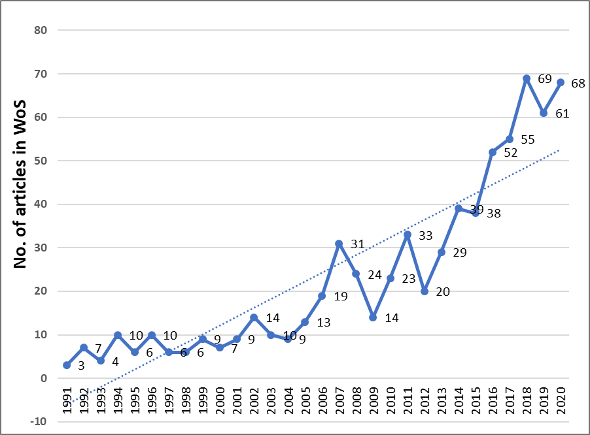
Fig. 1 The number of articles on construction conflict in the WoS core collection in 1991–2020.
2.2 Data Analysis
The bibliographic mapping of construction conflict can be illustrated by various kinds of networks such as co-authors, co-cited documents, co-occurrence of keywords, and so on, which can be built in CiteSpace.
Researchers can obtain highly cited documents through co-citation analysis. These documents are frequently cited in the selected domain, as well as, are the most important references to the research domain. Two co-cited documents are highly likely to have shared a similar concept. Through clusters of statistics, a set of closely related documents can be identified and aggregated into clusters representing the same research area (Chen, 2006). Keyword co-occurrence network is used to detect keywords that appear in at least two different documents within a time period (Chen et al., 2012). These high-frequency keywords and central keywords, as pivotal spots for the corresponding time period, can be considered part of the construction conflict knowledge base(Shi and Liu, 2019). It is also helpful to recognize references with strong citation bursts using CiteSpace. The reference, being frequently cited within a certain time period, will be identified as a strong citation burst as well as a milestone paper in the domain of construction conflict. (Chen, 2016). The nodes of strong bursts signify that these papers have received special attention in the corresponding time period, and they show the frontiers and hot spots of the discipline.
In the graph, there are numerous types of nodes and links, such as institutions, articles, authors, terms, and keywords, and the created nodes are represented differently in various networks. The created links represent co-citation or co-occurrence relationships (Song et al., 2016).

- Results of Scientometric Analysis
3.1 Co-author analysis
Information on article authors is available from the literature record, which makes it possible to identify leading researchers, institutions, and countries in construction conflict research. As a result, a network of co-authors and a network of co-author institutions and countries/regions have been generated.
3.1.1 Co-authorship network
According to the number of published journals, there are 10 most productive authors can be identified. As shown in Table 1, the top three are Sai On Cheung (City University of Hong Kong), Tak Wing Yiu (City University of Hong Kong) and Jiuping Xu (Sichuan University).
A collaborative author network is shown in Fig. 2, where each node represents an author and links between authors represent collaborations established through co-authorship in the article. Network pruning is recommended by Chen and Morris (2003) to remove excessive links through Pathfinder. And then, 654 nodes and 430 links were created in the co-authorship network. The node size represents the number of publications, and the thickness of the links between the nodes indicates the levels of the cooperative relationships in a given year (Zhao, 2017). The colors of links, e.g., blue, green, yellow, orange and red, correspond to different years from 1991 to 2020, as shown in Fig. 3.
In terms of collaboration, there are several closed-loop circuits in Fig. 2, indicating that the researchers of these circuits have established strong collaborative relationships, e.g., the circuit of Edwin H.W. Chan; Henry C.H. Suen; and Charles K.L. Chan. In addition, several research communities were identified, where many authors worked together with one or two highly productive author. Sai On Cheung and Tak Wing Yiu belong to the same research team and have established a strong collaborative relationship; Jiuping Xu was the central author of a research community, consisting of Fenisoky Penamora, Charles Shen, Xiaoling Song etc.

Table 1 The top 10 most productive authors.
Author | Institution | Country | Count | Percentage
Cheung, Sai On | City University of Hong Kong | China | 18 | 2.542%
Yiu, Tak Wing | City University of Hong Kong | China | 14 | 1.977%
Xu, Jiuping | Sichuan University | China | 9 | 1.271%
Skitmore, Martin | Queensland University of Technology | Australia | 8 | 1.130%
El-Rayes, Khaled | University of Illinois System | USA | 7 | 0.989%
Leung, Mei-yung | City University of Hong Kong | China | 6 | 0.847%
Pena-Mora, Feniosky | University of Illinois System | USA | 6 | 0.847%
Lingard, Helen | Royal Melbourne Institute of Technology | Australia | 6 | 0.847%
Akinci, Burcu | Carnegie Mellon University | USA | 5 | 0.706%
Bowen, Paul | University of Cape Town University | South Africa | 5 | 0.706%

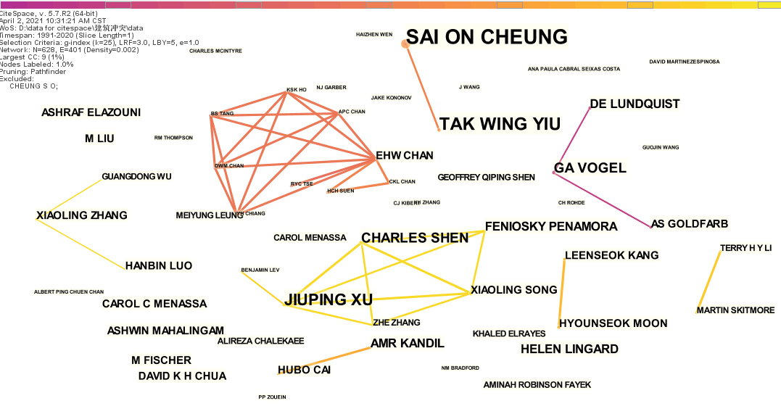
Fig. 2 Co-authorship network.
Fig. 3 Link colors corresponding to years 1991-2020
3.1.2 Network of countries/regions and institutions
A network was created to explore the distribution of articles on construction conflict based on contributions from institutions and countries/regions. This research power network includes 452 nodes and 849 links. The node size indicates the total number of articles published from 1991-2020. As shown in Fig. 4, the USA (203 articles), China (166 articles), Australia (151 articles), Canada (48 articles), England (45 articles) and South Korea (36 articles) have made main contributions to the studies on construction conflict. It can be inferred that these countries are comparatively ahead in the research of construction conflicts. The USA, as a very active country in the construction research, has made the major contribution to studies on construction conflict. Researchers from the United States have collaborated widely with researchers in other regions, including South Korea, Canada, Taiwan and Germany. Researchers from China have also had close collaboration with the colleagues from Australia and England.
The contribution of each institution was also identified, including City University of Hong Kong (35 articles), Hong Kong Polytechnic University (15 articles), Purdue University (15 articles), Stanford University (14 articles), The University of Hong Kong (12 articles), University of Illinois (12 articles) and Sichuan University (11 articles). These institutions play the important role in the research of construction conflict.
In graph theory, Freeman's intermediate centrality is defined as the ratio of the shortest path between two nodes to the sum of all these shortest paths (Freeman, 1977). A node with high intermediateness usually connects two or more large groups of nodes in which the node itself is present and can be detected by the purple ring in CiteSpace. With these nodes, clusters in the network can be separated (Girvan and Newman, 2002), and revolutionary scientific publications can be identified (Chen, 2006). In Fig. 4, nodes with high centeredness are identified and highlighted with purple circles. Countries/regions such as the USA (centrality = 1.60), China (centrality = 0.41), England (centrality = 0.25), Germany (centrality = 0.20), Australia (centrality = 0.19), France (centrality = 0.19), South Korea (centrality = 0.15) as well as the institutions such as Hong Kong Polytechnic University (centrality = 0.05), Purdue University (centrality = 0.04), Stanford University (centrality = 0.04), Sichuan University (centrality = 0.04) and City University of Hong Kong (centrality = 0.02) are major players in research activities between countries/regions. Additionally, the frequency of citations increased significantly in a certain period were found in countries/regions such as Germany (burst strength = 5.13, 2014-2017), the USA (burst strength = 4.33, 1994-1998), and at institutions such as City University of Hong Kong (burst strength = 4.31, 2006-2008) and Tongji University (burst strength = 3.56, 2018-2020). These indicated that the articles from these countries and institutions have attracted a great deal of attention in the respective time periods. In comparison with the number of articles published by countries/regions, the top countries in terms of the number of articles published, such as China, Australia and Canada, did not get a citation burst. It is also worth noting that there were no citation bursts from 2009-2013. This is in line with the fact that the number of articles did not increase significantly during these five years comparative to the previous years. Thus, it can be seen that the research in construction conflict has attracted much attention since 2014.

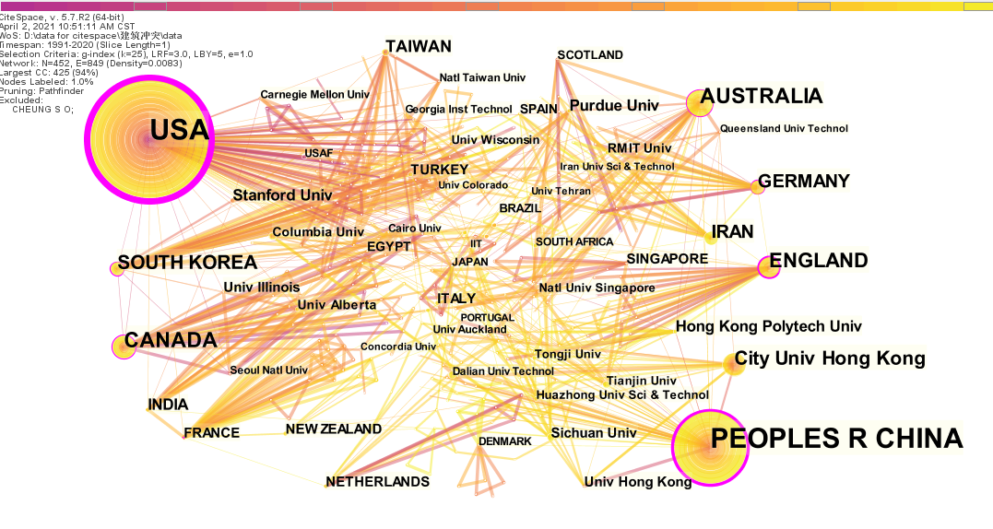
Fig. 4 Network of countries/regions and institutions.

3.2 Co-words analysis
The research on construction conflict has different themes and topics. With the assistance of keyword co-occurrence analysis, the research hotspots and future trends could be identified.
3.2.1 Network of co-occurring subject categories
Each journal publication in the WoS core collection database is assigned one or more topic categories. A network of co-occurring subject categories in construction conflict is then generated which includes 87 nodes and 414 links and is used to analyze emerging trends, as shown in Fig. 5. The node size indicates the number of articles within each category. Engineering (662 articles), civil engineering (467 articles), construction & building technology (260 articles), industrial engineering (240 articles), environmental engineering (91 articles) and environmental science & ecology (79 articles) were found to have the most abundant publication records.
In the past five years, there have been an increasing number of articles in the subject categories of environmental science & ecology, management, computer science, business & economics and environmental engineering. It implies that research methods and technology applications for construction conflicts are becoming more diverse. If looking closely into the specific articles, it can be seen that some keywords like BIM, model, algorithm, simulation are emerging which suggests the adoption of information technologies and model simulation is becoming the popular topics. It seems that researchers have gradually embarking on some new research fields with the mathematical and technological approaches of conflict resolution and management.
Several nodes have high intermediate centrality, as shown by the purple ring, which include the categories of multidisciplinary engineering (centrality = 0.61), civil engineering (centrality = 0.35), industrial engineering (centrality = 0.30), engineering (centrality = 0.29), construction & building technology (centrality = 0.16) and computer science & interdisciplinary (centrality = 0.14). It means that these categories have the significant impact on the development of construction conflict research. In addition, citation bursts were found in three subject categories: education & scientific disciplines (burst strength = 5.62, 2004-2008), green & sustainable science & technology (burst strength = 7.24, 2016-2020) and science & technology-other topics (burst strength = 6.53, 2018-2020). This suggests that these areas of research are more active in the respective time periods.

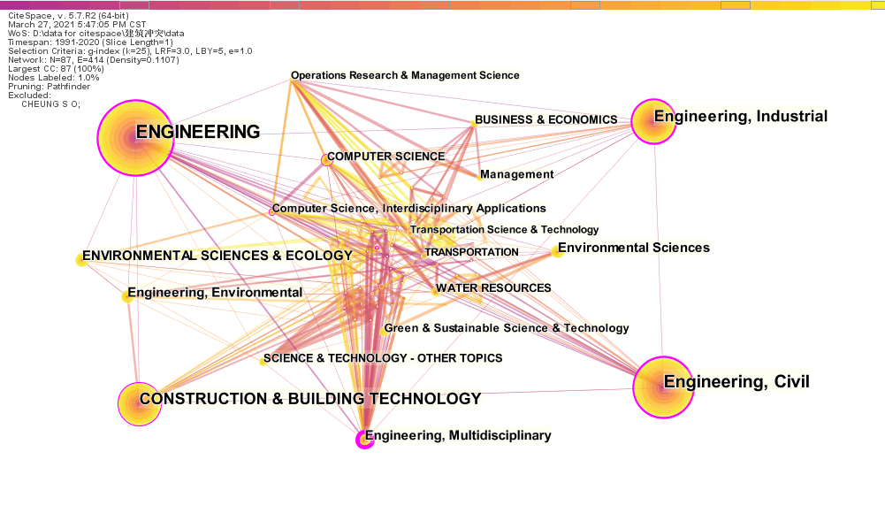
Fig. 5 Network of co-occurring WoS subject categories

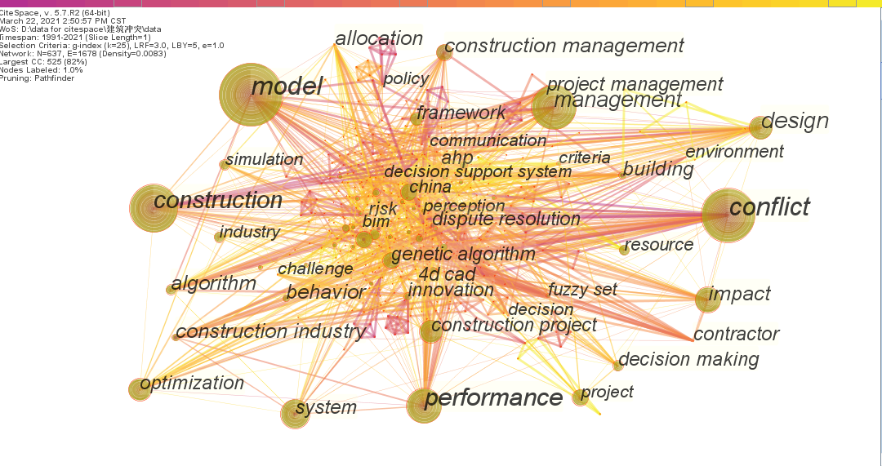
Fig. 6 Network of co-occurring keywords

3.2.2 Network of co-occurring keywords
The keywords present the core content of the article and show the development of the research topic over the time. In the WoS database, there are two types of keywords: (i) "author keywords", provided by authors; and (ii) "keywords plus", identified by journals. These two types of keywords extracted from 698 literature records were used to construct a co-occurring keyword network. Fig. 6 shows the network of co-occurring keywords, with 619 nodes and 1635 links.
The node size represents the frequency with which a keyword occurred in the dataset. The top 10 high-frequency keywords were “model” (frequency = 111), “construction” (frequency = 91), “management” (frequency = 80), “conflict” (frequency = 79), “performance” (frequency = 57), “system” (frequency = 54), “design” (frequency = 41), “impact” (frequency = 41), “optimization” (frequency = 39) and “genetic algorithm” (frequency = 29). These words are considered to be buzz words in this field of study. In addition, some keywords received relatively high betweenness centrality, such as “model” (centrality = 0.35), “conflict” (centrality = 0.24), “construction” (centrality = 0.15), “management” (centrality = 0.14) and “performance” (centrality = 0.14). They share a great proposition in construction conflict research and have a profound influence on the subject evolvement of construction conflict research. Six keywords were found to be citation bursts: “construction management” (burst strength = 6.8, 2010-2016), “conflict” (burst strength = 4.88, 2006-2009), “construction industry” (burst strength = 4.3,2003-2006), “sustainability” (burst strength = 4.27, 2018-2020), “dispute resolution” (burst strength = 3.69, 2003-2006) and “construction project” (burst strength = 3.45, 2014-2018), indicating how the research hot topics have evolved in the respective time.
3.3 Co-citation analysis
Co-citation is defined as the frequency with which two documents are cited together by other documents and is recognized as a proximity measure for documents (Small, 1973). In this study, co-citation analysis consists of journal co-citation analysis, author co-citation analysis and document co-citation analysis.
3.3.1 Journal co-citation network
As shown in Table 2, the ten major source journals for construction conflict research were identified based on statistics from the WoS core collection database. Journal of Construction Engineering and Management have published 120 articles (16.949%) in this field and occupied the top position, followed by Journal of Management in Engineering (49 articles) and Automation in Construction (48 articles). Five of the ten journals are published in the USA and two of them are published in the UK.
The references cited by the 698 retrieved records were analyzed, and then a journal co-citation network with 850 nodes and 3160 links was produced to detect the most significant cited journals, as indicated in Fig. 7. The node size indicates the co-citation frequency of each source journal. In terms of co-citation frequency, the top five most influential journals were Journal of Construction Engineering and Management (frequency = 488), Automation in Construction (frequency = 152), Journal of Management in Engineering (frequency = 147), Construction Management and Economics (frequency = 131) and International Journal of Project Management (frequency = 126). It can be found that the first three journals are also the most dominant source journals as shown in Table 2, which indicates that decent journals have contributed the most citations and high-quality articles.
The centrality of the cited journals is not highlighted by the purple ring as seen in Fig. 7, which is a result of the low centrality of all these journals. Some journals have achieved relatively high centrality, such as Journal of Construction Engineering and Management ASCE (centrality = 0.12), Journal of Computing in Civil Engineering (centrality = 0.11) and International Journal of Project Management (centrality = 0.11). These journals represent major intellectual turning points and linked journals in different phases. Furthermore, a total of 38 citation bursts were found. Sustainability-Basei (burst strength = 10.92, 2018-2020), Construction Management and Economics (burst strength = 10.15, 2003-2009), Journal of Construction Engineering and Management ASCE (burst strength = 7.78, 1999-2011), Academy of Management Journal (burst strength = 7.33, 2004-2014), Journal of Management in Engineering (burst strength = 4.74, 2010-2011). These findings indicate that articles published in these journals are highly cited in a short period of time and are therefore of great significance.

Table 2 The top 10 source journals for construction conflict research in 1991–2020
Source journal | Host country | Count | Percentage
Journal of Construction Engineering and Management | USA | 120 | 16.949%
Journal of Management in Engineering | USA | 49 | 6.921%
Automation in Construction | Netherlands | 48 | 6.780%
Journal of Cleaner Production | USA | 42 | 5.932%
Engineering Construction and Architectural Management | UK | 33 | 4.661%
Journal of Computing in Civil Engineering | USA | 21 | 2.966%
Building Research and Information | UK | 17 | 2.401%
Transportation Research Record | USA | 17 | 2.401%
Journal of Civil Engineering and Management | Lithuania | 15 | 2.119%
Canadian Journal of Civil Engineering | Canada | 14 | 1.977%

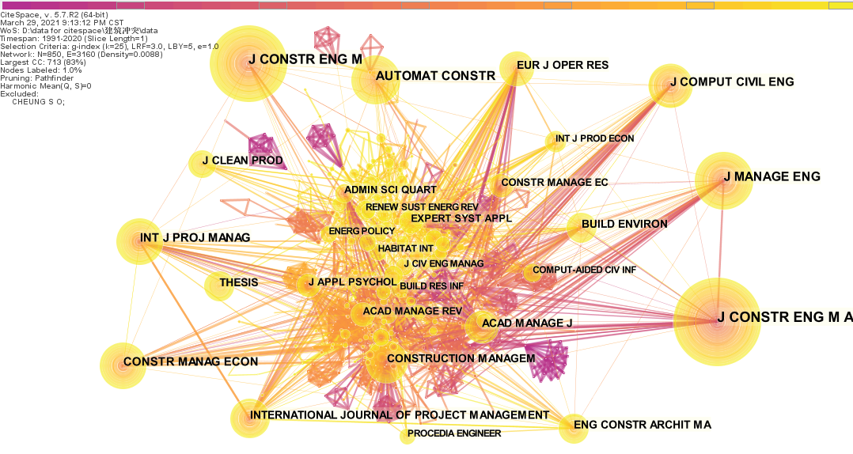
Fig. 7 Journal co-citation network

3.3.2 Author co-citation network
Author co-citation analysis can identify the relationships among authors, whose publications are cited in the same articles and analyze the evolution of research communities. Fig. 8 presents the author co-citation network, containing 940 nodes and 2911 links. The node size reflects the amounts of co-citations per author, and links between authors represent indirect collaboration based on the frequency of co-citations. The authors with the highest citation frequency were Sai On Cheung (frequency = 46, China), Burcu Akinci (frequency = 33, USA), Thomas L. Saaty (frequency = 30, USA), Mei-yung Leung (frequency = 26, China), Kalyanmoy Deb (frequency = 25, USA), David Arditi (frequency = 23, USA), Shaojun Guo (frequency = 21, China) and Albert P. C. Chan (frequency =21, China). The most frequently cited authors are mainly from China and the USA, which indicates that these two countries contribute significantly to the research in this field. Based on the betweenness centrality metric, the top five authors in terms of centrality were Sai On Cheung (centrality = 0.20), Albert P.C. Chan (centrality = 0.13), David Arditi (centrality = 0.12), Mei-yung Leung (centrality = 0.08) and Burcu Akinci (centrality = 0.06). They are the main intellectual drivers of construction conflict research and connected research in different research communities. It is notable that some authors have both high citation frequency and high centrality, such as Sai On Cheung, Mei-yung Leung and David Arditi. This phenomenon reflects that these authors’ works may have a fundamental impact and make genuine and noticeable contribution to research of construction conflict.
In addition, eighteen authors were found to be citation bursts and some of them obtained a high burst strength: Khaled El-Rayes (burst strength = 4.96, 2014-2018), Terry H.Y. Li (burst strength = 4.9, 2016-2020), David Arditi (burst strength =4.88, 2016-2018), Charles M. Eastman (burst strength =4.26, 2016-2020), Yongqiang Chen (burst strength =4.1, 2017-2020), C.M. Tam (burst strength =4.02, 2016-2018), Emad Elbeltagi (burst strength =4.00, 2014-2018), Nashwan Dawood (burst strength =3.99, 2011-2015), Albert P.C. Chan (burst strength =3.98, 2016-2020), WY Thabet (burst strength =3.9, 2011-2014) and M Latham (burst strength =3.85,2000-2008). They tend to influence the direction of construction conflict research and their articles deserve to be watched. Although Albert P.C. Chan was not among the most productive authors, he received a high co-citation frequency, high betweenness centrality and was among the citation bursts. According to the citation analysis report of the records in the WoS core database, one of his papers (Chan et al., 2004) had received a total of 231 citations till the end of 2020, which is the most frequently cited article.

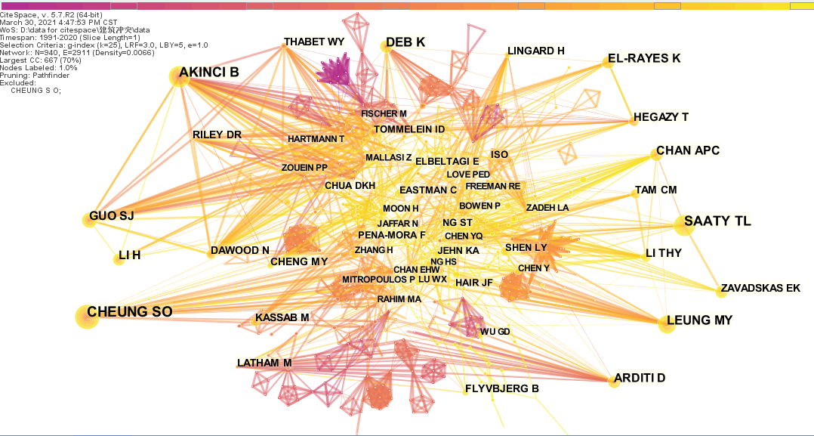
Fig. 8 Author co-citation network

3.3.3 Document co-citation network
Document co-citation analysis can analyze the underlying intellectual structure of a knowledge area and demonstrate the amount and authority of publications cited. In this process, co-citation clusters were identified. Cluster analysis is later used to detect and analyze emergent and abrupt changes in research trends over time and to identify the focus of research trends at a given time in the context of their intellectual basis. Clusters are arranged to reveal important intellectual turning points that deice research trends and the interconnections between different research trends (Zhao, 2017). According to the WoS citation metric, the top 25 cited documents are summarized in Table 3. As shown in Table 3, Chan et al. (2004) (231 citations), Koo and Fischer (2000) (223 citations) and Zhou and Zhong (2007) (182 citations) occupied the top three positions. Chan et al. (2004) aimed to explore critical success factors for partnering in construction projects, using factor analysis and multiple regression method. Koo and Fischer (2000) conclude that 4D model is a useful alternative to project scheduling tools like CPM networks and bar charts. A case study was used to demonstrate that 4D models are effective in evaluating the executability of a construction schedule and highlighted the need for improvements to 4D tools. It is evidently seen that BIM-4D should be considered as an important conflict management tool. In other studies, algorithm is used to resolve resource schedule conflicts. Zhou and Zhong (2007) proposed a generalized resource-constrained project scheduling formulation and presented a branch-and-bound solution procedure to obtain feasible schedules with guaranteed optimality.
Fig. 9 shows a document co-citation and co-citation cluster network with 840 nodes and 1738 links. Each node represents a document and is marked with the first author's name and year of publication. Each link represents a co-citation relationship between two related documents. The node size represents the co-cited frequency of the node document. It should be noted that the node documents were among the 24,055 documents referenced in the 698 records retrieved and not necessarily included in the 698 articles retrieved. Chen et al. (2014) (frequency = 8), Min et al. (2018) (frequency = 6), Zhang et al. (2013) (frequency = 6) occupied the top three positions, followed by Guo (2002) (frequency = 5), Cheung et al. (2006) (frequency = 5).
A total of 5 significant co-citation clusters were identified based on the keywords of the documents cited in each cluster, by the log-likelihood ratio (LLR) algorithm. In Table 4, the alternative label with the second and third highest LLR scores are also shown, and the clusters are sorted by size, i.e., the number of members. Cluster #0 “stakeholder conflict”, which has 42 members, was the largest one, while cluster #9 “public participation” was the smallest one, which has only 13 members.
The silhouette metric measures the average homogeneity of a cluster. For clusters of similar size, higher silhouette scores indicate that the cluster members are more consistent. The silhouette scores of these clusters range from 0.953 to 1.000, which indicates that the members of each cluster are sufficiently consistent. The average year of publication of a cluster, i.e., the mean year of publication, implies whether it is composed of the most recent literature or of older literature. Thus, cluster #3 and cluster #9 are composed of documents that are older than the other clusters. The representative documents of each cluster are the documents with the highest number of co-citations within the same cluster. These representative documents influence the labels of the clusters and are worth noting.
Cluster #0 “stakeholder conflict” has 42 members, and the representative document was Xue et al. (2020). This study establishes a network-based framework to analyze the dynamic pattern of stakeholder conflicts and proposes a stakeholder conflict map to provide management strategies, with a 16-year case study of the Hong Kong-Zhuhai-Macao Bridge project. Cluster #1 was labeled with “workspace requirement” which had 26 members, the representative document was Zhang et al. (2015), new methods have been developed to support project stakeholders with the identification and visualization of the required or potentially congested workspaces. Cluster #3 “worker safety behavior” has 20 members. The representative document was published by Wang et al. (2018), who examined the predictive powers of safety-related stress and psychological capital (PsyCap) on safety behavior, and the moderating role of PsyCap on the safety-related stress behavior relationship. Cluster #4 has 20 members and is labeled with “temporary facilities”. The representative document was Song et al. (2018). This study is among the first to plan appropriate construction temporary facilities (CTFs) layouts by taking bi-stakeholder conflict resolution into account. Cluster #9 “public participation” has 13members, the representative document was published by Li et al. (2016), who aimed to examine the perceptual differences between paired stakeholder groups from mainland China mega-cities and Hong Kong in rating their concerns over major infrastructure and construction (MIC) projects.

Table 3 The top 25 cited articles and an article with high betweenness centrality.
No. | Total citations | Article | No. | Total citations | Article | No. | Total citations | Article
1 | 231 | Chan et al. (2004) | 10 | 105 | Cheng et al. (2000) | 19 | 89 | Akinci et al. (2002b)
2 | 223 | Koo and Fischer (2000) | 11 | 104 | Carey and Crawford (2007) | 20 | 87 | Chan and Tse (2003)
3 | 182 | Zhou and Zhong (2007) | 12 | 103 | Eskandari et al. (2012) | 21 | 85 | Mahalingam and Levitt (2007)
4 | 170 | Ebrahimnejad et al. (2012) | 13 | 101 | Wang et al. (2007) | 22 | 78 | Rahman and Kumaraswamy (2004)
5 | 139 | Dossick and Neff (2010) | 14 | 99 | Brilakis et al. (2011) | 23 | 73 | Hu and Zhang (2011)
6 | 137 | Cheng et al. (2003) | 15 | 96 | Iyer and Jha (2006) | 24 | 73 | Juan et al. (2009)
7 | 121 | Chen and Luo (2014) | 16 | 96 | Akinci et al. (2002c) | 25 | 73 | Zhang et al. (1999)
8 | 119 | Sahin (1999) | 17 | 94 | Zouein and Tommelein (1999)
9 | 118 | Zhang and Hu (2011) | 18 | 93 | Li et al. (2013)

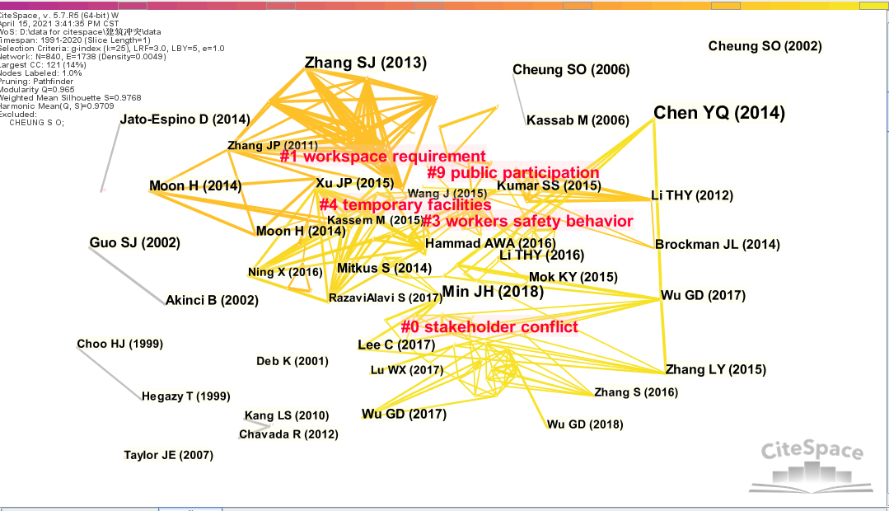
Fig. 9 Document co-citation network

Table 4 Co-citation clusters of construction conflict research 1991–2020.
Cluster ID | Size | Silhouette | Cluster label (LLR) | Alternative label | Mean year | Representative document
#0 | 42 | 0.968 | Stakeholder conflict | Team diversity; construction workspace management | 2016 | Xue et al. (2020)
#1 | 26 | 0.996 | Workspace requirement | Industry foundation; class-compliant 4d tool | 2013 | Zhang et al. (2015)
#3 | 20 | 0.953 | Workers’ safety behavior | Lankan commercial building sector; management style | 2014 | Wang et al. (2018)
#4 | 20 | 0.984 | Temporary facilities | Resolution-motivated strategy; material logistics | 2016 | Song et al. (2018)
#9 | 13 | 0.993 | Public participation | Modeling multi-stakeholder; decision rule approach | 2013 | Li et al. (2016)

- Conclusion
It is an acknowledged fact that construction conflicts are inevitable. The success of a building project is concerned with managers identifying and responding to various forms of conflict. During the past few decades, quite a few research efforts have been made, aiming to analyze why and how the conflict happens, and what effects and solutions the industry would be encountered. However, there is still not a thorough and systematic review against the previous studies. So, this study provides a scientometric review to fulfill the requirement and bridge the research gap. A total of 698 bibliographic records were collected from the WoS core collection database. Co-author analysis, co-word analysis, and co-citation analysis were conducted by using CiteSpace to identify and visualize the current state and trends of construction conflict research.
For the contribution and influence of the principal researchers identified in the co-authorship and author co-citation analysis, Sai On Cheung, Tak Wing Yiu and Jiuping Xu were the top three most productive authors in this field, while Sai On Cheung, Burcu Akinci, Thomas L. Saaty obtained the top three most co-citations. Apparently, Sai On Cheung can be regarded as a major research and has a sound contribution in this field of research. In addition, when comparing the most productive authors to the most co-citation authors, it was found that not all highly productive researchers receive the same high level of influence in construction conflict research. Some researchers who have no many publications (e.g. Albert P.C. Chan) can still receive a large number of co-citations and citation bursts which implies that his work was widely accepted by other researchers. The distribution of journal articles on construction conflict is mostly from the United States, China and Australia. In addition, City University of Hong Kong, Hong Kong Polytechnic University, Purdue University and Stanford University are the most productive institutions in the field of construction conflict. These countries and institutions also link research activities by each other.
Regarding the subject categories of construction conflict research, engineering, civil engineering, construction & building technology and industrial engineering were found to have the most abundant publication records. However, environmental science & ecology, management, computer science, business & economics and environmental engineering were the emerging categories of focus in the recent years. As for the keywords, “model”, “construction”, “management”, “conflict” had the most frequency, while “sustainability”, “construction project” received the citation bursts in more recent years. “optimization”, “genetic algorithm”, “BIM”, “4d cad” have gradually increased in frequency in recent five years.
Several core journals have published the most significant findings in construction conflict research, such as Journal of Construction Engineering and Management, Journal of Management in Engineering and Automation in Construction. These journals also have high co-citation and citation frequency, indicating their strong and sustained influence on construction conflict research. Most of the top 25 highly cited articles according to WoS citation metrics were published in these journals.
According to the document co-citation analysis results, Chen et al. (2014), Min et al. (2018) and Zhang et al. (2013) obtained the most co-citations. In addition, 5 co-citation clusters were identified based on the keywords related to the analyzed documents. Thus, some hot topics of construction conflict research can be summarized: stakeholder conflict, construction workspace management, class-compliant 4d tool, resolution-motivated strategy, project performance, material logistics and mega construction project success.
Several research trends are hence highlighted according to the scientometric analyses of the construction conflict topics. These include (1) conflict research around project stakeholders and project performance; (2) the application of BIM-4D and 5D technologies as well as mathematical theories and algorithms to the study of construction conflict management systems; and (3) conflict research on mega-complex projects. It suggests a direction of concentration for research on construction conflict.
The unique value of this study is to build a knowledge base for the domain of construction conflict based on keywords, clusters, and citation bursts adopting the sientometric approach. This study provides useful information for researchers and practitioners in the field of construction conflict research. It identifies the key scholars and institutions in construction conflict research, the current state of the research field, hot topics, and primary trends. In addition, for practitioners, this study provides reliable information regarding the past, evolvement, and thefuture trend research in construction conflict. Therefore, the findings will enable practitioners to benefit from the research findings of core studies or core institutions, to facilitate their attempts to follow proper procedures, and to select appropriate consulting agencies for their practices. The data can be updated regularly for construction conflict studies in the future, thus further improving the construction conflict knowledge base. The scientometrics methodology can also be used to visualize research trends in other topics.

AKINCI, B., FISCHEN, M. & LEVITT, R. 2002a. Formalization and Automation of Time-Space Conflict Analysis. JOURNAL OF COMPUTING IN CIVIL ENGINEERING, 16, 124-134.
AKINCI, B., FISCHEN, M. & LEVITT, R. 2002b. Formalization and automation of time-space conflict analysis‎. JOURNAL OF COMPUTING IN CIVIL ENGINEERING, 16, 124-134.
AKINCI, B., FISCHER, M. & KUNZ 2002c. Automated generation of work spaces required by construction activities‎. JOURNAL OF CONSTRUCTION ENGINEERING AND MANAGEMENT-ASCE, 128, 306-315.
BAI, L., WANG, Z., WANG, H., HUANG, N. & SHI, H. 2020. Prediction of multiproject resource conflict risk via an artificial neural network. Engineering, Construction and Architectural Management, Ahead of press.
BASTIAN, M., HEYMANN, S. & JACOMY, M. 2009. Gephi: an open source software for exploring and manipulating networks. International AAAI Conference on Weblogs and Social Media. San Jose, CA.
BENNETT, E. & NEILAND, A. 2001. Towards a better understanding of conflict management in tropical fisheries: evidence from Ghana, Bangladesh and the Caribbean. Marine Policy, 25, 365-376.
BRILAKIS, I., PARK, M.-W. & JOG, G. 2011. Automated vision tracking of project related entities‎. ADVANCED ENGINEERING INFORMATICS, 25, 713-724.
BROCKMAN, J. L. 2014. Interpersonal Conflict in Construction: Cost, Cause, and Consequence. Journal of Construction Engineering and Management, 140, 1-12.
CAREY, M. & CRAWFORD, I. 2007. Scheduling trains on a network of busy complex stations‎. TRANSPORTATION RESEARCH PART B-METHODOLOGICAL 41, 159-178.
CHAN, A. P. C., CHAN, D. W. M. & CHIANG, Y. H. 2004. Exploring critical success factors for partnering in construction projects. Journal of Construction Engineering and Management, 130, 188-198.
CHAN, E. H. W. & TSE, R. Y. C. 2003. Cultural considerations in international construction contracts‎. JOURNAL OF CONSTRUCTION ENGINEERING AND MANAGEMENT-ASCE 129, 375-381.
CHAREHZEHI, A., CHAI, C. & YUSOF, A. M. 2017. Building information modeling in construction conflict management. International Journal of Engineering Business Management 9, 1-18.
CHEN, C. 2006. CiteSpace II: Detecting and visualizing emerging trends and transient patterns in scientific literature. Journal of the American Society for Information Science and Technology 57, 359-377.
CHEN, C. 2016. CiteSpace: A Practical Guide for Mapping Scientific Literature, Nova Science Publishers.
CHEN, C., HU, Z. & LIU, S. 2012. Emerging trends in regenerative medicine: a scientometric analysis in CiteSpace. Expert Opinion on Biological Therapy, 12, 593-608.
CHEN, C. & MORRIS, S. 2003. Visualizing evolving networks: Minimum spanning trees versus pathfinder networks. Symposium on Information Visualization. TaiPei.
CHEN, L. & LUO, H. 2014. A BIM-based construction quality management model and its applications‎. AUTOMATION IN CONSTRUCTION, 46.
CHEN, Y., ZHANG, Y. & ZHANG, S. 2014. Impacts of Different Types of Owner-Contractor Conflict on Cost Performance in Construction Projects. . Journal of Construction Engineering and Management, 140, 1-8.
CHENG, E. W. L., LI, H. & LOVE, P. E. D. 2000. Establishment of critical success factors for construction partnering‎. JOURNAL OF MANAGEMENT IN ENGINEERING, 16, 84-92.
CHENG, S., CHAN, C. W. & HUANG, G. H. 2003. An integrated multi-criteria decision analysis and inexact mixed integer linear programming approach for solid waste management‎. ENGINEERING APPLICATIONS OF ARTIFICIAL INTELLIGENCE, 16, 543-554.
CHEUNG, S. O., YIU, T. W. & YEUNG, S. F. 2006. A study of styles and outcomes in construction dispute negotiation. Journal of Construction Engineering and Management 132, 805-814.
COSIER, A. R., DALTON, D. R. & TAYLOR, L. A. 1991. The positive effects of cognitive conflict and employee voice. Employee Responsibilities and Rights Journa, 4, 7-11.
DARKO, A., CHAN, A., HUO, X. & OWUSU-MANU, D. G. 2019. A scientometric analysis and visualization of global green building research. Building & Environment, 149, 501-511.
DEUTSCH, M. 1969. Conflict: Productive and destructive. Journal of Social Issues 25, 7-42.
DEUTSCH, M. 1973. The Resolution of Conflict: Constructive and Destructive Processes, New Haven, US Yale University Press.
DOSSICK, C. S. & NEFF, G. 2010. Organizational Divisions in BIM-Enabled Commercial Construction‎. JOURNAL OF CONSTRUCTION ENGINEERING AND MANAGEMENT-ASCE 136, 459-467.
EBRAHIMNEJAD, S., MOUSAVI, S. M. & TAVAKKOLI-MOGHADDAM, R. 2012. A novel two-phase group decision making approach for construction project selection in a fuzzy environment‎. APPLIED MATHEMATICAL MODELLING, 36, 4197-4217.
ESKANDARI, M., HOMAEE, M. & MAHMODI, S. 2012. An integrated multi criteria approach for landfill siting in a conflicting environmental, economical and socio-cultural area‎. WASTE MANAGEMENT 32, 1528-1538.
FREEMAN, L. C. 1977. L.C. Freeman, A set of measures of centrality based on betweenness. Sociometry 40, 35-41.
GIRVAN, M. & NEWMAN, M. E. 2002. Community structure in social and biological networks. Proc. Natl. Acad. Sci. , 99, 7821-7826.
GUO, S. 2002. Identification and resolution of work space conflicts in building construction. JOURNAL OF CONSTRUCTION ENGINEERING AND MANAGEMENT-ASCE 128, 287-295.
HAMMERSLEY, M. 2001. On ‘systematic’ reviews of research literatures: A ‘narrative’response to Evans & Benefield.” Br. Educ. Res, 27, 543-554.
HELLARD, R. B. 1988. Managing Construction Conflict, London, Longman Group UK Ltd,.
HESS, D. J. 1997. Science Studies: An Advanced Introduction, New York, New York University Press.
HU, Z. & ZHANG, J. 2011. BIM- and 4D-based integrated solution of analysis and management for conflicts and structural safety problems during construction: 2. Development and site trials. Automation in Construction, 167-180.
IYER, K. C. & JHA, K. N. 2006. Critical factors affecting schedule performance: Evidence from Indian construction projects‎. JOURNAL OF CONSTRUCTION ENGINEERING AND MANAGEMENT 132, 871-881.
JEHN, K. A. 1995. A Multimethod Examination of the Benefits and Detriments of Intragroup Conflict. Administrative Science Quarterly, 40, 256-282.
JIN, R., ZUO, J. & HONG, J. 2019a. Scientometric Review of Articles Published in ASCE’s Journal of Construction Engineering and Management from 2000 to 2018. Journal of Construction Engineering and Management, 145, 06019001:1-8.
JIN, R., ZUO, Y. & KASSIM, G. 2019b. Scientometric analysis of BIM-based research in construction engineering and management Engineering, Construction and Architectural Management 26, 1750-1776.
JUAN, Y.-K., KIM, J. H. & ROPER, K. 2009. GA-based decision support system for housing condition assessment and refurbishment strategies‎. AUTOMATION IN CONSTRUCTION, 18, 394-401.
KILMANN, R. H. & THOMAS, K. W. 1977. Developing a forced-choice measure of conflict-handling behavior: The ‘Mode’ instrument. Educational and Psychological Measurement, 37, 309-325.
KIM, K., WALEWSKI, J. & CHO, Y. K. 2016. Multiobjective Construction Schedule Optimization Using Modified Niched Pareto Genetic Algorithm. JOURNAL OF MANAGEMENT IN ENGINEERING, 32.
KOLB, D. M. & PUTNAM, L. L. 1992. The multiple faces of conflict in organizations. . Journal of Organizational Behavior, 13, 311-324.
KOO, B. & FISCHER, M. 2000. Feasibility study of 4D CAD in commercial construction. JOURNAL OF CONSTRUCTION ENGINEERING AND MANAGEMENT-ASCE 126, 251-260.
KOO, B., KIM, J. & KIM, J. I. 2013. An Empirical Study of MEP Workspace Modeling Approaches for 4d Model-based Time-space Conflict Analyses: Case Study on the International Linear Collider Project Ksce Journal of Civil Engineering, 17, 627-637.
LEUNG, M.-Y., LIU, A. M. M. & NG, S. T. 2005. Is there a relationship between construction conflicts and participants' satisfaction? Engineering, Construction and Architectural Management, 12, 149-167.
LI, T. H. Y., NG, S. T. & SKITMORE, M. 2013. Evaluating stakeholder satisfaction during public participation in major infrastructure and construction projects: A fuzzy approach‎. AUTOMATION IN CONSTRUCTION, 29.
LI, T. H. Y., NG, S. T. T. & SKITMORE, M. 2016. Investigating stakeholder concerns during public participation. PROCEEDINGS OF THE INSTITUTION OF CIVIL ENGINEERS-MUNICIPAL ENGINEER, 169, 199-219.
LI, Y., S, H. & X, R. 2015. Research on the Conflict Management of Stakeholders in a Construction Project. ICCREM, ASCE. Stockholm, Sweden.
MA, H., ZHANG, H. & CHANG, P. 2020. 4D-Based Workspace Conflict Detection in Prefabricated Building Constructions. Journal of Construction Engineering Management, 146, 04020112.
MAHALINGAM, A. & LEVITT, R. E. 2007. Institutional theory as a framework for analyzing conflicts on global projects‎. JOURNAL OF CONSTRUCTION ENGINEERING AND MANAGEMENT 133, 517-528.
MCMANAMY, R. 1994. Indusrty pounds away at disputes. Engineering news record, 24,3. . Engineering news record, 24, 3.
MIN, J., JANG, W. & HAN, S. 2018. How Conflict Occurs and What Causes Conflict: Conflict Analysis Framework for Public Infrastructure Projects. Journal of Management in Engineering, 34.
NARH, O. C., OWUSU, E. E., ODURO-APEATU, K. & TETTEY-WAYO, N. 2015. An exploratory study of professional conflicts and disputes within the construction industry. International Journal of Managerial Studies and Research, 3, 44-65.
PINKLEY, R. L. & NORTHCRAFT, G. B. 1994. Conflict frames of reference: implications for dispute processes and outcomes. Academy of Management Journal,, 37, 193-205.
POURIS, A. 2011. Scientometrics of a pandemic: HIV/AIDS research in South Africa and the world. Scientometrics 86, 541-552.
RAHMAN, M. M. & KUMARASWAMY, M. M. 2004. Contracting relationship trends and transitions‎. JOURNAL OF MANAGEMENT IN ENGINEERING, 20, 147-161.
SAHIN, I. 1999. Railway traffic control and train scheduling based on inter-train conflict management‎. TRANSPORTATION RESEARCH PART B-METHODOLOGICAL 33, 511-534.
SAMPAIO, A. Z., SIMOES, D. G. & BERFEJA, E. P. 2016. BIM Tools Used in Maintenance of Buildings and on Conflict Detection, Springer; Singapore, Sustainable Construction. Building Pathology and Rehabilitation,.
SCHNEIDER, J. W. 2004. Mapping scientific frontiers: The quest for knowledge visualization. Journal of the American Society for Information Science and Technology, 55, 363-365.
SHI, Y. & LIU, X. 2019. Research on the Literature of Green Building Based on the Web of Science: A Scientometric Analysis in CiteSpace (2002-2018). Sustainability, 11, 1-22.
SMALL, H. 1973. Co-citation in the scientific literature: a new measure of the relationship between two documents Journal of the Association for Information Science and Technology, 24, 265-269.
SONG, J., ZHANG, H. & DONG, W. 2016. A review of emerging trends in global PPP research: analysis and visualization. Scientometrics 107, 1111-1147.
SONG, X., ZHANG, Z. & XU, J. 2018. Bi-stakeholder Conflict Resolution-Based Layout of Construction Temporary Facilities in Large-Scale Construction Projects. INTERNATIONAL JOURNAL OF CIVIL ENGINEERING 16, 941-964.
THAMHAIN, H. J. & WILEMON, D. L. 1975. Conflict management in project life-cycle. Sloan Management Review, 16, 31-49.
VAN ECK, N. J. & WALTMAN, L. 2010. Software survey: VOSviewer, a computer program for bibliometric mapping. Scientometrics, 84, 523-538.
VAUX, J. S. & KIRK, W. M. 2018. Relationship Conflict in Construction Management:Performance and Productivity Problem. Journal of Construction Engineering and Management 144, 1-11.
WANG, D., WANG, X. & XIA, N. 2018. How safety-related stress affects workers' safety behavior: The moderating role of psychological capital. SAFETY SCIENCE 103, 247-259.
WANG, L.-C., LIN, Y.-C. & LIN, P. H. 2007. Dynamic mobile RFID-based supply chain control and management system in construction‎. ADVANCED ENGINEERING INFORMATICS, 21, 377-390.
WILLIAMSON, O. 1979. Transaction Cost Economics: The Governance of Contractual Relations. The Journal of Law and Economics, 22, 233-261.
XUE, J., SHEN, G. Q. & YANG, R. J. 2020. Dynamic Network Analysis of Stakeholder Conflicts in Megaprojects: Sixteen-Year Case of Hong Kong-Zhuhai-Macao Bridge. JOURNAL OF CONSTRUCTION ENGINEERING AND MANAGEMENT 146.
ZHANG, J. P. & HU, Z. Z. 2011. BIM- and 4D-based integrated solution of analysis and management for conflicts and structural safety problems during construction: 1. Principles and methodologies. Automation in Construction, 155-176.
ZHANG, L. & HUO, X. 2015. The Impact of Interpersonal Conflict on Construction Project Performance: A Moderated Mediation Study from China. International Journal of Conflict Management, 26, 479-498.
ZHANG, P., HARRIS, F. & OLOMOLAIYE, P. 1999. Location optimization for a group of tower cranes‎. JOURNAL OF CONSTRUCTION ENGINEERING AND MANAGEMENT-ASCE, 125, 115-122.
ZHANG, S., TEIZER, J. & LEE, J.-K. 2013. Building Information Modeling (BIM) and Safety: Automatic Safety Checking of Construction Models and Schedules. AUTOMATION IN CONSTRUCTION 29, 183-195.
ZHANG, S., TEIZER, J. & PRADHANANGA, N. 2015. Workforce location tracking to model, visualize and analyze workspace requirements in building information models for construction safety planning. AUTOMATION IN CONSTRUCTION, 60, 74-86.
ZHAO, X. 2017. A scientometric review of global BIM research: Analysis and visualization. Automation in Construction, 80, 34-47.
ZHENG, X., LE, Y., CHAN, A. P. C., HU, Y. & LI, Y. 2016. Review of the application of social network analysis (SNA) in construction project management research. International Journal of Project Management, 34, 1214-1225.
ZHOU, X. & ZHONG, M. 2007. Single-track train timetabling with guaranteed optimality: Branch-and-bound algorithms with enhanced lower bounds. TRANSPORTATION RESEARCH PART B-METHODOLOGICAL, 41, 320-341.
ZOUEIN, P. & TOMMELEIN, I. 1999. Dynamic layout planning using a hybrid incremental solution method‎ JOURNAL OF CONSTRUCTION ENGINEERING AND MANAGEMENT-ASCE, 125, 400-408.
ZUO, J. & ZHAO, Z. Y. 2014. Green building research–current status and future agenda: A review. Renewable & Sustainable Energy Reviews, 30, 271-281.

