**POST OCCUPANCY PERCEPTION OF ACOUSTICS, VENTILATION AND OVERHEATING WITHIN RESIDENTIAL DWELLINGS**

K Coleman Hodkinson Consultancy, London, United Kingdom

S Dance London South Bank University, London, United Kingdom

## 

## **1 INTRODUCTION**

There is an inter-relationship between acoustics, ventilation and overheating, therefore it is important to consider them together when designing a building. However, it is common for buildings to be designed with conflicting strategies on acoustics, ventilation and overheating. There is also a lack of understanding on residents’ perceptions on each issue which raises the questions ‘would residents be satisfied with their living conditions if the building met all the criteria set out for acoustics, ventilation and overheating?’ and, therefore, are the levels set appropriately.

Research was carried out on two residential buildings to monitor the noise and temperature levels. Questionnaires were also provided to residents to try and gauge their perceptions of the building’s acoustics, ventilation and overheating properties.

As well as current standards relating to the three issues,a comparison was also carried out against the draft Acoustic, Ventilation and Overheating Residential Design Guide (AVO Guide)1.This guide has been put together by the Association of Noise Consultants(ANC) to provide a way of assessing acoustics, ventilation and overheating, enabling a balanced design to be created.

The two buildings being assessed, as far as is known, were designed without overheating assessments being carried out and no consideration on how the acoustics, ventilation and overheating impact each other.

The draft AVO Guidehas been created to provide a way of assessing all three issues and providing a balanced design. This will then be used to determine if these perceptions could influence future revisions of the AVO Guide.

## **2 METHODOLOGY**

The two residential buildings were exposed to noise sources from the local A roads and West Midlands train line which had a range of slow and fast commuter trains and freight trains.Commuter trains run continuously throughout the day between 05.00 and 02.00 with the freight trains running throughout the day and the occasional train during the night hours.

### Noise measurements were taken using a Brüel & Kjær Class 1 sound level meter at façade locations and within bedrooms and living rooms for 15-minute periods to collect the LAFmax, LAeq, and LAF10, LAF90 to gain an understanding of the environmental noise levels experienced in these locations in accordance with the definition of habitable rooms in BS8233:2014.2

All noise measurements were taken during rush hour between the hours of 08.00 and 10.00 and 17.00 and 19.00 to ensure results are comparable and access could be obtained into the dwellings.

Data loggers were located within living spaces in each building to gather the temperature and humidity data over a two-week period. A data logger was also left in an external location between the buildings to compare the external temperatures to the internal temperatures measured within the dwellings. Monitoring took place between the 2nd July and the 16th July 2018 in order to capture the highest temperatures during the summer months (a worst-case scenario) when issues relating to noise, ventilation and overheating are elevated. Due to the exceptionally high temperatures recorded there was a need to open windows.

All residents were sent a questionnaire to gain an understanding of their perception of the thermal comfort, noise levels, ventilation and personal control. These can then be compared to the measurements recorded and the current standards.

## **3 BUILDING A-DESCRIPTION**

Building A was constructed in 2005.The original factory situated on the site was demolished, however the façade facing the road was retained as part of the planning approval. This development has 373 flats and houses. The retained façade elevation faces a busy A road which is approximately 50m from the development. There is a railway line running alongside the road which is approximately 120m from the development. The other side of the development the building is shaped to create two courtyards which some of the dwellings look out over with the Grand Union Canal running behind the development.The development relies solely on natural ventilation with trickle vents.

## 

## Figure 1 – Building A Location

## **4 BUILDING B-DESCRIPTION**

Building B was constructed in 2015 and is situated between busy A roads to the south and east and the West Midlands Trainline. The building is situated 5m and 70m from busy A roads and 230m from the railway line. The building has 13 flats and each dwelling has been designed with Mechanical Ventilation Heat Recovery (MVHR) systems which provides a continuous supply and extraction. The air passes over a heat exchanger which allows the heat to be reused.

## 

## Figure 2 – Building B Location

## **5 RESULTS**

### **5.1 Noise**

Noise levels measured within the dwellings of both buildings were too high when the windows were opened, so residents often left them closed. The orientation of the buildings had an impact, with those facing the main road noting the excessive noise. However, despite this, it was determined that noise was not the most pressing issue, the residents were accepting of the noise in favour of adequate ventilation and comfort. An example of the noise levels monitored within a sample dwelling in each building is shown below in Tables 1 and 2.

Overall the residents were not fully satisfied with the noise levels they were exposed to within their property. However,they seemed to accept the noise level as something they would get used to. This correlates with the noise monitoring data which highlighted that the noise levels regularly exceeded the levels set out in BS8233:2014 with windows open and on occasions the dwellings did not meet the set levels with windows closed.

Table 1 - Noise Measurement Results – Building B, Sample Dwelling

|  |  |  |  |  |  |  |  |  |  |
| --- | --- | --- | --- | --- | --- | --- | --- | --- | --- |
| Building A Sample Dwelling | | |  |  | |  | |  | |
| Location | Windows | LAFmax | | | LAeq | | LAF10.0 | | LAF90.0 |
| Living Room | Open | 60.3 | | | 46.4 | | 49.2 | | 39.0 |
| Living Room | Closed | 71.1 | | | 39.1 | | 36.8 | | 26.3 |
| Bedroom Two | Open | 62.5 | | | 43.3 | | 45.1 | | 37.1 |
| Bedroom Two | Closed (Secondary Glazing) | 60.9 | | | 29.3 | | 27.5 | | 18.0 |

Table 2 - Noise Measurement Results – Building B, Sample Dwelling

| Building B Sample Dwelling | |  |  | |  |  | |
| --- | --- | --- | --- | --- | --- | --- | --- |
| Location | Windows | LAFmax | | LAeq | | LAF10.0 | LAF90.0 |
| Living Room | Open | 90.5 | | 55.1 | | 54.7 | 46.9 |
| Living Room | Closed | 61.1 | | 35.9 | | 37.3 | 31.6 |
| Bedroom | Open | 73.8 | | 52.7 | | 54.1 | 41.2 |
| Bedroom | Closed | 58.4 | | 31.4 | | 33.0 | 27.6 |

### **5.2 Ventilation**

Building A is a naturally ventilated building with trickle vents and intermitted ventilation in the bathrooms, the majority of dwellings have windows on one façade and residents complained of a lack of crossflow ventilation. Although the residents were satisfied with the level of control they had, they were unsatisfied with the level of ventilation within the dwelling.

Building B has been designed with MVHR systems within each dwelling, residents had a lack of understanding of what the system was and how it worked. This led to the system not being used ormaintained correctly, which has an impact on the efficiency of the system. The noise levels of the MVHR monitored were negligible when set to background levels and this was reflected in the residents’ perception as they were overall unaware the ventilation system was running.

Despite Building B incorporating a mechanical ventilation design, residents did not show a greater level of satisfaction to Building A. However, overall residents in both buildings perceived the level of ventilation to be adequate.

### **5.3 Thermal Comfort**

It is important to note that data was collected throughout July 2018 which experienced an unprecedentheatwave, capturing the worst-case scenario.

The data collected indicated that the buildings are likely to exceed the CIBSE overheating criteria as temperatures exceeded 26°C, this indicates that the internal levels are too high and create an uncomfortable environment. The external measurements were reaching high temperatures during the day but at night reduced to between 10°C and 20°C. The internal temperatures at night time were 21°C or higher and in a few instances exceeded 26°C, see Figure 3. This exceeds the maximum limit for bedrooms for 1% of annual hours in naturally ventilated buildings and 3% of annual hours for mechanically ventilated buildings as stated within CIBSE TM59.3

Building B regularly recorded temperatures higher than in Building A and on four of the days the daytime temperatures exceeding 30°C despite having the MVHR running continuously bringing in external fresh air which is usually cooler than the internal temperatures.

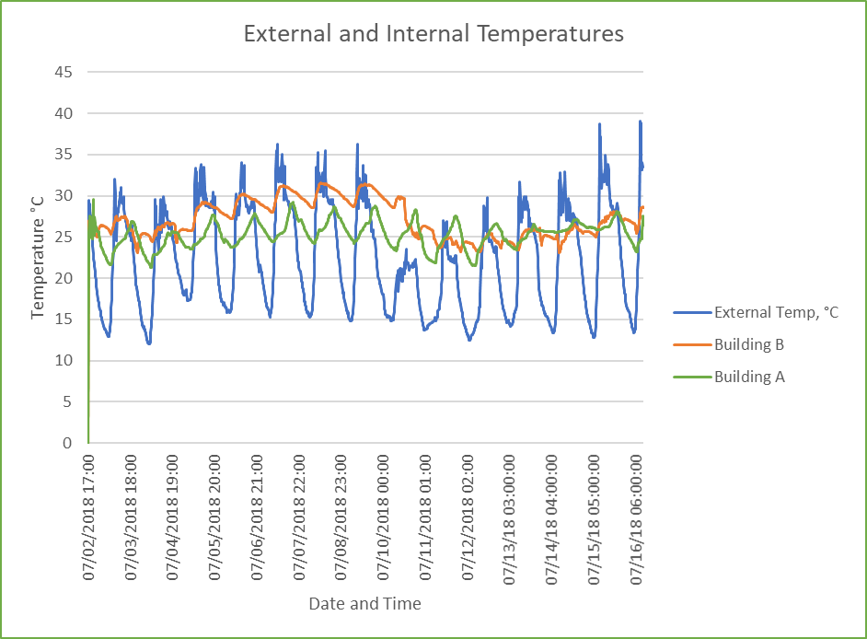

Figure 3 - External and Internal Temperatures

It appears that residents were resigned to the exposure to high levels of noise to improve ventilation and overheating and believe they will become accustomed to the noise level. Residents seemed unmindful of the health implications associated with long term exposure to noise, as demonstrated by the preference for comfort and ventilation over a quiet space, despite the increase in stress levels that noise can cause.

Residents commented on the lack of user control, it would seem that all dwellings had a lack of control. If there was an increase in user control for all three issues it is possible that the perception may change.

### **5.4 Acoustic, Ventilation and Overheating Residential Design Guide**

It should not be a choice between thethermal comfort, ventilation and noise – the three should work in together, which is an objective of the draft AVO Design Guide.

When comparing the buildings against the AVO Guide Building A was rated as medium risk as it is only required to carry out the level 1 assessment as level 2 is optional. Therefore, the following information is required:

* Details of external noise levels and method by which they have been determined;
* Description of provisions for the control of overheating (e.g. opening windows, attenuated vents, mechanical cooling); and
* Assessment of risk of adverse effect on occupants.

As residents were not satisfied with the temperature levels and ventilation within the dwellings this indicates that the building would have benefitted from further consideration of the ventilation and overheating design.

Building A is a large development and each elevation is exposed to different environmental conditions, therefore the building should be split to ensure accurate assessments were carried out.

Building B was categorised as high risk within the AVO Guide, therefore, an overheating assessment should be carried out. This correlates with residents’ perceptions as there was a level of dissatisfaction with the internal environment. Buildings categorised as high-risk require a level 2 assessment which must include:

* Statement of the overheating criteria being applied;
* Description of the provisions for meeting the stated overheating criteria. This should include, where relevant, the area of façade opening;
* Details of the likely internal ambient noise levels for the overheating condition and the method used to predict these;
* Estimate of how frequently and for what duration the overheating condition applies;
* Consideration of the effect of individual noise events; and
* Assessment of likely impact on occupants.

When reviewing the AVO Guide the residents’perception should be taken into account. To ensure the design solutions are used to their full potential it is important to educate the occupants so that they are aware of how the dwelling should work to maximise the ventilation, reduce the amount of overheating and limit the exposure to high levels of noise. This could be achieved by providing:

* A building user guide with details on ventilation systems;
* Advice on what measures need to be taken to minimise the overheating without compromising the amount noise exposure; and
* State what maintenance measures required.

## **6. CONCLUSION**

There is an inter-relationship between acoustics, ventilation and overheating as all are impacted by openable windows and therefore it is important to consider them together when designing a building.

There is a lack of understanding on residents’ perceptions on acoustics, ventilation and overheating. For example, are residents satisfied with their living conditions when the building standards set out for acoustics, ventilation and overheating are met? Do residents feel the levels set are too lenient or too stringent.

Perception from the residents of each building did not always align with the data gathered and residents were resigned to the exposure to high levels of noise to improve ventilation and overheating and believe they will become accustomed to the noise level. A larger study on existing residents’ opinions would provide a deeper understanding for designers of their perceptions. Consideration should be taken on how to educate the residents on how best to use their dwellings to ensure the design solutions are performing to the optimum level.

The dwellings assessed had to compromise on noise levels, ventilation or high temperature levels. However, they should not have to choose as they should work in together, which is an objective of the AVO Design Guide.

Residents commented on the lack of user control, it would seem that all dwellings had a lack of control. If there was an increase in user control for all three issues it is possible that the perception may change. User control could also be considered as residents indicated they were more satisfied with their environment when they felt they had control.

## **7. CRITICAL ASSESSMENT OF THE RESEARCH**

This study was limited by the number of volunteers willing to take part for monitoring and responses to questionnaires. The low number of responses to the questionnaire may not reflect the opinions of all residents who currently live in the building. It would have been beneficial to have carried out more detailed Interviews with residents to obtain a better insight into daily routines (window openings etc).

The buildings assessed were not designed with the use of the AVO Guide, if buildings were assessed which followed the AVO Guide this would provide an insight into residents’ perception to a building which has been designed to provide a balanced building when considering acoustics, ventilation and overheating.

The monitoring was over a short period of time, 2 weeks, and the project may have benefited from longer periods of monitoring to gain a clearer understanding of the noise levels over a period of a week for the noise and over a year for the temperature levels.

To provide a more accurate assessment of the indoor temperature levels a record of when windows were opened and closed should have been kept.

It was not possible to gain details of the original design e.g. plans, elevations, wall/window details M&E design. This could have allowed for some high-level modelling of the building to assess if the building is performing as it should.

**8. REFERENCES**

1. ANC (Acoustics & Noise Consultants). (2018, February). Acoustic, Ventilation and Overheating Residential Design Guide. Croydon.
2. British Standards. (2014). BS 8233:2014 Guidance on sound insulation and noise reduction for buildings. bsi.
3. CIBSE. (2017). CIBSE TM59. Design methodology for the assessment of overheating risk in homes. London: Chartered Instution of Services Engineers.