Cooling Effect of 3D Oscillating Heat Pipe with Nanofluid on Photovoltaic Panel in Hot Climates
Mahyar kargaran¹, Hamid Reza Goshayeshi¹*,Seyed Reza Saleh¹,Iman Zahmatkesh¹, Issa Chaer²
¹Department of Mechanical Engineering, Mashhad Branch, Islamic Azad University, Mashhad, Iran
²The School of Built Environment and Architecture, London South Bank University, SE1 0AA, London, United Kingdom

Abstract
Nowadays, there has been a growing trend toward using photovoltaic systems due to their high efficiency and cost-effectiveness; nevertheless, an inevitable side of solar panels is that their efficiency and life span experience a reduction when they are exposed to high intensity of solar irradiance and warm up, in other words, when they are cooled, the electrical efficiency is promoted. Using oscillating heat pipes is a creative and practical approach to enhance PV efficiency. Furthermore, applying nanofluid as a working fluid can play an important role in order to maximize panels productivity. The main objective of this investigation is to explore the cooling effect of a three-dimensional oscillating heat pipe on a photovoltaic panel, while graphene oxide nanofluid and distilled water are used as coolant. For this purpose, a novel three-dimensional oscillating heat pipe has been designed. The significant result from the study is that the cooling system was able to lower the temperature and improve power output of the PV by 8.6 °C and 2.78 (W), respectively, in the warmest time of the day, when graphene oxide nanofluid was used as a coolant.
Keywords: photovoltaic system, oscillating heat pipe, graphene oxide, nanofluid, heat transfer

1. Introduction
The rapid increase in global energy demand accompanied by the destructive effects of burning fossil fuels on the ozone layer and their limited capacity leads to drawing attention to green energy, harnessing and turning it into electricity. Solar photovoltaic technology has been considered as one of the most pragmatic approaches to generate electricity and subsequently can slow down the global climate change process. Nevertheless, installed PV power on a global scale has grown by 882 % from 2011 to 2020 [1]. Similarly, electricity generation from PV systems has experienced a dramatic rise of 1,212 % over the course of 10 years [2]. On the other hand, the instantaneous efficiency of the photovoltaic module is under considerable influence of the cell temperature of the module and the module loses 0.08% of its efficiency for every degree of divergence from direct sunlight [3]. Nonetheless, the electricity generated by PV varies by operating temperature, the higher the temperature (more than 25°), the lower the electrical efficiency. In other words, the PV module experiences 0.03% to 0.05% efficiency loss for each 1°C temperature increase [4]. There has been a considerable number of approaches to dissipate generated heat by PV modules in order to maximize the system efficiency and the important ones are listed below (Figure 1).
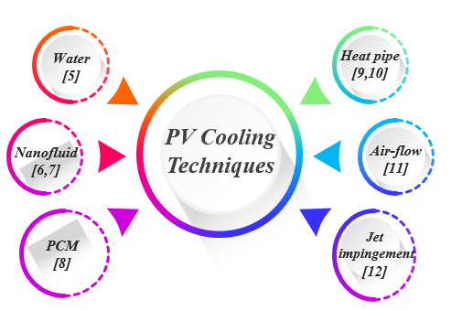

Figure 1. Different major cooling techniques of PV.

Heat Pipe is a type of heat exchanger that consists of a capillary tube that wraps between hot and cold areas, namely adiabatic, condensation, and evaporation sections. Heat is absorbed from evaporation and released from the condensation section. Heat pipe has different types shown in Figure 2 [13], this device has a very high heat transfer performance and offers low thermal resistance to transfer heat, and thermal energy [14]. Lightweight, low maintenance costs, minimal maintenance requirements, and long operating life are considered encouraging factors to use heat pipes [15,16]. The temperature of the heat source, filling ratio, working fluid, tilt angle, and lengths of evaporator and condenser have major impacts on heat pipe performance [17,18].
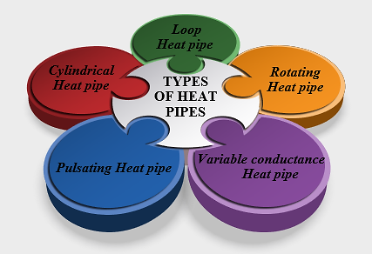
Figure 2. Different types of heat pipes

Oscillating heat pipe (OHP) is the last evolution of the conventional heat pipe. It has attracted growing interest because of its promising performance in heat transmission and apparently simple structure. [19].
Using heat pipes in PV is highly effective since it can dissipate considerable thermal energy and tackle freezing and overheating problems that typical PV modules always face. Thermo-physical properties of the coolant leave tremendous effect on heat pipes performance [20] and it has proved that using ethylene glycol, ethanol, and water offered low thermal efficiency [21]. Nanofluids, which include a base fluid and particles in nanometer size, such as ${Al}_{2}O_{3}$ [22], $SiO_{2}$ [23], ${Fe}_{3}O_{4}$ [24,25], ${Fe}_{2}O_{3}$ [26]and graphene oxide [27,29] also contribute to enhancing the productivity of HPs. Adding graphene oxide not only increases the thermal conductivity and viscosity of fluid but also improves the start-up performance of OHP [30]; however, high concentration can impede the thermal process since high concentration of graphene oxide can lead to high dynamic viscosity which impedes the movement of fluid in the OHP [31].Despite remarkable efforts that have been made in order to maximize the efficiency of PV modules and design different types of HPs, the challenge has yet to be solved.

Rittidech.S et al. [32] conducted an experimental investigation on the performance of a solar collector joint with an oscillating heat pipe while R134a was used as a coolant.it was demonstrated that not only the system proved highly resistant to corrosion and freezing, but also showed higher energy and economic efficiency. Kaya et al.[33] performed an experimental study on solar collector integrated with heat pipe when methanol and CuO-methanol were used as coolant. The thermal collector efficiency with nanofluid reached over 9%. Allouhi et al. [34] aslo carried out numerical investigations on cooling solar collect by heat pipe with three different nanofluids (CuO, ${Al}_{2}O_{3}$, and $TiO_{2}$ ) .while, heat pipe with CuO-based nanofluid showed the highest efficiency, 2.7% compared to water.

This study is remarkable and had a promising result since it suggests a productive passive cooling approach to reduce PV modules temperature. Furthermore, as far as the advantage of proposed system concerns, heat is dissipated from PV module by a simple and efficient method without power and special maintenance and also easy to install. This newly-designed heat pipe embraces the benefits of OHP and nanofluids technology and harness thermal energy without applying any external power sources such as pumps.

2. Experimental details

In this section, the experiment details and equations to assess system performance accompanied by error analysis are provided.
2.1. Experimental apparatus
All the tests have been conducted in Mashhad, Iran (latitude: 59.6067° E; longitude 36.2972° N) from 24 to 30 August. The setup mainly comprises a monocrystalline PV panel (RestarSolar) joined with a newly- designed three-dimensional OHP. Table 1 shows the specifications of PV.

Table 1: Electrical specifications of PV panel
Specification | Value
Model number | RTM050M
Nominal maximum power | 50W
Open circuit voltage ($V_{OC})$ | 24.6V
Short circuit current ($I_{sc}$) | 2.75A
Peak voltage ($V_{mp}$) | 20V
Peak current ($I_{mp}$) | 2.5A
Dimension | 680*547*30 mm
$${}_{e}$$ | 0.134

As displayed in Figure 3, the novel 3D -OHP was designed and made with the red copper tube with features shown in Figure 4.

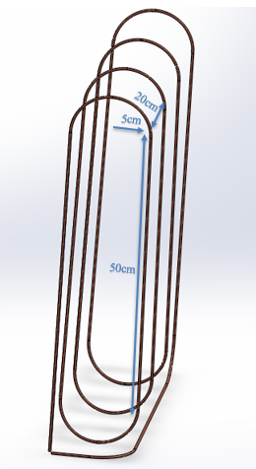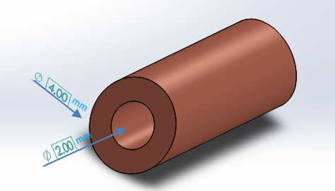

Figure 3. Schematic of newly-designed 3D-OHP
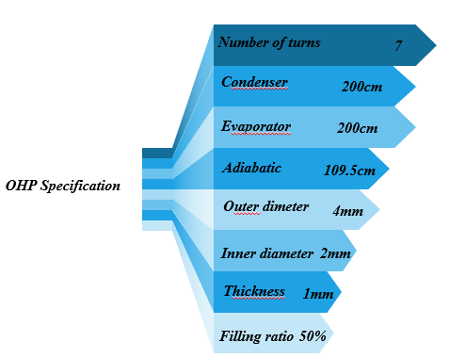
Figure 4. Design parameters of 3D-OHP

According to investigations, the maximum performance of OHP is produced on a filling ratio of 50% [35,36], thereby experiments were conducted on this value. The vacuum was created by a vacuum pump joint to a valve and the OHP was put under the suction pressure for 15 minutes. Thereafter, working fluid was injected. The filling ratio in all tests was 50% of the total volume of the OHP. The experimental test bed, configuration of the 3D- OHP and schematic of test bed are also displayed in Figure 5, Figure 6and Figure 7, respectively.

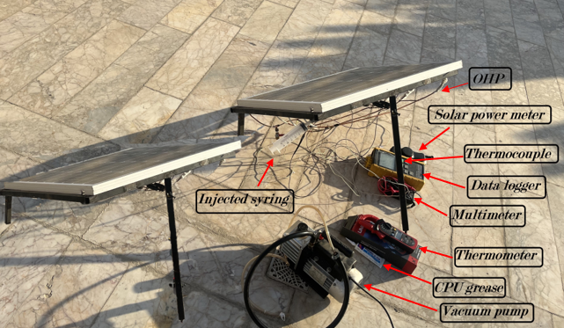
Figure 5. Picture of test bed

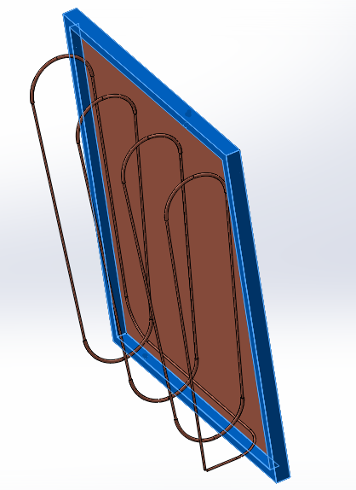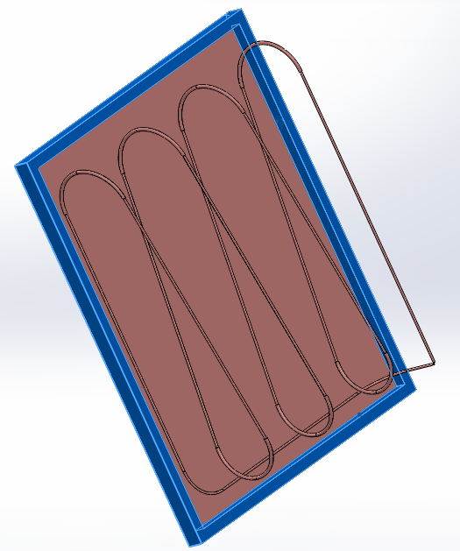
Figure 6. Configuration of the 3D-OHP and PV from different angles

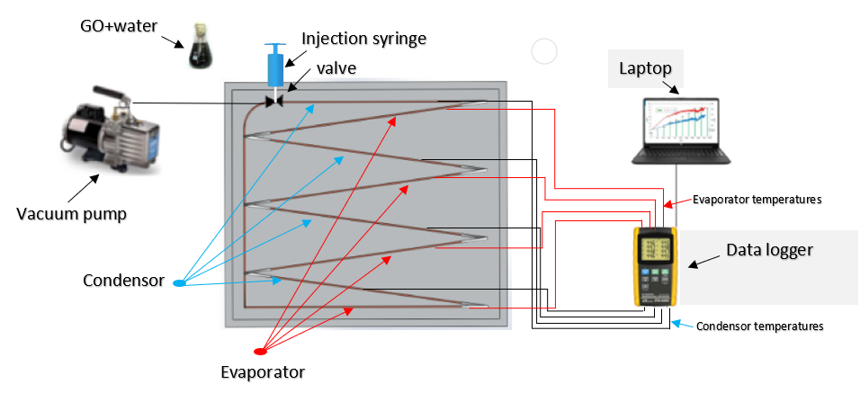
Figure 7. Schematic of test bed

It is worth mentioning that the lamination technique in order to make a connection between the evaporator section and the back of PV has been used [37]; nonetheless, when it comes to the experimental stage, the aforementioned approach was considered to be high-priced and demanding to operate; thereby, a sheet of copper with the thickness of 0.4 mm by means of CPU grease, which has a high thermal conductivity, over 100 times of air, was attached to the back of PV.
Regarding working fluid, the performance of graphene oxide (GO) nanoparticles and distilled water were investigated. To prepare nanofluid, graphene oxide was prepared by dispersing GO nanoparticles into DI water as a base fluid with 0.25 gr/lit concentration. Since GO nanofluid with surfactant sodium dodecyl sulfate (SDS) proved great stability [38], SDS was also used with a 1:1 ratio. After completing the preparation of working fluid, it is injected into a heat pipe at 50% filling ratio. The SEM and FESEM images of graphene oxide are depicted in Figure 8.
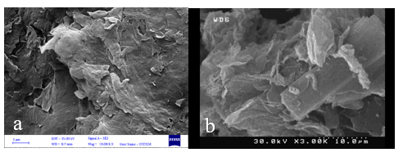
Figure 8. a) The FESEM image of GO b) The FESEM image of GO

The crystal structure of graphene oxide was also assessed by an X-ray diffractometer (XRD), which is shown in Figure 9.

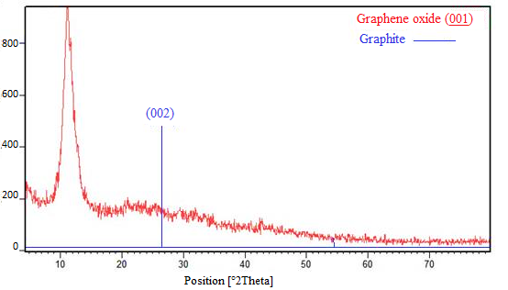

Figure 9. The XRD image of GO
Technical parameters of graphene oxide used in this study is also presented in table2.

Table 2. Technical parameters
Parameters | Values
Thickness | 3.4-7nm
Carbon purity | $$\sim 99\%$$
Number of layers | Average number of layers 6-10
Surface area (BET) | 100-300 $m^{2}/g$
Bulk density | 0.3g/cc
Lateral dimension | 10-50 $μm$

2.2. Energy analysis
In this part, the formulas applied to conduct energy analysis for OHP-PV are provided.
Temperatures were measured by placing six thermocouples on evaporation and condensation sections, three thermocouples for each section. Thermocouples were attached to temperature data logger BTM-4208SD and when temperatures in evaporation and condensation of the OHP were stabilized, they were recorded and averaged, which means:

(1) |  | $$T_{e}=\frac{1}{4}\sum_{i=1}^{4}{T_{i}}$$
(2) |  | $$T_{c}=\frac{1}{4}\sum_{i=5}^{8}{T_{i}}$$
Thermal resistance (R) is the criterion of assessing OHP performance measured by:
$$R=\frac{T_{evaporator}-T_{condenser}}{Q} (3)$$
Where Q is the heat received by OHP [39].
Concerning OHP-PV energy analysis, to obtain the thermal efficiency of PV, formula 4 is applied. [36].

$${}_{i}=\frac{\dot{m}C_{p}\int_{t_{1}}^{t_{2}}{{(T}_{o}-T_{i}})dt}{A\int_{t_{1}}^{t_{2}}{I_{T}}dt} (4)$$

PV conversion efficiency is expressed as the portion of electricity generated by PV to input the solar energy, obtained from equation 5 [40,41].
$${}_{e}=\frac{P_{out}}{P_{in}} =\frac{V_{mp}I_{mp}}{{AI}_{T}} (5)$$
Where $V_{mp}$ and $I_{mp}$ are peak voltage and current, respectively, A is the area of the PV collector and $I_{T}$ is solar radiation intensity measured by a solar power meter (ST-1307).
Eventually, the improvement of OHP-PV efficiency is calculated by following equation [42]

$${}_{I}=\frac{{}_{OHP-PV}}{{}_{PV}}-1 (6)$$

2.3. Error analysis
This part provides calculations regarding errors connected with measurements.
There are two types of uncertainty [43]. One of them comes from statistical methods which can be calculated by equation 7, and y hinges on inputs [44].

$$u\left(y\right)=\sqrt{{\left(\frac{δy}{δw_{1}}\right)}^{2} u^{2}\left(w_{1}\right)+{\left(\frac{δy}{δw_{2}}\right)}^{2} u^{2}({w_{2})+…}_{ }} \left(7\right)$$
And another one relates to equipment, which is obtained by [45].

$$u_{n}=a_{n}/\sqrt{3} (8)$$

And $a_{n}$ is provided by the manufacturer. The uncertainty of calculated variables is provided in Table 3.
Table 3: Uncertainty values
Parameter | Uncertainty
Ambient temperature $T_{a}$(°C) | ±0.1
Condenser temperature $T_{c}$(°C) | ±0.1
Evaporator temperature $T_{e}$(°C) | ±0.1
PV cell temperature $T_{s}$(°C) | ±0.1
Solar radiation intensity $I_{T}(W/{m^{2}})$ | ±1
Wind speed $V_{w}(m/s)$ | ±0.1
Voltage $V_{OC}$(V) | ±0.05
current $I_{sc}$(A) | ±0.0015

3. Results and Discussion
A series of experiments were performed on the roof with a height of 17 meters. During the test period, the PV-T collectors were located at a tilt angle of 30 degrees, and the experiments were conducted from 7:30 to 17.30. Since PV is a temperature-dependent performance, the PV cell temperature is an imperative parameter that illustrates the effectiveness of the proposed system.
The designed OHP-PV model is tested with water and graphene oxide nanofluid at volume concentrations of 0.25 gr/lit [33].
4.1. PV cell temperature
The data acquired from the PV panel is depicted in Figure 10 which indicates the PV temperature during the test time. Also, it is simply observed from Figure 11 that the high intensity of solar radiation and surrounding temperature is attributed to the increase of PV cell temperature, reaching 1128.5 W/m² in the mid-day.

Figure 10. Variation of PV and ambient temperature vs time

Figure 11. Variation of solar irradiance vs time

Two types of light strike PV surface, direct light which plays a paramount role in electricity generation, and scattered from the sky. The solar module should be tilted, in order to receive a considerable proportion of solar irradiance [46,47].
On the other hand, the peak OHP efficiency can be achieved in vertical orientation; however, the efficiency of PV is maximized at 30° due to the fact that the panel is exposed to maximum solar irradiance. Nevertheless, it has been proved that the effect of the tilt angle of PV outweighs the OHP angle [48].
In Figure 12, the thermal resistance of the OHP for graphene oxide nanofluid and DI water is displayed. As it can be clearly seen, adding graphene oxide makes an important contribution to reducing thermal resistance.

Figure 12. Thermal resistance vs received heat

Figure 13 shows the temperature in PV an OHP-PV during a fixed radiation time. It is clearly observed that by the passage of time, the gap between the temperature of PV and the proposed system widens. while the temperature of PV reaches up to 61.3°C, the value for the OHP-PV with water and graphene oxide nanofluid as working fluid peaks at around 56.9°C and 53°C, respectively, which indicates the fine performance of the proposed system especially when it comes to employing graphene oxide nanofluid as a coolant.

Figure 13. Comparison of temperature trend in conventional PV with OHP-PV with different working fluids vs time

Figure 14 demonstrates average wind speed, varied from over 2 m/s to just under 2.8 m/s, during the experiment time, which played a significant role in cooling down the condensers’ temperature.

Figure 14. Wind velocity vs time

Generated short- circuit current $I_{sc}$ and open-circuit voltage $V_{OC}$ of PV heavily hinge on radiation intensity and PV cell temperature [46]; however, when the cell temperature increases, short-circuit current slightly rises but open- circuit voltage experiences considerable reduction as it was displayed in Figure 15.

Figure 15. PV temperature effect on $V_{OC}$ and $I_{sc}$ vs time

As it can be seen in Figure 16, the evaporator temperature when water is used a coolant higher compare to GO nanofluid, reaches about 58°C and 52°C, respectively. As it expected, the condenser temperature follows the same trend and that is because of the fact that GO nanofluid has higher thermal conductivity which facilitate exchanging heat much more easily.

Figure 16. Comparison of average temperature of the condenser and the evaporator vs time

Since the optimum performance of PV occurs in 25 °C, in the beginning, the power output increases. Afterward, according to Figure 17, maximum power follows a downward trend as the temperature rises; nonetheless, the minimum generated power for PV is 35W, while the value for OHP-PV when water is used as working fluid is higher than 35.5W and even looks more promising for graphene oxide reaches 36.12W.
Figure 17. Comparison of power output in conventional PV with OHP-PV with different working fluids vs time

As it was mentioned earlier, with the increase in PV temperature, the electrical efficiency suffers a noticeable reduction, as shown in Figure 18. However, employing OHP leads to a remarkable improvement in electrical efficiency.

Figure 18. Comparison of electrical efficiency in conventional PV with OHP-PV with different working fluids vs time

5. Conclusions

The maximum power performance of photovoltaic panels is sensitive to the panel temperature and solar irradiance and they reduce by an increase of temperature. In this study, experiments were performed under the warm climate of Mashhad, and a new cooling approach was adopted to improve the electrical efficiency of the photovoltaic panel. For this purpose, a new three-dimensional oscillating heat pipe was designed and tested with two different working fluids, also the following conclusions are drawn from the case study:
- The use of 3D Oscillating heat pipe with Nanofluid reduced the temperature of the panel by 8 , which leads to improve power output (roughly 4W) and as a result the electrical efficiency of the PV panels is around 10%,while this value for water as a coolant is about 5%
- Applying GO nanofluid played a significant role in decreasing the start-up time and temperature of 3D- OHP and decreases the time around 25 minutes in compare with water as a coolant
- Using copper plate is a brilliant idea to heat exchange between panel and OHP and minimize heat loss
- Adding graphene oxide can reduce thermal resistance of the 3D-OHP over 30%
- The proposed cooling system is simple and quite cost-effective since it does not require any external power sources such as pumps, which is stimulating factor to be used in industrial and residential rooftop applications

Declaration of Competing Interest
The authors declare that they have no known competing financial interests or personal relationships that could have appeared to influence the work reported in this paper.

References
[1] Holechek, J. L., Geli, H. M., Sawalhah, M. N., & Valdez, R. (2022). A global assessment: can renewable energy replace fossil fuels by 2050. Sustainability, 14(8), 4792. https://doi.org/10.3390/su14084792

[2 Yolcan, O. O., & Kose, R. (2023). Photovoltaic module cell temperature estimation: Developing a novel expression. Solar Energy, 249, 1-11.https://doi.org/10.1016/j.solener.2022.11.020

[3] Kazem, H. A., Chaichan, M. T., Al-Waeli, A. H., & Sopian, K. (2020). A review of dust accumulation and cleaning methods for solar photovoltaic systems. Journal of Cleaner Production, 276, 123187.https://doi.org/10.1002/ese3.1043

[4] Hasan, K., Yousuf, S. B., Tushar, M. S. H. K., Das, B. K., Das, P., & Islam, M. S. (2022). Effects of different environmental and operational factors on the PV performance: A comprehensive review. Energy Science & Engineering, 10(2), 656-675. https://doi.org/10.1002/ese3.1043

[5] Sotehi, O., Chaker, A., & Maalouf, C. (2016). Hybrid PV/T water solar collector for net zero energy building and fresh water production: A theoretical approach. Desalination, 385, 1-11. https://doi.org/10.1016/j.desal.2016.01.034

[6] Aberoumand, S., Ghamari, S., & Shabani, B. (2018). Energy and exergy analysis of a photovoltaic thermal (PV/T) system using nanofluids: An experimental study. Solar Energy, 165, 167-177.. https://doi.org/10.1016/j.solener.2018.03.028
[7] Minea, A. A., & El-Maghlany, W. M. (2018). Influence of hybrid nanofluids on the performance of parabolic trough collectors in solar thermal systems: recent findings and numerical comparison. Renewable Energy, 120, 350-364. https://doi.org/10.1016/j.renene.2017.12.093
[8] Sardarabadi, M., Passandideh-Fard, M., Maghrebi, M. J., & Ghazikhani, M. (2017). Experimental study of using both ZnO/water nanofluid and phase change material (PCM) in photovoltaic thermal systems. Solar Energy Materials and Solar Cells, 161, 62-69. https://doi.org/10.1016/j.solmat.2016.11.032
[9] Hu, M., Zheng, R., Pei, G., Wang, Y., Li, J., & Ji, J. (2016). Experimental study of the effect of inclination angle on the thermal performance of heat pipe photovoltaic/thermal (PV/T) systems with wickless heat pipe and wire-meshed heat pipe. Applied Thermal Engineering, 106, 651-660.https://doi.org/10.1016/j.applthermaleng.2016.06.003
[10] Jouhara, H., Szulgowska-Zgrzywa, M., Sayegh, M. A., Milko, J., Danielewicz, J., Nannou, T. K., & Lester, S. P. (2017). The performance of a heat pipe based solar PV/T roof collector and its potential contribution in district heating applications. Energy, 136, 117-125. https://doi.org/10.1016/j.energy.2016.04.070
[11] Mojumder, J. C., Ong, H. C., Chong, W. T., Izadyar, N., & Shamshirband, S. (2017). The intelligent forecasting of the performances in PV/T collectors based on soft computing method. Renewable and Sustainable Energy Reviews, 72, 1366-1378.http://dx.doi.org/10.1016/j.rser.2016.11.225
[12] Nadda, R., Kumar, A., & Maithani, R. (2018). Efficiency improvement of solar photovoltaic/solar air collectors by using impingement jets: A review. Renewable and Sustainable Energy Reviews, 93, 331-353. https://doi.org/10.1016/j.rser.2018.05.025
[13] Jose, J., & Hotta, T. K. (2023). A Comprehensive Review of Heat Pipe: Its Types, Incorporation Techniques, Methods of Analysis and Applications. Thermal Science and Engineering Progress, 101860. https://doi.org/10.1016/j.tsep.2023.101860
[14] Wang, X., Wen, Q., Yang, J., Xiang, J., Wang, Z., Weng, C., ... & Zheng, S. (2022). A review on data centre cooling system using heat pipe technology. Sustainable Computing: Informatics and Systems, 35, 100774.https://doi.org/10.1016/j.suscom.2022.100774
[15] Alshukri, M. J., Hussein, A. K., Eidan, A. A., & Alsabery, A. I. (2022). A review on applications and techniques of improving the performance of heat pipe-solar collector systems. Solar Energy, 236, 417-433. https://doi.org/10.1016/j.solener.2022.03.022
[16] Shoeibi, S., Mirjalily, S. A. A., Kargarsharifabad, H., Khiadani, M., & Panchal, H. (2022). A comprehensive review on performance improvement of solar desalination with applications of heat pipes. Desalination, 540, 115983. https://doi.org/10.1016/j.desal.2022.115983
[17] Olabi, A. G., Haridy, S., Sayed, E. T., Radi, M. A., Alami, A. H., Zwayyed, F., ... & Abdelkareem, M. A. (2023). Implementation of artificial intelligence in modeling and control of heat pipes: a review. Energies, 16(2), 760.https://doi.org/10.3390/en16020760
[18] Pagliarini, L., Iwata, N., & Bozzoli, F. (2023). Pulsating Heat Pipes: critical review on different experimental techniques. Experimental Thermal and Fluid Science, 110980. https://doi.org/10.1016/j.expthermflusci.2023.110980
[19] Rudresha, S., Babu, E. R., & Thejaraju, R. (2023). Experimental investigation and influence of filling ratio on heat transfer performance of a pulsating heat pipe. Thermal Science and Engineering Progress, 38, 101649.https://doi.org/10.1016/j.tsep.2023.101649
[20] Zhou, Y., Yang, H., Liu, L., Zhang, M., Wang, Y., Zhang, Y., & Zhou, B. (2021). Enhancement of start-up and thermal performance in pulsating heat pipe with GO/water nanofluid. Powder Technology, 384, 414-422. https://doi.org/10.1016/j.powtec.2021.02.021
[21] Chilbule, P. V., Dhole, L. P., & Chavhan, G. R. (2023). Optimization of heat pipe charged with CuO nanofluid using Taguchi technique. Materials Today: Proceedings.https://doi.org/10.1016/j.matpr.2023.08.343
[22] Q Qu, J., Wu, H. Y., & Cheng, P. (2010). Thermal performance of an oscillating heat pipe with Al2O3–water nanofluids. International Communications in Heat and Mass Transfer, 37(2), 111-115. https://doi.org/10.1016/j.icheatmasstransfer.2009.10.001
[23] Qu, J., & Wu, H. (2011). Thermal performance comparison of oscillating heat pipes with SiO2/water and Al2O3/water nanofluids. International Journal of Thermal Sciences, 50(10), 1954-1962. https://doi.org/10.1016/j.ijthermalsci.2011.04.004
[24] Kang, S. W., Wang, Y. C., Liu, Y. C., & Lo, H. M. (2017). Visualization and thermal resistance measurements for a magnetic nanofluid pulsating heat pipe. Applied Thermal Engineering, 126, 1044-1050. https://doi.org/10.1016/j.applthermaleng.2017.02.051
[25] Davari, H., Goshayeshi, H. R., Öztop, H. F., & Chaer, I. (2020). Experimental investigation of oscillating heat pipe efficiency for a novel condenser by using Fe 3 O 4 nanofluid. Journal of Thermal Analysis and Calorimetry, 140, 2605-2614. https://doi.org/10.1007/s10973-019-09032-8
[26] Goshayeshi, H. R., Safaei, M. R., Goodarzi, M., & Dahari, M. (2016). Particle size and type effects on heat transfer enhancement of Ferro-nanofluids in a pulsating heat pipe. Powder Technology, 301, 1218-1226. https://doi.org/10.1016/j.powtec.2016.08.007
[27] Afsari, K., Emami, M. R. S., Zahmatkesh, S., Klemeš, J. J., & Bokhari, A. (2023). Optimizing the thermal performance of the thermosyphon heat pipe for energy saving with graphene oxide nanofluid. Energy, 274, 127422. https://doi.org/10.1016/j.energy.2023.127422
[28] Chang, C., Pei, L., Li, B., Han, Z., & Ji, Y. (2023). Fabrication and thermal performance of a solar-driven heat pipe filled with reduced graphene oxide nanofluids. Solar Energy, 264, 112007. https://doi.org/10.1016/j.solener.2023.112007
[29] Natesan, K., & Karinka, S. (2023). A comprehensive review of heat transfer enhancement of heat exchanger, heat pipe and electronic components using graphene. Case Studies in Thermal Engineering, 45, 102874. https://doi.org/10.1016/j.csite.2023.102874
[30] Nazari, M. A., Ghasempour, R., Ahmadi, M. H., Heydarian, G., & Shafii, M. B. (2018). Experimental investigation of graphene oxide nanofluid on heat transfer enhancement of pulsating heat pipe. International Communications in Heat and Mass Transfer, 91, 90-94. https://doi.org/10.1016/j.icheatmasstransfer.2017.12.006
[31] Zhao, X., Su, L., Jiang, J., Deng, W., & Zhao, D. (2023). A review of working fluids and flow state effects on thermal performance of micro-channel oscillating heat pipe for aerospace heat dissipation. Aerospace, 10(2), 179. https://doi.org/10.3390/aerospace10020179
[32] Rittidech, S., A. Donmaung,K. Kumsombut. "Experimental study of the performance of a circular tube solar collector with closed-loop oscillating heat-pipe with check valve (CLOHP/CV)." Renewable Energy 34.10 (2009): 2234-2238. https://doi.org/10.1016/j.renene.2009.03.021
[33] Kaya, Metin, Ali Etem Gürel, Ümit Ağbulut, İlhan Ceylan, Selim Çelik, Alper Ergün,Bahadır Acar. "Performance analysis of using CuO-Methanol nanofluid in a hybrid system with concentrated air collector and vacuum tube heat pipe." Energy Conversion and Management 199 (2019): 111936. https://doi.org/10.1016/j.enconman.2019.111936

[34] Allouhi, A.,M. Benzakour Amine. "Heat pipe flat plate solar collectors operating with nanofluids." Solar Energy Materials and Solar Cells 219 (2021): 110798. https://doi.org/10.1016/j.solmat.2020.110798

[35] Alizadeh Jajarm, A. R., Goshayeshi, H. R., & Bashirnezhad, K. (2022). Experimental study of thermal performance of a newly designed pulsating heat pipe with Fe3O4 nanofluid-exposed magnetic field and corrugated evaporator. International Journal of Thermophysics, 43(3), 40. https://doi.org/10.1016/j.ijheatmasstransfer.2017.02.040
[36] Zhang, D., He, Z., Guan, J., Tang, S., & Shen, C. (2022). Heat transfer and flow visualization of pulsating heat pipe with silica nanofluid: An experimental study. International Journal of Heat and Mass Transfer, 183, 122100. https://doi.org/10.1016/j.ijheatmasstransfer.2021.122100
[37] Aste, N., Leonforte, F., & Del Pero, C. (2015). Design, modeling and performance monitoring of a photovoltaic–thermal (PVT) water collector. Solar Energy, 112, 85-99. https://doi.org/10.1016/j.solener.2014.11.025
[38] Chen, F., Hu, M., Badiei, A., Yu, M., Huang, Z., Wang, Z., & Zhao, X. (2020). Experimental and numerical investigation of a novel photovoltaic/thermal system using micro-channel flat loop heat pipe (PV/T-MCFLHP). International Journal of Low-Carbon Technologies, 15(4), 513-527.https://doi.org/10.1093/ijlct/ctaa019
[39] Alexander, K., Gajghate, S. S., Katarkar, A. S., Majumder, A., & Bhaumik, S. (2021). Role of nanomaterials and surfactants for the preparation of graphene nanofluid: a review. Materials Today: Proceedings, 44, 1136-1143. https://doi.org/10.1016/j.matpr.2020.11.231
[40] Yazdanpanahi, J., Sarhaddi, F., & Adeli, M. M. (2015). Experimental investigation of exergy efficiency of a solar photovoltaic thermal (PVT) water collector based on exergy losses. Solar Energy, 118, 197-208.https://doi.org/10.1016/j.solener.2015.04.038
[41] Praveenkumar, S., Gulakhmadov, A., Agyekum, E. B., T. Alwan, N., Velkin, V. I., Sharipov, P., ... & Chen, X. (2022). Experimental study on performance enhancement of a photovoltaic module incorporated with CPU heat pipe—A 5E analysis. Sensors, 22(17), 6367. https://doi.org/10.3390/s22176367
[42] Agyekum, E. B., PraveenKumar, S., Alwan, N. T., Velkin, V. I., Shcheklein, S. E., & Yaqoob, S. J. (2021). Experimental investigation of the effect of a combination of active and passive cooling mechanism on the thermal characteristics and efficiency of solar PV module. Inventions, 6(4), 63. https://doi.org/10.3390/inventions6040063
[43] Agyekum, E. B., PraveenKumar, S., Alwan, N. T., Velkin, V. I., Shcheklein, S. E., & Yaqoob, S. J. (2021). Experimental investigation of the effect of a combination of active and passive cooling mechanism on the thermal characteristics and efficiency of solar PV module. Inventions, 6(4), 63. https://doi.org/10.3390/inventions6040063
[44] Santbergen, R., Muthukumar, V. A., Valckenborg, R. M. E., van de Wall, W. J. A., Smets, A. H. M., & Zeman, M. (2017). Calculation of irradiance distribution on PV modules by combining sky and sensitivity maps. Solar Energy, 150, 49-54. https://doi.org/10.1016/j.solener.2017.04.036
[45] Fouad, M. M., Shihata, L. A., & Morgan, E. I. (2017). An integrated review of factors influencing the perfomance of photovoltaic panels. Renewable and Sustainable Energy Reviews, 80, 1499-1511.https://doi.org/10.1016/j.rser.2017.05.141
[46] Hasan, Khaled, et al. "Effects of different environmental and operational factors on the PV performance: A comprehensive review." Energy Science & Engineering 10.2 (2022): 656-675. ] Hasan, K., Yousuf, S. B., Tushar, M. S. H. K., Das, B. K., Das, P., & Islam, M. S. (2022). Effects of different environmental and operational factors on the PV performance: A comprehensive review. Energy Science & Engineering, 10(2), 656-675. https://doi.org/10.1002/ese3.1043
[47] Kavoosi Balotaki, H., & Saidi, M. H. (2019). Design and performance of a novel hybrid photovoltaic–thermal collector with pulsating heat pipe (PVTPHP). Iranian Journal of Science and Technology, Transactions of Mechanical Engineering, 43, 371-381. https://doi.org/10.1007/s40997-018-0164-y
[48] Hassan, A., Abbas, S., Yousuf, S., Abbas, F., Amin, N. M., Ali, S., & Mastoi, M. S. (2023). An experimental and numerical study on the impact of various parameters in improving the heat transfer performance characteristics of a water based photovoltaic thermal system. Renewable Energy, 202, 499-512. https://doi.org/10.1016/j.renene.2022.11.087

