Value for Money Model for Industrial Investment in University Research
Simon P. Philbin
Imperial College London, South Kensington, London SW7 2AZ, United Kingdom.
E-mail: s.philbin@imperial.ac.uk
Abstract: University-industry collaboration is an important enabler of open innovation, however, there is a lack of understanding of how to measure the overall benefits of collaborative research projects in terms of value for money. Therefore, following a literature review, a conceptual model has been developed that provides a management framework for deriving the additional (leveraged) benefits of research undertaken at universities. The model itself is focused on the provision of value drivers (either knowledge or financial), which detail specific quantitative and qualitative metrics to enable the value for money case. The model has been initially investigated through a case study involving application to a university-industry strategic alliance over a two-year period. Preliminary findings indicate that the data and information supplied by the model helped the company to continue justifying its investment in research at the university and this has significantly strengthened the strategic alliance.

Keywords: University-industry collaboration; alliance management; value for money; open innovation.

1 Introduction
The subject of open innovation (Chesbrough, 2003) has been explored widely (Dodgson and Gann, 2010) and studies point to the particular benefits for industry arising from forming collaborative relationships with partners in order to enhance the company’s value proposition (Sammons, 2005). Such benefits could include the acquisition of knowledge or ideas by a company in order to improve products or services that are offered (Ding and Peters, 2000), or simply the ability to assess recent developments in science and technology so as to solve specific engineering problems (Schumacher, 1992). In this regard, industrial organisations are increasingly collaborating with universities for the provision of basic research (Dooley and Kirk, 2007) in the expectation of contributing to radical innovation for the company (Fleming and Sorenson, 2004).
This research and technology (R&T) activity could take the form of a university receiving monies directly from a company (i.e. contract research), or alternatively there may be third-party funding from a government agency that provides the university’s funding (in this latter case the collaborating company may or may not also receive monies from the government funding source). Moreover, at a low level of interaction there could be collaboration between a single academic at a university and an industrial contact, which gives rise to a small level of funding for a short research study. Whereas, at the other end of the spectrum, there could be a broad strategic alliance between a university and a major international company, where there are several teams of people involved and research programmes worth several million pounds are funded. Such strategic alliances can be a major source of competitive advantage for companies (Ireland et al., 2002) but unfortunately there is a lack of understanding of how to measure the performance of such collaborative alliances and by extension the ability to assess the value for money aspects of research.
2 University-Industry Research Collaboration
As the level of collaboration between universities and companies has increased (Iuan-Yuan et al., 2007), there has inevitably become higher competition between research intensive universities for industrial funding. Along with this greater interaction between universities and companies (Burnside and Witkin, 2008), there is a need for an improved understanding of the mechanisms of university-industry research collaboration (Hossain and Fazio, 2009) as well as a requirement to improve the management of such interactions (Kirkland, 2005). On this matter a process-based methodology has been proposed that emphasises a number of underpinning elements of university-industry collaboration (Philbin, 2008a), including creating value in terms of the business and technical missions of the collaboration; the role of a ‘collaboration agent’ to drive forward interactions; the need for social capital to facilitate collaboration; as well as a supporting sequence of activities to develop and manage joint scientific projects. Central to the creation of value in this model is the role of knowledge and consequently the performance of collaborative activities can be positioned in terms of the flow of knowledge between universities and companies, which is further underpinned by other studies on the significance of sharing knowledge across organisational boundaries (Sampson, 2007; Baba et al., 2009).
In this context, companies will naturally focus on the quality of data and information that arises from a particular collaboration with an academic institution (Philbin, 2008b). Where the quality of such knowledge (both explicit and tacit) is high and it represents an attractive return on investment for the company, then the collaboration is likely to flourish and conversely in the case of lower quality outputs from the university then the collaboration will be adversely affected. This predicament can therefore be analysed through a paradigm that is based on a financial perspective (i.e. the need for a company to achieve an appropriate return on investment) as well as a knowledge perspective (i.e. generating relevant and high quality data and information that the company can ultimately deploy through improved products or services). Moreover, in terms of the financial perspective, it is possible to examine so called research cost avoidance benefits for the company (Gray and Steenhuis, 2003). Research cost avoidance can be linked to how much it would cost a company to use alternative means, such as undertaking the research itself, in order to achieve a research outcome similar to that accrued from the collaboration pursued with a university. These costs can, for instance, be regarded in terms of the cost that it would require to initiate an entire new research area; costs associated with accessing relevant facilities; as well as the benefits from new academic staff being appointed in areas of strategic interest to the company.
Developing this analysis further and as companies seek to justify investment in university research collaborations and contracts, it can be discerned that there is a need to develop appropriate value for money drivers as the basis for such justification. Indeed whilst there have been some econometric studies on measuring firm-level innovation (Griliches, 1986), in this wider context there continues to be challenges in measuring the performance of innovation process, such as R&D (Dodgson et al., 2008). Consequently, this paper has been written in order to describe the preliminary development of a management framework for measuring the wider, or additional, benefits that arise from industrial investment in university research. The purpose for establishing the framework has been to identify the leveraged benefits of investment in university research and hence as a means to determine the value for money of research investment. It is suggested that this approach may be utilised by companies to help substantiate the business case for investment in university research. The model will also be of use in helping universities increase their level of engagement with industry.
3 Developing a Value for Money Model
In order to develop a value for money model for industrial investment in university research, it is useful to first consider the general benefits for both the company and the university that may arise from participation in collaborative research. To this end, Table 1 provides a representative list of such benefits.

Table 1 General benefits arising from research collaboration.
Benefits to industry | Benefits to academia
- Access to research results and the knowledge that is generated, e.g. through licensing of IPR (intellectual property rights).  - Access to a greater pool of expertise and range of scientific disciplines.  - Publications in scientific journals and conference proceedings with joint university/company authorship.  - Training of potential employees as well as existing staff through attending postgraduate degree programmes, e.g. PhD and postgraduate Masters.  - Access to independent assessment and scrutiny of research and technology programmes.  - Career development for scientists who interact with the university.  - Potential recruitment of well trained graduates and postgraduates. | - Access to technical developments in an industrial context and the corresponding application areas for scientific research. For example, this could include access to scientific data to populate computational models.  - Contact with a potential employer for graduate and postgraduate students.  - Funding from an industrial company that builds on the university’s core funding from government research agencies.  - Ideas generation from collaborative interactions with industry.  - Access to the company’s specialist equipment and high-value facilities, which may have been prohibitively expensive to procure.

Consideration of the general benefits arising from university-industry collaboration highlights the broad range of implications for both companies and universities but this scope of interaction can unfortunately also lead to difficulties in the formulation of an appropriate value for money model. Therefore, it is useful to examine the additional or leveraged benefits that may arise from such collaborations, which can be used as the basis for an appropriate value for money model. The foundation to this approach is that value for money measures can be identified, which detail the leveraged benefits arising from an industrial investment in research and which are in addition to the general benefits expected.
Consequently, this approach seeks to provide both quantitative and qualitative measures for the performance of the collaboration that exceed the normal outputs from collaborative activities, such as publications in journals, or opportunities for companies to recruit graduates/postgraduates from the university. Accordingly and in this context, measurement of value for money is defined as an assessment of the additional benefits arising from research collaboration, which can be regarded as sources of leverage on the industrial investment in research.
Through building on the literature described previously, it is therefore possible to conceptualise a value for money view (see Figure 1) that is based on two sets of value drivers, which are knowledge drivers and financial drivers. The model is based on the premise that research collaboration is a transformation process with appropriate inputs and outputs to the process. This process would be expected to deliver the general benefits described in Table 1, but in order to assess the value for money case, there is a need to measure the additional (or leveraged) benefits arising from a company’s investment in research at a university. Application of the model involves identification of sets of value for money drivers according to the two categories. Within these two areas, a range of specific parameters can be measured with defined quantitative and qualitative metrics.

Figure 1 Conceptual view of value for money model for industrial investment in university research.
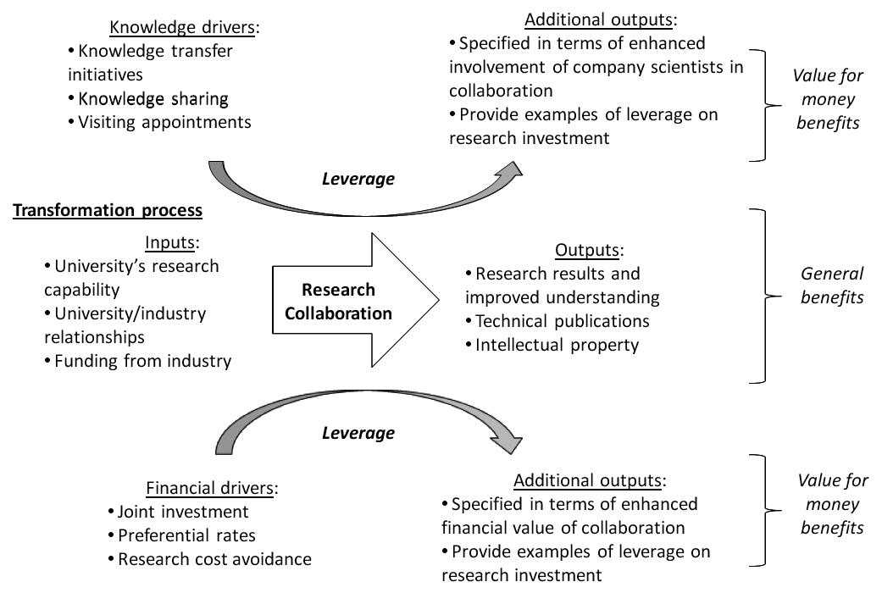

4 Case Study Application
The value for money model was initially investigated through a case study involving application to a university-industry strategic alliance over a two-year period. The strategic alliance is between Imperial College London (the university) and a leading UK scientific company and work funded at the university includes research in physics, materials science, chemistry and mechanical engineering. The company receives a large part of its funding from the UK government and so there is a need to continue justifying its investment in university research and it is in this context that the value for money model was implemented.
In order to apply the model, a number of specific parameters were identified, which had relevance to the strategic alliance and which could be periodically communicated to the company in order to establish the value for money attributes arising from the company’s investment in research programmes at the university. Table 2 provides details of these parameters together with corresponding metrics.
Table 2 Value for money parameters generated in case study investigation.

Value for money parameter | Metric
Knowledge drivers  - Participation by the company in a government funded programme to encourage knowledge transfer from universities to companies  - Appointment of company employees as visiting academics to undertake research or teaching at the university.  - Secondment of company employees to undertake PhD degrees at the university.  - Involvement of company scientists in departmental advisory committees and review boards for postgraduate degree programmes.  - Involvement of company scientists as industrial experts on multidisciplinary research programmes funded by government research agencies, e.g. EPSRC.  - Involvement of company scientists as industrial reviewers of PhD studentships funded by government research agency  Financial drivers  - Direct investment by the university through joint funding of major initiatives, e.g. capital expenditure for new experimental facilities to be used on industrially funded research programmes.  - Reduction in contract overheads applied as a form of preferential rate for research contracts with the company.  - Value of follow-on research projects generated.  - Access to university capabilities and facilities that may be utilised by company funded projects and associated company employees.*  - Major research council funded programmes that are aligned to the company’s R&T requirements.*  - Key academic appointments in areas relevant to the company’s research requirements.* | - No. of staff and value of projects (£).  - No. of staff.  - No. of staff.  - No. of staff.  - No. of staff.  - No. of staff and value of projects (£).  - Value of investment (£).  - Value of contract discounts (£).  - Value of projects (£).  - Value of facilities investments (£).  - Value of research programmes (£).  - Details of appointments.
* Related to research cost avoidance.

The parameters listed in Table 2 were incorporated into an annual report that is prepared by the university and submitted to a joint university/company strategic alliance board of management, which conducts a review of the overall progress of the alliance. This exercise was conducted for two successive annual reports thereby relating to progress of the strategic alliance over a two-year period. Feedback from senior company managers on the information supplied was highly positive and comments such as the following were received.
Company manager 1:
“This model is really useful as we can now use the data and information to continue making the case for our major investment in research at the university and in fact this material has been sent on to our main government sponsor”.
Company manager 2:
“What we really need is to quantify how we are leveraging our investment in university research and this tool really helps us with this”.
5 Conclusions
This paper has reported on a new conceptual model that identifies value for money attributes of university-industry research collaborations and which addresses the difficulties in the measurement of research contract and collaboration performance (Dodgson and Hinze, 2000). The model does however build on studies in the literature, which emphasise the importance of knowledge factors (Sampson, 2007; Santoro and Bierly, 2006) and financial factors (Gray and Steenhuis, 2003; Link, 1996) in determining the wider benefits arising from industrial investment in university research. Whilst there is not a specific category for social factors in the model, many of the activities detailed in the model’s parameters relate to social connections between the university and the company, such as the involvement of company scientists as industrial experts. Due to the underpinning nature of social capital in the collaboration process (Thune, 2007; Plewa and Quester, 2007) it is therefore important that this feature is reflected in the model.
Initial application of the model and use of the metrics has allowed the university to describe in detail the additional benefits arising from the research collaboration and which are specific examples of leverage from the industrial investment. This has helped the university to strengthen its alliance with the company and has contributed to the award of a number of research contracts for PhD and post-doctoral research projects. Further increased activity with the company has included a number of joint research workshops to identify new areas of research collaboration as well as joint investment in multidisciplinary research centres. Qualitative feedback and comments from the company’s management has confirmed the usefulness of the approach and the information provided.
These findings should help advance the understanding of how to measure, both qualitatively and quantitatively, the outputs of university-industry research collaborations and funded research contracts. Through improving the measurement of collaboration performance, companies will be able to more effectively translate basic research from universities into new products as part of the innovation process.
Future work is suggested on a wider application of the model across a larger selection of research collaborations and with different types of organisations. It is recognised that the current study has revealed preliminary findings through an initial application and so additional research should help further explore the model’s merits and any shortcomings.
6 References
Baba, Y., Shichijo, N. and Sedita, S. R. (2009) ‘How do collaborations with universities affect firms’ innovative performance? The role of “Pasteur scientists” in the advance materials field’, Research Policy, Vol. 38, Issue 5, pp. 756-764.
Burnside, B. and Witkin, L. (2008) ‘Forging Successful University-Industry Collaborations’, Research-Technology Management, Vol. 51, No. 2, pp. 26-30.
Chesbrough, H. (2003) Open Innovation: The New Imperative for Creating and Profiting from Technology, Cambridge, MA: Harvard Business School Press.
Ding, H. and Peters, L. S. (2000) ‘Inter-firm knowledge management practices for technology and new product development in discontinuous innovation’, International Journal of Technology Management, Vol. 20, Issue 5-8, pp. 588-600.
Dooley, L. and Kirk, D. (2007) ‘University-industry collaboration: Grafting the entrepreneurial paradigm onto academic structures’, European Journal of Innovation Management, Vol. 10, Issue 3, pp. 316-332.
Dodgson, M., Gann, D. and Salter A. (2008) The Management of Technological Innovation, Oxford University Press.
Dodgson, M and Gann, D (2010) Innovation: A Very Short Introduction, Oxford University Press.
Dodgson, M and Hinze, S. (2000). ‘Indicators Used to Measure the Innovation Process: defects and possible Remedies’, Research Evaluation, Vol. 8, No. 2, pp. 101-114.
Fleming, L. and Sorenson, O. (2004) ‘Technology as a Map in Technological Search’, Strategic Management Journal, Vol. 25, Issue 8/9, pp. 909-928.
Gray, D. O. And Steenhuis, H.-J. (2003) ‘Quantifying the benefits of participating in an industry university research center: An examination of research cost avoidance’, Scientometrics, Vol. 58, Mo. 2, pp. 281-300.
Griliches, Z. (1986) ‘Productivity, R&D and Basic Research at the Firm Level in the 1970s’, American Economic Review, Vol. 76, No. 1, pp. 141-154.
Hossain, L. and Fazio, D. (2009) ‘The social networks of collaborative process’, Journal of High Technology Management Research, Vol. 20, Issue 2, pp. 119-130.
Ireland, R. D., Hitt, M. A. and Vaidyanath, D. (2002) ‘Alliance management as a Source of Competitive Advantage, Journal of Management, Vol. 28, No. 3, pp. 413-446.
Iuan-Yuan, L., Chun-sien, W. and Chih-Jen, M. (2007) ‘Technology innovation and knowledge management in the high-tech industry’, International Journal of Technology Management, Vol. 39, Issue 1/2, pp. 3-19.
Kirkland, J. (2005) ‘Towards an integrated approach: university research management in an institutional context’, International Journal of Technology Management & Sustainable Development, Vol. 4, Issue 3, pp. 155-166.
Link, A. N. (1996) ‘Economic performance measures for evaluating government-sponsored research’, Scientometrics, Vol. 36, No. 3, pp. 325-342.
Philbin, S. (2008a) ‘Process model for university-industry research collaboration’, European Journal of Innovation Management, Vol. 11, No. 4, pp. 488-521.
Philbin, S. (2008b) ‘Measuring the performance of research collaborations’, Measuring Business Excellence, Vol. 12, No. 3, pp. 16-23.
Plewa, C. and Quester, P. (2007) ‘Key drivers of university-industry relationships: the role of organisational compatibility and personal experience’, Journal of Services Marketing, Vol. 21, No. 5, pp. 370-382.
Sammons, P. (2005) Buying Knowledge: Effective Acquisition of External Knowledge, Gower Publishing.
Sampson, R. C. (2007) ‘R&D Alliances and Firm Performance: The Impact of Technological Diversity and Alliance Organization on Innovation’, Academy of Management Journal, Vol. 50, No. 2, 364-386.
Santoro, M. D. and Bierly III, P. E. (2006) ‘Facilitators of Knowledge Transfer in University-Industry Collaborations: A Knowledge-Based Perspective’, IEEE Transactions on Engineering Management, Vol. 53, No. 4, pp. 495-507.
Schumacher, D. (1992) Get Funded! A Practical Guide for Scholars Seeking Research Support from Business, Newbury Park, CA: Sage Publications.
Thune, T. (2007) ‘University-industry collaboration: the network embeddedness approach’, Social and Public Policy, Vol. 34, No. 3, pp. 158-168.

