Proceedings of 2016 International Conference on Quality, Reliability, Risk,
Maintenance, and Safety Engineering (QR2MSE 2016)
2016 World Congress on Engineering Asset Management (WCEAM2016)
July 25-28, 2016, Jiuzhaigou, Sichuan, China
QR2MSE2016 & WCEAM 2016

Low Speed Bearing Condition Monitoring – A Case Study
Fang Duan¹, Ike Nze², Jinge Wang³, David Mba¹
1. School of Engineering, London South Bank University, London, SE1 0AA, UK
2. Capital Programmes Directorate, London Underground, London, SW1E 5ND, UK
3. School of Mechanical Engineering, Xihua University, Chengdu, Sichuan, 610039, P.R. China

Abstract
The heath condition of worm-wheel gearbox is critical for the reliable and continuous operation of passenger escalators. The vibration sensor has been widely installed in the gearbox and the vibration level is usually utilized as a health indicator. However, vibration level is not robust in slow speed bearing condition monitoring. In this paper, the health condition of two slow speed bearings was evaluated using vibration data collected from sensors installed in the shaft. It has been shown that the vibration level fails to indicator the bearing health condition. The assessment accuracy can be improved by combining several simple methods.

Keywords: condition monitor; slow speed bearing; worm-wheel gearbox; vibration
1 INTRODUCTION
London Underground (LU) is one of the world's oldest and busiest metro systems carrying excess of one billion passengers each year. The system serves 270 stations and total 11 train lines. In order to increase accessibility and cope with high passenger volume, LU manages 430 escalators within its stations for expeditious commuter movement during peak periods of travel. These escalators cope with heavier loads and up to 13,000 people an hour and run more than 20 hours a day. Escalator availability is essential for the prompt transport of passengers to and from the platforms. Therefore, it is tracked as a Key Performance Indicator (KPI) in LU performance reports released by the Mayor of London. Significant efforts have been made by LU to maintain the network escalator availability as high as above 95%.
LU escalators are driven by electric motors. Power from the motors is transmitted to the drive gear, which drives the escalator steps along with the chain, predominantly via a worm-wheel gearbox. Worm-wheel gearbox generates high friction compared to other gear types due to the entirely sliding action (as opposed to rolling) between worm and gear. Gearbox wear occurs during normal operation. Manufacturing tolerances, inappropriate installation poor maintenance and abnormal environmental conditions can accelerate gearbox wear [1, 2]. Hence, condition monitoring, regular inspection and maintenance are needed in order to obtain maximum usage and prevent from premature failure.
Preventive maintenance is the predominant mode of LU escalators service plan. Worm wheel replacements were carried out when wheel pitting damage was observed by maintenance crew. The assessment of the allowable pitting damage was dependent on crew experience and hence subjective; without the establishment of consistent criteria for the amount of pitting that will render worm wheel change necessary, premature replacements normally result in the wastage of otherwise useful worm wheel hours and additional labour costs. There has been a recent shift towards condition-based maintenance for greater effectiveness in manpower utilisation and machine-hour capitalization [3,4]. Condition monitoring is the process of machine health assessment while it is in operation. It not only can prevent an unscheduled work stoppage and expensive repair in the event of catastrophic failures but also can optimise machine performance, provide effective plan for scheduled maintenance manpower, and suggest the advance procurement of machine spare parts that need to be replaced to bring the machine back to health.
Condition monitoring through the use of vibration analysis is an established and effective technique for detecting the loss of mechanical integrity of a wide range and classification of rotating machinery. Equipment rotating at low rotational speeds presents an increased difficulty to the diagnostician, since conventional vibration measuring equipment is not capable of measuring the fundamental frequency of operation. Also, component distress at low operational speeds does not necessarily show an obvious change in vibration signature. Further details can be found in [5-8] Furthermore, in most of gears types, defects manifest as periodic impacts in the form of side-bands around the gear mesh frequencies [9]. However, such distinctive defect symptoms are not obvious for worm-wheel gearbox due to its continuous sliding interactions [10]. Therefore, diagnostics of a worm-wheel gearbox defects with vibration analysis is challenging. As a case study, vibration data of bearings from two stations was utilized to assess vibration based condition monitoring method. The current condition monitoring system provides a vibration level threshold to trigger an alarm before failure. However, this vibration level based method is not a robust indicator of bearing heath condition. The advanced signal processing method, such as spectral kurtosis kurtogram, envelope analysis and FM4* [11], or/and comprehensive assessments (e.g. acoustic emission [12]) are essential to improve accuracy.
2 Slow speed bearing Condition Monitoring
A main drive shaft of one of the LU escalators was selected to conduct condition monitoring. The shaft has two support bearings (SKF 23026 CCK/W33), spherical roller bearings, cylindrical and tapered bore, located at each end. The main drive shaft speed is 10 rpm. The calculated defect frequencies for the inner ring, outer ring and rolling element are 2.3, 1.87 and 1.58 Hz, respectively. The operating condition of the bearings was monitored by measuring vibration levels. Two vibration sensors (PRÜFTECHNIK VIB 6.127) were located at each end of the shaft, as shown in figure 1.

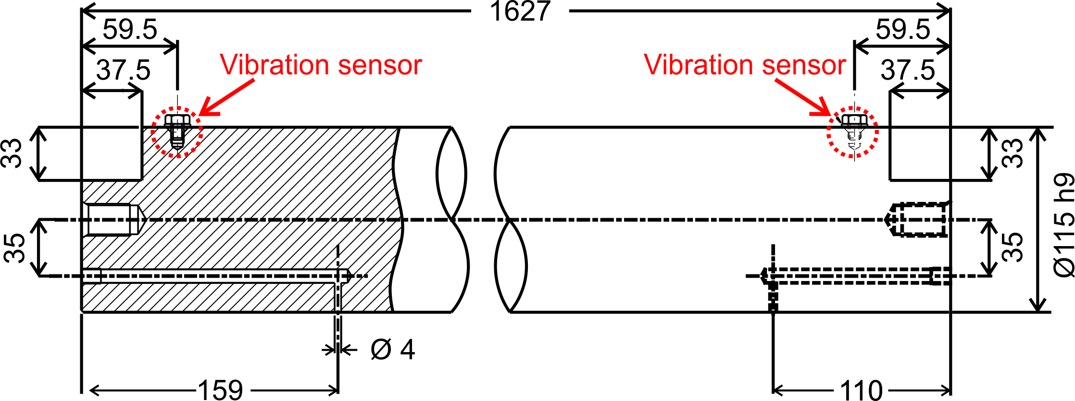

Figure 1 Shaft and vibration sensors
2.1 Vibration data analysis of Station A top shaft
The velocity overall trends of Station A top shaft left and right side are shown in figure 2(a) and (b), respectively. A threshold value of 2 mm/s is noted on the figures. In figure 2(a), the threshold was not exceeded at the shaft left side. However, on the right side the first observed data exceeding the threshold was noted in Oct. 2014. Thereafter several peaks above the threshold appeared in Jan. and Feb. 2015, as shown in Figure 2(b). After Feb. 2015, only a few peaks were observed before the bearing fault condition was identified in May 2015.

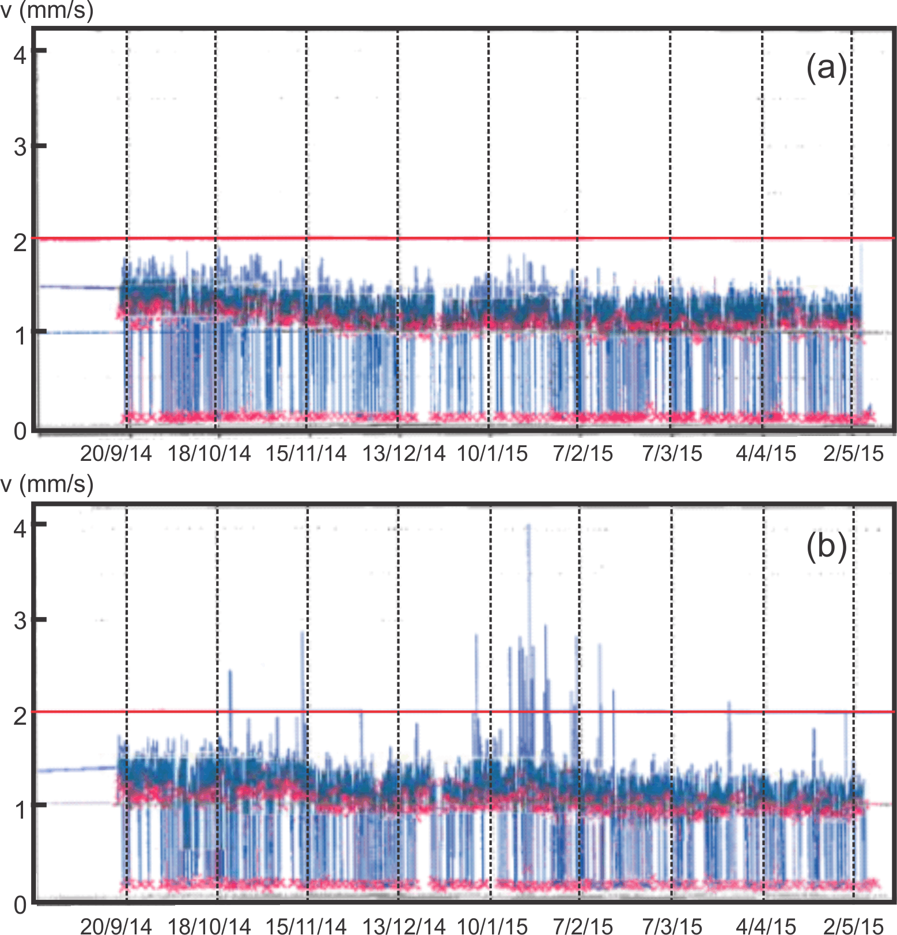

Figure 2 Velocity overall trends of Station A top shaft. (a) Left side vibration sensor; (b) Right side vibration sensor.

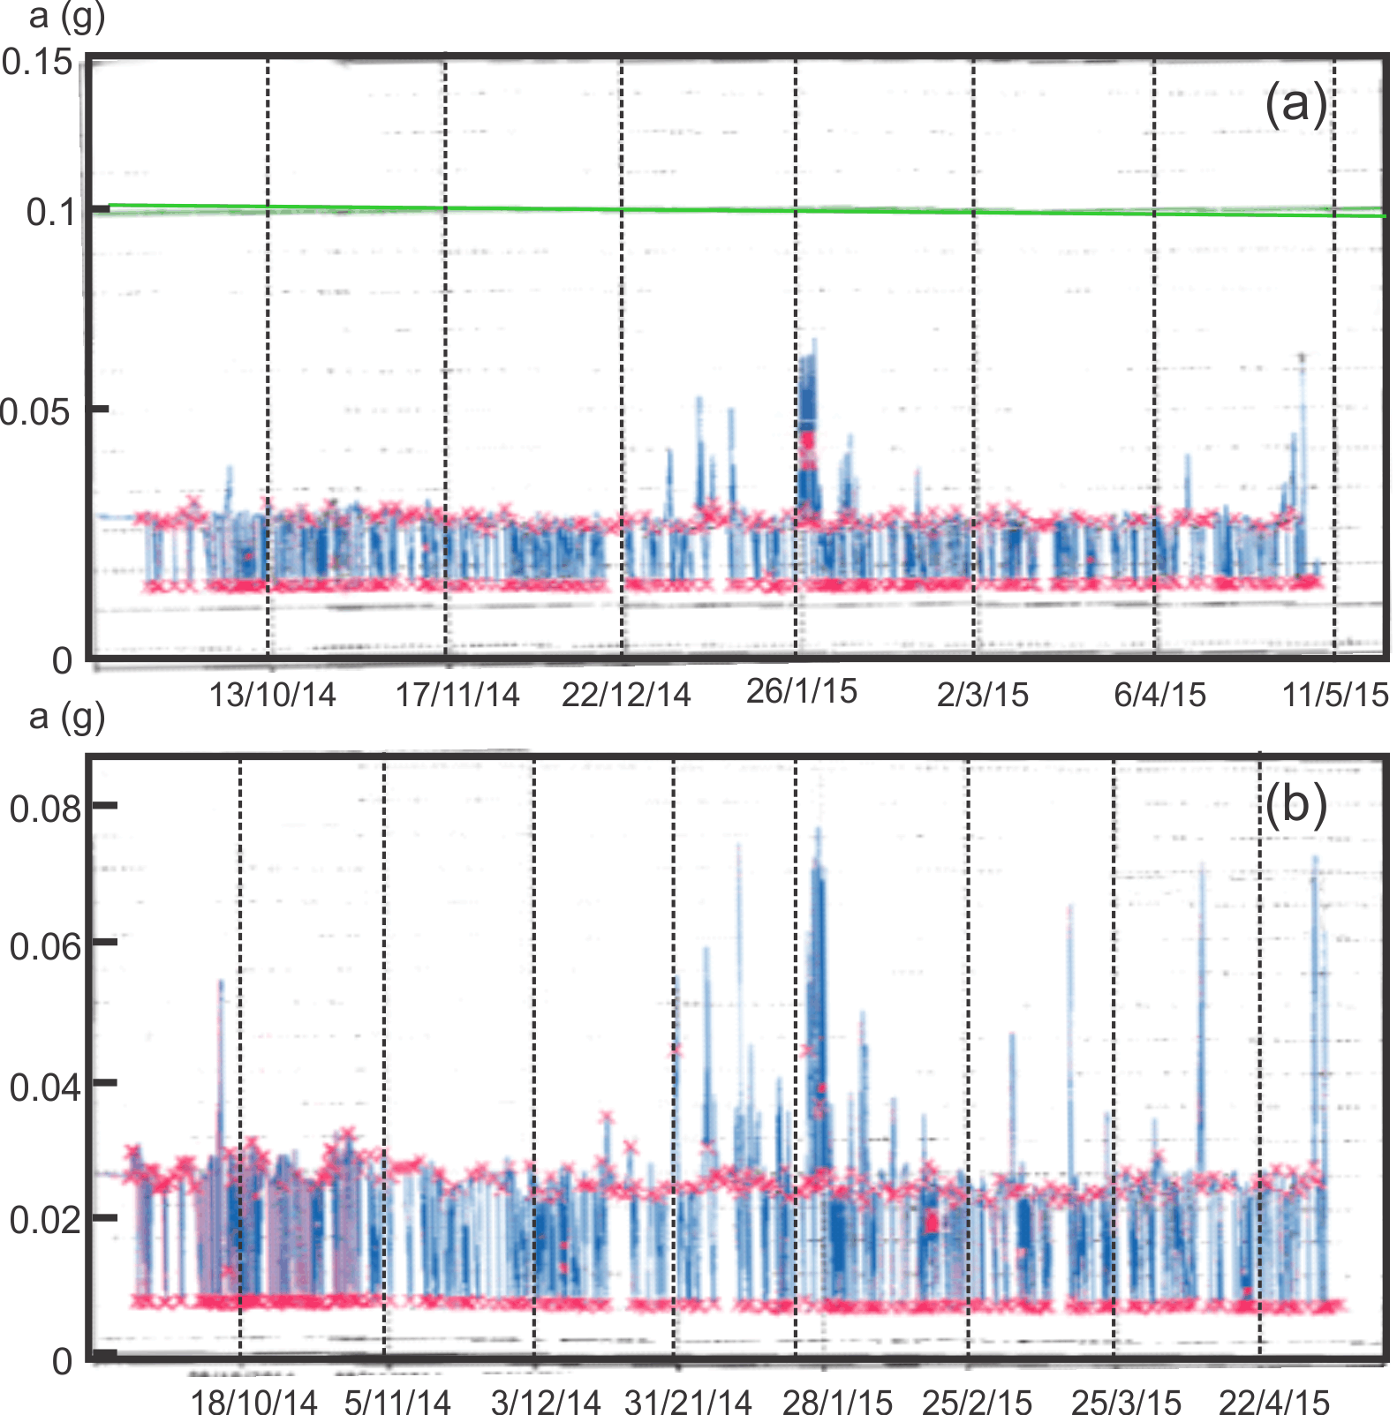

Figure 3 Acceleration overall trends of Station A top shaft. (a) Left side vibration sensor; (b) Right side vibration sensor.

The similar patterns were shown in acceleration overall trends of Station A shaft left and right side in Figure 3. It is known that damaged slow speed bearings will operate continuously irrespective of the level of damaged within the bearing. In some instances such damaged slow speed bearings have been known to completely grind away components within the bearing (rollers, cage) and for the shaft to eventually be supported by the bearing housing, leading to grinding of the shaft itself [13-16]. This implies that there are situations when the vibration of a damaged bearing will not increase with time due to increasing severity, on the contrary, the vibration may decrease. This is one of the reasons why other technologies have been assessed to give better indications of slow speed bearing condition [16,17].
2.2 Vibration data analysis of Station B top shaft
Vibration waveform data, typically acquired prior to post processing, from a similar machine at Station B top shaft left and right side was provided by LU. Figure 4 shows the vibration signal of top-shaft left in Mar. 2013. Total 307200 points are plotted in Figure 4(a). Zoomed data plots of 100000 to 110000, and 100000 to 101000 data points are shown in Figure 4(b) and (c), respectively. Figure 4 highlights what can only be described as transient events superimposed on underling vibration data. However closer observation of the data reveals the transient impact type events are not associated with electronic noise but are vibration type responses from the bearing. Such transient vibration events can be indicative of impending failure.
A time-frequency analysis and Fourier transform were undertaken on the vibration data. Figure 5 highlights that the transient vibration event contained frequencies of up to 100 Hz whilst figure 6 shows the spread of energy across 0 to 50 Hz, with the strongest energy concentration at 25 Hz. A FFT of the vibration data (data in Figure 4a) is shown in Figures 7. The shaft rotational speed is identified (0.17 Hz or 10 rpm) as well as several other peaks (0.43 Hz, 0.88 Hz and several multiples of 0.88 Hz). As the authors of this report do not have information of the exact machine configuration at Station B, the sources of these vibration peaks cannot be identified. However, it does suggest that such low frequencies can be measured with the currently employed sensors.
The distribution of vibration levels can also utilized as a health indicator. The vibration level of data in figure 4(a) is in the range of -5 and 4 mm/s. The distribution of vibration levels of these data points are grouped in 10 integral areas, as shown in Figure 8. For better visualization, the number of data points is plotted in the logarithmic. It can be seen that the vibration levels of most data points are within ±1 mm/s. A normal distribution is observed on a logarithmic scale. The same method is utilized to process all data of both left and right vibration sensor from Mar. to Aug. 2013 from Station A. The vibration level distributions of top shaft left and right vibration signal are shown in figures 9 and 10, respectively. It can be observed that deviation of left side of the vibration signal in Aug. is increased compared to the previous five months. On the contrary, there is not clearly pattern in the escalator top shaft right in figure 10. This bearing was not damaged.
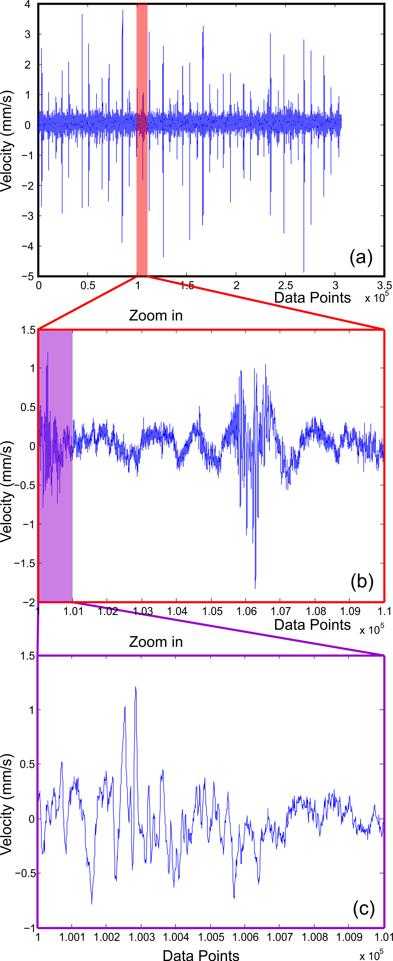

Figure 4 Top shaft left vibration signal. (a) Total 307200 points in March 2013; (b) Zoomed in data points from 100000 to 110000; (b) Zoomed in data points from 100000 to 101000

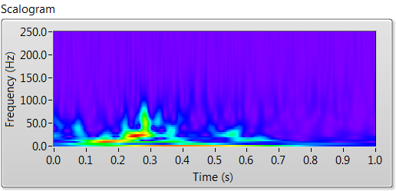
Figure 5 Time-Frequency plot of data displayed in Figure 4(c)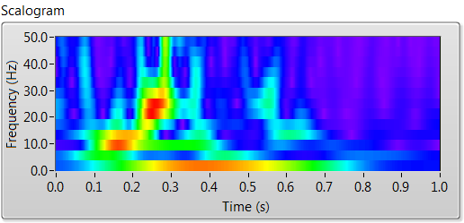
Figure 6 Zoom of time-Frequency plot of data displayed in figure 5
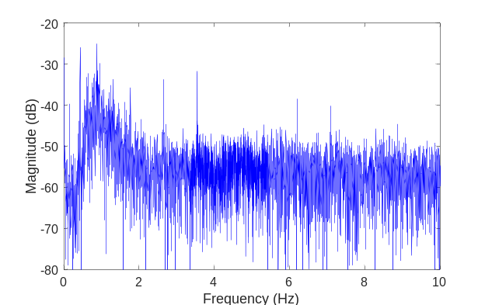
Figure 7 Spectrum of vibration data in figure 4(a)

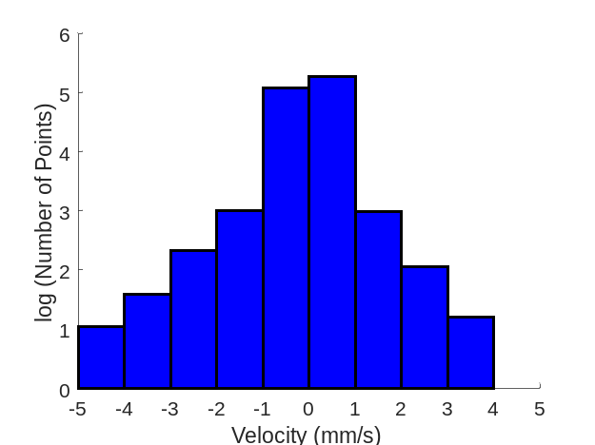
Figure 8. Top shaft left vibration level distribution. Number of point in the logarithmic scale.

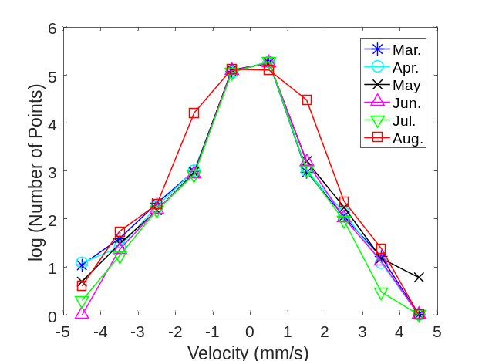
Figure 9. Top shaft left vibration signal from March to August 2013. Vibration level distribution in the logarithmic scale

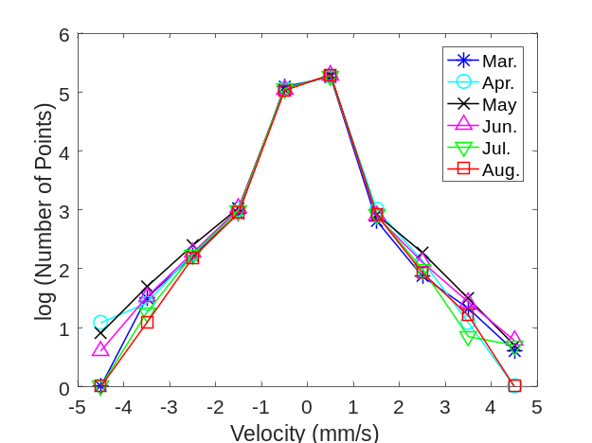
Figure 10. Top shaft right vibration signal from March to August 2013. Vibration level distribution in the logarithmic scale
3 Conclusions

Using vibration signal as a health indicator for a worm-wheel gearbox bearing is discussed in the paper. The case study shows the single vibration method cannot provide sufficient information for a condition assessment and combination of methods is recommended for meaningful analysis. An increasing or decreasing level of vibration can be attributed to slow speed bearing defects. This implies the interpretation of overall vibration data for slow speed bearings is not a robust indicator of condition. A better indicator may be trending vibration specific to a defined frequency or frequency bands.
References
- M. Elforjani, B. Charnley, D. Mba, “Observations of a naturally degrading slow speed shaft”, Nondestructive Testing and Evaluation,” vol. 25, no 4, pp. 267-278, 2010.
- M. Elforjani, D. Mba, “Monitoring the onset and propagation of natural degradation process in a slow speed rolling element bearing with acoustic” Emissions”, ASME, Journal of Vibration and Acoustics, vol. 130, 2008.
- D. Mba, N. Jamaludin, “Monitoring extremely slow rolling element bearings: Part-I”, NDT & E International, vol. 35, no. 6, pp. 349-358, 2002.
- D. Mba, N, Jamaludin, “Monitoring extremely slow rolling element bearings: Part II,” NDT & E International, vol. 35, no 6 pp. 359-366, 2002.
- K. Kuboyama, “Development of low speed bearing diagnosis technique”, NKK, Fukuyama Works, Fukuyama City, Hiroshima, Japan.
- R. G. Canada, J. C. Robinson, “Vibration measure- ments on slow speed machinery”. In Proceedings of Na- tional Conference on PredictiTe Maintenance Technology (P/PM Technology), Indianapolis, Indiana, vol. 8, No. 6, pp. 33- 37, 1995.
- J. C. Robinson, R. G. Canada, R. G. Piety, “Vibration monitoring on slow speed machinery: new methodologies covering machinery from 0.5 to 600 rpm”. In Proceedings of the Fifth International Conference on Profitable Condition Monitoring-Fluids and Machinery Performance Monitoring, BHR Group Publication (BHR Group, Cranfield), vol. 22, pp. 169-182, 1996.
- J. E. Berry, “Required vibration analysis techniques and instrumentation on low speed machines (particularly 30 to 300 rpm machinery)”. In Technical Associates of Charlotte Inc., Advanced Vibration Diagnostic and Reduction Techniques, 1992.
- D. Alan, Handbook of the condition monitoring techniques and methodology, Chapman and Hall, London, UK, 1998.
- P. Vahaoja, S. Lahdelma, J. Leinonen, “On the condition monitoring of worm gears”. London: Springer, pp. 332–43, 2006.
- F. Elasha, C. Ruiz-Cárcel, D. Mba, G. Kiat, I. Nze, G. Yebra, “Pitting detection in worm gearboxes with vibration analysis”, Engineering Failure Analysis, vol. 42, pp. 366-376, 2014.
- M. Elforjani, D. Mba, A. Muhammad, A. Sire, “Condition monitoring of worm gears”, Applied Acoustics, vol. 73, no. 8, pp. 859–863, 2012.
- N. Jamaludin, D. Mba, R. H. Bannister, “Monitoring the lubricant condition in a low-speed rolling element bearing using high frequency stress waves,” Journal of Process Mechanical Engineering, I Mech E, vol. 216, Part E, pp. 73-88, 2002.
- N. Jamaludin, D. Mba, R. H. Bannister, “Condition monitoring of slow-speed rolling element bearings using stress waves”. Journal of Process Mechanical Engineering, I Mech E. Pro. Inst. Mech Eng. vol. 215, Part E, no. E4, pp. 245-271, 2001.
- D. Mba, R. H. Bannister, Mr. G. E. Findlay, “Condition monitoring of low-speed rotating machinery using Stress Waves: Part I”, Journal of Process Mechanical Engineering, I Mech E. Pro. Inst. Mech Eng. vol. 213, Part E 1999.
- D. Mba, R. H. Bannister, Mr. G. E. Findlay, “Condition monitoring of low-speed rotating machinery using Stress Waves: Part II”, Journal of Process Mechanical Engineering, I Mech E. Pro. Inst. Mech Eng. vol 213, Part E 1999.
- D. Mba, “Applicability of acoustic emissions to monitoring the mechanical integrity of bolted structures in low speed rotating machinery: case study,” NDT and E International, vol. 35, no. 5, pp. 293-300. 2002.

Corresponding Author: duanf@lsbu.ac.uk Tel: +44-20-7815 7578.

