Adoption Central England Conference
Tuesday 27th September 2022

Effective Personal and Professional Judgement for panel members
Dr Arlene P Weekes

The presentation is based on a six-year study that examined how the personal and professional viewpoints of persons who serve on the adoption and fostering panel affect the work they do and the recommendations they make.

Abstract
In the UK, recommendations to approve adoptive parents and foster carers, and to determine which child is placed with which alternative parent or carer, rest with specialist panels. While the formal role and function of these panels are clear, there is concern that their composition, and the biographies and professional characteristics of members, could introduce bias and influence the decisions made. This study examined the validity of these concerns by observing the operation of 8 agencies, 15 panels, and interviewing 22 panel members. It was found that, although the panel system achieves its aims in terms of having a representative constitution and providing considered recommendations in a timely manner to senior managers, individual biography affects panel members in carrying out their role to an unexpectedly high degree, possibly leading to flawed decisions. Actions to help remedy this problem, at both an individual and group level, are suggested, including the use of the concept of Effective Personal and Professional Judgement (EPPJ).

1.0 Introduction
The idea for this topic of study began many years ago when I chaired a local authority adoption panel. During that time, I had many experiences which led me to question how panel members’ personal experiences and beliefs either positively or negatively contribute to their recommendations. These questions intensified as I continued to encounter professionals and panel members who clearly believed that they were acting in a completely objective and impartial way – that their values and personal experiences had absolutely no bearing on their judgement. Aware of the large body of evidence which shows that, as humans, it is impossible for us to be totally objective, I decided to research the question of how this lack of objectivity impacts us as social workers. In particular, I set out to answer a number of specific questions including: (a) In what ways do adoption and fostering panel members’ biographies, attitudes and values influence their role occupancy and recommendation making? (b) To what extent does a panel member’s conceptualisation of their professionalism impact on their role in the panel? (c) What are the group processes at play when panels make their recommendations?

2.0 Literature review
My exploration of the current state of knowledge included a historical overview, looking at how decisions were made alongside the legislative framework, specifically the 1976, 2011 and 2004/5 changes, as well as reviewing the limited number of research studies that had been carried out. To understand the current panel system, it is important to understand what came before. In fact, today’s panels have evolved from a less formally structured type of panel. In The Child’s Generation, Packman (1975) describe how it was the role of Child Care Officers to find, vet, match and supervise foster homes, and forge links between the child, their family and the foster family. Packman noted that the completed application would be considered by a panel comprised of agency representatives, who would make recommendations about suitability. However, the interviews undertaken by Prynn (2008) illustrate the subjectivity of many of social workers at the time, while Pennie (1993) found in her study that the attitudes and values of panel members, could lead to inconsistent outcomes dependent upon which members were in attendance. Additionally, Selwyn (1991) reported that adopters were often critical of the role of the panel, finding the system to be distant and unaccountable.
These criticisms led to a few studies that explored the workings of panel and their effectiveness. Miller and McNeish (1993), for example, found that panel members felt that speaking directly to applicants enabled them to gain a more balanced view of applicants, while a study by O'Sullivan (2004 & 2005) focused on the effectiveness of panels. After an analysis of inputs (reports and responses by attendees), processes (questions, answers and discussions), and outputs (recommendations, minutes and decision of the agency decision-maker), O’Sullivan found that quality output by panels depended critically on clear inputs.
As panels are made up of individuals, theories of thinking and personal development are clearly important. My PhD was undertaken at the Tavistock and Portman clinic, so it is perhaps not surprising that I looked at the work of Klein (1940, 197 ), Bion (1961 and 1962) and then Baron (1994), exploring how the self was determined through a process of splitting: an infant is filled with good and bad fantasies of self and others. This leads to the transference of negative internal feelings to an object (mother) in a process called ’projective identification’ - namely, the self is split off and projected into an object. As a person grows, so does their self and moral awareness. I followed this with a review of the literature on passions and values, starting with Bethan and Mill from the 19th century, through to Kohlberg (1958) and Zajonc (1980). Particularly noteworthy was the work of Schwartz (1992), who developed a theory of basic human values, arguing that values, including religious beliefs and views about others, are at the core of an individual’s self-concept.
In her examination of the descriptive and prescriptive approaches to decision theory and decision-making in child protection, Munro (2008) highlights the emotive and logical characteristics of decision-making and emphasises the interdependence of intuitive and analytical thinking - the former being more emotionally driven, and the latter using more overt cognitive skills. Peterson (2009) explored the concept of rational decision-making, concentrating on descriptive decision theories which explain the observed behaviours of decision-makers, as opposed to normative theories which seek to explore the calculations relating to what decision-makers are rationally expected to do.
There are some parallels, in terms of decision-making, between panels and juries. Bornstein and Greene (2011), for example, found that jurors evaluate information presented based on personal experience and knowledge; the emotiveness of jurors therefore affects information processing and decisions. In their research on the way judges operate, Bornstein and Miller (2009) found that a judge’s religion, and other background factors, influence decision-making, so judges are not as objective as many believe. Basing their decisions only on legislation and evidence.
Perhaps surprisingly, however, people seem to be less affected by their personal values and beliefs when on jury service than in other walks of life. A study by Pigott and Foley (1995) showed that jurors tend to be self-aware and personally biased during their deliberations, due to the need to publicly articulate their reasons for their views on a case. Jurors are more inclined to change their original views in favour of a majority decision in line with other jurors.
Of course, minimising personal bias and pre-decisional distortion is a good thing, but this does not address the problems associated with group decision-making, which may also give rise to ‘groupthink’. This was first identified by Irving Janis in 1982, and stems from his observation that the psychological pressures created by facing a common crisis generate a strong tendency to collaborate. This can result in a mode of thinking in which the desire to achieve group unanimity overrides individual freedom. Baron (1994) added to Janis’ work by showing that irrational and biased thinking is also evident in a closed group, indicating another group-level behavioural phenomenon that often leads to flawed decisions, while Hafsi (1999), found that people come to groups with a positive preconception, and often an idealised view of participating in a group. Other studies, such as the work of Peterson (2009), have explored the concept of rational decision-making, particularly in terms of descriptive decision theories, based on expectations of what will actually happen, and normative theories based on judgements of what should happen.

3.0 Methodology
With the aim of exploring and analysing the conscious and unconscious influences that individuals panel members use to construe the world, and how these contribute to recommendation-making, the methodology was constructivist-interpretivist in nature – i.e. based on the theory that knowledge is not found, but constructed and developed through the relationships and interactions between individuals. This challenges the objectivist perspective that there is just one external truth (Crotty, 1998).
Particularly important was the use of narrative interviews. According to Riessman (2008) this approach lends itself to the analysis of narrative, and he provides four options for analysing the data: structural analysis, dialogue, performance analysis and thematic analysis. Clandinin (2000) highlights the benefits of narrative as epistemology and describes a method of capturing the subject(s) with a three-dimensional approach: time, space/situation, and relationships (including that with the researcher).

4.0 Data collection
The source of data for this research was narrative interviews with 22-panel members. The interviews were carried out using the BNIM Biographic Narrative Interview Model. Alongside 15 panel observations, these were triangulated with the minutes from the panels observed. Below is an account of the two main sources and the subsequent findings.

4.1 Data profile
Interviewees
A breakdown of the data by key characteristics was:
Sex: The male: female breakdown of interviewees was 36% : 64%.
Ethnicity: white (UK) – 50%; white European – 5%; Asian – 18%; South Asian – 5%; African – 9%; Caribbean – 5%; Black British – 5%; mixed ancestry – 5%.
Occupation: social workers – 32%; fosterers – 18%; retired – 9%; psychologist – 9%; doctors – 5%; nurses – 5%; administrative – 5%; councillors – 5%; police community – 5%; early years 5%; solicitor – 5%; unemployed – 5%.

Type and location of panels
Panel type: Fostering (LA) – 50%; Fostering (IFA) - 12.5%; Joint - 12.5%; Adoption (Voluntary) - 12.5%; Adoption (LA) - 12.5%.
Panel Region: London (inner) - 25%; London (outer) - 25%; East Midlands - 25%; West Yorkshire - 12.5%; West Country - 12.5%

5.0 Narratives
5.1 Aspects of self brought to panel
Participants were asked to share their experiences using the Biographical Narrative Interview Model (BNIM) which is a semi-structured interview This begins with a single open question which Wengraf (2004) calls a ‘SQUIN’ (Single Question Aimed at Inducing Narrative). The opening question was:

“As you know, I am researching the lives of people who are part of adoption and fostering panels. So, can you tell me the story of your life, including being a member of panel, up to now all those events and experiences that are important to you personally. Start wherever you like, I won’t interrupt, I will just be taking some notes in case I have any further questions for after you’ve finished telling me about it all.”

This interpretation-based analysis examined how the interviewee told their story and how they lived their lives and any patterns that emerge. This provides insights into how the lived life was constructed. The BNIM process begins with a biographical data analysis (BDC), then a thematic field analysis (TFA) and finally examines the phases of subjectivity (SSS). A 3-Column Summary is shown in Figure 1.

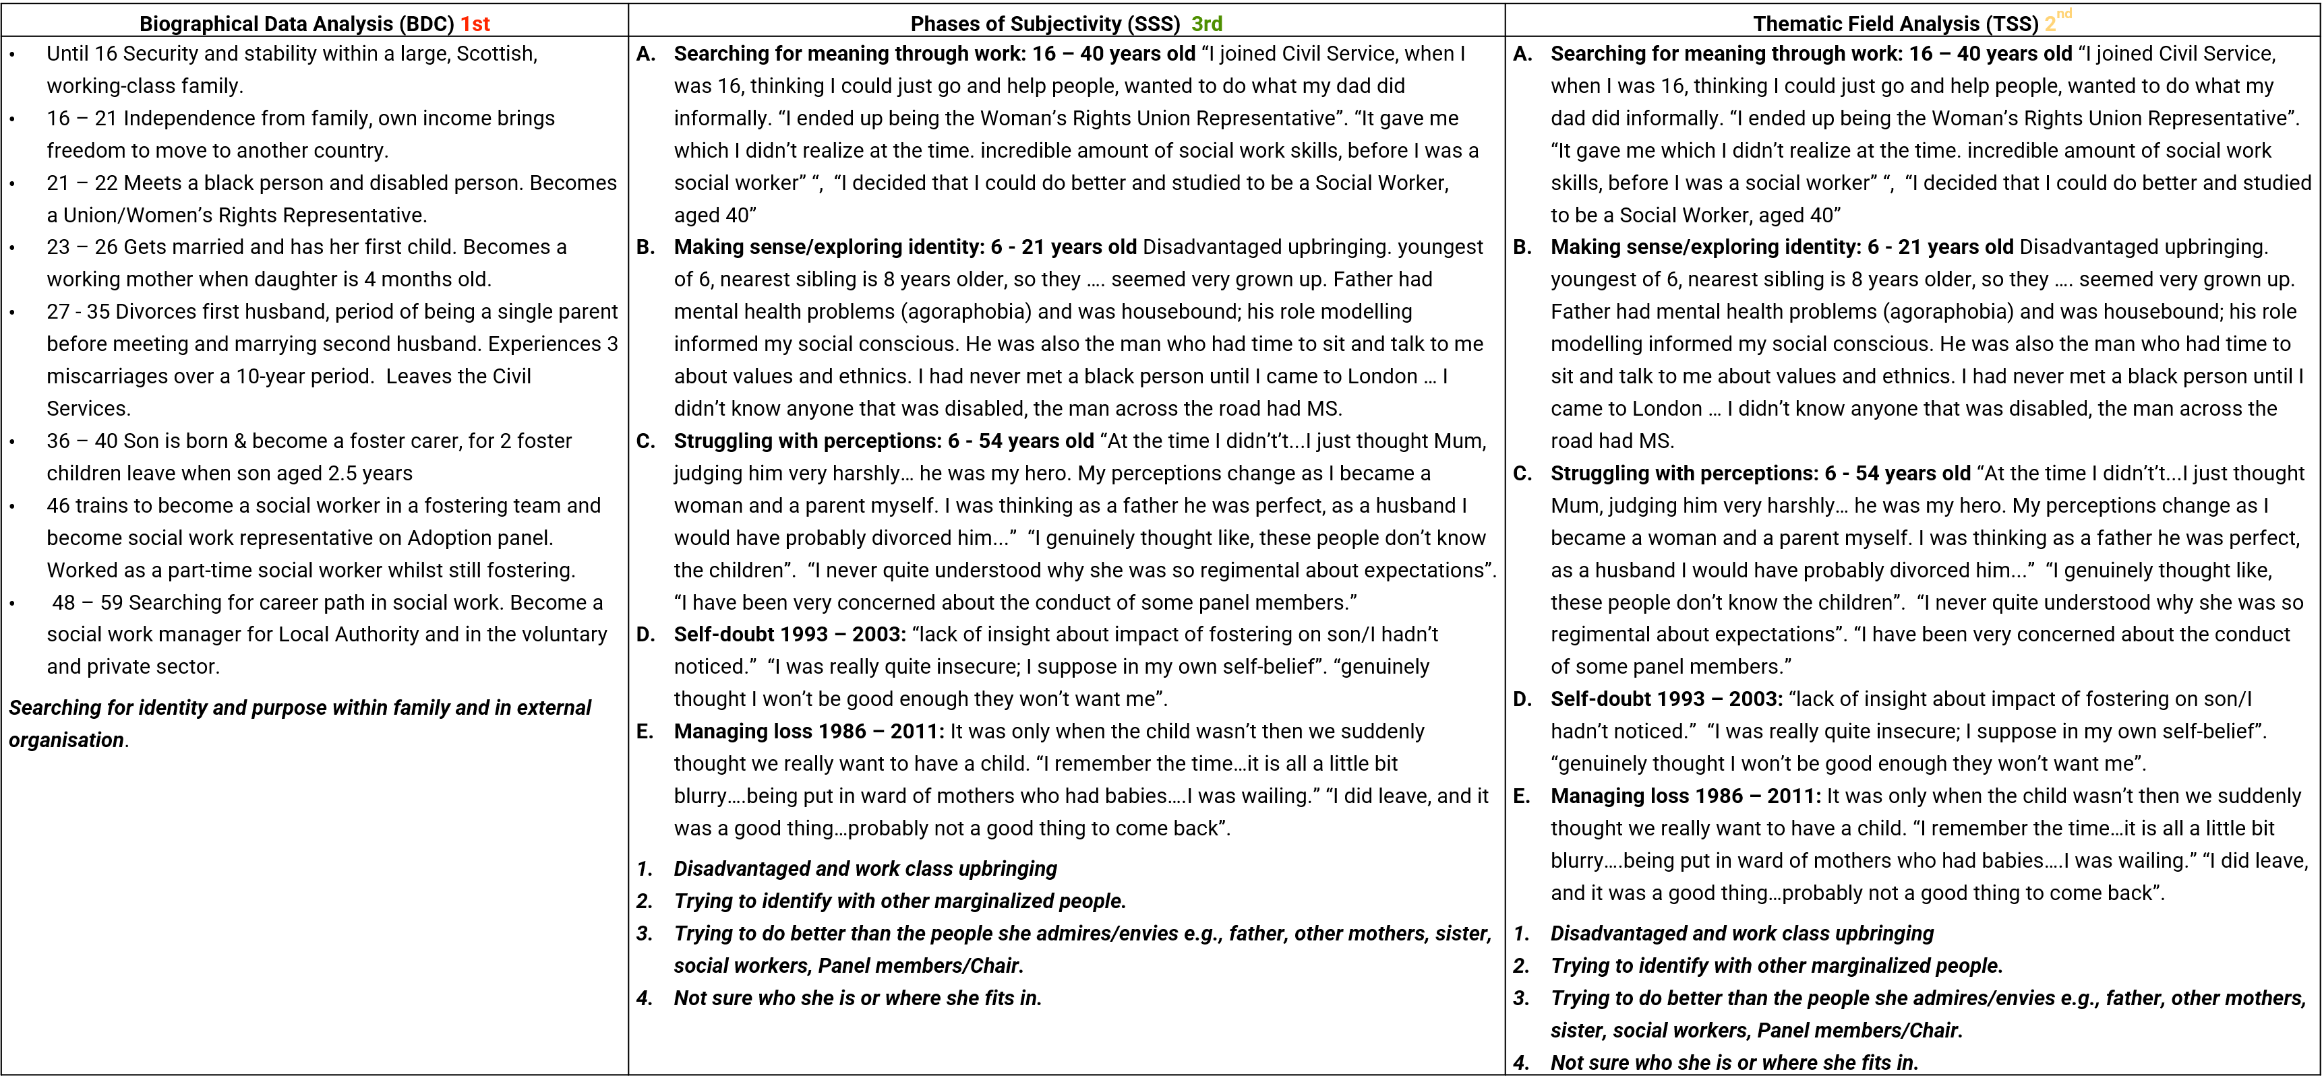
Figure 1: A 3-column summary of interview analysis

When all the interviews are completed, the summarised data is presented to the BNIM interpretative panel. The aimed of this is to minimise the subjectivity of the researcher and any blind spots they may have. The BNIM panel is tasked with broadening the structural hypotheses supplied for each respondent as a tool for making sense. Without this, the analysis would only yield the researcher's interpretation of the interview.
Each interviewee offered a unique personal experience and a perspective on their panel role. The BNIM processes illustrates both the uniqueness and similarities of panel members’ narratives and, based on their individual life histories, what they contribute to the panel task either positively or negatively.

5.2 Column Summary of each case
Cross-case theorisation via thematic field analysis provides an understanding of the interviewee’s life through their biographical narrative, illustrating that their social construction of their world is personal. Most of the interviewees’ narratives demonstrated three broad themes. Although these themes may not be surprising, the detail of the sub-themes may be more so. These include family (significance of parent(s) in worldview; significance of another family member; harm caused by a family member and position in the family); occupation (education as a form of liberation and professional kudos) and community (significance of class or racial identity to experiences of and in the world, and community responsibility). These ideas are illustrated in Figure 2 and Figure 3.

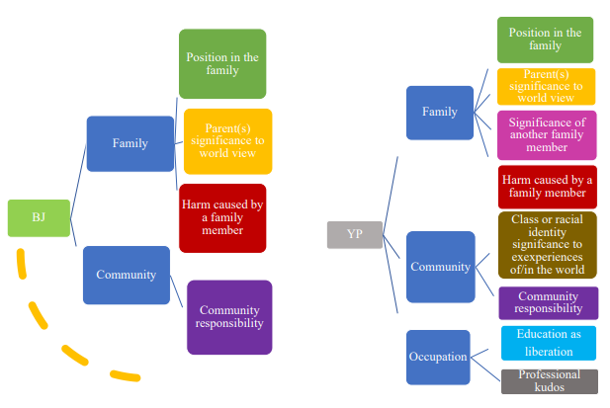
Figure 2: Themes and sub-themes identified from narratives.

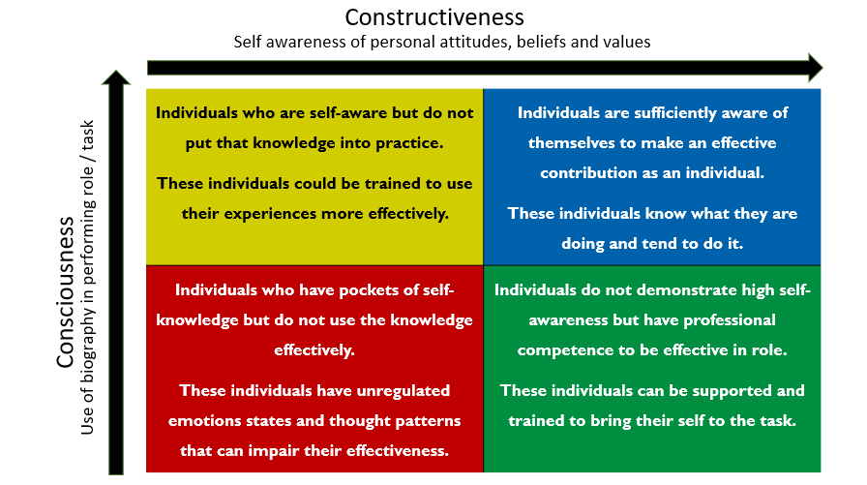
Figure 3. The quadrants of the Consciousness-Constructiveness Axis (CCA)

5.3 Narrative findings
The narratives derived from the interviews underlined the generally accepted fact that people have complex histories, views and personalities and that these influence the behaviour and performance of panel members in a variety of ways. For example, most panel members were either unaware of, or not in control of, their unconscious personality characteristics, which led to the projection of their views or attitudes onto social workers and applicants. Other panel members attempted to put aside their biographies when in a work context, often leading to an arid professional stance, negating the richness of experience they could bring to their relational and emotive role. Overall, the study showed that panel members could be categorised into four groups, each characterised by different levels of consciousness (awareness of their own views and attitudes) and constructiveness (the ability to take account of biography in performing their role/task).

6.0 Panel observations crossed referenced using the panel minutes
The findings of the study were compared with the concerns raised about panels in the Foster Care in England Review (Narey and Owers, 2018). Although there is no evidence that panels cause delay for children, the study indicated that some panels could function more efficiently in terms of attention, panel size, and the amount of time allocated to discussion. Most of the observations found that the composition of the panels' central lists was representative, though the influence of panel members’ race, disability, sexual orientation, class, and gender on their recommendation-making requires more study. There were some variations in the length of time allocated to hearing each case, and there is evidence that the competency and skill of the chair are critical in deciding whether the panel keeps on task and is able to carry out its duties efficiently. As a model, the court system represents an effective framework for conducting panels, in which a clerk or legal adviser informs judges and, in certain instances, jurors on the boundaries of their duty. Some authorities employ a system in which a (professional) independent panel advisor directs the panel in their assigned duties. Together with the Chair's expertise, their teamwork guarantees that the panel formulates clear, succinct questions and makes transparent recommendations. While it is true that certain local authority fostering panels no longer have a panel adviser, this study argues that this often results in poor use of panel time.

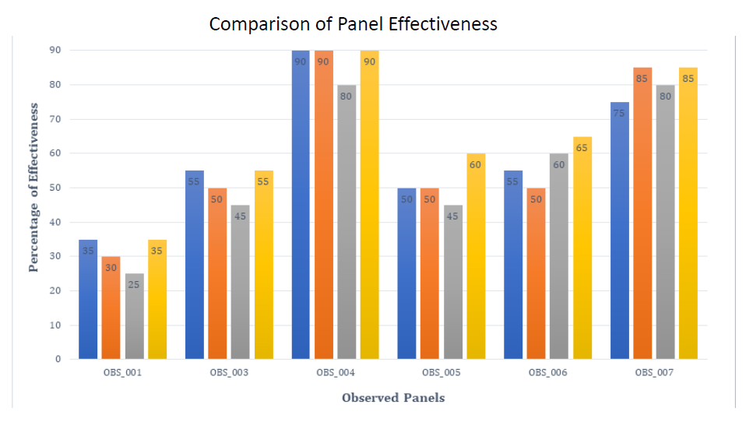
Figure 4. Comparison of panel effectiveness

6.1 Observation Findings
Panels were compared in terms of membership, effectiveness and delay. Panel effectiveness comprised four components: task focus, structure, professionalism and scrutiny. In general, the study showed that, where panels were well managed, they were also more transparent and less prone to ‘groupthink’ – the tendency to suppress individual freedom of expression in the interests of group cohesiveness (Janis, 1982). In these well-managed panels, ideas were critically and thoroughly examined, allowing further time for discussion, where necessary, before finalising decisions (see Figure 4).

7.0 Effective use of personal and professional judgement (EPPJ)
Of relevance to this study are the thoughts of Carl Jung (1961) on the Wounded Healer. He writes:

“ ….. The need for self-criticism …… No analysis is capable of banishing all unconsciousness forever.
The analyst must go on learning endlessly, and never forget that each new case brings a new problem
to light and thus gives rise to unconscious assumptions that had never before been constellated.
We could say, without too much exaggeration, that a good half of every treatment that probes
at all deeply consists in the doctor’s examining himself for only what he can put right in himself
can he hope to put right in the patient …… This, and nothing else, is the meaning of the
Greek myth of the wounded physician.” (Jung 1993, p 121)

The consciousness/constructiveness axis discussed earlier (Figure 3) was the basis of the development of the EPPJ model. This essentially encourages decision-makers to recognise, analyse and adapt personal values and preferences to help them become more professionally proficient, particularly in relation to decisions about others. As well as thinking about how they can, as individual panel members, self-manage, panel members should be assisted by the panel chair in self-regulating. ‘Good’ panels and teams, ‘held’ by a panel chair or manager, can be supported in using their personal biographies to function effectively. Similarly, some members are guarded about what they share, yet demonstrate an ability to remain on task. However, they need encouragement to be more empathetic, and to develop a less officious manner. The understanding and use of more EPPJ is a first step.

8.0 Discussion and recommendations
In all, the study made 18 recommendations, grouped under 4 categories: task focus, structure, professionalism and scrutiny. Details can be found in the Appendix.

Agencies should implement more rigorous recruiting and selection procedures for both prospective internal and external panel members. Panel membership should not be seen as a variety of paid volunteer work, and training (for panel members) should be increased to twice yearly, with one session devoted to an annual update on the panel's purpose and function. The tasks of panel administrators should be clearly stated, and they should be reminded of the need to adhere to the constraints of their nonvoting position. All personnel engaged in presenting, including social workers, team managers, panel members and the ADM, should be educated in the application of effective personal and professional judgement (EPPJ).

9.0 Conclusion
Complex processes are at play when individuals come together in groups to make recommendations. This study rejects the view that it is possible to completely avoid stereotypes and generalisations, and argues that panel members should be helped to construct an internal and external defence against unconscious influence, through the use of Effective Personal and Professional Judgement (EPPJ). This is intended to enable panel members to be more conscious of their own biases, and thus strive to make non-discriminatory recommendations. Agencies need to be more transparent and stringent in their recruitment of panel members, by examining the personal and social values which drive individuals and, therefore, panel judgements. Key to making effective recommendations is pre-panel quality assurance to reduce bias from assessors, as well as diligent scrutiny of reports and effective facilitation that enables members to focus on the task in hand.

References
Baron J (1994) Thinking and Deciding (2nd edn). Cambridge, UK/New York: Cambridge University Press.
Bion WR (1961) Experiences in Groups. London: Tavistock Publications.
Bion WR (1962) The psychoanalytic study of thinking. International Journal of Psycho-Analysis 43: 306–310.
Bion, W., R, Rosenfeld, H., & Segal, H. (1961). Melanie Klein. International Journal of Psycho-Analysis, 42, 4-8.
Bornstein, B. H., & Greene, E. (2011). Jury decision making: Implications for and from psychology. Current Directions in Psychological Science, 20(1), 63-67.
Bornstein, B. H., & Miller, M. K. (2009). Does a judge’s religion influence decision making?
Clansinin, D.J and Connelly,F.M (2000) Narrative Inquiry:Experience and Storyin Qualiyative Research. San Francisco, CA: Jossey-Bass
Crotty, M.(1998) The Foundations of social work research: meaning and perspectives in the research process. London. Thousand Oaks, C.A. Sage publication
Hafsi, T. (1999). Changing Complex Organizational Systems: The Pull Between Fundamentals and Trivia. In Relations of Complex Organizational Systems (pp. 85-114): Springer.
Janis IL (1982) Groupthink: Psychological studies of policy decisions and fiascoes (2nd edn). Boston, MA: Houghton Mifflin.
Jung C.G. (1961) The Practice of Psychotherapy. 2nd edn. Londong: Routledge.
Klein, M. (1975) Envy and Gratitude and Other Works 1946–1963. London: Hogarth Press and Institute of Psychoanalysis.
Klein, M. (1940). Mourning and its relation to manic-depressive states. International Journal of Psychoanalysis, 21 : 125-153.
Kohlberg, L. (1958) The development of modes of moral thinking in the years ten to sixteen. Unpublished PhD thesis. University of Chicago.
Miller, L. B., & McNeish, D. (1993). Paramountcy or partnership? Applicants attending adoption panel. Adoption & Fostering, 17(4), 15-22.
Munro, M. J. (2008). Foreign accent and speech intelligibility. Phonology and second language acquisition, 5, 193-218.
Narey, M. and Owers, M. (2018) ‘Foster Care in England Review’. The Stationery Office. Available at: https://assets.publishing.service.gov.uk/government/uploads/system/uploads/attachment_data/file/679320/Foster_Care_in_England_Review.pdf (Accessed: 28 December 2019).
O'Sullivan, T. (2004). Inputs to an adoption panel: a case study. Adoption & Fostering, 28(3), 41-51.
O’Sullivan T (2005) Processes and outputs of an adoption panel: A case study. Adoption & Fostering 29(3): 21–32.
Packman, J. (1975) The Child’s Generation: Child Care Policy from Curtis to Houghton. Oxford Blackwell
Pennie P (1993) Adoption panels: Room for improvement. Adoption & Fostering 17(2): 44–47. doi: 10.1177/030857599301700210
Peterson, M. (2009) An introduction to decision theory. New York: Cambridge University Press.
Pigott, M. A., & Foley, L. A. (1995). Social Influence in Jury Decision Making. Trial Dipl. J., 18, 101, 102.
Prynn, B. (2008). Reflections on past social work practice: The central role of relationship. The critical practitioner in social work and health care, 97.
Riessman, C. K. (2008). Narrative methods for the human sciences: Sage.
Schwartz, S. H. (1992) ‘Universals in the Content and Structure of Values: Theoretical Advances and Empirical Tests in 20 Countries’, in Zanna, M. P. (ed.) Advances in Experimental Social Psychology. Elsevier, pp. 1–65. doi: 10.1016/S0065-2601(08)60281-6.
Selwyn, J. (1991) ‘Applying to Adopt: The Experience of Rejection’, Adoption & Fostering, 15(3), pp. 26–29. doi: 10.1177/030857599101500307.
British Association of Social Work (2021) ‘There’s no such thing as Non-judgemental’, Professional Social Work, pp. 28-29
The Fostering Network (2021) ‘Rethinking fostering and adoption panels’, Foster Care magazine pp.17
Adoption & Fostering (2022)The biographic and professional influences on adoption and fostering panel members' recommendation-making Volume 45, Issue 4
Wengraf T (2004) Qualitative Research Interviewing: Biographic narrative and semi-structured methods. Thousand Oaks, CA: Sage Publications.
Zajonc, R. B. (1980). Feeling and thinking: Preferences need no inferences. American Psychologist, 35(2), 151–175. https://doi.org/10.1037/0003-066X.35.2.151

Appendix
Recommendations
Task focus (ability to remain on task verse going outside the remit):
- Agencies should develop more robust recruitment and selection processes for both internal and external potential panel members
- Interview questions recommended by the Warner Report to be used.
- Panel membership should not be viewed as a type of paid volunteering role (The Cambridge Dictionary defines volunteering as ‘to offer to do something that you do not have to do, often without having been asked to do it and/or without payment’).
- Exploration of the development of supervision and support structures for panel members.
- Panel Chairs and Panel Advisor to monitor panel members’ projections via their questions and responses in panel and to panel reports, where they may be exemplifying, for example, a ‘rescue’ mentality, and address these in an appropriate and timely manner.
- Panel member reviews should be known as appraisals, in order to constructively explore the extent to which panel members remain effective and still have ‘current currency’. If they are no longer suitable to remain in role, agencies should have transparent processes to terminate employment.
- Return to a fixed-term length of panel membership, as opposed to the current indefinite term.
- Panel-member training to increase to twice a year, one session of which should be an annual update on the role and function of panel, e.g., conformational bias, groupwork and anti-discriminatory practice.
- All new panel members should have a robust induction to include shadowing of or mentoring by an experienced panel member, who can assist the new member with the reading of paperwork and the formulation and asking of questions at panel.
- All individuals involved in presenting, social workers, team managers, panel members and ADM, need to be trained to make effective use of personal and professional judgement (EPPJ).
- Panel Administrators’ roles to be clearly defined, and they should be supported to remain within the parameters of their non-voting role.

Structure (organisation before, during and after the panel):
- Panel Chairs and Advisors to ensure that sufficient time is afforded to each case and that, as far as possible, the agenda is followed, to ensure good timekeeping and show respect for all attendees.
- Panels need to provide robust challenge to the paperwork presented.
- Agencies to ensure that the panel rooms are always well-lit and welcoming and are suitably formal but relaxed.
- Agencies to provide waiting rooms and refreshments for attendees.

Professionalism (professional versus unprofessional):
- Agencies need to review panel-reporting structures – Panel Chairs should routinely report to the Agency Decision-Makers rather than the Panel Advisors with whom they work with on a day-to-day basis.
Scrutiny (good quality assurance/scrutiny versus a conveyor belt/rubber-stamping of recommendations):
- Agencies should consider having an independent advisor with sufficient management knowledge and expertise to be the conduit of information between the agency and panel and vice versa.
- Agencies should review the inputs to panel in terms of conducting quality assurance processes on reports.

