Performance of different chemical soil stabilisers in the presence of sulphates
Maria Mavroulidou¹, Chris Gray¹, Mike J. Gunn¹
¹London South Bank University, UK,
mavroum@lsbu.ac.uk (corresponding author)
ABSTRACT: Ground improvement of sulphate-bearing soils with calcium-based stabilisers can be severely compromised due to delayed deleterious reactions of the sulphates with calcium, and the consequent formation of expansive crystals of minerals such as ettringite or thaumasite. Amongst other ways to prevent this or mitigate the effects, the literature recommended the use of slags and pozzolanic industrial by-products to replace partially calcium-based stabilisers. This study is thus focusing on assessing whether suitable combinations of such materials partially or fully replacing calcium lime could effectively stabilise sulphate-bearing soils. In addition, the use of magnesium-based additives instead the calcium-based ones is investigated. The added advantage of using these materials is that they are more environmentally friendly than Ordinary Portland Cement and calcium lime, whose production involves high energy input and CO₂ emissions. An artificial sulphate bearing soil was treated with mixtures of lime, paper sludge ash (PSA), pulverized fuel ash (PFA), ground granulated blast furnace slag (GGBS) and reactive magnesia cement. Using favourable conditions for the formation of sulphate-induced swelling, compacted soil samples were created and subjected to moisture ingress after 7 and 28 days of curing respectively. Following this, the swelling of the specimens was monitored, and their unconfined compressive strength (UCS) measured. It was found that, although some binder combinations were more successful and showed promise, no binder mix was fully successful in preventing the damage of the samples and suppressing swelling fully. More research is required leading to precise specifications, so that such stabiliser mixes can be used in industrial applications with confidence.
Keywords: ground improvement, sulphates, innovative binders

Introduction
In the context of engineering sustainability, chemical ground improvement is becoming an increasingly common practice to improve the hydromechanical properties of unsuitable for construction geomaterials, instead of the traditional practice of replacing them with a more suitable imported material and landfilling them. Some of the most common chemical additives used for ground improvement are cement and lime (the latter stabiliser being mostly used for clay soils). These materials are known to improve considerably the properties of soils in terms of strength and compressibility or plasticity characteristics. However, they could lead to long term problems when used for sulphate-bearing soils. Similar problems can also occur if soils stabilised with calcium-based stabilisers are subjected to a subsequent ingress of sulphates e.g., through water. This is because the calcium they contain can react with the sulphates (or sulphides), leading to the formation of expansive crystals such as ettringite (Ca₆Al₂(SO₄)₃(OH)₁₂·26H₂O) and/or thaumasite (Ca₃Si(OH)₆(CO₃)(SO₄)·12H₂O). This can cause serious and costly damage to roads and pavements founded on stabilised soils, due to heaving caused by these crystals. For instance, sulphate-induced heave damage to Texas highways was reported to have amounted to tens of millions of dollars in one decade (Harris et al, 2004). In the UK some high profile sulphate-induced heave damages were also reported, such as the failure of the Banbury section of the M40, which had resulted from a lack of early design guidance on the use of calcium-based stabilisers for sulphate-bearing soils. The reactions can be very rapid and occur overnight following a single rainfall event but in other cases the reactions are delayed and can take years to occur as e.g. mentioned in Mitchell (1986).

Ettringite /thaumasite expansive crystal formation in calcium stabilised sulphate bearing soils or calcium stabilised soils subjected to a subsequent ingress of sulphates e.g. through water, is a complex phenomenon. Due to the severity of the engineering problem, a lot of research has been carried out on the topic to gain a better understanding of the reactions and mineral formation and to find methods of minimising the risk of such reactions (e.g. Dermatas, 1995; Berger et al, 2001; Harris et al, 2004; Wild et al, 1999 etc.). As a result of this research effort, a number of recommendations were made, e.g. to set a limit of sulphate content beyond which calcium-based stabiliser treatment is not recommended (e.g. a safe limit has been identified as 2,000 ppm or 0.2% of soluble sulphate, whereas for sulphate contents above 7,000 ppm the use of calcium based stabilisers would not be recommended according e.g. to Harris et al, 2004); apply the stabiliser in two stages (Berger et al, 2001); to extend the mellowing periods as much as possible and use a low compaction density, so that expansive crystals have space for growing without disrupting the soil matrix (Harris et al, 2004); mix as much water as practically possible (Little et al, 2010) -for example, Harris et al (2004) suggest that 2% above optimum is better than optimum water content and suggest this as the maximum practical water content above optimum to add, but report that the National Lime Association recommends even higher water contents i.e. 3 to 5% above the optimum water content to give plenty of water for the sulphate to react; finally, it was recommended to use slags and pozzolanic materials such as ground granulated blast furnace slag (GGBS) and pulverised fuel ash (PFA) to replace partially calcium based stabilisers (Chesomi et al, 2017; Wild et al, 1999). However, the reactions and mechanisms of crystal growth (or the lack of it) are very complex and hence the topic constitutes the focus of ongoing research (e.g. Ouhadi & Yong, 2008; Little et al, 2010; Knopp & Moormann, 2016; Chrysochoou et al, 2012 etc.). In addition, with increasing environmental awareness, the use of innovative chemical stabilisers is actively researched. These are based on industrial waste materials (see e.g., Mavroulidou 2018; Mavroulidou et al. 2017; 2019; 2020) or alternatively, materials such as reactive magnesia cement, proposed to be more environmentally friendly than Ordinary Portland Cement in view of the lower temperatures involved in its production. The latter cements showed potential as soil stabilisers. Following early work by Xeidakis (1996), who showed that the addition of Mg(OH)₂ could result in expansive clay modification and discussed the theoretical possibility that Mg-based cementitious gels can form, recent research also showed that MgO at 5-20% per dry soil mass can be successful in stabilising clay soils (see e.g. Yi et al, 2014; 2015; 2016 or Gu et al. 2015).

The need has therefore emerged to investigate how these innovative stabilisers behave in the presence of sulphates in soil and whether they could be used without risks of sulphate induced reactions.

This study is thus focusing on assessing whether suitable combinations of such materials used to partially or fully replace lime could effectively stabilise sulphate bearing soils, while also suppressing the formation of expansive crystals.

Materials and methods
The soil used as basis for the experiments was an artiﬁcial sulphate-rich soil prepared by mixing kaolin clay from the South West of England supplied by Imerys, with 4% per soil mass analytical grade sodium sulphate powder supplied by Fisher Scientific. The clay and the sulphate were mixed in the form of dry powders. This mixture is referred to herein as ‘untreated soil’. Sodium sulphate was chosen due to its high solubility (as opposed e.g. to gypsum) to create favourable conditions for ettringite formation. Tests for the total and water-soluble sulphate content based on the gravimetric method of BS 1377-3:1990 (BSI, 1990) showed no evidence of sulphates in the original kaolin soil. The soil stabilisers used were: a) a hydrated lime with a relative Ca(OH)₂/CaO ratio of 4.88/1.00; b) Paper Sludge Ash (PSA) provided by a newspaper recycling company from the South-East of England. PSA is mainly a calcium aluminosilicate, as the principal compounds are lime (CaO) (ca 60%), silica (SiO₂) and alumina (Al₂O₃); due to high free lime contents PSA has a pH=12.3-12.4, which is the same as that of the hydrated lime used; (c) ground granulated blast furnace slag (GGBS) from Hanson-Regen; GGBS was used in mixes with other stabilisers, as when used on its own chemical reactions are slow, and Portland cement or lime normally provide the alkalinity to activate and accelerate these; (d) reactive magnesia cement i.e. calcined magnesite containing a minimum of 94 % MgO, supplied by Richard Baker Harrison Ltd. This is a light-coloured non-hazardous free-flowing powder, of a grading 95% finer than the 75 μm sieve, a specific surface area of 15.9 m²/g and a reactivity of 976s (in terms of time required for the neutralization of an acidic solution) as determined by Jin et al (2015) using the acetic acid test; e) PFA, a by-product of pulverised power station coal, commercially distributed by CEMEX as Cemex-450S. It is a dark grey powder of a grading 12% retained in the 45μm sieve and a specific surface area of 0.6 m²/g. Typical oxide compositions of the materials based on available suppliers’ information and the literature (Spathi, 2015; Bernal et al, 2014; Mozaffari et al, 2009; Mavroulidou et al, 2015 and Mavroulidou, 2018) are shown in Table 1. The particle size distribution of the tested soils and stabilisers based on hydrometer testing or information by the suppliers/literature is shown in Figure 1. For MgO mixes, typical MgO percentages recommended in the literature were used. The minimum required stabiliser dosage (per dry soil mass) for lime and PSA was determined from Initial Consumption of Lime (ICL) tests (Eades & Grim, 1965). These were 4% and 6% respectively. Different percentages were also used in the form of a parametric study, as these materials were partially replaced by PFA and GGBS. Note that the percentage of the stabilizers mentioned are per mass of the artificial sulphate rich soil (‘untreated soil’) mass.
Table 1. Typical oxide composition (%) of the stabilisers
Oxide | PFA | PSA | GGBS | MgO | Hydrated Calcium lime
SiO₂ | 45-51 | 19.20 | 34.68 | 1.00 | 0.70-1.00
Al₂O₃ | 27-32 | 8.70 | 14.16 |  | 0.10-0.20
CaO | 1-7 | 60.70 | 38.74 | 2.00 | 95.00-97.00
MgO | 1-4 | 2.80 | 7.74 | 94.00 (minimum) | 1.40-0.50
Fe₂O₃ | 7-11 | 0.50 | 0.05 |  | 0.06-0.10
Na₂O | 1 | 0.15 | 0.46
K₂O | 3-4 | 0.20 | 0.55
SO₃ | 0.8 | 0.48 | 0.21
P₂O₅ |  | 0.17
TiO₂ | 1 | 0.20
SrO |  | 0.09
MnO |  | 0.02
BaO |  | 0.04
Li₂O |  | 0.01
Refractory oxides (R₂O₃) |  |  |  | 0.70

The specimens were prepared so that conditions are most favourable for the formation of expansive minerals. Namely, a) low compaction water contents, adopting a constant liquidity index of IL=-0.05 for all soil mixtures to maintain the same consistency across samples; this IL is below the Proctor optimum –which is around the plastic limit-, thus more critical for expansion due to sulphates (Harris et al, 2004); b) short mellowing periods of 1h; c) a high compaction dry density for the clay, i.e. 1.4 g/cm³; d) application of stabilisers in one dose.

After mellowing for 1 hour, cylindrical specimens of 50 mm diameter and 100mm height were statically compacted at the required water content and dry density in equal layers, using a monotonic displacement rate of 1mm/min. Specimens still in moulds were wrapped in several layers of cling film and cured at constant moisture in an environmental cabinet (with temperature and humidity control) for the required period of time, i.e. 7 and 28 days. After constant moisture curing, and while still in the cabinet, the specimens (still in moulds) were placed on porous stones in a tray of water where they remained for 1½ months (to cause delayed migration of water); during this period the specimen swelling ΔH was recorded using external dial gauges mounted at the top of the specimens.

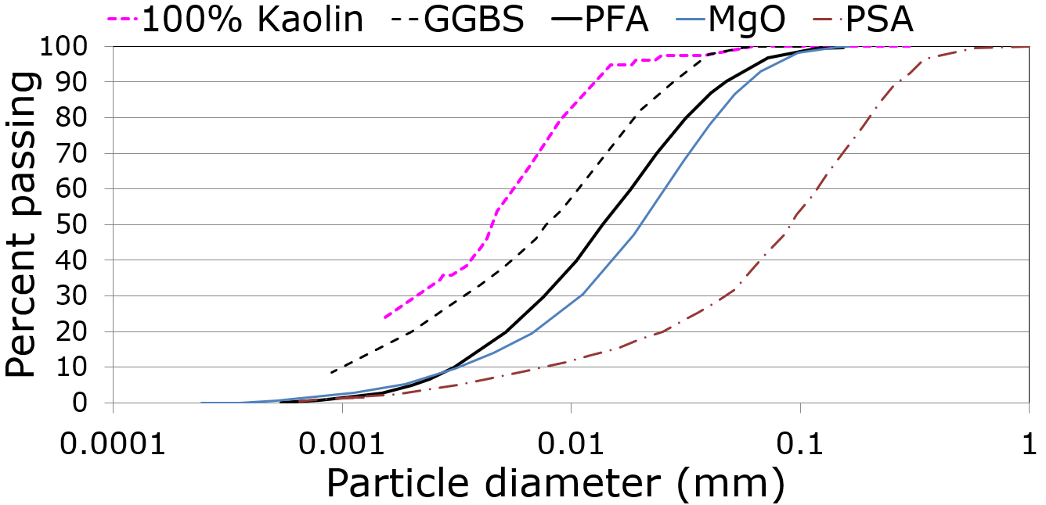
Figure 1. Particle size distribution of the kaolin soil and stabilisers

Results
Table 2 shows plasticity characteristics of the untreated and treated soils (at 1 h of mellowing). All stabilisers increased the liquid limit of the untreated soil, consistently with observations on lime-stabilised kaolinitic clay soils (Bell, 1996). Regarding unconfined compressive strength q_{u} and swelling ΔH of water immersed samples, Figures 2 and 3 show a summary of average values from at least duplicate samples (some tests were replicated in duplicate later). Based on these, there are indications that: a) PSA, rich in CaO, may perform better than lime, presumably due to its aluminosilicates content; b) GGBS improved the performance of lime but not as much that of PSA; c) PFA used at low proportions is not as effective as GGBS, failing to give higher strengths and resulting in higher expansions; d) MgO at high dosages gives relatively high strengths and low swelling but when used in combination with GGBS the results start worsen with higher GGBS dosages presumably due to the calcium in GGBS; e) most 28 day cured samples showed lower strengths than 7-day treated samples as hypothesised. However, the UCS results should be treated with caution as visual observations showed that no stabiliser mix prevented deleterious reactions, as salt crystals formed on the top of all samples (including purely MgO treated specimens, where magnesium sulphate crystals clearly appear to have formed, see Fig 4) so that specimens were cracked before UCS testing (see Fig. 4); the adopted compaction characteristics could have contributed to this. As a result of this, there could be large discrepancies in the values of q_{u} (with some outliers discarded being up to 4 times higher than the mean values shown), presumably depending on the crack pattern.
Table 2. Plasticity characteristics of the soil before and after treatments
Soil type | LL  (%) | PL  (%) | PI  (%)
Untreated soil | 52 | 25 | 27
4% lime-treated | 61 | 27 | 34
4% PSA-treated | 59 | 27 | 32
6% PSA-treated | 69 | 39 | 29
2% Lime-2% GGBS-treated | 58 | 32 | 26
2% PSA-2% GGBS-treated | 64 | 40 | 24
3% PSA-3% GGBS-treated | 63 | 37 | 26
2% Lime-2% PFA-treated | 65 | 43 | 22
3% PSA-3% PFA-treated | 63 | 44 | 19
10% MgO-treated | 62 | 38 | 24
12% MgO-treated | 54 | 36 | 18
9% MgO -3% GGBS-treated | 60 | 36 | 24
3% MgO -9% GGBS-treated | 60 | 37 | 23
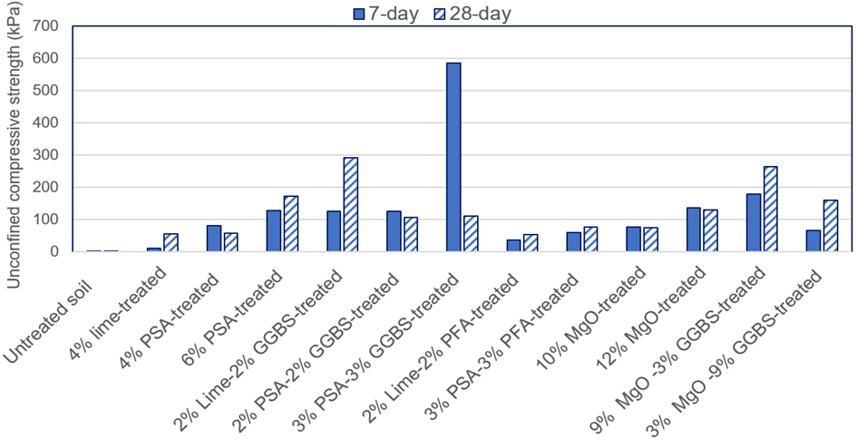
Figure 2. Unconfined compressive strength after immersion in water for 7 and 28 days respectively
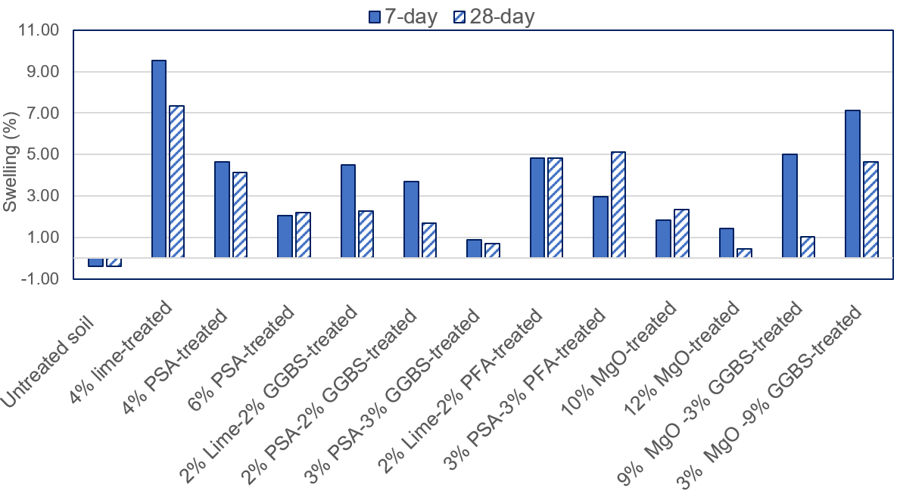
Figure 3. Change in height after immersion in water for 7 and 28 days respectively
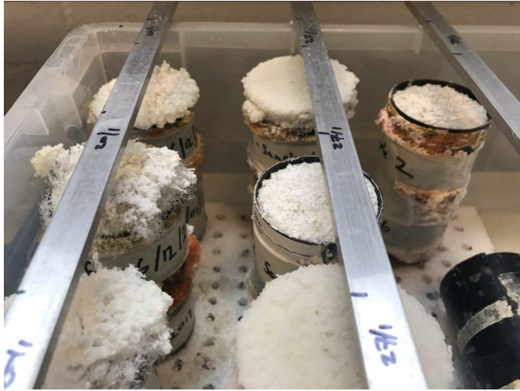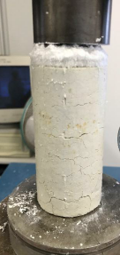
Figure 4. Salt formation in MgO mixes and specimen damage (here, MgO-GGBS mix) before UCS testing

Conclusions
The results showed that, providing most favourable conditions for the formation of expansive salts and potential resulting damage, no combination of binder was fully successful in preventing the damage of the samples and suppressing swelling. Although rich in CaO, PSA performed better than lime, presumably due to its aluminosilicates content. GGBS improved the performance of lime but not as much that of PSA, whereas PFA used at same proportions as GGBS was not as effective. MgO used on its own gave some promise however crystal forming was observed in all samples. The reactions and mechanisms of expansive crystal growth (or the lack of it) in sulphate bearing soils are very complex. Despite some promising results shown here and in the literature for admixtures with slags and pozzolans or alternative cements, it is the Authors’ opinion that more research is required leading to precise specifications, so that such stabiliser mixes can be used in industrial applications with confidence.
References
Bell FG. (1996). Lime stabilization of clay minerals and soils. Engineering Geology, 42(4), pp. 223–37.
Berger, E., Little, D.N., Graves, R. (2001). Technical Memorandum: Guidelines for Stabilization of Soils Containing Sulfates, NLA, http://www.lime.org/publications.html.
Bernal S, Ball R, Hussein O, Heath A & Provis J (2014) Paper sludge ash as a precursor for production of alkali-activated materials. 2nd International Conference on Advances in Chemically Activated Materials, June 1-3 2014, Changsha, China
British Standards Institution (BSI) (1990) BS 1377-3: 1990 Soils for Civil Engineering Purposes. London, UK: British Standards Institution
Cheshomi, A., Eshaghi, A., Hassanpour, J. (2017). Effect of lime and ﬂy ash on swelling percentage and Atterberg limits of sulfate-bearing clay. Applied Clay Science, 135, pp. 190–198.
Chrysochoou, M. Grubb, D.G., Malasavage, N.E. (2012). Assessment of sulfate-induced swell in stabilized dredged material: Is ettringite always a problem? Journal of Geotechnical and Geoenvironmental engineering 138 (3), 407-414.
Dermatas, D. (1995). Ettringite-induced swelling in soils: State-of-the-art. Applied Mechanics Reviews, 48 (10), pp: 659–673.
Eades, J.L., Grim, R.E. (1966). A quick test to determine lime requirements for soil stabilization. Transportation Research Board, Washington, DC Highway Research Record, 139, pp. 61–72.
Harris, P., Scullion, T., Sebesta, S. (2004). Hydrated lime stabilization of sulphate-bearing soils in Texas. Report FHWA/TX-04/0-4240-2, Texas Transportation Institute.
Gu, K., Jin, F., Al-Tabbaa, A., Shi, B., Liu, C, Gao, L. (2015). Incorporation of reactive magnesia and quicklime in sustainable binders for soil stabilisation. Engineering Geology, 195, pp. 53-62.
Jin, F., Gu, K., Al-Tabbaa, A. (2015). Strength and hydration properties of reactive MgO-activated ground granulated blastfurnace slag paste. Cement and Concrete Composites, 57, pp. 8-16.
Knopp J., Moormann C. (2016). Ettringite Swelling in the Treatment of Sulfate-Containing Soils Used as Subgrade for Road Constructions. Procedia Engineering, 143, pp. 28–137. doi:10.1016/j.proeng.2016.06.017
Little, D. N., Nair, S., Herbert, B. (2010). Addressing Sulfate-Induced Heave in Lime Treated Soils, Journal of Geotechnical and Geoenvironmental Engineering, 136 (1), pp. 110-118.
Mavroulidou, M. (2018). Use of paper sludge ash as a calcium-based stabiliser for clay soils Waste Management and Research, 36 (11), pp. 1066–1072.
Mavroulidou, M., Morrison T., Unsworth, C., Gunn, M.J. (2015). Properties of concrete made of multicomponent mixes of low-energy demanding binders. Construction and Building Materials 101, pp. 1122-1141.
Mavroulidou M., Ziniatis A., Gray C, et al (2017). Alternative calcium-based chemical stabilisers for ground improvement: Paper Sludge Ash treatment of London Clay, 15th International Conference on Environmental Science and Technology Rhodes, Greece, 31 August to 2 September 2017
Mavroulidou M., Garelick J., Gray C., Gunn MJ, Youssef A., Hassan S. (2019). A study on the use of paper recycling waste streams for geotechnical applications, XVII ECSMGE European Conference on Soil Mechanics and Geotechnical Engineering, Reykjavik, Iceland 1st- 6th September 2019
Mavroulidou M, Gray, C., Gumbochuma F, Gunn, M.J. (2020). A comparative assessment of chemical stabilisers including waste materials, for the treatment of swelling-shrinking soils, 4th European Conference on Unsaturated Soils (E-UNSAT2020), Lisbon 21-24 October 2020, E3S Web of Conferences 195, 03028 (2020) https://doi.org/10.1051/e3sconf/202019503028
Mitchell, J.K. (1986). Practical problems from surprising soil behavior. Journal of Geotechnical Engineering,112 (3), pp. 255–289.
Mozaffari, E., Kinuthia, J.M., Bai, J., Wild, S. (2009). An investigation into the strength development of Wastepaper Sludge Ash blended with Ground Granulated Blastfurnace Slag. Cement and Concrete Research, 39, pp. 942–949.
Ouhadi, V.R, Yong, R.N. (2008) Ettringite formation and behaviour in clayey soils Applied Clay Science, 42(1–2), pp. 258-265
Spathi, C. (2015) Novel applications for paper sludge ash. PhD thesis, Imperial College, London
Wild, S., Kinuthia, J.M., Jones, G.I., Higgins, D.D., (1999). Suppression of swelling associated with ettringite formation in lime stabilized sulphate bearing clay soils by partial substitution of lime with ground granulated blast furnace slag. Engineering Geology, 51 (4), pp. 257–277.
Xeidakis, G. (1996). Stabilization of swelling clays by Mg (OH)₂. Changes in clay properties after addition of Mg-hydroxide. Engineering Geology, 44(1-4), 107–120.
Yi, Y., Liska, M., Al-Tabbaa, A (2014). Properties of two model soils stabilized with different blends and contents of GGBS, MgO, lime, and PC. Journal of Materials in Civil Engineering, 26, pp. 267-274
Yi, Y., Zheng, X., Liu, S., Al-Tabbaa, A. (2015) Comparison of reactive magnesia- and carbide slag-activated ground granulated blastfurnace slag and Portland cement for stabilisation of a natural soil. Applied Clay Science, 111, pp. 21-26.
Yi, Y., Liska, M., Jin, F., Al-Tabbaa, A (2016). Mechanism of reactive magnesia – ground granulated blastfurnace slag (GGBS) soil stabilization. Canadian Geotechnical Journal, 53, pp. 773-782.

