FUNCTIONALITY and mechanical properties of steel Fibre reinforced Concrete IN Stemming building collapses in Nigeria
Olubisi Ige ^{(1) *}, Ebohon Obas John ⁽¹⁾, Theodore Conrad Haupt ⁽²⁾, Mariam Akinlolu ⁽²⁾.
⁽¹⁾ School of Built Environment and Architecture, London South Bank University, 103 Borough Road, London. SE1 0AA. UK.
⁽²⁾Faculty of Engineering, Mangosuthu University of Technology, Durban - South Africa
* Corresponding author: igeo4@lsbu.ac.uk

ABSTRACT

In Nigeria, building collapses is a common occurrence, and several factors have been advanced to explain the incidents, amongst these is the lack of understanding of the functionality and mechanical properties of steel fibre reinforced concrete. Such understandings can assist in stemming building collapses and attendant economic and social effects, particularly the health and safety of construction workers and occupants. This is achieved by understanding the functionality and mechanical properties of steel fibre reinforced concrete. As a way of demonstration, an efficient way to achieve this is to use thin short discrete steel fibres, this will allow, a multi-directional reinforcement, the process modifying and improving properties of the concrete, especially its ductility. Critical to this, is the understanding of the preference and selection of materials to make appropriate mixes for efficient result of steel fibre reinforced concrete. In other words, failure to pay attention to selection and use of materials will produce weak concrete structure and precipitating unwarranted disasters. This study investigates the effects of length and aspect ratio of steel fibres when mixed with different sizes of coarse aggregate on the workability and subsequently, on the mechanical properties of the material. Variables selected for the study were fibre lengths of 50 mm and 60 mm, aspect ratio of 45, 50 and 60, fibre dosages of 25 kg/m³, 40 kg/m³, 50 kg/m³ and 60 kg/m³ and maximum aggregate sizes of 10 mm and 20 mm. Mix proportions for the investigation were kept constant throughout the study. Slump test was performed on fresh concrete while compressive strength was measured using 100 mm cubes and flexural performance assessed through 150 mm x 150 mm x 600 mm prism. The experimental results confirm that the combination of geometry and maximum aggregate size in the mix has an important influence on the mechanical properties of hardened concrete. It is hoped that construction practitioners in Nigeria, and by extension, Africa, will evaluate their practices in light of this study.

KEYWORDS: Steel fibres, fibre geometry, aggregate size, workability, compressive strength, flexural properties.

1. Introduction
Building collapses, according to experts, owe to failures of buildings to perform the purpose for which they are built (Ede, 2016). As often as it is the case, building collapses result from three basic scenarios, which are serviceability limit state, ultimate limit state, and durability limit state (Taiwo and Afolami, 2011). Ultimate limit state failure is said to happen when the columns start to wobbles and overturn resulting in ultimate collapse or failed in ultimate limit state. The serviceability limit state relates to a civil engineering structure that fails to meet technical requirements for use despite its relative strength to remain standing. Structures of this nature would have surpassed a defined limit for either of the following properties - excessive deflection, vibration, and local deformation. Durability failure occurs when the components of the structure is weakened beyond reparable limits. Building collapse is a world-wide phenomenon with 181 incidents of building collapse reported across 51 countries, including India with 32 reported building collapse disasters, 13 in China, 13 in Egypt, 12 in Brazil, and 12 in Nigeria. The Bangladeshi reported building collapse incident in 2013 is instructive on the deadly consequences of such an event with the death of 1,127 occupants (Keim, 2021).
In Nigeria, incidents of building collapse have become more frequent in recent times and so has been the casualty figures (Ede, 2010), this can be said to owe to the unspring of high rise buildings in the country amongst other factors. According to the Nigerian Institute of Building (NIOB) in one building collapse in 2014, 115 people died, and in 2019, there were 43 building collapses with the unfortunate loss of many lives. This has forced a critical look at how buildings are procured and regulated in the country, and according to NIOB president, incidents of building collapses in Nigeria “looks like an indictment on building control agencies”, indicating the need for a reassessment of the building processes in Nigeria. One strategy is to look at strengthening building structures by paying particular attention to material, process and technological innovation in construction. This research has identified concrete as the major material component of construction for scrutiny. Indeed, concrete has continued to undergo relentless advances through theoretical and experimental research for decades, in order to significantly improve the material properties such as its strength and brittle nature of failure (Ferrara and Meda, 2006; Ige et. al, 2017). Although, some of these goals have been achieved, such as enhancement in compressive strength but this made the material to be more brittle and less ductile (Boulekbache et. al., 2016). In spite of the major milestones already accomplished in the technological enhancement of concrete properties, the challenges of concrete structures being subjected to more loadings as a result of growth in the world population, surge in natural disaster and terrorist attack through explosions experienced in progressive manner call for more technological solutions (Ige, 2017). Therefore, in order to further mitigate some of the undesirable properties of concrete, steel fibres which are short, thin, and discrete were introduced into the concrete matrix to improve many of its engineering properties such as its ductility and toughness (Ige et. al., 2017; Boulekbache et. al., 2016). This is accomplished by the ability of steel fibres to prevent or control the initiation and propagation of micro cracks into macro cracks within the concrete matrix, transferring stress across a crack by bridging it (Ige et. al., 2017).
Previous studies have investigated the effects of the inclusion of steel fibres in concrete and have concluded that some of the engineering properties of steel fibres significantly alter the properties of the resulting steel fibre reinforced concrete (SFRC). The fibre properties include fibre type, dosage, shape, length, and aspect ratio. The magnitude of the improvement in ductility and flexural strength is impacted by these parameters while the distribution and orientation of fibres also influence how the fibres are positioned for the bridging of the cracks, which subsequently affects the post-cracking ability of the matrix (Boulekbache et. al., 2016; Ige, 2017). Additionally, the engineering properties and the volume or dosage of the fibres in the matrix affect directly the workability of the fresh concrete. It has been reported that apart from the fibre geometry, lower steel fibre dosages of not more than 1% had negligible effect on the compressive strength, whereas, the flexural strength was significantly enhanced. However, it was also reported that high steel fibre dosages higher than 3% can negatively affect the workability in the fresh state, the compressive and flexural strengths of SFRC (Nehdi et.al., 2017). This could be as a result of balling effect causing an increase in voids in the matrix.
The hooked end steel fibres have been found to show best performance by their provision of strong mechanical anchorage within the matrix (Ige et. al., 2017). Notwithstanding, several research works that have been carried out on how to best explore SFRC in practice, experimental results on investigating the collaborating effects of steel fibres with the concrete components of the matrix and how the relationship between these materials affects the maximal productivity of the SFRC are considered few. Hence, more understanding of how the steel fibres and concrete components collaborate is essential to maximise the contribution of fibres to the improvement of mechanical properties of SFRC and subsequently, it’s potential in practice, especially for those in construction industries and academic communities.
This research work studies the effects of fibre geometry, dosage, and coarse aggregate size on the behaviour of fibres within the concrete matrix and the subsequent influence on the workability and the effects on flexural properties of steel fibre reinforced concrete.

2. EXPERIMENTAL PROCEDURES

The experimental programme for this research work was designed to investigate the performance of different geometry of steel fibres and dosages when combined with two maximum sizes of coarse aggregates. The effects of these variables were then investigated on the workability of the fresh steel fibre reinforced concrete and the subsequent effects on the mechanical performance of the steel fibre reinforced concrete (SFRC).
2.1 Materials
The steel fibre reinforced concrete mixtures studied in this research were produced with commercially available materials. The main constituents of the concrete were made to be consistent throughout, sustaining the same source so as to allow for consistency and proper comparison. Portland cement conforming with BS EN 197-118 (CEM 1 52.5R) (BSI, 2011), polycarboxylate polymer-based superplasticizer necessary to provide good workability at a low water/cement ratio, tap water and sea-won coarse and fine aggregates were employed in the concrete mixes. The 0.5 water/cement ratio was adopted for this study and was made constant for all the mixtures as well. In order to investigate the effect of materials on fresh and hardened properties of the steel fibres reinforced concrete, the variables selected were fibre lengths of 50 mm and 60 mm, aspect ratio (ratio of length to diameter of fibre) of 45, 65 and 80, and dosages of 0 kg/m³ (no fibres), 25 kg/m³, 40 kg/m³, 50 kg/m³ and 60 kg/m³ of steel fibres were employed. The fibres used for this investigation were the hooked end type supplied by Bekaert as shown in Figure 1. The coarse aggregates with maximum sizes of 10 mm and 20 mm as shown in Figure 2 were also chosen for the study. The maximum coarse aggregate size (d_{max}) and the geometry of the steel fibres used are as shown in Table 1.

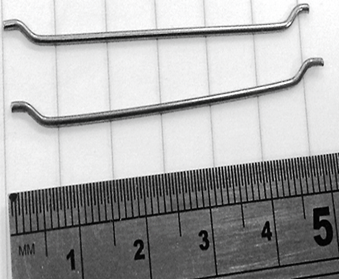

Figure 1. Hooked end steel fibres

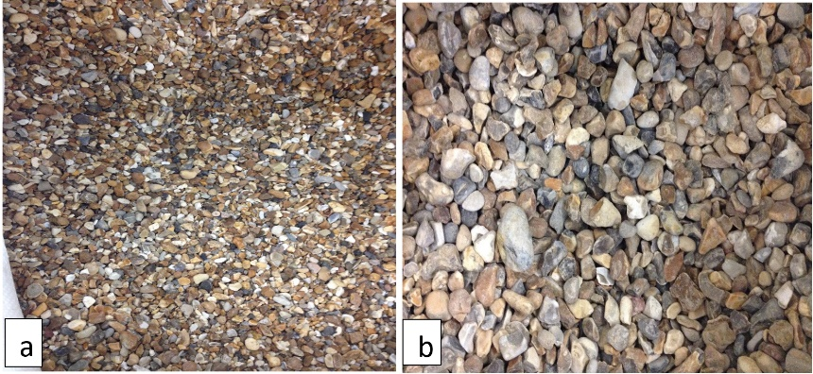
Figure 2. Gravel used as coarse aggregate with (a) 10 mm and (b) 20 mm size variables
2.2 Specimen and Procedures
A pan mixer of 0.05 m³ capacity was employed in mixing of the concrete while the same particular procedure was adopted for all the mixes in order to accomplish an even dispersion of fibres in the mix and to avoid balling effects in the mixtures. Gravel, sand and cement were first mixed in the mixer in a dried state for few minutes before water was added, and immediately followed by superplasticizer before being allowed to mix for another few minutes. The fibres were added last and then a further one to two minutes mixing was allowed to have the material sufficiently mixed. The workability of each mix was checked through slump test and findings were recorded. The mixtures were accomplished by following the dosages as shown in Table 1 for each maximum coarse aggregate size (d_{max}) and the geometry of the steel fibres.

Table 1. Aggregate maximum size and geometry of the steel fibres
d_{max} (mm) | Fibre Type | Fibre length (mm) | Fibre aspect ratio (length  /diameter) | Fibre dosage (kg/m³) | % by Fibre Volume
10 | 45/50 | 50 | 45 | 0 | 0
 |  |  |  | 25 | 0.31
 |  |  |  | 40 | 0.51
 |  |  |  | 50 | 0.64
 |  |  |  | 60 | 0.76
 | 65/60 | 60 | 65 | 0 | 0
 |  |  |  | 25 | 0.31
 |  |  |  | 40 | 0.51
 |  |  |  | 50 | 0.64
 |  |  |  | 60 | 0.76
 | 80/60 | 60 | 80 | 0 | 0
 |  |  |  | 25 | 0.31
 |  |  |  | 40 | 0.51
 |  |  |  | 50 | 0.64
 |  |  |  | 60 | 0.76
20 | 45/50 | 50 | 45 | 0 | 0
 |  |  |  | 25 | 0.31
 |  |  |  | 40 | 0.51
 |  |  |  | 50 | 0.64
 |  |  |  | 60 | 0.76
 | 65/60 | 60 | 65 | 0 | 0
 |  |  |  | 25 | 0.31
 |  |  |  | 40 | 0.51
 |  |  |  | 50 | 0.64
 |  |  |  | 60 | 0.76
 | 80/60 | 60 | 80 | 0 | 0
 |  |  |  | 25 | 0.31
 |  |  |  | 40 | 0.51
 |  |  |  | 50 | 0.64
 |  |  |  | 60 | 0.76
In each mixture, the workability of the mix was carried out through slump test according to BS EN 12350 Part 2, (BSI, 2009a). Slump test was carried out on both plain concrete without steel fibres and steel fibre reinforced concrete. Subsequently, for each aggregate size/fibre combination, three replicate of 100 mm cubes and 150 mm by 150 mm by 600 mm beam specimens were produced. All the specimens were cured in a water tank at 20 +2 °C until testing at 28 days. Compressive strength tests were carried out on 100 mm cubes employing ADR–Autotest machine with 2000 kN maximum capacity while beam specimens were tested for flexural properties using a Zwick/Roell Z250 universal testing machine with maximum capacity of 250 kN. All the tests in this research were carried out at a testing age of 28 days. The tests for beam specimens were accomplished under three point loading, (Figure 3) with notches introduced in the middle section to a depth of 25 mm using a diamond saw before testing. A crack mouth opening displacement (CMOD) gauge was positioned in the notch to control the test at the CMOD rates specified by BS EN 14651 (BSI, 2005).

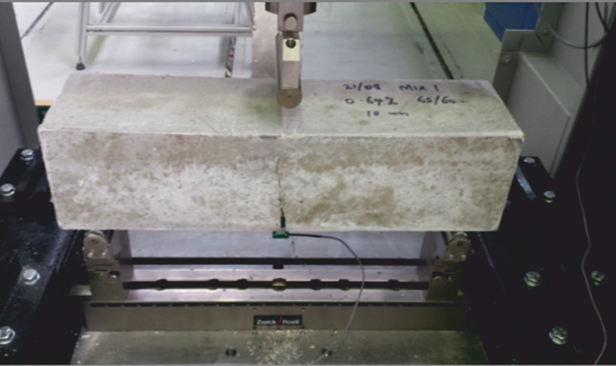
Figure 3. Measuring flexural strength under 3–point loading

3. RESULTS AND DISCUSSION
The effects of addition of fibres to concrete on the workability of fresh concrete investigated through slump test can be seen as presented in Table 2. This shows the values of slump tests conducted on fresh plain concrete and steel fibre reinforced concrete with varying fibre dosages, fibre aspect ratio, fibre length and two maximum sizes of coarse aggregate. The results from Table 2 reveal that slump values differ widely between 15 mm and 140 mm, showing decline in slump values as dosages of fibre increased. It can also be deduced that mixtures with maximum coarse aggregate size of 20 mm generally show better workability than mixtures with 10 mm maximum aggregate size as displayed by their slump values. Meanwhile, the mixtures of fibre length of 60 mm and aspect ratio (length/diameter) 65 and 80 with 10 mm maximum aggregate size provided the least slump values of 15 mm and 18 mm respectively at 60 kg/m³ dosages. The decline in workability noticed for mixture of steel fibre with length 60 mm and maximum aggregate size of 10 mm may be attributed to the non-compatibility of higher length of fibres and smaller aggregate size leading to balling effect especially at higher dosages, hampering the flow of cement paste. It is however noticed that the mixture with 25 kg/m³ dosage of steel fibres for both maximum aggregate sizes demonstrate higher slump values mostly, producing a better workability. This has been credited to the even distribution of fibres within the fresh concrete and hence, influencing the workability of the mixture. Largely, presence of steel fibres reduced the workability of concrete as checked by slump test. This assertion agrees with many other research (Ige et. al; Nehdi et.al., 2017; Soulioti et. al., 2011).

Table 2. Slump values of plain concrete and sfrc
Fibre type  AR/Length | Fibre dosage  kg/m³ | Slump, mm
 |  | 10 mm max aggregate size | 20 mm max aggregate size
 | 0 | 62 | 120
45/50 | 25 | 115 | 95
 | 40 | 53 | 125
 | 50 | 27 | 88
 | 60 | 36 | 53
65/60 | 25 | 55 | 140
 | 40 | 36 | 70
 | 50 | 32 | 55
 | 60 | 15 | 88
80/60 | 25 | 105 | 115
 | 40 | 34 | 135
 | 50 | 32 | 80
 | 60 | 18 | 65

The 100 mm cubes produced from different mixtures were employed to check the density of the plain and fibre reinforced concrete according to BS EN 12390-7 (BSI, 2009b) with the average results of three replicate cubes presented in Figure 4. The results depict that the average density of concrete with 10 mm maximum aggregate size having no fibres had the least value of 2377 kg/m³ whereas, the highest average density value of 2455 kg/m³ was recorded from the concrete mixture of 20 mm maximum aggregate size containing steel fibre 45/50 at 50 kg/m³ fibre dosage. The experimental values of density from this study have been found to be generally lower when compared to the theoretical values of density calculated, especially for the mixtures containing steel fibres. This could be attributed to the consequences of short period of compaction allowed at casting of concrete to guard against settlement or segregation of steel fibres in the mixture. Therefore, the plunge in the values of density obtained experimentally could have been as a result of air content of the mixture. Moreover, cubes from mixtures of 20 mm maximum aggregate size have higher values of density than their 10 mm maximum aggregate size counterparts. This trend is observed in the values of density recorded for all the mixtures of 20 mm maximum aggregate concrete when compared to that of 10 mm maximum aggregate concrete as clearly seen in Figure 4 which is the boxplot of summarised values of density as against the dosages of steel fibres and maximum aggregate sizes. This trend of the results was also seen in the workability results where 20 mm maximum aggregate size concrete had higher values of slump in general.

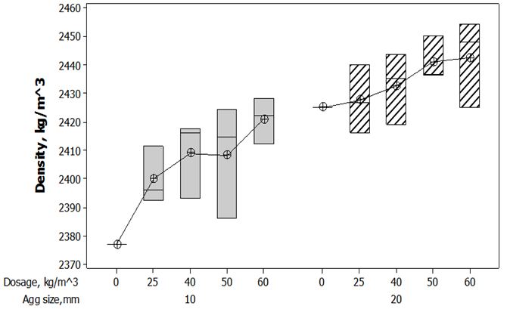
Figure 4. Summary values of density vs dosage and aggregate size

Figure 5 shows the compressive strength results of 100 mm cubes demonstrating the impact of steel fibres and maximum size of aggregate on SFRC. The presented results generally indicate a minor improvement in the compressive strength by means of the inclusion of steel fibres in concrete. The maximum increase in compressive strength initiated by the presence of steel fibres in 10 mm maximum aggregate size mixtures is about 5 MPa, translating to about 9% increase while that of 20 mm maximum aggregate size mixtures had the maximum increase of about 8 MPa, which is 14 % increase. The compressive strength of SFRC increases with increase in fibre dosage until optimum compressive strength was achieved at 50 kg/m³ fibre dosage for both aggregate sizes after which it declined. This may not be unconnected with the compaction effects on the mixtures with highest dosage of steel fibre (60 kg/m³) making the compaction of the mixture a bit difficult to accomplish, resulting in lower compressive strengths regardless of coarse aggregate sizes in the concrete mixture. In addition, the lower strengths obtained at the 60 kg/m³ can be attributed to consequences of low workability of fresh mixture achieved at higher fibre dosage. The results achieved are closely related to results from previous findings on compressive strength of SFRC (Mohammadi et.al., 2008; Sebaibi et. al., 2014).

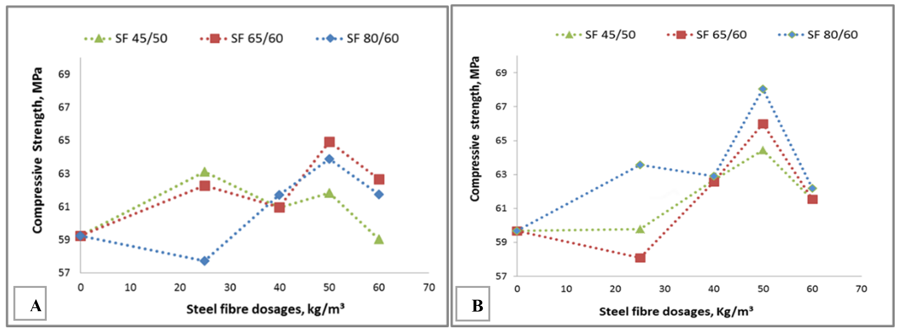
Figure 5. Relationship between compressive strength and dosages of different fibres, (A) 10 mm aggregate size (B) 20 mm aggregate size

The typical flexural stress versus CMOD relationship of the notched beams determined by three-point bending tests is shown in Figure 6. Average values of maximum load, flexural toughness and residual strength of SFRC beams exhibited related trends to those observed in the figure. Figure 6 is presented for both mixes of 10 mm and 20 mm maximum aggregate sizes summarised at steel fibre dosage of 50 kg/m³ for ease of comparison. Each concrete mixture is designated by its constituents, the type of steel fibre assigned by ‘aspect ratio/corresponding length of the fibre’ and the maximum coarse aggregate size. Plain concrete represents concrete mixture without steel fibres. It can be observed from the Figure that plain concrete of both aggregate sizes failed demonstrating brittle nature while other SFRC exhibited ductility behaviour. For each maximum aggregate size, all the flexural strength parameters showed increase as the aspect ratio increased. Moreover, the maximum aggregate size had a significantly effect on the flexural strength of the beam specimens, with the 20 mm maximum aggregate demonstrating higher strength for all fibre types. This is an suggestion that fibre length - coarse aggregate maximum size relationship is a factor to consider when choosing materials for fibre reinforced concrete.
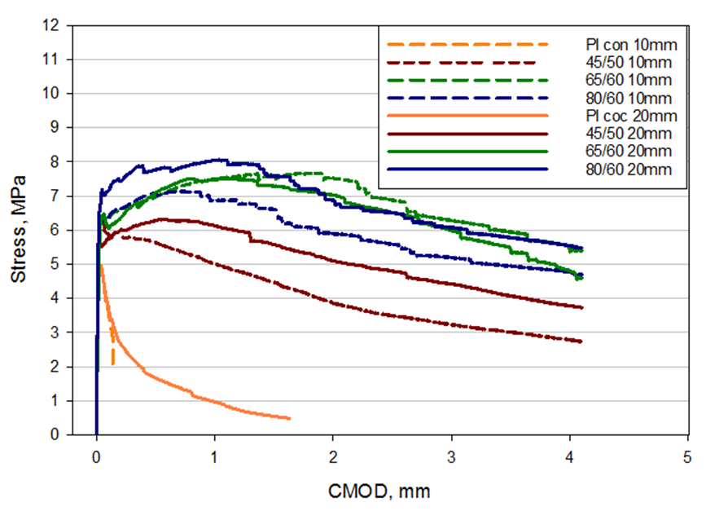
Figure 6. Flexural behaviour of plain and SFRC with 50 kg/m³ fibre dosage

4. CONCLUSIONS
Investigation of effects of maximum aggregate size, fibre type and dosage on the fresh and mechanical properties of concrete containing steel fibres has been carried out in this study. The results of the investigation have shown that all the parameters evaluated in this study have significant impact on both the fresh and mechanical performance of hardened SFRC. The workability of the fresh SFRC has been observed to influence the mechanical performance of the SFRC. The workability of fresh steel fibre reinforced concrete declined as the fibre dosage increases with lowest results witnessed at the highest dosage of 60 kg/m³ steel fibre in concrete. The density of plain concrete and steel fibre reinforced concrete mixes revealed that there was increase in density as the fibre dosage increases in the mixture. Also, mixtures of 20 mm maximum aggregate size generally recorded higher values of density than their 10 mm maximum aggregate size. Meanwhile, the effects of fibres on compressive strength are noticeable, with optimal compressive strength detected at fibre dosage of 50 kg/m³ and with fibre of 80 l/d ratio. The addition of steel fibres in concrete substantially improved the mechanical properties of concrete transforming it from a brittle to ductile material. The influence and effectiveness of steel fibres in concrete are particularly noticed at right dosages, appropriate combination of fibre geometry with corresponding aggregate size in concrete matrix. It is instructive that countries that disproportionately experience building collapses such as Nigeria should focus on the formation of form works that produce building structures. It is not sufficient to mix aggregates and steel fibre as necessarily determining strengths of structures, it is the combinations of these materials and the particular processes that determines the strengths of structures.

References
- Boulekbache, B., Hamrat, M., Chemrouk, M., & Amziane, S. (2016). Flexural behaviour of steel fibre-reinforced concrete under cyclic loading. Construction and Building Materials, 126, 253-262.
- BSI (British Standards Institute). (2005). Test method for metallic fibre concrete. Measuring the flexural tensile strength (limit of proportionality (LOP), residual). BS EN 14651:2005. London:BSI.

- BSI (British Standards Institute). (2009a). Testing fresh concrete-Part 2: Slump test. BS EN 12350-2: 2009. London: BSI.
- BSI (British Standards Institute). (2009a). Testing hardened concrete Density of hardened concrete. BS EN 12390-7:2009. London: BSI.
- BSI (British Standards Institute). (2011). Composition, Specifications and Conformity Criteria for Common Cements, in Part I: BS EN 197-1: 2011. London: BSI

- Ede, A. (2010). Building Collapse in Nigeria: the Trend of Casualties in the Last Decade (2000 -2010). International Journal of Civil & Environmental Engineering IJCEE-IJENS IJENS I J E N S, 10 (January 2010), 6–32

- Ede, A. (2016). Structural Stability in Nigeria and worsening Environmental Disorder: the way forward. The West Africa Built Environment Research Conference (WABER), Accra, Ghana. doi:10.1088/1757-899X/1036/1/012021
- Ferrara, L., & Meda, A. (2006). Relationships between fibre distribution, workability and the mechanical properties of SFRC applied to precast roof elements. Materials and Structures, 39(4), 411-420.

- Ige, O. A. (2017). Key Factors Affecting Distribution and Orientation of Fibres in Steel Fibre Reinforced Concrete and Subsequent Effects on Mechanical Properties (Doctoral dissertation, University of Portsmouth).

- Ige, O., Barnett, S., Chiverton, J., Nassif, A., & Williams, J. (2017). Effects of steel fibre-aggregate interaction on mechanical behaviour of steel fibre reinforced concrete. Advances in Applied Ceramics, 116(4), 193-198.

- Keim, A. (2021). When Buildings Collapse. About Disaster Doc. https://disasterdoc.org/when-buildings-collapse/ Accessed 06/09/2021 @ 18:25

- Mohammadi, Y., Singh, S. P., & Kaushik, S. K. (2008). Properties of steel fibrous concrete containing mixed fibres in fresh and hardened state. Construction and Building Materials, 22(5), 956-965.

- Nehdi, M. L., Najjar, M. F., Soliman, A. M., & Azabi, T. M. (2017). Novel steel fibre-reinforced preplaced aggregate concrete with superior mechanical performance. Cement and Concrete Composites, 82, 242-251.

- Sebaibi, N., Benzerzour, M., & Abriak, N. E. (2014). Influence of the distribution and orientation of fibres in a reinforced concrete with waste fibres and powders. Construction and Building Materials, 65, 254-263.
- Soulioti, D. V., Barkoula, N. M., Paipetis, A., & Matikas, T. E. (2011). Effects of fibre geometry and volume fraction on the flexural behaviour of steel‐fibre reinforced concrete. Strain, 47, e535-e541.

- Taiwo, A. A., & Afolami, J. A. (2011). Incessant building collapse: A case of a hotel in Akure, Nigeria. Journal of building appraisal, 6(3), 241-248. https://doi.org/10.1057/jba.2011.1
- Taylor, M., Lydon, F. D., & Barr, B. I. G. (1997). Toughness measurements on steel fibre-reinforced high strength concrete. Cement and Concrete Composites, 19(4), 329-340.

