A SYSTEMATIC REVIEW OF CONSTRUCTION SCHEDULING METHODS: TRENDS, GAPS, AND POTENTIAL RESEARCH AREAS

Construction projects are subject to diverse and complex challenges. However, most construction scheduling methods (CSM) do not adequately consider these complex challenges or the various causes of duration overruns in construction projects. Also, most CSM cannot efficiently process the vast data and the relationship between these factors or variables. It is essential to understand how these factors contribute to project duration overrun, their relationships, and how this information can improve construction project duration estimates. Therefore, to develop a reliable CSM, it is vital to understand the existing approaches to CSM, the gaps and trends. In this study, a total of 148 documents were extracted from Scopus database using Article Title, Abstract, and Keywords in the domain of CSM. The documents were retrieved using a bibliometric search. The search results were analysed using a scientometric approach, and the results were discussed. The bibliometric search suggests that the collected works on literature in the domain of CSM, in general, is increasing. Also, besides identifying influential journals, authors and countries, the study was crucially able to identify the gaps and trends in CSM. The findings show that the application of artificial intelligence (AI), contract time determination system (CTDS), BIM-based scheduling methods are approaches that can be explored further for reliable construction project time estimation. The results will be later discussed in detail as part of ongoing research.

Keywords: Construction Scheduling Methods (CSM), Scientometric Analysis, Bibliometric, Bibliographic Coupling, Artificial Intelligence.

INTRODUCTION
Project time has implications on its cost. For instance, the cost of preliminaries of any project (Flanagan and Jewell, 2018) and inflationary impact increase with increased project time. Also, project duration resulting from optimism bias, accelerated or inaccurate scheduling often results in productivity and quality delivery losses. Furthermore, the cost of rectifying poor-quality delivery is high. Hence, when time and cost overrun occurs, the original business case is highly impacted. Therefore, it is vital to ensure project duration estimates are reliable to curb cost overrun. To determine reliable project duration estimates, the estimating tool and process should have the ability to consider various project constraints and historical projects information and determine both linear and non-linear relationships between these varying variables.

There are various methods, tools and approaches to duration estimating in the construction industry. At the delivery stage, software applications like Asta Powerproject, Primavera P6 and Synchro use computer algorithms to implement scheduling methods like the Gantt Chart, Critical Path Method (CPM), Programme Evaluation and Review Technique (PERT), etc. for dynamic project scheduling and control. Some of the tools have functionalities to carry out 4D Planning. The ability of these tools to carry out these robust functions at the delivery stage is hugely due to the availability of detailed project information. This is not often the case during the early stages of the project life cycle; duration estimating is trickier. When preparing initial estimates in the early stages, planners must rely on experience and top-down estimating methods like expert judgment, parametric models, analogous, and benchmark data. These methods depend primarily on historical projects information. For example, the parametric models use the statistical relationship between project variables to estimate project duration (Arega, 2018). Example of parametric methods includes the Bromilow Time-Cost (BTC) Model (Petruseva et al., 2019), similar regression analysis or models and the BTC-based tool, the Building Cost Information Service (BCIS) Calculator.

In addition, the rise in computing power has led to some attempts at using Artificial Intelligence (AI) to predict and improve project time estimates (Pan and Zhang, 2021). The expectation for the AI approach is to develop systems that decide better or equal to a human being exposed to the same situation or similar level of existing information. Eber (2020) suggests that a crucial setback for the AI approach is insufficient information to provide statistically significant results or for the model development process to learn. Where sufficient historical project duration information and relevant variables are available, AI promises to be an approach that can be deployed to curb the challenge of unreliable project duration estimates. This AI approach and other estimating approaches will be further reviewed in this research.

Construction projects are subject to diverse and complex challenges and have been widely researched (Johnson and Babu, 2020). However, most approaches to duration estimating do not adequately consider these complex challenges or the various causes of duration overruns in construction projects, nor can they efficiently process the vast data and relationship between these factors or variables. It is essential to understand how these factors contribute to project duration overrun, their relationships and how this information can improve duration estimates. Therefore, to develop a reliable CSM, it is essential to understand the existing approaches to CSM, the gaps and trends.

RESEARCH METHODOLOGY
A systematic methodological approach was used to conduct a comprehensive review of existing literature. Also, a science mapping approach was used to develop a bibliometric map based on Scopus database of literatures on CSM. Figure 1 shows the steps followed in carrying out the detailed review. These steps include an initial search and determination of keywords and phrases, a bibliometric search, a scientometric data analysis and a summary discussion of analysis results.

Preliminary research
A simple search on Google Scholar (GS) generated a vast 4,080,000 results cutting across manufacturing, energy, software development, surgical procedures, flow shop, etc. Furthermore, a search on GS using construction scheduling methods reduced the search output. Still, there remained a considerable number of works of literature that were irrelevant to scheduling methods in construction or literature that are relevant to CSM that used other different keywords. Therefore, a preliminary search of possible keywords was required more as a beginning reference than as a definitive boundary (Hazen, 2010). This is necessary because scheduling cut across many disciplines. Also, the use of the word construction is often used across many disciplines as well. Therefore, from some of the relevant literatures, a combination of keywords was generated which can be used alongside construction to define the search parameters.

Data collection
Google Scholar (GS), Scopus and Web of Science (WoS) are the most common citation databases (Bakkalbasi et al., 2006). Bar-Ilan (2010) concludes that GS covers more citations compared to Scopus and WoS performed considerable better. However, GS is not very usable as a bibliometric data collection tool. Upon inputting the preliminary search of keywords and combination of keywords into both Scopus and WoS, Scopus generated 35993 document results compared to WoS’s 99 document results, of which 53 documents were relevant. This is indicative that as compared to Scopus, WoS has less coverage in the domain of CSM. However, this less coverage meant it was easy to analyse the 53 document results generated from WoS manually. From the manual analysis conducted, several keywords were manually and cautiously selected in the domain of CSM. These keywords and a combination of keywords became part of the input search parameters in Scopus database to enhance the number of documents to be analysed.

Figure 1. The methodological process

In this study, the search on Scopus was carried out in three stages.

First stage – Scopus searches: four sets of searches were conducted. The first set of searches was a search of combination of keywords like “Methods of Scheduling” OR “Scheduling Methods” OR “Approaches for Scheduling” OR “Scheduling Approaches” OR “Project Scheduling Methods” OR “Methods of Project Scheduling” OR “Project Scheduling Approaches”, etc. This search generated 759,942 document results. The second set of searches was a search of keywords and combination of keywords in “construction”, “construction industry” and “project management”. This search generated 1,376,718 document results. The third set of searches was a search of the keywords “Schedul*” including its suffix. This search generated 692,801 document results. The fourth set of searches was a search of keywords and combination of keywords in identified scheduling approaches like “Production Rate” OR “Algorithm” OR “Linear Scheduling” OR “Critical Path Method” OR “Critical Chain Method” OR “Mathematical Model”, etc. This search generated 6,350,271 document results. The fifth set of searches was a search of keywords and combination of keywords in subjects or domains that may also flag scheduling like "Processor" OR "Manufactur*" OR "Software Project” OR "Semiconductor" OR "Grid" OR "Circuit" OR "Surgery" OR "Electric*" OR "Batch-Product*" OR "Nuclear" OR "Power Plant" OR "Operating Room". This search generated 16,804,128 document results.
Second stage – Combined Queries: two sets of query combinations were conducted. The first set used the AND query to combine the first, second, third and fourth searches in the first stage - Scopus searches. This combined query generated 540 document results. The second set used the AND NOT query to combine the outcome of the first set of combined queries with the fifth set of searches in the first stage – Scopus searches. This combined query generated 215 document results as outcome for this stage.
Third stage – Filter (Limit/Exclude): a filter by subject was applied, limiting the results to ‘Engineering’, ‘Mathematics’, ‘Computer Science’, ‘Environmental Sciences’, ‘Decision Science’, ‘Multidisciplinary’, ‘Business Management & Accounting’, and ‘Economics, Econometrics & Finance’ subjects. This filter generated 177 documents results. Also, a filter by language limit to English was applied, which generated 167 documents. Furthermore, a filter by publication stage to final publication was applied, which generated 163 document results. Finally, a further filter by source title, by visually excluding irrelevant documents generated a final document result of 148 documents between 1986 and 2021. This result was exported from Scopus in .csv format to be used as input file in a data mining software for scientometric analysis.

Data analysis
To analyse the 148 documents manually would be time consuming and the data integrity would be damaged by subjective influence. A science mapping method has been employed to analyse the final document result retrieved from Scopus in the domain of CSM. Bibliometric analysis enables large volume of pieces of literature to be networked and mapped (González-Torres, 2020). We also used VOSviewer software to construct and visualise linkages of bibliometric sources (Hallinger & Nguyen, 2020). The 148 documents in .csv file was loaded into VOSviewer. The data source option selected on VOSviewer was the “Read data from bibliographic database files”, this allowed VOSviewer to recognise the column fields in the .csv file exported from Scopus. The bibliometric network allowed textual information from the 148 documents to be extracted and visualised based on the type of analysis and the counting method.
For example, the ‘Co-authorship’ analysis determines the items based on their number of co-authored documents; the ‘Co-occurrence’ analysis helps determine the relatedness of items based on the number of documents in which they occur together. For example, the ‘Citation’ analysis determines the relatedness of items based on the number of times they cite each other. The mapped connectivity or network in VOSviewer generated is based on the strong textual relationship in the 148 documents considered. Thus, the scientometric analysis may be constrained to a minimum of 20 citations and 4 documents to help focus on documents and citations with the strongest relationship and minimise the number of links in the maps. Despite this imposed constraint, not all documents may be shown fully in maps generated in VOSviewer. Therefore, details are shown in tabular format which were exported directly from VOSviewer. The resulting map constrained to a minimum of 4 occurrences shows nodes and links; each node represents a journal, and the links indicate the journals' citation relationship. The node size indicates the number of published papers; the thickness of the links indicates the strength of the analysed relationship (i.e., citation, keywords, etc.) between the journals. As illustrated in Figure 3, the size and font of journal nodes are clustered differently based on their number of published documents and citations. The higher the number of published documents and citations by a journal, the larger the node and font size. Also, the journals having a mutual citation are strongly related to each other. Upon the completion of each category of the scientometric analysis, the results were discussed. The discussion focuses on the trends in CSM, gaps and a proposal on approaches that can be further explored in construction project scheduling to help improve schedule predictability, robustness, and automation.

RESEARCH ANALYSIS, RESULTS AND DISCUSSION

Add a sentence here to describe this section

An overview of a bibliometric literature data
The number of papers published from 1986 to 2021 in the domain of CSM is shown in Figure 2. The collected data was up to October 2021; hence the number of published papers was incomplete for 2021. The trend analysis showed a significant interest in CSM in the late 19s, with 7 papers in 1998. Again, in 2003 and 2004, 15 papers were published. From then onward, despite the few valleys, the exponential trendline indicates a rise and upward prediction of published papers in the domain of CSM.

Figure 2. The trend of number of published documents per year from year 1986 to 2021

Influential journals
The science mapping of influential journals in the domain of CSM is shown in Figure 3. From the map and Table 1, the influential journals were ‘Automation in construction’, ‘Canadian journal of civil engineering’, ‘Construction management and economics’, ‘Engineering, construction and architectural management’, European journal of operational research’, ‘Journal of computing in civil engineering’, ‘Journal of construction engineering and management’, ‘KSCE journal of civil engineering’. These top influential journals were analysed and visualised in VOSviewer by Bibliographic coupling - sources. The top eight journals or sources were derived by limiting the documents to 4 and citations to 20. From the map, the Journal of construction engineering and management has the largest number of published papers (25 as shown in Table 1), with a very strong citation relationship with Journal of Computing in civil engineering, Construction management and economics, and Automation in construction.

Table 1 shows the detail information on the top influential papers in the domain of CSM. The European journal of operational research has the highest number of citations despite having five published journals in the domain of CSM, compared to Automation in construction with 8 paper publications and 165 citations. Therefore, it is important to also rank the papers within the context of the number of citations and number of published papers. The average citation helped to carry out this ranking; based on this, European journal of operational research has the strongest influence, while the Canadian journal of civil engineering has the least influence amongst the top 8 influential papers in the domain of CSM.

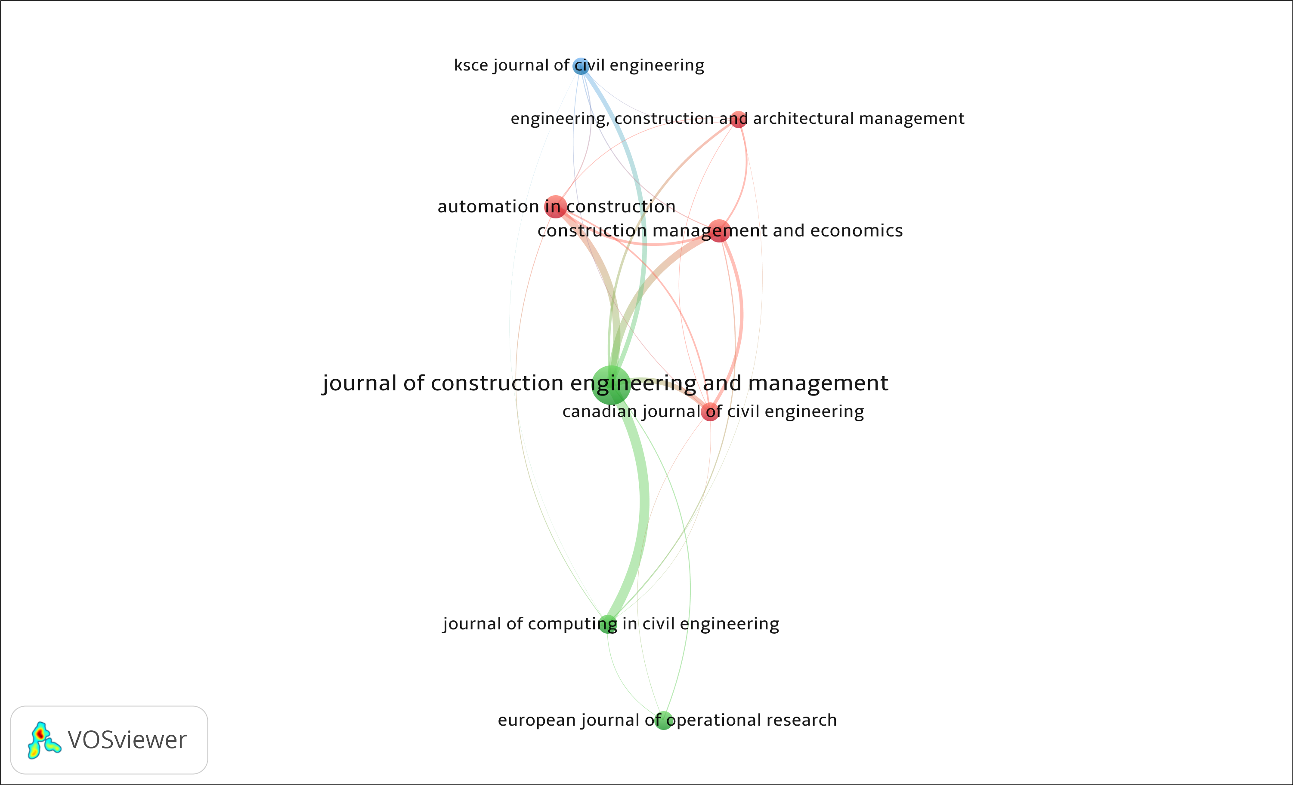
Figure 3. Science mapping of influential papers in the domain of CSM

Table 1: Influential Papers in the Domain of CSM
Source or Journal Name | Number of Publications | Citations | Average Citation
Automation in construction | 8 | 165 | 21
Canadian journal of civil engineering | 5 | 50 | 10
Construction management and economics | 8 | 202 | 25
Engineering, construction and architectural management | 4 | 52 | 13
European journal of operational research | 5 | 1103 | 221
Journal of computing in civil engineering | 5 | 98 | 20
Journal of construction engineering and management | 25 | 1026 | 41

Science mapping of co-occurrence of keywords
According to (Van Eck & Waltman, 2014), keywords in bibliometric networks depicts main topics by authors of previous research. This study adopted science mapping of co-occurrence of words using “fractional counting” and “all keywords” in VOSviewer to create bibliometric network. The minimum occurrence of major keywords was constrained to 2. As a result, 224 keywords met the threshold from a 975 total keywords. From the 224 keywords, most general words like construction projects, construction, scheduling, planning, etc. were excluded. Figure 4 shows the bibliographic network of the remaining 97 keywords. The result shown in Figure 4 and Table 2 has the main research topics identified as mathematical models, critical path method, algorithms, optimisation, linear scheduling methods, computer simulation, and pert. However, the keywords with the yellow and yellow-green nodes indicate the most recent published works in the CSM domain. A careful analysis shows that the keywords include intelligent systems, fuzzy logic, uncertainty analysis, probabilistic scheduling, and schedule optimisation.
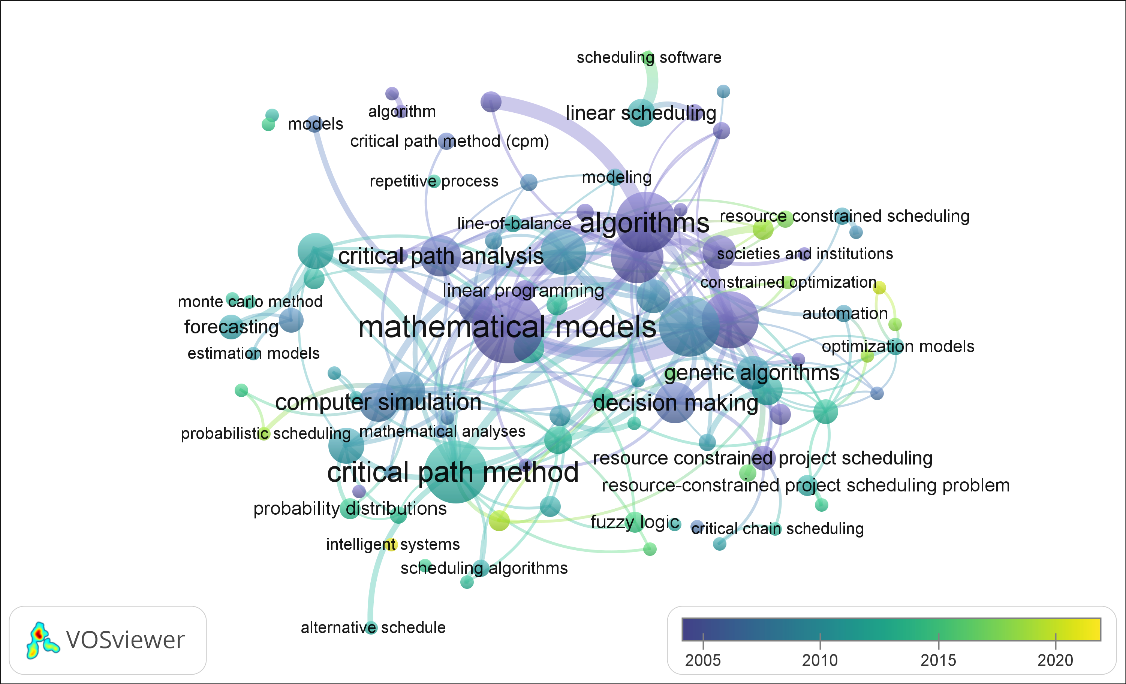
Figure 4. Bibliometric network of keywords with increased scope

Table 2: Most Occurring Keywords in the Domain of CSM
Keywords | Number of Occurrences
Mathematical Models | 26
Critical Path Method | 21
Algorithms | 20
Optimization | 20
Linear Scheduling Methods | 13
Computer Simulation | 10
Pert | 10

A careful study of these recent trends in research in the CSM domain shows that the reference to the keyword - intelligent systems were made by Le & Jeong (2020) in their book A daily work report based approach for schedule risk analysis. Despite the reference of the keyword – intelligent systems, the central focus of the study aims to leverage historical digital daily work report (DWR) data available in the Departments of Transportations’ (DOT) databases. This historical information is used to determine the probability distributions of the production rates of work activities then estimate the distributions of activity durations when quantities of the activities are provided. This piece of literature align more with a resource-driven scheduling method. Hence, it cannot be classified as an intelligent system based CSM. The second reference to the keyword - intelligent systems was made by Li (2021) in the book Exploration and research on project engineering management mode based on BIM, a project management method based on BIM is proposed – a fuzzy balanced scheduling method used to optimise and cluster the information data of construction project. This work cannot be categorised in the domain of CSM because it is centrally concern about scheduling and optimising an information database of construction projects. Therefore, recent trends indicate that literatures with the keyword – intelligent systems are very limited in the domain of CSM. However, there is a common use of fuzzy logic or fuzzy set in the domain of CSM. Five papers were published in the domain of CSM between 2011 and 2021. They include Fuzzy repetitive scheduling method for projects with repeating activities (Maravas & Pantouvakis, 2011), A fuzzy-based approach for proactive scheduling of construction projects (Sadeghi & Fayek, 2011), Simulating construction duration for multistory buildings with controlling activities (Nguyen, Phan & Tang, 2013), Creating a Construction Schedule Specifying Fuzzy Norms and the Number of Workers (Plebankiewicz & Karcińska, 2016), and Fuzzy Linear and Repetitive Scheduling for Construction Projects (Katsuragawa et al., 2021). According to (Lima et al., 2021), fuzzy logic (FL) serves as a qualitative interpretation tool for AI or intelligent systems. Hence, within the domain of CSM, these papers based on fuzzy logic may be categorised as part of AI or intelligent systems approach to scheduling. However, fuzzy logic is only one branch of AI application. Other branches exist like the Artificial Neural Network (ANN), expert system, knowledge-based systems and swarm intelligence (Dede et al., 2019). These branches were not flagged as scheduling methods in this scientometric study. This is a potential gap in the application of artificial intelligence in the domain of CSM that could be explored further.

In addition, the keyword - Uncertainty Analysis generated three papers. The first is A CPM-based scheduling method for construction projects with fuzzy sets and fuzzy operations (Ökmen & Öztaş, 2014). In this paper, the authors proposed that fuzzy sets represent the duration of activities, and network calculations can be performed by fuzzy operations. The activities start and finish, and the project completion time is then calculated as fuzzy sets. The second paper is the Critical Chain Design Structure Matrix Method for Construction Project Scheduling under Rework Scenarios (Ma et al., 2019), based on CPM and CCPM scheduling methods. And the third is the Dynamic decision support framework for production scheduling using a combined genetic algorithm and multiagent model (Du, 2021). These approaches are not deemed as new trends as fuzzy logic has been shown to have been adopted for some time now; also, the critical chain methods and algorithms are equally known approaches (see Figure 4).

Furthermore, the keyword - Probabilistic Scheduling generated two papers. The first is Reconsidering an Appropriate Probability Distribution Function for Construction Simulations (Thompson, Lucko & Su, 2016). The theory in this paper is like known schedule risk simulation methods or probabilistic scheduling like PERT and Monte Carlo Analysis. The second paper is Dynamic Contract Time Determination System for Highway Projects (Abdel-Raheem, Cantu & Wang, 2020), a preliminary framework for developing a computer-based system designed to determine a realistic contract duration for Texas Department of Transportation (TxDOT) projects. In addition to traditional deterministic scheduling based on production rates information saved in a database. The system also performs probabilistic scheduling, which uses the program evaluation and review technique. The application of this framework is common in the United States Department of Transportation. The application of this framework in building construction can be explored in further studies.

Finally, the keyword - Schedule Optimisation generated BIM-based construction scheduling method using optimisation theory for reducing activity overlaps (Moon et al., 2015). This study identifies overlapping activities, applies fuzzy theory, analyses risk levels for schedule overlap issues, and minimises the overlapping of highly risky activities using genetic algorithm (GA) theory. In the study by Moon et al. (2015), they suggested an optimal construction schedule (OCS) which is visualised in a BIM-based four-dimensional (4D) computer-aided design (CAD) environment. The OCS was developed by including fuzzy and GA analysis functions with a schedule simulator. Research is limited in the application of BIM in improving schedule predictability and robustness; the application of BIM in the domain of CSM remains an interesting proposition.

CONCLUSION
This study aims at reviewing works of literature in the domain of construction scheduling methods to understand the existing approaches to scheduling, gaps, and trends. A total of 148 documents from 1986 to October 2021 were retrieved from Scopus database using bibliometric search. A scientometric analysis was used to derive relevant bibliographic networks of prominent journals, keywords, co-author analysis, articles, and countries in the research of CSM.

Based on scientometric analysis and discussion of results, the main research topics identified include mathematical models, critical path method, algorithms, optimisation, linear scheduling methods, computer simulation, and pert. While the trend indicates a growing interest of research in CSM, the gaps in research studies show that further studies are required in the application of artificial intelligence, the application of CTDS framework in building construction, and the application of BIM in improving schedule predictability and robustness.
As part of more extensive research work, a detailed discussion will be done on the result of this scientometric study covering the existing scheduling methods, the trends and gaps discovered in literature. The outcome of the discussion will recommend the best-suited approach to adopt for automatic and reliable construction project duration estimation.

REFERENCES
Abdel-Raheem, M., Torres Cantu, C. and Wang, X., 2020. Dynamic Contract Time Determination System for Highway Projects. Transportation Research Record, 2674(5), pp.381-392.
Arega, M., 2018. Factors Causing Project Cost Overrun In Construction Project: In Case Of Rama Construction Plc (Doctoral dissertation, Addis Ababa University).
Bakkalbasi, N., Bauer, K., Glover, J., & Wang, L. (2006). Three options for citation tracking: Google Scholar, Scopus and Web of Science. Biomedical Digital Libraries, 3(1), 7. https://doi.org/10.1186/1742-5581-3-7
Bar-Ilan, J., 2010. Citations to the “Introduction to informetrics” indexed by WOS, Scopus and Google Scholar. Scientometrics, 82(3), pp.495-506.
Dede, T., Kankal, M., Vosoughi, A.R., Grzywiński, M. and Kripka, M., 2019. Artificial intelligence applications in civil engineering.
Derbe, G., Li, Y., Wu, D. and Zhao, Q. (2020) “Scientometric review of construction project schedule studies: trends, gaps and potential research areas”, Journal of Civil Engineering and Management, 26(4), pp. 343-363. doi: 10.3846/jcem.2020.12317.
Du, J., Dong, P., Sugumaran, V. and Castro‐Lacouture, D., 2021. Dynamic decision support framework for production scheduling using a combined genetic algorithm and multiagent model. Expert Systems, 38(1), p.e12533.
Eber, W., 2020. Potentials of artificial intelligence in construction management. Organisation, technology & management in construction: an international journal, 12(1), pp.2053-2063.
Flanagan, R. and Jewell, C., 2018. New Code of Estimating Practice. Hoboken, NJ: John Wiley & Sons, Inc.
González-Torres, T., Rodríguez-Sánchez, J.L., Pelechano-Barahona, E. and García-Muiña, F.E., 2020. A systematic review of research on sustainability in mergers and acquisitions. Sustainability, 12(2), p.513.
Hallinger, P. and Nguyen, V.T., 2020. Mapping the landscape and structure of research on education for sustainable development: a bibliometric review. Sustainability, 12(5), p.1947.
Hazen, B.T., 2010. Decision variables within reverse logistics. Adopting the is 2009 model curriculum: apanel session to address the challenges for program implementation, p.70.
Hosseini, M.R., Martek, I., Zavadskas, E.K., Aibinu, A.A., Arashpour, M. and Chileshe, N., 2018. Critical evaluation of off-site construction research: A Scientometric analysis. Automation in Construction, 87, pp.235-247
Johnson, R.M. and Babu, R.I.I., 2020. Time and cost overruns in the UAE construction industry: a critical analysis. International Journal of Construction Management, 20(5), pp.402-411.
Katsuragawa, C.M., Lucko, G., Isaac, S. and Su, Y., 2021. Fuzzy Linear and Repetitive Scheduling for Construction Projects. Journal of Construction Engineering and Management, 147(3), p.04021002.
Le, C. and Jeong, H.D., 2020. A Daily Work Report Based Approach for Schedule Risk Analysis. In CIGOS 2019, Innovation for Sustainable Infrastructure (pp. 1131-1136). Springer, Singapore.
Li, D., 2020, March. Exploration and Research on Project Engineering Management Mode Based on BIM. In International Conference on Application of Intelligent Systems in Multi-modal Information Analytics (pp. 180-184). Springer, Cham.
Lima, B.N., Balducci, P., Passos, R.P., Novelli, C., Fileni, C.H.P., Vieira, F., de Camargo, L.B. and Junior, G.D.B.V., 2021. Artificial intelligence based on fuzzy logic for the analysis of human movement in healthy people: a systematic review. Artificial Intelligence Review, 54(2), pp.1507-1523.
Ma, G., Hao, K., Xiao, Y. and Zhu, T., 2019. Critical chain design structure matrix method for construction project scheduling under rework scenarios. Mathematical Problems in Engineering, 2019.
Maravas, A. and Pantouvakis, J.P., 2011. Fuzzy repetitive scheduling method for projects with repeating activities. Journal of Construction Engineering and Management, 137(7), pp.561-564.
Moon, H., Kim, H., Kamat, V.R. and Kang, L., 2015. BIM-based construction scheduling method using optimisation theory for reducing activity overlaps. Journal of Computing in Civil Engineering, 29(3), p.04014048.
Nguyen, L.D., Phan, D.H. and Tang, L.C., 2013. Simulating construction duration for multistory buildings with controlling activities. Journal of Construction Engineering and Management, 139(8), pp.951-959.
Ökmen, O. and Öztaş, A., 2014. A CPM-based scheduling method for construction projects with fuzzy sets and fuzzy operations. Journal of the South African Institution of Civil Engineering= Joernaal van die Suid-Afrikaanse Instituut van Siviele Ingenieurswese, 56(2), pp.2-8.
Pan, Y. and Zhang, L., 2021. Roles of artificial intelligence in construction engineering and management: A critical review and future trends. Automation in construction, 122, p.103517.
Petruseva, S., Zileska-Pancovska, V. and Car-Pušić, D., 2019. Implementation of process-based and data-driven models for early prediction of construction time. Advances in Civil Engineering, 2019.
Plebankiewicz, E. and Karcińska, P., 2016. Creating a construction schedule specyfing fuzzy norms and the number of workers. Archives of Civil Engineering, 62(3).
Sadeghi, N. and Fayek, A., 2021. A fuzzy-based approach for proactive scheduling of construction projects. Annual Conference of the Canadian Society for Civil Engineering 2011, CSCE 2011, [online] Volume 3, pp.1776 - 1786. Available at: <https://www.scopus.com/inward/record.uri?eid=2-s2.0-84855799073&partnerID=40&md5=5845ca0bfa9e55b053778a505803e910> [Accessed 8 November 2021].
Thompson Jr, R.C., Lucko, G. and Su, Y., 2016. Reconsidering an appropriate probability distribution function for construction simulations. In Construction Research Congress 2016 (pp. 2522-2531).
Van Eck, N.J. and Waltman, L., 2014. Visualising bibliometric networks. In Measuring scholarly impact (pp. 285-320). Springer, Cham.

